1.1 What are Nature-Based Solutions? – Olivia Ollikainen
This module contains the MUST-KNOW contents of Nature-Based Solutions. You will learn what NBS are and how are they determined. Go through the learning material and then move on to the multiple-choice quiz that is based on these materials.
Introduction to NBS
Nature-Based Solutions use ecosystems and the services they provide to address societal challenges such as climate change, food security and natural disasters. The concept was created for solutions to work with ecosystems rather than relying on conventional engineering interventions, such as seawalls, to adapt to and mitigate climate change effects.
NBS can often be used in conjugation with other types of intervention. Food security challenges for example, are best addressed using a combination of measures including NBS (introducing agroforestry systems, restoring wetlands et cetera). The main objective of NBS is to support the achievement of society’s development goals and safeguard human well-being. NBS reflect cultural and societal values and enhance the resilience of ecosystems.
In 2016 the IUCN launched the definitional framework for NBS in which they were defined as “actions to protect, sustainably manage, and restore natural or modified ecosystems, that address societal challenges effectively and adaptively, simultaneously providing human well-being and biodiversity benefits” (IUCN 2016).
Today, there is a growing acknowledgement of the role that nature plays in our society. However, for most of the 20th century, decision makers treated the conservation of nature as peripheral to national and global agendas. At best, it was considered a worthy interest, at worst, an obstacle to development. A growing scientific consensus indicates that such views were deeply flawed and “nature is essential for human existence and good quality of life.” Most ecosystems are capable of providing multiple benefits, while simultaneously supporting the protection of the natural resource base. This fact means that ecosystem management is often the most promising route by which societal challenges can be addressed.
NBS Terminology
1. What are Nature-Based Solutions? Terminology
According to
- UnALab Nature-Based Solutions Technical Handbook (2019)
- IUCN Global Standards for Nature-Based Solutions (2020)
- European Commission: Nature-Based Solutions & Re-Naturing Cities, Final Report of the Horizon 2020 Expert group (2015)
2. Unpacking the term into its components
- Nature, relates to biodiversity (individual species, habitats, ecosystems) and/or ecosystem services
- Nature-Based refers to ecosystem approaches, or direct utilization of elements of biodiversity
- Solutions refers to a specific problem or challenge for which some recognizable solution or more beneficial outcome exist.
3. Definition according to IUCN
"Actions that protect, sustainably manage and restore natural or modified ecosystems that address societal challenges effectively and adaptively, simultaneously providing human well-being and biodiversity benefits." (IUCN 2016)
Definition according to EC
"Actions inspired by, supported by or copied from nature and which aim to help societies address variety of environmental, social and economic challenges in sustainable ways." (European commission 2020)
4. Differences
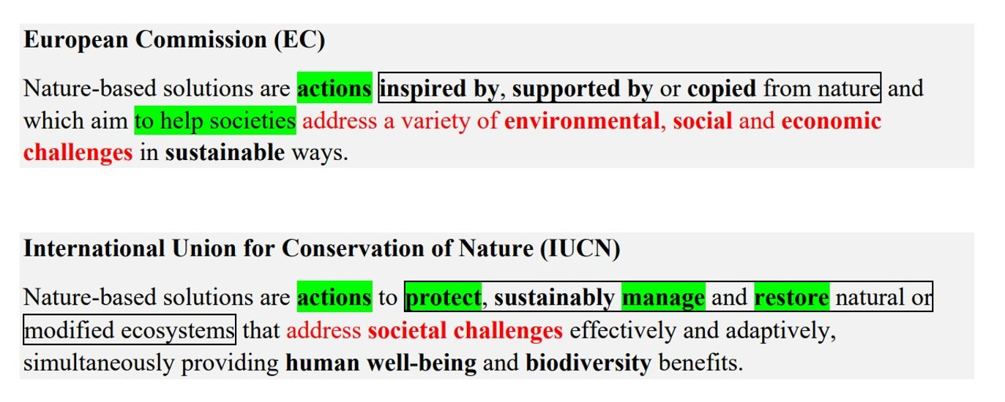
5. Comparing the concepts
- Both share the overall goal
  - Addressing major challenges (highlighted in red)
  - Both understand NBSes as actions, they have a different target (green mark)
  - The difference in the concept is seen in the way nature is framed (black frame)
- EC = Making use of and looking to nature for design and process knowledge.
- IUCN = Emphasis on ecosystem protection, restoration and management.

6. Categories of NBS actions
- Thinking
- Management
- Creation
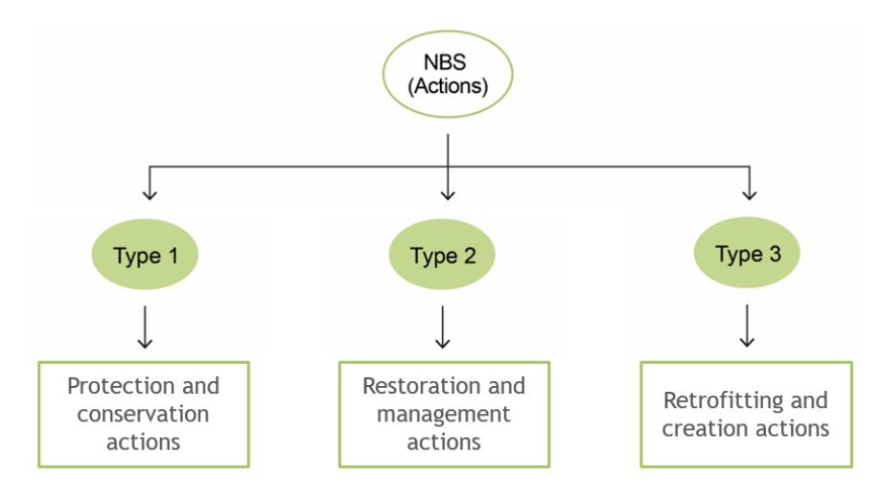
Figure 1. NBS actions, distinction according to type of actions (Eisenber & Polcher).
7. Closely related concepts
- NBS as an umbrella concept:
- Ecosystem-based Adaptation EbA
- Ecosystem-based Approaches EbA
- Green and blue Infrastructure GBI
- Ecosystem services ESS
- Ecosystem-based disaster risk reduction Eco-DRR
- 3-30-300 rule
8. Closely related concepts
- Nature-Inspired Solutions NIS
- Nature-Derived Solution NDS
- Nature-Based Thinking NBT
9. How to put NBS into practice
Features to describe Nature-Based Solutions
- Action-oriented
- Multi-functional (numerous co-benefits)
- Cost-effective (direct and indirect benefits exceed the costs of implementation and maintenance)
- Multi-scale
- Context-specific
- Participatory approaches (co-designing, co-creation, co-management, meeting the needs of various stakeholders)
10. Scaling up Nature-Based Solutions
NBS scaling requires strategic planning to ensure long-term sustainability. Effective scaling up includes these six strategies:​
- Evidence base and demonstration projects​
  - Develop a solid evidence base for NBS benefits (environmental, social and economic) and conduct demonstration projects to assess transferability and maximize the uptake of the most effective solutions.
- Business and investment models​
  - Create innovative funding and governance frameworks, promoting public-private partnerships for long-term financing and mainstreaming of NBS.
- Policy and legislation​
  - Align policies and regulatory frames to support NBSes, incorporating ecosystem values into urban planning
- Communication and education​
  - Strategic communication to mainstream NBSes by sharing practices, fostering policy change and expanding NBSes across regions and sectors. Engagement with citizens, policymakers and global networks is essential.​
- Innovative methods and local adaptation​
  - Using locally adapted methods for ecosystem services, considering variations in soil, climate and hydrology. Leverage existing city networks that enable replication and upscaling of successful NBSes.​
- National and global impact​
  - Contributing to national and global targets related to human well-being, climate change and biodiversity, including United Nations Declaration on the Rights of Indigenous Peoples (UNDRIP). Documenting contributions helps secure political and societal support.​

11. Exclusion criteria (Sowińska-Świerkosz & García, 2022, modified by eNaBlS Project Consortium 2024)​
Criteria that exclude other green/blue interventions from NBS​es
- No ecosystem integration​
  - NBSes must incorporate or improve ecosystems and biodiversity. This excludes activities such as wind, wave or solar energy.​
- Biomimicry​
  - Biomimicry is a process where we learn from, are inspired by and copy nature, for example, down feather insulation in winter coats.​
  - Copying nature’s designs and processes to find new ways of enhancing resilience is not enough unless it is used to improve ecosystems and biodiversity​
- Random interventions​
  - NBSes need defined goals and well-structured management systems. For example, artistic plant installations do not qualify.​
- Post-implementation goals​
  - NBS are oriented towards addressing pre-indentified problems. Historical gardens and parks that are modernized to meet current challenges exemplify this criterion.​
- Negative or no impact on biodiversity​
  - NBSes must enhance biodiversity.​
- Same benefit as grey infrastructure alone​
  - NBSes should offer additional benefits beyond traditional infrastructure. Actions should not replicate benefits of grey infrastructure without additional value​
- Unfair benefit distribution​
  - Simultaneous benefits to the environment and society with full engagement and consent of indigenous people and local communities.​
- Ineffective or inefficient solutions​
  - Effectiveness is context-specific and requires adaptive management​
- Top-down model of governance​
  - NBS includes transparent processes involving all stakeholders to address specific issues. Decisions must align with community needs and concerns.​
  - Implementing solutions without consulting local communities may risk amplifying social and economic inequalities​
- Static management approach​
  - Succesful NBS implementation requires day-to-day management enabling effective responses. Transparent decision-making processes are vital in this regard.​
- Unbalanced costs and benefits​
  - Financial expenses must be appropriate for the benefits they facilitate. The costs should be comparable to or lower than alternative solutions. For example, there should not be frequent plant replacement or constant infrastructure repairs.​
- Microscale approach​
  - Effective NBSes involve coordinated efforts that consider cumulative impacts and engage multiple stakeholders to achieve benefits.​

- Nature-Based Solutions have four principal goals (European Comission 2020)
- Enhancing sustainable urbanization​
- Restoring degraded ecosystems​
- Developing climate change adaptation and mitigation​
- Improving risk management and resilience
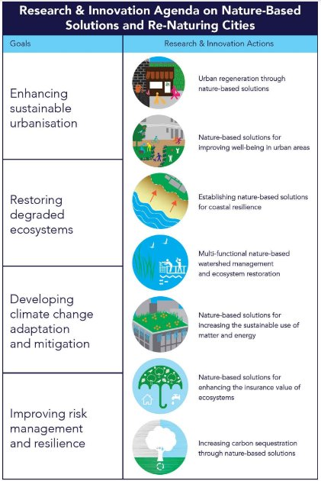
Figure 2. Reaserch & innovation agenda on Nature-Based Solutions and re-naturing cities. (European Comission)

- Examples of NBSes
- Ecosystem restoration

- Reforestation and replantation of native vegetation to restore degraded landscapes
- Restoration of wetlands to improve water quality and bd
- Regeneration of coral reefs and revitalization of depleted fisheries
- Rewilding of landscapes with key species in restoring and maintaining the structure and function of ecosystems
Ecosystem protection
- Conservation of undisturbed semi-natural areas to maintain their ecological integrity and the services they provide
- Establishment of protected areas to preserve wilderness and conserve biodiversity
- Restoration of degraded peatland ecosystems (suot) to mitigate (pienentää) climate-related challenges
- Indigenous land tenure systems, empowerment of local communities in natural resource management through initiatives
Green-blue infra and sustainable urban design
- Design, planning and implementation of infra and systems that integrate natural elements, offering multiple benefits to humans and the environment
- Installation of green roofs and walls
- Permeable pavements to enhance water management
- Creating green corridors and spaces
- Community gardens
- Fostering human-nature interaction in urban settings
Ecosystem-based approaches (EbA) and ecosystem disaster risk reduction (Eco-DDR)
- Strategies to mitigate climate-related and other hazards
- Emphasizes the role of biodiversity and ecosystem restoration practices to enhance resilience for human benefit
- EbA focus on climate-related hazards to slow-onset climate change impacts such as sea level rise.
- Eco-DDR addresses both climate-related (e.g., heat waves) and non-climate hazards (e.g., earthquakes)
- Agro-ecological methods to restore and maintain soil health, protect water resources ym.
- Mangrove restoration and sustainable management of forests as climate change resilience strategies
- Restoration of coastal wetlands to mitigate coastal erosion and provide flood protection
- Maintenance of healthy ecosystems to reduce the likelihood and severity of wildfires and landslides on forested mountains and slopes (stabilizing sediments)
Development of the concept of NBS
Several conservation approaches developed from the 1990s onwards are based on the purposeful management of ecosystems, such as Forest Landscape Restoration, Sustainable Land Management and Coastal Zone Management. These approaches provide benefits to society including jobs, improved land productivity, erosion control and carbon sequestration. Whether standalone or combined with other forms of solutions such as technology, conservation approaches can also be implemented with human well-being as a primary objective.
This evolution of thinking about conservation has led to a recognition of two broad domains of conservation interventions: those whose primary aim is to safeguard biodiversity for its inherent values, and those whose primary purpose is to safeguard society – what is now called Nature-Based Solutions (NBS). Both domains follow the same norms and principles of conservation.
The NBS concept was developed as part of an ongoing paradigm shift that began in the 1980s, in which people proactively protect, manage and restore ecosystems in addressing societal challenges. NBS acknowledge that biodiversity conservation and the protection of ecosystem services are essential for human well-being.
In 2020 the approach has gathered momentum with NBS incorporated into policy, economic plans, research questions and national strategies for biodiversity and climate change. Because of the growing appreciation, there is a real demand to define the term and enable resilient interventions.
For a solution to be considered as NBS, it must address one or multiple societal challenges but also, it must provide simultaneous benefits for biodiversity and human well-being. This is important for ensuring that the integrity and stability of the natural system is not undermined by practices that favor short-term gains, but compromise to provide benefits for future generations.
We need immediate transformational changes to reduce carbon emissions to limit global warming to 1.5 ℃ (IPCC 2018). The NBS concept provides an integrated approach that can help nations meet international agreements and targets, such as the United Nations Sustainable Development Goals (SDGs) and the Paris Agreement.
As the climate emergency deepens, both people and nature will be increasingly vulnerable to weather and climate extremes, and this interlinkage between people and nature offers opportunities in the shape of NBS.
Conclusion
Nature-Based Solutions are not a substitute for nature conservation. They embrace nature conservation and its principles. NBS offer one group of solutions, amoung others, to solve global societal challenges. They can complement and be implemented alongside other types of interventions.
A clear objective of NBS is to support cultural and social components and values. NBS are context-specific, both in time and space. For example, although climate change is a global issue, the issue can be addressed in different ways, scales and parts of the world.

References:
Eisenber B, Polcher V. 2019. Nature Based Solutions -Technical Handbook. Unalab.
European Commission. 2020. Towards an EU research and innovation policy agenda for nature-based solutions & re-naturing cities. Final report. European Union.
IUCN. 2020. Global Standard for Nature-based Solutions. A user-friendly framework for the verification, design and scaling up of NbS. IUCN.
Jones M, Keryan T, de Wit M, Klawitter J. 2024. Comprehensive Overview of Nature-Based Solutions: Harnessing Nature for Environmental and Social Benefits. ENABLS Project Consortium.
Sowińska-Świerkosz B, García J. 2022. What are Nature-based solutions (NBS)? Setting core ideas for concept clarification. Nature-Based Solutions.

