Resistant seedling materials for healthy forest ecosystems and climate change mitigation
Elina Oksanen
In this chapter/section, we learn how the use and production of resistant seedlings materials for reforestation, restoring degraded landscapes and increasing biodiversity of forest ecosystems can be regarded as NBS containing the whole production chain from research to forest management and industry. Application of novel tools and methodologies are an essential part of this process. In this chapter/section we use silver birch (Betula pendula) as an example of well-adapted genetic material for forestry in an unpredictable and rapidly changing northern environment.

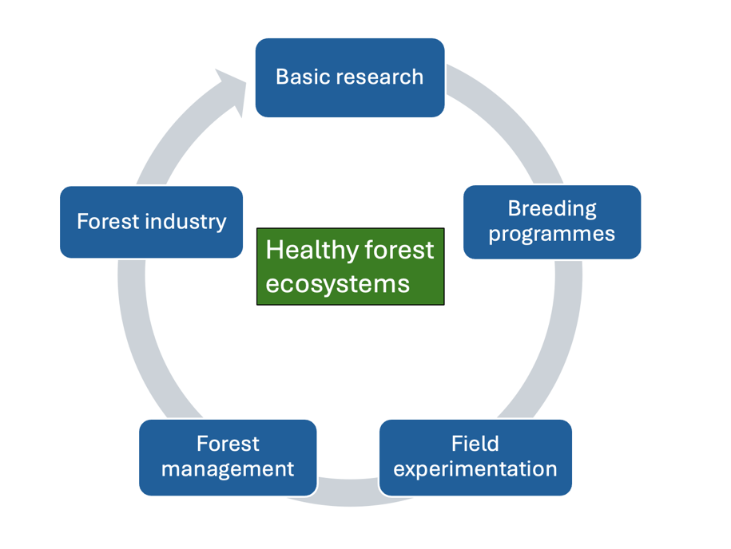
Figure 1. Relationship between basic research, tree-breeding programs, field testing, forest management and forest industry

Multifunctional role of forest ecosystems
Forest ecosystems play a multifunctional and critical role in all life on Earth, because they serve as carbon sink, a regulator for water and nutrient cycling, temperatures and the climate, and a source of raw materials for zero-carbon development of societies and for food production. Maintaining healthy forest ecosystems is important for disaster risk reduction (e.g., the severity of flooding, landslides, and storms), biodiversity, improved air quality and green space management. In addition, forest ecosystems have a tremendous recreational value and impact on human health (Figure 2). So, it is obvious that we should see forest ecosystems (and natural ecosystems in general) more broadly than just from the point of view of exploitation or protection. A forest can be seen simultaneously as a source of wood material (living from), as a maintainer of biodiversity and as a carbon sink (living with), as a landscape and recreational use (living in) or as part of an individual's or a community's identity (living as).

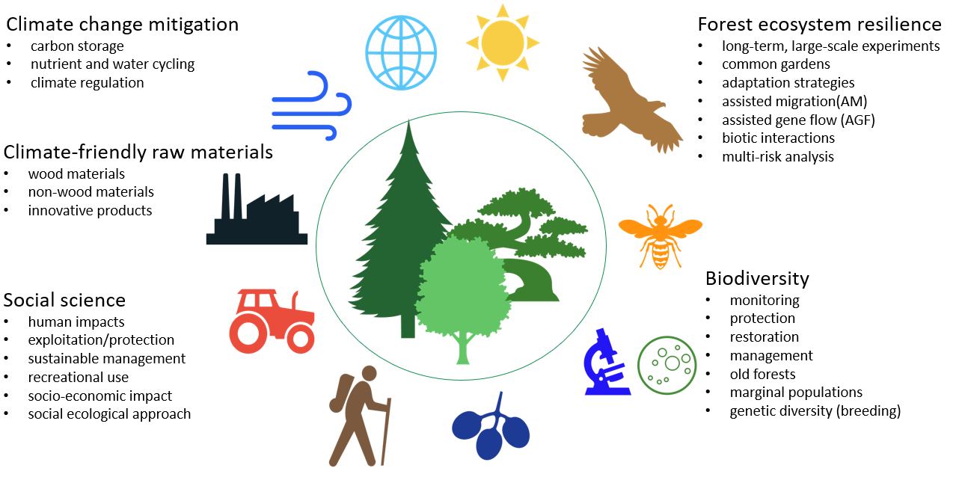
Figure 2: Multifunctional role of forest ecosystems.

Forests have a key role in climate policy
Forests are playing a key role in European and global carbon economy and climate policy,
aiming to achieve climate neutrality in the EU by 2050. A new strategy for EU forests for 2030 outlines the importance of forest for biodiversity maintenance and climate-neutral objectives. One of the practical tasks in this process is the plantation of 3 billion additional trees in the European area by 2030. Recently, the role of forests in maintaining biodiversity has gained more attention due to the rapid loss of biodiversity everywhere in the globe. The EU Nature Restoration Law is a key element of the EU Biodiversity Strategy and has the target of recovering at least 20% of Europe's land and sea areas by 2030, including forests. This is a significant opportunity to increase the resilience of future forests.

Problem: Forest dieback, reduced growth and biodiversity loss
In general, models predict increased dieback and reduced growth of many European forest tree species, including the silver fir (Abies alba), the European beech (Fagus sylvatica) and the sessile oak (Quercus pertaea). In particular, boreal forest ecosystems are subject to rapid warming of the environment because a 4–11°C increase in mean temperatures is expected in this zone by the end of this century. Recent studies have indicated that the dominating conifer trees the Scots pine (Pinus sylvestris) and the Norway spruce (Picea abies) of boreal zones are more sensitive to warming than broad-leaved (deciduous) tree species. Therefore, major changes in tree species composition can be expected, for example, in Finland and the whole Scandinavian area. For sustainable forestry and future silviculture in a rapidly changing environment, we urgently need resistant plant materials for different habitats and areas.

- In Finland, there are two native birch species, the silver birch (Betula pendula) and the downy birch (Betula pubescens) which are becoming more important for the future silviculture in the North. B. pendula has been economically more important, but both species are considered critical for enhancing biodiversity and soil-nutrient status in the low-nutrient northern environment. Silver birch has been extensively studied for decades and has become a model species for acclimation and adaptation for rapidly changing environment.

Solution: Breeding for resistant tree materials
There is an increasing demand for wood and wood products due to growing world population and the anticipated transition from a fossil-based to a bio-based economy. However, wood materials will need to be produced on less land because more space is needed for human activities and agriculture. Current challenges with population growth, climate change, weather extremes, land-use change and increasing risks of pest and pathogen invasions require advanced breeding programs combining novel genetic approaches with field experimentation (NBS). Future breeding programs should focus on potential tree species, also covering physiological, structural, ecological and biochemical aspects and the whole value chain, including wood processing. At the moment, such advanced breeding programs exist for only a handful of forest tree species.
- While laboratory studies are necessary for molecular and genetic knowledge, ecologically relevant field experiments (e.g., common gardens) are important because they serve as natural laboratories for understanding forest dynamics and impacts on biodiversity in the long-term. The main benefit of the field experiments is that they can include all complex multifactor interactions among the components of forest ecosystems (e.g., climatic factors, soil factors, pests and pathogens).
Basic research is a starting point for any breeding programmes, indicating the most suitable targets (i.e. tissues, organs, physiological or biochemical processes) for breeding purpose, thus reflecting the bottom-up approach. For example, silver birches have been studied intensively for their responses to the main climate change factors: greenhouse gases (CO₂ and tropospheric ozone), increasing temperature, changes in precipitation (drought and wetness) as well as the interaction of these factors.

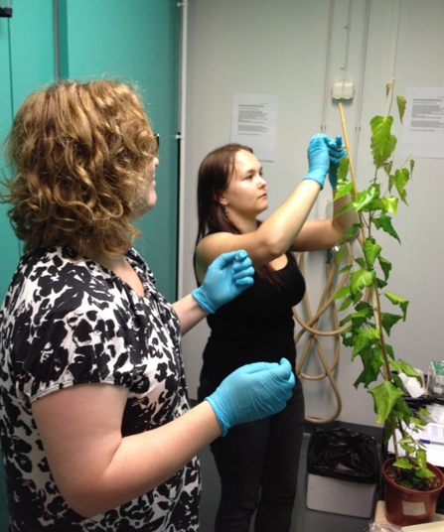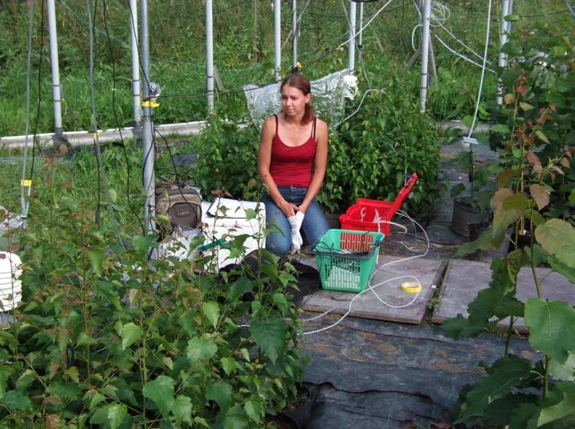
Figure 3. Basic research is a starting point for the development of resistant seedling materials. Study plants are exposed to different treatments (e.g., high temperature, CO₂, ozone, drought), samples are collected for chemical, metabolomic or genetic analyses (left) and measured for gas exchange, photosynthetic parameters or other key physiological processes (right). Photo: Elina Oksanen.

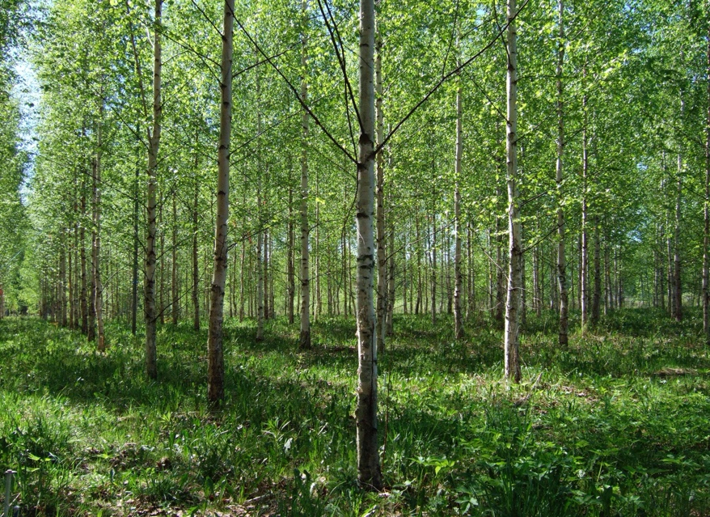
Figure 4. Long-term field experiments with different genotypes of silver birch (Betula pendula) have provided valuable information about genetic differences in photosynthetic efficiency, growth and biomass accumulation a resistance against pest and pathogens. Study site in Punkaharju, Finland. Photo: Elina Oksanen.

- Several complementary experiments in laboratory and natural field conditions have indicated that increasing temperatures and CO₂ levels can improve the growth and biomass accumulation of birch, but at the same time, there is an increasing risk of herbivore damage. On the other hand, negative impacts of high humidity, soil drought and increasing tropospheric ozone has been clearly demonstrated, e.g., in photosynthetic processes. In the natural environment, forest trees are simultaneously exposed to several interacting (positive and negative) abiotic and biotic factors. Therefore, the breeding of multiple resistant seedlings is necessary. A rich genetic pool of birches is valuable for developing multi-resistant materials for healthy forest ecosystems.

From research to innovative products and NBS applications
Conventional breeding is based on a selection of superior and resistant wild genotypes but requires long-term field experiments. Novel molecular tools (phenomics, genomics, metagenomics, metabolomics, transcriptomics, protemics), New Genomic Techniques (NGT), system biology approaches and intergated databases have significantly enhanced and refined the breeding processes. (*Note that genetically modified organisms (GMOs) do not fall under the NBS definition, but rather belong to NIS (Nature-Inspired Solutions). However according to new EU regulation, NGTs correspond to naturally occurring varieties and are therefore closer to NBS). Modelling is an important part of breeding procedures. However, long-term field trials are always necessary to investigate the persistence of the feature produced by any genetic technology.

As a result, several benefits and resistance traits can be achieved that enhance the acclimation capacity and/or biomass production of the trees:
- Improved water uptake and nitrogen fixation
- Increasing disease and pest resistance
- Increasing cold and drought resistance
- Better quality of wood, e.g., by increasing fiber length and reducing lignin, which are desirable properties in the cellulose industry
- Reducing branches and increasing rot resistance, which is desired in the sawmill industry
- Early flowering (with those species that begin to flower very late) for an accelerated breeding process

Some forest tree species, such as poplars and birches, have been used to clean up contaminated lands. It has been possible to improve this “phytoremediation” process by way of genetic engineering: producing fast-growing trees that are effective for removing heavy metals and toxic elements such as mercury and zinc, pesticides, explosives and oils, particularly in former industrial areas.

Forest managers, forest companies and industry have a key role in sustainable nature
-friendly forestry
The end-users of the seedling materials are forest managers, forest owners, forest companies
and finally, the industrial sector. For example, in Finland, the forest industry has created the
roadmaps for green and vibrant economy and diverse, multifunctional forests. In these
roadmaps, volunteer actions aimed at protecting biodiversity and curbing the growth of the
number of endangered species play a significant role. Biodiversity is promoted through the
nature management of commercial forests and by protecting areas rich in biodiversity.
Forest certification promotes the sustainable use of forests, in which nature management is
an essential part of daily operations in forestry, e.g., through retention trees, decaying wood and buffer zones of water systems.

- Various means are required to safeguard biodiversity including adequate forest management methods for different forests, building mosaics of differently aged and structured forests as well as joint research and development projects and forest programs.
- Increasing volume and diversity of deciduous trees, such as birches and aspens, is an important part of the strategy by the forest industry. These species are known to enhance biodiversity and forest soil fertility, providing long-term benefits for the forest owners as well.

In the longer term, it is helpful to remember that the forest industry is dependent on research collaborations and basic research, thus closing the circle of this chapter.

References
Gauthier S, Bernier P, Kuuluvainen T, Shvidenko AZ, Schepaschenko DG (2015) Boreal forest health and global change. Science 349(6250): 819‐822. DOI: 10.1126/science.aaa9092.
Oksanen E (2021) Birch as model system for acclimation and adaptation of northern forest ecosystem to changing environment. Front For Glob Change 10, May 2021. DOI: 10.3389/ffgc.2021.682512.
Reich PB, Bermudez R, Montgomery RA, Rich RL, Rice KE, Hobbie SE, Stefanski A (2022) Even modest climate change may lead to major transitions in boreal forests. Nature. Aug; 608(7923): 540-545. Epub 2022 Aug 10. DOI: 10.1038/s41586-022-05076-3.
Salemaa M, Hotanen J-P, Oksanen J, Tonteri T, Merilä P (2023) Broadleaved trees enhance biodiversity of the understorey vegetation in boreal forests. For. Ecol. Manag. 546: 121357. https://doi.org/10.1016/j.foreco.2023.121357.
Salojärvi J, Smolander O-P, Nieminen K, et al. (2017) Genome Sequencing and Population Genomic Analyses Provide Insights into the Adaptive Landscape of Silver Birch. Nature Genetics 49: 904-912. DOI: 10.1038/ng.3862.)

