Invasive Alien Species
Elina Oksanen
The aim of this Chapter/Section is to (I) introduce the increasing threat of the invasive alien species that are recognized as one of the main direct drivers of change in nature globally, alongside climate change, pollution, land- and sea-use change and exploitation of organism and (II) explain the increasing need for methodologies and tools for prevention, early detection and effective control of invasive alien species. NBS can provide novel technologies and multi-actor engagement for the control of this threat.

Introduction to invasive alien species
- Invasive alien species are species (animals, plants or other organisms) that are introduced to new regions through human activities and are known to have negative impacts on biodiversity, local ecosystems and species.
- The term invasive alien species belongs under the broader term biological invasion, which is used to describe the process involving the intentional or unintentional transport or movement of a species outside its natural range by human activities and its introduction to new regions, where it may become established and spread (See Figure 1)
- More than 37,000 established alien species have been introduced by human activities across every region of Earth, with ca. 200 new alien species reported every year. 3,500 of all recorded invasive species are categorized as invasive alien species with existing evidence of negative impacts on local nature, natures’s contributions to people and human wellbeing.
- The impact of invasive alien species is variable, depending on the species, the ecosystems and the region. In general, island ecosystems are very vulnerable to this threat, but nature in conserved and remote areas can also be affected by invasive alien species.
- While many invasive alien species have been intentionally introduced outside their natural range around the world (e.g., for hunting, fishing or horticultural purposes) there have been many unintentional introductions through contaminants of traded goods and international transport (vessels, marine routes).
- Figure 1 is illustrating the process of biological invasions.

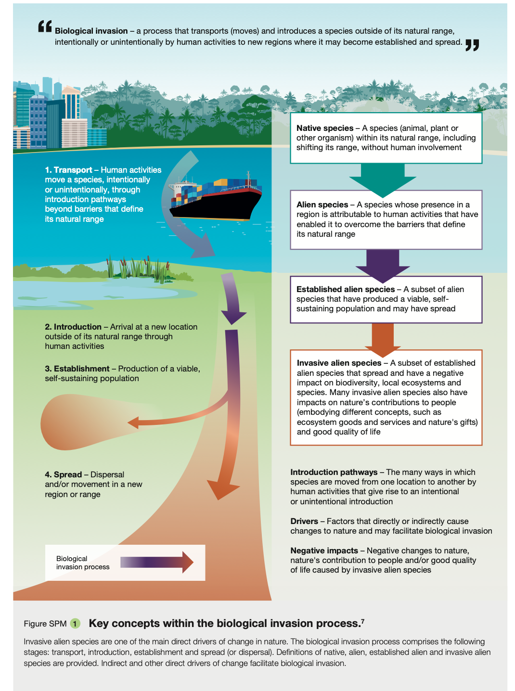
Figure 1. Reference: IPBES 2023 (Reproduction: This publication may be reproduced in whole or in part and in any form for educational or non-profit services without special permission from the copyright holder, provided acknowledgement of the source is made. The IPBES secretariat would appreciate receiving a copy of any publication that uses this publication as a source.).

Problem:
- Alien species are being introduced by human activities to all regions and biomes of the world at unprecedented rates. Some of the species have become invasive, causing negative or even irreversible impacts on nature.
- Invasive alien species cause dramatic and even irreversible changes to ecosystems and biodiversity, resulting in adverse and complex changes in natural ecosystems, such as species extinctions, regionally and globally. Today, 60% of recorded species extinctions are known to be attributed by invasive alien species.
- Invasive alien species cause biotic homogenization, i.e., ecosystems and biological communities across the globe become more similar and lose their uniqueness.
- The economy, food and water security as well as human health and wellbeing are profoundly and negatively affected by invasive alien species.
  - It has been estimated that the global economic costs of invasive alien species have quadrupled every decade since 1970. In 2019, global annual costs of biological invasions exceeded US$423 billion.
  - Invasive alien species can also serve as vectors for infectious zoonotic diseases that can lead to epidemics, such as malaria, dengue fever, chikungunya, Zika, yellow fever and West Nile fever, which are transmitted by invasive mosquito species (e.g., Aedes albopictus and Aedes aegyptii).
  - Some invasive plant species (e.g., the Heracleum-group) may also cause harm to people's health due to toxic and allergenic properties.
- Invasive alien species tend to increase inequity and marginalization in societies, in particular among people with direct contact and livelihoods in nature, such as Indigenous Peoples. Traditional and rural communities can be seriously affected by invasive alien species.
- So far, policies and their implementation have been insufficient in managing biological invasions and preventing and controlling invasive alien species globally.
  - The main progresses are in Aichi Biodiversity Target 9 (By 2020, invasive alien species and pathways are identified and prioritized, priority species are controlled or eradicated, and measures are in place to manage pathways to prevent their introduction and establishment); Sustainable Development Goal Target 15.8 (By 2020 introduce measures to prevent the introduction and significantly reduce the impact of invasive alien species on land and water ecosystems, and control or eradicate the priority species) and The Kunming-Montreal Global Biodiversity Framework (Target 6, Eliminate, minimize, reduce and or mitigate the impacts of invasive alien species on biodiversity and ecosystem services by identifying and managing the pathways of the introduction of alien species, preventing the introduction and establishment of priority invasive alien species, reducing the rates of introduction and establishment of other known or potential invasive alien species by at least 50 per cent by 2030, and eradicating or controlling invasive alien species, especially in priority sites, such as islands.).
  - While the majority of invasive alien species are spreading unintentionally, the current regulations for border biosecurity (i.e., inspections undertaken by quarantine officers of commodities, goods and people) cannot fully protect from illegal transport.
- Ongoing and future amplification of the drivers (climate change, transport, land-/sea-use change, pollution, socio-economic change) will increase the frequency and extent of biological invasions and the impacts of invasive alien species.
- The magnitude of the future threat from invasive alien species is difficult to predict due to complex interactions and feedback among direct and indirect drivers of change in nature. For example, natural disturbances such as wildfires, flooding and drought are unpredictable and may strongly shape and amplify biological invasions regionally.
- Figure 2 illustrates the impacts of invasive alien species in more detail.

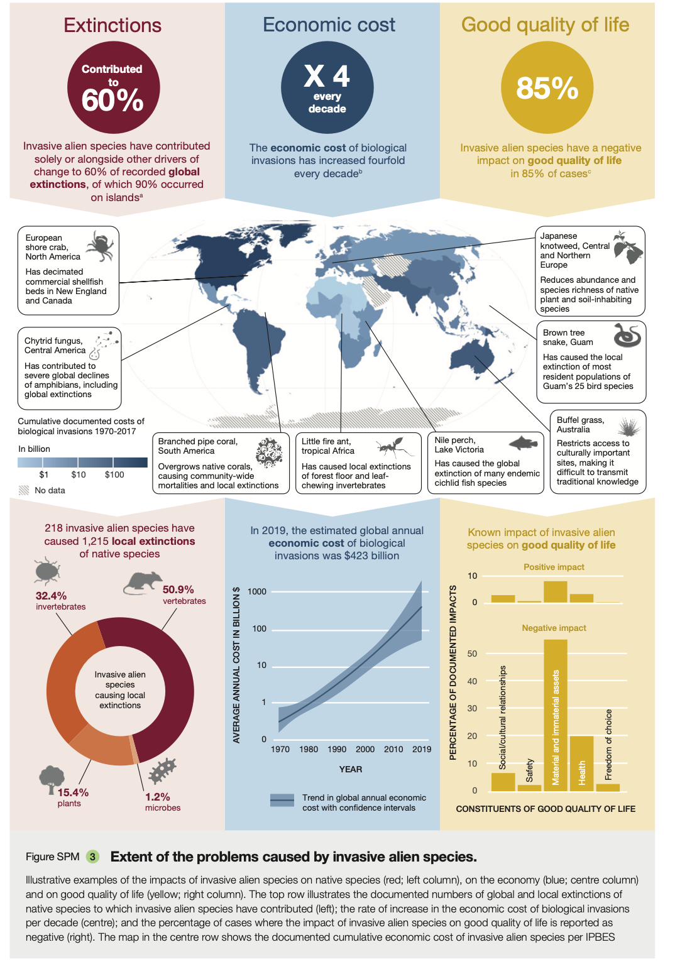
Figure 2. Reference: IPBES 2023 (Reproduction: This publication may be reproduced in whole or in part and in any form for educational or non-profit services without special permission from the copyright holder, provided acknowledgement of the source is made. The IPBES secretariat would appreciate receiving a copy of any publication that uses this publication as a source)

Solutions and multi-actor collaborations:
- The spread of invasive alien species and their negative impacts can be prevented and mitigated through effective management and collaboration.
- The prevention of invasive alien species is always the best and first option in the management strategy.
  - Prevention can be achieved through strictly enforced import controls, appropriate biosecurity legislation, and measures to address escape from confinement.
  - Prevention is particularly critical in marine and connected water systems.
  - Prevention has been particularly effective on islands.
- Early detection, eradication, containment and control are also effective in specific contexts.
- Novel tools and emerging technologies, including mobile application for early detection, biotechnology, bioinformatics, eDNA, remote sensing and data analytics support the management of biological invasions.
  - For example, “Crowdsorsa” is an excellent example of successful mobile application, engaging citizens and school classes in the improvement of city environments through detection and monitoring of invasive alien species
  - https://www.crowdsorsa.com (tämä on tietenkin tuote, jota ei ehkä suoraan voida mainostaa kurssilla, mutta tuo Youtube on kai mahdollinen?)
- Management of biological invasions benefits from engagement with stakeholders and local communities and Indigenous Peoples.
- Multi-stakeholder engagement, including risk communication and context-specific application, can improve public acceptability and adoption of new tools and technologies for managing biological invasions.
- A proper risk assessment and related management framework is crucial to guiding management planning and actions for rapid responses, including the use of novel and environmentally sound technologies, as well as capacity building.
- Eradication attempts has been successful particularly on isolated island ecosystems and for invasive alien vertebrates, especially for small and slow-spreading populations.
- Integrated governance (Figure 3) with ambitious progress through a complementary set of strategic actions is needed to limit the global problem of invasive alien species throughout the biological invasion process and at local, national and regional scales.
  - Integrated governance includes effective coordination and collaboration across international and regional mechanisms promoting policy coherence, development and adoption of effective and achievable national strategies, broad engagement across all stakeholders, Indigenous Peoples and local communities, innovation, research and technology supporting information systems, infrastructures and data sharing.
- Increasing public awareness, commitment, engagement and capacity-building are important in fighting against invasive alien species, and can be promoted by campaigns, education, citizen science, and targeted investment in research innovation and environmentally sound technology.

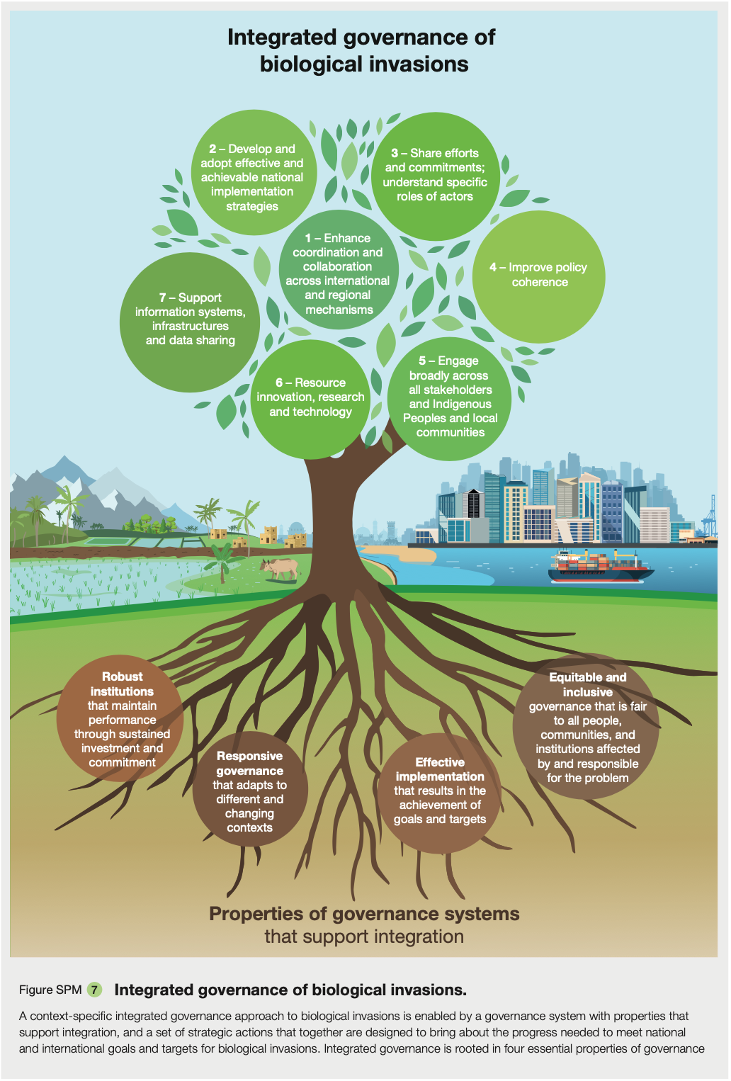
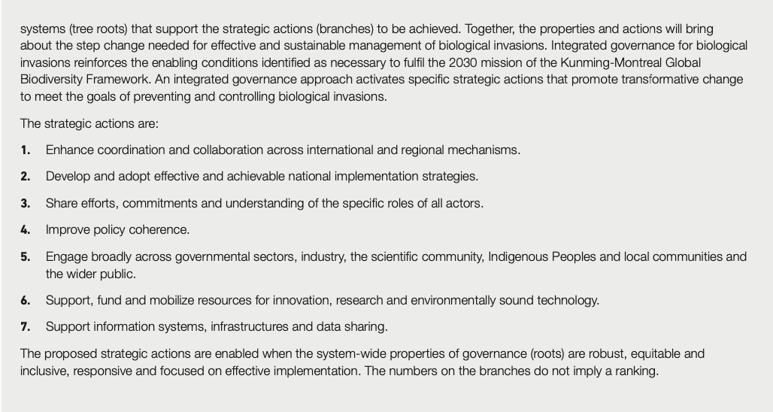
Figure 3. Reference: IPBES 2023 (Reproduction: This publication may be reproduced in whole or in part and in any form for educational or non-profit services without special permission from the copyright holder, provided acknowledgement of the source is made. The IPBES secretariat would appreciate receiving a copy of any publication that uses this publication as a source.).

Management of invasive alien species in Finland
- Finland’s National Strategy on Invasive Alien Species aims to prevent the damage and risks caused by invasive species to Finnish nature, while promoting the sustainable use of natural resources, trade and industry, socio-economic wellbeing and the wellbeing of people. The goal of the strategy is to minimize the risk of invasive alien species already established in Finland or that have a probability of being introduced to Finland.
  - The strategy has been prepared in collaboration between a broadly based working group and experts.
  - The most important way to combat and prevent the invasion of harmful alien species is to spread information as efficiently as possible about the harm caused by the species and about the methods available for combating them. For example, voluntary information or eradication campaigns can be used for this purpose.
- All invasive alien species in Finland have been listed on the webpage www.vieralslajit.fi
  - The national list of alien species includes those alien species that are not included in the EU list but can be considered harmful in Finnish conditions.
  - There is a continuous evaluation process of species (including garden and horticultural species) regarding their invasive properties.
  - For example, garden lupin (Lupinus polyphyllus), Himalayan balsam (Impatiens glandulifera), bay barnacle (Amphibalanus improvisus) and raccoon dog (Nyctereutes procyonoides) are widely spread in Finland and difficult to manage.
  - For some mammals, such as raccoon dogs, detection by drones and remote sensing tools (i.e., thermal cameras) are being developed to minimize the disturbing effect on other species.
- The management measures for invasive alien species in Finland are selected according to the risk assessment and estimated costs and benefits of the prevention measures.
  - The risk assessment is based on the typical qualities of the species, their harmful effects, their opportunities to spread and thrive in our climate, the current stage of their spreading, their current distribution and the prevention measures available.
  - A management plan addresses the prevention of occurrences of alien species and describes the responsible parties and cooperation partners for the implementation of the measures and also presents a schedule and the best practices for its implementation.
- For eradication of small predators, such as raccoon dogs and mink, extensive collaboration with hunters and hunting teams is necessary, as is the development of improved management strategies for city areas, because trapping is not possible in populated areas.

At the end of this chapter/section, you can think about the most important invasive alien species in your area. Do you know if there are any actions or campaigns fighting against these species?

References

IPBES (2023). Summary for Policymakers of the Thematic Assessment Report on Invasive Alien Species and their Control of the Intergovernmental Science-Policy Platform on Biodiversity and Ecosystem Services. Roy, H. E., Pauchard, A., Stoett, P., Renard Truong, T., Bacher, S., Galil, B. S., Hulme, P. E., Ikeda, T., Sankaran, K. V., McGeoch, M. A., Meyerson, L. A., Nuñez, M. A., Ordonez, A., Rahlao, S. J., Schwindt, E., Seebens, H., Sheppard, A. W., and Vandvik, V. (eds.). IPBES secretariat, Bonn, Germany. https://doi.org/10.5281/zenodo.7430692

