The Importance of Food Production for Society and the Challenges in Agriculture
Agriculture and biodiversity – by Olivia Ollikainen
Introduction
In this chapter, you will learn about the relationship between agriculture and biodiversity, focusing on the impacts of agricultural practices on ecosystems. You will learn solutions to enhance biodiversity within agricultural systems, including rewilding, agroecology and sustainable policies. Through case studies, you will gain insights about the balance between food production, agricultural productivity and planetary boundaries and how agricultural systems can be transformed to benefit both human societies and natural ecosystems.
Problem
Agriculture is one of the leading causes of biodiversity loss worldwide, due to its impacts on ecosystems, including land use changes, habitat fragmentation and pollution. While agricultural practices differ greatly across regions in scale, methods and ecological consequences, the intensification of modern farming has largely contributed to declining biodiversity. In Finland, agriculture occupies 2.3 million hectares – similar to the agricultural area in the Netherlands – and affects both farmland and adjacent ecosystems, such as aquatic environments through eutrophication (HELCOM 2023).
Traditional farming has created semi-natural habitats like grasslands and meadows, known as traditional rural biotopes. These habitats are among the most species-rich and endangered in northern Europe, supporting 42 habitat types, of which 40 are critically endangered and two are endangered. The area of traditional rural biotopes has declined by over 90% in the past 50 years, severely impacting species such as the Eurasian curlew (Numenius arquata) and the Eurasian skylark (Alauda arvensis), which now rely on alternative farmland habitats. The diversity of species inhabiting grasslands will primarily depend on both a landscape’s structural diversity and its grassland management practices. In the boreal region of Europe, the current extent of semi-natural grasslands is only a few percent of what it was 100 years ago due to intensification of production and large-scale abandonment in other regions. Other impacts come from pesticide drift, invasive species and nutrient deposition from agricultural and industrial sources.
Key issues
Pollution and water management
Habitat loss and fragmentation
Soil degradation
Climate change

Fig 1. The key challenges of modern agricultural practices that compromise ecosystems’ ability to provide essential services, endangering food security and environmental health (Pereira 2017).
Rapid changes in farming landscapes, such as the growth of farm and field parcels, subsurface drainage, the shift of fodder production and grazing from meadows to grass fields, and the use of pesticides and industrially produced fertilizers have led to habitat loss and a decrease in farmland biodiversity. The decline of open habitats is a major driver of species endangerment. This loss of biodiversity reduces ecosystem services critical to agriculture, such as pollination and pest control, thereby threatening food security.
Nature-Based Solutions for agriculture & food systems
Agriculture does solve societal problems such as food security. It maintains some biodiversity and culture, field plants provide clothing, pharmaceuticals, flowers and bioenergy. Healthy soil also sequestrates carbon. The thing is that agriculture is so high-yielding it has little or no cultural or recreational value. Intensive farming does not support high levels of biodiversity. When forests, wetlands and peatlands have turned into cultivated fields, the soil’s organic matter decreases, and it results in carbon losses.
Nature-Based Solutions principles
- Minimizing disturbance of other ecosystems including pollution resulting from nutrient runoff.
- Non-expansion of farmland on nature ecosystems
- Restoration
- Maintaining soil fertility, structure and composition
- Functioning species interactions
- Adaptability
Nature-Based Solutions adapted to farming
- Minimal disturbance to soil
  - Benefits vegetation and biotic communities
- Diversification of cropping
- Full integration on livestock into arable production
- Complex systems
  - Agroforestry, integrated aquaculture, agricultural rewilding
- Landscape structure
  - Non-cropped elements and areas (e.g., margins and ditches)
  - Green and blue corridors for ecosystem services and conservation
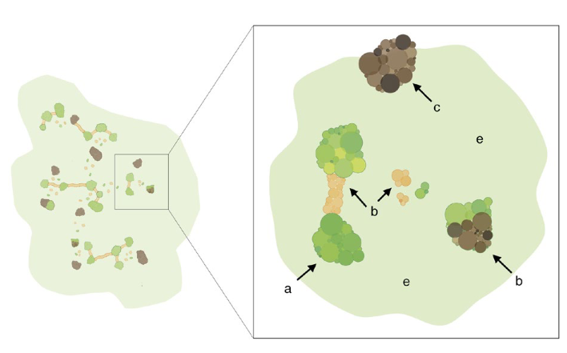
Fig 2. An idealized, ecologically resilient network. a) improving the habitat quality, b) increasing an existing habitat size, c) creating new cites (brown) d) creating features that facilitate dispersal (corridors and stepping stones) and e) greening the matrix, “softening” the “non-habitat” area between patches. (Isaac et al. 2018)
Case example 1: Finnish Action Plan for Pollinators and the EU’s Common Agricultural Policy
Approximately 75% of the world's major crops depend on pollinators, and they are particularly important to fruit and berry production. In Finland, key crops such as zucchini, cucumber, turnip rape and broad bean depend on insect pollinators. The annual economic value of insect pollinators is around 50 million euros in Finland while globally, pollination services are worth $235–577 billion.
The Finnish National Strategy and Action Plan for Pollinators (Ministry of the Environment 2022) aligns with the EU Biodiversity Strategy aiming to halt the decline in the numbers of pollinators and their diversity by 2030 through strengthening the populations of pollinator species and ensuring the pollination of both wild and cultivated plants. The abundance of Anthophila (bees and bumblebees) is supported by flowering food plants and an extensive area of habitats excluded from cultivation. Enhancing the biodiversity of agricultural ecosystems and landscapes can reduce pesticide use and outbreaks of pests when the number of natural predators is increased and diverse varieties of crops are used.
Case example 2: The EU’s Common Agricultural Policy (CAP)
The European Union’s Common Agricultural Policy supports biodiversity-friendly practices, including crop rotation, winter cover crops, green manuring grasses and catch crops, many of which align with organic farming principles. The EU pays compensation for organic farming in order to promote both economic and ecological sustainability.
CAP aims to conduct competitive agriculture in a sustainable way across the EU area. For example, eco-scheme subsidies are granted to farmers who maintain winter vegetative cover on their fields, cultivate green manure leys or biodiversity-enhancing crops. Farmers receiving environmental subsidies commit to practices that reduce environmental impacts, in which case the compensation offsets the costs and possible loss of income arising from these practices. These practices include perennial biodiversity strips, pollinator’s food crops, buffer zones, catch crops and soil improvement plants.
Water conservation and climate objectives are met when the vegetative cover on fields is maintained year-round. This supports biodiversity, soil health, carbon sequestration in the soil and reduces nutrient leaching caused by erosion. By reducing nutrient emissions from agriculture, the state of water bodies can be substantially improved.
The EU is preparing a legislative proposal on soil health (European Commission 2023) which, if implemented, will improve the ecological condition of agricultural soils. Food security can be bolstered by increasing domestic seed production, improving crop adaptability to Finnish conditions, and reducing dependency on imported grains while minimizing the risk of spreading invasive alien species.
Agreements supporting agricultural biodiversity and landscape management help maintain biotopes and other natural pastures that are not located on farmland. These areas often have high natural or landscape values and are managed annually by grazing or mowing.
Grasslands for biodiversity
Permanent agricultural grasslands are known to support a higher level of biodiversity than arable land. The lowest levels of biodiversity tend to be on permanent grasslands with particularly high fertilizer inputs, grazing pressure, frequent mowing operations and temporary grasslands (leys). Temporary grasslands are regularly re-seeded with one or more species of grass or grass-legume mixtures. These are relatively common in dairy production and are part of organic arable farming.
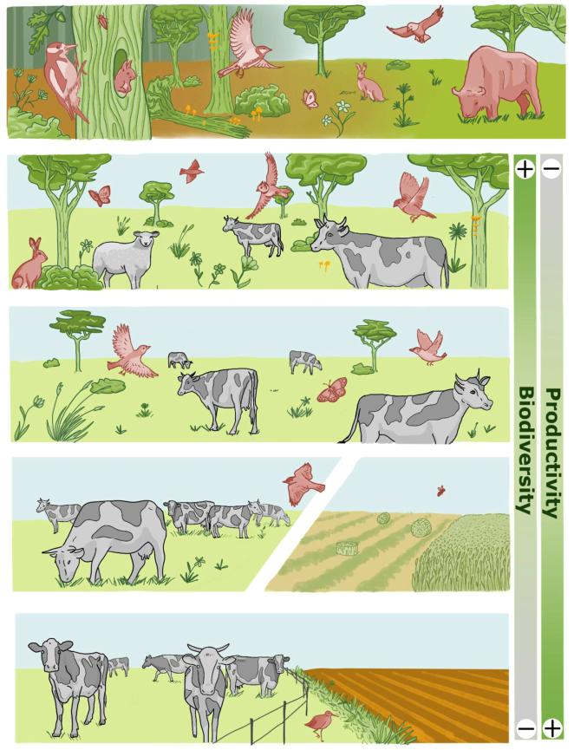
Figure 3: The general relationship between biodiversity and biomass production by agriculture across main grassland types: a) pre-agricultural ecosystem with wild herbivores maintaining native grasslands and creating mosaics of semi-open grassy patches in woodland; b) semi-natural grassland grazed by domesticated herbivores or used for traditional hay making; c) and d) agronomically improved permanent grassland under different levels of management intensity for pasturing and forage production; e) rotational grasslands cultivated as part of arable field rotations. Image by Lola Fernández Multigner.

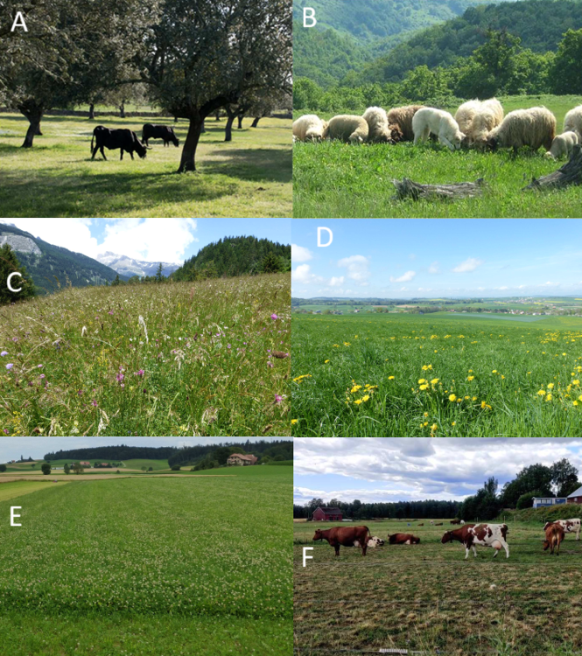
Figure 4. Secondary grasslands under different management and land use intensities. a) traditional agroforestry system with extensive pasture areas (Image by HNV-Link), b) extensively managed mountainous pasture (image courtesy of Wikimedia). (https://commons.wikimedia.org/wiki/File:Pojejena,_Romania_-_panoramio.jpg), c) extensively managed permanent subalpine hay meadow, d) intensively managed permanent grassland, e) cultivated grass-legume ley, f) intensively managed cultivated pasture for dairy production (Aino Pietikäinen). All other images by Jean-Yves Humbert.
Traditional rural biotopes: Due to a long history of evolutionary co-adaptation between native herbivores and other species, grazing by domesticated livestock is generally associated with higher pastoral biodiversity and is also widely used as a conservation tool. Increasing management pressure along any of the above aspects is likely to adversely affect biodiversity. Grazing is an important form of management on grasslands and low-to-moderate grazing intensities would support the highest multi-taxa diversity.
Leaving non-productive margins on intensively managed grassland can enhance biodiversity. It works as a refuge for numerous organisms, such as bumblebees, beetles and spiders, and along watercourses, they can operate as buffer zones for water protection.
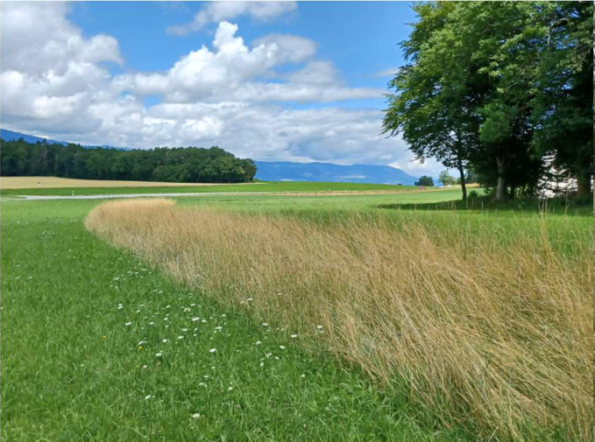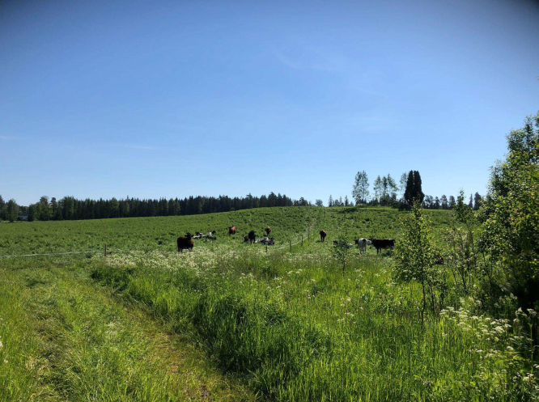
Figures 5 and 6. An example of a mowing refuge on a grassland. Image by Jean-Yves Humbert. Partially fenced out margin along a stream creates a diversity of conditions to benefit several species. Image by I. Herzon.
Sowing a seed mixture and direct seeding by transferring hay from a freshly mowed biodiversity-rich donor grassland are the most common methods used in semi-natural grassland restoration. Species richness can be achieved by combining seeds from the donor grassland with commercial seeds or only using seeds from donor grassland. Also, livestock can be used to spread seeds of native species when letting them move across large areas.
Benefits of reduced livestock production
Maintaining current livestock numbers is sustainably unfeasible. Pig and poultry farming, along with some dairy production, heavily relies on imported grains and concentrated feed. Current livestock practices reduce the potential arable land available for crops for human consumption, degrade biodiversity, and increase agricultural emissions.
Reducing livestock production and increasing grazing could mitigate ecological damage and dependence on imported feed. A reduced number of livestock and increased grazing could also enhance animal welfare. Simultaneously, promoting domestic cultivation of legumes for human consumption would increase plant-based diets in line with nutritional recommendations.
- Legumes are an excellent source of plant-based proteins (providing essential amino acids), fibers, vitamins and minerals
- Legumes can also improve soil fertility by fixing atmospheric nitrogen into soil by way of their symbiotic root nodules and N-fixing bacteria (Rhizobium).
- Legumes can also be used as ‘cover plants’ between the main crop species, which suppresses weeds, prevents erosion of the soils and retains soil moisture.
The decline in the genetic diversity of domesticated species poses a global threat not only for crop production but also to livestock production. For instance, native cattle breeds are better adapted to grazing traditional rural biotopes than modern, intensively bred commercial breeds. These native breeds can feed on a variety of plants and are able to move in diverse terrains effectively.
Can Finland maintain sufficient domestic food production if more farmland is allocated to biodiversity-enhancing practices? It has been estimated that current production levels can be preserved even if organic farming expands to 25% of arable land by 2030 and approximately 28% of farmland is allocated to biodiversity-enhancing measures, such as fallows, biodiversity strips, and perennial grassland fields. Under this scenario, the EU's biodiversity strategy targets for agricultural landscapes would be fully met, assuming that the decline in red meat consumption, observed since 2018, continues. Achieving these ambitious goals requires improved crop varieties suitable for organic farming and expanded advisory services.

It is obvious that downsizing and improvements to the livestock system are needed to stay within planetary boundaries while producing safe and nutritious food for all. Improving production alone and increasing efficiency will lead to a fundamentally unsustainable state of the system. Benefits from the increasing efficiency at the production level can exacerbate environmental and social impacts such as the generation of nutrient surpluses in livestock farms. Stakeholders that are dependent on livestock production are understandably concerned about the future of their livelihood. We need principles of just transition to ensure that the food system can deliver safe and nutritious food to all while safeguarding other societal goals.
The livestock has also a social role. The values of livestock and traditional agrarian systems were developed during times of low population densities and in rural societies. With a world population approaching 10 billion and with limited planet and resources, such systems cannot sustain the consumption levels typical of the high- and middle-income countries. Development of new forms of livelihoods and production methods with re-evaluated and reinvented social roles for animals is at the core of any just transition. A just transition needs to provide alternative employment in rural areas, involving and empowering those affected, protect human rights, maintain geopolitical security and support human capacities and agency.
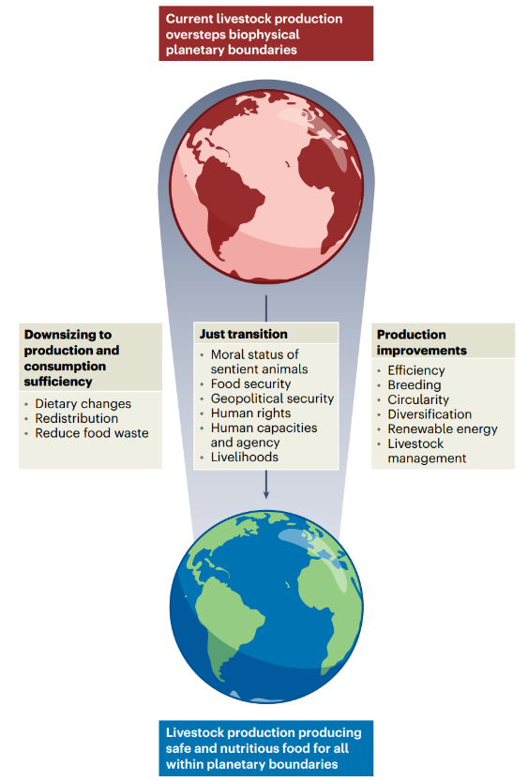
Figure 7. Livestock contributes to sustainable food systems in reaching its goals of providing safe and nutritious food only if its production fits within biophysical planetary boundaries (Herzon et al. 2024).

Rewilding of agricultural systems
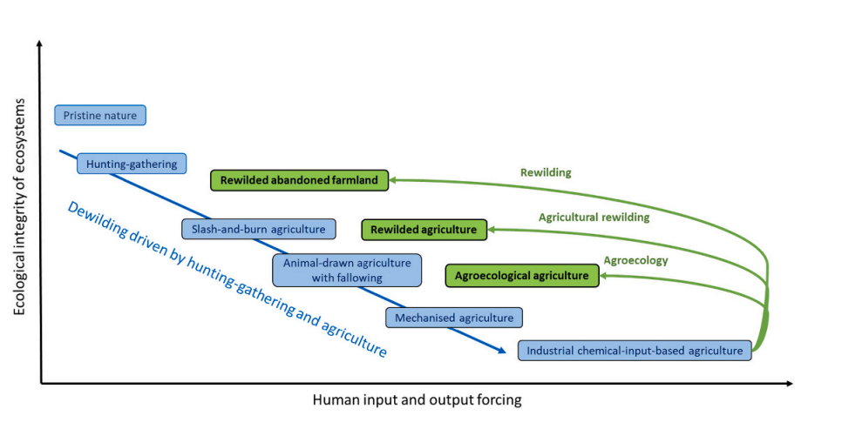
Figure 8. Over time, human food product procurement has involved increased human forcing of natural processes and degraded the ecological integrity of ecosystems. This evolution is considered a continuous dewilding process (blue). Recently, certain agricultural landscapes and farms have decreased human forcing of natural processes and improved the ecological integrity of ecosystems. This evolution has three forms: agroecology, agricultural rewilding and rewilding (green) (Corson et al. 2022).

Towards increased biodiversity by agroecology, rewilding and agricultural rewilding
Agroecology means “the application of ecological concepts and principles to the design and management of sustainable agroecosystems” (Gliessman 1998). These practices aim to design complex and resilient ecosystems that favor natural processes and biological interactions so that farms can sponsor their own soil fertility, crop protection and still, productivity. Although no definitive set of agroecological practices exists approaches like organic agriculture, agroforestry and permaculture are closely linked. Agroecological livestock systems rely more on ecosystem services than human inputs, so they can be considered biodiversity-based systems. Traditionally, biodiversity conservation and restoration involve continued human intervention, such as habitat creation or manipulation and culling of invasive species.

Rewilding aims to restore ecosystems with minimal human intervention. Rewilding processes occur after major human disturbance and the aim is to rebuild a natural ecosystem and restore natural processes that would have been present had the disturbance not occurred (Carver et al. 2021). Agricultural rewilding combines low-intensity grazing with habitat restoration, balancing biodiversity goals with limited productivity. The aim is to reduce the intensity of agricultural management and implement conservation actions in farmed landscapes. This approach is particularly relevant for marginal lands where high-intensity farming is neither sustainable nor economically viable. The Rewilding Britain website (https://www.rewildingbritain.org.uk/) introduces 11 case studies of agricultural rewilding projects. The management of the projects has varied from governmental, commercial and non-governmental organizations to a combination thereof. The actions of rewilding, such as habitat restoration, tree planting, species reintroduction and deer control have been engaging several stakeholders into the project (e.g., volunteers, coordinators, educators, tourists and local businesses).
The characteristics of four animal-based forms of land use, in order of increasing ecological integrity of ecosystems (Clay et al. 2020)
Characteristic | Industrial livestock production | Agroecological livestock system | Agricultural rewilding | Rewilding
Premise | Demand for animal food is large and increasing. Increasing input-use efficiency decreases environmental impacts peer unit of product. | Replacing human inputs with natural processes creates self-sufficient production-consumption systems | Grazers can transform farmland into a biodiverse ecosystem, which allows some harvest. | Promotes self-sustaining ecosystems and enhances conservation status of biodiversity.
Management practices | Large farms, intensive use of human inputs such as feed, antibiotics and buildings. | Diversified crop-livestock farms, local breeds fully or largely outdoors, for local markets | Large areas with a diverse mixture of herbivores that are managed to develop self-sustaining ecosystems, regular harvest of traditional livestock | Large areas with herbivores and sometimes carnivores, protects native biodiversity, functionally important communities of species
Strengths | Higher productivity per unit of land | Lower environmental impacts, favorable for biodiversity, resilient to changes, optimal local knowledge | Excellent for biodiversity and provision of ecosystem services | Best for biodiversity, ecological integrity and ecosystem services
Weaknesses | Lower animal welfare, high environmental impact | Lower productivity per unit of land | May lack consideration of local culture and traditions, lower productivity | May lack consideration of local culture and traditions, conflict with agriculture

Biodiversity is central to both agroecology and agricultural rewilding; the main difference between them is the degree of human intervention and thus agricultural productivity. Transitioning from industrial to agroecological livestock systems reduces environmental impacts, favors biodiversity and enhances the maintenance of ecosystem services as well as cultural ecosystem services. Agricultural rewilding may allow livestock systems to further reduce their impacts.
Conclusion
Transforming agriculture to support biodiversity is essential for sustaining ecosystems and securing global food systems. While challenges like soil degradation and pollinator loss are significant, solutions such as agroecology, policy-driven incentives and rewilding demonstrate that that balance is achievable.
Biodiversity conservation is an advancing research area in land management. There is evidence that intensification of grasslands and arable systems has led to losses of farmland biodiversity. Grasslands have a great potential for supporting biodiversity within human-managed landscapes. The optimal idea is to create a spatio-temporal mosaic of highly productive areas, extensively managed parcels and native vegetation.
Specific methods need to be adapted to all land, taking the geographic, climatic, agricultural and socio-economic contexts into consideration. The trade-offs between achieving various benefits, including biodiversity and high yields, need to undergo systemic changes at the food system level. Along with the adjustment of management, a shift towards more plant-based human diets is a prerequisite for achieving such a change of paradigm in agriculture and society.
Reflect on your local agricultural practices. Consider how biodiversity methods could be applied to them.

References
Carver, S., Convery, I., Hawkins, S., Beyers, R., Eagle, A., Kun, Z., Van Maanen, E., Cao, Y., Fisher, M., Edwards, S.R., Nelson, C., Gann, G.D., Shurter, S., Aguilar, K., Andrade, A., Ripple, W.J., Davis, J., Sinclair, A., Bekoff, M., Noss, R., Foreman, D., Pettersson, H., Root-Bernstein, M., Svenning, J.C., Taylor, P., Wynne-Jones, S., Featherstone, A.W., Fløjgaard, C., Stanley-Price, M., Navarro, L.M., Aykroyd, T., Parfitt, A., Soul´e, M., 2021. Guiding principles for rewilding. Conserv. Biol. 35, 1882–1893. https://doi.org/10.1111/cobi.13730.
Clay N., Garnett T. & Lorimer J. 2020. Dairy intensification: drivers, impacts and alternatives. Ambio 49, 35-48.
Corson M. S. Mondière A., Morel L. van der Werd H. M. G. 2022. Beyond agroecology: agricultural rewilding, a prospect for livestock systems. A review. Agricultural Systems. 199:103410.
Euroopan komissio. 2023. Euroopan parlamentin ja neuvoston direktiivi maaperän seurannasta ja kestokyvystä (maaperän seurantaa koskeva laki). COM (2023) 416.
Gallé R, Happe AK, Baillod AB, Tscharntke T, Batáry P. 2019. Landscape configuration, organic management, and within-field position drive functional diversity of spiders and carabids. Journal of Applied Ecology 56:63– 72.
Gliessman S. R-, Engles E-, Krieger R. 1998. Agroecology: ecological processes in sustainable agriculture. CRC press.
HELCOM. 2023. State of the Baltic Sea. Third HELCOM holistic assessment 2016–2021. Baltic Sea Environment Proceedings 194.
Heliölä J, Kuussaari M, Rytteri S, Holopainen S, Korpela E-L, Paukkunen J, Suuronen A, Pöyry J. 2022. Pölyttäjien kannankehitys, seuranta ja hyönteispölytyksen taloudellinen arvo Suomessa. PÖLYHYÖTY-hankkeen loppuraportti. Suomen ympäristökeskuksen raportteja 34/2022. Suomen ympäristökeskus.
Herzon I., Mazac R., Erkkola M. et al. 2024. Both downsizing and improvements to livestock systems are needed to stay within planetary boundaries. Nature Food 5, 642–645 https://doi.org/10.1038/s43016-024-01030-w
Herzon, I., Raatikainen, K.J., Helm, A., et al. 2022. Semi-natural habitats in the European boreal region: Caught in the socio-ecological extinction vortex? Ambio 51, 1753–1763. https://doi.org/10.1007/S13280-022-01705-3/FIGURES/1
Holopainen S, Lehikoinen A 2022. Role of forest ditching and agriculture on water quality: connecting the long-term physico-chemical subsurface state of lakes with landscape and habitat structure information. Science of the Total Environment 806:151477.
IPBES. 2019. Summary for policymakers of the global assessment report on biodiversity and ecosystem services of the Intergovernmental Science-Policy Platform on Biodiversity and Ecosystem Services. Díaz S, Settele J, Brondízio ES, Ngo HT, Guèze M, Agard J, Arneth A, Balvanera P, Brauman KA, Butchart SHM, Chan KMA, Garibaldi LA, Ichii K, Liu J, Subramanian SM, Midgley GF, Miloslavich P, Molnár Z, Obura D, Pfaff A, Polasky S, Purvis A, Razzaque J, Reyers B, Roy Chowdhury R, Shin YJ, Visseren-Hamakers IJ, Willis KJ, Zayas CN (toim.). Secretariat of the Intergovernmental Science-Policy Platform on Biodiversity and Ecosystem Services.
Kaartinen NE, Tapanainen H, Maukonen M, Päivärinta E, Valsta LM, Itkonen ST, Pajari A-M, Männistö S. 2022. Partial replacement of red and processed meat with legumes – a modelling study of the impact on nutrient intakes and nutrient adequacy on the population level. Public Health Nutrition 26:303–314
Lehikoinen, A., Aalto, J., Boström, C., Ekroos, J., Herzon, I., Hyytiäinen, K., Häyrynen, S., Jarva, J., Jokimäki, J., Kotiaho, J. S., Kuussaari, M., Kosenius, A.-K., Laine, I., Mykrä, H., Onkila, T., Paloniitty, T., Pappila, M., Silfverberg, O., Sääksjärvi, I.E., Wolff, L.-A. ja Rytteri, S. 2024. Maatalousalueiden luonnon monimuotoisuuden edistämisen keinot ja hyödyt Suomessa. Luontopaneelin yhteenveto ja suositukset luontopolitiikan suunnittelun ja päätöksenteon tueksi. Suomen Luontopaneelin julkaisuja 2A/2024
Pereira L. S. 2017. Water, agriculture and food: Challenges and issues. Water Resources Management, 31:2985–2999.
Potts S. G., Imperatriz-Fonseca V. L., Ngo H. T. (toim.). 2016. The assessment report of the Intergovernmental Science-Policy Platform on Biodiversity and Ecosystem Services on pollinators, pollination and food production. Secretariat of the Intergovernmental Science-Policy Platform on Biodiversity and Ecosystem Services.
Röös, E., Mayer, A., Muller, A., et al. 2022. Agroecological practices in combination with healthy diets can help meet EU food system policy targets. Sci. Total Environ. 847, 157612. https://doi.org/10.1016/J.SCITOTENV.2022.157612
Schils, R.L.M., Bufe, C., Rhymer, C.M., et al. 2022. Permanent grasslands in Europe: Land use change and intensification decrease their multifunctionality. Agric. Ecosyst. Environ. 330. https://doi.org/10.1016/j.agee.2022.107891
Therond O., Duru M., Roger-Estrade J. & Richard G. 2017. A new analytical framework of farming system and agriculture model diversities. A review. Agron. Sustainable Development 37:21.
Tiainen J, Hyvönen T, Hagner M, Huusela-Veistola E, Louhi P, Miettinen A, Nieminen T, Palojärvi A, Seimola T, Taimisto P, Virkajärvi P. 2020. Biodiversity in intensive and extensive grasslands in Finland: the impacts of spatial and temporal changes of agricultural land use. Agricultural and Food Science 29:68–97.
Toivonen M, Huusela-Veistola E, Herzon I. 2018. Perennial fallow strips support biological pest control in spring cereal in Northern Europe. Biological Control 121:109–118.
Tribaldos T. & Kortetmäki T. 2022. Just transition principles and criteria for food systems
Vickery, J. & R. Arlettaz. 2012. The importance of habitat heterogeneity at multiple scales for birds in European agricultural landscapes. In: Birds and Habitat: Relationships in Changing Landscapes (ed. R.J. Fuller), pp. 177-204. Cambridge University Press, Cambridge.https://doi.org/10.1046/J.1365-2664.2001.00626.X
Wezel A. 2017. Agroecological practices for sustainable agriculture. p. 504. World Scientific. https://doi.org/10.1142/9781786343062_bmatter

