Crop wild relatives (CWR)
Elina Oksanen
In this chapter/section, we learn how crop wild relatives (CWR) can improve crop production and agriculture and rapidly change climate enhancing food security locally and globally. We virtually visit the largest seed storage on the globe, Svalbard Global Seed Vault, as well as one of the most famous botanical gardens for genetic diversity of plants, The Kew Gardens.

Introduction to CWR
- Crop wild relatives (CWR) are wild plant species that are closely related to crops, forming a pool of genetic diversity with superior adaptive traits
- CWR are valuable for use in ongoing and future breeding programs because they may contain superior adaptive traits against environmental stresses, pests and pathogens
- CWR are gaining more and more importance due to climate change, land degradation, soil impoverishment, pests and disease epidemics as well as genetic erosion of modern crop plants
- For plant breeding, CWR should be readily accessible in, e.g., in situ or ex situ conservation facilities such as germplasm banks
- Unfortunately, CWR are often threatened in their natural habitats. Conservation efforts have not been sufficient and there is lack of awareness of CWR values by stakeholders and site managers
- Understanding the value of genetic CWR resources is the most important promoter of the conservation of CWR
- The need to improve the conservation of CWR has been recognized by the Convention on Biological Diversity (CBD) (2010) and the Global Strategy for Plant Conservation (2011–2020). Therefore, it is important to develop ways to safeguard these important genetic resources.

Problem: Genetic erosion of crop plants, climate change, biotic and abiotic stresses
- Modern agriculture is based on relatively few crop species and high-yielding varieties/cultivars
- Modern agriculture addresses high yields, economic stability and political relationships. However, there has been a gradual loss of genetic variation (i.e., genetic erosion) in crops due to the modernization of agricultural practices over time
- Local varieties and landraces, adapted to harsh and variable conditions, have been replaced by modern varieties, which is the main reason for the genetic erosion
- Genetic erosion has been accelerated, e.g., by environmental degradation, globalization, urbanization, economic development, deforestation and devastating wildfires
- Genetic erosion has occurred at three levels of integration: the crop, variety and allele levels
- One of the main problems in the modern cultivars is their susceptibility to pests and diseases, which was first detected in the USA during the Southern Corn Leaf Blight epidemic (1970–71). After that, recommendations were made to widen the genetic pool of cultivars for major staples (e.g., wheat, corn)
- The narrow genetic variety of modern cultivars also makes them vulnerable to extreme weather conditions, soil degradation, salinity, chemicalization and other pollutants. In practice, crop plants are often simultaneously affected by multiple stresses. Multi-resistant properties are therefore increasingly important
- The urgent need for restoration and maintenance of genetic diversity of crops is now apparent, and numerous national and international programs have been created to collect and maintain the genetic diversity of crops in genebanks and conservation sites
Solutions: Conservation of CWR, in situ and ex situ

- The need to improve the conservation of CWR has been recognized by the Convention on Biological Diversity (CBD) (2010) and the Global Strategy for Plant Conservation (2011–2020). Therefore, it is important to develop ways to safeguard these important genetic resources.
- The conservation of CWR requires close cooperation between stakeholders, researchers, policy makers, economics and many other members of society
- The conservation of CWR can be improved through the network of genetic reserves
- The first step in the conservation of targeted CWR is a management plan, including site description, target taxa description, habitat characterisation, conservation objectives, prescriptions, workplan and resources, monitoring and evaluation
- Conservation is possible in situ or ex situ
  - In situ conservation means protecting all living species (especially wild and endangered species) in their original habitats and environment
  - Ex situ conservation means conserving all the living species in the man-made or artificial habitats (such as seeds in gene banks or botanical gardens) resembling their natural living habitats
  - In situ and ex situ conservation are complementary and comprehensive protection of CWR which requires the development of both methods

- For in situ conservation, a proper strategy for habitat management must be created. For example, protective slopes to cool winds are sometimes necessary for the sensitive plants. Increasing topographic heterogeneity and ecological niches is favorable for many plant species. Woody debris has a beneficial effect on soil ecosystems and stabilize near-surface temperature and moisture. Removal of invasive species is increasingly important in a warming climate. Connectivity between the habitats ensures genetic flow and maintenance of genetic diversity. Fragmented habitats are one of the main causes of biodiversity loss globally.
- For ex situ conservation, seed banks and botanical gardens are the most common. The largest seed collection on the globe is located in Svalbard. The Svalbard Seed Vault storage is carved into the solid rock of the Plateau Mountain, offering optimal conditions for long-term storage. The Seed Vault stores more than one million seed samples from gene banks around the world acting as a safety backup for the world’s crop diversity

  - Virtual Tour of the Svalbard Global Seed Vault https://seedvaultvirtualtour.com
- Read more about us at www.seedvault.no


Figure 1. The Svalbard Global Seed Vault is a safe place to store plant seeds in a cold and dry environment. Photo: Michael Major for Crop Trust

- While botanical gardens are attractive for the general public and tourists, they are also extremely important for research and conservation. Botanical Gardens Conservation International works to secure plant diversity for the well-being of people and the planet globally.
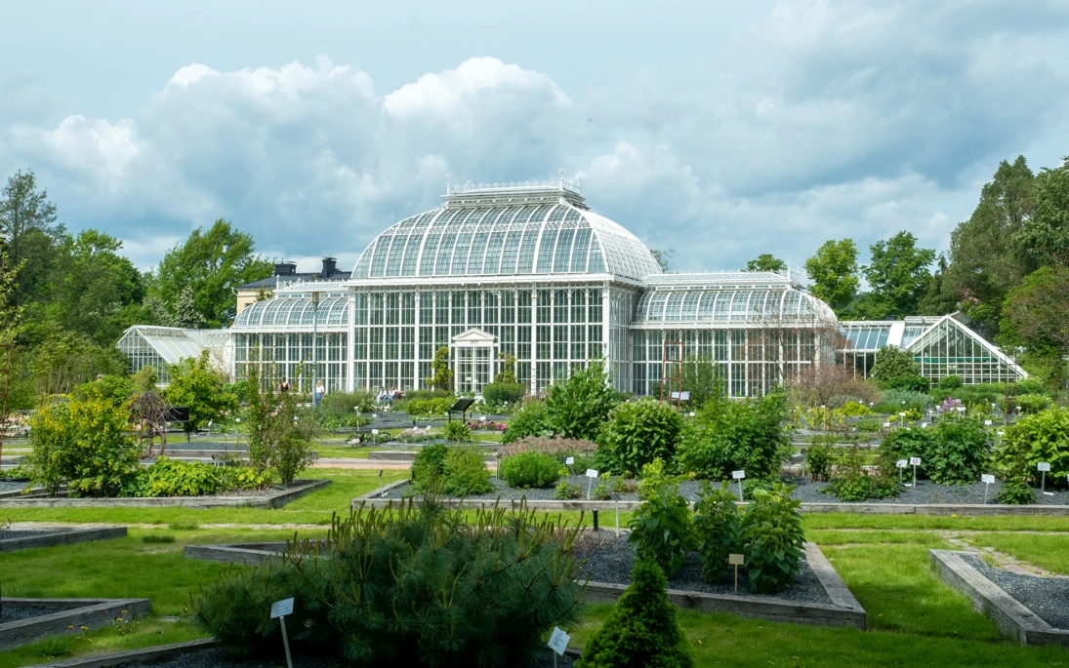
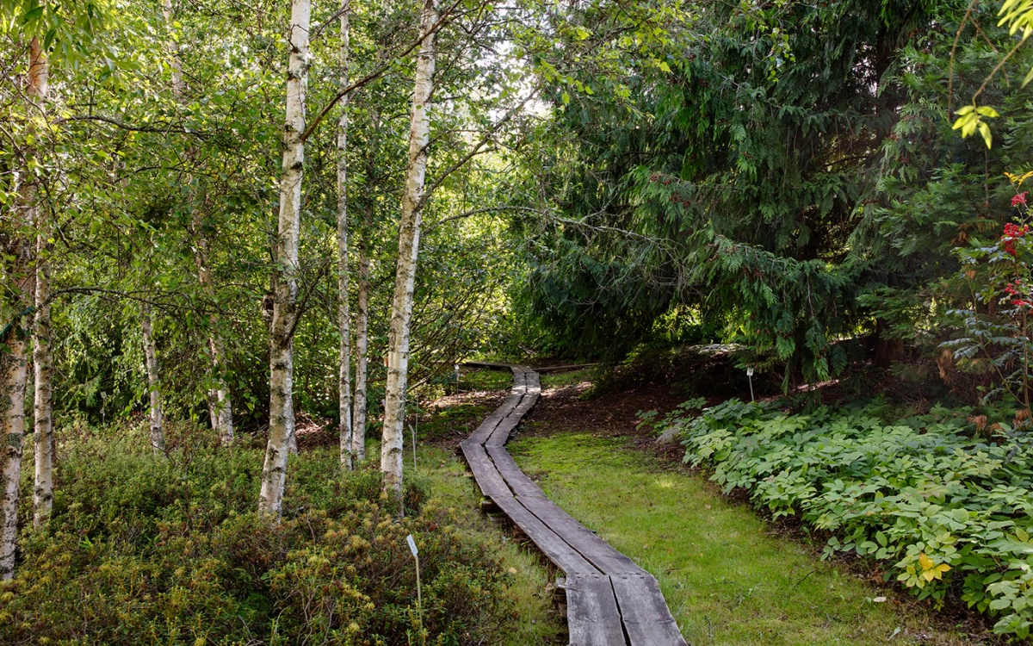
Figure 2a and b. Botanical gardens in Kaisaniemi and Kumpula are part of LUOMUS and the Botanical Gardens Conservation International network. Photos: Natalia Alam, Emma Suominen

- Kew Gardens in London, UK has one of the most diverse collections of living plants of any botanical garden in the world. Virtual Tour of Kew Gardens: https://www.youtube.com/watch?v=yyOrRpkZtKY
- CWR resources provide new alleles for crop breeding. The breeding programs usually aim to increase the resistant traits of crops to biotic (insects, diseases) or abiotic stresses (extreme weather, floods, soil drought), crop quality (protein or vitamin contents, lipid composition, flavor), or plant structure and yield. Novel molecular and New Genomic Techniques (NGTs) are used in breeding combined with field testing and selection of superior genotypes.

CWR in The Nordic countries
- In the Nordic countries, the wild plants have unique adaptations for cold climate and extensive variation in the photoperiod
- over 2 700 taxa related to food, forage, medicinal, ornamental and forestry plants have been registered in the area
- Nordic plants have been adapted to local, harsh conditions with several traits that have potential use in breeding and pre-breeding efforts for future conditions
- There have been numerous collaborative projects for seed collection, exhibitions and conservation of CWR among the Nordic countries, botanical gardens and natural history museums (e.g., LUOMUS, Finland)
- The collected seeds are donated to NordGen for processing, conservation and making them available for researchers, plant breeders, botanical gardens and museums (Virtual Tour to Svalbard Global Seed Vault)

At the end of this chapter/section you can think where the nearest CWR is to you and which crop plant species are the most valuable in your region. Do you know whether the genetic erosion is a problem in this crop species?

References

Iriondo, J.M., Magos Brehm, J., Dulloo, M.E., Maxted, N. (eds.) 2021. Crop Wild Relative Population Management Guidelines . Farmer’s Pride: Networking, partnerships and tools to enhance in situ conservation of European plant genetic resources. Available at http://www.farmerspride.eu/
Fitzgerald H, Palmé A, Asdal Å, Endresen DTF, Kiviharju E, Lund B, Rasmussen M, Thorbjörnsson H, & Weibull J (2019). A regional approach to Nordic crop wild relative in situ conservation planning. DOI:10.1017/S147926211800059X
Khoury, C.K., Brush, S., Costich, D.E., Curry, H.A., de Haan, S., Engels, J.M.M., Guarino, L., Hoban, S., Mercer, K.L., Miller, A.J., Nabhan, G.P., Perales, H.R., Richards, C., Riggins, C. and Thormann, I. (2022), Crop genetic erosion: understanding and responding to loss of crop diversity. New Phytol, 233: 84-118. https://doi.org/10.1111/nph.17733

