Case example: Regenerative Agriculture
In this chapter, you will learn about regenerative agriculture and its pivotal role in food production and sustainable farming. By the end of this chapter, you will understand how regenerative practices can improve soil health, increase resilience and contribute to addressing global environmental challenges.
The foundation of all farming is healthy and well-maintained soil. If fields are cultivated in a way that deteriorates soil quality, the resilience of the soil—its ability to withstand and recover from changes—will diminish. The future of food production demands new insights and sustainable methods.
Globally, our food systems face various ecological, economic, and sociocultural sustainability challenges. Serious ecological issues include climate change, biodiversity loss, and major disruptions in nitrogen and phosphorus cycles. Regenerative agriculture provides an opportunity to produce food profitably while ensuring future food security.
Background
Efforts have long been made to cultivate fields sustainably so that soil fertility does not decline. In practice, this means preserving the soil's productive capacity, maintaining dead organic matter, and ensuring proper water management and soil structure. In Finland, the most common issues affecting soil fertility are soil compaction and water management problems.
At the core of regenerative agriculture is healthy soil that produces reliable, high-quality yields with minimal inputs. Healthy soil also sequesters carbon. Regenerative agriculture differs from sustainable agriculture by aiming not only to maintain the current state of the soil but also to repair deficiencies and create new value. It is an ecosystem-revitalizing approach that builds on soil health.
Regenerative agriculture harnesses natural processes and mimics natural cycles, focusing on photosynthesis and carbon sequestration, nutrient and water cycles, and pollination. Farming becomes a self-renewing process rather than a finite activity.
Principles of Regenerative Agriculture
Regenerative agriculture has three key principles:
- Maximize photosynthesis by maintaining continuous plant cover and balanced plant nutrition on the fields.
- Maximize microbial activity by introducing microbes as an initial input on degraded soils. Grow living root systems year-round and keep soil healthy, you can tell by the smell!
- Maximize protection by minimizing tillage, disturbances, and the use of pesticides, while maintaining sustainable practices.
By following these principles, soil fertility and yield reliability improves, and the environment receives several benefits.
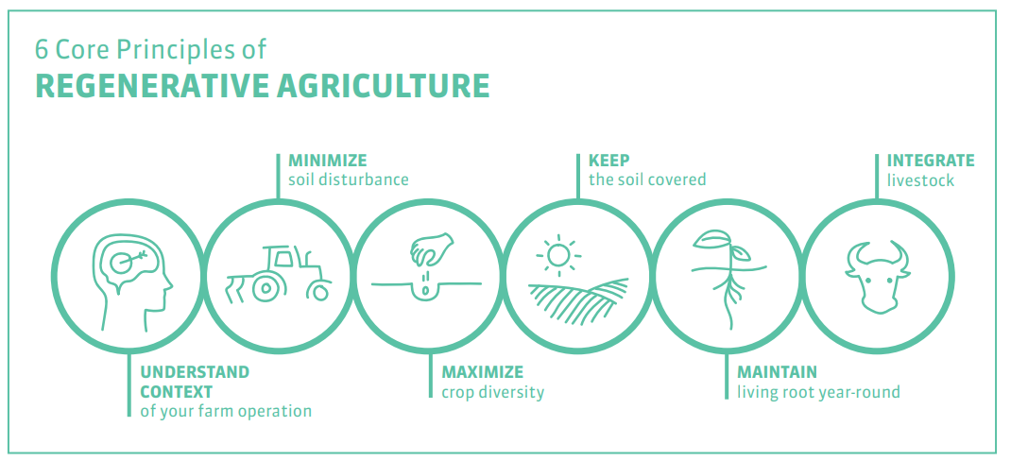
Photo 1. Core principles of Regenerative agriculture by General Mills (2021). In addition to the three key principles introduced above, they underline the farmer’s responsibility to understand their own fields and livestock integration.
Methods
Farming begins with a deep understanding of the soil. A simple way to assess soil structure is by digging a pit and analyzing it. Healthy soil smells pleasant and contains abundant organic matter. All methods must be well-planned and -timed, as not all practices suit every field. Improving soil structure requires first ensuring proper drainage (repair subsurface drainage if necessary). Compaction can be addressed through biological-mechanical aeration, which combines mechanical subsoiling and the cultivation of deep-rooted plants. A diverse crop rotation and consistent plant cover provides nutrition and protection for soil organisms.
Examples of regenerative farming practices
- Keeping fields covered year-round with the help of catch and undersown crop, grasses and winter cereals.
- Minimizing and timing tillage appropriately.
- Using organic fertilizers and reducing pesticides by using preventive crop protection methods.
- Maintaining diverse crop rotations, as greater diversity of plant species is beneficial. Increasing the share of perennial plants.
- Incorporating agroforestry practices to enhance carbon sequestration and biodiversity. For example, windbreaks in fields can support pollinators and natural pest control.
- Adding biochar to fields.
- Adopting carbon farming practices on peatlands by promoting perennial grasses.
Carbon Farming as Part of Regenerative Agriculture
The term “carbon farming” highlights practices that focus specifically on soil carbon storage. Finnish soils are relatively young, with inherently high carbon reserves. This makes preserving soil carbon particularly important in Finland, compared to Southern Europe, where soils have lower carbon levels due to prolonged intensive farming and erosion (Ollikainen 2020).
Increasing soil carbon reserves is a long process requiring further research. While decades of measurements and calculations provide an understanding of carbon sequestration's potential scale, precise estimates of how much carbon specific methods store and for how long are still uncertain.
Increasing carbon inputs into soil positively impacts soil fertility and carbon storage (Heinonsalo et al. 2020). Although all plants sequester carbon during growth, not all plant species contribute to permanent soil carbon. Carbon harvested with crops does not enhance soil carbon reserves. Catch crops, however, protect the soil, reduce erosion, and continue photosynthesis after the main crop has been harvested.
Carbon farming improves soil organic matter, supports soil microbial diversity, and reduces carbon and surface soil loss from fields.
Chapter 2: Soil provides ecosystem services
Soil enables the production of crops and the growth of forests. It purifies water and regulates water resources. Soil also plays a role in climate regulation by mitigating the harmful effects of greenhouse gases in the atmosphere, storing carbon, and controlling greenhouse gas formation within the soil.
The most significant ecosystem services provided by soil, especially in agricultural contexts, are:
Biomass production | Water purification and storage | Climate regulation and carbon storage | Biodiversity maintenance and habitat provision | Nutrient cycling and storage
Crop production and forest growth | Regulation of water resources: soil receives, retains, and stores water while removing harmful substances. | Soil mitigates the harmful effects of greenhouse gases by storing carbon and controlling their formation.  Soil contains more stored carbon than all vegetation and the atmosphere combined (Ciais et al. 2013). | Provides habitat for a diverse range of organisms | Nutrients released from fertilizers are retained in the soil and transformed into forms usable by plants. Soil supports processes that capture nutrients from air and water.

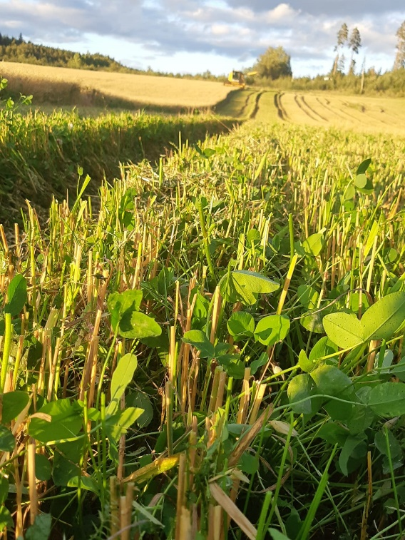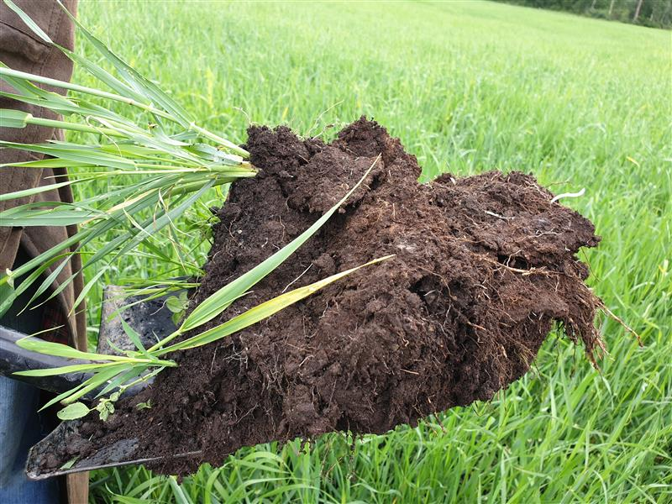
Photo 2 & 3. Catch crop protects land and remains to photosynthesize after the crop plant has been harvested. Photo: Eliisa Malin. Healthy soil is airy and has round crumbs. A shovelful of organic soil. Photo: Soja Sädeharju.

Biological, Physical, and Chemical Properties of Soil
For plant growth and carbon sequestration, the most crucial component of soil is organic matter, which includes plant roots, soil fauna, microbes, and decomposing plant and animal residues. The amount of organic matter in soil can be increased by incorporating green biomass, livestock manure, or soil amendments such as compost and by-products from the paper industry. Practices like growing grasses, cultivating deep-rooted plants, using undersown crops, and implementing planned crop rotations also contribute to increasing organic matter.
Biological activity in soil organisms regulates greenhouse gas formation and preserves organic matter within the soil (Vestberg & Timonen 2018). An increase in microbial biomass promotes carbon sequestration, as stable soil carbon is primarily composed of dead microbial biomass on the surface of the mineral material and inside soil crumbs, where it is protected from decay (Caputo 2018). Soils are considered organic when their organic matter content exceeds 20 %. Organic soils are considered peatlands with a corresponding figure of 40 %.
The texture and structure of soil significantly impact its water retention, aeration, and capacity to support plant growth. Improving soil physical properties often involves practices like minimizing compaction and ensuring adequate drainage.
Finland's bedrock consists predominantly of acidic rock types. These rocks consist of various minerals, each with a unique chemical composition that influences reactions on their surfaces, such as nutrient retention. Minerals release ions into the soil, which plants use as nutrients. Major cations (electropositive ions) in soil include calcium (Ca²⁺), magnesium (Mg²⁺), and potassium (K⁺).
The cation exchange capacity (CEC) measures soil’s ability to retain and release nutrients. Finer-textured soils and soils rich in organic matter have higher CEC due to more nutrient-binding sites.
Soil acidification occurs when hydrogen ions (H⁺) replace nutrient cations on soil particles, making the cations vulnerable to leaching and unavailable to plants. As a plant absorbs nutrients from the soil, it must release ions of the same sign (H⁺) to maintain electrical balance. In this case, acidity accumulates in the soil and pH decreases. Some cations are removed from the soil by harvest, but some cations can return to the soil through plant residues. Liming materials are commonly used to neutralize soil acidity by releasing hydroxide (OH⁻), which neutralizes hydrogen ions.
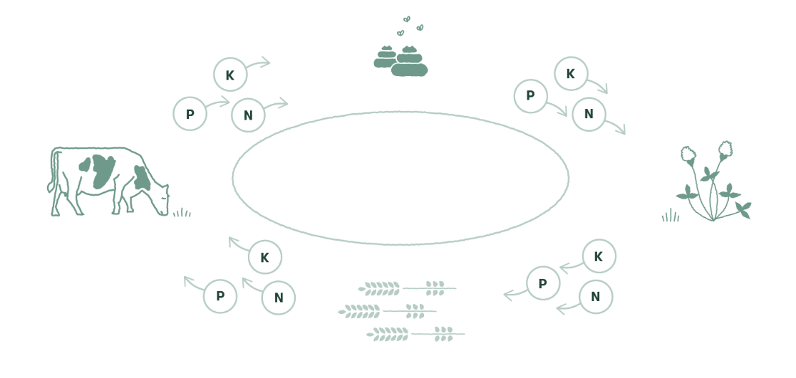
Photo 4. A closed nutrient cycle. Socio-cultural sustainability and the transparency of food production can be improved, for example, by favoring local actors who use regenerative farming. This strengthens the local economy while keeping the nutrient cycles as closed as possible. (BSAG 2017)
Conclusion
Regenerative farming is more than a set of farming techniques – it represents a paradigm shift towards systems that work with nature rather than against it. By improving soil health, restoring ecosystems and addressing the global challenges of climate change and biodiversity loss, regenerative farming provides a sustainable pathway for future food production. We need collaboration between farmers, researchers and policymakers to implement and scale these practices.
Question 1
Regenerative agriculture is
a) one-time improvements to the soil
b) continuously renewing processes in farming
c) a new certified method of farming
d) an approach to food production that revitalizes the entire agricultural ecosystem
Question 2
Why can organic matter be considered the most critical property of soil?
a) Improves soil fertility and enhances soil structure
b) Retains nutrients and buffers pH changes
c) It gives the field a nice smell
d) Improves water retention

References
Baltic Sea Action Group. The E-college for Regenerative Farming. Chapter 1 Regenerative Farming and Chapter 2 Soil. Writers: Soja Sädeharju, Eliisa Malin, Jenni Jääskeläinen, BSAG.
BSAG. 2017. Eloisa pelto. Ruokopelto-hankkeen opas muhevampaan maaperään. https://www.bsag.fi/wp-content/uploads/2019/05/Eloisa-pelto-Ruokopelto-hankkeen-opas_Sivu_01.jpg Baltic Sea Action Group. Published 2017.
Caputo, S. 2018. How urban farmers are learning to grow food without soil or natural light. https://theconversation.com/how-urban-farmers-are-learning-to-grow-food-without-soil-or-naturallight-88720 The Conversation. Published 13.2.2018. Cited 22.11.2024.
Ciais, P., Sabine, C., Bala, G., Bopp, L., Brovkin, V., Canadell, J., Chhabra, A., DeFries, R., Galloway, J., Heimann, M., Jones, C., Le Quéré, C., Myneni, R.B., Piao, S. & Thornton, P. 2013. Carbon and Other Biogeochemical Cycles. Teoksessa: Stocker, T.F., Qin, D., Plattner, G., Tignor, M., Allen, S. K., Boschung, J., Nauels, A., Xia, Y., Bex, V. & Midgley, P. M. (toim.). Climate Change 2013: The Physical Science Basis. Contribution of Working Group I to the Fifth Assessment Report of the Intergovernmental Panel on Climate Change. Cambridge, United Kingdom and New York, NY, USA: Cambridge University Press. s. 465-570. PDF-form: https://www.ipcc.ch/site/assets/uploads/2018/02/WG1AR5_all_final.pdf
General Mills 2021. Regenerative Agriculture. https://www.generalmills.com/en/Responsibility/Sustainability/Regenerative-agriculture General Mills.
Heinonsalo, J., Heimsch, L., Helenius, J., Huusko, K., Höijer, L., Joona, J., Kanerva, S., Karhu, K., Kekkonen, H., Koppelmäki, K., Kulmala, L., Lötjönen, S., Mattila, T., Ollikainen, M., Peltokangas, K., Regina, K., Soinne, H., Wikström, U. & Viskari, T. 2020. Hiiliopas – katsaus maaperän hiileen ja hiiliviljelyn perusteisiin. Baltic Sea Action Group. 60 p. https://carbonaction.org/wpcontent/uploads/2020/01/BSAG-hiiliopas-1.-painos-2020.pdf
Ollikainen, M. 2020. Hiiliviljelyn talous. Esitys Carbon Action -hiiliviljelijöille. 8.12.2020.
Vestberg, M. & Timonen, S. 2018. Rihmankiertämät – kasvien ja sienten erottamaton elämä. Omakustanne. s. 356.

