3.1 Food waste management

3.1.1 Introduction and problems in food waste management

Food production is one of the most critical aspects of human development. In an era where environmental sustainability is paramount, the issue of food waste has emerged as a critical challenge. Globally, approximately one-third of all food produced is lost or wasted, amounting to about 1.3 billion tons annually. This not only represents a significant economic loss but also exacerbates environmental degradation through the unnecessary use of resources and increased greenhouse gas emissions. Sustainable food waste management, therefore, is not just an environmental imperative but also a socio-economic necessity. By implementing effective strategies to reduce, reuse, and recycle food waste, we can mitigate its adverse impacts and move towards a more sustainable and resilient food system.

In Finland food waste is included in biowaste waste category. The Finnish waste directive states that biowaste must be sorted into a separate composter or biowaste bin in all urban areas over 10 000 inhabitants. In most municipalities, biowaste is gathered by municipal or regional waste management organization. Even though legislation defines biowaste recycling strictly, there is still about 32% biowaste in household mixed waste in Finland. Household mixed waste is incinerated in incineration plants, which is not an efficient way to treat biowaste. If biowaste is incinerated, all the nutrients are lost in the incineration process. There are other ways to process biowaste that recycles the nutrients back into use.

Biowaste contains high amounts of phosphorus, nitrogen and kalium, which are critical nutrients for cultivation. The United Nations have defined phosphorus and nitrogen as a an aspect of planetary boundaries (Figure 1). In planetary boundaries, phosphorus and nitrogen are included in the biogeochemical flows, which means the disruption of the natural nutrient cycles through the environment and organisms which are vital for supporting life and maintaining ecosystems. There are certain levels determined for different sections of planetary boundaries and the biogeochemical flows are critically over the safe operating space. This means that the human population should significantly change the use of nitrogen and phosphorus. One way to change the flows would be more efficient recycling and reusing of food waste, which is addressed by not incinerating or landfilling the biowaste.

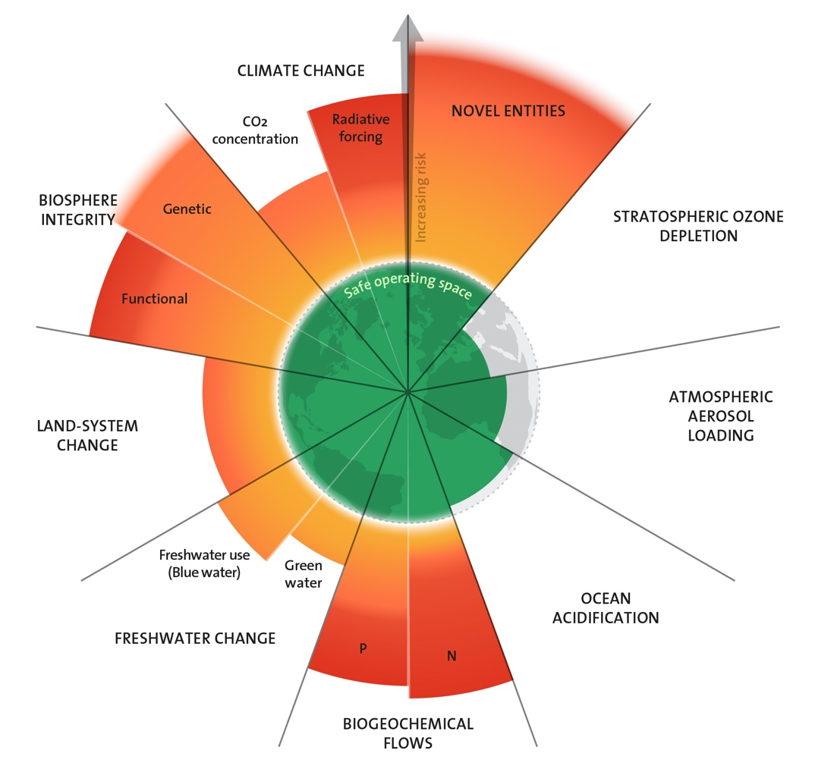
Figure 1 Planetary boundaries. Source: Azote for Stockholm Resilience Centre, based on analysis in Richardson et al 2023. https://www.stockholmresilience.org/research/planetary-boundaries.html

3.1.2 Solutions

In Finland, there are two different methods for treating biowaste in common use. These are composting and anaerobic digestion (AD). Both of these are highly related to Nature-Based Systems.

COMPOSTING

Composting is a nature-based recycling process that decomposes organic matter into a nutrient-rich soil material, compost. Anything that grows will decompose eventually, and composting is just an enhanced version of natural decomposing via its provision of an ideal environment for bacteria, fungi and other decomposing organisms. Usual composting process conditions occur around 30-40 °C, with low amounts of oxygen available.

The main product of the composting process is compost. Compost is a solid phase product that is left after the decomposing process. Compost contains most of the nutrients that biowaste has contained before the composting process. Compost can be further processed to biofertilizers which can be used for cultivation. These biofertilizers are sustainable substitutes to industrial fertilizers which have high an environmental footprint.

The composting process is very scalable to different needs. Here are some types of composters starting from small household size and scaling up to the municipal scale:

- Household composters
- Countertop Composters
  - Use Case: Ideal for small apartments or homes with limited space. These compact units can sit on your kitchen counter and are designed to handle daily food scraps.
  - Examples: Electric composters like the Lomi or FoodCycler dehydrate and grind food waste, reducing its volume significantly. However, they produce dehydrated food scraps rather than true compost
- Outdoor Tumblers
  - Use Case: Great for homes with a garden. These bins can handle larger volumes of waste and speed up the composting process by allowing you to turn the compost regularly.
  - Examples: Black&Decker Tumbling Composter, which has two chambers for various stages of composting and is easy to rotate

- Community and small-scale composters
- Stationary Bins
  - Use Case: Suitable for community gardens or small farms. These bins can handle larger amounts of organic waste and are designed to be turned manually.
  - Examples: Greenes Fence Co. Cedar Wood Composter, which is durable and can be expanded by connecting additional bins
- Vermicomposters
  - Use Case: Ideal for schools, community centers, or small urban farms. These systems use worms to break down organic waste, producing high-quality compost.
  - Examples: Worm Factory 360, which is designed for efficient worm composting and can be used indoors or outdoors

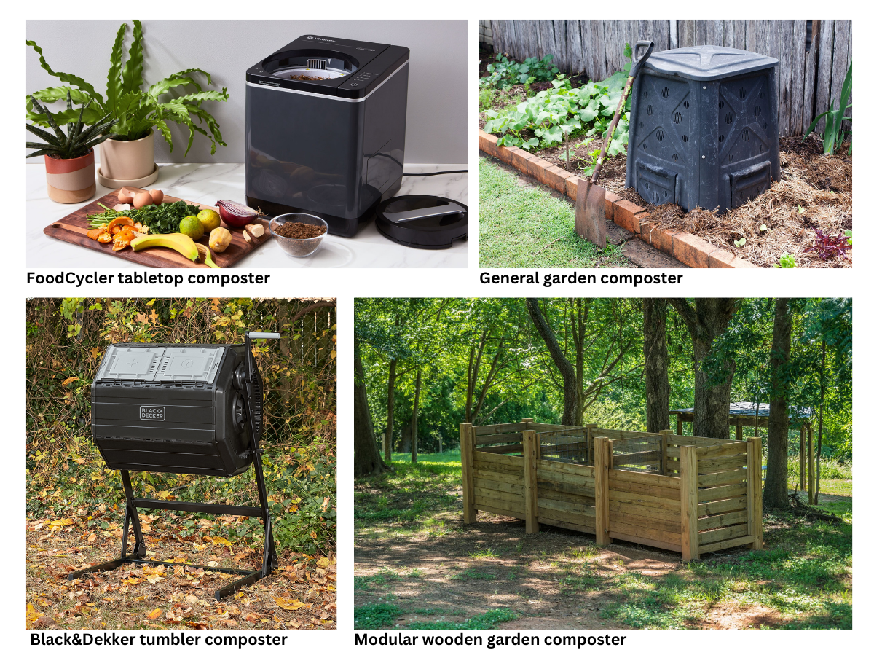
Figure 2 Different types of small-scale composters. Photo references at the end of the document

- Industrial and large-scale composters
  - Windrow Composting
    - Use Case: Used by municipalities and large farms. Organic waste is piled into long rows (windrows) and turned regularly to aerate the compost.
    - Examples: Large-scale windrow composting facilities that handle tons of organic waste, including yard trimmings, food scraps, and agricultural waste
  - In-Vessel Composting
    - Use Case: Suitable for urban areas or facilities with limited space. Organic waste is composted in enclosed containers, which control environmental conditions to speed up the process.
    - Examples: Industrial in-vessel composting systems used by waste management companies to process large volumes of organic waste efficiently
  - Aerated Static Pile Composting
    - Use Case: Ideal for large-scale operations that need to process organic waste quickly. This method uses forced air to aerate the compost pile, reducing the need for turning.
    - Examples: Composting facilities that use aerated static piles to handle municipal solid waste and produce compost for agricultural use
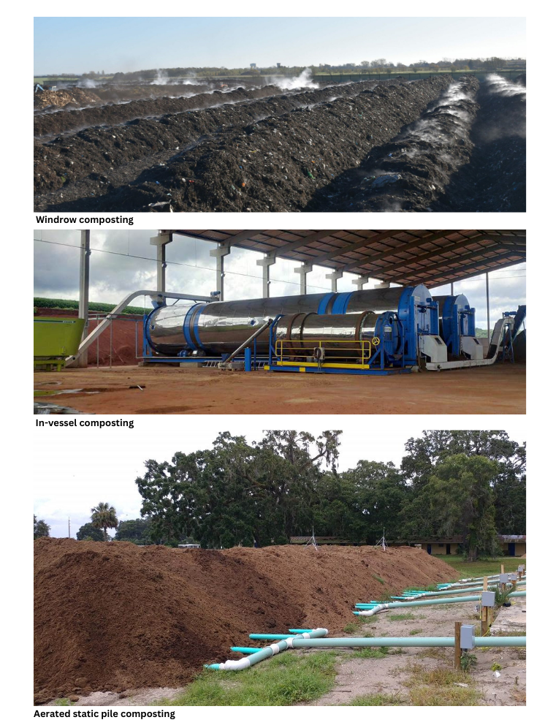
Figure 3 Different types of large-scale composting. Photo references at the end of the document

ANAEROBIC DIGESTION

In brief, the AD process is a boosted composting process. Where composting process conditions were around 30-40 °C and there are oxygen available, AD-process conditions are significantly warmer, around 50-70 °C and there are absence of oxygen.

Anaerobic digestion occurs in a series of steps involving different types of microorganisms. The process can be divided into four main stages:

- Hydrolysis: Complex organic materials such as carbohydrates, fats, and proteins are broken down into simpler compounds like sugars, fatty acids, and amino acids.
- Acidogenesis: The products of hydrolysis are further broken down by acidogenic bacteria into volatile fatty acids, alcohols, hydrogen, and carbon dioxide.
- Acetogenesis: Acetogenic bacteria convert these volatile fatty acids and alcohols into acetic acid, hydrogen, and carbon dioxide.
- Methanogenesis: Finally, methanogenic archaea convert acetic acid, hydrogen, and carbon dioxide into methane and water.

This entire process takes place in a sealed, oxygen-free environment called a digester, which can vary in size and design depending on the specific application and feedstock.

Anaerobic digestion produces two main products:

- Biogas: This is a mixture of gases, primarily methane (CH₄) and carbon dioxide (CO₂), with small amounts of other gases such as hydrogen sulfide (H₂S). Methane is the key component, making biogas a valuable source of renewable energy. Methane contains a very high amount of energy and it can be used as fuel in many adaptations, for example in vehicles, generators and it can be exported to the national gas grid. During the last decade, the use of biomethane has been increasing in Finnish public transport. Biogas buses are in use at least in Vaasa, Lappeenranta and Hämeenlinna. In Sweden, biogas has been in use in public transport even longer.

- Digestate: This is the residual material left after the digestion process. It consists of both solid and liquid fractions. The solid fraction can be used as a soil conditioner or compost, while the liquid fraction is rich in nutrients and can be used as a fertilizer.

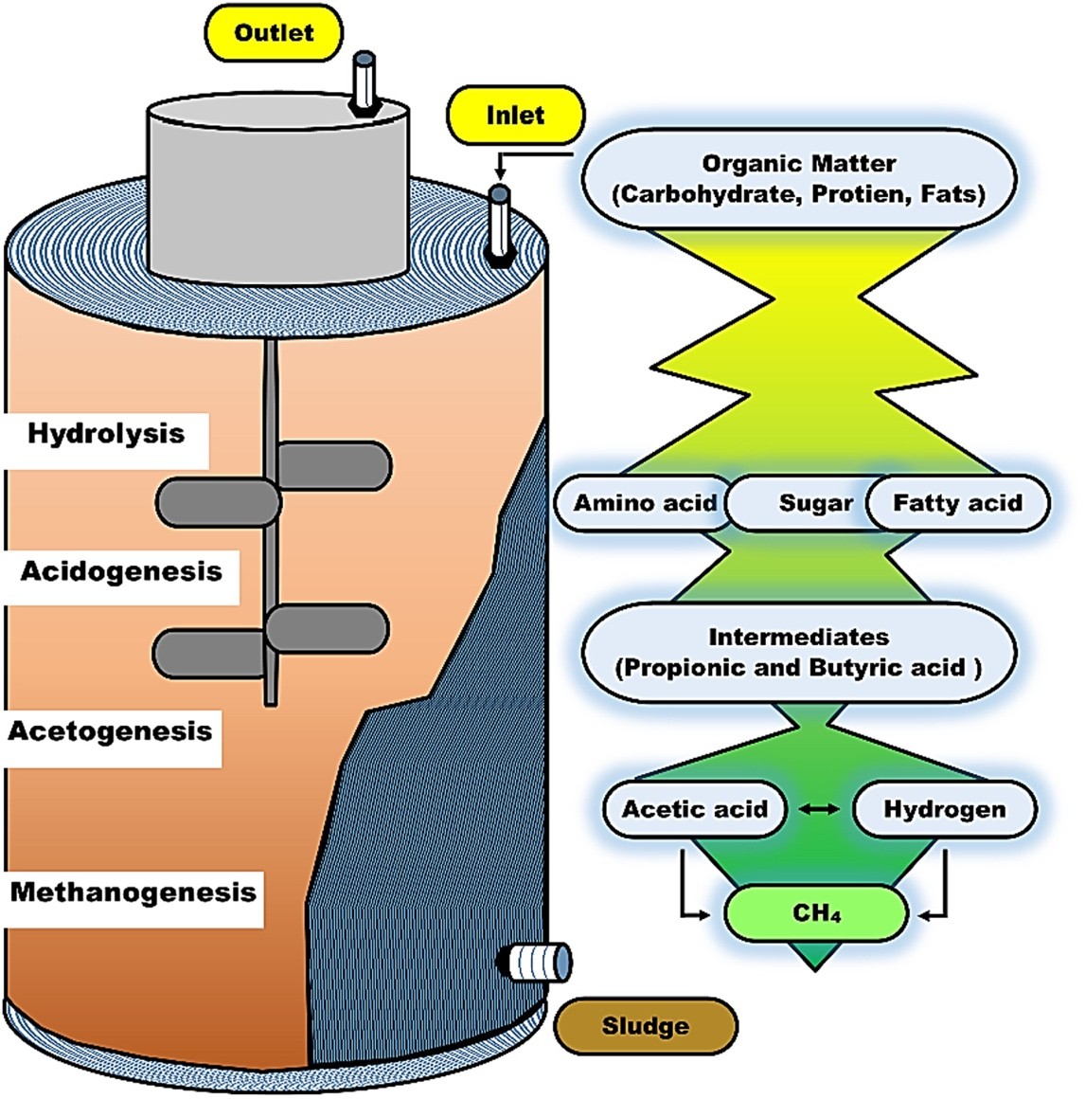
Figure 4 Anaerobic digestion process figure. Source: https://doi.org/10.1002/wer.1219

THE BENEFITS OF COMPOSTING AND AD-PROCESS

Composting and anaerobic digestion offer numerous environmental, economic, and social benefits:

- Renewable energy production: By converting organic waste into biogas, anaerobic digestion provides a sustainable and renewable source of energy, reducing reliance on fossil fuels.
- Waste management: These processes help to manage and reduce the volume of organic waste, including agricultural residues, food waste, and animal manure. This not only minimizes waste disposal issues but also reduces greenhouse gas emissions from landfills.
- Nutrient recycling: The digestate produced AD process and compost from composting are rich in nutrients like nitrogen and phosphorus, which can be used as natural fertilizers soil improvement materials, reducing the need for chemical fertilizers and enhancing soil health.
- Reduction of greenhouse gas emissions: By capturing methane that would otherwise be released into the atmosphere from decomposing organic matter, anaerobic digestion significantly reduces greenhouse gas emissions.
- Economic benefits: These processes can create economic opportunities through biogas, digestate and compost production, which can be sold or used to offset energy and cultivation costs.

3.1.3 Case examples

The Ämmässuo recycling center in Espoo uses both processes introduced in this paper. They sort the biowaste into different sections and treat the sections with the processes most suitable for each type of biowaste. Fine-grained (<80mm) matter is directed to the AD process to biogas plant and coarse (>80mm) matter is directed straight to composting to windrow composting field. This means that about 50% of biowaste goes to the AD process and 50% goes to composting.

The biogas plant is used to gather biogas from biowaste. In Ämmässuo 1000 kg of biowaste produces 200 cubic meters of biogas. Yearly, this means that Ämmässuo produces 4.4 million cubic meters of biogas. The biogas is burned in the Ämmässuo power plant which produces 9.5 GWh of electricity and 8.6 GWh of heat yearly.

The digestate of the AD process is directed to composting where it is produced to compost. The composting plant produces 17 000 tons of compost yearly which is sold as soil enhancing material for green infrastructure or cultivation.
Here is a video of Ämmässuo facilities (unfortunately, the video is only in Finnish, but the composting plant and biogas plant can be seen in the video from 1:20 to 3:00): https://www.youtube.com/watch?v=RyKS-5WrSkk

Here is a video about food waste recycling in England by GENego: https://www.youtube.com/watch?v=RyKS-5WrSkk

Here is a video about organic waste recovery explaining AD-process by Veolia: https://www.youtube.com/watch?v=lHyL41grGUo&t=14s

3.1.4 Conclusions

Planetary boundaries are critically exceeded by nitrogen and phosphorus. Composting and anaerobic digestion are solutions to more sustainable nutrient use that rely heavily on NBS. Composting is a nature-based recycling process that decomposes organic matter into nutrient-rich soil material, compost. The AD process is an improved composting process by increasing the temperature of the process and making the conditions anaerobic. The benefits of composting and AD processing are renewable energy production, efficient waste management, nutrient recycling, reduction of greenhouse gases and some economic opportunities.

References:

Azote for Stockholm Resilience Centre, based on analysis in Richardson et al 2023. https://www.stockholmresilience.org/research/planetary-boundaries.html

Fallde M., Eklund M., 2015. Towards a sustainable socio-technical system of biogas for transport: the case of the city of Linköping in Sweden. Available at: https://doi.org/10.1016/j.jclepro.2014.05.089

Janke L., Ruoss F., Hahn A., Weinrich S., Nordberg Å., 2022. Modelling synthetic methane production for decarbonising public transport buses: A techno-economic assessment of an integrated power-to-gas concept for urban biogas plants. Available at: https://doi.org/10.1016/j.enconman.2022.115574

Ayilara, M., Olanrewaju, O., Babalola, O., Odeyemi, O. 2020. Waste Management through Composting: Challenges and Potentials. Available at: https://doi.org/10.3390/su12114456

HSY, Ämmässuon ekoteollisuuskeskus. Available at: https://www.hsy.fi/jatteet-ja-kierratys/ammassuon-ekoteollisuuskeskus/biojatteen-kasittely/

Rehman M., Iqbal A., Chang C., Li W., Ju M. 2019. Anaerobic digestion. Available at: https://doi.org/10.1002/wer.1219

References for figures 2 and 3:

Foodcycler: https://foodcycler.com/

General garden composter: https://www.familyhandyman.com/article/what-i-wish-i-knew-before-starting-a-compost-bin/

Black&Decker Tumbler: https://www.blackanddecker.com/products/bdstga9701

Wooden modular composter: https://www.compostmagazine.com/three-bin-composting-system/

Windrow composting: https://www.envar.co.uk/open-windrow-composting/

In-vessel composting: https://compost-turner.net/composting-technologies/in-vessel-composter-and-windrow-turner.html
Aerated static pile composting: https://btbfarm.com/2023/06/05/composting-using-the-static-aerated-pile-method/

