Foreword / Be forewarned
The exercises on PowerPoint and Word have been made using the desktop applications of the programs. It is highly recommended that you also use the desktop apps.

Why? / Pros and cons?
Desktop application | O365 / web-based application
- More tools More options  - Tools work well  - Installed on the computer not dependent on Internet connection  - May not save automatically – that feature must be turned on manually | - Less tools Less useless tools  - Tools work well enough – mostly  - No installation required Can be used with any computer with internet connection  - Automatically saves to the cloud service

The most important reasons to use the desktop application is that tools actually work and the result is as it is shown on the screen. The O365 has serious problems when adding pictures to a document, specifically when trying to place the image side by side with text. The page borders also cause trouble on O365, as in when printing documents O365 may show everything fitting on one page when in fact the rows at the bottom of the page go onto the next page. If you do not need these features, O365 can be a very useful tool.

How to identify desktop / O365 apps?
Put the application to full screen mode. Do you see a text field / row for internet address? Or even other internet tabs, like Moodle? Then you are using the web-based application.

Instructions
First of all, a few tips that may save you from reading most of the instructions. Time is precious, after all.
- You will probably learn best if you try to solve the problem yourself first. Only seek instructions when you have tried and failed a few times.
  - If you try and something strange happens, Ctrl + z is the hotkey for reverting the last thing you did.
- Almost all the tools have a ToolTip. Move the cursor over some button and let it hover there without clicking it. A text explaining the use of the button will appear. If the button has a hotkey, it will also read on the ToolTip.
- Word has a built-in search engine. If you want to do something, try typing it to the search text field and press Enter.
Microsoft has a vast amount of instructions and manuals for their products. Bellow are topics you will need for completing the tasks on this course. They are also linked to Microsoft instructions on the topic (with the exception of changing the font). The topics are ordered from most common to more rare or something needed only later in the task. Bellow are also pictures of where you can find the tools on desktop application.
- Copy, cut and paste (fig. 1)
- Changing the font, font size and color (fig. 1)
- Bold, italic and underline (fig. 1)
- Bulletpoints / list (fig. 1)
- Aligning the text and line spacing (fig 1.)
- Changing the margins (Layout tab)
- Adding pictures (Insert Tab, fig. 2)
  - adding picture at all (fig. 2)
  - getting the picture in the right place (fig. 3)
Note: Do not press Enter to change the text row to make space for the picture. The text will automatically move out of the way of the picture.
  - adding captions
- Contextual tabs (Picture, Table, Shape, Smart Art, Header and Footer) (fig. 3)
- Tables (fig. 2)
- Shapes (fig. 2)
- Smart Art (fig. 2)
- Header, Footer and Page number (fig. 2)
- Saving and saving as PDF (fig. 1 & 4)
- Optional: Using templates (fig. 4)
- Optional: Page break (fig. 2)

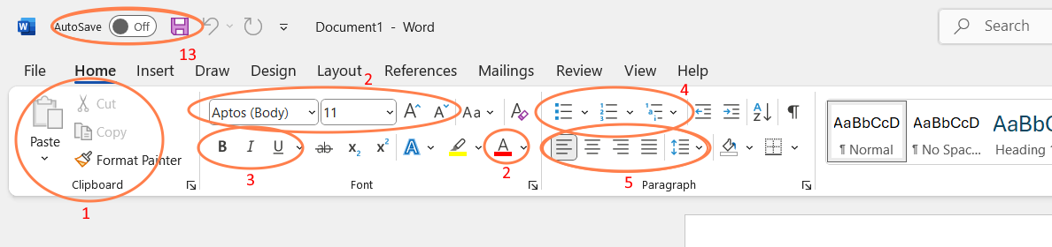
Figure 1

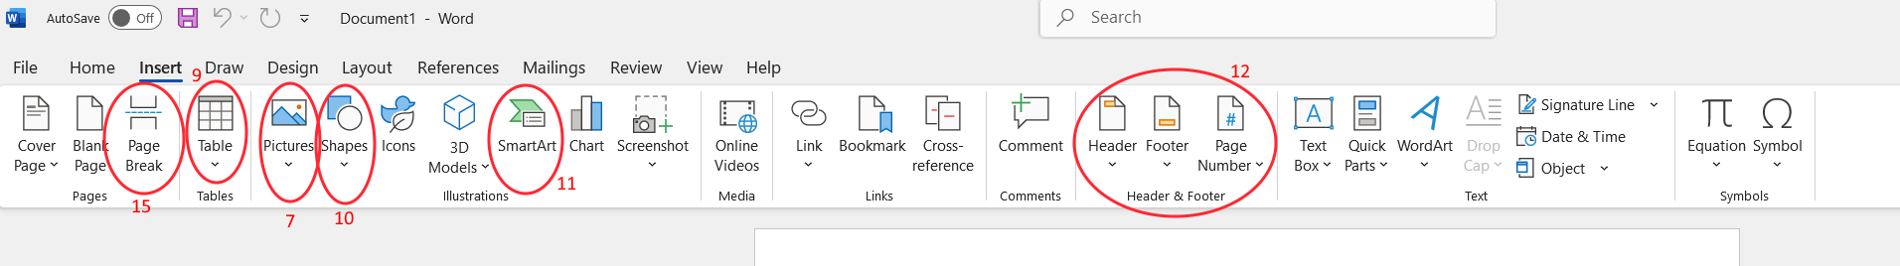
Figure 2

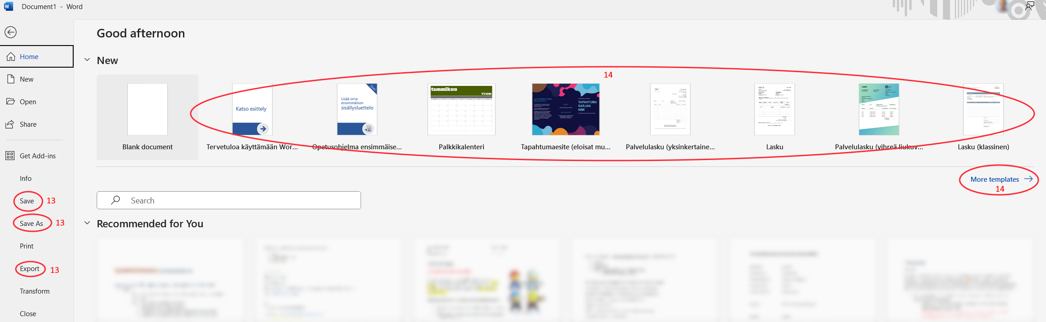
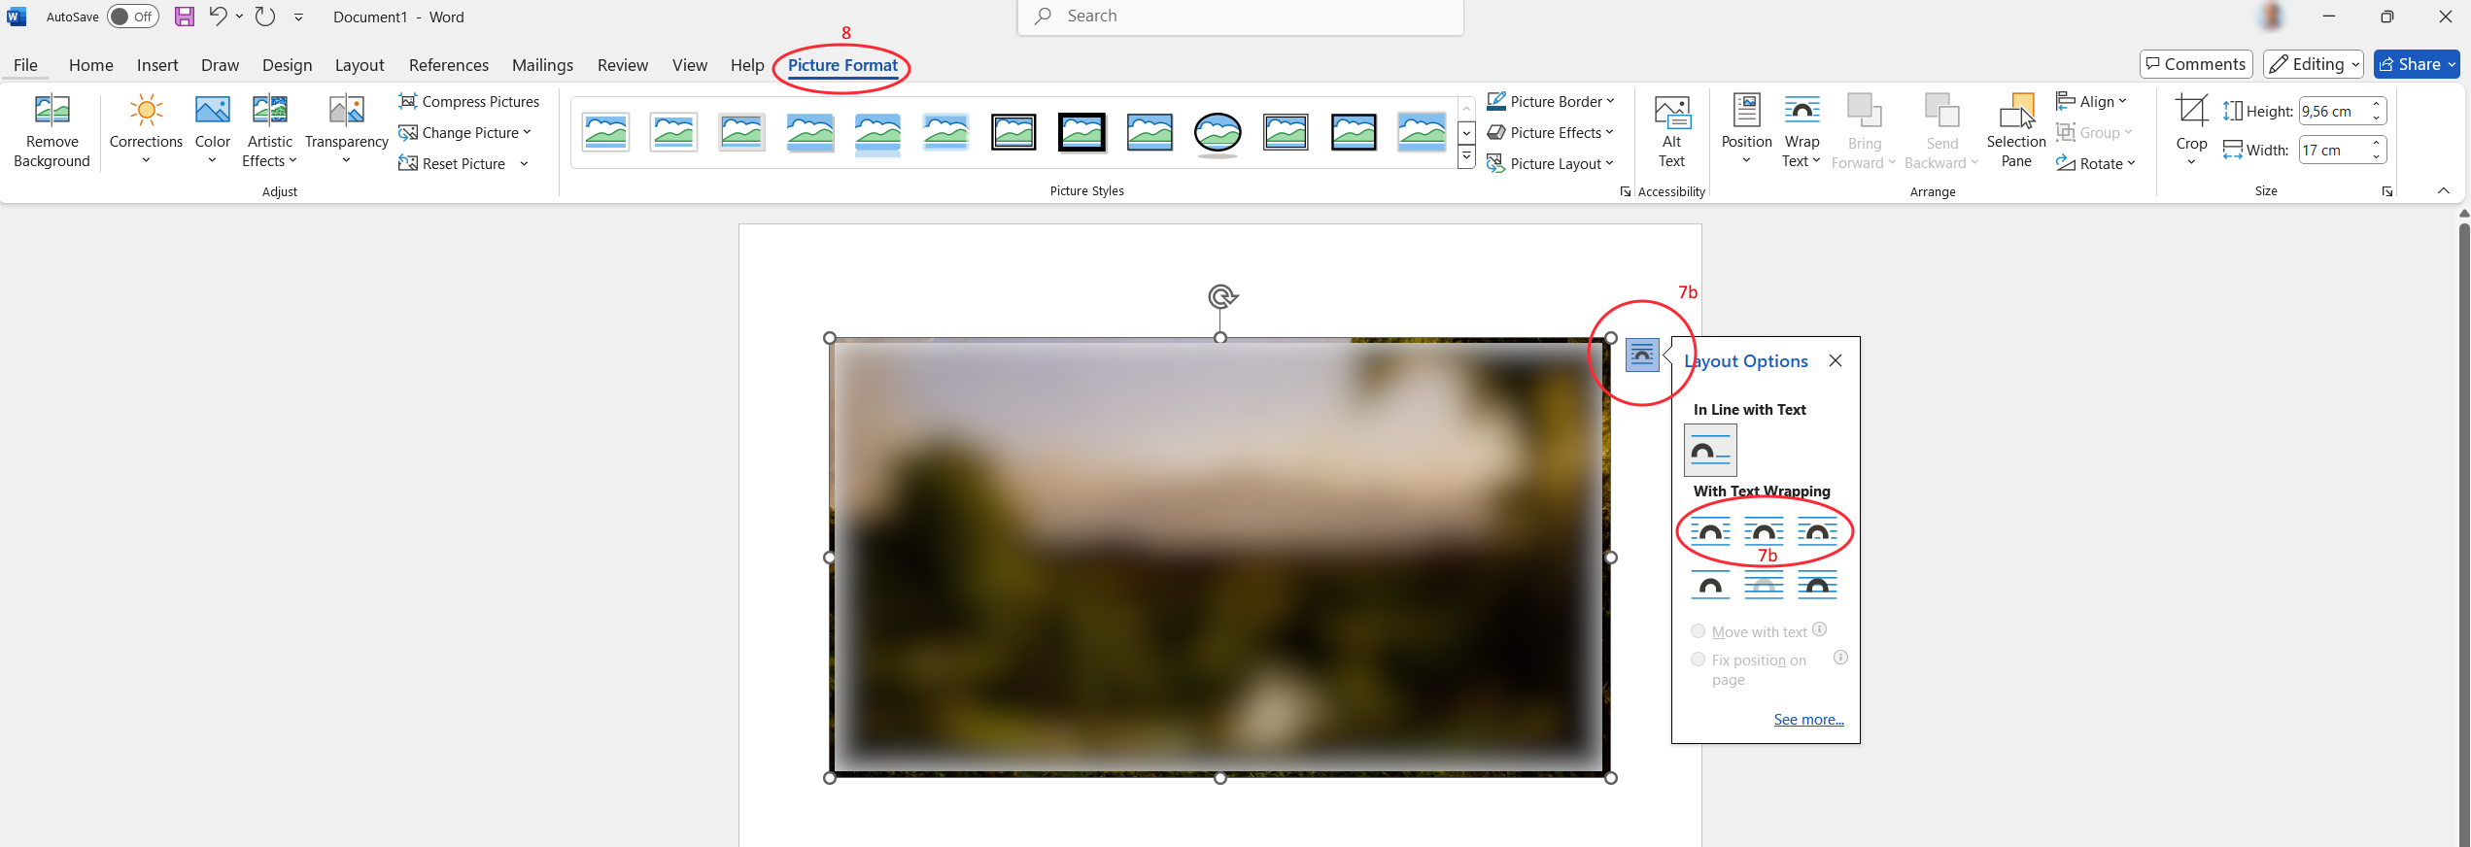
Figure 4
Figure 3

