1. Introduction

Figure 1 Introduction video: LIFE Revives FPM
a. What is the Freshwater Pearl Mussel?
The freshwater pearl mussel (Margaritifera margaritifera) is a long-lived bivalve mollusc that thrives in clean, cold rivers and streams. This remarkable species can live for over a century, with some individuals reaching up to 200 years of age. It is critically endangered worldwide and is listed as a priority species under the EU Habitats Directive. Its presence indicates high water quality, making it an important bioindicator for healthy aquatic ecosystems.
Where are Raakku Rivers?
In Finland, Sweden, Norway and Estonia, specific rivers known as "Raakku rivers" host significant populations of these mussels. These rivers are characterized by pristine conditions necessary for the mussels' survival and reproduction.
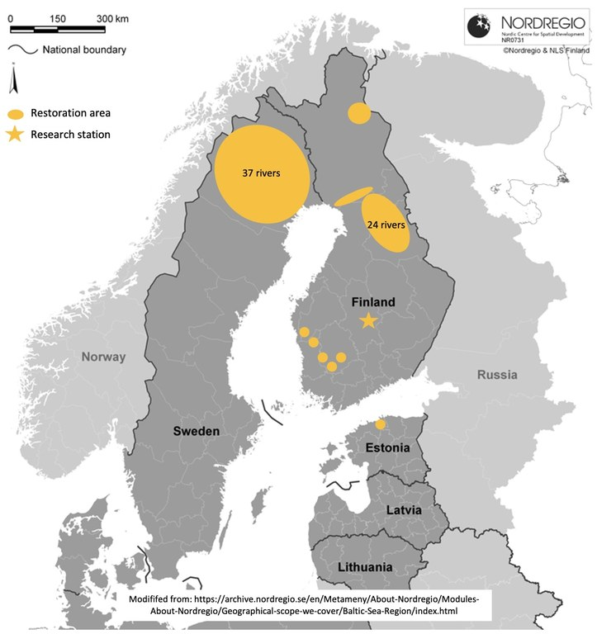
Figure 2 Target area of the LIFE Revives Project: Finland, Sweden and Estonia
b. Impact on the Ecosystem
Freshwater pearl mussels play a crucial role as indicator, umbrella and flagship species in river ecosystems by providing several essential services:
- Ecosystem Services: They enhance the ecological balance of riverine habitats.
- Nutrient Retention: By filtering large volumes of water, mussels remove particles and recycle nutrients within the ecosystem.
- Water Purification: Their filtration improves water clarity and quality, benefiting both aquatic life and human communities. An adult mussel filters around 50 litres of water per day.
- Carbon Fixation: Mussels contribute to carbon sequestration, mitigating climate impacts.
- Keystone Species: Due to their significant role in maintaining ecological stability, they are considered keystone species.
- Habitat Creation: Mussels provide microhabitats for invertebrates and juvenile fish, supporting biodiversity.
- Food Source: Indirectly, they sustain fish populations by nourishing bottom-dwelling organisms.
- Water Quality Improvement: Their activities enhance the overall health of rivers, promoting a balanced ecosystem.
2. Problem Behind the Case
a. Threats to the Raakku
Freshwater pearl mussels face numerous threats, jeopardizing their survival:
- Habitat Loss and Degradation:
  - Siltation: Sediment from land-use activities, such as forestry and agriculture, accumulates in riverbeds, smothering mussel habitats and hindering juvenile growth.
  - Water Pollution: Runoff from agricultural chemicals, industrial discharges, and urban wastewater reduces water quality, directly affecting mussels.
  - Habitat Fragmentation: Structures like dams, hydropower plants and road crossings block migratory paths of host fish (Atlantic salmon (Salmo salar) and brown trout (Salmo trutta)), disrupting the mussel lifecycle.
- Biodiversity Loss: Declining mussel populations lead to reduced riverine biodiversity, weakening ecosystem resilience.
- Forestry Industry Impacts: Events like the 2023 incident involving Stora Enso’s Forest machines emphasize the need for sustainable forestry practices in mussel habitats.
b. Endangered Status
FPM populations are rapidly declining across Europe. In Finland, Sweden,Norway and Estonia, inadequate reproduction rates among populations exacerbate the risk of extinction. This critical situation calls for immediate conservation efforts to secure their future.
3. Solutions and Collaboration
a. The LIFE Revives Project
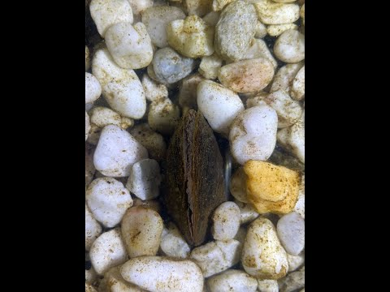
Figure 3 Video diary 2023 of the LIFE Revives Project
LIFE Revives is a six-year initiative aimed at enhancing the ecological conditions of freshwater pearl mussel populations. The project adopts a holistic approach involving habitat restoration, species reinforcement, and stakeholder collaboration.
b. Importance of Buffer Zones
Buffer zones along riverbanks are instrumental in:
- Reducing Sedimentation: Acting as natural filters, they trap sediments and prevent soil erosion.
- Improving Water Quality: They mitigate nutrient runoff, safeguarding aquatic habitats.
- Enhancing Biodiversity: Buffer zones serve as habitats for various plant and animal species, supporting overall ecosystem health.
c. Breeding the Mussel
Captive breeding programs at facilities like the Konnevesi research station are crucial for:
- Reinforcing Populations: Reintroducing captive-bred mussels bolsters wild populations and prevents local extinctions.
- Research and Development: These programs enhance understanding of mussel biology and breeding techniques.
d. Other Studies
- Monitoring Programs: Continuous tracking of mussel populations, habitat conditions, and restoration outcomes ensures adaptive management.
- Research on Host Fish: Understanding the relationship between mussels and host fish is vital for designing effective conservation strategies.
- Genetic analyses: Population genetic analyses of northern freshwater pearl mussel populations. Low genetic diversity is a matter of concern, as it may reduce the ability of species to adapt to changes in the environment.
- New Populations: Searching for new mussel populations
e. Public Awareness and Education
Raising public awareness is a cornerstone of the project. Key initiatives include:
- Environmental Education Programs: Informing communities about the ecological value of mussels and the need for their protection.
- Outreach Initiatives:
  - Collaborations with schools and youth groups to foster conservation enthusiasm.
  - Development of educational materials and online resources.
  - Organization of public events and workshops to engage broader audiences.
f. LIFE Revives Collaboration
The project emphasizes a collaborative approach involving multiple stakeholders:
- Government Agencies: Environmental, forestry, and water management authorities work together to ensure policy alignment and effective implementation.
- NGOs: Conservation organizations and research institutions provide technical expertise and advocacy support.
- Forestry Sector:
  - Engagement with forestry companies promotes sustainable practices in FPM catchments.
  - Development of guidelines for minimizing forestry impacts on mussel habitats.
- Landowners: Encouraging landowners to adopt best management practices and actively participate in habitat restoration.
5. Conclusion
The freshwater pearl mussel (Margaritifera margaritifera) serves as a symbol of pristine aquatic ecosystems and a key bioindicator for environmental health. The LIFE Revives project addresses the urgent need to conserve this critically endangered species by implementing habitat restoration, breeding programs, and stakeholder engagement strategies. Through collaborative efforts involving governments, NGOs, the forestry sector, and local communities, LIFE Revives is paving the way for a sustainable future where rivers thrive, biodiversity flourishes, and the freshwater pearl mussel endures. This comprehensive initiative underscores the importance of conservation as a shared responsibility, ensuring the resilience of our natural ecosystems in Finland, Sweden, and Estonia.
References:
Figure 2 : https://www.jyu.fi/science/en/bioenv/research/natural-resources-and-environment/life-revives/project/target-areas
Figure 4 : https://www.jyu.fi/science/en/bioenv/research/natural-resources-and-environment/life-revives/project/conservation-actions

Other sources:
LIFE Revives
Oulasvirta, P. (Ed.), Taskinen, J., Aspholm, P. E., Kangas, M., Larsen, B. M., Luhta, P.-L., Moilanen, E., Olofsson, P., Salonen, J., Veersalu, A., & Välilä, S. (2015). RAAKKU!: Freshwater pearl mussel in northern Fennoscandia. Nature conservation publications of Metsähallitus. Series A 214.

