Waste to energy exercises

Find the latest environmental report of your nearest waste incinerator.
- Do you sort waste better than people in Karelia? How do you recycle your waste? What should be done that recycling could be better?

Waste fraction | (%) 2017
Biowaste | 19,78
glass and ceramics | 1,62
Metal | 2,91
Big pieces | 0
Soil | 1,39
Energy waste | 45,01
not usable plastic | 0,84
waste wood | 1,35
waste paper and cardboard | 12,7
ungraded sorted waste | 0
WEEE (waste electrical equip.) | 0,11
Textile and diaper | 16,3
Avarage moisture | 37,3

- Compare flue gas emission concentrations. Are the limits same in EU?
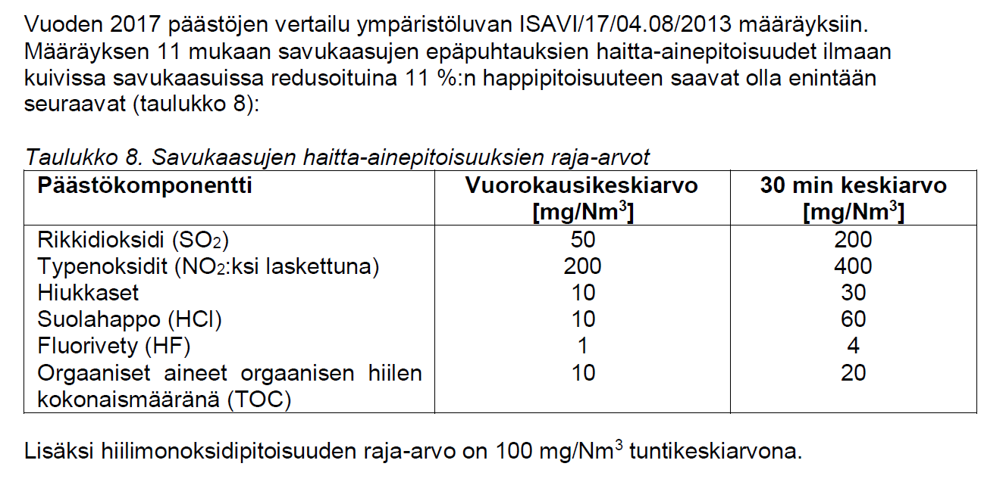

- Compare annual emissions results. Compare results to the E-PRTR threshold value too.
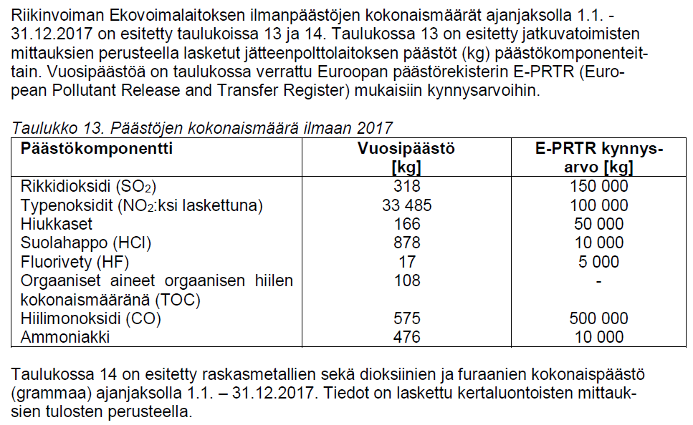
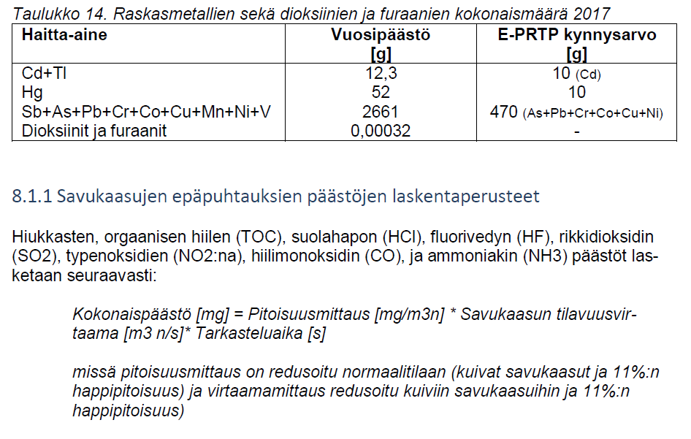
- Compare the results if the incineration process generates wastewater.
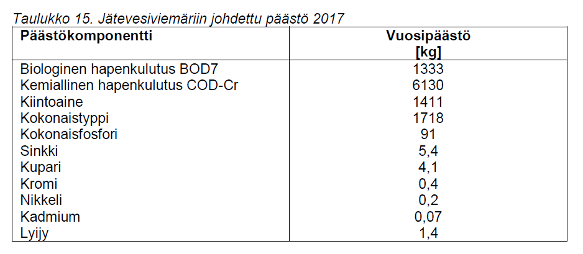
Source: RIIKINVOIMA OY EKOVOIMALAITOS Ympäristöluvan mukainen vuosiraportti 2017

- Calculate the effective calorific value of the woodchips in the arrival state when the effective heat value of the dry matter is 19 MJ / kg. The moisture content of the chips is 55%. (answer: 7,2 MJ / kg)
$$q_{p,net,ar}=q_{p,net,d}*\left(\frac{100-M_{ar}}{100}\right)-0,02443*M_{ar}$$

q_{p,net,ar} = effective calorific value at arrival, MJ/kg
q_{p,net,d} = effective calorific value in the dry matter, MJ/kg
M_{ar} = fuel humidity on arrival state, wt%
Where 0,02443 is the evaporation enthalpy correction factor.

- Calculate the effective heat value of the woodchips in the arrival state, taking into account the water phase changes. Chip temperature is -20 ºC. The moisture content and the effective heat value of the dry matter are the same as in heating of ice c=2,09 kJ / kg ºC, melting of ice c = 333 kJ / kg, heating water c=4,19 kJ / kg ºC, water evaporation c=2260 kJ / kg. (answer: 6,9 MJ / kg)

- As in exercise 6 but the chips have a temperature of 25 ºC. (answer: 7,1 MJ / kg)

