4.1 NBS in urban management

4.1.1 Introduction to urbanization
More than half of the world population lives in urban areas nowadays. The change to this state has been dramatically quick in terms of human history. In only a few decades, the human population’s living settings have been changed from mostly rural and local communities to large and highly dense cities. This phenomenon is called urbanization, and it is one of the megatrends of human history. The image below presents urbanization on a world scale.

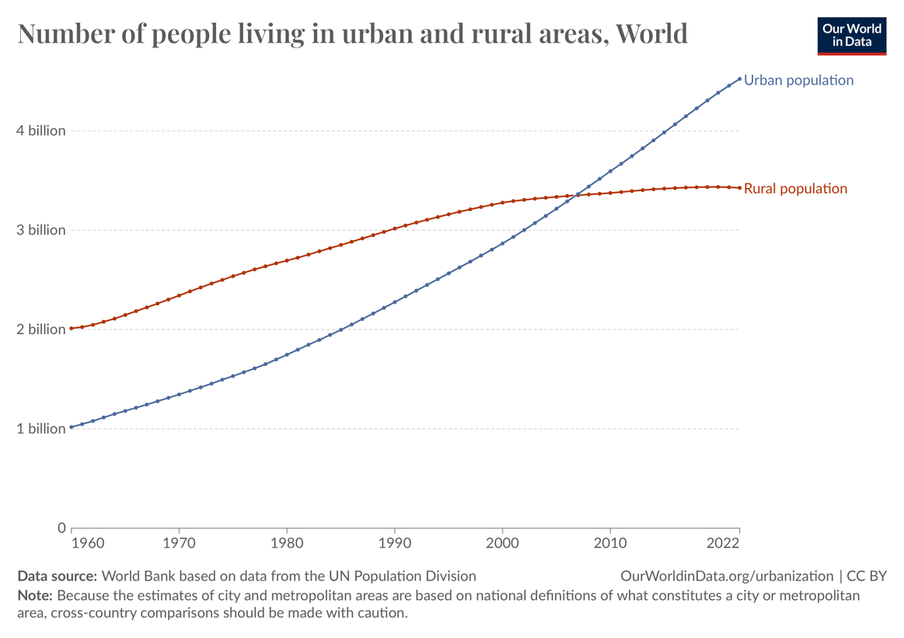
Figure 1 Number of people living in urban and rural areas, World. Source: https://ourworldindata.org/urbanization

In Finland, urbanization is even stronger than the whole-world scale. About 85% of the inhabitants of Finlan live in urban areas.
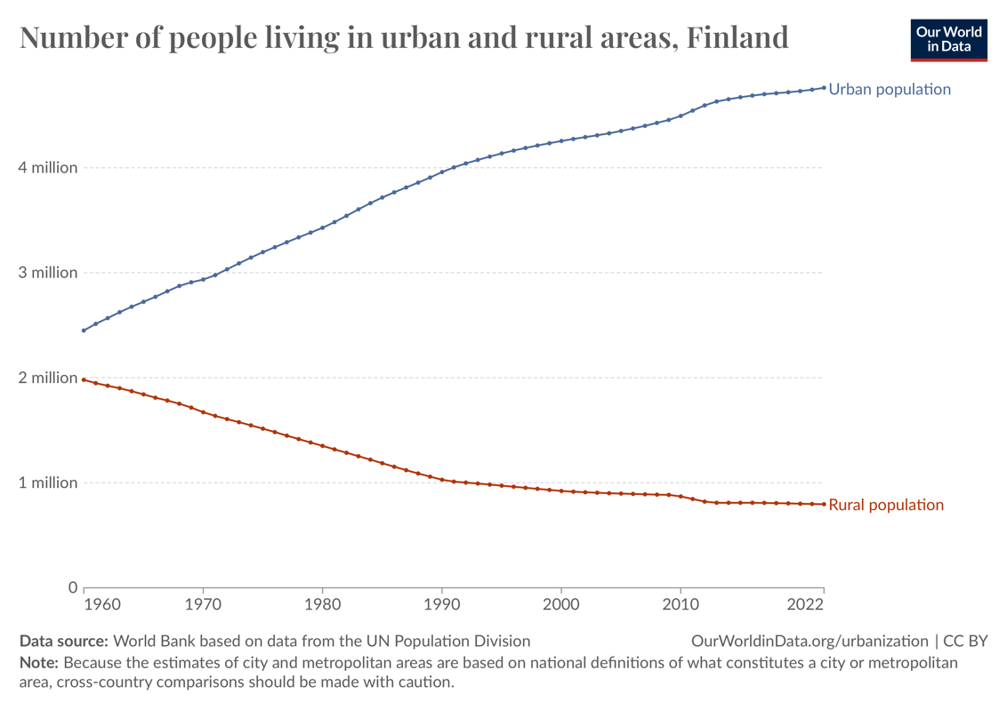
Figure 2 Number of people living in urban and rural areas, Finland. Source: https://ourworldindata.org/urbanization

The environmental aspect of urbanization is a double-edged sword. Many people's first thought is that large urban areas are worse for the environment compared to rural areas. The truth might be contrary to this belief, since there are also many positives from urbanization. In dense urban areas, there is less need for resources per inhabitant than in rural areas. For example, plumping and district heating are the kinds of attributes that are way more resource efficient per capita in cities than in rural areas. Another example of the pros of urbanization is the use of cars per capita, in which urban areas are more efficient than rural areas. In urban areas, there is usually efficient public transport that replaces the need for private car usage. This phenomenon decreases the carbon footprint of urban areas vs rural areas per capita severely.
Hungry for more info about the benefits of urbanization?
- More of these benefits of urbanization are presented for example in the book: Meyer, William B. 2013. The Environmental Advantages of Cities: Countering Commonsense. Available at: https://doi.org/10.7551/mitpress/9513.001.0001
- Another interesting study of this phenomenon is a study about China’s increase in land carbon sink caused by urbanization: Zhang, X., Brandt, M., Tong, X. et al. 2022. A large but transient carbon sink from urbanization and rural depopulation in China. Nat Sustain 5, 321–328. Available at: https://doi.org/10.1038/s41893-021-00843-y

As there are benefits in urbanization, there are also disadvantages which might be more discussed and better known publicly than the benefits. Urban areas as ecosystems are usually not rich or versatile, with a lot of concrete and asphalt pavement and other “lifeless” structures and materials. Even though these typical structures related to urban areas are efficient, they have some problems related to the environment and human health. To manage these problems, urban management is needed. Nature-based systems can play a key role in urban management.

Without reading the next chapter, what kind of problems or threats do you think there are in urban areas related to the environment and human health?

4.1.2 Problems in urban management

Stormwaters and flooding

Traditional city urban areas are mainly impervious surfaces and buildings which prevent water from infiltrating the ground so increased runoff happens in urban areas. During heavier rain, cities’ rainwater drainage systems may not be able to handle the increased runoff so that can lead to flooding. Increased runoff and flooding may result in water carrying pollutants and leaching of harmful substances, such as heavy metals and oils to water bodies which may cause a threat to natural water ecosystems.

Urban heat island phenomenon

The urban heat island phenomenon (UHI) has a typical effect on urban areas, which means that urban areas are significantly warmer than surrounding rural areas. There are many reasons for the UHI effect, one of which is dark urban surfaces that are warmed by the absorption of solar radiation. These urban surfaces tend to warm quicker than natural and rural surfaces.

Another aspect of urban surfaces is their weak albedo. Albedo is a fraction of sunlight that is diffusely reflected by the surface. It is measured from 0 to 1 (0 is all absorbed to surface, 1 is all reflected by surface). Urban surfaces generally have lower albedo than croplands and forest areas. Albedo is related to the heat island effect as it is part of the phenomenon of why dark surfaces warm quickly in cities. Albedo also has a significant effect on global warming since surfaces that absorb solar radiation increase global warming and surfaces that reflect solar radiation mitigate global warming.

Aside from the effect on raised temperature, UHI causes other problems as well. UHI can cause effects on local meteorology, for example altering local wind patterns, increasing humidity and cloud formation leading to increased rainfall in urban areas. For human health, UHI causes some threats as well. UHI can increase the magnitudes and lengths of heatwaves with also-increasing night temperatures that work as a cool relief to high daytime temperatures. Increased temperatures cause heat illnesses, such as heat strokes, heat exhaustion and heat syncope. Heat illnesses are dangerous, particularly for elderly people.

Air quality

Urban air quality is a critical aspect of creating and managing sustainable and healthy cities. In dense urban areas, air quality can deteriorate to unhealthy levels due to the activities in the city. The usual pollutants in urban air are:
- Nitrogen Dioxide (NO₂): Mainly from vehicle exhaust and industrial activities, it can cause respiratory problems.
- Particulate Matter (PM): Tiny particles from construction sites, unpaved roads, and fires that can penetrate deep into the lungs.
- Ozone (O₃): Formed when NO₂ and volatile organic compounds react to sunlight, which causes respiratory issues.
- Sulfur Dioxide (SO₂): Produced by burning fossil fuels, it can cause acid rain and respiratory problems

4.1.3 Solutions

Urban green areas

Urban green areas in urban management, often referred to as urban green spaces, include parks, gardens, urban forests, green roofs, and other vegetated areas within cities. These spaces are designed to bring nature into urban environments, providing numerous benefits for both the environment and the community. These are some of the benefits from green areas:
- Air Quality Improvement: Trees and plants in urban green spaces absorb pollutants and produce oxygen, which improves air quality. Studies have shown that urban vegetation can significantly reduce air pollution levels.
- Temperature Regulation: Green spaces help mitigate the urban heat island effect by cooling the surrounding areas. This is particularly important in densely populated cities where temperatures can be significantly higher than in rural areas.
- Stormwater Management: Vegetation in green spaces absorbs rainwater, reduces runoff and the risk of flooding. This natural absorption process helps manage stormwater more effectively.
- Mental Health: Access to green spaces has been linked to reduced stress, lower levels of depression, and improved overall mental well-being. Research during the COVID-19 pandemic highlighted the importance of green views and access to nature for mental health.
- Physical Health: Green spaces encourage physical activities such as walking, jogging, and cycling, which can help reduce obesity and cardiovascular diseases. Studies have shown that people living near green spaces are more likely to engage in physical activities.
Green roofs

Green roofs, also known as vegetated roofs, are an innovative solution in urban management. A green roof is a layer on top of a building's normal roof that consists of soil and vegetation layers. The usual structures of a green roof from bottom to top are waterproof membrane, root barrier, drainage layer, filter layer, growing medium and a vegetation layer.

There are a few different kinds of green roofs in use. The main differences are in the vegetation and growing medium since these layers need to be adjusted to be suitable for the climate. Common plants include sedum, grasses, and wildflowers.

There are many advantages of using green roofs that can help solve the problems in urban areas mentioned in chapter 4.1.2. These are some of the known advantages of green roofs, most of them are similar to those mentioned in the green areas section since green roofs are part of the green areas:

- Stormwater management: Green roofs can significantly reduce stormwater runoff by absorbing and retaining precipitation. This helps mitigate flooding and reduces the burden on urban drainage systems.
- Energy efficiency: By providing natural insulation, green roofs help reduce the energy needed for heating and cooling buildings. This leads to lower energy consumption and costs.
- Urban heat island phenomenon: Green roofs can lower urban temperatures by absorbing less heat compared to conventional roofs. This is related to green roofs albedo, which is higher than normal roof materials’ albedo. This helps reduce the urban heat island effect, making cities more comfortable during hot weather.
- Air quality improvement: Vegetation on green roofs can filter airborne pollutants and produce oxygen, contributing to better air quality in urban areas.
- Biodiversity and habitat creation: Green roofs provide habitats for various plant and animal species, enhancing urban biodiversity and creating green spaces in densely built environments.
- Aesthetic and recreational benefits: Green roofs can transform unused rooftop spaces into attractive, usable areas for recreation and relaxation, improving the quality of life for urban residents.
- Noise reduction: The layers of soil and vegetation on green roofs can act as sound insulation, reducing noise pollution in urban areas.
- Longevity of roof membranes: Green roofs protect the underlying roof membrane from UV radiation and extreme temperatures, potentially extending the lifespan of the roof.

Retention and detention basins:

Retention basins, also known as wet ponds, are designed to hold a permanent pool of water. They capture and store stormwater runoff, allowing pollutants to settle and be absorbed by aquatic plants. These basins are particularly effective in removing sediments and nutrients from the water, which helps to improve water quality before it is released into natural water bodies.

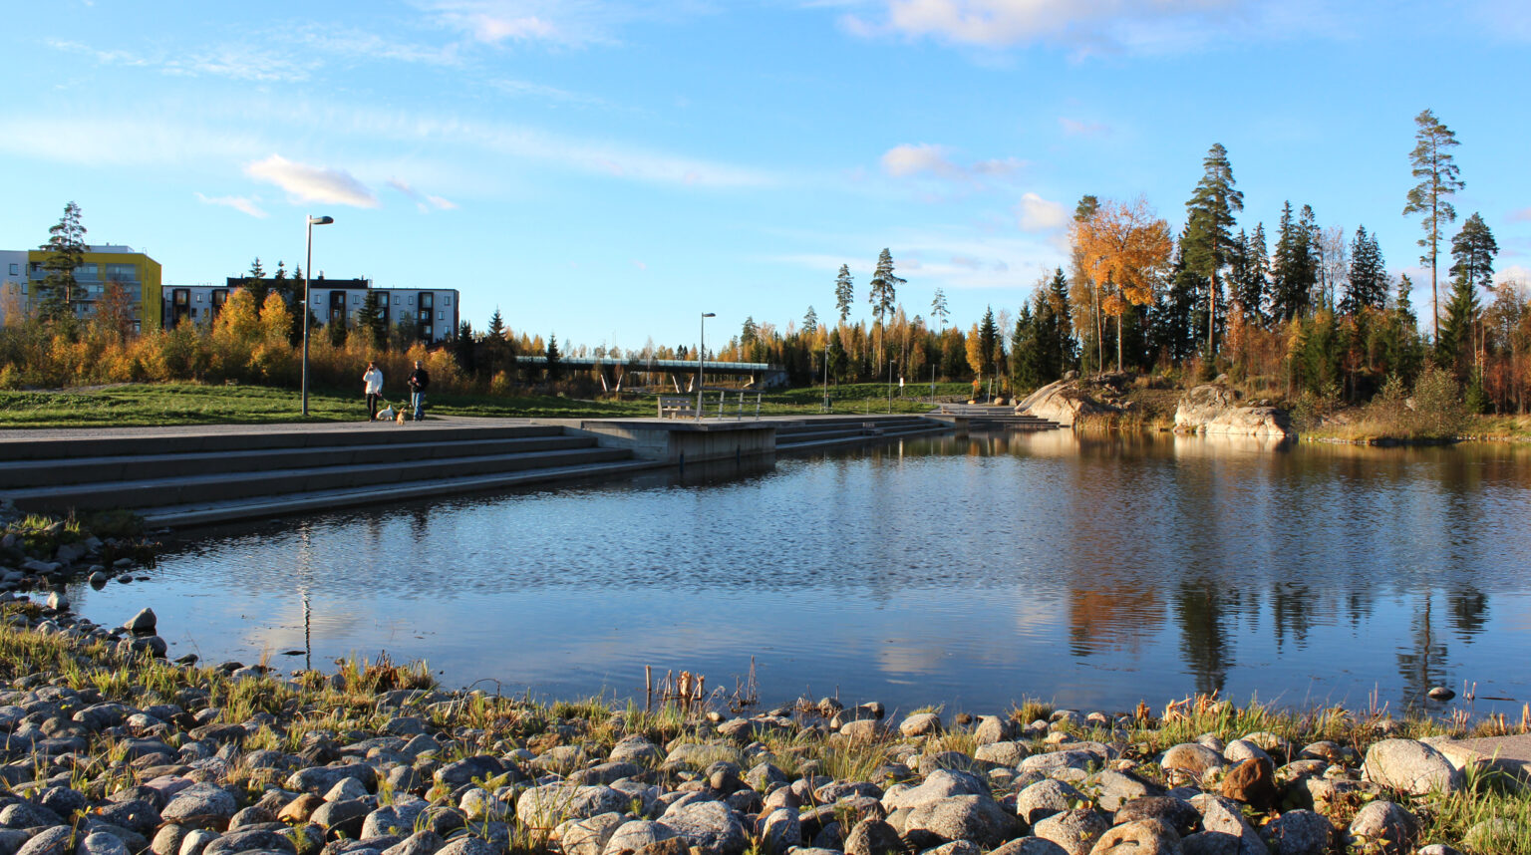
Figure 4 Retention basin in Vuores central park in Tampere, Finland. Source: https://vuores.fi/palvelut/keskuspuisto/

Detention basins, or dry ponds, are designed to temporarily hold stormwater and release it slowly to prevent flooding. Unlike retention basins, they do not have a permanent pool of water. These basins are primarily used for flood control and to reduce the peak discharge of stormwater into downstream areas.

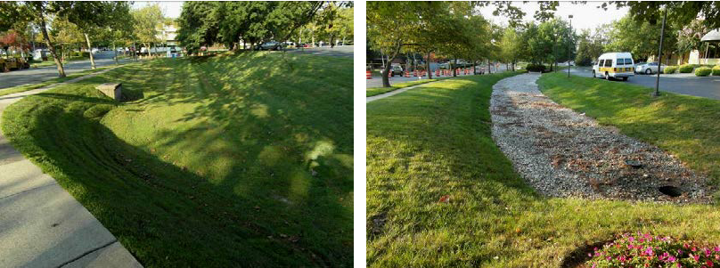
Figure 5 Different types of detention ponds, on the left there is a spillway, on the right there is a drainage ditch. Source: https://www.researchgate.net/publication/279718301_Green_Infrastructure_A_Strategic_Tool_for_Climate_Change_Mitigation_in_Urban_Environments

Both types of basins play a vital role in urban stormwater management by:
- Reducing flood risk: By controlling the rate and volume of stormwater runoff.
- Improving water quality: By removing pollutants from stormwater before it enters natural water bodies.
- Enhancing biodiversity in urban areas: Providing green spaces and habitats for natural ecosystems.

4.1.4 Case example

Oslo, Norway

Oslo as a city is committed to the plan to eliminate all their greenhouse gases by the year 2030.
To become carbon-negative and respond to the increasing urbanization, it has been necessary for Oslo city to implement new technologies in urban management which rely heavily on the NBS technologies.

For adjusting to the rainfall and flooding in the urban areas, Oslo developed a Stormwater 3-step strategy (S3SS). It means that different types of rainfall are handled in three rain intensity categories (low, moderate and heavy). Rainfall from small rainfall (<10 mm) events should be able to be infiltrated in permeable surfaces, which are mainly green areas and green roofs. Moderate rainfall (once every five years) should be able to be delayed in urban areas before it is channeled further. This delay is done using permeable surfaces and detention and retention basins. Then the heavy rainfall (once in 100 years) is channeled to the canals, flood plains and open water streams. This strategy is an efficient and sustainable way to treat rainfall in urban areas and it is mostly based on NBS systems.

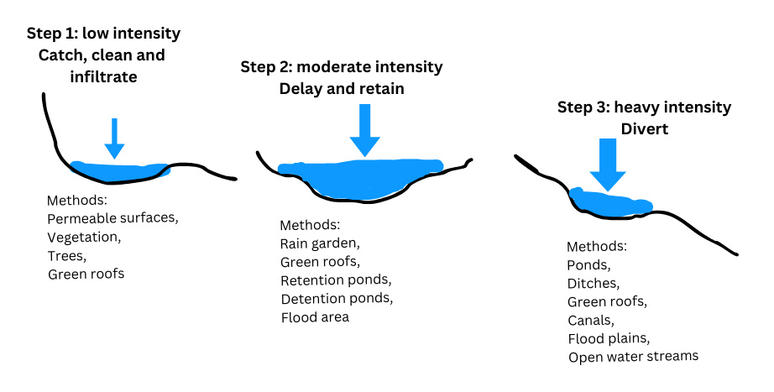
Figure 6 Oslo's Stormwater 3-step strategy. Modified from: https://doi.org/10.3390/w16152089

Conclusion
In short, urbanization has advantages and disadvantages for the environment and human health. NBS technologies can have a significant role in sustainable and healthy urban planning. Key NBS technologies in urban management include green parks, green roofs and retention/detention ponds. These technologies can offer solutions to problems related to air quality, urban heat island phenomenon, noise reduction, biodiversity and stormwater treatment.

Food for thought: Go for a walk in an urban area near you. What kind of NBS systems can you find related to urban management? You can also investigate the area through Google earth/satellite. Can you find stormwater management ponds that way?

References:

Meyer, William B. 2013. The Environmental Advantages of Cities: Countering Commonsense. Available in: https://doi.org/10.7551/mitpress/9513.001.0001

Zhang, X., Brandt, M., Tong, X. et al. 2022. A large but transient carbon sink from urbanization and rural depopulation in China. Nat Sustain 5, 321–328. Available in: https://doi.org/10.1038/s41893-021-00843-y

Phelan P., Kaloush K., Miner M., Golden J. Phelan B., Silva H., Taylor R., 2015. Urban heat island: Mechanisms, implications, and possible remedies. Available in: https://doi.org/10.1146/annurev-environ-102014-021155

United Nations Environment Programme, Urban air quality management toolbook. Available in: https://wedocs.unep.org/bitstream/handle/20.500.11822/8728/Urban_quality_management_toolbook.pdf?sequence=3

Oberndorfer E., Lundholm J., Bass B., Coffman R., Doshi H., Dunnett N., Gaffin S., Köhler M., Liu K., Rowe B. 2007. Green Roofs as Urban Ecosystems: Ecological Structures, Functions, and Services. Available in: https://doi.org/10.1641/B571005

Perivoliotis, D., Arvanitis, I., Tzavali, A., Papakostas, V., Kappou, S., Andreakos, G., Fotiadi, A., Paravantis, J. A., Souliotis, M., & Mihalakakou, G. 2023. Sustainable Urban Environment through Green Roofs: A Literature Review with Case Studies. Available in: https://doi.org/10.3390/su152215976

Shahmohammad, M., Hosseinzadeh, M., Dvorak, B. et al. 2022. Sustainable green roofs: a comprehensive review of influential factors. Available in: https://doi.org/10.1007/s11356-022-23405-x

Karamoutsou, L., Veliou, E., Kvernberg, E. B., & Psilovikos, A. 2024. Urban Stormwater Management: A Sustainable Approach. Available in: https://doi.org/10.3390/w16152089

