Nature-based Solutions (NbS): general information
Sustainable Nature-based Solutions (NbS) can be defined as “actions to protect, sustainably manage and restore natural or modified ecosystems that address societal challenges effectively and adaptively, simultaneously providing human well-being and biodiversity benefits” (IUCN, 2016).
The philosophical background of NbS is based the biomimicry – the processes where we learn from or inspire by nature (Stefanikas et al., 2021). NbS should be cost-effective and provide environmental, social, and economic benefits assisting in building resilience. NbS utilize the power of functioning ecosystems as infrastructure and develop economically profitable designs with no further harm to nature and environment. NbS can be classified to three major classes such as 1) Nature-based solutions sensu stricto (NbS s. str.), 2) Nature-derived solutions (NdS), 3) Nature-inspired solutions (NiS). Although, a collective term NbS is usually applicable to all these types of solutions.
NbS s. str. use the power of functioning ecosystems as infrastructure. For example, those are green and blue infrastructures.
NdS are not directly based on functioning ecosystems, but those utilize production methods deriving from natural sources. Examples include wind, wave, and solar energy, helping to fulfil low carbon energy needs of society.
NIs include innovative design and production of materials, structures, and systems that are modelled on biological processes and are nature-inspired. For example, those are biofuels, bioplastics, or other biomaterials.
There are serious environmental concerns requiring rapid implementation of NbS. All these environmental concerns possess both philosophical and economical grounds. The examples of environmental issues are:
- Natural ecosystems have declined by 47% on average, relative to their earliest estimated states.
- Approximately 25% of species are already threatened with extinction in most animal and plant groups studied.
- Biotic integrity – the abundance of naturally present species – has declined by 23% on average in terrestrial communities.
- The global biomass of wild mammals has fallen by 82%. Indicators of vertebrate abundance have declined rapidly since 1970.
- 72% of indicators developed by Indigenous peoples and local communities show ongoing deterioration of elements of nature important to them (IPBES, 2019b; IPCC, 2018, PwC & WWF, 2020)

It has been suggested to define three levels of scales for the NbS (Figure 1)

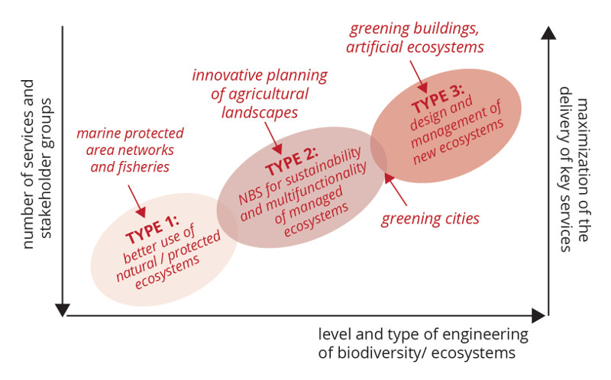
Figure 1. Types of the NbS depending on the scale (Woo, 2020)
NbS of the type 1: Strategy-related NbS. They are aiming at minimal or no intervention in ecosystems. This type of NbS, for example, include the establishment of protected areas or conservation zones; limitation or prevention of specific land use and/or practices; ensuring ecological networks (protection from fragmentation); regular monitoring of physical, chemical or biological indicators.
NbS of the type 2: Managment-related NbS. They are at the development of sustainable, multifunctional ecosystems. A striking example of the NbS of a second type is the creation and preservation of habitats and shelters to support biodiversity (e.g., insect hotels for wild bees, next boxes for native bats and birds, stopover habitat/”rest stops” for migratory birds, installation of apiaries). The other example is the sustainable fertilizer use, control of erosion through management of grazing animal stocking density and exclusion of grazing animals from riparian areas and the others.
NbS of the type 3: Design-related NbS. These solutions involve highly intensive ecosystem management. The example can be an intensive management or construction of new ecosystems, green areas, urban parks and gardens of all sizes, heritage parks, botanical garden, green strips, green transport tracks. The other examples can include soil conservation and quality management frameworks, slope revegetation, cover crops, windbreaks, conservation tillage practices, permaculture, utilizing deep-rooted perennials. The intense projects such as building blue infrastructure or green built environment are also related to the 3rd type of NbS.
The concept of NbS is an “umbrella” concept which is used in relation to several other terms as well. Those are, for example, ecosystem-based adaptation (EbA), ecological engineering (EE), ecological restoration (ER).
NbS can be developed and designed for different types of the ecosystems such as rivers and wetlands, forests, mountains, coastal ecosystems, farmlands, industrial or urban environments.
Nature-based Solutions (NbS): examples from urban green infrastructure (UGI)
As a part of developing and designing NbS, work by Dr. Oksana Skaldina included NbS for Finnish urban environments. The aim was to optimize different elements of urban green infrastructure (UGI) including traffic-related green spaces (TRUGs) to improve biodiversity of pollinators with the mission to fulfill the demands of the European Nature Restoration Law (The EU #NatureRestoration Law). Pollinators is a globally decreasing group of the insects providing essential ecosystem services (ES). So, rapid actions should be undertaken to improve the sustainability of their populations. The two-years research project was aiming to evaluate floral resources (considering both spontaneous vegetation and ornamental plants) attracting pollinators, but also to assess pollinator communities in urban areas and reveal potential risks, which might prevent increase of pollinator-friendly floras in cities.
Our key-finding related to NbS.
- In cities, insect-pollinated vascular plants enhance environmental quality, support pollinators, and provide essential ecosystem services for citizens. Floral communities associated with traffic-related green spaces should be considered as valuable elements of urban green infrastructure (UGI). Those should be better integrated into designing of green corridors for ecologically important insects.
- Similar richness of flowering plants (but not total plant species) in urban and suburban locations might indicate equal importance of ecosystem services provided by flowering plants in cities irrespective of location.
- Because traffic islands and parking lots contain rich plant communities, they should be better integrated into UGI and valued by city planners.
- Management intensity in terms of grass cuts should be ecologically justified, and the creation of urban meadows might provide valuable NbS of the type 3 for urban areas.
- An increase in the number of insect-pollinated plant species in urban traffic-related green spaces might help to improve environmental quality in cities in terms of increasing pollinator biodiversity and reducing pollution.
- When considering placing ornamental plants for urban areas, their capability to attract pollinators should be carefully evaluated.

References:
Skaldina O, Nylund A, Ramula S (2024) Neglected puzzle pieces of urban green infrastructure: richness, cover, and composition of insect-pollinated plants in traffic-related green spaces. Landscape Ecology 39, 80.
Eisenberg B, Polcher V (2019) Nature-based solutions – technical handbook. Institute of Landscape Planning and Ecology, 137 pp.
IUCN (2020). Guidance for using the IUCN Global Standard for Nature-based Solutions. A user-friendly framework for the verification, design and scaling up of Nature-based Solutions. First edition. Gland, Switzerland: IUCN.
Goodwin S, Olazabal M, Castro AJ, Pasqual U (2023) Global mapping of urban nature-based solutions for climate change adaptation. Nature Sustainability 6: 458-469
Stefanikas AI, Calheiros CSC, Nikolaou I (2021) Nature-based solutions as a tool in the new circular economic model for climate change adaptation. Circular Economy and Sustainability (2021) 1:303–318

