Nature-Based Solutions in a context of environmental justice – A review
(Li et al. 2024)
Nature’s contributions to people play a vital role in support of human existence and quality of life but are often distributed unequally across space and time (IPBES 2019). IPBES reports that negative effects are disproportionate and will especially affect marginalized and Indigenous peoples and rural communities. Interventions can only be successful with the inclusion of different knowledge systems and participation of affected groups, including Indigenous people and local communities. For example, existing adaptation efforts in Polar Regions have benefited from the inclusion of Indigenous and local knowledge.
NBS may trigger or aggravate inequalities, and the question of how to address issues of justice and socio-spatial inequality is important (Menton et al. 2020). Justice has to be one of the key aspects in the development of NBS framework in the future (Schlosberg 2013). Environmental justice researchers have exposed and criticized that NBS hurt the living environment, housing prices, facilities, etc. For instance, NBS tends to serve high-income groups, which is unfair to the disadvantaged groups in society (Anguelovski et al. 2022). NBS should be used in recognizing and addressing the unequal distribution of environmental benefits and burdens among different social groups.

Environmental justice
Environmental justice examines the complex relationship between people and nature and proposes potential solutions. Originally environmental justice focused on the unfair distribution and governmental protection of environmental risks. Robert Bullard, a pioneer in environmental injustice gradually expanded the field’s scope from transportation to urban planning and from environmental health to hazard management.
Currently there is a consensus that environmental justice comprises distributive, procedural and recognition types (Clough 2018). This perspective considers the who, why, when and where of upholding fairness. As the field of environmental justice continues to expand, environmental risk, harm and degradation are recognized as constituting categories of environmental justice (Menton et al. 2020). In this text environmental justice is framed in three dimensions: distributive, procedural and recognition justice (Figure 1).
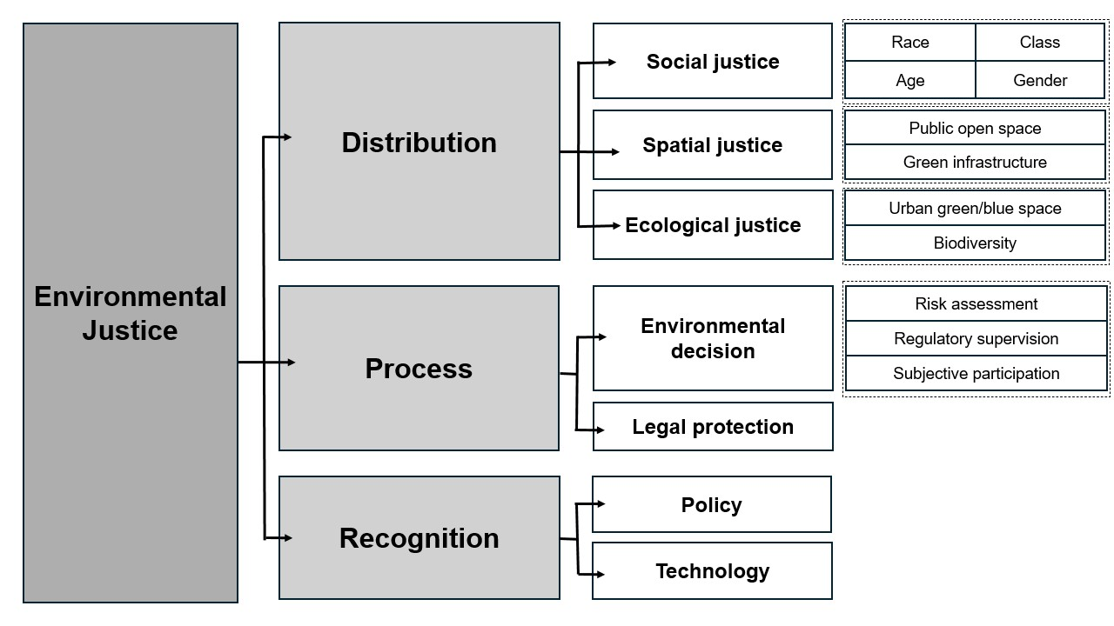
Figure 1. Review framework of environmental justice. Simplified from Li et al. 2024.
Distributive justice is categorized into social, spatial and ecological justice. Social justice refers to the unequal distribution of environmental risks and benefits based on gender, class, ethnicity or age. Spatial justice refers to the disparity in geospatial arrangement and extent of provision for public open space as well as green infrastructure. Ecological structure concerns the establishment of fair and balanced relationships between human beings and non-human entities.
Procedural justice refers to whether the subject of environmental justice can participate in assessment, decision-making, supervision and other links in a series of processes of environmental decision-making. Risk assessment before, during and after environmental decision-making are all key factors affecting procedural justice. Procedures must not only be open but also be protected by law, thus legal support also falls under this category.
Recognition justice is that the implementation of environmental justice requires the support of relevant national and governmental policies and documents. This also includes the development and support of related technologies.

Environmental justice-oriented NBS policymaking
Research on NBS policies is in its early stages and can integrate with other factors like science and community engagement. Extensive studies emphasize that citizen involvement, political support, social inclusion, public acceptance, financial support, monitoring, evaluation, and upscaling are key success factors for co-creating NBS for urban regeneration.
Open innovation, partnerships among stakeholders, effective monitoring and evaluation systems, education and training are crucial drivers in urban settings. Policymakers need to establish the existing policy system by identifying institutional, legal, social, and economic factors for initiating, planning, designing, and implementing NBS within the context of environmental justice.
Design
During the policy design phase, both supply side and demand side correspond primarily to the demand entities and policymakers. On the demand side, issues such as mismatched demand entities, weak or biased demand awareness result in suboptimal effect of NBS. The government and urban green policies play a significant role in pursuing fairness in NBS for demand entities. NBS in the design phase often makes pre-assumptions about the preferences of urban and community residents based on empirical data, overlooking the actual needs of Indigenous Peoples and local communities. This can lead to a breakdown of trust and misunderstanding regarding NBS.
The internal distribution of power among implementers, decision-makers, policymakers and the most vulnerable socioeconomic groups, can influence the perception and welfare entitlements of different economic groups towards NBS. Groups with lower social status and weaker economic strength lack competitiveness in internal power distribution.
Inclusive planning aims to achieve better outcomes for various stakeholders. This may include inclusivity of diverse demographic types and economic backgrounds, such as low-income populations. Therefore, the design phase is a crucial stage for high-level collaboration and communication between participants and policymakers. The introduction of facilities, for example community gardens and public activity centers could enhance community awareness.
Relevant regulations and policies should be enacted to safeguard the interests of special groups, such as elderly groups, who need appropriate shelter during extreme summer conditions in parks.
Implementation
Multidisciplinary expertise and knowledge reservoirs, along with strategic collaboration across various government departments, are crucial factors in ensuring effective policy implementation. For example, the city of Vienna, as part of its recently formulated Green and Open Space Strategy, has adopted a multilayered communication process. This includes resident surveys about their values concerning green spaces, including preferences for activities and how they envision the management of these spaces in the future (Beatley 2012). Also, the city’s senior policymakers are regularly briefed on the benefits and objectives of the strategy, and they are invited to participate in the strategy formulation process.
Conclusion: The implementation process must uphold openness, transparency and intellectual legitimacy in the governance process for citizens, practitioners and policy stakeholders. The creation of spaces for cross-sectoral dialogue result in adaptive co-management and knowledge sharing.
Monitoring and evaluation
One of the reasons for the inefficiency and inequity of NBS policies is the insufficient supervision and evaluation after implementation. The main reason is a single evaluation dimension and the unfair evaluation object.
Currently, the monitoring process of NBS program measures predominantly concentrates on ecosystem indicators and detection methods, which falls short in assessing environmental information pertinent to human well-being. This gap can be addressed by Eco-EJ indicator, which combines both ecological and human environmental indicators. This allows for a more inclusive evaluation that considers cultural and environmental injustices and their potential health impacts. as well as the associated heath concerns.
Conclusion: These frameworks encompass supervising urban green initiatives and actions, promoting democratic control over public space decisions. The choice and application of monitoring methods depend on the specific NBS being monitored, available resources, and the types of human and natural resources involved (Kumar et al. 2021).
As climate change concerns grow, integrating NBS into the environmental justice framework addresses urgent issues at the intersection of the domains of social justice and environmental protection. The framework combining NBS and environmental justice represents an innovative approach, addressing limitations in conventional NBS applications for hazard prevention.

References:
Anguelovski, Isabelle, Anna Livia Brand, Malini Ranganathan, and Derek Hyra. 2022. “Decolonizing the Green City: From Environmental Privilege to Emancipatory Green Justice.” Environmental Justice 15(1):1–11. doi: 10.1089/env.2021.0014.
Calliari, Elisa, Sergio Castellari, McKenna Davis, Joanne Linnerooth-Bayer, Juliette Martin, Jaroslav Mysiak, Teresa Pastor, Emiliano Ramieri, Anna Scolobig, Marjolein Sterk, Clara Veerkamp, Laura Wendling, and Marianne Zandersen. 2022. “Building Climate Resilience through Nature-Based Solutions in Europe: A Review of Enabling Knowledge, Finance and Governance Frameworks.” Climate Risk Management 37:100450. doi: 10.1016/j.crm.2022.100450.
Clough, Emily. 2018. “Environmental Justice and Fracking: A Review.” Current Opinion in Environmental Science & Health 3:14–18. doi: 10.1016/j.coesh.2018.02.005.
Li, Yantong and Zhai, Wei and Yang, Zheng and Tang, Junqing and Li, Haiyun and Huang, Huanchun, A Review of Nature-based Solutions to Environmental Hazards Through the Lens of Environmental Justice (February 13, 2024). http://dx.doi.org/10.2139/ssrn.4724771
Menton, Mary, Carlos Larrea, Sara Latorre, Joan Martinez-Alier, Mika Peck, Leah Temper, and Mariana Walter. 2020. “Environmental Justice and the SDGs: From Synergies to Gaps and Contradictions.” Sustainability Science 15(6):1621–36. doi: 10.1007/s11625-020- 807 00789-8.
Schlosberg, David. 2013. “Theorising Environmental Justice: The Expanding Sphere of a Discourse.” Environmental Politics 22(1):37–55. doi: 10.1080/09644016.2013.755387.

