Pro Agria Eastern Finland (Rural Women’s Advisory Organization, Maa- ja kotitalousnaiset)
Text by Päivi Jokinen, translated and edited by Olivia Ollikainen.
Rural Women’s Advisory Organization (RWAO) is a nationwide Finnish expert organization in food, nutrition, entrepreneurship, rural landscape and environment and it works as a part of ProAgria. Rural areas are perceived as a vital part of Finland’s success and the increased vigor of rural areas are preferred. RWAO’s aim is to promote lively, active and equal communities and strengthen women’s role in them. The approach is from a rural perspective and the mission is to provide people knowledge and concrete tools for the increased interest in local food and its cultivation, biodiversity and sustainability. The mission is to build the world’s cleanest and most vigorous rural areas now and in the future.
RWAO has nine regional centers throughout Finland. The foundation of the organization is nearly 23 000 members in over 900 associations at the local level. In this chapter, we are focused on the work and actions of RWAO Eastern Finland.
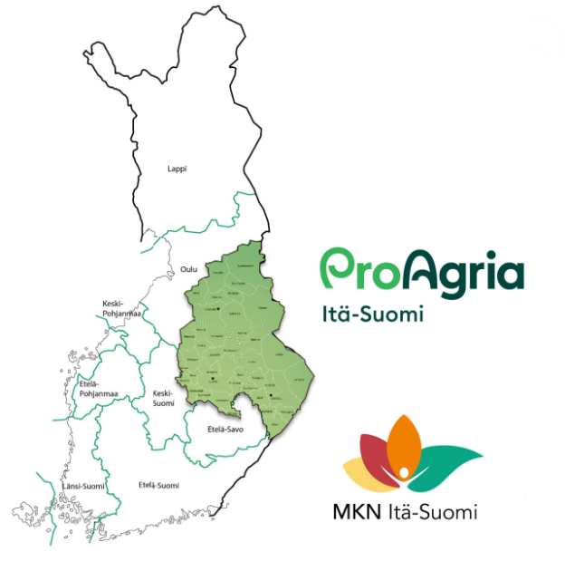
Fig 1. Map of Finland and the action area of ProAgria Eastern Finland.
At the heart of the action is promoting biodiversity together with landowners, municipalities and cities, associations and businesses. Landowners and residents are an integral and active part of the different phases of the projects. RWAO raises public awareness of the values and opportunities of the cultural environment, valuable landscapes and local cultural heritage which are important stages in implementing Nature-Based Solutions in action.
Landscape services
RWAO provides expert services and advice in rural landscape and nature management. Planning services include treatment planning for traditional rural biotopes, urban meadows and recreational areas, inclusive planning of village landscapes, beaches and treatment and control of invasive alien species. They collaborate with various stakeholders regarding biodiversity and water site restoration.
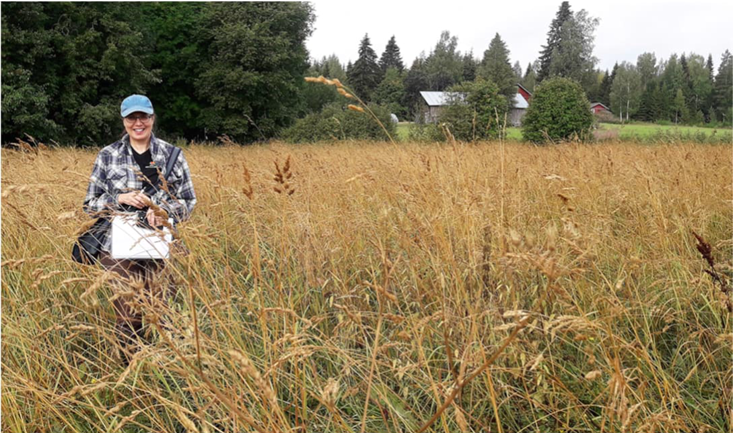
Fig. 2. Päivi Jokinen doing a field survey in a rural area. Photo by Jaana Puhakka.
Case examples: Lake restoration in Ylä-Valtimo, North Karelia
Background
The village of Ylä-Valtimo is located in North Karelia, in the municipality of Valtimo, within the city of Nurmes. Ylä-Valtimo is part of a nationally valuable landscape area, where various waterbodies form an integral part. The defining features of the landscape include open agricultural fields with farms along the shores of lakes, the lakes themselves, and the high hills. The village has approximately 300 residents. The village is home to the active Ylä-Valtimo Village Association (Ylä-Valtimon kyläyhdistys ry). Community spirit and collaboration play a central role in their action. The villagers have collectively built, for example, a viewing tower and a lean-to shelter and various events are organized annually.
The villagers are concerned about Lake Ylä-Valtimo becoming overgrown and eutrophicated. The swimming area has been unusable, and the lake has become filled with aquatic vegetation.The condition of the lake has deteriorated, although it is still classified as having a good ecological status. The lake has started to eutrophicate due to sediment and nutrient runoff from agriculture and forestry in the catchment area, particularly via the Pertunjoki River. The lake was also lowered in the 1800s. Recent years’ heavy rainfall has increased the load on the waterbody from agricultural and forestry activities.
Humans have often accelerated natural development or caused significant changes to the natural state of shorelines. The most common problems are shoreline flattening, silting and overgrowth of aquatic vegetation. These issues are usually caused by an excessive influx of nutrients and sediment into the water bodies from the catchment area. In some places, overgrowth may also be due to a decrease in the lake’s water level or the fact that the beaches are no longer grazed.
The restoration project
In 2020, training for waterbody restoration coordinators began as part of the KAIPO project (https://www.proagria.fi/hankkeet/kaipo-verkko in Finnish). The goal was to encourage local residents to learn about waterbody restoration practices. The village developed a restoration plan for 2020-2030 and the plan aims to safeguard the lake’s good ecological status and prevent further degradation. The plan is updated annually based on completed initiatives.
The efforts began with improving the swimming area and reducing overgrown vegetation along the lake’s shoreline. The villagers are engaged and connected to the water’s protection through a shared important location.
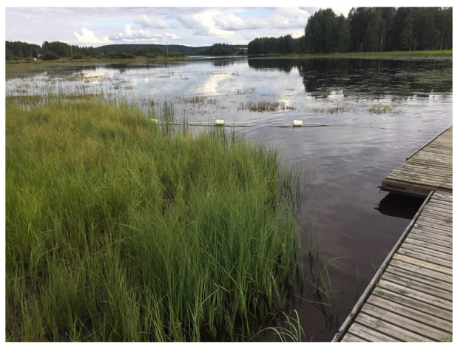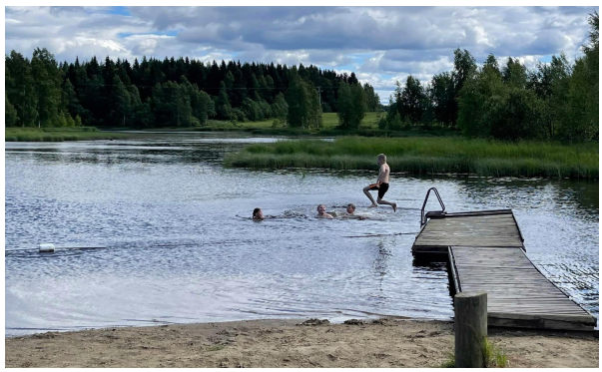
Figures 4 & 5. The public beach before and after restoration. Photos courtesy of the Ylä-Valtimo Village Association.
The vegetation was removed mechanically by grinding the roots of yellow water lilies (Nuphar lutea) and mowing other aquatic plants such as water horsetail (Equisetum fluviatile) and the common reed (Phragmites australis). The goal of removing aquatic vegetation is to thin out overly dense growth or reduce the area it covers. Reducing aquatic vegetation improves recreational use, enhances the landscape and improves the water flow in the lake’s narrow parts. It can also create more favorable breeding grounds for birds and fish.
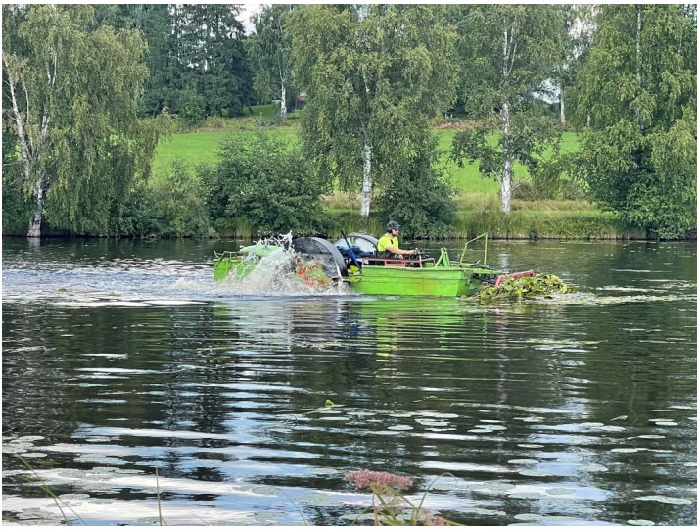
Figure 6. The mowing and harvesting of aquatic plants by machine. Photo courtesy of the Ylä-Valtimo Village Association.
Yellow waterlily has a thick rhizome rooted in the bottom sediment. Leaves grow from the rhizome, some of which float on the water’s surface and are easy to detect. Reducing yellow water-lily populations solely by cutting its leaves is not effective, as most of the plant’s nutrient reserves are stored in its thick rhizome. The removal of aquatic vegetation should be carried out in agreement with authorities and other users of the water area, as it may cause temporary water turbidity, disturbance at the extraction site or other inconveniences. Sometimes machinery cannot be used at the site because there are water and sewer pipes at the bottom of the lake. Scuba diving enables extended work underwater in these cases.
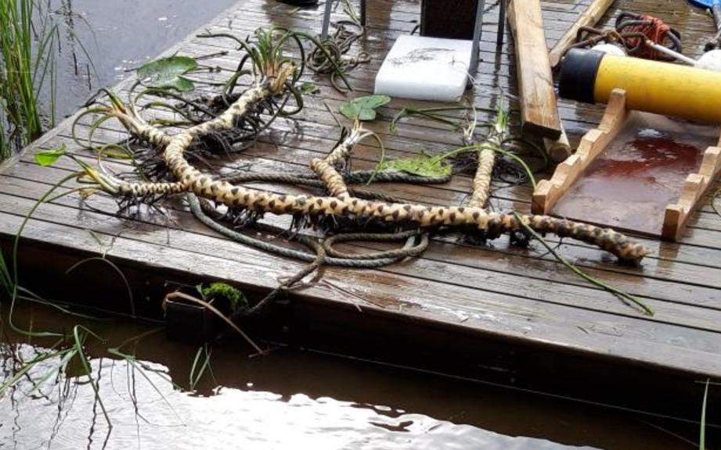
Figure 7. Yellow water lily roots are thick and usually intertwined with one another. Photo courtesy of ProAgria Eastern Finland.
In Ylä-Valtimo, the mowed vegetation was pushed to the shore with a machine, from which it is transported further away from the shoreline. If plant debris is left in the water, it also consumes oxygen as it composes and releases nutrients into the water and increases algae growth. Yellow waterlily can also easily put down roots again from the pieces. Villagers volunteered to lift the mowed plants out of the water and pile them up. The vegetation was then transported to a local farmer's organic field to be used as soil improver.
The swimming area’s aquatic vegetation was mechanically mowed annually in 2020, 2021, and 2024. These efforts will continue as part of the restoration plan in the coming years.
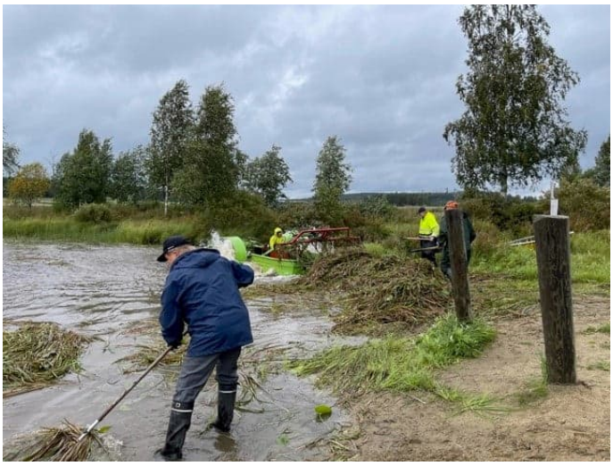
Figure 8. The mowed plant waste that is brought to the shore is removed from the water. Photo courtesy of the Ylä-Valtimo Village Association.
Reducing external nutrient loading is crucial for improving the lake’s condition.
A restoration plan was therefore commissioned for the Pertunjoki River catchment area, which drains into Lake Ylä-Valtimo.
Pertunjoki Catchment Restoration Plan
The plan identifies areas within the catchment where sediment runoff into the water system occurs, such as erosion in streambeds or along ditch banks caused by heavy water flow. It proposes restoration measures to reduce sediment and nutrient input into waterbodies, including bottom weirs in streams, constructed wetlands, sedimentation basins and overland irrigation fields.
The plan does not obligate landowners to undertake restorative actions. Projects are implemented gradually based on landowner interest and available funding.
In 2023, a settling basin was excavated along a stream feeding into Pertunjoki on private land. Its purpose is to reduce sediment, such as sand and silt, and nutrients entering Pertunjoki and eventually Lake Ylä-Valtimo, thereby helping maintain the lake’s good ecological status.

The managing and designing of the water restoration plan
Collaboration
- villagers, land owners, cottagers
- authorities such as ELY centre and municipality
- joint property management association (owner’s of the water area)
- contractors
- other co-operation networks, ProAgria, RWAO
Funding
- different initiatives
- funding from the ELY Centre, the city, village association and individual people

Overall management by the Ylä-Valtimo Village Association
Permits and notifications
- submission of permits and notifications, e.g., mowing and dredging notice to the Centre for Economic Development, Transport and the Environment (the ELY Centre)
Communications
- deciding on the responsibilities for information
- planning of publicity
- communication tools and channels

Invasive alien species voluntary efforts – Garden lupin (Lupinus polyphyllus)
Garden lupin is included in the national list of invasive alien species in Finland. It mainly reproduces from seeds, which can remain viable in the soil for several years, but vegetative reproduction is also possible. The seeds are carried further mostly through roadside mowing and soil and garden waste. Garden lupin is extremely difficult to eradicate altogether, but there are good reasons to control its spread. The species spreads vigorously along roadsides but also to meadows and groves which leads to the endangerment of native plants. Garden lupin’s dense growth and nitrogen-fixing ability alter soil nutrient levels, favoring its own growth and resulting in reduction of plant diversity. The removal is labor-intensive but effective for localized outbreaks.
The problem | The spread of invasive alien species’ garden lupin in the village landscape reduces biodiversity.
The goal | Preventing the spread of garden lupin in village landscapes
The measures | The villagers working and volunteering together: Removing garden lupin blossoms, mowing and digging up rhizomes.
The prerequisite | Perseverance, a manager of the community labor, motivated villagers

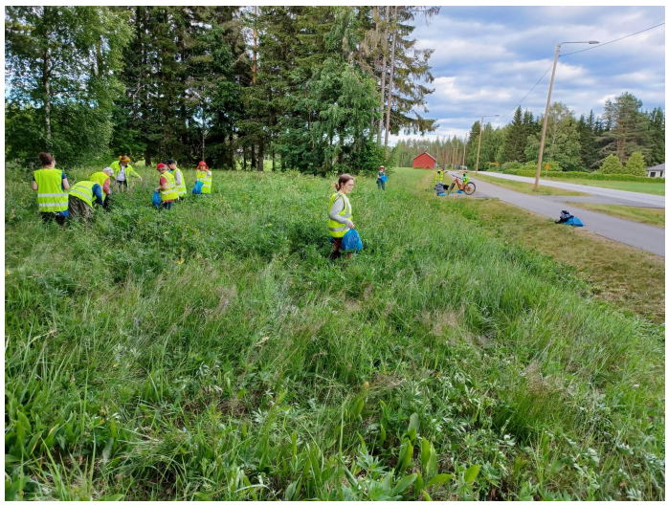
Figure 11. Villagers removing garden lupin blossoms to prevent seeding. Photo by Päivi Jokinen.
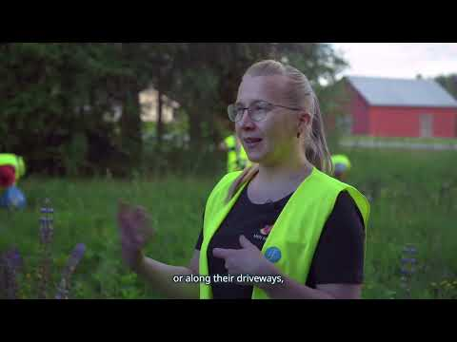
YouTube video: Villagers of Sotkuma in Polvijärvi are working together to prevent the spread of garden lupin in the village landscape.
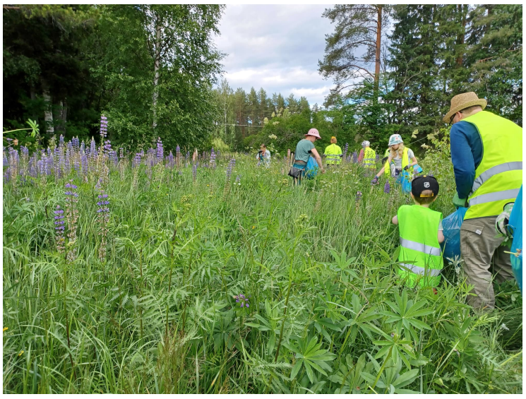
Figure 12. Photo by Päivi Jokinen.

Sheep taking care of the landscape
In the center of Polvijärvi municipality, grazing is used to manage an old, overgrown field. Grazing sheep keep the landscape open and diverse. Sheep eat the shoots of garden lupin that have spread to the pasture from the roadside, so they take care of the invasive species for us.
The sheep spend the whole summer on the site and are not given supplemental feed. They consume only the grass, herbaceous vegetation and shrubs in the pasture. Over time, the area transforms into a meadow rich in various plant species and insects. Watching the sheep grazing in the urban area brings joy and relaxation, especially to preschool children and elderly residents of care homes that are brought to the site to enjoy the view.

Knowledge and information are shared during local landscape walks
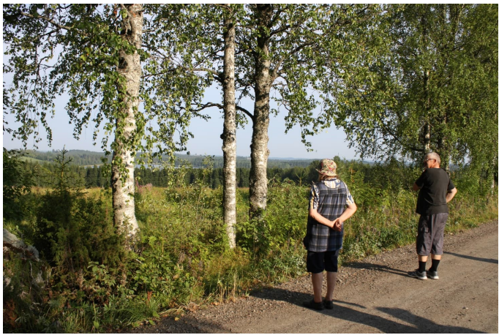
Figure 15. Village landscape walk in the nationally valuable landscape area of Sonkaja in Ilomantsi. Photo by Päivi Jokinen.
During a local landscape walk, participants stroll together along village roads with an expert from RWAO and discuss their experiences and share knowledge. If necessary, part of the route is covered by car. The route is agreed upon with the participants at the beginning. The walk involves reflections about the values of the village landscape, how it can be managed, and the benefits of doing so. The focus is on broader landscape features rather than private yard areas. The aim is to bring landscape-related matters into discussion and inspire the preservation of landscape values.
After the walk, the village receives a report from the expert highlighting the key points and sites discussed during the walk. The landscape walk facilitates a multidirectional exchange of knowledge. New information about the environment is shared by the expert with the villagers. Local ‘hidden’ knowledge about nature and history is shared by the villagers with the expert and amongst themselves. Villagers often possess valuable information that hasn’t been documented. This approach can be utilized in participatory land use planning.

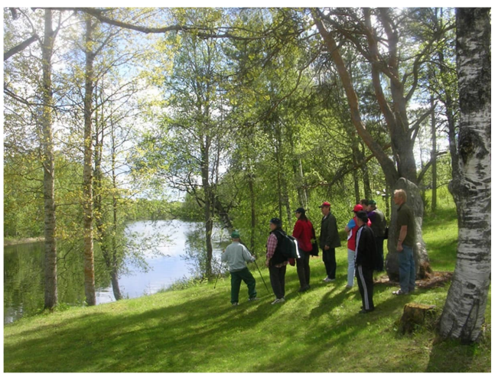
Figure 16. Village landscape walk in the regionally significant landscape area in Nurmijärvi Lieksa. Photo by Sara Mutanen.

