4.3. Remediation of contaminated environment

Introduction to remediation of contaminated environments

Contaminated sites in Finland

Finland, known for its pristine natural landscapes, faces significant challenges with contaminated sites due to industrial activities, waste disposal, and historical land use practices. Contaminated soil and groundwater pose risks to human health and the environment, necessitating comprehensive remediation efforts. The Ministry of the Environment in Finland oversees the management and remediation of these sites, ensuring that contamination is addressed systematically and sustainably. The national risk management strategy for contaminated land outlines the priorities and actions required to mitigate these risks.

The European Union has registered potentially contaminated sites since the 1980s and nowadays it has been estimated that there are over 2.8 million contaminated sites in the EU. In Finland, there are about 29 000 contaminated sites registered, 7000 of them have already been remediated or are under remediation. Based on these facts, there is a great need for remediation action in Europe. Figure 1 presents some statistics about contaminated sites from different countries, note that data is quite old so there are more sites registered nowadays.

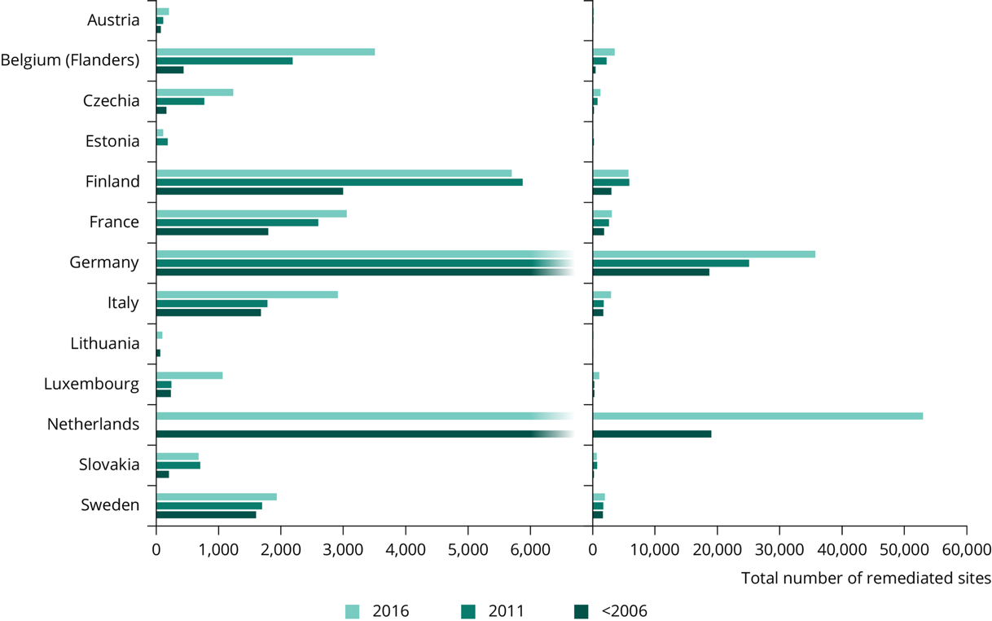
Figure 1 Contaminated sites in Europe. Source: https://www.eea.europa.eu/en/analysis/indicators/progress-in-the-management-of
Based on the figure: What do you think causes the differences between countries amounts of contaminated sites? Do you think this data is reliable? Do you think countries’ historical events can be seen in this figure?

The need for remediation action

Remediation of contaminated environments is crucial for several reasons. Firstly, it protects human health by reducing exposure to hazardous substances. Contaminated sites can lead to serious health issues, including respiratory problems, skin conditions, and even cancer. Secondly, remediation helps preserve ecosystems by preventing the spread of pollutants that can harm wildlife and plant life. Additionally, clean and safe land is essential for economic development, as it can be repurposed for residential, commercial, or recreational use once remediated.

Remediation action usually benefits the environment and human health. Traditionally remediation is done with excavation, which means that the contaminated soil is excavated and transported away from the site. The contaminated soil is usually finally deposited into a waste treatment plant, which is not a sustainable way to treat the matter.
Here is a list of some of the drawbacks related to traditional remediation methods, such as excavation:

- Environmental disturbance: Excavation involves the physical removal of contaminated soil, which can lead to significant disruption of the site. This process often results in soil erosion, loss of vegetation, and habitat destruction.
- Secondary pollution: The transportation of contaminated materials to disposal sites can cause secondary pollution. Dust and volatile organic compounds (VOCs) can be released into the air during excavation and transport, posing additional health risks.
- High costs: Excavation is labor-intensive and requires heavy machinery, making it an expensive option. The costs associated with transporting and disposing of contaminated soil further add to the financial burden.
- Limited sustainability: Traditional methods do not promote long-term ecological restoration. They often involve the disposal of contaminated materials in landfills, which can lead to long-term environmental issues.
- High CO₂ emissions: Excavation and trasport of the contamined soil produces high amounts of CO₂ and other greenhouse gas emissions adding pressure to climate change prevention.

Nature based systems in remediation methods

Nature-based systems offer sustainable alternative solutions to traditional methods for the remediation of contaminated sites. These methods are gaining traction due to their sustainability, cost-effectiveness, and ability to provide multiple ecological benefits. Here are some key aspects of NBS in remediation:

Phytoremediation:
Phytoremediation is a remediation method that uses plants to absorb, sequester, and detoxify pollutants from soil and water. Certain plants, known as hyperaccumulators, can take up heavy metals and other contaminants, making them effective for cleaning up polluted sites.

Phytoremediation can be used in certain contaminated sites where the harmful substances’ concentration is not too strong in the soil or groundwater. In addition, the contaminant cannot be too deep in the soil or groundwater since plants do not have the ability to reach very deep. About 10 meters deep soil or groundwater is the maximum reach of the phytoremediation method. Also, the timeframe of phytoremediation is long, it can be over 10 years, so phytoremediation is not suitable for sites that need to be treated as quickly as possible. On the other hand, for areas where the concentration of contaminants are rather low and timeframe is not strict, phytoremediation is one of the cheapest and environmentally friendliest methods to remediate.

There are many different plant species suitable for phytoremediation and the specie that is used have to be decided based on the harmful substance and contaminated site’s properties. Common species used in remediation are poplars (genus: Populus) and brassicas (genus: Brassica). These both have the ability to remediate heavy metals (cadmium, lead, mercury, etc.) and volatile hydrocarbons (vinyl chloride, benzene, etc.) from the soil. Heavy metals and volatile hydrocarbons are two of the most common causes of environmental contamination. In recent studies, it has been found that birches (betula bendula) can work as a hyperaccumulators for some heavy metals (zinc), chlorinated substances (trichloroethylene) and microplastics. This means that it is possible that birches could be efficient solutions in remediation, especially in northern climates, such as in Finland, where birches are a very common tree species.

All in all, phytoremediation is one of the most sustainable methods for remediation of contaminated environment. It is suitable for non-urgent contaminated sites since phytoremediation’s effect is rather slow. The species used for remediation should be chosen depending on the contaminant and the site’s properties.

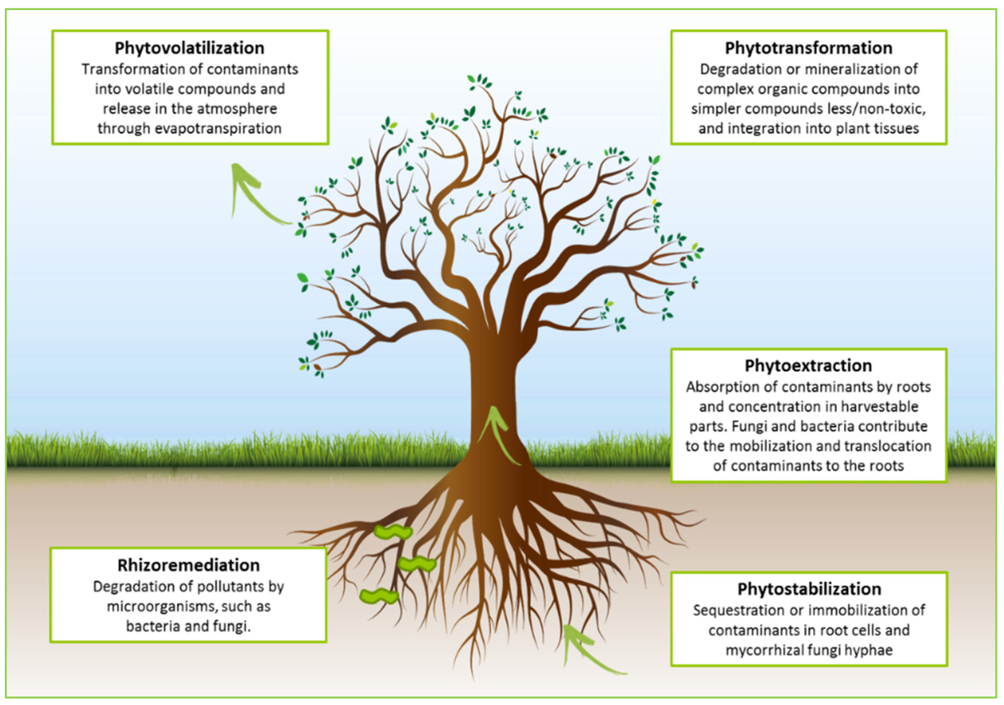
Figure 2 Phytoremediation mechanisms. Source: Fanny Rohrbacher and Marc St-Arnaud https://doi.org/10.3390/agronomy6010019

Bioremediation:
Bioremediation is a remediation method that utilizes microorganisms to degrade organic contaminants in soil and water. By enhancing the natural microbial processes, bioremediation can effectively reduce pollution levels without the need for extensive excavation or chemical treatments. Bioremediation methods are more effective than phytoremediation but they also can be more distruptive to natural processes of the soil even though most of the bioremediation methods can be classified as NBS.

There are several different bioremediation methods invented with different applicabilities. Here are descriptions of a couple of them: Biostimulation and bioaugmentation. Biostimulation is a method which works by stimulating the existing bacteria in the ground to remediate the contaminant. This can be done by adding various forms of bacteria rate-limiting nutrients and electron acceptors, such as phosphorus, nitrogen, oxygen, carbon, etc. Another way is adding electron donors (organic substrates) to the soil, which allow indigenous micro-organisms to use the contaminant as electron acceptors. This way, the chemical formulas of the contaminants can be altered to different less harmful substances.

Bioaugmentation is often done with the biostimulation since they have same approach to remediation. In bioaugmentation micro-organisms are added to the soil to boost the natural rate of degration of harmful contaminants. If biostimulation is possible in the site, bioaugmentation can boost the biostimulation by adding the same contaminated site’s natural micro-organisms to the soil. If there are no natural micro-organisms that can degrade the contaminants, then exogenous micro-organisms can be added that are suitable for remediation of the contaminant.

Constructed Wetlands:
Constructed wetlands are engineered systems designed to mimic the functions of natural wetlands. They are used for the treatment and remediation of various types of contaminated environments, including wastewater, surface water, and groundwater. These systems utilize a combination of physical, chemical, and biological processes to remove contaminants. Typically, they involve water as the primary medium that carries contaminants, a substrate (soil) that provides a surface for microbial activity and plant roots, plants that play a crucial role in the uptake and transformation of contaminants, and microorganisms that break down organic pollutants and facilitate nutrient cycling.

There are two main types of constructed wetlands: surface flow wetlands and subsurface flow wetlands. Surface flow wetlands mimic natural wetlands with water flowing over the surface and are effective for treating contaminants in surface water and runoff. Subsurface flow wetlands, on the other hand, have water flowing through a porous medium like gravel beneath the surface, which helps treat wastewater and groundwater.

Constructed wetlands are versatile and can be used to treat a variety of contaminants, including nutrients such as nitrogen and phosphorus compounds from agricultural runoff, heavy metals from industrial effluents, pathogens from sewage and wastewater, and organic pollutants like hydrocarbons from industrial discharges. They offer several benefits, including being cost-effective with lower operational costs compared to conventional treatment methods, sustainable by utilizing natural processes and reducing the need for chemical treatments, and supporting biodiversity by enhancing local ecosystems.

However, there are challenges associated with constructed wetlands, such as design complexity that requires careful planning to ensure effectiveness and the need for regular monitoring and maintenance to prevent clogging and ensure optimal performance. Despite these challenges, constructed wetlands offer a sustainable and effective solution for the remediation of contaminated environments, by leveraging natural processes to improve water quality and support ecological health.

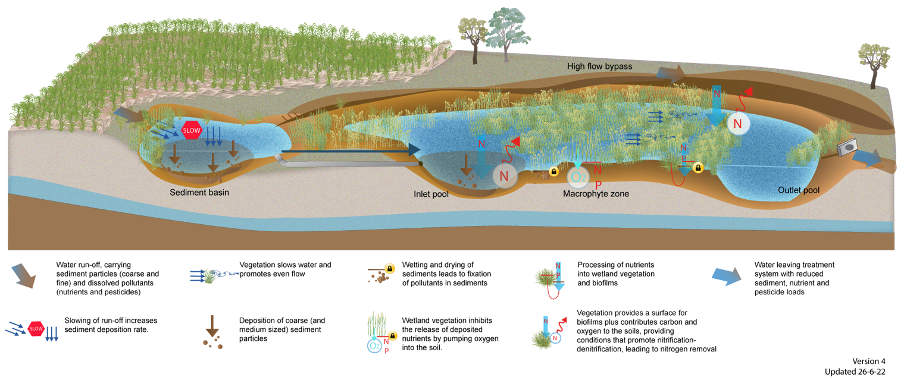
Figure 3. Cross-section of constructed wetland. Source: https://wetlandinfo.des.qld.gov.au/wetlands/management/treatment-systems/for-agriculture/treatment-sys-nav-page/constructed-wetlands/construction-operation.html#prettyPhoto

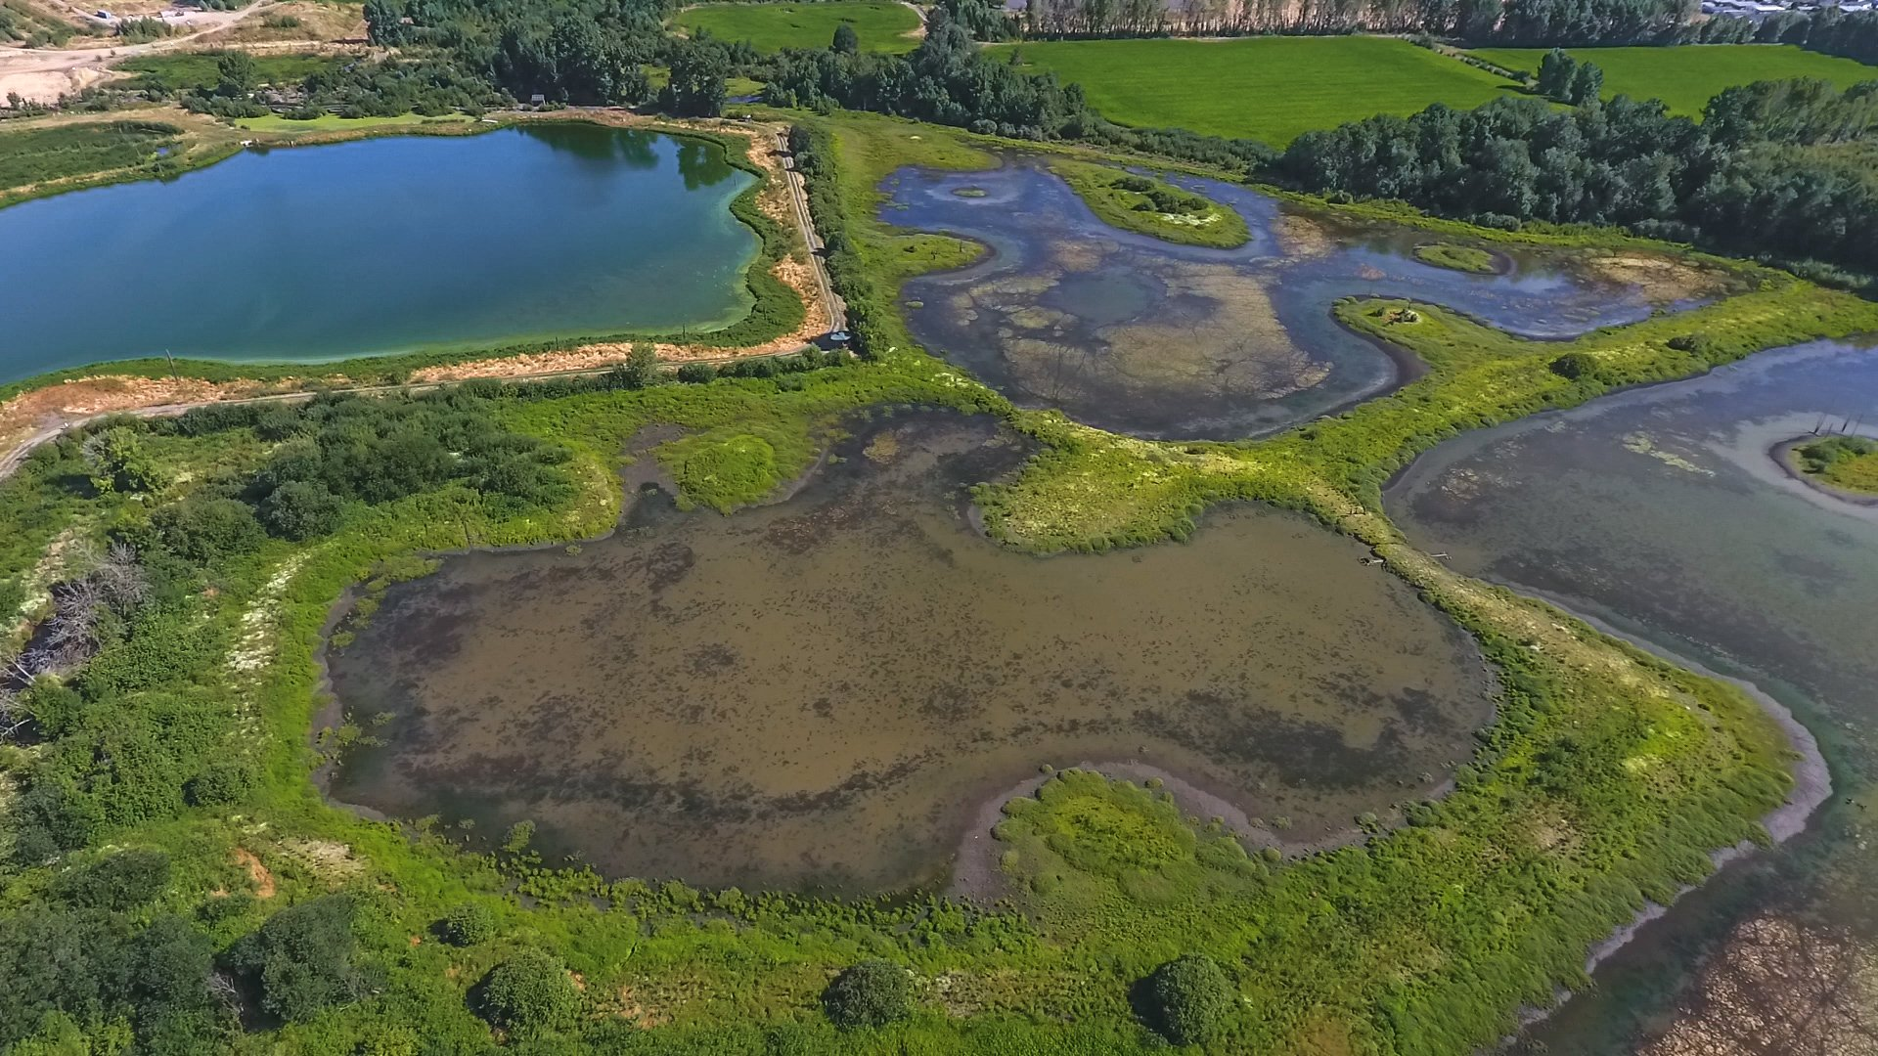
Figure 4. Aerial image of constructed wetland in Forest Grove, Oregon, USA. Source: https://www.wetlandsconservancy.org/constructed-wetlands

Benefits of NBS in remediation of contaminated environment:

NBS methods offer several advantages over traditional remediation methods:
- Environmental friendliness: NBS methods use natural processes involving microorganisms, plants, or enzymes to break down contaminants, avoiding the introduction of harmful chemicals into the environment
- Cost-effectiveness: NBS often requires less equipment and labor, reducing overall costs. Traditional methods like excavation and incineration can be expensive due to the need for heavy machinery and extensive site work
- Sustainability: NBS methods are sustainable as they rely on natural processes that can continue over time without significant human intervention
- Minimal disruption: NBS methods typically involve less disturbance to the site. It doesn't require the removal of large amounts of soil or water, which helps maintain the natural ecosystem
- Versatility: NBS methods can be applied to a wide range of contaminants, such as hydrocarbons, heavy metals, and organic compounds
- Reduced risk of secondary pollution: Since NBS methods are in situ, which do not involve transporting contaminated materials, there is less risk of spreading pollutants to other areas

However, it's important to note that bioremediation can be slower and is highly dependent on environmental conditions, which might not make it suitable for all situations.

Case examples

Helsinki diesel oil contamination case

A case in Helsinki related to diesel oil contamination in water and soil bodies included bioremediation. The primary goal was to find an effective and economical method to remediate diesel oil contamination in both aquatic and terrestrial environments. The project utilized bioremediation techniques, including biostimulation and bioaugmentation. Biostimulation involved adding nutrients and oxygen to enhance the activity of indigenous microorganisms. Bioaugmentation included introducing specific microbial strains to accelerate the degradation process.

In the aquatic environment, the case focused on using cotton grass fiber, a natural by-product of peat harvesting, to absorb diesel oil. This method not only removed the oil but also provided a large surface area for microbial colonization, enhancing the bioremediation process. For soil contamination, the project compared different combinations of nutrients, bulking agents, aeration, and microbial inocula. The combination of aeration and slowly released nitrogen was found to be particularly effective in promoting oil hydrocarbon degradation.

The project demonstrated that bioremediation could significantly reduce diesel oil contamination in both environments. The use of natural materials like cotton grass fiber and the enhancement of microbial activity proved to be effective strategies. One of the challenges was the variability in environmental conditions, which could affect the consistency of the results. The study highlighted the importance of site-specific assessments and the potential for indigenous bacteria to adapt and efficiently degrade contaminants.

More about the case: https://helda.helsinki.fi/server/api/core/bitstreams/c921319c-e4a1-4841-9c8b-a05c1f8835b8/content

Phy2Climate -project:
The Phy2Climate project is an innovative initiative funded by the European Union's Horizon 2020 Research and Innovation Programme. The main goal of Phy2Climate is to combine phytoremediation with the production of clean biofuels. This project aims to recover arable land contaminated with various pollutants and simultaneously produce sustainable biofuels.

The idea is that the project focuses on energy crops that have good phytoremediation capacities, such as oleaginous and lignocellulosic species. These are used to remediate the site and then the crops filled with contaminants are processed into biofuels through pyrolysis and catalytic converting. The end products are biofuels, such as methanol, diesel and gasoline.

Phy2Climate includes five pilot sites located in Spain, Serbia, Lithuania, Argentina, and India. These sites represent different environmental conditions and common soil contaminants, providing a comprehensive validation of the phytoremediation and biofuel production processes. The project aims to improve the overall sustainability of contaminated land remediation and biofuel production. It contributes to global initiatives like the Mission Innovation Challenge and supports several UN Sustainable Development Goals.

More about Phy2Climate: https://www.phy2climate.eu

Conclusion

In conclusion, while traditional remediation methods like excavation have been effective in certain scenarios, their environmental impact and high costs necessitate the exploration of more sustainable and less disruptive alternatives. NBS methods offer promising solutions that can address contamination while minimizing ecological disturbance and promoting long-term e nvironmental health. The use of NBS remediation methods are still very case-specific and their use needs to be planned carefully.

References

Austen K., Maclean J., Balanzategui D., Hölker F. 2021. Microplastic inclusion in birch tree roots. Available at: http://dx.doi.org/10.1016/j.scitotenv.2021.152085

Dmuchowski W., Gozdowski D., Bragoszewska P., Baczewska A., Suwara I. 2013. Phytoremediation of zinc contaminated soils using silver birch. Available at: http://dx.doi.org/10.1016/j.ecoleng.2014.07.053

Greksa A., Ljubojevic M., Blagojevic B. 2024. The Value of Vegetation in Nature-Based Solutions: Roles, Challenges, and Utilization in Managing Different Environmental and Climate-Related Problems. Available at: https://doi.org/10.3390/su16083273

International Water Association. 2022. Integrating nature-based solutions into wastewater treatment. Available at: https://thesourcemagazine.org/integrating-nature-based-solutions-into-wastewater-treatment/

Lewis J., Qvarfort U., Sjöström J. 2015. Betula pendula: A Promising
Candidate for Phytoremediation of TCE in Northern Climates, International Journal of
Phytoremediation. Available at: https://doi.org/10.1080/15226514.2013.828012

Moazzem S., Bhuiyn M., Muthukumaran S., Fagan J., Jegatheesan V. 2024. A Critical Review of Nature-Based Systems (NbS) to Treat Stormwater in Response to Climate Change and Urbanization. Available at:
https://link.springer.com/article/10.1007/s40726-024-00297-8

Reynolds, Nigam. 2023. Bioremediation vs. Traditional Remediation Methods: A Comparative Analysis. Available at: https://www.hilarispublisher.com/open-access/bioremediation-vs-traditional-remediation-methods-a-comparative-analysis.pdf

Siitan M. 2022. Computational risk assessment methods for contaminated sites in Finland. Available at:
https://www.theseus.fi/bitstream/handle/10024/752787/Siitan_Martin.pdf?sequence=2

Song Y., Kirkwood N., Maksimovic C., Zheng X., O’Connor D., Jin Y., Hou D. 2019. Nature based solutions for contaminated land remediation and brownfield redevelopment in cities: A review. Available at:
https://doi.org/10.1016/j.scitotenv.2019.01.347

Ympäristö.fi. Pilaantuneet maa-alueet. Available at: https://www.ymparisto.fi/fi/saasteettomuus-ja-ymparistoriskit/pilaantuneet-maa-alueet

