Suunnitelma:
Customer service in English

Kuvaus:
Katso linkit ja tee annetut tehtävä.

Task 6

Customer service

Katso alla olevat linkit ja tee tehtävät. Tehtävässä on yhdistelytehtävä asiakaspalveluun liittyvistä lauseista sekä monivalintakysymyksiä liittyen kahvilaan.
Conversation at a Café (Coffee Shop) - Useful Phrases in English - YouTube
Ordering Coffee | Travel English - YouTube
COFFEE SHOP ☕️ Vocabulary and Phrases || English Lesson - YouTube
English Speaking Practice: Order a Coffee ☕️ || Real Conversation - YouTube

1/10
Etsi seuraavien kahvilalauseiden englanninkieliset vastineet
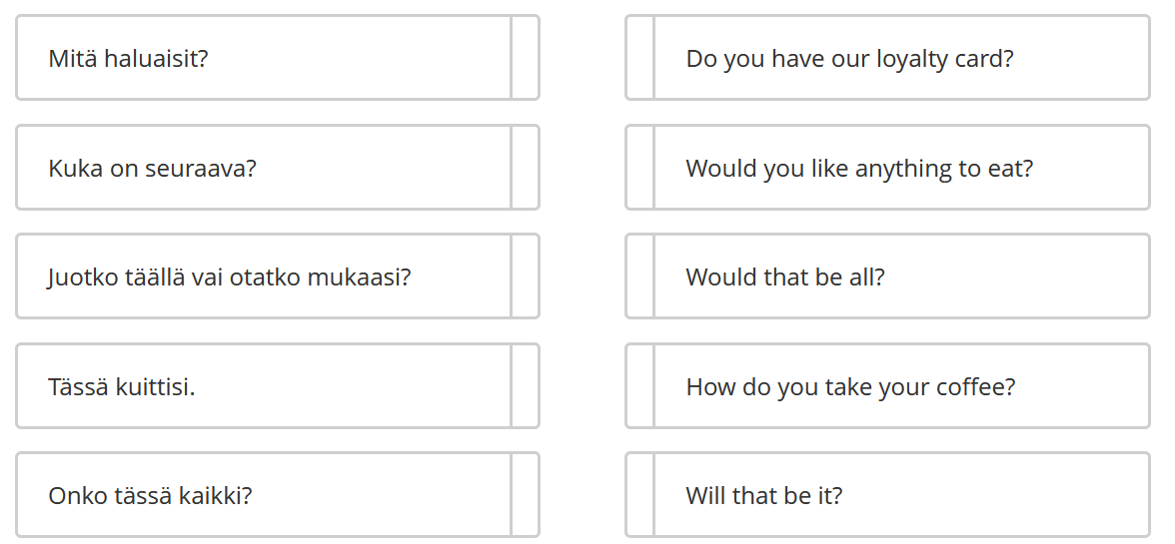
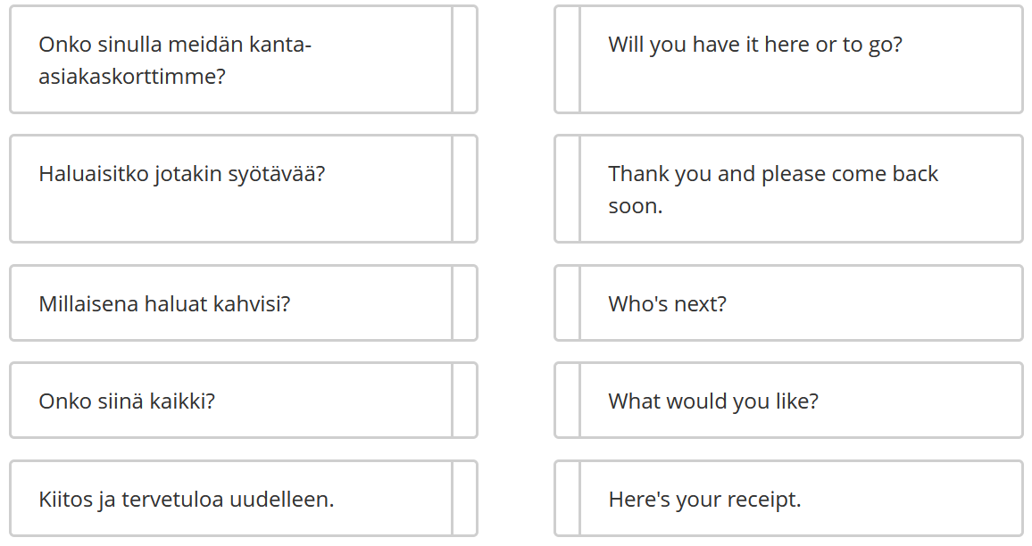

2/10
Beverages mean the same as
drinks
sandwiches
something sweet
something to eat

3/10
Which of these are non-dairy types of milk?
almond milk
oat milk
cream
soya milk
milk

4/10
What’s a treat?
meat
soup
a delicious food/snack that is not eaten often
daily meal

5/10
What’s a loyalty card?
credit card
debit
a bill
offers some rewards or points to the customer, for example buy 6 coffees get one free

6/10
What does a service attendant do?
doesn't make the food or drinks
provides customer service
does no cleaning
helps the clients

7/10
What does ‘black coffee’ mean?
no sugar, no milk or cream
without sugar or milk/cream
sugar but no cream or milk
with milk but no cream

8/10
What is chai?
spiced tea
ice coffee
coffee
tea in many languages

9/10
What does a barista do?
helps with customer service
cooks
works in a bar
makes speciality coffee beverages
10/10
Which of these are speciality coffee drinks?
latte
drip coffee
expresso
chai
almond
cappuccino

