Outi Helin
Suomen Koodikoulu

Introduction to teaching robotics

Contents

1. Overview of automation and robotics
1.1 Automation, embedded systems and robotics
1.2 Robotics and programming
1.3 Why to teach robotics?
1.4 How to teach robotics?
2. Robotics and the society
2.1 Everyday robotics
2.2 Industrial work
2.3 Robotic Process Automation
2.4 Future
3. Teaching robotics on different education levels
3.1 Devices and programming environments suited for educational use
3.2 Teaching as support for learning robotics
4. Robotics exercises without robotics devices
4.1 EV3 programming in a simulator
4.1 Micro:bit programming in MakeCode
4.3 Robotics games

Overview of automation and robotics
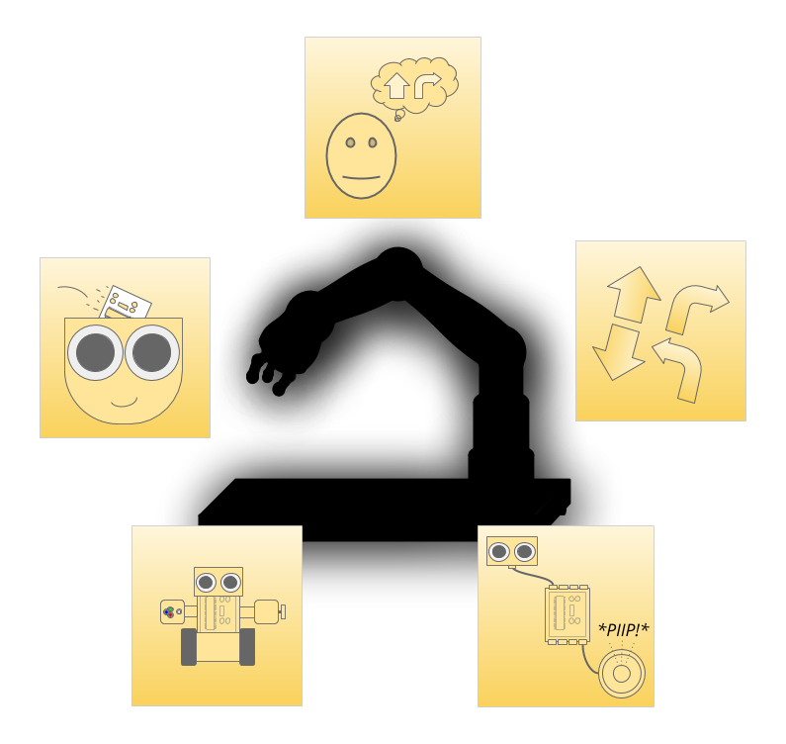
In this chapter, we 1.1 introduce the concepts of automation, robotics and embedded systems, 1.2 discuss the relationship between programming and robotics, 1.3 give reasons for teaching robotics, and 1.4 lay grounds for teaching robotics.

Introduction

Robotics is one of the hottest discussion topics at the moment, especially when we talk about the future of work, or ways to make our day-to-day life a little easier. Modern home appliances already rely on robotics, and industrial robots have been working in factories for decades. We obviously don’t want anyone to lose their job because of robots, but we also don’t want people to do jobs that are dangerous or highly monotonous. At the same time, factories and corporate giants are eager to find out which processes can be automated in the name of cost-efficiency.
What makes a device a robot? Is my dishwasher a robot? Are we already driving robot cars?

Automation, embedded systems and robotics

Whether we are talking about manufacturing, grading tests, or washing the dishes at home, we’re are talking about labour. To turn ungraded tests into graded ones, we need to go through a grading process. Many tasks in any process can be automated. The goal of automation is to replace or reduce the role of human labour in a process. A machine that works automatically represents automation.
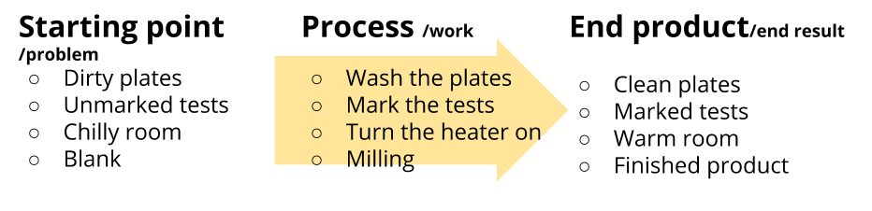
Figure 1: Automation is useful. By automation, we aim at making a process or a part of it automated.
In order to make a task automatic, we need to be able to control it. Many Finnish houses are equipped with traditional radiators that regulate the temperature automatically. The operation is controlled by a valve that responds mechanically to thermal expansion, and releases the optimal amount of hot water. Old dishwashers, in turn, combine a timer and dishwashing: the duration of the cycle is set with a timer, and the cycle ends automatically when the time is up. In this kind of automation, operations are controlled either mechanically or electronically. In order to get the task successfully done, traditional automation requires predictable environments.
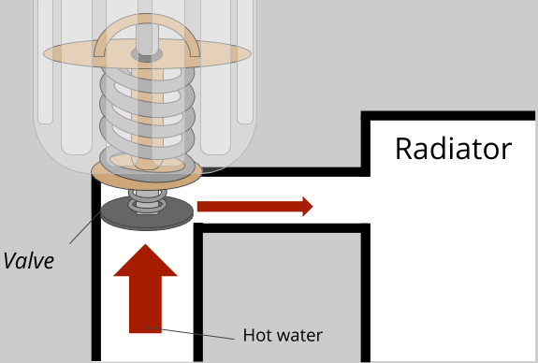
Figure 2: Water-circulating radiator. One of the most common automation application is used to regulate the temperature in buildings. We don’t have to keep adjusting water-circulating radiators, as they maintain the same temperature with the help of a valve.
What if we connect a computer to a heating system? The computer becomes a part of a complete device, making the setup an embedded system*. When a device is controlled by a computer, we can also utilise sensors that give the computer feedback on the current environment and how the process is coming along. For example modern dishwashers are equipped with computers that receive information on the amount of dishes and dirt from sensors.
In addition to sensors, setups include actuators, such as motors, speakerphones, screens, and LED lights. A computer tells the actuators what to do in accordance with a program. By altering the program, we can directly affect the way the data from sensors is used, and what the actuators do. Altering a program is called programming.
* In the Finnish national core curriculum for basic education 2014, the following learning objectives were outlined for middle school crafts: “Implement embedded systems in crafts by using programming for designs and products”. (Finnish National Agency for Education 2014: grades 7-9, crafts S3). In other words, all pupils should create an embedded system such as a robot or any other product that can be controlled by a programmable computer.
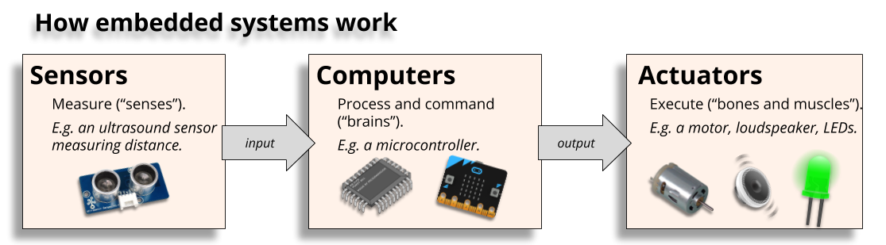
Figure 3: How embedded systems work. At its most simple form, the way embedded systems work can be illustrated as cause and effect: computer receives information on the surroundings from sensors and execute operations in accordance with its program with the help of actuators.
Robotics is a branch of engineering that combines mechanics, electronics, and programming. Robots are machines or setups that can perform physical tasks (mechanics) by supplying power (electronics) to the executing components in accordance with a program written for a computer (programming). As we mentioned before, a modern dishwasher is an embedded system, but it’s also a robot. Robots are always controlled by a computer, which means that all robots are embedded systems.
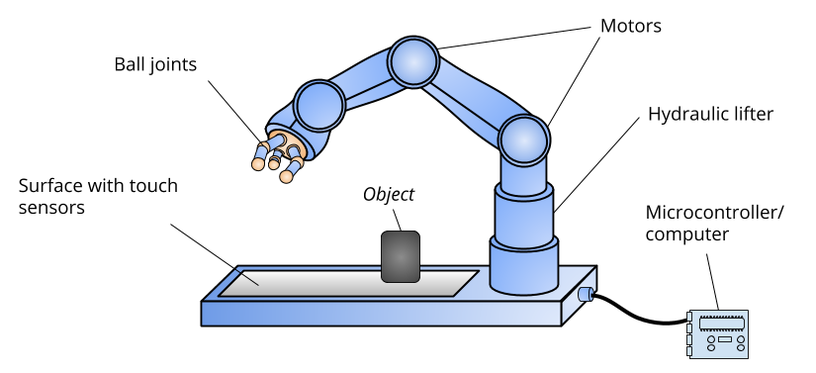
Figure 4: If this kind of a robot was designed, built, and programmed well, it could automatically detect an object placed on the surface, grip it, and lift it to a designated spot. Based on the input from the touch sensors, the program written for the microcontroller will first locate the object, and then move the hand to the right spot.
As most robots execute designated processes automatically, they are considered automation. However, if the nature of the robot’s only process is something useless and trivial, such as moving forward and turning around before a wall, it doesn’t represent automation. If we connect such a robot to a vacuum cleaner, we give the robot a purpose. That would make it automation, or an automated vacuum cleaner or a robot vacuum cleaner, to be more precise.
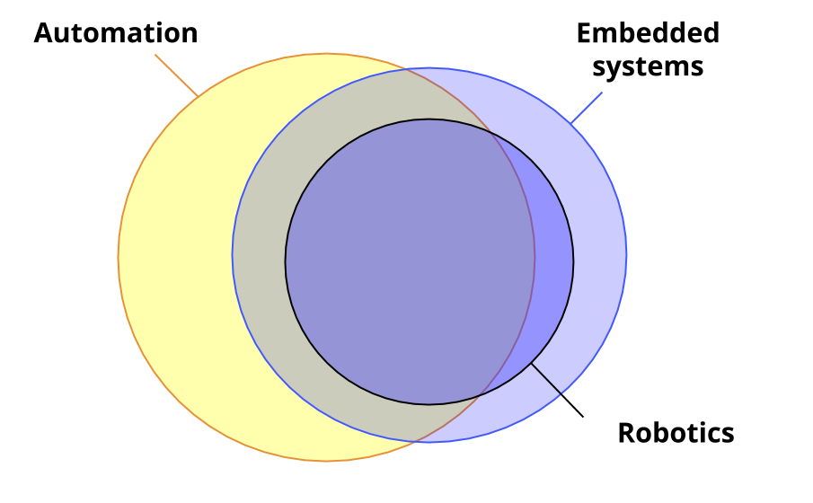
Figure 5: Relationships between terms. Nowadays, a substantial part of automation is controlled by computers, i.e. embedded systems. All robots are embedded systems. Robots are usually used to automate a process.
By definition, all robots are embedded systems, but all embedded systems aren’t robots. For example, modern cars have several computers (microprocessors) in them even if they aren’t actual robot cars. The computers control certain sub-processes, such as tasks related to breaking or speed, and they do it automatically. Modern dishwashers, for their part, utilise sensor technology and computers to control the washing process. By definition, a modern dishwasher is a robot, as it takes care of the process automatically and independently from start to finish, and reacts to factors such as the number of dishes and how dirty they are. Both cars and dishwashers are considered embedded systems because they have one more computers embedded into them. As computers control only certain sub-processes and not the whole car, cars aren’t considered robots. However, cars and driving make up a significant subcategory of robotics: more and more of their safety and ease-of-use related functions are automated with the help of robotics.

In this learning unit of robotics, we define robots the following way:
A robot:
- Is an embedded system that includes computer-controlled actuators and possible sensors that measure different conditions of the environment.
- Consists of moving parts that are moved with the help of actuators, such as electric motors.
- Can be reprogrammed.
Defining the concept of a robot may seem challenging, but people still recognise a robot when they see one. Outlining the extreme ends of what robots can be like helps to make the definition clearer.
Extreme ends of what robots can be like:
- A robot can move autonomously or follow the commands of a remote control.
- A robot can be capable of reacting to changes in its environment with the help of dozens of sensors, or it can rely on remote controlling alone.
- A robot may have a face, look like an animal, or consist of just one limb, such as a hand.
- A robot can be designed to perform an important manufacturing process, or its only function can be to entertain humans or family pets.

Robotics and programming
By programming, we can give computers detailed instructions on how to function in different kinds of situations. A situation can be as simple as a click of a button that leads to an operation performed by the program. If the operation is very complex, such as robot cars recognising traffic signs, we need a complex artificial intelligence program. In both cases, the program is in control of the effect of the operation. As a rule of thumb, robots don’t do anything that isn’t in their program. Since robots and automation are programmed by humans, humans are responsible for their actions.
However, robotics is not just about programming, which means that we need to understand the role of mechanics and electronics as well. As we already established, programming is used to give instructions to computers, and computers operate actuators in accordance with their program. But how can we tell a computer to operate things like a motor? To do that, we need a programming environment which is a computer program that a programmer uses to write or assemble a program. In the programming environment, the commands are given in a programming language. Typically, programming environments are used on a separate computer (desktop computers, laptops or tablets). When we want to run a program in a robot, the programming environments compiles the program we have written in a programming language into a format that the robot can process, and after that the program is saved into the memory of the robot’s computer.
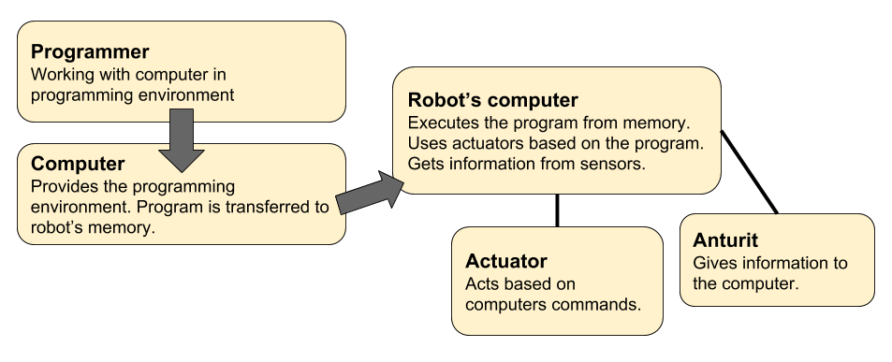
Figure 6: Programming a robot. Typically, robots are programmed on a separate computer with the help of a programming language in a programming environment. The programmer writes the program in a programming language, and the environment compiles it into a format that a robot can process. This way the programmer’s original idea is turned into the robot’s actions.
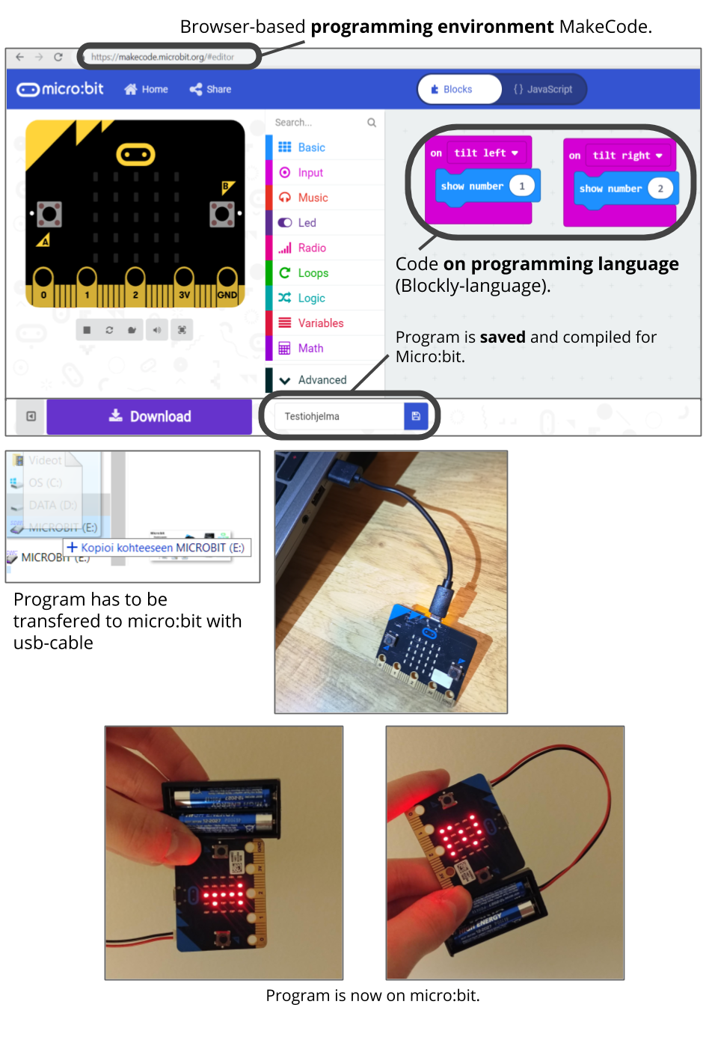
Figure 7: From idea to robot’s activity. The picture illustrates the process of how a code written by a programmer is turned into a robot’s activity.

Why to teach robotics?
Computers and programming are integral parts of modern technology. More and more computers are embedded into different kinds of setups, mostly for safety, ease-of-use, and cost-related reasons. Monotonous, physically demanding tasks are carried out with the help of technology. In addition to industrial assembly lines, postal services and cash registers are being automated. Self-service cash registers have already made their way into many stores. At least Amazon and DHL are currently trying to carry out short-distance deliveries with unmanned drones. The future of work will be significantly altered as automation and robotics develop, which allows us to save human touch and potential to tasks that specifically call for them: work that include creativity, unpredictable circumstances, and social interaction. Additionally, humans are required for many tasks that are related to automation, such as overseeing automated systems. If buses are replaced with robot cars one day, we will still need transport professionals to oversee them.
Current and future development of technology is more and more heavily based on solutions created by programming. As one of the most important goals of teaching and education is to help learners understand how the (technological) world works, robotics and programming cannot be overlooked. In future decades, they will be more or less a part of general knowledge. We don’t all have to be experts on robotics, but it’s useful to understand the phenomenon.

How to teach robotics?
There are already several established learning pathways and teaching methods created in schools and institutions that have invested in robotics. Below, you’ll find an example of a robotics learning pathway:
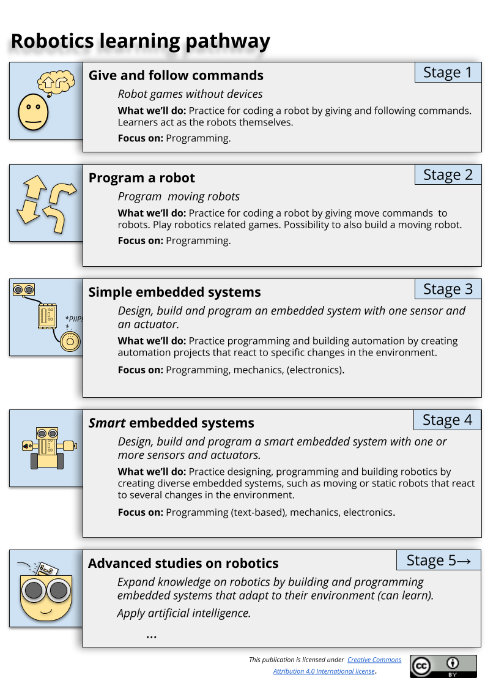
Figure 8: Robotics learning pathway. Teaching robotics is heavily based on concrete examples and programming. Focal points in electronics and mechanics vary from project to another. The basics of programming are introduced by playing a robot, and from there we work our way towards creating robotics. Devices play an important role in the projects.
The most natural and motivating way to learn robotics is through projects where learners get to create robots and automation that’s relevant to their age group and fits their skills level. We’ll work our way towards project work by starting with concrete exercises where learners get to play a robot and follow commands, give commands to friends, and use simple commands to program existing robots (stages 1-2). The first projects start with simple automation, such as automated alarms that react to changes in the environment, e.g. distance, with the help of sensors (stage 3). In the next phase, we design, build and program automation and robots that can for example stay on a table top without falling down, detect other robots, and follow a line (stage 4). A good example of this is the Sumo robot project that has been popular in many Finnish schools. Stage 5 of robotics learning pathway includes demanding projects meant for differentiation and extra-curricular interests.

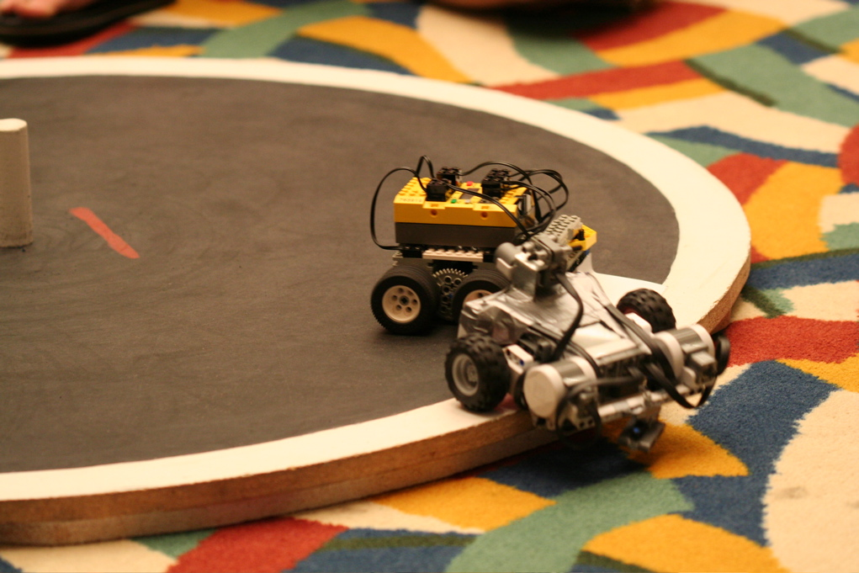
Figure 9: Sumo robots. Sumo robots try to stay on a game board longer than their opponents. They are allowed to push each other. Innokas network organises tournaments to find out who has built the best Lego sumo robots in Finland.
The focal point of robotics depends on the device we are using. Before choosing devices, it’s good to know what we want to teach and who we are teaching it to. You’ll find detailed information on choosing devices as well as age-appropriate robotics and teaching methods in chapter 3. Teaching robotics on different education levels.

2 Robotics and the society

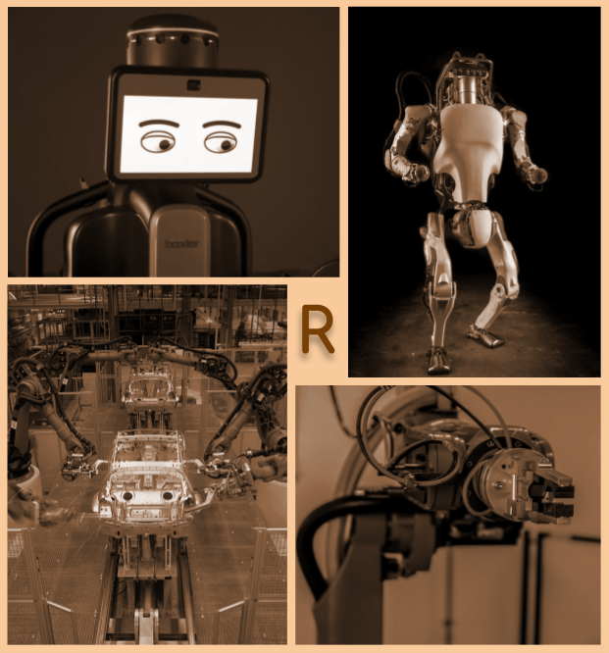
In this chapter, we discuss the role of robotics in 2.1 modern life, 2.2 industrial work, 2.3 software work, and 2.4 the future.

Everyday robotics
Everyday robotics may sound like a futuristic idea, but robots and embedded systems are already integral parts of many people’s everyday life. Below, you’ll find examples of these kinds of appliances and systems:
Robot vacuum cleaners
Robot vacuum cleaners can be found in many households. They search through the apartment by driving around it, drawing a map of the apartment for their program as they go. They use different kinds of sensors to observe their surroundings, ultrasound sensors in particular. We could say that a robot vacuum cleaner is a simple form of a learning machine: it memorises the outlines of the apartment, and performs its cleaning tasks according to them. Robot grass cutters operate in the same way, but as there are no walls around, the area needs to be outlined with a boundary wire.
Trip computer
Most modern cars are fitted with a trip computer that receives data on the environment and the state of the car from several sensors. Most of the system’s task are related to safety and ease-of-use. Cars with the newest technology available monitor the driver’s state of alertness based on driving behaviour and eye movements. If the driver seems to be tired, the computer plays a sound alert and suggests taking a break.
Other appliances
Modern home appliances utilise robotics to make using them easier, more efficient and more economical. Modern washing machines use sensors to determine the weight of the laundry load and monitor the use of water and spin speed accordingly.
Smart traffic lighting
Busy intersections are usually controlled by computers. Under the intersections, there are loop detectors that work like metal detectors. This provides computers with input on the number cars, and they use this information to decide which lights will turn green. Most detectors are set to detect the weight of a small passenger car, so that’s why a moped driver might have to sit behind red lights until a passenger car comes along.
Artificial intelligence
Artificial intelligence is a program that is capable of intellectual functions. The possibilities for its development are nearly limitless, and it can also be programmed to develop itself. Many of us have taken part in developing artificial intelligence without even knowing it: some websites ask us to write the word we can see in a picture, or click the section of a picture that has a traffic sign it it. The answers we have given are used to create artificial intelligence programs for things like robot cars.
Summary
Robots can be used for processes where automation improves safety, ease-of-use and efficiency. On the other hand, they can also be used to avoid tasks that are monotonous or uncomfortable. More and more homes are already equipped with robot vacuum cleaners and grass cutters. The share of robotics in future homes can only be guessed. We’ll discuss this in more detail in section 2.3 Future.

Industrial work
Throughout the history, the needs of factories and assembly lines have played an important role in the development of automation and robotics. Automation has come a long way from the overhead hooks and conveyor belts in Ford factories to robots and artificial intelligence. If you ask someone to draw a robot, they’ll most likely draw an angular form with human limbs and face. In reality, robots only have the limbs and appendages that are necessary for their operation, and they look nothing like humans — at most, they resemble a single limb.
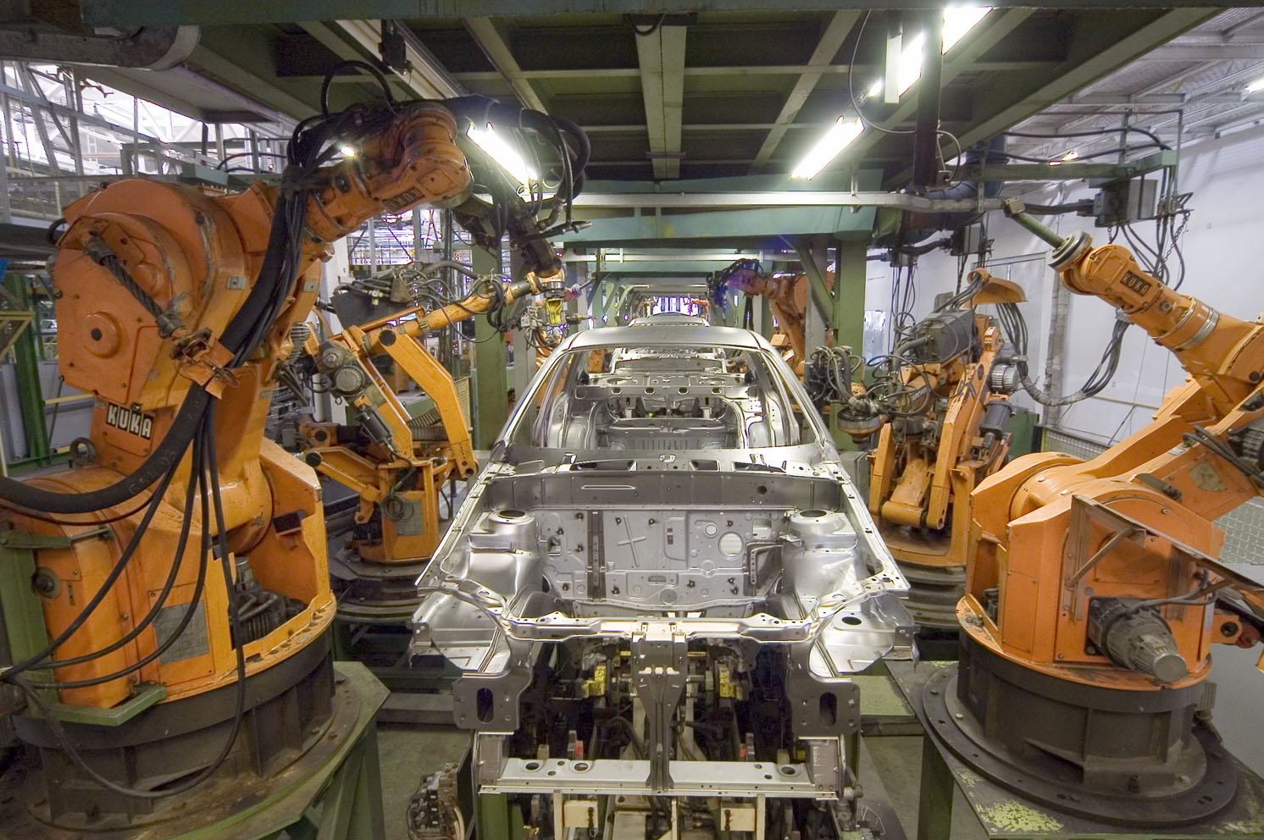
Figure 8: Industrial robots. Industrial automation has utilised robots for a long time. Most industrial robots are like huge mechanical hands that are bolted to a mounting. In the picture, robots manufactured by the German company KUKA Robotics are assembling a car chassis.
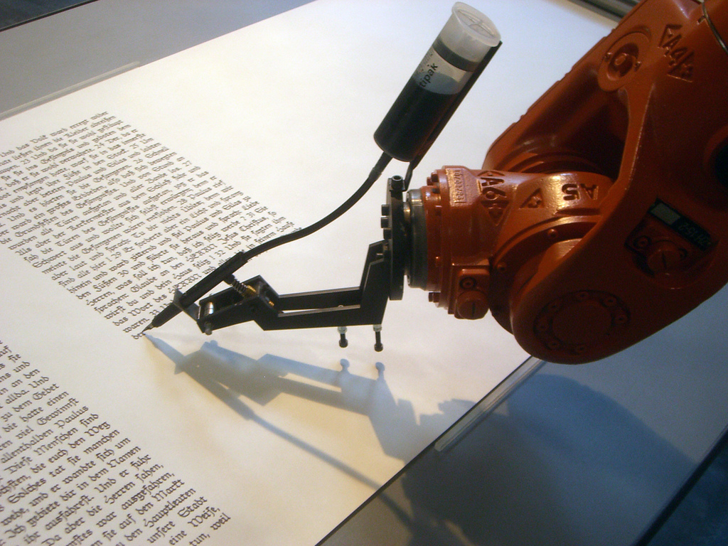
Figure 9: Precision of industrial robots. Precision and reliability play important roles in the design and mechanics of industrial robots. In the picture, you can witness the absolute precision of a robot: it is performing a calligraphy task.
In addition to assembly lines, welding and other processes that require precision, robots are used for different kinds of tasks in warehouses. Most warehouses categorise and number their products in any case, so using a robot to find and shelve them pays off. This is the case especially in large warehouses. These kinds of robots are obviously not bolted to a ground as their added value is in their mobility.
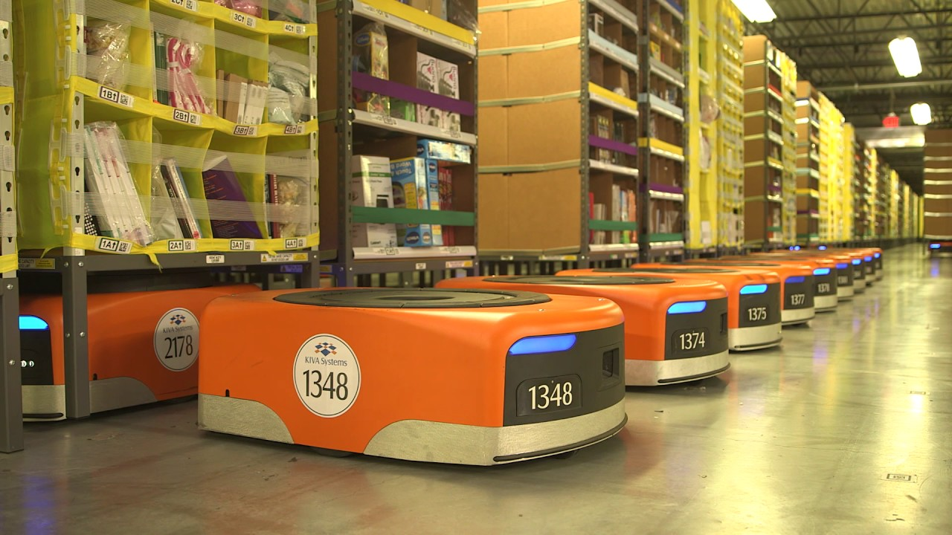
Figure 10: Warehouse robots. Online shopping giant Amazon already utilises robots in their largest warehouses. These robots may look simple, but they are capable of lifting entire shelves.
Modern-day industrial automation relies heavily on robotics, but in industrial context, automation requires not only robots but also supervision and designing. The hierarchies of industrial automation can be illustrated with the help of an automation pyramid. In it, the level that is comprised of sensors and actuators is called the field level. The computers that control them (microcontrollers and microprocessors), whether they are embedded in the robot or not, make up the control level. You’ll find the complete automation pyramid in the picture below (Figure 11).

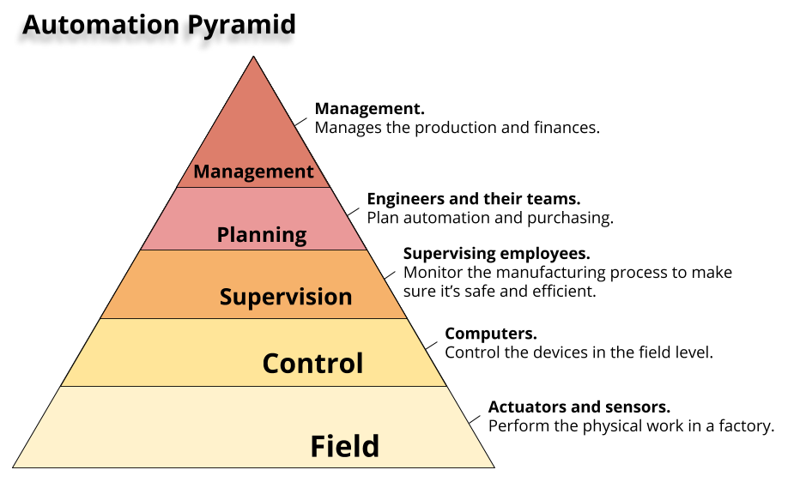
Figure 11: The Automation Pyramid. Industrial automation can be divided into five different levels: field level, control level, supervisory level, planning level, and management level. (Source: https://realpars.com/automation-pyramid)
Currently used industrial robots usually combine the field and supervisory levels (an embedded system). Even if all the work in a factory was automated, we would still need humans for supervisory, planning and management levels. Essentially, the development of automation runs from the bottom levels upwards. Some of the work on the supervisory level can already be automated.

2.3 Robotic Process Automation

Robotic Process Automation (RPA) is a technology used for automating processes related to office and knowledge work. By definition, knowledge work refers to work where the most important tool is knowledge, and it’s an important factor behind different kinds of services. Online banking services may seem like they operate by themselves, but a lot of human input is at work all the time. Human input is needed to manage login details and key codes, software management during malfunctions, and regulatory requirements such as risk management and anti-money laundering policies.
Robotic Process Automation is all about creating automation with the help of software. “A robot” is a software that uses information systems the same way a human user would. It opens systems, fills in blanks, and clicks buttons on user interfaces according to the rules it has been given. Software robots aren’t physical beings; they are software solutions that automate the use of other software products.

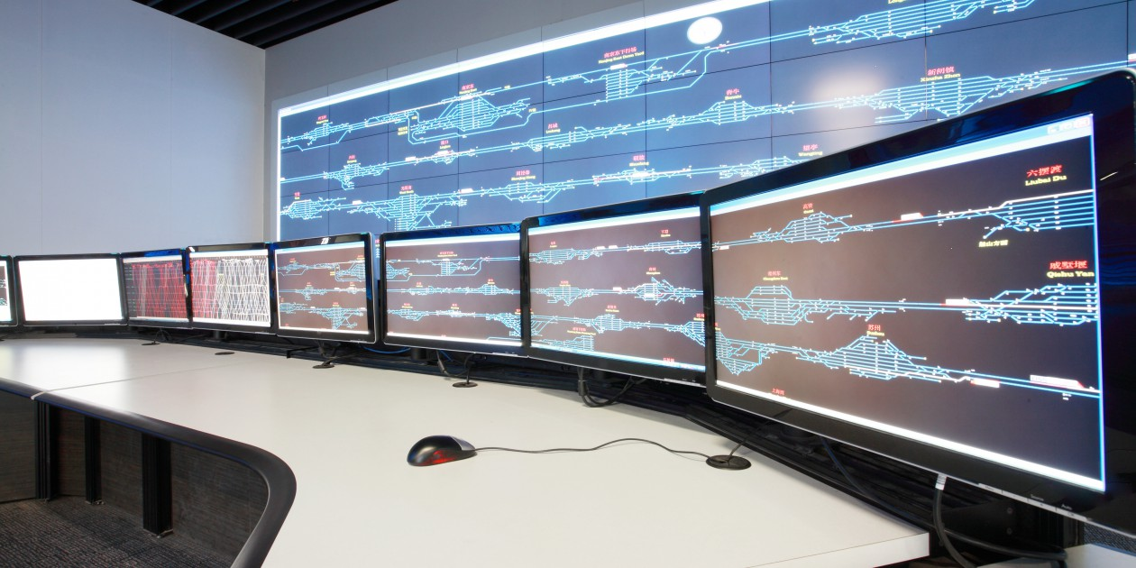
Figure 11: Robotic Process Automation. Software robots are programs that use software products like a human employee would.
Software robots can be used to automate routine tasks such as processing reports, retrieving and transferring information between different applications, and creating user login details. If a process is repeated according to a similar pattern over and over again, it’s something a software robot could learn to do.
The forerunners of software robots include test automation systems and different kinds of “bots”. The most widely known applications of them are search engine bots and systems that run quizzes on a variety of entertainment websites.
Teaching a software robot is usually done with the help of graphical user interfaces. Currently used software robots require detailed instructions for each step of the process. They are taught the procession and procedures in the same way we would teach a temporary substitute of a human professional: open the program by clicking here, use these login details to access it, press here to carry out the operation, save the report in this file. The software robots we use at the moment cannot learn new things by themselves, but they can carry out a process over and over again if they have been given the instructions on how to do it.
Teaching a robot doesn’t require traditional programming skills or software development projects, and that makes it far easier and faster than traditional information system development. Robotic process automation can also save a lot of manual work, which means there is less room for human errors. Fields such as payroll administration, logistics, accounting, or insurance management could utilise robots to do calculations and process reports to meet regulatory requirements. Robots can retrieve necessary information from systems and handle the cases they have been taught to handle, and form a list of cases that they can’t handle themselves and give it to humans. This would allow human employees to focus on work that require ideation and consideration, and let robots deal with “boring” routine work.
Robotic process automation can be used to create new services, improve the speed and quality of services, and cut down on costs when some of the labour input can be replaced with a robot. Robots don’t take breaks or need days off, and they can work 24 hours a day, if needed. This means the upkeep of a robot may turn out to be easier and more cost-efficient than having an employee.
Robotic process automation is already utilised in many industries. In the future, the applications will become more versatile, as the development of artificial intelligence in robots moves forward and robots learn to improve their own operations. According to many studies (*, **), robotic process automation will be the most significant change the concept of work has seen since the industrial revolution. There has been public debate on whether traditional jobs will disappear entirely, or whether we should be afraid of robots replacing us in the working life. On the other hand, there are studies (***) that show that robotics and artificial intelligence will create at least as many new jobs as they take over from humans. What is certain is that the nature of knowledge work will change, and that utilising robotics might well become the next basic skill for office workers.
Sources for this section:
*Ohjelmistorobotiikka ja tekoäly – soveltamisen askelmerkkejä. Kääriäinen, Jukka; Aihkisalo, Tommi; Halén, Marco; Holmström, Harald; Jurmu, Petri; Matinmikko, Tapio; Seppälä, Timo; Tihinen, Maarit; Tirronen, Justus (2018-10-30)
**Introduction to Robotic Process Automation: a Primer. The Institute for Robotic Process Automation. Casale,‎ F., Dilla, R., Jaynes, H., Livingston, L. & Matrisciani, M. (2015).
***Gartner Says By 2020, Artificial Intelligence Will Create More Jobs Than It Eliminates: https://www.gartner.com/newsroom/id/3837763

2.4 Future
“IoT - Internet of Things”
Smartphones, smartwatches, smartboard, smart lights… “Smart” has become an integral part of technology. In the context of technology, smartness refers to embedding computers and sensors into devices that can draw use from them. In other words, smart devices are examples of consumer-level embedded systems. In recent years, smart devices have become more and more common in regular homes. The following example illustrates an imaginary “smart home” in the form of a short story:
“When I returned from work, my virtual assistants wish me welcome. The lights are automatically switched to purple as I told the system this morning that I’d like the lights to be of that colour. I throw my QR-coded outdoor clothes into a box where a robot will automatically sort them to their own shelves in my closet. The sensors pick up dirt in my hat, so it’s redirected to a laundry basket and into a queue. As I’m going to need the hat tomorrow, sports socks are knocked down on the priority list to make room for the hat.
Before I even arrived, the system had already figured I was on my way based on the GPS tracker in my phone. Therefore, the dinner was already set when I arrived. Last time, I forgot to tell the system to change Tuesday’s dinner into something other than the same old mac and cheese, so mac and cheese is what I’m having… I say: “Google. Erase mac and cheese from the menu. Replace with spaghetti and meatballs.” I think whether I should sometimes try to cook the dinner myself, as the robot-cooked meals are starting to get a little tiring, but I just don’t have the time to do that. The fridge is full of groceries that have been automatically sorted from the food order that was delivered by a drone. No one seems to go to a supermarket anymore.
I sit on my armchair, and the television automatically turns to the channel that’s just airing my favourite show. I tell the system to lift the footrest under my feet. I notice that the footrest of the armchair next to me has also been lifted, and think to myself that the system must have confused my heavy backpack for a human sitting on the chair. At the same time, I notice myself hoping that someone would come and visit so that I could cook a dinner for everyone. Everyone just seems so busy these days.”
This kind of a smart home could already be accomplished. Smart lights and voice-activated televisions are reality in many homes. Consumers can buy voice-activated virtual assistants (such as Amazon Echo and Google Home) that control other appliances from the same product line as well — let alone email or social media. As was the case in our story, a single artificial intelligence will control everything in the smart homes of the future, and all humans have to do is to tell that artificial intelligence what to do. An automated chef or a clothes sorter we mentioned in the story could already be achieved by mimicking industrial automation, but these kinds of applications are still very expensive and hard to put into practice in the context of a household.
When home appliances and other devices are connected to the internet like they were in the story, we call it an IoT system (Internet of Things). When we turn a coffee maker into an embedded system that’s connected to the internet, we can check our smartphones to see if we forgot to turn it off when we left the house. However, IoT systems may leave our homes exposed to cyber attacks: if our appliances are connected to the internet, a competent hacker can gain access to them or collect information on how we use them. We have already witnessed real-life cases where hackers have gained access to web cameras on computers. This means that IoT sets new challenges for information security. The rise of smartphones has made these challenges current already.

Teaching robotics on different education levels
In this chapter, we introduce a. devices and programming environments suited for educational use, and b. guidelines for teaching that supports learning robotics and automation.

Devices and programming environments suited for educational use
Robotics combines mechanics, electronics and programming. Robotics sets, such as Lego Mindstorms and VEX IQ, make starting a little easier as they decrease the role of electronics substantially, and make the mechanics and programming aspects easier. Robotics sets make building mechanical setups simple and easy. In most cases, programming environments are designed to make programming as straightforward and intuitive as possible.

Lego and Vex robots focus on the mechanics and programming aspects of robotics, whereas Micro:bit, Arduino and Raspberry Pi promote combining electronics and programming. Micro:bit and Arduino are simple microcontrollers that are well suited for all education levels and all learners from beginners to the more advanced ones. Raspberry Pi is a small computer that that utilises the Raspbian operating system. It can be used like any personal computer, and it’s is a good choice for advanced projects on robotics and programming, especially IoT projects that require internet connection.

On the following pages, we introduce the commonly used devices (platforms and robotics sets) that are best suited for educational use: Bee-Bot, Lego EV3, Micro:bit, VEX IQ, Arduino and Raspberry Pi. You’ll find descriptions of each device, recommendations for the Robotics learning pathway stages 1-5 (Appendix 1) and different education levels, and the aspects of robotics they cover.
The devices best suited for educational use are introduced on the following pages, each on their own page. Each introduction comes with a suggestion for the stage in the robotics learning pathway. Brackets around a stage means that the device is suitable for that stage only indirectly or with the help of accessories.

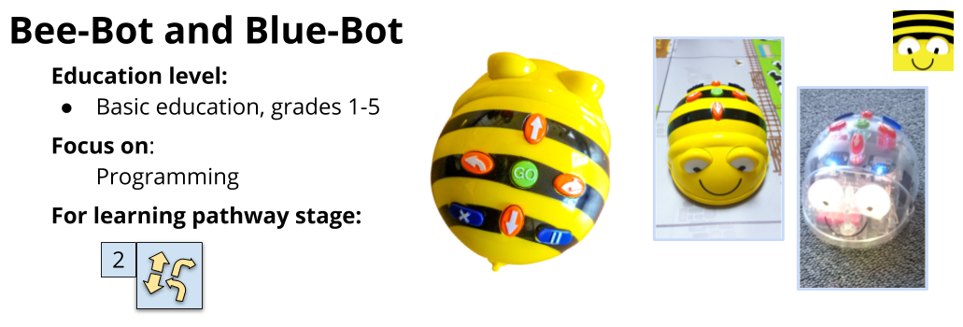

Bee-Bot and Blue-Bot are robots that are designed for beginners and allow simple move commands (move forward or backwards, turn left or right). Bots are an example of concrete low threshold programming devices. Bee-Bots are programmed using buttons on their back, whereas Blue-Bots can be programmed on computers, tablets or phones with the help of bluetooth connection. The maximum number of commands you can give to a Bot is 40 at a time.
Bot accessories include different kinds of underlays and mats that are great for integrating programming into other subjects: you can use for example a map of Europe as an underlay. Making your own underlays is relatively easy as well. As Bots move 15 cm per command and turn 90°, the underlays are typically grids with 15cm × 15cm boxes.
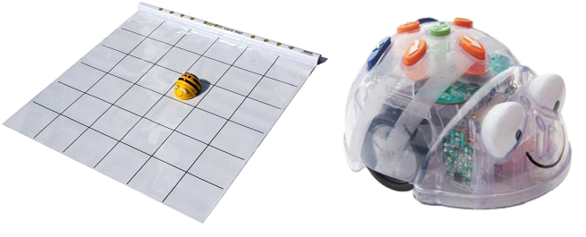
Figure 1: Bee-bot/Blue-bot mats. An easy way to integrate programming into different subjects is to use grid mats that have clear plastic pockets or a plastic cover. The mats can be used for different kinds of memory games on subject contents without the robot getting stuck between the cards.

When using bots, the focus is firmly on programming. However, bots are an approachable way to get started with robotics and programming a robot. Using bots can help understand that robots are devices that use electricity and perform in a way they were programmed to perform within the limits of their parts.

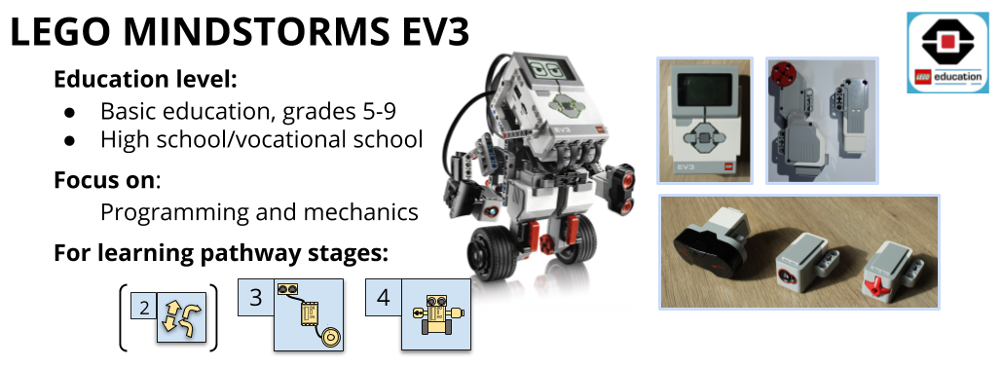

Mindstorms EV3 is a robotics set by Lego. It consists of a programmable central unit, different kinds of sensors, motors and building blocks. The central unit can be connected to Lego color, light, touch, sound, gyro, temperature, infrared and ultrasound sensors easily with one cable.
The robot can be programmed in a downloadable visual programming environment (LEGO MINDSTORMS Education EV3) that can be used on computers and tablets, or using the MakeCode environment for browsers (https://makecode.mindstorms.com/).
Strengths:
- Practically all kids are familiar with Lego sets, and the sets offer a lot of possibilities for mechanics.
- Low threshold learning. Building moving robots is easy. Focus is on programming and mechanics. Any Lego blocks can be used for EV3 building.
- EV3 has a wide user base. In Finland, EV3 robots are present in the annual RoboCup Junior national championships, and in the 2018 YLE tv series Robomestarit.
- The visual programming environment is relatively intuitive and promotes algorithmic thinking. MakeCode environment also allows using JavaScript programming language. For EV3 and Vex robots, there is also a programming environment called RobotC where robots are programmed using the C language.
Challenges:
- Building blocks are made of plastic, which makes the stability and accuracy of e.g. self-made gears weaker.
- Creating advanced programs may seem a little disorganised in the Lego visual programming environment.
- Bluetooth connections aren’t always reliable.
- Can’t be used to teach electronics.
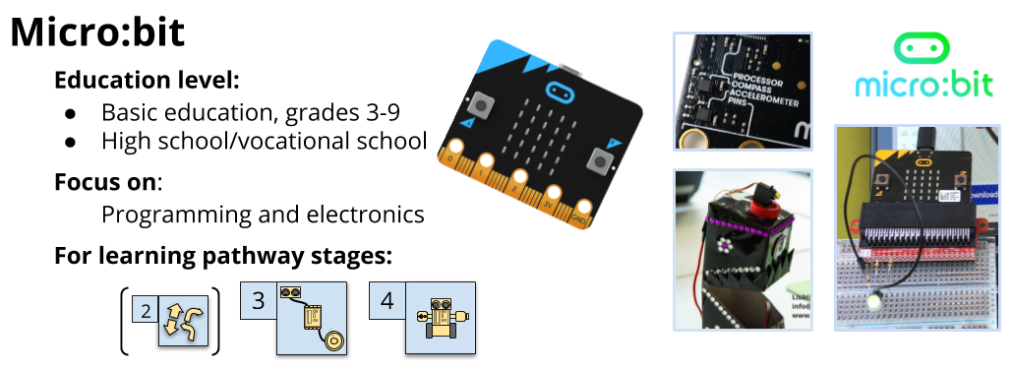

Micro:bit is a platform created by BBC, and it’s meant for device-oriented programming exercises for all ages. Micro:bit is a microcontroller, i.e. a simple computer on a single integrated circuit. It comes with an integrated compass, accelerometer, temperature sensor, two buttons, and a 5 × 5 LED matrix (a simple display).
Devices are programmed mainly in the visual MakeCode programming environment (https://makecode.mindstorms.com/) for browsers, using either blocks or JavaScript programming language. Micro:bits can also be programmed in browsers using the Python language that’s popular among beginners (https://python.microbit.org/).
Strengths:
- Very durable despite its looks.
- Affordable device that’s compatible with most electronics parts.
- Easily scaled for educational use from basics to advanced robotics contents.
- Programming environment (MakeCode) supports shifting from block programming towards text-based programming.
- Plenty of example projects on the MakeCode and Innokas network websites and YouTube.
- Micro:bit is very popular around the world, and is it’s becoming increasingly popular in Finland as well. More and more materials and support are made available.
- Well suited for combining contents from electronics and programming in combined schools (grades 1-9). Excellent choice for embedded system projects in crafts.
Challenges:
- Connecting discrete components requires accessories, bulky conductors or soldering.
- The threshold for building mechanics is higher than when using sets like Lego or VEX.
- Output voltage is only 3.3V.

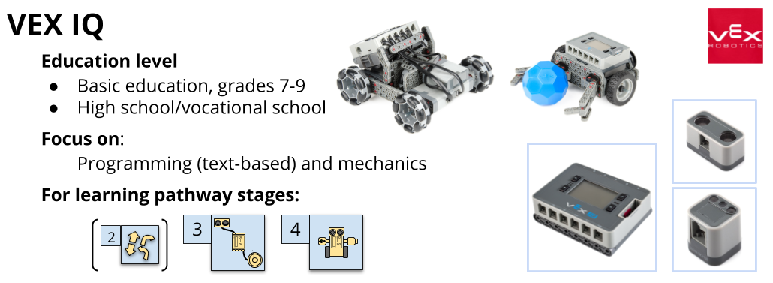

VEX IQ is a robotics set created by VEX robotics, and just like the Mindstorms EV3 set, it comes with a central unit, different kinds of sensors, motors and building blocks. The central unit can be connected to VEX series colour, touch, gyro, and ultrasound sensors easily with one cable.
The VEX central unit is programmed using the C language in the text-based RobotC programming environment that can be downloaded and used on a computer, or in the block-programming environment ModKit for VEX (https://www.vexrobotics.com/vexiq/resources/programming).
Strengths:
- Lego style building set. Includes sturdy metal parts.
- Moving robots are easy to build. Focus is on programming and mechanics. The range of accessories is wide. More affordable than Lego sets.
- VEX robotics competitions increase their popularity year after year, and they’re not far from Lego competitions.
- VEX robots can be programmed using either a text-based or block-programming environment. RobotC environment allows fully text-based programming with the C language, or using a block language that’s based on the C language. Additionally, an easier block programming option is available in the ModKit for VEX environment.
Challenges:
- Modkit for VEX licence is not free.
- RobotC programming environment is not that intuitive, meaning that getting started may require some work.
- Can’t be used to teach electronics.
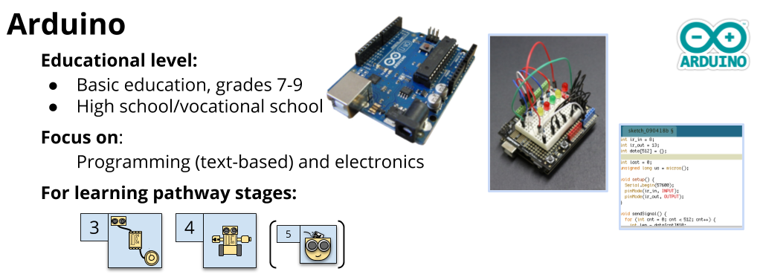

Arduinos are microcontrollers that can be used for high-performance and complex robotics projects. Especially the Arduino versions Uno, 101 and Micro are well suited for educational use, as they are reasonably approachable platforms, and good for creating quick prototypes. The Arduino MKR series is suited for IoT projects. Additionally, Arduino can be used to create smart textiles with microcontrollers such as LilyPad Arduino or Adafruit.
The programming environment, Arduino IDE, can be downloaded or used in browsers, and the used programming language is C++. Other environments are available as well, for example the block-programming environment ArduBlock.
Strengths:
- Well suited for all kinds of programs thanks to the wide variety of platforms and components.
- Chance to incorporate programming and crafts: there are microcontrollers that are meant for using with textiles.
- Enables upwards differentiating.
- Arduino has an active and wide user base around the world: the website https://create.arduino.cc/projecthub introduces users’ projects. You can search inside the projects based on project categories or platforms.
Challenges:
- Using discrete functions requires connecting with pins. The threshold for getting started may be higher than when using Micro:bit, as Arduino (Uno) is based on discrete components from the beginning, whereas Micro:bit comes with a built-in LED matrix and sensors.
- The threshold for building mechanics is higher than when using sets like Lego or VEX.
- Not a single platform, and there are several manufacturers and brands. The number of platforms and components makes it harder to get a grip of.
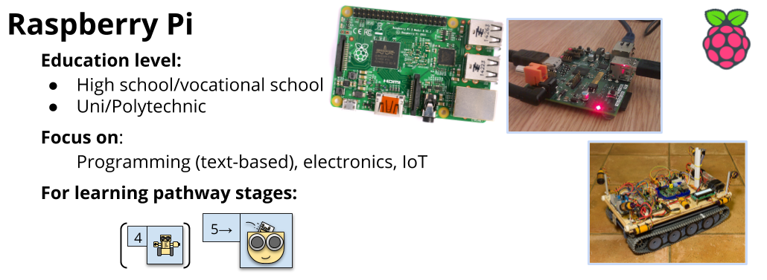

Micro:bit and Arduino are simple microcontrollers, whereas Raspberry Pi is a small computer that utilises the Raspbian operating system. It can be used like any personal computer. Raspberry Pi is a good choice for advanced projects on robotics and programming, especially if the performance of Micro:bit or Arduino isn’t sufficient for the needs of the project. Without a doubt, Raspberry Pi is the best alternative for IoT projects as it comes Wi-Fi enabled.
Raspberry Pi can be connected to screens, mouses and keyboards. Programming is carried out in its own operating system, meaning that there’s no need for a separate computer. For the programming, the most commonly used programming language is Python, but there are plenty of options to choose from: Java and C-family languages, and even block programming in Scratch.
Strengths:
- Suits all kinds of projects thanks to a wide variety of platforms and components.
- A multi-core processor enables even complex programs.
- Lots of possibilities for upwards differentiation. Excellent for IoT projects.

Challenges:
- Challenging in the beginning. Hard to adapt for easier projects.
- Based on discrete components from the beginning.
- Using discrete electronic components (motors, leds, sensors...) is somewhat slower than with microcontrollers. This makes Arduino a better choice for projects such as a line-following robot.

Further information:
Devices:
Bee-Bot/Blue-Bot: https://www.bee-bot.us/
Lego Mindstorms EV3: https://www.lego.com/mindstorms/
Vex Robotics: https://www.vexrobotics.com/
Micro:bit: https://microbit.org/
Arduino: https://www.arduino.cc/
Raspberry Pi: https://www.raspberrypi.org/

Programming environments:
Lego Mindstorms EV3: https://www.lego.com/en-gb/mindstorms/learn-to-program
RobotC: http://www.robotc.fi/
Modkit for Vex: https://www.modkit.com/vex
MakeCode: https://makecode.com
Micro:bit Python: https://python.microbit.org/
Arduino IDE: https://www.arduino.cc/en/Main/Software
ArduBlock: http://blog.ardublock.com/

Learning material and training:
Learning material and training on robotics and programming - Code School Finland: https://codeschoolfinland.com/wp/
Learning material on robotics - Innokas network: https://www.innokas.fi/en/

Additional robot devices:
Further information on robots - Koodauspaja (in Finnish): http://www.koodauspaja.fi/materiaalia/
Sphero robots: https://www.sphero.com/education/
mBot: https://www.makeblock.com/steam-kits/mbot
ROBBO: https://www.robbo.world/

Teaching as support for learning robotics
By looking at the national curriculums from countries around the world, including Finland, it’s easy to see that programming is becoming a basic skill that everyone should know something about. This goal has meant that the need for low threshold programming has been on the rise. Graphic programming environments that allow programming using puzzle-like blocks instead of text-based codes have become more common and versatile. Additionally, more microcontrollers (meaning small, simple computers) are developed with kids and beginners in mind (such as Micro:bit). This means that anyone interested in creating robotics applications or even IoT systems can do it – they don’t need to get a degree in engineering first. The possibility to explore these skills should be offered already in basic education.
The most natural way to learn robotics is through a. age-appropriate material that fits the skills level, and b. motivating projects on concrete devices.
- Age-appropriate material that fits the skills level
When choosing what devices to use, the age group and skills level of learners need to be taken into consideration. Using ready-built robots (Bee-Bot), simple platforms (Micro:bit) or Lego-style building sets (Lego EV3) lightens the load of learning contents and crafts skills requirements. Young kids and learners with motorical issues may also benefit from using tablets instead of computers.

Likewise, the age group and skills levels are important factors when choosing the programming language and environment. In early childhood education, learners benefit from concrete learning methods, so exercises that don’t require devices or that are very concrete are a good place to start (stages 1-2). The same goes for older learners who have never programmed before, but in their case, starting from stage 3 is still recommended. For the first automation projects (stage 3), graphic programming environments are recommended for all learners regardless of their age.

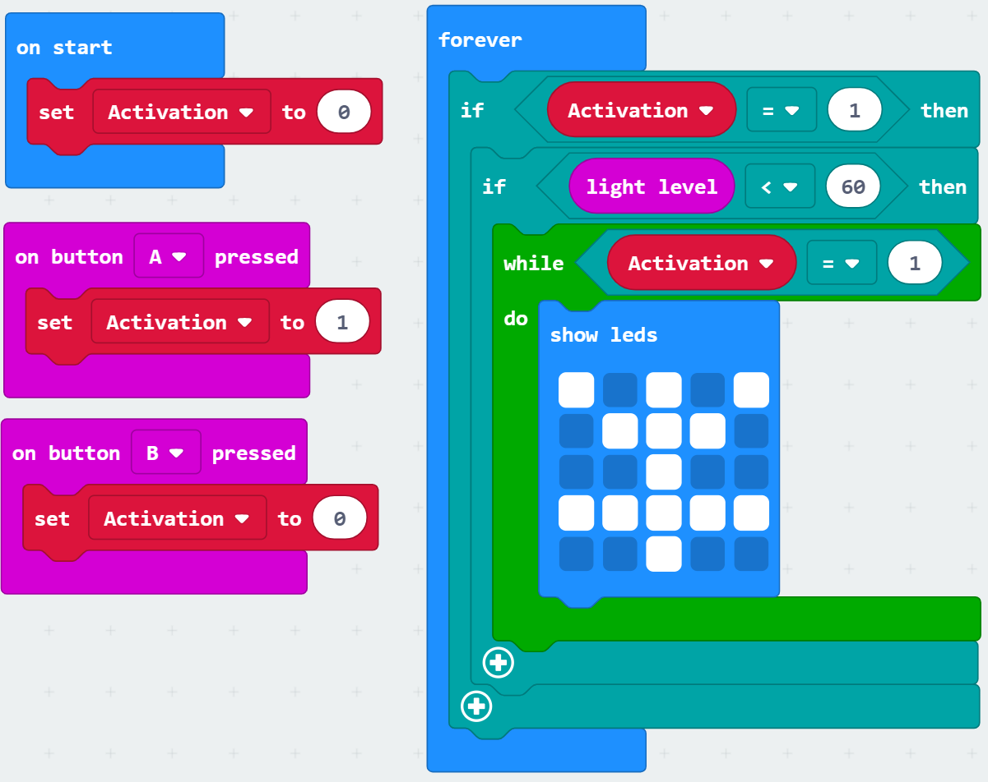
Figure 1: Graphic programming environment, block programming. A program made for Micro:bit in the graphic MakeCode programming environment.
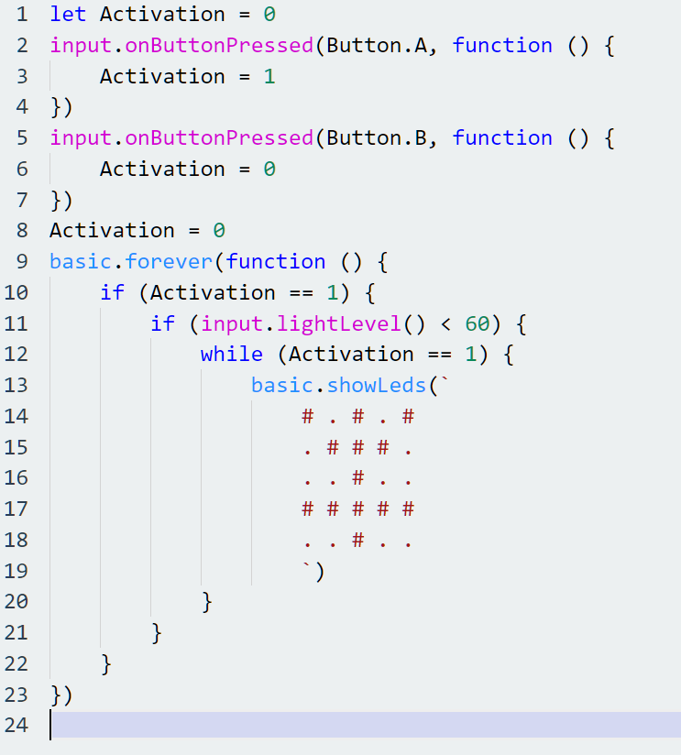
Figure 2: Text-based programming environment. This is the same Micro:bit program (as in figure 1), this time in a text-based form, written in JavaScript.
In text-based programming environments, the programming language commands are usually given in English. The most popular graphic programming environments (such as Scratch and MakeCode) have been translated into other languages, as well. This means that language barriers shouldn’t come in the way of learning robotics.
Versatile projects with a lot of room for applications are especially handy as far as differentiation goes. Let’s take access control alarms as an example. All alarms have the same operating principles: when a sensor notices something changing, the alarm is set off. However, the applications can be anything from very simple to highly complicated. In its most simple form, the alarm is set off by pushing a button, whereas a more complicated one may require input from several sensors, or cooperation between several devices that communicate with one another.
Playing games that support learning (such as programming exercises on the code.org website) can increase motivation and help understand the basics of programming a robot. However, it’s not exactly a concrete learning method, as games are about steering a virtual character forward. This means that the challenges presented by real life, such as the laws of physics, aren’t presented in an ideal way. Games can still be a motivational way to introduce a subject, or they can be used as extra material for a learning unit.
After basic education, learners’ skills in problem-solving, mathematics, and languages should be on a level that doesn’t restrict choosing devices and programming environments too much. However, the Lego EV3 series or Micro:bits are good choices for teaching basics or even more advanced contents (stages 2-4) to adults, as well.
- Motivating projects on concrete devices
Creating a concrete product is motivating in itself. However, the best way to spark even more motivation is to choose a meaningful project: the products are addressed afterwards, presented, and usable even after the learning unit is over. In an ideal situation, the projects are presented to an audience, such as other groups and peers, so that the creator gets to act as an expert.
Competitions can be used as a part of a learning unit, but competing shouldn’t be a goal in itself. If a group is working on robots that can perform several tasks, one of them being following a line, it’s ok to organise a line-following competition. In this case, the competition can motivate the group to put more effort into their work. After the competition, the development of the robots should continue.
Robotics projects offer natural problem-solving lessons that simulate real-life situations and ways to solve problems in working life. When we’re solving problems, the first step should be to divide the task into subgoals that help us solve the case. In other words, there’s no point in trying to solve the whole problem in one go. Let’s say we want to build a robot that can carry a water pitcher around the table. Our subgoals could be:
- Robot moves
- Robot stays on the table top
- Robot has a sensible route
- Robot stops when the pitcher is lifted
- Robot moves and stops without spilling any water
The robot is designed and built with these subgoals in mind. After that, it’s time to start working on subgoal 1 and the problem-solving routine.

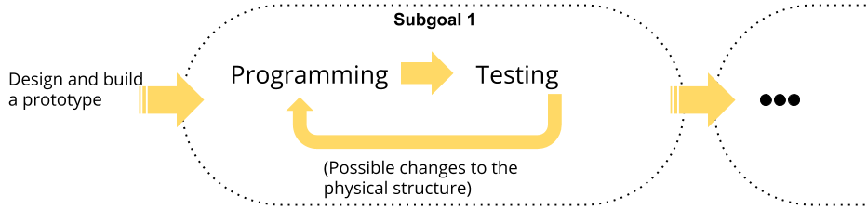
Figure 3: Problem-solving routine. The robot is programmed, the program tested, and the physical structures changed or fixed until the subgoal is reached. After that, it’s time to move on to the next subgoal.
The projects and devices should always be chosen with learning objectives in mind. In the National Core Curriculum for Basic Education, The Finnish National Agency for Education states that one of the learning objectives for crafts on grades 7-9 is implementing embedded systems in crafts by using programming for designs and products. The goal is stated on a very general level, which means that local curriculum writers are left with a lot of room for options. But what if the local writers don’t have basic knowledge of programming or embedded systems? There’s a danger that the learning objective is copied to the local curriculum as it is, which means that the responsibility is thrusted upon teachers. Many schools and municipalities have seeked outside help to tackle challenges with programming and robotics. More and more companies offer learning material and training sessions to help solve these issues. In Finland, such companies include Code School Finland, Innokas network and mehackit.
*Finnish National Agency for Education 2014 - National Core Curriculum for Basic Education 2014. https://www.oph.fi/download/163777_perusopetuksen_opetussuunnitelman_perusteet_2014.pdf

Robotics exercises without robotics devices
In this chapter, you’ll find 4.1. programming exercises for the Lego EV3 simulator which is easy to use, 4.2. programming exercises for a Micro:bit simulator, and 4.3. links to robotics related games. For the exercises in this section, you don’t need any devices other than a computer.

4.1 EV3 programming in a simulator

See file “EV3 programming in a simulator.pptx”

4.2 Micro:bit programming in MakeCode

See file “Micro:bit programming in MakeCode.pptx”

4.3. Robotics games
There are plenty of robotics programming exercises available in a game format. They can be used as an introduction to a theme or as additional material, but not as a framework for a learning unit. In most cases, these games concentrate on a specific aspect of robotics, usually programming.

The chart below includes examples of games that can be used to support learning:

Game | Content | Focus on | Grade level | Availability | Link
Code.org | Website with versatile programming exercises. | Progr. | 1-9 | Free, for browsers | Click!
LightBot | Give movement commands to a robot (easy). | Progr. | ALL | Free, for browsers | Click!
Robo Do It | Give movement commands to a robot (moderate). | Progr. | 3→ | Steam (<1€) | Click!
Algo Bot | Give movement commands to a robot (hard). | Progr. | 7→ | Steam (<10e) | Click!
QWOP | Demonstrates the difficulty of moving limbs | Mech. | 3→ | Free, for browsers | Click!
Scrap Mechanics | Versatile, caricature-style game for building mechanics, includes sensors. | Mech. | 5→ | Steam (<20e) | Click!
Xemo: Robot simulation | Animate robot limbs. | Mech. | 7→ | Steam (free) | Click!
Robotics in VR | EV3 constructing and programming in a virtual reality | Progr.  +  Mech. | 7→ | Steam (<10€, VR device required) | Click!

Micro:bit Rock Paper Scissors

Subtasks of the game:
- three different “weapons”
- hand movement
- randomization

1. Variable “weapon”
Make a variable called weapon.
Open the Variables tab, and choose Make a variable.
Name it weapon, and it will appear as a block in the Variables tab.

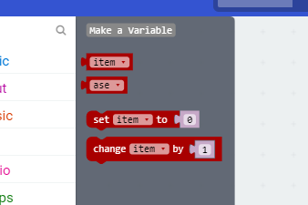

2. Hand movement
Set on shake as input. You’ll find the Set item to block in the Variables tab, and if you click the small arrow pointing downwards, you can choose the weapon as a variable.
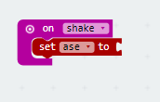

3. Randomization
From the Math tab, select the pick random 0 to block. As the options start from zero, the range is 0 to 2. This means that you should add 2 as the last number. 0 = Rock, 1 = Paper 2 = Scissors.

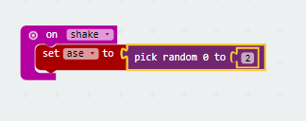

4. Conditional statements
The first conditional statement / if-then says that if the result of the shake is 0, the picture shown on the LED screen is the rock. You’ll find the conditional statement and equals blocks in the Logic-tab.

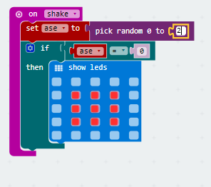

Add the rest of the conditional statements the same way. Replace 0 with 1 and 2, and set the LED lights to show scissors and paper.

You can duplicate a conditional statement by right-clicking it. After duplication, change the the number of the option, and set the LED picture.
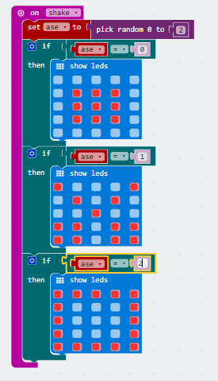

YOUR GAME IS READY TO BE PLAYED! Download the code to your Micro:bit and challenge your friends to battle against Micro:bit.

