CASE: Digibale – assignment
- Explore the material of the digibale.
- Explore Industry 4.0.
  - Example links:
  - https://ec.europa.eu/futurium/en/system/files/ged/a2-schweichhart-reference_architectural_model_industrie_4.0_rami_4.0.pdf
  - https://www.acatech.de/wp-content/uploads/2018/03/acatech_STUDIE_Maturity_Index_eng_WEB.pdf
  - You can also use other sources related to.
- Consider how the digibale is part of industry 4.0.
  - Make a PowerPoint slideshow.
  - Use pictures to help.
  - Example pictures:
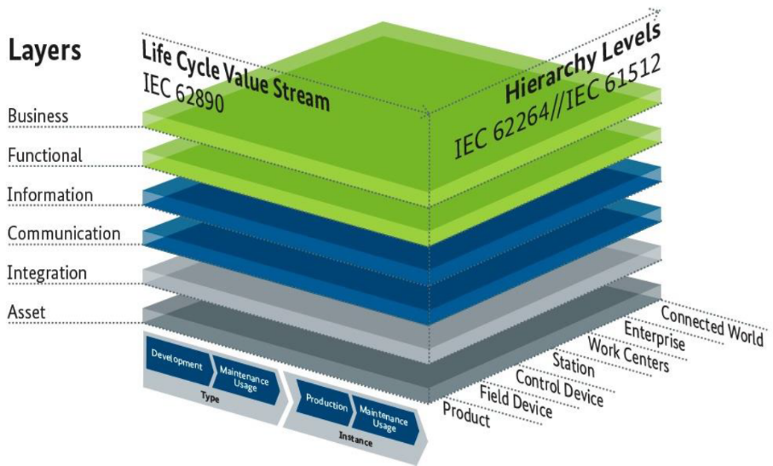
RAMI 4.0 – The Reference Architectural Model for Industry 4.0
https://ec.europa.eu/futurium/en/system/files/ged/a2-schweichhart-reference_architectural_model_industrie_4.0_rami_4.0.pdf

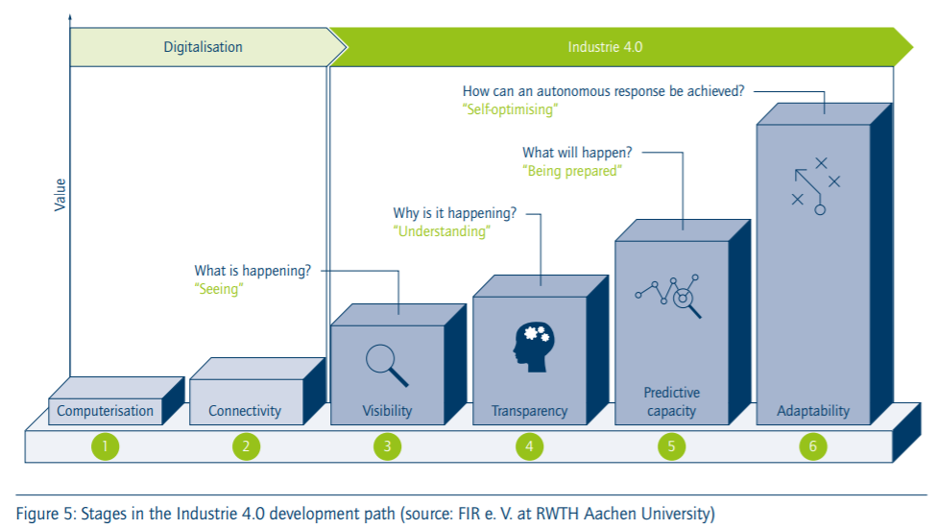
https://www.acatech.de/wp-content/uploads/2018/03/acatech_STUDIE_Maturity_Index_eng_WEB.pdf

