2. Polymerization
2.1. What are the most important polymerization reactions?
Addition and condensation reactions
2.2. How the following polymers can be produced?
2.2.1.
A. HD-PE, LD-PE,
  - by applying intense heat to petroleum and then cracking to create ethylene gas
  - 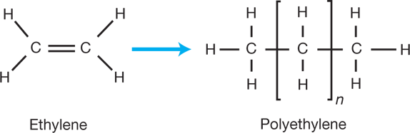
  - And then at extremely high pressures for forming LD-PE. And control the chain transfer reagent can form HD-PE.
https://www.aiche.org/resources/publications/cep/2015/september/making-plastics-monomer-polymer
B. PA,
1. It's an interfacial polymerization, two liquids phase form a polymer membrane, and hexamethylenediamine react with sebacic acid chloride. (in laboratory)
2. Condensation reaction, the hydroxyl from the carboxylic acid combines with a hydrogen from the amine and gives rise to water. (in industry)
C. PTFE
1. synthesis of Calcium Fluoride Sulphuric Acid and Chloroform
2. polymerization of pure TFE under properly environment.
D. PVC
1. polymerization of vinyl chloride monomer including suspension, emulsion, and bulk methods
2. under a few bars at 40 – 60°C. VCM is pressurized and liquefied then pull it into reactor with water and suspending agents in where also contain initiator.

2.2.2. Polyurethane, Polyesters, Phenol-formaldehyde, Vinyl-esters
Polyesters ...
Vinyl-esters Copolymerisation of vinyl acetate with ethylene
Phenol-formaldehyde Also known as Bakelite. The polymer is formed in a single reaction, where every ring-shaped phenol reacts with three formaldehyde molecules. This simple reaction yields a strong, cross-linked molecular structure.
Polyurethane Reaction products of di-isocyanantes and diols such as the common ethylene glycol. Modern production of PU resins often employs more complicated components in place of glycol such as polyester chains with hydroxyl groups at the ends to produce different end products, but the di-isocyanates remain as the defining feature of polyurethanes.
Scott, G.: Polymers and the environment
2.3. Write the chemical reactions of the previous polymers
PVC
n CH₂=CHCl ＝ -[-CH₂-CHCl-]-n
PE
n H₂C=CH₂→-[-H₂C-CH₂-]-n
PTFE
n CF₂=CF₂→-[-CF₂—CF₂-]-n
Polyurethane
-N=C=O+HO- → -NH-COO-

References:
https://www.aiche.org/resources/publications/cep/2015/september/making-plastics-monomer-polymer
Scott, G.: Polymers and the environment

