ASSIGNMENT: LIFESTYLE TEST AND REDUCING CONSUMPTION OF NATURAL RESOURCES
For teacher Soile Kallinen (Haaga-Helia UAS) has created this assignment which has been piloted during fall 2019-fall 2020 in multinational student groups.
This assignment consists of two parts: individual and group assignment. The outcome can be for example a report or a power point slide presentation. Here you find guidelines for group discussion report as a final outcome of the assignment. Results can also be collected to the excel chart (anonymous, be fake names) or students can discuss in teams and create column charts etc.

Aim of the assignment
The aim of this task is to make students think of their own lifestyle habits and identify areas where they could reduce their consumption of natural resources and carbon footprint. Students will compare their own consumption to the consumption of the average Finn. Students will understand the consumption also in various countries. Students also discuss how to reach future consumption of CO2 levels by reducing the consumption.
Part 1. Individual (hometask)
1. Go to Sitra Lifestyle test and add your personal data to each section.
https://www.sitra.fi/en/articles/lifestyle-test-shows-threat-opportunity-environment/
2. After each section, write down your personal CO2 emission figures.
3. Read your results at the end, write down your total consumption of CO2.
4. Read the results of the CO2 emissions of the average Finn and write down the consumption of CO2 (the average Finn) in each section.
5. Read the guidelines for part 2 and prepare for the group discussion.

Part 2. Reflections of the results in small discussion groups
1. Discuss your main findings of the Sitra´s Lifestyle test
Take your notes and discuss in small discussion group during the session or virtually.
2. Combine each other´s consumption levels into a table chart (excel)
Compare each other´s results to the consumption of the average Finnish citizen and to one other country´s citizen presented in Figure 1 (choose either Japan, China, India or Brazil).
3. Give ideas to each other how to reduce the consumption
Think of how you could reduce the CO2 emissions, especially in the sections where you had the most CO2 emissions. Try to find concrete actions that have the most impact to CO2 emissions. You find some tips in Sitra´s websites and from 1.5 Degree Lifestyles report (see the list of sources).
4. Consider especially consumption targets in the future
Consider also how to reach CO2 target levels of 2030 and 2050 in Finland. What do you need to do to change your lifestyle and to reduce your own consumption? See the Figure 1 below.
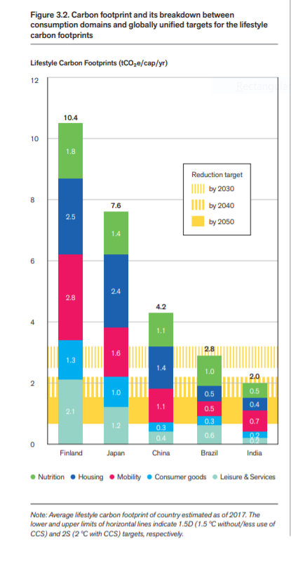
Figure 1. Carbon footprint and its breakdown in various countries Source: 1.5 Degree Lifestyles. Page 14.

Part 3. Write a discussion summary of your results in part 2

1. Write a discussion summary of your reflections. You can create table charts of CO2 consumptions levels (of your group members and the average Finn and one chosen country).
2. The length of your summary is approximately 4 pages.

Useful sources:

1.5 Degree Lifestyles. Targets and options for reducing lifestyle carbon footprints. Aalto University. Page 14. URL: https://www.aalto.fi/sites/g/files/flghsv161/files/2019-02/15_degree_lifestyles_mainreport.pdf

Facts about the average Finn (visit the website after you have finished your own test)
https://www.sitra.fi/en/articles/carbon-footprint-average-finn/

Sitra´s Lifestyle Test:
https://www.sitra.fi/en/articles/lifestyle-test-shows-threat-opportunity-environment/

