Physical and chemical phenomena and their application
2 osp

2024

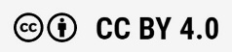
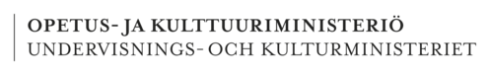
CHEMISTRY 1 osp
misa muotio, piritta niemi, leena ristiharju, tanja suikkanen, sampo tuominen
Rahoittaja:

Vierko |www.keuda.fi/keuda/hankkeet/vierko

Contents
Introduction 3
1. Structure and properties of matter 3
1.1 Periodic table and elements 3
1.2 Structure of matter 5
1.3 Atomic models 5
1.4 Atomic number 6
1.5 Neutrons in an atom 7
1.6 Octet 8
1.2.1 Properties of a substance 11
1.2.2 Mixtures and pure substances 11
1.2.3 Mixtures 12
13
1.2.4 Heterogeneous mixtures 14
1.2.5 Solubility of a substance 15
2. Chemical reactions 19
2.1 Chemical reactions: combustion 22
2.2 Chemical reactions: Oxidation and reduction and metals 24
2.3 Acids and bases 31
33
3. Concentration 35
3.1 Mass percentage 35
3.1.1 Tasks 36
3.2 Volume percentage 37
3.2.1 Tasks 37
4. Amount of substance 38
4.1 What means amount of substance? 39
4.1.1 Tasks 39
4.2 How to calculate the amount of substance? 39
3.2.1 Tasks 40
4.3 How to calculate the mass? 40
4.3.1 Tasks 41
5. Chemical safety 41
5.2 Theory 42
5.2 Tasks 46
2. Chemistry exam 47
Lähdeluettelo 53

Introduction
In the chemistry section, students will explore common substances used in the field, their properties, and how to handle them safely.

Structure and properties of matter
Learning goals: what is the difference between mixtures and pure substances, properties of matter, how do you read the periodic table and structure of matter.

Do you need to identify elements and compounds in your field?

Periodic table and elements
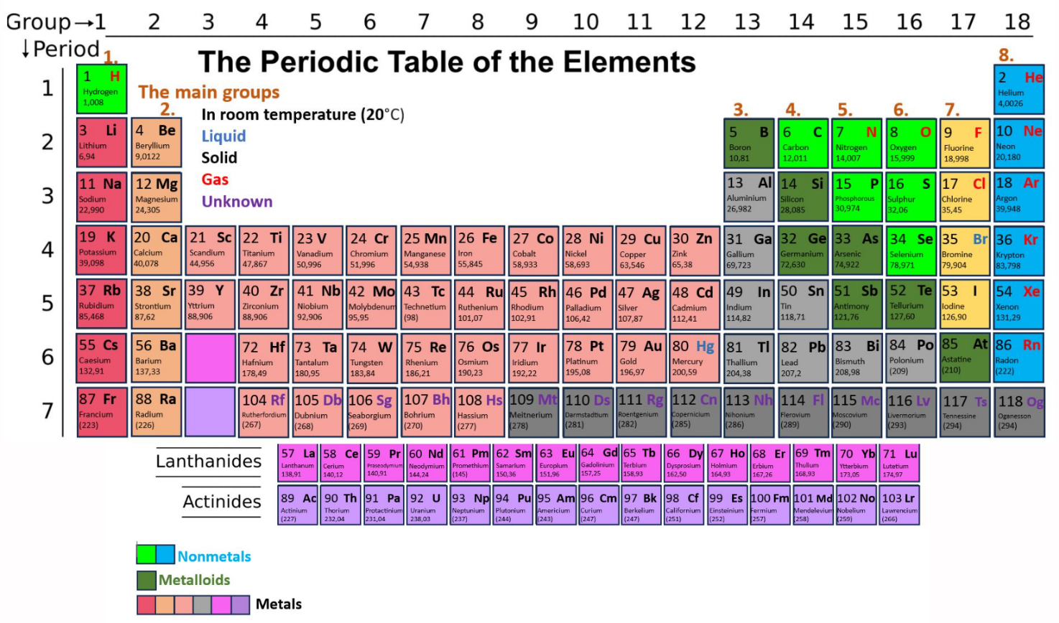
Learn about the periodic table and atoms.

All known elements are arranged in the periodic table. The order is based on the size and the electron shell structure. Dimitri Mendelejev was the first person to arrange the atoms into this periodic table around 1800. At that time, many of the elements we know today had not yet been discovered.
Watch a video about the periodic table here. THE PERIODIC TABLE
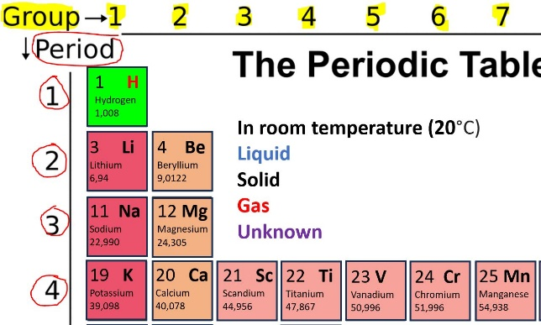
There are 18 groups (vertical columns) and 7 periods (horizontal rows) in the periodic table. There are eight main groups where elements have the same number of electrons in the valence shell. Transition metals are located between these main groups. They are in groups 3-12. These transition metals tend to have one or two electrons in the valence shell.

There are 8 main groups in the periodic table. They have specific names. That you will learn in the next slide. The ordinal number of the main group tells you how many electrons are in the valence shell (atoms outer shell). The exception is helium, which has only 2 valence electrons.
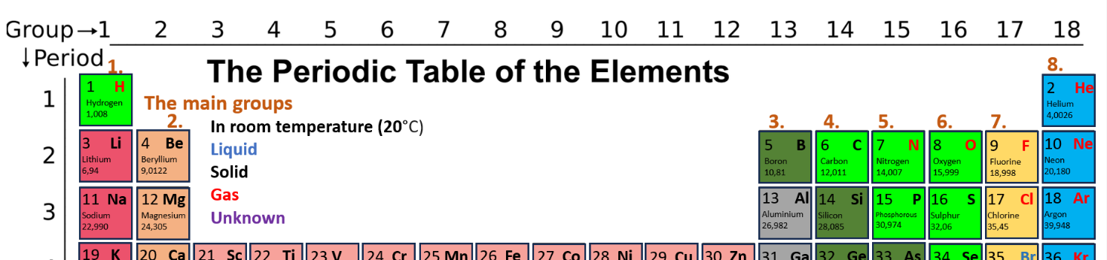

Task: Match the correct names with the spaces.
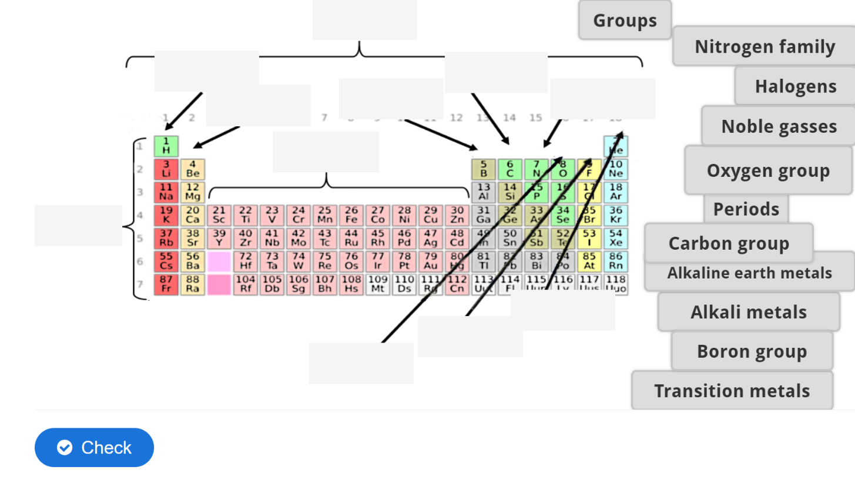
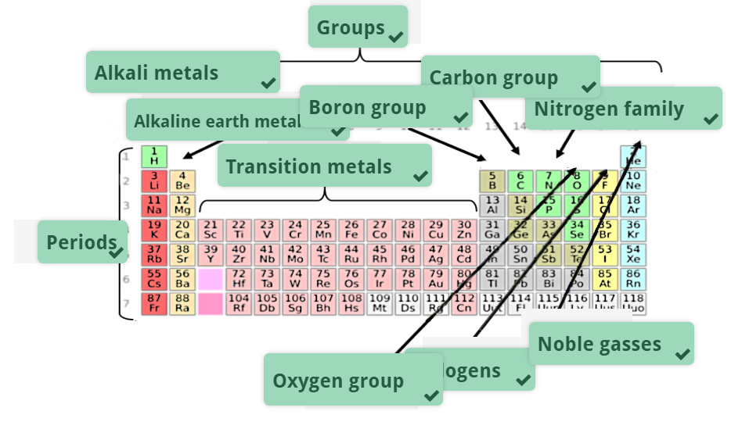

Structure of matter
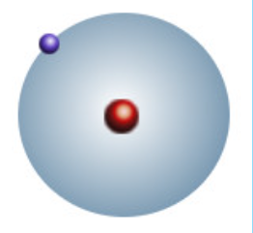
Atoms consist of elementary particles, which are proton (+), neutron (uncharged) and electron (-). The nucleus in the center of the atom contains protons and neutrons, and electrons circulate around the nucleus (electron cloud). An atom is an uncharged particle, so it has an equal number of positive protons and negative electrons.

Hydrogen is the simplest element. In its nucleus there is one proton and in the electron shell one electron.

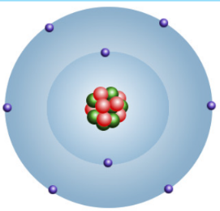

Oxygen atom has eight protons and neutrons in its nucleus. The innermost electron shell has two electrons and the second shell has six.

Atomic models
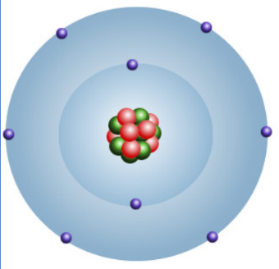
In Bohr's atomic model, electrons orbit the nucleus in electron shells (energy levels) and each shell only holds a certain number of electrons. The electrons orbiting the nucleus fill these shells starting with the innermost shell and moving outward.

Bohr's atomic model. An oxygen atom.

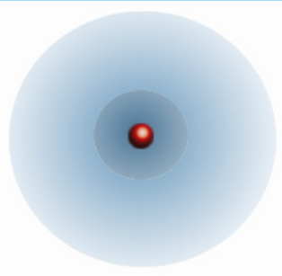
In 1926, Erwin Schrödinger (1887–1961) created a mathematical model that describes the position and energy state of an electron in three-dimensional space. According to this quantum mechanical atomic model, electrons do not have a certain stationary trajectory. Instead, their position can only be expressed with a certain probability. The quantum mechanical atomic model is based on the assumption that electrons have both particle-like and wave-like properties.

Quantum mechanical atomic model.

Tasks
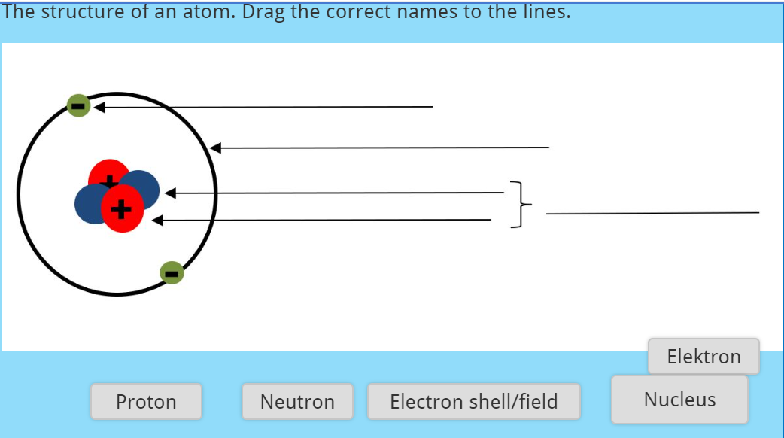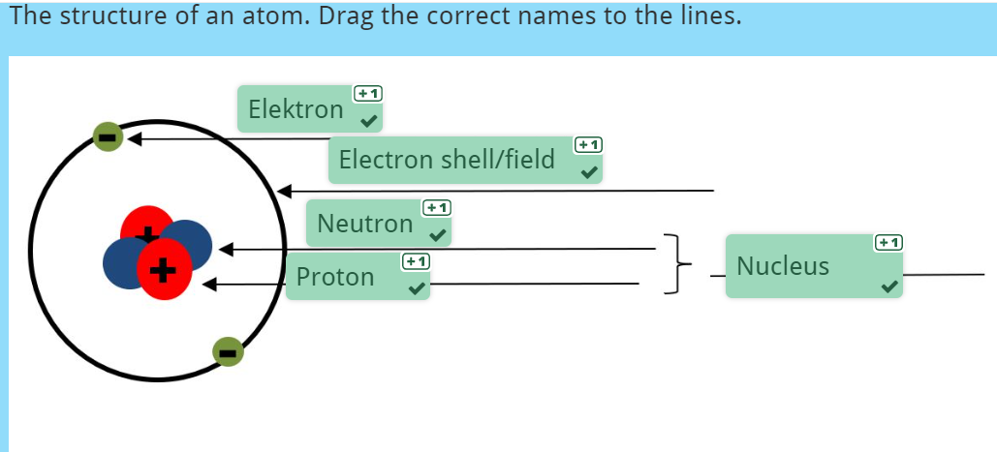
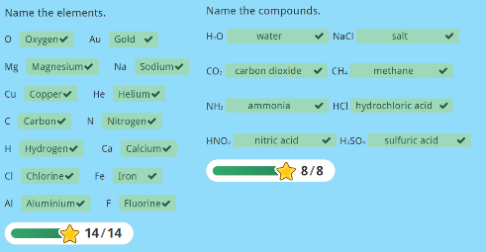
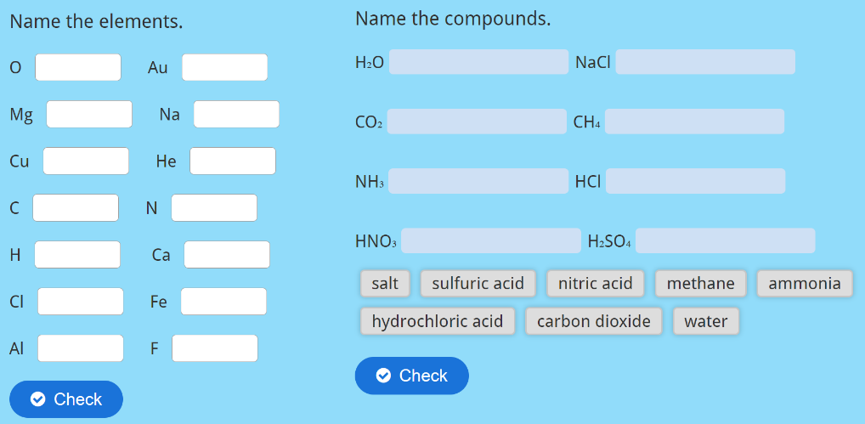

Atomic number

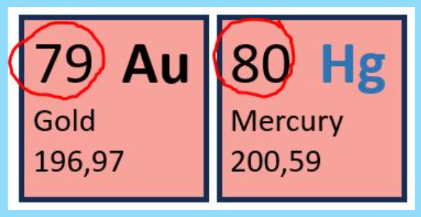
Atomic number tells the number of protons and electrons in an element. Every element on the periodic table has its own atomic number. For example, hydrogen has atomic number 1, helium has atomic number 2 and lithium has atomic number 3.

Atomic number of gold and mercury
The atomic number of gold is 79 and the atomic number of mercury is 80.

Neutrons in an atom
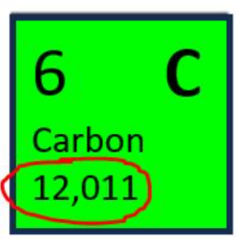
The mass number is the total number of protons and neutrons in the nucleus of an atom. However, the number of neutrons in the elements varies, even though the order number (i.e. the number of protons) is the same. In this case, we are talking about different isotopes of the substance.
The periodic table does not show the mass numbers of the elements, but the relative atomic weights or masses of the substances. The relative atomic mass is the concentration-weighted average of the atomic weights of atoms of different masses in the naturally occurring mixture of isotopes of an element.

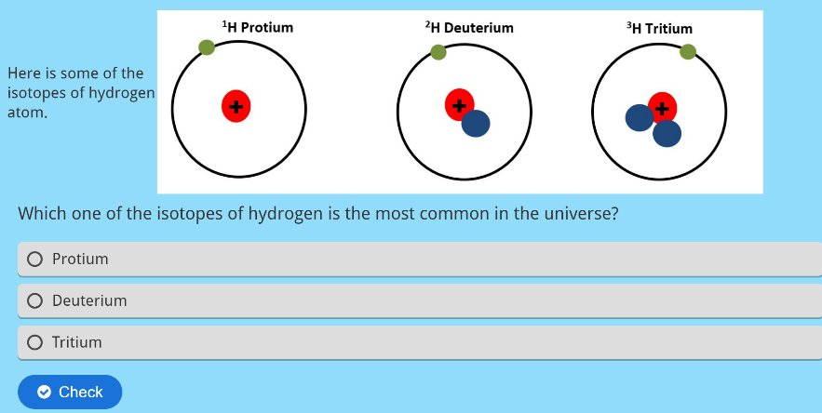
Tasks

Answer 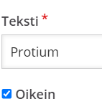

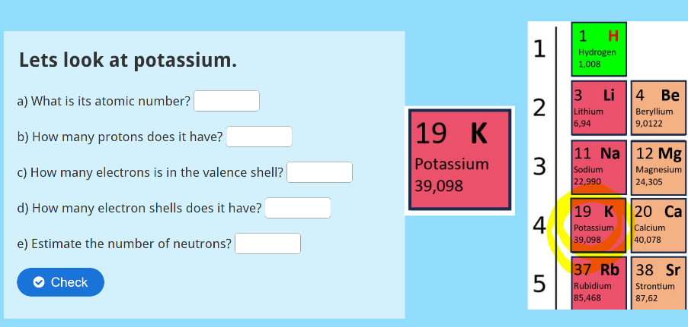

Answers
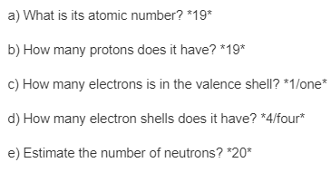

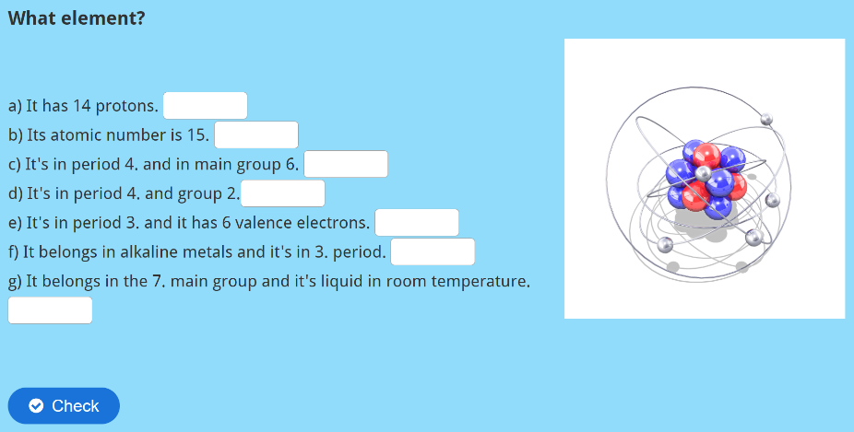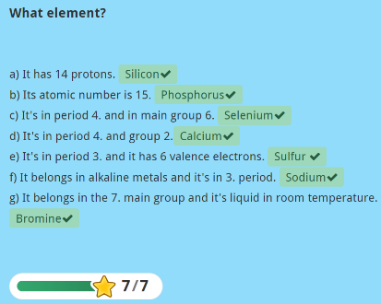
Answers: a) It has 14 protons. *Silicon*
b) Its atomic number is 15. *Phosphorus*
c) It's in period 4. and in main group 6. *Selenium*
d) It's in period 4. and group 2. *Calcium*
e) It's in period 3. and it has 6 valence electrons. *Sulfur/Sulphur*
f) It belongs in alkaline metals and it's in 3. period. *Sodium*
g) It belongs in the 7. main group and it's liquid in room temperature. *Bromine*

Octet
All elements tend to have the same electron structure as the noble gases. That is, 8 electrons for the valence shell. This structure is also called an octet. Since noble gases already have this structure, they do not react very easily. They are stable/inert.

The chemical properties of an element therefore depend on their electron structure and how easily it can achieve the octet in its valence shell.

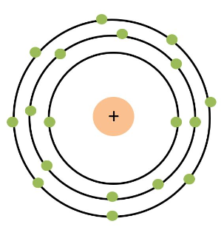
Argon
The photo shows Argon's electron shell structure. Argon belongs to the noble gases that already have an octet. It has 8 electrons in its valence shell and therefore does not react with other elements.

  - Tasks
Vastaus perässä.
- Chemical symbol for hydrogen is? H
- Chemical symbol for nitrogen is? N
- Chemical symbol for oxygen is? O
- Chemical symbol for lithium is? Li
- Chemical symbol for iron is? Fe
- Chemical symbol for carbon is? C
- Chemical symbol for copper is? Cu
- Chemical symbol for silicon is? Si
- Chemical symbol for tin is? Sn
- Chemical symbol for aluminium is? Al
- Fill in the blanks with correct words.
_____ consists of nucleus and electrons surrounding it.
In the ______ there are protons and neutrons. Protons are _____ charged particles. Electrons are _____ charged particles.
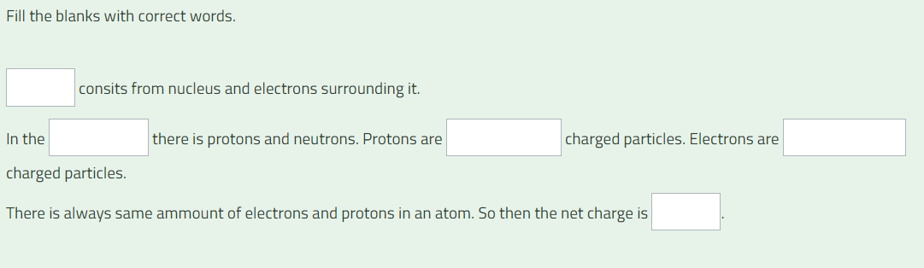
There is always the same amount of electrons and protons in an atom. So, then the net charge is _____.

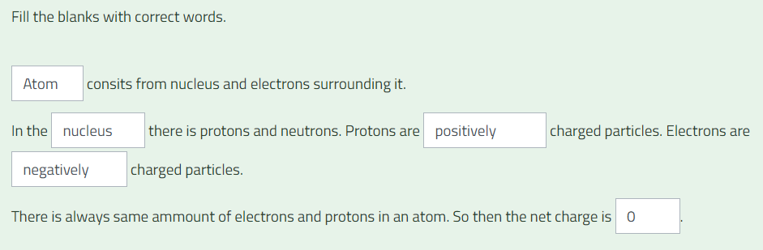

- Choose the correct words:
[[1]] tells you how many [[2]] there are in an atom.
[[3]] there can be different amount of [[4]] in the same element. [[5]] is the same element but with a different mass number.

All the known elements are arranged into the [[6]] by their [[7]] and [[8]] structure.
There are 18 groups in the periodic table but only eight [[9]]. The number of the main group tells you how many [[11]] are in the [[10]] shell. Between the groups 2 and 13 are [[12]]. Those [[13]] similar electron structure filling rule as main group elements.
[[14]] are horizontal lines in the periodic table. The number of the period tells you how many [[15]] there are in the atom.

[[1]], [[2]], [[3]], [[4]] and [[5]] pudotusvalikko yksi eli vaihtoehdot: Atomic number, protons, In the nucleus, neutrons ja isotope.
[[6]], [[7]], [[8]] ja [[9]] pudotusvalikko kaksi eli vaihtoehdot: periodic table, atomic numbers, electronic ja Main groups.
[[10]], [[11]], [[12]] ja [[13]] pudotusvalikko kolme eli vaihtoehdot: valence, electrons, transition metals ja don’t follow.
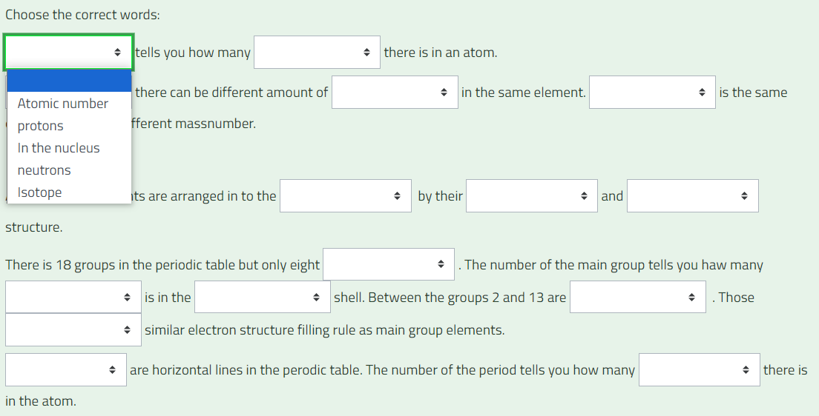
[[14]] ja [[15]] pudotusvalikko neljä: Periods ja electron shells.

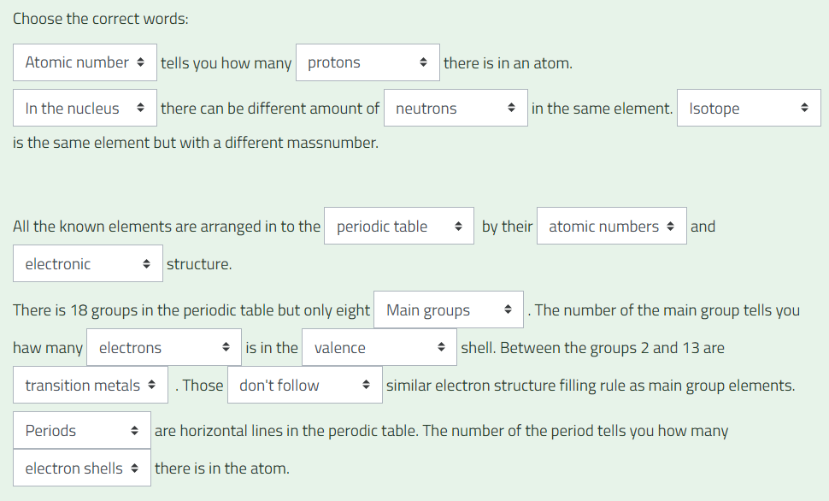
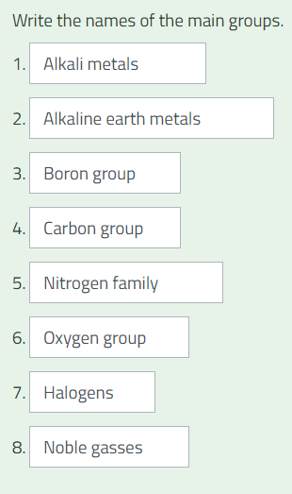
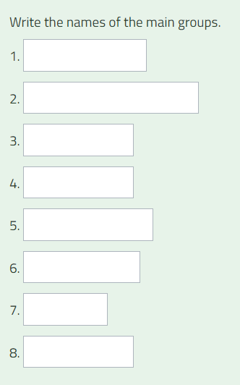

- What element?
It has six electrons in the valence shell and it's in the second period in the periodic table.
Oxygen
- What element?
It has two electrons in the valence shell and it's in the third period in the periodic table.
Magnesium

  - About substances and their properties
    - Properties of a substance
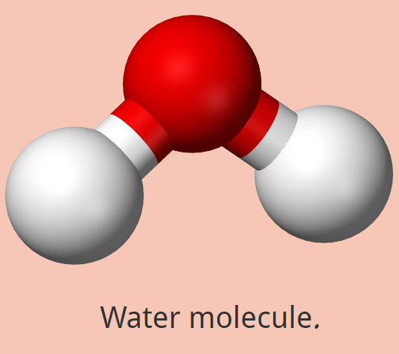
What substance? It is colourless, odourless and tasteless. It boils in 100 degrees Celsius and it is liquid in room temperature. It's a good solvent and its pH value is 7.

The substance described above is water. The hints are the physical and chemical properties of water. Physical properties are colour, state of matter, odour, taste and boiling point. Solubility and acidity are chemical properties. Each substance has certain properties by which it can be identified.

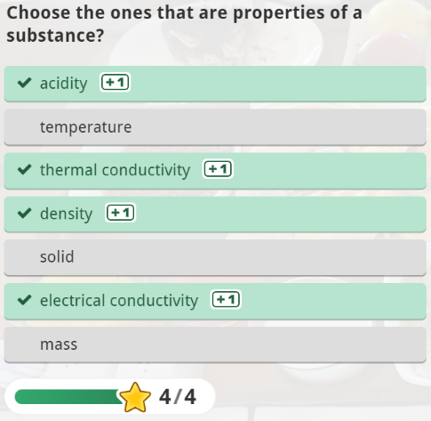
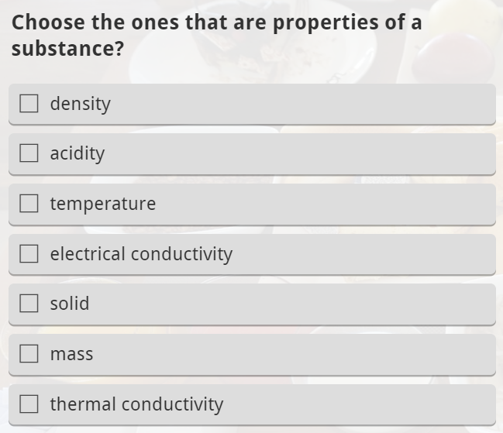

1.2.2 Mixtures and pure substances

Substances can be divided to pure substances and mixtures.
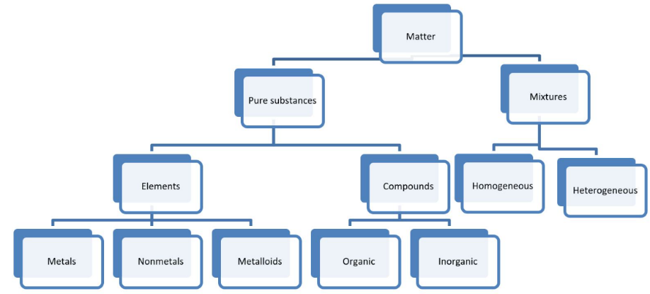
For pure substances, which are compounds and elements, the structural parts are similar. They also have a chemical symbol or formula.
In a mixture, there are two or more elements or compounds mixed, but not reacted together.
Pure substances can be called a chemical substance. In nature, substances rarely occur as pure elements. Usually, they are mixed to form a mixture. In EU chemical legislation, mixtures are not considered substances.
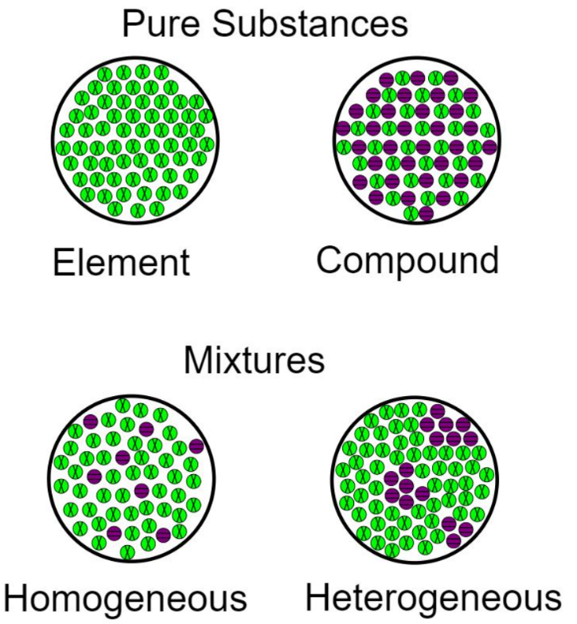
By John Trombley - Own work, CC BY 4.0, https://commons.wikimedia.org/w/index.php?curid=61264362

1.2.3 Mixtures

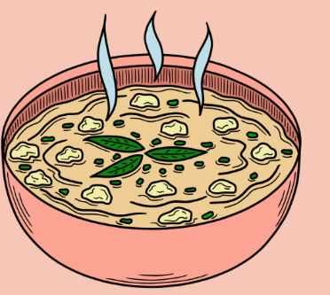
In mixtures, the structural parts of two or more substances are mixed together. Each substance retains its characteristic properties in the mixture, so substances can be separated from the mixture using different methods. Such methods include, for example, filtration, extraction, crystallization, distillation and chromatography.
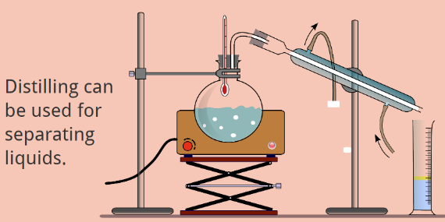
A liquid mixture is usually called a solution when different substances cannot be separated from the mixture with the naked eye. The substance that is present the most is called the solvent.

Task: Put the substances to the correct categories.

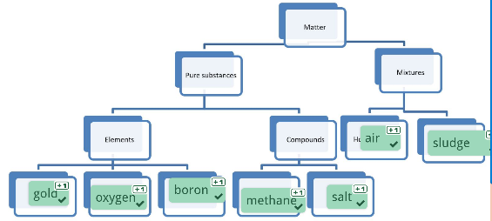
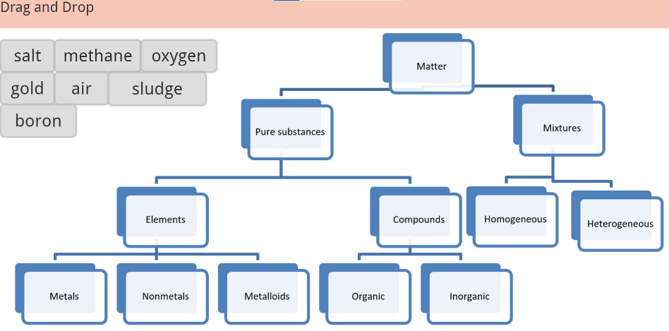
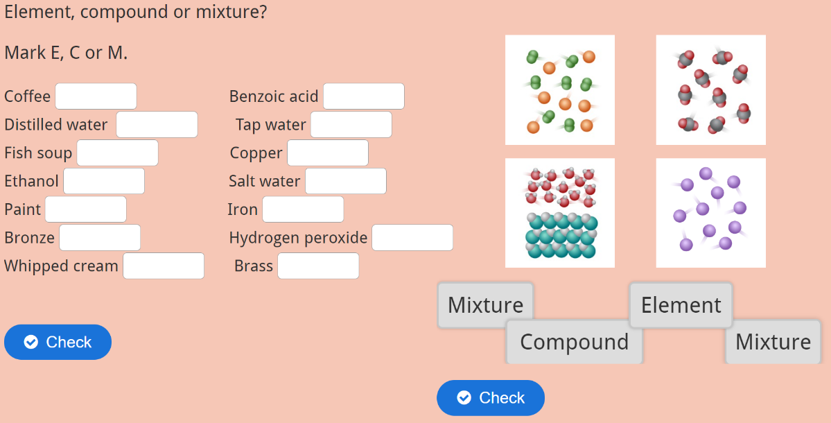
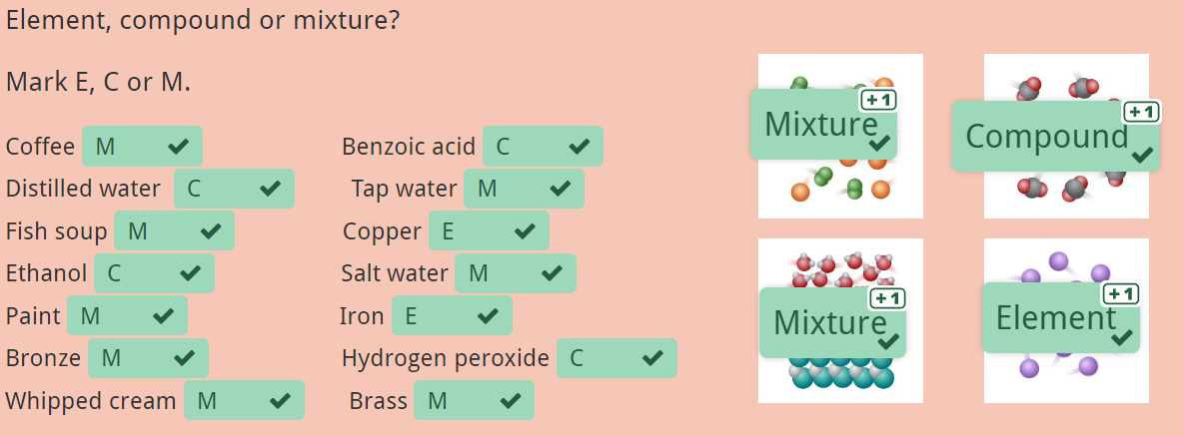
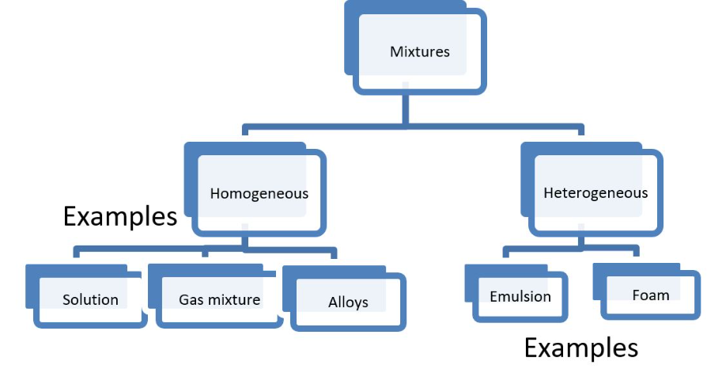
A homogeneous mixture has a uniform composition. However, the components of the mixture can be separated from each other by e.g. distillation, if they have different boiling points. In a heterogeneous, i.e., mixture of mixed composition, different sub-areas (phases) are observed, for example in a mixture of oil and water. The components of a heterogeneous mixture can be separated, for example, by filtering.

1.2.4 Heterogeneous mixtures

Mixture | State of matter | Explanation and example
Fog | Gas and liquid | Small liquid particles in gas.  Examples: clouds, hairspray, mist.
Foam | Gas mixed in liquid/solid | Gas bubbles in liquid or solid substance.  Examples: Whipped cream, marshmallows.
Smoke | Gas and solid | Small solid particles in gas.  Examples: Dusty air, soot, sandstorm.
Suspension | Liquid and solid | Small solid particles in liquid.  Examples: Oral suspension medicine, sludge.
Gel | Solid and liquid | Solid substance has absorbed liquid.  Examples: Jelly, kissel, hair gel.
Emulsion | Undissolved liquids | Undissolved liquids mixed.  Examples: Mayonnaise, emulsion hand cream.

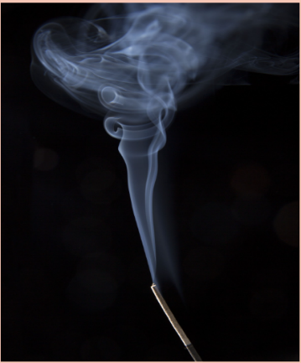
Cigarette smoke contains ammonia, acetone, arsenic, benzene, benzopyrene, butane, cadmium, DDT, formaldehyde, carbon monoxide, methanol, naphthalene, nickel, titanium, toluene and hydrogen cyanide.

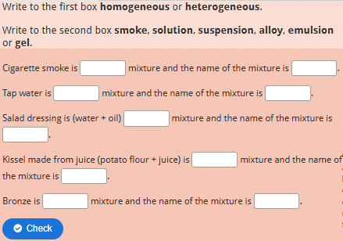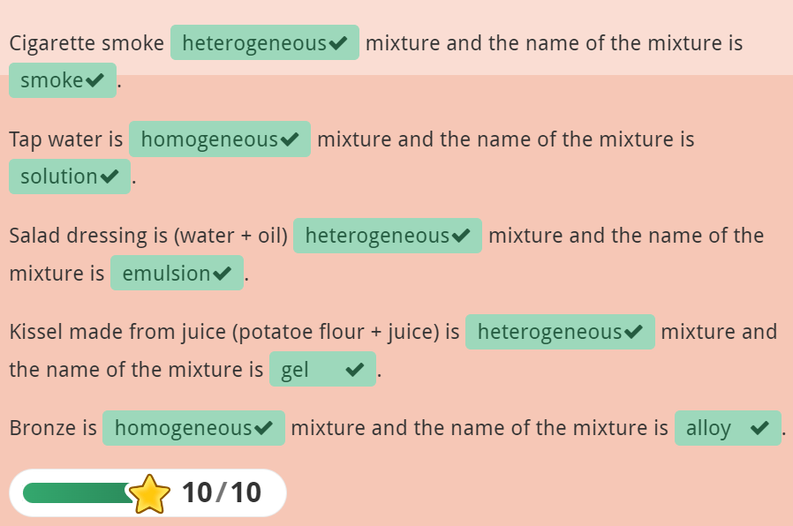

1.2.5 Solubility of a substance

When you dissolve salt into water it becomes a homogeneous mixture, because the salt will dissolve in water. At some point it will become a saturated solution. If you still add salt, it doesn't dissolve anymore. Then the solution is a heterogeneous mixture.
A Saturated solution means that no more of the same substance can dissolve in the solute. Sometimes you still can dissolve other substances to a saturated solution.
Factors that may speed up the dissolving. Some will even increase the dissolving.

Factor
Temperature
Stirring
Surface area
Pressure (affects only with gasses)
The nature of the substances

So, if you want to dissolve sugar into a cup of coffee fast. You should have hot coffee. You should stir it with a spoon and you should use granulated or powdered sugar.

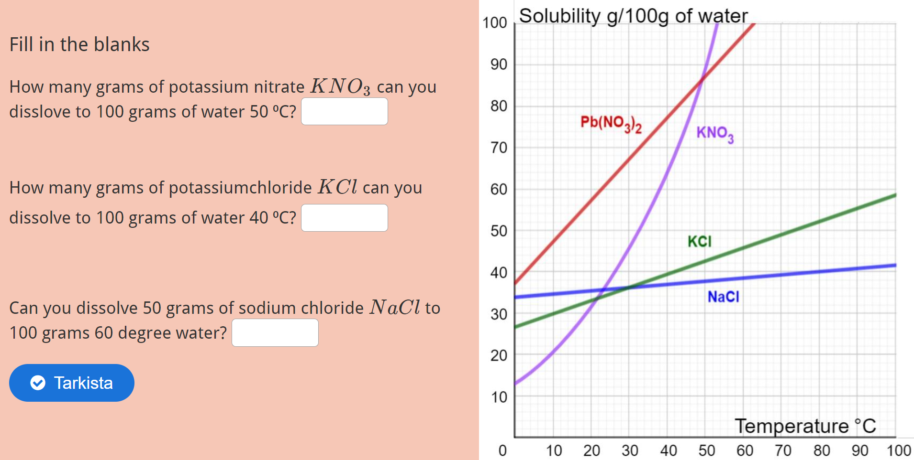

Answers: How many grams of potassium nitrate \(KNO_3\) can you dissolve to 100 grams of water 50 ⁰C? *90 g/90g/90*
How many grams of potassium chloride \(KCl\) can you dissolve to 100 grams of water 40 ⁰C? *40 g/40g/40*
Can you dissolve 50 grams of sodium chloride \(NaCl\) to 100 grams 60 degree water? *No/no/no I can't/I can't*

1.2. Tasks

1. Which of the following are chemical properties?
a. Flammability of dry paper.
b. Gold is shiny.
c. Gallium metal melts at 30 ⁰C.
d. The pH value of water is 7 (neutral).
e. Iron metal rusts.
f. A green banana turns yellow when it ripens.
g. Iron is soft when pure.
h. Mercury is a very dense liquid.
Answer: a, d, e and f

2. Choose the correct term/explanation for the mixtures.
Two undissolved liquids mixed.
Small solid particles mixed in liquid.
Solid substance has absorbed liquid and swollen.
Small liquid particles mixed in gas.
Two metals mixed.
Small solid particles mixed in gas.
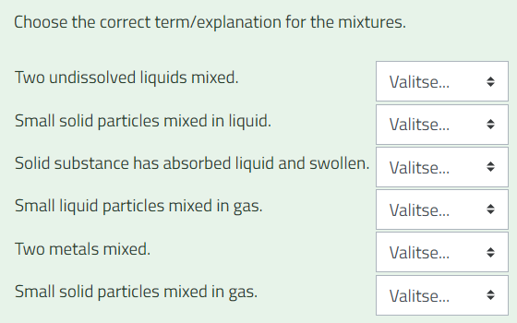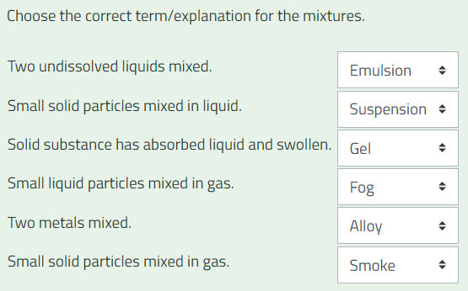

3. Air is...
a. Element
b. Homogeneous mixture
c. Compound
d. Heterogeneous mixture
Answer: b

4. Fish soup is...
a. Element
b. Homogeneous mixture
c. Compound
d. Heterogeneous mixture
Answer: d

5. Pure ethanol is...
a. Compound
b. Heterogeneous mixture
c. Homogeneous mixture
d. Element
Answer: a

6. Graphite is...
a. Heterogeneous mixture
b. Compound
c. Homogeneous mixture
d. Element
Answer: d (It’s carbon)

7. Bronze is...
a. Homogeneous mixture
b. Compound
c. Element
d. Heterogeneous mixture
Answer: a

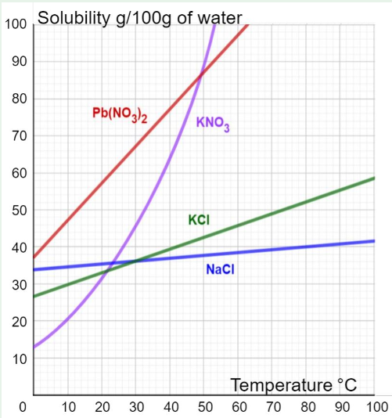
8.

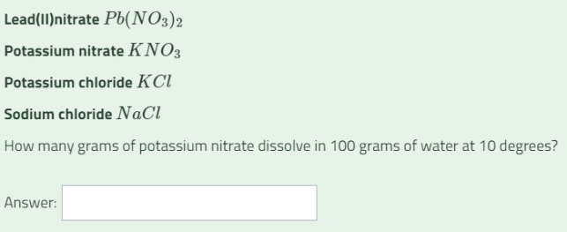

≈ 20 g
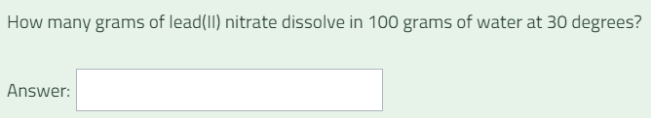

≈ 56 g

1.2.2 Task

Build the following atoms with AtomBuilder. Take a picture of each finished atom with the screenshot tool and paste it into a Word document. Return the word file here, named as Atoms.
You can find the number of elementary particles for each atom in this periodic table.
a) Lithium
b) Helium
c) Carbon
d) Oxygen

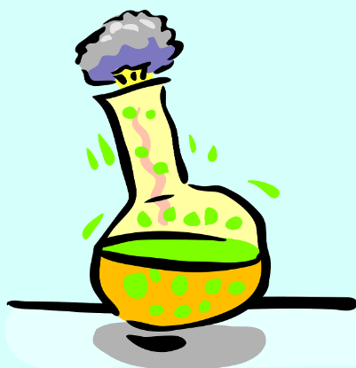
2. Chemical reactions
Learn about
- Chemical reactions
- Combustion
- Properties of metals
- Atomic bonding
- Oxidizing and reduction reactions
- Acids and bases

Think! Do these chemical phenomena have an above-average importance in your field? What kind of chemical phenomena do you deal with daily?

In a chemical reaction, new compounds are created. The elements do not change, but the reacting atoms rearrange themselves. The bonds of the starting materials are broken and the atoms form new bonds in the reaction products.

Factors that affect the reaction speed:
- The chemical properties of the substances
- Surface area
- Concentration
- Temperature
- Pressure (only with gas)
- Stirring
- Catalyst

Catalyst
A catalyst is a substance that speeds up a reaction, but its amount is not consumed in the reaction. That is, its presence is enough to speed up reactions.
Examples of catalysts can be found, for example, in cars. A Catalytic converter uses noble metals such as platinum or rhodium as catalysts. The function of the catalyst is to remove harmful gases from the exhaust gases, such as carbon monoxide.


Combustion is a chemical reaction with oxygen. In addition, burning requires a combustible substance (fuel) and heat.
Combustion produces oxides.
More about this in the next chapter LEARN: Chemical reaction_combustion.

Oxidation-reduction reactions
In these reactions, electrons are transferred from one atom to another. A substance is said to be oxidized when it gives up electrons and when it receives electrons it is said to be reduced.

In oxidation-reduction reactions one substance is oxidized and the other substance is reduced.
Examples of oxidation and reduction:
Zinc oxidizes:
Zn→Zn²⁺+2e⁻
Silver is reduced:
2Ag⁺+2e⁻→2Ag
Learn more about this in chapter LEARN: Chemical reactions_Oxidizing and reduction.

Rusting or corrosion
Less noble metal is corroded by the oxygen and moisture in the air. For example, iron rusts when left in the yard.
The greater the difference in reactivity between two metals, the easier they form an electrochemical pair, where one of the metals is reduced and the other is oxidized. For this reason, for example, a steel (steel contains iron) roof should not be fixed with copper nails (or a copper roof with iron nails).
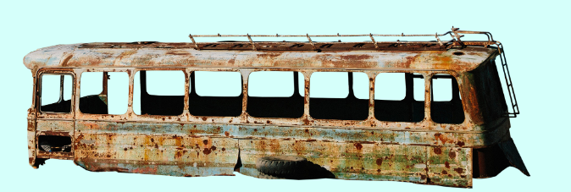
Protection against rust

- Regular maintenance.
- Painting metal.
- Using stainless steel.
- Galvanizing: Coating metal with another metal (zinc).
- Oiling, greasing, waxing e.g. bicycle chains, car bottom or surface.
- Galvanic anode or sacrificial anode


More examples about chemical reactions

Photosynthesis is a chemical reaction that binds carbon dioxide and water with the help of sunlight into sugar and oxygen. Sunlight is bound into chemical energy in plants.
The reaction equation is
6CO₂+6H₂O→C₆H₁₂O₆+6O₂

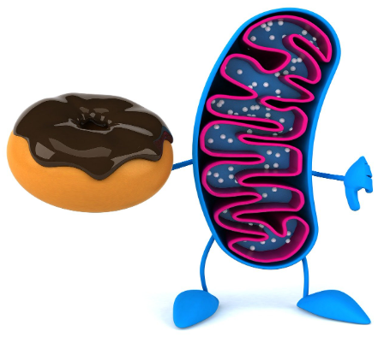
Cellular respiration is the reverse reaction to photosynthesis. It takes place in cells and provides energy for cell metabolism. Carbon dioxide, water and energy are therefore released in cellular respiration. In cells, energy is bound to ATP molecules, whose energy the cell can further use for other reactions.
sugar+ oxygen → carbon dioxide + water
C₆H₁₂O₆+6O₂ → 6CO₂+6H₂O

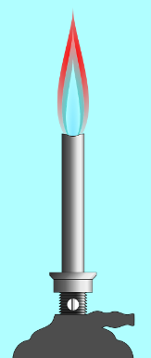
2.1 Chemical reactions: combustion

When hydrogen and oxygen react with each other, water is produced. This reaction is called the hydrogen combustion reaction. The systematic name for water in chemistry is dihydrogen monoxide. Generally, in a combustion reaction, some substance reacts chemically with oxygen and oxides are formed as reaction products.
When a flame is visible in the combustion reaction, we speak of rapid combustion. Burning without a flame is slow burning. Examples of slow burning are food digestion, rusting, rotting and decompose.

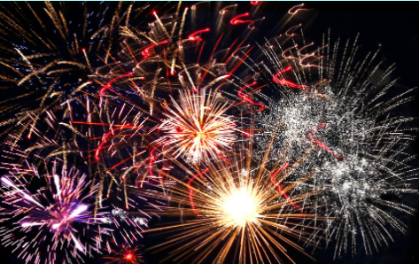
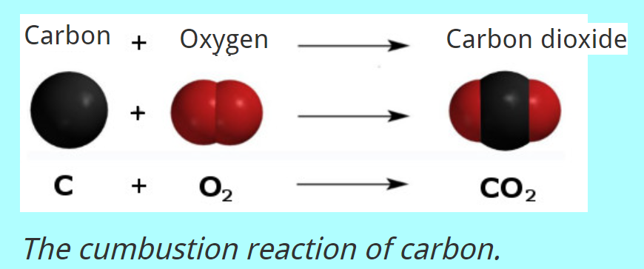

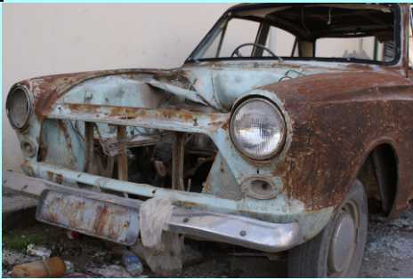
Rapid combustion.

Slow burning (rusting).

Example. Let's burn a magnesium strip and write a reaction equation for it. The reaction reactants are placed on the left side of the equation and the reaction products are placed on the right side of the equation.
2Mg+O₂→2MgO
No substance is lost in the reaction. So always check that you have the same amount of atoms on both sides.
This reaction equation is balanced.

Combustion can only occur when the temperature is high enough. However, the ignition temperature varies for different substances.
Combustion must always include oxygen and combustible material. Note that not all substances burn. Such substances include, for example, water and carbon dioxide. They do not burn because they are products of combustion.

Extinguishing a fire is based on interfering with the combustion event. A fire can be extinguished by removing one of the components of the fire, either by reducing the heat, removing combustible materials or reducing the oxygen concentration.
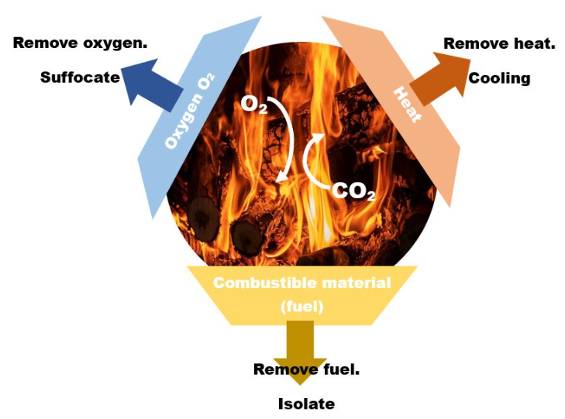
Isolate
Suffocate
Cool

2.2 Chemical reactions: Oxidation and reduction and metals

Chemical reactions happen because each atom wants eight valence electrons, or an octet. Atoms either donate their valence electrons (in whole or in part) to another atom or complete their valence shells by receiving electrons (in whole or in part) from another atom.
The number of valence electrons of an atom depends on whether it is easier for it to donate, receive or share electrons.
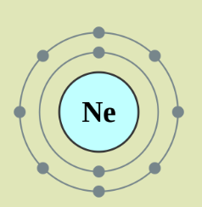
When an element gives up electrons, it becomes oxidized. An element that takes electrons is reduced. When elements react, the number of electrons given and received must be equal.

The noble gases have a full octet in their valence shell, except for helium, which only has two electrons in its only shell. Due to their electronic structure, they do not easily participate in chemical reactions.

Ionic compounds
When a metal and a non-metal react with each other, ionic compounds are created. A metal atom donates all its outer electrons to a non-metal atom. After donating the electrons, the metal atom gains a positive charge, so it is called a positive ion.
Similarly, a non-metal atom becomes a negative ion by receiving electrons. There is an electrical attraction between the positive and negative charges that holds the ions together: an ionic compound is formed.
In chemistry, all ionic compounds are called salts (salt).
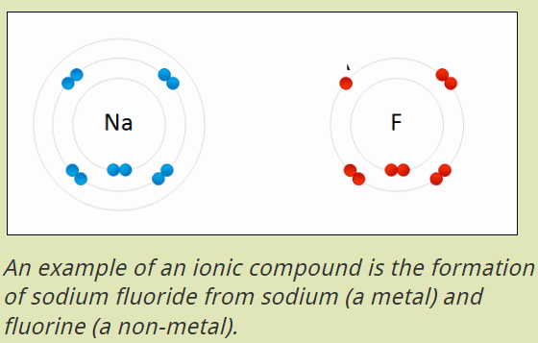Animaatio

Molecular compound
Nonmetal atoms share outer electrons with each other rather than give them to each other. The bond formed from shared electron pairs is called a covalent bond (or molecular bond) and the resulting compound is a molecular compound.

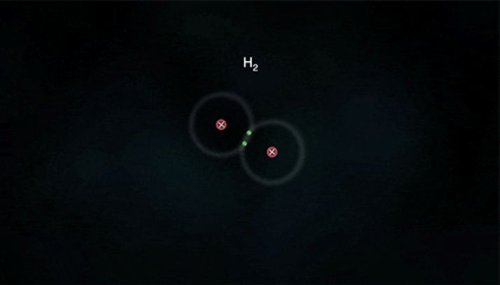Animaatio
Hydrogen atoms share their single electron with another hydrogen atom to form a hydrogen molecule.
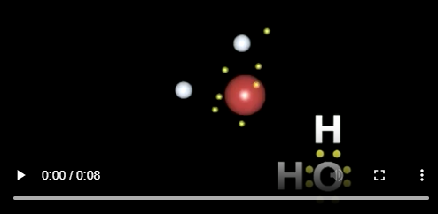 Video
In the video, an oxygen atom and two hydrogen atoms share electrons to form a water molecule.

More than half of the elements are metals. Metal atoms are held together by metallic bonding, which explains the properties of metals.

Metallic bonding
Due in part to the metallic bonds between atoms, metals have certain properties.
Properties of metals
- conduct electricity and heat
- toughness and malleability
- high density
- impervious to light
- shiny
- solid at room temperature (except mercury)
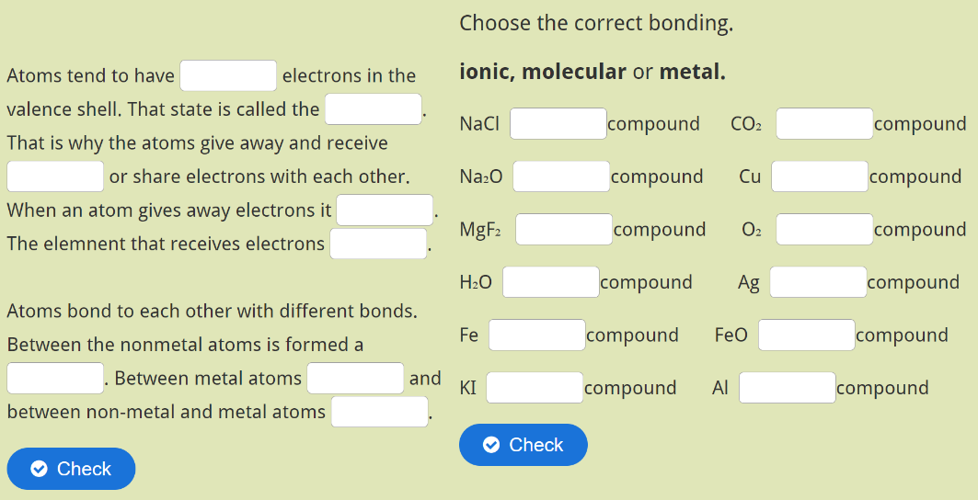
Atoms tend to have *8/eight* electrons in the valence shell. That state is called the *octet*. That is why the atoms give away and receive *electrons/valence electrons* or share electrons with each other. When an atom gives away electrons it *oxidises/oxidizes*. The element that receives electrons *reduces*.
Atoms bond to each other with different bonds. Between the nonmetal atoms is formed a *covalent bond/molecular bond/molecular compound*. Between metal atoms *metal bond/metallic bonding/metal compound* and between non-metal and metal atoms *ionic bond/ionic compound*.
NaCl *ionic*compound CO₂ *molecular*compound
Na₂O *ionic*compound Cu *metal*compound
MgF₂ *ionic*compound O₂ *molecular*compound
H₂O *molecular*compound Ag *metal*compound
Fe *metal*compound FeO *ionic*compound
KI *ionic*compound Al *metal*compound

Galvanic series
Different metals react with other substances in different ways. Such reactions include e.g. combustion, reactions with water, hydrochloric acid or another metal. For example, gold does not rust (slow burning), but iron does.
A metal’s reactivity depends on how easily it can donate its electrons to other substances. In the reaction, the metals are oxidized into positive metal ions.
Two metals can react with each other when one is in elemental form (uncharged) and the other as a positive ion (+).
For example, in the reaction between iron and a copper ion, the copper ion accepts two electrons from the iron. The copper ion is reduced to elemental form and the iron atom is oxidized to ionic form.
Fe + Cu²⁺ ---> Fe²⁺ + Cu
Cu + Fe²⁺ ---> Cu²⁺ + Fe this reaction does not occur because iron gives up electrons (i.e. oxidizes) more easily than copper.
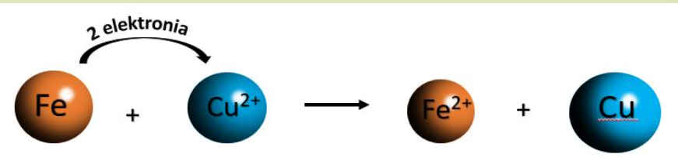

Metals can be arranged according to their reactivity. It's called galvanic series.
In general, noble metals do not react with acids to release hydrogen. Noble metals are, for example, copper, silver, platinum and gold.
Less noble metals react with acids to release hydrogen and they form ions easily.
Galvanic series
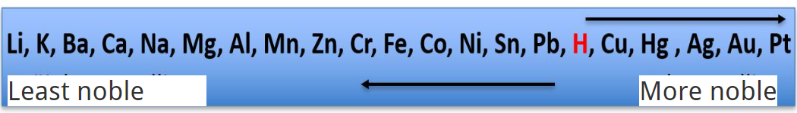
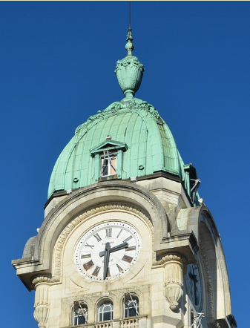
Copper is a noble metal and does not corrode even in humid conditions. It has been used, for example, as a roofing material for valuable buildings. Copper first turns into black copper oxide. This further reacts with water and oxygen to form copper hydroxide and copper carbonate. These give the copper a green surface called patina. The patina protects the underlying copper from moisture and oxygen.

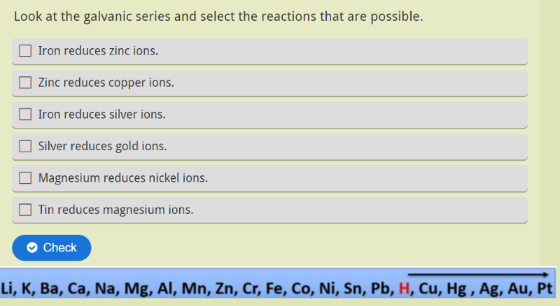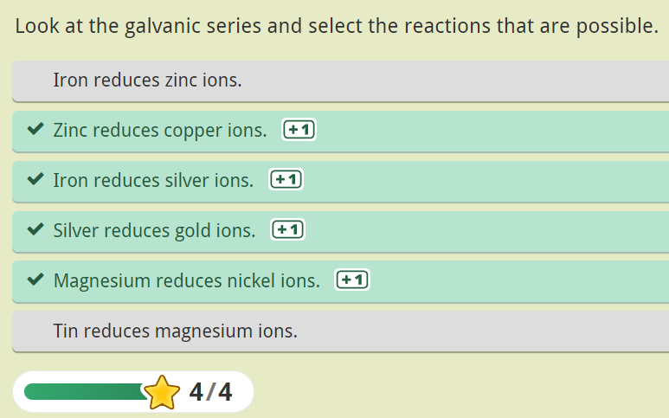

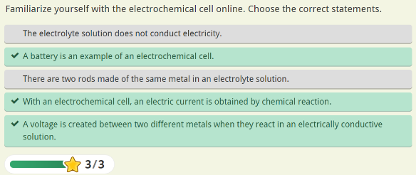
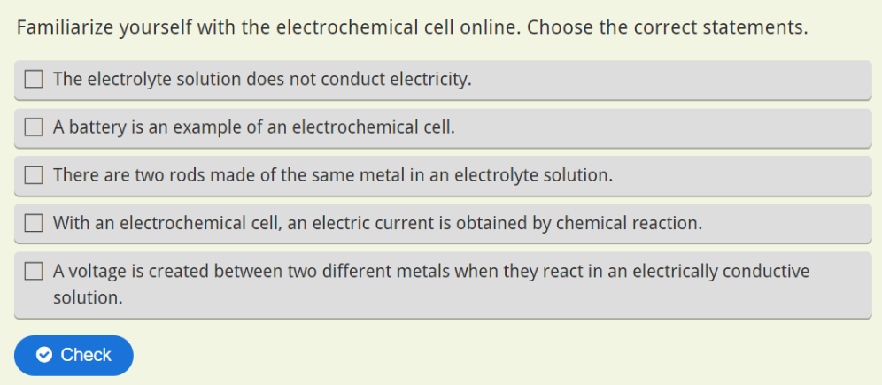

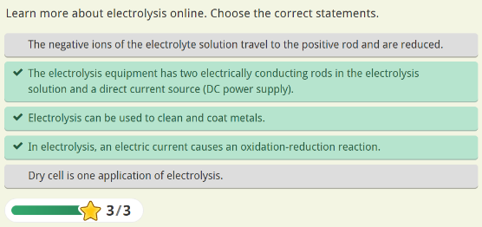
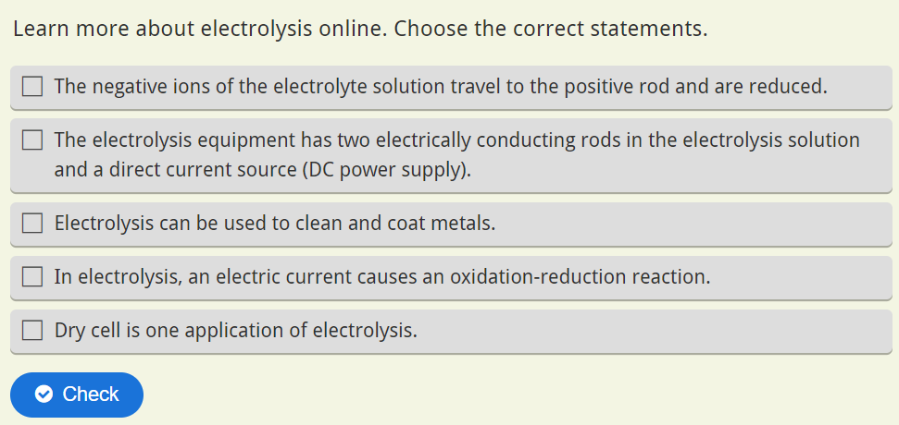

2.1 Tasks
- In an ionic bonding, atoms donate or receive electrons.
True Answer: True
False
- A negative ion is created when an atom gives up electrons.
True Answer: False
False
- Metals conduct electricity because the electrons stay in their specific positions.
True Answer: False
False
- No octet is formed in a covalent bond.
True Answer: False
False
- A metal and a non-metal can form ionic compounds with each other.
True Answer: True
False
- When an atom gives up two electrons, it gets a charge of magnitude...
- -1 Answer: b. +2
- +2
- 2
- +1

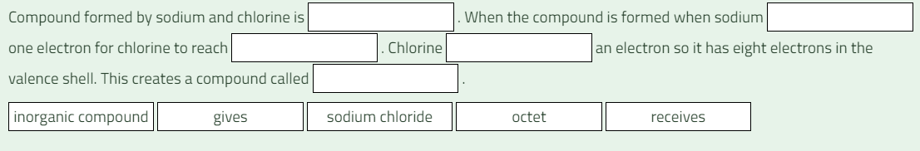
- Compound formed by sodium and chlorine is [[1]]. The compound is formed when sodium [[2]] one electron for chlorine to reach [[3]]. Chlorine [[4]] an electron so it has eight electrons in the valence shell. This creates a compound called [[5]].
Answers
[[1]] inorganic compound
[[2]] gives
[[3]] octet
[[4]] receives
[[5]] sodium chloride
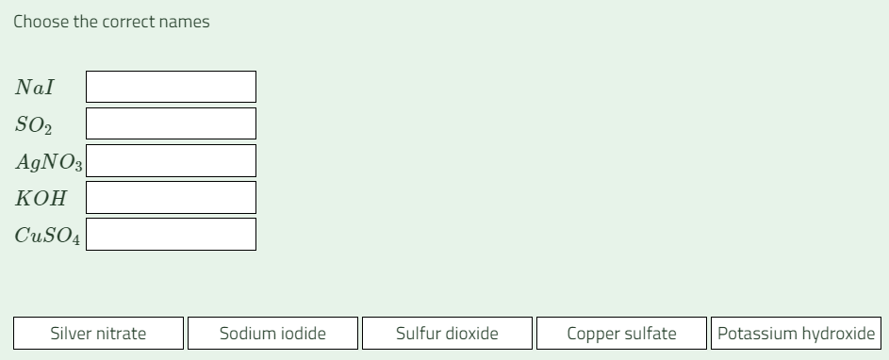
- Choose the correct names.
\(NaI\) | [[1]]
\(SO_2\) | [[2]]
\(AgNO_3\) | [[3]]
\(KOH\) | [[4]]
\(CuSO_4\) | [[5]]
Answers
[[1]] Sodium iodide
[[2]] Sulfur dioxide
[[3]] Silver nitrate
[[4]] Potassium hydroxide
[[5]] Copper sulfate

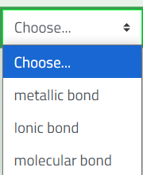
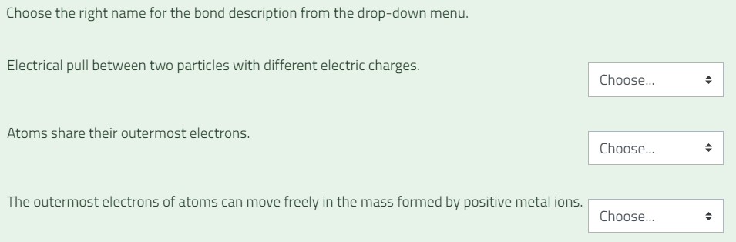
Answer
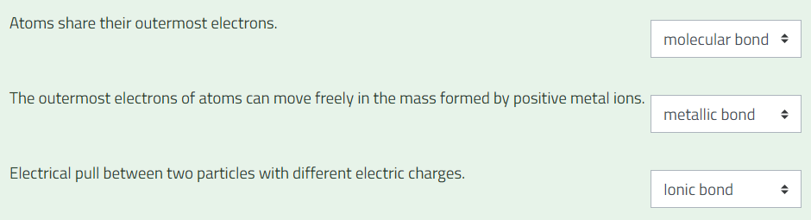
- Choose the right name for the bond description from the drop-down menu.
Electrical pull between two particles with different electric charges.
The outermost electrons of atoms can move freely in the mass formed by positive metal ions.
Atoms share their outermost electrons.

- Choose the properties of metals from the list below.

a. Large density.
b. Conducts electricity.
c. Translucent.
d. Easily malleable.
e. Solid in room temperature.
f. Easily crumbles.
g. Conducts heat.
h. Hard to mix with other metals.

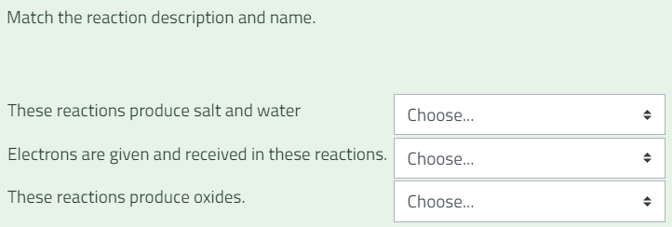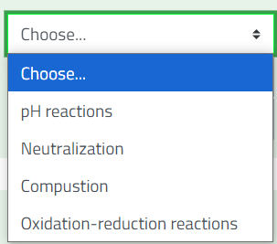

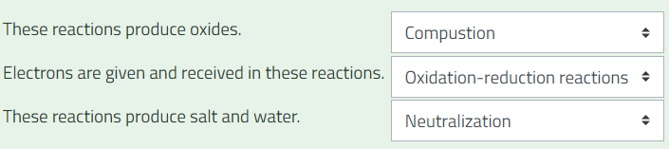
- Match the reaction description and name. Answer
These reactions produce salt and water.
Electrons are given and received in these reactions.
These reactions produce oxides.
- The copper roof can be nailed with iron nails.
True Answer: False
False
- Iron atoms are reduced when they rust.
True Answer: False
False
- In the following reaction, zinc is oxidized:
Zn→Zn²⁺+2e⁻
True Answer: True
False
- Oxygen is released in cellular respiration.
True Answer: False
False
- Oxygen is released in photosynthesis.
True Answer: True
False
- Check the reaction equations so that both sides have the same number of atoms and correct the coefficients. Answers
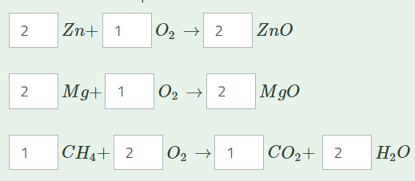
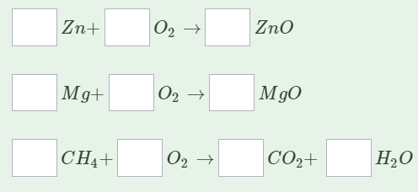
- What is rust and how can it be prevented/slowed down?

- Choose the statements from the list where a chemical reaction takes place.
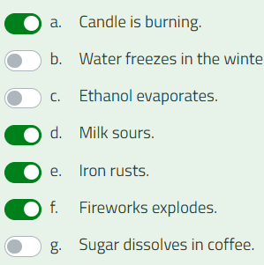
a. Fireworks explodes. Answers
b. Ethanol evaporates.
c. Water freezes in the winter.
d. Sugar dissolves in coffee.
e. Iron rusts.
f. Milk sours.
g. Candle is burning.

2.3 Acids and bases
A substance can be acidic, basic or neutral. You can recognize an acidic food by its sour taste. Acidic substances include e.g. apples, oranges, grapefruit, sourdough bread, sour milk products such as buttermilk and yogurt.
Most detergents are alkaline. Alkaline substances feel slippery on the fingers. Both strong acids and strong bases are corrosive and can act as solvents.
Video https://www.youtube.com/watch?v=ja7p_tzTTEA&t=1s
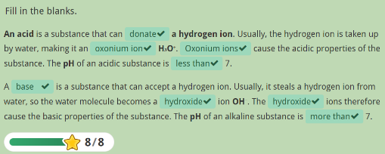
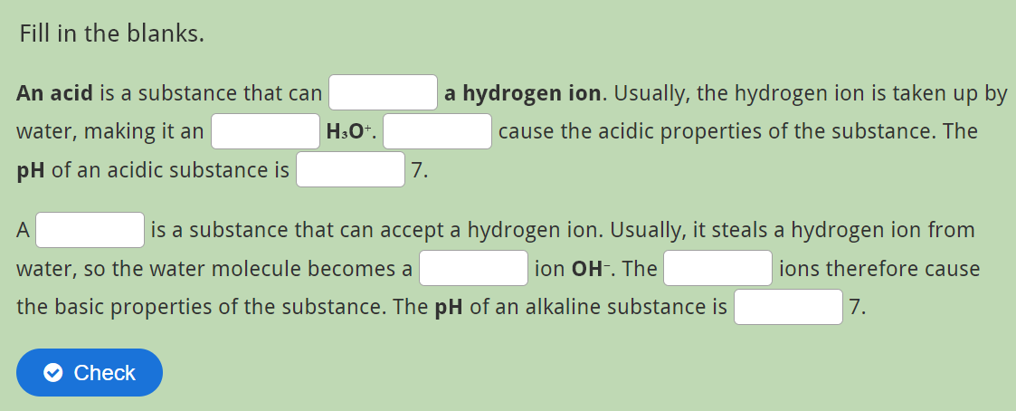
Fill in the blanks.
An acid is a substance that can_____ a hydrogen ion. Usually, the hydrogen ion is taken up by water, making it an_____ H₃O⁺. _____cause the acidic properties of the substance. The pH of an acidic substance is_____ 7.
A _____ is a substance that can accept a hydrogen ion. Usually, it steals a hydrogen ion from water, so the water molecule becomes a _____ ion OH⁻. The _____ ions therefore cause the basic properties of the substance. The pH of an alkaline substance is _____ 7.

The measure of acidity is the pH value
Some acidic substances are more acidic than others and some basic substances are more basic than others. This means that acids and bases can vary in strength.
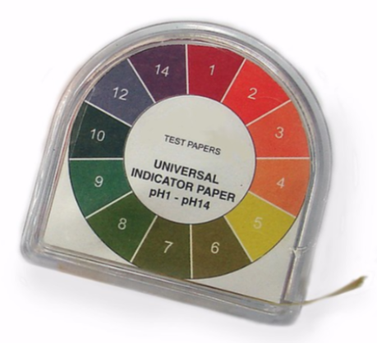
The acidity of substances is measured from their aqueous solution and expressed on the pH scale. The pH value indicates how many oxonium ions are present in the aqueous solution. The lower the pH of the aqueous solution, the more oxonium ions it contains and the more acidic it is.
pH < 7, solution is acidic.
pH = 7, solution is neutral.
pH > 7, solution is basic.

Indicator paper. There is a color scale in the side of the container.

The indicator
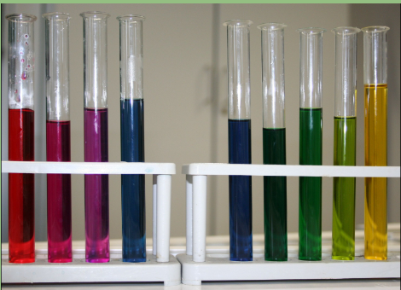
The pH indicator indicates whether the substance is acidic or basic by a color change. Indicators include, for example, phenolphthalein and pH paper. The blue and red dyes (anthocyanins) present in the cell fluid of some plants are also indicators. Such natural indicators can be found, among others, in red cabbage and blueberries. Since the color of the indicator only indicates whether the solution is acidic, neutral or basic, a pH meter is used to determine the exact pH value.

There is red cabbage juice in the test tubes. Acids and bases of different strengths have been added to the juice, so the color of the juice varies.

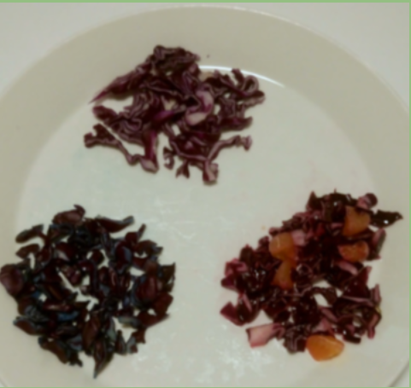

In the upper part of the plate is pure red cabbage, on the left is red cabbage with baking soda and on the right is red cabbage with some orange added.

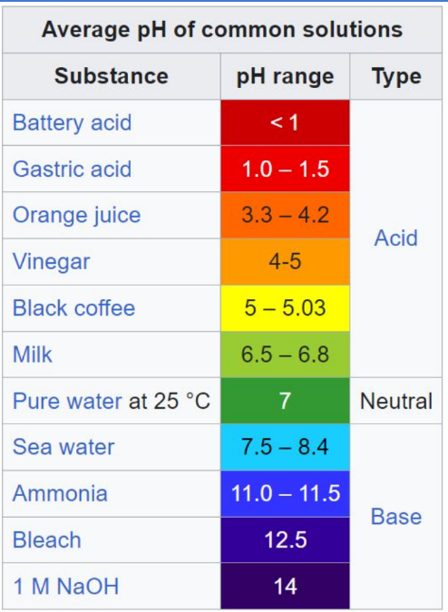
The table contains the pH values ​​of some substances. The table is a screenshot from Wikipedia's Acidity page: https://en.wikipedia.org/wiki/PH

Neutralization
A neutralization reaction is an event where equal amounts of acidic and basic substances are mixed together. In this case, the acidic and basic properties of the substances disappear and the solution becomes neutral (pH= 7).
acid + base => salt + water
Example NaOH + HCl => NaCl + H₂O
sodium hydroxide + hydrochloric acid => sodium chloride + water
Sodium chloride is known as table salt.
https://www.youtube.com/watch?v=aXs4gS43rko

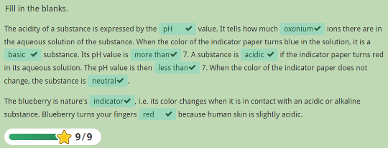
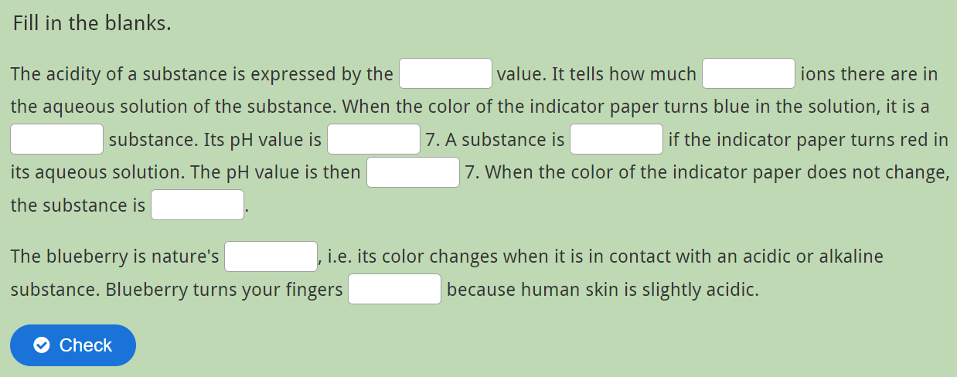

Fill in the blanks.
The acidity of a substance is expressed by the _____ value. It tells how many _____ ions there are in the aqueous solution of the substance. When the color of the indicator paper turns blue in the solution, it is a _____ substance. Its pH value is _____ 7. A substance is _____ if the indicator paper turns red in its aqueous solution. The pH value is then _____ 7. When the color of the indicator paper does not change, the substance is _____.
The blueberry is nature's _____, i.e. its color changes when it is in contact with an acidic or alkaline substance. Blueberry turns your fingers _____ because human skin is slightly acidic.

https://phet.colorado.edu/sims/html/ph-scale-basics/latest/ph-scale-basics_all.html
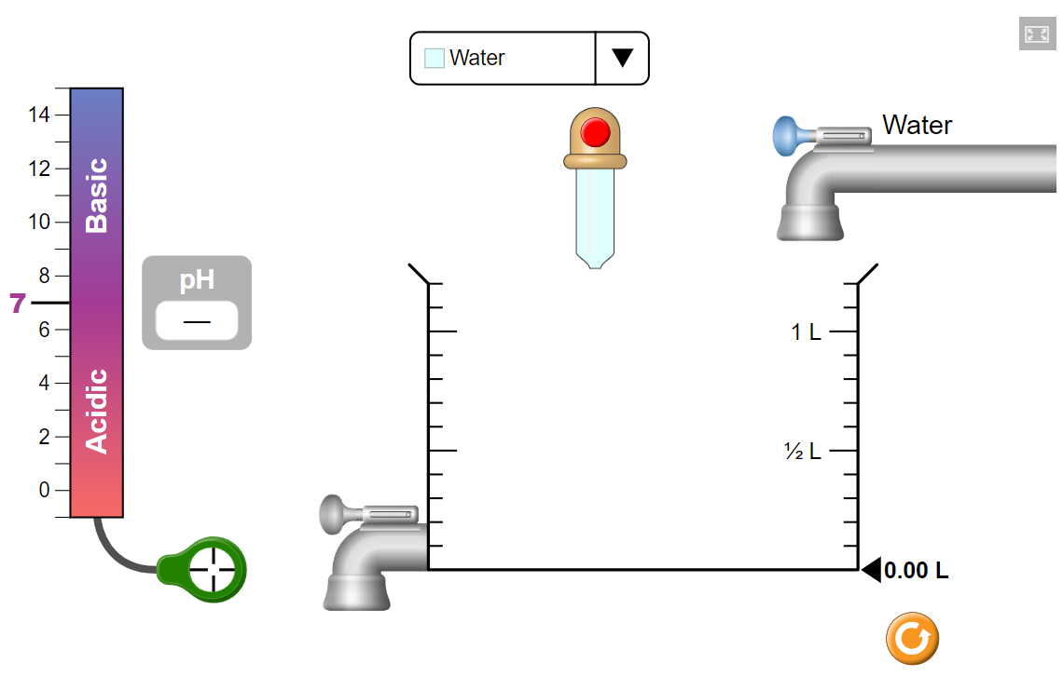
Do the pH measurement task and measure the pH values ​​for the following substances:

What is the pH value of pure water? 7
What is the pH value of battery acid? 1
What is the pH value of blood? 7,4
What is the pH value of chicken soup? 5,8
What is the pH value of coffee? 5
What is the pH value of drain cleaner? 13
What is the pH value of hand soap? 10
What is the pH value of milk? 6,5
What is the pH value of orange juice? 3,5
What is the pH value of soda pop? 2,5
What is the pH value of spit? 7,4
What is the pH value of vomit? 2

3. Concentration

The goal is to learn

- What does the chemical quantity mass percentage mean?
- What does the chemical quantity volume percentage mean?
- How to calculate mass percentages?
- How to calculate volume percentages?

Think about it! In what situations do you calculate concentration in your work?

3.1 Mass percentage
A nurse said that a glass (2,5 dl) of soda contains about the equivalent of 10 sugar cubes. What percentage is this, meaning what is the sugar content of the soda?

The concentration can be calculated either as mass percentage or volume percentage. In this example, the volume of the sugar is unknown, but the mass is known.

The mass of a sugar cube is 3,2 g. Therefore, we will calculate the mass percentage. The mass of the soda is 250 g.

The mass percentage is calculated by dividing the mass of the dissolved substance by the total mass of the solution. In this example, sugar is considered the dissolved substance and soda is the solution.

There are ten sugar cubes, so the mass of the sugar is 10 ∙ 3.2 g = 32 g.

The sugar content of the soda =

$\frac{32 g}{32 g + 250 g}$∙ 100 % = 11,3... % ≈ 11 %

The result of 11% means that the soda consists of 11% sugar and 89% other ingredients.

In this another example 50 g of salt is dissolved in 10 liters of water. Calculate the salt concentration of the resulting solution.

The amount of salt is given in grams. Let's also convert the amount of water to grams. When the volume of water is one liter, its mass is one kilogram. Therefore, the mass of 10 liters of water is 10 kilograms, or 10 000 grams.

Salt concentration =

$\frac{mass of the salt}{total mass of the solution}$∙ 100 % =

$\frac{50 g}{10 050 g}$∙ 100 % = 0,5 %

3.1.1 Tasks

- Dissolve 12 g of table salt in five liters of water. Calculate the salt concentration of the resulting solution.
Solution: $\frac{12 g}{12 g + 5 000 g}∙ 100 \% =0,2 \%$
- Dissolve 100 g of sugar in 2,5 liters of water. Calculate the sugar concentration of the resulting solution.

Solution: $\frac{100 g}{100 g + 2 500 g}∙ 100 \% =3,8 \%$
- What is the concentration of the saline solution in mass percentage if there are 150 g of salt in 3 kg of solution?
Solution: $\frac{150 g}{3 000 g}∙ 100 \% =5 \%$
- In the preparation of sweet berry jam, a 35% sugar solution is used. How much sugar has been dissolved in the water if 1,5 kg of solution is prepared?

Solution: $0,35 ∙ 1,5 kg =0,525 kg = 525 g$

- Brass contains 55% copper and 45% zinc. If a brass object has a mass of 1 750 g, how much copper is in the object? And how much zinc?

Solution:

Copper $0,55 ∙ 1 750 g =962,5 g ≈960 g$
Zink $0,45 ∙ 1 750 g =787,5 g ≈790 g$

- You need to prepare a 2% sugar solution. How much sugar should you weigh if you have half a liter of water?
Solution:

$$\frac{x}{x + 500 g}= 0,02$$

X = 10 g

3.2 Volume percentage
The concentration of a solution can be expressed as a volume percentage when both the solute and the solvent are in liquid form.

Mix one liter of apple juice concentrate (concentration 100%) with four liters of water. What is the concentration of apple juice in the resulting diluted apple juice?

The volume percentage is calculated by dividing the amount of concentrate by the total volume of the final juice.

The volume percentage =

$\frac{volume of dissolved subs\tan{c}e}{volume of the solution}∙ 100 \%$ =

$$\frac{1 l}{1 l + 4 l}∙ 100 \% = 20 \%$$

3.2.1 Tasks

- Dissolve 15 ml of acetone in one liter of water. What is the acetone concentration of the resulting solution?

Solution: $\frac{15 ml}{15 ml + 1000 ml}×100 \% =1,5 \%$

- Dissolve 125 ml of alcohol in 625 ml of water. What is the alcohol concentration of the resulting solution?

Solution: $\frac{125 ml}{125 ml + 625 ml}×100 \% =17 \%$
- A wine is stated to have an alcohol concentration of 8 %. How many milliliters of alcohol are in a 750 ml bottle of wine?
Solution: 0,08 × 750 ml = 60 ml

- E85 gasoline consists of ethanol and regular gasoline. It contains 15 % ethanol and 85 % regular gasoline. If the car’s tank volume is 55 liters and the tank is filled to capacity, how much ethanol is added? And how much regular gasoline?

Solution:

Ethanol: 0,15 × 55 l = 8,25 l
regular gasoline: 0,85 × 55 l = 46,75 l

- Two lye solutions are mixed together. The first solution has a concentration of 3 % and a volume of 2 liters. The second solution has a volume of 4 liters and a lye concentration of 2 %. What is the lye concentration of the resulting solution after mixing?

First solution: 0,03 × 2 l = 0,06 l
Second solution: 0,02 × 4 l = 0,08 l

Amount of lye (100 %) = 0,06 l + 0,08 l = 0,14 l

Total volume = 2 l + 4 l = 6 l

The lye concentration in the end = $\frac{0,14 l}{6 l}×100 \% =2,3 \%$

4. Amount of substance

The goal is to learn
- What does amount of substance mean?
- How to calculate the amount of substance?
- How to calculate the mass when the amount of substance is known?

Think about it! In what situation in your job is it important to know what the amount of substance means?

4.1 What does amount of substance mean?
If you were asked, what is meant by amount of substance, what would you answer? You might answer that it refers to how much of a substance there is. The quantity could be expressed using mass (kilograms) or volume (for example liters).

The answer would be correct, but when it comes to chemical quantity, the unit is not kilogram or liter. In this paragraph, you will learn a new way to express the amount of substance.

Amount of substance is a fundamental quantity in the SI system. Its unit is the mole. The mole indicates the quantity of constituent particles in a substance. Constituent particles are atoms and molecules.

One mole is 6,022 • 10²³ constituent particles. This number is called Avogadro's number after its discoverer, Amedeo Avogadro.

The symbol for amount of substance is n.
The symbol for the unit of mole is mol.

4.1.1 Tasks

1. Write Avogadro’s number without exponential notation.
Solution: 6022 000 000 000 000 000 000 00
2. How many oxygen atoms are there in one mole of oxygen gas?
Solution: 60,22 ∙ 10²³
3. How many carbon atoms are there in five moles of carbon?
Solution: 3 011 000 000 000 000 000 000 000 = 3,011 ∙ 10²⁴
4. How many moles are there in 18,066 ∙ 10²³ iron atoms?
Solution: 3
5. How many moles are there in 60,22 ∙ 10²³ sodium atoms?
Solution: 10

4.2 How to calculate the amount of substance?

To calculate the amount of substance, you need to know the molar mass of the substance. The unit of molar mass is g/mol, which means molar mass is the mass of a substance when there is one mole of it.

Molar mass is calculated using the atomic masses found in the periodic table.

Let's now calculate the molar mass of water. The symbol for molar mass is M.

M(H₂O) = 2 * hydrogen atomic mass + oxygen atomic mass
M (H₂O) = 2 * 1 g/mol + 16 g/mol = 18 g/mol

Let's calculate another example.
What about the molar mass of hydrochloric acid, HCl, how is that calculated?

M(HCl) = hydrogen atomic mass + chlorine atomic mass
M(HCl) = 1 g /mol + 35 g/mol = 36 g/mol

The amount of substance is now calculated by dividing the mass of the sample by its molar mass.
This is expressed as an equation:

n = $\frac{m}{M}$

n = amount of substance (mol)
m = mass (g)
M = molar mass (g/mol)

3.2.1 Tasks
1. Let's weigh a teaspoon of table salt. The mass is 5 g. What is the amount of substance? The chemical formula of table salt is NaCl.

Solution:
M(NaCl) = 58 g/mol
n = 5 g / 58 g/mol = 0,09 mol

2. Let's weigh a tablespoon of baking soda. The mass is 9 g. What is the amount of substance? The chemical formula of baking soda is NaHCO₃.

Solution:
M(NaHCO₃) = 84 g/mol
n = 9 g/84 g/mol = 0,11 mol

4.3 How to calculate the mass?

What if we want to determine the mass when the amount of substance and molar mass are known? We need to solve for mass first from the equation involving the amount of substance. Let's write down a numerical calculation next to the equation involving the amount of substance.

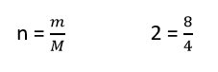

In the numerical example, the number 8 is in the same position as the requested mass (m) in the equation for the amount of substance. The question then is, how can 8 be calculated using the numbers 2 and 4? Multiplication!

So, we can conclude that mass is calculated by multiplying the amount of substance and molar mass together.

m= n • M

4.3.1 Tasks
1. In the laboratory work, 2 moles of sodium hydroxide (NaOH) are needed. How many grams of sodium hydroxide should be weighed for the task?

Solution:
M(NaOH) = 40 g/mol
m = 2 mol × 40 g/mol = 80 g

2. In the laboratory work, 3.5 moles of hydrochloric acid (HCl) are needed. How many grams of hydrochloric acid should be weighed for the task?

Solution:
M(HCl) = 36 g/mol
M = 3,5 mol × 36 g/mol = 126 g

5. Chemical safety

The goal is to learn
- the concept of a "hazardous chemical"
- to read a safety data sheet
- what are TVATM symbols and H-statements
- what hazardous chemicals are used in your field

Think about it! Are hazardous chemicals handled more frequently in your field?

5.2 Theory
A chemical is a substance that 1) has a known structure and 2) has a name corresponding to its structure. A chemical can be an element, a chemical compound, or a mixture formed from the aforementioned.  A synthetic chemical is a substance produced by the chemical industry for a specific intended use (e.g., medicines, hygiene products, cleaning agents, etc.). | 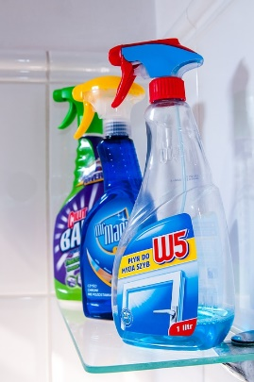

Some chemicals can be hazardous to humans or the environment. Chemicals are classified with warning labels according to the danger they pose: 1) flammable and explosive, 2) hazardous to health, and 3) hazardous to the environment.  In Finland, the Safety and Chemicals Agency (Tukes) monitors and promotes the safety of chemicals. | 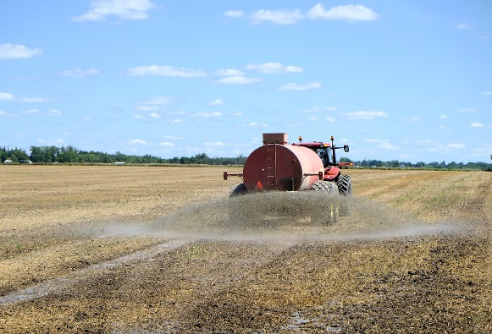

Safe use of a chemical requires knowledge of its composition, hazardous properties, as well as safe usage methods and conditions. Therefore, the workplace must have an up-to-date list of hazardous chemicals and safety data sheets (SDS) available to employees. The safety data sheet provides information on the hazardous properties of the chemical and safe handling practices.

When selecting chemicals for use, the goal is to choose a product that is as safe as possible and suitable for its intended purpose. It is also important to consider the amount of waste generated from the use of the chemicals and how that waste will be managed.

It must also be determined at the workplace whether chemical exposure occurs during work or work processes. The hazards related to exposure are assessed, and measures are implemented to ensure that the risks are controlled.

Safety data sheet  The safety data sheet contains essential information about the chemical's properties, hazards, health effects, and safe storage, handling, and disposal.  The safety data sheet is prepared by the chemical manufacturer, distributor, or another party responsible for placing the chemical on the market. The safety data sheet is delivered to the workplace with the first shipment of the chemical.  Here is an example of the safety data sheet for the cleaning agent ROST OFF BLUE ICE. | 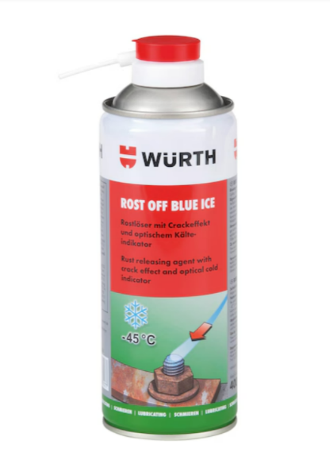

The content of a Safety Data Sheet  - Identification information  On the first page, you will find the trade name of the chemical, the contact information of the chemical's supplier, and the intended uses of the chemical. | 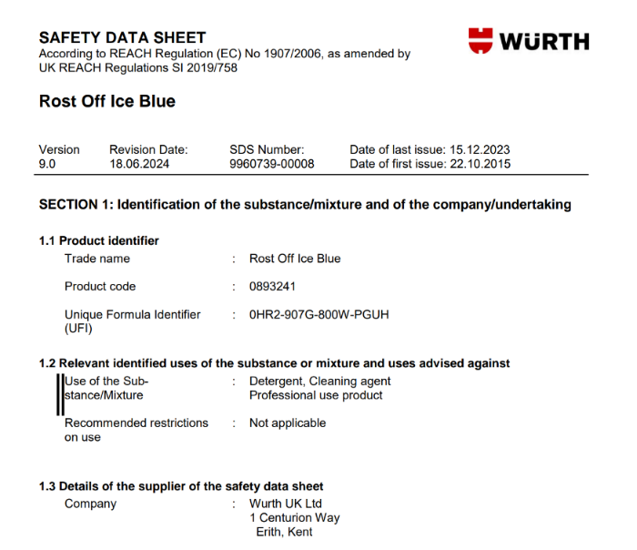

- Hazard identification  The hazard classification of the product and the warning labels provide an overview of the potential dangers that may arise from using the chemical.  The hazard statements (H-statements) of the chemical are used in workplace risk assessments, and the precautionary statements (P-statements) are used for prevention. | 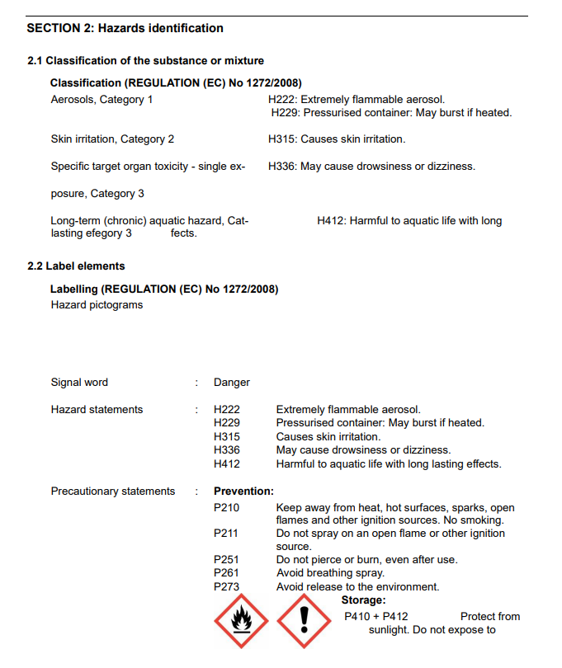

- Composition  The table of hazardous ingredients in the chemical includes, in addition to the ingredient's name, its concentration in the product (%) and its hazard classification. | 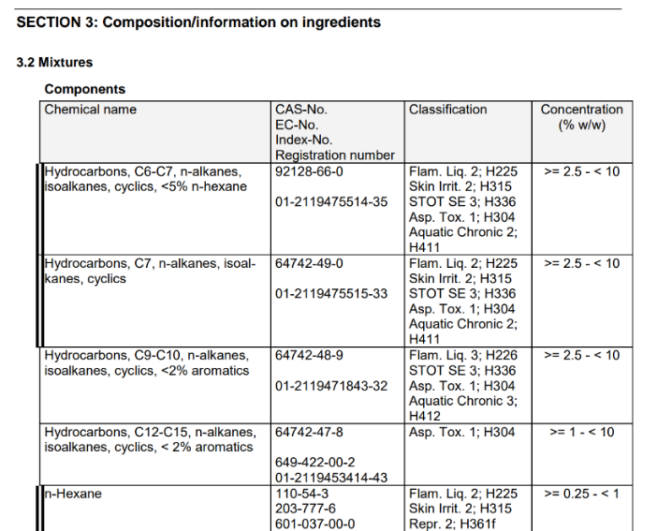

4.First-aid measures  The first-aid measures describe the actions to take if the chemical has been inhaled, has come into contact with the skin or eyes, or has been ingested. Additionally, the main symptoms and effects caused by exposure are described. | 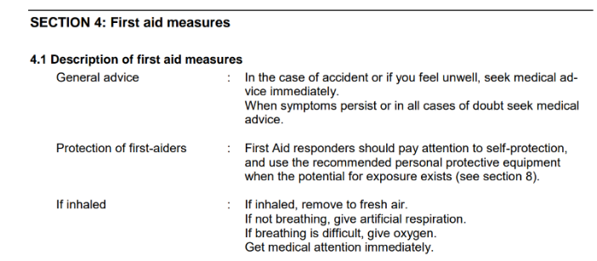

5.Firefighting measures  Suitable extinguishing agents for fire situations and other fire prevention instructions. | 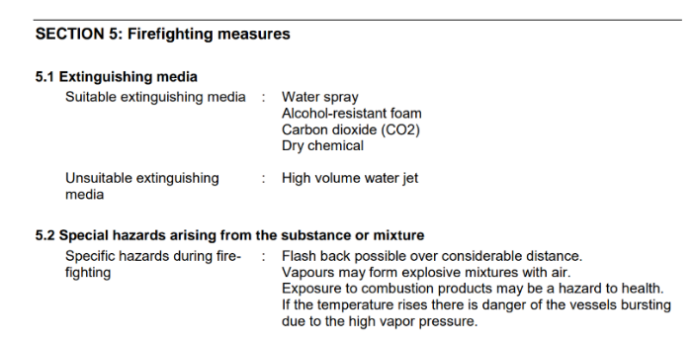

7. Handling and storage  Instructions regarding the use of chemicals, storage conditions, equipment, or other technical solutions (e.g., ventilation arrangements). | 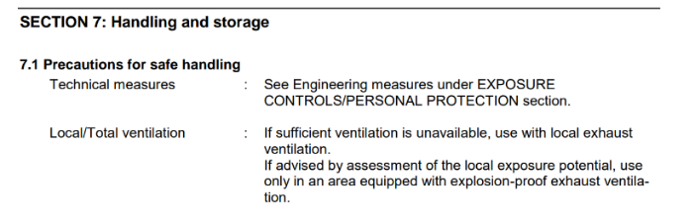

8. Exposure prevention and personal protective equipment  Guidelines for managing exposure and the occupational exposure limits (OELs), including HTP values and biological exposure limit values, used in exposure assessment. | 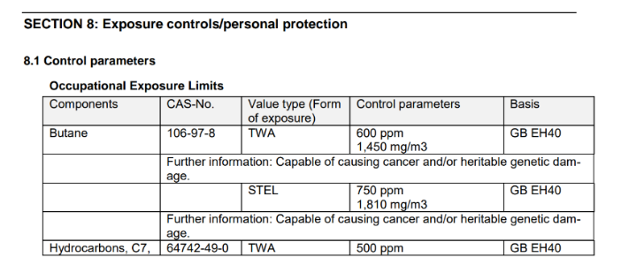

9. Physical and chemical properties
Information about the chemical's properties, such as state, odor, color, acidity, melting and boiling point, solubility, etc.

10. Stability and reactivity
Information on possible hazardous reactions, conditions to avoid, and incompatible materials.

11. Information related to toxicity
12. Information on environmental hazards
13. Waste disposal considerations
Instructions for disposing of both used and unused products and packaging.

13. Transport information
15. Regulatory information
16. Other information

At the workplace, it is important to be familiar with at least those sections of the safety data sheet that indicate the hazardous properties of the product, first aid instructions, exposure prevention, and required personal protective equipment.

Chemical packaging warning labels include hazard symbols, precautionary statements, and danger and safety phrases. Everyone should know what the different hazard symbols mean.

Guidelines for the Safe Use of Chemicals in School and the Workplace
- Ensure that you have received training and work instructions for the use of the chemical.
- Familiarize yourself with the chemical's hazard properties before starting work and be aware of any potential dangers.
- Make sure you understand the instructions for the safe use and storage of the chemical.
- Ensure that you know how to respond in emergency or accident situations if necessary.
- Verify that the safety data sheet has the same chemical name as the chemical packaging.
- If in doubt, ask your teacher, workplace supervisor, or employer!

5.2 Tasks

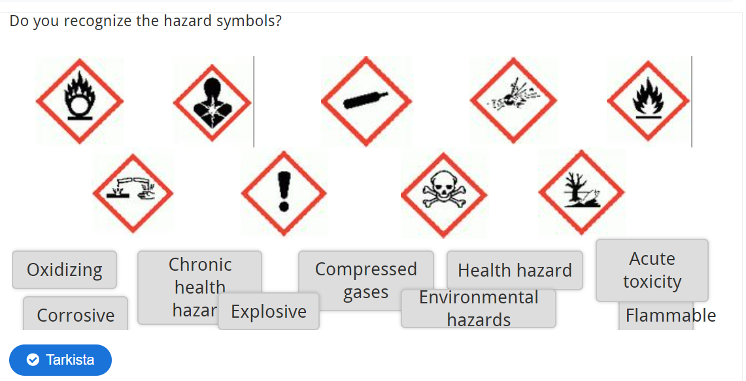
Hazardous chemicals in your field of study (approved/assessed by teacher)
- Create a Power Point presentation titled "Hazardous Chemicals in My Field of Study." The presentation should include a Title Slide + at least 5 slides.
- Start by describing generally what types of chemicals are used in your field and in what kinds of tasks they are used.
- Define what constitutes a hazardous chemical and describe what hazardous chemicals are present in your field and what kind of harm they can cause.
- Take a photo (or find an image online) of three hazardous chemicals in your field. Present each chemical on its own slide.
- Include a link to the safety data sheet for each chemical. You can find this by googling "chemical name + safety data sheet."
- For each chemical, gather the following information from the safety data sheet and include it on the slide:
  - Purpose of the chemical
  - Safety symbols
  - Hazardous properties (H-statements)
  - Protective measures (prevention of exposure)
  - Instructions for storage and disposal
- If there are many H-statements, it is sufficient to mention only the codes of the statements.
- Submit the presentation here.

Chemistry exam

- Choose the statements that are correct.

- CFCs cause ozone depletion.
- Copper has 29 protons.
- Ammonia is a strong acid.
- Oxygen is produced in the combustion reaction.
- Distilled water is a good conductor of electricity.
- Iron reduces the zinc ion.
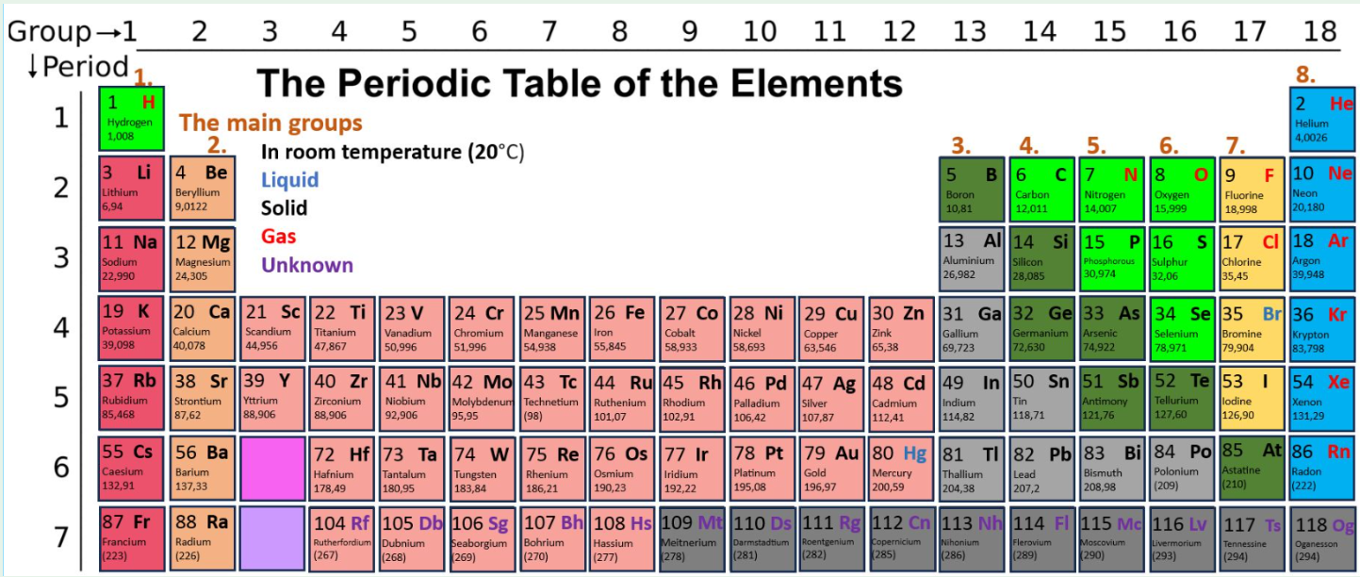
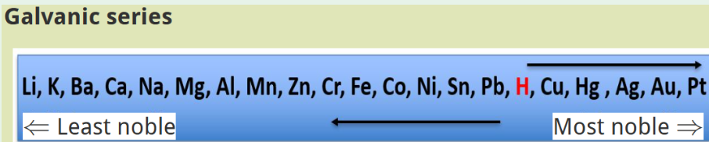

- Correct the wrong statements you chose in the previous task into correct statements with reasons.
- Name the parts of an atom in the picture.

A = {1:SHORTANSWER:=electron~=Electron}
B = {1:SHORTANSWER:=proton~=Proton}
C = {1:SHORTANSWER:=nucleus~=Nucleus}
What element is in the picture? {1:SHORTANSWER:=sodium~=Na}
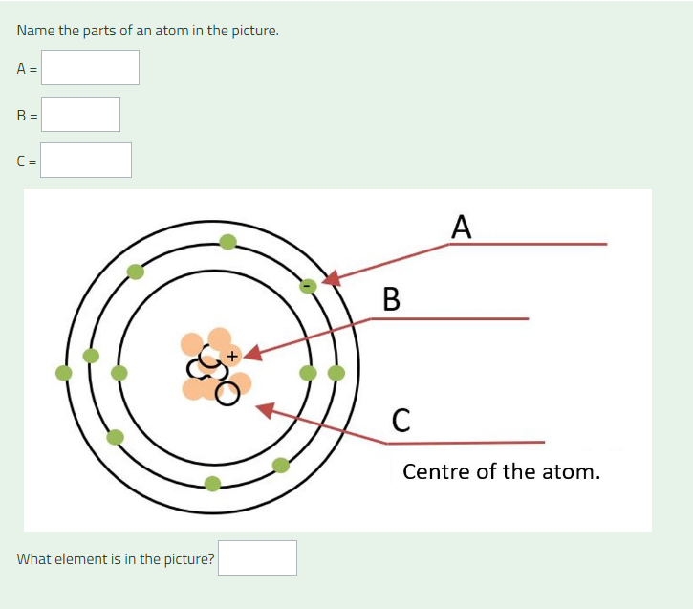
- 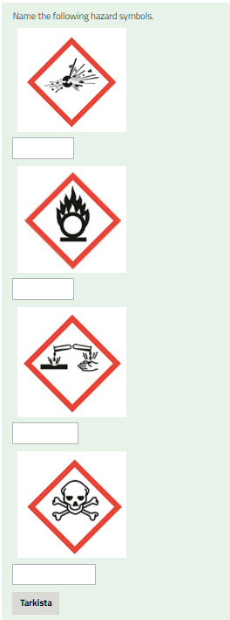
5. Open the safety data sheet of LV hand disinfectant and find the requested information..
Safety data sheet
a) Use of the substance: {1:SA:=For repetitive disinfection of hands}
b) Hazard symbols: {4:MRH:=flammable~environmental hazard~oxidizing~serious health hazard~gas under pressure~=health hazard~explosive~acute toxicity}
c) Hazard statements in order: {1:SA:= H225, H319}
d) Flash point: {1:NM:=12} ºC
e) What is the first aid measure if the chemical is inhaled: {1:SA:=Move to fresh air}
Katso kuva seuraavalla sivulla!
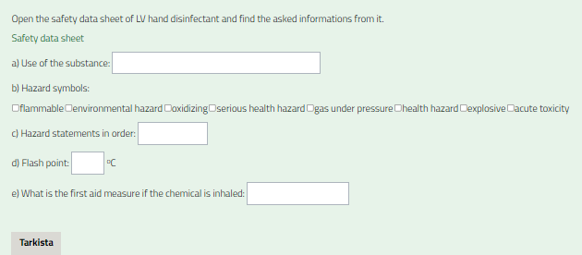
Linkki käyttöturvallisuustiedotteeseen: LV Hand Disinfectant - EcoOnline

6. How is a hazarous chemical defined?

Tarkistusohje opettajalle:
A substance that is

1) fire and explosion hazard

2) dangerous to health (dangerous to humans and animals is also accepted)

3) dangerous for the environment

7. Substance is called [[1]], when pH is less than 7.

Substance is called [[2]], when pH is over 7.

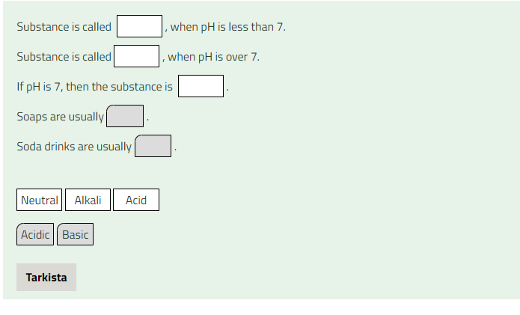
If pH is 7, then the substance is [[3]].

Soaps are usually [[4]].

Soda drinks are usually [[5]].

[[1]] Acid
[[2]] Alkali
[[3]] Neutral
[[4]] Basic
[[5]] Acidic
8. What is a slow combustion? List three (3) examples of slow combustion.

Tarkistusohje opettajalle: Slow burning is a combustion reaction where the reaction happens very slowly.

Examples: rusting, cellular respiration, mould growth and digestion.

9. What is an indicator? Name two (2) natural indicators.

Tarkistusohje opettajalle: The pH indicator indicates whether the substance is acidic or basic by a color change.

Nature’s indicators are for example: red cabbage (or purple cabbage), blueberry, tea, turmeric, grape juice, turnip skin and curry powder.

10. What does neutralization mean? What substances are produced in the neutralization reaction?

Tarkistusohje opettajalle: A neutralization reaction is an event where equal amounts of acidic and basic substances are mixed together. In that chemical reaction salt and water are produced.

11. What is a galvanic series and what is its significance?
Tarkistusohje opettajalle: Metals can be arranged according to their reactivity. It's called galvanic series.

12. What is the molar mass of ammonium chloride? Use the periodic table.
The chemical formula is NH₄ClNH₄Cl.
Remember to write the unit and you don't need to round the answer.

13. What is the molar mass of ammonium chloride? Use the periodic table.

The chemical formula is NH₄Cl.

Remember to write the unit and you don't need to round the answer.

Vastaus: 53,489 g/mol

14. a. Explain, what is meant by the amount of substance.

b. There are 10 grams of table salt (NaCl) in the glass. What is the amount of substance?

15. What is the amount of substance? There is 90 g of ethanol C₂H₆O? n=m÷M

16. 2 liters of hand rinse solution is prepared. For that, mix 160 ml of concentrate with water. What is the concentration of the hand rinse solution in percentages by volume?

Round the answer to the nearest tenth and give a unit. E.g. 12.3%.

Lähdeluettelo

Materiaali pohjautuu Avointen oppimateriaalien kirjastossa olevaan suomenkieliseen vastaavaan Moodle-pohjaiseen materiaaliin: Fysikaaliset ja kemialliset ilmiöt ja niiden soveltaminen (pakollinen) 2osp - Avointen oppimateriaalien kirjasto (aoe.fi)
Alkuperäisen materiaalin tekijät: Jaana Parkkila, Ulla-Maija Norman, Krista Lehto, Mira Pirttikoski, Timo Suorsa (OSAO)

Tämä materiaali on tuotettu VIERKO-hankkeessa
vuonna 2024.
VIERKO on toteutettu Opetus- ja kulttuuriministeriön
vuonna 2023 myöntämällä ammatillisen koulutuksen strategiarahoituksella. VIERKO on kuudenkymmenen-
kahden (62) koulutuksen järjestäjän yhteisponnistus.
Työtä on koordinoinut Keski-Uudenmaan koulutus-
kuntayhtymä Keuda.

Hankkeessa on kehitetty vieraskielisen koulutuksen laatua
ja kotimaisten kielten opetuksen tarjontaa ammatillisessa koulutuksessa.

Lisätietoa:
https://www.keuda.fi/keuda/hankkeet/vierko/

https://creativecommons.org/licenses/by/4.0/


Oppimateriaalit:

CC BY-SA 4.0 Deed | Nimeä-JaaSamoin 4.0 Kansainvälinen | Creative Commons
https://creativecommons.org/licenses/by/4.0/

Oppimateriaalit:



CC BY-SA 4.0 Deed | Nimeä-JaaSamoin 4.0 Kansainvälinen | Creative Commons

