HACKATHON – INNOVATE CIRCULAR ECONOMY 5 credits
  - –DETAILED INSTRUCTION OF TEAM WORK, PHASES AND TASKS

“Innovating with companies and utilizing design and business expertise”

Learning objectives
- Students learn innovate system level circular economy solutions and new business possibilities in order to create positive environmental impacts.
- Students learn how to use storytelling and system level innovation methods, and circular economy tools in multidisciplinary teams

The process
Triple Diamond process with seven phases
The main idea of “the triple diamond and half” process is, its emphasis on the “divergent” and “convergent thinking”, where first many ideas are created, before refining and narrowing down to the best idea. This is happening several times in this seven phases model; Understand, Define, Sketch, Decide, Test prototypes, Validate and Roadmap&Reflect. Phases are named partly after Google Design Sprint, but the tools and methods are different.

This innovation model forces the students to go through each stage of the innovation process from insight into the problem to the final solution following the steps of the model. During the process, several versatile design and business methods and tools can be used to get students deeper into the almost unmanageable challenges and problems. The focus is on storytelling and system level thinking

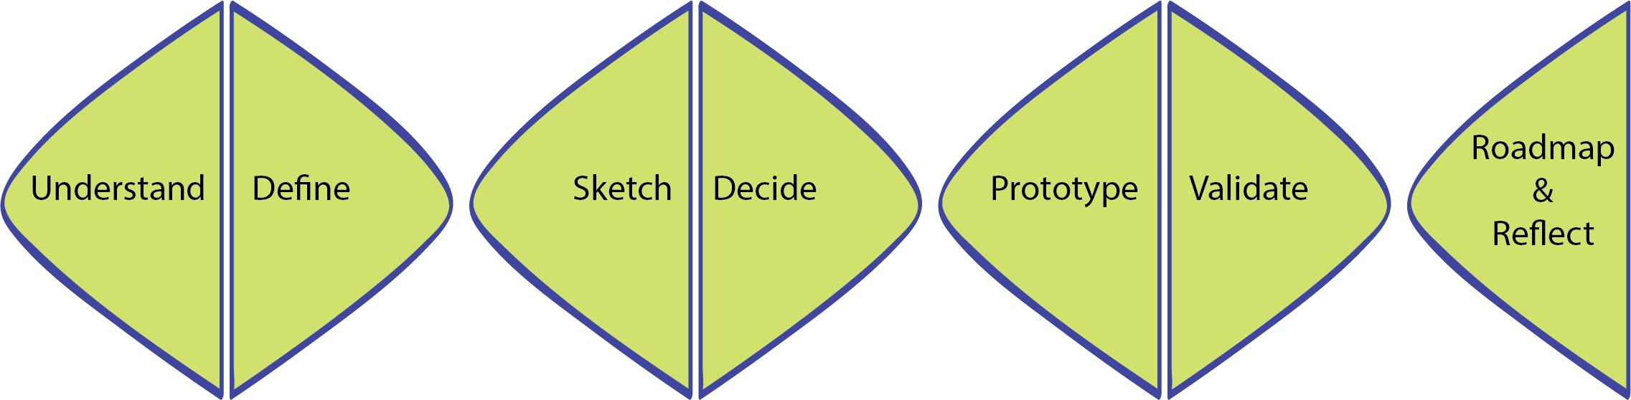
Picture: The course structure and the seven phases of innovation and learning process

The course content:
This course has two parts.
Part 1
• Part 1 is the Understand phase; student will learn the basic knowledge of circular economy
4-6 weeks independent study period
1. Basic of circular economy -exam
2. Circular business models -assignment
3. Get to know the client company –assignment
Weight of grading 30 %

Part 2
4 days Hackathon Camp -innovation process has seven phases
•In the Define phase, student will learn define the complex challenges
•In the Sketching, Develop, Decide, testing Prototypes phases, student will learn develop ideas
•In the Validate phase, student will learn present their concepts
•In the Roadmap phase, student will learn to look to the future. Reflection phase, student will learn reflect their learning process

Weight of grading 70 %
- Innovation / significance / meaningful
- Utilization of the idea / business potential
- Visuality and attractiveness
- Innovation process (including workshops and mentoring) and utilization of theory and tools
- Documentation for the CE Design Sprint Diary

Look for more information: Attachment 1. The Assessment Criteria and Grading Scale

PART 1.
PHASE 1: UNDERSTAND
In this first phase student will learn the basic knowledge of circular economy
- 4-6 weeks independent study period

Step 1 | Basics of Circular Economy - multiple-choice exam  - Use for learning material Circular.now pages. Use HAKA autenthication https://mooc.helsinki.fi/course/view.php?id=118.  - In this assignment use only Introduction to Circular Economy material that is part of Aalto University Mooc course (other material is not part of assignment)  Chapters:  1. What is circular economy?  2. Planetary boundaries  3. From linear model to the circular economy  4. Steering Instruments for the circular economy  5. Circular economy business models  - Make 10 questions for students. Student will get 1 point of each right answers and -0,5 point of each wrong answers. Student can do the test three times. The best result of all three session will be the final result.  Look for more information: Attachment 2/ Basics Of Circular Economy - Multiplechoise Exam
Step 2 | Circular Economy Business Model Pre-Assignment  Learning objectives  The objective of this task is to make you to understand what type of business models are used in circular economy. You will search and evaluate company cases, services, products or business sector  This assignment consists of the two individual parts:  • searching and analyzing (phase 1 and 2)  • virtual peer-evaluation (phase 3)  Look for more information: Attachment 3. Circular Economy Business Model Pre-Assignment
Step 3 | Assignment: Get To Know Your Client Company  Learning objectives  The aim is to obtain sufficient basic information about the target company before starting the innovation.  The aim is to get acquainted with the target company and its operating environment.  The aim is for the student to learn to collect and evaluate information about the target company.  Look for more information: Attachment 4. Get To Know Your Client Company

PART 2.
4 days Hackathon Camp -innovation process has seven phases

PHASE 1. DEFINE
In this phase, student will learn define the complex challenges
Step 1  DAY 1  60 min | Kick-off and Hackathon 4 days schedule  Building the multidisciplinary teams
Step 2  DAY 1  30 min | Design Driven Innovation  - Introduction to innovation process.  Trying to get significant new "meaningful" radical innovations - at the system level. Innovation can direct companies in a completely new direction - strategic changes, new forms of businesses and collaboration, etc.  The Design Driven Innovation process model is not only about the functions of products and services but also the experience and meaningful for users.  The model has three steps:  • Listening  • Interpreting  • Addressing  The most important phase is interpreting and it is important to choose the interpreters from multidisciplinary sectors from cultural to technology sector.  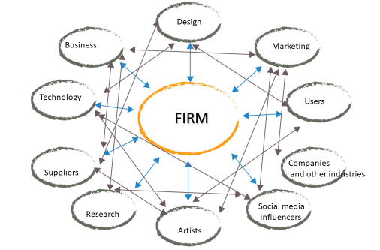  Picture. The multidisciplinary context of design-driven-innovation. Based on Vergandi (2009)  Read more  - Verganti, Roberto. 2009. Design-driven innovation: changing the rules of competition by radically innovating what things mean. Harvard Business Press  - Design for Europe. What is Design driven Innovation  - http://designforeurope.eu/what-design-driven-innovation  - Zampollo, Francesca. 2015. Design-Driven Innovation VS User-Centred Design.Not Really…  - https://www.researchgate.net/publication/277305559_Design-Driven_Innovation_vs_User-Centred_Design_Not_really  - https://www.researchgate.net/publication/233994126_The_Exploration_of_Design_Driven_Innovation_as_a_Dynamic_Capability
Step 3  DAY 1  30 min | Presentation of the innovate team work  Case company presentations  The Hackathon challenge from the company 1.  The Hackathon challenge from the company 2.
Step 4  Day 1  30 min | Create new circular economy business possibilities and climate solutions  - Introduction to innovation process.  Five Circular business models  - Circular Supply Chain  - Sharing Platform  - Product Life Extension  - Recovery & Recycling  - Product as a Service  - Sitra. https://teknologiateollisuus.fi/fi/circular-economy-playbook
Step 5  DAY 1  60 min | Innovation starts  Use for brainstorming and innovation online collaborative whiteboard platform. Platform enables distributed teams to work effectively together, from brainstorming with digital sticky notes to planning and managing agile workflows  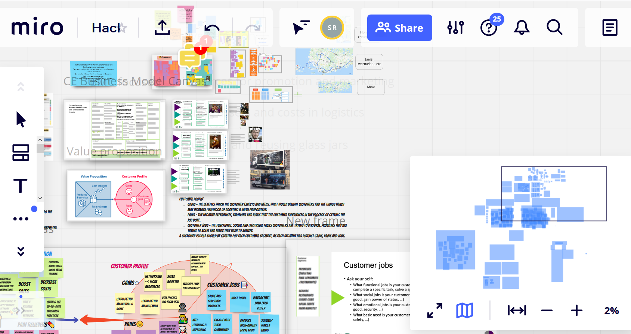  Picture: Working view of the innovation and storytelling process during Hackathon - Innovate Circular Economy distance learning period. Miro platform  Online collaborative whiteboard platform examples  - Miro https://miro.com  - Padlet https://padlet.com/  - Flinga https://flinga.fi/  - Microsoft Whiteboard https://www.microsoft.com/fi-fi/microsoft-365/microsoft-whiteboard/digital-whiteboard-app  For brainstorming, choose one or several methods and tools different methods and tools  - https://www.circulardesignguide.com/methods  - https://www.designkit.org/methods  - Universal Methods of Design : 100 Ways to Research Complex Problems, Develop Innovative Ideas, and Design Effective Solutions
Step 6  DAY 1  30 min | Sharing of ideas  Student teams share the ideas to each others
Step 7  DAY 1  30 min | STORYTELLING METHODS;  Introduction  Storytelling can be used as a problem-solving tool. The story creates an easily understandable chain of events from problems to possible solutions. A narrative helps to experience someone else's experiences and feelings, making the design process deeper and more meaningful.  A typical story has three phases; the beginning, the middle and the end and the challenge problem being addressed.  - Opening scenes introduce characters, plots, and settings, and where the story is going.  - The middle part has tensions; the crises and the challenges or barriers  - At the end the paths drawn together and things are explained or resolved  Read more;  Rafiq Elmansy, 2018. The Role of Storytelling in the Design Process  https://www.designorate.com/the-role-of-storytelling-in-the-design-process/  STORYBOARD  IDENTIFY THE CHALLENGE AND POSSIBLE SOLUTION AS A JOURNEY  Learning objectives  The aim is to be acquainted with the storyboard method and apply its possibilities both as a team's own tool and in presenting the concept to the client.  What is a storyboard and why to use it?  - The storyboard presents the challenge or its solution by visualizing the story on the cartoon screen or as animation  - Storyboards are easily and quickly interpreted, comprehensible globally. When needed, works without words  - Particular emphasis on communication  - Visualization is an effective way of looking at the whole and its  - problem areas  - Visualization is often an easier way to communicate to your team or to outsiders than just verbal description  - As an alternative to drawing, you can use miniatures made of, for  - example, modeling wax, Legos or paper / cardboard  - You can also make a storyboard with photos, video, animation or combining different technigues  Things to consider when planning and making a storyboard  - Remember the person involved in the story. What is the relationship between a person and a story / idea? The main character, his/her personality and, if necessary, other persons and their personalities  - What is the environment in which the story takes place?  - What is the challenge or step you want to describe?  - How many steps / screens do you need?  - What visualization method do you use?  - How do you bring out the things that are more relevant?  - What are the conclusions?  - Keep it simple  The work begins with creating the story of the challenge and defining the objectives of the challenge.  Make a script drafts first  - You need drawing paper or you can even use Post-it sticky notes  - Make a grid, for example 3-6 squares  - Outline your challenge story in boxes  - Make several quick sketches of your storyboard  - Stick figure technique enough to illustrate the essentials of the story, at least within your team  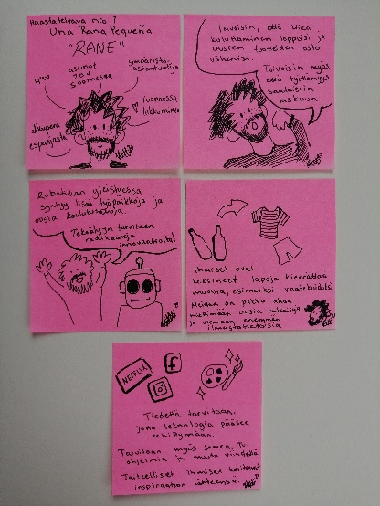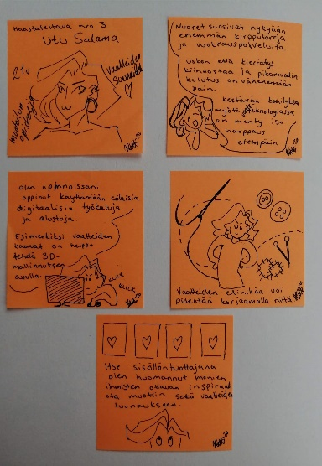  Picture: Storyboard drafts by Katarina Weeman, Savonia-amk  Storyboard, examples of techniques  - Storyboard. MuonaMartti. Erik Lehtosaari, Ira Leppänen, Assi Hautamäki, Carita Ahonen. Savonia AMK  - https://www.instagram.com/havikkihandlaajat/?hl=en  - Drawing and animation: Storyboard. Nyyrikki. Henna Hiltunen, Riina Kärkkäinen ja Taru Rinne. Savonia AMK  - https://www.youtube.com/watch?v=ryqjJB0nmTo&feature=youtu.be  More tools and methods for making storyboards  - Free animation tools  - https://www.rawshorts.com/automated-video-creation  - Tips to making storyboard  - https://www.instructables.com/Storyboarding-for-Product-Design/  - https://www.designkit.org/methods/35  - https://www.ibm.com/design/thinking/page/toolkit/activity/storyboard  - Sketching 101: How to draw minimum viable characters for storyboards  - https://blog.prototypr.io/
Step 8  DAY 1  120 min | Students start storytelling with storyboard technique
Step 9  DAY 2  15 min | STORYTELLING METHODS; CONCEPT CAPTURE.  WHAT IS THE STORY OF YOUR CONCEPT?  - Introduction to concept stories  Once students have produced several ideas, it is time to refine them into fully-fledged concepts, concepts that you are able to test.  - Give descriptive and inspiring name to your concept  - Describe your concept  - Visualize your concept idea with storyboard  - Make three different concept ideas!  - How does your concept work?  - Who is the target user?  - What value would it brings?  - Are their any anticipated barriers/challenges to your concept?  - What are the key factors for success?  - How do you want to influence into the future with this concept idea?  Use the worksheet below to develop these concepts so that you can present and communicate them in a tangible way.  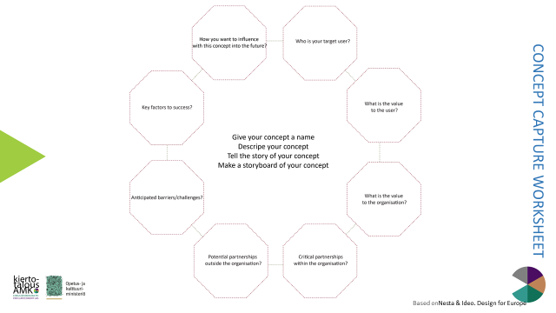  Picture: Concept Capture Sheet. Adapt. Designing for Public Services https://media.nesta.org.uk/documents/nesta_ideo_guide_jan2017.pdf
Step 10  Day 2  240 min | Students start story telling with concepts stories and ideas
Step 11  DAY 2  60  min | Creative briefing of three concept stories and ideas  - Presentations to the companies  Pitching 15min/group

PHASE 2. SKETCHING
In this phase, student will learn to develop ideas

Step 1  DAY 3  30 min | STORY TELLING METHODS; SOLVE WITH BUSINESS STORIES  CIRCULAR ECONOMY BUSINESS MODEL CANVAS AND CLIMATE IMPACTS.  Understand more the frontage of your business and that what is happening at the backstage  - Partners, resources, key activities, channels, customer relationships  - Earning Model - Where Does Money Come From?  - Environmental Impact / Climate Change - How Does Your Solution Save the Planet?  - Positive effects /Negative effects  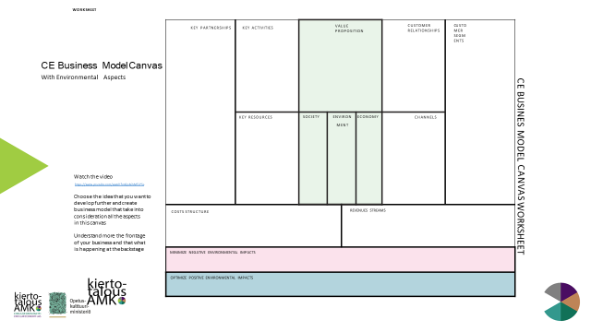  Picture. Circular Economy Business Model Canvas And Climate Impacts
Step 2  DAY 3  15 min | STORY TELLING METHODS; VALUE PROPOSITION CANVAS.  DEFINE THE STORY OF CUSTOMER.  Understand deeply the main and side roles/players of your story. What are the needs, feelings, motions, problems and tasks of the different players? How the climax of the story solve the problem and needs of main players.  - https://www.b2binternational.com/research/methods/faq/what-is-the-value-proposition-canvas/
Step 3  DAY 3  60 min | Students starts developing and testing ideas with CE BMC

PHASE 3. DEVELOP
In this phase, student will learn develop ideas

Step 1  DAY 3  60 min | Students starts develop concept ideas with value proposition canvas

PHASE 4. DECIDE
In this phase, student will learn to refine and narrow down to the best idea
Step 1  DAY 3  30 min | Choose the best choice of your concept ideas  Voting method  https://toolkits.dss.cloud/design/method-card/dot-voting/

PHASE 5. TESTING PROTOTYPES
In this phase, student will learn testing ideas with rapid prototypes
Step 1  DAY 3  120 min | STORY TELLING METHODS;  PROTOTYPING – TELL THE STORY WITH CONCREATE PROTOTYPES.  Create rough and rapid prototypes to test your concept!  Look for instruction:  https://www.circulardesignguide.com/post/rapid-prototyping  https://www.lab8.fi/fast-prototyping/  Examples  - https://www.instagram.com/muki.muotoilua.kiertotalouteen/
Step 2  DAY 3  60 min | Presentation and test of prototypes, concept captures and CE BMC (shortly) + test feedback

PHASE 6. ROADMAP
In this phase, student will learn to look to the future and consider, with what team and expertise can the concept be implemented
Step 1  DAY 4  120 min | STORY TELLING METHODS;  ROADMAP- HOW THE STORY WILL CONTINUE IN THE FUTURE?  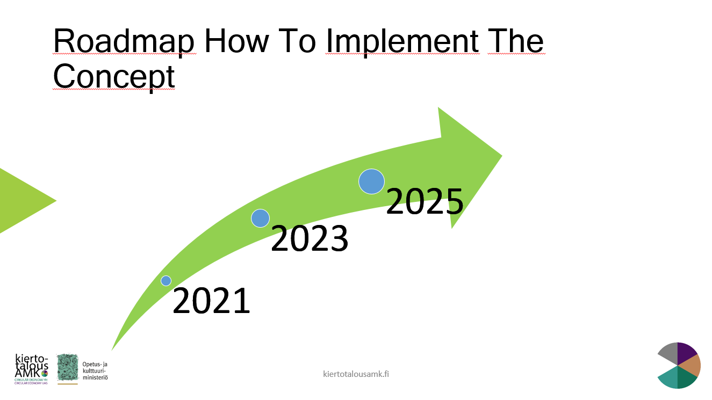  Picture: Roadmap

PHASE 7. VALIDATE
In this phase, student will learn present their concepts

Step 1  DAY 4  120 min | Validate and finalize the concept  Content of the Final Concept  Description of the concept  - Name and story of your concept  - How your concept is unique compared to others?​  - What are the key success factors?​  - What are the main obstacles and challenges for your concept?​  - Prototype or demo​  Define the story of customer. Customer / end customer profile and issue​  - Benefits / value to customers and end users​  Solve with business stories. Business Model (other areas of CE BMC)​  - Partners, resources, key activities, channels, customer relationships​  - Earning Model - Where Does Money Come From?​  - Environmental Impact / Climate Change - How Does Your Solution Save the Planet?​  - Positive effects​ /Negative effects​  - Markets and competitors in Finland and worldwide​  - An estimate of the business potential​  How the story will continue in the future?  - Roadmap to year 2025  - With what team and expertise can the concept be implemented?
Step 2  DAY 4  30 min | Presentations of final concepts to the companies and stakeholders  Pitching 10 min/group  Example of presentation: https://www.instagram.com/p/B3tzeOQnoAU/
Step 3  DAY 4  60 min | Feedback from  - Companies  - Students  - Teachers

PHASE 8. REFLECT
In this phase, student will learn reflect their learning
- Independent studies
Step 1  DAY 5 | STORY TELLING METHODS;  CE DESIGN SPRINT DIARY - TELL YOUR LEARNING STORY  Each team keeps its own project Design Sprint Diary.  The diary should show the progress of the innovation process and the reflection of each step; Understand, Define, Sketch, Decide, Prototype, Validate and Roadmap&Reflect.  Collect the visualizations into the diary: Drawings, charts, storyboard examples, etc. You can also attach short videos.  At the end of the process, the team will make also reflection and self-assessment  The diary should include the reflection of each member of the team: what did you learn? What did I learn (subject matter, skills, ways of knowing and working)? What did you learn together? What changes happened in my attitude, my confidence, my way of going about or looking at things? What kind of things the team succeeded in? What could you have done better?  Look for more information: Attachment 5. Assignment. CE Design Sprint Diary

ATTACHMENT 1. THE ASSESSMENT CRITERIA AND GRADING SCALE

Weight Pre-assignments 30 %
•Basic of circular economy -exam 10 %
•Circular business models -assignment 10 %
•Get familiar to Circular economy in food sector 10 % /Analyzing companies 10 %

Innovation process 70 %
•Design Sprint Diary 15%
•Process and final presentation 55 %

The assessment criteria and grading scale

Evaluation Criteria - Grade 1
Student is
Able to innovate, develop, and find solutions to business circular economy challenges in multi-disciplinary teams. Able to use storytelling and circular economy tools and methods as part of the innovation process

Evaluation Criteria - Grade 3
Student is
Able to innovate, develop and find solutions to the business circular economy challenges in multidisciplinary groups. Able to use storytelling and circular economy tools and methods as part of the innovation process. Able to view innovations from a circular economy perspective

Evaluation criteria - grade 5
Student is
Able to innovate, develop and find solutions to the business circular economy challenges in multidisciplinary teams. Able to use storytelling and circular economy tools and methods as part of the innovation process. Able to justify innovation from the circular economy and business profitability perspective

ATTACHMENT 2/ BASICS OF CIRCULAR ECONOMY - MULTIPLECHOISE EXAM
Weight of grading 10p / 100.

1. Log in Circular.now pages using HAKA autenthication https://mooc.helsinki.fi/course/view.php?id=118.

2. In this assigment use only Introduction to Circular Economy material that is part of Aalto University Mooc course (other material is not part of assignment)
Chapters:
1. What is circular economy?
2. Planetary boundaries
3. From linear model to the circular economy
4. Steering Instruments for the circular economy
5. Circular economy business models

- Complete the multiple-choice test using Mooc Introduction to circular economy material. (Rests and assignments in MOOC-platform don´t include in this course. You get 1 point of each right answers and -0,5 point of each wrong answers. You can do the test three times. The best result of all three session will be your final result.

ATTACHMENT 3/ CIRCULAR ECONOMY BUSINESS MODEL PRE-ASSIGMENT SPRING 2020
Weight of grading 10p / 100.

Learning objectives
The objective of this task is to make you to understand what type of business models are used in circular economy. You will search and evaluate company cases, services, products or business sector.
This assignment consists of the two individual parts:
• searching and analyzing (phase 1 and 2)
• virtual peer-evaluation (phase 3)

Phase 1. Search and learn the main principles of business models in Circular Economy (CE)
Sources or you can use own sources:
• Download Sitra’s Playbook: Circular Economy Playbook: Circular Economy business models for Finnish SMEs in the manufacturing industries: http://www.kasvuakiertotaloudesta.fi/ o See pages:
▪ page 20 and 24, Five business models
▪ page 25, Circular value change
▪ page 26, Business models types, sub-models, descriptions
▪ page 28, Finnish manufactures examples

• Business examples: https://www.sitra.fi/en/projects/interesting-companies-circular-economy-finland/#what-is-it-about
• Additional material o www.sitra.fi
o https://www.ellenmacarthurfoundation.org/
o https://ec.europa.eu/environment/circular-economy/index_en.htm

Study
• What are different CE business models and what type of environmental impacts have they?
1. Product Life-Extension
2. Product as a Service
3. Sharing Platform
4. Recovery and Recycling
5. Circular Supply Chain

• Get familiar with the CE business model cases

Phase 2. Search your own business case (national or international) that presents one of the CE business model
Search and create
• Create a power point slide set to present and post it to given virtual learning system like Moodle. • Tell shortly, why you have chosen the case
• Present and describe your case by using “Business Model Canvas” ▪ Watch the video. Business Model Canvas explained: https://www.youtube.com/watch?v=QoAOzMTLP5s
▪ Download the “Official business model canvas” or draw the canvas yourself https://www.strategyzer.com/canvas/business-model-canvas

Describe which CE business model/s are used in the case and justify your choice
- Evaluate your case based on circular economy, environmental impacts and climate change
- What are existing the positive or/and negative environmental impacts?
- How the case could improve the circular economy, decrease environmental and climate change impacts?
- You can use following issues e.g. • carbon footprint and renewable or bioenergy
- use of recyclable bio-based and renewable materials
- extension of the re-cycle trough re-design, prepare, maintenance, upgrading, resale and remanufacturing
- usage rates of collaborative products/services
- ecological material choices, used packages and transportation

• Remember to add your sources in each slide and create the reference list. Return date XX.

Phase 3. Peer-evaluate at least three returned assignment
• Give feedback at least for three returns o Choose returns that all returns get some feedback. Target is that all returns get maximum three feedback of peer-students.

Evaluate the returns based on following criteria:
- How the case fit to CE business models?
- How well the assignment instruction is followed? Is something missing?
You can use following issues e.g.
- carbon footprint and renewable or bioenergy
- use of recyclable bio-based and renewable materials
- extension of the re-cycle trough re-design, prepare, maintenance, upgrading, resale and remanufacturing
- usage rates of collaborative products/services
- ecological material choices, used packages and transportation

- How interesting and meaningful is the case?
- What did you like? What could have been improved? Was something unclear?
- Give you feedback by XX.XX
Assignment criteria
- 70 % Phase 1 and 2
- 30 % Peer-evaluation
- Late return equals the grade of 0. This is assignment is not repeatable

ATTACHMENT 4. ASSIGNMENT. GET TO KNOW YOUR CLIENT COMPANY
Weight of grading 10p / 100.

Objectives of the task
- The aim is to obtain sufficient basic information about the target company before starting the innovation.
- The aim is to get acquainted with the target company and its operating environment.
- The aim is for the student to learn to collect and evaluate information about the target company.

Instructions
Gather information about the company from various sources (websites, company publications, scientific journals, digital channels, sustainability report, annual reports, company customer magazines, competitors' materials, etc.):
- Strategy
- Products and services
- Customers and distribution channels
- Partners and other stakeholders
- Production
- Turnover and key cost factors
- Locations
- Environmental programs and actions
- Responsibility programs
- Competitors
The most important trends and drivers of change affecting the company are e.g. environmental and technological factors

Report format and sources used
The format of the report is free and will not be published. The report serves as a note to the student during the innovation and may contain directly copied elements such as images and texts. However, the sources should be marked separately for each material. The student utilizes the report in an innovation task. Length about 5 pages in Word pages

ATTACHMENT 5. ASSIGNMENT. CE DESIGN SPRINT DIARY
Weight of grading 15p / 100.

Learning objectives
The objective of this task is to learn to document the entire process using the steps of design sprint and reflect own learning process.

Content:
Each team keeps its own project diary.
The diary should show the progress of the innovation process and the reflection of each step; Understand, Define, Sketch, Decide, Prototype, Validate and Roadmap
Collect the visualizations into the diary: Drawings, charts, storyboard examples, etc. You can also attach short videos.
At the end of the process, the team will make also reflection and self-assessment

The diary should include the reflection of each member of the team: what did you learn? What did I learn (subject matter, skills, ways of knowing and working)? What did you learn together? What changes happened in my attitude, my confidence, my way of going about or looking at things? What kind of things the team succeeded in? What could you have done better?

The assignment starts on date and will be uploaded to Moodle in pdf format latest date
Remember to mark the names of all group members in the diary!

To recap, the process steps in brief
1. UNDERSTAND · A broad understanding of the challenge and its scope · Basic of Circular Economy · Business models in the circular economy. What did you learn in this phase?
2. DEFINE · Company challenge · Making the creative brief of team; Understanding, exploring and defining the challenge · Received feedback
The team gathers the most important aspects of the phase. What did you learn in this phase?
3. SKETCH · Sketching and developing ideas · CE Business Model Canvas draft · Positive environment / climate impacts · Storyboard The team gathers the most important aspects of the phase. What did you learn in this phase?
4. DECIDE · Choosing the final idea for further development · Received feedback
The team gathers the most important aspects of the phase. What did you learn in this phase?
5. PROTOTYPE · Testing and developing an idea · Storyboard and prototypes
The team gathers r the most important aspects of the phase. What did you learn in this phase?
6. VALIDATE · Finalizing presentations/pitches · Storyboard · CE Business Model Canvas · Received feedback
The team gathers the most important aspects of the phase. What did you learn in this phase?
7. ROADMAP. Look into the future
8. REFLECTION AND SELF-ASSESSMENT - Each group member's own reflection - What did I learn and how did it develop?
- What did you learn together? - Group self-assessment based on the evaluation criteria

