Entrepreneurship and Entrepreneurial Activities
(YTYY)
2024



Jaana torseke, kati saario, sini viinikka, sirpa mertaniemi,
suvi lehtinen, suvi leppänen
Rahoittaja:

Vierko |www.keuda.fi/keuda/hankkeet/vierko

Sisällys
Introduction 2
1. Orientation: What is Entrepreneurship? 4
1.1 Task: Differences between Entrepreneurship and Paid Job 6
1.2 Task: Entrepreneur Stories 9
2. Acting in Accordance with the Company’s Objectives 10
2.1 The Importance of Business in Society 11
2.2 TEST The Importance of Business in Society 18
2.3 Working with a Customer- Centred and Cost-Efficient Approach – self evaluation 20
2.4 Task: Reflection 22
3. Developing a Business Idea and the Possibilities to Implement it 23
3.1 Business Idea 25
3.2 Task Business Idea 26
3.3 A SWOT Analysis: Risks and Possibilities 28
3.4 Task SWOT Analysis 29
3.5 Business Model Canvas 30
3.6 Explanations of business model canvas “ingredients” 31
3.7 Task: Create Your Own Business Model Canvas 32
3.8 Key Services and Information Sources that Support Setting up a Business 33
3.9 Evaluate Your Ability to Be an Entrepreneur - Self-Assessment Task 35
4 Additional Material 36
Ohjeita kurssin käyttöön opettajalle 38
Lähdeluettelo 39

Introduction
Welcome to the Entrepreneurship and Entrepreneurial Activities course!

This course is part of the common units and covers compulsory studies in entrepreneurship and entrepreneurial activities.

The scope of this unit is 1 competence point.

By completing this unit, you will gain new knowledge about entrepreneurship and entrepreneurial activities.
In this course, you will learn how to work effectively to achieve a company’s goals. You will learn why businesses are important for society. You will think about how your actions can be more customer-friendly and cost-effective. You will also understand how your actions affect your workplace.

During your studies, you will complete assignments and show your competence in three different learning outcomes:
- understand the importance of business in society
- work with a customer-centered and cost-efficient approach
- understand the significance of their actions as part of the work community

After your studies, you will be able to evaluate a business idea to decide if it can succeed. You will practice creating business ideas. You will learn about the necessary connections and financial requirements. You will learn about important services for starting a business. You will assess your own skills to work as an entrepreneur. You will also learn about the risks and opportunities of running a business.

You will complete assignments and show your competence in different learning outcomes:
- generate a business idea, taking into account customers’ needs
- find key services and information sources that support setting up a business
- Determine the networks required to realize the business idea
- assess the financial preconditions for implementing the business idea
- assess their capacities for working as an entrepreneur
- determine the risks and opportunities involved in business

Before you start working on the tasks, carefully read the targeted learning outcomes and the detailed instructions under the headings. By reading them, you will better understand how to gain the required competence and demonstrate what you have learned.
Many of the tasks include appendix texts or links to materials, images, and videos. Study these materials, practice, and complete the required tasks carefully. If no specific link is provided, you can search for information online. In some tasks you can use AI (generative artificial intelligence), but this is only allowed as indicated by traffic lights. So, you must obey the traffic lights!
How to use sources and AI (generative artificial intelligence)​
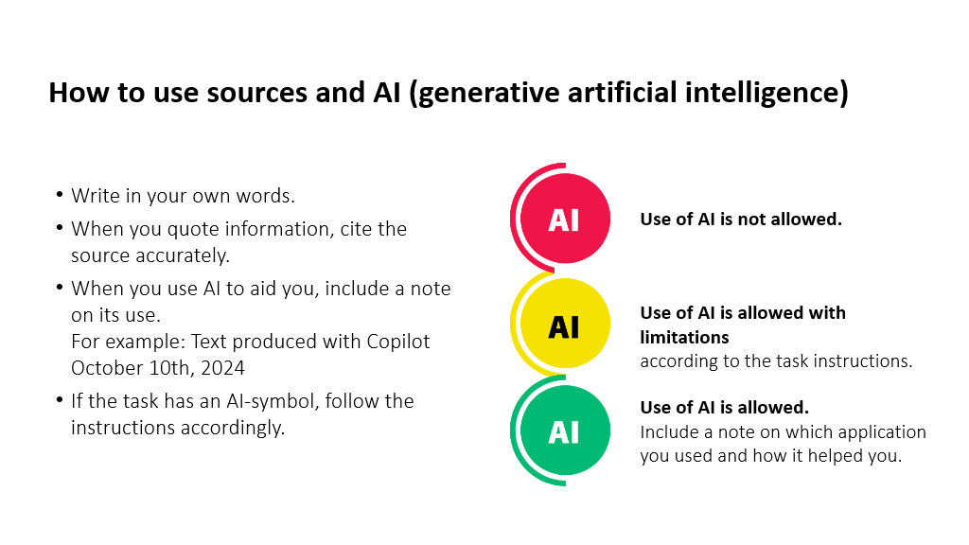

Compulsory competence requirements, 1 cp

Acting in accordance with the company's objectives
The student
- understands the importance of business in society
- works with a customer-centered and cost-efficient approach
- understands the significance of their actions as part of the work community

Assessing the business idea and the possibilities to implement it
The student
- generates a business idea, taking into account customers’ needs
- finds key services and information sources that support setting up a business
- determines the networks required to realize the business idea
- assesses the financial preconditions for implementing the business idea
- assesses their capacities for working as an entrepreneur
- determines the risks and opportunities involved in business

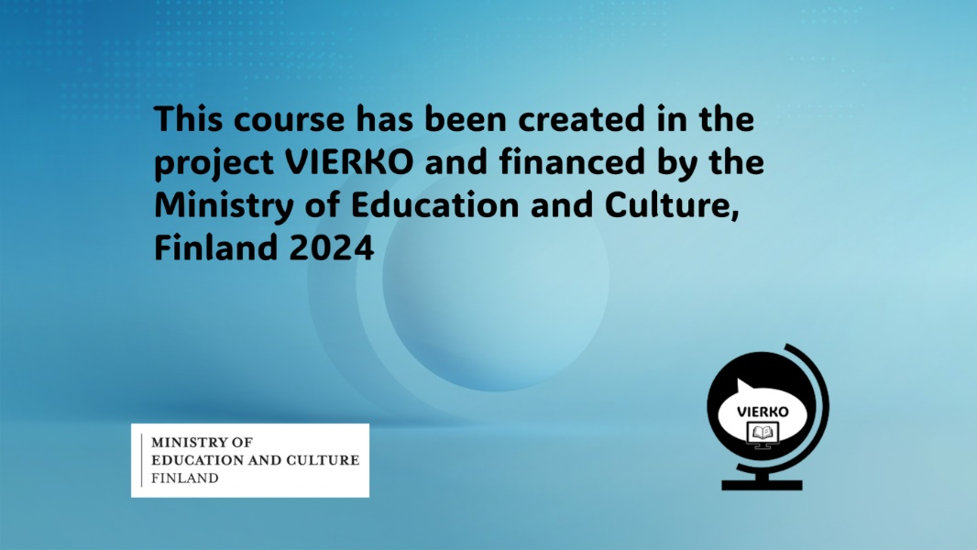

Pre- course survey
Answer the following questions. (Time to complete max 3 min.)
What do you wish to learn? See the course contents and goals. Give examples.

Orientation: What is Entrepreneurship?

Entrepreneurship is a way of working, employing yourself and possibly even others. Entrepreneurship is using your competence and believing in your business idea. As a business owner, you have both more responsibility and more freedom compared to working for someone else. At best it is an inspiring everyday life where you get to choose your way of working and work schedule.

Entrepreneurship is not just about starting, managing, and developing your own business. Entrepreneurial skills are also needed in studies, job searching, and even when working for someone else. The same qualities valued in entrepreneurs are also appreciated in the workplace.

In Finland anyone can become an entrepreneur. There is no right age, gender, education, or work experience for it. The foundations for starting a business are the aspiring entrepreneur’s own desire and will. When starting a business, you must have sufficient knowledge and expertise in your chosen field. Also, acquire the necessary entrepreneurial skills. Continuously develop your professional and entrepreneurial skills to ensure your business keeps up with development.

If you want to work as an entrepreneur in Finland and you are a citizen of a country other than an EU or Nordic country, you need an entrepreneur’s residence permit. You can find more information about entrepreneur permits on the Info-Finland website: Yrittäjäksi Suomeen) (Source: Yrittäjät.fi & Uusyrityskeskus.fi)

Task: Differences between Entrepreneurship and Paid Job


How to use sources and AI (generative artificial intelligence)

Use of AI is not allowed.

You may use AI for brainstorming tasks and creating images. You cannot directly copy text generated by AI. You must write the text in your own words. When you use AI, include a reference at the end of the text: (AI application used, description of use, and date).
AI utilizes materials available on the internet, which may be incorrect or copyrighted. You must ensure that the information generated by AI is accurate. The responsibility is yours.

Task:
Visit the website Entrepreneur or employee - Yrittajat.fi to learn about the differences between entrepreneurship and paid job. After reading, complete the following task. You can find the answers in the article.

Match the Correct Words/Phrases to Entrepreneurship or Employment

Independence x
Regular monthly salary
Risk-taking x
Flexible working hours x
Employment benefits
Business idea x
Annual leave
Customer acquisition
Workplace trainings
Networking x

Entrepreneurship

_______________________________________

_______________________________________

_______________________________________

_______________________________________

_______________________________________

Paid job

__________________________________________

__________________________________________

_________________________________________

_________________________________________

_________________________________________

(Tehdään H5P:llä tehtävä, jossa sanat voi vetää omiin lokeroihinsa, itsetarkistavatehtävä)

Grading:

K5 (5 points, all 10 answers correct)
H4 (9 answers correct)
H3 (8 answers correct)
T2 (7 answers correct)
T1 (5 answers correct)

You can attempt the task as many times as necessary.

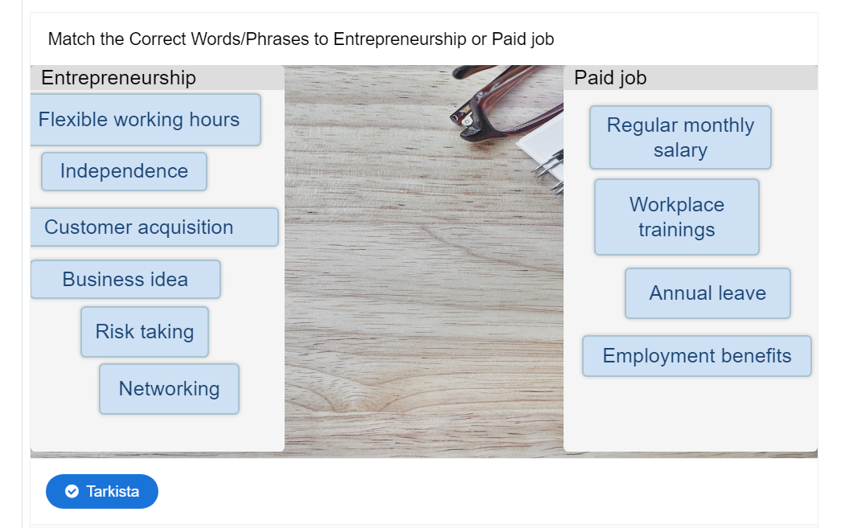

Task: Entrepreneur Stories

How to use sources and AI (generative artificial intelligence)

 Use of AI is allowed with limitations according to the task instructions.

You may use AI for brainstorming tasks and creating images. You cannot directly copy text generated by AI. You must write the text in your own words. When you use AI, include a reference at the end of the text: (AI application used, description of use, and date).
AI utilizes materials available on the internet, which may be incorrect or copyrighted. You must ensure that the information generated by AI is accurate. The responsibility is yours.

Task: Find an entrepreneur story that interests you on the Enterprise Agency website: https://uusyrityskeskus.fi/kategoriat/yrittajatarina-en/

Briefly summarize the entrepreneurial story you chose and answer the following questions:
- How did the entrepreneur start their business?
- Why is entrepreneurship a good option for them?
- What are your current thoughts about entrepreneurship?
- List 5-8 positive aspects and challenges of being an entrepreneur.
Assessment:
K5 All four questions answered thoughtfully and with justification
K4 Four questions answered at a basic level
T1 Partial and limited answers to questions

Acting in Accordance with the Company’s Objectives
Learning outcomes

The student
- understands the importance of business in society
- works with a customer-centred and cost-efficient approach
- understand the significance of their actions as part of the work community

Start by learning the study material about entrepreneurship in Finland.
In this section, there are a total of three tasks:
Test
Self-Evaluation
Reflection task



The Importance of Business in Society

Enterprises in Finland

There are 443 731 enterprises in Finland (Statistics Finland, Structural business and financial statement statistics 2022), excluding agriculture, forestry and fishing industries.

Enterprises employ 1,4 million people and pay taxes, which fund public services for everyone.

About 93% of enterprises have fewer than 10 employees.

(Sources: Suomen Yrittäjät, Statistics Finland 2022)

Entrepreneur Statistics
Suomen Yrittäjät general presentation (yrittajat.fi)

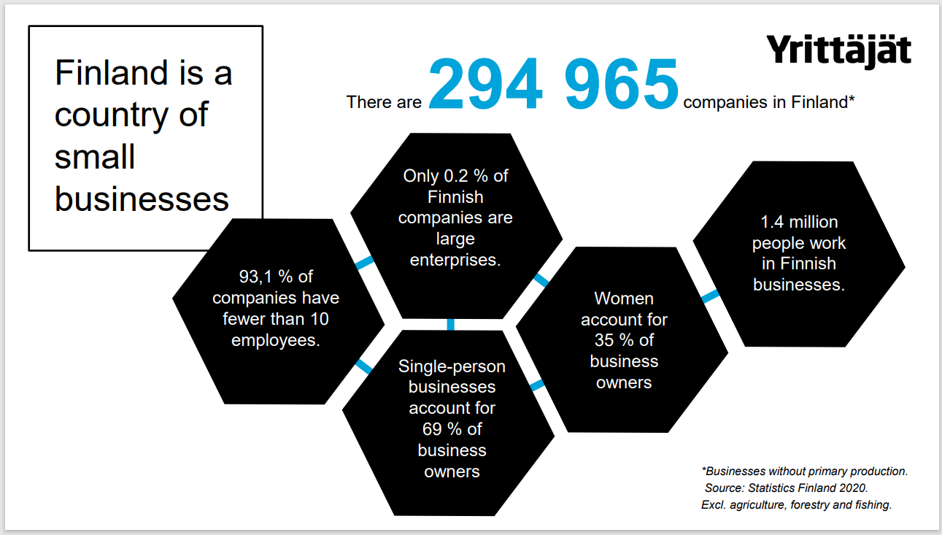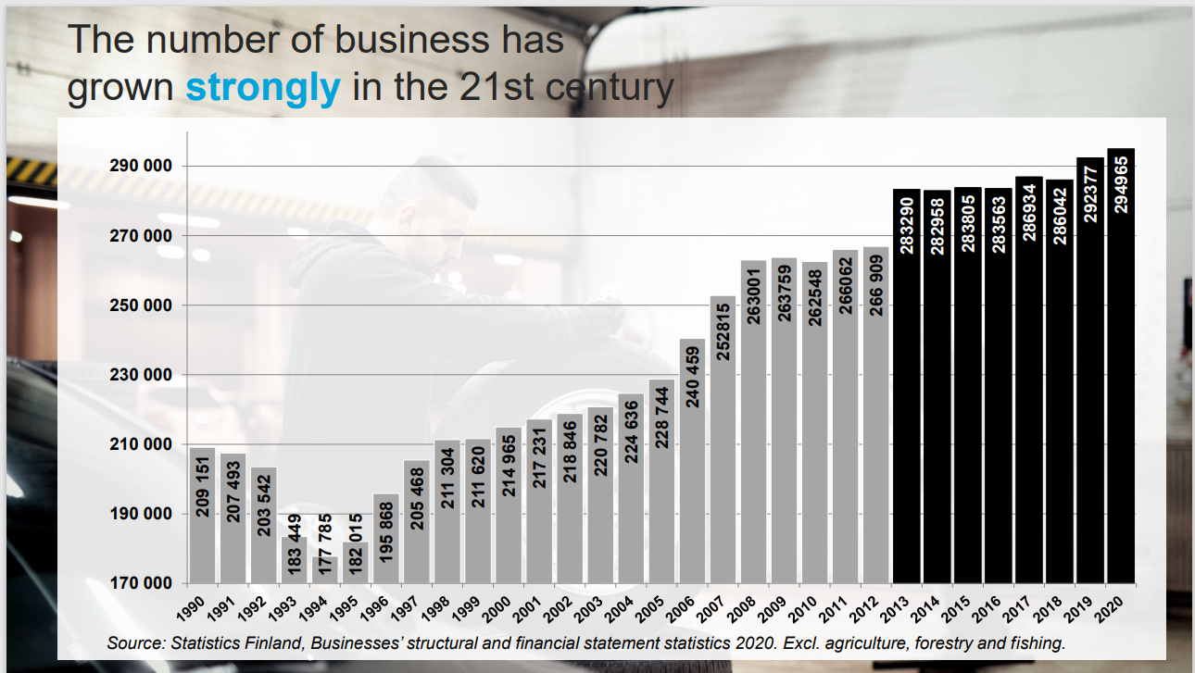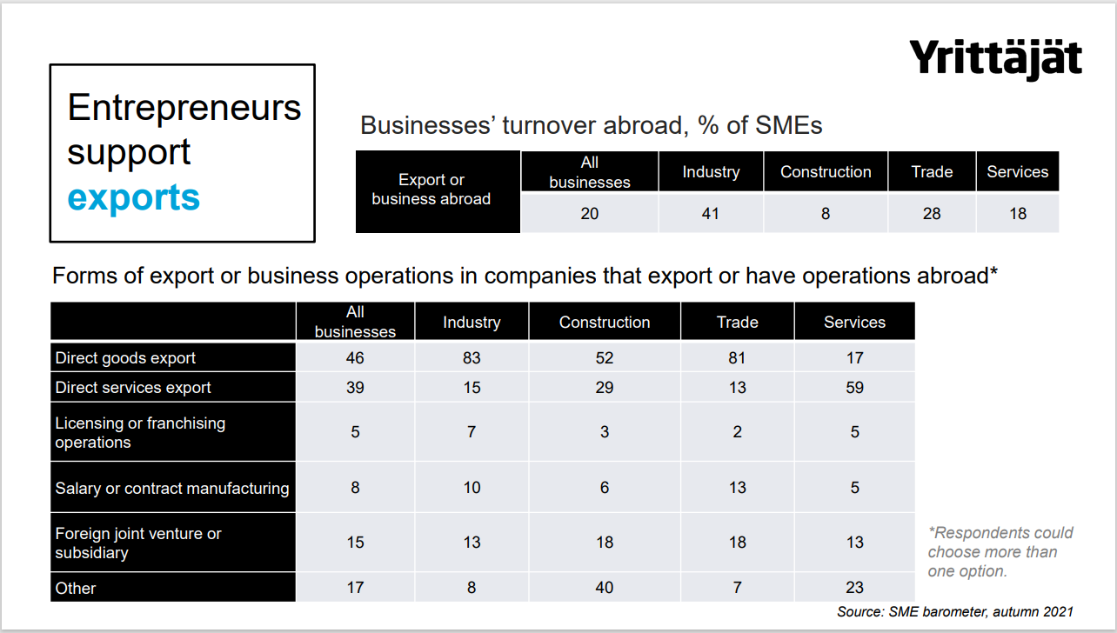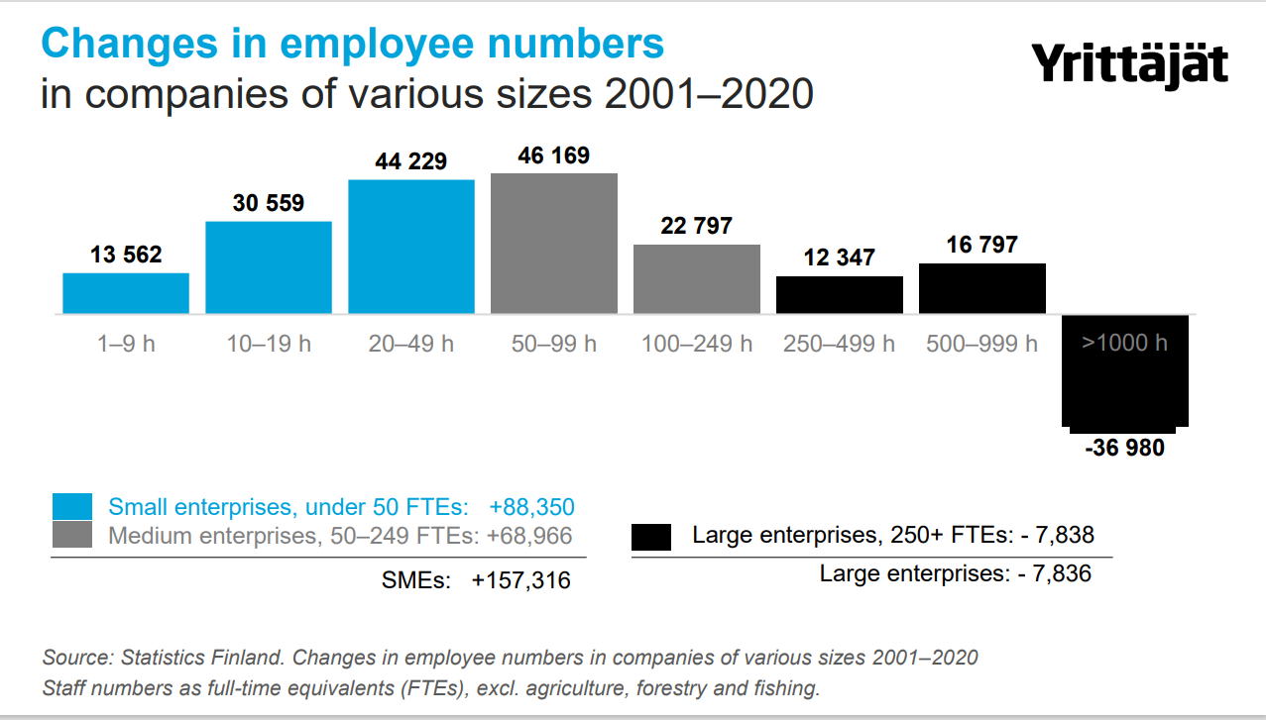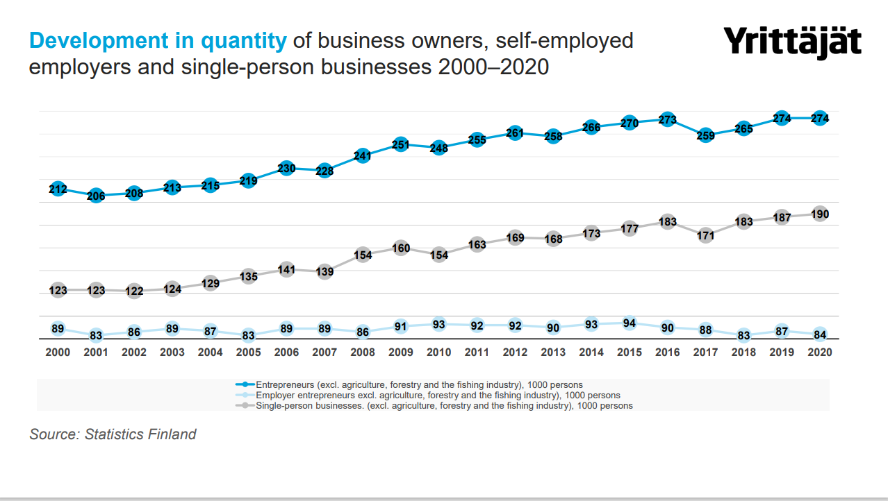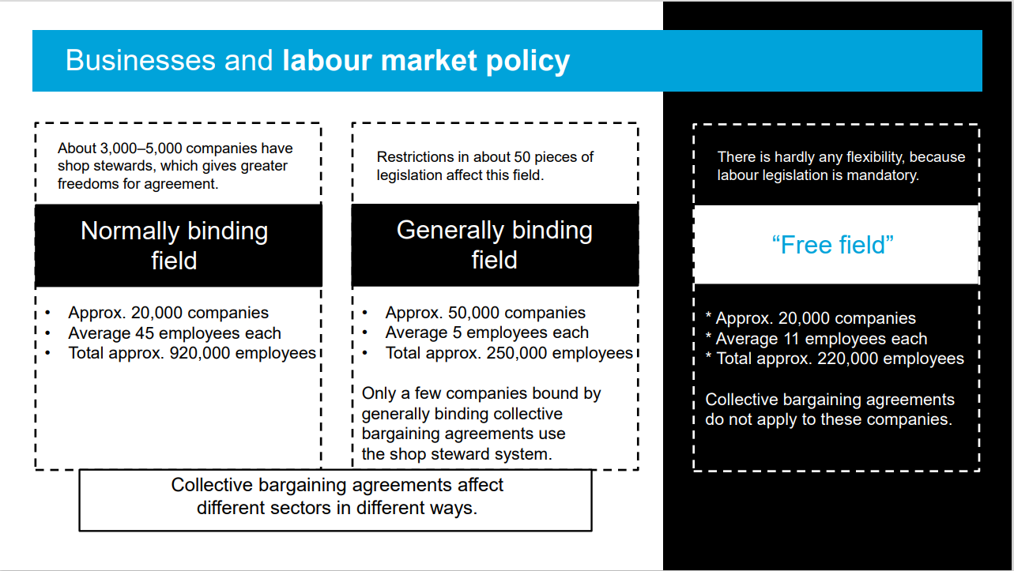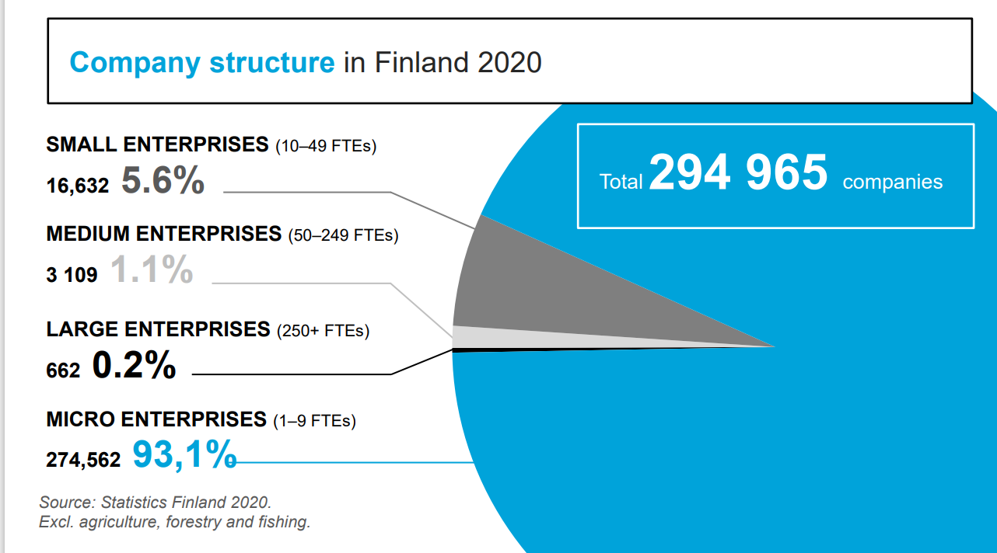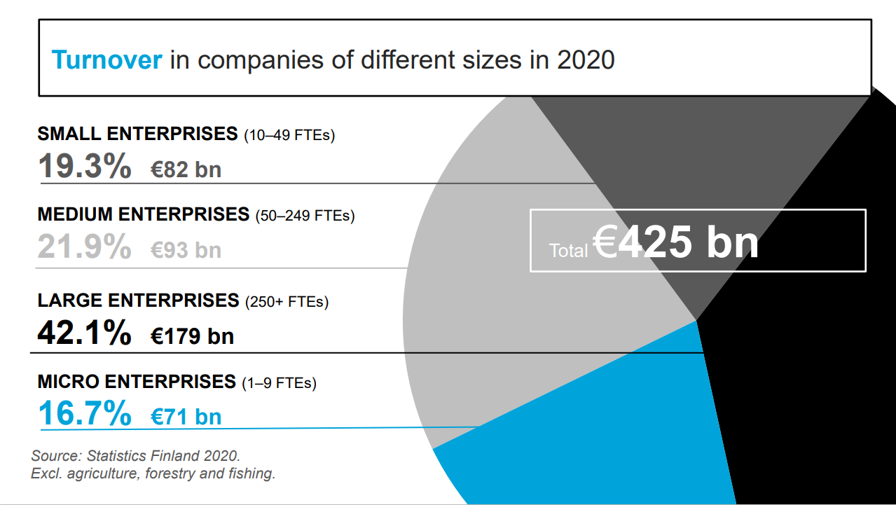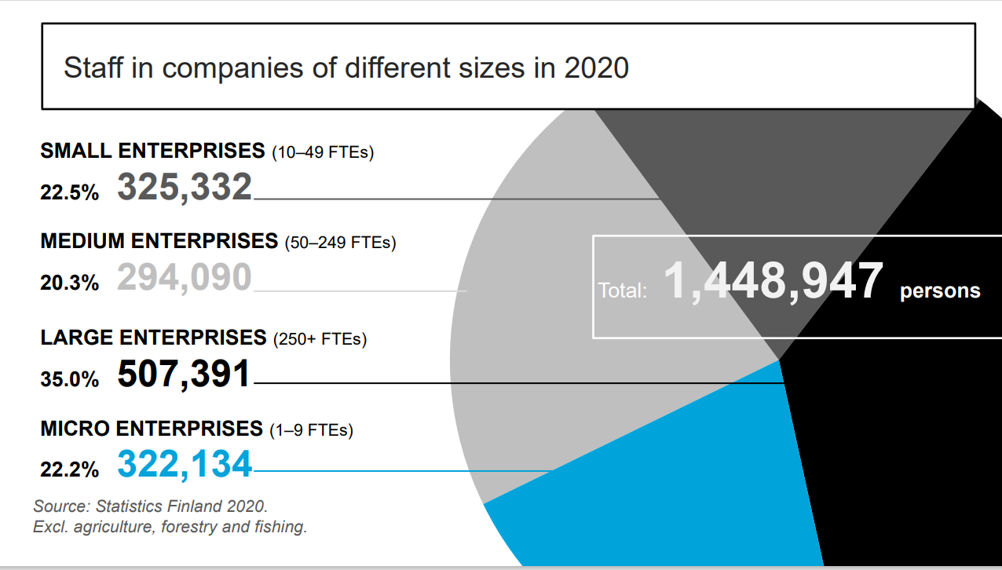

An Introduction to Entrepreneurship video (youtube.com): https://youtu.be/Sar6D45VrrM (4:26). Choose English subtitles from the settings).

2.3 The importance of Business in Society

Companies Create Jobs

About 70% of Finns work in private companies. In the future, businesses will play an even bigger role in employment as the public sector reduces its responsibilities.

Companies Boost Growth and Innovation

Companies help the economy grow. Competition between companies promotes innovation, and companies contribute to the overall well-being of society.

Companies Generate Tax Revenue

Businesses and their employees directly and indirectly fund the majority of public expenses by paying taxes on their profits or salaries.

Companies Engage in Foreign Trade

Foreign trade is crucial for Finland. While the country has limited natural resources, it has a great deal of expertise. Products and services are exported abroad.


Canva 30.10.2024
The Importance of Companies to Consumers and Entrepreneurs

Companies provide goods and services, giving consumers the possibility to choose products and services that best suit their needs. Consumers can influence a company’s development through their purchasing decisions.

For entrepreneurs, running a business provides both employment and income. It also gives them a chance to fully utilize their skills.

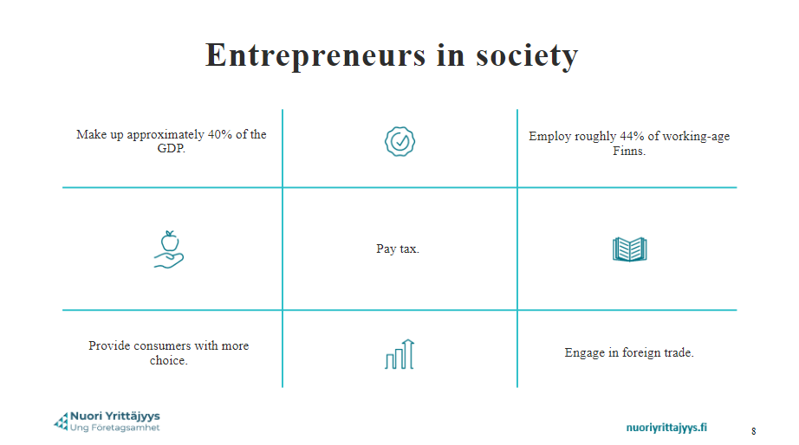,
Source: nuoriyrittajyys.fi 1.6.2024

TEST The Importance of Business in Society

How to use sources and AI (generative artificial intelligence)

Use of AI is not allowed.

1. How many enterprises are there in Finland?
a) 1,4 million
b) 11 798
c) 443 731 XX

2. How many people work in businesses (2020)?
a) 1.4 million XX
b) 1.3 million
c) 1.5 million

3. What happened to the number of business owners, self-employed
employers and single-person businesses between 2002 and 2020?
a) The numbers decreased
b) The numbers increased XX
C) There was no change

4. How many percent of companies in Finland are micro-enterprises (fewer than 10 employees)?
a) 0.2%
b) 5.6%
c) 93.1% XX

5. Entrepreneuship has no value
A) socially
B) economically
C) culturally
D) none of the above XX

6. As an entrepreneur you get to decide
a) how much money you make
b) your working hours XX
c) what the weather is like

7. Why is entrepreneurship important for the national economy?
a) Businesses create jobs. XX
b) The Enterprise offers cool space traveling options
c) Businesses can make their own laws

8. What percentage of taxes in Finland comes from businesses?
a) More then 80%
b) Around 60% XXX
c) Successful businesses don`t pay tax

9. Businesses
a) provide healthy competition XXX
b) make monopoly possible
c) can only function in national market

10. Foreign trade
a) relies only on natural resources
b) is not very important economically
c) exports both services and products XX

Grading:
K5 (5 points, all 10 answers correct)
H4 (9 answers correct)
H3 (8 answers correct)
T2 (7 answers correct)
T1 (5 answers correct)
You can attempt the task as many times as necessary.

Working with a Customer- Centred and Cost-Efficient Approach – self evaluation

How to use sources and AI (generative artificial intelligence)

Use of AI is not allowed.

Response options:
Regularly
Often
Sometimes
Never
I don’t know / Not relevant to my job

- I work proactively and independently.

- I offer constructive suggestions for improvement.

- I think about how to work more efficiently.

- I prioritize tasks.

- I am friendly, polite, and considerate of my co-workers.

- I give positive feedback, thank, and encourage my co-workers.

- I help and advise my co-workers.

- I greet customers.

- I try to find the best solution for the customer.

- I understand that money only comes from customers.

- I keep the promises I make to customers.

- I upsell whenever possible (encourage the customer to buy more)

- I ask for help and advice when needed.

- I adhere to my working hours.

- I follow workplace rules and safety guidelines.

- I maintain cleanliness and order at the workplace.

- My appearance is neat.

- I work with goals in mind and pay attention to detail.

- I take care of my own well-being at work.

- I constantly improve my professional skills.

- I solve problems independently.

- I am flexible when tasks require it.

- I speak positively about my employer.

- I promote my employer on social media.

- I handle my employer’s property carefully.

- I avoid wasting raw materials and supplies.

- I respect the skills and experience of others.

- I respect co-workers from different cultural backgrounds.

- I understand that my boss can't do everything.

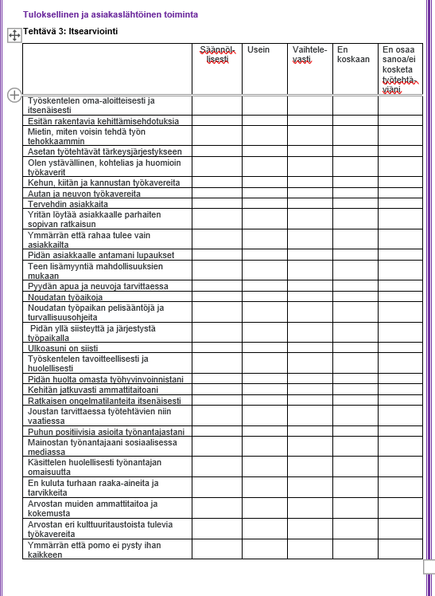

Task: Reflection

How to use sources and AI (generative artificial intelligence)

Use of AI is not allowed.

Task

Part 1
Think about your own strengths and weaknesses. Also, provide examples of these strengths and weaknesses.

What are you good at?

What do you know?

What strengths do you have?

How can you use your strengths in your future profession?

In what areas could you improve yourself and in what way?

Part 2
Give an example of a company that, in your opinion, operates in a customer-centred way. Explain in a few sentences how customer orientation is reflected in the company’s actions.

Assessment:

K5 Table is completed, and additional questions are answered thoughtfully and with detailed explanations.

H4 Table is completed, and additional questions are answered on a basic level.

H3 Table is completed, and additional questions are answered briefly and superficially.

T2 Table is completed, but the additional questions were not answered.

Developing a Business Idea and the Possibilities to Implement it

Source: Canva 30.10.2024

Evaluating a Business Idea and Its Viability

Content and Tasks:
- Developing a business idea
- SWOT Analysis: Assessing risks and opportunities (Internal and external factors)
- Business Model Canvas (BMC)
- Information sources that support starting a business
- Evaluate your ability to be an entrepreneur – take the self-assessment test at https://oma.yrityssuomi.fi/yrittajatesti-soveltuvuus/aloitus

Assessing the business idea and the possibilities to implement it
The student
- generates a business idea, taking into account customers’ needs
- finds key services and information sources that support setting up a business
- determines the networks required to realize the business idea
- assesses the financial preconditions for implementing the business idea
- assesses their capacities for working as an entrepreneur
- determine the risks and opportunities involved in business

Business Idea

A business idea expresses the core purpose of the business. It answers these key questions: what, why, to whom, and how.

What makes a business idea viable? Search for information about business ideas, using several internet sources. Generate a business idea for a business that is under planning, imaginary, or maybe already existing.

Your approach should be customer-centered and cost-efficient, also taking into consideration the current business environment.

To create a business idea, follow these key steps:

Identify a Need or Problem: Look for unmet needs or issues in your community or industry that you can address.

Innovate: Develop a unique solution or improve an existing product or service.

Evaluate Feasibility: Is the idea practical and profitable? Do you have the resources, skills, and market demand?

Market Research: Understand your target market, competition, and trends.

Revenue Model: Plan how your business will make money.

These steps provide a foundation for developing a solid business idea. For more details, visit:
Business Ideas: Introduction, Definitions, Features, Need and Techniques (businessmanagementideas.com)

Business idea / A Video by the Enterprise Agencies: https://youtu.be/f8KQ1ZEJLAw
▶ How to Come Up with an Innovative Business Idea | HBS Online Harvard Business School: text + video 2:24. Factors to consider, examples of innovative business ideas.

Task Business Idea

How to use sources and AI (generative artificial intelligence)
Use of AI is allowed with limitations according to the task instructions.

You may use AI for brainstorming tasks and creating images. You cannot directly copy text generated by AI. You must write the text in your own words. When you use AI, include a reference at the end of the text: (AI application used, description of use, and date).
AI utilizes materials available on the internet, which may be incorrect or copyrighted. You must ensure that the information generated by AI is accurate. The responsibility is yours.


Source: Canva 30.10.2024
  - Generate a business idea (a product or a service). You can present your business idea using the ready-made template below.

Present it in an easy-to-understand format that CLEARLY answers these four questions: WHAT (solution)? WHY (problem)? TO WHOM (customers)? HOW (where/physical place)?

  - Your next task is to come up with a name and a slogan for your company.
Example: Nike - “Just Do It”.

A good company slogan is memorable and reflects the core message of the company, product, or service. Here you can try using artificial intelligence to come up with the name. You can use tools like Microsoft's Copilot AI tool or ChatGPT.

Provide the AI tool with information that describes your company's products and services, values, and image.

Include in your answer:

a) the name and the slogan you came up by yourself

or

b) if you used artificial intelligence to complete the task, list all the prompts that you gave the AI tool. Choose the name and slogan you think are the best. (If prompts are not listed in your answer, it will lower your grading.)

Note! If you want to use the name in establishing a real business in Finland, check that the name is available. You can check this on the PRH name service at https://nimipalvelu.prh.fi/nipa/fi.

liikeideapiirakka.pptx
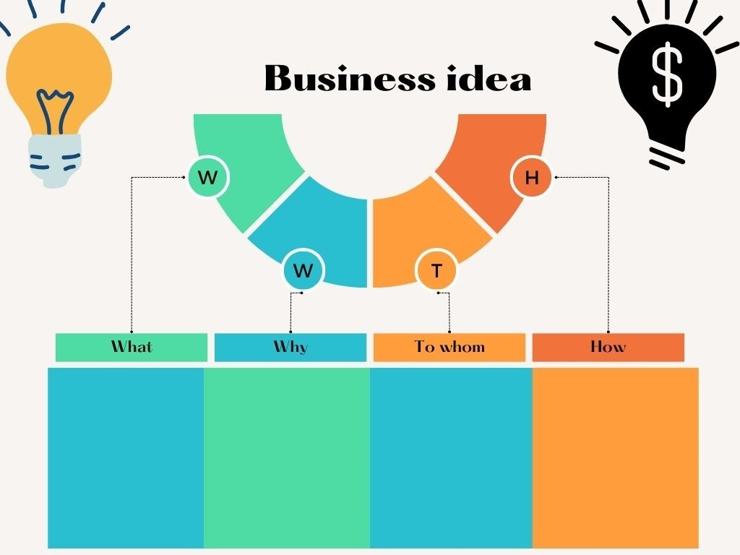

Assessment

K5 The business idea and name follow the instructions, and all four questions are answered.
H3 A name has been created, and all four questions are answered.
T1 The name has not been carefully considered, and the answers are incomplete.

A SWOT Analysis: Risks and Possibilities

To succeed as an entrepreneur, you must be prepared to take calculated risks. Business risks can be e.g. financial risks, information security risks, contractual risks, liability risks, business interruption risks or environmental risks. You can partially prepare for risks with insurance.

A SWOT analysis is a strategic tool for evaluating and understanding some essential internal and external factors in a business, your experience, knowledge, and strengths. SWOT analysis allows you to map the strengths, weaknesses, opportunities and threats of a business idea, entrepreneur, and company. This technique can also be used at the business ideation stage and will help you understand if you should introduce a new product or service.

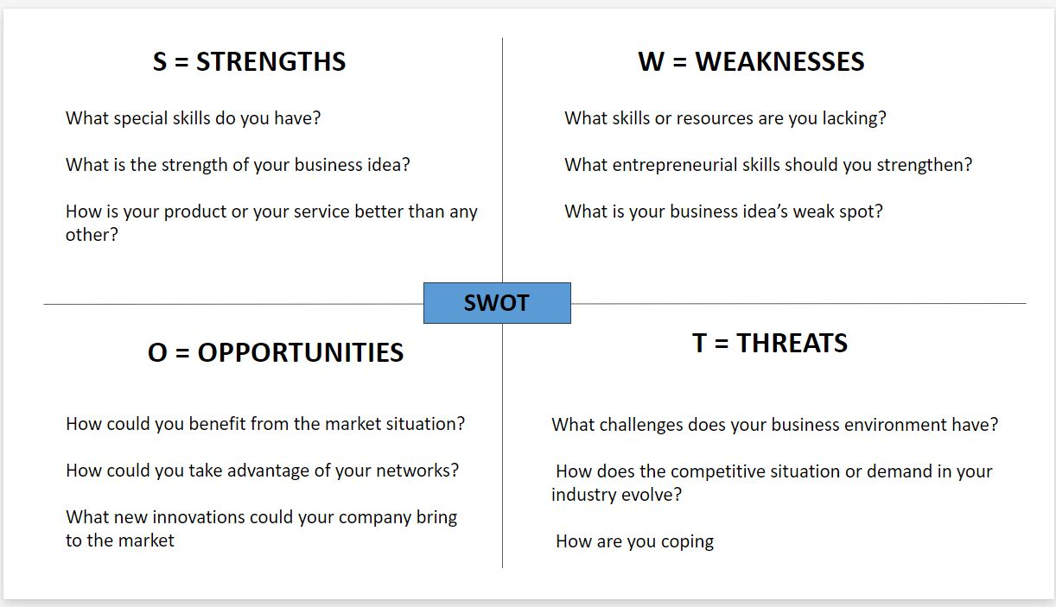

Task SWOT Analysis
How to use sources and AI (generative artificial intelligence)
Use of AI is allowed with limitations according to the task instructions.

You may use AI for brainstorming tasks and creating images. You cannot directly copy text generated by AI. You must write the text in your own words. When you use AI, include a reference at the end of the text: (AI application used, description of use, and date).
AI utilizes materials available on the internet, which may be incorrect or copyrighted. You must ensure that the information generated by AI is accurate. The responsibility is yours.

Task:
Document all essential strengths and weaknesses, opportunities, and threats on your business idea that you presented previously.
Submit your business idea SWOT analysis below.

Swot tyhjä pohja.pptx

Assessment:

K5: Each point and question in the SWOT analysis carefully considered with diverse and critical justifications

H3: Each point generally considered on a basic level

T1: Brief and somewhat incomplete responses

Business Model Canvas
The Business Model Canvas is a visual representation of the 9 key building blocks that form the foundations of every successful business. It’s a visual overview of your entire business on a single canvas containing these 9 key building blocks:

- Customer Segments

- Value Propositions

- Channels

- Customer Relationships

- Revenue Streams

- Key Resources

- Key Activities

- Key Partners

- Cost

The Business Model Canvas explained: https://youtu.be/QoAOzMTLP5s

An example of Business Model Canvas: Zara. Note that the example provided is very basic and that your canvas needs to be much more detailed. (See instructions for each part of the canvas below.)

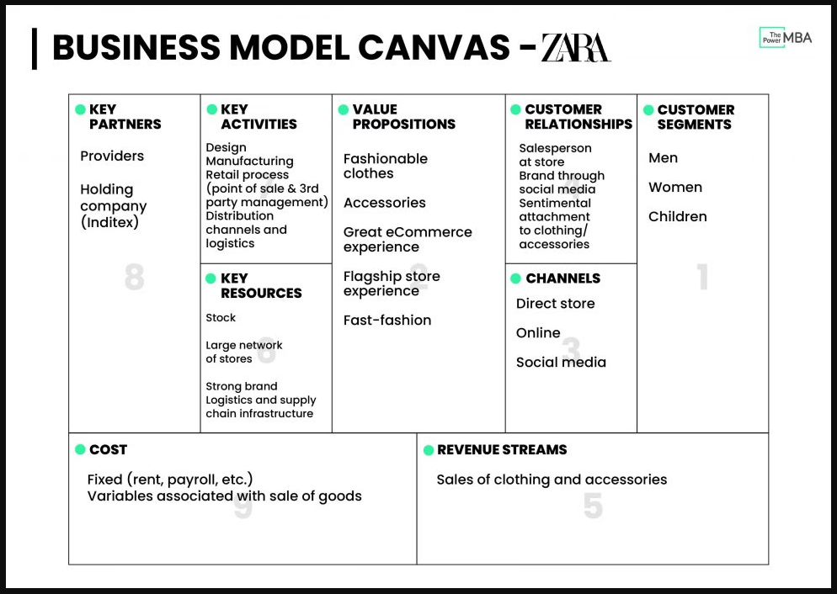
Source: The 9-Step Business Model Canvas Explained (2023 Update) (thepower.education)

Explanations of business model canvas “ingredients”

Customer segments:
It is not realistic to try to sell everything to all possible customers. Instead, you need to think about who your product or service is targeted at. This helps you to do more targeted marketing and design products and services that meet their expectations. When you focus your resources on the right customer segments, your use of money and time is more efficient. Describe here which customer groups your company serves. How would you describe your customers? For example, what age are they, what gender do they represent, what kind of things are they interested in, what do they value, and what is their lifestyle like? Describe what problems or needs they have that your product or service addresses.

Value proposition:
Describe what unique value you offer to your customers. Explain how your product or service differs from competitors' products. Why do customers choose your product or service?

Channels:
Describe how you reach your customers. Explain which channels you use for selling and marketing your products and services to your customers. Where can customers buy your company's product or service? For example, do you have an online store, a brick-and-mortar store, or both? Specify which social media is appropriate for your business and target group.

Customer relationship:
Describe how you maintain customer relationships. How and on which channels do you ensure good customer service? Do you have loyalty programs or other customer benefits? Explain how you collect feedback.

Revenue streams:
Revenue streams refer to all the ways your company earns money. Describe the main products or services you sell. Revenue streams can include product sales and additional services offered with them. You can also create partnerships or collaborations and earn income through reselling, joint marketing, or advertising revenue.

Key resources:
Describe the most important resources you need to run your business. For example, what facilities, machines, and equipment do you need to produce your products or services? Do you need staff to run your business? What digital tools and platforms do you need for your business? Describe the raw materials and materials you need to produce your products. How do you handle transportation/logistics?

Key activities:
Describe the most important tasks you need to perform to produce and sell your products and services. Key activities can include, for example, product design and manufacturing, service production, marketing and sales, distribution and logistics, customer service, financial management, and personnel management.

Key partners:
Describe the most important partners you need to run your business. Partners can include suppliers, subcontractors, logistics companies, advertising agencies, social media influencers, banks and financial institutions, organizations, educational institutions, IT service providers, and accounting firms.

Cost:
Watch the following video (change the subtitles to English): Yrityksen talous - YouTube. Then describe the costs in your business. Also, estimate how much money you need to start your business. Yrityksen talous

3.7 Task: Create Your Own Business Model Canvas
How to use sources and AI (generative artificial intelligence)
Use of AI is allowed with limitations according to the task instructions.

You may use AI for brainstorming tasks and creating images. You cannot directly copy text generated by AI. You must write the text in your own words. When you use AI, include a reference at the end of the text: (AI application used, description of use, and date).
AI utilizes materials available on the internet, which may be incorrect or copyrighted. You must ensure that the information generated by AI is accurate. The responsibility is yours.

Task:
Using your business idea from the previous task, create a business model canvas. Add key services, information sources, and other networks that are essential for your business idea to succeed.

Please use this template: Business Model Canvas eng.dotx (sharepoint.com)

Evaluation:
K5: Each point is considered thoughtfully and critically, with diverse reasoning.
H3: Each point is generally considered at a basic level.
T1: Short and partially incomplete answers.

3.8 Key Services and Information Sources that Support Setting up a Business

How to use sources and AI (generative artificial intelligence)
Use of AI is not allowed.

Task: Review the “Guide to Becoming an Entrepreneur”, then complete the test.

You will find the answers in the guide.
https://uusyrityskeskus.fi/en/help-for-entrepreneurs/guide-to-entrepreneurship/

What is the main task of the Finnish Enterprise Agencies (Uusyrityskeskus)? Choose one.
a) Help find a job in Finland
b) Advise on how to establish a business in Finland XX
c) Help find premises for the business

When can an entrepreneur receive earnings-related unemployment benefits? Choose one.
a) When the business activity ends and the entrepreneur has been a member of the Unemployment Fund for Finnish Entrepreneurs XX
b) When customer acquisition fails and the company's bank account is empty
c) When the entrepreneur has a baby

On which site can you create a business plan? Choose one.
The Tax Administration website (Vero.fi)
The Finnish Center for Pensions (Eläketurvakeskus)
Job Market Finland (Työmarkkinatori) XX

Where can you apply for a start-up grant? Choose one.
a) Ministry for Foreign Affairs (Ulkoministeriö)
b) TE Office (TE-toimisto) XX
c) Suomi.fi service

Where can you search for businesses on sale? Choose two.
www.franchising.fi
www.firmakauppa.fi XX
www.yrityskaupat.net XX
www.yrittajat.fi

Where is the business establishment notification made? Choose one.
a) YTJ service XX
b) Tax Office
c) TE Office

Which of these insurances is mandatory for entrepreneurs? Choose one.
a) YEL insurance XX
b) Travel insurance
c) Business premises insurance

Is bookkeeping mandatory for entrepreneurs? Choose one.
a) Yes XX
b) Sometimes
c) No

Where can you get more information about tax matters? Choose one.
a) www.ytj.fi
b) www.yrittajakassa.fi
c) www.vero.fi XX

Where can you get a loan when starting a business? Choose two.
a) Bank XX
b) Finnvera XX
c) Finnish Enterprise Agencies
d) TE Office

Assessment:

K5: 9-10 points

H4: 7-8 points

H3: 6 points

T2: 4-5 points

T1: 3 points

Evaluate Your Ability to Be an Entrepreneur - Self-Assessment Task
How to use sources and AI (generative artificial intelligence)

Use of AI is not allowed.

- Think about your own abilities and take a test on your suitability to become an entrepreneur. To take the test in English, change the language on the top-right corner of the page. To complete this assignment, copy the summary of the test results and submit it below. Soveltuvuus yrittäjäksi - Yrittäjyystestit - ELY-keskus Complete the entrepreneur test My Enterprise Finland | Entrepreneur test: Suitability to become an entrepreneur (yrityssuomi.fi)

- Based on the test you just completed, give three reasons why you would be a good entrepreneur and three areas where you still need to improve to become a successful entrepreneur.
Consider whether starting a business is a possibility for you in the future. What factors need to be in place, and what potential obstacles do you face? If you don’t want to start a business, explain why.
What have you learned about entrepreneurship while taking this course? Share your key insights.

Assessment:

K5: Entrepreneur test completed, with thoughtful and well-reasoned responses to the additional questions.
H4: Entrepreneur test completed, with basic responses to the additional questions.
H3: Entrepreneur test completed, with brief and somewhat incomplete responses to the additional questions.
T2: Entrepreneur test completed, but no responses provided for the additional questions.

4 Additional Material

Here you can find extra resources on entrepreneurship. These materials can help you with your studies. If you’re interested in learning more about entrepreneurship, feel free to explore these resources as well.

These steps provide a foundation for developing a solid business idea.
For more details, visit: Business Ideas: Introduction, Definitions, Features, Need and Techniques (businessmanagementideas.com)

How to Find Business Ideas - The Ultimate Guide (2023) (youtube.com) (Video 3:52.)

Entrepreneurial story: https://youtu.be/t72j4ukLghw (video 2:03)
Light entrepreneur:
https://youtu.be/TOErCl58P0g (video 0:30)
Kevytyrittäjyys ja osuuskunta englanniksi.PDF

Enterprise Agencies, Becoming an entrepreneur, video playlist.
You will find videos for guidance: https://www.youtube.com/playlist?list=PLIBloQrO8cWxXdX2ZmpoS0MkJ7AHeD0sL

More information in English Becoming an entrepreneur in Finland www.uusyrityskeskus.fi

Entrepreneur guides Enterprise Finland www.yrityssuomi.fi/en
The Centres for Economic Development, Transport and the Environment (ELY Centres) www.ely-keskus.fi/en
TE-services: Services for new entrepreneurs www.te-services.fi
Employers and entrepreneurs Federation of Finnish Enterprises www.yrittajat.fi/en
Finncham www.kauppakamari.fi/en

Ohjeita kurssin käyttöön opettajalle

Kurssi on jaettu seuraaviin osa-alueisiin

 |  | tehtävät
Ohjeet opiskeluun | Introduction
Johdatus yrittäjyyteen | What is Entrepreneurship? | 2 tehtävää
Yrityksen tavoitteiden mukaisesti toimiminen | Acting in Accordance with the Company’s Objectives | 3 tehtävää
Liikeidean ja sen toteuttamismahdollisuuksien arvioiminen | Developing a Business Idea and the Possibilities to Implement it | 5 tehtävää

Kurssi alkaa ohjeita opiskeluun -osiolla, jossa kerrotaan kurssin osaamistavoitteet ja sisällöt.

What is Entrepreneurship osa-alueen materiaali ja tehtävät johdattelevat opiskelijan yrittäjyyden aiheisiin.

Acting in Accordance with the Company’s Objectives osa-alueessa tehtävässä Yrityksen tavoitteiden mukaisesti toimiminen: Itsearviointitehtävä toimii jo itsestään oppimateriaalina, kun opiskelija käy kaikki 29 kohtaa tässä läpi.

Arviointi
Arviointiin avuksi on tehty valmis arviointiasteikko jokaiseen tehtävään. Tehtävien yhteydestä löydät tehtäväkohtaisen arviointiasteikon.

Lähdeluettelo

Harvard Business School. How to Come Up with an Innovative Business Idea. Video. Katsottavissa How to Come Up with an Innovative Business Idea | HBS Online

Nuoriyrittajyys.fi, luettu 1.6.2024

Nuori Yrittäjyys. Johdatus yrittäjyyteen. Video. Katsottavissa: https://www.youtube.com/watch?v=Sar6D45VrrM Katsottu 29.4.2024.

Strategyzer. The Business Model Canvas explained. Video. Katsottavissa: https://youtu.be/QoAOzMTLP5s Katsottu 20.5.2024.

Suomen Uusyrityskeskukset ry. Business idea. Katsottavissa https://youtu.be/f8KQ1ZEJLAw Katsottu 15.5.2024.

Suomen Yrittäjät, Statistics Finland 2022, https://www.yrittajat.fi/wp-content/uploads/2024/06/entrepreneurship-statistics-2022.pdf 13.5.2024

The 9-Step Business Model Canvas Explained (2023 Update), luettu 20.5.2024.

Uusyrityskeskus.fi, luettu 13.5.2024

Varsinais-Suomen Yrittäjät. Yrityksen talous. Video. Katsottavissa: Yrityksen talous. Katsottu 15.5.2024.

Yrittäjät.fi, luettu 13.5.2024

Tämä materiaali on tuotettu VIERKO-hankkeessa
vuonna 2024.
VIERKO on toteutettu Opetus- ja kulttuuriministeriön
vuonna 2023 myöntämällä ammatillisen koulutuksen strategiarahoituksella. VIERKO on kuudenkymmenen-
kahden (62) koulutuksen järjestäjän yhteisponnistus.
Työtä on koordinoinut Keski-Uudenmaan koulutus-
kuntayhtymä Keuda.

Hankkeessa on kehitetty vieraskielisen koulutuksen laatua
ja kotimaisten kielten opetuksen tarjontaa ammatillisessa koulutuksessa.

Lisätietoa:
https://www.keuda.fi/keuda/hankkeet/vierko/

https://creativecommons.org/licenses/by/4.0/


Oppimateriaalit:

CC BY-SA 4.0 Deed | Nimeä-JaaSamoin 4.0 Kansainvälinen | Creative Commons
https://creativecommons.org/licenses/by/4.0/

Oppimateriaalit:



CC BY-SA 4.0 Deed | Nimeä-JaaSamoin 4.0 Kansainvälinen | Creative Commons

