Green Export Growth from the Circular Economy

Green Export Growth from the Circular Economy
A Hands-On Guide for Finnish SME Exporters
Welcome to the online course "Green Export Growth from the Circular Economy"!
In this course, we embark on a journey to explore the intersection of sustainability and export growth, focusing on innovative approaches rooted in the circular economy framework.
Across four insightful episodes, we will delve into key aspects essential for thriving in today's global marketplace while prioritizing environmental responsibility.
Throughout this course, you will gain an understanding of how businesses can leverage circular economy principles to enhance their competitiveness in international markets. Each episode offers valuable insights and practical strategies that can be applied to your export ventures.
As you progress through the course, we encourage you to reflect on your learning outcomes and consider how you can integrate these principles into your business practices. By embracing sustainability and circularity, you contribute to a healthier planet and unlock new opportunities for growth and innovation.

Remember, the key to success lies in applying what you learn.
Take the time to assess your own needs, identify areas for improvement, and take action to implement positive change.
So, let's explore the transformative power of the circular economy in driving green export growth.
Your journey towards sustainable success starts now!

This course content is offered under a CC attribution share alikeLinks to an external site. license. Content in this course can be considered under this license unless otherwise noted.

Episode 1: Business Opportunities and Innovative Business Models
Episode 2: Sustainable Supply Chain
Episode 3: Sustainable Packaging
Episode 4: Business Circular Economy Transformation

Learning Objectives:
You will be able to
Identify innovative business models integrating circular economy principles for export growth.
Develop and manage sustainable supply chains aligned with circular economy principles to enhance export competitiveness.
Apply sustainable packaging practices to meet export market requirements and reduce environmental impact.
Utilize strategies to lead the integration of circular economy principles into business strategies, fostering sustainable export growth.

To achieve the learning outcomes, you must take responsibility for your learning. We recommend that you invest in independent knowledge acquisition and the application of knowledge to your company's export trade.
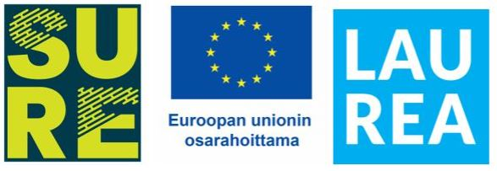
Course Overview:
In Episode 1, we explore the vast landscape of business opportunities within the circular economy framework, emphasizing innovative business models tailored for export growth.
Episode 2 delves into the intricacies of building sustainable supply chains aligned with circular economy principles, providing insights to enhance competitiveness in export markets.
In Episode 3, sustainable packaging practices take center stage, as we uncover strategies to meet export market requirements while minimizing environmental impact.
Finally, Episode 4 focuses on business transformation, guiding you in integrating circular economy principles into strategies to foster sustainable export growth.
Join us in this insightful journey to unlock the potential of Green Export Growth from Circular Economy.

Assesment & evaluation
This course is assessed with a pass/fail scale. To pass the course you need to familiarize yourself with the course materials and pass the tests and assignments with a passing score. The passing score is stated on each test. This course is valued as 1 study point which equals to 27 hours of studying.

Questions & communication
If you have a question about the contents of this MOOC, please contact the teacher responsible for this MOOC by sending an email to: TÄHÄN VASTUUOPETTAJAN NIMI JA YHTEYSTIEDOT

If you are experiencing technical difficulties, please contact the Laurea Service desk via their service portal: https://servicedesk.laurea.fi/ or send a message to servicedesk@laurea.fi

If you have questions about the crediting or completion of this MOOC, please contact the Laurea MOOC team via email: mooc@laurea.fi
Before contacting the MOOC team, please go through the FAQ section at the bottom of this page.
Remember, every bit of knowledge gained is a step toward expertise. Let's kickstart this learning journey together!

This course content is offered under a CC attribution share alike license. Content in this course can be considered under this license unless otherwise noted.

EPISODE 1 Business Opportunities and Innovative Business Models
Welcome to Episode 1 of the “Green Export Growth from the Circular Economy" online course!
Get ready to dive into the eco-friendly business world - where we make green not just a color, but a currency!
In this session, you’ll:
- Explore the concept of the circular economy and its implications for businesses.
- Examine how the business landscape is evolving in the EU and globally towards circular economy practices.
- Identify various business opportunities within the circular economy framework, with a specific focus on innovative business models for export growth.
Prepare to tap into your full potential and lead the charge in adopting sustainable business strategies.
Let's turn challenges into opportunities and pave the way for a greener, more prosperous future together!

Introduction - What’s the Circular Economy?
Integrating circular economy principles into daily operations is important for exporting SMEs. This involves designing products for durability, reuse, and recycling, as well as optimizing resource use throughout the supply chain.
Embracing circularity can enhance competitiveness, reduce environmental impact, and open up new market opportunities.
Keeping abreast of relevant regulations and certifications is also crucial for success in the circular economy.
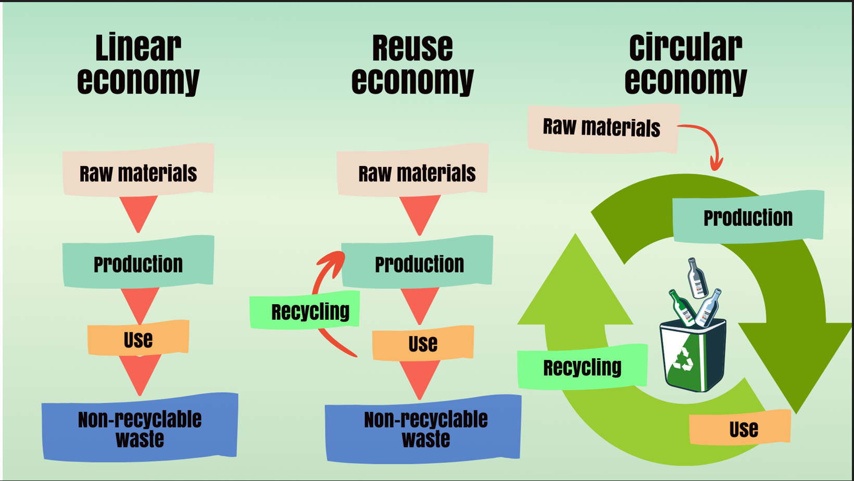
Tämän lähde on: From a linear to a circular economy | Circular economy | Government.nl

VIDEO : Why is the Circular Economy important?

"The world's population has tripled since 1950, and the average income level of people has quintupled. By the year 2019, economic activity in the world had grown 13 times larger than it was in 1950.
As a result, the burdens humans impose on nature increasingly exceed its capacity for renewal and sustainability.
Biodiversity is declining faster than ever before in human history, which could have unpredictable and catastrophic consequences for the balance of nature and humanity."
(Source: Sixten Korkman. Talous ja humanismi (Economy and Humanism). Publisher: Otava Ltd, 2022)

Planetary Challenges
Climate Change
Achieving the 1.5-degree target is becoming increasingly difficult; without additional actions, the world is on track for a 2.6-degree warming.
(Source: UN COP27, Egypt, 2022. Five Key Takeaways from COP27 | UNFCCC)
Biodiversity Loss
Biodiversity loss is among the top five risks globally.
Over 90% of biodiversity loss is a result of material, fuel, and food production.
(Source: WEF: Global Risks Report 2023: Global Risks Report 2023 | World Economic Forum | World Economic Forum (weforum.org))
Resource Overconsumption
Resource use has more than tripled since 1970 and is rapidly increasing.
Consumption patterns are harmful to the environment and health.
Consumption is unevenly distributed.
(Source: UNEP: Global resources Outlook 2019. Global Resources Outlook 2019: Natural Resources for the Future We Want - Summary for Policymakers (unep.org))
Environmental Pollution
Pollution of air, water, and soil resulting from our production and consumption patterns damages the environment. This causes climate change and biodiversity loss, and affects the health and well-being of people and animals globally.
(Source: UNEP: Global environment outlook 2019. Global Environment Outlook 6 | UNEP - UN Environment Programme)

Circular economy as a solution to global challenges?
With current climate commitments, only 15% of emission reduction targets are achieved. The circular economy can achieve the remaining 85%.
Only 7.2% of the global economy operates according to circular economy principles.
A global circular economy would enable a return to an economy operating within planetary boundaries.
(Source: Circle Economy: Circularity Gap Report, 2023.
https://www.circularity-gap.world/2023)

In this activity, you will be presented with a series of statements about the circular economy.
Your task is to determine whether each statement is true or false based on the knowledge you've gained from the material about the importance of the Circular Economy.

True or False?
- The world's population has tripled since 1950, and the average income level of people has quintupled. - True
- Achieving the 1.5-degree target is becoming increasingly difficult; without additional actions, the world is on track for a 2.6-degree warming. – True
- Over 50% of the global economy operates according to circular economy principles. - False (The actual percentage is 7.2%.)
- The circular economy can achieve the remaining 85% of emission reduction targets. - True
- Over 90% of biodiversity loss is a result of material, fuel, and food production. - True
- Resource use has more than tripled since 1970 and is rapidly increasing. - True
- Only 15% of emission reduction targets are achieved with current climate commitments. - True
- Biodiversity loss is among the top five risks globally. - True
- Only 7.2% of the global economy operates according to circular economy principles. - True
- A global circular economy would enable a return to an economy operating within planetary boundaries. - True

Grow Green - Interview 1

Get ready for an enlightening and inspiring conversation! Dive into Jussi's interview with Riitta as they explore the dynamic landscape of sustainable export strategies and the circular economy.
Gain valuable insights, discover innovative approaches, and uncover actionable steps to propel your business toward a greener, more sustainable future.
Don't miss out on this opportunity to learn from industry experts and unlock the potential for sustainable success. Tune in now and embark on your journey towards sustainable growth!

Meet Jussi, your host, and guide throughout this journey into the world of green export growth from the circular economy.
With his warm personality and passion for sustainability, Jussi is here to make your learning experience informative, engaging, and enjoyable.
As an experienced interviewer, he knows just how to ask the right questions to uncover valuable insights from our expert guests.
Get ready to join Jussi as he navigates the complexities of eco-friendly business practices and unlocks the secrets to sustainable success in the global marketplace.

Meet Riitta, your senior advisor in green export growth from the circular economy
With vast experience and a passion for sustainability, Riitta is your go-to expert for consulting exporting SMEs on navigating the complexities of eco-friendly business practices.
She's dedicated to helping businesses thrive while making a positive impact on the planet.
With her wealth of knowledge and sharp insights, Riitta is poised to guide you toward sustainable success in the global marketplace.

Introducing “Grow Green”! In this series, we delve deep into the world of eco-friendly business practices and explore how businesses can thrive while making a positive impact on the planet.
Join us as we uncover valuable insights and strategies to unlock a multitude of benefits while contributing to the preservation of our planet for future generations.
Let's grow green together and pave the way for a more sustainable and prosperous future!

Jussi: Riitta, thank you for joining us today. Could you please help our viewers understand what exactly the circular economy entails and why it's such a game-changer for businesses looking to thrive in today's market?
Riitta: Of course, Jussi. The circular economy is all about minimizing waste and maximizing resource efficiency. Instead of the traditional “take-make-dispose” model, it focuses on keeping products and materials in use for as long as possible. By doing so, we not only contribute to environmental sustainability but also bolster economic resilience. It's a win-win approach that benefits both our planet and our businesses.
Jussi: That sounds like a significant departure from conventional economic models. How does the circular economy address some of the pressing environmental challenges we face today?
Riitta: Indeed, Jussi. The circular economy serves as a means to slow down climate change, biodiversity loss, and the overconsumption of natural resources. By optimizing the use of materials and energy while minimizing waste, it offers a sustainable system that benefits both the economy and the environment.
Jussi: It's remarkable how it aligns environmental goals with economic ones. You mentioned maximizing the value of products and materials in use for as long as possible. How does this aspect contribute to the circular economy's objectives?
Riitta: In the circular economy, maximizing product and material value is key. It's about moving from ownership to service-based consumption. By extending product lifespans through reuse, refurbishment, and sharing platforms, we cut waste and preserve resources, getting the most out of what we have.

Jussi: That shift in consumption patterns sounds transformative. How does the circular economy empower businesses to generate more value with fewer resources?
Riitta: Great question, Jussi. The circular economy offers businesses tools and strategies to optimize resource use and add value. This includes eco-design for efficient products, circular supply chains to cut waste, and digital tech for better resource management. Embracing these tools drives innovation, cuts costs, and boosts environmental performance for more sustainable operations.
Jussi: Riitta, one interesting point from the principles of the circular economy is that it offers an opportunity for proactive engagement rather than a passive observer role. Could you elaborate on what this means for businesses, and how they can actively participate in the circular economy?
Riitta: Absolutely, Jussi. The idea here is that the circular economy invites businesses to take an active role in shaping a more sustainable future, rather than simply reacting to environmental challenges. Instead of being passive observers, businesses have the opportunity to proactively engage in circular practices, such as redesigning products for longevity, implementing closed-loop systems, or collaborating with partners to optimize resource use across the value chain. By taking this proactive approach, businesses not only contribute to environmental sustainability but also position themselves as leaders in their industries, driving innovation and creating value for both society and the economy.
Jussi: That's fascinating, Riitta. So, essentially, businesses have the power to be agents of change rather than bystanders in the transition to a circular economy.
Riitta: Exactly, Jussi. The circular economy presents businesses with an opportunity to rethink traditional business models and embrace more sustainable practices. By actively engaging in circular initiatives, businesses can unlock new growth opportunities, reduce environmental impact, and enhance their long-term competitiveness. It's about recognizing the role that businesses play in shaping our collective future and embracing that responsibility with enthusiasm and commitment.
Jussi: Riitta, one aspect we haven't touched upon yet is the capability of companies transitioning to a circular economy-based business to meet the growing expectations for sustainable business from customers, partners, and investors. How important is it for businesses to align with these expectations, and what role does the circular economy play in ensuring their long-term viability?
Riitta: Ah, an excellent point, Jussi. In today's increasingly environmentally conscious world, businesses are facing growing pressure from stakeholders to demonstrate their commitment to sustainability. Customers, partners, and investors are all demanding greater transparency and accountability when it comes to environmental and social impact. This presents both a challenge and an opportunity for businesses. By embracing circular economy principles, companies can not only meet these expectations but also differentiate themselves in the market and enhance their long-term viability. It's about building trust and credibility with stakeholders by demonstrating a genuine commitment to sustainability across all aspects of the business.
Jussi: That's a compelling perspective, Riitta. So, essentially, the circular economy serves as a framework for businesses to not only respond to stakeholder expectations but also future-proof their operations in an increasingly sustainability-focused market?
Riitta: Precisely, Jussi. By transitioning to a circular economy-based business, companies can position themselves as leaders in sustainability, attract environmentally conscious customers and partners, and access new markets and opportunities. It's about aligning business objectives with societal and environmental goals, ensuring that businesses not only survive but thrive in the rapidly changing landscape of the 21st century.
Jussi: Riitta, thank you so much for sharing your expertise and insights on the circular economy. It's been a truly enlightening conversation.

Riitta: Thank you, Jussi. It's been my pleasure. I'm glad we had the opportunity to discuss such an important topic, and I hope our conversation inspires businesses to embrace sustainability and drive positive change in the world.
Jussi: Absolutely, Riitta. Here's to a greener tomorrow.
And to our viewers, stay tuned! We'll delve deeper into the changing business landscape and its adaptation to sustainable practices with Riitta soon. Until then, keep exploring and learning.

The Definition of the Circular Economy - Briefly
- The circular economy aims to minimize waste and maximize resource efficiency.
- It keeps products and materials in use for as long as possible.
- This approach contributes to environmental sustainability and economic resilience.

The Circular Economy
- Aims for a carbon-neutral economic system that operates within the planet's carrying capacity.
- A means to slow down climate change, biodiversity loss, and the overconsumption of natural resources.
- A sustainable system for both the economy and the environment, optimizing the use of materials and energy while minimizing waste.
- Maximizes the value of products and materials in use for as long as possible.
- Consumption is based on access to services rather than ownership.
- Provides businesses with tools to generate more value with fewer resources.
- Circular economy offers an opportunity for proactive engagement rather than a passive observer role.

The transition of a company to a circular economy-based business offers:
- Tools for increased value generation with fewer resources.
- Capability to meet the growing expectations for sustainable business from customers, partners, and investors, ensuring business viability in the future.
- Ability to respond to tightening regulations demanding sustainable business and circular economy practices.
- Means to cut business costs and reduce business risks.
- Opportunity to implement environmentally, socially, and economically sustainable business practices.

To conclude, the Circular Economy presents a transformative opportunity for exporting SMEs to embrace sustainability, drive green growth, and shape a more resource-efficient and resilient future.

Next, we will present you with a set of true or false statements. Your task is to evaluate these statements regarding the definition of the Circular Economy and the benefits offered by transitioning a company to a circular economy-based business.

True or False?

- The circular economy aims to minimize waste and maximize resource efficiency. - True
- The Circular Economy aims for a carbon-neutral economic system that operates within the planet's carrying capacity. – True
- The Circular Economy provides businesses with tools to generate more value with fewer resources. - False (It aims to do so, but it may not provide all the necessary tools.)
- The Circular Economy is a means to slow down climate change, biodiversity loss, and the overconsumption of natural resources. - True
- The Circular Economy offers a means to cut business costs and reduce business risks. - False (While it can lead to cost reductions and risk mitigation, it may not be a direct guarantee.)
- The Circular Economy offers an opportunity for proactive engagement rather than a passive observer role. - True
- The transition of a company to a circular economy-based business offers the capability to meet the growing expectations for sustainable business from customers, partners, and investors, ensuring business viability in the future. - True

Keep the momentum going! Next up, Jussi continues his insightful conversation with Riitta as they delve into the evolving business landscape and how it's adapting to sustainable practices.

Grow Green – Interview 2

Gain valuable knowledge about the changing regulatory environment, shifting consumer preferences, technological advancements, and their impact on businesses worldwide.
Don't miss out on this opportunity to stay ahead of the curve and unlock the potential for sustainable growth in your own business.
Tune in now and be part of the conversation shaping the future of eco-friendly business practices!

Jussi: Riitta, welcome back to our discussion. Let's delve into how the business landscape is evolving toward circular economy practices, especially regarding regulatory changes. Can you explain how these regulations are shaping the business environment?
Riitta: Thank you, Jussi. It's great to be back. Regulatory changes in the EU and globally are pivotal in promoting sustainability and circular economy practices. They aim to cut emissions, enhance resource efficiency, and elevate environmental standards. Compliance isn't just a legal requirement but also strategic for businesses to remain competitive and future-proof.
Jussi: That's crucial, Riitta. How about consumer preferences? How do they influence businesses' sustainability efforts?
Riitta: Consumer preferences are shifting towards sustainable products, urging businesses to adopt eco-friendly practices. Not meeting these expectations risks reputation and market share loss. Hence, businesses invest in sustainable innovation, transparency, and ethical sourcing to align with consumer values and stay competitive.
Jussi: It's impressive how consumers are driving change. What about technological advancements? How do they contribute to sustainable growth?
Riitta: Technology is pivotal in driving sustainable growth by enabling eco-friendly solutions across industries. From renewable energy to digital platforms for circular supply chain management, tech advances drive efficiency gains and environmental impact reduction. Leveraging these tech tools opens new growth and innovation avenues for businesses.
Jussi: Insightful, Riitta. Lastly, how does international trade impact the environment?
Riitta: International trade shifts resource-intensive production from high-income to low-income countries, exacerbating environmental burdens. While Europe and North America import materials, Asia and Pacific countries export due to industrial growth. This stresses the importance of sustainable global trade practices.
Jussi: Thank you for these insights, Riitta. The shift toward circular economy practices is indeed multifaceted. It requires proactive engagement and strategic vision from businesses, as you mentioned.
Riitta: Exactly, Jussi. Embracing sustainability and circular economy principles not only mitigates environmental impact but also fosters growth, innovation, and long-term success for businesses.
Jussi: Riitta, thank you for sharing your expertise once again. It's been a pleasure discussing these important topics with you.
Riitta: Thank you, Jussi. I appreciate the opportunity to contribute to the conversation.
Jussi: To our viewers, thank you for joining us. Stay tuned for more insightful discussions on sustainable export strategies and circular economy practices.
Riitta: Remember, the journey to sustainability starts with small steps. Let's keep moving forward together.
Jussi: Absolutely, Riitta. Until next time, goodbye everyone!
Regulatory changes
The EU and many countries globally are implementing regulations to promote sustainability and circular economy practices.
These regulations aim to reduce emissions, improve resource efficiency, and elevate environmental standards.
Consumer preferences:
Increasing demand for sustainable products and services compels businesses to adopt eco-friendly practices.
Failure to meet these expectations may lead to reputational risks and loss of market share.
Technological advancements:
Technological innovations are driving sustainable growth by enabling the development of eco-friendly solutions across various industries.
Supply chain transparency:
There is increasing pressure on companies to ensure transparency and accountability throughout their supply chains.
This includes tracking the environmental and social impact of products from sourcing to disposal.
Investor pressure:
Investors are increasingly considering environmental, social, and governance (ESG) factors when making investment decisions, favoring companies committed to sustainability, thus driving businesses to integrate sustainability into their operations and reporting practices.

Changes in the Business Environment

International trade and environmental impact
- Only Europe and North America are net importers of materials when considering all materials used in the production of exported/imported products.
- Asia and Pacific countries are net exporters of materials, as a result of the strong growth in industrial product exports.
- Resource-intensive production has shifted from high-income importing countries to low-income exporting countries. This has, in turn, exacerbated environmental burdens in low-income countries.
(Source: UNEP, Sustainable Trade in Resources: Global Material Flows, Circularity and Trade, 2020. Sustainable Trade in Resources: Global Material Flows, Circularity and Trade | UNEP - UN Environment Programme)

EU's Circular Economy Regulation

The EU has implemented various measures, including circular economy action plans and strategies, to promote sustainability and achieve carbon neutrality by 2050.
2015: EU's first circular economy action plan
2019/2020: EU's Green Deal program and the Just Transition Mechanism
2020: EU's Biodiversity Strategy for 2030 and the Farm to Fork Strategy
2021: EU's Taxonomy for Sustainable Activities to Promote Green Investments
March 30, 2022: The European Commission's Circular Economy Package I
November 30, 2022, Circular Economy Package II

EU's Circular Economy Regulation

EU Commission Vice President Frans Zimmerman:
"Achieving the EU's carbon neutrality target by 2050 and preserving the natural environment requires full circularity in the EU."
Circular economy is increasingly integrated into EU criteria and regulations.
Sustainable, circular economy-based products are becoming the norm in the EU, applying to almost all products.
(Source: European Commission)

EU's Circular Economy Regulation
- The goal of the EU taxonomy is to promote the achievement of EU environmental objectives. Taxonomy = sustainability criteria for promoting green investments.
- It aims to channel investments into responsible business practices and achieving the goals of the European Green Deal program. Capital markets can offer benefits (e.g., cheaper financing) to responsible companies.
- If a company wants to attract a share of investments aimed at responsible solutions, it must ensure that its operations and product range perform well within the taxonomy framework.

Finland
The circular economy is the new foundation of Finland's economy. The goal is carbon neutrality by 2035, as set in the Government's policy decision in 2021 and the Circular Economy Strategic Programme.

Now, go ahead and evaluate each statement to test your knowledge! Assessing the accuracy of each statement will help you identify areas where you might need further clarification or study.

True or False?
- Regulatory changes aim to reduce emissions, improve resource efficiency, and elevate environmental standards. - True
- Failure to meet increasing consumer demand for sustainable products may not lead to reputational risks and loss of market share. - False
- Technological innovations are not driving sustainable growth across various industries. - False
- There is increasing pressure on companies to ensure transparency and accountability throughout their supply chains. - True
- Investors are not considering environmental, social, and governance (ESG) factors when making investment decisions. - False
- Europe and North America are net exporters of materials when considering all materials used in the production of exported/imported products. - False
- Resource-intensive production has shifted from low-income exporting countries to high-income importing countries. - False
- The EU has not implemented various measures to promote sustainability and achieve carbon neutrality by 2050. - False
- Circular economy-based products are not becoming the norm in the EU, applying to almost all products. - False
- The goal of the EU taxonomy is to promote the achievement of EU environmental objectives. - True
- Finland has not set carbon neutrality by 2035 as the goal for its economy. – False
- Businesses are facing increasing pressure to ensure transparency and accountability throughout their supply chains, including tracking the environmental and social impact of products from sourcing to disposal. - True

Next, we delve together into the discussion between Jussi and Riitta on innovative business models leveraging circular economy principles.
We encourage you to study the circular business model canvas carefully. This canvas serves as a valuable tool for understanding and visualizing the key components of circular business models.
By following the discussion closely, you'll gain insights into how these models differ from traditional ones, examples of successful implementation, and important considerations such as supply chain impacts, financial viability, scalability, regulatory challenges, and the role of collaboration.
Stay engaged and take notes as you explore this important topic, as it will provide you with valuable insights into sustainable export strategies and circular economy practices.

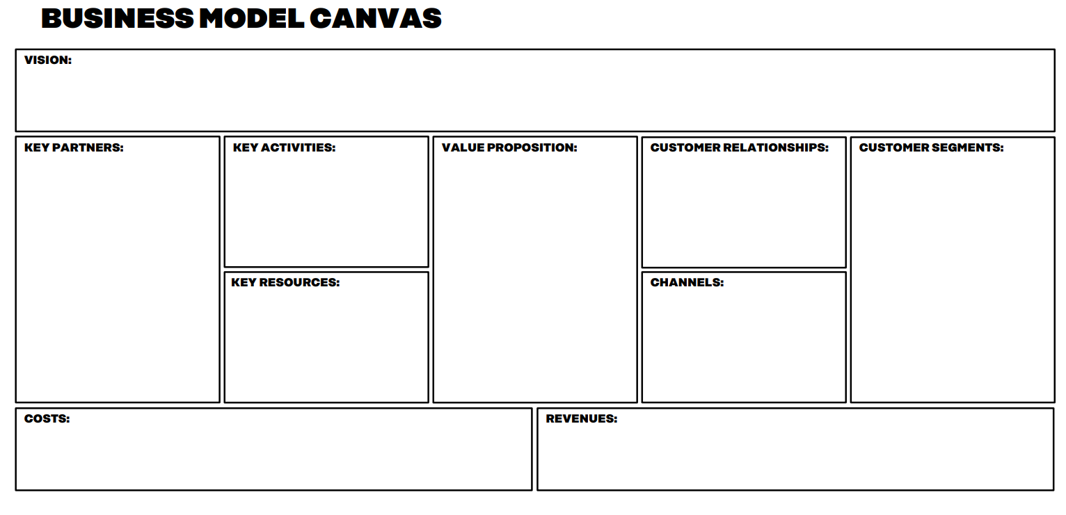

The business model canvas has been developed by Osterwalder & Pigneur (strategyzer.com).
They have added some prompts and questions that you might find helpful in the context of the circular
economy.

KEY PARTNERSHIPS
How might you strengthen your partnerships with organisations across the value chain to beneﬁt from circularity (ﬂows of materials, information and capital) in the system?
What new or unexpected partnerships can you form to grow circularity within your organisation and the system?
KEY ACTIVITIES
What activities might best help you achieve your value proposition?
What might be the positive externalities (i.e. the consequences of your actions on others) of your activities? And how might you monitor and design out any negative externalities?
How might you create new forms of human, natural or ﬁnancial capital?

KEY RESOURCES
How might you build a multi-disciplinary team within or across organisations to create value in a circular economy? How might you embrace connectivity?
What capabilities do you need to enable circular ﬂows and feedback mechanisms and run your organisation successfully in the short and long term?
Where will your resources come from
(renewable or ﬁnite source) and what will happen to them after use?

VALUE PROPOSITION
Start by asking yourself: what are the needs you are aiming to meet? Is it a product or is a service required to fulﬁl these needs?
Is there anything associated with your product/service that has potential value to others?
How will you create a compelling story about your value proposition?
How might you enhance your value proposition from the outset by designing for adaptability and continuous evolution?

CUSTOMER RELATIONSHIPS
What feedback loops will you build in with your customers to become more nimble and adaptable to their feedback?
How might you connect customers with other parts of the journey of your product/service or materials?

CHANNELS
How might you redesign your relationship with your supply chain?
How might you build feedback loops directly into your product/service that allow you to identify new opportunities?
What role could you play in the reverse logistics chain?

CUSTOMER SEGMENTS
Who will be the main customers or users of your product/service?
Who else might beneﬁt from or will be aﬀected by your materials/product/service? Also consider beneﬁciaries beyond your immediate value chain and industry.

COSTS
Which costs could be shared or lowered through other users and partners?
Could you shift from an ownership model of under-utilised assets to payment for access and usage?
How might you reduce cost volatility and dependence on the use of ﬁnite resources? What can you do to mitigate risk?

REVENUES
How might you diversify opportunities to increase resilience, growth and innovation?
How might “growing the pie” (through value creation elsewhere in the system) impact favourably on your own future success?
How might your business model help create other types of value? Human, social or natural capital?
How might new services increase revenue from existing products, assets or your delivery systems?

Grow Green, Interview 3
Jussi: Welcome back, Riitta. Let's continue our discussion on innovative business models leveraging circular economy principles. How do these models differ from traditional business models, and what unique features do they incorporate?
Riitta: Thank you, Jussi. It's great to be back. Innovative business models rooted in the circular economy differ from traditional ones by emphasizing resource efficiency, waste reduction, and product longevity. Unlike linear models focused solely on selling products and maximizing profits, circular models prioritize sustainability and long-term value creation. They often involve strategies such as product-as-a-service, where customers pay for usage rather than ownership, or sharing platforms that enable multiple users to access a single product.
Jussi: That's insightful, Riitta. Can you provide examples of businesses successfully implementing these circular business models?
Riitta: Absolutely. For example, there are companies offering clothing rental services instead of traditional retail sales. By enabling customers to rent apparel for specific occasions, these businesses reduce the demand for new clothing production and promote reuse. Similarly, businesses in the electronics sector are adopting leasing or subscription models for devices, extending product lifecycles and minimizing electronic waste. These examples illustrate how circular business models can align profitability with environmental sustainability.
Jussi: Thank you. Now, let's bring in some questions from our exporting SMEs. Riitta, one SME is interested in how circular business models can impact their supply chain. Can you elaborate on this?
Riitta: Certainly. Circular business models often require businesses to rethink their supply chains. They need to prioritize sustainability, resource efficiency, transparency, and ethical sourcing practices. This may involve sourcing materials from recycled or renewable sources, ensuring no child labor is involved. Also, it includes establishing partnerships with suppliers committed to circularity and ethical standards. Moreover, it involves implementing reverse logistics systems for product recovery and recycling. By optimizing their supply chains for circularity, SMEs can reduce waste, enhance resilience, and create value throughout the value chain.
Jussi: Thank you, Riitta. Another SME is curious about the financial viability of implementing circular business models. How can businesses ensure profitability while embracing sustainability?
Riitta: It's a valid concern. While transitioning to circular business models may require upfront investments in technology, infrastructure, and workforce training, businesses can reap long-term benefits in terms of cost savings, enhanced brand reputation, and access to new markets. Additionally, circular models often enable businesses to capture value from products throughout their lifecycle, generating revenue streams beyond traditional sales. By carefully planning and implementing circular strategies, SMEs can achieve both financial and environmental sustainability.
Jussi: Riitta, let's delve deeper into the scalability of circular business models. How adaptable are these models for SMEs looking to expand their operations internationally?
Riitta: That's an excellent question. Circular business models can indeed be highly scalable for SMEs venturing into international markets. One of the key advantages is their flexibility and adaptability to diverse market conditions and consumer preferences. For example, product-as-a-service models can be easily customized to meet the specific needs of different regions or target demographics. Similarly, sharing platforms can be scaled up or down depending on demand, allowing SMEs to expand their customer base without significant capital investment. Additionally, by embracing digital technologies and data analytics, SMEs can optimize their operations and streamline supply chains across borders, further enhancing scalability and efficiency.
Jussi: That's fascinating. How about regulatory challenges? Are there any legal or regulatory barriers that SMEs need to consider when implementing circular business models on a global scale?
Riitta: Absolutely. While circular business models offer numerous benefits, SMEs must navigate various legal and regulatory frameworks when expanding internationally. This may include compliance with environmental regulations, waste management policies, and product labeling requirements in different countries. Additionally, intellectual property rights and licensing agreements may vary across jurisdictions, posing challenges for SMEs seeking to protect their innovations and technologies. Moreover, trade agreements and tariffs can impact the cost and feasibility of international operations, requiring SMEs to conduct thorough market research and due diligence before expanding into new markets.
Jussi: Thank you for highlighting those considerations. SMEs must understand the regulatory landscape when venturing into international markets. Lastly, let's address the role of collaboration and partnerships in the success of circular business models for SMEs. How can strategic alliances with other businesses or organizations enhance the effectiveness of circular initiatives on a global scale?
Riitta: Collaboration and partnerships play a pivotal role in advancing circular business models and driving sustainable innovation on a global scale. SMEs can benefit significantly from strategic alliances with suppliers, manufacturers, research institutions, and non-governmental organizations to co-create and implement circular solutions. By pooling resources, expertise, and networks, SMEs can overcome common challenges such as access to financing, technology transfer, and market penetration. Moreover, collaborative initiatives can amplify the impact of circular initiatives by fostering knowledge exchange, sharing best practices, and advocating for supportive policies at the national and international levels. Ultimately, by working together towards common sustainability goals, SMEs can achieve greater resilience, competitiveness, and positive societal impact in the global marketplace.
Jussi: Thank you,for your invaluable insights into innovative business models leveraging circular economy principles. These models hold tremendous potential for SMEs seeking to thrive in today's global marketplace while promoting sustainability.
Riitta: My pleasure, Jussi. I'm glad we had the opportunity to explore this important topic together.
Jussi: And to our viewers, thank you for joining us. We hope you found this discussion enlightening and inspiring as you navigate your journey toward sustainable business practices.
Riitta: Remember, embracing circular economy principles isn't just about environmental stewardship; it's also about driving innovation, creating value, and securing long-term success for your business.
Jussi: Absolutely, Riitta. Stay tuned for more insightful discussions on sustainable export strategies and circular economy practices. Until next time, keep exploring and innovating. Goodbye for now!
Riitta: Goodbye, everyone, and remember to keep thinking circular!

Test your knowledge

Before attempting the nano scenarios and multiple-choice questions, review the content provided in Episode 1 on Business Opportunities and Innovative Business Models. Pay attention to key concepts, definitions, and examples presented.
Nano scenarios are brief, practical situations that challenge you to apply your understanding of circular economy principles to real-world business scenarios faced by exporting SMEs.
For each nano scenario, carefully read the situation presented and consider how circular economy principles could be applied to address the challenges or opportunities described.
After reading each scenario, select the multiple-choice option that best aligns with circular economy principles or offers the most sustainable solution.
Once you've answered all the questions, evaluate your responses. Consider why you chose a particular option and how it relates to circular economy concepts discussed in the episode.
Reflect on your performance and areas where you may need further understanding. Use any incorrect responses as learning opportunities to deepen your knowledge of circular economy principles and their application in business.
These ten nano scenarios offer practical situations where circular economy principles can be applied within the daily operations of exporting SMEs, fostering sustainability and resilience in business practices.
Take the test now to assess your knowledge and reinforce what you've learned. It's a great way to ensure you've grasped the key concepts covered in this episode. You need to score at least 7 points from the maximum of 10 points to complete the test. You can try the test 5 times. If you can't complete the test within 5 tries you need to contact the responsible teacher of the MOOC.

Multiple Choice Questions – Nano Scenarios
Nano Scenario 1: Product Redesign
The exporting SME, EcoTech Solutions, specializes in manufacturing electronic devices. In response to customer feedback and market trends, they are considering redesigning their flagship smartphone to align with circular economy principles. Which approach best exemplifies circular economy principles in product redesign?
A) Introducing a new model every year with minimal changes to encourage frequent upgrades
B) Designing the smartphone with easily replaceable parts to extend its lifespan and facilitate repair
C) Using non-recyclable materials to reduce production costs
D) Implementing planned obsolescence to drive future sales
Correct Answer: B) Designing the smartphone with easily replaceable parts to extend its lifespan and facilitate repair
Explanation: By designing the smartphone with easily replaceable parts, EcoTech Solutions can extend the product's lifespan, reduce electronic waste, and facilitate repair, aligning with circular economy principles.

Nano Scenario 2: Regulatory Compliance
GreenTech Innovations, an exporting SME specializing in sustainable packaging solutions, aims to expand its market presence in the European Union. Which action best demonstrates compliance with EU regulations promoting sustainability and circular economy practices?
A) Ignoring EU regulations and focusing solely on cost reduction
B) Disregarding environmental impact assessments for new product lines
C) Lobbying against environmental regulations to minimize business constraints
D) Investing in research to develop eco-friendly packaging materials
Correct Answer: D) Investing in research to develop eco-friendly packaging materials
Explanation: Investing in research to develop eco-friendly packaging materials demonstrates compliance with EU regulations promoting sustainability and circular economy practices, aligning with GreenTech Innovations' business objectives.

Nano Scenario 3: Market Differentiation
EcoFoods Ltd., an exporting SME specializing in organic food products, wants to differentiate itself in the competitive market by embracing circular economy principles. Which strategy best aligns with circular economy principles to enhance EcoFoods' market position?
A) Implementing a food waste reduction program and offering compostable packaging

B) Outsourcing production to countries with lax environmental regulations
C) Increasing packaging waste to enhance product visibility on shelves
D) Ignoring consumer demand for sustainability to focus on short-term profits
Correct Answer: A) Implementing a food waste reduction program and offering compostable packaging
Explanation: Implementing a food waste reduction program and offering compostable packaging demonstrates EcoFoods' commitment to circular economy principles, addressing environmental concerns, and meeting consumer demand for sustainable products.

Nano Scenario 4: Supply Chain Transparency
CleanTech Apparel, an exporting SME specializing in eco-friendly clothing, aims to enhance transparency and accountability throughout its supply chain. Which action best demonstrates CleanTech Apparel's commitment to supply chain transparency and circular economy principles?
A) Concealing information about suppliers and manufacturing processes to protect trade secrets
B) Partnering with suppliers who engage in unethical labor practices to reduce production costs
C) Implementing blockchain technology to trace the origins of raw materials and ensure ethical sourcing
D) Neglecting environmental and social impact assessments to streamline production
Correct Answer: C) Implementing blockchain technology to trace the origins of raw materials and ensure ethical sourcing
Explanation: Implementing blockchain technology allows CleanTech Apparel to trace the origins of raw materials, ensuring ethical sourcing and transparency throughout the supply chain, in line with circular economy principles.

Nano Scenario 5: Investor Relations
SustainableTech Solutions, an exporting SME specializing in renewable energy technologies, seeks to attract investment to fuel its expansion plans. Which approach is most likely to appeal to investors committed to sustainability and circular economy principles?
A) Focusing solely on short-term profits and disregarding environmental impact
B) Demonstrating a commitment to sustainable business practices and disclosing environmental performance metrics
C) Minimizing transparency regarding the company's environmental footprint to attract a broader investor base
D) Ignoring investor preferences and focusing on traditional financing options
Correct Answer: B) Demonstrating a commitment to sustainable business practices and disclosing environmental performance metrics
Explanation: Demonstrating a commitment to sustainable business practices and disclosing environmental performance metrics is likely to appeal to investors committed to sustainability and circular economy principles, fostering trust and long-term partnerships.

Nano Scenario 6: Waste Reduction
EcoCrafts, an exporting SME specializing in handmade artisanal goods, is looking for ways to reduce waste in its production process. Which initiative best aligns with circular economy principles to minimize waste?
A) Increasing production batch sizes to meet fluctuating demand
B) Donating unsold inventory to landfills to make room for new product lines
C) Implementing a system to repurpose production waste into new products or materials
D) Outsourcing manufacturing to countries with lax environmental regulations to cut costs
Correct Answer C) Implementing a system to repurpose production waste into new products or materials
Explanation: Circular economy principles emphasize minimizing waste by finding ways to reuse, recycle, or repurpose materials. Option C aligns with these principles by suggesting a proactive approach to managing production waste. By implementing a system to repurpose waste into new products or materials, EcoCrafts can reduce the amount of waste sent to landfills, conserve resources, and create value from materials that would otherwise be discarded.

Nano Scenario 7: Sustainable Packaging
GreenGourmet, an exporting SME that produces gourmet food products, wants to transition to more sustainable packaging options. Which action demonstrates a commitment to circular economy principles in packaging design?
A) Using single-use plastic packaging to reduce production costs
B) Exploring alternatives like biodegradable or compostable packaging materials
C) Increasing the use of non-recyclable materials to enhance product aesthetics
D) Avoiding packaging redesign to maintain brand consistency
Correct answer: B) Exploring alternatives like biodegradable or compostable packaging materials.

Explanation: Circular economy principles emphasize the importance of minimizing environmental impact and promoting resource efficiency throughout the product lifecycle. Option B aligns with these principles by suggesting the exploration of alternative packaging materials that are biodegradable or compostable. These materials can help reduce waste and environmental pollution by breaking down naturally after use, contributing to a more sustainable and circular approach to packaging.

Nano Scenario 8: Energy Efficiency
TechGear Ltd., an exporting SME manufacturing electronic devices, is striving to improve energy efficiency in its operations. Which approach best reflects circular economy principles to reduce energy consumption?
A) Leaving manufacturing equipment running continuously to meet production quotas
B) Investing in energy-efficient machinery and upgrading lighting systems
C) Ignoring energy consumption metrics and focusing solely on output volume
D) Increasing reliance on fossil fuels to power manufacturing processes
Correct answer: B) Investing in energy-efficient machinery and upgrading lighting systems.
Explanation: Circular economy principles emphasize resource efficiency and sustainability, including energy consumption reduction. Option B aligns with these principles by suggesting investment in energy-efficient machinery and upgrading lighting systems, both of which can significantly reduce energy consumption during manufacturing operations. This approach demonstrates a proactive effort to minimize energy waste and optimize resource use, thereby supporting the goals of the circular economy.

Nano Scenario 9: Lifecycle Assessment
BioTech Solutions, an exporting SME producing biodegradable cleaning products, wants to conduct a lifecycle assessment to measure its environmental impact. Which step should BioTech Solutions prioritize to align with circular economy principles?
A) Disregarding the environmental impact of raw material extraction and transportation
B) Assessing the energy efficiency of production processes and distribution logistics
C) Excluding end-of-life considerations and product disposal from the assessment
D) Prioritizing cost reduction over environmental considerations in the assessment
Correct answer: B) Assessing the energy efficiency of production processes and distribution logistics.
Explanation: Conducting a lifecycle assessment (LCA) is essential for understanding the environmental impact of products throughout their entire lifecycle. Option B aligns with circular economy principles by focusing on assessing the energy efficiency of production processes and distribution logistics. This step acknowledges the importance of resource efficiency and sustainability, which are core principles of the circular economy. By evaluating energy consumption and efficiency, BioTech Solutions can identify opportunities to minimize environmental impact and optimize resource use across the product lifecycle.

Nano Scenario 10: Collaborative Partnerships
GreenLogistics, an exporting SME specializing in eco-friendly transportation solutions, seeks to enhance collaboration with suppliers to further its sustainability goals. Which collaboration strategy best exemplifies circular economy principles?
A) Selecting suppliers based solely on cost competitiveness without considering sustainability practices
B) Establishing partnerships with suppliers committed to reducing carbon emissions and adopting green practices
C) Ignoring supplier practices and focusing solely on expanding market reach
D) Outsourcing transportation operations to countries with lower labor costs without considering environmental impact
Correct answer is B) Establishing partnerships with suppliers committed to reducing carbon emissions and adopting green practices.
Explanation: Best exemplifies circular economy principles because it involves collaborating with suppliers who share the SME's commitment to sustainability. By selecting suppliers committed to reducing carbon emissions and adopting green practices, GreenLogistics aligns its supply chain with circular economy principles focused on environmental sustainability. This approach emphasizes the importance of supplier sustainability practices and promotes the circularity of resources throughout the supply chain. Options A, C, and D do not prioritize sustainability or circular economy principles. Option A focuses solely on cost competitiveness, while Option C ignores supplier practices altogether, and Option D prioritizes cost savings over environmental impact, which is contrary to circular economy principles.

EPISODE 2 Sustainable Supply Chain

Welcome to Episode 2 of our course on Sustainable Supply Chain! In this episode, we will delve deeper into the transformation from traditional (linear) supply chains to sustainable supply chains.
Get ready to:
Compare and contrast traditional (linear) supply chains with sustainable supply chains, understanding how the latter incorporates principles of circular economy and environmental sustainability.
Explore the components and principles of a supply chain aligned with circular economy practices. Learn how sustainable practices can enhance efficiency, reduce waste, and promote environmental stewardship.
Gain insight into the importance of transparency, traceability, reverse supply chains, and digitalization in promoting sustainability within the supply chain. Discover how these elements contribute to ethical sourcing, waste reduction, and overall sustainability goals.
By exploring these topics, you'll not only deepen your understanding of sustainable supply chain management but also gain practical insights that can be applied in real-world business scenarios.
Let's journey together towards a sustainable future in supply chain management!

Introduction – What’s a Sustainable Supply Chain?
Traditional linear supply chain comprises the entirety of activities involved in the movement of goods, from raw material production to delivery to the end user. It consists of the combination of suppliers, support organizations, and customers involved in the process.
(Source: Kuoppala, A. (2021): Älykkään toimitusketjun hyödyt ja haasteet. Benefits and Challenges of an Intelligent Supply Chain.)
A sustainable supply chain integrates environmental, social, and economic considerations into its operations to minimize negative impacts and promote long-term resilience.
It emphasizes responsible sourcing, resource efficiency, transparency, and stakeholder engagement to create value while safeguarding the planet and supporting communities.
Searcy (2016) defines a sustainable supply chain through four hierarchical strategies: legal, ethical, responsible, and sustainable. A sustainable supply chain incorporates all four strategies.
The usage of the concept varies. It can refer to the sustainability of the order-to-delivery supply chain, the extended order-to-delivery supply chain, or the entire supply chain encompassing material circulation. Source: Searcy (2016) What Makes a Supply Chain Sustainable? (mit.edu)
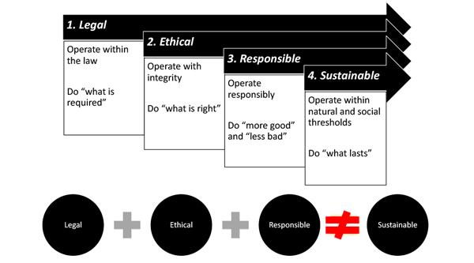
(Source: Searcy, C. (2016) What Makes a Supply Chain Sustainable? (mit.edu))

Implement a True or False task with statements reflecting the key concepts to swiftly assess comprehension of the definitions.

True or False?
- In the traditional linear supply chain, raw material production is excluded from the process. (False)
- The traditional linear supply chain encompasses activities from raw material production to end-user delivery. (True)
- A sustainable supply chain integrates environmental, social, and economic considerations to minimize negative impacts and promote long-term resilience. (True)
- Searcy (2016) defines a sustainable supply chain through four hierarchical strategies: legal, ethical, responsible, and sustainable, and it includes all four strategies. (True)
- A sustainable supply chain primarily emphasizes short-term gains over long-term resilience. (False)
- The concept of a sustainable supply chain is universally interpreted in the same manner across industries and regions. (False)
- The concept of a sustainable supply chain can refer to various scopes, including the order-to-delivery supply chain, the extended order-to-delivery supply chain, or the entire material circulation supply chain. (True)
- In a sustainable supply chain, environmental, social, and economic considerations are given equal importance in decision-making processes. (True)

Attention, everyone! Get ready for an enlightening discussion on sustainable supply chains in Grow Green, Interview 4! First, study the figure "Traceability and visibility" below.
Get excited for some valuable insights ahead!

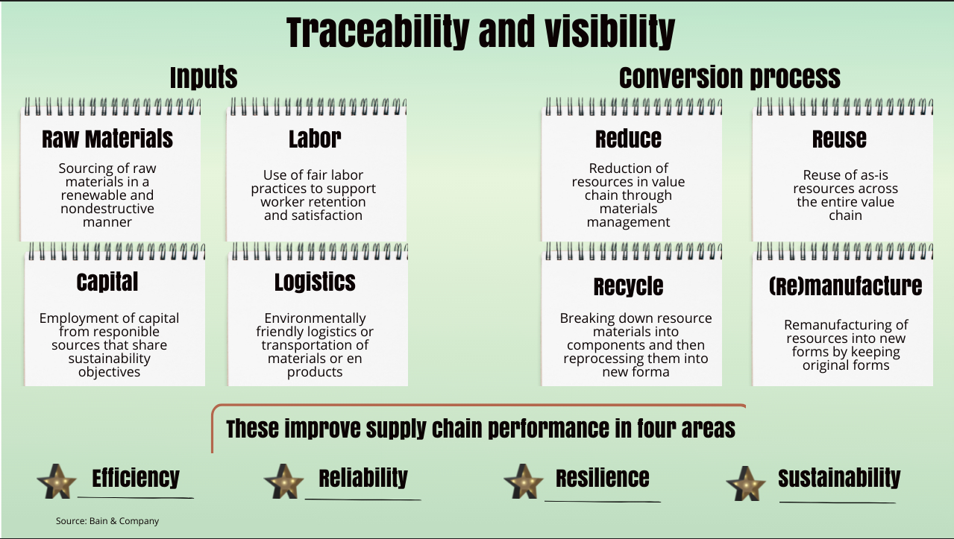
(Source: 4 ways industry can make supply chains more sustainable | World Economic Forum (weforum.org))

Grow Green, interview 4

Jussi: Welcome, Riitta. In today's discussion, we'll be exploring sustainable supply chains. We aim to understand how sustainable supply chains incorporate principles of circular economy and environmental sustainability. Can you help us understand the key differences and how sustainable supply chains integrate circular economy principles and environmental sustainability?
Riitta: Absolutely, Jussi. In a traditional linear supply chain, we see the full spectrum of activities involved in moving goods, from raw material production to delivering them to the end user. This includes suppliers, support organizations, and customers. However, in a sustainable supply chain, the focus shifts to ensuring social, economic, and environmental sustainability throughout the process.
Jussi: That's insightful. What are the key strategies involved?
Riitta: A sustainable supply chain encompasses four strategies: legal, ethical, responsible, and sustainable. This ensures compliance with regulations, ethical business practices, responsibility towards stakeholders, and a commitment to long-term sustainability.
Jussi: It sounds comprehensive. Could you explain how the concept of a sustainable supply chain can vary in its application?
Riitta: Certainly.The term "sustainable supply chain" can refer to different scopes, such as the sustainability of the order-to-delivery process, the extended supply chain, or even the entire supply chain involving material circulation. This flexibility allows businesses to tailor their approach to sustainability based on their specific operations and objectives.
Jussi: Let's explore the concept of circular economy supply chains. We often hear about preserving the value of materials and keeping the material loop as closed as possible. Could you explain what this entails?
Riitta: Absolutely. Circular economy supply chains aim to maintain the value of materials by minimizing waste and maximizing reuse. This involves keeping materials circulating within the organization, within the industry, or even between industries. By doing so, we ensure that resources are used efficiently and sustainably.
Jussi: That makes sense. So, how do traceability and transparency fit into this picture?
Riitta: Traceability and transparency are essential in circular economy supply chains. They enable us to track the journey of materials from production to disposal, ensuring accountability and promoting responsible practices. With transparency upstream, we can take responsibility for the collection and delivery of materials, while downstream transparency facilitates reverse logistics, allowing us to reclaim and reprocess used materials effectively.
Jussi: It sounds like ownership plays a crucial role as well. Can you elaborate on that?
Riitta: Certainly. In circular economy supply chains, ownership often remains with the product manufacturer, even after the product is sold. This concept of "product as a service" means that customers have usage rights rather than ownership rights. This shift encourages manufacturers to design products for durability and reuse, fostering a more sustainable approach to consumption.
Jussi: I see. And what about minimizing the use of non-renewable materials and reducing waste generation?
Riitta: Minimizing the use of non-renewable materials and reducing waste generation are central goals of circular economy supply chains. We achieve this by designing products to be durable and materials to be reusable, using sustainable and safe materials, and implementing recycling programs for products, components, and materials at the end of their lifespan. Additionally, revamping production processes to collect inputs and reuse them, as well as designing reverse supply chains and sustainable packaging, are key strategies in this endeavor.
Jussi: Fascinating. Lastly, how do we bring about these changes in practice?
Riitta: Implementing circular economy principles requires changes at various levels, from procurement practices to partnership strategies and from transparency measures to operational models. This includes building the necessary supply chains for byproducts, collaborating with producers of recycled and renewable materials, and educating both supply chain members and customers on new operating models.
Jussi: Thank you, Riitta, for shedding light on these important aspects of circular economy supply chains. Transitioning to such models requires a holistic approach and concerted effort from all stakeholders involved.
Riitta: Absolutely, Jussi. Embracing circular economy principles in supply chain management holds the key to a more sustainable and resilient future for businesses and society as a whole.
Jussi: In our upcoming show, Riitta will be addressing inquiries directly from SMEs like yours, providing invaluable insights and guidance on navigating the complexities of exporting while embracing circular economy principles. Don't miss this chance to gain personalized advice and practical solutions tailored to your business needs.
Riitta: Looking forward to it!

Grow Green – Interview 5

Your new task requires carefully reading the article, thoroughly studying its contents, and closely examining the figures included within. Additionally, you'll need to create True or False statements related to the article's key content to assess comprehension effectively.

Article:

A supply chain revolution: how the circular economy unlocks new value, by Catherine Weetman, 3rd February 2017, A supply chain revolution: how the circular economy unlocks new value (rethinkglobal.info)

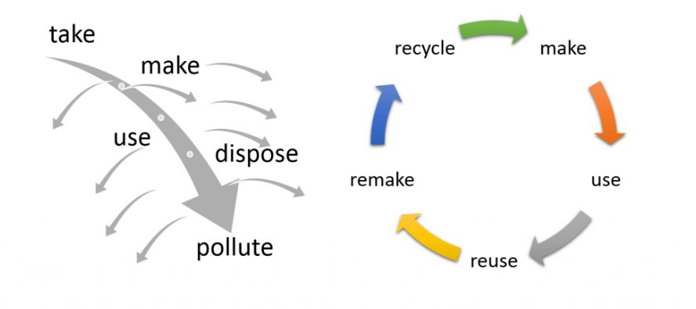
The circular economy creates and captures new value for businesses, and adds extra dimensions to supply chains. It’s gaining momentum as a critical tool for future-fit businesses. Nike, M&S, Renault and many others are developing circular products and services. Circular start-ups are thriving. My book explores the drivers and benefits of the circular economy in detail, with wide-ranging examples and digs deep into the implications for the supply chain.

Here’s how to get started.

Turbulence ahead
After a turbulent 2016, it feels like our world is changing ever faster: ‘megatrends’ include urbanisation, a redefined world order, rising inequality and political upheaval. Predictions include 3 billion new consumers set to enter the market by 2030 and the internet-connected population doubling to 5 billion in the next 5 years – fantastic business opportunities. Disruptors, like Airbnb, Spotify, Uber and others, scale up rapidly, displacing established brands and entire sectors. Amazon has even filed a patent for aerial warehouses. Most businesses operate on ‘throughput’ principles (see the footnote on issues of the linear economy): take some materials, make a product, sell it and work out how to sell the next one. But this approach shackles growth for many businesses as demand for resources, land and water outstrips supply.

A circular revolution

So, how do you survive and thrive in these challenging conditions? Across the globe, in every sector, start-ups and big businesses are exploring the ‘systems thinking’ approaches of the circular economy. Some businesses are trying to disrupt from the inside: how would a new competitor design your business? How would a disruptor innovate products and services, decouple resources from profit, build brand loyalty and create resilient, adaptive organisations?

OK, give me the lowdown on the circular economy

Instead of leaking value by discarding products and materials after use, the circular economy redesigns products, processes, supply chains and business models to yield more value. Creating durable products, and recovering products and materials at end of use, enables reuse, repair, remanufacture and recycling. Simple examples include:

Making orange juice: the ‘waste’ becomes by-products, with pectin, pulp and zest for food manufacture and essential oils for pharmaceuticals and cosmetics.
Commercial photocopiers aren’t sold now; photocopying is a service with efficient repair networks plus refurbishment and remanufacture to enable second and third ‘lives’ for each machine.
Circular economy approaches regenerate ecosystems to better support human health and well-being. By converting ‘take-make-waste’ into ‘value loops’, creating more from less, they decouple resource use from value creation.

From leaky to loopy – extra dimensions for the supply chain
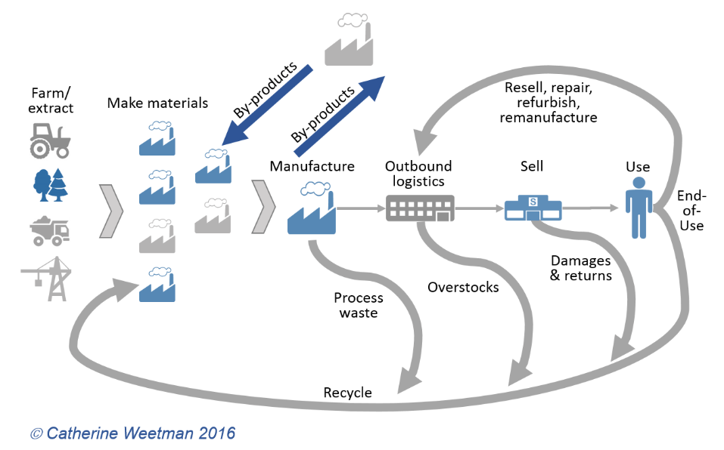

Circular economy terminology often categorises materials into two groups.

Biological nutrients – food, fibres, timber – should be sustainable, renewed to meet or exceed the rate of extraction.
Technical nutrients – metals, minerals, fossil fuels – should cycle infinitely. Product design can support effective separation at end of use for efficient recycling.
This over-simplifies the choices, but starts to encourage a different mind-set, focussing on material choices and the ease of separation at end-of-use. Another lens to use is ‘100% yield’ rather than ‘zero waste’. Here businesses create new value from by-products and co-products and look for ways to recover and reuse energy and water inputs. ‘Green chemistry’ and bio-refineries are finding new ways to extract valuable bio-chemicals from waste streams, providing inputs for pharmaceuticals, food and cosmetics before using the residual materials to create energy… take a look at how British Sugar has created new value streams from sugar beet.
When supply chains become multi-dimensional: new flows and formats, service networks, more ‘touch-points’, recovery loops for products and materials – they are ‘loopy’ instead of leaky. Cycling materials and protecting their value (ready for resale, repair, remanufacturing or recycling) means re-thinking reverse supply chains and packaging design – not just Reverse Logistics 2.0!

Procurement processes and contracts should focus on outcomes, enabling a ‘win-win’ approach for suppliers and buyers. Can you swap finite materials for recycled or renewable (and ensure biomaterials don’t displace a food crop or contribute to deforestation)? Do you purchase something that is recyclable, but not recycled? Can you change that?

New by-products could be chemicals, gases or bulk solids, with diverse handling and transport needs that contrast with the mainstream products.

New partners will emerge – perhaps supplying their by-products or high-quality recyclate to you as specialist repair and remanufacturing providers, or in eco-parks with symbiotic flows of materials meaning ‘waste’ from one company becomes a ‘nutrient’ for a neighbour.
How do I get started?

Talk about circular approaches with your colleagues across the business – what’s already happening in your sector or in other supply chains? There are likely to be a few ‘quick wins’ you can investigate, so you can begin the circular journey with little disruption and risk.

Prioritise: are there some high-risk products or materials you buy, with volatile prices, toxic or scarce materials that you could replace with something safe and secure? Where are the biggest opportunities for value – could you recover your own resources, or create value from a new by-product? Could you design something to be more easily disassembled for repair or recycling? Could you swap from buying a product to contracting for service or performance, such as ‘tyres by the mile’?
Work with suppliers to share your vision, scan for ideas and specify the goal (not the ‘how to’). Help your suppliers innovate for a ‘win-win’ outcome.
Use learnings from those quick wins, build your experience and gain buy-in from other stakeholders.
Invest the learnings and benefits in the next projects – perhaps bigger scale or requiring more disruption to existing processes
Tell the story to suppliers and consumers – engage a wider group of stakeholders and create momentum
Strategies and initiatives will evolve and improve, as you build on lessons learned (read my book for more ideas, implications and innovation tips). You could choose simple examples to use yourself: a repairable Fairphone, 3D printed sunglasses, or some recycled pens. You don’t need to create a completely closed loop product or service, or reinvent your entire supply chain – just start somewhere!

Footnote: the value leakage in our linear economy
Marketing aims to create a dissatisfaction with what we have now, encouraging us to buy more ‘stuff’, or replace what we have with something ‘better’. We could describe our current economy as a ‘waste’ system. It is woefully inefficient, using ‘subtractive’ manufacturing processes: start with a lump of something and knock bits off to make the shape needed. At end of use materials are sent for landfill, incineration or exported (often to where materials can be recovered without onerous safety regulations), allowing value to leak out of the system. For food, one-third is wasted between farm and fork; only around 14% of plastic packaging is even collected for recycling; a record 53.6 million metric tonnes of electronic waste (e-waste) was generated worldwide in 2019, up 21 percent in just five years, according to the UN’s Global E-waste Monitor 2020. Harmful ‘externalities’ from farming, extraction and manufacture – toxic waste, pollution of air, atmosphere, water and soil – are destroying the living systems we depend on – pressuring the earth systems and biodiversity ‘services’ we depend on, like never before. We make more ‘stuff’ to replace these degraded natural systems, or suffer the consequences through disease, healthcare costs and productivity leakages.
Versions of this article were first published by Kogan Page in February 2017.

True or False statements related to the article "A Supply Chain Revolution: How the Circular Economy Unlocks New Value"
- SMEs can benefit from the circular economy by creating and capturing new value for their businesses. (True)
- Large companies like Nike, M&S, and Renault are not actively involved in developing circular products and services, thus limiting opportunities for SMEs to engage in circular practices. (False)
- Circular start-ups face significant challenges and are not thriving in the current business landscape. (False)
- The article provides a comprehensive examination of the circular economy, offering practical examples and insights tailored to the needs and capabilities of SMEs. (True)
- SMEs are not affected by global trends such as urbanization, rising inequality, and political upheaval. (False)
- Predictions suggest that SMEs will not encounter new consumers entering the market by 2030. (False)
- SMEs operating on 'throughput' principles may experience constrained growth due to resource scarcity, impacting their supply chain resilience. (True)
- Circular economy approaches aim to discard products and materials after use, neglecting opportunities for SMEs to redesign them for additional value. (False)
- By embracing circular economy principles, SMEs can contribute to ecosystem regeneration and enhance support for human health and well-being. (True)
- SMEs should not prioritize circular approaches in their business strategies as they are not relevant to their operations. (False)

Relax and tune in now to engage in a conversation that holds the potential to revolutionize your approach to sustainability in your export operations! Let's explore together and discover new pathways to eco-friendly practices.

Grow Green, Interview 5
Guests: Markku from GreenTech Solutions and Sara from EcoFashion

Jussi: Before we dive into our discussion, let's introduce our esteemed guests joining us today. We have Markku from GreenTech Solutions, and Sara representing EcoFashion - welcome! Riitta and I are genuinely thrilled to delve into the world of sustainable supply chains and circular economy practices with such esteemed guests. So, let's kick off the discussion and explore your questions together!
Riitta: Couldn't agree more, Jussi.
Jussi: Thank you, Riitta. Markku, please go ahead with your question.
Markku: Thank you for this opportunity to be here today. In GreenTech Solutions, we're eager to transition our current linear supply chain model to a circular economy supply chain. Riitta, what would be the first step?
Riitta: The first step in transitioning to a circular economy supply chain would be to conduct a thorough assessment of your current supply chain practices and identify areas where circular economy principles can be integrated. This involves analyzing your product lifecycle, identifying opportunities for waste reduction and resource optimization, and evaluating potential collaborations with suppliers and partners.
Markku: That makes sense. We've already begun analyzing our product lifecycle, but I think we need to delve deeper into identifying specific areas where we can implement circular economy practices effectively. Would you recommend starting with a pilot project or taking a broader approach across the entire supply chain?
Riitta: That's a great question. Both approaches have their merits, but it often depends on the scale and complexity of your operations. A pilot project can provide valuable insights and allow you to test different strategies in a controlled environment before scaling up. On the other hand, taking a broader approach across the entire supply chain demonstrates a strong commitment to sustainability and can generate a more significant long-term impact. Ultimately, the best approach will depend on your specific goals, resources, and organizational culture.
Markku: Considering our goals, would it be beneficial to explore reverse logistics opportunities during the assessment phase of transitioning to a circular economy supply chain?
Riitta: Absolutely.. Exploring reverse logistics opportunities during the assessment phase is crucial for identifying potential challenges and designing effective strategies to overcome them. It allows us to evaluate the feasibility and impact of integrating reverse logistics into our supply chain model early on, ensuring a smoother transition towards a circular economy approach.
Jussi: Riitta, could you briefly explain to our audience what is meant by reverse logistics?
Riitta: Reverse logistics involves managing the flow of products and materials from consumers back to manufacturers for reuse, refurbishment, or recycling. It's essentially the process of handling returned items and managing their journey through the supply chain in a way that minimizes waste and maximizes value extraction.
Markku: Riitta, could you elaborate more on the challenges of reverse logistics in the transition to a circular economy supply chain?
Riitta: In the tech industry, reverse logistics plays a crucial role in managing the return and recycling of electronic products and components. This includes devices like smartphones, laptops, and other electronics. With the rapid pace of technological advancements, managing the end-of-life products becomes increasingly important to prevent electronic waste and recover valuable materials for reuse or recycling. However, the tech industry faces unique challenges in reverse logistics, such as handling diverse types of electronic products, ensuring data security during the return process, and complying with regulations related to e-waste management.
Markku: How about opportunities?
Riitta: Despite these challenges, there are opportunities for tech companies to implement innovative solutions like product take-back programs, refurbishment centers, and partnerships with recycling facilities to enhance their reverse logistics processes and promote sustainability.
Markku: Thank you, Riitta. That's insightful. We will explore more about the possibilities of riverse logistics.
Riitta: Absolutely, Markku. It's a crucial aspect of sustainable supply chains, ensuring that resources are used efficiently and responsibly.
Jussi: Indeed, reverse logistics holds immense potential for businesses to minimize waste and maximize value from end-of-life products. Now, let's hear from Sara from EcoFashion. What's your question?
Sara: Firstly, I'm thrilled to be part of this enlightening discussion. One of the challenges we've encountered at EcoFashion is ensuring sustainable sourcing practices throughout our supply chain.
Jussi: What kind of obstacles have you faced?
Sara: While we're committed to using eco-friendly materials, it can be challenging to trace the origins of raw materials and ensure they meet our ethical and environmental standards. Limited transparency in the sourcing process makes it difficult to verify whether materials are truly sustainable, leading to uncertainty and potential risks to our brand's reputation.
Riitta: Absolutely, Sara, sustainable sourcing is a critical aspect of fostering a more eco-conscious fashion industry. One approach to overcome the obstacle of limited transparency in the sourcing process is to establish direct relationships with suppliers who share your commitment to sustainability. By collaborating closely with suppliers and conducting thorough audits, you can gain greater visibility into their practices and ensure alignment with your ethical and environmental standards.
Sara: That makes a lot of sense, Riitta. Building strong partnerships with suppliers who prioritize sustainability sounds like a proactive step toward ensuring the integrity of our supply chain. Conducting thorough audits will not only help verify their sustainability claims but also foster accountability and transparency throughout our sourcing processes. Thank you for the insightful advice!
Riitta: Additionally, consider implementing certification schemes or third-party verification processes for your raw materials. These certifications can provide independent validation of sustainability claims and offer reassurance to consumers about the authenticity of your eco-friendly products.
Sara: That's a great suggestion, Riitta. By obtaining certifications from reputable organizations, we can demonstrate our commitment to sustainability transparently and credibly. It not only enhances the credibility of our eco-friendly products but also builds trust with consumers who prioritize ethical and environmentally responsible brands. Thank you for highlighting this important aspect of sustainable sourcing!
Riitta: One more thing, consider integrating recycled or upcycled materials into your product lines. Doing so not only lessens our dependency on virgin resources but also aids in waste reduction and environmental conservation. This innovative approach aligns with environmentally conscious consumers and positions us as leaders in sustainable fashion.
Sara: Absolutely, Riitta. Integrating recycled or upcycled materials into our product lines not only reduces our reliance on virgin resources but also contributes to waste reduction and environmental conservation. It's an innovative approach that resonates with environmentally conscious consumers and positions us as leaders in sustainable fashion. Thank you for emphasizing the importance of embracing alternative sourcing strategies!
Markku: I couldn't agree more with the importance of sustainable sourcing in our industry. At GreenTech Solutions, we've also been exploring alternative materials and suppliers to reduce our environmental footprint. Transitioning to more sustainable sourcing practices not only aligns with our values but also presents opportunities for innovation and differentiation in the market. It's inspiring to hear about your efforts, Sara, and I believe collaborating on sustainable sourcing initiatives can drive positive change across industries.
Jussi: Thank you all for your engaging questions. There are exciting opportunities for businesses of all sizes to embrace circular economy principles and create value while minimizing environmental impact. Unfortunately, we're running short on time and must bring this discussion to a close. However, I encourage each of you to continue exploring sustainable practices within your respective industries and to collaborate on initiatives that drive positive change. Thank you once again for your participation, and let's continue working towards a more sustainable future.
Riitta: Absolutely, Jussi. It's inspiring to see companies like yours taking proactive steps towards sustainability. Together, we can drive positive change and build a more resilient future for all.
Markku and Sara: Thank you!

After the official show ends, the participants linger for a casual conversation.
The group continues their discussion, exchanging ideas and experiences late into the evening, united in their shared vision for a greener, more sustainable world.
As they network, you'll have an opportunity to assess your understanding with true or false statements.

True or False?
- The conversation emphasizes that the initial step in transitioning from a linear to a circular supply chain is to conduct comprehensive evaluations of existing supply chain practices, pinpointing opportunities for the integration of circular economy principles. (True)
- Reverse logistics solely pertains to managing the flow of products and materials from manufacturers to consumers, rather than from consumers back to manufacturers for reuse, refurbishment, or recycling. (False)
- The obstacles encountered by the tech sector in reverse logistics include managing a wide array of electronic products, guaranteeing data security during returns, and adhering to regulations concerning e-waste management. (True)
- A viable strategy for mitigating the issue of limited transparency in the sourcing process is to solely rely on indirect communication channels with suppliers who may not prioritize sustainability. (False)
- Through acquiring certifications from reputable institutions, small and medium-sized enterprises (SMEs) can openly and convincingly showcase their dedication to sustainability. (True)
- Incorporating recycled or upcycled materials into the product lines increases the company’s dependence on new resources and does not aid in minimizing waste or conserving the environment. (False)

Slide 1:
Approaching the final test of this episode, we're almost there. But before that, let's delve into digitalization in circular economy supply chain management.

Slide 2:
Key Points (1)
The circular economy is experiencing increasing demands for material recycling and higher proportions of recycled materials in production.
Additionally, the diverse material flows from various sources require efficient management practices.

Slide 3:
Key Points (2)
Material traceability plays a crucial role, especially with tightening regulations surrounding product origin reporting.
Moreover, the growing reporting requirements underscore the importance of traceable material origin.

Slide 4:
Key Points (3)
Ensuring quality management across raw materials, logistics, inventory, billing, and reporting is paramount for smooth operations in the circular economy supply chain.
The benefits of implementing such quality management practices include enhanced traceability, improved cost-effectiveness, reduced errors, and increased agility within the system.

Slide 5:
Summary:
Digitalization is crucial for optimizing circular economy supply chain management.
Enhanced traceability and cost-effectiveness are among the key benefits.
Adaptation to tightening regulations and growing reporting requirements is essential for success in the circular economy sector.

Test your knowledge
Before attempting the nano scenarios and multiple-choice questions, review the content provided in Episode 2 on Sustainable Supply Chain Practices. Pay attention to key concepts, definitions, and examples presented.
Nano Scenarios are brief, practical situations that challenge you to apply your understanding of sustainable supply chain principles to real-world business scenarios faced by exporting SMEs.
For each nano scenario, carefully read the situation presented and consider how sustainable supply chain principles could be applied to address the challenges or opportunities described.
After reading each scenario, select the multiple-choice option that best aligns with sustainable supply chain principles or offers the most environmentally friendly solution.
Once you've answered all the questions, evaluate your responses. Consider why you chose a particular option and how it relates to sustainable supply chain concepts discussed in the episode.
Reflect on your performance and areas where you may need further understanding. Use any incorrect responses as learning opportunities to deepen your knowledge of sustainable supply chain principles and their application in business.

These ten nano scenarios offer practical situations where sustainable supply chain principles can be applied within the daily operations of exporting SMEs, fostering environmental sustainability and resilience in business practices.

Nano Scenario 1: Ethical Sourcing
GreenTech Innovations, an exporting SME specializing in sustainable packaging solutions, wants to ensure ethical sourcing of raw materials for its products. Which action best demonstrates GreenTech Innovations' commitment to ethical sourcing and sustainable supply chain practices?
A) Sourcing materials from suppliers with known records of environmental violations to reduce costs
B) Conducting due diligence to ensure suppliers adhere to fair labor practices and environmental regulations
C) Ignoring supplier practices and focusing solely on product quality
D) Outsourcing sourcing operations to countries with lower labor costs without considering environmental impact
Correct Answer: B) Conducting due diligence to ensure suppliers adhere to fair labor practices and environmental regulations
Explanation: Option B aligns with sustainable supply chain practices by emphasizing the importance of conducting due diligence to ensure that suppliers adhere to fair labor practices and environmental regulations. This approach demonstrates GreenTech Innovations' commitment to ethical sourcing and sustainability by actively seeking suppliers who uphold these standards. By verifying supplier practices, GreenTech Innovations can mitigate the risk of supporting unethical or environmentally harmful practices in its supply chain, ultimately promoting responsible sourcing and sustainable business practices.

Nano Scenario 2: Carbon Footprint Reduction
EcoFoods Ltd., an exporting SME specializing in organic food products, aims to reduce its carbon footprint throughout its supply chain. Which initiative best aligns with sustainable supply chain principles to minimize carbon emissions?
A) Increasing the use of air freight for faster product delivery
B) Implementing logistics optimization to reduce transportation distances and mode shifts
C) Disregarding emission metrics and focusing solely on cost reduction
D) Expanding the supplier network without considering transportation emissions
Correct Answer: B) Implementing logistics optimization to reduce transportation distances and mode shifts
Explanation: Option B aligns with sustainable supply chain principles by focusing on logistics optimization to reduce transportation distances and mode shifts. By optimizing logistics, EcoFoods Ltd. can minimize carbon emissions associated with transportation, contributing to the overall reduction of its carbon footprint. This initiative demonstrates a proactive approach to sustainability by prioritizing environmental considerations in supply chain operations.

Nano Scenario 3: Waste Management
CleanTech Apparel, an exporting SME specializing in eco-friendly clothing, seeks to minimize waste in its manufacturing processes. Which action best demonstrates CleanTech Apparel's commitment to waste reduction and sustainable supply chain practices?
A) Implementing recycling programs to repurpose textile scraps and unused materials
B) Disposing of production waste in landfills without considering recycling options
C) Ignoring waste management practices and focusing solely on production output
D) Outsourcing manufacturing to countries with lax environmental regulations to cut costs
Correct Answer: A) Implementing recycling programs to repurpose textile scraps and unused materials
Explanation: Option A aligns with CleanTech Apparel's commitment to waste reduction and sustainable supply chain practices by implementing recycling programs to repurpose textile scraps and unused materials. This initiative demonstrates proactive efforts to minimize waste in manufacturing processes, contributing to the circularity of resources and reducing environmental impact.

Nano Scenario 4: Renewable Energy Adoption
SustainableTech Solutions, an exporting SME specializing in renewable energy technologies, wants to power its manufacturing facilities using renewable energy sources. Which approach best reflects SustainableTech Solutions' commitment to renewable energy adoption and sustainable supply chain practices?
A) Increasing reliance on fossil fuels to reduce energy costs
B) Ignoring renewable energy options and focusing solely on production efficiency
C) Outsourcing energy production to suppliers without considering renewable options
D) Investing in solar panels and wind turbines to generate renewable energy on-site
Correct Answer: D) Investing in solar panels and wind turbines to generate renewable energy on-site
Explanation: Option D aligns with SustainableTech Solutions' commitment to renewable energy adoption and sustainable supply chain practices by investing in solar panels and wind turbines to generate renewable energy on-site. This initiative demonstrates a proactive approach to reducing carbon emissions, promoting environmental sustainability, and minimizing dependence on fossil fuels.

Nano Scenario 5: Supplier Diversity
EcoCrafts, an exporting SME specializing in handmade artisanal goods, aims to diversify its supplier base to enhance resilience and sustainability. Which strategy best aligns with sustainable supply chain principles to promote supplier diversity?
A) Relying solely on a single supplier to streamline procurement processes
B) Engaging with local artisans and small-scale producers to support community development
C) Ignoring supplier relationships and focusing solely on cost reduction
D) Outsourcing production to countries with lower labor costs without considering social impact
Correct Answer: B) Engaging with local artisans and small-scale producers to support community development
Explanation: Option B aligns with sustainable supply chain principles by promoting supplier diversity through engagement with local artisans and small-scale producers. This strategy not only supports community development but also fosters resilience and sustainability by reducing dependency on a single supplier and integrating local economies into the supply chain.

Nano Scenario 6: Water Conservation
GreenGourmet, an exporting SME that produces gourmet food products, wants to minimize water usage in its production processes. Which action demonstrates a commitment to water conservation and sustainable supply chain practices?
A) Disregarding water consumption metrics and focusing solely on production output
B) Increasing water usage to enhance production efficiency
C) Implementing water recycling systems to reuse water in production processes
D) Outsourcing production to countries with lower water costs without considering environmental impact
Correct Answer: C) Implementing water recycling systems to reuse water in production processes
Explanation: Option C aligns with sustainable supply chain principles by demonstrating a commitment to water conservation through the implementation of water recycling systems. This initiative promotes resource efficiency by reusing water in production processes, reducing overall water consumption, and minimizing environmental impact.

Nano Scenario 7: Circular Packaging
TechGear Ltd., an exporting SME manufacturing electronic devices, seeks to adopt circular packaging solutions to reduce waste. Which action demonstrates a commitment to circular packaging and sustainable supply chain practices?
A) Using single-use plastic packaging to reduce production costs
B) Exploring options like biodegradable or compostable packaging materials
C) Increasing the use of non-recyclable materials to enhance product aesthetics
D) Avoiding packaging redesign to maintain brand consistency
Correct Answer: B) Exploring options like biodegradable or compostable packaging materials
Explanation: Option B aligns with sustainable supply chain practices by demonstrating a commitment to circular packaging solutions. Biodegradable or compostable packaging materials contribute to waste reduction by breaking down naturally after use, thus minimizing environmental impact and promoting resource efficiency.

Nano Scenario 8: Ethical Labor Practices
BioTech Solutions, an exporting SME producing biodegradable cleaning products, wants to ensure ethical labor practices throughout its supply chain. Which action should BioTech Solutions prioritize to align with sustainable supply chain principles?
A) Engaging with suppliers known for exploiting labor to reduce production costs
B) Ignoring labor practices and focusing solely on product quality
C) Outsourcing production to countries with lower labor costs without considering labor conditions
D) Conducting supplier audits to verify compliance with fair labor standards
Correct Answer: D) Conducting supplier audits to verify compliance with fair labor standards
Explanation: Prioritizing supplier audits to verify compliance with fair labor standards demonstrates BioTech Solutions' commitment to ethical labor practices and aligns with sustainable supply chain principles. By ensuring that suppliers adhere to fair labor standards, BioTech Solutions promotes social responsibility and transparency throughout its supply chain.

Nano Scenario 9: Transparency and Traceability
GreenLogistics, an exporting SME specializing in eco-friendly transportation solutions, aims to enhance transparency and traceability in its supply chain. Which action best demonstrates GreenLogistics' commitment to transparency and traceability in sustainable supply chain practices?
A) Concealing information about suppliers and transportation routes to protect business interests
B) Ignoring supply chain visibility and focusing solely on cost reduction
C) Outsourcing transportation operations to countries with lower labor costs without considering transparency
D) Implementing blockchain technology to trace the origins of products and ensure ethical sourcing
Correct Answer: D) Implementing blockchain technology to trace the origins of products and ensure ethical sourcing

Explanation: Implementing blockchain technology to trace the origins of products and ensure ethical sourcing demonstrates GreenLogistics' commitment to transparency and traceability in its supply chain. Blockchain enables secure and transparent record-keeping, allowing GreenLogistics to track products from their origin to their final destination, ensuring ethical sourcing practices and enhancing supply chain visibility.

Nano Scenario 10: Social Responsibility
EnviroTech, an exporting SME manufacturing sustainable technology products, wants to integrate social responsibility into its supply chain practices. Which approach best reflects EnviroTech's commitment to social responsibility and sustainable supply chain practices?
A) Implementing fair labor standards and supporting community development initiatives
B) Partnering with suppliers known for exploiting labor to reduce costs
C) Ignoring social impact considerations and focusing solely on product quality
D) Outsourcing production to countries with lower labor costs without considering social responsibility
Correct Answer: A) Implementing fair labor standards and supporting community development initiatives
Explanation: Implementing fair labor standards and supporting community development initiatives demonstrates EnviroTech's commitment to social responsibility and sustainable supply chain practices. By ensuring fair treatment of workers and contributing to community development, EnviroTech promotes ethical practices and social sustainability throughout its supply chain.

EPISODE 3 Sustainable Packaging
Welcome, everyone, to Episode 3 of our learning journey: Sustainable Packaging.
In this episode, we'll delve into the world of sustainable packaging, uncovering its importance in minimizing environmental impact and championing recyclability and reusability.
We'll start by exploring the regulatory landscape surrounding packaging, shedding light on how regulations are evolving to tackle environmental challenges and foster sustainable packaging solutions.
Next, we'll take a deep dive into the concept of the Circular Economy.
We'll examine innovative strategies aimed at reducing plastic waste, improving recycling infrastructure, and transitioning towards alternative materials to create a more sustainable future.
So, buckle up, get ready to learn, and let's embark on this enlightening journey into the realm of sustainable packaging.
Start by reading the introduction and watching the videos.

Introduction: What is Sustainable Packaging
For exporting SMEs, sustainable packaging refers to the use of eco-friendly materials and practices in packaging goods for international trade.
It involves choosing packaging materials that have minimal environmental impact, such as recycled or biodegradable materials, and designing packaging solutions that optimize resource use and reduce waste generation.
VIDEO
Key Aspects of Sustainable Packaging
- Choosing packaging materials that are recyclable, biodegradable, or made from renewable resources can help minimize environmental impact. Examples include recycled cardboard, bioplastics, and compostable materials.
- Designing packaging to be lightweight and space-efficient can reduce transportation costs and emissions associated with shipping goods internationally. Additionally, designing packaging for easy disassembly or reuse can further minimize waste.
- Ensuring that packaging materials and practices comply with relevant international regulations and standards, such as those governing packaging waste management and restrictions on hazardous substances.
- Considering the preferences of international consumers who may prioritize sustainability when making purchasing decisions. Packaging that communicates its eco-friendly attributes can enhance product appeal and market competitiveness.
- Collaborating with suppliers and logistics partners to optimize packaging materials and transportation processes, aiming to reduce environmental impact across the entire supply chain.
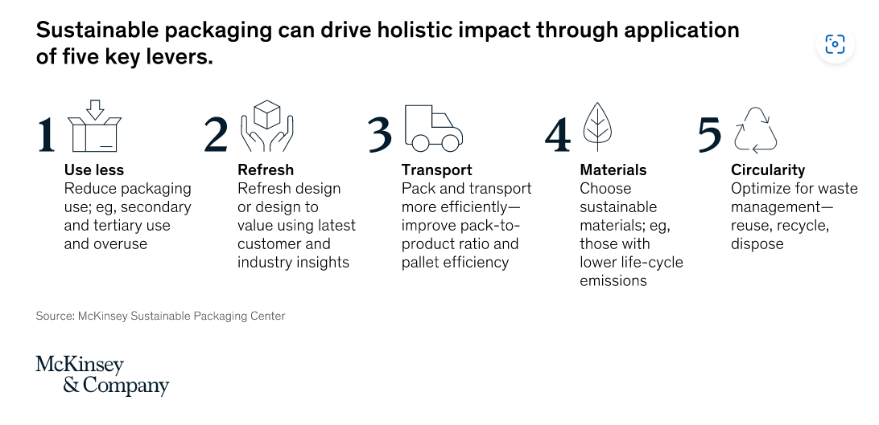

Let's play a quick round of true or false! Read each statement carefully, trust your instincts, and have fun testing your very basic knowledge about sustainable packaging. You've got this!

True or False?
- Sustainable packaging for exporting SMEs involves using eco-friendly materials and practices in packaging goods for international trade. – True

- Sustainable packaging may include choosing materials like recycled cardboard, bioplastics, and compostable materials to minimize environmental impact. – True

- Designing packaging to be lightweight and space-efficient can increase transportation costs and emissions associated with shipping goods internationally. – False;

This statement is false because lightweight and space-efficient packaging reduces transportation costs and emissions associated with shipping goods internationally. Lightweight packaging requires less fuel for transportation, lowering the carbon footprint of shipping. Similarly, space-efficient packaging allows more products to be transported in a single shipment, maximizing cargo space and reducing the number of trips needed. Thus, both aspects contribute to lower transportation costs and emissions.

- Ensuring compliance with relevant international regulations and standards is not necessary for sustainable packaging practices. – False

Explanation: This statement is false because compliance with international regulations and standards is essential for sustainable packaging practices. These regulations cover waste management, recycling, hazardous substances, and environmental impact. Non-compliance can result in environmental harm, legal issues, reputational damage, and trade barriers. Therefore, businesses must ensure their packaging aligns with these standards.

- Packaging that communicates its eco-friendly attributes may not affect product appeal or market competitiveness. – False

Explanation: This statement is false because packaging that communicates its eco-friendly attributes often enhances product appeal and market competitiveness. Eco-conscious consumers are more likely to choose products with sustainable packaging, thereby increasing demand and potentially driving sales. Additionally, showcasing environmental responsibility through packaging can positively influence brand perception and loyalty among consumers who prioritize sustainability.

- Collaborating with suppliers and logistics partners is not essential in optimizing packaging materials and transportation processes for reducing environmental impact. – False

Explanation: Collaborating with suppliers and logistics partners is essential for optimizing packaging materials and transportation processes to reduce environmental impact. Working together allows businesses to streamline operations, identify opportunities for improvement, and implement sustainable practices effectively. Coordination ensures the availability of eco-friendly packaging materials and the optimization of transportation routes to minimize carbon emissions.

Get excited for another round of insightful videos! Let's keep the momentum going as we explore further into the fascinating world of sustainable packaging.

VIDEO:

Why is Sustainable Packaging Important?
“190kg of packaging waste was generated by each European in 2021.
And this figure will grow by nearly 20% in 2030, if things stay the same.
We cannot let that happen.”
Source: Teresa Ribera Rodríguez, Spanish third vice-president of the government and minister for the ecological transition and the demographic challenge

The carbon dioxide emissions caused by packaging are equivalent to the total emissions of a small or medium-sized EU country.

Packaging contaminates soil and land areas and accounts for approximately half of marine litter.

VIDEO:

How packaging regulation is changing in the EU by 2030?
Objectives
- Full recyclability of packaging.
- Mandatory percentage of recycled material in new plastic packaging. This will facilitate the transformation of recycled plastic into valuable raw material.
- Each package must have a label indicating the material it is made of and which waste stream it belongs to. The same labels must be placed on waste collection containers. The same symbols are used throughout the EU.
Environmental impacts
- Greenhouse gas emissions will decrease to 43 million tonnes (compared to 66 million tonnes).
- Water use will decrease by 1.1 million cubic meters.
- The amount of environmental damage caused to society and the economy will decrease by €6.4 billion.
Economic impacts
- The single-use packaging industry will need to invest in transitioning, but overall the economic and job-creating impact is positive in the EU.
- Increased reuse is expected to create 600,000 jobs in the reuse sector.
- Significant innovation in packaging solutions is expected.
- If the savings were passed on to consumers, each European could save nearly €100 annually.

New regulations on packaging and packaging waste
- Prevent the generation of packaging waste by reducing its quantity, limiting unnecessary packaging, and promoting reusable and refillable packaging solutions. For consumer products, a minimum proportion of reusable or refillable packaging is required. Clarifications will be made to the labeling of reusable packaging.
- Make all packaging on the EU market recyclable and increase the use of recycled plastic in packaging.
- To address unnecessary packaging, certain packaging forms will be prohibited.
- For example, single-use food and beverage packaging is consumed in restaurants and cafes, single-use fruit and vegetable packaging, mini-sized shampoo, and other packaging in hotels.

Provisional agreement on the proposal for regulation concerning packaging and packaging waste
- Reached between the EU Member States, the European Parliament, and the Commission on March 4, 2023.
- Aim: Reduce packaging waste, increase high-quality recycling, reduce resource consumption, and create a market for recycled materials.
- Obligations for re-use and re-fill: Binding targets proposed for 2030, and indicative targets for 2040, varying by type of packaging.
- Exemptions are allowed based on certain conditions, with Finland advocating exemptions for highly perishable beverages, wine, and certain types of packaging.
- Businesses are obliged to offer a re-fill option for takeaway products by 2030.
- Requirements for safe and sustainable packaging: All packaging must be recyclable, with headline targets for minimum recycled content in plastic packaging.
- Commission to assess the state of bio-based plastic packaging technology.
- Stricter requirements for substances of concern and labeling.
- Exemption from deposit return system if separate collection rate exceeds 80% in 2026.
- Prohibition of single-use plastic packaging for various products and sectors.

In this True or False task, you'll test your understanding of sustainable packaging and EU regulations. It's not just about getting the answers right but also about learning more about how packaging impacts our environment and the steps being taken to address it.

True or False?
- The amount of packaging waste generated by each European in 2021 decreased by 20% compared to the previous year. – False

Explanation: The statement incorrectly claims that the amount of packaging waste generated by each European decreased by 20% in 2021, whereas the video suggests that the waste generation is expected to grow by nearly 20% in 2030 if current trends continue.

- Each European produced 190kg of packaging waste in 2021, and this amount is expected to increase by almost 20% by 2030 if current trends continue. – True

- The greenhouse gas emissions produced by packaging equate to the total emissions of a small or medium-sized country within the EU. – True

- Packaging has no role in contaminating soil, or land areas, or contributing to marine litter. - False

Explanation: The statement contradicts the video's assertion that packaging contaminates soil, and land areas, and contributes to marine litter, which accounts for approximately half of the litter.

- Packaging pollution contributes to soil and land contamination, comprising roughly half of the waste found in marine environments. – True

- Carbon dioxide emissions caused by packaging are negligible and have no significant environmental impact. – False
Explanation: This statement is inaccurate as it denies the significant environmental impact of carbon dioxide emissions caused by packaging, which the video indicates are equivalent to the emissions of a small or medium-sized EU country.
- Packaging regulation in the EU by 2030 aims for full recyclability, mandatory percentage of recycled material in new plastic packaging, and clear labeling of packaging materials and waste streams. – True

- The new packaging regulations in the EU by 2030 aim to increase the production of single-use plastic packaging to meet consumer demands. False

Explanation: This statement inaccurately suggests that the new packaging regulations in the EU by 2030 aim to increase the production of single-use plastic packaging, whereas the regulations focus on reducing packaging waste and promoting sustainability.

One Package at a time

Get ready to be inspired! Join Riitta in her motivational speech. She highlights how being ahead of the curve not only positions SMEs as leaders in environmental stewardship but also gives them a competitive edge in the market.
By embracing sustainability early on, SMEs can attract environmentally conscious consumers, enhance their brand reputation, and capitalize on emerging opportunities in the green economy.

VIDEO
Motivational Speech: One Package at a Time
By Riitta
Ladies and gentlemen,
As we navigate the ever-changing landscape of global trade, SMES must seize every opportunity for growth and success. Today, I want to talk to you about a transformative shift that not only benefits our planet but also presents remarkable economic prospects for exporting SMEs: sustainable packaging practices.
Yes, transitioning to sustainable packaging may involve initial investments, but let me assure you, the returns far outweigh the costs. By embracing sustainability, SMEs have the chance to innovate, create, and forge partnerships in the burgeoning reuse sector. Aligning with regulations not only ensures compliance but also opens doors to new revenue streams.
Moreover, early adoption of sustainable packaging offers a competitive edge. By meeting regulatory standards ahead of time, we position ourselves as leaders in environmental stewardship. This not only attracts environmentally conscious consumers but also enhances our brand reputation, setting us apart in a crowded marketplace.
Let's not overlook the resource efficiency aspect. Sustainable packaging isn't just about saving the planet; it's about saving costs too. By reducing consumption and promoting recycling, SMEs can streamline operations, minimize waste, and slash expenses associated with packaging materials. It's a win-win situation for both our bottom line and the environment.
Furthermore, consumer demand for sustainable products is on the rise. By meeting this demand with eco-friendly packaging solutions, we not only capture market share but also foster lasting relationships with our customers. Their loyalty to our brand grows as they see our commitment to sustainability reflected in every package they receive.
Yes, compliance with sustainability regulations requires effort, but it's an investment in our future. By embracing sustainable practices, we not only fulfill our corporate social responsibility but also contribute to a healthier planet for generations to come. Together, let's pave the way for a brighter, greener future, one package at a time.

Thank you!

True or False?
- Sustainable packaging practices offer remarkable economic prospects for exporting SMEs. True
- Transitioning to sustainable packaging always involves significant initial investments. False
- Early adoption of sustainable packaging can give SMEs a competitive edge in environmental stewardship. True
- Sustainable packaging practices focus solely on saving the planet and do not have any cost-saving benefits for SMEs. False
- Consumer demand for sustainable products is declining rather than increasing. False

Get ready to explore strategies, innovations, and challenges in plastic management for a greener future! Let's watch the video!

VIDEO

Plastic Circular Economy
- Over 1000 organizations have committed to the goals of plastic circularity through the Global Commitment and the Plastics Pact Network by 2025.
- The work of the International Negotiation Committee (INC) to create a global legally binding plastic treaty under the UN began in March 2022, to decide on the treaty by 2024.
- (Sources: UN treaty on plastic pollution (ellenmacarthurfoundation.org; The Vision for Circular Economy for Plastics: https://youtu.be/xmTQA-RNygQ)

Circular Economy Package II (November 30, 2022): Biobased, biodegradable, and compostable plastics?
- Goal: Reduce uncertainty related to biobased, biodegradable, and compostable plastics.
- Sustainable sourcing of biomass and adherence to sustainability criteria must not cause harm to the environment. The principle of cascading use of biomass, where organic waste and by-products are prioritized as raw materials, should be followed.
- To prevent greenwashing and consumer deception, avoid terms such as "bioplastic" or "biobased."
- Industrially compostable plastics are permitted only in certain applications and conditions.

Clarify claims regarding these plastic products.
- Industrially compostable plastics: Specify industrial composting and the proper disposal method.
- Specify the receiving environment (soil, water, etc.).
- Specify the time required for biodegradation.
- Prohibit claims of biodegradability for products that cause littering.
- Disclose the percentage of biobased plastic in the product (precise and measurable).

Presentation: Sustainable Packaging Success for Exporters

Close to the testing your knowledge, are you ready to gain valuable insights into sustainable packaging practices for exporting SMEs?
Here's your chance to participate in an enlightening lecture led by our esteemed senior advisor, Riitta, during “Export Industry Days”.
In this exclusive session, Riitta will delve into the world of sustainable packaging, offering expert guidance on how exporting SMEs can leverage eco-friendly packaging solutions to enhance their competitiveness and environmental sustainability.
By participating in Riitta's lecture, you'll have the opportunity to:
Gain a deeper understanding of the importance of sustainable packaging in the context of international trade.
Learn about key trends, challenges, and opportunities associated with sustainable packaging for exporting SMEs.
Discover practical strategies and best practices for implementing sustainable packaging initiatives within your business.
Engage in discussions, ask questions, and exchange ideas with Riitta and fellow participants to enhance your knowledge and insights.
Don't miss out on this invaluable opportunity to learn from Riitta's wealth of experience and expertise in sustainable packaging for exporting SMEs. Join us for an insightful and inspiring session that could transform the way you approach packaging in your export endeavors!

Presentation: Sustainable Packaging Success for Exporters
By Riitta
VIDEO
Introduction
Greetings, esteemed participants! Today, I'm thrilled to introduce you to a topic that holds immense potential for our industry: sustainable packaging. As we navigate the ever-evolving landscape of global trade, it's imperative that we not only meet market demands but also prioritize environmental stewardship. Sustainable packaging offers us the opportunity to do just that, by reducing our ecological footprint and enhancing our competitiveness in the international market.
Before we proceed further, let's pause for a moment of interaction. I invite each of you to reflect on a recent experience where you consciously chose a product based on its sustainable packaging.
What motivated your decision?
Was it the recyclability of the materials, the brand's commitment to environmental responsibility, or perhaps the convenience of reusable packaging formats?
Feel free to share your thoughts in the chat, and let's kickstart this dialogue on sustainable packaging together!

[Imaginary Chat Replies]
Participant 1: "For me, it was the brand's commitment to environmental responsibility. Seeing a company take proactive steps towards sustainability instantly grabs my attention and earns my trust as a consumer."
Participant 2: "I agree! Recyclability is a big factor for me. Knowing that I can dispose of the packaging responsibly and contribute to reducing waste makes me more likely to choose a product."
Participant 3: "Convenience plays a significant role in my decision-making process. Reusable packaging formats like refillable containers or bottles are not only environmentally friendly but also offer practicality in terms of storage and usage."
Participant 4: "I've noticed that the packaging design itself can influence my decision. Brands that incorporate eco-friendly materials without compromising aesthetics tend to catch my eye and make me more inclined to purchase their products."
Section 1: Understanding the Shift Towards Sustainability
VIDEO
In recent years, we've observed a significant resurgence of interest in reusable packaging solutions, driven by escalating sustainability pressures. While refillable or reusable packaging isn't a new concept, it's experiencing a revival due to heightened awareness of environmental issues and regulatory pressures. Historically, reusable packaging was prevalent, particularly in segments like beverage bottles with deposit systems. However, it gradually lost ground to single-use alternatives due to factors such as cost efficiency and brand differentiation.
Today, with increasing consumer demand for circular solutions and regulatory interventions promoting reuse, reusable packaging is undergoing a renaissance. Countries like France, Germany, and South Korea are implementing regulations and incentives to encourage the adoption of reusable packaging. Additionally, startups and pilot programs are emerging, focusing on food service, e-commerce, and beauty industries.
However, despite this momentum, reusable packaging solutions face several barriers, including cost, supply chain complexities, consumer acceptance, and food safety concerns. Without proactive measures, the global penetration of reusable packaging is projected to remain limited, reaching only 5 percent or less of the market by 2030.
Now, let's take a moment to discuss. What do you see as the biggest challenges to wider adoption of reusable packaging?

[Imaginary Chat Replies]
Participant 5: "I believe one of the biggest challenges is changing consumer habits. Many people are used to the convenience of single-use packaging and may be reluctant to switch to reusable options, especially if it requires additional effort like returning containers."
Participant 6: "Cost could be a significant barrier. While reusable packaging may be more sustainable in the long run, the initial investment can be higher for businesses, especially small and medium-sized enterprises (SMEs). Finding ways to make reusable packaging more cost-effective upfront could encourage wider adoption."
Participant 7: "Infrastructure limitations pose a challenge, particularly in regions where recycling and waste management systems are underdeveloped. Without adequate facilities for collecting, cleaning, and refilling reusable containers, it's difficult to scale up reusable packaging initiatives effectively."
Participant 8: "I think participant education is key. Many people may not fully understand the environmental benefits of reusable packaging or how to properly engage with it. Increasing awareness and providing clear information about the importance of reusable options could help overcome this hurdle."
Participant 9: "Regulatory barriers might also hinder wider adoption. While some regions are implementing incentives for reusable packaging, others may lack supportive policies or face conflicting regulations that discourage investment in sustainable alternatives."

Section 2: The Case for Sustainable Packaging in Exporting
Sustainable packaging is not just a moral imperative but also a strategic advantage for exporters. It enables us to align with evolving consumer preferences and regulatory landscapes, positioning our brands as environmentally responsible and socially conscious. The benefits of sustainable packaging extend beyond mere compliance; they encompass enhanced brand reputation, market access facilitation, and operational efficiencies.
Brand Reputation and Consumer Preference: Consumers are increasingly gravitating towards brands that prioritize sustainability. By embracing sustainable packaging practices, exporters can differentiate themselves in the market, attracting environmentally conscious consumers who value ethical and eco-friendly products. This not only enhances brand loyalty but also fosters positive brand perception, driving long-term competitiveness and profitability.
Regulatory pressures, as seen in examples like France, Germany, and South Korea, are compelling exporters to adopt sustainable packaging solutions. By proactively embracing sustainable packaging, exporters can navigate regulatory requirements more effectively, ensuring compliance with various market standards and regulations. This, in turn, facilitates smoother market access and minimizes the risk of encountering trade barriers, thereby safeguarding market share and profitability.
There is the potential for cost savings and operational efficiencies associated with sustainable packaging. While there may be initial investment costs involved in transitioning to sustainable packaging solutions, the long-term benefits far outweigh the expenses. By reducing packaging waste and optimizing resource use, exporters can streamline their operations, minimize overhead costs, and enhance supply chain resilience. Moreover, innovations in reusable packaging formats offer opportunities for innovative business models and value chain collaborations, further driving cost efficiencies and competitive advantage.
As we delve deeper into the benefits of sustainable packaging, I'm curious to hear from each of you about any specific challenges you've encountered or overcome in implementing sustainable packaging practices within your export businesses.
Have you faced resistance from stakeholders, logistical hurdles, or perhaps uncertainties about the return on investment?
Share your thoughts and experiences in the chat, and let's explore how we can address these challenges together.
[Imaginary Chat Replies]
Participant 10:
"In our company, one of the main challenges we faced was convincing our suppliers to switch to more sustainable packaging materials. Some were hesitant due to concerns about cost and availability, while others simply preferred the familiarity of traditional packaging options."

Participant 11:
"We've struggled with finding the right balance between sustainability and product protection. It's often challenging to source materials that are both eco-friendly and capable of preserving the quality and integrity of our products during transit."

Participant 12:
"Logistics has been a significant hurdle for us. Implementing sustainable packaging often requires changes to our supply chain and distribution networks, which can be complex and time-consuming to navigate. Ensuring that our products reach customers efficiently while minimizing environmental impact remains a constant challenge."

Participant 13:
"Measuring the ROI of sustainable packaging initiatives has been a concern for us. While we believe in the long-term benefits, it can be difficult to quantify the immediate financial impact, especially when factoring in upfront investment costs and potential savings over time."

Section 3: Key Considerations for Implementing Sustainable Packaging
VIDEO
Implementing sustainable packaging practices is a multifaceted endeavor that demands meticulous planning and strategic foresight. To effectively transition to sustainable packaging solutions, exporters must navigate various considerations and adopt a holistic approach that encompasses environmental impact assessment, design innovation, and infrastructure investment.
Exporters must begin by conducting comprehensive assessments of their current packaging practices to identify areas for improvement. This involves evaluating the environmental footprint of packaging materials, energy consumption, and waste generation throughout the product lifecycle. By leveraging tools such as lifecycle assessments (LCA), exporters can gain insights into the ecological implications of their packaging choices and identify opportunities for optimization and eco-friendly alternatives.
Collaboration with packaging suppliers is paramount in sourcing eco-friendly materials and fostering innovation in sustainable packaging solutions. By engaging proactively with suppliers, exporters can leverage their expertise and technological capabilities to identify and integrate environmentally preferable materials into their packaging designs. This collaborative approach promotes transparency, accountability, and continuous improvement across the supply chain, driving collective efforts towards sustainability goals.
Sustainable packaging design is characterized by its emphasis on recyclability, reusability, and biodegradability, without compromising product protection and consumer convenience. Exporters should prioritize the adoption of packaging formats that align with circular economy principles, enabling materials to be reused, recycled, or composted at the end of their lifecycle. This requires a shift towards innovative packaging designs that minimize material usage, optimize resource efficiency, and enhance end-of-life recoverability, thereby reducing environmental impact and promoting resource conservation.
Investment in infrastructure and logistics capabilities is essential to support the implementation of sustainable packaging initiatives. Exporters should allocate resources towards establishing recycling facilities, implementing reverse logistics networks, and enhancing waste management infrastructure to facilitate the collection, sorting, and processing of recyclable materials. By investing in robust infrastructure, exporters can close the loop on their packaging supply chains, promote circularity, and minimize environmental pollution associated with packaging waste.
Before we delve deeper into our discussion, let's take a moment to reflect on the key considerations outlined for implementing sustainable packaging practices.
Here's a question to ponder: What do you believe is the most challenging aspect of transitioning to sustainable packaging solutions within your organization?
Feel free to share your thoughts and insights in the chat. Let's explore this together and uncover strategies to address these challenges effectively.

[Imaginary Chat Replies]
Participant 14:
"I think one of the challenges here is finding suppliers who align with our sustainability goals. It can be tricky to identify suppliers who offer truly eco-friendly materials and are committed to sustainable practices throughout their operations."

Participant 15:
"Absolutely! And even when we find eco-friendly materials, ensuring they meet our performance requirements can be a challenge. There's often a trade-off between sustainability and functionality."

Participant 16:
"I agree. Another consideration is scalability. While a particular eco-friendly material or packaging design might work for small-scale production, it may not be feasible to implement on a larger scale without significant investment or logistical challenges."

Section 4: Case Studies and Best Practices
To inspire and inform our exporting community, let's explore some real-world examples of companies that have successfully implemented sustainable packaging strategies. From innovative packaging designs to closed-loop recycling systems, these case studies demonstrate the diverse approaches to sustainable packaging and the positive impact it can have on businesses and the environment.
Refillable Beverage Bottles:
Many countries, including those in the Nordic region, Germany, and Latin America, have implemented successful deposit systems for beverage bottles. These systems encourage consumers to return their bottles for reuse, reducing single-use packaging waste and promoting a circular economy.
Reusable Packaging in Food Service:
In response to sustainability pressures, restaurants and cafes in countries like France and Germany are adopting reusable packaging solutions. For instance, in France, there are specific reuse targets set for 2023 and 2027, along with a ban on single-use solutions in certain establishments starting in 2023.
Disposable Cup Deposits:
South Korea introduced disposable cup deposits for coffee shops and fast-food outlets in 2022. This initiative encourages consumers to return their cups for recycling or reuse, promoting responsible consumption and waste reduction.

Feel free to share your insights and experiences related to these case studies, or if you'd like to explore another aspect further!

[Imaginary Chat Replies]
Participant 17: "I'm interested in the role of innovation in sustainable packaging. Are there any emerging technologies or materials that could revolutionize the way we approach packaging sustainability?"

VIDEO
In the chat, we have an excellent question about the role of innovation in sustainable packaging. Indeed, innovation plays a crucial role in driving progress towards more sustainable practices. There are several emerging technologies and materials that hold promise in revolutionizing the way we approach packaging sustainability.
One area of innovation is in the development of bio-based materials, such as bioplastics derived from renewable sources like corn starch, sugarcane, or cellulose. These materials offer an alternative to traditional petroleum-based plastics and can be biodegradable or compostable, reducing the environmental impact of packaging.
Another exciting area is the advancement of packaging design and manufacturing processes that prioritize material reduction and optimization. Technologies like 3D printing allow for the creation of customized, lightweight packaging solutions that minimize waste and resource consumption.
Additionally, advancements in recycling and waste management technologies are enabling the development of closed-loop systems, where packaging materials can be efficiently collected, sorted, and recycled back into new products. This circular approach to packaging helps to conserve resources and reduce the reliance on virgin materials.
Furthermore, digital technologies such as blockchain are being explored to enhance transparency and traceability throughout the packaging supply chain, ensuring that sustainable practices are upheld from sourcing to disposal.
As you can see, there's a wealth of innovation happening in the field of sustainable packaging, offering exciting opportunities for businesses to reduce their environmental footprint and meet the growing demand for eco-friendly products. I encourage you to stay updated on the latest developments in this space and consider how you can incorporate innovative solutions into your packaging strategies."
[Imaginary Chat Replies]
Participant 18: "I'd like to hear about any cultural or behavioral differences in consumer attitudes towards sustainable packaging. Do certain regions or demographics show more enthusiasm or resistance towards these initiatives?"

VIDEO
Now, we have time for one more question. Let's take the one that delves into an important aspect of sustainable packaging adoption—consumer attitudes and behaviors. Indeed, cultural and demographic factors can significantly influence how individuals perceive and engage with sustainable packaging initiatives.
Research suggests that consumer attitudes towards sustainability can vary widely across different regions and demographic groups. For example, consumers in some European countries, such as Germany and the Nordic countries, tend to demonstrate higher levels of environmental awareness and may be more inclined to prioritize sustainability in their purchasing decisions.
Similarly, younger generations, such as Millennials and Gen Z, are often more environmentally conscious and may actively seek out products with eco-friendly packaging. This demographic cohort is particularly receptive to messaging around sustainability and may be more willing to pay a premium for products that align with their values.
Conversely, cultural norms and economic factors can also shape consumer behavior towards sustainable packaging. In regions where disposable income is lower or where convenience is highly valued, consumers may prioritize affordability and convenience over environmental considerations. Additionally, cultural attitudes towards waste management and recycling practices can vary, influencing consumer receptivity to initiatives like reusable packaging or deposit systems.
Understanding these cultural and behavioral nuances is essential for businesses looking to implement sustainable packaging strategies effectively. By tailoring messaging and packaging solutions to resonate with the values and preferences of specific target markets, companies can better engage consumers and drive the adoption of sustainable practices.
Ultimately, fostering widespread acceptance of sustainable packaging requires a multi-faceted approach that takes into account cultural, demographic, and economic factors. By acknowledging and addressing these differences, businesses can build more inclusive and effective sustainability initiatives that resonate with diverse consumer audiences."

Let's wrap up today's discussion with our key takeaways!
I will start. My top takeaway from today's discussion is the importance of innovation in driving sustainable packaging solutions. Embracing emerging technologies and materials can revolutionize our approach to packaging sustainability and pave the way for a greener future.

[Imaginary Chat Replies]

Participant 19: "My key takeaway is the significance of understanding consumer attitudes and behaviors towards sustainable packaging. Tailoring strategies to resonate with diverse consumer preferences is essential for successful adoption."
Participant 20: "I agree. Understanding consumer behavior is crucial, but my top takeaway is the role of collaboration in promoting sustainable packaging. Partnerships between businesses, governments, and NGOs are key to driving meaningful change."
Participant 21: "For me, the main takeaway is the need for businesses to adapt their strategies to regional and cultural differences. What works in one market may not necessarily work in another, so it's important to customize approaches accordingly."
Participant 22: "I echo the sentiments about regional differences. My top takeaway is the importance of transparency and communication in sustainable packaging initiatives. Building trust and credibility with consumers through clear messaging is essential for driving adoption."
Participant 23: "My key takeaway is the potential cost savings and operational efficiencies associated with sustainable packaging. Investing in eco-friendly solutions not only benefits the environment but also enhances business resilience and competitiveness."
Participant 24: "Finally, my top takeaway is the long-term impact of sustainable packaging on our planet. By prioritizing environmental stewardship today, we're laying the foundation for a healthier and more sustainable future for generations to come."

VIDEO
With these key takeaways in mind, let's continue our journey towards sustainable packaging and work together to create a greener, more sustainable tomorrow!
Thank you for your time!

Test your knowledge

Nano scenario: A small food export company wants to enter a new market in Europe known for its stringent environmental regulations. They have been using traditional plastic packaging for their products. How can they adapt their packaging to comply with the market's sustainability requirements while maintaining product integrity? (D)

- The SME could continue using traditional plastic packaging but increase the thickness of the plastic to make it appear more environmentally friendly.
- The SME could opt for cheaper packaging materials that are not biodegradable or compostable, as they are more cost-effective and easier to procure.
- The SME could ignore the market's regulations altogether and continue using traditional plastic packaging, relying on the assumption that enforcement of environmental regulations is lax in the new market.
- The SME could explore alternatives such as biodegradable or compostable packaging materials. They can research to find suppliers offering sustainable packaging solutions that align with the market's regulations. Additionally, they could redesign their packaging to minimize waste and use eco-friendly printing inks and labels.

Nano scenario 2: A cosmetic SME is exporting its products to countries with growing awareness of plastic pollution. They currently use plastic bottles and containers for their products. How can they transition to more sustainable packaging options without compromising the quality and appeal of their products? (C)

- The SME could continue using plastic bottles and containers but simply change the color of the plastic to green or blue, giving the appearance of being eco-friendly without changing the material.
- The SME could opt for cheaper packaging materials that are not recyclable or reusable, such as low-quality plastic or non-biodegradable materials, to reduce costs.
- The SME can consider switching to recyclable or reusable packaging materials such as glass or aluminum. They can collaborate with packaging designers to create aesthetically pleasing and functional eco-friendly packaging that appeals to environmentally conscious consumers. Moreover, they can communicate their sustainability efforts transparently on product labels and marketing materials to build trust with customers.
- The SME could ignore the issue of plastic pollution and continue using plastic packaging, relying on marketing tactics to distract consumers from the environmental impact of their products.

Nano scenario 3: A fashion SME is expanding its export markets and wants to minimize its environmental impact throughout its supply chain, including packaging. They currently use plastic polybags for garment packaging. How can they adopt sustainable packaging practices to reduce waste and meet export market requirements? (B)
- The SME could continue using plastic polybags but decrease the thickness of the plastic to reduce material usage, without considering alternatives.
- The SME could switch to biodegradable or recycled paper-based garment bags or cardboard boxes for packaging. They can explore innovative packaging solutions such as plant-based fabrics for garment bags or reusable packaging options. Additionally, they can implement a take-back program where customers can return packaging for recycling or reuse, further reducing waste.
- The SME could opt for cheaper packaging materials that are not biodegradable or recycled, such as non-biodegradable plastic or Styrofoam, to save costs.
- The SME could ignore the issue of plastic pollution and continue using plastic polybags, relying on the assumption that customers prioritize convenience over environmental concerns.

Nano scenario 4: An electronics SME is exporting its products to regions with increasing regulations on electronic waste management. They currently use plastic and foam packaging materials for product protection. How can they improve their packaging to comply with environmental regulations and reduce their carbon footprint? (D)
- The SME could continue using plastic and foam packaging materials but decrease the thickness of the plastic and foam to reduce material usage, without considering alternatives. The SME could save costs by reducing the thickness of plastic and foam packaging materials while still meeting regulatory requirements. This would minimize the environmental impact without the need for a complete redesign.
- The SME could switch to cheaper packaging materials that are not environmentally friendly, such as non-recyclable plastic or Styrofoam, to reduce costs. By opting for cheaper packaging materials, the SME can maintain profitability while fulfilling its regulatory obligations. Non-recyclable plastics and Styrofoam are readily available and cost-effective.
- The SME could continue using plastic and foam packaging materials but implement a buy-back program where customers can return packaging for reuse, rather than redesigning the packaging entirely. Implementing a buy-back program allows the SME to promote sustainability without incurring the costs associated with redesigning packaging materials. Customers benefit from incentives to return packaging, leading to increased brand loyalty.
- The SME can redesign its packaging to use materials that are easier to recycle or have a lower environmental impact, such as molded pulp or corrugated cardboard. They can collaborate with logistics partners to optimize packaging sizes and reduce excess packaging material. Additionally, they can educate customers on responsible disposal practices and provide information on how to recycle electronic packaging components.

- What is sustainable packaging?
Packaging made from non-recyclable materials.
* Packaging that prioritizes environmental, social, and economic factors.
Packaging designed exclusively for luxury products.
Packaging with high production costs.

- Which of the following is NOT a benefit of sustainable packaging?
Enhanced brand reputation.
Reduced environmental impact.
Compliance with regulations.
*Lower production costs.

- What are the key components of sustainable packaging?
*Biodegradability, reusability, and recyclability.
Recyclability, durability, and affordability.
Aesthetics, convenience, and cost-effectiveness.
Exclusivity, luxury, and branding.

- How does sustainable packaging contribute to environmental sustainability?
By increasing packaging waste.
*By reducing carbon emissions.
By promoting single-use plastics.
By utilizing non-renewable resources.

- What role does consumer behavior play in the adoption of sustainable packaging?
*It drives demand for eco-friendly products.
It has no impact.
It discourages businesses from adopting sustainable practices.
It leads to higher production costs.

- How can exporting SMEs ensure the sustainability of their packaging throughout the supply chain?
By ignoring environmental concerns.
*By collaborating with suppliers.
By using non-recyclable materials.
By focusing solely on profitability.

- What challenges might export SMEs face when transitioning to sustainable packaging?
*Resistance from stakeholders.
Increased consumer demand.
Lower production costs.
Lack of regulatory support.

- How can exporting SMEs measure the effectiveness of their sustainable packaging initiatives?
By ignoring feedback from consumers.
By focusing solely on short-term profits.
By disregarding environmental impact.
*By conducting lifecycle assessments.

- What are the potential risks of not adopting sustainable packaging practices for exporting SMEs?
Increased market competitiveness.
Higher profitability.
*Negative brand reputation.
Regulatory compliance.

- How can exporting SMEs communicate their commitment to sustainable packaging to consumers?
By ignoring consumer preferences.
By using misleading marketing tactics.
*By providing transparent information.
By prioritizing profitability over sustainability.

- Which factors should export SMEs consider when selecting sustainable packaging materials?
Cost and convenience.
Aesthetics and branding.
Exclusivity and luxury.
*Environmental impact and recyclability.

- What strategies can export SMEs implement to overcome barriers to sustainable packaging adoption?
Ignoring consumer feedback.
Increasing production costs.
*Collaborating with stakeholders.
Focusing solely on short-term gains.

- How can exporting SMEs ensure the long-term success of their sustainable packaging initiatives?
*By integrating sustainability into their core business practices.
By ignoring environmental concerns.
By prioritizing profitability over sustainability.
By disregarding consumer preferences.

EPISODE 4 Business Circular Economy Transformation

Welcome to Episode 4! In this episode, you will discover your business opportunities, recognize essential transformation capabilities, and navigate your transformation journey.
You will have the opportunity to participate in training, which will guide you through the process of business circular economy transformation.

Trainer: Riitta, Senior Advisor for Green Export Growth from the Circular Economy
Title of the Training: Export Circular Transformation
Objective: Equip SMEs in the export industry with the knowledge and tools to embark on a circular economy business transformation journey for sustainable growth.
Here's how you can make the most out of this learning experience:
Join the webinar conducted by Riitta, our senior advisor for green export growth from the circular economy.
Pay close attention to Riitta's insights and guidance as she shares valuable knowledge and practical strategies for circular transformation.
Actively engage with the webinar content, participate in interactive exercises, and take notes on key concepts and takeaways.
Reflect on how the concepts discussed by Riitta apply to your business context.
Consider how you can leverage Riitta's insights to identify opportunities for circular innovation and develop a strategic roadmap for transformation.
After the webinar, review your notes and reflect on the key learnings and action points.
Take proactive steps to implement circular initiatives within your business, leveraging the knowledge and strategies gained from the webinar.
Keep abreast of the latest trends, case studies, and best practices in circular business transformation to stay inspired and motivated on your journey.
Join Riitta's webinar now and dive deep into the world of export circular transformation.
Let's unlock new opportunities for sustainable growth together!

VIDEO:

Hello everyone, and welcome to our webinar on Export Circular Transformation!
I'm Riitta, your guide for today's session, and I'm thrilled to have you join me as we explore the exciting world of circular economy transformation for the export industry.
Now, let's get started and make the most out of today's session.
Today we'll explore how to identify your business opportunities, what capabilities circular economy transformation requires, and what steps could be part of your transformation journey.
Before we begin, I'd like to let you know that today's presentation draws heavily from SITRA's handbook titled “Sustainable growth with circular economy business models: A playbook for businesses.”. This comprehensive resource is packed with valuable insights, practical tools and case studies.
I encourage each of you to explore this playbook carefully after today's training.
The playbook guides you in constructing a business model canvas as you progress through the book. The business model is surely a familiar concept to all of you. Simply put, a business model is a view of how a company operates and a way to describe how it fulfills the value proposition it offers to customers. It's essential to ensure that costs do not exceed revenue in the long term.
I also want to introduce you to a tool that is based on the traditional business model and has been developed based on the Circular Economy Business Model by Christiaan Kraaijenhagen, Cecile van Oppen, and Nancy Bokken. In this tool, the value proposition is divided into three sections, where the impact of the value proposition on society, the environment, and the economy is assessed.
Additionally, under the cost and revenue streams, both negative and positive environmental impacts in this model are taken into account. It is important to also record how the model reduces negative environmental impacts and increases positive impacts. This tool helps to delve into environmental impacts and related management aspects.
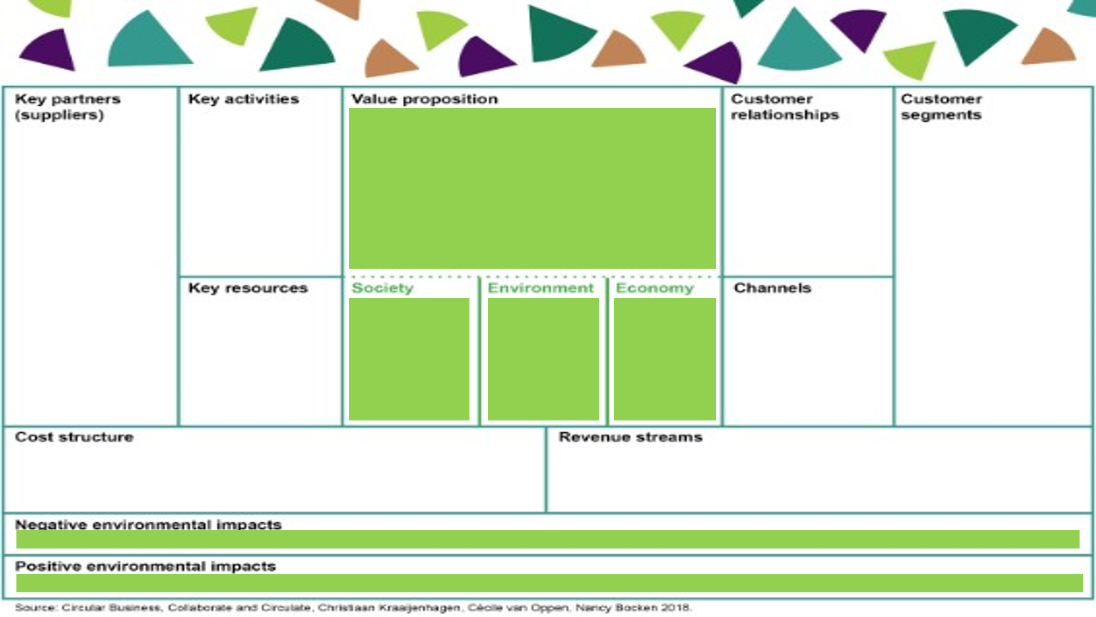

In this playbook, there are five parts, of which the first one is "Understanding the importance of the circular economy." We've already talked a lot about this before.
The first part of the playbook compiles changes in the operating environment that the circular economy helps to adapt to:
1. Climate change and biodiversity loss,
2. Regulation and policy,
3. Customer-orientation and changing consumption,
4. Technology and data,
5. Economic rationale.
We're asked to consider what the change in the operating environment means to companies from these perspectives: license to operate, efficiency and resilience, as well as growth and differentiation.
The goal of the first part of the playbook is to identify the risks and opportunities of the changing operating environment:
What risks relating to the changing business environment can you identify today?
What opportunities relating to the changing business environment can you identify today?
The goal is also to start outlining the company's circular economy vision:
What could the company's circular economy business look like in the future?
Indeed, since we have already discussed these matters before, I just want to remind you of how I see this. So, the goal of the circular economy is a profitable business within the Earth's carrying capacity. In that sense, the circular economy offers solutions to our environmental challenges.
The playbook provides a valuable tool for reflecting on the effects of environmental changes on business operations.
You must think: "What does this mean for my business?
I highlight that each company must undertake this task independently. Nobody can do it for you.
I want to give you one example. We often think that this change incurs costs, but companies have reported that transitioning to a circular economy supply chain can enhance their resilience.
For example, during the pandemic and logistical challenges, a customer noted that transitioning to a circular economy supply chain improved their resilience by reducing their dependence on externally sourced raw materials and components.
We have multiple other examples that transitioning to a circular economy supply chain reduced costs in several ways:

- Reduced dependence on external suppliers
- Lowered risk of supply chain disruptions
- Efficiency improvements
- Long-term sustainability
Overall, transitioning to a circular economy supply chain can simultaneously reduce costs and enhance resilience, thereby improving companies' ability to adapt to changing circumstances.
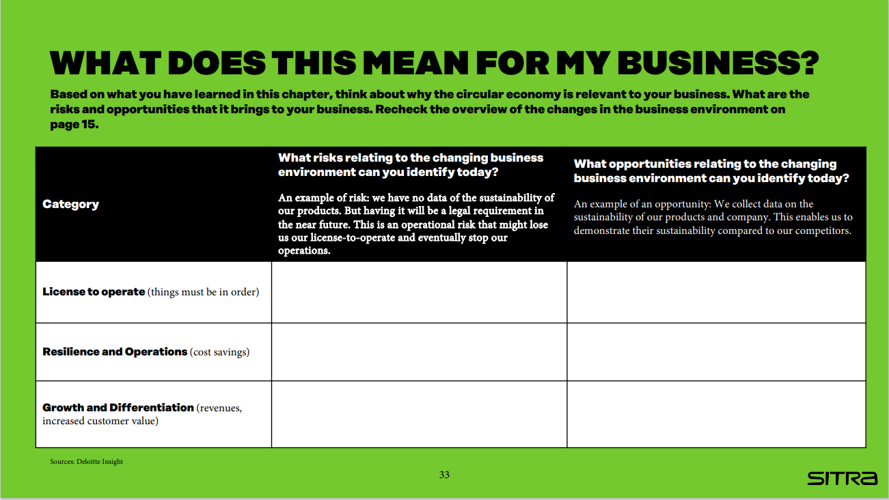
Back to this tool. This tool is a simple table, the added value of which is to guide thinking towards the right aspects. What is filled into the table is indeed specific to the industry, company, product/service/solution.
In addition, I hope that in this context, we also consider how the business currently impacts the environment and what opportunities there are to reduce this impact - or not so much to do less harm, but rather to see if we could perhaps do something that affects nature's ability to regenerate.
Today, there is much talk about regenerative circular economy, where the focus is on considering the environmental impacts while making decisions about our operations - and especially those positive environmental impacts.
And that doesn't appear in this tool. But it's something I would like you to consider alongside the questions in the playbook.
And then, when you move on to the business model after you have considered what changes are happening in the business environment - what risks and opportunities are associated with them and what impacts they have on your company specifically, it's good to consider what we would like to aim for.
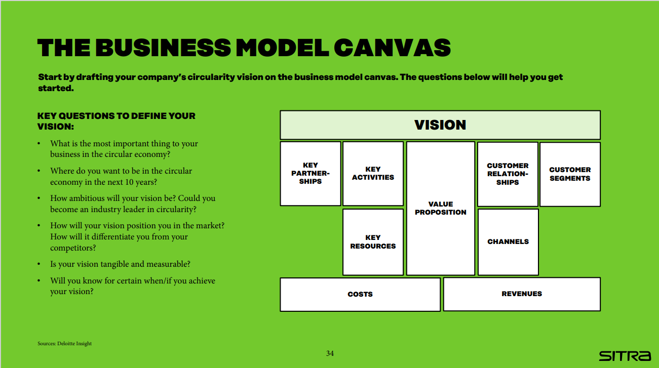
When you write this down, it doesn't mean that it's set in stone, but I strongly recommend that you draft a circular economy vision for your company.
The vision should incorporate thoughts on risks and opportunities, and these playbook questions also help in defining the vision:
- What is the most important thing to your business in the circular economy?
- Where do you want to be in the circular economy in the next 5 - 10 years?
- How ambitious will your vision be? Could you become an industry leader in circularity?
- How will your vision position you in the market? How will it differentiate you from your competitors?
- Is your vision tangible and measurable?
The vision is good to summarize in one sentence.
In the early stages, it's indeed good to think about what direction we want to take and then refine it as thinking progresses in later stages.

VIDEO:

So, how are those circular economy opportunities identified?
At this point, I've combined chapters 2 and 3 of the playbook. Chapter 2 focuses on Unlocking the circular opportunities. Here are the essential questions:
- What are the inefficiencies in your value chain?
- How can the circular economy turn inefficiencies into opportunities?
- How can the circular economy add value?
I would remind you that globally, less than 10% of materials return to circulation. Everything we can do for recycling and reuse is important and necessary. The key is how to act differently in inefficiencies - that's where the potential lies.
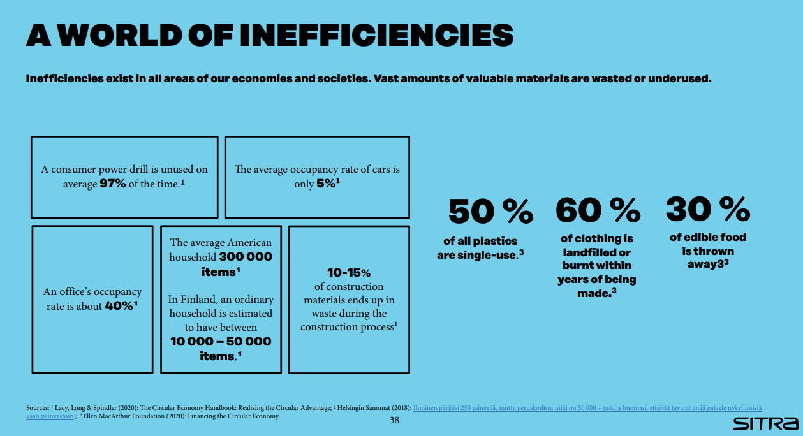

Inefficiencies include unsustainable use of materials and underutilized capacities, premature product lives, wasted end-of-life value, and unexploited customer engagements.

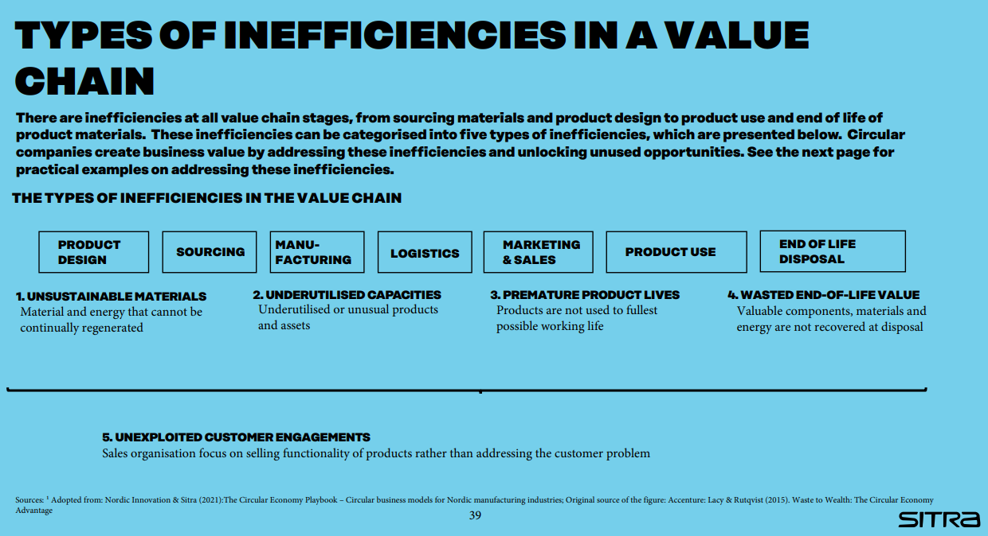

Well, how can we then derive business values from inefficiencies?

When addressing unsustainable materials, businesses can begin by assessing their current practices and pinpointing areas for integrating sustainable raw materials. This could entail sourcing recycled materials or investigating renewable alternatives to conventional resources. Businesses can also adopt renewable energy sources like solar or wind power.
Volvo as an example: About a third of the materials used in a new Volvo truck are recycled, and up to 90% of the truck can be recycled at the end of its life. In the longer term, Volvo aims to comprehensively replace unsustainable materials with recyclable materials.
When tackling underutilized capacities, businesses can optimize their use of facilities, equipment, and personnel. This involves implementing energy-efficient technologies, promoting resource sharing, and investing in workforce training to boost productivity.
BlaBlaCar is an example who has turned this inefficiency into an opportunity by creating a platform that connects drivers and passengers willing to travel together and share the cost of the journey.
When dealing with premature product lives, businesses can prioritize waste reduction, reuse, and recycling throughout the product lifecycle. This involves redesigning products to facilitate easier recycling, establishing take-back programs, and exploring innovative recycling technologies.
Emmy for example, collects used clothes and sorts, photographs, and prices them to sell online.
When faced with wasted end-of-life value, businesses can transition to solution-centric sales approaches by comprehending customers' sustainability requirements. This could entail bundling products and services or providing leasing and maintenance alternatives to prolong product lifecycles and minimize waste.
Neste for example, uses oil and fat waste to produce renewable traffic fuels.
When confronted with unexploited customer engagements, businesses can implement strategies to better understand customer needs and preferences. This may involve conducting market research, gathering feedback, and analyzing customer data to identify opportunities for improved engagement and enhanced customer satisfaction. By leveraging these insights, businesses can tailor their products and services to better meet the needs of their target audience, ultimately driving growth and fostering long-term customer relationships.
Michelin for example, started offering tires as a service (the pay-per-mile model) to its truck customers.
VIDEO
Now, let’s talk about adding value to a company through the circular economy.
When considering how customer-centricity helps realize circular economy opportunities, the focus should shift from individual products and production to holistic solutions and the entire value chain.
When it comes to information flow, data should flow in from customers, rather than the company solely pushing information outwards.
By listening to customers and addressing their needs, it's crucial that information also flows internally within the company, from sales representatives to other departments.
Efficient information sharing enables the utilization of customer insights across the entire company, in all different functions. Based on this, new and better solutions can be provided to customers. Data integration should be achieved throughout the entire value chain.
Performance indicators should be designed to measure progress toward future goals rather than focusing solely on the present. Instead of measuring the sales value of products individually, it's important to measure it by customer. The goal is to determine how much value the current service offering generates for an individual customer.

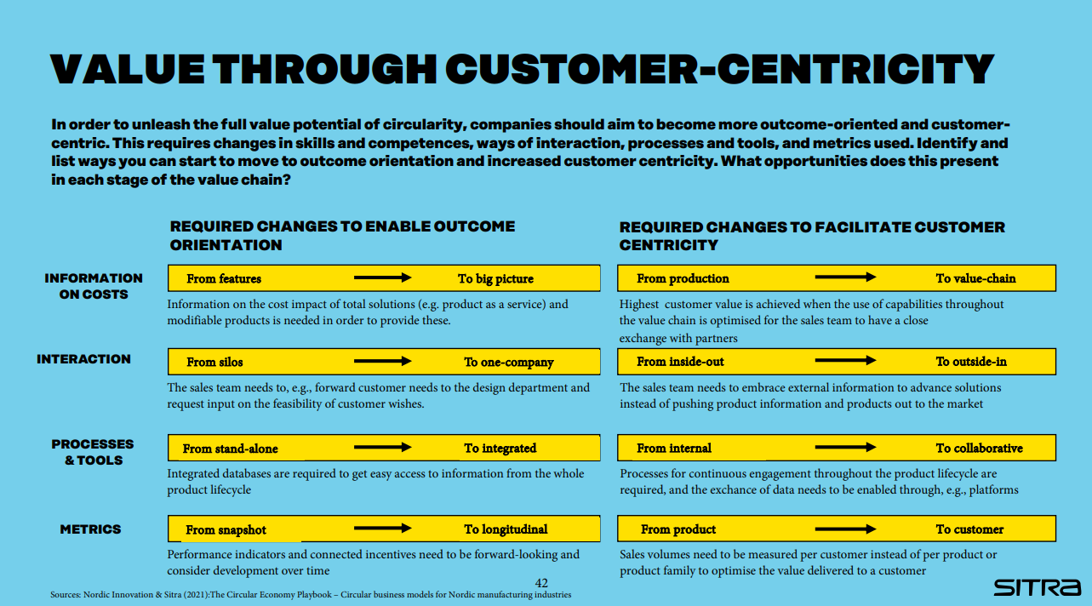

Now we are back to the inefficiencies.
In the playbook, there's another table aimed at helping to contemplate the right aspects: Tools: "Assess inefficiencies and opportunities". This tool is for reflecting on the inefficiencies we currently have. Besides identifying existing inefficiencies, it's important to consider whether these can be transformed into customer value. The tool provides useful guiding questions for identifying inefficiencies.
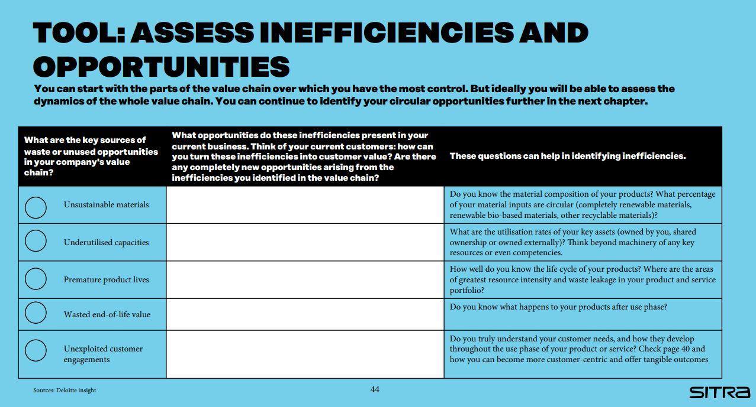

Once we've taken a look at the inefficiencies in our current operations, the next step is to consider how we can improve efficiency and generate new value through our business model.
The five Circular economy business models offer innovative approaches to achieve this goal:
1 Circular inputs: This involves using recycled, bio-based materials, and renewable energy in our production processes. By creating sustainable, repairable, and recyclable products, we can minimize waste and environmental impact.
2 Sharing platforms: Digital platforms enable us to optimize the utilization of goods and resources by facilitating sharing, renting, and leasing. This not only reduces resource consumption but also promotes collaborative consumption. It's worth noting that not all sharing platforms are circular economy initiatives, although sharing platforms enable circular economy business models. With these examples, it's important to be cautious.
3 Product as a service: Instead of traditional ownership models, we can offer our clients access to products through services like leasing and renting. This shift towards "product-as-a-service" encourages longer product lifecycles and fosters a circular consumption pattern.
4 Product life extension: We can prolong the lifespan of products through repair, maintenance, upgrades, and resale services. By extending the life of products, we reduce the need for new resource extraction and minimize waste generation.
5 Resource recovery: This involves recovering materials and resources from products that have reached the end of their useful life. By implementing effective resource recovery processes, we can reintroduce valuable materials back into the production cycle, closing the loop and reducing the need for virgin resources.

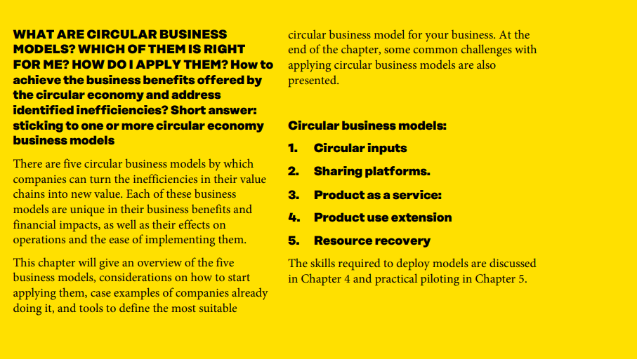

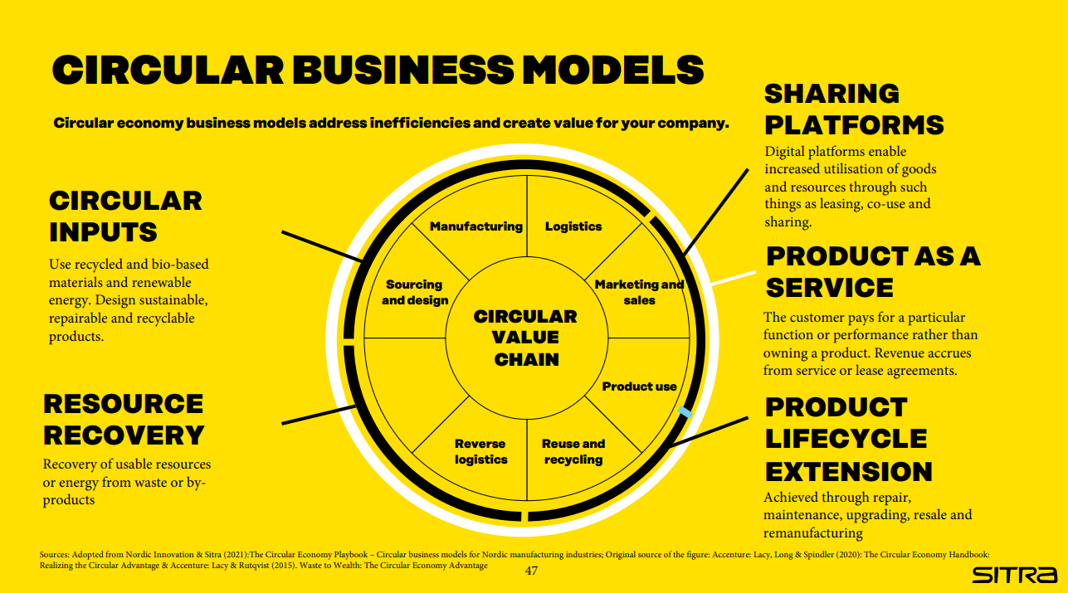

Each circular business model includes several sub-models, which offer practical insights into implementing circularity in various industries. These sub-models outline specific actions companies can take to transition towards circular practices.
Let's take a quick look at some of these sub-models:
Sustainable product design focuses on creating durable and repairable products, such as modular designs.
Circular supplies involve using recyclable materials in production, like renewable and bio-based materials, to increase recovery rates.
Sharing platforms enable increased utilization of capacity.
Product-as-a-Service offers customers access to products through subscription or usage-based charges.
Product use extension includes activities like repair, maintenance, and upgrading to prolong product lifecycles.
Resource recovery encompasses recycling, upcycling, and returning materials to the source to minimize waste.
Understanding these sub-models can provide valuable insights into how your company can embrace circularity and create new opportunities for sustainability and innovation.

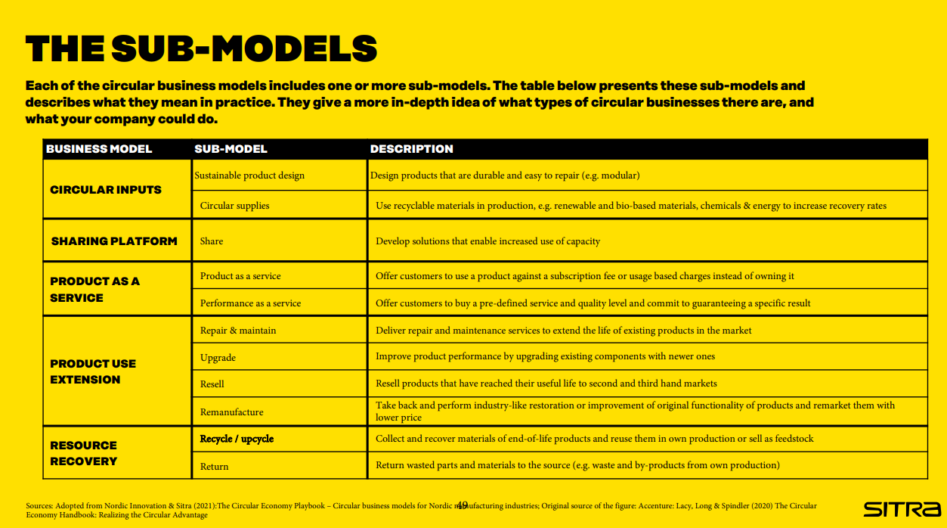

Here you can explore examples of companies that are noteworthy in the field of circular economy.

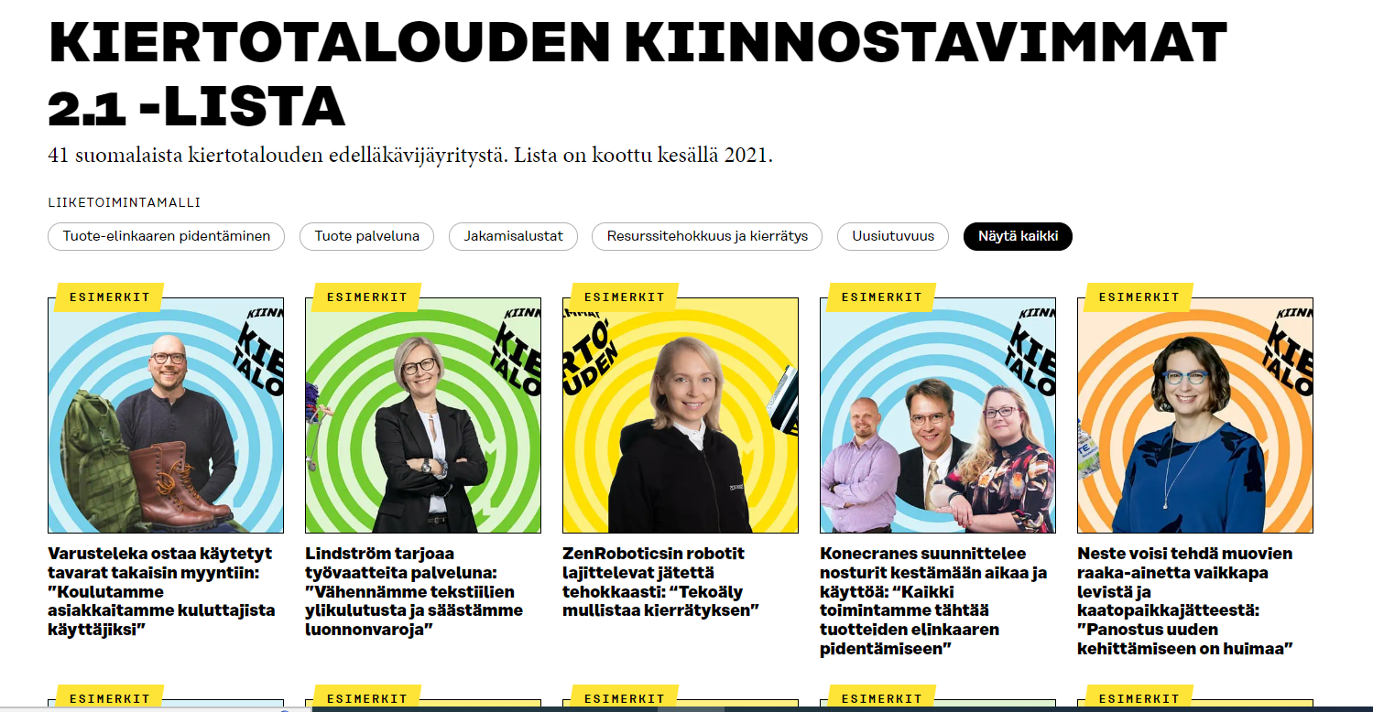

https://www.sitra.fi/en/projects/interesting-companies-circular-economy-finland/#what-is-it-about
VIDEO:
Next, let's delve into how different business models impact the value chain.
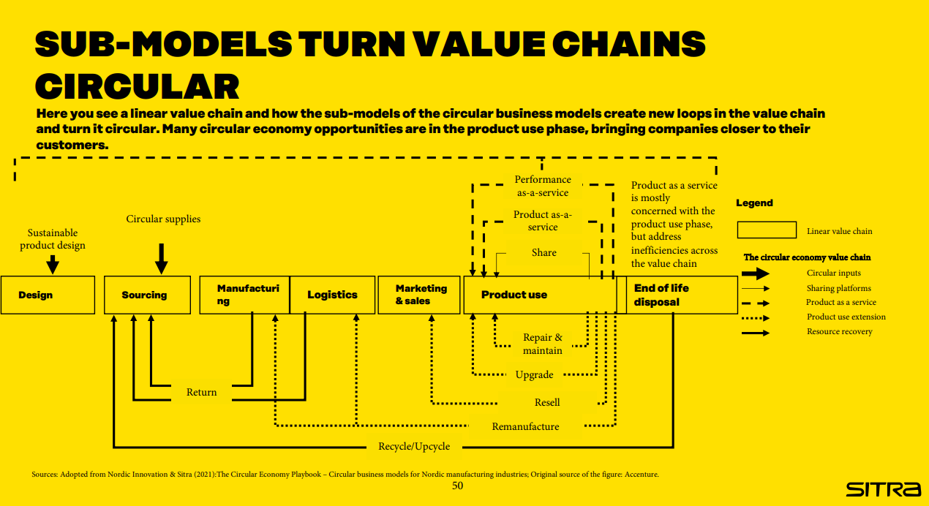Here you see a linear value chain and how the sub-models of the circular business models create new loops in the value chain and turn it circular. Many circular economy opportunities are in the product use phase, bringing companies closer to their customers.
It's important to note that various circular economy models impact different segments of the value chain.
In the playbook, there's more detailed information on different business models, their impacts, implementation methods, and case examples.

Here's a tool that aims to draw your attention to how the business models you've conceptualized would impact your value chain and what factors should be considered. With this tool, you sketch your value chain on paper and then contemplate which of these business models or their sub-models could work for your company. It helps identify opportunities at various stages of the value chain.
These tools are extremely valuable. They help to think, focus attention, but also to visualize. They make thoughts visible. And that enables sharing thoughts and having discussions within the organization. They facilitate collective thinking.

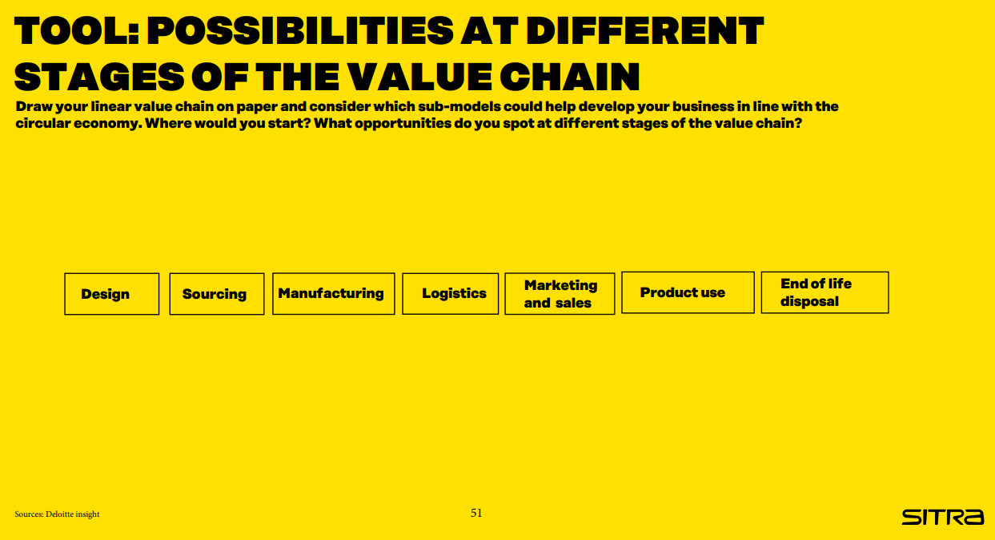

Each of these business models naturally has its challenges. Somewhat different challenges. Of course, any business transformation involves challenges. These are both generally related to business and specifically related to the circular economy.
If we think about internal challenges for the company related to organizational competence, it certainly requires investment. Actions affect different parts of the organization. If we want a comprehensive change in the organization, it also requires a change in mindset throughout the organization. Old structures and cultures change slowly. It requires more patience and investment than building a new company based on circular economy principles or implementing change in a very young organization.
There are challenges related to customers. And it's important to consider the adoption of the new business model from the perspective of customers. What are the incentives? Can we offer incentives to customers? Incentives that make the new model appealing.
Customer communication is extremely important to clearly and understandably convey the additional benefits offered by the new model to customers.
The third level is the ecosystem level, where these challenges exist. And often, if we transition to such a circular economy business model, we need to rethink the entire partnership network and ecosystem. There may be new players, some players may drop out, and in this context, building the circular economy value chain and implementing a new collaboration model throughout the entire ecosystem is extremely important.
If our cycle doesn't work properly, neither will our business.
I won't go through the challenges in detail now, but you can revisit them independently in the playbook.
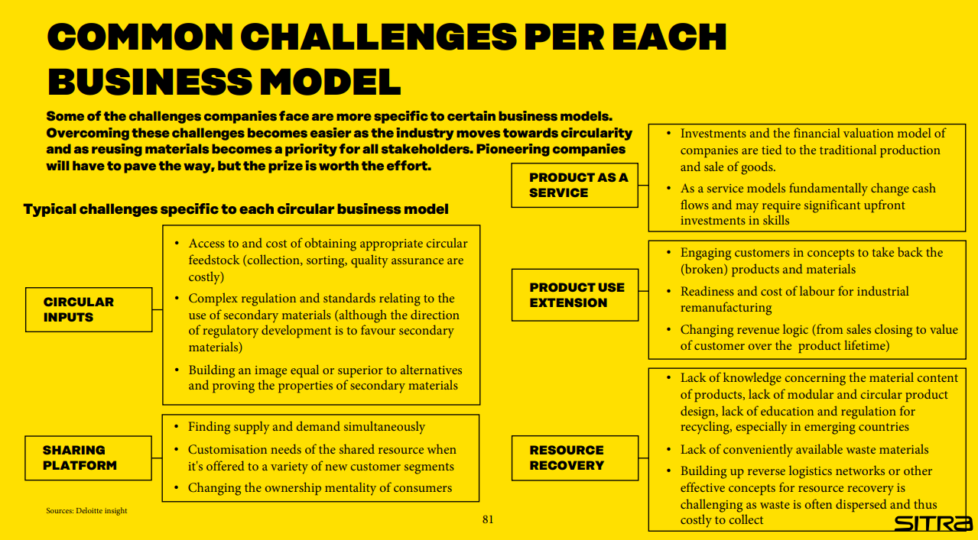

In the next tool, there's just a list of questions, but that's actually a very good thing because it contains the right questions. These are the things to ponder and seek answers to when planning your own business model.

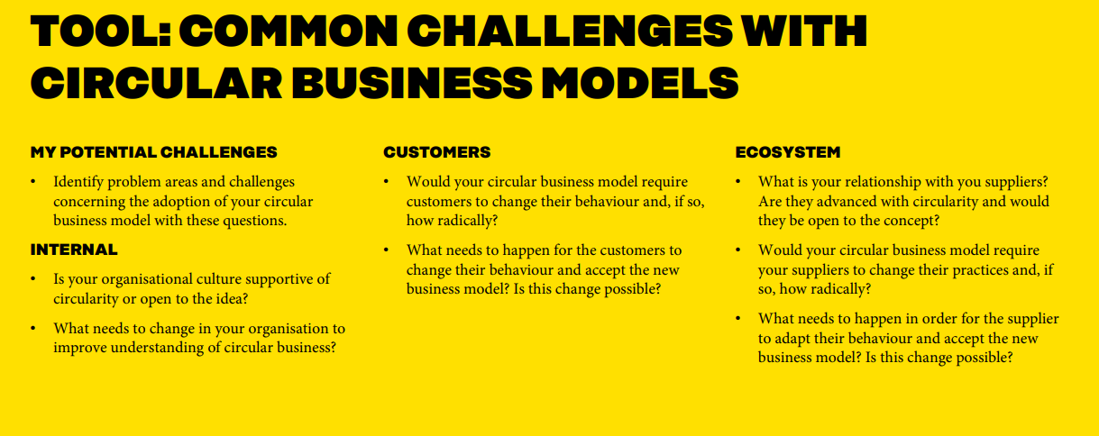

And then in the playbook, there's a separate tool for the actual planning of the business model. It's good to plan the business model. And all these things should be done step by step.
Once we've gone through the earlier stages, here we can consider what could be a suitable business model or business models for our company.
What is the business potential of the business model/models?
What are the new revenue and expense streams?
Are there any new kinds of cost savings?
Does it affect customers' image of the company?
Does the change in the business model help manage risks?
Does it help improve environmental or social impacts?
These are perhaps the most important questions when considering business potential.
And then, for the business to have any chance, we also need customers.
Who would be the customers for this new type of business model? Who would be interested? Would anyone be interested? If not, we have to go back to the starting point and think again.
What is the additional value and benefit the customer receives?
What is the thing that customers would be willing to pay enough for to create a profitable business?
Finally, you need to look inward and examine the company's readiness for change, for developing a circular economy business. You can do that by revisiting those previously discussed challenges.

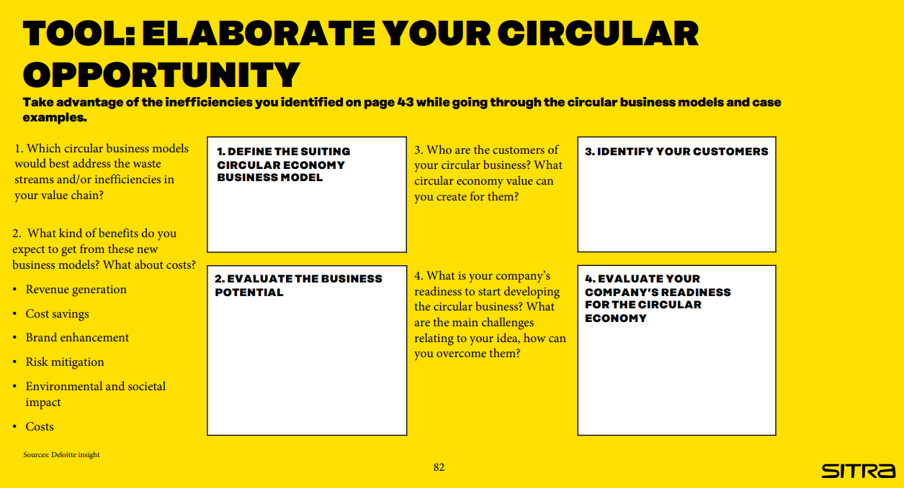

Businesses have several opportunities, so it's important to consider where to start. In that case, a quadrant like this is useful. If you have identified various circular business opportunities, this tool will help you gain an understanding of which initiatives to prioritize.
Accessibility refers to how easy or difficult it is for the company to implement the planned solution.
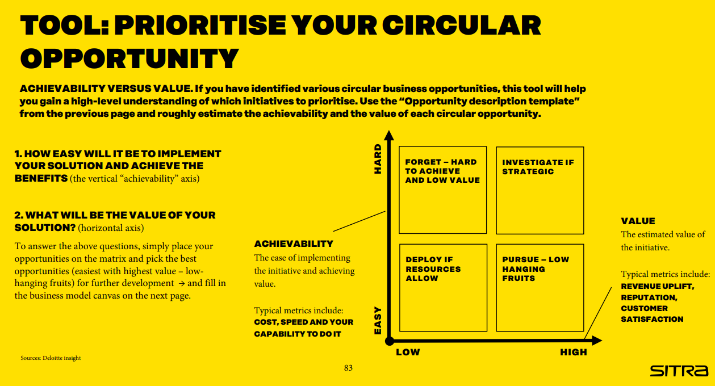
After going through these different stages we've covered today, the company is ready to fill out the entire business model canvas.
Let’s go through the questions:
KEY ACTIVITIES
• What measures are needed to deliver your circular value proposition and set up the business?
VALUE PROPOSITION:
• What unique value can you create with circular economy and for whom?
• What is your compelling circular economy story line?
CUSTOMER RELATIONSHIP:
• How can you engage with customers to gain meaningful feedback and include them in the journey?
CUSTOMER SEGMENTS:
• Who are your main customers?
• Who else can benefit from your value proposition?
CHANNELS:
• What channels will you use to sell your
products or services?
COSTS:
• What is your cost structure?
• Where can circular thinking decrease the costs of operations?
• Where could partnerships and the utilization of shared assets decrease costs?
REVENUE:
• How do you generate revenue?
• What types of other values are created with your circular vision and how do they impact the value of your business

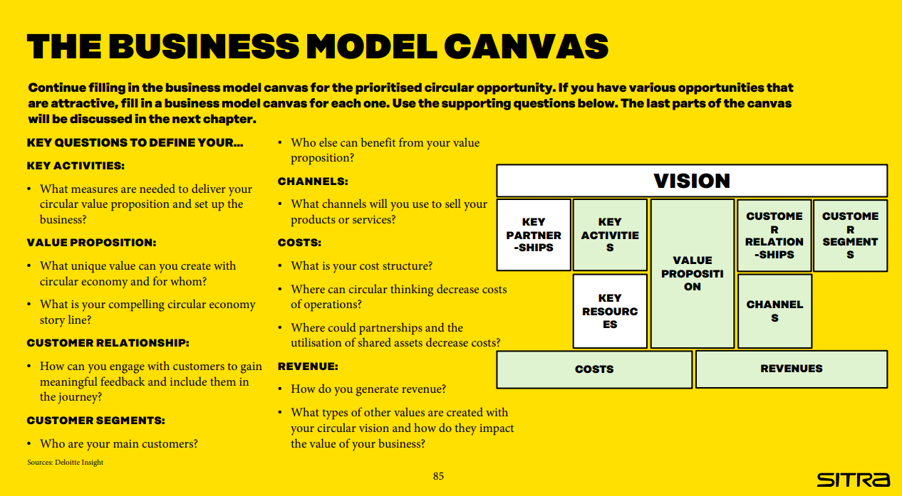
VIDEO
Alright everyone,
We have had a long session already, but I want to emphasize a crucial aspect: the capabilities we need to make this circular business model shift a reality.
Think of your company as a ship navigating uncharted waters. To sail smoothly into the circular economy, we need a sturdy vessel with the right crew and equipment. These are the capabilities that will steer us in the right direction and weather any storms along the way.
First off, let's talk about company culture. It's not just about policies and procedures; it's about mindset. We need to foster a culture that values innovation, collaboration, and sustainability. It's about getting everyone on board with the idea that change is not just necessary but exciting.

Next up, let's dive into operations. We need to rethink every aspect of how we do business – from design and production to distribution and waste management. It's about finding ways to do more with less, to minimize waste, and to maximize the value of every resource we use.
And let's not forget about partnerships. No company can go it alone on this journey. We need to work hand in hand with suppliers, customers, and other stakeholders to create a truly circular ecosystem. It's about building relationships based on trust, transparency, and shared values.
So, as we wrap up, I want each of you to think about the capabilities your company needs to thrive in the circular economy. Identify areas where you can strengthen your skills, invest in training and development, and foster a culture of continuous improvement.

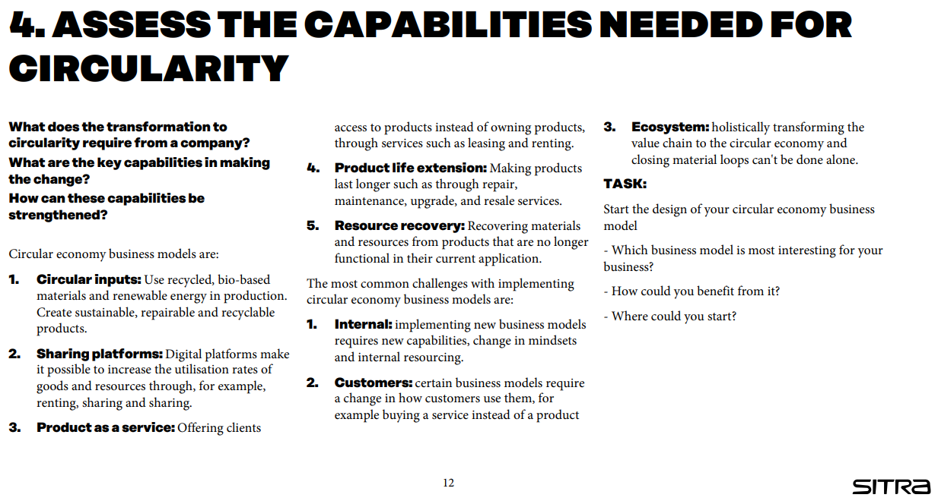

In the playbook, there's a detailed section on different capabilities, how to build them, and examples related to each. I strongly recommend using the tools provided to evaluate the required capabilities.

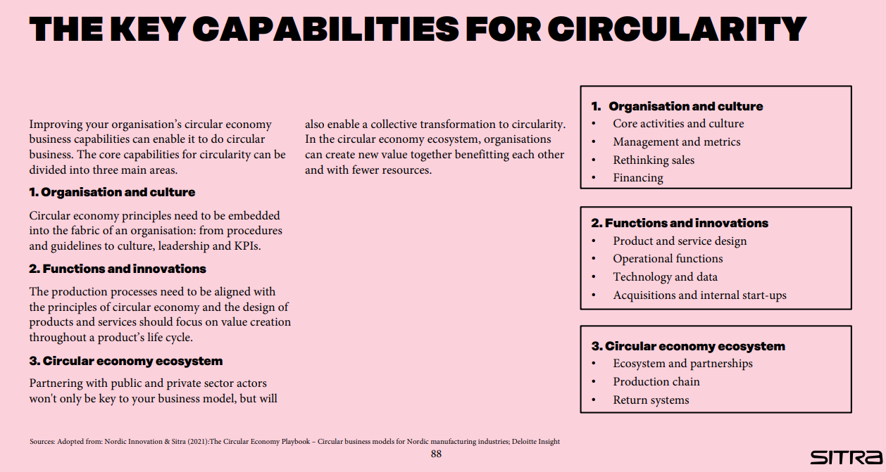

Use the capability assessment tool to start thinking about the most relevant circular capabilities of your company and the areas where you need to improve.

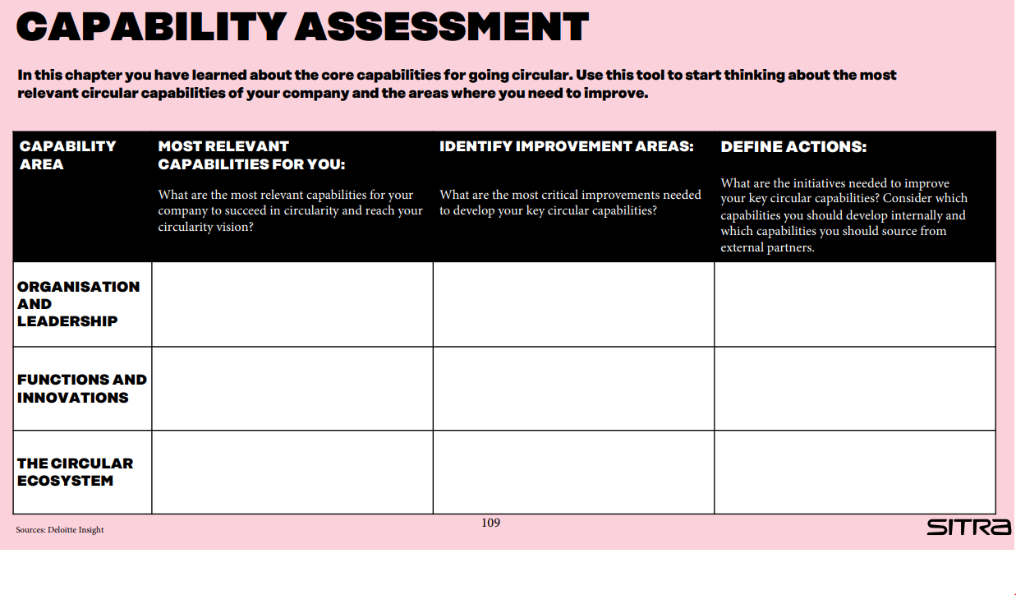
Now, let's focus on the two remaining sections of the business model canvas: Key Partnerships and Key Resources.
In Key Partnerships, we need to identify the essential collaborators who can help us leverage existing circular opportunities or even create new ones. Think about who you need to work with to achieve your circular goals. Are there specific challenges you're facing that require collaboration? Consider potential partners who can help address these challenges. Also, reflect on whether there are any gaps in your network. Have you identified any needs or demands that aren't being met? Perhaps there are opportunities for new partnerships to support your circular business endeavors.
Moving on to Key Resources, here we'll determine what material or immaterial capabilities are necessary to bring our value proposition to life. Take stock of the resources you currently have and assess whether they align with your needs. Do you possess all the capabilities required to execute your circular business model effectively? If not, consider how you can acquire or develop these capabilities to ensure success.

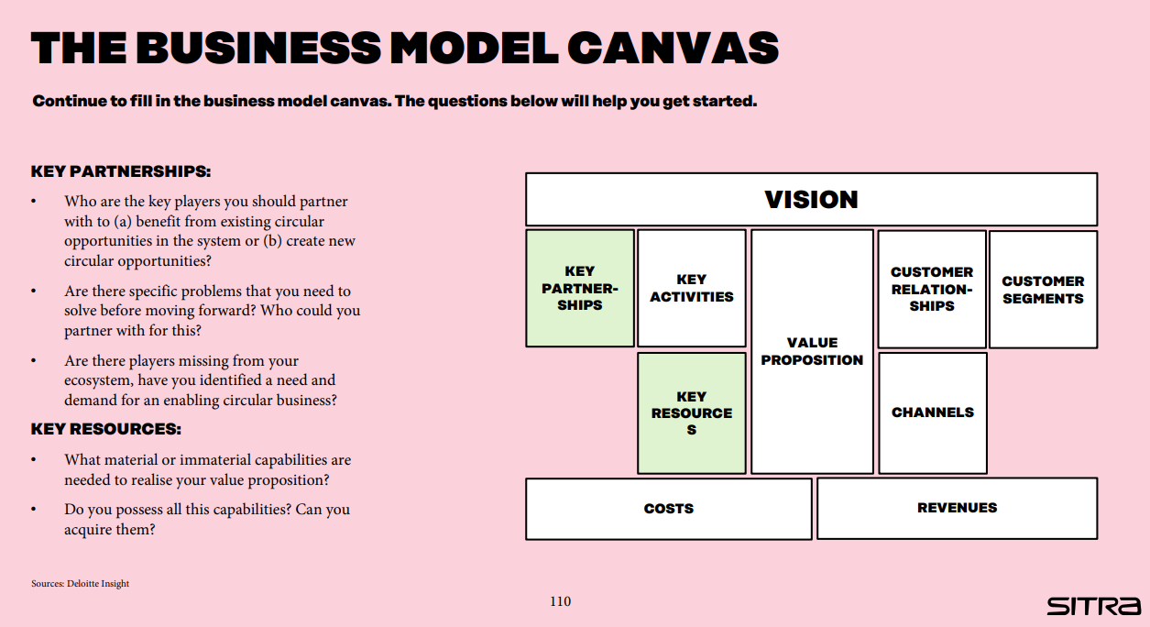

All right, let's discuss quickly how to move forward on our journey toward circular business transformation. In this chapter, we'll explore two distinct approaches that any company can adopt to carve out its path to circularity.
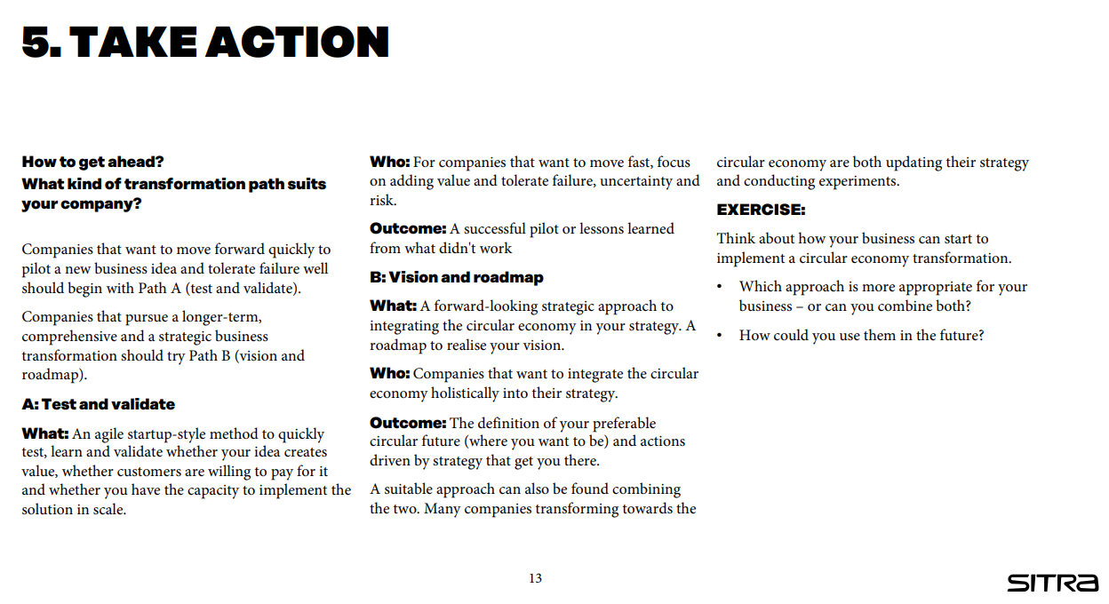

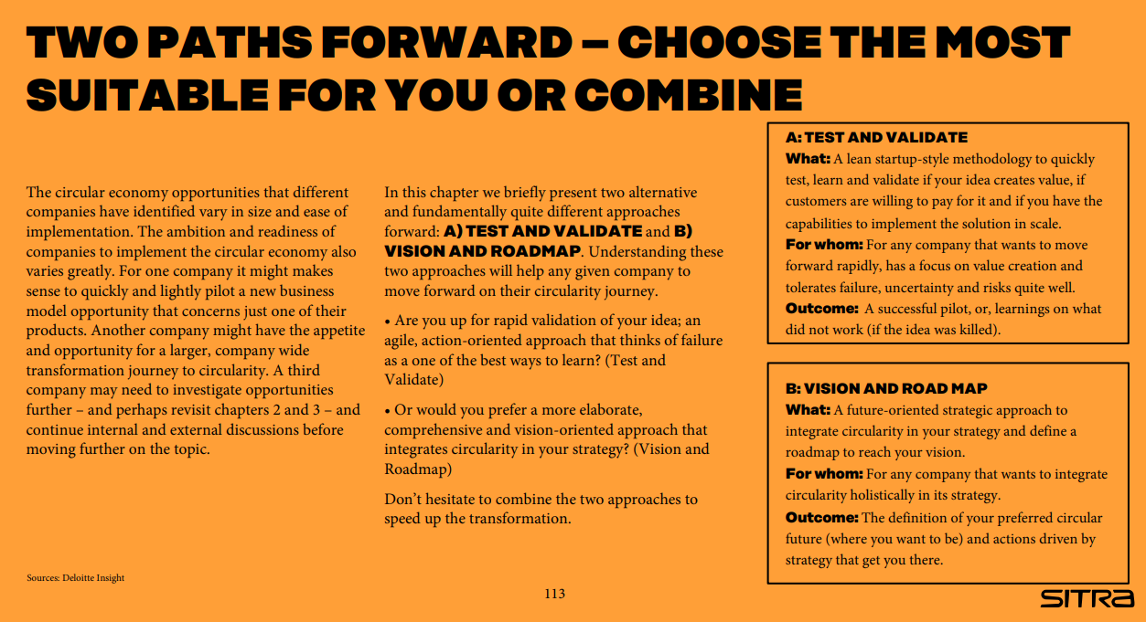

First up, we have Path A: Test and Validate. This approach is ideal for companies eager to swiftly pilot a new business idea and are comfortable with the possibility of failure.
Here, we embrace a lean startup mindset, finalize our circular business model canvas, and mobilize our company resources to kickstart quick piloting and validation of our circular business concept.
Through testing and iteration based on customer feedback, we'll hit (or miss) our pilot targets and ultimately decide the fate of our pilot—whether to scale it up, pivot, or discontinue it.

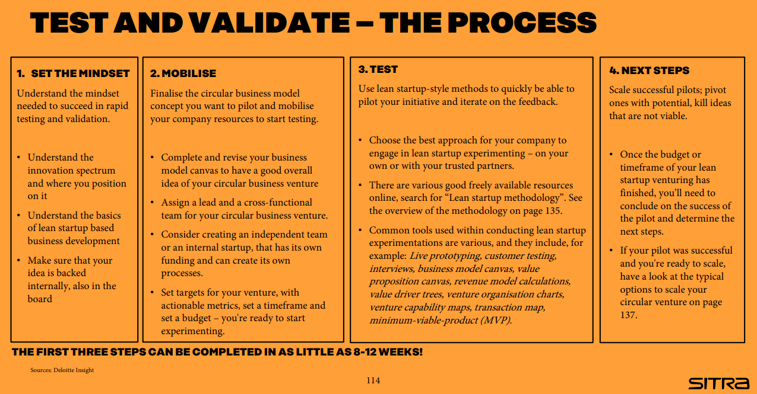

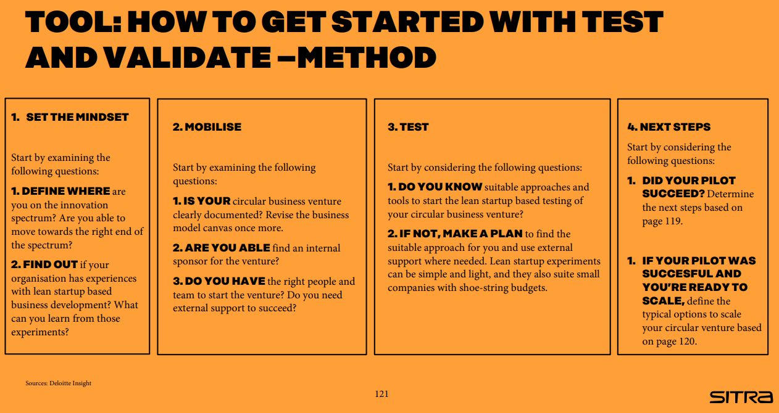

Next, we have Path B: Vision and Roadmap. This path is tailored for companies committed to a more long-term, strategic business transformation towards circularity.
We start by envisioning where we want to be in the next decade or so, integrating circularity into our company strategy, and defining the necessary initiatives to unlock the full potential of circularity and realize our circular vision.

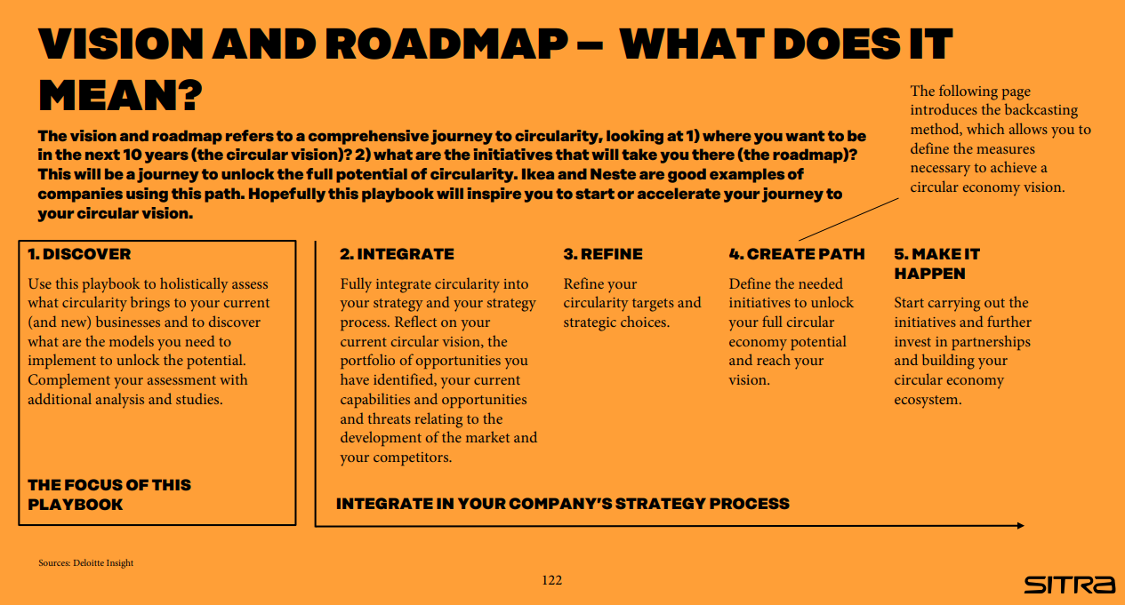

Let's delve into a concept called backcasting, also known as strategies of trajectory. It's a method that flips the traditional planning approach on its head. Instead of starting from where we are now and projecting into the future, we begin with a clear vision of our desired future and work backward to determine the actions needed in the present to make that vision a reality.
Here's how it works:
First, we define our preferred future—where we want to be in the long term, say 5 to 10 years down the line.
Then, we map out the most effective path to reach that future, considering three key timeframes: the now (what we can do in the next 6 to 12 months), the next (our goals for the next 1 to 5 years), and the beyond (our vision for the 5 to 10-year horizon).
Our circular economy vision, seamlessly integrated into our company strategy, serves as our compass for this journey. Backcasting empowers us to analyze our future aspirations, trace them back to the present, and identify the actions that will generate the most value along the way.
While the overall structure of the roadmap to our circular vision will be unique to our company, it's crucial to maintain a balanced focus across all three time horizons. By continuously operating on these horizons and avoiding the temptation to fixate solely on short-term gains, we can effectively steer our organization toward the realization of our circular vision.

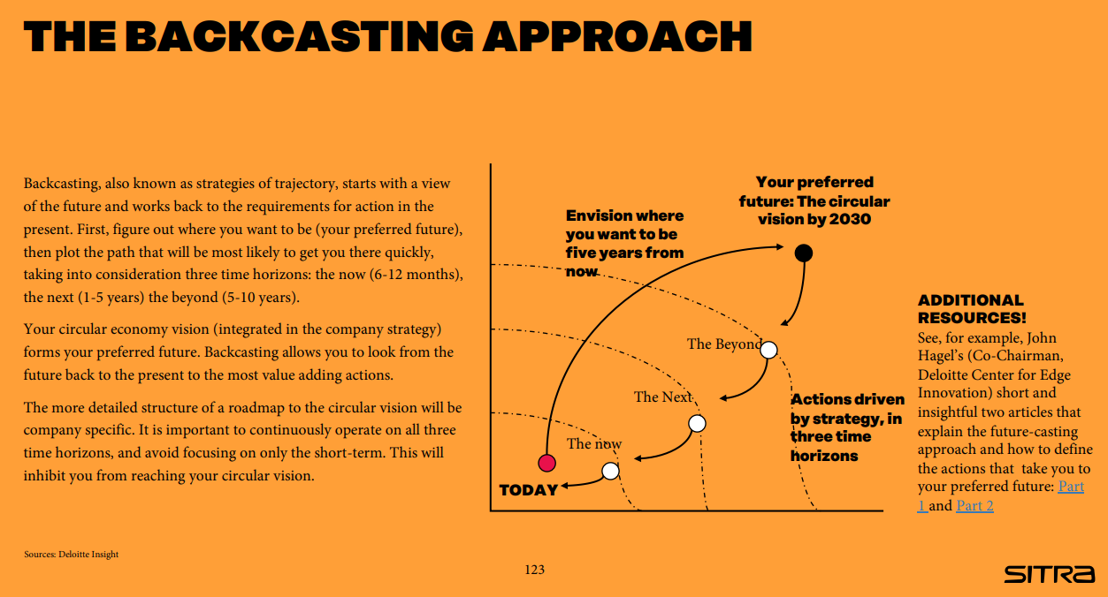

In conclusion, let's remember these key action recommendations:
- Share your newfound insights with our team or board, fostering understanding and alignment.
- Advocate for the prioritization of the circular economy with our company directors, driving commitment from the top.
- Establish a dedicated team to spearhead circular change, ensuring focused efforts and accountability.
- It's crucial to regularly assess our strategy's alignment with evolving business landscape dynamics, staying agile and responsive.
- Uncover circular economy opportunities across our entire value chain, maximizing our potential impact.
- With these insights in mind, craft a comprehensive plan for executing circular operations, ensuring clarity and direction.
- Finally, let's actively engage colleagues, customers, and partners in refining and validating our plan, leveraging their diverse perspectives for success.

Thank you.

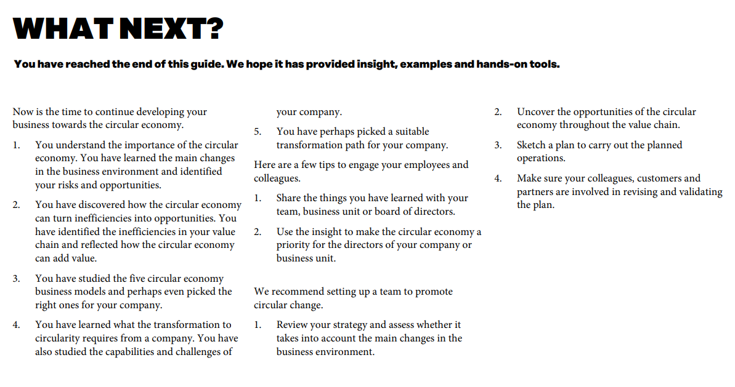

FINAL TEST/GREEN EXPORT GROWTH FROM THE CIRCULAR ECONOMY

Nano Scenario 1: Value Proposition
A small technology export company specializing in electronic devices is keen on transforming its business model to embrace circular economy principles. They aim to minimize waste and maximize resource efficiency in their operations. How can they ensure their value proposition aligns with circular economy principles?
A) The company could focus solely on product functionality and price competitiveness, ignoring environmental considerations.
B) The company could explore innovative ways to extend the lifespan of their electronic devices, such as offering repair services and upgrades.
C) The company could continue using traditional packaging materials to minimize costs, disregarding their environmental impact.
D) The company could prioritize short-term profitability over long-term sustainability, neglecting opportunities for circular innovation.
Correct Answer: B) The company could explore innovative ways to extend the lifespan of their electronic devices, such as offering repair services and upgrades.

Explanation: By extending the lifespan of their products through repair services and upgrades, the company can align its value proposition with circular economy principles, promoting resource efficiency and waste reduction. This approach also enhances customer satisfaction and builds brand loyalty among environmentally conscious consumers.

Nano Scenario 2: A small furniture export company is examining its key partnerships to drive circular economy initiatives. They are seeking ways to collaborate with suppliers, manufacturers, and distributors to implement sustainable practices throughout their supply chain. How can they identify and engage strategic partners who share their commitment to circularity and environmental responsibility?
A) The company could prioritize partnerships based solely on cost-effectiveness, overlooking sustainability criteria.
B) The company could conduct thorough research to identify potential partners who already have a track record of implementing sustainable practices.
C) The company could randomly select partners and hope they align with their circular economy goals.
D) The company could rely solely on its existing network of suppliers and partners.
Correct answer: B)
Explanation: Thorough research enables the identification of partners aligned with the company's circular economy goals and sustainability commitments. This ensures collaborations with like-minded organizations, enhancing the likelihood of successful circularity integration.

Nano Scenario 3: Customer Relationships
A transportation logistics company is exploring ways to enhance its customer relationships while integrating circular economy principles into its business model. How can they engage with their customers to promote sustainability and environmental responsibility?
A) The company could prioritize cost savings and operational efficiency over customer relationships, neglecting opportunities for sustainability engagement.
B) The company could implement transparent communication channels to educate customers about their sustainability initiatives and encourage environmentally responsible behavior.
C) The company could focus solely on profit maximization and disregard customer feedback and preferences regarding sustainability.
D) The company could offer discounts and promotions to customers without considering the environmental impact of their purchasing decisions.

Correct Answer: B) The company could implement transparent communication channels to educate customers about their sustainability initiatives and encourage environmentally responsible behavior.
Explanation: Transparent communication fosters trust and loyalty among customers, enabling the company to engage with them effectively on sustainability initiatives. By educating customers about their environmental impact and promoting environmentally responsible behavior, the company can align its customer relationships with circular economy principles.

Nano Scenario 4: Key Resources
A textile manufacturing company is seeking to transition to a circular economy model to minimize waste and maximize resource efficiency in its operations. How can they optimize their key resources to support their circular economy goals?
A) The company could continue sourcing materials from conventional suppliers without considering their environmental impact or sustainability practices.
B) The company could rely solely on traditional methods of production, disregarding advancements in technology and process optimization that could enhance resource efficiency and minimize waste.
C) The company could prioritize short-term cost savings over long-term sustainability, neglecting opportunities for circular innovation.
D) The company could explore alternative sourcing options, such as recycled or organic materials, to minimize environmental impact and promote circularity.
Correct Answer: D) The company could explore alternative sourcing options, such as recycled or organic materials, to minimize environmental impact and promote circularity.
Explanation: By sourcing materials from recycled or organic sources, the company can reduce its environmental footprint and promote circularity in its supply chain. This approach aligns with circular economy principles by prioritizing resource efficiency and minimizing waste generation.

Nano Scenario 5: Revenue Streams
A renewable energy startup is looking to diversify its revenue streams while integrating circular economy principles into its business model. How can they generate revenue while promoting sustainability and environmental responsibility?
A) The company could focus solely on maximizing profits without considering the environmental impact of its revenue-generating activities.
B) The company could explore innovative business models, such as leasing or subscription services, to promote product reuse and minimize waste generation.
C) The company could ignore customer feedback and preferences regarding sustainability, prioritizing revenue generation over environmental responsibility.
D) The company could offer discounts and promotions to customers without considering the long-term environmental impact of its pricing strategies.
Correct Answer: B) The company could explore innovative business models, such as leasing or subscription services, to promote product reuse and minimize waste generation.
Explanation: Innovative business models like leasing or subscription services promote product reuse and minimize waste generation, aligning with circular economy principles. By offering such services, the company can generate revenue while promoting sustainability and environmental responsibility.

Nano Scenario 6: Capabilities for Circular Transformation
A medium-sized manufacturing company is committed to transitioning to a circular economy model to enhance its environmental sustainability and competitiveness in the global market. What capabilities and competencies does the company need to develop to successfully implement circular transformation?
A) The company could continue relying on its existing workforce without providing additional training or resources for circular economy initiatives.
B) The company could invest in training programs to build employees' knowledge and skills in circular economy principles and practices.
C) The company could prioritize short-term profitability over investing in capabilities for circular transformation, risking long-term competitiveness.
D) The company could outsource circular economy initiatives to third-party consultants without involving internal stakeholders in the process.
Correct Answer: B) The company could invest in training programs to build employees' knowledge and skills in circular economy principles and practices.
Explanation: Investing in training programs allows the company to develop internal capabilities and empower employees to drive circular transformation initiatives. By building knowledge and skills in circular economy principles and practices, employees can actively contribute to the company's transition to a circular business model, fostering innovation and long-term competitiveness.

References

Betti, Saenz, Stephan, 2020. 4 ways industry can make supply chains more sustainable | World Economic Forum (weforum.org). 4 ways industry can make supply chains more sustainable | World Economic Forum (weforum.org)
Betti, Saenz, Stephan, Cronin. 2021. Digital traceability can make supply chains more sustainable | World Economic Forum (weforum.org). Digital traceability can make supply chains more sustainable | World Economic Forum (weforum.org)
BUSINESS FINLAND. 2021. Kyselytutkimus. Kestävän kehityksen tila suomalaisissa pk-yrityksissä. https://www.businessfinland.fi/48fb89/globalassets/finnish-customers/news/news/2022/business-finland-kestava-kehitys--kyselytulokset-medialle-.pdf
Circle Economy Foundation. The Circularity Gap Report. CGR 2023 (circularity-gap.world)
Circular Design. Circular Design Toolkit. Tools - Ecodesign Toolkit (circulardesign.tools)
Circular Design Suomi. Circular Design – kehityspolku kohti kiertotaloutta -valmennusohjelma. Circular Design (kiertotaloussuomi.fi)
Ellen McArthur Foundation. It’s time for a circular economy. https://www.ellenmacarthurfoundation.org/
European Commission. Biodiversity strategy for 2030. Biodiversity strategy for 2030 - European Commission (europa.eu)
Euroopan komissio. Euroopan vihreän kehityksen ohjelma. Euroopasta ensimmäinen ilmastoneutraali maanosa. Euroopan vihreän kehityksen ohjelma - Euroopan komissio (europa.eu)
Euroopan komissio. 2022. Vihreän kehityksen ohjelma: Kestävistä tuotteista normi ja Euroopalle resurssiriippumattomuus. Kestävistä tuotteista normi (europa.eu)
Euroopan komissio. 2022. Euroopan vihreän kehityksen ohjelma: Loppu pakkausjätteelle, tehoa uudelleenkäyttöön ja kierrätykseen. Euroopan vihreän kehityksen ohjelma: Loppu pakkausjätteelle, tehoa uudelleenkäyttöön ja kierrätykseen - Euroopan komissio (europa.eu)
Eurooppa-neuvosto. Pellolta pöytään. Pellolta pöytään - Consilium (europa.eu)
Euroopan parlamentti. Oikeudenmukaisen siirtymän rahasto. Oikeudenmukaisen siirtymän rahasto (europa.eu)
European Union. Circular economy. New rules on packaging and packaging waste. Circular economy - Publications Office of the EU (europa.eu)
Helsingin Sanomat. 5.3.2023. Ulkomaat. HS Ympäristö. YK:ssa solmittiin historiallinen sopimus valtamerien suojelemiseksi - Ulkomaat | HS.fi
Helsingin Sanomat. 4.2.2023. Politiikka. HS-haastattelu. Tutkijatähti: Suomen nieluromahdus on osa ”erittäin huolestuttavaa” globaalia trendiä - Politiikka | HS.fi
Helsingin Sanomat. 19.12.2022. Politiikka. Luontokato. Yllätyssopu: Kolmannes maapallon pinta-alasta suojellaan – koskee myös Suomea - Politiikka | HS.fi
Jäättelä, R. 2023a. Kiertotalous ja yrityksen liiketoimintamahdollisuudet. VIVA-hankkeen webinaarisarja ”Kiertotaloudesta vihreää kasvua”. 2.3.2023.
Jäättelä, R. 2023b. Kestävä toimitusketju. VIVA-hankkeen webinaarisarja ”Kiertotaloudesta vihreää kasvua”. 9.3.2023.
Jäättelä, R. 2023c. Kestävä pakkaaminen. VIVA-hankkeen webinaarisarja ”Kiertotaloudesta vihreää kasvua”. 15.3.2023.
Jäättelä, R. 2023d. Yrityksen kiertotaloustransformaatio. VIVA-hankkeen webinaarisarja ”Kiertotaloudesta vihreää kasvua”. 22.3.2023.
Kuoppala Aleksi. 2021. Älykkään toimitusketjun hyödyt ja haasteet. Älykkään toimitusketjun hyödyt ja haasteet - Trepo (tuni.fi)
McKinsey & Company. 2022. Sustainability in packaging: Five key levers for significant impact. Sustainable packaging: Five key levers for impact | McKinsey
McKinsey & Company. 2022. Reusable packaging: Key enablers for scaling. Reusable packaging: Key enablers for scaling | McKinsey
McKinsey & Company. 2020. Sustainability in packaging: Inside the minds of global consumers. Sustainability in packaging | McKinsey
OECD. 2022. Green innovation and the impact of economic shocks. Green Growth and Sustainable Development Forum 2022 - ggsd-2022 (oecd.org)
OECD Urban Studies. 2020. The Circular Economy in Cities and Regions. The Circular Economy in Cities and Regions : Synthesis Report | OECD Urban Studies | OECD iLibrary (oecd-ilibrary.org)
Rethink Global. A supply chain revolution: how the circular economy unlocks new value. A supply chain revolution: how the circular economy unlocks new value (rethinkglobal.info)
Savonia AMK. 24.5.2022. Savonia-artikkeli. Kiertotalouden mukaisella suunnittelulla on valtava ympäristövaikutus. Savonia-artikkeli: Kiertotalouden mukaisella suunnittelulla on valtava ympäristövaikutus - Savonia-AMK
Searcy (2016) What Makes a Supply Chain Sustainable? What Makes a Supply Chain Sustainable? (mit.edu)
SITRA. 2018. Mitä nämä käsitteet tarkoittavat? Mitä nämä käsitteet tarkoittavat? - Sitra
SITRA. Kestävää kasvua kiertotalouden liiketoimintamalleista. Käsikirja yrityksille. https://www.sitra.fi/app/uploads/2022/02/kestavaa-kasvua-kiertotalouden-liiketoimintamalleista-2-1.pdf
SITRA. Most interesting companies in the circular economy in Finland 2.1. Most interesting companies in the circular economy in Finland 2.1 - Sitra
SITRA. Sustainable growth with circular economy business models. A playbook for businesses. Sustainable growth with circular economy business models - Sitra
Suomen pakkausyhdistys ry. Tietoa pakkauksista. Tietoa pakkauksista | Suomen Pakkausyhdistys ry
Teknologiateollisuus. Kestävää kasvua kiertotaloudesta | Teknologiateollisuus - Google-haku
UN Environment. 2019. Global Environment Outlook 6. Global Environment Outlook 6 | UNEP - UN Environment Programme
UN. 15 April 2021. Shifting to a Circular Economy Essential to Achieving Paris Agreement Goals. Shifting to a Circular Economy Essential to Achieving Paris Agreement Goals | UNFCCC
UNEP Sustainable Trade in Resources. Global Material Flows, Circularity and Trade. Sustainable Trade in Resources | Resource Panel
UNFCCC. 2016. Implementing Circular Economy Globally Makes Paris Targets Achievable. Circular economy 1.pdf (unfccc.int)
UNIDO.2018. Circular Economy. Circular_Economy_UNIDO_0_.pdf (unfccc.int)
Valtioneuvosto. Suomen toimialakohtaiset tiekartat vähähiilisyyteen 2030. Yhteenveto toimialojen vähähiilitiekartoista - Valto (valtioneuvosto.fi)
Valtioneuvoston periaatepäätös kiertotalouden strategisesta ohjelmasta. Valtioneuvoston+periaatepäätös+8.4.2021+kiertotalouden+strategisesta+ohjelmasta.pdf (ym.fi)
YLE. 20.11.2022. Analyysi: Egyptin ilmastokokous päättyi mahalaskuun – vain yksi toivonpilkahdus kuultiin, ja sekin peittyi lentokoneiden pauhuun | Yle
Ympäristöhallinnon verkkopalvelu. Tuotesuunnittelu. Tuotesuunnittelu (ymparisto.fi)
Ympäristöministeriö. Kiertotalouden strateginen ohjelma. Kiertotalouden edistäminen - Ympäristöministeriö
Ympäristöministeriö. Vapaaehtoiset green deal -kiertotaloussitoumukset. Kiertotalouden green deal - Ympäristöministeriö
World Economic Forum. Global Risks Report 2023. Global Risks Report 2023 | World Economic Forum | World Economic Forum (weforum.org)
World Economic Forum. Davos Agenda. May 17, 2022. The circular economy: how it can lead us on a path to real change. Why we need a true circular economy for a waste-free world | World Economic Forum (weforum.org)
AI tools utilized: SteveAI (for videos), ChatGPT and Copilot for Microsoft 365 (for content discussion and task sparring), Podcastle (for podcasts)

