Promotion of Sustainable Development

2024
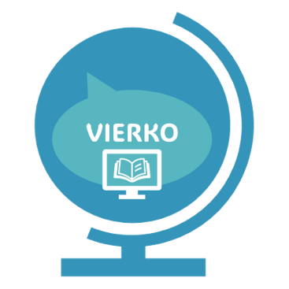

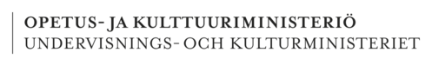
Compulsory competence requirements
Pylvänäinen Liisa
Rahoittaja:

Vierko |www.keuda.fi/keuda/hankkeet/vierko
Sisällys
For the Teacher 4
1. Welcome to study Promotion of Sustainable Development 5
2. Start here 6
3. Vocabulary 8
4. Introduction 23
5. Principles of sustainable development 26
5.1 Basics of Sustainable Development 27
5.2 Agenda 2030 29
5.2.1 Video 30
5.2.2 H5P Agenda 2030 goals 31
5.3 People and the Environment 37
5.3.1 Climate Change 38
5.3.2 Biodiversity 38
5.3.3 Natural Resources 41
5.3.4 Cultural Heritage 42
5.4 Final test 42
6. Carbon neutrality and a circular economy 44
6.1 Energy and material efficiency 45
6.1.1 Natural resources and energy efficiency 45
6.1.2 Learn about material efficiency 47
6.2 Waste sorting 48
6.2.1 Practise sorting waste 49
6.2.2 Practise the benefits of recycling 49
6.3 Carbon cycle and carbon neutrality 50
6.3.1 Practice your knowledge related to carbon sinks and carbon neutrality. 51
6.4 Lifestyle and carbon footprint 52
6.4.1 Evaluation of the task 52
6.4.2 The task 53
6.5 Life cycle of a product 55
6.5.1 Learning materials 55
6.5.2 The task 56
6.6 What is the difference between linear and circular economy? 57
6.6.1 Learning materials 57
6.6.2 Learning task 59
6.7 Final test 59
7. Ethical aspects of operation 61
7.1 Task 1 Agenda 2030 and ethics 64
7.2 Task 2 Vocabulary – Ethical issues 65
7.3 Final task / Ethical issues and guidelines in everyday life and at work 66
8. Self evaluation and feedback 67
Lopuksi 70
Lähdeluettelo 71

For the Teacher
This material consists of material, tasks and tests for the compulsory studies of Promotion of Sustainable Development. The course material has been created to be used on online courses and is also available in Moodle and Itslearning format. This script has some notes that refer to task types in the online environments already available (for instance H5P, Moodle vocabulary, exam etc.), but all the task and test material can be used in any other suitable format on other online learning platforms. The script also includes illustrations (sometimes two on the same topic for Moodle navigation pictures & material page pictures) for different topics.

The course material is based on the qualification requirements of Finnish vocational education and training.

The course consists of material (texts, videos, pictures etc. to be studied), tasks (different kinds of tasks to be used as learning activities that are not assessed and graded by the teacher but do give feedback on progress) and tests (these are assessed and graded). The course grade is based on the tests (50% of the points -> adequate 1).

The course material consists of the following parts:
- Welcome to study Promotion of Sustainable Development
  - information on VIERKO-project
- Start here
  - Information on the qualification requirements
  - Information on AI
  - Pre-course survey
- Vocabulary
  - Sustainable development vocabulary
- 1. Introduction
  - Introductory material
  - Key terms of sustainable development
  - Key terms task
- 2. Principles of sustainable development
  - Material and tasks on the basics of sustainable development, Agenda 2030, climate change, biodiversity and cultural heritage.
  - Final test
- 3. Carbon neutrality and circular economy
  - Material and tasks on natural resources, energy efficiency, material efficiency, waste sorting and recycling, carbon sinks and carbon neutrality, carbon footprint, circulat economy, product life cycle and carbon cycle and carbon neutrality
  - Graded Task and Final test
- 4. Ethical aspects of operation and training
  - Material and tasks on ethical issues vocabulary, Agenda 2030 and ethics, ethical guidelines in everyday life and at work
  - Final task
- Self-evaluation and feedback
This course has been produced by the following teachers:

Marjo Heikkinen (Sedu), Sanna Järvinen (Winnova), Minna Kiviharju, Aino-Maija Kyykoski, Leena Lähteenmäki, Salla Petäjä (Stadin AO), Jaana Piironen (Gradia), Elina Pirkkalainen (Gradia), Piia Poutanen, Saija Rehtijärvi, Outi Suopanki, Satu Tasala, Johanna Toivola, Jaana Torseke, Tiina Tuovinen, Sini Viinikka ja Riina Virkkunen.

Further information: Liisa Pylvänäinen (liisa.pylvanainen@gradia.fi)

Welcome to study Promotion of Sustainable Development
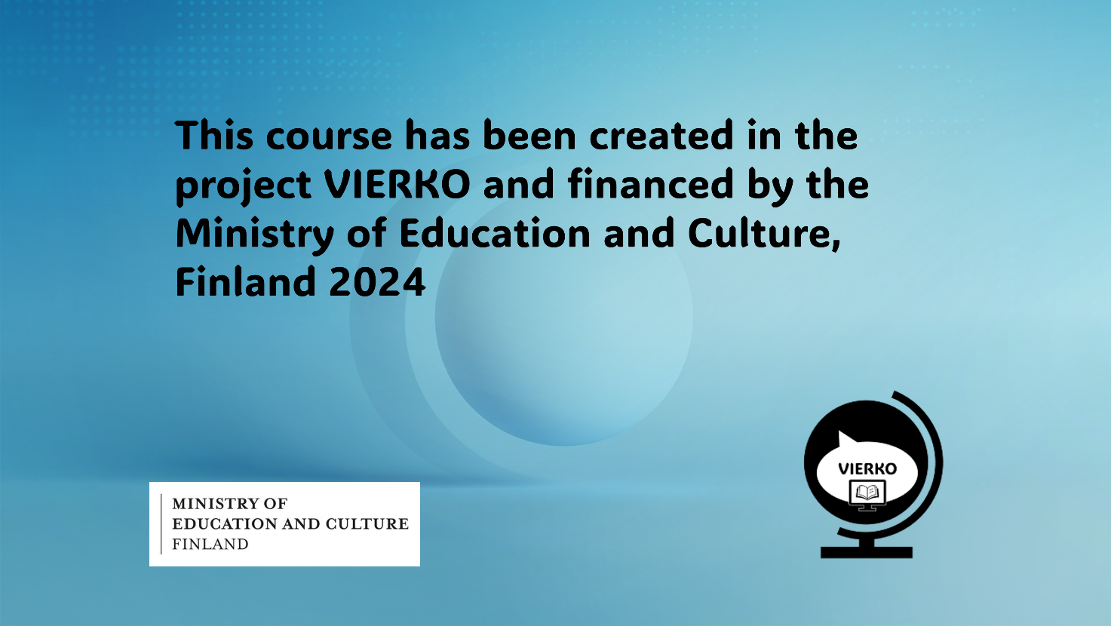

Get started by studying the Start here section.

Start here

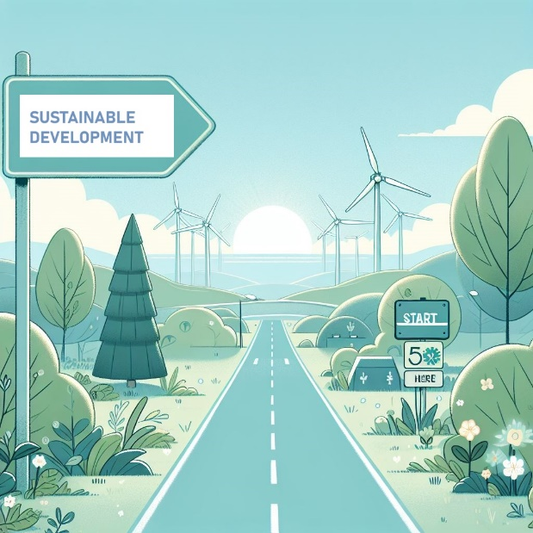
(Picture: Start here / Sustainable development 1, cc Elina Pirkkalainen 2024, AI generated, Copilot designer)
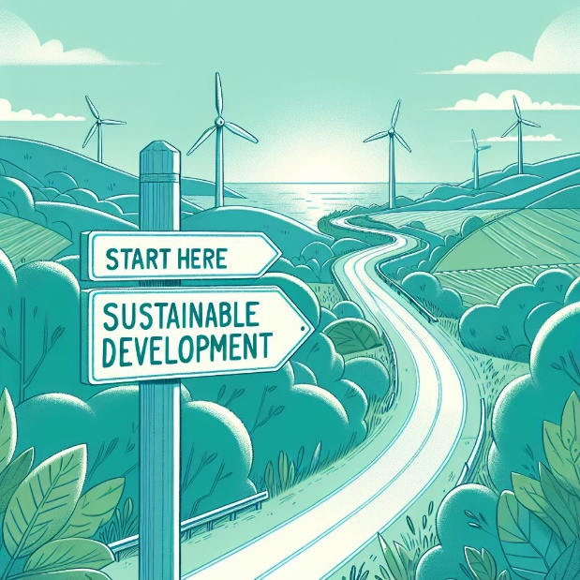
(Picture: Start here, cc Elina Pirkkalainen 2024, AI generated, Copilot designer)

Contents of the course:

On this course you will learn about:
- The principles of sustainable development
- Carbon neutrality and a circular economy
- Ethical aspects of operation
The competence requirements of this course are as follows:

Principles of sustainable development:

The student:
- knows the main objectives of ecological, financial, social and cultural sustainability in sustainable development and their interconnections
- perceives the role of human activities in climate change
- understands the importance of biodiversity and recognises the necessity of sustainable use of natural resources nationally and globally
- identifies operating methods of sustainable development in their own life and work.

Carbon neutrality and a circular economy

The student:
- understands the principles of carbon neutrality and a circular economy
- identifies the energy or material efficiency of a product or a service.

Ethical aspects of operation

The student
- identifies some ethical choices included in the set of tasks

- evaluates their own decisions and those of others ethically

You can read more about assessment here:
Compulsory competence requirements

The course will be graded 1 to 5. To achieve grade 1 you will need to have a 50% correct score of each task.

The course consists of an introduction, 3 units and self-assessment and feedback.

It is recommended you do them in numerical order. You will be informed of the details of assessment in each unit.
The use of Artificial Intelligence and Google Translate is not allowed for producing text, unless permission is granted in the instructions for the exercise.

How to use sources and AI

- Write in your own words.
- When you quote information, cite the source accurately.
- When you use AI to aid you, include a note on its use.
For example: Text produced with Copilot October 10th, 2024
- If the task has an AI-symbol, follow the instructions accordingly.
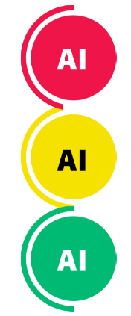

Use of AI is not allowed.

Use of AI is allowed with limitations
according to the task instructions.

Use of AI is allowed.
Include a note on which application
you used and how it helped you.

Vocabulary

(Picture: Vocabulary/Book 1, cc Elina Pirkkalainen 2024, AI generated, Copilot designer)


(Picture: Vocabulary/Book 2, cc Elina Pirkkalainen 2024, AI generated, Copilot designer)

You can use this extensive vocabulary while studying to help you get aquainted with sustainable development concepts and terminology.

In Moodle this material was created using the vocabulary activity, which enables linking vocabulary & tasks together if needed.

Sustainable Development – Vocabulary

Agenda 2030 | Agenda 2030 includes goals to support sustainable development. There are 17 goals.  The goal of Agenda 2030 is to safeguard the well-being of people and the planet.  UN member states have jointly agreed on the goals of Agenda 2030.  All countries must comply with the targets.
Alien species | Alien species are plants, animals or other organisms that are introduced by humans,  either intentionally or accidentally, into places outside of their natural range.  Examples of alien species in Finland include: large-leaved lupine, spanish slug and American mink.
Biodiversity | Biodiversity refers to the number of animal and plant species present in a given area.  Biodiversity is very important. The greater the biodiversity, the better it is for the planet and people.  The diverse nature is home to a wide variety of animals and plants.
Biodiversity loss | Today, many more organisms are becoming extinct than ever before. We are in the sixth wave of extinction in Earth's history. Biodiversity loss threatens biodiversity. Biodiversity loss is caused by human activity.
Biodegradable | Material that breaks down to carbon dioxide and water through a biological process (anaerobic or aerobic).
Capital | Capital refers to assets and funds that can be owned and exchanged. Capital includes, for example, money deposited in an account, land, buildings, machinery and equipment. In business, employee training is also a form of capital. In business, capital means resources. Resources are needed to start and maintain a business.
Carbon dioxide | Carbon dioxide is a compound with carbon and oxygen. It is a greenhouse gas. Trees and soil absorb carbon dioxide from the air. When wood is burned, the carbon stored in it is released as a gas into the air. Humans cause too much carbon dioxide emissions. Carbon dioxide remains in the atmosphere, preventing heat from escaping into space. Therefore, the climate is warming.
Carbon footprint | Carbon footprint is a descriptive word. Food, goods and services have a carbon footprint. The carbon footprint describes how much greenhouse gases are emitted in the production of a product. A human’s carbon footprint per year is calculated when emissions from food, goods, travel and services are added together.
Carbon handprint | The carbon handprint shows how much good we are doing for the climate. For example, if a company's product or service helps people reduce their emissions, its carbon handprint is large. The larger the carbon handprint, the less emissions are generated. Therefore, a large carbon handprint is better for the planet.
Carbon neutral | Carbon neutrality means that we produce no more carbon dioxide emissions than can be sequestered from the atmosphere into carbon sinks. To achieve carbon neutrality, we need to capture all the world's greenhouse gas emissions. Trees and plants absorb carbon dioxide from the air. The seas are also carbon sinks. Carbon neutrality means that carbon dioxide, or CO2, does not increase in the target atmosphere.
Carbon sink | Carbon sinks are places that absorb carbon and reduce the impact of carbon emissions. The most important natural carbon sinks are soil, forests, and oceans
Child labour | Child labour means that a child is working. Work is detrimental to children’s development and health because, for example, they cannot attend school. In addition, the work can be dangerous. Child labour is illegal in most countries, but law enforcement is difficult. Children work, for example, in the clothing industry and in the cultivation of tobacco, coffee, rice and cocoa. Children also work in the extraction of metals and minerals. In the world, almost one child out of ten works.
Circular economy | In circular economy energy and raw materials are recycled. Then natural resources will be used as little as possible. The goods are manufactured in such a way that they can be modified and repaired. Co-ownership, renting and lending are important. In production in accordance with the circular economy, the aim is to ensure that no waste or little waste is generated. All possible material will be utilised somewhere else. The importance of immaterial assets is increasingThe circular economy is one solution to mitigate climate change
Climate anxiety | A feeling of fear, worry or excitement associated with climate change.  Young people bear a significant and disproportionate burden of climate change,  which makes it more common among young people.
Climate change | Human activity has increased the amount of various greenhouse gases in the atmosphere. The amount of greenhouse gases increases when, for example, forests are felled and fossil fuels are used. When there are too many gases, the greenhouse effect intensifies and warms the climate. As the climate warms, there will be disturbances in the climate. This is called climate change. Climate change results in severe weather events such as floods, storms, extreme drought and heat.
Climate impact | Many human actions affect the climate. When we want to combat climate change, we need to assess the climate impacts of our actions. In addition, we must choose a course of action that does not increase the amount of greenhouse gases. Different forms of energy have different climate impacts. It is important to assess these effects.
Collective labour agreement | The collective agreement contains common conditions, i.e. rules for all professionals in one sector/field.  Terms of employment include, for example, pay, working hours and holidays. Collective agreements are concluded by employers' and employees' organisations.  Workers in different sectors/fields have different collective agreements.
Corporate responsibility | Corporate responsibility means that the company operates according to the principles of sustainable development.  A responsible company  • respects human rights  • takes environmental impacts into account  • operates openly  • supervises its operations  • reports on its operations.  The operations of a responsible company are reliable, economical,  socially acceptable and respectful of the environment.
Cultural heritage | Cultural heritage refers to material and immaterial resources inherited from the past  that reflect people's values, beliefs, knowledge, and traditions. For example, it can include buildings, objects, stories, customs, art and landscapes. Cultural heritage is not just a permanent collection of remnants of the past, but it is a continuous process of creating and passing on different values and meanings.
Cultural identity | Cultural identity is the feeling that you belong to a group that behaves in the same way, speaks the same language and the worldview of whose is based on a common set of values, past and traditions. However, cultural identity is never complete, it is shaped and evolves throughout life.
Cultural sustainability | Cultural sustainability aims to preserve cultural diversity. It supports the lifelong development and formation of each person's cultural identity. It promotes intercultural interaction, pluralism and tolerance.  Important areas for development and maintenance are:  • internationality  • cultural heritage and historical awareness  • cultural environments  • creativity  • multiculturalism and diversity  • locality  • intergenerationality  • customs.  It is important not only to preserve cultural practices, but also to learn how to modify and change them.
Decoupling | Decoupling (disconnection) means separating two related things. For example, the use of natural resources and economic growth. The goal of decoupling may be, for example, for the economy to grow even though less natural resources are used than at present. It is a process of separating economic growth from environmental degradation, meaning that an economy can grow without corresponding increases in environmental pressure. For example, achieving economic growth while reducing carbon emissions or resource consumption would be considered a successful decoupling.
Earth Overshoot Day | Overconsumption means that we use too many natural resources. Natural resources include, for example, water, wood, oil and metals.  Overconsumption is when we buy more goods than we need. Overshoot Day is the day each year when man has used more natural resources than the Earth can provide for the entire year in question.
Ecological backpack | The amount of natural resources that a product requires in addition to its own weight  during its life cycle.  The amount of natural resources that the product requires; material and energy costs  at all stages of the product including the transport, use, disposal, etc. The calculation also includes  hidden and side streams.  The "weight" of the rucksack is significantly more than the product itself.  There are five different groups of ecological backpacks:  - inanimate, i.e. abiotic materials  - animate i.e. biotic materials  - agricultural and forestry land masses  - water  - air and its constituents
Ecological carrying capacity | Human activity places a strain on the planet and nature. Stress is caused by production,  consumption and waste. Ecological carrying capacity refers to the amount of stress  that the Earth and nature can withstand at most. If the planet's ecological  carrying capacity limit is exceeded, there will be environmental damage and it will harm our well-being.
Ecological footprint | The ecological footprint shows how much land and water is needed to prepare the consumption needed by a person or a group of people. Consumption includes the production of food, materials and energy, and waste management.  The smaller the ecological footprint, the better it is for nature.  The ecological footprint shows how our lifestyles affect the well-being of the planet.
Ecological reconstruction | Ecological reconstruction means making society and the economy not based on  overconsumption of natural resources. In ecological reconstruction,  Some things need to be re-thought to make them more sustainable. These include, for example,  •food production  •energy production  •housing  •mobility  New methods are better for the environment. Ecological reconstruction is a tremendously significant societal change. In ecological reconstruction, practices and policies are developed to slow down climate change
Ecological sustainability | Ecological sustainability means that we take care of nature. Then the earth's natural resources  will suffice. We need to take care of animals, plants, atmosphere, water, soil and bedrock.  Overconsumption and emissions threaten ecological sustainability.  Without nature, people cannot survive.  Therefore, ecological sustainability is the most important aspect of sustainable development
Economic sustainability | Economic sustainability is one aspect of sustainable development. A sustainable economy secures the well-being of people and communities. Economic decisions take account of nature, natural resources and social stability. Natural resources are used in such a way that the carrying capacity of nature is not exceeded. For example, recycling and the use of renewable natural resources are economically sustainable.
Eco-social education | This concept encompasses the understanding of human rights and responsibilities based on our interdependence with nature and other people. It emphasizes sustainable living, social justice, and the importance of ecological and social values over purely economic ones. Economy is just a way to build well-being for people and nature.
Ecosystem | An ecosystem is an entity formed by a specific area, such as a lake. The ecosystem includes:  • living nature (animate), such as animals and plants;  • non-living nature (inanimate), such as water and rocks.  In an ecosystem, the living and non-living nature of the area live in interaction  with each other and the environment.
Ecosystem service | Well-functioning and healthy ecosystems provide people with a variety of commodities that we cannot live without. Ecosystem services include, for example, clean water, oxygen and food.  Thanks to insects, plants provide us with food. It is important to protect nature and the environment. Only that way the ecosystem services will keep on working.
Environmental education | Environmental education is one aspect of education. Its goal is a life that is sustainable.  The purpose of environmental education is to change the values, knowledge, skills and practices of individuals  or communities in line with sustainable development.  Environmental education takes place  in different places, such as in kindergartens, schools, museums and nature houses.  Environmental education often involves learning in nature and doing various exercises.
Environmental responsibility | Environmental responsibility means acting in the best possible way for the environment. The aim is to:  • protect nature;  • conserve natural resources;  • reduce natural risks.
Ethical dilemma/question | An ethical question or ethical dilemma is a situation in which one has to decide what is the right or wrong mode of action because of the conflict of values and principles.  For example, it may be difficult for a company to decide whether to maximize profits  or protect the environment if these goals conflict.
Ethical guidelines/ Code of Conduct | Ethical Guidelines / Code of Conduct aim/s to promote ethical and trustworthy practices by providing guidance on how ethical principles can be applied to activities in different contexts.  For instance different fields of work can have different focal points on which ethical issues need to be carefully considered in everyday situations.
Equality | Equality means that all people are equally valuable and have the same rights. For example, women are valued as highly as men. Equality means that all people or groups of people are treated well. If someone needs more help, she/he needs to get more help.
EU Green Deal | The Green Deal is the European Union’s (EU) action plan for green development. With it, the EU aims for carbon neutrality by 2050. The goals of the action plan include reducing emissions and preserving Europe’s natural environment. The four main areas of the action plan are:  - Carbon-free energy  - Transition to a circular economy  - Reducing energy consumption  - Clean forms of transport and mobility.
Fossil fuels | Fossil fuel is a substance used in energy production. Fossil fuels are produced from non-renewable energy sources. Fossil fuel forms over millions of years when organisms that died long ago are buried underground. Oil, natural gas, and coal are fossil fuels. The use of fossil fuels results in carbon dioxide emissions and environmental pollution.
Global responsibility | Global responsibility means that people understand where inequality in the world comes from and how they can reduce it themselves. What we do affects people around the world in many ways. Global responsibility is that people want to make the world fair for everyone.
Greenhouse effect | The Earth is surrounded by the atmosphere. The atmosphere allows light and heat from the sun to pass through, but it does not allow all the heat back into space. This is called the greenhouse effect. The greenhouse effect is important because it allows us to live on Earth in the way we do today. However, man-made carbon dioxide emissions intensify the greenhouse effect, which causes the earth warm too much.
Greenhouse gas | Greenhouse gases are gases that compress into the atmosphere and regulate the Earth's temperature. The sun's heat rays pass through the gases to the earth, but the heat does not reach space. Methane and carbon dioxide are the main greenhouse gases. There are too many greenhouse gases in the atmosphere today. Therefore, the Earth is warming. This is because people use fossil fuels and fell forests on a non-sustainable.
Human rights | All people must have the same rights, i.e. human rights. Human rights are safeguarded by international treaties. Human rights are very important and should therefore be respected by all. The treaties have defined:  • fundamental rights  • children's rights  • the rights of other groups, such as women, people with disabilities and minorities.  These are groups in need of special protection. Violation of human rights means  that fundamental human rights have been violated.  All people are equally valuable. Therefore, everyone has the same rights.
Inequality | Inequality means that there are differences between people that are unfair. Some people are in a better situation than others. However, these unfair differences can be prevented. Inequality is visible in differences such as wealth, health, social exclusion, and education. For example, not all young people can afford hobbies or healthy food. Society’s services aim to reduce inequality. For instance, education is free, and meals are provided during the school day.
Inclusion | The definition includes the idea that diversity no longer exists, but all men are equal. Inclusion refers to inclusion and participation, i.e. how much, for example, an activity, service or organization includes people who could otherwise be excluded or marginalized.
Infrastructure | Infrastructure refers to the basic structures and services of society. With their help, society works well. Infrastructure includes, for example, waste management, water management, transport networks and telecommunications networks. Basic services include, for example, education and medical care.
Labour Force | Labour force refers to all those people who are employed in a company or sector/field. It can also refer to, for example, people that a company can hire to work in an area. Labour shortage means that workers cannot be found for a job.
Life cycle | The life cycle is the whole life or existence of something from beginning to end.  The life cycle of a product refers to the different stages of a product's life cycle.  An example, the life cycle of a t-shirt:  - Cotton is grown and collected.  - At the factory, cotton is used to make yarn.  - The T-shirt is designed and manufactured.  - The finished shirt is transported for sale.  - The shirt is sold.  - The shirt is worn.  - The shirt is no longer used, in which case it is taken for sale to a flea market, for example.  - The shirt is no longer fit for use.  - The material of the shirt is recycled.  It is important to be aware of the environmental impacts of a product's life cycle and strive for minimal environmental damage at every stage.
Linear economy | Linear economy refers to an economic model in which products are manufactured that are only used for a short time. Then the products are discarded and become waste. Linear economy consumes natural resources and generates a lot of waste.
Natural resource | Natural resources mean things that come from nature. Man can exploit natural resources. Natural resources include, for example, wood, water and oil. Several different metals and minerals are mined from the soil in Finland. They, too, are natural resources. Forests are our most important natural resource. Forests provide raw material for industry. Forests also  act as carbon sinks. In addition, they are a pleasant natural environment for all of us.
Nitrogen | Nitrogen is an element. The chemical symbol of nitrogen is N. Much of the air is nitrogen. Nitrogen is absorbed by rain into the soil. Bacteria break down nitrogen and release it back into the atmosphere.  Nitrogen is important for all life. Plants need nitrogen in order to grow
Non-renewable energy | Non-renewable energy is produced from natural resources that are created very slowly. These are consumed than new ones are created to replace them.  Non-renewable energy sources include oil, coal, natural gas and peat. When these are burned, greenhouse gases are produced.  Nuclear power produces only few emissions, but it produces hazardous nuclear waste.
Non-renewable resource | A non-renewable resource is a substance or energy that does not regenerate in nature or is regenerated very slowly and exploited by humans.  Oil is a non-renewable resource. New oil is not produced in nature so quickly that it could replace the oil  we use today.  Peat is also now classified as a non-renewable resource,  because new peat is produced so slowly.
Nutrient cycle | Nitrogen, phosphorus and carbon are important nutrients and building materials for life. They first circulate from plants to animals. Then they return back to the soil through feces. This is called the nutrient cycle. Bacteria and micro-organisms break down and transform living matter so that plants can use it for growth. This is important in order to secure food production. Ecosystem services secure the nutrient cycle.
Minerals | A mineral is an element that exists naturally in solid form. Minerals are an important natural resource. They are constantly mined to make things important to people, such as building materials. Smart devices contain several different minerals and metals. Metals, as well as raw materials for concrete, glass, porcelain and many fertilizers, are obtained from minerals in the soil.
Mining (quarrying) | Quarrying (mining) means extracting and deploying natural resources from the soil. For example, humans mine minerals, metals, ore and rock. Quarrying or mining Quarrying places stress on the environment and changes how ecosystems operate
Occupational safety and health | OSH means that workers can work safely. OSH can mean, for example, that an employee does not fall ill from the work he or she is doing. Occupational safety and health also determine the length of the working day. Overtime may not be imposed without a separate agreement. Safety gear and/or safety procedures at work are important. For example, a helmet, gloves and goggles help you work safely.
Phosphorus | Phosphorus is an essential nutrient for plants and animals. Its chemical symbol is P. Phosphorus naturally occurs in soil and rock. In agriculture, phosphorus that is industrially produced is used. The use of such non-natural phosphorus causes problems in soil and water bodies. Water bodies become eutrophic, and there is no longer oxygen in them. This is a problem, for example, in the Baltic Sea
Polluter pays principle | The polluter pays principle is a legal principle which particularly affects tort law  and environmental law.  Essentially, it means that polluters are financially responsible for the pollution they cause.
Poverty | Poverty is a concept used to describe the economic and social condition of a person. Poverty is often associated with how little money a person has at their disposal and their chances of a good life.  More than 700 million people on Earth live in extreme poverty, i.e. on less than $2.15 a day.
Production chain | The production chain describes the manufacture of a product from start to finish. The production chain begins with the cultivation or procurement of raw materials and ends with the finished product.  Every producer should know their own production chains.
Renewable energy | Renewable energy is environmentally friendly. When renewable energy is produced, it does not emit  greenhouse gases or emissions. Renewable energy sources are wind, water and sun.
Renewable resource | A renewable resource is a substance or energy that is rapidly regenerated in nature and utilized by humans. Wood is a renewable natural resource, as felled wood can be replaced by a new tree.
Restoration | Helping an area with diminished natural values to recover towards its natural state through active human restoration, repair, and maintenance efforts. For example, the restoration of a drained bog would begin by blocking the ditches so that the water level can rise to its original level, allowing the species typical of the bog type to start returning.
Side stream | Side stream is excess material and energy. It is produced in addition to the product being manufactured. The side stream can be, for example, energy or residual material. Side streams should be reused as material or energy for another product. Then there will be no waste. Then there is also no need for new material. Side streams can be, for example sawdust, which are produced during sawing. Sawdust can be used as a raw material in the paper industry.
Sustainable development | Sustainable development means that the next generations will have as good or better conditions than we do now. Our current way of life consumes more natural resources than they can generate. Prosperity and wealth are unevenly distributed. This is not sustainable. We need to take care of the environment and other people. The economy and consumption must also be responsible. Sustainable development means taking care of the environment and people and  spending money responsibly.
United Nations | The UN is a system of multilateral cooperation made up of several different institutions and sub-associations, funds and partners.  The United Nations was established after the Second World War as an organization  for the cooperation of nations, whose goal was to protect the world from new wars.  The UN is, above all, a forum for discussion and negotiation between states.  The international agreement establishing the United Nations (United Nations),  is called the UN Charter.
Waste Act | The Waste Act helps to save natural resources. The Waste Act ensures that waste is managed correctly. Then they will not litter the environment. The purpose of the Act is to reduce environmental problems and the dangers that waste poses to human health. According to the Waste Act, sorted material is directed to reuse. Circular economy utilizes sorted materials. That makes them new products.
Waste (loss) | Waste, or loss, means the products or raw materials that are lost, expired, spoiled or broken in the company. In this case, the company can no longer sell or exploit them. In restaurants, for example, waste occurs when meat or vegetables spoil before they are produced. Waste has a major impact on climate. When a spoiled product is thrown away, it becomes waste. At the same time, the material and energy used to make the product is lost.
Wicked problem | A wicked problem is a complex problem and therefore very difficult to solve. There are a number of variable factors involved in this wicked problem. There is no direct answer to them.  People have caused wicked problems. In order to solve problems, cooperation is needed.  Wicked problems include climate change and biodiversity loss
World Heritage Site | World Heritage is the world's unique culture and natural heritage which we want to preserve for future generations. Exceptionally significant evidence of culture or a building representing a significant historical period can reach to UNESCO World Heritage Site List.

Introduction

(Picture: Introduction/ person & flip chart, cc Elina Pirkkalainen 2024, AI generated, Copilot designer)
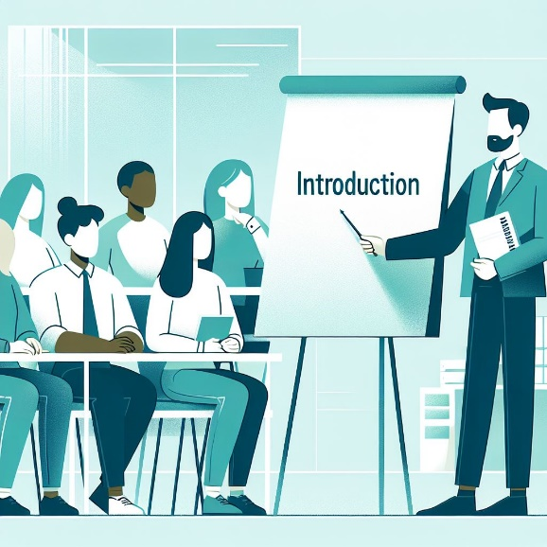
(Picture: person & flip chart and audience, cc Elina Pirkkalainen 2024, AI generated, Copilot designer)

As an introduction to sustainable development watch the video One Earth – Environmental Short Film by Romain Pennes in You Tube (4,5 min)

https://www.youtube.com/watch?v=QQYgCxu988s

After the video, play Flash Cards and think about circumstances related to sustainable development. Click the correct mark if the word relates to sustainable development.

https://wordwall.net/fi/resource/77138816

Tässä pelin sanat, jotka kaikki liittyvät kestävään kehitykseen.

Words in flash cards are:

Biodiversity
Powerty and slums
Deforestation
Soil pollution
Climate change
Rain forests as Carbon sinks
Desertification
Endangered species
Environmental effects of mining
Intensive agriculture
Carbon – non-renewable natural source
Transport and CO2 emissions
Urbanization and light pollution
Over-consumption
Mountains of waste
Oil industry
Ocean liners and ocean pollution
Energy consuming industry
Mining and environmental effects
Inhuman work circumstances

Get familiar with vocabulary related to sustainable development and practice the key terms by making drag the words -exercise

Kestävän kehityksen termien raahaustehtävä

Sustainable Development Terms

Termit ovat erillisenä PDF-liitteenä tämän kurssin materiaaleissa. Alustalla ne kannattaa linkittää tähän tehtävän alkuun.

Drag the words (H5P) Moodle

kuvituksena kuva koivunlehdestä, lähde: Papunet (Sami Älli)
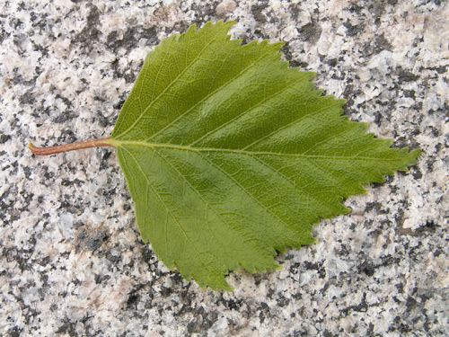

Drag and connect the definition with the right term

Biodiversity | the number and variety of animal and plant species that are present in a certain area
Life cycle | various stages of the product, from production to disposal
Carbon footprint | this tells how much greenhouse gases are produced during the manufacturing of a product
Carbon neutrality | carbon dioxide emissions are produced only to the extent that carbon sinks can bind and store them
Circular economy | when making new products, natural resources are used as little as possible, and no waste is produced
Carbon offsetting | individuals can compensate for the greenhouse gas emissions that they produce
Renewable energy | wind power, hydropower and solar power are examples of this type of energy sources
Resilience | nature’s capacity to return the balance in ecosystems and humans’ ability to adapt to changes
Fossil fuels | oil, natural gas and coal are produced from these non-renewable energy sources
Waste | products or raw materials that disappear, expire, spoil, or break in a company

Principles of sustainable development
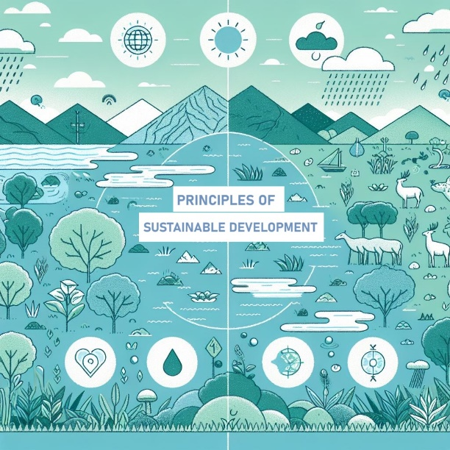

(Picture: Principles of sustainable development, cc Elina Pirkkalainen 2024, AI generated, Copilot designer)
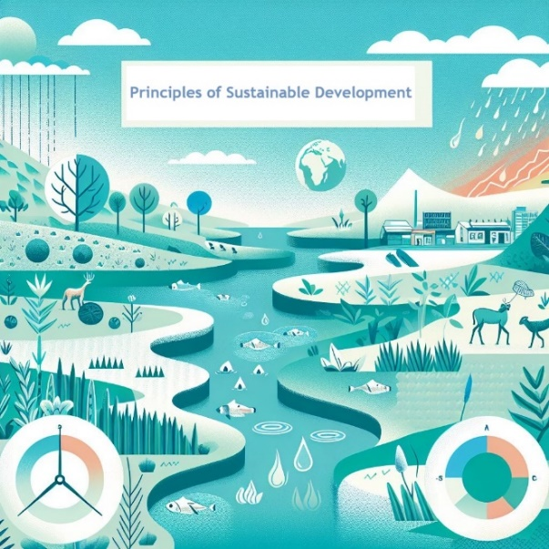
(Picture: Principles of sustainable development, cc Elina Pirkkalainen 2024, AI generated, Copilot designer)

Goals:
- You will know the main objectives of ecological, financial, social and cultural sustainability in sustainable development and their interconnections.
- You will be able to perceive the role of human activities in climate change.
- You will understand the importance of biodiversity and recognise the necessity of sustainable use of natural resources nationally and globally
- You will be able to identify operating methods of sustainable development in your own life and work.

Basics of Sustainable Development

(PIcture: Bacground picture for task/meadow, sky, water, trees, cc Elina Pirkkalainen 2024, AI generated, Copilot designer)

H5P-esitys (voi toteuttaa myö diaesityksen ja tehtävien yhdistelmänä tms.)

Dia 1. What is sustainable development?
Sustainable development refers to continuous and guided change in society, which occurs globally, regionally, and locally. Its goal is to ensure good living conditions for current and future generations. This involves equal consideration of the environment, people, and the economy in decision-making and actions. (Source: Ministry of the Environment)

Development is sustainable only if it is simultaneously ecologically, economically, culturally, and socially sustainable. (Source: UN Association of Finland)

Dia 2. The Dimensions of Sustainable Development
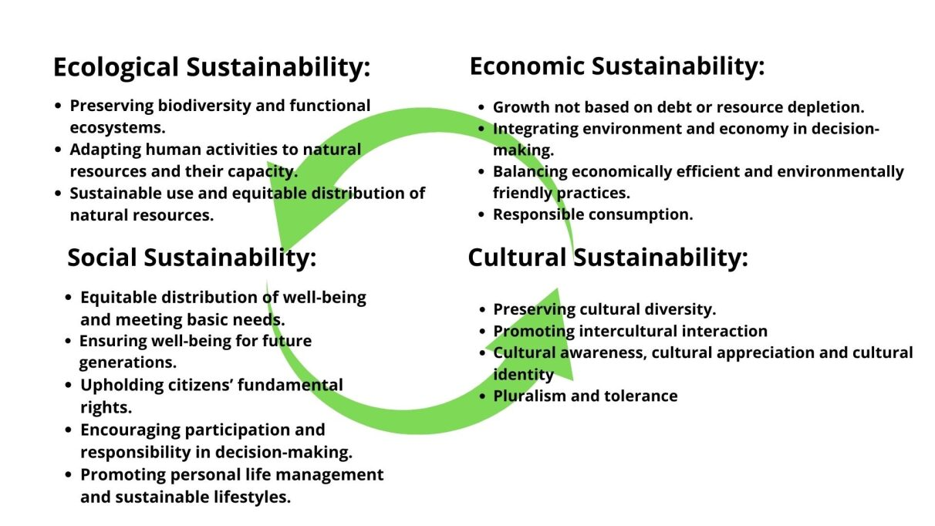
(Picture, The aspects of sustainable development, cc Pirkkalainen 2024)

Dia 3. Assignment 1. The dimensions of sustainable development

Watch the videos and complete the tasks.

- What is sustainability? | ACCIONA (youtube.com) 1,43 min
- BIC: Two minutes to understand sustainable development (youtube.com) 3,49 min
- What is Sustainability (youtube.com) 3,06 min

Drag the words into the correct boxes (raahattavat sanat alleviivattu)

Ecological sustainability development means taking care of nature and the environment.
Economical sustainability refers to using money and resources wisely in the long term.
Social sustainability involves caring for people's well-being and acting justly.
Cultural sustainability involves passing down languages and traditions from one generation to the next.

Dia 4. Task 2 The dimensions of sustainable development

Choose the right answer

Ecological sustainable development includes  - increasing ones own consumption  - protecting flying squirrel habitats  - sorting waste | Social sustainable development means  - bullying at school or work  - using required safety gear at work  - taking care of people who are worse off than you
Economical sustainability means  - thinking before buying  - balance between income and expenses  - taking quickie loans offen | Cultural sustainable development means  - respecting different cultures  - preserving traditional crafts trades  - demolishing old buildings in the area

Dia 5. Task 3. The dimensions of sustainable development
What is included in the different dimensions of sustainable development?

Do you know how to categorize the following concepts into the different dimensions of sustainable development? Complete the assignment and find out.

Ecological sustainable development | Economic sustainable development | Social sustainable development | Cultural sustainable development
4 boxes | 4 box | 4 boxes | box

Drag the text boxes into the correct dimensions. (raaahattavat sanat listattu alla)

Biodiversity Climate change Resource efficiency
Health care Well-being Protecting traditions
Education Human rights Responsible consumption
Nature Conservation Emission taxes Circular economy
Diversity of cultures Equality Pollution Reduction

Dia 6. Task Dimensions
Drag the words into the right boxes (raahattavat sanat alleviivattu)

Recycling cardboard into toilet roll: circular egonomy
A product of good environmental choice: the Nordic Swan Ecolabel
A product or service manufactured or produced in Finland: Key Flag Symbol
As little materials as possible per product: material efficiency
Reducing fuel consumption: energy efficiency

Agenda 2030
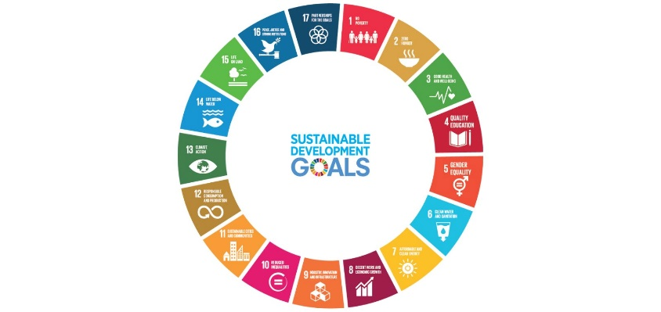
(Picture: Agenda 2030 goals, cc UN 2017)

Agenda 2030 is an international plan created by the United Nations (UN) with the goal of making the world a better place for all of us. The plan includes 17 goals that focus on eliminating poverty, protecting the environment, and increasing well-being. All UN member states approved this plan in 2015, and the aim is to achieve the goals by 2030. The goals apply to all countries and people.
H5P. ASSIGNMENT 1. Watch the videos and answer the questions.

VIDEO: Supersankarihommia ja kestävää kehitystä 2030
VIDEO: Maailman suurin oppitunti, osa 1

- The video describes two serious problems that threaten both people and the planet. What are these two problems? Choose the two correct answers.
- Problems in different professional fields
- Problems faced by elderly people
- Inequality
- Wars and conflicts
- Climate change

- Which organization aimed at solving global problems is mentioned in the video?
Answer: UN/United Nations/united nations

- The organization has released a publication. Which problems does the publication aim to change or remove in the world?
- The goal of the publication is for the world to pay more attention to sustainable development. Sustainable development should equally consider the environment, the economy, and people. Additionally, the publication aims to eliminate extreme poverty from the world.
- The goal of the publication is to increase renewable resources in the world and to stop all wars and conflicts.

Video
Watch the video that explains in more detail what Agenda 2030 means. Video link.
The United Nations Sustainable Development Goals (youtube.com)

The universal declaration of human rights was proclaimed by the United Nations General Assembly in Paris on 10 December 1948. It is an important international document and is in many ways linked to the Agenda 2030 goals. Read about the universal declaration of human rights here.

https://www.un.org/en/about-us/universal-declaration-of-human-rights

H5P Agenda 2030 goals
The following image presents the Agenda 2030 goals. The agenda contains a total of 17 different goals, and below is a description of how each goal is reflected in Finnish society. Read the examples and answer the questions (Yes / No)

(Rakennetaan H5P Course presentation -elementillä. Yksi tavoite per yksi sivu. Sivun vasempaan laitaan kuva ko. Agendan tavoitteesta ja oikealla selitysteksti sekä kysymys ja vastausvaihtoehto single option yes/no. Ihan jokaisessa tavoitteessa ei ole kysymystä. Suoritusten seurantaan riittää, että tämä aktiviteetti on tehty, ei tarvita pisterajoja).

(Kuvat saa ladattua tältä sivulta https://www.un.org/sustainabledevelopment/news/communications-material/)

1 No Poverty
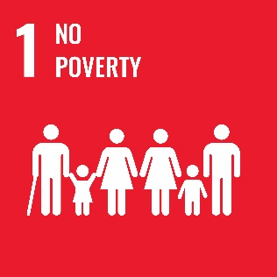
(Picture: Agenda 2030/Goal 1,No Poverty,cc UN 2017)

In Finland, social security helps people cope with financial difficulties, such as unemployment or illness.

Do you know where to seek help or support if you face financial challenges?

2 Zero Hunger
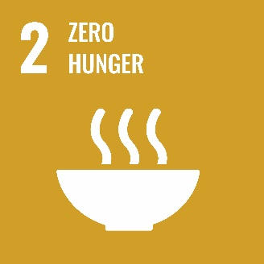
(Picture: Agenda 2030/Goal 2, Zero Hunger, cc UN 2017)
Many schools and educational institutions offer affordable or free meals to ensure all students get enough nutrition daily.
Do you get enough nutritious food daily as a student?

3 Good Health and Well-being
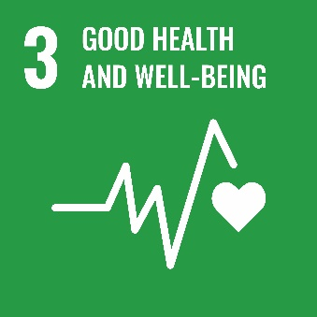
(Picture: Agenda 2030/Goal 3, Good Health and Well-being, cc UN 2017)

In Finland, healthcare is often free or affordable, and you can easily see a doctor if you're feeling unwell.

Do you know where to seek healthcare services when you need them?

4 Quality Education
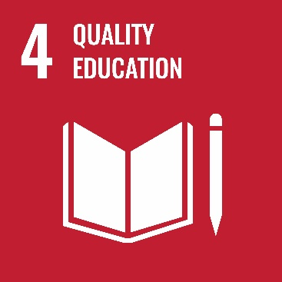
(Picture: Agenda 2030/Goal 4, Quality Education, cc UN 2017)
In Finland, education is free for everyone, from comprehensive school to higher education.
Can you access education and learn new things without having to pay a lot of money?

5 Gender Equality
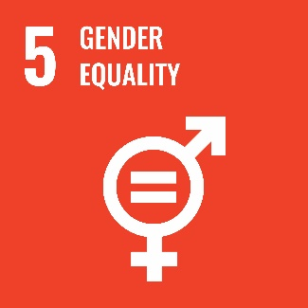
(Picture: Agenda 2030/Goal 5, Gener equality, cc UN 2017)
In Finland, men and women have the same rights to education, jobs, and participating in society.

Do you feel that you have the same opportunities as others, regardless of gender?

6 Clean Water and Sanitation

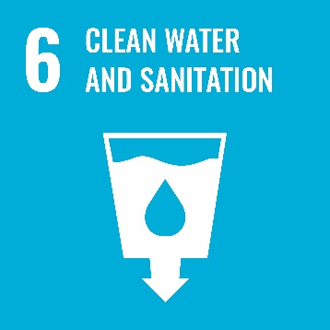
(Picture: Agenda 2030/Goal 6 Clean water and sanitation, cc UN 2017)

In Finland, tap water is clean and safe to drink, and there is usually no need to buy bottled water.

7 Affordable and Clean Energy
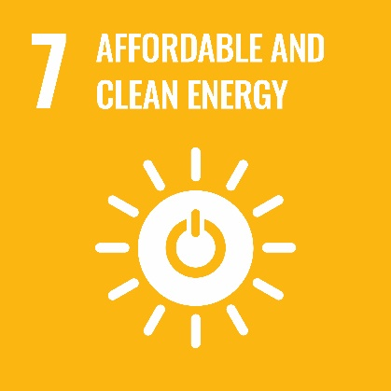
(Picture: Agenda 2030/Goal 7 Affordable and clean energy, cc UN 2017)

In Finland, a lot of electricity comes from renewable energy sources, such as wind and hydropower.

8 Decent Work and Economic Growth
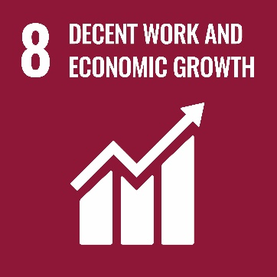
(Picture: Agenda 2030/Goal 8, Decent work and economic growth, cc UN 2017)

In Finland, labor laws ensure fair working conditions, such as minimum wage and access to occupational healthcare.

Do you have the opportunity to work in a job where you are treated fairly and receive adequate pay?

9 Industry, Innovation, and Infrastructure
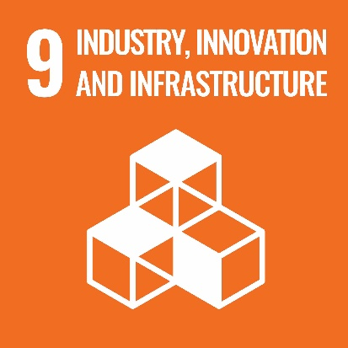
(Picture: Agenda 2030/Industry, innovation and infrastructure, cc UN 2017)

Many companies in Finland are developing sustainable innovations, such as recyclable products and energy-efficient solutions.

Have you noticed examples of sustainable solutions in your everyday life or education that could improve life?

10 Reduced Inequalities
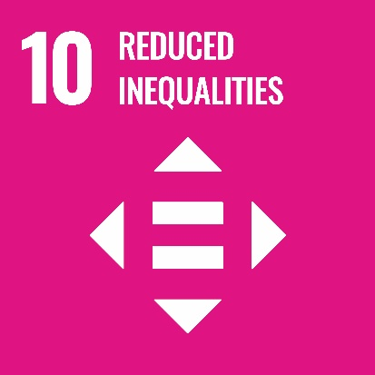
(Picture: Agenda 2030/Goal 10 Reduced inequalities, cc UN 2017)
In Finland, there are programs to help everyone feel equal, like language training and support for immigrants to help them participate equally in society.
Have you received support to help you adjust to a new environment and reduce feelings of inequality?

11 Sustainable Cities and Communities
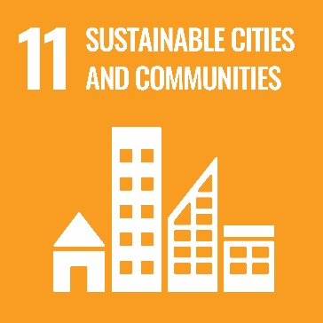
(Picture: Agenda 2030/Goal 11 Sustainable cities and communities, cc UN 2017)

Many Finnish cities offer good public transport services and safe residential areas designed to meet the needs of all residents.

Do you feel that your neighborhood and city are safe and provide good services for all residents?

12 Responsible Consumption and Production
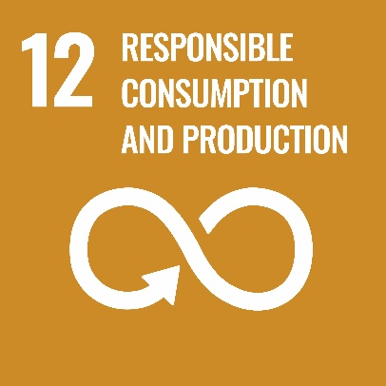
(Picture: Agenda 2030/Goal 12 Responsible consumption and production, cc UN 2017)

Recycling is common in Finland, and there are systems for recycling plastic, metal, and glass.

Do you recycle (take bottles to the bottle return and sort waste) and choose eco-friendly products?

13 Climate Action
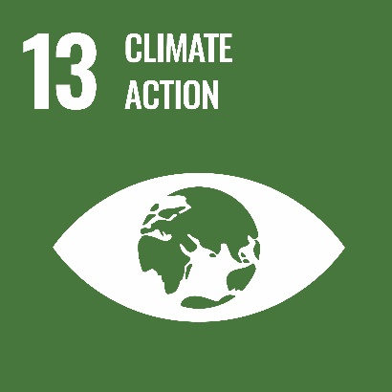
(Picture: Agenda 2030/Goal 13, cc UN 2017)
Finland has many programs that encourage people to save energy and make environmentally friendly choices.

Do you make choices in your daily life that help reduce the effects of climate change?

14 Life Below Water
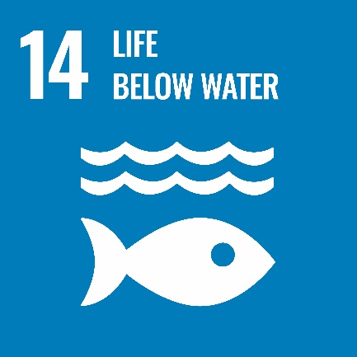
(Picture: Agenda 2030/Goal 14 Life below water, cc UN 2017)

Finland has many lakes and seas with strict environmental regulations to protect water quality and ecosystems.

15 Life on Land
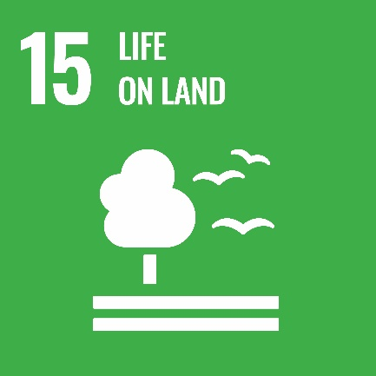
(Picture: Agenda 2030/Goal 15 Life on land, cc UN 2017)

Forest protection is important in Finland, and national parks provide spaces to preserve biodiversity.

16 Peace, Justice, and Strong Institutions
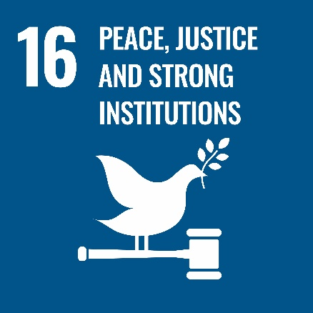
(Picture: Agenda 2030/Goal 16 Peace, justice and strong institutions, cc UN 2017)

In Finland, the justice system is independent, and everyone has the right to fair treatment and safety.

17 Partnership for the goals
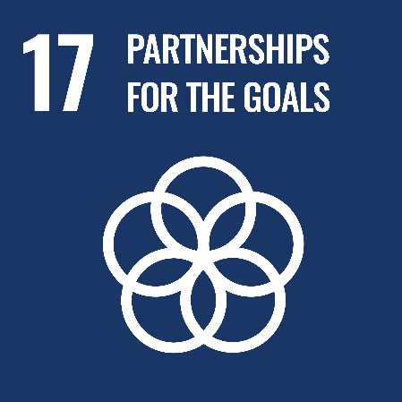
(Picture: Agenda 2030/Goal 17 Partnreship for the goals, cc UN 2017)

Many communities and organizations in Finland work together to achieve sustainable development goals, for example by organizing events and campaigns.

People and the Environment

Climate Change
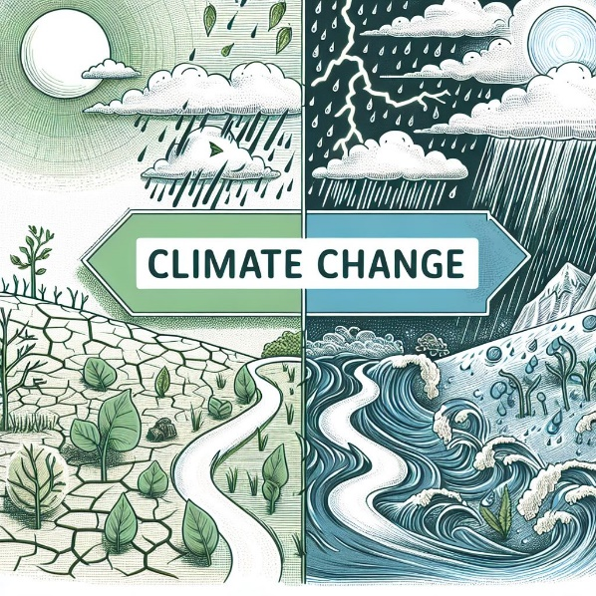
(Picture: Climate change cc Elina Pirkkalainen 2024, AI generated, Copilot designer)

Climate change is a global challenge. It poses a serious threat to ecosystems, economies and people’s health. We need to work together quickly to reduce its effects and protect our planet.

Task: Read about climate change and answer the questions.
https://www.un.org/en/climatechange/science/causes-effects-climate-change

- What are the main causes of climate change?
- What are the main effects of climate change?

Biodiversity
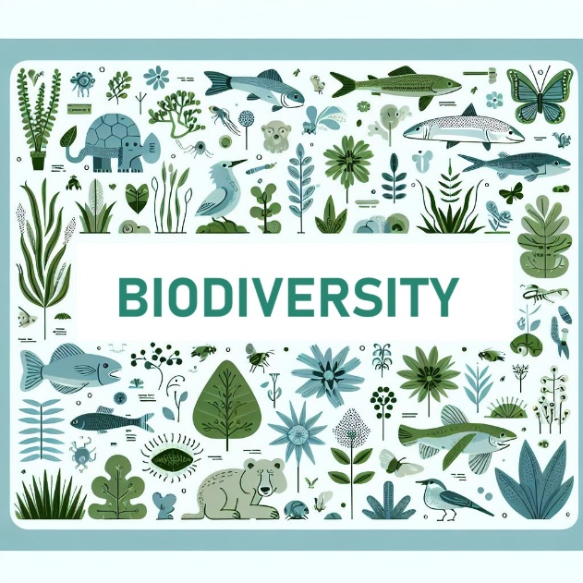
(Picture: Biodiversity 1/animals, plants, insects ect. cc Elina Pirkkalainen 2024, AI generated, Copilot designer)

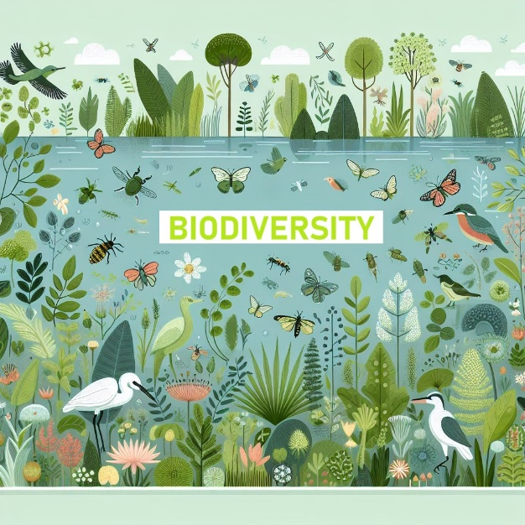
(Picture: Biodiversity 2/ animals, plants, insects etc. cc Elina Pirkkalainen 2024, AI generated, Copilot designer)

Task 1: Watch the video and read about biodiversity and protecting your local nature.

https://youtu.be/b6Ua_zWDH6U?si=lKKypgRm1Bpn6qlo
https://www.eea.europa.eu/en/topics/in-depth/biodiversity
https://www.ymparisto.fi/en/sustainable-life/protect-your-local-nature

Task 2. Read the questions and choose the correct answer(s). Some questions may have more than one correct answer.

Moodleen / Itsiin viejälle: oikeat vastaukset merkitty violetilla.

1. What is biodiversity? (Choose all that apply)

a) The variety of different species of plants and animals in an environment
b) The number of cities in a country
c) The variety of ecosystems, species, and genes in a region
d) The number of forests in a country

2. Why is biodiversity important? (Choose all that apply)

a) It supports ecosystem services that humans rely on, like clean air and water
b) It helps to reduce pollution
c) It makes a region more attractive for tourism
d) It prevents the extinction of species

3. What is happening to biodiversity in Europe and in the world?

a) It is rapidly increasing
b) It is declining at an alarming rate
c) It is stable and not changing
d) It is no longer under threat

4. What are some of the main causes of biodiversity loss in Europe? (Choose all that apply)

a) Urbanization and leisure activities
b) Pollution from agriculture
c) The spread of invasive species
d) Climate change

5. How is Europe addressing biodiversity loss? (Choose all that apply)

a) By increasing the number and area of protected sites
b) By passing laws like the Nature Restoration Law
c) By encouraging more hunting activities
d) By reducing motor sport activities

6. Which of the following are ways to help maintain your local environment? (Choose all that apply)

a) Participating in voluntary work to combat invasive species
b) Monitoring land use planning in your area
c) Letting natural habitats grow wild without any care
d) Reporting your nature observations to local services

7. What is an invasive species, and why is it a problem?

a) Native species that are naturally found in an area and support biodiversity
b) Non-native species that can harm local ecosystems and biodiversity
c) Species introduced by humans that always improve biodiversity
d) Species that help to reduce the effects of pollution

8. What can you do to support biodiversity at home? (Choose all that apply)
a) Avoid using pesticides in gardening
b) Create a meadow or wetland in your housing area
c) Collect and remove litter from nature
d) Ignore injured animals, as nature will take care of them

Natural Resources
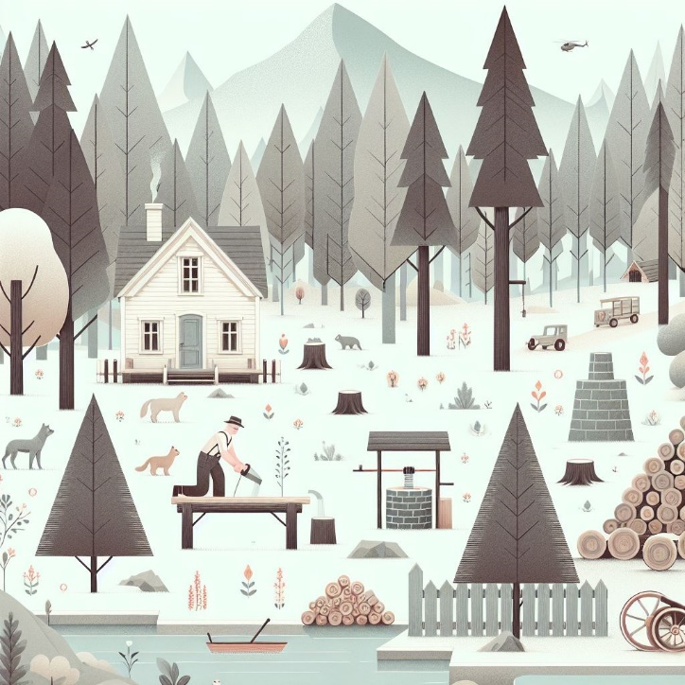
(Picture: Natural resources, cc Elina Pirkkalainen 2024, AI generated, Copilot designer)

Natural resources refer to materials that can be extracted from the environment and utilized by humans. Examples of natural resources include forests, plants, animals, minerals, and fresh water. The Earth’s natural resources are finite. Humans should use these resources sustainably so that future generations can also meet their basic needs, such as food and clean air.

Natural resources can be categorized into renewable and non-renewable resources.
- Renewable resources are those that can be considered renewable or can increase through some mechanism. Examples of renewable resources include forests, water, and sunlight (solar energy).
- Non-renewable resources are those that are available only in a finite amount. These include fossil fuels (such as oil and natural gas) and minerals (like iron, gold, and lithium).

Task 1. (Multiple choice, Moodle H5P)
Choose which of the following are renewable resources:

- Oil
- Forest berries
- Solar energy
- Iron
- Wind energy
- Biogas
- Lithium battery
- Freshwater
- Coal
- Peat

Task 2. What can you do to preserve natural resources in your work in your field of profession?

Cultural Heritage

(Picture: Cultural heritage / Taj Mahal, cc Elina Pirkkalainen 2024, AI generated, Copilot designer)

Cultural identity is an important part of who we are as individuals and communities. Cultural identity involves the shared beliefs, languages, traditions, and practices in a community. Cultural heritage refers to the tangible and intangible elements, such as monuments, arts, rituals, and customs that are passed from generation to another. In the world of rapid globalization, preserving cultural identity and heritage is crucial to maintain cultural diversity, and communities’ unique character and history.

Unesco, What is Intangible Cultural Heritage: https://ich.unesco.org/en/what-is-intangible-heritage-00003

Task: Read about cultural heritage and answer the question.

What do you consider to be your personal cultural heritage (tangible and intangible)?

Final test
FINAL TEST - Principles of Sustainable Development (Total 23 points, 13 points equal to satisfactory 1)
Tenttiaktiviteetti (Moodlessa)

True or false (total 6 points, ½ points each, 4 points equal to satisfactory)
- Sustainable development only means environmental protection (false)
- Sustainable development aims to balance economic, social, and environmental aspects. (correct)
- Sustainable development does not include social justice (false)
- Sustainable development promotes the use of renewable energy. (correct)
- Sustainable development is solely the responsibility of governments, and individuals have no role in it. (false)
- Sustainable development aims to reduce poverty and improve the quality of life for everyone. (correct)
- Agenda 2030 includes 17 sustainable development goals that countries should achieve by 2030. (correct)
- Agenda 2030 focuses only on environmental protection and does not include social or economic goals. (false)
- Agenda 2030 was endorsed by the UN in 2015. (correct)
- The goals of Agenda 2030 only apply to developing countries. (false)
- Agenda 2030 aims to eradicate poverty in all its forms everywhere in the world. (correct)
- Agenda 2030 includes goals to promote peace and justice. (correct)

GRADED ASSIGNMENT:
(total 17 points, 9 points equal to satisfactory)

- Briefly define what sustainable development means. (1 point)
- What are the four dimensions of sustainability? (1 point)
- What do these four dimensions include? Mention at least one key aspect of each of the four different areas of sustainable development. (2 points)

- What is Agenda 2030? (1 point)
- Mention at least three sustainable development goals. (1 point)
- How can you influence these aspects through your own actions? (1 point)

- What does biodiversity mean? Why is it important? (1 point)
- What is social and cultural sustainable development? What aspects are included in social and cultural sustainable development? (2 points)
- How can you promote social and cultural sustainable development, for example, in school or at work? (1 point)
- What do human rights and fundamental rights mean? (2 points)
- Do you think we live in an equal world? Give some examples. (2 points)
- How can you promote sustainable consumption when considering housing, food, transportation, hobbies, and your purchases? (2 points)

Carbon neutrality and a circular economy
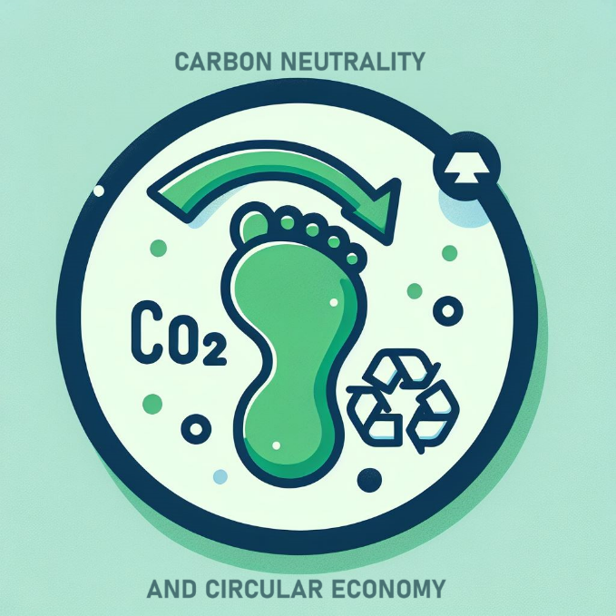

(Picture: Carbon neutrality and circular economy 1, cc Elina Pirkkalainen 2024, AI generated, Copilot designer)
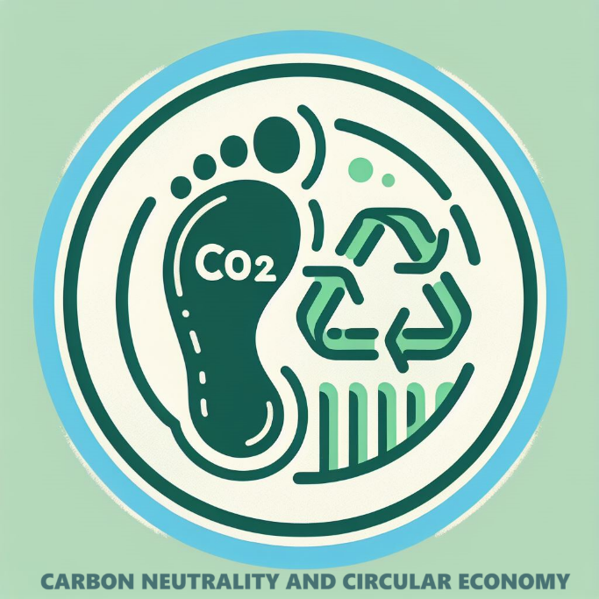

(Picture: Carbon neutrality and circular economy 2, cc Elina Pirkkalainen 2024, AI generated, Copilot designer)

Goals
- You will understand the principles of carbon neutrality and a circular economy.
- You will be able to identifiy the energy or material efficiency of a product or a service.

Evaluation of part 3
- This part is evaluated in the combination of a task and a test.
- Lifestyle and carbon footprint task, total 7 points
- Final test, total 21 points

Energy and material efficiency
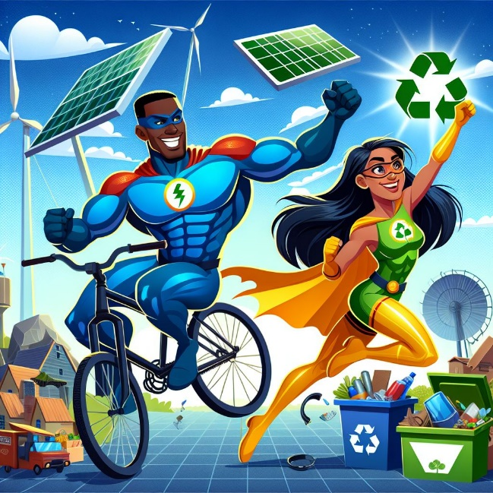
(Picture: Energy and material efficiency superheroes, cc Elina Pirkkalainen 2024, AI generated, Copilot designer)

Let’s imagine that energy and material efficiency are like two superheroes fighting together to save the world!

Energy Eric is a hero who ensures we use energy wisely. He turns off lights when they are not needed and uses solar panels to harness the power of the sun. Energy Eric also loves cycling because it saves fuel and keeps him fit!

Material Mary, on the other hand, is a master of recycling and reusing. She makes new things out of old items and comes up with creative ways to reduce waste. Material Mary can turn an old t-shirt into a handy shopping bag or use glass jars as storage containers.

When these two heroes join forces, they can reduce environmental impact and save natural resources. Their adventures teach us that small actions can have a big impact. So, the next time you turn off the lights or recycle a plastic bottle, remember that you are part of Energy Eric and Material Mary’s team!

Natural resources and energy efficiency

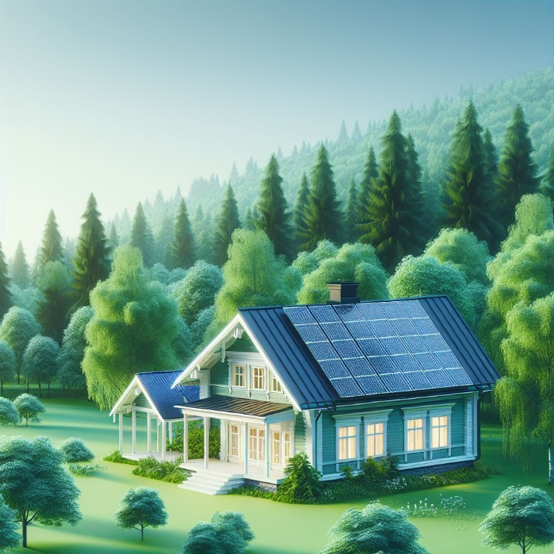
(Picture: Natural resources and energy efficiency a house with solar panels, cc Elina Pirkkalainen 2024, AI generated, Copilot designer)

Tässä tehtävässä on oikein väärin väittämiä, perässä true / false. Tässä tehtävässä on myös muutamia valitse oikeat vaihtoehdot kohtia. Oikeat vaihtoehdot tehtävänannon perässä, väärät kursiivilla. Huom! Väärä vaihtoehto on vain kohdissa 4 ja 8.
Practise natural resources and energy efficiency by task-based learning in kahoot or in test.

Tässä kahoot-linkki.
https://create.kahoot.it/share/natural-resources-and-energy-efficiency/38a74e01-bdd9-4da0-8fb3-978a5ece059c

Tässä kahoot kysymykset testiä varten.
Questions related to natural resources and energy efficiency are either true/false or pick all more correct answers.

- Everything found in nature that humans can utilize are natural resources. True
- Pick renewable resources. Tree / fish / strawberry / oat
- Pick non-renewable resources. Oil / coal / gold / cobalt
- Pick flows that do not deplete with use. Wind / solar energy / oil
- We use natural resources so much that we would need two Earths to sustain it. This is called overconsumption. True
- Fast fashion is an example of overconsumption. True
- Natural resources are not needed for energy production. False
- Pick fossil fuels. Natural gas / coal / oil / tree
- Fossil fuels are not causing any greenhouse gas emissions. False
- Energy efficiency = the efficient use of energy and the reduction of greenhouse gas emissions in a cost-effective way. True
- Energy labeling = information about the energy consumption of household appliances and electronic devices. True
- LED lights consume more energy than incandescent bulbs. False
- Energy-efficient appliances can reduce your electricity bill. True
- A heat pump cannot heat a house in winter. False
- An uninsulated house loses more heat than a well-insulated house. True
- Solar panels do not work on cloudy days. False
- Leaving electrical devices on standby does not consume energy. False
- Placing refrigeration appliances in a cool location improves their energy efficiency. True
- Energy efficiency does not impact the environment. False
- Everyone can have an impact on the use of natural resources and energy efficiency. True

Learn about material efficiency
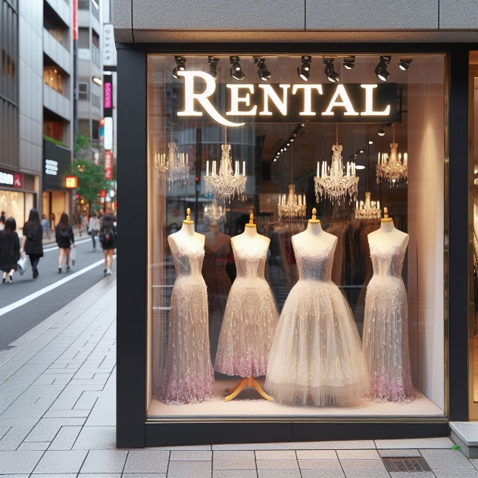
(Picture: Material efficiency / evening gown rental boutique, cc Elina Pirkkalainen 2024, AI generated, Copilot designer)
Yhdistelytehtävä, jossa pitää yhdistää aihe ja esimerkki.
Aihe ja siihen liittyvä esimerkki on erottu tavuviivalla.

Material efficiency saves the climate, natural resources, and costs. The following items are related to improving material efficiency. In this task, match the item with the category of material efficiency.

- Recycled raw material – dish brushes made from recycled plastic
- Utilizing by-products – pellets made from sawdust
- Improving the use of raw materials an energy in production processes – an energy audit
- Minimizing and optimizing trasportation and packaging – sheets packed in cardboard
- Enhancing product longevity, versatility, and maintainability – headphones with three parts, each replaceable by the user, and spare parts available for sale
- Renting used products – clothing rental service

Waste sorting
Proper waste sorting is an essential environmental action.
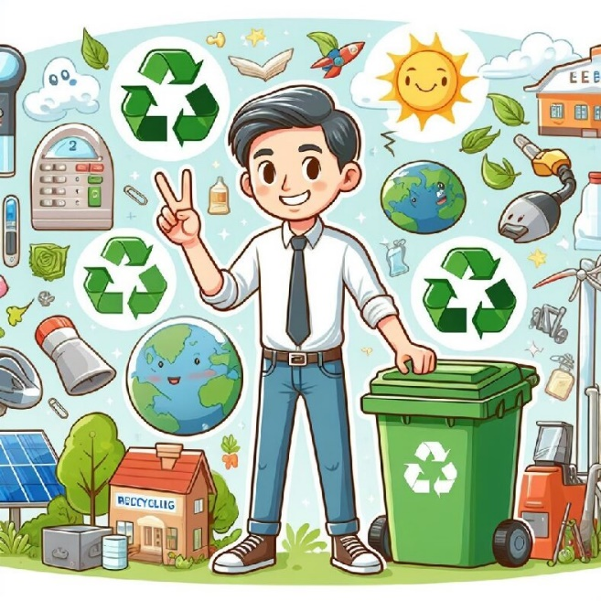
(Picture: A man sorting waste, AI generated)

By avoiding unnecessary consumption, recycling and reusing materials, we can ensure that resources are utilized efficiently. This practise helps conserve natural resources, protect the environment, and save energy. Remember to sort your waste into the appropriate bins to contribute to a more sustainable future!

See for more information on the sorting quide via the link below. On the website, you can enter the name of the waste and find out the correct recycling/waste point.

https://www.hsy.fi/en/waste-and-recycling/waste-guide/

Practise sorting waste
Tässä tehtävässä pitää yhdistää jätemateriaali oikeaan kierrätysastiaan.
Tee kolme erillistä kysymyssettiä, jokaisessa viisi jätettä ja viisi kierrätysastiaa (1 – 5, 6 – 10 ja 11 – 15).
Jätemateriaaliin liittyvä kierrätysastia on erotettu tavuviivalla.

Practice sorting waste by choosing the correct recycling bin.

- Potato peel – Biowaste
- Batteries, energy saving light bulbs – Hazardous waste, take to the store that sells the products
- Broken television – Stores that sell electrical appliances
- Plastic packaging – Plastic waste
- Paperboard core – Cardboard bin

- Paint – Hazardous waste, take to a waste center
- Glass bottle – Glass bin
- Energy drink can – Take to the grocery store
- Metal can – Metal bin
- Dirty food packaging – Mixed waste bin

- Broken phone – Electrical and electronic waste
- Broken t-shirt – Textile recycling
- Expired medicine - Pharmacy
- A coffee package – Plastic waste
- Plastic toy – Mixed waste bin

Practise the benefits of recycling
Practise the benfits of recycling a little further. Connect waste and benfits.

Tässä yhdistelytehtävässä harjoitellaan kierrätyksen hyötyjä. Tehtävässä pitää yhdistää jätejae ja hyödyt. Jätejae ja siihen liittyvät hyödyt on erotettu tavuviivalla.
- Mixed Waste - Incineration at high temperatures (1000°C) in a waste-to-energy plant. The energy produced from incineration is utilized in district heating networks and industrial processes. This helps replace fossil fuels and reduce climate change.
- Plastic - Recycling saves non-renewable natural resources (e.g., oil) and reduces greenhouse gas emissions, as producing recycled plastic consumes less energy than producing new plastic. Additionally, recycling helps reduce the amount of plastic in nature and oceans, protecting animals and ecosystems.
- Biowaste - Sorted into two categories – coarse waste becomes soil improver, and sludge is used to produce methane or biogas, which can replace fossil fuels.
- Metal - Saves non-renewable natural resources and reduces the need for new mines, as used metals in rich forms can be made into new products.
- Medicine Recycling - Prevents the development of antibiotic-resistant bacterial strains and protects the normal functioning and reproduction of aquatic organisms. Prevents disinfectants from entering nature, where they can kill aquatic organisms and beneficial soil microbes, thus disturbing the balance of ecosystems.

Carbon cycle and carbon neutrality
Understanding the carbon cycle and carbon footprint is essential in addressing climate change. The carbon cycle is the natural process through which carbon is exchanged between the atmosphere, oceans, soil, and living organisms, involving processes like photosynthesis, respiration, decomposition, and combustion.

On the other hand, a carbon footprint measures the total amount of carbon dioxide emissions for which an individual or organization is responsible, including activities such as driving, electricity use, and food consumption. These two concepts are interconnected because our carbon footprint impacts the carbon cycle. By reducing our carbon footprint, we help maintain the balance within the carbon cycle and mitigate climate change.

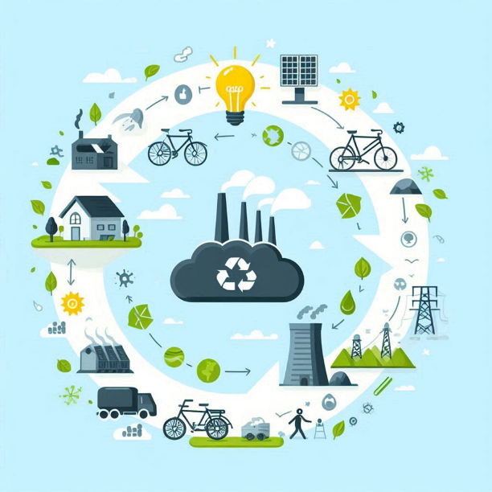
(Picture: carbon cycle, cc AI-generated)

Practice your knowledge related to carbon sinks and carbon neutrality.

What does the term carbon-neutral product or service mean?

Valitse kaikki oikeat vaihtoehdot:

Select all correct statements:
- A carbon-neutral product or service does not increase the amount of climate-warming gases in the atmosphere. (correct)
- A carbon-neutral product or service uses only electricity produced by nuclear power. Then it does not emit climate-warming gases. (false)
- A carbon-neutral product or service consumes fewer natural resources and increases biodiversity. (correct)
- Carbon-neutral products or services do not generate climate-warming gases at all. (correct)

Carbon neutrality

Valitse kaikki oikeat vaihtoehdot:

Select all correct statements:
- To achieve carbon neutrality, emissions must be reduced and the remaining emissions compensated. (correct)
- Carbon neutrality means that no carbon dioxide emissions are generated. (false)
- Carbon neutrality can only be achieved by reducing industrial emissions. (false)
- Carbon neutrality was achieved in many countries years ago. (false)
- The carbon neutrality targets are part of the Paris Climate Agreement, which aims to limit global warming to below 2°C. (correct)

Carbon sinks

Valitse oikea vastaus:

Which of the following is an effective carbon sink?
- forest (correct)
- concrete buildings (false)
- solar power plant fields (false)

Carbon cycle

Valitse kaikki oikeat vastaukset:

Select all correct statements:
- The carbon cycle involves the exchange of carbon between the atmosphere, oceans, soil, and living organisms.
- Photosynthesis is a process in the carbon cycle where plants release carbon dioxide into the atmosphere. (false)
- Decomposition is a part of the carbon cycle where dead organisms are broken down, releasing carbon back into the soil and atmosphere.
- Combustion of fossil fuels decreases the amount of carbon dioxide in the atmosphere. (false)

Lifestyle and carbon footprint
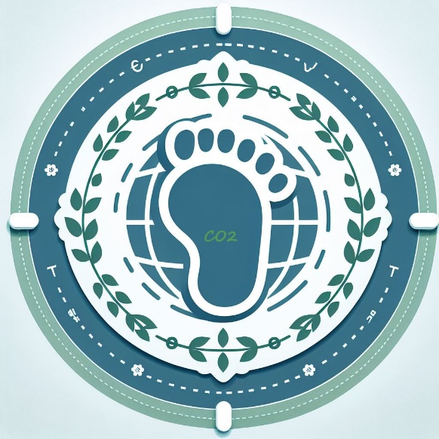
(Picture: Carbon footprint, cc Elina Pirkkalainen 2024, AI generated, Copilot designer)

Our daily choices have a significant impact on the environment and climate change. While individual actions might seem small, their collective effect is substantial. For instance, conserving energy, recycling, and choosing a more sustainable diet can greatly reduce our carbon footprint. As more people make environmentally friendly choices, the effects multiply, and together we can slow down climate change.

Evaluation of the task

Tämä teksti näkyviin opiskelijalle.

This task is important, because part 3 is evaluated as a combination of this task and the final test.
- Lifestyle and carbon footprint task, total 5 points
- Final test, total 21 points
Tämä on opettajan ohje tehtävän arviointiin sekä oikeat vastaukset, ei saa näkyä opiskelijalle.

In addition to the final test, evaluate the Lifestyle and Carbon footprint task (total 5 points)

Tässä pisteytys ja oikeat vastaukset.

- What does climate change mean? (1 point) - oikeassa vastauksessa tulee löytyä lämpötilan nousu, ihmisen vaikutus, fossiiliset polttoaineet ja metsien hakkuut

Correct answer: Climate change means long-term changes in the Earth’s weather patterns, especially an increase in global temperatures. It is mainly caused by human activities like burning fossil fuels and deforestation, which increase greenhouse gases in the atmosphere.

- What does carbon footprint mean? (1 point)

Correct answer: A carbon footprint measures the total amount of carbon dioxide emissions for which an individual or organization is responsible, including activities such as driving, electricity use, and food consumption.

- Take a screenshot of your test result. (1 point) - kuva otettu omasta testituloksesta

- What does your carbon footprint look like if you compare it to the footprint of (other) Finnish people? (1 point)

Correct answer: Depending on your test result, greater than / less than 8900 kg. (riippuen omasta testituloksesta suurempi / pienempi kuin 8900 kg)

- What is the average Finns’ carbon footprint now? (1 point) - oikea vastaus 8900 kg

Correct answer: 8900 kg

The task

Now it is your turn to find out what you can do to reduce your carbon footprint.

- What does climate change mean? Write about your thoughts, at least three sentences.

- What does carbon footprint mean? Write about your thoughts, at least three sentences.

- Now take the Lifestyle test https://pslifestyle-app.net/

Take a look at your test result and your carbon footprint in more detail. Do not close the test – you will need the answers when you do the exercise.

- Take a screenshot of the top of the page that shows your test result and attach the image here. You can also write your result here.

- What does your carbon footprint look like if you compare it to the footprint of (other) Finnish people?

- The carbon footprint target for Finns is 2,500 kg CO2e by the year 2030. What is the average Finns’ carbon footprint now?

- Study your carbon footprint in more detail. What are the three things that increase your carbon footprint most? And by how many percent?
Write your answers in the table below.

Things that increase my carbon footprint | By how many percent? | Does the result surprise you? Why?
1.

2.

3.

- Open “the tips for you” page at the bottom of the page. Study the tips that are suggested for you.

Choose a tip from each area. How could you change your own habits for the better? Write in the table below.
Area | A tip given by the test that you can carry out | What good can come out of this? (at least two things)
Housing
Moving (from one place to another)
Food
Goods and services

- Finally, watch this video: https://youtu.be/J_iDcKDAwbA

Life cycle of a product
The life cycle of a product can be surprisingly long. Here you have a video, a picture and an exercise you can practice the phases related to the life cycle of product or device with. Challenge yourself to think about environmental, economic, and social impacts of these phases. Let’s study!

Learning materials

Watch the video called The life cycle of a T-shirt – Angel Chang TED ed
(6 min)

Study the picture describing the life cycle of metal:

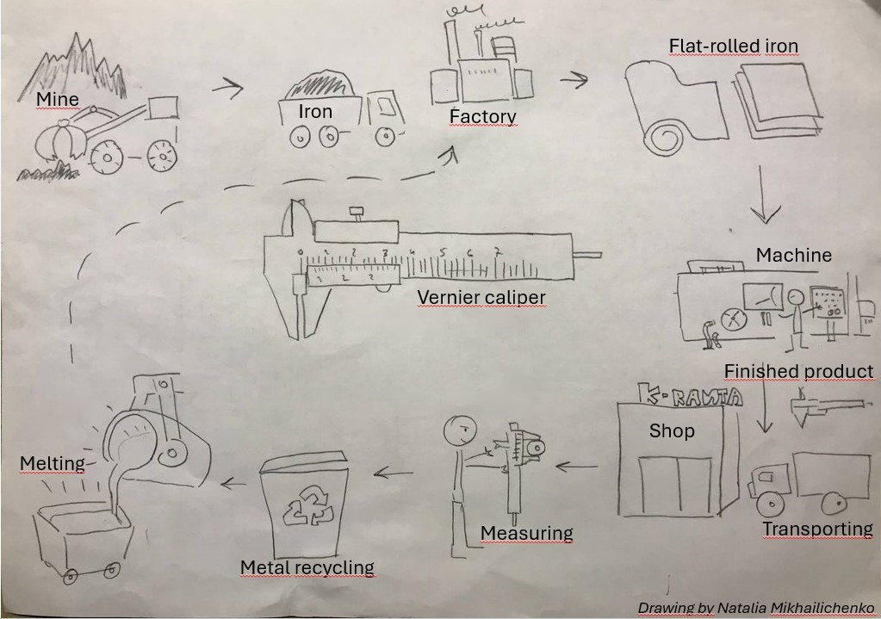
(Picture: the life cycle of metal, cc Natalia Michailichenko)

The task
Choose a device which uses a power source (for example a power drill or a mixer).
Think about your own field.

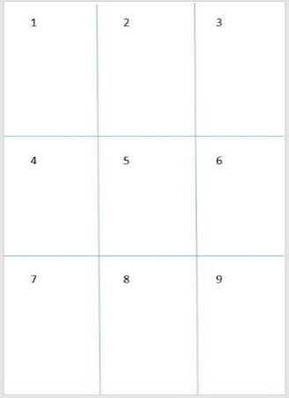

Tässä tehtävässä voi kirjoittaa vastaukset tai piirtää yllä olevan ruudukon mukaisesti paperille.
Answer the questions below OR draw and write your answers in the squares on paper.
Turn in your answer as a text or as a picture.

- What materials is the device made of?
Where do the materials come from? And how?

- How are the raw materials transported to the production site?

- Where is the device made? How is it made?

- What is this device?

- How is the device transported to the shop?
How is the device packed?

- Where will you buy the device?

- How will you transport the device?

- How are you going to use the device?
What are the environmental impacts when you use the device?

- How can you recycle this device?

What is the difference between linear and circular economy?
As an introduction to linear and circular economy, watch the video.

Re-thinking Progress: the Circular Economy

Learning materials
The current linear economic model is unsustainable and based on the overconsumption of natural resources. Problems with the linear economy are, for example: Many landfill sites are needed, litter in the seas and in nature are increasing and natural resources are running out globally.
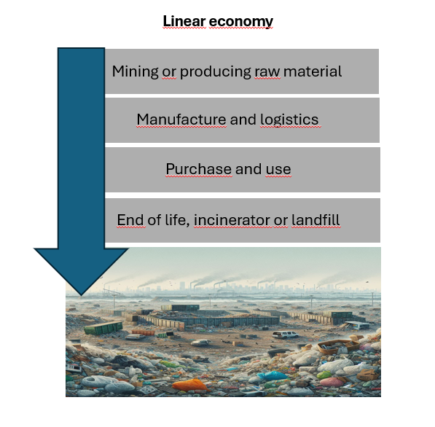
(Picture: linear economy, cc Vierko Tiina Tuovinen 2024)

In a circular economy, the goal is for all materials to circulate. To promote circular economy, we can develop new ways to utilize products and their parts or raw materials. The design phase is one of the most important aspects of the circular economy: products must be designed to last longer, be repairable, and their materials need to be reusable. Not all products need to be owned; instead, their use can be shared, borrowed, and recycled among multiple owners and for different purposes. Legislation in the EU is trying to promote a circular economy and all of us can have an impact to reduce waste and enable materials to circulate.

(Picture: circular economy, cc Vierko Tiina Tuovinen 2024)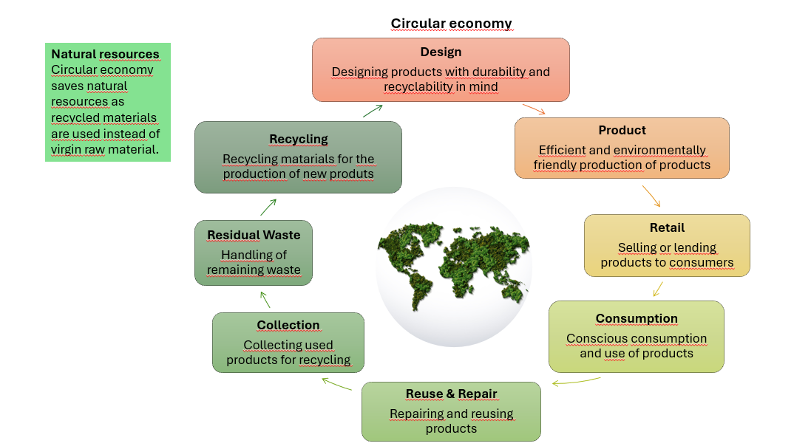(Picture: circular economy, cc Vierko Tiina Tuovinen 2024)

Learning task
Opiskelija pohtii aihetta vastaamalla näihin kysymyksiin.

- What is the difference between linear and circular economy?

- Why is the circular economy a better option for environment?

- What are the operating methods of circular economy? Give some examples.

Final test
FINALTEST Carbon neutrality and circular economy (Total 26 points, 13 points required for grade satisfactory 1)

Energy and material efficiency (3 points)

– valitse oikea vaihtoehto (väärä kursiivilla)

- Globally, most of energy is produced by fossil fuels / by renewable resources
- Energy efficiency increases costs / reduces the need of energy production
- Anyone can implement material efficiency by renting / by buying brand new stuff

Waste sorting (4 points)

- valitse oikea vaihtoehto (väärä kursiivilla), jos vastaa väärin, tulee sulkeissa oleva oikea selitys

- What is the correct waste bin for dirty plastic? plastic waste / mixed waste (Only clean plastic is suitable for plastic waste.)
- Expired medicine makes nature more safe / damages the nature (Expired medicine should be sorted properly in a pharmacy to, for example, avoid antibiotic resistance)
- What is the correct waste bin for potato beel? mixed waste / biowaste (Biomaterial weakens the combustion (burning process and leads to the formation of methane gas in a landfill.)
- What happens to mixed waste in Finland? It ends up in landfills/ It is burned to produce energy (Mixed waste is burned to avoid the formation of methane, which is a greenhouse gas)

Carbon neutrality (6 points)

- kirjoita kolme oikeaa vastausta, sulkeissa oikeat vaihtoehdot

- Write three most important fossil fuels. (1. oil / crude oil, 2. Carbon / carbon / coal, 3. methane / natural gas
- Write three most important carbon sinks. (1. soil, 2. forest / forests, 3. ocean / oceans / sea / seas)

Life cycle of a power drill (porakone) (3 points)

- valitse oikeat vaihtoehdot (väärät kursiivilla), jos vastaa väärin, tulee sulkeissa oleva oikea selitys

- What natural resources are needed? Plastic / oil / metal / electricity (Plastic and electricity are not natural resources)
- What are the environmental impacts of the use? None / environmental impacts of electricity production (Electricity is needed for use or charging, and electricity production has environmental impacts.)
- What is the correct waste bin for a drill? Metal / Mixed waste / Electrical and electronic waste (A power drill is an electrical device, and it must be recycled as electronic waste.)

Circular economy

What does the term circular economy mean? (1 point)​

- valitse oikea väittämä, suluissa väittämän selitys

- A product or service is designed so that it consumes as few natural resources as possible, is long-lasting, repairable and easy to recycle.​
True. (It is essential that the activity or product is planned from the very beginning so that the burden on the environment is as low as possible throughout the life cycle of the product or service)
- It is synonymous with recycling. All materials in the product must be recyclable.​
False. (Recycling is part of the circular economy, but the circular economy is much more than recycling)

Circular economy is - mark correct or false (total 4 points, ½ points each)​

- merkitse onko kohta oikein vai väärin

- sharing economy (correct)​
- more and more products are borrowed and lended (correct)​
- always buying products as new (false)​
- repair services are expected to disappear. (false)​
- waste is incinerated (false)​
- waste is no longer waste but valuable raw material (correct)​
- all material remains in use and circulation (correct)​
- the goods are more durable (correct)​

Ethical aspects of operation
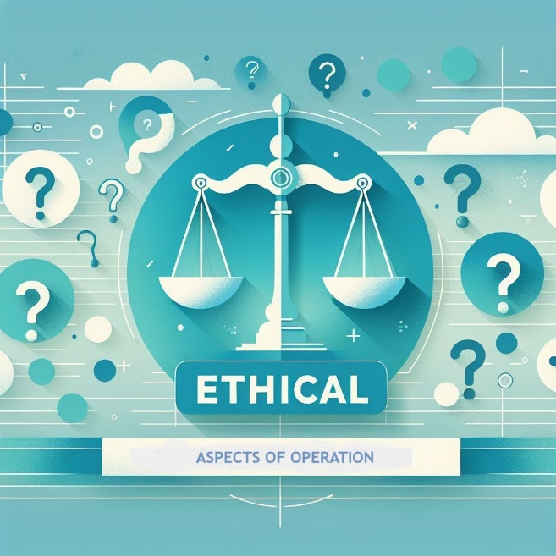
(Picture: Ethical aspects of operation 1/scales of justice+question marks, cc Elina Pirkkalainen 2024, AI generated, Copilot designer)

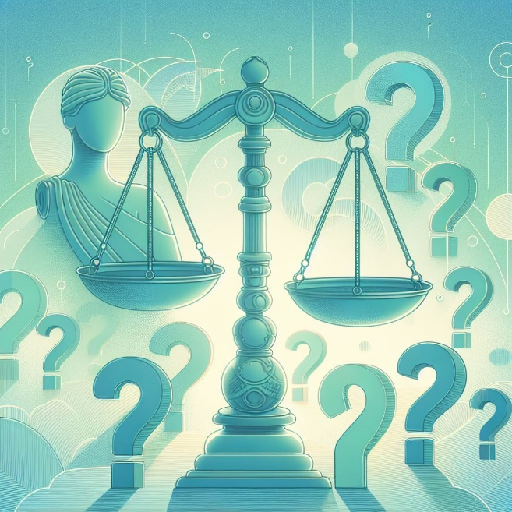
(Picture: Ethical aspects of operation 2/scales of justice + question marks, cc Elina Pirkkalainen 2024, AI generated, Copilot designer)

Goal:
- You will be able to identify some ethical choices included in the set of tasks
- You will be able to evaluate your own decisions and those of others ethically.

Ethical Perspective, Ethical Questions and Ethical guidelines

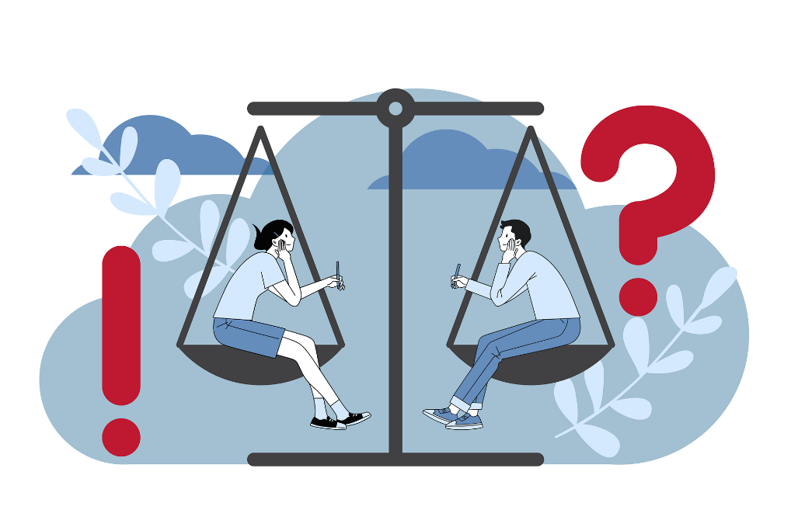
(Picture: Two people in conversation on theopposite sides of a scales, cc Rosy, Bad Homburg, Germany Pixabay 2024)

An ethical perspective is the way people view life, situations, or their positions in terms of what they believe is right. It helps identify and distinguish concepts of good and bad and enables systematic thinking to solve problems from different perspectives. An ethical perspective relates to moral choices and helps define what is virtuous and what is not. The primary ethical perspectives can be categorized as responses to life questions and what is believed to be right.

Vocabulary:
Ethical guidelines - a framework or set of rules that are used to monitor and address ethical issues related to various aspects such as humans, personal data, animals, environment, health and safety, and artificial intelligence during research projects.
Ethical dilemma - a problem in the decision-making process between two possible options, neither of which is absolutely acceptable from an ethical perspective
Global Responsibility - The recognition that countries have an obligation to address global issues such as poverty, environmental degradation, human rights violations, and peacekeeping efforts.
Global Citizenship - Social, political, environmental, and economic actions of globally minded individuals and communities on a worldwide scale.
Human rights - the basic rights and freedoms that belong to every person in the world, from birth until death, which apply regardless to where you are from, what you believe or how you choose to live your life.

Knowledge - facts, information, and skills acquired through experience or education
Opinion - a view or judgement formed about something, not necessarily based on fact or knowledge
Value - principles or standards of behaviour on the importance, worth, or usefulness of something

Ethical Perspective, Ethical Questions and Ethical guidelines

An ethical perspective is the way people view life, situations, or their positions in terms of what they believe is right. It helps identify and distinguish concepts of good and bad and enables systematic thinking to solve problems from different perspectives. An ethical perspective relates to moral choices and helps define what is virtuous and what is not. The primary ethical perspectives can be categorized as responses to life questions and what is believed to be right.

Vocabulary:
Ethical guidelines - a framework or set of rules that are used to monitor and address ethical issues related to various aspects such as humans, personal data, animals, environment, health and safety, and artificial intelligence during research projects.
Ethical dilemma - a problem in the decision-making process between two possible options, neither of which is absolutely acceptable from an ethical perspective
Global Responsibility - The recognition that countries have an obligation to address global issues such as poverty, environmental degradation, human rights violations, and peacekeeping efforts.
Global Citizenship - Social, political, environmental, and economic actions of globally minded individuals and communities on a worldwide scale.
Human rights - the basic rights and freedoms that belong to every person in the world, from birth until death, which apply regardless to where you are from, what you believe or how you choose to live your life.

Knowledge - facts, information, and skills acquired through experience or education
Opinion - a view or judgement formed about something, not necessarily based on fact or knowledge
Value - principles or standards of behaviour on the importance, worth, or usefulness of something

Task 1 Agenda 2030 and ethics
Revise the Agenda 2030 goals:
https://keAgenda 2030
Which of these goals do you think include ethical choices?

1.No poverty
2.Zero hunger.
3.Good health and well-being.
4.Quality education.
5.Gender equality
6.Clean water and sanitation
7.Affordable and clean energy
8.Decent work and economic growth
9.Industry, innovation and infrastructure
10.Reduced inequalities
11.Sustainable cities and communities
12.Responsible consumption and production
13.Climate action
14.Life below water
15.Life on land
16.Piece, justice and strong institutions.
17.Partnerships for the goals

Why did you choose these?

Oikea vastaus: kaikki. Palaute avovastaukseen: All of these include ethical choices. You may need to consider for instance the costs vs. human rights or .....

Task 2 Vocabulary – Ethical issues

Correct answers: 1F 2A 3D 4B 5H 6C 7E 8G
- Connect the term with its definition

1 | Ethical guidelines | A | a problem in the decision-making process between two possible options, neither of which is absolutely acceptable from an ethical perspective
2 | Ethical dilemma | B | Social, political, environmental, and economic actions of globally minded individuals and communities on a worldwide scale.
3 | Global Responsibility | C | facts, information, and skills acquired through experience or education  peacekeeping efforts.
4 | Global Citizenship | D | The recognition that countries have an obligation to address global issues such as poverty, environmental degradation, human rights violations, and peacekeeping efforts.
5 | Human rights | E | a view or judgement formed about something, not necessarily based on fact or knowledge
6 | Knowledge | F | a framework or set of rules that are used to monitor and address ethical issues related to various aspects such as humans, personal data, animals, environment, health and safety, and artificial intelligence during research projects.
7 | Opinion | G | principles or standards of behaviour on the importance, worth, or usefulness of something
8 | Value | H | the basic rights and freedoms that belong to every person in the world, from birth until death, which apply regardless to where you are from, what you believe or how you choose to live your life.

Final task / Ethical issues and guidelines in everyday life and at work
Total 15 points, 7,5 points required for grade Satisfactory 1
(Moodle-tenttiaktiviteetti)

- Everyday choices. Choose one of these topics (or come up with your own example of an everyday ethical dilemma). What do you think is right or wrong and? Why?

- Fast Fashion
- Increasing Petrol tax to reduce emissions
- Reducing animal based product consumption.
- Encouraging aggressive behaviour in games like ice hockey.
- Polluter pays priniciple
- Hunting
- Forestry and biodiversity loss

- Find ethical guidelines for your field/future occupation

Review the guidelines and choose three imprtant points that the guidelines highlight. In your own words describe how these are implemented in practise. Explain why you chose these specific points
Remember to include the online link if you found a set of guidelines online

- Now, search for the ethical guidelines of another field. Review the guidelines and write down in your own words 3 things that differ from the guidelines in your own field. What do you think might be the reason for these differences? Hint: You can explore, for example, the ethical guidelines for doctors or lawyers; you can find them by searching online.

Arvioinnista:
1. Läpäisyvaatimus: valittu aihe on eettistä pohdintaa sisältävä asia ja sille on annettu lyhyt, yksinkertainen perustelu. Perusteluiden monipuolisuus ja syvällisyyden aste vaikuttaa arviointiin tästä ylöspäin.
2. Läpäisyvaatimus: Valinnat löytyvät. Pieni kuvaus aiheesta löytyy ja jokainen on perusteltu jollain tavalla. Kuvauksen laajuus ja perusteluiden syvällisyys valinnoille vaikuttaa arviointiin tästä ylöspäin.
3. Läpäisyvaatimus: valinnat löytyvät ja on pyritty löytämään syitä eroille. Pohdinnan laajuus vaikuttaa arviointiin tästä ylöspäin.

Self evaluation and feedback
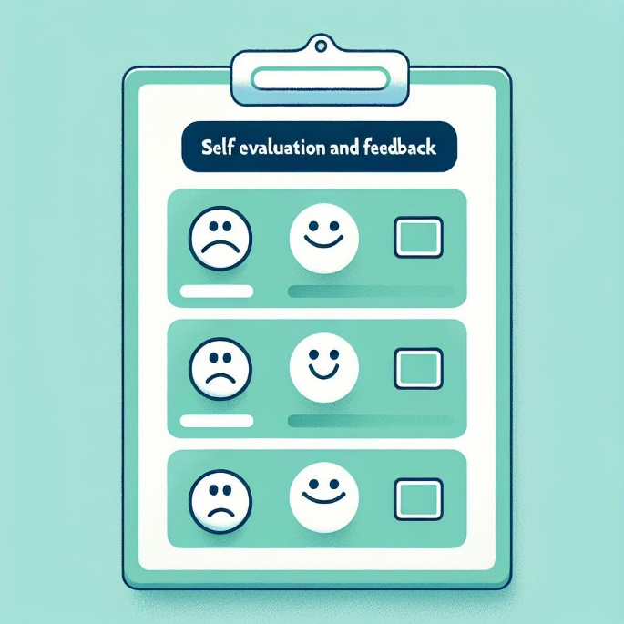
(Picture: Self-evaluation and feedback 1, cc Elina Pirkkalainen 2024, AI generated, Copilot designer)

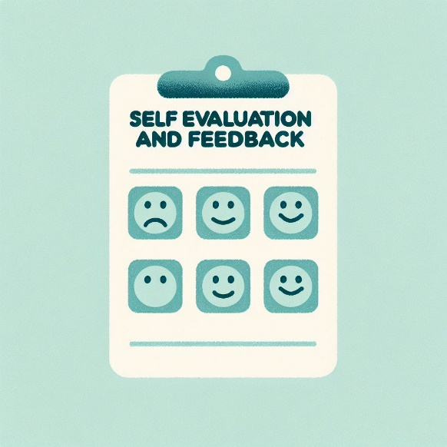
(Picture: Self-evaluation and feedback 2, cc Elina Pirkkalainen 2024, AI generated, Copilot designer)

Self-evaluation and Feedback Time to complete max 5 min.

1) Please rate the following. Circle your choice.

Rating Scale 1 = Strongly disagree 2 = Disagree 3 = No comment 4= Agree 5= Strongly agree
- The contents of the course met my expectations. 1 2 3 4 5
- I enjoyed studying on this course. 1 2 3 4 5
- The instructions were clear. 1 2 3 4 5
- The tasks were versatile. 1 2 3 4 5
- The number of tasks was appropriate/OK. 1 2 3 4 5
- The course was useful and improved my skills. 1 2 3 4 5

2) The hours spent on studying. Please tick your answer.
0 - 10 h □
11 - 20 h □
more than 20 h □
3) Describe you studying process. Please tick your answer.
I did the tasks independently. □
I needed help in doing the tasks. □
Please write how you received assistance:

4)What was your best achievement?

5) What did you find challenging?

6) How would you rate your skills on completing this course? Please tick your choice.

Satisfactory 1 □
Satisfactory 2 □
Good 3 □
Good 4 □
Excellent 5 □

Give reasons:

Lopuksi
Osa-alueen opettajat eri oppilaitoksista ovat luoneet tämän verkkokurssin sisällön. Sisältöä saa muokata oppilaitoksen tarpeisiin sopivaksi. Verkkokurssista on olemassa valmis Moodle-pohja, joka löytyy aoe.fi-sivustolta kurssin nimellä, ja on otettavissa sieltä suoraan oppilaitoksen käyttöön. Myös Itslearning-kurssiin löytyy ohjeet aoe.fi-sivustolta, mutta itse kurssimateriaali on saatavissa Itslearningin kirjastostosta.

Lähdeluettelo
Nykyisessä asiakirjassa ei ole lähteitä.

Lähteet muotoon:

Sukunimi, Etunimen etukirjain, Vuosiluku, Teoksen/lähteen nimi

Linkki, päivämäärä jolloin haettu/luettu.

Verkkolähteiden merkitsemiseen apua voi katsoa: Tekstiviitteet ja lähdeluettelo: tee näin - Lähdeviittaamisen tueksi - LibGuides at Haaga-Helia University of Applied Sciences

Tämä materiaali on tuotettu VIERKO-hankkeessa
vuonna 2024.
VIERKO on toteutettu Opetus- ja kulttuuriministeriön
vuonna 2023 myöntämällä ammatillisen koulutuksen strategiarahoituksella. VIERKO on kuudenkymmenen-
kahden (62) koulutuksen järjestäjän yhteisponnistus.
Työtä on koordinoinut Keski-Uudenmaan koulutus-
kuntayhtymä Keuda.

Hankkeessa on kehitetty vieraskielisen koulutuksen laatua
ja kotimaisten kielten opetuksen tarjontaa ammatillisessa koulutuksessa.

Lisätietoa:
https://www.keuda.fi/keuda/hankkeet/vierko/

https://creativecommons.org/licenses/by/4.0/


Oppimateriaalit:

CC BY-SA 4.0 Deed | Nimeä-JaaSamoin 4.0 Kansainvälinen | Creative Commons
https://creativecommons.org/licenses/by/4.0/

Oppimateriaalit:



CC BY-SA 4.0 Deed | Nimeä-JaaSamoin 4.0 Kansainvälinen | Creative Commons

