Art and creative expression (VVTL)
2024

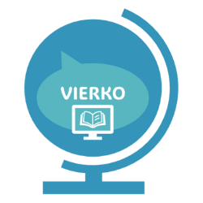
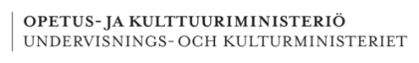
Verna Dahlman, Maria Hyväri, Kati Kaksonen, TIina Kujala, Mirka Lehmus, pirita Nurmi, anna-Mari PIIRAINEN, ARja Snygg ja ANNE Willemsen-Puranen
Tekijät
Rahoittaja:

Vierko |www.keuda.fi/keuda/hankkeet/vierko

Sisällys
Welcome to study! 2
Introduction 3
1. Recognising the importance of cultures and art for wellbeing 5
1.1 The student uses different forms of culture and art in their work 5
1.1.1 The importance of art in my profession 5
1.2 The student recognises examples of local and national culture and art 7
1.2.1 Reproduction 7
1.2.2 Finnish art 9
1.3 The student recognices the effects of art and culture on wellbeing 20
1.3.1 On the concept of art 20
1.3.2 My life playlist 22
1.3.3 Art from Taiko 23
1.3.4 The importance of art and culture for well-being 24
2. Self-expression by means of art and creative expression 26
2.1 The student develops their creative expression 26
2.1.1 Marimekko Goes VIERKO 26
2.2 The student expresses themselves by means of art and creative expression independently or in cooperation with others 27
2.2.1 My dreams for the future – collage 28
2.2.2 My profession – comic 29
2.2.3 Creative Self-introduction 32
3. Creative self-expression by writing 34
3.1 The student tries different ways of creative writing 34
3.1.1 Analysing the artwork 34
3.2 The student takes advantage of different fictional texts when writing 36
3.2.1 Creative writing 36
3.3 The student uses literature to support their work 39
3.3.1 Literature and my work 39
Conclusion 43
Lähdeluettelo 46
APPENDIX 1 Art at Work 52
APPENDIX 2 Art and Creative Expression in Different Professional Fields 56
APPENDIX 3 Visual Arts - Reading a Picture 64
APPENDIX 4 Composition 67

Welcome to study!
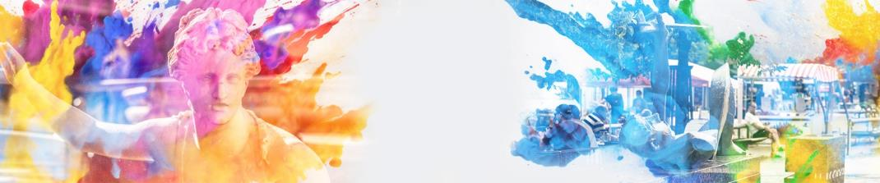
Kuvan lähde: Seinäjoen koulutuskuntayhtymä Sedun kuvapankki.

Opintojakson sisältö:
- Yhteiset tutkinnon osat, Viestintä- ja vuorovaikutusosaaminen:
  - Taide ja luova ilmaisu (VVTL), pakolliset osaamistavoitteet, 1 osp

Content of the study unit
- These studies are part of common units.
- In this course you will study the compulsory studies of the Art and creative expression (VVTL), 1 cp.

Alkukysely:
- Vastaajien nimet tallennetaan ja näytetään vastausten kanssa opettajille.

Pre-course survey – Start here!

Tell about your learning goals for the course.
- See the course contents and goals. What do you wish to learn? Give examples!
- Choose a (course grade) goal for yourself. Circle the number (1-5) of your choice.

Satisfactory 1
Satisfactory 2
Good 3
Good 4
Excellent 5
- How to avoid plagiarism. Tick the boxes after reading to show you agree.
- I will not copy works such as texts or pictures unauthorized. □
- If I make a direct quotation, I will use quotation marks. For example, "This is a quotation”. □
- If I cite a website, I will name the source. For example, yle.fi/news 27 May 2024. □
- I will not return tasks done by another person as my own. □
- I will not return tasks done by AI as my own. □
- If I use AI generated work, I will cite it. For example, Open AI 8 April 2024 □

Verkko-osoite:

ePerusteet: Art and creative expression (VVTL):
Art and creative expression (VVTL)

Introduction
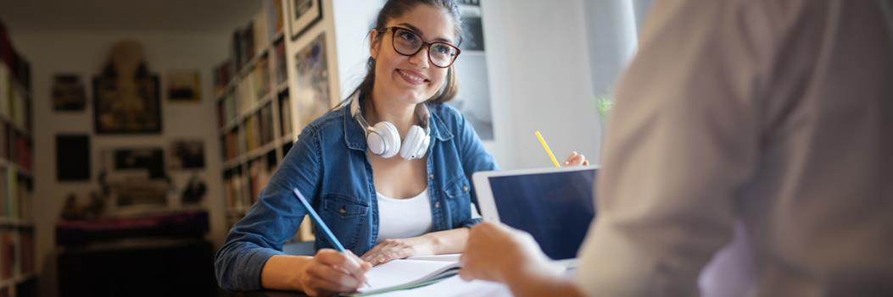
Kuvan lähde: Seinäjoen koulutuskuntayhtymä Sedun kuvapankki.

Welcome to studies of Art and creative expression

These studies are part of common units. In this course you will study the compulsory studies of the Art and creative expression.
- The scope of unit is 1 competence point.
- The content of the studies is divided into three targeted learning outcomes.
- Some of the tasks are optional. You can choose the tasks that suit you best.
After studying this part of common unit, you will have a lot of new knowledge about art and creative expression. You will understand the importance of arts and culture for your well-being, and you will recognise and acknowledge the visibility and impact of the arts both in your professional life and in your free time. You will learn to understand art and to express yourself through art.

During your studies, you will complete tasks and show your competence in three different learning outcomes:
- Recognising the importance of cultures and art for wellbeing
- Self-expression by means of art and creative expression
- Creative self-expression by writing
For art-related activities, there is always an option where you don't have to buy art supplies yourself. However, remember that if you make some of your own products or works, such as drawing, baking, sewing or building, make them visible. For example, you can take photos of your works or products and include them in your answers to the exercises.

Before you start working on the tasks, carefully read the targeted learning outcomes and detailed instructions under the headings. By reading them, you will better understand how you can acquire the needed competence and demonstrate what you have learned.

Many of the tasks include appendix texts or links to various texts, images and videos. Study these materials, practice and complete the required tasks carefully. If there is no specific link to a source of information, you are free to look for information, for example by searching online. In some tasks you can use AI (generative artificial intelligence), but this is only allowed as indicated by traffic lights. So, you must obey the traffic lights!
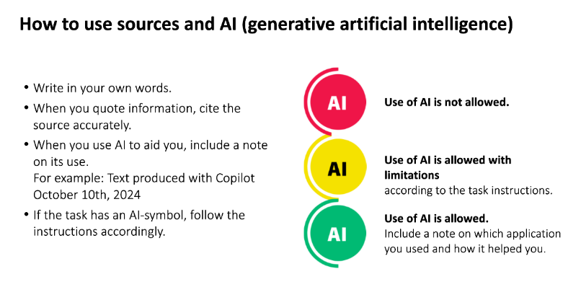

In many professions, creativity and problem-solving skills are an important part of professional competence. You can also learn about art and creative expression in your professional life and vocational studies. Some of the tasks will allow you to use the knowledge and skills you have learnt in your own field of work. It may also be that your hobbies and past work will support these studies. It ‘š worth bringing those up!

Opintokokonaisuuden rakenne mukailee Taide ja luova ilmaisu, pakollinen osa-alueen osaamistavoitteita:
- Opiskelija tekee tehtävän jokaisesta osaamistavoitteesta.
- Osaamistavoitteessa 2.2. on useampi vaihtoehtoinen tehtävä, joista opiskelija valitsee mieleisensä.
- Opettaja voi halutessaan rakentaa myös osaamistavoitteeseen 1.3. vastaavan vaihtoehtoisuuden.
- Vaihtoehtoisuus edistymisen seurannassa (Moodle):
  - Vaihtoehtoiset tehtävät jäävät sinisiksi osaamisen etenemisen seurantaan.
  - Opiskelija kirjaa opettajalle lähetettävään päättökyselyyn, mihin vaihtoehtoisista tehtävistä hän on vastannut.

Recognising the importance of cultures and art for wellbeing
Learning outcomes:

By successfully completing the tasks, you will demonstrate your competence in the compulsory studies of Art and Creative Expression (VVTL): Recognising the importance of cultures and art for wellbeing.

The student uses different forms of culture and art in their work
Completing the task:
- Answer the question about how art is reflected in your work and profession.
- Choose task A or B according to your preference: you can write or create a visual mind map.

Tehtävä

Task

The importance of art in my profession
In this section, you will learn about the importance of art in your professional field.

Check out the learning material

Reflect on and find out about the importance and impact of art in your profession.
Read: Art at Work (Appendix 1)
Read: Art and culture in different professional fields (Appendix 2)

The role of art in the workplace

Art in the workplace takes many different forms. In the world of work, art can be found in the work itself and in the workplace. For example, decorating cakes, working the land, at the activity sessions, doing hair, making advertisements or publications, building, etc. All these are related to art in some way.

Art is also reflected, for example, in workplace furnishings, in the way cars and furniture are decorated, in the pleasant sounds or smells and decorative objects that bring joy and pleasure.

Write about visible art in the workplace. Remember that pictures say a lot, so take pictures and share the art you find.

Reflect on and seek information about the importance and impact of art in your work.
Use the texts Art at Work (Appendix 1) and Art and culture in different professional fields (Appendix 2) to help you.
You can also find more information on the qualification requirements of your vocational field and other sources.

Instructions for the learning task:

Choose one of tasks A or B.
Return the task as a file, video or online text.

A. Create a visual mind map combining image and word on the topic "Making the most of arts and culture in my field".

Or

B. Write a reflection on the theme "The multifunctional use of arts and culture in my field".

Verkkotehtävän palautusohjeet. Muotoile tarvetta vastaavaksi.

This is how you return the task:

To return the assignment, click on the Add submission -button below.
Return online text: type your answer in the text box. Click the Save Changes button to confirm your text.
Return pictures: Select files from OneDrive, PC or mobile device. To confirm sending the files, press the Save Changes button.
Image file recovery types: JPEG, TIFF or PNG.

The maximum length of a text response is 300 words.

The task will be assessed numerically, on a scale of 1 to 5.


Use of AI is not allowed

Suositeltava palautusmuoto: Verkkoteksti/Online text.

The student recognises examples of local and national culture and art
Completing the task:
- Explore the art collection of the National Gallery of Finland.
- Create your own vision of a classical work of art.
- Demonstrate your knowledge of Finnish art and culture in an online test.

Tehtävä

Task

Reproduction

The Finnish National Gallery and the National Inventory of Living Cultural Heritage preserve our cultural heritage. Cultural heritage consists of tangible or intangible things or practices inherited from the past. It includes literature, art, monuments, skills, and stories (Finnish National Agency for Education). The National Gallery comprises collections from the Ateneum Art Museum, the Museum of Contemporary Art Kiasma, and the Sinebrychoff Art Museum.

You can explore the works in the collections using the National Gallery’s artwork search.

Instructions for the task: Create a reproduction or imitation of an artwork

Explore the National Gallery’s collection through this link. The homepage will display the collection of artworks.

Browse the artworks and choose one that interests you from the collections.

Create a reproduction of the artwork. (For tips on reproductions, you can check out the Instagram page Karanteenitaidetta or the Yle article Underwear turned into a Renaissance cap).

Study the poses and expressions of the people in the artwork and think about how you could replicate them.

Use materials you find as props. In this task, trash can be treasure! Utilize twigs, cones, toilet paper, cardboard, wool yarn, old clothes – anything!

Take a photo of your artwork.

Mention which artwork you used as the basis for your work and include a picture of it in your response.

Verkkotehtävän palautusohjeet. Muotoile tarvetta vastaavaksi.

This is how you return the task:

To return the assignment, click on the Add submission -button below.
Return online text: type your answer in the text box. Click the Save Changes button to confirm your text.
Return pictures: Select files from OneDrive, PC or mobile device. To confirm sending the files, press the Save Changes button.
Image file recovery types: JPEG, TIFF or PNG.
Videos restore: You can use e-learning environments own video recorder or record a video, for example on your phone, and restore e-learning environments video file.
To restore an audio file, use e-learning environments recorder.

The maximum length of text response is 200 words.

The task will be assessed numerically, on a scale of 1 to 5.

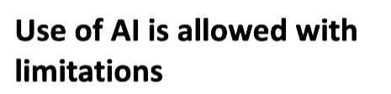
- In this task, you can use AI to search for information. However, you should also check the links in the help text. Do the task without the AI, using your own personal expression.

Finnish art

In this section, you will demonstrate your expertise in Finnish art and culture.

Tentti

Task

Test your skills

Instructions

In each section, select one or more correct answer options.
A maximum of 44 points can be scored for the test. To pass the test, you must score at least 17 points.

Verkkotentin ohjeet. Muotoile tarvetta vastaavaksi.

This is how you do the test:

When you want to start the test, press the button below to Tee tentti nyt (take the exam now).
- Press the button Aloita tentti / Start attempt. The test run time begins.
- When you want to move forward in the test, press the Seuraava sivu / Next Page button.
- Once you have answered all the questions, press the Lopeta tentti / Finish attempt button.
- In the end, you will see all your answers.
- Send the answers and stop the test. Press the Palauta kaikki ja lopeta / Submit all and finish

Use of AI is not allowed

Tentin oikeat vastaukset lihavoituina tai oikeassa järjestyksessä. Sekoita vastaukset tarvittaessa.

Question1. Early ages

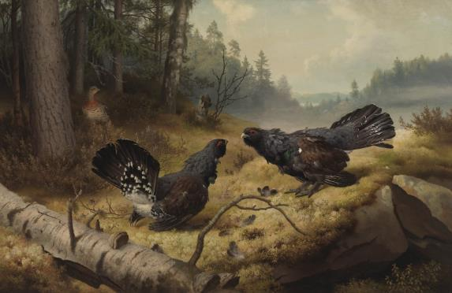
Who painted this work Taistelevat Metsot?
a) Ferdinand von Wright
b) Magnus von Wright
c) Johannes Takanen

Kuva: Kansallisgalleria
Question 2: Composers and poet of a golden age
Draw the names in the right places:

was a famous Finnish composer. He composed Finlandia hymn.
is well known for the wedding march he composed.
The poem Nocturne is written by

Eino Leino
Toivo Kuula
Jean Sibelius

Question 3: Golden ages

Choose the right author and work:
- Eero Järnefelt, Raatajat rahanalaiset
- Akseli Gallen-Kallela, Lemminkäisen äiti
- Hugo Simberg, Haavoittunut enkeli
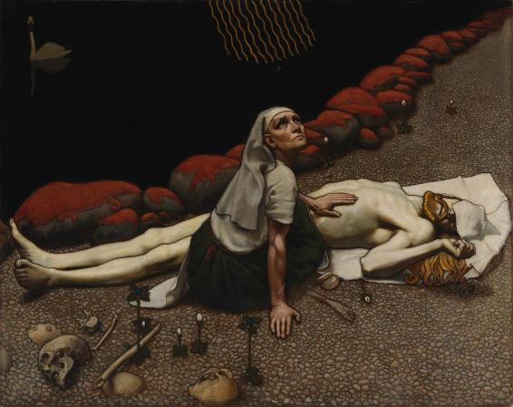
Kuva: Kansallisgalleria

Question 4:
Enter the name of the author in the box.
A Finnish author whose most famous work, Sinuhe the Egyptian (Sinuhe egyptiläinen), has been translated into 40 languages.

Finnish writer and academic whose most famous works are Unknown Soldier (Tuntematon sotilas) and Under the North Star (Täällä Pohjantähden alla).

Question 5: 20th century art

Select the correct author and title of the work.
- Erik Bergman, Le Voyage
- Tapio Wirkkala, Ultima Thule
- Eila Hiltunen, Sibelius-monumentti
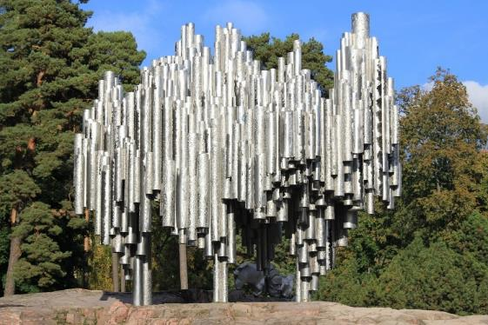
Kuva: Pixabay

Question 6: Design
What is the name of this lamp by Eero Aarnio?
- Kupla
- Tupla kupla
- Puppy
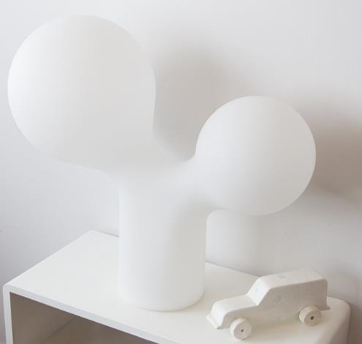
Kuva: Pixabay

Question 7: Contemporary art
What kind of art is Jukka Haapalainen known for?
- Dance
- Visual arts
- Music
- Architecture
Question 8: Sculptors and architects
Drag the right author and work onto the image.
Kuvat: Kansallisgalleria ja Pixabay

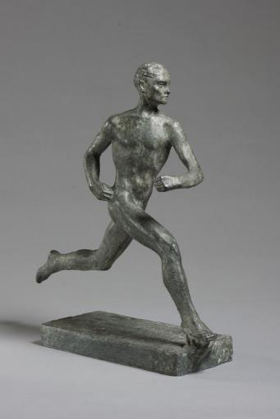
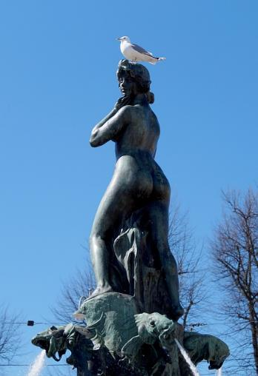
Ville Vallgren, Havis Amanda
Wäinö Aaltonen. Paavo Nurmi

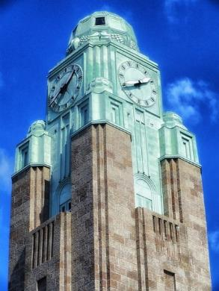
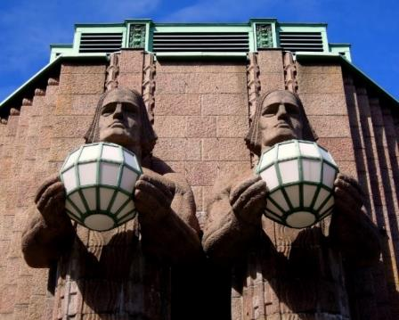

Eliel Saarinen, Helsingin rautatieasema
Emil Wikström, Lyhdynkantajat

Question 9: The golden age of Finnish design
One of Finland's most internationally renowned ceramic and glass artists is .
His most famous dishes are the Kartio-glasses and Teema-dishes.
Designer designed Ultima Thule dishes.
designed not only buildings but also dishes. The Aalto glass she designed Aalto glass (i.e.Bölgeblick) is very familiar to Finns.
was an architect and designer. His design Aalto vase can be found in many Finnish homes
designed S-pad i.e. S-pata, which is made of cast iron.
The famous Marimekko Unikko pattern is designed by .
Kaj Franck, Tapio Wirkkala, Aino Aalto, Alvar Aalto, Timo Sarpaneva, Maija Isola.

Question 10: Architecture
Connect the building with the Finnish architect who designed it.
Toronto town hall is designed by
Viljo Revell
Finlandia Hall is designed by
Alvar Aalto
Eduskuntatalo i.e. Parliament House is designed by
J. S. Siren
Hospitz Betel is designed by
Erik Bryggman

Question 11: Contemporary art
Pair the book with its author, a director or actor with a film.
Rakkaani merikapteeni
Klaus Härö
7 veljestä
Martti Suosalo
Pojat
Vesa-Matti Loiri
Hytti nro 6
Rosa Liksom
Puhdistus
Sofi Oksanen

Question 12: Modern art
Connect the work and its author:
Leena Luostarinen
Adriana aus Naxos
Hannu Siren
Lähtö
Juhana Blomstedt
Vapaaheitto
Soile Yli-Mäyry
Asphalt Light
Kuutti Lavonen
Pyhän Olavin kirkon maalaukset
Markus Copper
Seitsemän meren arkkienkeli

Question 13: 20th century art
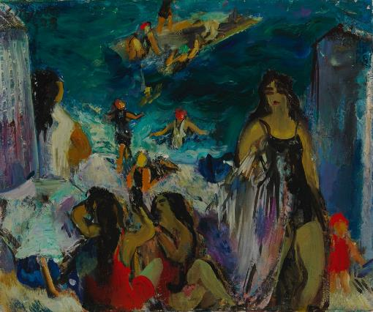
Choose the right title and author of the work

a) Mika Waltari, Sinuhe Egyptian (i.e. Sinuhe Egyptian)
b) Tyko Sallinen, Hihhulit (i.e. Fanatics)
c) Eemu Myntti, Uimarannalla (i.e. On the beach)

Kuva: Kansallisgalleria

Question 14: Symbolism

Choose the right title and author
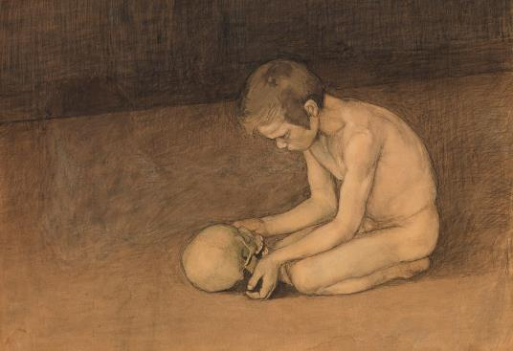
a) Eemu Myntti, Uimarannalla (i.e. On the beach)
b) Magnus Enckell, Poika ja pääkallo (i.e. Boy with Skull)
c) Pekka Halonen, Poika rannalla (i.e. Boy on the beach)

Kuva: Kansallisgalleria

Question 15: Expressionism

Choose the correct name of the work and author.
See photo from this link.

a) Tyko Sallinen, Hihhulit (i.e. Fanatics)
b) Mika Waltari, Sinuhe egyptiläinen (i.e. Sinuhe Egyptian)
c) Magnus Enckell, Poika ja pallo (i.e. Boy with a ball)

Question 16: Golden ages
Choose the correct name of the work and author.
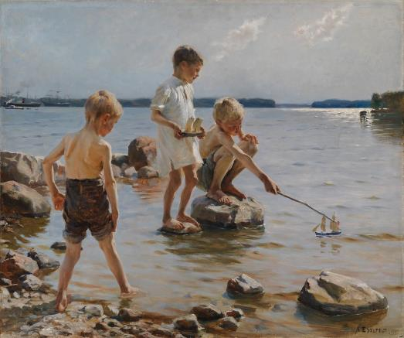

a) Pablo Picasso, Kylpijät (Bathers)
b) Pekka Halonen, Poikia rannalla (Boys on a beach)
c) Albert Edelfelt, Leikkiviä poikia rannalla (Playing boys on a beach)

Kuva: Kansallisgalleria

Question 17: Golden ages
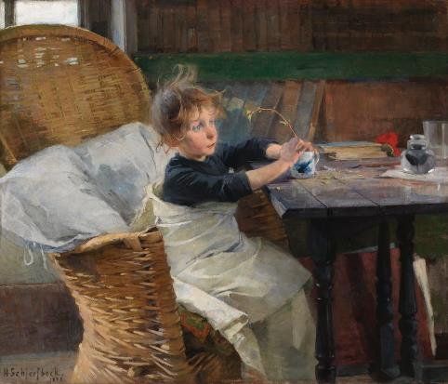
Choose the right title and painter

a) Ville Vallgren, Havis Amanda
b) Hugo Simberg, Haavoittunut enkeli (i.e. The wounded angel)
c) Helene Schjerfbeck, Toipilas (i.e. The Convalescent)

Kuva: Kansallisgalleria

Question 18: Golden ages

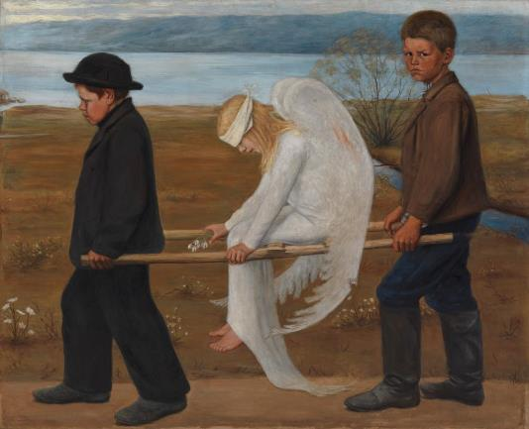
Choose the right name and author.

a) Hugo Simberg, Haavoittunut enkeli
b) Johannes Takanen, Andromeda
c) Pekka Halonen, Oijustie

Kuva: Kansallisgalleria

Question 19: Early ages

Who painted Sorsia?
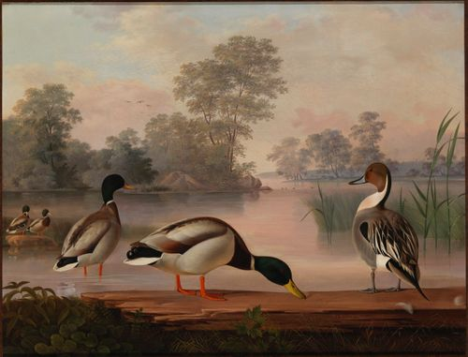
a) Magnus von Wright
b) Ferdinand von Wright
c) Kaj Stenvall

Kuva: Kansallisgalleria

Question 20: 19th century sculptors

Who made the sculpture Andromeda?
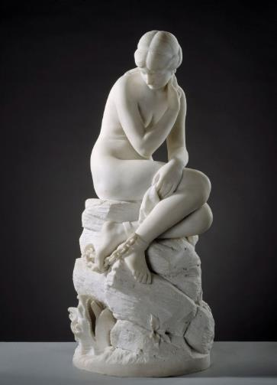

a) Magnus von Wright
b) Johannes Takanen
c) Walter Runeberg

Kuva: Kansallisgalleria

Question 21: 19th century sculptors

Who made the sculpture of J. L. Runeberg?
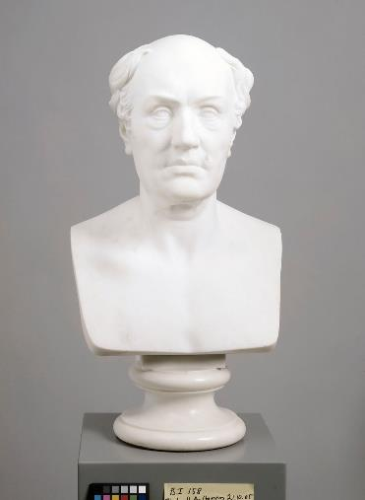

a) Walter Runeberg
b) Wilhelm von Wright
c) Johannes Takanen

Kuva: Kansallisgalleria

The student recognices the effects of art and culture on wellbeing
Completing the tasks:
- Find out what art is and what purpose it has.
- Create a playlist of your own life.
- Reflect on your own preferences in art.
- Explain how you improve your well-being through art and culture.

Tehtävä

Task

On the concept of art
Explore the world of art: read, listen and watch the subject you are studying through texts that unfold from a picture ThingLink

Report on Taikusydän’s Activities in 2023 | Taikusydän (turkuamk.fi)

https://youtu.be/Uak9tEFIKGU

Europe Timeline | Oxford Art (oxfordartonline.com)

The arts - Wikipedia

Unlocking the Functions of Art: More Than Meets the Eye! (youtube.com)
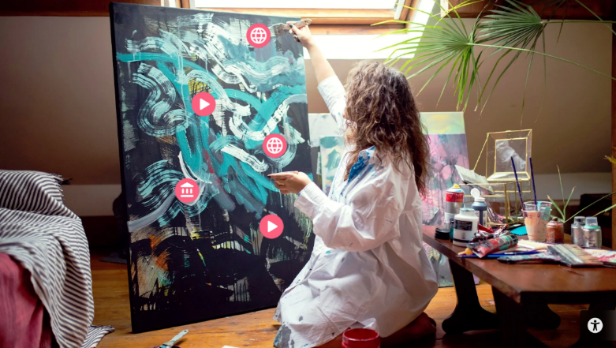

Answer the following questions.

What is art? What are the types of art?

What are the functions of art? Give examples.

Consider which of the following factors influence the interpretation of a work of art.

Verkkotehtävän palautusohjeet. Muokkaa tarvetta vastaaviksi.

This is how you return the task:
To return the assignment, click on the Add submission -button below.
Return online text: type your answer in the text box. Click the Save Changes button to confirm your text.

The maximum length of a response is 300 words.

The task will be assessed numerically, on a scale of 1 to 5.

In this task, you can use AI to search for more information. However, you should also check all the links in the ThingLink picture. Do the task without the AI. using your own personal writing. Include your own views and experiences in your response
Tehtävä

Task

My life playlist
Art has been proven to have many significant effects on human well-being.
You can read about the impact of art in these articles:

Art really affects health: Arts and health
The effects of art and culture on health: Arts and culture for health and wellbeing
In the following task, you will reflect on how music affects and has affected your well-being.

Introductions for the task

Reflect on the songs that have marked different stages of your life.
Think about choosing songs that bring back happy memories, remind you of someone special, or recall a meaningful event.

Create a list of these songs and the memories they hold. This will be your "playlist of life."

To guide your reflection, consider these questions:
- What songs do you remember from your childhood, teenage years, or time spent with friends?
- What emotions do these songs evoke?
- Why is each song important to you?

You can list more than five songs if you like. For each song include:
- Song title and artist (with a link to the song, if possible).
- Life stage it connects to.
- Why it was meaningful to you?

Verkkotehtävän palautusohjeet. Muokkaa palautus Wordissa tarvittaessa ruudukoksi.

To return the assignment, click on the Add submission -button below.
Return online text: type your answer in the text box. Click the Save Changes button to confirm your text.

The maximum length of a response is 300 words.

The task will be assessed passed - to be completed (hyväksytty – täydennettävä).

Use of AI is not allowed

Tehtävä

Task

Art from Taiko

Dive into the vibrant world of art at Taiko, an amazing online art store! Explore their vast collection and choose two paintings that would bring life and inspiration to your own home.

Taiko – art shop online
Watch the video

Explore and Choose:
Browse through the diverse selection of artwork at Taiko.
Pick two paintings that speak to you and would look perfect in your space.

Capture and Justify:
Take screenshots of the paintings you’ve chosen.
Write a brief explanation for each choice. Explain why these pieces caught your eye and how they would enhance your home.

Let your personal style shine through your selections!

Verkkotehtävän palautusohjeet. Muokkaa tarvetta vastaaviksi.

To return the assignment, click on the Add submission -button below.

Submit Your Work:
Choose the most suitable tool for you (e.g., PowerPoint, Word, Canva) and submit the task as a link in the online text box.

The task will be assessed passed - to be completed (hyväksytty – täydennettävä)
Use of AI is not allowed

Tehtävä

Task

The importance of art and culture for well-being

Engaging in art and cultural activities offers many benefits to individuals that impact both mental and physical well-being:

Creating or experiencing art, such as painting, listening to music, or attending theater, helps express emotions and can provide ways to cope with stress, anxiety, and other negative feelings. Many studies show that art promotes mental health by improving self-awareness and reducing symptoms of depression.

Participating in art activities enhances cognitive skills such as creative thinking, problem-solving, and imagination.

Cultural activities, such as visiting museums or reading literature, can increase knowledge and improve the ability to understand different perspectives and worldviews (Helpful Professor).

Engaging in cultural activities, such as watching theater or attending concerts, creates opportunities for social interaction and can strengthen the sense of belonging. Art connects people from diverse backgrounds, promoting cross-cultural understanding and dialogue.

Immersing oneself in art, whether through listening to music or creating art, can reduce stress and help with relaxation. This is partly because art activates the brain's reward system and fosters a state of relaxation.

For example, theater performances and literature can help people better understand others' emotions and motives, enhancing empathy and social awareness (Greater Good).

Cultural activities, such as dancing or choir singing, can also offer physical benefits, as they promote exercise, improve body coordination, and support heart health.

Engaging in art and cultural activities can bring psychological, physical, and social benefits, making it an important component of overall well-being.

Answer the questions:

- What art or cultural experience has been particularly meaningful in your life and positively impacted you?
- How do you think art and cultural experiences contribute to human well-being?
- What types of art and cultural experiences do you find most interesting? Why?

Additional reading:

The intersection of art and health: How art can help promote well-being 2023. The intersection of art and health: How art can help promote well-being - Mayo Clinic Press

What is the evidence on the role of the arts in improving health and well-being? A scoping review 2019. What is the evidence on the role of the arts in improving health and well-being? A scoping review (who.int)

Verkkotehtävän palautusohjeet. Muokkaa tarvetta vastaaviksi.

This is how you return the task:

To return the assignment, click on the Add submission -button below.

Return online text: type your answer in the text box. Click the Save Changes button to confirm your text.

The maximum length of a response is 300 words.
The task will be assessed passed - to be completed (hyväksytty – täydennettävä).

Use of AI is not allowed

Self-expression by means of art and creative expression
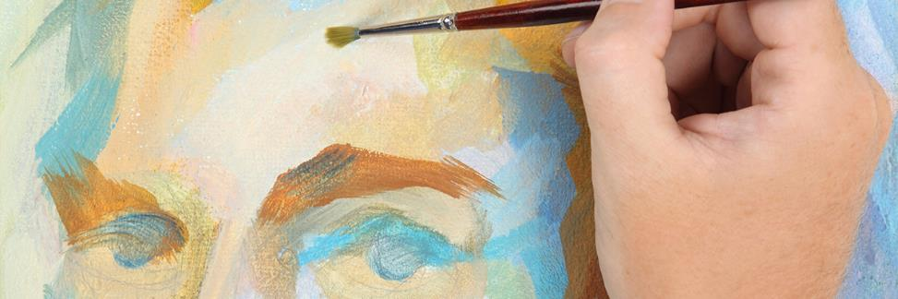Kuvan lähde: Seinäjoen koulutuskuntayhtymä Sedun kuvapankki.

Learning outcomes:

By successfully completing the tasks, you will demonstrate your competence in the compulsory studies of Art and Creative Expression (VVTL): Self-expression by means of art and creative expression.

The student develops their creative expression
Completing the task:
- Develop your creative expression by designing your own pattern with real tools of designers.
- Create your own brand by writing a product story and coming up with a brand name.

Tehtävä

Task

Marimekko Goes VIERKO
"Marimekko is a renowned Finnish lifestyle design company, celebrated for its unique prints and vibrant colors.”

Your task: Design a fresh and exciting pattern inspired by Marimekko.

To help spark your creativity, explore Marimekko, for inspiration.

When selecting colors for your design, visit Pantone (specifically the Pantone Color of the Year) for additional ideas.

Decide the intended use of your pattern—e.g., will it be for clothing, accessories, home textiles, or tableware?

Finally, give your design a name and write a brief background explaining how you came up with it.

Verkkotehtävän palautusohjeet. Muokkaa tarvetta vastaaviksi.

This is how you return the task:

To return the assignment, click on the Add submission -button below.
Submit your project either as a screenshot or by providing a link in the online text box.

Along with the picture of your design, please remember to include its name, intended use, and a brief background with your submission.

The task will be assessed numerically, on a scale of 1 to 5.

Use of AI is not allowed

The student expresses themselves by means of art and creative expression independently or in cooperation with others
Completing the task:
- Choose task 2.2.1, 2.2.2 or 2.2.3 according to your preference: you can create a collage, write a comic of your profession or introduce yourself by creative expression.
- You will develop your creative expression skills through composition, drawing, crafting, photography and writing.

Vaihtoehtoinen tehtävä

Task

My dreams for the future – collage

In this task, the goal is to create a collage.

A collage refers to an art form where different materials, such as photographs, texts, drawings, or other objects, are combined into a single artwork. These materials are often glued or attached to a surface, creating a visual composition that can be abstract or representational. Collage allows artists to blend a variety of styles and elements, playing with contrasts and layered meanings.

Next, watch the videos that provide various tips on how to make collages.

https://youtu.be/sLooH5Y_Rk8?si=8ypGIxyRiTg_PL_J

https://youtu.be/_0r_sgEMpak?si=1hWO3BUvRHEkrWr_

Next, create a collage with the theme "My Dreams for the Future."

Find some old magazines or advertisements along with a pair of scissors. Use images cut from the old magazines in your collage.

Make use of other materials as well. Glue the images onto an A4 or A3-sized piece of paper to create a unified whole and a new picture.

Additionally, you can draw or paint to extend the scenery or event from the magazine cut-outs.

Take photos of your work at the beginning and then when it's finished, capturing how your process progresses.

Give your work a title (e.g., "A Day in the Life of a Practical Nurse," "My Dream Job," or "My Dreams for the Future").

Finally, describe in a few sentences what your collage represents or depicts.

You can also complete this task using a drawing program on a computer (remember to take a few pictures of the work process in that case as well).

Note! The images must be clear.

On the last slide of your presentation, describe the work process in a few sentences: What was difficult? What was easy? What did you learn?

Verkkotehtävän palautusohjeet. Muokkaa tarvetta vastaaviksi.

This is how you return the task:

To return the assignment, click on the Add submission -button below.
Return online text: type your answer in the text box. Click the Save Changes button to confirm your text.
Return pictures: Select files from OneDrive, PC or mobile device. To confirm sending the files, press the Save Changes button.
Image file recovery types: JPEG, TIFF or PNG.
Videos restore: You can use e-learning environments own video recorder or record a video, for example on your phone, and restore e-learning environments video file.
To restore an audio file, use e-learning environments recorder.

The maximum length of a text response is 100 words.

The task will be assessed numerically, on a scale of 1 to 5.
In this task, you can use AI to search for information. However, you should also check all the links in the introduction of how to make collages. Do the task without the AI using your own personal writing. Include your own views and experiences in your response.

Vaihtoehtoinen tehtävä

Task

My profession – comic

In this task, the goal is to create a comic. A comic is a visual narrative consisting of sequences of images and often text that together create a story. Comics can be single image pairs, such as cartoons, or longer stories divided into multiple pages or episodes. Comics combine visual art with text and can cover a wide range of themes and styles. The text in a comic can appear in speech bubbles or as captions.

First, explore the videos and background materials that explain how to draw comics.

https://youtu.be/JwMXTQi4ya8?si=uEo9vl-gaUO3L40P

https://youtu.be/5KX7WpRVtVU?si=s22FZKS5VbUBeFgB

https://ramstudioscomics.com/index.php/comic-art-and-drawing-tutorials/

Step-by-Step Guide: My Comics Process (comicsforbeginners.com)

Next, find a joke, belief, legend, or short story related to your future profession. Use this joke or story as the basis for your comic strip.

Design a short comic strip, consisting of 2-4 panels. You can draw your own characters (even simple stick figures) or use existing characters by cutting them out from old comics.

Write down the original text. As you proceed, take a few photos of the stages of creating the comic.

This task should be done by hand.

Start by sketching out the comic, considering the storytelling stages: what will you convey through images and what through text? How will you present the text: as speech bubbles or captions alongside the images?

First, draft a rough sketch to test the size and number of panels: how many panels do you need to tell this story? 2, 3, or 4?

Draw the comic in pencil. Don’t forget the title. Take some photos of the sketch and drawing stages.

Once you have finalized the text, clean up the comic using a fine black pen or marker. Erase any pencil marks. You can also color the comic with colored pencils if you wish.

Remember to write your name on the comic.

Take a photo of the completed comic. You should have a total of 4-5 photos documenting the creation process.

Compile the photos and texts into a single document, such as a PowerPoint presentation. On the final slide, write a few sentences about the creation process: what was difficult, what was easy, and what did you learn?

Verkkotehtävän palautusohjeet. Muokkaa tarvetta vastaaviksi.

This is how you return the task:
To return the assignment, click on the Add submission -button below.

Return file: Select files from OneDrive, PC or mobile device. To confirm sending the files, press the Save Changes button.
File type: PowerPoint (PPTX). To confirm sending the files, press the Save Changes button.

The task will be assessed numerically, on a scale of 1 to 5.

Use of AI is not allowed

Vaihtoehtoinen tehtävä

Task

Creative Self-introduction

Me, Myself and I: Creative Self-Introduction

Create an inspiring presentation to introduce yourself creatively using PowerPoint, Canva, or any other tool that sparks your creativity. This is your opportunity to showcase who you are and what makes you unique. Here are some ideas to get you started:

About You:
Who are you? Share any interesting facts about yourself.
What are you studying? Shead light on your field of study and why you chose it.
What are your hobbies? What do you love to do in your free time?
Where do you live? Describe your neighborhood.

Art and Creative Expression in Your Daily Life:
How does art shape your life? Illustrate how art and creative expression are woven into your everyday activities.
Be specific: Mention your favorite music, movies, TV shows, books, art, interior designs, fashion, food, drawing, painting, or crafts. Let your personality shine through these details!

Your Soul Landscape:
Visualize and describe a place that inspires you. This could be a real place or a dreamscape. Why is it special to you? How does it fuel your creativity?

Art or Artist That Speaks to You:
Share a connection. Present an artist or a piece of artwork that deeply resonates with you.

Your Grading Goal:
Set your sights. Share your grading goal on a scale from 1 to 5. Aim high and share what you hope to achieve in this course.

Verkkotehtävän palautusohjeet. Muokkaa tarvetta vastaaviksi.

This is how you return the task:
Choose the most suitable tool for you (PowerPoint, Word or Canva) and submit the task as a link in the online text box.
Unleash your creativity! This is your canvas and chance to shine - let your imagination run wild!
Be bold with colors, play with shapes and symbols, have fun with layout, include images - pictures that tell your story or personal photographs if you're comfortable.

Return file: Select files from OneDrive, PC or mobile device. To confirm sending the files, press the Save Changes button.

To return the assignment, click on the Add submission -button below.
File type: PowerPoint (PPTX), Canva (JPG, PNG) or Word (JPG, DOCX). To confirm sending the files, press the Save Changes button.

The task will be assessed numerically, on a scale of 1 to 5.

Use of AI is not allowed

Creative self-expression by writing

Kuvan lähde: Seinäjoen koulutuskuntayhtymä Sedun kuvapankki.

Learning outcomes:

By successfully completing the tasks, you will demonstrate your competence in the compulsory studies of Art and Creative Expression (VVTL): Creative self-expression by writing.

Tehtävä

Task

The student tries different ways of creative writing
Completing the task:
- You will learn how to composite an artwork and demonstrate what you have learned by making one.
- You will learn how to analyze different works of art and images.

Analysing the artwork
In this section, you will learn about composition and how to analyze a picture. Image reading, the analysis of an image, helps you to interpret the image.

Have a look at the learning material:
A picture always tells the viewer something. Visual literacy is about observing, experiencing and interpreting an image. Many different messages can be read from images. The person who takes the picture always has an idea of what he or she wants the picture to say.
The image tells but does not always give clear answers. There are many different things that influence the interpretation of an image, such as your cultural background, your age and your gender.

The role of composition is to give direction and purpose to the gaze. It is the process of building up an image and arranging what you see in it into as pleasing a whole as possible. Harmony and balance are important, but so are different tensions and variations. All of the above add interest to the image and a desire to interpret it.
You can practice your picture-reading skills by thinking about what you want to say with your own work.

Visual literacy is important in today's society, where images are everywhere. We live in a visual world where images are constantly present. The symbolism of images and the information they convey often replace written text. The skill of making and reading pictures helps you to understand the information conveyed by the images around you.
Find out more:
- Read: Visual Arts - Reading a Picture (Appendix 3)
- Read: Composition (Appendix 4)
- Read: Abstract Art Abstract art - Wikipedia
- Read: Figurative Art Figurative art - Wikipedia

- Photos in the workplace
How do you feel about the pictures? How do you use images to tell your story? How are images used in your workplace? Look at the images in your workplace. Think about why they are used and where they are used. Could you use the pictures for a particular task or work step? Use the instructions below to make a picture essay on the topic.

- Analyze a picture.
Select the image you like. You can choose from museum collections such as Kiasma or the Sinebrychoff Art Museum or from Finnish National Gallery Kansallisgalleria. You can also choose one of your own images or an image from your own field. Write or explain what you see in a picture or artwork.
Use image reading tools to help you (Visual Arts - Reading a Picture, Appendix 3).

Verkkotehtävän palautusohjeet. Muokkaa tarvetta vastaaviksi.

This is how you return the task:

To return the assignment, click on the Add submission -button below.
Return online text: type your answer in the text box. Click the Save Changes button to confirm your text.
Return pictures: Select files from OneDrive, PC or mobile device. To confirm sending the files, press the Save Changes button.
Image file recovery types: JPEG, TIFF or PNG.

The maximum length of a text response is 300 words. Attach a photo of the work you have analysed to your task return.

The task will be assessed numerically, on a scale of 1 to 5.

Use of AI is not allowed

The student takes advantage of different fictional texts when writing
Completing the task:
- Write using creative writing methods.
- Choose 1 tasks from options A-F that are most suitable for you.

Tehtävä

Task

Creative writing

Explore the subject material

The art of writing is the art of creation. Creative writing is playing with words and painting with images. Words can be used to influence, touch, create emotions, caress and love. Words can change the world, bring the past to life and predict the future. Words can guide, entertain, make you laugh and bring you to tears. So, words have great power. When it comes to writing, the only limit is your imagination.

Creative writing reveals the rhythm of words, the fun of words and the horror of words. Words can revive and offend. The responsibility of the writer is great, because the power of words is immense. Creativity is like a little child at play in all of us. It pushes boundaries, seeks new things, falls in love and gets angry. Creativity can be fragile and vulnerable and sometimes it gets lost. But creativity is never lost, it is found when you look for it. Writing is one of the best ways to find yourself. Creative writing can open your life to new joy and exhilaration. Test your limits and break them.

Check out the Following:
How to write a movie? https://www.torontofilmschool.ca/blog/what-is-a-screenplay/
How to make comics? How to Make Comics: What Are the Elements of a Comic? | Magazine | MoMA
What is fan fiction? Fan fiction - Wikipedia
Howe to write poetry? https://www.bbc.co.uk/bitesize/articles/zsbsxbk#zvcgdnb
How to write drama for theater? https://www.southwestern.edu/live/files/4182-guide-for-writing-in-theatrepdf

Do the Task to be Assessed:

Choose 1-3 of the tasks from the list below and write. Return the task as a file or web text.
A. Write a fan fiction story
Try fan fiction (see Fan fiction - Wikipedia). Use a story you know as a starting point for your text: a film, TV series, novel, comic or game. Write a new story of your own invention, set in the world of the original story and featuring at least one of the characters from the original story.

B. Write a sensory story as follows:
First, choose a strong emotion, such as love, fear, joy or anger. Imagine yourself in a situation that is strongly associated with the emotion you have chosen. Go through the different human senses and write a descriptive text. Use a watch and write for at least five minutes on each point:
- What do you see around you?
- What do you hear around you?
- What do you smell?
- What do you taste?
- What do you feel?

C. Learn about Comics and Make Your Own Comic
Use the following website to help you: How to Make Comics: What Are the Elements of a Comic? | Magazine | MoMA
Draw and write a free-form cartoon using the instructions you find.

D. Design a Film
Start planning your film by writing a theme, subject and story for your film.
Check out the site: https://www.torontofilmschool.ca/blog/what-is-a-screenplay/
You can either make your film by writing a presentation of it, including an introduction to the idea and a script, or you can also shoot a short film and send it back as an task.

E. Write with Drama
Write a scene from a play in which two people have a dialogue. Make up your own topic.
Use the following supporting materials:https://www.southwestern.edu/live/files/4182-guide-for-writing-in-theatrepdf

F. Write Contemporary Poetry:
- write a concluding poem see.: https://www.bbc.co.uk/bitesize/articles/zsbsxbk#zvcgdnb
- write a picture poem, outline the text in the shape of a picture of your choice (e.g. car, heart, etc.)
- write a poem about your profession

Verkkotehtävän palautusohjeet. Muokkaa tarvetta vastaaviksi.

This is how you return the task:

To return the assignment, click on the Add submission -button below.
Return online text: type your answer in the text box. Click the Save Changes button to confirm your text.
Return pictures: Select files from OneDrive, PC or mobile device. To confirm sending the files, press the Save Changes button.
Image file recovery types: JPEG, TIFF or PNG.

The maximum length of a text response is 400 words. Attach a photo of the work you have analysed to your task return.

The task will be assessed numerically, on a scale of 1 to 5.

Use of AI is not allowed

The student uses literature to support their work
Completing the task:
- You will learn how important reading is.
- You will discover fictional literature about your profession.
- Do both tasks, A and B.

Tehtävä

Task

Literature and my work
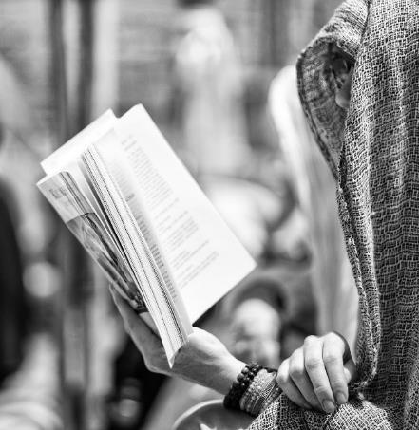
Kuva: Christopher Michel (Linkki: File :Person reading a book.jpg - Wikimedia Commons)

Why should one read literature?

In general, it is evident that reading all kinds of literature is beneficial. The positive effects of literature can be gained not only from reading fiction but also from engaging with non-fiction and opinion pieces. Literature impacts us whether we read physical books or e-books.

What benefits does reading and literature offer? How can reading support one's work? Literature can support one's work in many ways, as numerous studies suggest that reading can develop skills that are specifically needed in the professional world. Additionally, various studies indicate that reading literature has numerous benefits that can be both psychological and physical.

Firstly, reading enhances social skills that are also necessary in the workplace. It expands vocabulary and improves self-expression. These skills are crucial for interaction in the professional environment. For example, according to a Finnish physician Atte Virolainen, the ability to express oneself and a broad vocabulary impact even the job application phase, as the applicant can describe themselves and their skills more comprehensively.

In some jobs, literature can even be directly applied to the tasks at hand. For instance, someone working in social work might organize reading sessions or address emotions through reading or writing.

The ability to empathize with others is also essential in the workplace. Research shows that reading literature increases empathy because it allows readers to explore different human experiences and lives. Reading, particularly so-called high literature, also affects brain function. The impact of reading is noticeable in the brain long after reading, and the more complex the narrative structure, the more actively the brain engages.

Memory is another crucial aspect in the workplace, and reading has a positive impact on memory. Reading improves long-term memory and helps practice the art of concentration. If one hasn’t read for a while, focusing on reading might be challenging, but persistence in reading gradually enhances concentration skills.

There are many physical benefits of reading as well: it lowers heart rate, relaxes the body, and helps to forget stressful thoughts. Reading in one's free time thus helps in coping better physically in the workplace.

Reading literature also has broader impacts. It helps in understanding oneself better. Through literature, one can strengthen their social or cultural identity. A frequent reader often becomes adept at expressing opinions, thus contributing to social equality. Vocabulary also improves through reading, especially when engaging with both classic and contemporary literature. Reading provides tools for understanding, interpreting, and analyzing information, thus preventing social exclusion. A person is less easily deceived if they understand what they are reading and can recognize false information. This way, individuals can better stand up for themselves in everyday life and the workplace.

“It could even be thought that a person who reads a lot is a friend anyone would want: intelligent, empathetic, and inventive.” (Puska)

Literature supporting your own work – tasks!

A. Watch the following videos and choose the correct answer option.
Background material: Videos from the Lukuliike project

1. Dog's Job Link to the video: Koiranvirka (youtube.com)
https://youtu.be/_qSOb0cE2MM?si=Uti57u6XW7eRlSp6

Question: Why did the person in the video start working as a dog?
a. Because they enjoy the outdoors
b. Because they love animals
c. Because they cannot read and don’t know what’s written in the contract. (correct answer)

2. Eye Candy Link to the video: Silmänruokaa (youtube.com)
https://youtu.be/9jpZIHARhAs?si=OMposno-IZiWexSn

Question: Why does the person in the video eat sheep’s eyes?
a. Because they like them
b. Because they cannot read and don’t understand what they’re ordering (correct answer)
c. Because they are adventurous

3. Scarlet Flower Link to the video: Tulipunatukka (youtube.com) https://youtu.be/WGYoMGGHGvY?si=uFs5HRAp0iRg2FSb

Question: Did the person in the video get the haircut they wanted?
a. Yes, because she is a fiery type
b. No, because she couldn’t read what the bottle contained (correct answer)
c. Maybe she did, maybe she didn’t

The task will be assessed as pass or fail.
You have to get 100 % right to pass.

B. My Profession in Literature

Are there works of fiction that depict your profession or touch upon it in some way? Choose one example where your field is depicted or referenced. If possible, read the work. Find the following information about the work and answer the questions:

What is the title of the work?
Who is the author?
What does the work address?
How is your profession portrayed in the work?
What do you think about how your profession is portrayed in the book? What thoughts does the work evoke?
If you cannot find any works related to or touching upon your field, only answer the following question:

Why might I not find works related to my profession?

Verkkotehtävän palautusohjeet. Muokkaa tarvetta vastaaviksi.

To return the assignment, click on the Add submission -button below.
Return online text: type your answer in the text box. Click the Save Changes button to confirm your text.

The maximum length of a text response is 400 words. Attach a photo of the work you have analysed to your task return.

The task will be assessed numerically, on a scale of 1 to 5.

Use of AI is not allowed

Conclusion
We´d love to hear your feedback! Please take a moment to share your thoughts.

Kyselyllä kerätään palautetta verkko-opintoina suoritettavasta tutkinnon osa-alueesta Art and creative expression, pakollinen (VVTL). Samaa kyselypohjaa voidaan hyödyntää myös lähiopetuksena suoritettavissa opinnoissa.
Palautteen avulla kehitetään opintojen laatua. Palaute annetaan anonyymisti.

Please rate your learning experience on a scale from 1 to 5 (1 = dissatisfied - 5 = very satisfied)

Interestingness of the topics
○ 1 ○ 2 ○ 3 ○ 4 ○ 5
Interestingness of content
○ 1 ○ 2 ○ 3 ○ 4 ○ 5
Benefit in terms of personal work and leisure time
○ 1 ○ 2 ○ 3 ○ 4 ○ 5

Usability of the study module
Please rate your learning experience on a scale of 1-5 (1 = dissatisfied - 5 = very satisfied)

Clarity of instructions
○ 1 ○ 2 ○ 3 ○ 4 ○ 5
Practicality of the e-learning environment
○ 1 ○ 2 ○ 3 ○ 4 ○ 5
Clarity of tasks
○ 1 ○ 2 ○ 3 ○ 4 ○ 5

Learning outcomes
Please rate your learning experience on a scale from 1 to 5 (1 = dissatisfied - 5 = very satisfied)

I can put into practice the knowledge and skills I have learned
○ 1 ○ 2 ○ 3 ○ 4 ○ 5
I think I achieved all targeted learning outcomes
○ 1 ○ 2 ○ 3 ○ 4 ○ 5

What contributed to my learning?

What was good about the course?

What could be improved in the course?

Overall assessment of the course

Please rate your experience of the course on a scale of 1 to 5 (1 = dissatisfied - 5 = very satisfied)

Overall rating of the studies
○ 1 ○ 2 ○ 3 ○ 4 ○ 5

Mikäli käytät Moodlen aktiviteettia, jossa opettaja saa opiskelijalta viestin, kun opinnot on suoritettu, liitä palauteaktiviteetti After studies -painikkeeseen. Opiskelija vastaa tähän palautteeseen painettuaan aktiviteettia.
Jos lisäät useampia vaihtoehtoisia tehtäviä, kirjoita myös niistä kysymys, johon opiskelija vastaa mitkä vaihtoehtoisista tehtävistä hän on suorittanut.

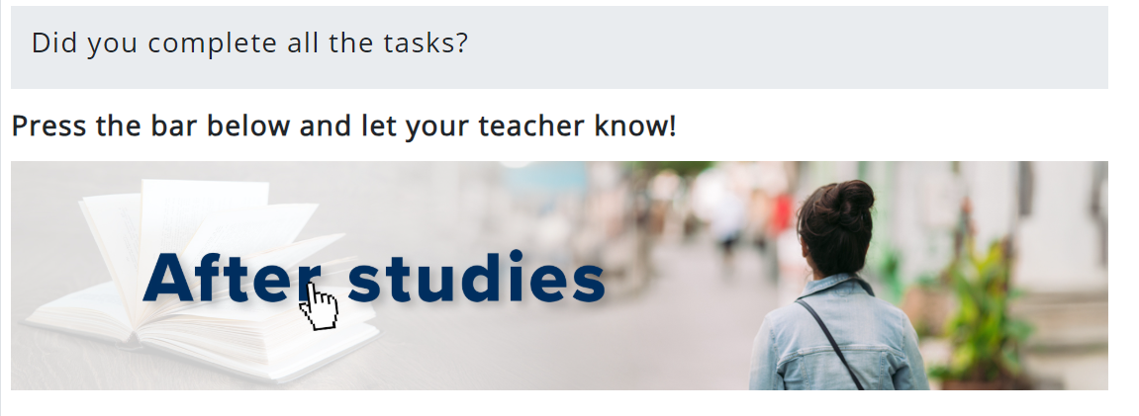
Kuvan lähde: Seinäjoen koulutuskuntayhtymä Sedun kuvapankki.

Check carefully that you have returned all the tasks. Answer a few more questions. The teacher will be informed of your answers automatically.

All tasks completed? Click here to let your teacher know!
I have completed all the tasks in every competence.
○ Yes
○ No
○ I don´t know

In learning goal 2.2. I have done the task:
○ 2.2.1 My dreams for the future - collage
○ 2.2.2 My profession - comic
○ 2.2.3 Creative self-introduction

Lähdeluettelo
Julkiset verkkosivut:

Kansallisgallerian kokoelmahaku. Luettavissa:
https://www.kansallisgalleria.fi/fi/search Luettu 11.11.2024

Kalsareista tehtiin renessanssimyssy – Näin hurahdimme karanteenitaiteeseen 2020. Luettavissa:
https://yle.fi/aihe/artikkeli/2020/05/23/kalsareista-tehtiin-renessanssimyssy-nain-hurahdimme-karanteenitaiteeseen Luettu 12.12.2024

Report on Taikusydäns´s Activities in 2023. Luettavissa:
https://taikusydan.turkuamk.fi/en/general/report-on-taikusydans-activities-in-2023/ Luettu 12.12.2024

Oxford Art Online. Grove art online. Benezit Dictionary of Artists. Oxford University Press 2024. Luettavissa:
https://www.oxfordartonline.com/page/europe-timeline Luettu 12.12.2024

Wikipedia, The arts. Luettavissa:
https://en.wikipedia.org/wiki/The_arts Luettu 12.12.2024

World Health Organization. Arts and health. Luettavissa:
https://www.who.int/initiatives/arts-and-health Luettu 12.12.2024

Tailkusydän. Arts for wellbeing. Arts and culture for health and wellbeing 2023. Luettavissa:
https://taikusydan.turkuamk.fi/en/frontpage/arts-for-well-being Luettu 12.12.2024

Taiko Finnish art online, taiteen verkkokauppa. Luettavissa: https://en.taiko.art/search?page=1 Luettu 12.12.2024

Marimekko, virallinen vieraskielinen verkkosivusto. Luettavissa: https://www.marimekko.com/us_en Luettu 12.12.2024

The intersection of art and health: How art can help promote well-being 2023. https://mcpress.mayoclinic.org/living-well/the-intersection-of-art-and-health-how-art-can-help-promote-well-being/ Luettu 12.12.2024

What is the evidence on the role of the arts in improving health and well-being? A scoping review 2019. https://iris.who.int/handle/10665/329834 Luettu 12.12.2024

Pantone Color Solutions, Trends, Guides and Tools, Pantone EU. https://www.pantone.com/eu/en/ Luettu 12.12.2024

Drawing Tutorials. Ram Studios Comics. Luettavissa:
https://ramstudioscomics.com/index.php/comic-art-and-drawing-tutorials/ Luettu 12.12.2024

Step-by-Step Guide: My Comics Process. ComicsForBeginners by Palle Schmidt 2024. Luettavissa: https://comicsforbeginners.com/step-by-step-guide-my-comics-process/ Luettu 13.12.2024

Wikipedia, Abstract art. Luettavissa: https://en.wikipedia.org/wiki/Abstract_art
Luettu 13.12.2024

Wikipedia, Figurative art. Luettavissa: https://en.wikipedia.org/wiki/Figurative_art
Luettu 13.12.2024

Wikipedia, Fan fiction. Luettavissa: https://en.wikipedia.org/wiki/Fan_fiction
Luettu 13.12.2024

KS2 Writing poetry, BBC 2024. Luettavissa: https://www.bbc.co.uk/bitesize/articles/zsbsxbk#zyg3khv
Luettu 13.12.2024

Guide for Writing in Theatre. Dr. Sergio Costola, Southwestern University. https://www.southwestern.edu/live/files/4182-guide-for-writing-in-theatrepdf
Luettu 13.12.2024

What is a Screenplay? An Introduction for Aspiring Screenwriters. Toronto Film School, Pajkovic, N. 2023. Luettavissa: https://www.torontofilmschool.ca/blog/what-is-a-screenplay/
Luettu 13.12.2024

MoMA Magazine, How to Make Comics: What Are the Elements of a Comic? Gavaler, C. 2021. Luettavissa: https://www.moma.org/magazine/articles/621 Luettu 13.12.2024

Sosiaalinen media:

Museokortti haastaa: tee oma versiosi taideteoksesta ja merkitse #karanteenitaidetta.
museot.fi/karanteenitaidetta https://www.instagram.com/karanteenitaidetta/. Luettu 11.11.2024

Videot:

What is creative wellbeing? Taikusydän-yhteyspiste. Youtube-video. Katsottavissa:
https://youtu.be/Uak9tEFIKGU?si=F8y4GYJBiCe9XmW2
Katsottu, 12.12.2024.

Unlocking the Functions of Art: More Than Meets the Eye! Sedu eKampus YouTube-kanava, tuotettu teköälyllä. Katsottavissa: https://www.youtube.com/watch?v=V0x9ZF2HKA4 Katsottu, 12.12.2024.

Taiko Finnish Art Online. Taiko.fi YouTube-kanava. Katsottavissa: https://www.youtube.com/watch?v=ncaJWISJJWc&t=13s
Katsottu, 12.12.2024.

How to Make a Collage – Materials, Composition and Tips. Mr. Otter Art Studio YouTube-kanava. Katsottavissa: https://www.youtube.com/watch?v=sLooH5Y_Rk8
Katsottu, 12.12.2024.

Nasic Collage Techinques, Learn beginner steps to create collage art. Blue Lava Art YouTube-kanava, Russo Scherr, J. Katsottavissa: https://www.youtube.com/watch?v=_0r_sgEMpak
Katsottu, 13.12.2024.

How to Start Drawing Comics - Working with Primitives. Proko YouTube-kanava. Katsottavissa: https://www.youtube.com/watch?v=JwMXTQi4ya8
Katsottu, 13.12.2024.

Basics of Comic Composition. Proko YouTube-kanava. Katsottavissa: https://www.youtube.com/watch?v=5KX7WpRVtVU
Katsottu, 13.12.2024.

Koiranvirka. Opetus- ja kulttuuriministeriön YouTube-kanava 2018. https://www.youtube.com/watch?v=_qSOb0cE2MM
Katsottu, 13.12.2024.

Silmänruokaa. Opetus- ja kulttuuriministeriön YouTube-kanava 2018. https://www.youtube.com/watch?v=9jpZIHARhAs
Katsottu, 13.12.2024.

Tulipunatukka. Opetus- ja kulttuuriministeriön YouTube-kanava 2018. https://www.youtube.com/watch?v=WGYoMGGHGvY
Katsottu, 13.12.2024.

Kuvat:

Pixabay (CCO)
Kansallisgalleria (Tekijänoikeusvapaat)
Wikimedia (CC)
Seinäjoen koulutuskuntayhtymä Sedun kuvapankki.

Kuvalinkit:

Kartio ja Teema, katsottavissa:
3322216631_e2e976d3a3_z.jpg (576×432) Katsottu 12.12.2024.

Ultima Thule, katsottavissa:
Iittala_Ultima_Thule.jpg (4032×3024) Katsottu 12.12.2024.

Aalto-lasi, katsottavissa:
8588726677_019e790b1e_c.jpg (800×494) Katsottu 12.12.2024.

Aalto-vaasi, katsottavissa:
0085509ed68772357c04efe1b3c103cc3bc2cf0d57246479b4e2cdd438e5720a.jpg (2048×1729) Katsottu 12.12.2024.

S-pata, katsottavissa:
10056988294_d924a3bb21_h.jpg (1500×1500) Katsottu 12.12.2024.

Unikko, katsottavissa:
Marimekko_Unikko.jpg (500×504) Katsottu 12.12.2024.

Toronton kaupungintalo, Sivusto SNmatkakuvaaja, sakuva.kuvat.fi. Katsottavissa:
KANADA: CA309502 Kanada Toronton kaupungintalo (Revell) Katsottu 12.12.2024.

Finlandia-talo, katsottavissa:
Finlandia_A-Wiki.jpg (2429×2198) Katsottu 12.12.2024.

Eduskuntatalo, katsottavissa:
Eduskuntatalo_-_panoramio_(1).jpg (4612×2593) Katsottu 12.12.2024.

Hospiz Betel, kuva Milla Järvipetäjä / Bryggman Institute. Katsottavissa:
Hospitz Betel · Finnish Architecture Navigator Katsottu 12.12.2024.

Leena Luostarinen, Ariana Aus Naxos, katsottavissa:
a3bcb945cfa7fa2816af2f8f3e5573df_l.jpg (842×550) Katsottu 12.12.2024.

Hannu Siren, Lähtö:
1920px-Hannu_Siren_Lähtö_1979.jpg (1920×1081) Katsottu 12.12.2024.

Juhana Blomstedt, Vapaaheitto:
Vapaaheitto_fotoByKuvatapio.JPG (1500×1004) Katsottu 12.12.2024.

Soile Yli-Mäyry, Asphalt Light
5658294861_89f27b7679_h.jpg (1599×1261) Katsottu 12.12.2024.

Kuutti Lavonen, Pyhän Olavin kirkon maalaukset, katsottavissa:
3934591864_dabf1fcb0e_k.jpg (2047×953) Katsottu 12.12.2024.

Markus Copper, Seitsemän meren arkkienkeli, katsottavissa:
pic_5_5562055_k7192899_1200.jpg (793×1200) Katsottu 12.12.2024.

Christopher Michel. Person reading a book.jpg - Wikimedia Commons. Katsottu 13.12.2024.

Tämä materiaali on tuotettu VIERKO-hankkeessa
vuonna 2024.
VIERKO on toteutettu Opetus- ja kulttuuriministeriön
vuonna 2023 myöntämällä ammatillisen koulutuksen strategiarahoituksella. VIERKO on kuudenkymmenen-
kahden (62) koulutuksen järjestäjän yhteisponnistus.
Työtä on koordinoinut Keski-Uudenmaan koulutus-
kuntayhtymä Keuda.

Hankkeessa on kehitetty vieraskielisen koulutuksen laatua
ja kotimaisten kielten opetuksen tarjontaa ammatillisessa koulutuksessa.

Lisätietoa:
https://www.keuda.fi/keuda/hankkeet/vierko/

https://creativecommons.org/licenses/by/4.0/

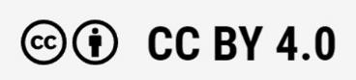
Oppimateriaalit:

CC BY-SA 4.0 Deed | Nimeä-JaaSamoin 4.0 Kansainvälinen | Creative Commons
https://creativecommons.org/licenses/by/4.0/

Oppimateriaalit:

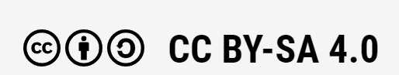

CC BY-SA 4.0 Deed | Nimeä-JaaSamoin 4.0 Kansainvälinen | Creative Commons

APPENDIX 1

APPENDIX 1 Art at Work

The word culture refers to all human activity and its products. Art is also part of everyday life: its various forms are part of your life. You can use art in many ways, both at work and in your free time. As a worker, you are expected to be punctual, goal-oriented and determined, for example. You will also need to learn new things and be able to adapt to changing situations. You may have to adapt to change very quickly. Art can help you in difficult situations. For example, listening to music can help you calm down or give you more energy. Art can help you enjoy your work and improve your performance. Art can also inspire you and make you more efficient at work.

What are the Benefits of Art for the Working Life and the Worker?
Aesthetics means beauty and good taste. Art is reflected in the aesthetics of built spaces and environments. Examples include the design of buildings and parks, home decoration, photography, etc. An aesthetic, inviting and welcoming space helps you learn and encourages creative thinking and ingenuity. Art can also help you in your professional life. Above all, art also helps you to cope. Listening to good music, watching a film, reading a book or visiting an art exhibition can help you to cope with everyday life. Art can also be useful in a broader context at work. For example, in education, art-related tasks can help you to improve your work-related skills. It also helps you to realize and understand things in a new way. Different artistic methods can be used to make the values, rules and attitudes of the work community visible. Creative writing or improvisation exercises, for example, can also be used to help employees understand how to act in different situations.

The art-based method means working with different art forms. Forms of art-based methods include word art, circus, film, photography, theatre, dance, visual arts, music or a mixture of different art forms. Employers can use art-based methods if they want to strengthen trust and a sense of community among employees. Various art-based methods can be used to develop cooperation and interaction skills in the work community. Art can be used to improve employee well-being and work organization. It can also help to maintain good management.

Employees have a responsibility to develop their own work and working conditions. Art-based methods can strengthen the employee's self-esteem and commitment to work and the work community. They can also help to alleviate feelings of incompleteness and diversity. Participation in artistic activities can also strengthen mental balance. Art also revitalizes, refreshes and helps maintain mental balance.

APPENDIX 1

Art and Creative Solutions

Art-based activities can be used to develop solutions to existing problems and find new ways of looking at things. Artistic work can help employees, the employer and, at the same time, the whole work community. Through art work, employees can reflect on their relationship with their work and strengthen their motivation to work.
The positive impact of art-based methods on the work community is often linked to quality. They are not easy to prove, as they have an impact in many ways. Good effects cannot always be guaranteed, measured or proven. The easiest way to identify an arts-based intervention is to look at and write down a changed situation using a variety of examples. If at least some of the employees feel that art-based working is important and significant, the change will be worthwhile.

The Impact of Art on the Work Community

The functioning and working methods of the work community can be improved by working with art-based methods during working hours. For many, doing art during the working day can be a confusing experience. Art-based activities are usually facilitated by an art professional. They may lead the activity alone or in collaboration with professionals in fields such as social work, health or education. The methods of art-based work can be applied to group or individual work. The methods can help you to better understand your own professional strengths and how you work in different situations. An important starting point is your own attitude and curiosity about new working methods.

Relations Between Art and Workers

A specialist in art-based practices may be called in if there is a dispute or disagreement between employees. However, art-based methods do not solve the problem or provide therapy. However, they can help to make the problem more understandable and can also have a therapeutic effect. However, seeing the result of your creative work is usually always rewarding.
Participating in art is about working together. Involving the work community in arts-based activities makes for more collaborative and imaginative working. Doing art together can also make it easier to cope with change and increase well-being for all. The responsibility for well-being at work is always shared: the result of the work community, management and employees.

Art and Culture for Health

In their book Culture and Health, Markku Hyyppä and Hanna-Liisa Liikanen say: "Cultural and artistic experiences are positive emotions that are related to people's social relationships and maintain well-being." Health is nowadays defined as physical, mental and social balance in

APPENDIX 1

relation to people's life goals. Research shows that culture and the arts are known to be resources that have a positive impact on health.

Art does not leave you cold, they say. Art, in its various forms, can be a holistic experience of enjoyment that engages the whole person and gives a strong sensory and emotional satisfaction. Art is a product of creativity and a means to positive ends. Pleasure and displeasure are emotions. Emotions are at the intersection of culture and health, acting as a bridge between the human community and the individual. Cultural and artistic experiences generate emotions that influence and balance the psycho-physiological regulatory system in the brain. A permanent balance of the human mind, brain and body's regulatory system with the social environment is the key to well-being and health. Emotions affect the whole person, including bodily functions, memory, cognition, intellectual functioning in general and the personality. Hyyppä (1997) gives a good description of this: "When you meet an old friend, your heart pounds (from excitement), your skin tingles (from excitement), your facial muscles change (to joy), your other muscles relax (to friendliness) and your bowels calm down (from empathy). Changes occur in the internal organs, glands, muscles and immune system, which are then transmitted via nerve pathways to the frontal lobe, where the self-regulating nervous system, motor nervous system and hormone secretion are activated. For example, if stress hormones are released on high levels and the autonomic nervous system becomes overactive, the human immune system is weakened. This in turn contributes to illness."

People need experiences and beauty in their everyday lives. Art and culture are easy to access and are around us all the time. Can people grasp them? For example, do care institutions know how to support celebrations or rituals that are important to people. Do they celebrate birthdays, Christmas, Midsummer? Does the architectural environment support people's well-being and comfort? Does it make good use of interior design, lighting, colors and shapes? These all play a role in people's well-being and health. They can even help people to heal more quickly. It is important to remember that for many people, their everyday environment and long-term home is a care home.

Their studies (Hyyppä, Liikanen) have identified four major factors that support the positive impact of arts and cultural activities on human well-being. First and foremost, art as an experience, meaning and art experience as such, as part of human needs. Art stimulates the senses and enriches the world of experience. The second is the link between arts and cultural activities and good health, better working capacity and good life experiences. Thirdly, the sense of community and networks created through cultural activities and leisure that help us to manage our lives better. Fourth, the impact of art, architecture and interior design to create a more welcoming environment. Beautiful surroundings and nature are invigorating and contribute to rehabilitation.

APPENDIX 1

Key Issues in the Text
- An aesthetic, or beautiful and inviting space to help you think creatively and be inventive
- Art revitalizes, refreshes and helps you to cope.
- Art contributes to the well-being of the employee and the work community.
- The art-based method means working with different types of art.
- Art-based working methods can be applied to group or individual work.
- Art-based methods can be used to strengthen an employee's self-esteem and commitment to work and the work community.
- Art-based working can be used to develop solutions to existing problems and to find new ways of looking at things.
- Involving the work community in art-based activities increases the flow of cooperation and ingenuity.

APPENDIX 2

APPENDIX 2 Art and Creative Expression in Different Professional Fields

Key Concepts in the Text:
- aesthetic means beautiful, aiming at beauty or aiming for beauty. Showing good taste.
- culture means all the products of man and his activities. Culture is the totality of the intellectual and material achievements of a community or of humanity, i.e. civilization. Culture can also refer to a person's habitat, environment or way of interacting with other people.
- design language refers to the appearance of an object or design product. It can express the look typical of the designer, i.e. the product's designer or the period.
- ethics and morality are almost the same thing. They consider what is the right thing to do. Ethics is a field of study that examines morality and the principles of ethical behavior, such as what is right and wrong. Ethics is about good and evil, values and norms, rights and duties. Morality refers to the practical action of human beings in accordance with ethics in matters of ethics.
- physical bodily, made by hand or by the power of the body, pertaining to the body, material.
- professional ethics is a branch of applied ethics that deals with the ethics of professional actions. Professional ethics encompasses the purpose of actions and the goals of action. Professional ethics are sustainable, ethical and responsible.
- psychic mental, thought and mind activity.
- quality target means the degree of accuracy. Quality is the measure of the extent to which a product or products meet the requirements.
- style is reflected in the products of all art forms. Periods and regions in history share stylistic features that can be used to show that a work belongs to a period, a region (country) or even an artist. Style history divides historical periods into different stylistic periods according to style.
- visual means that something is perceptible, visible, to be seen. Pertaining to outward appearance, usually beautiful.

Art and Creativity in the Vehicle and Logistics Sectors

High professional ethics and customer service efficiency are required of those working in the vehicle sector. They are expected to be self-motivated, punctual, decisive and able to work with a variety of people in a team. Decisiveness, cooperation and punctuality are qualities that can also be developed through artistic and creative expression. The professional ethics of those working in this field must also be high. They must be able to work in accordance with the quality objectives set. They must also be able to improve their own performance to
APPENDIX 2
achieve them. They must take responsibility for the cleanliness of their working environment and for maintaining an orderly working environment. A functional, clean and pleasant working environment brings efficiency and increases productivity. In customer service situations, when talking to customers, a broader knowledge of art and culture is already required. It is useful to be familiar with the history and style periods of design in your profession, the most famous car models, brands and designers.

Logistics workers need to understand the importance of physical and psychic performance in their jobs. They are expected to have high morals and professional ethics, a positive attitude towards others and a customer-oriented mindset. Art and art activities can develop mental well-being and enhance social interaction skills. Those working in this field are expected to work with specialized client groups in service and interaction situations. Artistic activities can enhance social well-being and improve cooperation and interaction skills. Workers in logistics also need to be able to maintain, evaluate and develop their working environment. They can influence their environment in terms of visual, aesthetic, social, material and cultural factors. Improvements to the physical environment of the workplace can create a more relaxed, warm and airy atmosphere. The successful performance of tasks in this sector also requires the maintenance of good physical fitness. Artistic pursuits have been shown to be directly linked to mental well-being and job performance. A valued employee develops the appreciation of his or her profession through his or her own activities, and art enhances the ability to make creative decisions.

Creativity and Art in the Hairdressing and Beauty Care & in the Textiles and Fashion Industry

Hairdressers and beauty carers working in the hair and beauty sector are expected to be innovative, creative, have a good aesthetic vision and be proactive. All expectations in the sector are in line with the competence objectives for art and creative expression. The value base of the sector is a successful service package: a welcoming environment and customer-oriented service skills. Professionals support and guide the client's individual style and beauty and make them feel good. The client's individual style and beauty must be supported, guided and supported, and the client's well-being must be ensured. To achieve the skills required by the value base of the sector, students should also have a good knowledge of the history of style. Knowledge of key works in the history of art helps to understand the history of style and, where appropriate, provides a historical reference for hairstyles from different periods. An understanding of the history of hairstyles also serves as inspiration. In addition, knowledge of the subject requires overall visual and compositional skills. Drawing skills also need to be practiced, for example for sketching hairstyle designs. The most important aspect of the sector is to master the aesthetic aspect of customer service.

Fashion, interior design and textiles workers are expected to have an interest in dress, fashion, design and color. All these requirements are also included in the objectives of artistic and creative expression. Fashion is part of art and its study. It requires creativity and problem-solving skills, as well as the ability to perceive the visual environment.

APPENDIX 2
Undergraduate degrees in the field cover the history and styles of dress. In the interior design sector, you will study styles, colors, lighting and materials and how they interact with each other. Artisans are required to have an interest in traditional working methods, materials and restoration, as well as in manual skills. A broad knowledge of national, local and European art underpins the study of the profession and serves as a reference point and inspiration for new creation. Creativity and problem-solving are essential for all workers in the fashion, interior design and textiles sectors. The mission of the fashion, interior design and textiles sector is to provide products and services that satisfy the needs of consumers and customers for protection and aesthetics. The objectives of the production of a product or
service are usability, high quality, health, aesthetics and pleasure. Working in the sector is based on collaboration with a wide range of stakeholders. Networking and successful cooperation, both nationally and internationally, require respect for customers and fellow human beings, knowledge and appreciation of each other's work, environment and way of thinking, and an equal and tolerant attitude.

Harnessing Creativity in the Agricultural Sector

In the agricultural sector, you are expected to be cooperative and willing to learn new things. They need to maintain their working capacity and be able to take on different tasks without prejudice. Studies have shown that artistic pursuits have a direct link to mental well-being and job satisfaction. Art-based methods can help in work situations, improving job satisfaction, efficiency and performance. For example, listening to music while working can brighten up your day. The requirement skills also include the ability to actively contribute to the sense of community in the workplace. This can also be promoted through art-based methods. Those working in agriculture must also understand the importance of cleanliness for the well-being of the workplace and maintain cleanliness on their own initiative. Improvements to the physical environment have been found to play a role in creating a more relaxed, warmer and happier atmosphere.

Art and Creativity in the Surface Treatment, Wood Industry and in Construction

Those working in the surface treatment sector must have a broad appreciation of different forms of art and culture. The aim of the sector is to create the conditions for a comfortable and pleasant built environment. This requires knowledge and practice of aesthetics appropriate to the sector. They must be able to work with neatness and precision and keep their workplace tidy. The most relevant forms of art and culture are the visual arts, in particular al secco and al fresco wall paintings and various ornamental styles. A general knowledge of architecture is also important. The painter will also have an advantage in recognizing the style history prevalent in Finland and the details associated with them, such as interior decoration styles. In decorative painting, the painter should recognize the main professional traditions in his field and strive to maintain them to a reasonable degree. This requires knowledge of the built cultural heritage. Purely creative expression is required, for example in the knowledge of the principles of coloring. Knowledge of the styles and ornamentation of different periods in Finland.
APPENDIX 2

Aesthetics and ease of use of manufactured products are core values of the wood industry. The sector must recognize the diversity of art and culture. For those working in the sector, the most important art form is design, i.e. the design and shaping of an object. They must be able to demonstrate the various manufacturing options that affect the production and appearance of a product, considering the effects of different materials and technical solutions on the final product. In addition, when manufacturing a product for a customer, they must be able to take account of the customer's wishes when planning the execution of the work and present alternative solutions for the execution of the work. All of these require creative expression skills, the ability and willingness to develop one's own creative expression in a goal-oriented manner. It is also important to recognize the stylistic differences between cultures and art forms and the details associated with them, such as interior and design styles.

A person working in the construction industry must have a broad understanding of the different forms of the built environment. For the builder, essential values include achieving quality objectives, comfort, aesthetics and the preservation of the building's heritage. To achieve these values, students should be able to identify architectural traditions and cultural contexts, including differences in style. Multidisciplinary skills are an asset for those working in the field, as there are always good employment prospects for a skilled and qualified worker. Multidisciplinary requires a broad knowledge of the whole sector, including the arts, such as architecture. Architecture includes not only building design and construction drawings, but also all aspects of urban planning, such as designing and drawing up plans. Students should also recognize the percentage principle of building, which contributes to the amenity of the built environment. They must also work to set quality objectives and develop their own activities to achieve them. In addition, art and creative expression have an essential impact on well-being: a competitive worker in the sector is motivated to maintain and promote his or her ability to function and work independently.

Artistic Skills in the Restaurant and Catering Service, Food Production, Cleaning and Property Services

Restaurant and catering chefs and waiters are expected to be prompt, systematic, flexible, creative and economical in their work. The ability to work creatively is therefore one of the basic requirements for a worker in this sector. A versatile capacity for creative expression is required. The use of color, visuality and aesthetics are applied to the design of dishes. Visuality is also essential in the construction and commercialization of food portions. The attractiveness of a dish can be enhanced by, for example, the right composition. Consideration of the aesthetics of the dining space and the choice of decoration will be made to reinforce the theme of the event. Knowledge and understanding of the form of design products such as textiles and tableware are an important part of visualizing a welcoming space. The tableware is also composed to suit the occasion and the space. Employees need to be familiar with color, balance and appropriateness. More artistic and creative expression is required of the entrepreneur. For example, a business idea should be designed to be
APPENDIX 2
visually and culturally appealing. This can include a wide range of content that is relevant to the curriculum of artistic and creative expression.

Food makers, baker-confectioners, meat products processors and dairy persons working in the food industry are expected to be responsible, punctual, tidy and quality-conscious. Food plays an important role in preserving Finnish food culture and the living countryside. People working in this sector must be familiar with the culture and traditions of the region. In food production, the objectives are safety, high quality, healthiness, ease of use, aesthetics and pleasure. The study and practice of art and creative expression develops an eye for quality. The products produced must have an attractive appearance. A holistic appreciation of craftsmanship and responsibility for maintaining one's own well-being are also key principles. The need to respond to changing situations and requirements is facilitated using art-based working methods. Artistic methods help people to innovate and embrace change.

Those working in the cleaning and property services are expected to be self-motivated and have good interpersonal and interpersonal skills. You will work on a variety of customer sites. You will be required to be able to independently observe and identify issues relating to the comfort, condition and functionality of a property. A comfortable and pleasant environment increases customer satisfaction. Art can be used to make the environment more relaxed, warm and cheerful. Those working in the cleaning and property sector should also recognize the importance of a visually and aesthetically functional environment for well-being. A skilled professional will also develop their practice in response to feedback. A visually appealing environment increases customer satisfaction.

It is important for people working in all sectors to recognize the importance of cultural pursuits as part of life and of arts experiences as part of life management (e.g. understanding the healing effects of the arts, the pleasurable effects and the use of the arts to promote autonomy and functional capacity with different client and patient groups).

The Role of Art and Creative Expression in the Social and Health Care Sector

Social and health care jobs aim to promote both your own wellbeing and the wellbeing and good life of your clients. Art is reflected in the aesthetics of the environment: spaces must be comfortable, refreshing and pleasurable. The appropriateness of the space is also influenced by the physical and psychic effects of the colors and design used in the space, such as the use of light and natural elements, the use of empowering art and the creation of experiences. Social and health workers need to understand the role of art and creative expression in maintaining and promoting their own health and the health and functional capacity of their clients. Wellbeing can be achieved, for example, through aesthetic experiences, activity, joy and life management by art and culture.

APPENDIX 2
The Role of Art and Creative Expression in the Business Profession

In business, for example in sales or finance, the ability and willingness to work with different people is essential. You must be able to work alone and in a team. They must be creative and curious and can work diligently and with a focus on results. All these qualities can be strengthened through skillful and creative expression. In business, it is also important for employees to contribute to customer satisfaction and positive experiences through their work. The employee must be able to prepare for service situations independently and find areas for improvement in customer-oriented activities. Visual skills can improve customer service and financial results, especially in sales. Employees must also understand their own role, the importance of their work and the principles of the organization as part of a productive work community and well-being at work. All the above can be found in art and culture. Employees need to take care of their professional profile. It is an advantage to be able to use different digital channels creatively to communicate with clients. Art and creativity contribute to achieving the requirements.

APPENDIX 2

Creative Skills in in Electrical Engineering and Automation Technology

The electrical and automation worker should be able to get along with different stakeholders. They must also be eager to learn new things. In addition, the basics of international competences, such as intercultural competence and multiculturalism, are essential for workplace interactions. The ethical goals of the sector are operational reliability, customer focus, entrepreneurial spirit, a total economic approach and responsibility for the well-being of staff. The arts and creative expression can be used to achieve all of these.

Creative Skills in in Information and Communications Technology (ICT) Jobs

Anyone working in ICT must have good professional ethics. Workers in this field are subject to strict confidentiality requirements. Workers handle equipment and systems where citizens' personal data are stored or transmitted. The short life cycles of products and the rapid renewal of different generations of equipment also place greater demands on the customer service skills of those working in the sector. Rapid innovation and development in information and communication technologies require self-development. Art-based methods help to innovate and absorb change. In the management of working methods, tools and materials, students and workers in this field are expected to have a broad knowledge of the aesthetic principles of the sector. The sector must promote a comfortable and attractive working environment to improve the result of the work carried out. A holistic knowledge of aesthetics is therefore required, as is the ability to assess and develop one's working methods and working environment.

Creative Thinking in in Building Maintenance Technology Sector

The building maintenance sector, the plumbing trade, is part of the building industry, which is based on the value of the human need for protection from the elements and the need to improve the functionality of buildings and their integration into the environment. Its social purpose is to safeguard the quality of life, the functioning of society and the health, safety and well-being of the built and natural environment. The result of the work process must be of high quality, economical and functional. The worker must be able to work to the quality objectives set for the work and to develop his/her performance to achieve these objectives. They must also assess their own work against quality standards. A quality eye is developed through the exercise of creative thinking. In addition, good cooperation skills are required. Understanding the needs of different stakeholders and working constructively together requires a broad range of skills and understanding, including the objectives of art and creative expression.

Aesthetics in Mechanical Engineering and Production

The core value and starting point for the mechanical engineering and production sectors is product quality: durability and reliability, safety, functionality, ease of use, low energy
APPENDIX 2
consumption and aesthetics. Manual dexterity and precision are key assumptions for those working in the sector. Products manufactured in this sector must be dimensionally accurate. Specialized skills can also be

oriented towards design and product development work. The worker must be able to solve problems and develop better ways of working based on feedback. Knowledge of arts and cultures can enhance the ability to design different solutions for tasks requiring design and problem-solving skills. The requirements of the sector also include the systematic development of skills and working capacity and the identification of areas for improvement. Art and creative expression are essential for the independent maintenance and development of working capacity and well-being.

APPENDIX 3

APPENDIX 3 Visual Arts - Reading a Picture

Analysis of the image using methods based on stylistic history and formal analysis, i.e. the form of the work.

Interpret the picture from the following ten different perspectives:

1. Form
2. Color
3. Texture
4. Movement
5. Time
6. Space
7. Materials
8. Narration or narrative
9. Issues of power
10. Experientiality

1. Form
- are there any exceptional forms in the work?
- what shape is the work itself?
- is the work horizontal or vertical?
- balance?
- are there any diagonal or rotating movements?

2. Color
- what is the main colour of the work?
- colour analysis:

- colour always depends on light, while light has a particular impact on experience
- lighting arrangements
- the softness of the colour, the texture of the surface, its evenness or unevenness
- how colour appeals to the emotions
- colour harmonies, inharmonies
- quotations, i.e. whether the colour refers to some other subject, whether the colour is a commentary on something else

3. Texture, i.e. the surface structure of the material

- sense of touch - eye contact (pay attention to sense of touch, especially in a 3-dimensional object)
- in what way is the author present through texture?

APPENDIX 3

4. Movement
- optical vibration
- rhythms
- tensions between parts
- direction of movement (out, out, center, opposition, up, down, etc.)
- tensions within the work and with the environment
- calmness or restlessness
- how is the movement created or stopped, why?

5. Time
- the longer the distance, the longer the time between parts.
- metaphors¹ (hourglass, magnifying glass, still lives)
- quotations in time, references to earlier art or works

6. Space
- sensing space, work in space
- perspective
- structuring the space
- moving in space
- spatially moving works (optical movement or "real movement", the work appears to move in the eye or moves in a real, mechanical way)
- empty space (essential!), full space
- intensive space

7. Materials
- different materials affect us in different ways
- what is the main material of the work itself?
- value perceptions, value-linkage and price of the material?
- is the material expensive or cheap?
- are ideological material choices (e.g. organic or recycled materials) used in the choice of material or in the presentation of the product

8. Narration or narrative
- content questions, what does the target present? (e.g. in abstract art, the interior is often revealed through the name and date of the work)
- narrative in relation to similar works of art?
- quotations, references, identifiability
- iconography:
- attributes ²
- ancient mythologies
- identifying the symbols
- symbols familiar to the public, culture-specificity

APPENDIX 3

9. Issues of Power
- different politics (e.g. ethnicity, commercialism, gender, feminism)
- ideologies, ideology criticism
- visual politicization
- viewer's position or seat
- staring works (self-portraits, portraits)

10. Experientiality
- how do I experience this work of art?
- what emotions does the artwork evoke?

APPENDIX 4

APPENDIX 4 Composition

Composition also refers to good composition, i.e. the arrangement, grouping or setting of different parts of a picture in such a way that the parts form a coherent, interesting or meaningful whole. The general view is that a work of art is aesthetically pleasing when its parts together create a balanced impression. Harmony is achieved if the composition appears stable, and there is no need to add or remove anything.

The aim of composition is to structure and organize the image. If the arrangement of the elements is successful, the image retains its attractiveness and is easy to perceive. If a picture is to be "hidden" things too, it is done by embellishing the elements in relation to each other. The basis for this is the natural need for man to organize and classify his environment, to perceive entities consisting of particles and vice versa.

We live in a world where the volume of visual communication has increased and continues to grow. To maintain the possibility of making genuine choices about ourselves and our actions, one must be able to interpret visual information on many levels:

Visual Level
  - What the picture is based on (formal review)
Emotional level
  - How do I experience the image? Reactions and emotions; do I like it or not? (experiential dimension)
Target level
  - What does the image maker mean by the elements of the image; idea, message, theme, valuations (meaning dimension)
Materialist Issues
  - How is the image made; with what medium and/or technique?
Contextual dimension
  - What is the background of the picture? At what time and place is the image bound.
  - The viewer's background (e.g. age, gender, education, experiences, etc.) also influences the viewing and interpretation of the image.

In interesting images, color, texture, content and mood often support each other and are significant from the viewer's point of view. By utilizing these elements, the viewer can be
APPENDIX 4
attracted to the image. One effective tool is the use of contrast, or opposites. They can reinforce or weaken the desired point in the image or even affect the interpretation of the image.

A good composition is used to structure and organize the image. If the arrangement of the elements is successful, the image will be interesting and easy to perceive. It is interesting to look at the picture, as it can please the eye, give the interpretation different possibilities or raise questions.

Each composition is equally correct, but one is more interesting than the other. Different people also like different things when it comes to composition. Next, some good compositional methods.

Basic Visual Elements

Point
A harmonic composition can arise from a single point because it is equated with the surrounding space. A point can be an independent part of a composition, but it is only the tension between the two elements that creates the impression of space and motion. Individual features of different sizes give an impression of depth.

Line
A line is the intersection of two surfaces or the groove of a moving point.
  - Horizontal line. The simplest straight line is a horizontal line. It is perceived as cold, flat and flat, calm and permanent, among other things. The balance is also attached to the horizontal line.
  - Vertical line. It is perceived as high, rising and solemn, warm and moving.
  - Diagonal. The third basic type of straight lines is diagonal, or diagonal line parallel to the diagonal. It tends to be dramatic, lively, and action.
  - Other features. The line can also include different movements: ascending, descending, circling, approaching, fleeing, slowing down and accelerating. The curved line is perceived as soft, dynamic and variable. The means of expression of the line are line direction, density, location, shape, darkness, thickness, quantity, breaks and rhythm.

Surface
The base surface is the surface on which the work is done. The shape of the base surface, i.e. the relationship of the sides to each other, determines the nature of the surface. The most balanced and neutral base surface is a square.

In compositing, attention can be diverted away from the corners by leaving them appropriately poorer, so that, for example, lines can be used to draw the eye to the most important parts of the surface. The upper part of the surface is usually perceived as light and
APPENDIX 4
the lower part as heavy. The upper part is also usually perceived as distant and the lower part as closer (e.g. landscape). The middle is calm.

Volume
Volume, three-dimensionality or mass.

Rhythm
Rhythm can mean regular repetition of lines, shapes, colors and degree of lightness or darkness. Rhythm is the force that binds the surface of a picture together, linking the different parts of the composition. The rhythm can be bound, where an element is repeated regularly, or free, where an element is repeated irregularly.

Balance
Balance, which can be either static, i.e. stationary, or dynamic, i.e. tense. An unbalanced composition is disharmonious. This is when the image feels unstable, and the viewer feels the need to change or move something.

Tension and dynamics
Tension and dynamics provide the image surface with event and life. The tension-free balance is easy and safe, but it seems monotonous after a while. Tension and dynamism are created, for example, by juxtaposing opposites. In compositions, pairs of opposites can be one-to-many, small-to-large, light-heavy, light-dark, rest-movement, open-closed.

Figurative transformers

The size of the shape is perceived in relation to the surrounding patterns.
The shape can be sharp, angular or round and can be visible or touchable by hand.
The placement of shapes is in relation to the surrounding shapes, e.g. above, below, next to and behind. Shapes can also be crossed, diagonal or parallel to each other. On the surface of the image, they may be in the center and on the edges.
The direction of the shapes can be on the surface so that it has a clear direction of movement. The trajectory may be upwards, downwards, leftwards, rightwards, diagonally, or in a circle or spiral.
Number of shapes: if there are only a few shapes, their placement on the surface or in space is crucial for composition. If there are many shapes, it is a good idea to group them together to create a structured whole.
The distance between shapes can be either even or variable. Parts that are close together form complete groups or figures.
The density of shapes is determined by the number of parts on the image surface or space. In a heavier, more powerful form, parts may be in a denser than light form.

APPENDIX 4
Placing things/objects in the picture

The golden ratio is an old compositional rule that applies to all visual expression. It is called the harmonic ratio, which helps in positioning the elements of an image. In simple terms, golden ratio means dividing a segment of a line by a ratio of 2:3, where the ratio of the longer part of the segment to the shorter part is the same as the ratio of the whole segment to the longer part.
The golden ratio was invented by the Pythagoreans in 500 BC, probably from a pentagon, where the ratio of diagonals to sides is distributed according to the golden ratio. A total of 200 golden sections can be discerned from the diagram.

The ratio of the Golden ratio is the same as the Fibonacci infinite number series, 1,1,2,3,5,7 etc. It appears repeated in all forms of nature, even humans, i.e. DNA molecules, are formed accordingly. The proportions of the Golden Ratio are seen in many ways in nature, for example in the number of petals on flowers, the spiral patterns of seed pods, the proportions in the shapes of shells and animal horns. The golden ratio in the composition of a work of art is above all the relationship of the details to the whole. What matters is where in the picture the figures or objects are placed.

The viewer's attention can be directed to the desired point by placing the most important element of the picture according to the golden ratio. The symmetry of the composition appears balanced. In a picture, the points of the golden ratio are the intersections of horizontal and vertical lines. For example, by placing the horizon on one horizontal line and the main subject on another vertical line, you have created an image with elements in the golden ratio.

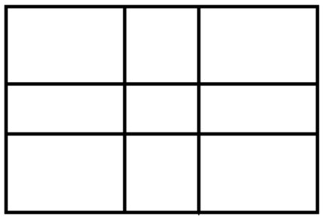

APPENDIX 4
The rule of thirds is a compositional rule used by visual artists such as photographers, painters and graphic artists. It is based on a simplified grid obtained through the golden ratio. The image is divided into nine equal parts vertically and horizontally. The four intersections of the lines can be used to place objects that are important for the composition of the picture. This can add more tension, power and interest to the image than placing the compositional elements in the middle of the picture. This grid can be found on most mobile phone cameras, or at least in photo editing software.

Contraposto is a compositional rule of ancient sculpture. The pose of a human figure follows the principle of rhythmic opposition, for example, with two parts of the body rotating in opposite directions. The weight of the body is then supported by one leg. In this way, the posture appears more relaxed and natural.

