Foresight for Export Growth - Anticipating Future Skills Needs
A Hands-on Guide for
1. Finnish SME Exporters eager to initiate or expand export operations,
2. Students with aspirations for a future career in the export industry,
3. Professionals transitioning to the export industry from other sectors, and
4. Individuals seeking initial orientation in export during onboarding processes.

Welcome to the course!
Congratulations on taking a proactive step in investing time and energy in professional growth and expertise in the dynamic field of export!
In this course, you will gain essential knowledge and practical skills that are directly applicable to your role as an SME exporter, student, or professional transitioning to the export industry.
The course explores futures thinking and foresight in the realm of export. Through four insightful episodes, we'll examine crucial aspects for succeeding in today's global marketplace, focusing on anticipating future skill needs for the next 3-5 years.
You'll learn how businesses can use futures thinking and foresight principles to boost their competitiveness in international markets. Each episode provides valuable insights, practical strategies, and tools that you can apply to your export endeavors.
As you move through the course, we encourage you to reflect on what you've learned and think about how to integrate these principles into your business practices. By adopting foresight, you'll contribute to unlocking new opportunities for growth and innovation.
Remember, success comes from applying what you learn. Take the time to assess your needs, identify areas for improvement, and take action to implement positive changes. Let's explore the transformative power of foresight in driving future export growth.
Your journey to long-term success begins now!

Episode 1: Benefits of Futures Thinking and Foresight for Export Businesses
Episode 2: Assessing Skills Data for Future Export
Episode 3: Creating Export Skill Scenarios
Episode 4: Applying Scenarios Strategically in Export

Learning Objectives:
You will be able to
Define futures thinking and foresight and fundamental concepts related to them. Recognize the benefits of futures thinking and foresight for export businesses.
Evaluate the pros and cons of different data sources in anticipating future skills needs in a 3-5-year horizon.
Utilize the PESTE framework to collect and categorize data on political, economic, social, technological, and environmental factors affecting exports. Analyze these factors to anticipate their impact over the next 3-5 years, synthesizing data into scenarios that forecast future skill needs and challenges in the export sector.
Apply scenarios in strategic planning and decision-making processes for export businesses to proactively manage and prepare for future skill needs. Continuously refine scenarios based on evolving data and insights to effectively anticipate and address future skill requirements 3-5 years ahead.
To achieve the learning outcomes, you must take responsibility for your learning. We recommend that you invest in independent knowledge acquisition and the application of knowledge to your company's export trade.

Course Overview
In Episode 1, you will explore the transformative potential of futures thinking and foresight in gaining a competitive edge in export businesses.
In Episode 2, you will assess different data sources to anticipate future skill needs in a 3-5-year horizon.
In Episode 3, you will develop skills in synthesizing data into coherent scenarios for future skill needs in the export sector, using the PESTE framework to analyze external factors impacting exports over the next 3-5 years.
Episode 4 will guide you to apply scenarios in strategic planning and decision-making for export businesses, proactively managing future skills needs, refining scenarios with evolving data, and developing adaptive strategies for anticipated skill requirements 3-5 years ahead.

This course content is offered under a CC attribution share alike license. Content in this course can be considered under this license unless otherwise noted

Assesment & evaluation
This course is assessed with a pass/fail scale. To pass the course you need to familiarize yourself with the course materials and pass the tests and assignments with a passing score. The passing score is stated on each test. This course is valued as 1 study point which equals to 27 hours of studying.

Questions & communication
If you have a question about the contents of this MOOC, please contact the teacher responsible for this MOOC by sending an email to: TÄHÄN VASTUUOPETTAJAN NIMI JA YHTEYSTIEDOT

If you are experiencing technical difficulties, please contact the Laurea Service desk via their service portal: https://servicedesk.laurea.fi/ or send a message to servicedesk@laurea.fi

If you have questions about the crediting or completion of this MOOC, please contact the Laurea MOOC team via email: mooc@laurea.fi

Before contacting the MOOC team, please go through the FAQ section at the bottom of this page.

Remember, every bit of knowledge gained is a step toward expertise. Let's kickstart this learning journey together!

EPISODE 1: Benefits of Futures Thinking and Foresight for Export Businesses
Welcome to Episode 1 of the “Foresight for Export Growth - Anticipating Future Skills Needs” online course!
Are you ready to explore how to anticipate changes in the export industry? In this session, we'll equip you with foundational concepts to navigate the dynamic landscape ahead.
Here's what you can expect:
- Explore the concepts of futures thinking, foresight, and their application in anticipating changes in the export industry.
- Understand how anticipating future skills needs can significantly enhance your competitive edge in the export market.

Let's get started! First, ensure you grasp basic terms and their relevance to the export business. Study the text and videos, then test yourself with true or false statements to gauge your understanding.

Introduction - What is Futures Thinking?
Futures thinking is a method that explores multiple possible futures, rather than predicting just one.
It helps organizations and individuals:
- Envision different scenarios.
- Prepare for a range of potential outcomes.
- Identify uncertainties and understand their implications.
- Foster a proactive mindset for strategic planning that is adaptable and resilient to change.

VIDEO :Illustrating Futures Thinking: Navigating a Global Pandemic Scenario
Imagine a scenario where a global pandemic significantly disrupts supply chains and consumer behavior. In this scenario:
Export businesses face challenges in sourcing raw materials and components, leading to delays in production and fulfillment.
Consumer demand shifts towards essential goods and online shopping, while traditional retail experiences a downturn.
Governments implement strict lockdown measures, impacting international trade and logistics.
Businesses that quickly adapt by diversifying their supply chains, investing in e-commerce capabilities, and implementing remote work policies thrive in this new environment.
However, those who fail to anticipate these changes struggle to survive, facing supply chain disruptions, decreased consumer demand, and financial losses.
This scenario highlights the importance of futures thinking in anticipating and preparing for various possible futures, enabling businesses to proactively respond to emerging trends and uncertainties.

Introduction - What is Foresight?
Foresight is a strategic planning process that helps organizations anticipate future trends, developments, and potential disruptions.
By analyzing current data, trends, and expert insights, foresight enables businesses to identify and prepare for various future scenarios.
The foresight process consists of different phases:
- setting the time perspective
- collecting data
- analyzing data
- use of the results
- follow-up

VIDEO:Foresight Process for a Food Sector Company

Setting the Time Perspective
The food sector company begins by setting the time perspective for its foresight exercise, considering the unique dynamics of the food industry. It may focus on short-term horizons to address immediate challenges, such as shifting consumer preferences, as well as long-term horizons to anticipate future trends, such as technological advancements in food production.
Collecting Data
The company collects a wide range of data sources relevant to the food sector, including market research reports, consumer surveys, industry publications, and government regulations. It also gathers insights from key stakeholders, such as suppliers, distributors, and consumers, to capture diverse perspectives on emerging trends and developments.
Analyzing Data
The collected data is analyzed using various analytical methods, including trend analysis, scenario planning, and SWOT analysis (Strengths, Weaknesses, Opportunities, Threats). The company identifies key drivers of change in the food industry, such as demographic shifts, technological innovations, and regulatory changes, and assesses their potential impact on its business operations.
Use of the Results
Based on the analysis, the company develops strategic insights and recommendations to guide its decision-making processes. It identifies opportunities for product innovation, market expansion, and strategic partnerships to capitalize on emerging trends and mitigate potential risks. The company also updates its business strategies and operational plans to align with the anticipated future scenarios.
Follow-up
The company implements a follow-up process to monitor the implementation of its foresight findings and track the evolution of key trends and scenarios over time. It regularly reviews and reassesses its strategic priorities considering new developments and adjusts its plans accordingly to maintain agility and responsiveness in the dynamic food industry landscape.

More Definitions (CONCEPT CARDS/KÄSITEKORTIT)
Practice with these concept cards to deepen your understanding and sharpen your ability to apply these concepts to the export industry.
Reflect on how each concept relates to real-world scenarios and consider its implications for strategic planning.
Embrace this opportunity to reinforce your knowledge and develop critical thinking skills. Happy learning!

Scenario
An internally consistent, plausible, and logical story of the future, which illustrates the development from the present toward a possible future.
Example: An exporting SME envisions a scenario where emerging markets in Africa significantly increase demand for eco-friendly products. The company prepares by developing a green product line and establishing partnerships in these regions.
Factor
A variable or phenomenon that describes changes impacting the future.
Example: A factor for an exporting SME might be changes in international trade regulations. Understanding these changes helps the SME adapt its export strategy to comply with new rules.
Driver
A key variable that causes alternative development paths.
Example: Technological innovation is a driver for an exporting SME. Adoption of new production technologies can lead to more efficient processes, enabling the SME to reduce costs and offer more competitive prices in international markets.
Actor
An individual or organization that influences the future through their decisions and actions.
Example: A major retailer in a target export market is an actor. Their decision to prioritize sustainable sourcing can influence the SME to adopt sustainable practices to meet the retailer's requirements and secure a contract.
Vision
A description of the desired future. A vision presents a goal to pursue, requiring action to make it a reality.
Example: The SME's vision is to become a leading exporter of high-quality organic food products in Europe. This vision drives the company to invest in organic farming practices and certifications.
Visionary concept
A future-oriented concept based on future market needs is identified in alternative scenarios.
Example: The SME envisions a future where aging populations in South America drive demand for digital health products. They create specialized smart health monitoring devices for elderly users, anticipating market trends. This vision stems from analyzing various scenarios, including demographic shifts, technology advancements, and regulatory changes. By exploring different futures, the SME identifies opportunities and develops strategies to meet emerging needs.

Key Assumptions Related to Futures Thinking
Unlock the power of futures thinking! Learn why understanding key assumptions about the future is crucial for navigating uncertainty and shaping outcomes.
This video explores how embracing uncertainty and actively shaping the future can empower you to thrive in an ever-changing world.
VIDEO: Key Assumptions Related to Futures Thinking
Ray Amara, a former president of the Institute for the Future, highlighted three key principles that futures thinking is based on:
- The future is unpredictable.
- This acknowledges that the future is inherently uncertain, and there is no single correct outcome.
- It encourages us to consider multiple possibilities rather than seeking a definitive answer.

- The future is not predetermined. It remains open to various possibilities and choices.
- This premise emphasizes that the future is not fixed and can be influenced by our decisions and actions.
- It invites us to actively shape the future through our choices.

- Our choices have an impact on the future.
- This premise underscores the active role of individuals and organizations as agents of change in shaping the future.
- It emphasizes the importance of considering not only external factors but also our own decisions and behaviors in creating future outcomes.
In summary, futures thinking invites us to be proactive, adaptable, and imaginative in navigating an uncertain world.

Tasks of Future Research Adapted from Roy Amara 1981
Unlock the secrets of effective future research.
This video reveals the core tasks of imagination, analysis, and participation, guiding you to envision possibilities, assess probabilities, and align future outcomes with collective aspirations.
VIDEO:
Imagination: What’s Possible?
- Involves creative thinking and envisioning various possibilities.
- Combines intuitive insights with objective information.
- Helps explore potential futures beyond what is immediately evident.
Analysis: What’s Probable?
- Focuses on assessing likely outcomes.
- Analyzes data, trends, and patterns.
- Considers the interests and actions of key actors in shaping the future.
Participation: What’s Preferable?
- Centers on values and desired outcomes.
- Encourages collaboration and cooperation.
- Aims for a future that aligns with our collective aspirations.
In summary, these tasks guide effective futures research and strategic planning.

True or False?
In this exercise, you'll encounter statements regarding the basics of futures thinking and foresight. Your job is to assess whether each statement is accurate or not, drawing from your understanding of the introduction and foundational definitions provided in the material.

1 Futures thinking predicts just one possible future. (False)
Futures thinking fosters a proactive mindset rather than a reactive one. It encourages organizations to anticipate potential future scenarios and prepare for them in advance, rather than simply reacting to events as they unfold.
2 Futures thinking helps in envisioning different scenarios. (True)
3 Futures thinking prepares only for a specific outcome. (False)
Futures thinking prepares for a range of potential outcomes. It acknowledges the inherent uncertainty of the future and encourages organizations to consider multiple possibilities rather than focusing on a single outcome.
4 Identifying uncertainties is not a part of futures thinking. (False)
Identifying uncertainties is a crucial aspect of futures thinking. It involves recognizing unknown factors and understanding their potential impact on future outcomes, enabling organizations to make more informed decisions and plan effectively in the face of uncertainty.
5 Futures thinking encourages a reactive mindset. (False)
Futures thinking fosters a proactive mindset rather than a reactive one. It encourages organizations to anticipate potential future scenarios and prepare for them in advance, rather than simply reacting to events as they unfold.
6 Foresight is a strategic planning process that helps organizations anticipate future trends. (True)
7 The foresight process consists of setting the time perspective, collecting data, and analyzing data. (True)
8 Use of the results is not a phase in the foresight process. (False)
The use of results is an integral phase in the foresight process. After collecting and analyzing data, the results are utilized to inform decision-making, develop strategies, and implement actions to shape desired futures, making it a crucial part of the overall process.
9 A scenario is a story of the past, not the future. (False)
A scenario is a story of the future, not the past. It is a narrative that describes one possible future outcome based on various factors and assumptions. Scenarios are used to explore different potential futures and their implications.
10 A factor describes changes impacting the future. (True)
11 An actor in future planning refers only to individuals, not organizations. (False)
In the context of future planning, an actor refers to both individuals and organizations that can influence future outcomes through their decisions and actions. It includes not only individual decision-makers but also organizations, institutions, governments, and other entities that play a role in shaping the future.
12 A visionary concept is based on current market needs, not future ones. (False)
A visionary concept is based on future market needs rather than current ones. It involves identifying emerging trends, shifts, and opportunities in the market landscape and developing innovative solutions to meet future demand. Therefore, a visionary concept looks ahead to anticipate future needs and trends, rather than solely addressing current market requirements.

Futures thinking and foresight
Now that you're familiar with the basic concepts, your task is to embark on Pentti's learning journey as the CEO of PureFinn Organics.
While Pentti is a fictional character, his experiences are relatable for aspiring entrepreneurs.
Dive into Pentti's story to uncover why futures thinking and foresight are vital for exporting SMEs.
Explore how anticipating future trends, challenges, and skill needs 3-5 years ahead can shape the success of an export venture.

VIDEO: Meet Pentti, the CEO of "PureFinn Organics", a small but growing SME that specializes in producing and exporting organic berry products. The company prides itself on high-quality, sustainable, and locally sourced organic berries. The company’s product line includes fresh organic berries, berry jams, and freeze-dried berry powders.
PureFinn Organics has a clear vision for the next five years: to become a European leader in providing sustainable and high-quality organic berry products while fostering environmental stewardship and community well-being.
To achieve this vision, the company's strategy includes expanding its product line to include innovative organic berry-based products, leveraging technological advancements like AI to optimize production and distribution processes, and implementing sustainable practices throughout its operations.
Additionally, PureFinn Organics aims to strengthen its presence in key European markets through strategic partnerships and targeted marketing efforts, ensuring long-term growth and success in the increasingly competitive organic food industry.
To summarize:
Vision for the next five years
- Become a European leader in providing sustainable and high-quality organic berry products.
- Foster environmental stewardship and community well-being.
Strategy to achieve the vision
- Expand the product line to include innovative organic berry-based products.
- Leverage technological advancements like AI to optimize production and distribution processes.
- Implement sustainable practices throughout operations.
- Strengthen presence in key European markets through strategic partnerships and targeted marketing efforts.
Pentti is heavily involved in the day-to-day operations, overseeing everything from production to distribution. This constant focus on immediate needs makes it difficult for him to dedicate time to strategic planning and future growth. A significant challenge is the impending retirement of his experienced export manager, creating a skills gap in managing export operations and international market strategies. Additionally, PureFinn Organics is still recovering from the disruptions caused by the pandemic, which affected supply chains and sales.
Pentti feels somewhat overwhelmed by the persistent changes and uncertainties across various fronts: geopolitical shifts, trade agreements, currency fluctuations, evolving consumer preferences, technological advancements like AI, and escalating sustainability requirements. He acknowledges the importance of remaining well-informed and flexible in this dynamic landscape but occasionally struggles to determine the best course of action to ensure the company's continued growth and stability.
Despite these challenges, Pentti is eager to ensure the long-term success and sustainability of PureFinn Organics but, as described, lacks both the time and knowledge to do that. He is actively following business news and industry reports to stay informed about market trends and developments. However, he finds himself a bit confused about which sources provide high-quality data. He recognizes the importance of reliable information in making informed decisions but struggles to discern the most trustworthy sources amidst the abundance of available information.
To summarize:
Business challenges
- Time constraints for strategic planning due to heavy involvement in day-to-day operations
- Impending retirement of experienced export manager leading to skills gap
- Recovery from pandemic disruptions impacting supply chains and sales
- Overwhelmed by changes and uncertainties:
Geopolitical shifts
Trade agreements
Currency fluctuations
Evolving consumer preferences
Technological advancements like AI
Escalating sustainability requirements
- Struggling to determine best course of action for growth and stability
- Lack of time and knowledge for long-term success
- Confusion about high-quality data sources despite following business news and industry reports

Pentti will participate in the webinar “Foresight for Export Growth” led by senior advisor Johan in the local event hosted by the exporters' association, alongside other CEOs of small exporting businesses.
Meet Johan, a seasoned senior advisor on foresight with a strong background in consulting and mentoring exporting SMEs. With expertise in strategic planning and scenario analysis, Johan has helped numerous businesses navigate complex challenges and capitalize on emerging opportunities in the global market.
Known for his hands-on approach and collaborative mindset, Johan provides tailored guidance and support to SMEs looking to achieve sustainable growth and stay ahead of the competition. His practical solutions grounded in foresight and strategic thinking have empowered businesses to overcome obstacles and thrive in the ever-evolving business landscape.

Foresight for Export Growth, by senior advisor Johan in the local event hosted by the exporters' association
VIDEO: Johan: Good morning, esteemed business leaders! Have you ever felt like you're driving through fog, unsure of what lies ahead? Well, today, we're going to equip you with the foresight to clear that fog and navigate your businesses toward success.
Before we dive into today's discussion, let me address a question that might be on some of your minds: "What if all our time goes into putting out fires, leaving no room to plan for the future?" Well, I'm here to tell you that by prioritizing foresight, we can not only extinguish those fires more efficiently but also prevent many of them from igniting in the first place. Let's uncover how we can strike a balance between the urgent needs of today and the opportunities of tomorrow.
First and foremost, foresight empowers proactive preparation. We need to understand changes in the ever-evolving international landscape, including shifts in consumer preferences, regulations, economic conditions, and technological advancements.
For instance, businesses that anticipated the rise of e-commerce were able to adapt their strategies and stay ahead of the competition.
Moreover, foresight provides businesses with a competitive edge. By identifying emerging trends early on, we can innovate and implement new practices before our competitors, securing a strong position in the market. Understanding global trends ensures our businesses remain relevant and competitive on the international stage.
For example, businesses that recognized the shift towards sustainable products early adapted by developing eco-friendly product lines, capturing a growing market segment before others.
Additionally, foresight is essential for effective risk management. By anticipating potential disruptions, such as supply chain issues or geopolitical changes, we can develop robust strategies to mitigate risks and ensure continuity in our operations, even in challenging times.
For example, a company that anticipated potential geopolitical tensions affecting its supply chain secured alternative suppliers and diversified its logistics network, ensuring minimal disruption when the tensions eventually escalated.
Furthermore, foresight fuels innovation and drives growth.
For instance, a company that foresaw the growing demand for sustainable products in the market invested in research and development to create eco-friendly alternatives.
By aligning their product innovation with emerging market trends, they not only met consumer demand but also gained a competitive advantage over rivals who were slower to adapt.
This proactive approach to innovation enabled the company to capture a larger market share and foster long-term growth and sustainability.
Lastly, foresight broadens perspectives, considering multidisciplinary and multiple values. It helps in making future-oriented decisions, whether in policy-making or strategic planning, steering you toward a prosperous future.
A concrete example of how foresight broadens perspectives could involve a company in the renewable energy sector. Let's say a renewable energy company is considering expanding its operations into a new market.
Through foresight, the company conducts thorough research into not only the technological aspects of renewable energy but also the economic, social, and environmental factors relevant to the target market.
This multidisciplinary approach allows the company to make future-oriented decisions that align with its values and goals.
For instance, by considering factors like government policies, local regulations, community engagement, and environmental impact, the company can develop a comprehensive strategy for market entry that not only maximizes profitability but also fosters sustainable development and positive societal outcomes. This holistic approach, driven by foresight, ensures that the company's expansion efforts are well-informed, ethical, and geared toward long-term success.
In essence, foresight isn't just about predicting the future; it's about shaping it. It empowers you to navigate uncertainties, seize opportunities, and chart a course toward long-term success in the global marketplace.

Why Foresight is Important for Exporting SMEs (koontidia esityksestä)
- Proactive preparation
- Competitive advantage
- Risk management:
- Innovation and growth
- Broadening perspectives

VIDEO: Johan: Now, let’s revisit the topic of risk management that we referred already earlier.
You might be wondering why we're spending more time discussing risk management in today's session. Allow me to clarify the significance of this focus. The answer is simple: in the dynamic world of international trade, effective risk management is not just wise—it's essential for survival and growth. As businesses venture into global markets, the ability to foresee and address potential risks is critical.
Let's provide more detailed strategies and examples for mitigating risks through foresight:
Diversification of Suppliers
Businesses can mitigate the risk of supply chain disruptions by diversifying their supplier base. By sourcing components or raw materials from multiple suppliers across different regions, companies can reduce dependency on any single source.
For example, a manufacturing company operating in multiple countries may establish supplier relationships in various regions to minimize the impact of geopolitical tensions or natural disasters.
Supply Chain Mapping
Conducting thorough supply chain mapping helps identify vulnerabilities and potential points of failure. By understanding the entire supply chain network, including suppliers, logistics partners, and distribution channels, businesses can proactively address weak links and implement contingency plans.
For instance, a food retailer may map its supply chain to identify critical suppliers and alternative transportation routes to ensure uninterrupted product availability during emergencies.
Investment in Technology
Leveraging technology can enhance risk management capabilities by improving visibility and real-time monitoring of supply chain activities. Implementing advanced analytics, Internet of Things (IoT) sensors, and blockchain technology can provide greater transparency and traceability, enabling early detection of potential disruptions.
For instance, a pharmaceutical company may use blockchain technology to track the movement of temperature-sensitive drugs across the supply chain, reducing the risk of spoilage and ensuring product quality.
Collaboration and Partnerships
Collaboration with industry peers, government agencies, and non-governmental organizations can strengthen risk management efforts. By sharing information, best practices, and resources, businesses can collectively address common challenges and build resilience.
For example, a consortium of shipping companies may collaborate to develop a standardized protocol for responding to maritime security threats, safeguarding the entire industry against piracy and terrorism risks.
Scenario Planning
Foresight enables businesses to develop scenario-based risk management strategies. By envisioning various plausible scenarios, such as economic downturns, trade disputes, or natural disasters, companies can prepare tailored response plans.
For example, a global logistics company may create contingency plans for port closures, labor strikes, or fuel price fluctuations, ensuring operational resilience and customer satisfaction.
By employing these strategies and integrating foresight into their risk management practices, businesses can enhance their resilience and ensure continuity in operations, even in the face of unforeseen challenges. Not to forget about continuous monitoring and evaluation.

Enhancing Risk Management through Foresight (koontidia esityksestä)
- Diversification of suppliers
- Supply chain mapping
- Investment in technology
- Collaboration and partnerships
- Scenario planning

VIDEO: Johan: Now let’s explore the concept of a scenario in more detail to understand its crucial role in shaping future strategies.
Scenarios serve as concise summaries derived from the detailed analysis of future information. Just like a manuscript guides actors through a theatrical performance, scenarios offer us descriptions of alternative future developments, providing a roadmap for navigating the uncertainties that lie ahead.
These narratives are not just imaginative tales but are carefully crafted, consistent, credible, and logical storylines of the future. They vividly describe the journey from our current reality to the various possible futures that await us. By analyzing these scenarios, you can anticipate future skill needs and adapt your workforce accordingly. This helps in preparing for new environments, ensuring your business remains agile and ready to seize emerging opportunities.
When creating scenarios, there’s no fixed number required, but it’s common practice to develop 3 to 5 distinct scenarios. This range allows us to cover a broad spectrum of possibilities without overwhelming complexity.
The time horizon for these scenarios can be quite extensive, often looking 10 to 20 years into the future or even further. This long-term perspective is crucial for strategic planning, enabling businesses to prepare for significant shifts and trends well in advance.
For export businesses, considering scenarios over a period of at least 3 to 5 years is particularly valuable. It allows these businesses to anticipate changes in market conditions, regulatory environments, and consumer behaviors, giving them the agility to adapt and maintain a competitive edge in the global marketplace.
In summary, scenario planning is a vital tool for strategic foresight. It equips us with the knowledge to anticipate future challenges and opportunities, ensuring that our businesses can thrive in an ever-changing world. Let's leverage the power of scenarios to steer our businesses confidently into the future.

Essential Characteristics of Scenarios (koontidia esityksestä)
- Summarizing future information analysis
- Theatrical origin akin to a "manuscript"
- Consistent, credible, and logical future storylines
- Creation of typically 3 to 5 scenarios
- Coverage of long-term periods (10 to 20 years)
- Valuable for export SMEs over a minimum of 3 to 5 years

VIDEO: Pentti asks Johan: Johan, as we've explored the concept of scenarios, I'm curious about how we can create these scenarios. It sounds like it requires specialized skills and a lot of effort. Frankly, I'm not yet fully convinced about dedicating time and resources to this endeavor. Can you elaborate on whether it's truly worth the investment?

VIDEO: Johan responds: Pentti, I completely understand your concerns. While creating scenarios does require some effort and expertise, the benefits far outweigh the investment. And you'll pick up the process quickly. Plus, once you get the hang of it, you'll find that it becomes an invaluable tool for steering your business in the right direction.
To give you a brief overview, the process generally involves three main phases: research and analysis, scenario development, and strategic planning based on the scenarios.
I highly recommend that you participate in our upcoming scenario workshop series. It's a great opportunity to learn the process and gain practical insights into how scenarios can benefit your business.

VIDEO:Pentti: Johan. I'll certainly consider it. Thank you!
IDEA BUBBLE OF PENTTI: "Hmm, I'm not sure if I can spare the time for foresight. But if I don't invest in learning now, I could risk the future growth of our business. Maybe it's worth a shot."

VIDEO: Johan: From here, we can smoothly transition to understanding uncertainty, a crucial aspect of strategic planning, particularly for businesses striving for long-term success.
Johan: Let's break down uncertainty into manageable levels to better understand its impact on our strategic planning.
- Certainties of the future
This is when there's only one foreseeable outcome, offering a high level of predictability.
For example, if a trade agreement is set to expire, and all signs point to its renewal, the outcome is certain.
- Probabilities of the future
Here, one outcome is more likely than others, but there's still some uncertainty.
For instance, if market research suggests that a new product will be well-received, but there's a chance of unexpected competition, there's a level of uncertainty about its success.
- Uncertainties of the future
This level involves multiple potential outcomes, signifying a significant degree of uncertainty.
An example would be the impact of geopolitical tensions on export regulations. Multiple factors can influence the outcome, making it hard to predict.
- Wild cards of the future
These are unforeseen events or surprises that were not previously anticipated, such as sudden changes in government policies or natural disasters disrupting supply chains.
- Taboos of the future
At this level, certain possibilities are not openly discussed or considered due to societal or cultural norms.
For instance, if a company operates in a conservative market where certain products or marketing strategies are deemed unacceptable, these are considered taboos of the future.
Understanding these levels helps us prepare for a range of possibilities, enabling us to develop robust strategies that can adapt to different scenarios.

Levels of Uncertainty (koontidia esityksestä)
- Certainties of the future
- Probabilities of the future
- Uncertainties of the future
- Wild cards of the future
- Taboos of the future

VIDEO:Participating CEO: Johan, before you wrap up this session, I'd like to share a few thoughts, especially regarding the upcoming scenario workshops you recommended. I've participated in previous workshops together with our development manager.
Since then, we've adopted this scenario-based model within our management team and plan to continue working on scenarios next month.
In my opinion, this model offers an excellent framework for identifying and developing various alternative scenarios. Naturally, recognizing and enhancing critical competencies is an integral part of this scenario work.

VIDEO: Johan: Thank you for sharing your experience and insights. It's fantastic to hear how you and your team have successfully integrated the scenario-based model into your strategic planning.
I'm thrilled to know that you will continue working on scenarios.
I completely agree that recognizing and developing critical competencies is a crucial aspect of this process.
Your approach serves as an excellent example and encouragement for others.
As we conclude, remember that the journey of foresight is about transforming uncertainties into strategic advantages. By incorporating foresight into your strategic planning, you can seize opportunities that others might miss. Foresight is not just about predicting the future; it's about shaping it.
Thank you for your attention and active participation.
As your fellow CEO mentioned, the benefits of scenario-based planning are clear, and the workshops are designed to equip you with the necessary skills and knowledge to navigate future uncertainties.
I hope to see you all there! Let's continue to learn and grow together as we prepare for the future.

Test your knowledge

Here are 30 multiple-choice questions based on the content of Episode 1: Benefits of Futures Thinking and Foresight for Export Businesses

1 What is the primary goal of futures thinking in the export industry?
a) To predict a single future outcome
*b) To explore multiple possible futures
c) To eliminate uncertainties
d) To focus solely on current trends

2 Which concept helps organizations anticipate changes and prepare for various future scenarios?
a) Strategic analysis
*b) Futures thinking
c) Market research
d) Trend following

3 What is foresight primarily used for in strategic planning?
a) Predicting exact future events
b) Reacting to past events
*c) Proactively adapting to potential future changes
d) Ignoring uncertainties

4 Which of the following is NOT a key benefit of integrating foresight into strategic planning?
*a) Enhancing reactive decision-making
b) Preparing for industry shifts
c) Identifying emerging opportunities
d) Reducing risk through proactive adaptation

5 Futures thinking encourages businesses to:
a) Focus only on immediate profits
*b) Explore different scenarios and possibilities
c) Ignore potential future disruptions
d) Follow the same strategies as their competitors

6 Which of the following best describes the application of foresight in the export industry?
a) Developing a fixed strategic plan
*b) Creating flexible strategies that can adapt to various futures
c) Ignoring changes in the global market
d) Focusing only on past performance

7 What type of mindset does foresight foster in strategic planning?
a) Reactive and fixed
*b) Proactive and adaptable
c) Conservative and risk-averse
d) Short-term and speculative

8 One strategic benefit of foresight is:
a) Increasing uncertainty in business operations
*b) Preparing for a range of potential outcomes
c) Focusing only on immediate challenges
d) Ignoring long-term industry trends

9 Which of the following is a foundational concept of futures thinking?
a) Fixing a single strategic path
*b) Exploring multiple scenarios
c) Reacting to past events
d) Focusing only on current profits

10 How does futures thinking help organizations in the export industry?
a) By ensuring consistent sales growth regardless of market conditions
*b) By preparing for a range of potential outcomes and uncertainties
c) By focusing solely on optimizing current operational efficiency
d) By predicting exact future trends based on past performance

11 What is a scenario in the context of strategic foresight?
a) A fixed prediction of the future
*b) A concise summary derived from detailed future analysis
c) A random guess about future events
d) A detailed plan for current operations

12 Why is it particularly valuable for export businesses to consider scenarios over a period of at least 3 to 5 years?
a) To focus on short-term profits
b) To ignore current market conditions
*c) To anticipate changes in market conditions, regulatory environments, and consumer behaviors
d) To avoid adapting to new environments

13 What is the primary purpose of scenario planning?
a) To develop a single, definitive plan
b) To ensure businesses focus solely on immediate challenges
*c) To equip businesses with the knowledge to anticipate future challenges and opportunities
d) To eliminate all uncertainties

14 How do scenarios help businesses remain agile?
a) By ignoring long-term trends
*b) By vividly describing possible futures
c) By focusing only on past performance
d) By reducing the number of strategic options

15 What characterizes a well-crafted scenario?
a) Imaginative but inconsistent tales
b) Random and speculative narratives
*c) Consistent, credible, and logical storylines
d) Detailed but irrelevant descriptions

16 Why is a long-term perspective crucial in strategic planning?
a) To ensure businesses only react to immediate issues
*b) To prepare for significant shifts and trends well in advance
c) To focus on past successes
d) To avoid considering future possibilities

17 What role do scenarios play in navigating uncertainties?
a) They eliminate all uncertainties
*b) They provide a roadmap for navigating uncertainties
c) They predict exact future events
d) They focus only on current trends

18 How does scenario planning benefit businesses in the export industry?
a) By ensuring they remain focused on current markets
b) By ignoring potential future changes
*c) By preparing them for new environments and emerging opportunities
d) By limiting their strategic options to a single path

19 What characterizes certainties of the future in strategic planning?
*a) One foreseeable outcome with high predictability
b) Multiple potential outcomes with significant uncertainty
c) Events not previously anticipated
d) Possibilities not openly discussed due to societal norms

20 What best describes the probabilities of the future?
a) One foreseeable outcome with high predictability
*b) One outcome is more likely than others, but some uncertainty remains
c) Multiple potential outcomes with significant uncertainty
d) Events not previously anticipated

21 Which level of uncertainty involves multiple potential outcomes and significant uncertainty?
a) Certainties of the future
b) Probabilities of the future
*c) Uncertainties of the future
d) Wild cards of the future

22 What are wild cards of the future?
a) One foreseeable outcome with high predictability
b) One outcome is more likely than others, but some uncertainty remains
c) Multiple potential outcomes with significant uncertainty
*d) Unforeseen events or surprises not previously anticipated

23 Which of the following describes taboos of the future?
a) One foreseeable outcome with high predictability
b) One outcome is more likely than others, but some uncertainty remains
c) Multiple potential outcomes with significant uncertainty
*d) Possibilities not openly discussed or considered due to societal or cultural norms

24 Why is it important to understand different levels of uncertainty in strategic planning?
a) To focus solely on immediate challenges
b) To develop a single, definitive plan
*c) To prepare for a range of possibilities and develop robust strategies
d) To eliminate all uncertainties

25 Which example best illustrates certainties of the future?
a) Market research suggesting a new product will be well-received
*b) A trade agreement set to expire, and all signs point to its renewal
c) The impact of geopolitical tensions on export regulations
d) Sudden changes in government policies

26 Which example best illustrates probabilities of the future?
a) A trade agreement set to expire and all signs point to its renewal
*b) Market research suggesting a new product will be well-received but with some competition
c) The impact of geopolitical tensions on export regulations
d) Sudden changes in government policies

27 Which example best illustrates uncertainties of the future?
a) A trade agreement set to expire and all signs point to its renewal
b) Market research suggesting a new product will be well-received but with some competition
*c) The impact of geopolitical tensions on export regulations
d) Sudden changes in government policies

28 Which example best illustrates wild cards of the future?
a) A trade agreement set to expire and all signs point to its renewal
b) Market research suggesting a new product will be well-received but with some competition
c) The impact of geopolitical tensions on export regulations
*d) Sudden changes in government policies or natural disasters disrupting supply chains

29 Which example best illustrates taboos of the future?
a) A trade agreement set to expire and all signs point to its renewal
b) Market research suggesting a new product will be well-received but with some competition
c) The impact of geopolitical tensions on export regulations
*d) Certain products or marketing strategies deemed unacceptable in a conservative market

30 How does understanding levels of uncertainty aid in strategic planning?
a) By focusing on current operational efficiency
b) By ensuring businesses react to immediate issues
*c) By enabling the development of robust strategies that can adapt to different scenarios
d) By predicting exact future events

EPISODE 2 Assessing Skills Data for Future Export
Welcome to Episode 2 of our course, "Foresight for Export Growth - Anticipating Future Skills Needs." In this session, we will delve into the assessment of skills data and explore various sources for its collection.
Here's what you can expect:
Explore the concept of skills data: Understand what skills data is and why it matters.
Gain insight into data assessment: Learn how to identify high-quality data sources that provide insights into future skill demands 3-5 years ahead.
Discover the significance of sourcing relevant information: Understand the importance of obtaining information from diverse and reliable sources.
Let's get started and equip ourselves with the knowledge to anticipate future skills needs and drive export growth. Your journey towards mastering these skills begins now!

Concept Practice
Before we proceed, let’s review the concept of skills data and test the understanding with true or false statements.
Skills data:
Skills data refers to the comprehensive information about an individual or team’s competencies, including their expertise, knowledge, and qualifications pertinent to job performance. This encompasses both hard skills and soft skills, measured through metrics like years of experience and qualitative assessments such as performance reviews and self-evaluations. Such data is gathered from various sources, including job descriptions, training records, development discussions, and operational documents like strategic plans, proposals, and project documentation (Miller 2021).
For export companies, skills data signifies the organization's collective proficiency and readiness to compete in global markets while supporting sustainable growth. To anticipate future skills needs, small businesses should analyze data from various external sources, such as industry trends and market analyses, alongside internal assessments of employee capabilities.

True or False?
1 Skills data refers to the comprehensive information about an individual or team’s competencies, including their expertise, knowledge, and qualifications pertinent to job performance. True
2 Skills data only includes hard skills and excludes soft skills. False
3 Metrics like years of experience and qualitative assessments such as performance reviews and self-evaluations are used to measure skills data. True
4 Skills data is gathered exclusively from job descriptions and training records. False
5 Development discussions and operational documents like strategic plans, proposals, and project documentation are sources of skills data. True
6 For export companies, skills data signifies the organization's readiness to compete only in local markets. False
7 Skills data helps export companies support sustainable growth by signifying the organization's collective proficiency. True
8 To anticipate future skills needs, small businesses should solely rely on internal assessments of employee capabilities. False
9 Analyzing industry trends and market analyses are essential for anticipating future skills needs in small businesses. True
10 Skills data is irrelevant for strategic planning in small export companies. False

Skills Data as an Asset for Export Companies

As our CEO Pentti navigates the complexities of running his growing SME, he stumbles upon an insightful article from the Laurea Journal titled "Osaamisdatasta vientiyrityksen voimavara – kuusi oppia oikeiden tietolähteiden tärkeydestä" (translated: "Skills data as an asset for export companies – six lessons on the importance of right data sources"). Intrigued by the title, Pentti delves into the article, eager to uncover valuable insights that could help address some of his company's challenges.
The article explores the critical role of data sources in empowering export businesses, shedding light on six key lessons derived from real-world experiences. Pentti finds resonance in the lessons outlined, especially as he grapples with identifying reliable information sources amidst the abundance of available data. He realizes the importance of discerning trustworthy sources to make informed decisions and drive strategic growth for PureFinn Organics.
As Pentti continues to reflect on the article's findings, he is struck by the possibilities presented through scenario work. The article discusses how scenario planning can help export companies anticipate future challenges and opportunities, enabling them to proactively adapt their strategies. This resonates deeply with Pentti, who recognizes the need for a structured approach to navigate the uncertainties of the business landscape.
Armed with newfound insights from the Laurea Journal article, Pentti feels inspired and empowered to explore scenario planning as a strategic tool for PureFinn Organics. He envisions leveraging scenario work to develop robust strategies that not only address current challenges but also position the company for long-term success in the competitive export market.
With a renewed sense of clarity and purpose, Pentti sets out to integrate the learnings from the article into PureFinn Organics' strategic planning process. He is determined to harness the power of data and scenario thinking to drive innovation, resilience, and sustainable growth for his company in the years to come.
Please read from the Laurea Journal the article titled "Osaamisdatasta vientiyrityksen voimavara – kuusi oppia oikeiden tietolähteiden tärkeydestä”/ “Skills Data as an Asset for Export Companies – Six Lessons on the Importance of Right Data Sources”.
in Finnish here:
in English here:
Or watch in English here
It will be essential for our upcoming activities.

Let's verify your understanding of the key points from the article:

True or False?
False: Job advertisements indicate what skills companies need in the future, not just right now.
Job advertisements typically reflect immediate skill needs rather than future ones. They are more indicative of current requirements rather than long-term trends.
True: Export data compiled by experts from public sources may focus more on current situations and past events.
True: One of the tips for SMEs to support skills anticipation is imagining different future scenarios and preparing for them.
True: Actively following international news and expert opinions are suggested to provide clues about market changes and future trends.
True: Examining news data and expert discussions on social media can help find signs of changing skill needs.
True: Networking with other stakeholders is suggested to share skills and find common solutions.
True: It's essential to continuously update skills data and assess its usability in decision-making as skill needs and markets are constantly changing.
False: All international research data accurately reflects the specific needs of export companies.
While international research data provides valuable insights, it may not fully capture the nuanced needs of export companies. Export companies often have specific requirements and challenges that may not be adequately represented in general research data.

Let's continue our journey by listening to a podcast.

In an ever-changing global market, foresight and adaptability are key. Meet Ella Andersson, the voice behind “Design Your Biz Future”, who is revolutionizing how we think about international business and future design.
Ella's podcast serves as a platform where industry leaders, entrepreneurs, and futurists converge to explore innovative strategies, share success stories, and discuss the transformative potential of forward-thinking approaches in international business. Join Ella as she inspires listeners with innovative strategies and practical insights for navigating the future of global business.
As our CEO Pentti delved into the vast world of business podcasts, he found Ella’s insights particularly valuable for navigating global markets with strategic foresight. He discovered a special episode titled "Data Source is the Queen," marked as Episode 100. This milestone episode promised a deep dive into sourcing high-quality data—a topic close to Pentti's heart as he sought reliable information to steer his business forward.
Introducing Ella's Expert Guests:
Dr. Maria Johansson, Data Analytics Innovator
Dr. Maria Johansson is a trailblazer in data analytics with over two decades of experience in harnessing data to drive business strategies. As the founder of Data Insights Consulting, she advises global corporations on leveraging advanced analytics to uncover actionable insights and enhance decision-making processes.
Mr. Kenji Yamamoto, Global Market Analyst
With a career spanning global market analysis, Mr. Kenji Yamamoto is renowned for his expertise in identifying emerging trends and economic forecasts. As the Chief Economist at Global Trends Institute, he guides organizations in understanding market dynamics and navigating geopolitical challenges to optimize international business strategies.
Dr. Sophia Chen, Environmental and Social Impact Researcher
Dr. Sophia Chen is a leading researcher at the intersection of environmental sustainability and business impact. Her work at the Center for Sustainable Futures focuses on integrating environmental and social considerations into corporate strategies, promoting responsible business practices for a sustainable future.
Ms. Amanda Nielsen, Chief Executive Officer (CEO), GlobalTech Solutions
Ms. Amanda Nielsen brings a wealth of experience as the CEO of GlobalTech Solutions, a multinational company specializing in innovative technology solutions for global markets. With a background in strategic leadership and business development, she offers insights into how data analytics influence executive decision-making and business growth strategies.
Each expert brings a wealth of experience that will help us decode the complexities of sourcing high-quality data and anticipating future skills needs.

Access the podcast here:
Podcast Episode No 100: "Data Source is the Queen"
Host: Ella Andersson
Guests:
Dr. Maria Johansson, Data Analytics Innovator
Mr. Kenji Yamamoto, Global Market Analyst
Dr. Sophia Chen, Environmental and Social Impact Researcher
Ms. Amanda Nielsen, Business Intelligence Specialist

PART 1
Ella Andersson: Welcome, everyone, to a special episode of “Design Your Biz Future”. Today, we're exploring why “Data Source is the Queen”, focusing on identifying the right data sources to anticipate skills needs three to five years ahead. Joining me are esteemed experts who bring unique insights into this critical aspect of business strategy. Welcome!
Let’s begin by exploring the importance of skills data. Dr. Johansson, could you elaborate on that point with an example from your experience?
Dr. Maria Johansson: Thank you, Ella! It’s an honor to be here. Skills data, from an organizational standpoint, is more than just a collection of abilities and experiences. It’s the backbone of strategic decision-making. For small export companies, understanding their employees' skills—whether it's technical expertise, cultural fluency, or market-specific knowledge—can determine their readiness to compete in global markets.
Mr. Kenji Yamamoto: Absolutely, Maria. In my experience as a global market analyst, skills data is indeed essential for forecasting trends and identifying emerging opportunities. Small companies often overlook the power of data analytics in anticipating market shifts and positioning themselves ahead of competitors.
Dr. Sophia Chen: I couldn't agree more, and I'd like to add that integrating skills data into business practices from a sustainability perspective helps companies align with environmental and social priorities. It's not just about economic success but also about responsible growth that considers broader impacts.
Ms. Amanda Nielsen: As a CEO navigating global markets, I’ve seen firsthand how skills data drive innovation and operational efficiency. It enables us to adapt swiftly to new demands and expand into new markets with confidence.
Ella Andersson: Why is it important for small companies to anticipate skills needs three to five years in advance?
Dr. Maria Johansson: Anticipating skills needs allows small companies to proactively develop their workforce and avoid potential talent shortages. This forward-thinking approach enhances operational efficiency and supports long-term growth strategies.
Mr. Kenji Yamamoto: Moreover, in fast-evolving industries and global markets, having a clear understanding of future skills requirements enables small companies to stay competitive. It positions them to capitalize on emerging opportunities and navigate challenges effectively.
Dr. Sophia Chen: Planning ahead also fosters resilience. By anticipating skills needs related to sustainability, technology advancements, and regulatory changes, small companies can align their business practices with evolving societal expectations and market demands.
Ms. Amanda Nielsen: Lastly, anticipating skills needs promotes a culture of innovation and continuous improvement within the organization. It encourages employees to develop new skills and stay ahead of industry trends, driving sustainable growth and maintaining a competitive edge.
Ella Andersson: Where should a small export company source skills data to identify its current skills and competence state?
Dr. Maria Johansson: Small companies can start with foundational sources such as job descriptions, performance evaluations, and feedback mechanisms from employees and supervisors. These provide a clear picture of existing skills and competencies within the organization.
Mr. Kenji Yamamoto: Networking with industry peers and participating in professional associations also offer valuable insights into industry standards and skill benchmarks, helping small companies gauge their current capabilities.
Ella Andersson: And how can small export companies effectively identify future skills needs?
Dr. Sophia Chen: To identify future skills needs, small companies should look beyond internal sources. Engaging with industry analysts, attending conferences, and monitoring global trends in technology, sustainability, and regulatory changes can provide valuable foresight.
Ms. Amanda Nielsen: Additionally, collaborating with educational institutions and research organizations can offer insights into emerging technologies and skill sets that will be in demand in the coming years.
Ella Andersson: How can small companies bridge the gaps between their current skills state and future needs?
Dr. Maria Johansson: Bridging these gaps requires a strategic approach. Small companies can invest in targeted training programs, and continuous workplace learning like mentorship initiatives, and cross-functional projects to upskill their workforce and align competencies with future requirements.
Mr. Kenji Yamamoto: Continuous monitoring and evaluation of skills development initiatives are crucial. It ensures that the company remains agile and responsive to changing market dynamics and technological advancements.
Ella Andersson: Let's explore external sources for sourcing skills data. What do you consider high-quality data sources when we talk about anticipating future skills needs of export businesses?
Dr. Maria Johansson: That's a great but extremely difficult question. Job market data, such as job postings, is often cited as a valuable source. These sources provide real-time insights into labor market trends and skill demands, offering a snapshot of current industry needs.
Mr. Kenji Yamamoto: Absolutely, job market data is invaluable because it's up-to-date and directly reflects current labor market conditions. It enables companies to swiftly address urgent hiring needs and skill gaps.
Dr. Sophia Chen: Yes, however, the challenge lies in the fact that job ads primarily reflect current skill demands rather than future ones. They typically focus on public advertisements and overlook internal hires and headhunter placements. Moreover, job ads often include information about company values and preferred traits in addition to required skills, which can complicate the extraction of purely skill-related data.
Ella Andersson: It seems that we must move beyond job market data in this context. What other sources would you recommend?
Dr. Maria Johansson: Beyond job market data, industry reports are invaluable. They provide a comprehensive view of sector-specific trends and skill demands and incorporate insights from key stakeholders and experts within the industry.
Ms. Amanda Nielsen: Yes, I agree. Research data such as industry reports, market analyses and academic studies, sourced from industry associations, market research firms, or consulting companies, offers valuable insights into long-term trends and emerging skill demands across different regions and sectors. Additionally, leveraging research data from reputable institutions and think tanks helps to identify technological advancements and market shifts that will shape future skill requirements.
Mr. Kenji Yamamoto: Absolutely, Amanda. I would also emphasize the importance of investment data, economic forecasts, and government statistics. Understanding where investment flows are directed and how economic trends are evolving can pinpoint growth areas and the corresponding skills needed. Moreover, analyzing export data and trade statistics offers valuable indicators of market expansion and shifts in demand, crucial for aligning skills development with international trade opportunities.
Dr. Sophia Chen: Research data provides valuable insights into broad trends but may overlook the specific needs of export companies, which vary significantly by industry. Local differences such as cultural nuances and regulatory frameworks also heavily influence future skill requirements, aspects that research data may not capture adequately. Moreover, while research data is valuable for long-term projections, it may not swiftly adapt to rapid changes or emerging technologies in the dynamic global market landscape.
Dr. Sophia Chen continues: Investment data often falls short in accurately predicting future skill needs because its primary focus is on financial metrics and economic trends rather than specific workforce capabilities. While it offers insights into economic shifts and industry growth, its direct correlation to skills development and deployment within export companies can be limited.
Ella Andersson: Great points. What about using news flow as a source for future skills needs?
Dr. Maria Johansson: News flow can provide real-time insights into new trends, technological advancements, and changes within industries. It helps SMEs stay informed about evolving market demands and how job requirements are shifting.
Mr. Kenji Yamamoto: I agree, Maria. News coverage captures immediate events and updates that reflect changes in skill needs. For instance, reports on emerging technologies, regulatory shifts, or expansions into new markets often provide early signals about the skills that will be in demand. SMEs can leverage this timely information to pivot their workforce development strategies and capitalize on emerging opportunities.
Dr. Sophia Chen: News data is indeed a valuable source for identifying real-time updates on geopolitical developments, regulatory changes, and industry disruptions, all of which have a profound impact on future skills needs in export businesses. These insights are crucial for guiding proactive adjustments in workforce planning and strategy.
However, it's important to note that while news flow provides timely information, its reliability and depth of analysis can vary widely. Small companies should exercise caution and rigorously assess the credibility of their sources. Cross-checking information from multiple reputable outlets helps ensure accuracy and relevance in anticipating future skills requirements.
Ms. Amanda Nielsen: Absolutely, Sophia. News flow serves as a valuable snapshot of current events, offering insights into immediate developments such as regulatory shifts, market fluctuations, and emerging technologies. However, it may not always provide a comprehensive understanding of long-term trends or structural changes in the economy that can influence future skills needs. For small companies aiming to anticipate skills requirements three to five years ahead, it's essential to complement news data with deeper analyses and industry reports that offer a broader perspective on evolving market dynamics and workforce demands.
Dr. Sophia Chen: Absolutely, Amanda. When relying on news data for anticipating future skills needs, it's crucial to be mindful of potential biases in reporting. News outlets often prioritize sensational or short-term events, which may not always reflect the underlying long-term trends shaping skill requirements in export businesses. Therefore, while news flow provides real-time updates and immediate insights, small companies should complement this information with more in-depth analyses and diverse sources to gain a balanced perspective on future skill needs. This approach ensures a comprehensive understanding of both immediate developments and underlying structural shifts affecting workforce planning and strategy.

PART 2
Ms. Amanda Nielsen: Absolutely true. While news data offers timely updates, it's essential for businesses to corroborate this information with sources like economic reports, industry studies, and academic research. These sources provide a more comprehensive and balanced view of future skills needs, offering deeper insights into long-term trends and structural changes that may impact workforce requirements in export businesses. Integrating multiple sources ensures a robust foundation for strategic decision-making and proactive workforce planning.
Ella Andersson: So, while news provides valuable insights, combining various data sources is key for SMEs to navigate global business effectively. By integrating real-time updates from news sources with comprehensive data from economic reports, industry studies, and academic research, SMEs can gain a holistic understanding of evolving market demands and future skills needs. This approach ensures informed decision-making and strategic planning, enabling businesses to adapt proactively to dynamic global trends and maintain competitive advantage in the export sector.
Dr. Maria Johansson: Social media analytics, online databases, and web scraping tools provide real-time insights into consumer behavior, sentiment analysis, and digital interactions. These tools enable businesses to monitor how the market reacts immediately to events and uncover emerging trends that may not be captured in traditional reports. By harnessing these digital sources, companies can gain a deeper understanding of customer preferences, industry dynamics, and evolving market demands. This proactive approach empowers businesses to adapt swiftly and strategically, enhancing their competitive edge in the dynamic global marketplace.
Mr. Kenji Yamamoto: Absolutely, the value of leveraging good data lies in its accuracy, timeliness, and relevance to the specific needs of the business. Selecting data sources that align with organizational objectives and operational strategies is crucial. By integrating diverse data sources such as social media analytics, online databases, and web scraping tools alongside traditional reports, companies can achieve a comprehensive understanding of market dynamics. This approach facilitates informed decision-making, proactive adaptation to emerging trends, and maintains a competitive edge within the industry.
Ella Andersson: Each data source offers unique perspectives that collectively provide a holistic view of the market landscape.
Dr. Sophia Chen: Absolutely, Ella. Prioritizing data accuracy and reliability is crucial. This builds trust with stakeholders and enhances the credibility of strategic decisions.
Ella Andersson: What are your thoughts on AI-powered tools that mine big data from the job market and research data to create competency maps? Could this be a solution for small companies?
Dr. Maria Johansson: AI-powered tools that mine big data use advanced algorithms and analytics to analyze vast amounts of data from job postings, industry reports, economic trends, and academic studies. These tools can in some cases be a solution for small companies.
Dr. Sophia Chen: The effectiveness of AI in forecasting skills needs 3-5 years ahead hinges on data quality—accuracy, completeness, and timeliness are crucial for meaningful insights. AI-powered tools can process large volumes of data from diverse sources like job postings, industry reports, and economic trends. However, their predictive accuracy heavily relies on the quality of input data and the robustness of algorithms used in analysis. Therefore, ensuring data quality is paramount to deriving actionable insights that small companies can rely on for long-term workforce planning and strategic decision-making.
Mr. Kenji Yamamoto: Despite AI's advanced capabilities in data analysis and prediction, human interpretation remains essential. While AI can process vast amounts of data and generate insights, its outputs should be validated against real-world observations and industry expertise. This validation helps ensure the reliability and relevance of the insights provided by AI-powered tools. Human oversight also helps interpret nuanced trends, contextualize findings within the broader business environment, and make informed decisions based on both quantitative data and qualitative understanding. Therefore, integrating AI with human judgment enhances the robustness and practical applicability of future skills forecasting for small companies navigating complex global markets.
Dr. Sophia Chen: Human judgment is vital for decisions. AI provides recommendations but integrating them with organizational priorities and ethical considerations requires human insight.
Ms. Amanda Nielsen: Small companies may find AI-powered competency mapping impractical. They often benefit more from hands-on skill assessment and development suited to their specific needs.
Ella Andersson: Summarizing our discussion, AI models rely on high-quality data for meaningful insights. Human oversight ensures AI adapts to evolving business needs and market dynamics, maintaining relevance. While AI can analyze vast data and generate insights, human involvement is crucial. Humans validate AI outcomes by cross-referencing them with real-world observations and industry knowledge to ensure accuracy and relevance.
Ms. Amanda Nielsen: Ultimately, while AI-powered competency mapping offers potential benefits such as efficiency and scalability, its implementation may not be feasible or cost-effective for small companies. These businesses often find greater value in practical, hands-on approaches to skill assessment and development that are tailored to their specific contexts and capabilities.
Ella Andersson: All this can be incredibly confusing and overwhelming for small companies. What advice would you offer them? How can they navigate all of this, especially when resources are limited? How can small export companies effectively gather and utilize skills data, especially when resources are limited?
Dr. Maria Johansson: Start with the basics—job descriptions, performance reviews, and employee feedback. These sources provide foundational insights into existing skills and potential gaps. Leveraging technology for data analytics can further refine this information, making it actionable for strategic planning.
Mr. Kenji Yamamoto: Networking and partnerships are also invaluable. Collaborating with industry associations, educational institutions, and even competitors can yield rich data on market trends and skill requirements.
Dr. Sophia Chen: Small companies should also consider the future when collecting skills data. Anticipating trends in sustainability, technology adoption, and regulatory changes ensures they stay relevant and resilient in a rapidly evolving global landscape.
Ms. Amanda Nielsen: It’s about being proactive rather than reactive. Continuous learning and development programs foster a culture of innovation and adaptability, equipping employees with the skills needed to drive growth and sustainability.
Ella Andersson: What advice would you give to small export companies looking to future-proof their business through skills data?
Dr. Maria Johansson: Invest in data literacy across the organization. Employees at all levels should understand the importance of data-driven decision-making and be empowered to contribute insights.
Mr. Kenji Yamamoto: Stay agile. The ability to pivot based on new data and market insights is crucial for staying ahead in competitive global markets.
Dr. Sophia Chen: Embrace diversity. Skills data should reflect diverse perspectives and experiences, enhancing creativity and problem-solving capabilities within the company.
Ms. Amanda Nielsen: Lastly, foster a culture of curiosity and experimentation. Encourage employees to explore new skills and technologies that could transform your business.
Ella Andersson: We’ve delved into the significance of selecting precise data sources for export market analysis. Now, let’s explore how PESTE factors—political, economic, social, technological, and environmental—intersect with this crucial process.
Dr. Maria Johansson: PESTE factors are crucial because they provide a framework for understanding the external environment in which businesses operate. Take political factors, for instance. Data on government policies and regulatory changes directly impact export strategies. Businesses need reliable sources that track political stability and trade agreements to anticipate market shifts.
Mr. Kenji Yamamoto: Absolutely, Maria. Economic factors are equally critical. Sources like economic reports and industry analyses offer insights into GDP growth, inflation rates, and currency fluctuations. These data points are essential for assessing market potential and consumer spending patterns, and guiding strategic decisions for export activities.
Dr. Sophia Chen: Social factors shouldn't be overlooked either. Demographic data, cultural preferences, and consumer behavior insights help businesses tailor their products and marketing strategies to local markets. Understanding social trends ensures that businesses remain relevant and resonate with target audiences.

Part 3
Ms Amanda Nielsen: Technological factors are rapidly shaping global markets. Data on technological advancements, digital adoption rates, and innovation trends are essential. Businesses that leverage sources providing insights into emerging technologies can stay competitive by integrating these advancements into their export strategies.
Ella Andersson: And let's not forget environmental factors. Regulations, sustainability initiatives, and climate considerations are increasingly influencing consumer preferences and market dynamics. Data sources that cover environmental policies and their impacts help businesses navigate sustainability requirements and align with market expectations.
Dr. Maria Johansson: Integrating PESTE analysis into data sourcing ensures that businesses have a comprehensive understanding of the external factors shaping export markets. By selecting high-quality data sources that encompass political, economic, social, technological, and environmental dimensions, businesses can make informed decisions that drive sustainable growth and competitive advantage.
Mr. Kenji Yamamoto: It's about having a holistic view. PESTE factors provide the context businesses need to interpret data accurately and forecast market trends effectively. By incorporating these insights into their data strategy, businesses can mitigate risks, seize opportunities, and optimize their export operations.
Ella Andersson: Thank you all for emphasizing the crucial role of PESTE factors in guiding the selection of reliable and high-quality data sources for export market analysis. Understanding these external influences is indispensable for businesses striving to navigate global markets successfully.
Ella Andersson continues: Building on our discussion, how can PESTE factors assist in identifying future skills needs for businesses, particularly SMEs?
Dr. Maria Johansson: PESTE factors provide a forward-looking perspective that SMEs can leverage to anticipate future skills demands. For instance, political factors such as regulatory changes or international trade agreements may dictate new compliance requirements or market access conditions. SMEs need data sources that track these developments to foresee emerging skill requirements in legal compliance or international trade expertise.
Mr. Kenji Yamamoto: Indeed, Maria. Economic factors also play a crucial role. Economic forecasts and industry analyses highlight growth sectors, technological advancements, and shifts in consumer behavior. SMEs can use this data to identify skills needed in emerging industries or sectors experiencing rapid technological adoption.
Dr. Sophia Chen: Social factors contribute by illuminating demographic shifts and changing consumer preferences. Data on population trends, cultural diversity, and lifestyle changes guide SMEs in adapting their workforce capabilities to meet evolving customer demands. Understanding social dynamics ensures SMEs remain responsive and inclusive in their talent strategies.
Ms. Amanda Nielsen: Technological advancements underpin future skills requirements. Data on innovation trends, digital transformation, and automation forecasts help SMEs identify skills in cybersecurity, data analytics, and digital marketing. By aligning with technological advancements, SMEs can proactively develop talent pools equipped to drive innovation and competitiveness.
Ella Andersson: Lastly, environmental factors influence future skills needs through sustainability initiatives and regulatory changes. SMEs need data sources that monitor environmental policies, green technologies, and corporate sustainability trends. This data informs skills development in areas such as environmental management, renewable energy technologies, and sustainable supply chain practices.
Dr. Maria Johansson: By integrating PESTE analysis into their foresight strategies, SMEs gain a comprehensive understanding of external factors shaping future skills demands. This holistic approach allows SMEs to anticipate market shifts, align workforce capabilities with emerging trends, and foster resilience in a dynamic global economy.
Mr. Kenji Yamamoto: Ultimately, leveraging PESTE factors in skills forecasting empowers SMEs to stay ahead of industry developments, adapt proactively to external changes, and maintain a competitive edge in their respective markets.
Ella Andersson: Thank you for exploring how PESTE factors contribute to identifying future skills needs. Building on our discussion about PESTE factors, let's explore how scenario-creation workshops could assist small companies in anticipating future skills needs. Maria, what are your thoughts on this?
Dr. Maria Johansson: Scenario creation workshops are invaluable for small companies navigating uncertain futures. These workshops involve brainstorming different plausible futures based on varying combinations of external factors—political, economic, social, technological, and environmental (PESTE). By developing multiple scenarios, small companies can envision potential outcomes and identify corresponding skills requirements.
Mr. Kenji Yamamoto: Absolutely, Maria. Scenario-creation workshops foster strategic thinking by challenging assumptions and preparing for diverse possibilities. They encourage small companies to consider how different external factors might interact and impact their operations, thereby guiding proactive skills development strategies.
Dr. Sophia Chen: Moreover, scenario workshops promote resilience. They help small companies anticipate disruptions and adapt their skills portfolios accordingly. By exploring alternative futures, businesses can identify critical skills that will be essential across various scenarios, ensuring preparedness for whatever the future holds.
Ms. Amanda Nielsen: Scenario creation workshops also cultivate innovation and collaboration within small companies. They bring together diverse perspectives and encourage cross-functional teams to collectively envision and plan for future challenges and opportunities.
Ella Andersson: As we close, let's offer some advice to a small company just starting with foresight and using generative AI. They have a long way to go to adopt these different methods. Maria, what would you say?
Dr. Maria Johansson: Start simple and don’t try to do everything at once. Begin with the most critical data you need. Use AI tools that are user-friendly and scalable. Focus on learning and experimenting. As you get comfortable, gradually expand your capabilities.
Mr. Kenji Yamamoto: Absolutely, Maria. Begin by identifying your specific business needs and goals. Choose one or two key areas where AI can make a significant impact, like market analysis or customer insights. This targeted approach will help you see benefits quickly and build confidence.
Dr. Sophia Chen: Don’t overlook the importance of data quality. Even if you're starting small, ensure the data you collect is accurate and reliable. Invest time in understanding the basics of data management. Also, be patient – building data capabilities takes time and effort.
Ms. Amanda Nielsen: Leverage free or low-cost tools and resources available online. Many platforms offer basic analytics and AI features that can be very effective for beginners. Also, take advantage of online courses and tutorials to build your team’s skills.
Dr. Maria Johansson: Collaboration is key. Engage with experts, join forums, and network with other small businesses to learn from their experiences. Don’t hesitate to seek mentorship or professional advice when needed.
Mr. Kenji Yamamoto: Keep your team involved in the process. Encourage them to experiment with new tools and share their insights. Building a data-driven culture early on will pay off as you grow and scale your AI and foresight capabilities.
Dr. Sophia Chen: Lastly, maintain a forward-looking mindset. Keep an eye on industry trends and advancements in AI. Being adaptable and open to new technologies will help you stay ahead as your business evolves.
Ella Andersson: Great advice, everyone. While AI offers predictive insights, it's essential to complement these with human judgment to ensure practical application. Start with small-scale implementations and gradually expand as you gain confidence in AI's capabilities. Now I would like you to summarize today's fantastic discussions into key takeaways, highlighting why “Data Source is the Queen”.
Dr. Maria Johansson: Data source is the queen because it forms the bedrock of informed decision-making. High-quality data fuels accurate insights into current trends and future projections, crucial for strategic planning and competitive advantage.
Mr. Kenji Yamamoto: From a global market perspective, data source reigns supreme in anticipating shifts and identifying emerging opportunities. It provides the necessary intelligence to navigate complexities and stay ahead in dynamic business environments.
Dr. Sophia Chen: For sustainability and responsible business practices, data source plays a pivotal role. It ensures that decisions are grounded in reliable information, aligning business goals with environmental and societal needs for long-term viability.
Ms. Amanda Nielsen: In the realm of technological innovation and business growth, data source empowers us to innovate boldly and scale effectively. It's the cornerstone that guides our strategic initiatives and fosters continuous improvement.
Ella Andersson: Wow! To summarize: Data is the queen because it drives informed decisions, enables strategic foresight, and aligns business practices with sustainability goals.
To our listeners, stay tuned for more episodes where we dive deeper into these critical topics. This is "Design Your Biz Future." Until next time!

----------------
After listening to the podcast during his walk in the woods, our CEO Pentti reflects on his key takeaways about why data sources reign supreme. Now, he's even more enthused about foresight and is finally ready to enroll in Johan's workshop after prolonged hesitation.
Here are Pentti's key takeaways about why "Data Source is the Queen". Please read them and reflect on your key takeaways.

- Data Drives Strategy: Data is not just information; it's the foundation for making strategic decisions in a complex global market.
- Anticipate and Adapt: By analyzing diverse data sources, businesses can anticipate market trends and adapt quickly to changes.
- Competitive Edge: Reliable data gives a competitive edge by identifying opportunities and mitigating risks effectively.
- Future Readiness: Understanding future skills needs through data helps in preparing the workforce for upcoming challenges.
- Integration is Key: Integrating various data sources ensures a comprehensive view for informed decision-making and sustainable growth.

Let's put your knowledge to the test with True or False Statements.
Testing your understanding of the podcast content not only reinforces what you've learned but also helps identify areas where you might need further clarification. It's a valuable way to ensure that you've grasped the key concepts and can apply them effectively.
Plus, it encourages active engagement with the material, which enhances retention and comprehension. So, let's dive in and see how well you've absorbed the insights from the podcast!

True or False?

- True: The podcast emphasizes that data collection for export insights helps organizations anticipate market trends, seize opportunities, and manage risks effectively.
- True: According to the podcast, AI tools can automate data collection from various sources such as social media, market reports, and financial data, enabling SMEs to gather comprehensive information efficiently.
- False: The podcast suggests that AI tools can replace the need for human decision-making entirely in data analysis. Explanation: While AI tools can enhance data processing and analysis, human judgment and interpretation are still crucial in deriving actionable insights and making strategic decisions.
- False: The podcast indicates that only digital sources such as social media analytics and web scraping tools provide real-time data on market dynamics. Explanation: While digital sources offer real-time insights, traditional sources such as surveys, interviews, and government statistics also contribute valuable data that complements digital analytics in market analysis.
- True: The podcast discusses the importance of SMEs identifying future skills needs by leveraging data on industry trends, technological advancements, and demographic shifts.
- False: Using a single data source is sufficient to understand complex market dynamics. Explanation: The podcast emphasizes the importance of integrating various data sources.
- True: PESTE factors (Political, Economic, Social, Technological, Environmental) are highlighted as crucial in understanding external influences on business operations and selecting valid high-quality data sources.
- True: The podcast advises SMEs to start with simple steps in utilizing AI and foresight techniques, gradually expanding capabilities as they gain comfort and experience.
- False: The podcast claims that news flow is the most reliable source for identifying future skills needs due to its real-time updates. Explanation: While news flow provides timely insights, its reliability and depth of analysis can vary. It is recommended to corroborate news information with more comprehensive data sources like economic reports and industry studies for a balanced view.
- True: Reliable data gives businesses a competitive edge by identifying opportunities and mitigating risks effectively.
- True: The podcast highlights the significance of integrating various data sources to gain a comprehensive view of informed decision-making and sustainable growth.
- False: Data accuracy is not important as long as there is enough data to analyze. Explanation: The podcast values data accuracy as crucial for decision-making.

Test your knowledge: Episode 2 - Assessing Skills Data for Future Export
Multiple Choice Questions

1 What does skills data include?
A) Only hard skills such as technical certifications
B) Both hard skills and soft skills (correct)
C) Only soft skills such as communication and teamwork
D) Only qualitative assessments such as performance reviews

2 For export companies, why is skills data important?
A) To reduce the number of employees
B) To measure individual employee satisfaction
C) To assess the organization's readiness to compete in global markets (correct)
D) To determine salary adjustments

3 Which external sources should small businesses analyze to anticipate future skills needs?
A) Employee feedback
B) Competitors' financial statements
C) Industry trends and market analyses (correct)
D) Internal project documentation

4 What is one way skills data supports sustainable growth in an organization?
A) By increasing the number of job descriptions
B) By facilitating better employee development and training plans (correct)
C) By eliminating performance reviews
D) By decreasing training records

5 Which of the following best describes the role of skills data in an organization?
A) It only tracks employees' academic qualifications.
B) It measures both the qualitative and quantitative aspects of employees' competencies. (correct)
C) It focuses solely on employees' job satisfaction levels.
D) It collects information only from external sources.

6 How can skills data be used in performance management?
A) By replacing annual reviews with quarterly reviews
B) By providing insights into employees' strengths and areas for development (correct)
C) By reducing the number of development discussions
D) By focusing exclusively on employees' weaknesses
7 Why should small businesses consider internal assessments of employee capabilities?
A) To comply with legal regulations
B) To better understand the current skills landscape and plan for future needs (correct)
C) To discourage employees from seeking other job opportunities
D) To reduce the need for external market analyses

8 What aspect of skills data helps in qualitative assessment?
A) Number of years of experience
B) Technical certifications
C) Performance reviews and self-evaluations (correct)
D) Job descriptions

9 In the context of skills data, what is meant by “sustainable growth”?
A) Environmentally friendly Growth
B) Growth that can be maintained over the long term by continually developing employees' skills (correct)
C) Growth that relies on external hiring only
D) Growth that reduces operational costs

10 Why is skills data important for small companies?
A. To reduce operational costs
B. To forecast market trends (correct)
C. To comply with legal regulations
D. To enhance employee benefits

11 How can small companies bridge gaps in skills data?
A. Through workforce diversity initiatives
B. By investing in employee wellness programs
C. With continuous learning and development (correct)
D. By reducing operational overhead

12 What is emphasized as a challenge when using job market data for skills forecasting?
A. Accuracy of demographic trends
B. Cultural diversity insights
C. Biases in company preferences
D. Focus on current rather than future needs (correct)

13 Which source of data provides real-time updates on market demands and technological shifts?
A. Industry reports
B. Economic forecasts
C. Government statistics
D. News flow (correct)

14 What is recommended for small export companies looking to future-proof their business through skills data?

A. Stay agile and adaptable (correct)
B. Invest heavily in AI technologies
C. Focus on immediate market demands
D. Minimize workforce diversity

15 What foundational sources should small companies start with to identify their current skills and competencies?
A. Job market data
B. Performance evaluations and job descriptions (correct)
C. Economic forecasts
D. Networking with industry peers

16 What is the benefit of leveraging AI-powered tools for skills forecasting?
A. Efficiency and scalability (correct)
B. Accuracy of historical data
C. Real-time market updates
D. Cultural diversity insights

17 Why should small companies stay informed about technological advancements?
A. To comply with international regulations
B. To predict economic forecasts
C. To align workforce capabilities with industry trends (correct)
D. To reduce operational costs

18 What is the primary purpose of gathering relevant data from various sources for export analysis?
A) To identify competitors in the market
B) To predict market trends and manage risks (correct)
C) To analyze internal business operations
D) To assess customer satisfaction levels

19 Which statement about the integration of various data sources is true?
A) It reduces the need for data analysis
B) It provides a limited view of market conditions
C) It ensures a comprehensive understanding of decision-making (correct)
D) It focuses solely on economic factors

20 What advice is valid to SMEs starting with AI and foresight techniques?
A) To adopt all AI tools simultaneously
B) To prioritize data quantity over quality
C) To begin with simple steps and gradually expand capabilities (correct)
D) To ignore data management strategies
21 Which statement about news flow as a source for identifying future skills needs is false?
A) It offers real-time updates on market dynamics
B) It provides a comprehensive analysis of long-term trends (correct)
C) It requires corroboration with other data sources
D) Its reliability and depth of analysis may vary

22 How does integrating various data sources contribute to informed decision-making?
A) By reducing the need for human judgment(correct)
B) By limiting the scope of market analysis
C) By prioritizing technological factors
D) By providing a comprehensive view of market conditions

23 What is a key advantage of using reliable data for businesses in export markets?
A) It eliminates the need for strategic decision-making
B) It increases operational costs
C) It identifies opportunities and mitigates risks effectively (correct)
D) It focuses solely on short-term gains

24 Which framework is used to categorize and analyze key external factors influencing the export industry?
A) SWOT analysis
B) PESTE framework (correct)
C) Porter's Five Forces
D) Balanced Scorecard

EPISODE 3 Creating Export Skill Scenarios

Welcome to Episode 3 of our course, “Foresight for Export Growth - Anticipating Future Skills Needs”. In this session, we will equip you with essential tools and strategies for effective foresight processes and developing practical scenarios.
Here's what you can expect:
Utilize the PESTE framework to systematically identify, categorize, and analyze key external factors—political, economic, social, technological, and environmental—that influence exports.
Identify the most significant factors likely to affect future skill needs in export markets to prioritize the most impactful drivers.
Create multiple plausible scenarios using generative AI tools to facilitate discussions on key drivers and potential future scenarios, enhancing your strategic planning.

By the end of this session, you will gain invaluable insights into anticipating future skills needs and positioning your business for sustainable growth in the global marketplace.

Join our Senior Advisor Johan's Online Scenario Creation Workshop: Foresight for Export Growth, where you'll unlock the power of strategic foresight. Together with industry peers, you'll learn practical techniques to navigate uncertainties and seize opportunities in the export industry.
Start by watching the introduction video Johan has prepared for the participants, serving as a preliminary orientation task.

Video Message from Johan: Introduction to the PESTE Framework
Johan:
Hello everyone! I'm Johan, your guide through this exciting journey of strategic foresight.
Before we dive into our “Foresight for Export Growth” workshop, let's ensure we're all on the same page about the factors that shape our industry's future.
I am glad you are watching this orientation video. Please remember to complete the preliminary task at the end.
[Transition to Slide Presentation: Title - Understanding PESTE Framework]
Johan:
In this video, we'll explore the PESTE framework, a powerful tool for analyzing external factors impacting the export industry.
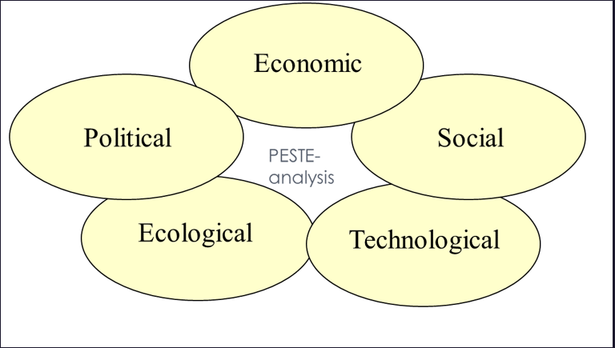
Director Timo Vuori from the Confederation of Finnish Industries (EK) recently shared data that perfectly aligns with this framework.
[Slide 1: Overview of PESTE Framework]
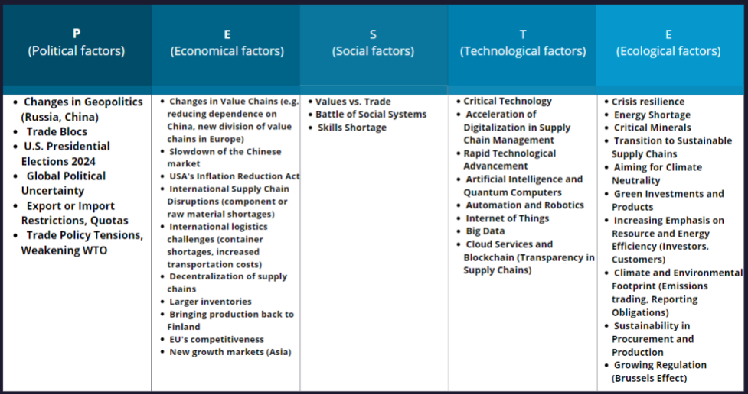
Johan:
PESTE stands for Political, Economic, Social, Technological, and Environmental factors. These elements help us understand the broader context in which our businesses operate.
[Slide 2: Political Factors]
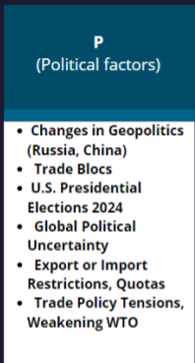
Johan:
Let's start with political factors. These include geopolitical changes, trade policies, and government regulations. For instance, upcoming elections or international trade agreements greatly influence export strategies.
Example: A new trade agreement between the EU and a non-EU country could open new markets or impose new tariffs affecting export pricing.
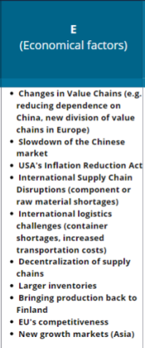
Johan:
Next, economic factors such as inflation rates, currency fluctuations, and global economic growth impact market dynamics and profitability.
Example: Fluctuations in the exchange rate can affect the cost competitiveness of your exports in different markets.
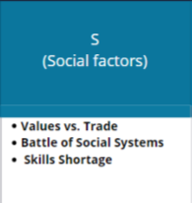
Johan:
Moving on to social factors, which encompass demographic shifts, cultural trends, and consumer behavior. Understanding societal changes helps you tailor your products and services to meet evolving customer needs.
Example: An aging population in certain countries may increase demand for healthcare products and services.
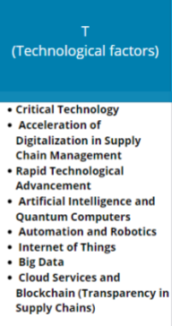
Johan:
Technological factors are crucial in today's digital age. Advancements in AI, IoT, and blockchain revolutionize supply chains and operational efficiencies, presenting new opportunities and challenges.
Example: The adoption of blockchain technology can enhance transparency and traceability in your supply chain, appealing to customers concerned about ethical sourcing.
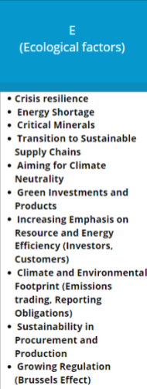
Johan:
Lastly, environmental factors, including climate change and sustainability efforts, increasingly shape business practices and corporate responsibility strategies.
Example: Increasing regulations on carbon emissions might require businesses to invest in cleaner technologies or adopt more sustainable practices.
[Closing Scene: Johan back on camera]
Johan:
Thank you for watching! For self-reflection: Which external factors affect your business most?
Your insights will be valuable as we prepare for our workshop. Let's put these insights into action!
Now, let's test your knowledge with a hands-on activity.
Below this video, you'll find Timo Vuori's presentation, and a drag-and-drop task based on it. Sort the factors into the correct PESTE categories. This exercise will prepare you for our upcoming scenario-building workshop, where we'll explore how these factors influence future skill needs in the export sector.
Get ready to dive deeper into strategic foresight!

You can access Timo Vuori’s presentation from November 28th, 2023 here: presentation slides (see file)

Drag-and-Drop Task
Instructions:
Drag each factor listed below into the correct PESTE (Political, Economic, Social, Technological, or Environmental) category box.
While dragging and dropping, consider which factors are most critical for your company’s field of business.
Once completed, you'll be prepared for the "Foresight for Export Growth" Online Scenario Creation Workshop led by Johan.
Factors:
Factors and their PESTE Categories:
- Trade blocs (P)
- Slowdown in the Chinese market (EC)
- Artificial Intelligence and quantum computing (T)
- Critical technology (T)
- Climate and environmental footprint (EN)
- Challenges in international logistics (container shortages, increased transportation costs) (EC)
- Global political uncertainty (P)
- Values vs. trade (S)
- EU competitiveness (EC)
- Responsibility in procurement and production (S)

- Repatriation of production to Finland (EC)
- Geopolitical changes (Russia, China) (P)
- USA's Inflation Reduction Act (P)
- Automation and robotics (T)
- Emerging growth markets (Asia) (EC)
- Rapid technological advancement (T)
- Big data (T)
- Focus on sustainable supply chains (EN)
- Resilience (EC)
- Shortage of skilled labor (S)

- Disruptions in international supply chains (component or raw material shortages) (EC)
- Trade policy tensions, declining WTO (P)
- Green investments and products (EN)
- Energy shortage (EN)
- Decentralization of supply chains (EC)
- Internet of Things (T)
- Larger inventories (EC)
- Pursuit of carbon neutrality (EN)
- Social struggle of societal systems (S)
- Cloud services and blockchain (transparency in the supply chain) (T)
Key:
P: Political
EC: Economic
S: Social
T: Technological
EN: Environmental

Now you are skilled to join our Senior Advisor Johan's “Foresight for Export Growth” Online Scenario Creation Workshop, where you'll unlock the power of strategic foresight. Together with industry peers, you'll learn practical techniques to navigate uncertainties and seize opportunities in the export industry.

VIDEO:
“Foresight for Export Growth" Online Scenario Creation Workshop
Part 1
Greetings everyone, and a warm welcome to today's online workshop on foresight processes tailored for SMEs in the export industry. I'm Johan, and I bring with me years of experience advising businesses like yours on strategic planning and scenario analysis to navigate the complexities of global markets.
I have structured this workshop into small chunks of micro-learnings. After each chunk, there will be interactive small tasks for you to complete.
To kick things off, we have an icebreaker task designed to ignite your imagination. The task is called: “Future News Headlines for Finnish Export SMEs”.
Imagine yourself as a journalist forecasting future scenarios impacting Finnish export SMEs.
Craft one positive and one negative news headline based on the PESTE factors identified in the orientation video.
This exercise encourages you to think critically about the potential future scenarios. By creating positive and negative headlines, you engage with the complexities of the PESTE factors and their implications for business success.
First, you will have 5 minutes for independent thinking. After this, we'll move into smaller breakout rooms to brainstorm and refine your headlines collaboratively. In the breakout room, your goal is to choose one positive and one negative headline as your final output.

Task:
Write your positive headline here
Write your negative headline here

VIDEO
part2
All right, time to wrap up. For each breakout room, please type your positive headlines into the chat.

Let's take a look
Breakout room 1: Trade Blocs Open Lucrative Markets for Finnish Export SMEs
Breakout room 2: AI Revolutionizes Supply Chains for Finnish Exports
Breakout room 3: Green Investments Expand Finnish Export Market
Breakout room 4: Ethical Consumption - Trends Drive Finnish Export Growth
Breakout room 5: Political Stability Fuels Finnish Export Opportunities
Breakout room 6: Economic Recovery Bolsters Finnish Export Sales
Great work, everyone! These headlines are a fantastic start and show a range of positive futures for Finnish export SMEs.
Now, let's move on to your negative headlines. Please type your selected negative headlines into the chat.
Let's see what can be found here
Breakout room 1: Geopolitical Tensions Disrupt Trade for Finnish Export SMEs
Breakout room 2: Technological Failures Hinder Finnish Export Efficiency
Breakout room 3: Environmental Regulations Increase Costs for Finnish Exports
Breakout room 4: Social Unrest Leads to Declining Demand for Finnish Products
Breakout room 5: Political Instability Creates Barriers for Finnish Export Growth
Breakout room 6: Economic Downturn Shrinks Market for Finnish Exports

Well done! Great efforts! This warm-up has opened our minds to a wide range of possible futures – both positive and negative. These headlines perfectly showcase various opportunities and challenges that we might face. Thank you all for your active participation!

Multiple Choice Questions
Based on the six positive and six negative headlines, select the optimal strategic action or prediction for Finnish export SMEs in each scenario.
Headline 1: Trade Blocs Open Lucrative Markets for Finnish Export SMEs
What should Finnish export SMEs do to take advantage of new trade agreements?
- Expand production without changing their marketing strategy.
- Increase investment in traditional marketing methods.
- Focus on expanding their marketing efforts in new markets.
- Leverage strategic partnerships to enter new markets efficiently. *

Headline 2: AI Revolutionizes Supply Chains for Finnish Exports
How can Finnish export SMEs leverage AI technology effectively?
- Reduce investment in technology to cut costs.
- Focus only on traditional supply chain methods.
- Invest in AI-driven supply chain management systems.*
- Outsource all supply chain operations.

Headline 3: Green Investments Expand Finnish Export Market
Which strategy aligns with the growing demand for sustainable products?
- Shift production to non-renewable resources.
- Ignore environmental trends and continue with current products.
- Develop and market eco-friendly products.*
- Reduce emphasis on sustainability.

Headline 4: Geopolitical Tensions Disrupt Trade for Finnish Export SMEs
What should Finnish export SMEs do to mitigate the impact of geopolitical tensions?
- Diversify their export markets.*
- Cease all export activities.
- Focus on a single market.
- Ignore the geopolitical changes.

Headline 5: Technological Failures Hinder Finnish Export Efficiency
How can Finnish export SMEs prepare for potential technological failures?
- Rely solely on a single technology.
- Ignore potential technological risks.
- Develop contingency plans and backup systems.
- Invest in training and upskilling employees for tech troubleshooting.*

Headline 6: Environmental Regulations Increase Costs for Finnish Exports
What is the best strategy to comply with stringent environmental regulations?
- Evade compliance to cut costs.
- Optimize operational processes to reduce environmental impact.*
- Relocate to regions with less stringent regulations.
- Invest in sustainable technologies and practices.

You can continue to Johan's “Foresight for Future Export” Online Scenario Creation Workshop from here. The topic of this video is the foresight process. Best of luck on your journey! Happy learning!

VIDEO
Part 3

Next, I'll introduce the foresight process along with two practical models designed to help you effectively prepare for the future: a 2x2 scenario planning matrix and a spectrum of scenarios spanning from positive to negative outcomes. These models encompass a wide range of potential developments that could impact your business.

KUVION ALLA ON AINA KYSEISEEN KUVIOON KUULUVA TEKSTI
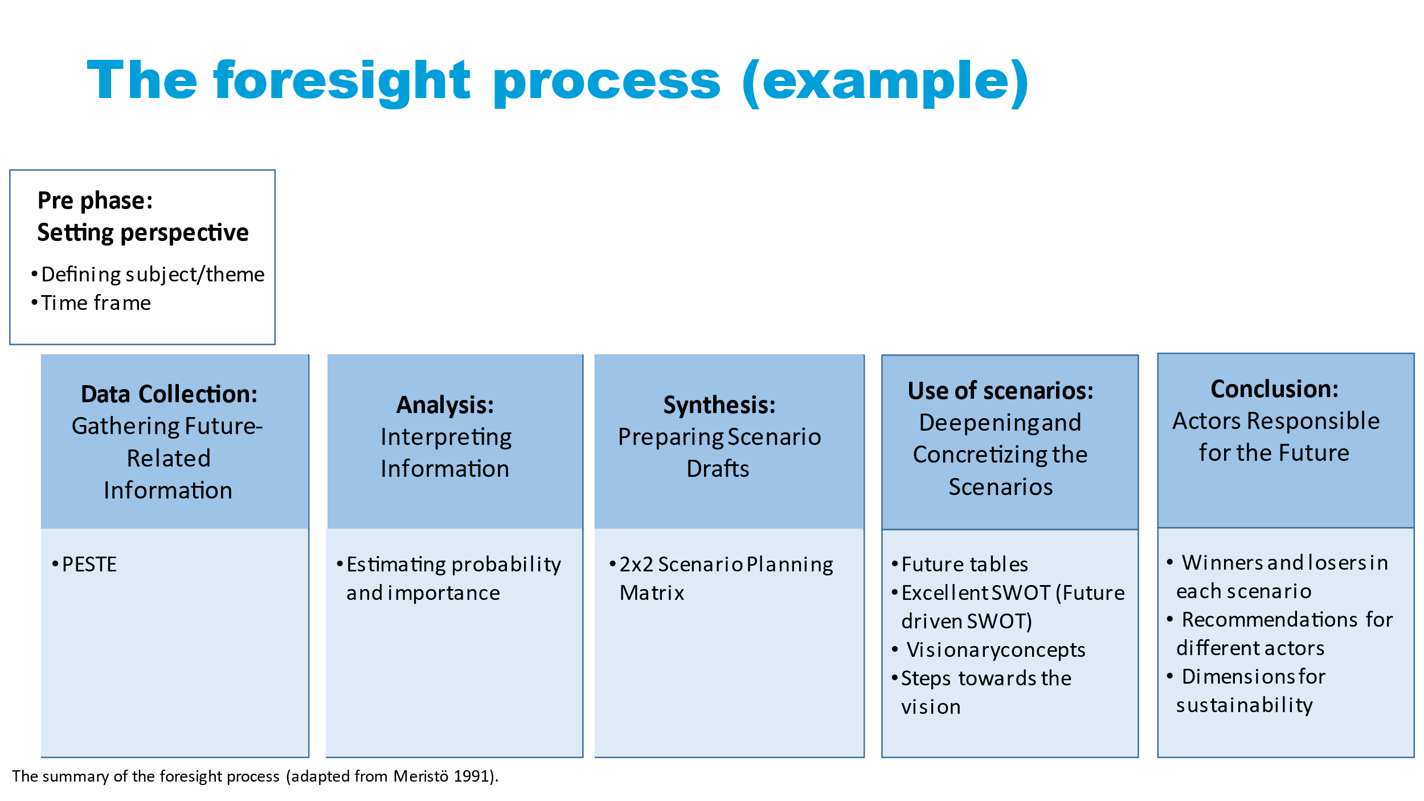

Here’s a visual overview of the entire process. Let's explore each element in detail:

Pre-phase:
Setting perspective
- Defining subject/theme
- Time frame

Firstly, every successful foresight initiative begins with establishing the perspective during the pre-phase. Here, we define our subject—Finnish SMEs—and our timeframe, with a specific focus on a 3-5-year horizon.

Data Collection: Gathering Future- Related Information

- PESTE

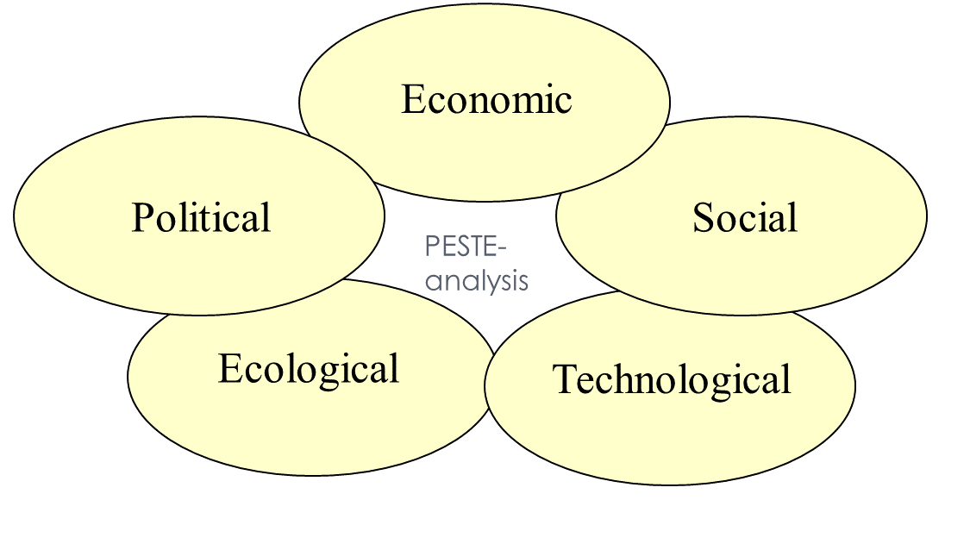
The first phase involves data collection, where we gather future-related information and categorize it using frameworks like PESTE, which covers political, economic, social, technological, and environmental factors. You should be familiar with this approach from the preliminary orientation task I sent you before this workshop.
I will use a Finnish technology exporter as an example. The company specializes in exporting advanced cybersecurity solutions to global markets. Here's how we could apply the PESTE framework:
Political Factors: Evaluate international regulations on data privacy and cybersecurity standards, trade agreements affecting export tariffs, and government policies supporting cybersecurity initiatives.
Changes in data protection laws in key export markets could impact compliance requirements for cybersecurity solutions.
Economic Factors: Assess global economic conditions affecting corporate IT budgets, currency exchange rates influencing export pricing, and economic growth in emerging markets.
Economic downturns in major export destinations may reduce IT spending, affecting demand for cybersecurity solutions.
Social Factors: Analyze trends in digital transformation, awareness of cybersecurity risks among businesses, and cultural attitudes toward data privacy.
Increasing awareness of cyber threats could drive demand for advanced cybersecurity solutions in global markets.
Technological Factors: Consider advancements in artificial intelligence for threat detection, innovations in cloud security solutions, and trends in remote work technologies.
The adoption of AI-driven cybersecurity tools could enhance the effectiveness of cybersecurity products.
Environmental Factors: Consider environmental policies influencing digital transformation trends or sustainability initiatives impacting technology adoption.
Regulations promoting energy-efficient data centers or eco-friendly IT practices could influence the demand for cybersecurity solutions that align with sustainable business practices.

Analysis: Interpreting Information

- Estimating probability and importance

Once we have gathered the data on political, economic, social, technological, and environmental factors, we move on to analysis and interpretation for example, by estimating the probability and the importance of the data. This step helps us identify key drivers shaping the future landscape of our businesses.
Using our case company again, here is an example of estimating probability:
Political Factors: Evaluate the likelihood of changes in international regulations impacting data privacy laws and cybersecurity standards. Assess the probability of new trade agreements that could influence export tariffs.
The probability of stricter data protection regulations being implemented in key export markets within the next two years is moderate to high based on current political discourse and legislative proposals.
Economic Factors: Analyze the likelihood of economic downturns affecting corporate IT budgets and the purchasing power of potential clients in emerging markets.
With recent economic forecasts indicating a potential slowdown in global GDP growth, there is a moderate probability of reduced IT spending among businesses, impacting demand for cybersecurity solutions.
Social Factors: Determine the probability of increased awareness and concern among businesses regarding cybersecurity risks and data breaches.
Given recent high-profile cyber incidents, the probability of businesses prioritizing cybersecurity investments over the next few years is considered high.
Technological Factors: Assess the probability of advancements in AI-driven cybersecurity technologies impacting market demand and competitive dynamics.
Environmental Factors: Evaluate the probability of environmental policies indirectly affecting digital transformation trends or sustainability initiatives within the technology sector.
Although cybersecurity is not directly impacted by environmental factors, there is a probability of green technology initiatives indirectly influencing corporate IT strategies and expenditures.

Next, let’s look at assessing importance.

Political Factors: Determine the potential impact of political changes on regulatory compliance costs and market access.
Changes in data privacy regulations could significantly impact the cost structure of cybersecurity solutions and market entry strategies, making this factor highly important.

Economic Factors: Evaluate the importance of economic conditions on pricing strategies and revenue projections.
Economic downturns could critically affect the purchasing power of potential clients and alter budget allocations for cybersecurity investments, highlighting the importance of economic factors.
Social Factors: Assess the influence of societal attitudes towards data privacy and cybersecurity awareness on market demand.
Increased awareness and concern among businesses regarding cybersecurity risks could profoundly impact market demand and customer preferences, making social factors highly important.
Technological Factors: Analyze the significance of technological advancements in shaping competitive advantages and product innovation.
Advances in AI-driven cybersecurity technologies are crucial for maintaining competitive edge and meeting evolving customer expectations, underscoring the importance of technological factors.
Environmental Factors: Consider the indirect effects of environmental policies on corporate IT strategies and digital transformation initiatives.
While environmental factors have minimal direct impact on cybersecurity solutions, understanding their potential indirect influence on market dynamics is still important for comprehensive strategic planning.

By estimating the probability and importance of each factor, our Finnish cybersecurity technology exporter can prioritize strategic initiatives and allocate resources effectively. This analysis enables the company to anticipate future challenges and opportunities in the global cybersecurity market, ensuring proactive decision-making and sustainable growth.

VIDEO
Part 4

Synthesis: Preparing Scenario Drafts

- 2x2 Scenario Planning Matrix

Next, we draft scenarios using methods like the 2x2 scenario planning matrix. This matrix helps us visualize potential futures based on two critical drivers chosen from our analysis.

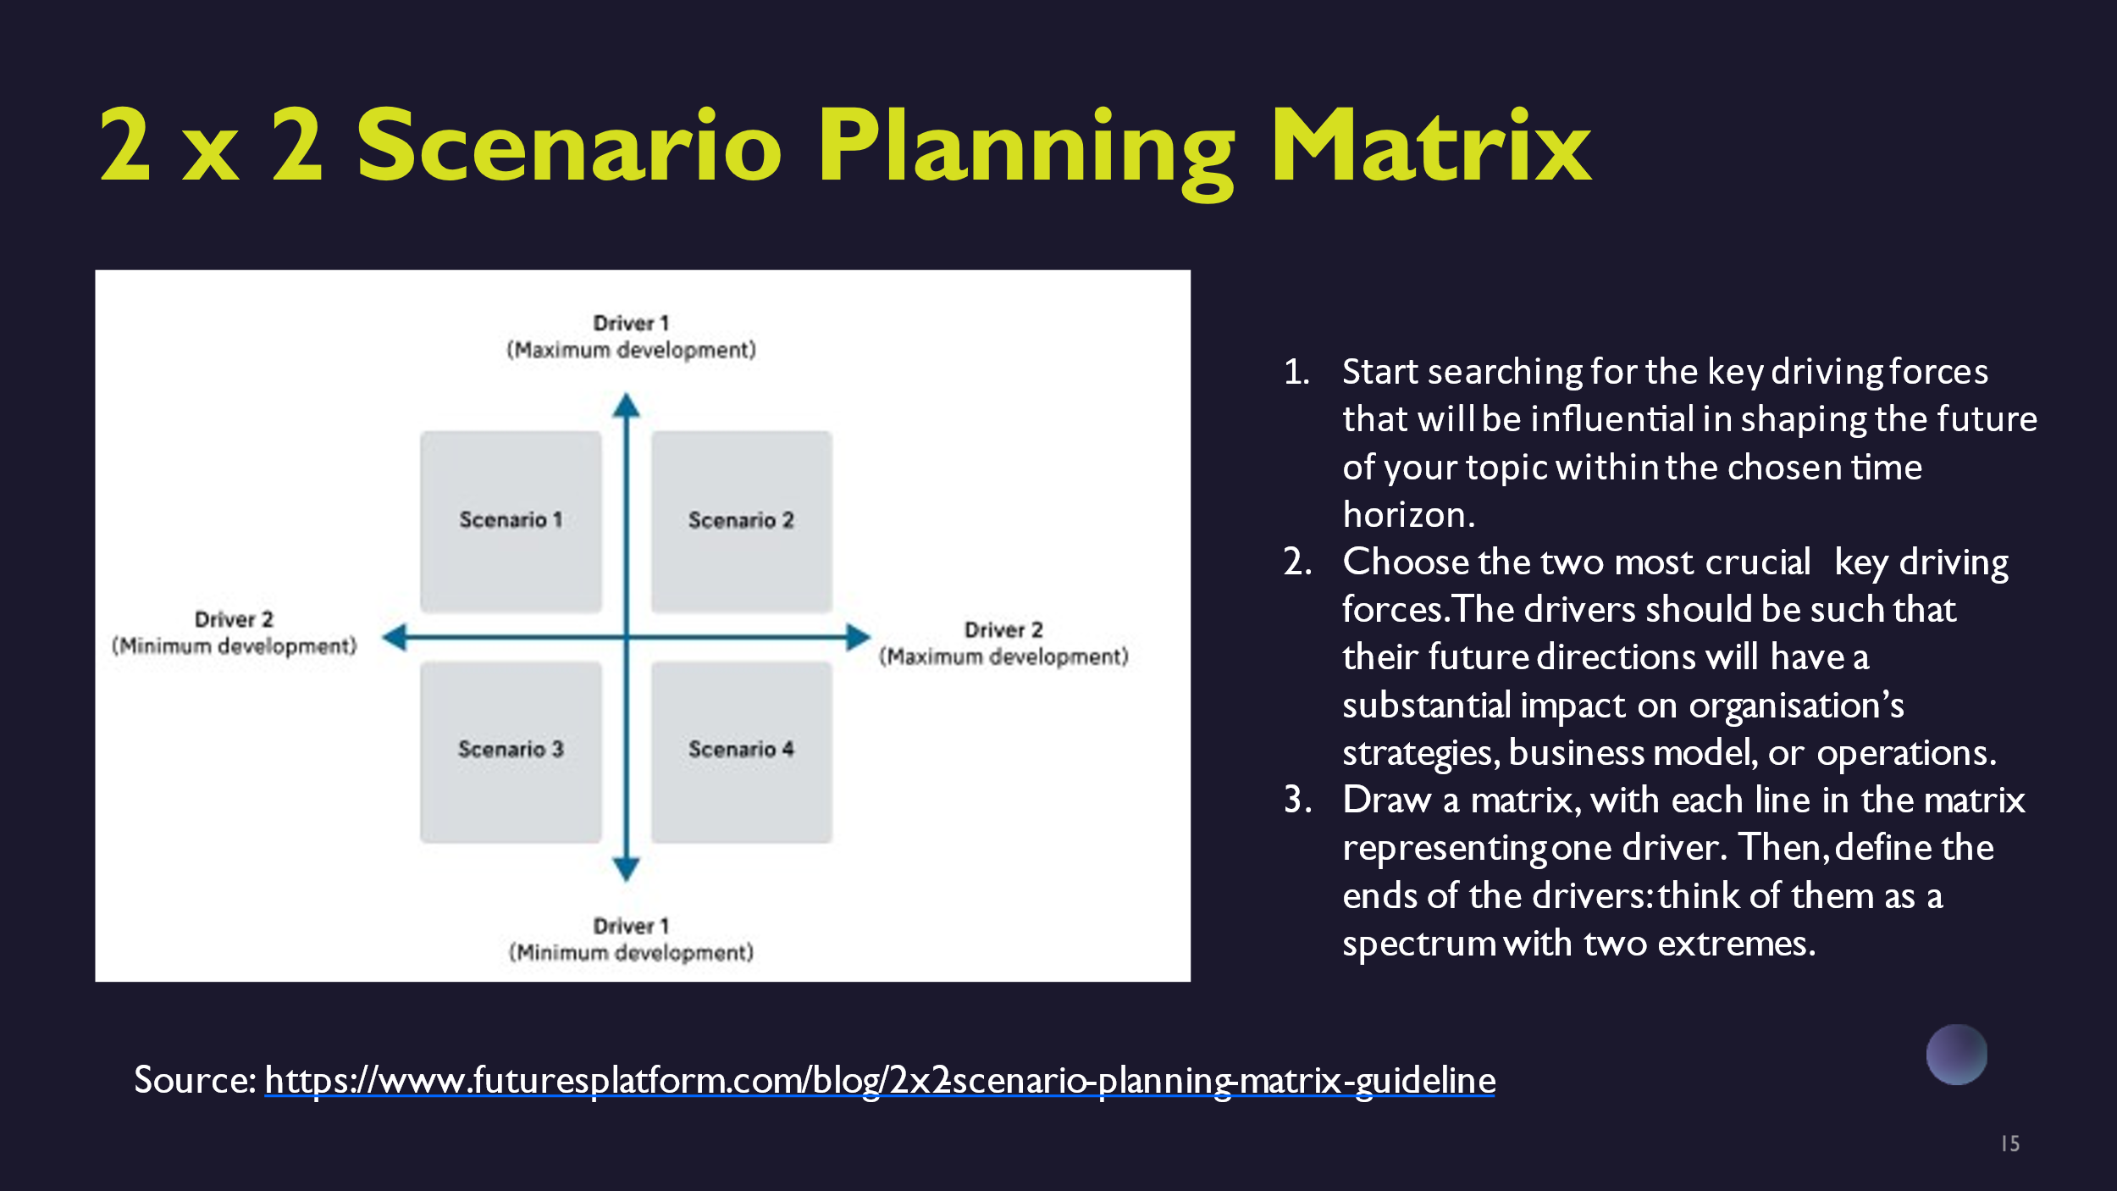

We begin by identifying the key driving forces that will shape the future of your topic. You can utilize the PESTE framework (Political, Economic, Social, Technological, Environmental) to guide this process. Once these driving forces are identified, choose the two most critical ones that will significantly impact your organization’s strategies, business model, or operations in the future.
Next, create a matrix where each axis represents one of these key drivers. Define the extremes of each driver along its axis to create a spectrum. The first key driver will be represented on the vertical axis, while the second key driver will be on the horizontal axis. This matrix setup will visually illustrate how different combinations of these drivers could potentially shape various future scenarios.

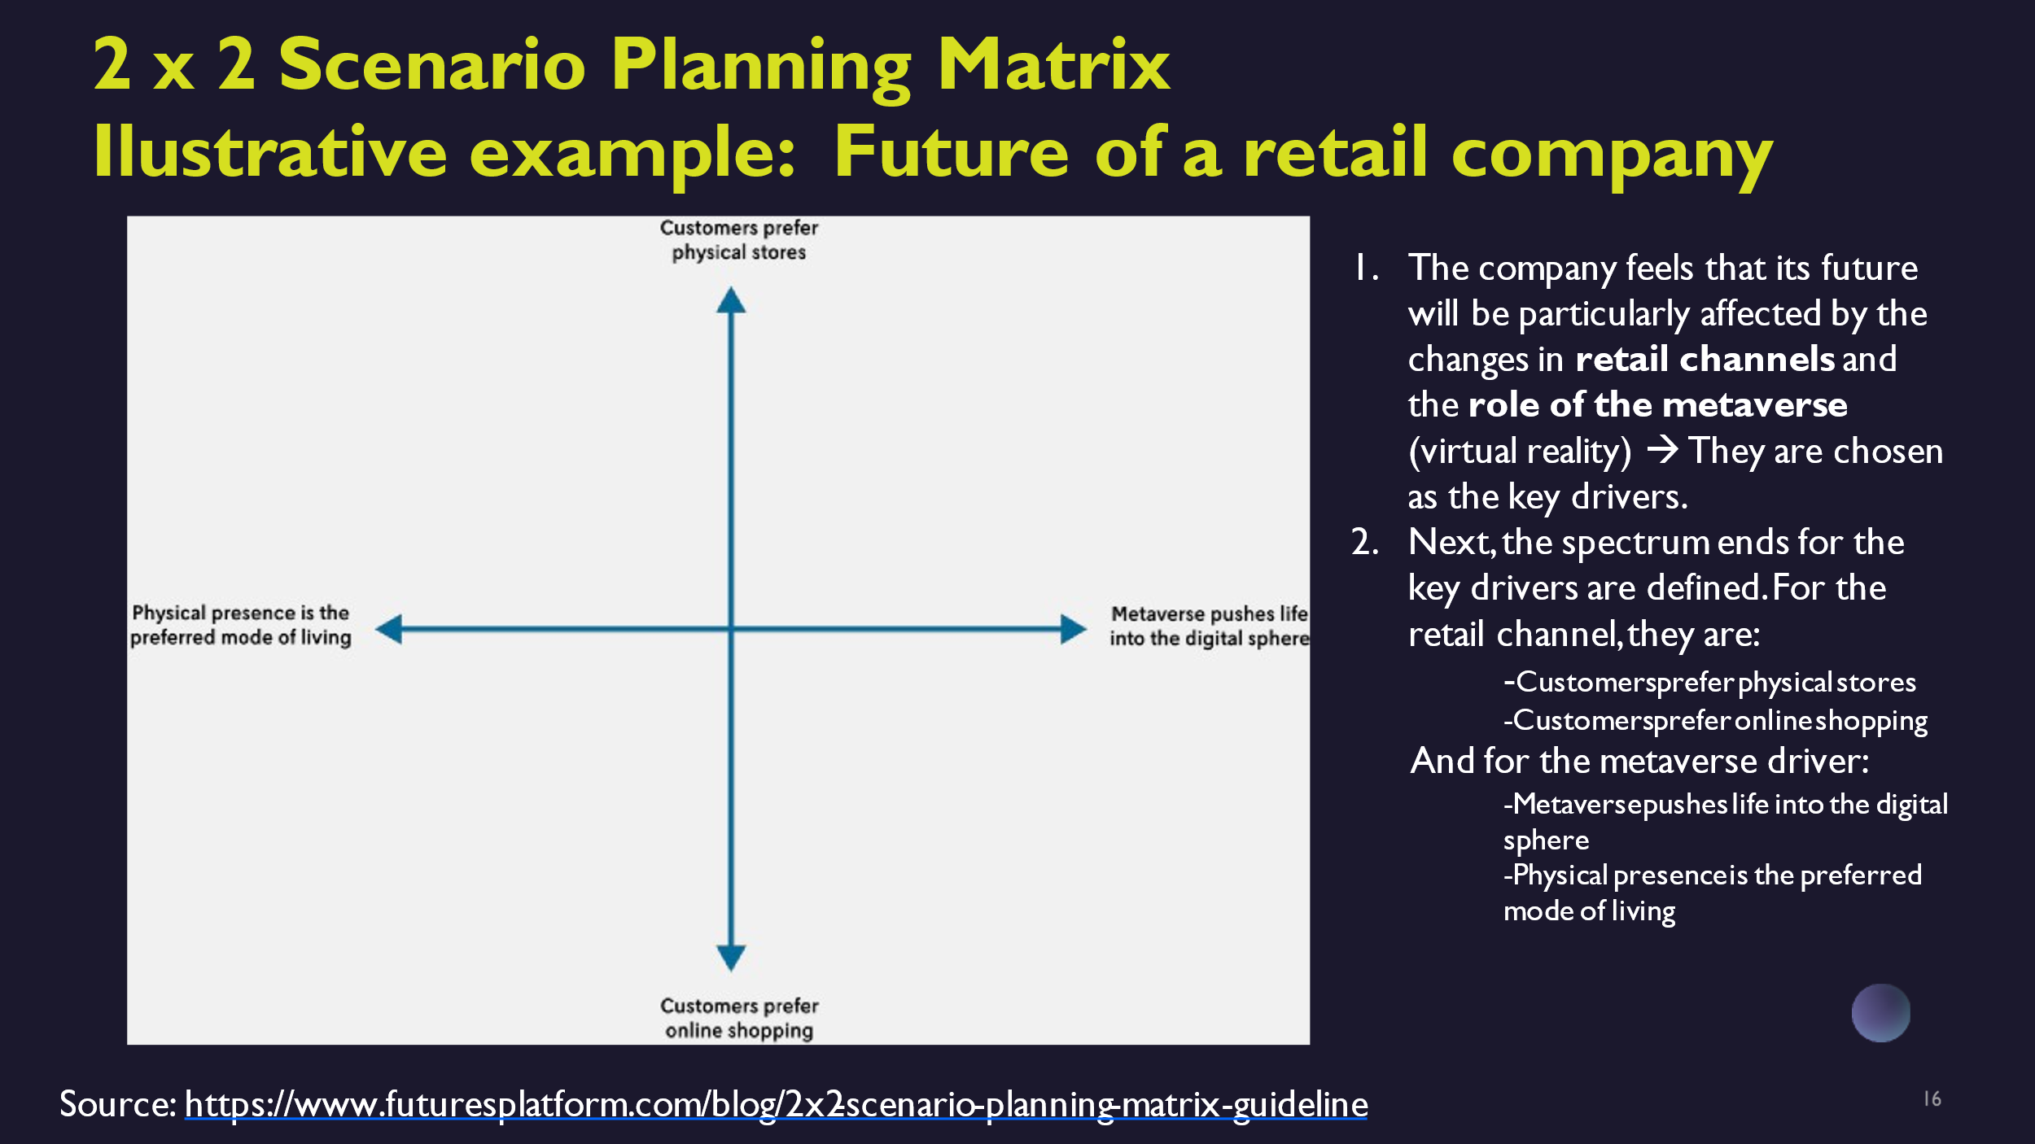

First, before we continue with our case company, we here envision exploring the impact of retail channel changes and the role of the metaverse on a hypothetical retail company's future. By delineating the extremes of these drivers, we generate multiple plausible scenarios to explore strategic responses.
In this example, the retail company anticipates that changes in retail channels and the emergence of the metaverse (virtual reality) will significantly shape its future. These factors are identified as the key drivers.
Next, we define the spectrum ends for each key driver:
For the retail channel, the spectrum ranges from “Customers prefer physical stores” to “Customers prefer online shopping”.
Regarding the metaverse driver, the spectrum ranges from “Metaverse accelerates life in the digital realm” to “Physical presence remains the preferred mode of living”.
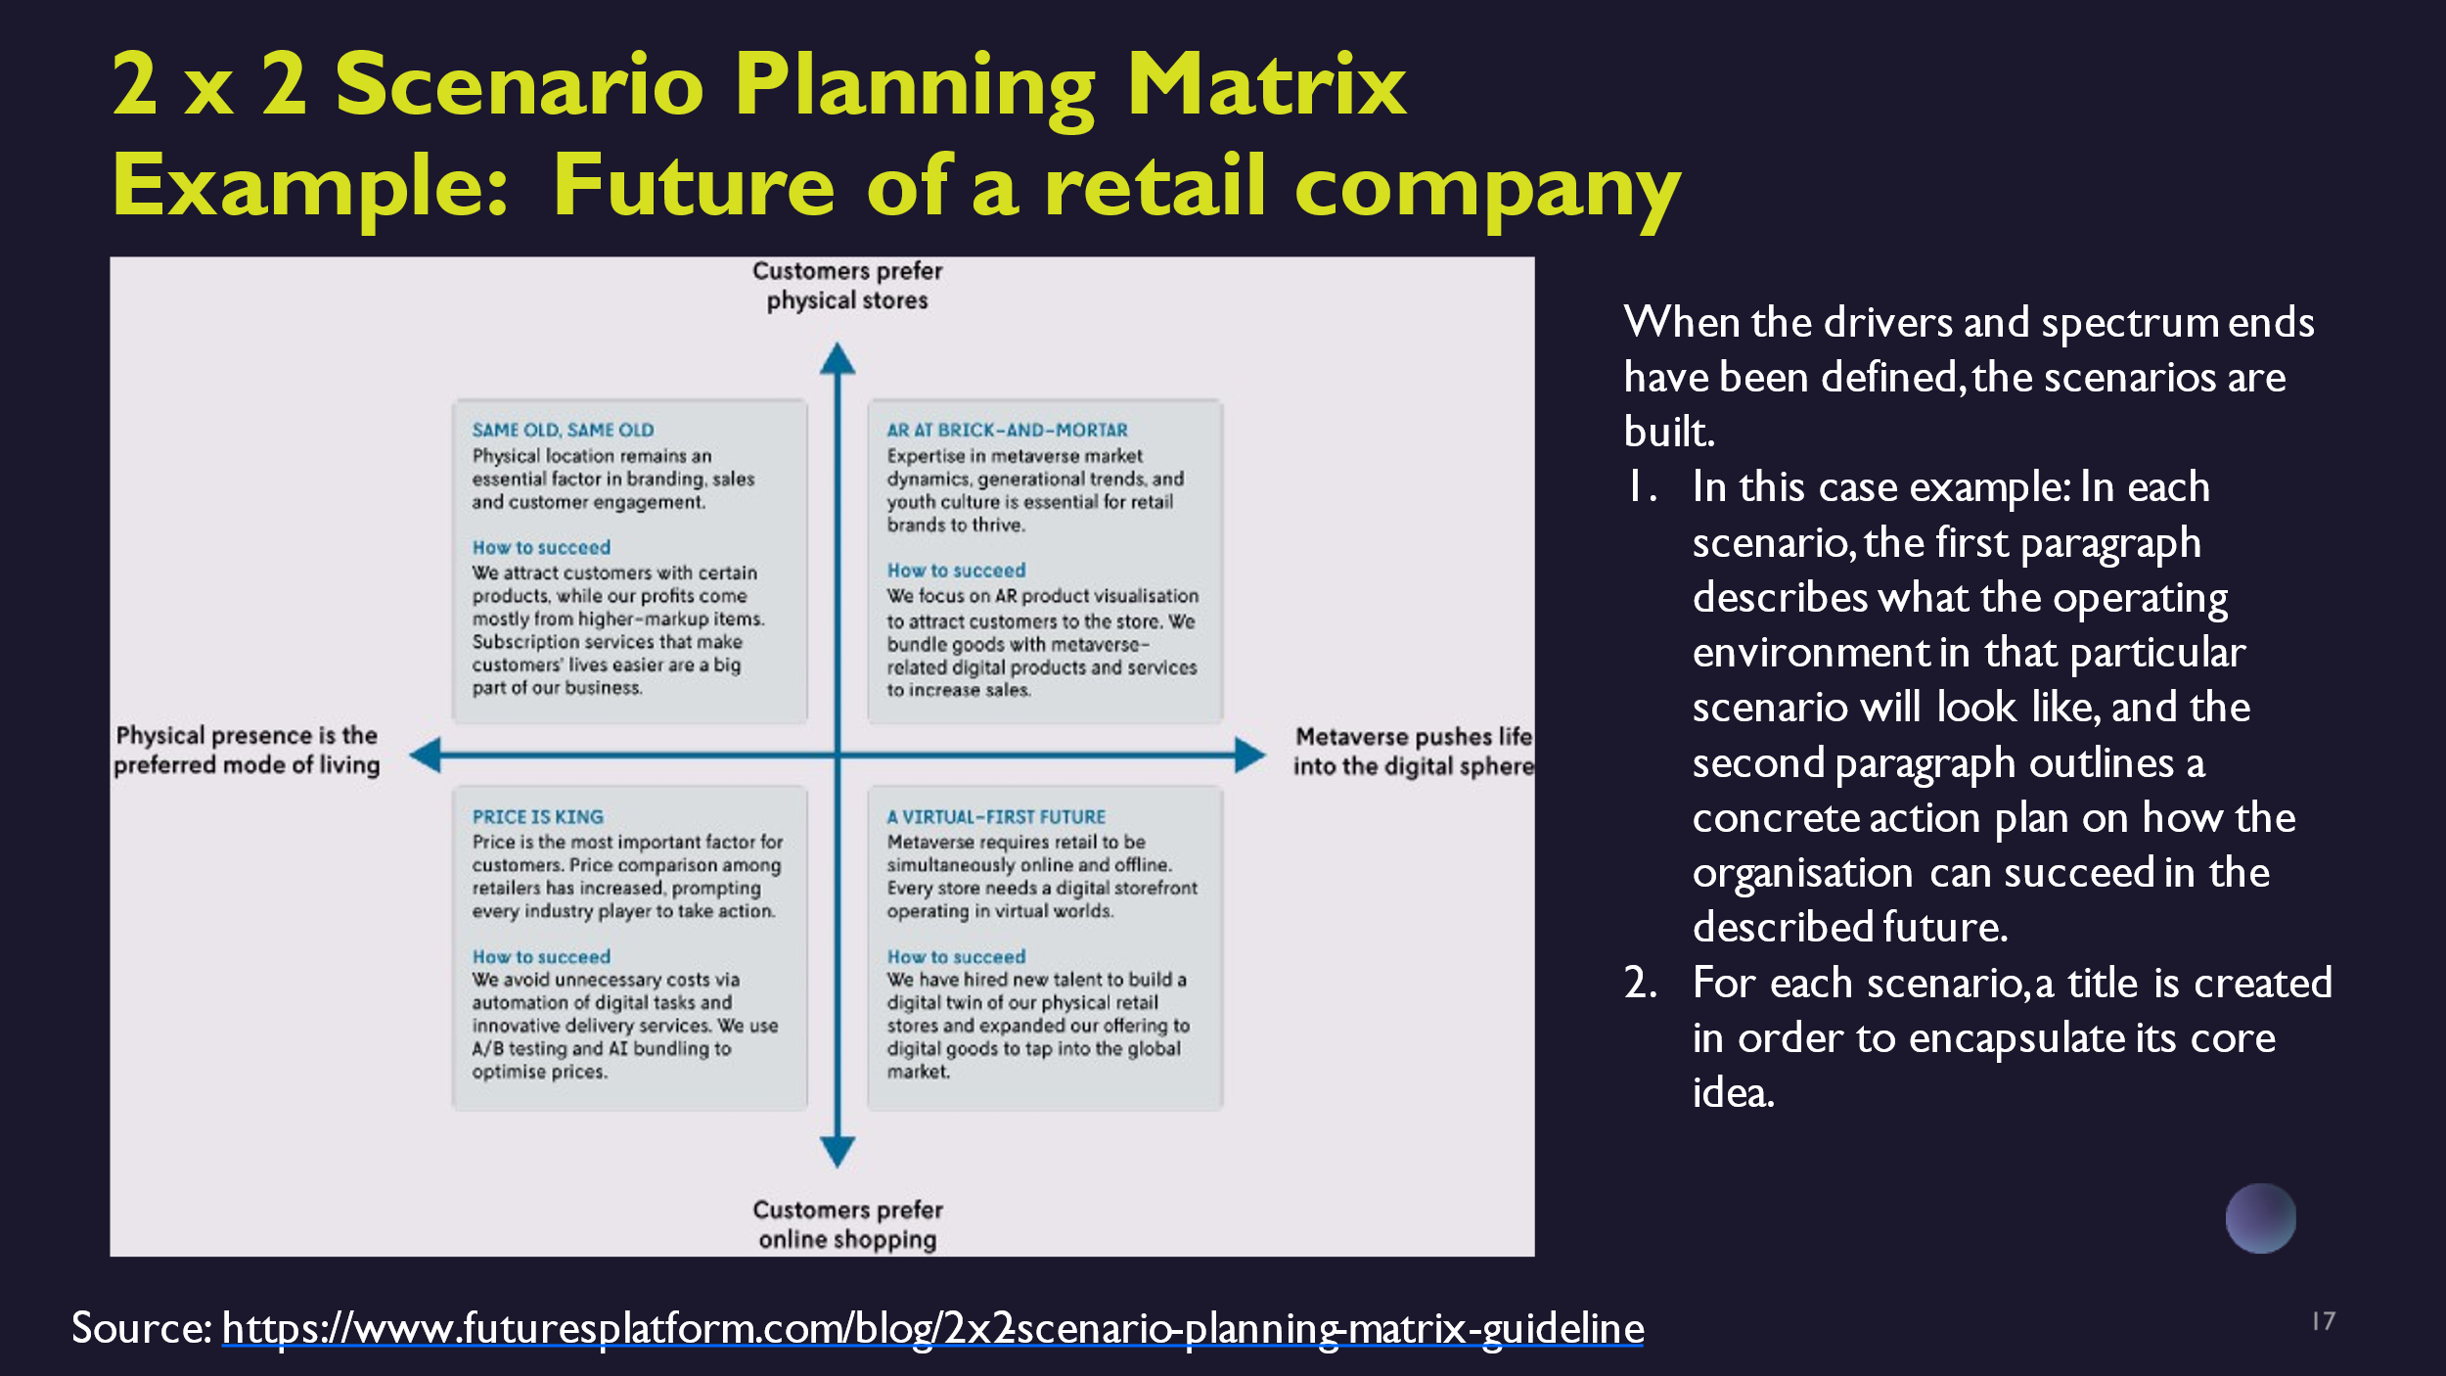

Once the key drivers and their spectrum ends have been defined, you can start building the scenarios.
In this example, each scenario includes two main parts:
- A description of what the operating environment will look like in that particular scenario.
- A concrete action plan outlining how the organization can succeed in the future.
Each scenario is given a title that encapsulates its core idea.
For our case company, we identify the key driving forces that will shape the future of the cybersecurity technology exporter within our chosen time horizon. These key drivers significantly impact the organization’s strategies, business models, or operations. In our case, those are
- technological advancements in AI and
- regulatory changes in data privacy.
We visualize potential futures based on these two critical drivers:
- The vertical axis represents technological advancements in AI, ranging from minimal integration in cybersecurity solutions to widespread adoption leading to autonomous threat detection and response systems.
- The horizontal axis depicts regulatory changes in data privacy, ranging from stringent regulations imposing heavy compliance burdens to harmonized global standards fostering seamless market access.
By plotting these drivers on the matrix, we can create four distinct scenarios that outline plausible futures for our cybersecurity technology exporter:
Scenario A: Minimal AI Integration with Stringent Data Privacy Regulations
Scenario B: Minimal AI Integration with Harmonized Data Privacy Standards
Scenario C: Advanced AI Integration with Stringent Data Privacy Regulations
Scenario D: Advanced AI Integration with Harmonized Data Privacy Standards

VIDEO
Part 5

Now, let's take a closer look at the scenarios.
In Scenario 1, which we can name AI-Powered Expansion,
AI-driven cybersecurity solutions dominate the market, enhancing operational efficiency and threat mitigation. Favorable regulatory conditions facilitate global market expansion without major compliance hurdles.
Action Plan could be:
- Invest heavily in AI research and development.
- Expand into new markets with relaxed data privacy regulations to capitalize on early adopter advantages.

In Scenario 2, which we can name Regulated AI Revolution,
technological breakthroughs in AI bolster cybersecurity capabilities, but stringent data privacy regulations increase compliance costs and operational complexities.
Action Plan could be:
- Develop adaptive compliance strategies.
- Strengthen partnerships with regulatory bodies to influence policy development while optimizing existing solutions for regulatory compliance.

In Scenario 3, which we can name Agile Market Entry,
the slow adoption of AI in cybersecurity limits technological advancement. However, favorable regulatory environments foster agile market entry and operational flexibility.
Action Plan could be:
- Focus on incremental AI integration.
- Leverage regulatory leniency to innovate customer-centric cybersecurity solutions tailored to emerging market needs.

In Scenario 4, which we can name Compliance-Driven Innovation,
minimal progress in AI applications hinders cybersecurity innovation. Complex data privacy regulations restrict market expansion and increase compliance burdens.
Action Plan could be: Diversify product offerings beyond AI-driven solutions. Invest in compliance automation tools and strategic partnerships to navigate regulatory complexities while exploring niche markets.

Use of scenarios: Deepening and Concretizing the Scenarios

- Future tables
- Excellent SWOT (Future driven SWOT)
- Visionary concepts
- Steps towards the vision

From here, we can further develop and refine these scenarios using additional methods such as future tables, future-driven SWOT analyses, visionary concepts, and actionable steps toward achieving our vision. For today’s workshop, we will focus specifically on developing visionary concepts.

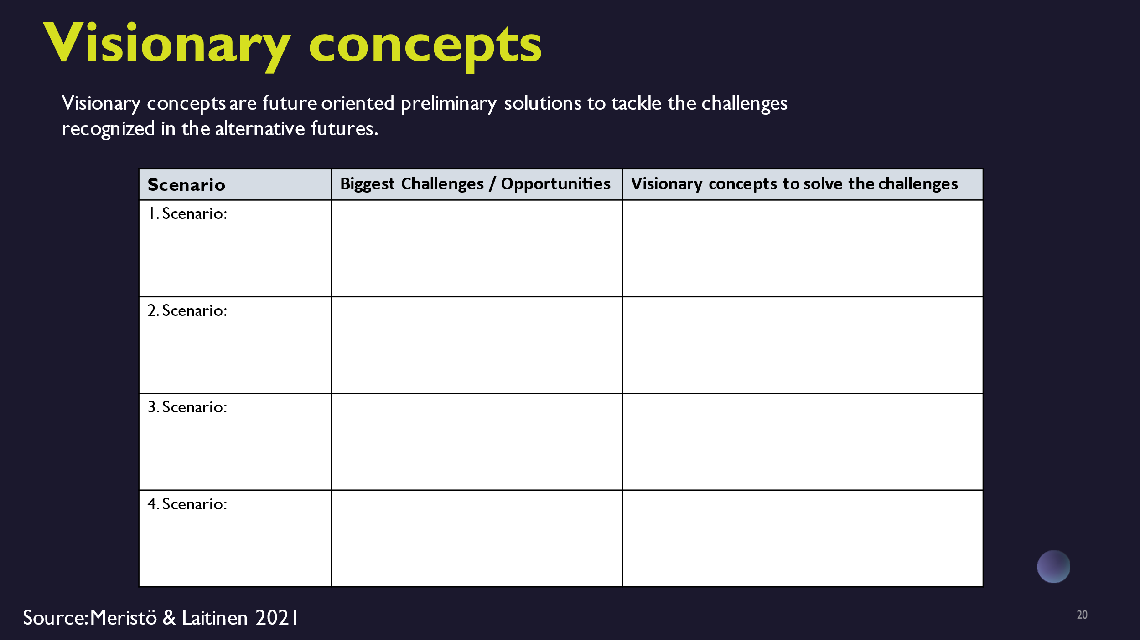

Visionary concepts that are future-oriented preliminary solutions to address challenges identified in alternative future scenarios. These concepts should aim to position your organization competitively in the future landscape. You can create a table including the following sections:
- List the alternative future scenarios.
- Identify the major challenges and opportunities associated with each scenario.
- Propose innovative concepts or strategies to solve the identified challenges for each scenario.

Scenario | Biggest Challenges | Opportunities | Visionary Concepts
AI-Powered Expansion | - Ensuring the quality and security of AI solutions - Managing rapid growth in diverse regulatory environments | - Leading the market with AI-driven innovations - Expanding globally without major compliance issues | AI-Focused Niche Expertise - Partner with established AI firms to enhance offerings - Focus on a few key markets with relaxed regulations to maximize impact
Regulated AI Revolution | - High compliance costs - Navigating complex and varying regulations | - Establishing a strong compliance-oriented brand - Leveraging regulatory expertise as a competitive edge | Compliance-Ready AI Solutions - Develop scalable AI solutions that meet regulatory requirements - Create a compliance advisory service to assist customers with regulations
Agile Market Entry | - Slow technological adoption - Potential market fragmentation due to varying regulatory leniency | - Ability to quickly enter and adapt to new markets - Flexibility in product offerings | Flexible AI Integration - Provide modular AI solutions that can be easily adapted - Focus on customer feedback to quickly iterate and improve products
Compliance-Driven Innovation | - Limited innovation in AI - High compliance and operational costs | - Niche market opportunities in non-AI solutions - Strong positioning in compliance automation | Smart Compliance Tools - Develop user-friendly compliance tools tailored for SMEs - Diversify offerings with non-AI cybersecurity solutions to reduce dependency on AI innovation

We also aim to apply this method to anticipate future skills needs. You can analyze the future skills needed in each alternative business scenario and identify existing skills gaps. This involves emphasizing the specific skills crucial for business resilience and growth, as well as assessing current gaps and emerging needs in different future contexts. Here’s how you can map skills needs in our case:
- As you develop visionary concepts, consider the skills necessary to implement these strategies effectively.
- Skills needs may include technical expertise (e.g., AI development skills, cybersecurity knowledge, soft skills (e.g., regulatory compliance, agile methodologies), domain-specific knowledge (e.g., international regulations, market analysis), and specialized competencies (e.g., UX/UI design).
In our case, we anticipate these future skills needs:
- AI expertise in cybersecurity: To develop and secure AI solutions effectively.
- AI development skills: To integrate and innovate AI-powered technologies.
- Regulatory compliance knowledge: To navigate complex and varying regulations globally.
- Global market expansion: To effectively expand into new international markets.
- Legal knowledge: To ensure compliance with regulatory requirements.
- Compliance management skills: To develop and maintain compliance-oriented strategies.
- Regulatory analysis: To understand and comply with evolving regulations.
- Agile development methodologies: To quickly adapt to changing market needs.
- Market analysis: To identify and capitalize on market opportunities.
- Customer feedback analysis: To iteratively improve products based on user input.
- UX/UI design: To create user-friendly compliance tools and solutions.
These skills are crucial for navigating challenges and seizing opportunities outlined in each scenario effectively. After mapping the skills, you can identify any skill gaps, which requires understanding the current skills and competencies of your personnel. This knowledge helps pinpoint areas where continuous learning should be focused.
Furthermore, you can explore Generative AI tools such as Copilot and Chat-GPT. These tools enhance interactive discussions and refine ideas during scenario development and decision-making. Training for these tools will be conducted in a separate workshop.

Conclusion:
Actors Responsible for the Future

- Winners and losers in each scenario
- Recommendations for different actors
- Dimensions for sustainability

After scenario crafting, we identify winners and losers and then create actionable recommendations to understand the implications for stakeholders. For instance, in a scenario of increased global demand for cybersecurity solutions due to rising threats to critical infrastructure, Finnish cybersecurity technology exporters could thrive. Their expertise in advanced encryption and threat detection positions them well to meet the demand for secure digital infrastructures. Conversely, organizations in countries with lax cybersecurity regulations or outdated measures may face heightened risks and disruptions, potentially categorizing them as losers.
Actionable recommendations include:
- Strengthening international partnerships: Encouraging Finnish firms to forge alliances with global enterprises and governments seeking robust cybersecurity solutions.
- Investing in innovation: Increasing R&D investments to enhance cybersecurity technologies continually, staying ahead in innovation.
- Advocating for stringent cybersecurity policies: Urging policymakers to enforce global standards, creating an environment conducive for Finnish exporters.
- Enhancing workforce skills: Promoting cybersecurity training programs to equip local talent with skills to develop cutting-edge solutions.
These steps help Finnish cybersecurity exporters navigate global challenges effectively, ensuring sustained growth and resilience in the digital era.

We'll now take a 15-minute break. Afterward, I'll introduce you to one additional method for creating scenarios. If you have any questions or uncertainties about the foresight process, please feel free to share them in the chat. I'll collect them for a Q&A session later.

Now it’s a good time to test your knowledge with true or false statements.

True or False

The foresight process begins with defining the subject and timeframe during the pre-phase. true
Scenario planning involves identifying key drivers that will significantly impact an organization’s strategies or operations. true
The 2x2 scenario planning matrix involves plotting two key drivers on axes to visualize potential futures. true
Generative AI tools like Chat-GPT and Copilot are utilized to enhance interactive discussions and refine ideas during scenario development. true

Future tables are structured frameworks used to outline potential future developments and their implications. true
Future-driven SWOT analysis extends traditional SWOT analysis by focusing on future strengths, weaknesses, opportunities, and threats. true
Scenario crafting in the workshop involves identifying winners and losers based on potential future developments. true
False - The foresight process begins with implementing strategies and operations without defining the subject and timeframe during the pre-phase.
False - Scenario planning involves predicting exact outcomes rather than identifying key drivers that will significantly impact an organization’s strategies or operations.
False - The 2x2 scenario planning matrix involves plotting multiple key drivers on axes to visualize potential futures based on different combinations of these drivers.
False - Generative AI tools like Chat-GPT and Copilot are not utilized in scenario development; they are used only for general data processing tasks.
False - Future tables are unstructured frameworks used to outline potential future developments without considering their implications for strategic planning.
False - Future-driven SWOT analysis does not extend traditional SWOT analysis; instead, it focuses solely on current strengths, weaknesses, opportunities, and threats.
False - Scenario crafting does not involve identifying winners and losers based on potential future developments; it focuses solely on internal strategy development.

Let's harness our learning momentum and dive back into the workshop. Remember, each step forward brings us closer to mastering essential foresight skills that will shape our future success!

VIDEO
Part 6
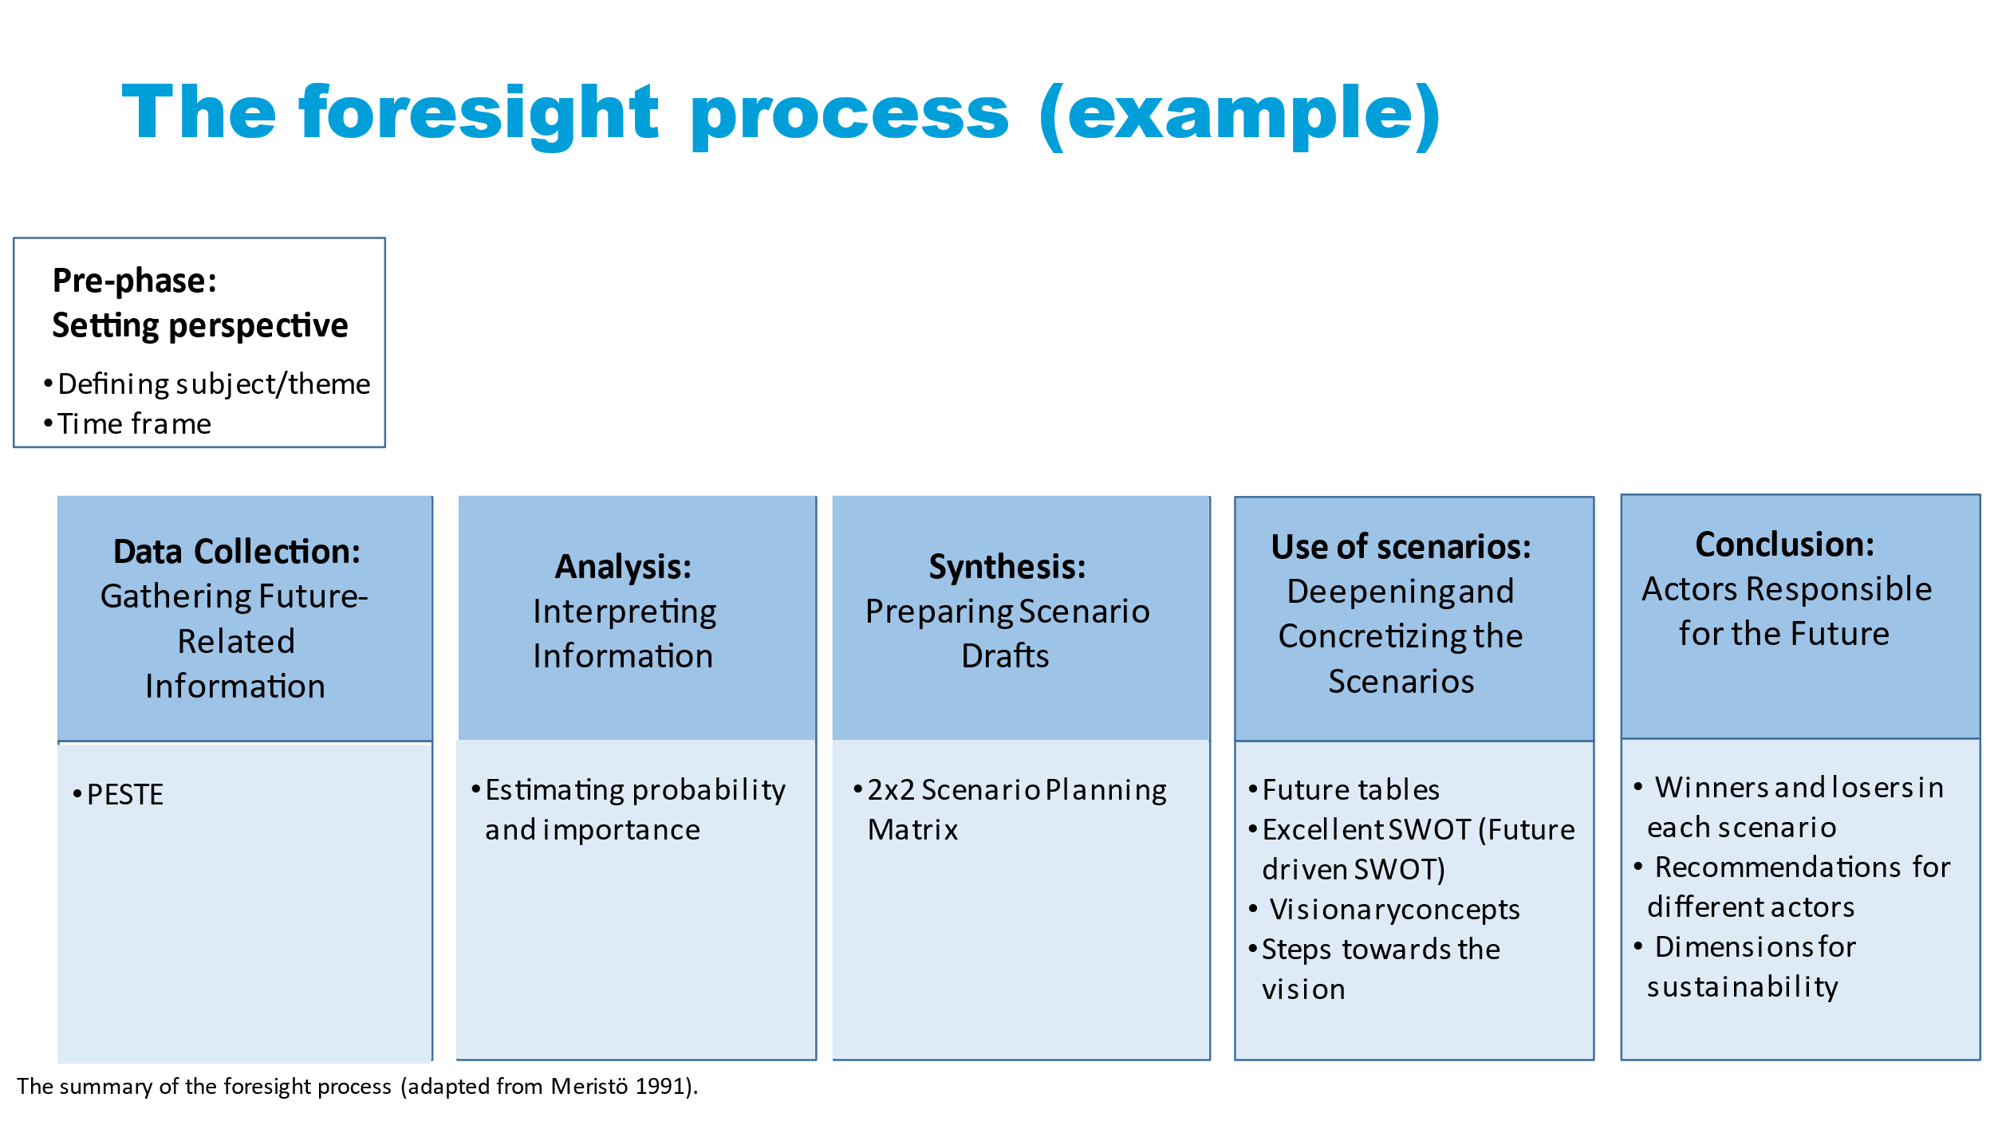
All right, welcome back! Let's continue exploring the foresight process with a focus on leveraging Generative AI insights. In our previous session, you learned how to create scenarios using the 2x2 scenario planning matrix. Now, we will delve into a spectrum of scenarios ranging from positive to negative outcomes. I'll guide you through this step-by-step process.

Step 1: Define Your Focus
Select a specific business area for scenario planning (e.g., market expansion, product innovation).
Step 2: Gather Information
- Collect data from high-quality sources.
- Categorize data using the PESTELE framework - Political, Economic, Social, Technological, Ecological, Legal, and Ethical factors.
- Utilize Chat-GPT or Copilot via platforms like OpenAI's API for brainstorming, trend analysis, and extracting information.
- Clearly define PESTELE factors of interest and engage in interactive discussions with Chat-GPT or Copilot to explore and refine ideas.
- Pose questions or prompts to AI tools about trends, regulations, and market conditions for each PESTELE category.
- Leverage AI capabilities for efficient data processing and pattern recognition.

Step 3: Analyze Insights
- Use AI-driven insights to identify key drivers impacting your business’s future.
- Engage in real-time discussions with Chat-GPT or Copilot discussions to interpret complex data from Step 2's data collection.
- Pose specific questions or prompts to Chat-GPT or Copilot about insights derived from data analysis.
- Review outputs generated by Chat-GPT or Copilot to pinpoint influential drivers for strategic responses.
- Inform strategic decision-making processes with AI-generated insights.

Step 4: Generate Scenarios
- Develop scenarios (Continuation, Positive Development, Negative Development, Catastrophic, Unexpectedly Positive) based on identified key drivers:
  - Continuation Scenario: Projecting current trends and stability.
  - Positive Development Scenario: Envisioning favorable conditions and outcomes.
  - Negative Development Scenario: Considering challenges and risks.
  - Catastrophic Scenario: Exploring extreme events or disruptions.
  - Unexpectedly Positive Scenario: Anticipating unforeseen opportunities.
- Use AI to adjust variables and explore alternative futures.
- Utilize AI-generated scenarios for decision support and contingency planning.

Step 5: Analyze Scenarios
- Pose scenario-specific queries to AI tools regarding workforce implications.
- Use AI to analyze scenario impacts on future skills environments.
- Identify skill gaps and align workforce capabilities with future needs using AI insights.
- Support strategic decision-making with AI-generated scenario analyses.

Step 6: Continuous Learning
- Real-time Monitoring and Adjustment:
  - Employ AI for ongoing monitoring of industry trends and scenario evolution.
  - Continuously analyze new data against scenario indicators.
  - Refine scenario analyses based on updated data and changing business conditions.
Iterative Refinement:
  - Engage in iterative discussions with AI tools to fine-tune scenario parameters.
  - Adjust inputs based on the latest developments and insights.
Learning Integration:
  - Integrate AI-generated insights into organizational planning frameworks.
  - Inform long-term workforce planning and skills development strategies.
  - Ensure alignment of learning initiatives with anticipated future business scenarios.

By following these steps and leveraging AI-driven insights, export SMEs can enhance their strategic foresight capabilities, making informed decisions that foster resilience and sustainable growth in an evolving business landscape.
I want to emphasize that in both foresight processes we covered today—the 2x2 scenario planning matrix and exploring a spectrum of scenarios from positive to negative outcomes—you have the opportunity to integrate visionary concepts and other previously discussed tools. Before we wrap up today, I'll provide a brief introduction to these tools.

Future Tables
Future tables are structured frameworks designed to outline potential future developments and their implications. They provide a visual representation of scenarios, helping anticipate shifts in markets, regulations, and technology. By organizing potential futures systematically, you can align your business strategies with upcoming trends. For example, if stricter environmental regulations are anticipated, a future table can aid in planning for compliance and innovation in sustainable practices.

Excellent SWOT (Future-driven SWOT)
This approach extends traditional SWOT analysis by focusing on future strengths, weaknesses, opportunities, and threats. For export SMEs, it involves anticipating how future trends and disruptions could impact competitive positioning. For instance, identifying opportunities in emerging eco-friendly markets or threats from new trade barriers ensures proactive strategy formulation that prepares for diverse scenarios.

Steps Towards the Vision
This method involves mapping out concrete actions and milestones to achieve long-term strategic goals. For export SMEs, it breaks down visionary aspirations into manageable steps. For example, leading in exporting sustainable products might require investing in green technologies, obtaining certifications, and forming partnerships with eco-conscious suppliers. This approach ensures your overarching vision is supported by a clear, actionable roadmap.
By integrating these methods into your foresight processes, you can develop robust strategies that prepare your export SME for a spectrum of possible futures, fostering resilience and sustainable growth in an evolving business landscape.
To conclude today's session, I recommend the Foresight Workbook for Practitioners by Meristö & Laitinen, 2021. This resource contains the tools and models we discussed today, along with additional valuable information.
I've noticed several questions in the chat, and I'll address them in a video that I'll send to you.
Johan: Thank you all for your engagement and insightful questions during today's session. Your active participation has been invaluable. I look forward to addressing your queries in the video and don't hesitate to reach out if you have further thoughts or need additional information.

Test your foresight and strategic thinking skills with these true or false statements about the tools and concepts in scenario planning and AI-driven insights. Challenge yourself to identify the correct answers and deepen your understanding of how these tools can shape future business strategies!

True or False?

Future Tables provide a visual representation of scenarios to help anticipate shifts in markets, regulations, and technology. True
Visionary concepts are rigid frameworks that do not allow for flexibility or adaptation to changing circumstances. False
Future-driven SWOT analysis ignores potential opportunities and threats arising from future trends and disruptions. False
Excellent SWOT extends traditional SWOT analysis by focusing on future strengths, weaknesses, opportunities, and threats. True
Future Tables organize potential futures systematically, aiding in aligning business strategies with upcoming trends in various sectors. True
Visionary concepts primarily focus on historical trends rather than future possibilities. False
Future-driven SWOT analysis only considers current strengths and weaknesses without projecting into the future. False
Conversational Generative AI tools like Chat-GPT and Copilot assist in brainstorming, trend analysis, and extracting insights from data. True
Conversational Generative AI tools like Chat-GPT and Copilot enable interactive discussions to explore and refine ideas related to PESTELE factors. True
AI capabilities facilitate efficient data processing, pattern recognition, and scenario generation for strategic planning. True
Generative AI tools cannot adjust variables and explore alternative futures in scenario planning. False
Businesses can use AI-generated insights from these tools to inform decision-making processes and enhance foresight capabilities. True
Conversational Generative AI tools like Chat-GPT or Copilot cannot assist in real-time discussions or interpret complex data effectively. False
AI tools like Chat-GPT or Copilot cannot be used to pose specific questions about trends, regulations, and market conditions within the PESTELE framework. False
Scenarios like Positive Development and Catastrophic help in exploring different potential outcomes for strategic planning. True
Scenario planning involves projecting current trends and stability into the future. True
The Negative Development Scenario does not focus on potential challenges and risks. False
AI-generated scenarios can be used for decision support and contingency planning. True
The Continuation Scenario involves projecting future trends rather than current trends and stability. False
The Positive Development Scenario only considers adverse conditions and outcomes. False



Test your Knowledge of Episode 3: Creating Export Skill Scenarios

1Which of the following is NOT a component of the PESTE framework?
A) Political
B) Economic
C) Sustainability (correct)
D) Social

2. What is the primary purpose of using the PESTE framework in analyzing external factors?
A) To predict exact outcomes of future scenarios.
B) To identify and categorize key external influences. (correct)
C) To focus solely on technological advancements.
D) To analyze internal operational efficiencies.

3. Which example best illustrates a technological factor?
A) Currency exchange rate fluctuations affecting export profitability.
B) Aging populations increasing demand for specific products.
C) Adoption of blockchain technology for supply chain transparency. (correct)
D) Cultural shifts influencing consumer preferences.

4. What are the two practical models for preparing for the future?
A) SWOT analysis and future tables
B) 2x2 scenario planning matrix and future-driven SWOT analyses (correct)
C) PESTE framework and actionable steps
D) Visionary concepts and spectrum of scenarios

5. During the pre-phase of a foresight initiative, what are the two key elements?
A) Business model and operational strategies
B) Industry sector and customer demographics
C) Subject and timeframe (correct)
D) Technological advancements and regulatory changes

6. What framework is used for categorizing future-related information during the data collection phase?
A) SWOT
B) STEEP
C) PESTE (correct)
D) 2x2 matrix

7. What is the significance of estimating the probability and importance of data during analysis and interpretation?
A) To predict exact outcomes of future scenarios
B) To prioritize strategic initiatives and allocate resources effectively (correct)
C) To ensure compliance with regulatory standards
D) To eliminate uncertainties completely

8. Which of the following is NOT a key driver to create scenarios using the 2x2 scenario planning matrix?
A) Political factors
B) Economic factors
C) Environmental factors
D) Financial factors (correct)

9. How does the 2x2 scenario planning matrix visually represent different scenarios?
A) Through a spectrum of positive to negative outcomes
B) By listing four detailed action plans
C) Using a timeline with past, present, and future events
D) Through a matrix with two critical drivers on its axes (correct)

10. In scenario planning, what is the purpose of defining the extremes of each key driver along its axis?
A) To minimize the impact of external factors
B) To create a spectrum of possible futures (correct)
C) To eliminate one of the key drivers
D) To focus solely on technological advancements

11. What strategic benefit is highlighted in drafting scenarios based on identified key drivers?
A) Ensuring compliance with global regulations
B) Facilitating discussions on regulatory changes
C) Exploring potential responses to future developments (correct)
D) Accelerating technological advancements

12. What is the critical outcome of defining scenarios using the 2x2 matrix?
A) Generating multiple plausible futures (correct)
B) Predicting exact market trends
C) Eliminating uncertainties completely
D) Implementing immediate action plans

13. Which phase follows data collection and analysis in foresight process?
A) Pre-phase
B) Interpretation (correct)
C) Scenario drafting
D) Action planning

14. What additional methods can be used for further developing and refining scenarios beyond the 2x2 matrix?
A) Future tables and future-driven SWOT analyses (correct)
B) Political analyses and PESTE frameworks
C) Regulatory compliance and economic forecasts
D) Technological advancements and environmental factors

15. How does the PESTE framework assist in analyzing external factors affecting export markets?
A) By focusing solely on technological advancements
B) By analyzing internal business strategies
C) By categorizing political, economic, social, technological, and environmental factors (correct)
D) By predicting short-term market fluctuations

16. Why is it crucial for SMEs to identify future skills needs?
A) To reduce operational costs
B) To align workforce capabilities with market demands (correct)
C) To increase product diversity
D) To expand into new geographical markets

17. How do PESTE factors contribute to selecting valid high-quality data sources?
A) By prioritizing local market trends
B) By focusing on digital sources only
C) By analyzing internal company data
D) By providing a framework for understanding external influences (correct)

18. What does the PESTE framework primarily help analyze?
A. Internal business processes
B. Competitor strategies
C. External factors affecting businesses (correct)
D. Employee satisfaction

19. Which of the following is NOT a component of the PESTE framework?
A. Political factors
B. Economic factors
C. Strategic factors (correct)
D. Technological factors

20. Which of the following is a political factor affecting export strategies?
A. Demographic shifts
B. Cultural trends
C. Trade policies (correct)
D. Technological advancements

21. What type of factors encompass inflation rates and currency fluctuations?
A. Political factors
B. Economic factors (correct)
C. Social factors
D. Technological factors

22. What societal changes can impact business strategies?
A. Climate change
B. Technological advancements
C. Demographic shifts (correct)
D. AI and IoT

23. Which factor in the PESTE framework relates to advancements in AI and blockchain?
A. Political factors
B. Economic factors
C. Social factors
D. Technological factors (correct)

24. What kind of factors include climate change and sustainability efforts?
A. Political factors
B. Economic factors
C. Social factors
D. Environmental factors (correct)

25. Which framework helps businesses understand geopolitical changes and government regulations?
A. SWOT analysis
B. PESTE framework (correct)
C. Porter's Five Forces
D. BCG Matrix

26. What aspect of business does the PESTE framework primarily focus on?
A. Internal operations
B. External environment (correct)
C. Employee satisfaction
D. Financial reporting

27. Why are technological factors crucial in today's business environment?
A. They shape cultural trends.
B. They impact demographic shifts.
C. They revolutionize supply chains. (correct)
D. They influence government regulations.

28. In scenario planning using the 2x2 matrix, what is the purpose of defining the extremes of each key driver along its axis?
A) To minimize the impact of external factors
B) To create a spectrum of possible futures (correct)
C) To eliminate one of the key drivers
D) To focus solely on technological advancements

29. What strategic benefit is highlighted in drafting scenarios based on identified key drivers?
A) Ensuring compliance with global regulations
B) Facilitating discussions on regulatory changes
C) Exploring potential responses to future developments (correct)
D) Accelerating technological advancements

30. What is the critical outcome of defining scenarios using the 2x2 matrix?
A) Generating multiple plausible futures (correct)
B) Predicting exact market trends
C) Eliminating uncertainties completely
D) Implementing immediate action plans

31. What is the primary purpose of using future tables in strategic foresight?
A) To eliminate uncertainties completely
B) To predict exact outcomes of future scenarios
C) To create a spectrum of possible futures
D) To provide a visual representation of scenarios to anticipate shifts in markets, regulations, and technology (correct)

32. How does future-driven SWOT analysis extend traditional SWOT analysis?
A) By focusing solely on current strengths and weaknesses
B) By ignoring potential opportunities and threats arising from future trends (correct)
C) By disregarding technological advancements
D) By minimizing the impact of external factors

33. Which method aids in outlining potential future developments and their implications?
A) Action planning
B) Visionary concepts
C) Future tables (correct)
D) Regulatory compliance

34. What does future-driven SWOT analysis primarily focus on?
A) Historical trends
B) Future strengths, weaknesses, opportunities, and threats (correct)
C) Current market conditions
D) Short-term business strategies

35. How do conversational Generative AI tools like Chat-GPT and Copilot assist in foresight processes?
A) By eliminating the need for data collection
B) By predicting exact outcomes of future scenarios
C) By facilitating real-time discussions and refining ideas related to PESTELE factors (correct)
D) By replacing human decision-making entirely

EPISODE 4: Applying Scenarios Strategically in Export

Welcome to Episode 4 of our course “Foresight for Export Growth - Anticipating Future Skills Needs”. In this session, we explore the strategic application of scenario planning within the dynamic global export landscape and future skill environments.
By the end of this session, you will gain invaluable insights into integrating scenarios into strategic planning, equipping you with the foresight needed to navigate uncertainties and seize opportunities in the global export arena.
Join our Senior Advisor Johan for an insightful Q&A videos where he addresses all the burning questions. After watching, test your knowledge with our true or false statements and solidify your understanding.

VIDEOT JOKAISESTA VASTAUKSESTA:
Hello everyone! It's great to see you again. I hope you've had a chance to reflect on our workshop and have started developing your scenarios. Thank you for your insightful questions. I'm here to provide answers to all 20 questions, and I hope you find these videos helpful. Here we go!

Participant 1:
Question: "With so many external factors at play, how can we ensure that our scenarios remain relevant over time?"
Johan’s response: Regularly revisit and update scenarios based on new data and emerging trends. Stay connected to industry developments and adjust scenarios accordingly. Engage stakeholders and monitor external changes to ensure scenarios reflect current realities. Flexibility and agility are key to maintaining relevance in a dynamic environment.

Participant 2:
Question: "What are some common pitfalls businesses encounter when drafting scenarios, and how can they be avoided?"
Johan’s response: One common pitfall is overemphasis on a single scenario or failure to consider a wide range of possibilities. It's essential to maintain flexibility and prepare for multiple outcomes. Avoid bias by involving diverse perspectives in scenario development. Lastly, ensure scenarios are actionable by tying them to specific strategies and contingency plans.

Participant 3:
Question: "How can we effectively prioritize which scenarios to focus on, given limited resources and time?"
Johan’s response: Prioritization is crucial. Start by identifying scenarios with the highest impact on your business. Consider factors like probability, potential profitability, and alignment with your strategic goals. Utilize tools like scenario planning matrices to visually prioritize and focus resources where they will have the most significant impact.

Participant 4:
Question: "How can small businesses like us effectively integrate foresight into our day-to-day operations without overwhelming our people?"
Johan's response: Integrating foresight involves embedding it into strategic planning processes. Start by dedicating regular time for foresight discussions and scenario reviews. Use simple tools like SWOT analyses or future tables to keep it manageable. Foster a culture of continuous learning and adaptation, where foresight becomes a natural part of decision-making.

Participant 5:
Question: "What role does leadership play in effectively implementing foresight strategies within an organization?"
Johan's response: Leadership is critical in driving foresight initiatives. Leaders set the tone for prioritizing future thinking and allocating resources. They foster a culture of openness to change and innovation, encouraging teams to embrace foresight as a strategic advantage. Leadership support ensures alignment between foresight activities and overall business objectives.

Participant 6:
Question: "How can SMEs like us measure the success of their foresight initiatives?"
Johan's response: Success can be measured by the ability to anticipate and respond effectively to future challenges and opportunities. Look at indicators such as improved decision-making, proactive market positioning, and enhanced resilience to disruptions. Track outcomes against scenario projections and adjust strategies based on lessons learned. Continuous improvement and adaptation are key to long-term success in foresight.

Participant 7: "How can we effectively communicate scenario outcomes and implications to stakeholders, including investors and partners?"
Johan's Response: Effective communication of scenario outcomes is crucial for gaining buy-in from stakeholders, including investors and partners. Begin by clearly outlining the different scenarios, their underlying assumptions, and the implications for the business. Use visual aids such as charts or graphs to illustrate key points and make the scenarios easier to understand. Tailor your communication to the specific interests and concerns of each stakeholder group, highlighting how each scenario impacts their role or investment. Encourage dialogue and feedback to ensure alignment and address any misconceptions. By fostering transparency and engagement, you can build trust and support for the strategic decisions derived from scenario planning.

Participant 8: "What role do data analytics and AI play in enhancing the accuracy and relevance of scenario planning?"
Johan's Response: Data analytics and AI play a transformative role in scenario planning by providing deeper insights and enhancing the accuracy of projections. These technologies enable businesses to analyze vast amounts of data, identify patterns, and simulate various scenarios with greater precision. AI-powered algorithms can model complex interactions and predict potential outcomes based on real-time data inputs. By leveraging data analytics and AI, businesses can refine their scenario assumptions, test hypotheses more rigorously, and uncover hidden opportunities or risks. This capability not only improves the relevance of scenario planning but also empowers decision-makers to make more informed and proactive choices in an increasingly dynamic environment.

Participant 9: "In the context of global economic shifts, how should we adapt our scenario planning to account for geopolitical risks?"
Johan's Response: Global economic shifts and geopolitical risks require businesses to adopt a comprehensive approach to scenario planning. Start by integrating geopolitical analysis into your scenario frameworks, identifying key geopolitical factors that could impact your business operations or market dynamics. Consider scenarios that range from geopolitical stability to heightened geopolitical tensions and their potential implications on supply chains, market access, and regulatory environments. Engage with experts in geopolitics to stay informed and incorporate diverse perspectives into your scenario planning process. By anticipating geopolitical risks and adapting your strategies accordingly, you can enhance resilience and mitigate potential disruptions in global markets.

Participant 10: "How can we ensure that scenario planning remains agile and responsive in rapidly changing markets?"
Johan's Response: Agility and responsiveness are critical for effective scenario planning in rapidly changing markets. Start by adopting an iterative approach to scenario development, regularly updating assumptions and adjusting scenarios based on emerging trends and market dynamics. Utilize real-time data sources and predictive analytics to monitor changes and anticipate shifts in customer behavior, competitor strategies, and economic conditions. Foster a culture of experimentation and learning within your organization, encouraging teams to challenge assumptions and explore alternative scenarios. Implement scenario planning tools and frameworks that facilitate quick scenario adjustments and enable decision-makers to act swiftly in response to new information. By embracing agility and responsiveness, businesses can navigate uncertainty more effectively and capitalize on opportunities in dynamic market environments.

Participant 11: "How can scenario planning aid us in identifying and prioritizing potential new international markets for expansion?"
Johan’s Response: Scenario planning allows businesses to assess various market entry scenarios, considering factors such as regulatory environments, market demand, cultural nuances, and competitive landscapes. By exploring different scenarios, businesses can strategically prioritize markets that offer the best growth opportunities and mitigate risks associated with international expansion.

Participant 12: "What role does scenario planning play in developing robust risk management strategies for global operations?"
Johan’s Response: Scenario planning helps businesses anticipate and prepare for a range of global risks, including geopolitical tensions, economic fluctuations, natural disasters, and supply chain disruptions. By simulating these scenarios, businesses can proactively develop contingency plans, diversify supply chains, and establish resilient operational frameworks that minimize potential disruptions and ensure continuity.

Participant 13: "How can scenario planning foster innovation in developing products/services tailored for diverse global markets?"
Johan’s Response: Scenario planning facilitates a structured approach to understanding market needs and adapting products/services to meet diverse global demands. By exploring scenarios related to customer preferences, technological advancements, regulatory changes, and competitive dynamics across different regions, businesses can innovate strategically. This enables them to launch products/services that are well-aligned with market expectations and capable of gaining a competitive advantage in global markets.

Participant 14: "How can scenario planning help assess and foster continuous learning and competence development within the workforce?"
Johan’s Response: Scenario planning is instrumental in identifying future skill gaps and areas for competence development. By envisioning various future scenarios, businesses can pinpoint the skills and knowledge that will be critical to their success. This allows for the creation of targeted training programs and continuous learning initiatives to upskill employees accordingly. Furthermore, scenario planning encourages a culture of adaptability and continuous improvement, as employees become more aware of potential future challenges and are better prepared to address them. This proactive approach ensures that the workforce remains competent and competitive in a rapidly evolving market.

Participant 15: "How can Gen AI help us leverage scenario planning to identify and develop emerging skills that are not yet mainstream but may become critical in the future?"
Johan’s Response: Conversational AI can play a pivotal role in scenario planning by providing real-time insights and facilitating dynamic discussions about future skill needs. These AI systems can analyze vast amounts of data from various sources, identifying trends and emerging skills that are still under the radar. Through interactive and adaptive dialogues, conversational AI can help businesses explore different scenarios, ask the right questions, and uncover hidden patterns. This enables companies to anticipate future skill requirements and develop targeted training programs before these skills become critical. By integrating conversational AI into their strategic planning processes, businesses can stay ahead of the curve and ensure they are prepared for the evolving demands of the market.

Participant 16: "In what ways can scenario planning help us prepare for shifts in global labor markets and talent availability?"
Johan’s Response: Scenario planning enables businesses to anticipate and prepare for shifts in global labor markets, such as talent shortages, changes in labor regulations, or the impact of automation. By considering various scenarios, companies can develop strategies to attract and retain talent, such as flexible working arrangements, partnerships with educational institutions, and investment in reskilling and upskilling programs. This proactive approach ensures that businesses remain resilient and competitive despite fluctuations in the global talent landscape.

Participant 17: "How can foresight help businesses aim for and achieve their sustainability goals?"
Johan's Response: Foresight is instrumental in helping businesses aim for and achieve their sustainability goals by providing a strategic framework to anticipate and plan for future environmental, social, and economic challenges. Through scenario planning, businesses can explore the long-term impacts of their operations and identify opportunities for sustainable practices.
By integrating sustainability into their foresight processes, companies can proactively address regulatory changes, resource constraints, and shifts in consumer preferences toward greener products and services. This helps businesses to not only comply with environmental regulations but also to lead in sustainability innovation, giving them a competitive advantage.

Foresight enables businesses to identify key sustainability trends and emerging technologies that can reduce their environmental footprint. For example, businesses can explore scenarios involving the adoption of renewable energy, circular economy models, and sustainable supply chain practices. This strategic approach helps companies to set realistic and impactful sustainability targets, measure progress, and adapt their strategies as new information becomes available.
Moreover, foresight encourages a holistic view of sustainability, considering the interconnectedness of environmental, social, and economic factors. This ensures that sustainability initiatives are not only environmentally sound but also socially responsible and economically viable.
In essence, foresight empowers businesses to anticipate future sustainability challenges, innovate responsibly, and align their long-term goals with global sustainability standards. This proactive stance not only enhances their reputation but also ensures their resilience and success in a future where sustainability is increasingly paramount.

Participant 18: "How can foresight help businesses grow and achieve strong performance, resilience, and vitality?"
Johan's Response: Foresight is a powerful tool that can significantly enhance a business's growth, performance, resilience, and vitality. By systematically exploring and preparing for future scenarios, businesses can anticipate changes and proactively adapt their strategies. This forward-thinking approach enables companies to identify and seize new opportunities, optimize resources, and innovate effectively.
Foresight helps businesses stay ahead of the curve by continuously monitoring and analyzing trends, emerging technologies, and market dynamics. This allows organizations to make informed decisions, mitigate risks, and navigate uncertainties with greater confidence. By preparing for multiple potential futures, businesses can build resilience against disruptions and rapidly respond to unforeseen challenges.
Moreover, integrating foresight into strategic planning fosters a culture of continuous learning and adaptability. It encourages employees to think creatively and develop skills that will be valuable in the future. This not only enhances individual performance but also contributes to the overall vitality and sustainability of the organization.
Ultimately, foresight equips businesses with the insights and agility needed to thrive in a constantly evolving environment, ensuring long-term success and competitiveness.

Participant 19: "Green transition is a big opportunity. How can foresight, and especially conversational AI, help us in achieving our circular economy goals?"
Johan's Response: The green transition presents a significant opportunity for businesses to innovate and adopt sustainable practices, and foresight plays a crucial role in achieving circular economy goals. Foresight allows businesses to anticipate future regulatory changes, resource scarcities, and shifts in consumer demand toward more sustainable products. By exploring various scenarios, businesses can identify and implement strategies that minimize waste, maximize resource efficiency, and promote recycling and reuse.
Conversational AI, in particular, can enhance these efforts by facilitating real-time data analysis and stakeholder engagement. AI-driven tools can analyze vast amounts of data from diverse sources, including market trends, environmental reports, and consumer feedback, to identify patterns and predict future developments. This helps businesses make informed decisions about adopting circular economy practices.
Moreover, conversational AI can engage employees, customers, and partners in discussions about sustainability initiatives. By using AI-powered chatbots and virtual assistants, businesses can gather insights, share best practices, and promote awareness about circular economy principles. These tools can also provide personalized recommendations for improving sustainability efforts, ensuring that all stakeholders are aligned with the company’s green transition goals.
In summary, foresight combined with conversational AI enables businesses to proactively plan for a circular economy, leverage data-driven insights, and engage stakeholders effectively. This strategic approach not only supports the green transition but also enhances the resilience and competitiveness of the business in a rapidly evolving market.

Participant 20: "I am concerned about whether we can really anticipate future skill needs in a 3-5 year horizon. What does it require from us? And how could conversational AI tools help?"
Johan's Response: Anticipating future skill needs over a 3-5 year horizon is indeed challenging but achievable with the right approach and tools. It requires a commitment to continuous learning, staying informed about industry trends, and regularly updating your scenario planning frameworks. To do this effectively, it's crucial to source high-quality and diverse data from a variety of reliable sources, including industry reports, academic research, market analyses, and internal performance data.
Conversational AI tools can be instrumental in this process. These tools can analyze vast amounts of data from various sources, identify emerging trends, and provide real-time insights. By aggregating and synthesizing data from multiple high-quality sources, conversational AI can help you uncover patterns and anticipate future skill requirements. These tools facilitate dynamic and interactive discussions, allowing you to explore multiple scenarios and their implications for future skill needs.
Moreover, conversational AI can support continuous learning and adaptation by providing personalized training recommendations based on identified trends and individual employee profiles. This ensures that your workforce is prepared for future challenges, enhancing your organization's agility and competitiveness. By leveraging conversational AI and high-quality data sources, businesses can make more informed decisions and proactively develop the skills that will be critical in the future.

True or False?

- Scenario planning involves considering a wide range of possibilities for future developments in the global export landscape and future skill environments. (True)
- Regularly revisiting and updating scenarios based on new data and trends is crucial for maintaining their relevance over time. (True)
- One common pitfall in scenario planning is focusing too much on a single scenario and neglecting others. (True)
- It is advisable to prioritize scenarios based on their probability, potential profitability, and alignment with strategic goals. (True)
- Small businesses can effectively integrate foresight into their operations by dedicating regular time to foresight discussions and using simple tools like SWOT analyses. (True)
- Leadership plays a critical role in driving foresight initiatives within an organization. (True)
- The success of foresight initiatives can be measured by improved decision-making and proactive market positioning. (True)
- Data analytics and AI enhance the accuracy and relevance of scenario planning by analyzing vast amounts of data and simulating scenarios. (True)
- Businesses should consider geopolitical factors in their scenario planning to prepare for global economic shifts. (True)
- Agility and responsiveness are essential for scenario planning to remain effective in rapidly changing markets. (True)
- Scenario planning helps in identifying and prioritizing potential new international markets for expansion. (True)
- Scenario planning aids in developing robust risk management strategies for global operations by simulating various global risks. (True)
- Scenario planning facilitates innovation in developing products/services tailored for diverse global markets by anticipating future demands. (True)
- Scenario planning identifies future skill gaps and areas for competence development within the workforce. (True)
- Conversational AI can help identify and develop emerging skills critical for the future through real-time insights and dynamic discussions. (True)
- Scenario planning helps in preparing for shifts in global labor markets and talent availability by anticipating changes and developing strategies. (True)
- Foresight supports businesses in achieving sustainability goals by anticipating and planning for future environmental, social, and economic challenges. (True)
- Foresight enhances business growth, performance, resilience, and vitality by systematically preparing for future scenarios and seizing opportunities. (True)
- Scenario planning aims to predict a single most likely future outcome for the global export landscape and future skill environments. (False)
- The primary goal of this session is to equip participants with advanced insights into scenario planning techniques. (False)
- A common pitfall in scenario planning is overemphasizing the importance of a single scenario over others. (False)
- Small businesses can effectively integrate foresight into their operations solely through the use of advanced AI algorithms. (False)
- Success of foresight initiatives can be measured primarily by financial metrics. (False)
- Data analytics and AI enhance scenario planning accuracy and relevance by simplifying data analysis. (False)
- Businesses should focus exclusively on geopolitical factors in their scenario planning, disregarding economic shifts. (False)
- Agility and responsiveness are essential for scenario planning to remain effective in rapidly changing markets, but they are not critical. (False)

Key Takeaways
What are your key takeaways from this MOOC? Please submit an answer to the forum below. You need to start at least one post or comment on a post already made in order to proceed.

FINAL TEST of the course
This test is designed to assess comprehension and application of the course content related to futures thinking, foresight, data assessment, scenario creation, and strategic application in the context of export businesses.

1 What is the primary benefit of futures thinking and foresight for export businesses?

A) Identifying historical trends
B) Reacting to immediate market changes
C) Gaining a competitive edge (Correct)
D) Reducing operational costs

2 Which statement best defines futures thinking?

A) Analyzing current market conditions
B) Focusing on short-term profitability
C) Anticipating and preparing for future scenarios (Correct)
D) Implementing immediate strategic plans

3 What is a key challenge when evaluating different data sources for anticipating future skills needs?
A) Over-reliance on qualitative data
B) Difficulty in accessing data
C) Ensuring data accuracy and relevance (Correct)
D) Complexity of data visualization techniques

4 What is the purpose of synthesizing data into scenarios for future skill needs in the export sector?
A) To create detailed historical records
B) To forecast potential challenges and skill requirements (Correct)
C) To reduce reliance on external data sources
D) To analyze short-term market fluctuations

5 How can scenarios be applied strategically in export businesses?
A) By predicting a single most likely future outcome
B) By proactively managing and preparing for future skill needs (Correct)
C) By focusing exclusively on short-term decision-making
D) By avoiding flexibility in strategic planning

6 What is a crucial aspect of refining scenarios based on evolving data and insights?
A) Maintaining the initial scenario without adjustments
B) Ignoring new trends and industry developments
C) Continuously updating scenarios to reflect current realities (Correct)
D) Applying scenarios only to long-term strategic goals

7 What does futures thinking primarily involve in the context of export businesses?
A) Reacting to current market trends
B) Anticipating and planning for future scenarios (Correct)
C) Analyzing historical export data
D) Ignoring long-term strategic planning

8 Which benefit does foresight provide for export businesses that react to future scenarios?
A) Immediate profitability
B) Long-term resilience and adaptability (Correct)
C) Short-term cost reduction
D) Limited market expansion

9 When assessing future skills needs, what is a potential drawback of relying solely on industry reports?
A) Limited availability of data
B) Inability to predict technological advancements
C) Bias in data interpretation (Correct)
D) Lack of government support

10 Which data source is crucial for identifying emerging skills in the export sector?
A) Historical employment records
B) Industry forecasts and trends (Correct)
C) Academic research on past skills
D) Regulatory changes in the export market

11 What is the main purpose of using the PESTE framework in scenario planning for export skills?
A) To evaluate current market conditions
B) To analyze external factors impacting exports (Correct)
C) To develop short-term business strategies
D) To increase operational efficiency

12 Which factor is typically included in the PESTE framework?
A) Legal analysis
B) Industry competitors
C) Environmental impacts (Correct)
D) Internal workforce dynamics

13 Why is synthesizing data into scenarios important in forecasting future skill needs?
A) To validate past business decisions
B) To identify potential market competitors
C) To anticipate challenges and opportunities (Correct)
D) To reduce stakeholder engagement

14 How can scenario planning aid export businesses in long-term strategic planning?
A) By focusing only on short-term objectives
B) By predicting a single future outcome
C) By proactively managing and preparing for future challenges (Correct)
D) By ignoring industry trends

15 What is a critical aspect of refining scenarios based on evolving data and insights?
A) Avoiding flexibility in strategic planning
B) Continuously updating scenarios to reflect current realities (Correct)
C) Maintaining the initial scenario without adjustments
D) Applying scenarios only to short-term goals

16 How does futures thinking differ from reactive decision-making in export businesses?
A) It focuses on short-term profitability
B) It anticipates and prepares for future scenarios (Correct)
C) It disregards external market factors
D) It avoids long-term planning

17 Which skill is essential for effectively synthesizing data into scenarios for future skill needs?
A) Technical expertise in export regulations
B) Analytical skills (Correct)
C) Basic knowledge of export logistics
D) Social media marketing proficiency

18 Why is it crucial for export businesses to refine scenarios with evolving data and insights?
A) To predict immediate market changes
B) To maintain historical data accuracy
C) To effectively anticipate and address future skill requirements (Correct)
D) To limit strategic adaptation

19 What role does foresight play in enhancing export businesses' resilience to market disruptions?
A) It restricts adaptation to new market trends
B) It anticipates and prepares for potential challenges (Correct)
C) It increases dependence on short-term strategies
D) It decreases operational flexibility

20 Which step is essential for integrating futures thinking into an export business's strategic planning process?
A) Ignoring external market factors
B) Adopting a reactive decision-making approach
C) Emphasizing long-term goals and strategies (Correct)
D) Reducing investment in new technologies

21 How can export businesses benefit from using the PESTE framework to analyze external factors?
A) By focusing solely on internal operational issues
B) By identifying political and economic trends impacting exports (Correct)
C) By ignoring technological advancements
D) By avoiding environmental regulations

22 Which strategy is effective for export businesses to proactively manage future skill needs?
A) Reacting to immediate market changes
B) Developing adaptive strategies based on scenario planning (Correct)
C) Avoiding long-term strategic planning
D) Disregarding future technological advancements

23 What does synthesizing data into scenarios for future skill needs help export businesses achieve?
A) Short-term financial gains
B) Long-term strategic planning and adaptation (Correct)
C) Immediate market dominance
D) Historical data accuracy

24 What best describes the probabilities of the future?
a) One foreseeable outcome with high predictability
b) One outcome is more likely than others, but some uncertainty remains (correct)
c) Multiple potential outcomes with significant uncertainty
d) Events not previously anticipated

25 How do PESTE factors contribute to selecting valid high-quality data sources?
A) By prioritizing local market trends
B) By focusing on digital sources only
C) By analyzing internal company data
D) By providing a framework for understanding external influences (Correct)

26 What is a key advantage of using the 2x2 scenario planning matrix?
A) Predicting exact market trends
B) Minimizing external uncertainties
C) Creating a spectrum of possible futures (Correct)
D) Focusing exclusively on current strengths

27 How do future tables assist in strategic planning?
A) By analyzing historical data trends
B) By providing a visual representation of future scenarios (Correct)
C) By focusing solely on short-term goals
D) By minimizing the impact of economic factors

28 What is a primary benefit of future-driven SWOT analysis?
A) Ignoring future opportunities
B) Focusing on current market conditions
C) Anticipating future strengths and weaknesses (Correct)
D) Limiting analysis to internal factors only

29 Why are visionary concepts valuable in scenario planning?
A) They restrict flexibility in planning
B) They focus on short-term outcomes
C) They explore future possibilities and adaptations (Correct)
D) They avoid consideration of technological advancements

30 How can AI tools enhance the effectiveness of scenario planning?
A) By restricting data interpretation
B) By eliminating the need for human analysis
C) By facilitating interactive discussions and insights extraction (Correct)
D) By focusing exclusively on economic factors

