Maintaining ability to work and wellbeing at work
2024




Sanna-Kaisa Lintu, MIKKO PASANEN, annika pisano, marjo-riitta rytinki, miikka tujula ja anne willemsen-puranen
Rahoittaja:

Vierko |www.keuda.fi/keuda/hankkeet/vierko
SISÄLLYSLUETTELO
1. Käsikirjoituksen käyttö 4
2. Introduction 5
2.1. Course structure 5
3. In the beginning of the course 6
3.1. Well-being questionnaire 6
3.2. Well-being diary 7
4. Course themes and tasks 9
4.1. Health-promoting exercise 10
4.1.1. Slides 10
4.1.2. Tasks 15
4.2 Nutrition 17
4.2.1. Slides 17
4.2.2. Tasks 24
4.3 Self-knowledge and interaction 26
4.3.1 Slides 26
1.1.1 Tasks 35
4.3. Work ergonomics 39
1.1.2 Slides 39
1.1.3 Tasks 45
4.4. Sexual well-being 46
1.1.4 Slides 46
1.1.5 Tasks 53
4.5. Sleep and recovery 55
1.1.6 Slides 55
1.1.7 Tasks 62
4.6. Intoxicants 64
4.7.1. Slides 64
1.1.8 Tasks 72
4.7. Well-being at work 74
1.1.9 Slides 74
1.1.10 Tasks 79
4.8. Strength training 80
1.1.11 Slides 81
1.1.12 Tasks 87
5. Competence display and self-evaluation 89
5.1. Final exam 89
5.2. Self evaluation 97
6. Evaluation 98
6.1. Evaluation requirements 99
7. Closing words 100
8. References 101

1. Käsikirjoituksen käyttö
Käsikirjoituksessa on kaikki kurssin materiaalit tekstimuodossa. Mukana on myös esitysgrafiikkaohjelmilla tehdyt materiaalit, joista on kuvakaappauksena esimerkki siitä, miltä ne näyttävät kurssilla. Esitysten tekstit on tuotu käsikirjoitukseen, jotta ne voi kopioida ja tehdä materiaalista oppilaitokseen sopivan. Käsikirjoituksen yhteydessä aoe.fi-sivustolla on myös alkuperäinen tiedosto, jos oppilaitos haluaa käyttää valmista materiaalia.

Tehtävien alussa on kuvaus siitä, miten tehtävä on tehty verkkokursseille. Sen lisäksi kuvauksessa on vaihtoehtoisia toteuttamistapoja, jos organisaatio ei käytä Moodlea tai itslearningia. Oppilaitos voi halutessaan käyttää tehtäviä myös paperisena, jos se on oppilaitoksessa hyväksytty suoritustapa. Kuvaus on sijoitettu tekstiruudun sisään kursiivilla tällä tavalla:

Kuvaus on sijoitettu tekstiruudun sisälle.

Kurssi on jaettu kolmeen osaan: Hyvinvointisuunnitelma ja hyvinvointipäiväkirja, kurssin teemat ja tehtävät sekä osaamisen osoittaminen ja itsearviointi.

Kurssin yhdeksän teemaa ovat: terveyttä edistävä liikunta, ravinto, vuorovaikutus, ergonomia, seksuaaliterveys, uni ja lepo, päihteet, työhyvinvointi, voimaharjoittelu. Nämä teemat sisältävät osaamisen hankkimisen materiaalit sekä niihin liittyvät tehtävät. Tehtäviä voi muokata sellaisiksi, että ne soveltuvat oppilaitoksen käyttöön.

Oppilaitos saa itse päättää, voiko joissain tehtävissä käyttää tekoälyä. Alla kuvana ohje tekoälyn käytöstä.
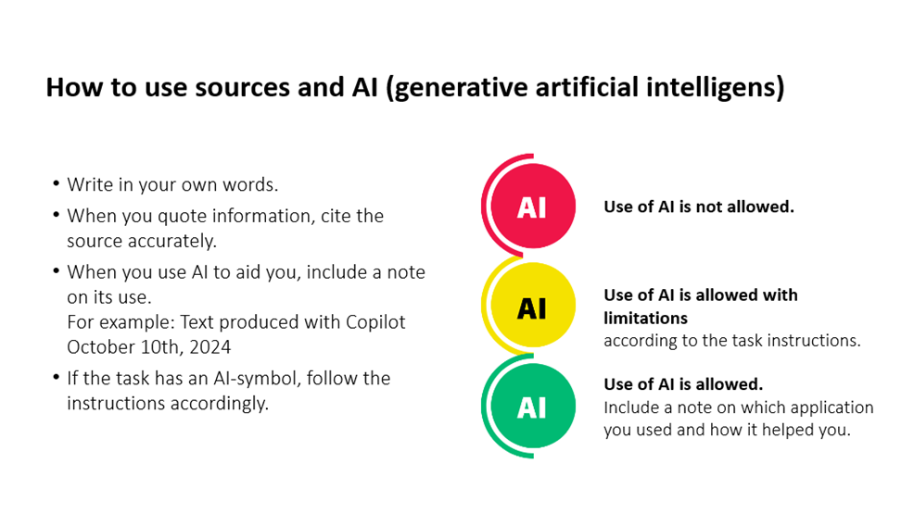

2. Introduction
Kurssin esittelyosiossa on kuvattu kurssin tavoitteita ja rakennetta.

Maintaining ability to work and well-being at work learning

Welcome to study the subject of wellbeing regarding the maintenance of working ability. During the course you will reflect, plan, implement and evaluate your skills among health based moving, nutrition, sleeping and recovery. And also dive into the topics which affect our health and wellbeing in bigger picture when speaking of intoxicants, sexual wellbeing, working ergonomics, working wellbeing and human interaction. Key competence requirements of the course on maintaining ability to works and well-being at work learning are formed by the Finnish National Agency of Education and are described below according to the instructions (FNAE, 2022).

- Understanding health differences in one's own age group
- The promotion of one's own health from the perspective of exercise, nutrition, recovery, mental well-being, intoxicants, sexual health and human interactions in a planned manner
- Reflects on the implementation of one's own health-promoting plan and critically reflects on the matter
- Knows how to search for information about the benefits and recommendations of exercise, knows how to develop physical fitness factors
- Recognizes the effects of work ergonomics, load factors, and knows how to develop operating instructions
- Recognizes risks that occur at work and knows how to act in accident situations, knows how to seek additional help

2.1. Course structure
Kurssin alussa opiskelija täyttää hyvinvointikyselyn ja asettaa itselleen hyvinvointiaan tukevan tavoitteen, jonka toteutumisen etenemistä seurataan ja arvioidaan kurssin aikana.
- Well-being questionnarie and well-being diary
- Course themes and tasks followed by the studying material
- Competence display and self evaluation

Start the course by filling the well-being questionnaire. Then set yourself a goal to focus on during the course. Fill the well-being diary during your studies and reflect your behavior with the knowledge you learn.

In the beginning of the course

Kurssin aluksi opiskelija orientoituu kurssin aiheisiin täyttämällä verkko-oppimisalustalle rakennetun alkukartoituskyselyn omaan hyvinvointiinsa liittyen. Tätä osiota ei arvioida. Lisäksi voit esitellä kurssin alussa opiskelijalle hyvinvointipäiväkirjan, jota voit käyttää kurssin toteuttamismuotoon (lähi/etä) sopivalla tavalla.

3.1. Well-being questionnaire
- Introduction:  At the beginning of the course, complete a well-being questionnaire that helps you reflect on your health and well-being from the perspective of work ability. The result of the questionnaire will not be assessed. The aim is to encourage you to think about your own well-being and prepare for the topic to be studied.  - Questions:  - How much basic activity or incidental exercise do you have in your daily life?  Answers:  My daily life is very active / I´m active every now and then / I´m not very active  - Are you satisfied, how active are you?  Answers:  Yes, I think i´m satisfied / Occasionally yes, but I could add some movement to my days / Occasionally yes, but I could add some movement to my days  - What is the overall level of stress or load in your daily life at the moment?  Answers:  My life is quite light and easy / I´m stressed every now and then, but I can manage / I feel I´m quite stressed every day and something should be done about it  - How often do you sleep in a way that makes you feel refreshed in the morning?  Answers:  I wake up fresh every almost morning / I´m refreshed sometimes / I´m tired almost every day  - Does your nutrition support your energy levels?  Answers:  Yes, I´m mostly energetic and vibrant / Usually I eat well, but I could pay attention to some things / There is quite a lot to improve in my nutrition  - Can I influence my own wellbeing?  Yes / Maybe / No  - How motivated are you to study topics related to your own health?  Very motivated / quite motivated / It´s not my main interest in life | Questionnarie is built into Itslearning or moodle learning platform:  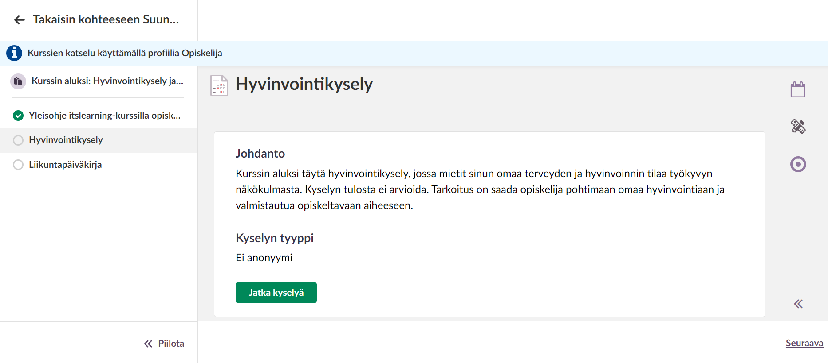  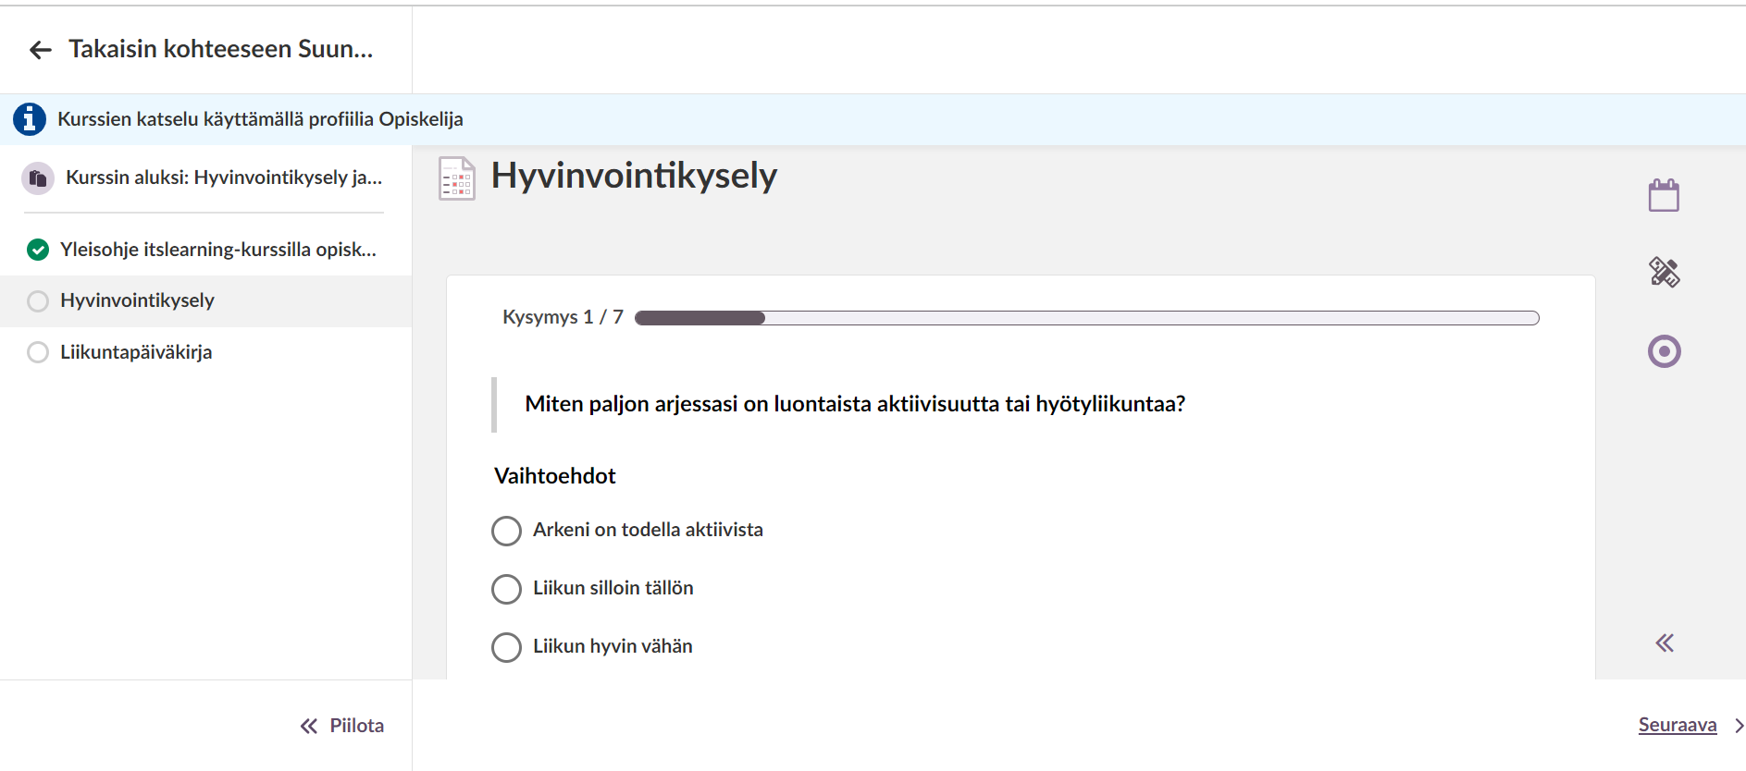

3.2. Well-being diary
Opiskelija täyttää kurssin aikana hyvinvointipäiväkirjaa, joka käsittelee hyvinvoinninteemoista arkiaktiivisuuden, ravitsemuksen, unen ja mielen hyvinvoinnin. Opiskelija aloittaa tekemällä Smart Moves -sivustolta alkukartoituskyselyn, jonka jälkeen hän asettaa itselleen tavoitteen, mihin keskittyy viikon aikana. Viikon aikana opiskelija täyttää hyvinvointipäiväkirjaa ja lopuksi reflektoi tehtävän onnistumista.

- Headline:  Well-being diary: Maintaining work ability and well-being  - Introduction:  First set a goal for yourself, then fill in a well-being diary for one week. Fill the boxes for activity, nutrition, sleep, and mood every day. Also mark the rest days for the exercise. Fill the discussion at the end.  - Set a goal:  First dot this Wellbeing test (Open link by klicking the text) and then reflect on your own health habits and write down into this box one goal you want to focus on during the week. The goal may be related to exercise, nutrition, or sleep. In addition, write how you plan to achieve your goals, what kind of things you need to focus on.  - Activity:  Write in the box how active you were during the day? What kind of exercise did you do and how much? Please check these: Physical activity recommendations  - Nutrition:  In the box, write the answer to the question related to nutrition.  - Sleep:  Write in the box how many hours you slept, and did you feel energetic or tired during the day?  - Mood:  Describe how you feel and think about how exercise, nutrition or sleep might affect your mood.  - Discussion:  How did you find filling the diary? Describe how well you managed to reach your goal, consider why this happened. What are you willing to do in the future to maintain your wellbeing? What challenges you might face and how could you solve these?  - Feedback:  Any other thoughts for the teacher.  - Finnish activity recommendations:  Picture: Physical activity recommendation for 18–64-year-olds - UKK-instituutti (ukkinstituutti.fi) | 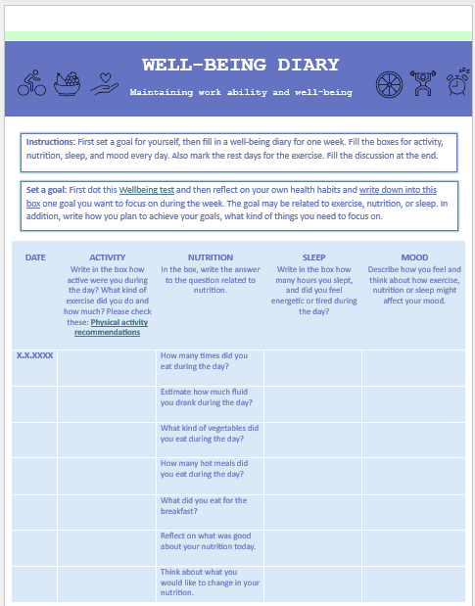  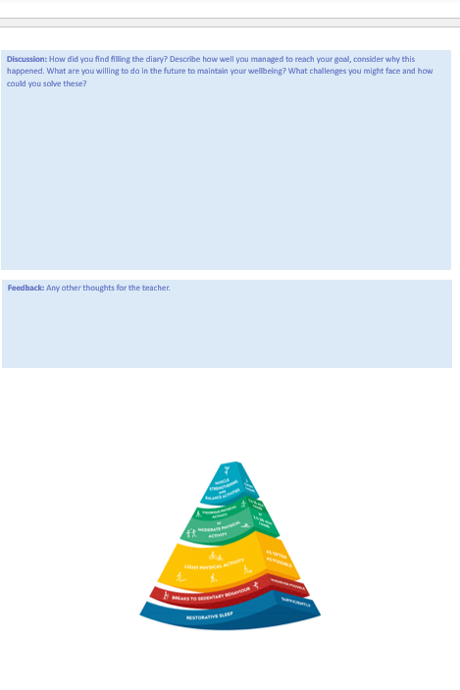

Course themes and tasks
Alta löytyvät kurssin kaikki kurssin aikana opiskeltavien teemojen diasarjat ja tehtävät.

Here you can find all the contents and tasks based on the key competence requirements.

4.1. Health-promoting exercise
Osiossa on diaesitys aihealueesta terveyttä edistävä liikunta ja kuusi siihen liittyvää tehtävää.

4.1.1. Slides

Slide 1 – Contents
- CONTENT OF THE LESSON  - WHAT DOES HEALTH-PROMOTING EXERCISE MEAN?  - HEALTH BENEFITS OF PHYSICAL ACTIVITY  - PHYSICAL FUNCTION  - SOCIAL FUNCTIONING  - MENTAL FUNCTIONING  - HEALTH-PROMOTING FITNESS FACTORS  - RISKS OF IMMOBILITY  - FOR REFLECTION | 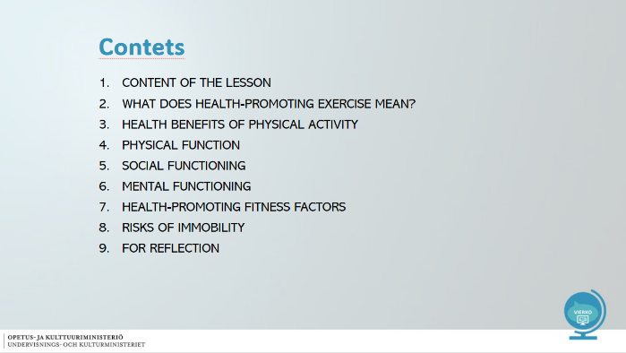

Slide 2 - CONTENT OF THE LESSON
- What does health-promoting exercise mean?  - Physical, mental and social functioning  - How exercise affects different areas of functional capacity  - Fitness factors and their utilisation in working life  - Risks of immobility | 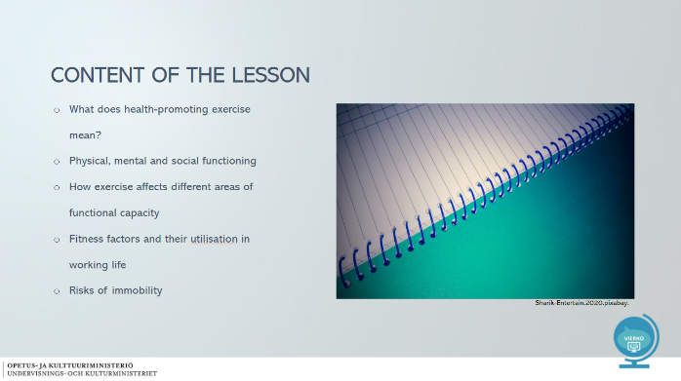
Slide 3 - WHAT DOES HEALTH-PROMOTING EXERCISE MEAN?
- Versatile exercise, such as activity throughout the day, non-conditioning exercise (cleaning, commuting, playing with children), walking, cycling, swimming and gym  - Health promoting effect  - Health-promoting exercise is  - Meaningful to you  - Regular  - Varied  - Heart-rate raising  - For example, 30 minutes of brisk walking every day  - Read more about mobility recommendations here!  - The goals of physical activity are individual  - How to add beneficial exercise to people's everyday lives?  IMPORTANT WORDS:  Health-promoting exercise, everyday activity, beneficial exercise, versatile, regular, individual | 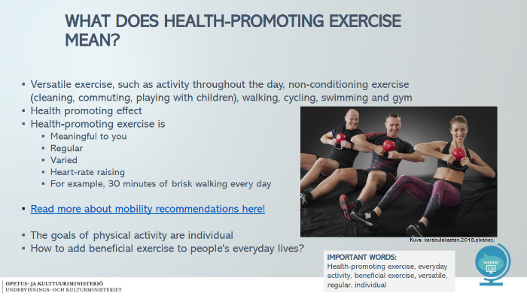

Slide 4 - HEALTH BENEFITS OF PHYSICAL ACTIVITY
- PHYSICAL FUNCTION  - MENTAL FUNCTIONING  - SOCIAL FUNCTIONING  SEE HERE: Health benefits of exercise (Finnish)  IMPORTANT WORDS:  Physical, mental and social, functional capacity, health impact, health benefit | 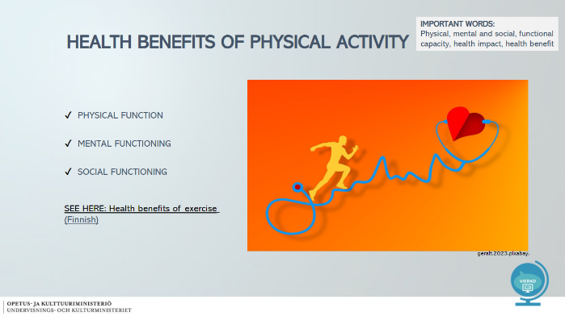

Slide 5 - PHYSICAL FUNCTION
- Development of fitness factors  - Disease prevention  - Musculoskeletal system  - Heart and circulatory system  - Type 2 diabetes  - Oncology  - The parasympathetic nervous system is activated  - Helps a person calm down  - How does physical functioning promote coping in working life?  FIND OUT WHAT THE TERMS MEAN: Fitness factor, musculoskeletal system, circulatory, type 2 diabetes | 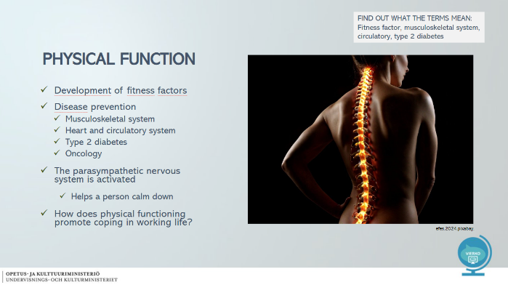
Slide 6 - SOCIAL FUNCTIONING
- Friends and interaction  - Emotional skills  - Teamwork skills and consideration of others  - Positive self-image  - Identity  - My time  - What social skills are needed in your job?  FIND OUT WHAT THE TERMS MEAN: Interaction, self-image, identity, emotional skills, teamwork | 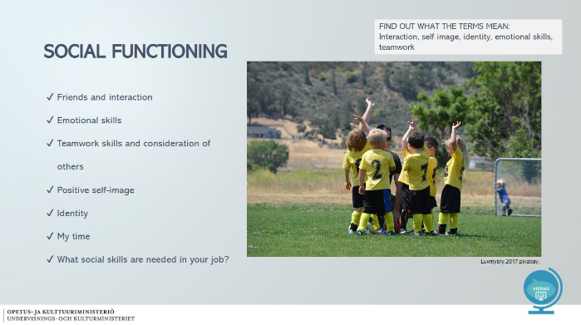

Slide 7 – MENTAL FUNCTIONING
- Mental health promotion  - Positive effect on mood  - Helps with stress management  - Experiences, joy and refreshment  - Memory and learning (cognitive functioning)  - How do you take care of your coping at work?  FIND OUT WHAT THE TERMS MEAN: Mental health, mood, cognitive function | 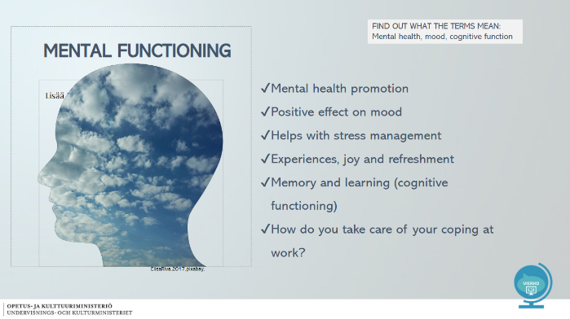

Slide 8 - HEALTH-PROMOTING FITNESS FACTORS
- Fitness factors include:  - Endurance fitness (aerobic fitness)  - Muscle tone  - Body control  - Mobility of muscles, joints and tendons  - Bone strength  - Suitable weight  - In which areas of fitness do you want to improve?  - What fitness factors do you need in your work?  IMPORTANT WORDS: Fitness, endurance, muscle strength, mobility, skeleton | 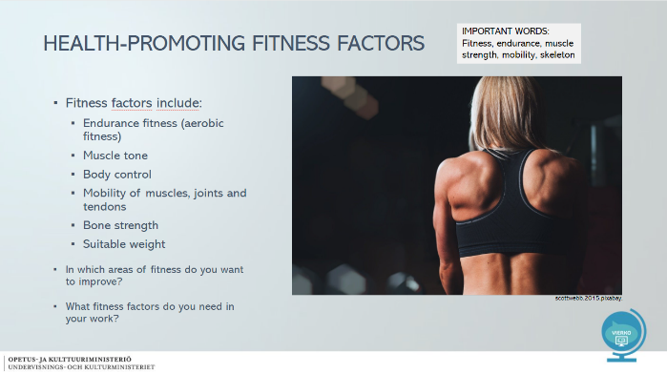

Slide 9 - RISKS OF IMMOBILITY
- Lifestyle diseases on the increase  - For example, type 2 diabetes, cardiovascular diseases, MSDs  - Overweight increases and fitness factors decrease  - A passive lifestyle can negatively affect mental health and social relationships  - Personal health suffers and sick leaves may increase in the workplace  Read: Liikkumattomuus vaikuttaa työkykyyn (Finnish)  See: Liikkumattomuus (subtitles)  IMPORTANT WORDS: Immobility, MSDs, overweight, lifestyle, sick leave | 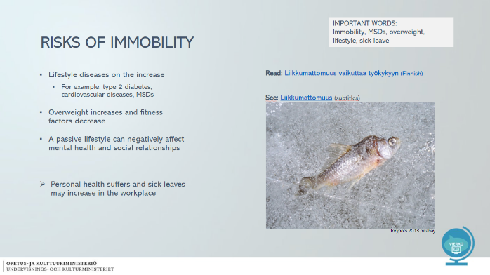

Slide 10 - FOR REFLECTION
- WHAT IS HEALTHY EXERCISE?  - WHAT IS FUNCTIONAL CAPACITY?  - WHAT AREAS OF FUNCTIONAL CAPACITY DO YOU KNOW?  - HOW CAN YOU IMPROVE YOUR CONDITION? | 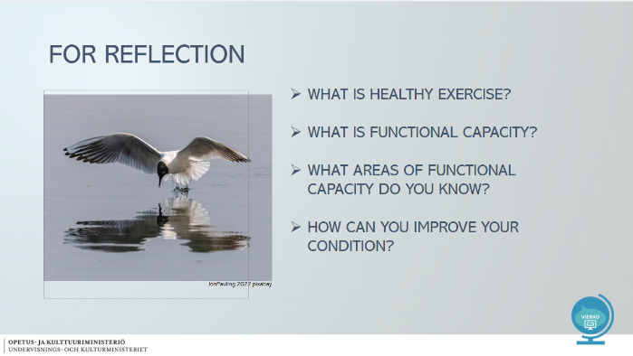

Slide 11 - FOR REFLECTION
- Read: Liikunnan vaikutukset terveyteen  - Find out how exercise affects human health?  - Immediately during exercise  - After 2-3 weeks  - After 2-3 months  - In six months  - Hereafter | 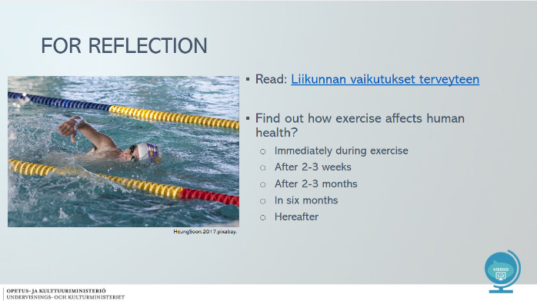

Pictures used in the slideshow (Pixabay):
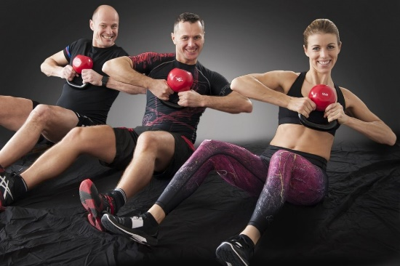
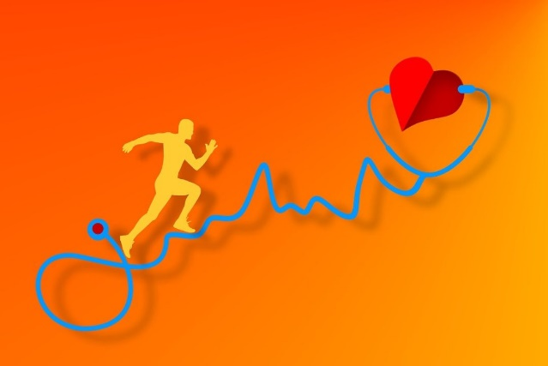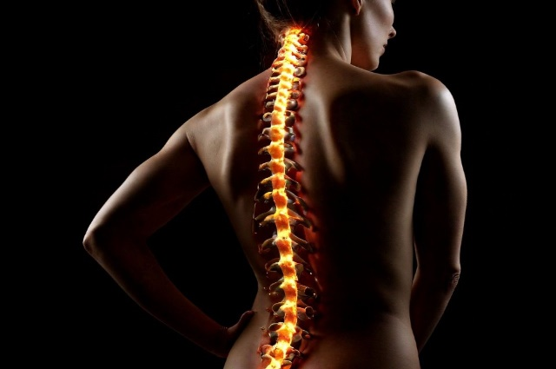
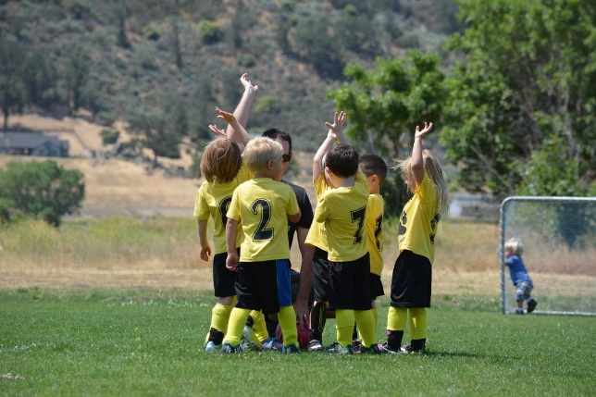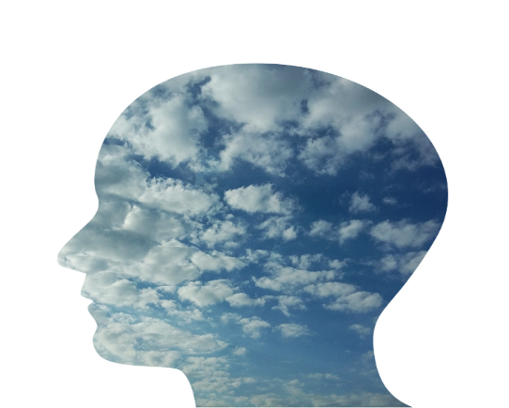

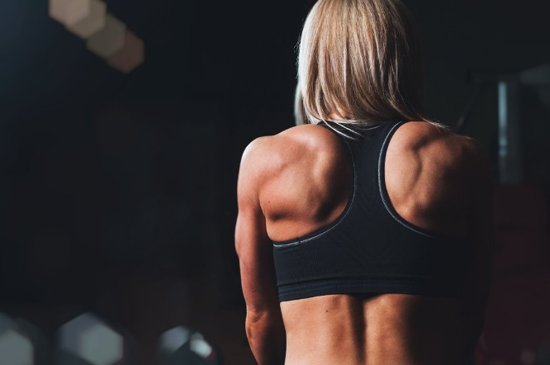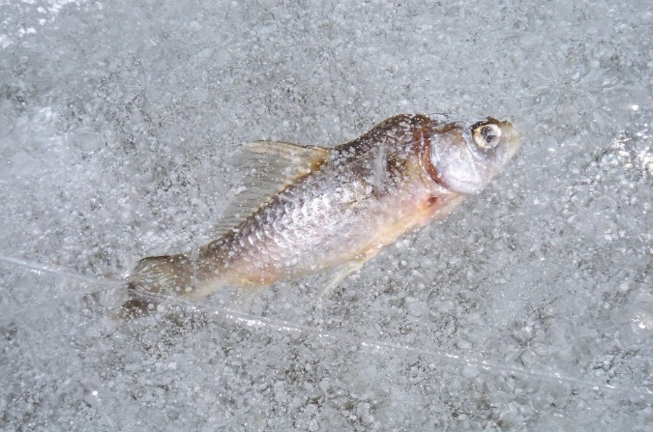
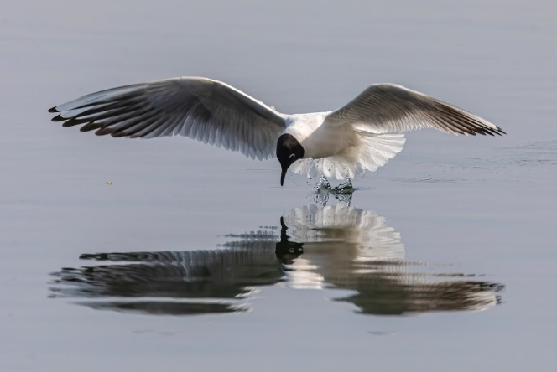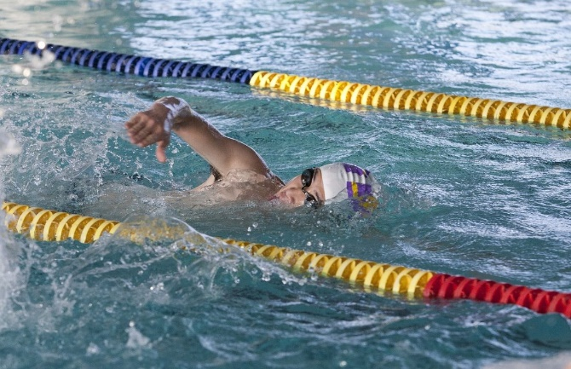

4.1.2. Tasks
Verkkokurssilla tehtävät on tuotettu alustan omilla toiminnoilla. Tehtävät voi tehdä myös esimerkiksi Forms-lomakkeena. Kysymyksen oikea vastaus on lihavoitu ja oikeita vastauksia voi olla useampia.

Health-promoting exercise:

In this section, students study what physical, mental and social functioning is and how exercise affects different areas of functional capacity.

Let's learn what fitness factors are and how you can benefit from them in working life.
In addition, the risks associated with immobility are considered.

Question 1
In this question, you will be presented with 3 blank fields where you should enter your answers. First, read the surrounding text, and then write your answer.
Exercise supports people's overall well-being. Fitness factors develop, which supports coping in everyday life. Regular exercise can prevent, for example, musculoskeletal disorders, strengthen the cardiovascular system and type 2 diabetes.
Which area of functional capacity is discussed above: (physical, mental, social, functional capacity)
Physical functioning

Exercise brings people together, and exercising together with friends or family refreshes the mind and supports people's well-being. Exercise can be used to strengthen emotional and teamwork skills, for example. Exercise moments can also provide people with time for themselves.
Which area of functional capacity is discussed above: (physical, mental, social-functioning)
Social functioning

Exercise promotes mental health and has a positive effect on mood. Regular exercise also helps with stress management. New experiences and experiences experienced through mobility refresh the mind. Exercise also supports brain health and supports learning, for example.
Which area of functional capacity is discussed above: (physical, mental, social-functioning)
Mental functioning

Question 2
Tell me, what are fitness factors? You can choose more than one option.

Disease prevention
Identity development
Muscle strength and endurance
Respiratory and circulatory system condition
Gym workout
Mobility of muscles, joints and tendons

Question 3
Health-promoting exercise means that a person engages in various activities that are suitable for him/herself and support, for example, the development of various fitness factors and all areas of functional capacity.
What criteria are we talking about?

Versatile exercise
Exercise that increases heart rate
Regular exercise

Question 4
A person's fitness factors develop when enough exercise is added to everyday life. Inactivity or occasional movement does not develop, for example, physical fitness, which supports overall well-being.
Which health-promoting exerciser are we talking about?

Versatile exercise
Regular exercise
Threshold for movement

Question 5
A person between the ages of 16 and 65 should exercise for either 2.5 hours of vigorous or 1.5 hours of strenuous exercise, as well as training that supports muscle strength and movement control at least twice a week.
Which health-promoting exerciser are we talking about?

UKK mobility recommendations
Threshold for movement
Exercise that increases heart rate

Question 6
Exercise often takes place through hobbies. However, everyday exercise is very important. For example, commuting exercise, using stairs, taking breaks from sitting, doing household chores and changing working postures support a person's ability to stay active.
Which health-promoting exerciser are we talking about?

Benefit/everyday exercise
Recommendations for physical activity
Versatile exercise

4.2 Nutrition
Nutrition osiossa on diaesitys aihealueesta ravitsemus ja kuusi siihen liittyvää tehtävää.

4.2.1. Slides

Slide 1
Contents of the course  - Nutritional recommendations  - Nutrients  - Food rhythm  - Individual diets  - Nutrition checklist | 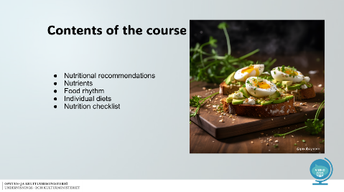

Slide 2
Nutritional recommendations  - The nutritional recommendations are based on scientific studies  - The recommendations tell you what you should eat and how much  - They guide you to choices that promote health  More information:  Finnish Ruokavirasto: nutritional recommendation  KEY WORDS: nutritional recommendation, scientific  studies, choice, diet | 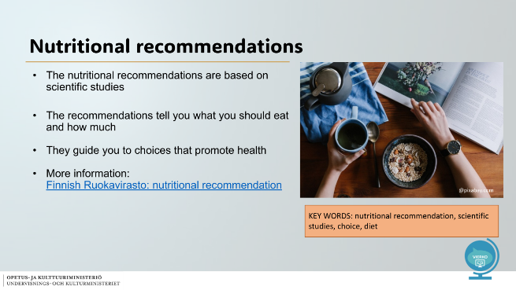

Slide 3
Food triangle  - The food triangle reflects the amounts of different food groups in a good diet  - It would be good to eat more  of those at the bottom of the triangle  Less of those at the top of the triangle  KEY WORDS:  Food, meat preparation, poultry, whole grain  Ruokakolmio. Terveyttä ruoasta!  Suomalaiset ravitsemussuositukset 2014. Valtion ravitsemusneuvottelukunta. | 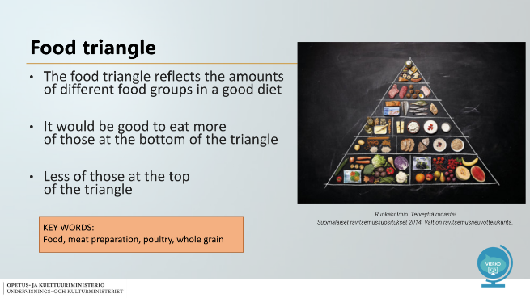

Slide 4
Plate model  - The plate model helps in choosing a good meal  - Fill half of the plate with vegetables  - ¼ potatos, rice or other cereal products  - ¼ source of protein e.g fish or chicken  If you want, you can leave the milk product and the berries to be eaten as a snack  KEY WORDS: plate model, meal, source of protein, milk product | 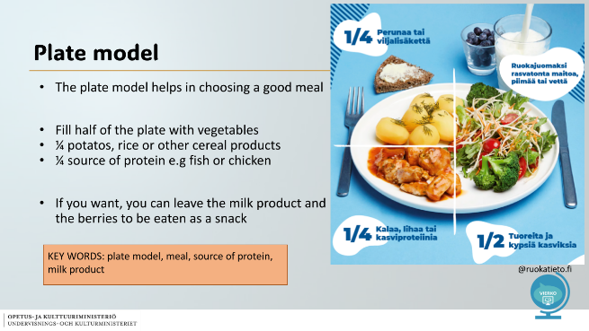

Slide 5
Nutrients  - The body needs an appropriate amount of different nutrients  Nutrients are divided in two categories:  ENERGY NUTRIENTS  - Carbohydrates  - Fats  - Proteins  Energy is needed for the body’s basic metabolism, heat production and movement  PROTECT NUTRIENTS  - Vitamins  - Trace elements  - Dietary fibers  Protective nutrients participate in the maintenance of vital functions and the body’s regulatory tasks | 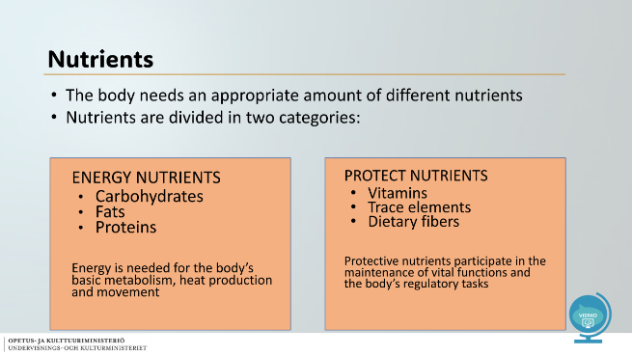
Slide 6
Energy nutrients  Carbohydrates  - Energy source  - Cereal products, vegetables, berries, fruits  45-60% of the daily diet  Fats  - Hormone function, brain, energy source  - Soft fats - use a lot: oils, margarine, nuts and fish  - Hard fats - use wisely: butter, meat and dairy products  20-35% of the daily died  Proteins  - Building material  - Legumes, poultry, red meat, dairy products, egg  10-20% of the daily diet | 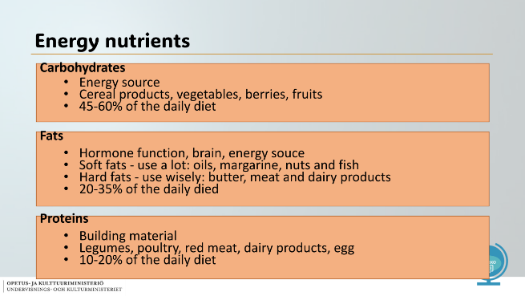

Slide 7
Protective nutrients  - Substances necessary for the body  You get protective nutrients from a versatile and plant-based diet  Vitamins  - Improve immunity  - Promote metabolism and hormone function  In Finland, only vitamin D is recommended as a dietary supplement all year around  Minerals and trace elements  - Building materials for cells and tissues  - Promote alertness and prevent fatique  E.g. potassium, sodium, zinc, iron | 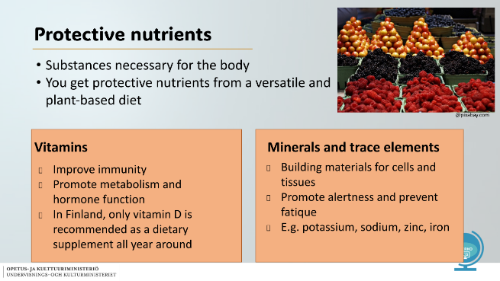

Slide 8
Make a good choice  - Choose whole grain products  - Rye bread and wholemeal bread  - Dark pasta and rice  - You get more protective nutrients and energy nutrients  - Increase fiber intake  - Lowers blood pressure, prevents intestinal diseases, helps weight control  🡪 Whole grains promote human health  KEY WORDS: whole grain, fiber, blood pressure, intestinal diseases, weight control | 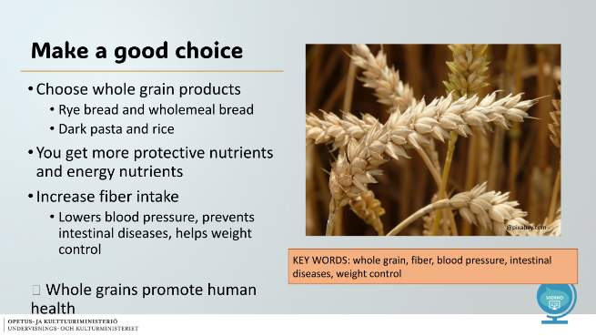

Slide 9
Meal rhythm  - The body needs food at regular intervals, approx. every 3-4 hours  - Eating regularly keeps your blood sugar level and keeps you alert  - A good food rhythm makes it easier to avoid unhealthy snacks, excessively large food portions and snacking in the evenings  - Plan and anticipate your meal rhythm at work and in your free time  07-08.00 Breakfast  11-12.00 Lunch  14-15.00 Snack  17-18.00 Dinner  20-21.00 Evening snack  THINK! How does your own meal rhythm differ from the recommendation in the picture?  KEY WORDS: food rhythm, regular blood sugar, alertness, snack, nibble, plan, anticipate | 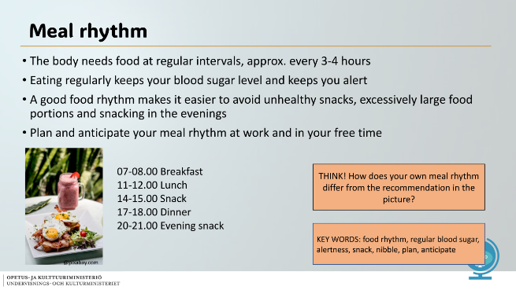

Slide 10
Individual diets  - One or more food items are omitted from the diet  - Health reasons (e.g. allergies, fodmap)  - Ethical reasons (e.g. vegan)  - Religious reasons (e.g. pork)  - A person following an individual diet should make sure that he gets all the necessary nutrients  KEY WORDS: individual, died, ethical, necessary, nutrient | 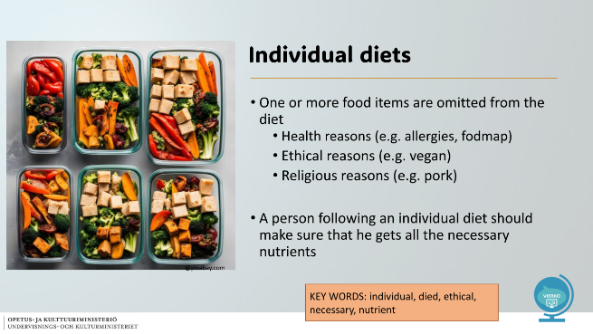

Slide 11
Nutrition checklist  - Eat wisely 80 % of the time, the remaining 20% you can eat more casually  - Remember versatility and colours on a plate  - Favor vegetables, whole grains and good fats  - Use red meat, salt, hard fats, sugar and alcohol sparingly  - In accordance with a sustainable diet, prefer local food and especially domestic seasonal vegetables  - Eat enough and enjoy the food! | 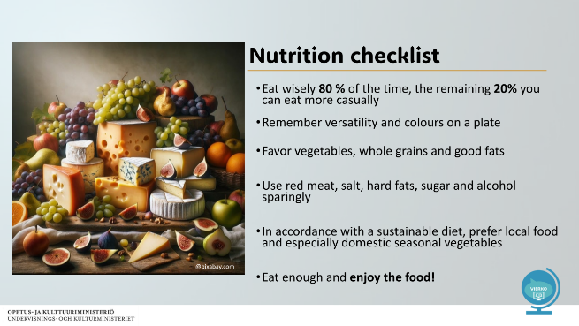

Slide 12
VIERKO  Vieraskielisen opetuksen kehittäminen  Kotimaisten kielten opetuksen tarjonnan ja laadun kehittäminen  ammatillisessa koulutuksessa 2024  Lisätietoa:  https://www.keuda.fi/keuda/hankkeet/vierko/ | 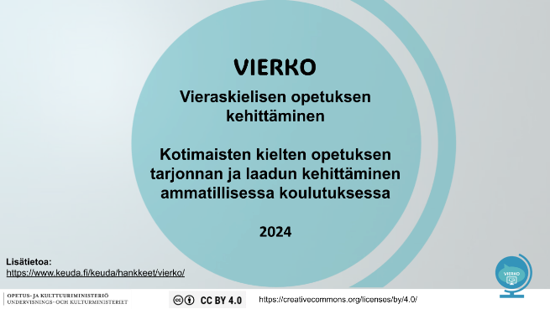

Pictures used in the slideshow:
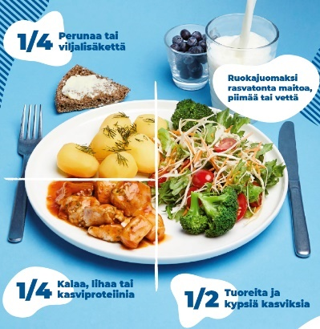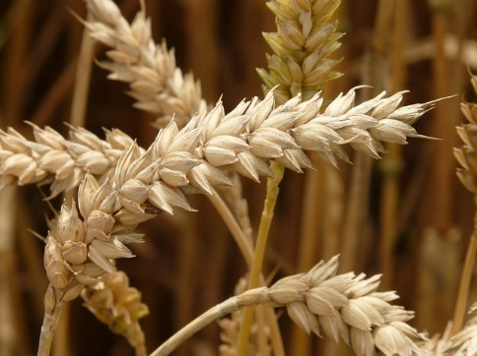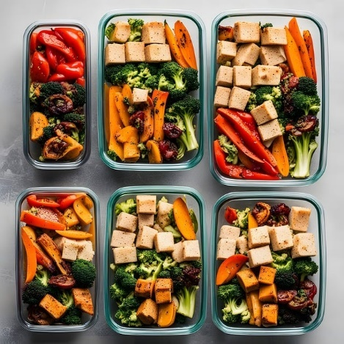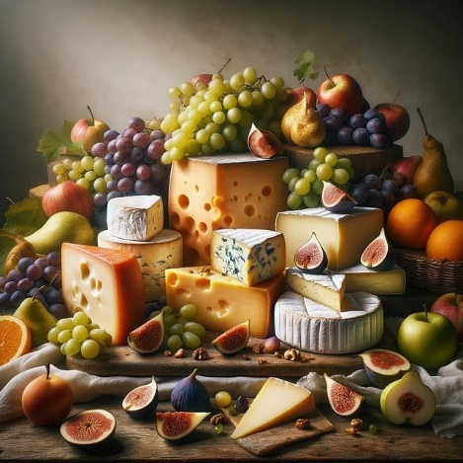

4.2.2. Tasks
Verkkokurssilla tehtävät on tuotettu alustan omilla toiminnoilla. Tehtävät voi tehdä myös esimerkiksi Forms-lomakkeena. Kysymyksen oikea vastaus on lihavoitu ja oikeita vastauksia voi olla useampia.

Introduction text to the tasks:

In this section we study content related to nutrition. Let's find out what the nutritional recommendations, nutrients, food rhythm mean. We will also familiarize ourselves with individual diets. Finally, let's summarize which things are important in nutrition and help make you healthy
food choices.

Question 1
Why do nutritional recommendations exist?
- Nutritional recommendations are needed so that we can create a personal relationship to different foodstuffs
- The nutritional recommendations tell you which things must be left out of the diet
- The central goal of nutritional recommendations is to improve the health of the population through nutrition

Question 2
Which three are energy nutrients?
Fats
Carbohydrates
D vitamins
Proteins
Fibers

Question 3
Which two are protective nutrients?
Cereal products
Hormones
Vitamins
Minerals and trace elements

Question 4
What two are the functions of vitamins?
They improve immunity
They burn fat
Protects against allergies
Promote metabolism and hormone function

Question 5
Instructions
Place the following words in the correct boxes:
unhealthy / 3-4 / blood sugar / alertness / too big / snacking

Answer
In this question you are presented with 6 blank fields to fill in
your answer. First read the surrounding text and then write your answer.

The body needs food at regular intervals, about every ___ hour. - 3-4

Eating regularly keeps your ____ even and ____ above. - blood sugar/alertness

A good meal rhythm makes it easier to avoid ___ snacks, - unhealthy

___ food portions and ___ in the evenings. - too big / snacking

Question 6
Complete the sentence and find the pairs.

The food triangle - half of the plate is filled with vegetables

The food triangle - helps a good meal in enlightenment

The plate model - those at the top are eaten the least

The plate model - reflects the quantities of different food groups

4.3 Self-knowledge and interaction
Osiossa on diaesitys aihealueesta itsetuntemus ja vuorovaikutus sekä viisi siihen liittyvää tehtävää.

4.3.1 Slides

Slide Self-knowledge and interaction
- SELF-KNOWLEDGE AND INTERACTION  - Interaction skills and good self-knowledge promote work ability​​ | 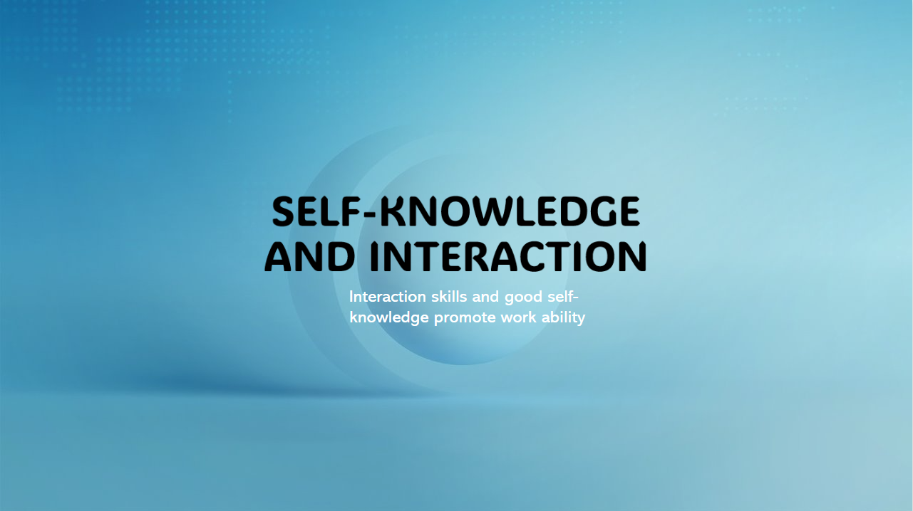

Slide 1 – Contents
- CONTETNT OF THE LESSON  - BASIC HUMAN NEEDS  - WHAT IS INTERACTION?  - WHAT IS GOOD INTERACTION?  - SOCIAL MEDIA AND INTERACTION  - GOOD BEHAVIOR ON SOCIAL MEDIA  - WHAT ARE THE BENEFITS OF GOOD INTERACTION SKILLS IN WORKING LIFE?  - WAT IS SELF_KNOWLEDGE?  - TASKS | 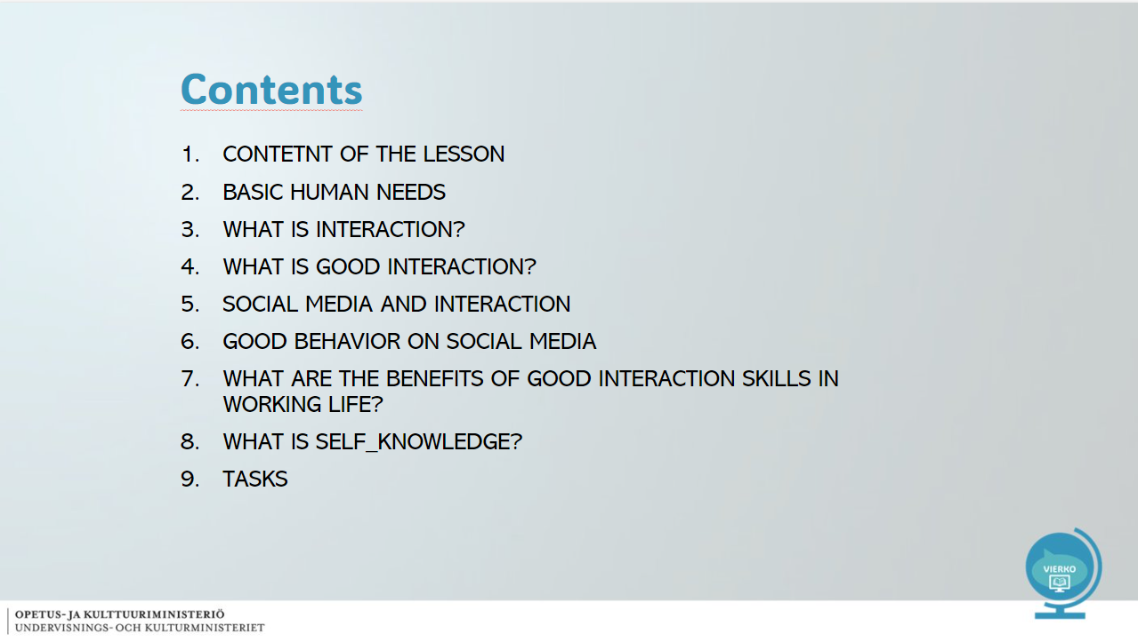

Slide 2 - CONTENT OF THE LESSON
- What does interaction and self-knowledge mean?  - Guidelines for good interaction  - Guidelines for good interaction on social media  - What are the benefits of interaction skills in working life?  - Identifying one's own character strengths and utilising them in working life  IMPORTANT WORDS: interaction, social media, self-knowledge, basic needs, character,  strength | 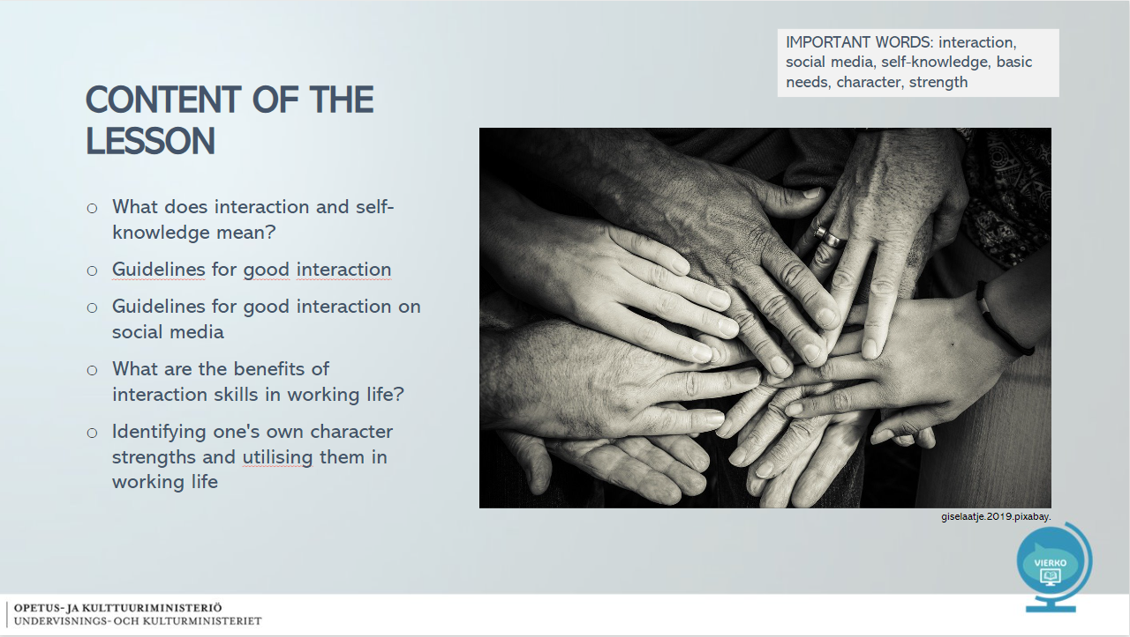

Slide 3 - Basic human needs
- Well-being requires the fulfilment of basic needs  - Basic needs include:  - Physiological needs = food, drink, sleep, rest  - Security needs = protection in crisis situations  - Social needs = love, friendship, family  - Needs for appreciation = self-confidence, experience of dignity  - Self-actualization needs = I am important and meaningful  - Transcendence  IMPORTANT WORDS: basic need, security, protection, crisis situation, appreciation, self-confidence, meaningful | 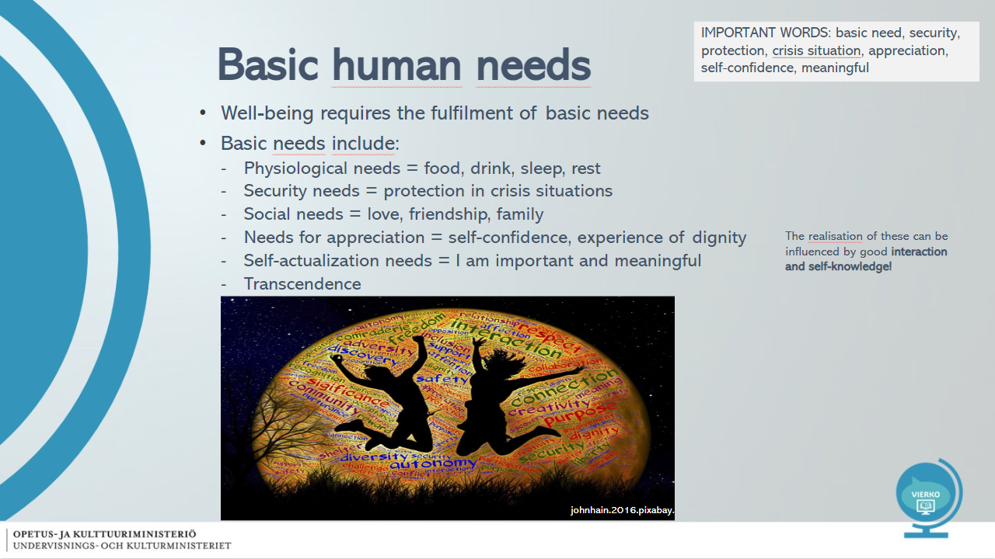

Slide 4 - What is interaction?
- "Interaction skills refer to the ability and willingness to exchange thoughts, experiences, opinions or actions with others and to work together"  - Ponder: What is the difference between sociability and social skills?  IMPORTANT WORDS: People skills, experience, opinion, working together | 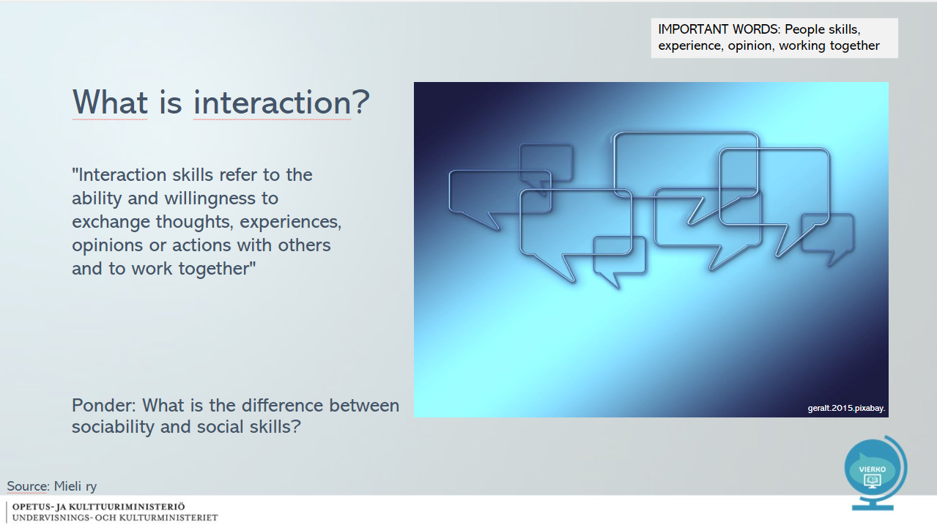

Slide 5 - What is good interaction?
- Be present in the conversation, do not constantly use, for example, the phone  - Actively listen to what the other person wants to say  - Keep eye contact  - Take others into account, don't talk out of turn  - Put yourself in the other person's shoes  - Encourage and be positive  - Share your thoughts  - It's OK to disagree – how do you react to disagreements?  Read: What makes a good listener?  IMPORTANT WORDS: Active listening, eye contact, react, disagreement, sociability | 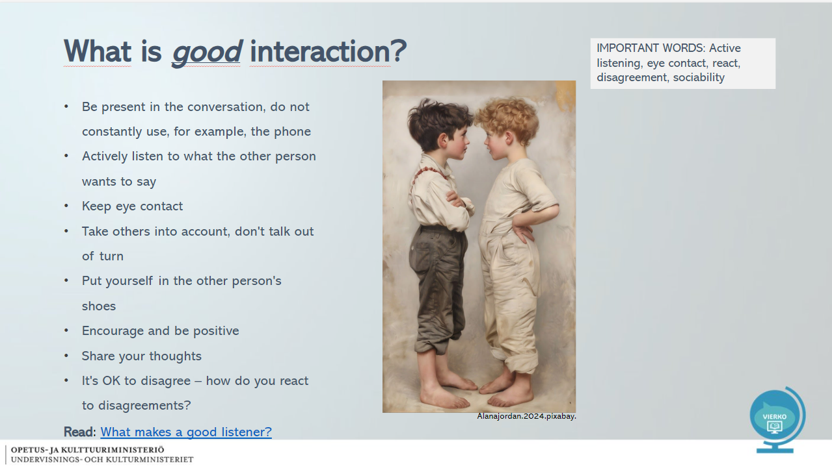

Slide 6 - Social media and interaction
- Social media involves interacting with others without body language  - Commenting, getting to know each other, marking favorites, sharing content, and so on  - Social media increases sociability, networking and communality  - There is also disruptive behaviour on social media  - Netiquette means good behavior online  - People have the right to be at peace also online, read more here!  - What should you tell us about yourself online? Read more here!  Follow On Tik Tok @konstaapelidaniel  IMPORTANT WORDS: Social media, social media, body language, networking, community, harassment, behavior, responsibility | 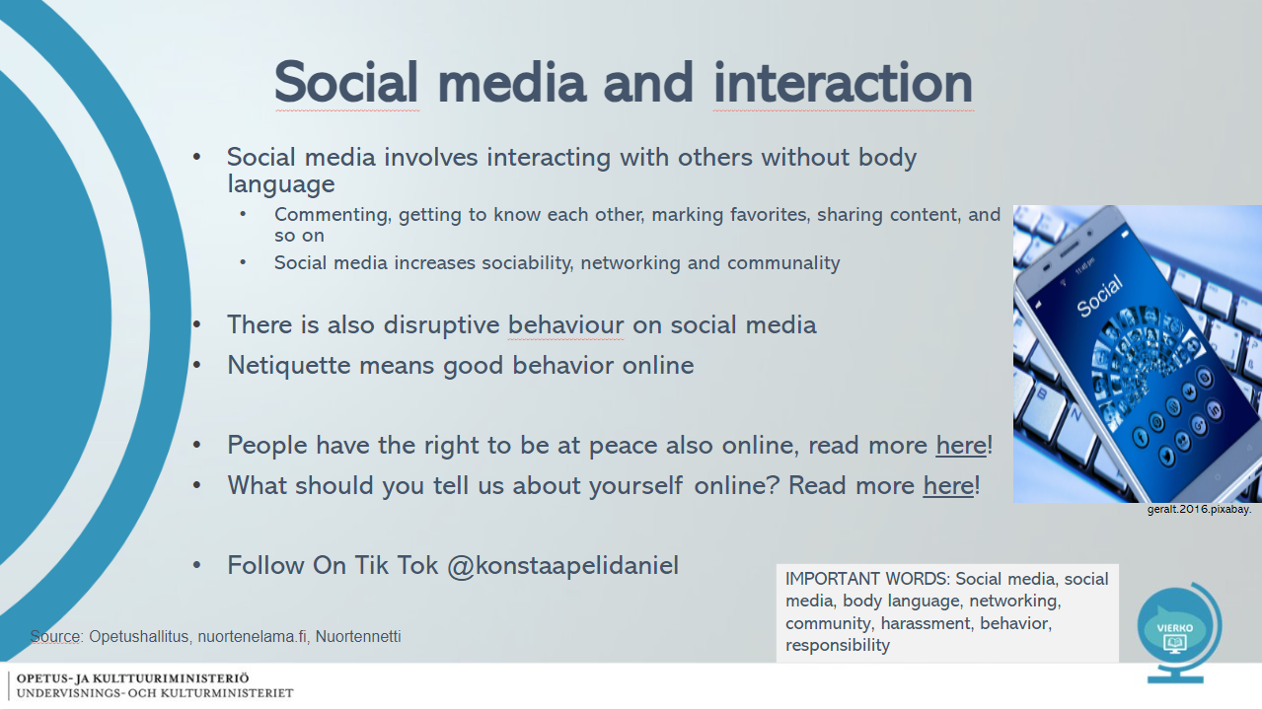

Slide 7 - Good behavior on social media
- Ponder whether you behave the same way online and live?  - Obey the law  - Act constructively and respectfully  - Take other people into consideration, be supportive  - Do not post material or messages produced by others without permission  - Don't post offensive content  - Be source critical, don't spread rumors  - Report disruptive behavior!  - You are responsible for your behaviour on social media  ” Is my text true?  Is my text relevant?  Is my text necessary?”  IMPORTANT WORDS: online, live, obey the law, constructive, respectful, note, publish, critical, rumor | 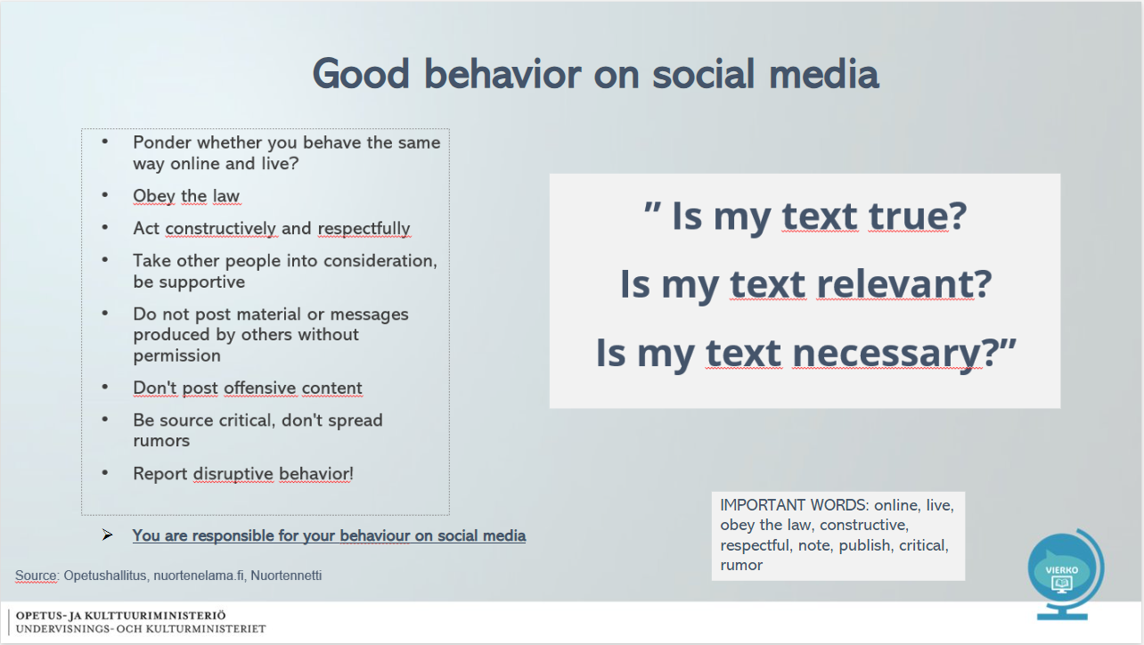

Slide 8 - What are the benefits of good interaction skills in working life?
- Has a positive impact on the working atmosphere and increases job satisfaction  - The experience of dignity increases the employee's self-confidence and the courage to show their competence  - Enables respect between colleagues  - A person's needs in the workplace are spoken out constructively and can be influenced  - Provides an expert image of the employee > Creates opportunities for success  Ponder: What kind of interaction do you bring with you  work community?  IMPORTANT WORDS: respect, dignity, assertiveness, competence, work atmosphere, constructive, knowledgeable | 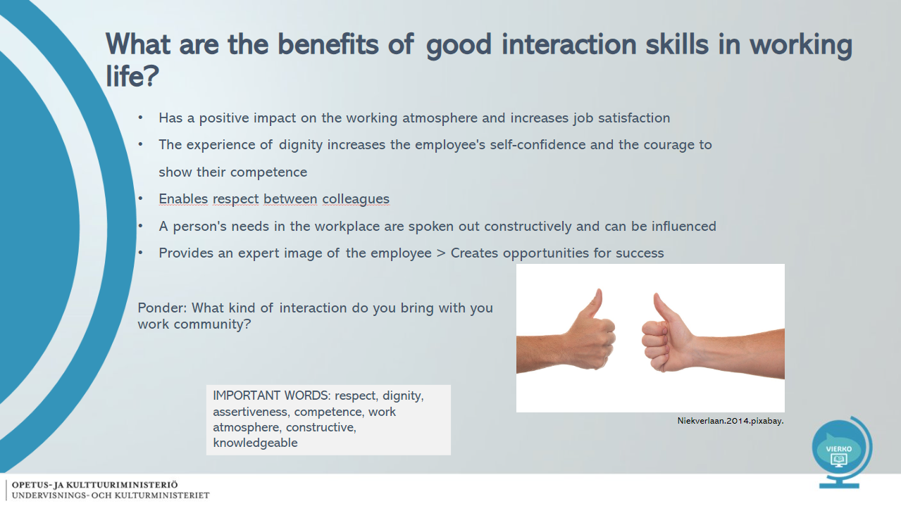

Slide 9 - What is self-knowledge?
- "Ability to perceive one's own thoughts, feelings, needs and desires, strengths and development needs."  IMPORTANT WORDS: thought, feelings, needs, desires, strengths, development | 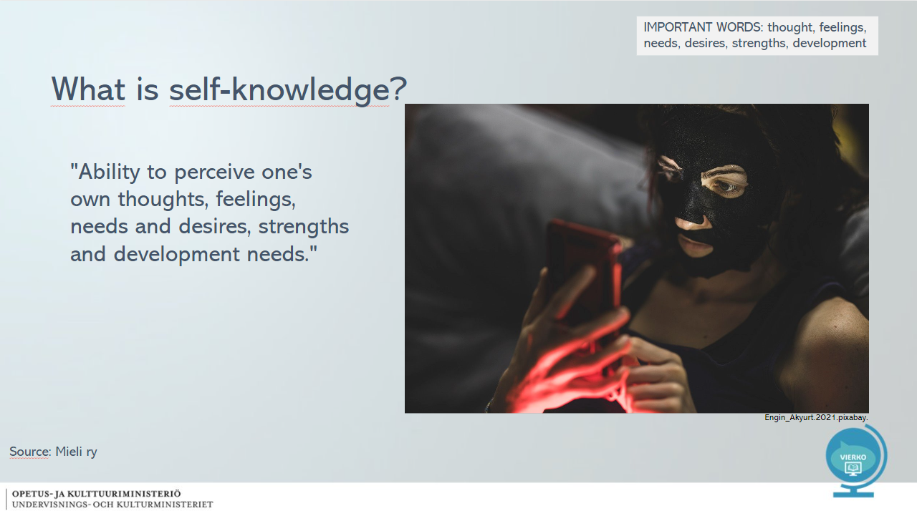

Slide 10 - Identify your strengths – TASK
STEP 1  The following slide has 24 strengths.  Choose 3 strengths that you have.  Ponder how these attributes benefit your work?  IMPORTANT WORDS: Identify, strength, attributes | 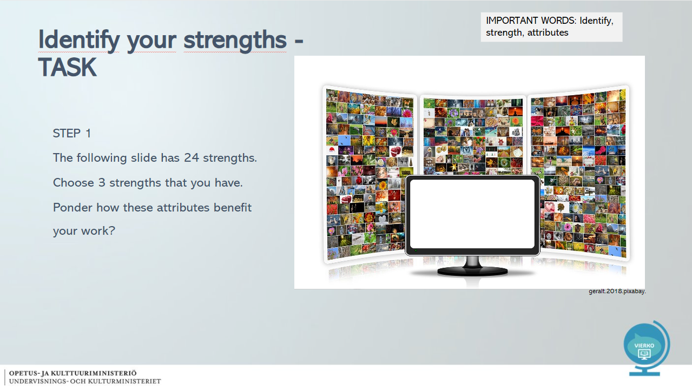

Slide 11 - STRENGTHS – Choose 3 strengths that you have
- Creativity  - Curiosity  - critical thinking  - desire to learn  - Wisdom  - Courage  - Gutsiness  - Honesty  - Energetic  - the ability to love  - Helpfulness  - social intelligence  - Loyalty  - Justice  - leadership skills  - ability to forgive  - Modesty  - practical wisdom  - self-discipline  - sense of beauty  - Thankfulness  - Optimism  - Sense of humour  - Fidelity | 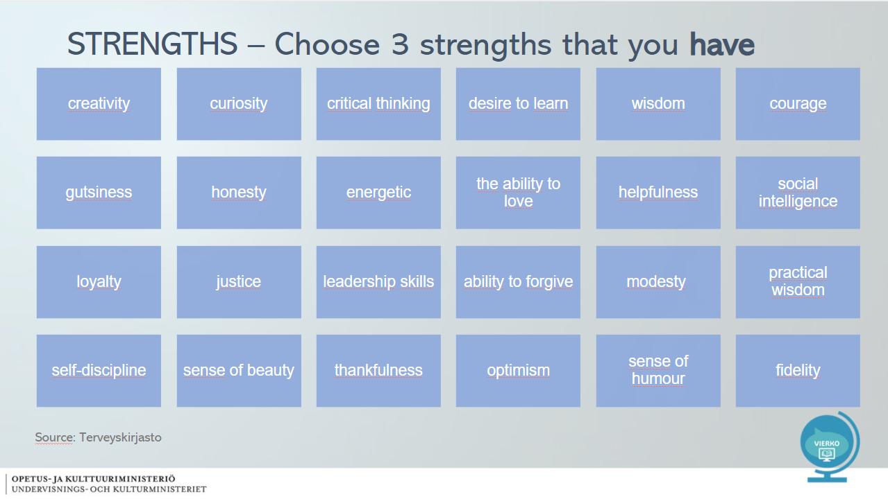

Slide 12 - Identify your strengths – TASK
STEP 2  Tell your partner about your strengths and tell them how they benefit in working life.  Listen quietly as your partner tells you about their strengths.  STEP 3  Now choose one strength that you lack that could be necessary in working life.  IMPORTANT WORDS: Identify, strength, benefit, working life, necessary | 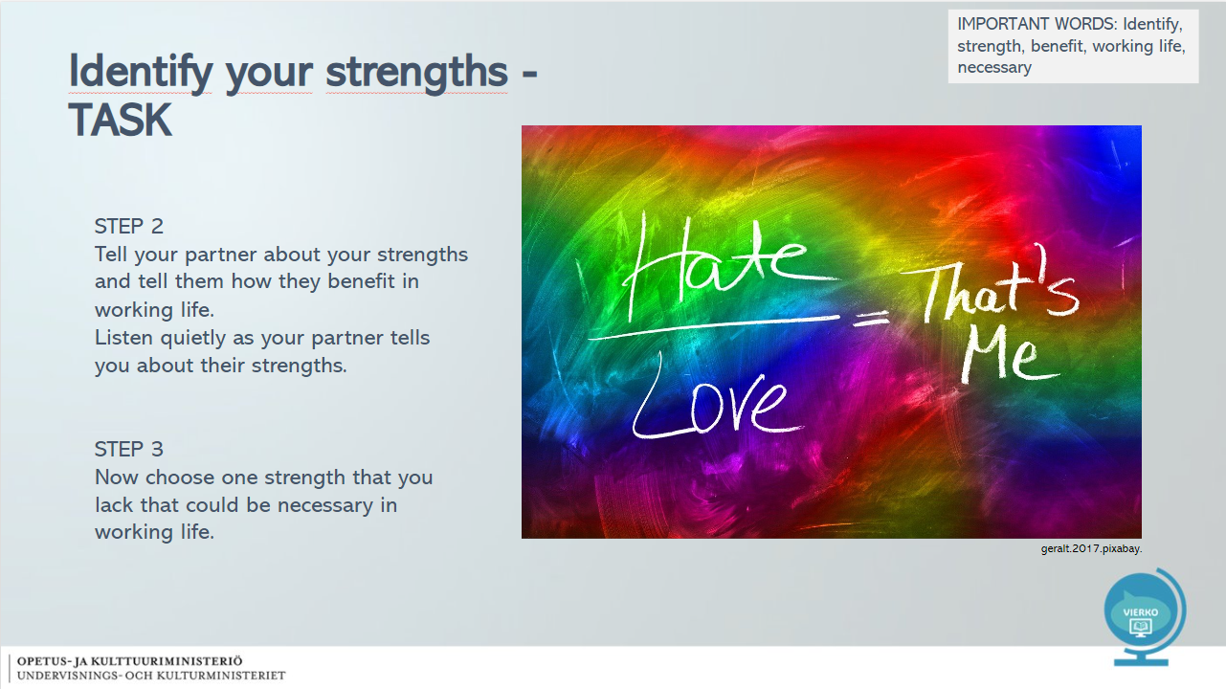

Slide 13 - Choose one strength that you would like to strengthen in yourself
- Creativity  - Curiosity  - critical thinking  - desire to learn  - Wisdom  - Courage  - Gutsiness  - Honesty  - Energetic  - the ability to love  - Helpfulness  - social intelligence  - Loyalty  - Justice  - leadership skills  - ability to forgive  - Modesty  - practical wisdom  - self-discipline  - sense of beauty  - Thankfulness  - Optimism  - Sense of humour  - Fidelity | 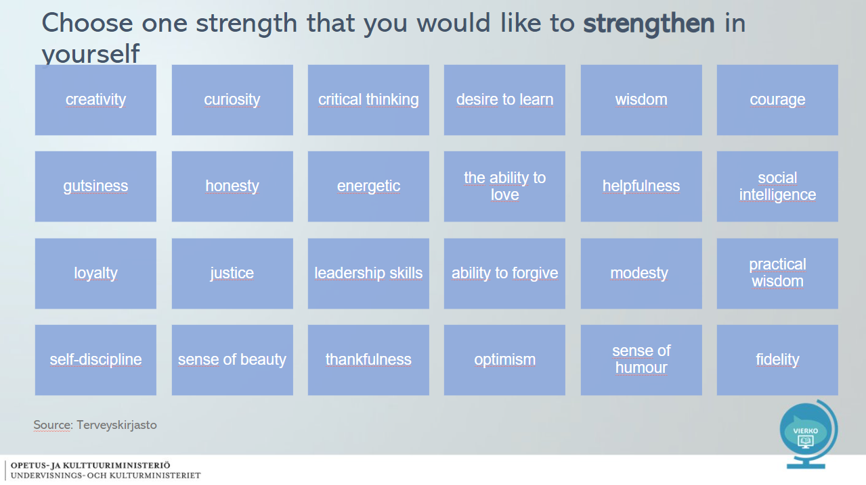

Slide 14 – TASK
Ylppä and Pinja are good friends. Both have worked at Veke's warehouse for about 4 years. Ylppä has been asked to talk to a supervisor and offered a promotion. Instead, Pinja learns that she will be transferred to another department due to a lack of resources. Pinja did not wish for the transfer.  Ylppä and Pinja meet during a lunch break. Ylppä is excited about the new situation, but Pinja's mind is down.  - How should Ylppä handle the situation? | 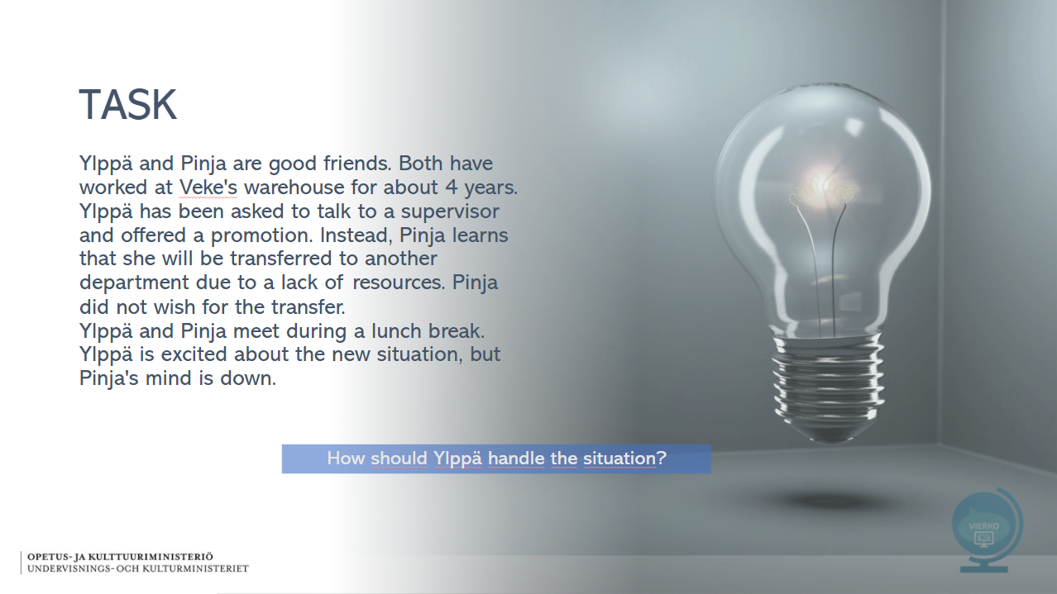

Slide 15 – TASK
Angie works in sales in the electronics department during her first year and has been a reliable and conscientious employee.  The supervisor has forwarded customer feedback to Angie via email, in which Angie's work and customer service are written about in a very negative way. The supervisor asks Angie to respond to her via email about the events of that day and demands an explanation of the behavior.  - What went wrong here? | 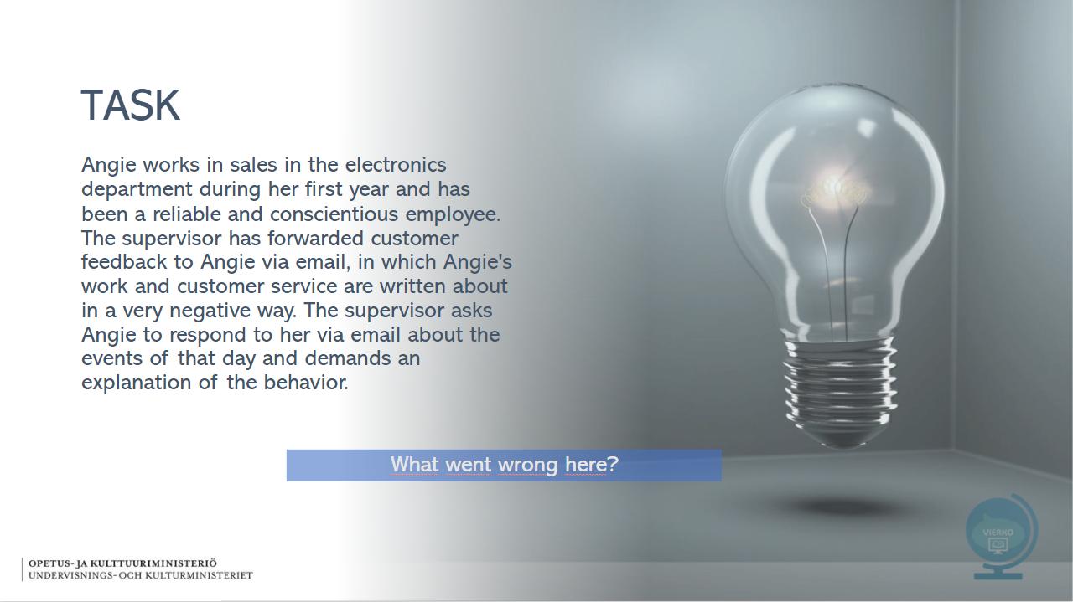

Pictures used in the slideshow (Pixabay):
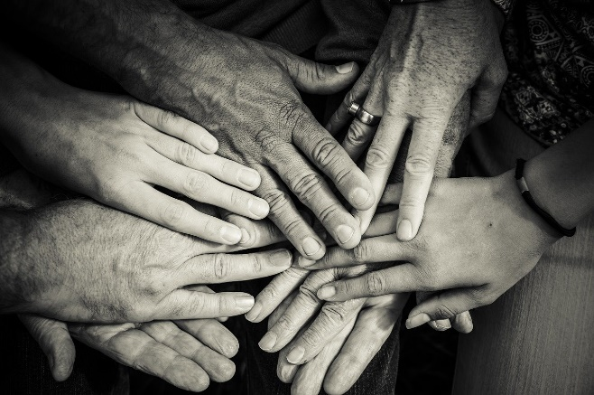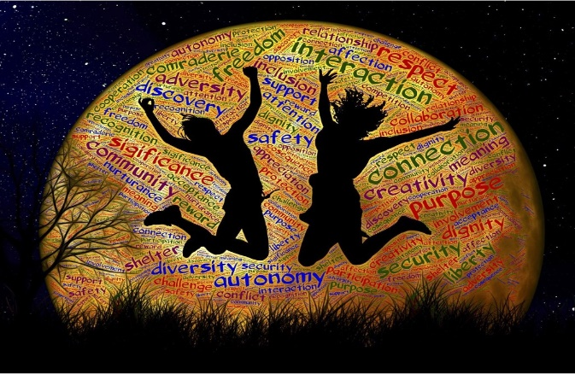

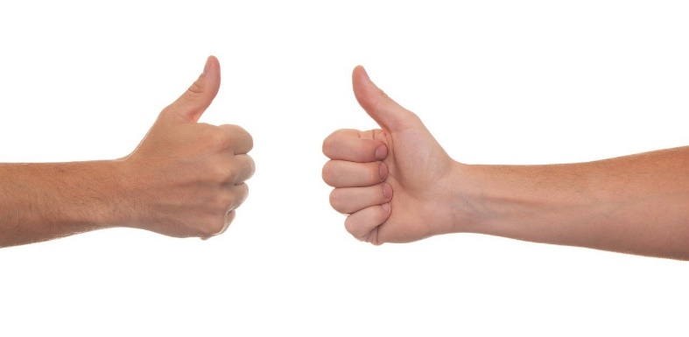
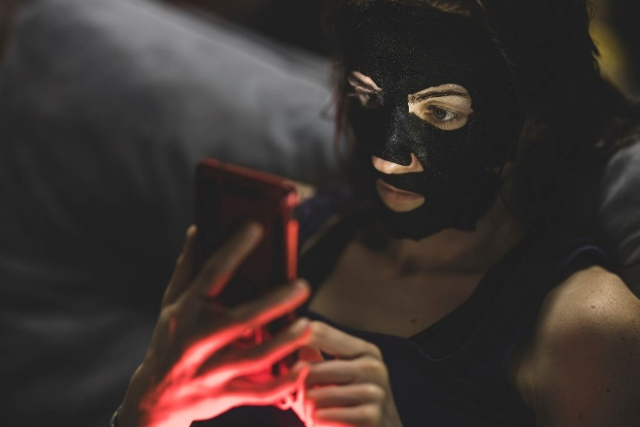


Tasks

Verkkokurssilla tehtävät on tuotettu alustan omilla toiminnoilla. Tehtävät voi tehdä myös esimerkiksi Forms-lomakkeena. Kysymyksen oikea vastaus on lihavoitu ja oikeita vastauksia voi olla useampia.

In this section, you will learn important interaction skills that help you build lasting relationships both in your free time and in working life.

Good communication skills enable success in different areas of life. The students will learn what interaction means in working life and social media. In addition, the students will learn about self-knowledge and their own strengths.

Question 1

In this question, you will be presented with 6 blank fields in which you should enter your answers. First, read the surrounding text, and then select your answer from the drop-down menu in each field.

What are basic human needs? (correct answer)

________________________ (physiological needs) = Food, drink, sleep and rest

________________________(security and safety needs) = Need for protection in critical situations

________________________(social needs) = Love, friendship, family

________________________(esteem needs) = Self-confidence, experience of dignity

________________________(self-actualisation needs) = I am important and meaningful

________________________(transcendence) = I can cope with demanding situations

Question 2

Take a look at the images below and think about what media criticism means and why is it important?
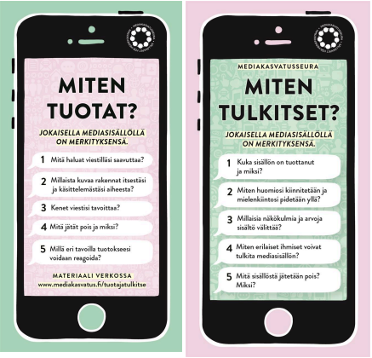

How do you create media?
Every piece of media content has a meaning.
What do you want to achieve with your message?
What kind of image do you build of yourself and the topic you are discussing?
Who does your message reach?
What are you leaving out and why?
What are the different ways to react to your output?

How do you interpret media?
Every piece of media content has a meaning.
Who produced the content and why?
How is your attention captured and maintained?
What kind of perspectives and values does the content convey?
How can different people interpret media content?
What is omitted from the content? Why?

Optional assignment:
Take the digital wellbeing test.
https://www.nuortennetti.fi/netti-ja-media/digihyvinvointi/digihyvinvointi-testi/

Select the correct statements below (note: select several).

Media criticism is the ability to consider which perspectives the content represents. (correct)

When examining the content, you are able to identify whether the media content is created by, for example, an individual, a group, an organisation, a private company or an authority. (correct)

A critical observer understands that a person interprets messages from their own point of view. (correct)

A skilled media user understands what the aim of the media content is (marketing, expression of opinion, statement...) (correct)

Question 3

In social media, the consequences of behavior are just as relevant as in face-to-face interaction.

Choose the correct answer.

Yes, everyone must take responsibility for their own behavior, whether they are on social media or face-to-face. (correct)

Maybe, bad behavior on social media is easier because you don't really have to face the person.

No, social media involves much lighter communication.

Question 4

What is good interaction?

Make complete sentence by finding the correct pairs.

Share your own thoughts - don't interrupt or talk out of turn.

Listen actively - do not constantly use, for example, the phone.

People may disagree - this is how you allow for a good conversation.

Take others into account - the important thing is to consider how you will react to disagreements.

Be present in the conversation - what the other person wants to say.

Question 5

In this question, you will be presented with 6 blank fields in which you should enter your answer. First, read the surrounding text, and then select your answer in each field drop-down menu. Select words that match the text from the menu.

Interaction skills in working life have a positive effect on ______________________ (working atmosphere, waste disposal, retirement).

By being a _____________________(positive, critical, deep) colleague, you increase everyone's enjoyment at work.

Positive encounters increase an employee’s ______________________ (self-assurance, wages, cleanliness).

When there is a good atmosphere at the workplace, colleagues respect each other, and people dare to show their skills.

Good interaction skills also enable discussion about _______________________ (sensitive, daily, weather) issues.

People can express their needs and wishes ________________________ (safely, ominously, sharply), in which case challenges can be influenced.

Good interaction skills give a _______________________(professional, difficult, perplexed) image of the employee and create opportunities for success.

Work ergonomics
Osiossa on diaesitys aihealueesta työergonomia ja viisi siihen liittyvää tehtävää.

Slides

Slide 1- WHAT DOES ERGONOMICS MEAN?

-Ergonomics is the proactive design and comprehensive development of work and the work environment.  -Good ergonomics supports and enhances human health and well-being.  -Ergonomics ensures that work is productive and safe.  THE GOAL IS TO:  -match the job to the worker and the worker to the job.  -Ergonomics supports work ability and a long career.  IMPORTANT WORDS: anticipate, plan the operating environment,  productivity, suitable  READ MORE: Kokonaisvaltainen ergonomia | Työterveyslaitos (ttl.fi) | 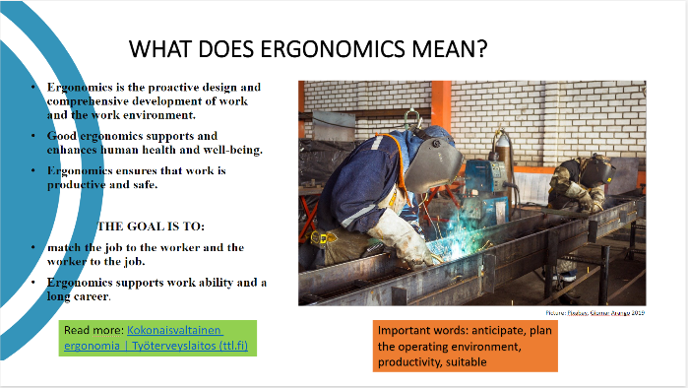

Slide 2- WORK ERGONOMICS INCLUDES

-Physical ergonomics  -Cognitive ergonomics  -Organisational ergonomics | 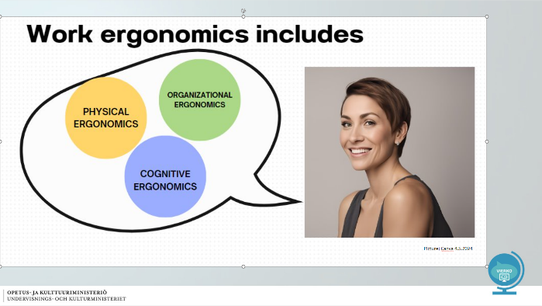

Slide 3- PHYSICAL ERGONOMICS

- Working postures  - Working environment  - Work stations  - Work tools  - Working methods  IMPORTANT WORDS: anatomy, physiology, characteristic, action, function  VIDEO:  Delivery Ergonomics Distribution by Car (youtube.com)  READ MORE: Delivery Ergonomics - The Centre for Occupational Safety (ttk.fi) | 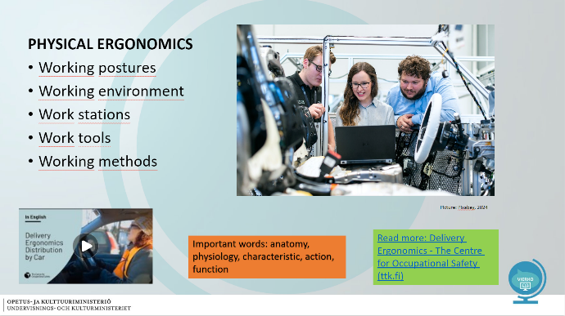

Slide 4- BREAK EXERSICE

Break Exercise Benefits :  - Both body and mind are refreshed  - Improved alertness enhances concentration and focus, which improves work performance and can also promote learning.  - stimulates muscle circulation and improves their metabolism, reduces musculoskeletal strain, pain and stress, and relaxes tense muscles.  VIDEO:  Jumppakissan taukojumppa (youtube.com)  READ MORE: Selkäliitto in Brief | Selkäliitto (selkakanava.fi) | 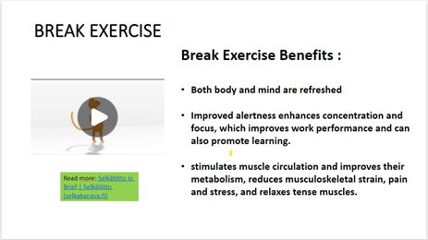

Slide 5- COGNITIVE ERGONOMICS

Coordination of work with human cognitive abilities and their limitations.  Cognitive abilities include  - perception  - memory  - learning  - linguistic functions  - decision-making  - individual thinking  Example: Orientation to work tasks and systems, delimitation of one's own work.  READ MORE: Cognitive Work | Finnish Institute of Occupational Health (ttl.fi) | 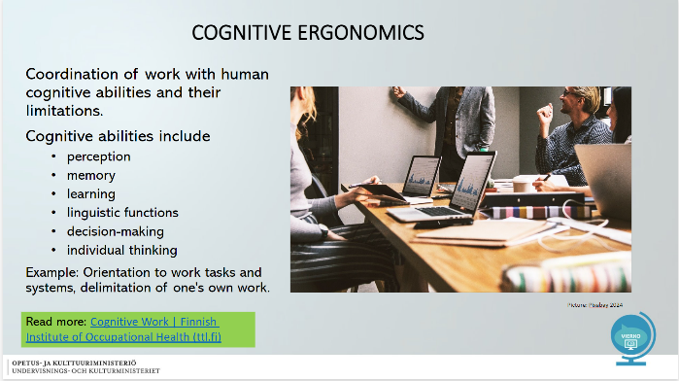

Slide 6- LOAD FACTORS IN COGNITIVE WORK

•distractions  •interruptions  •information overload  IMPORTANT WORDS:  Coordination, information processing, ability, limitation, system, orientation, delimitation  Read more: https://www.ttl.fi/en/learning-materials/cognitive-work | 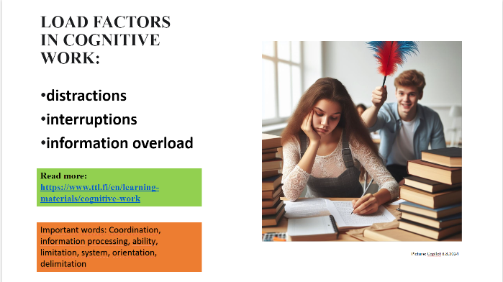

Slide 7- HOW TO REDUCE COGNITEVE WORK LOAD?
How you can reduce cognitive ergonomic load?  FILM:  https://www.youtube.com/watch?v=MKyiUK5er2Q  You can get English subtitles for the video. | 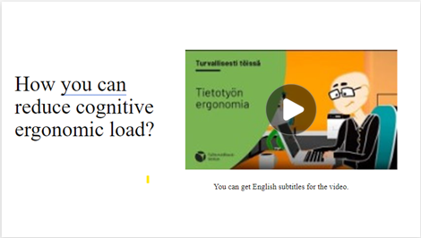

Slide 8- ORGANIZATIONAL ERGONOMICS

SOLUTIONS IN ORGANIZATIONAL ERGONOMICS SUPPORT  - ethical decisions at work,  - work processes,  - workplace arrangements, and  - recovery.  THEY HELP WITH  - managing remote work  - scheduling breaks  - planning work shifts and working hours | 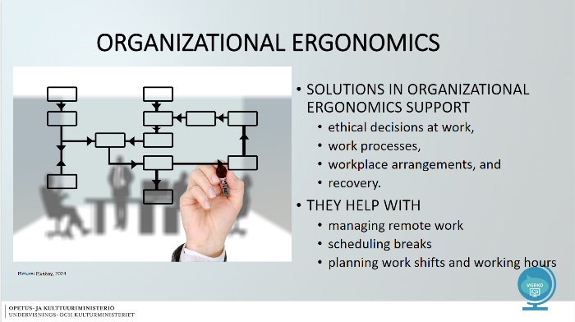

Slide 9- ERGONOMICS CHECKLIST
- Think ahead and anticipate ergonomic challenges  - Choose better ways to perform your tasks  - take care of your well-being both during work and in your free time  - use assistive tools when necessary  - remember good working postures  - take regular breaks  IMPORTANT WORDS: anticipate, challenge, working posture, invest, work environment, assistive device  READ MORE:  Työturvallisuuskeskus (ttk.fi) | 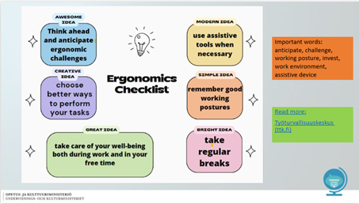

Slide 10- REFERENCES

Selkäliitto- The Finnish Spinal Health Association  Selkäliitto in Brief | Selkäliitto (selkakanava.fi)  Työterveyslaitos- Finnish Institute of Occupational health  The Centre for Occupational Safety (ttk.fi)  Työturvallisuuskeskus- The Centre for Occupational Safety  The Centre for Occupational Safety (ttk.fi) | 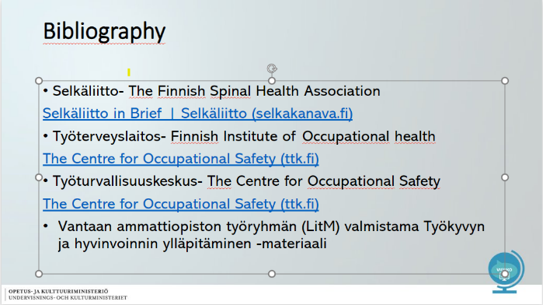

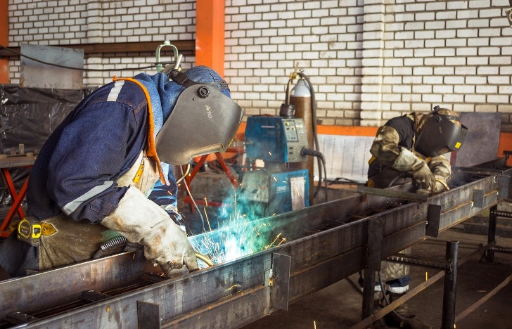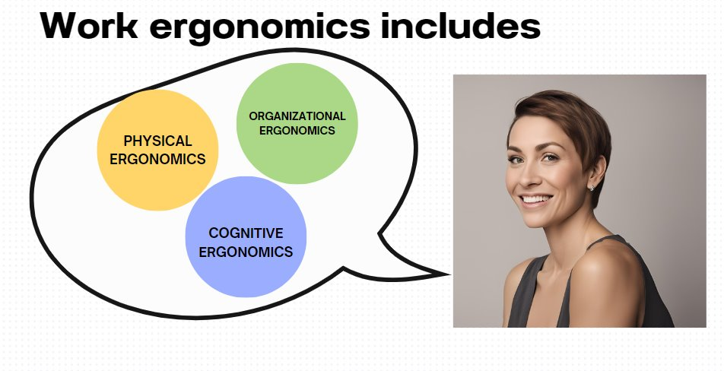

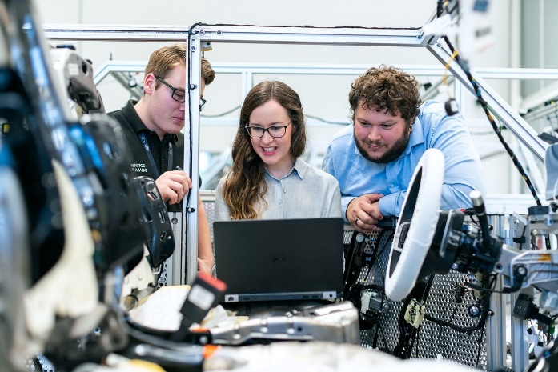
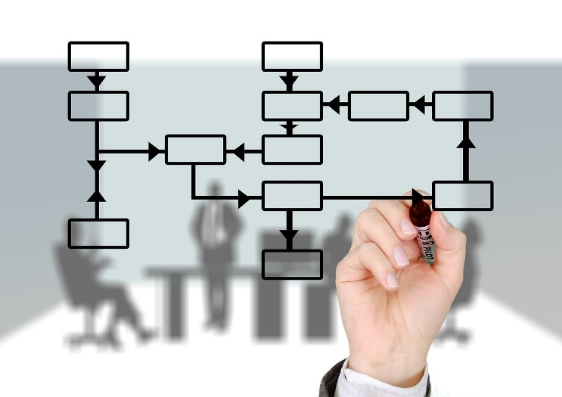

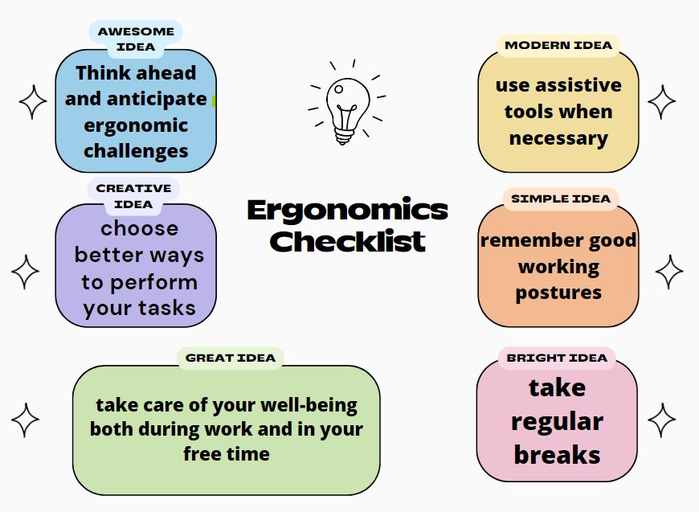

Tasks

Verkkokurssilla tehtävät on tuotettu alustan omilla toiminnoilla. Tehtävät voi tehdä myös esimerkiksi Forms-lomakkeena. Kysymyksen oikea vastaus on lihavoitu ja oikeita vastauksia voi olla useampia.

Question 1

In this question you will be presented with 6 blank fields to fill in. First read the surrounding text, then choose your answer in each box from the drop-down menu.

- Good ergonomics supports and develops people's ________________ (health, muscle growth, sleep hygiene) and______________________________ (well-being, eating habits, variety of free time activities.)
- With ergonomics, work is____________ (productive, exciting, risky) and ________________ (Safe, Unsafe, Unnecessary) .
- Work ergonomics is_______________________ (work, leisure) and ___________________________________( operational environment, exercise habits) proactive planning and comprehensive development.

Question 2

In this question you will be presented with 3 blank fields to fill in. First read the surrounding text, then choose your answer in each box from the drop-down menu.

- Areas of ergonomics are_______________( physical, physiological, anatomical), _____________________ (cognitive, mental, behavioristic and_____________________ (organisatorial, operational, osmotic) ergonomics.

Question 3

Physical ergonomics refers to the application of the function of human anatomical and physiological according to the characteristics. Physical ergonomics includes (select one or more options).

- Working positions
- Linguistic functions
- Working time arrangements
- Working tools

Question 4

Cognitive ergonomics means co-ordination of work with human information processing abilities and their limitations.
Cognitive ergonomics, therefore, deals with: (Select one or more options.)

- Working methods
- Detection
- Memorization
- Staff

Question 5
Organizational ergonomics is concerned with the optimization of sociotechnical systems
This contains
(Select one or more options.)

- Working tools
- Learning
- Working time arrangements
- Work processes

Sexual well-being
Osiossa on diaesitys aihealueesta ja seitsemän siihen liittyvää tehtävää.
Osiossa on diaesitys aihealueesta seksuaalinen hyvinvointi ja kuusi siihen liittyvää tehtävää.

Slides

Slide 1- CONTENT OF TEACHING
- Sexuality terms  - Sexual diversity  - Sexual rights  - LGBTI rights  - Sexual justice  - Age of concent  - sexual health  - contraception | 

Slide 2- WHAT DOES SEXUALITY MEAN?
SEXUALITY TERMS  SEXUALITY:  Everything related to an individual's sexuality  SEXUAL WELL-BEING:  Part of people's overall well-being  SEXUAL RIGHTS:  Rights related to human sexuality, defined by law, fundamental human rights  SEXUAL HEALTH:  Physical, mental, social and emotional sexual health | 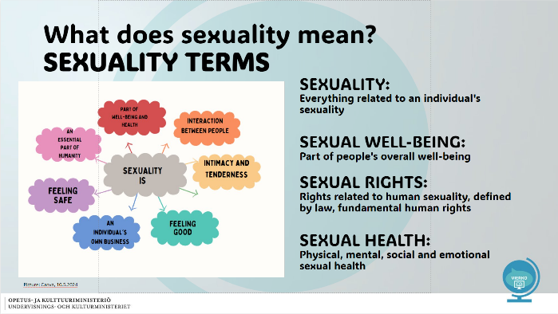

Slide 3- SEXUAL WELL-BEING AND SEXUAL DIVERCITY
GENDER IDENTITY  - the personal sense of one's own gender  SEXUAL ORIENTATION  - who you’re attracted to and who you feel drawn to romantically, emotionally, and sexually.  INTIMATE RELATIONSHIPS  - close, personal connection between individuals characterized by emotional, physical and sexual intimacy  →Sexuality changes and develops throughout life  IMPORTANT WORDS: diversity, gender identity, sexual orientation, reproduction  READ MORE:  Sexuality - Väestöliitto.fi (vaestoliitto.fi) | 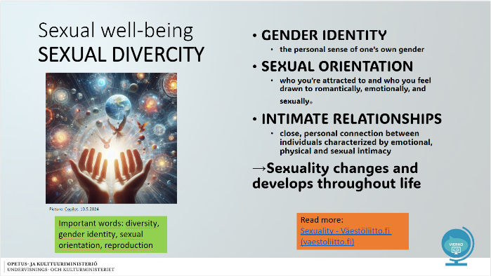

Slide 4- SEXUAL RIGHTS
-are part of human rights.  -they are recognised by international human rights treaties.  SEXUAL RIGHTS INCLUDE:  - the right to sexual education  - the right to bodily integrity  - the right to decide whether or not to have children;  - the right to pursue a satisfying and enjoyable sex life  IMPORTANT WORDS: sexual identity, responsible, sexual self-image, sexual harassment, activity  READ MORE:  Sexual rights - Väestöliitto.fi (vaestoliitto.fi)  Gender equality – THL  FILM:  How has Gender Equality Shaped Finland? (youtube.com) | 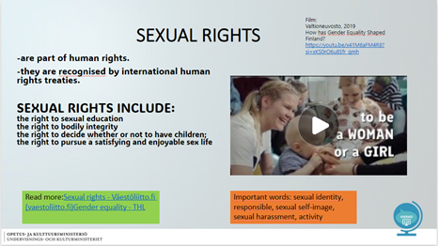

Slide 5- LGBTI RIGHTS

FILM:  Helsingin yliopiston avoin yliopisto, 2018.  Lesson 11 Human Rights part 3 LGBTI rights in Finland, Finnish Political Culture and System.  Lesson 11 Human Rights part 3 LGBTI rights in Finland, Finnish Political Culture and System (youtube.com)  Helsingin yliopiston avoin yliopisto  Watch the film.  What do LGB TI rights mean in Finland? | 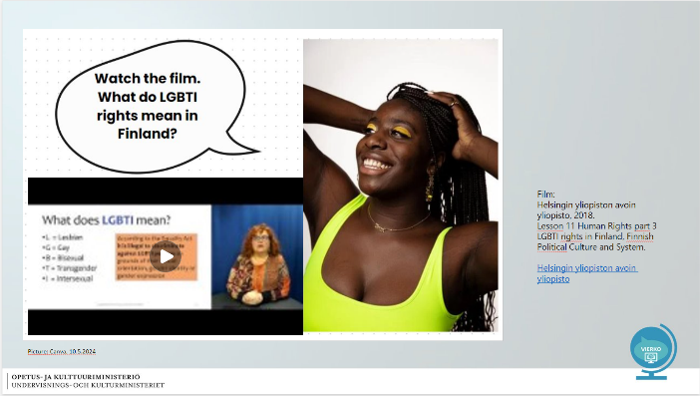

Slide 6- SEXUAL JUSTICE
- Sexual rights apply to everyone  - Everyone has the right to decide for themselves on matters related to their sexuality  - It is everyone´s duty to respect the sexual education on others  - All rights also include the obligation and responsibility to act accordinly  READ MORE:  Sexualoffenceslaw - Ministry of Justice (oikeusministerio.fi) | 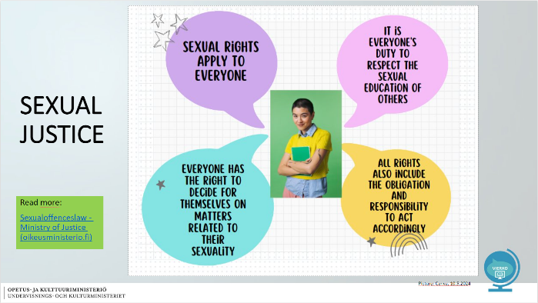

Slide 7- AGE OF CONSENT
16  Is is prohibited to perform sexual acts on a person under 16 years of age  18  A person in a position of trust or authority must not perform sexual acts on a person under 18 years of age  IMPORTANT WORDS: sexual rights, duty, respect, decide, responsibility, sexual act, relationship of trust, position of authority  READ MORE:  Finnish society course - Sexual health and sexuality (migri.fi) | 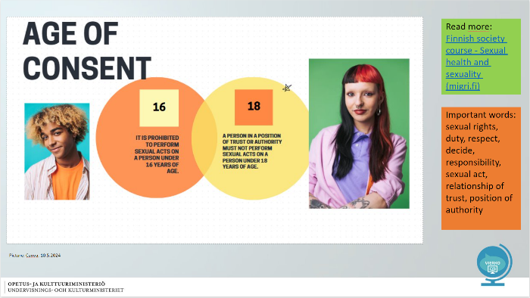

Slide 8- SEXUAL HEALTH
It means that you are able to enjoy your sexuality and express it without:  - sexually transmitted infections  - discrimination  - unwanted pregnancy  - abuse or pressure  IMPORTANT WORDS: health organization, physical, mental, social, emotional  PONDER: What kind of sex education have you received?  READ MORE:  Finnish society course - Sexual health and sexuality (migri.fi) | 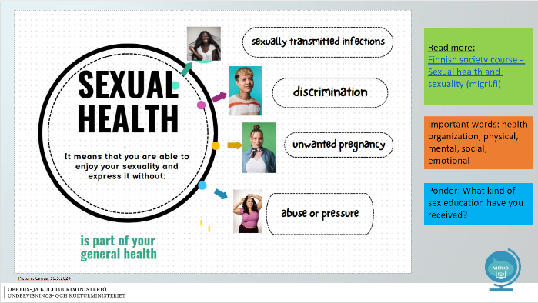

Slide 9- CONTRACEPTION
- Taking care of contraception is taking care of yourself and your partner  - Contraception is a shared responsibility for everyone involved  - The goal of contraception is to prevent pregnancy and sexually transmitted infections  IMPORTANT WORDS:  contraception, partner, sexually transmitted infection, pregnancy  READ MORE:  Birth control methods - FSHS (yths.fi) | 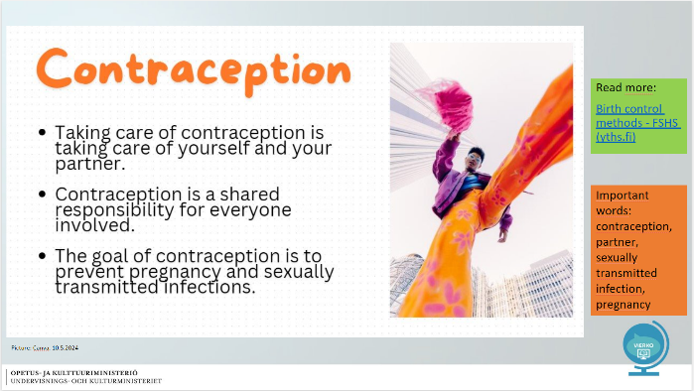

Slide 10- CONTRACEPTION METHODS
Condom, Contraceptive ring  Birth control pill, Contraceptive implant,  Contraceptive patch, Intrauterine device (IUD)/ Hormonal (IUD)  - A condom is the only contraceptive method that protects against sexually transmitted infections (STIs).  - The emergency contraceptive pill is used when other contraceptive methods fail  - The emergency contraceptive pill is not a regular contraceptive method  Read more:  Birth control methods - FSHS (yths.fi) | 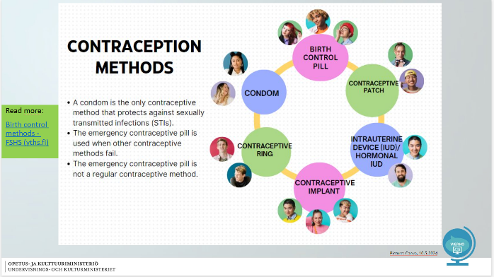

Slide 11- REFERENCES

Sexuality - Väestöliitto.fi (vaestoliitto.fi)  Sexual health - FSHS (yths.fi)  Sexual health (who.int)  Finnish society course - Sexual health and sexuality (migri.fi)  Sexualoffenceslaw - Ministry of Justice (oikeusministerio.fi)  Sexual and reproductive health of immigrants - THL | 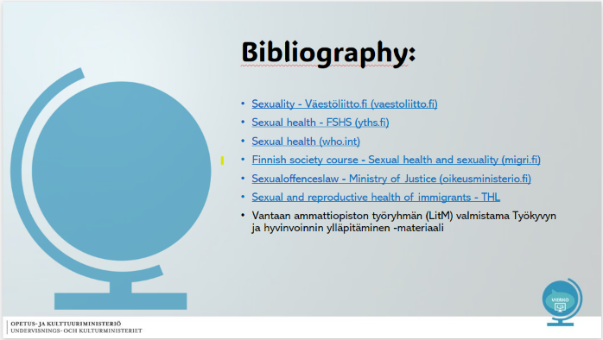

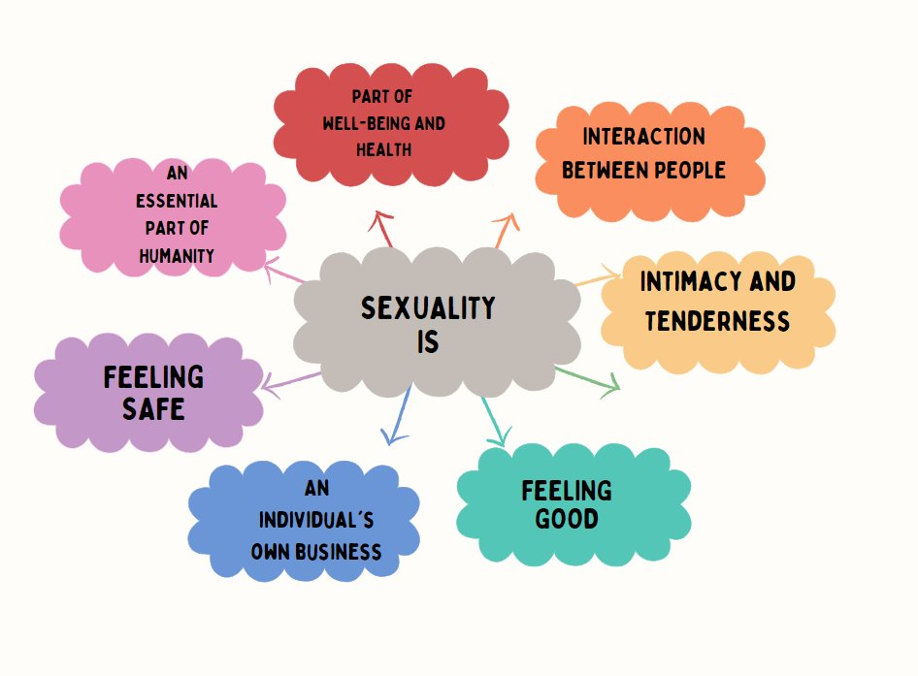
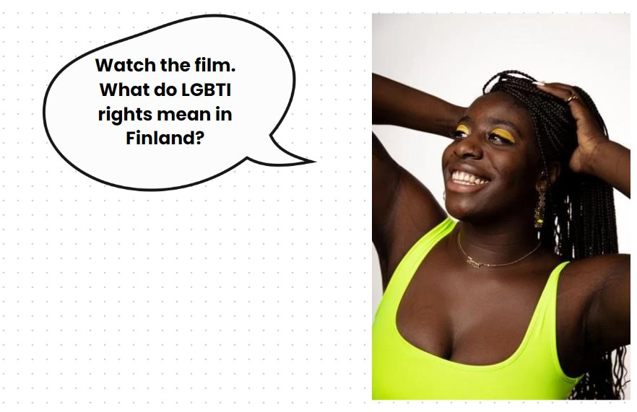
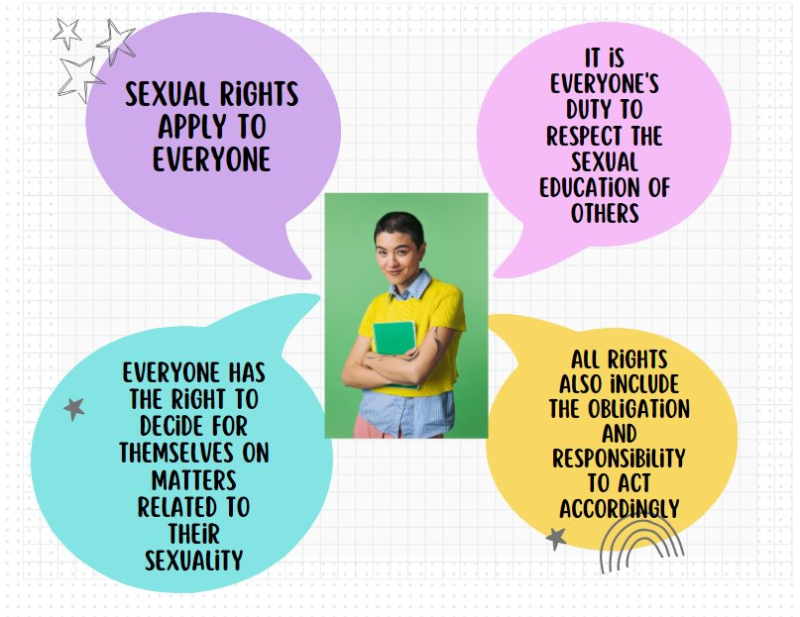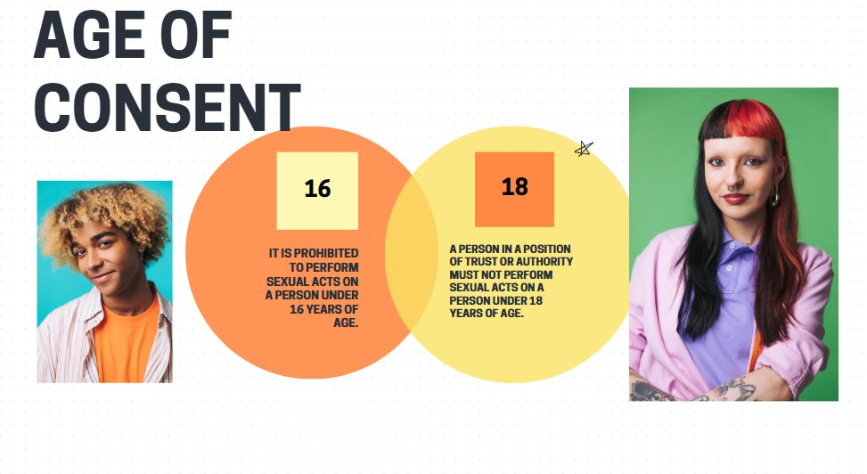
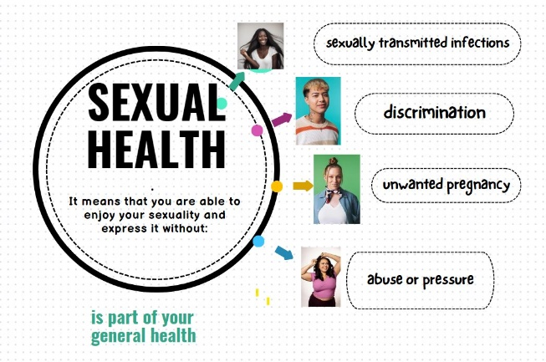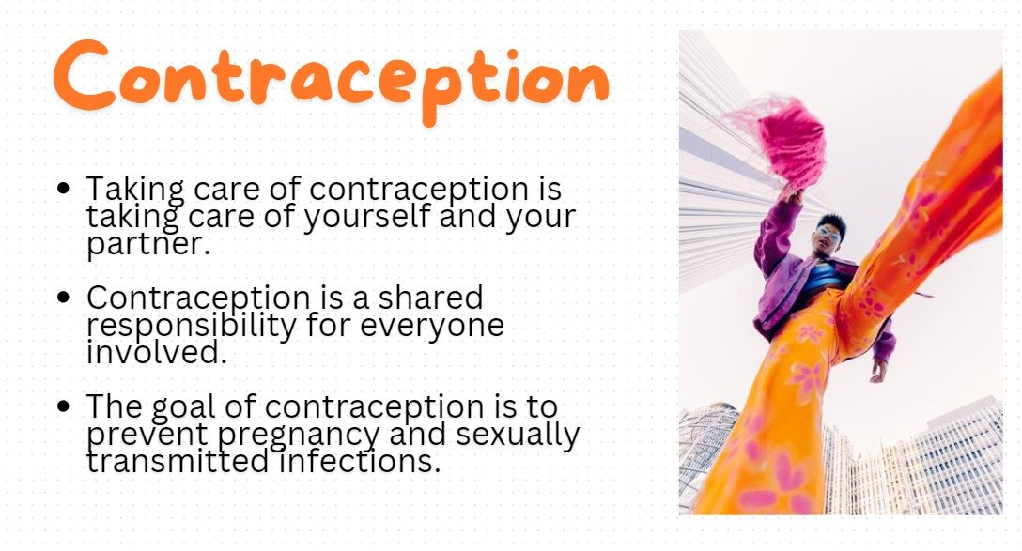
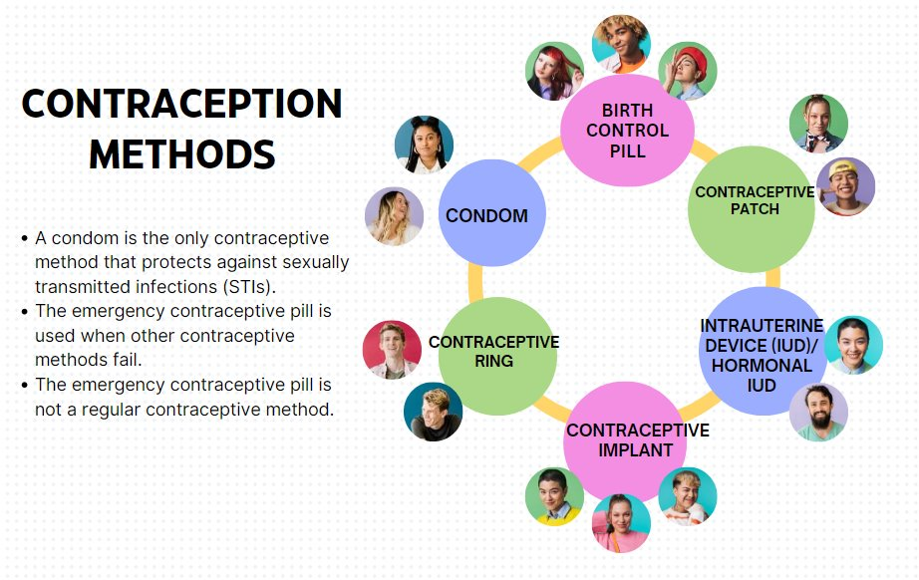

Tasks
Verkkokurssilla tehtävät on tuotettu alustan omilla toiminnoilla. Tehtävät voi tehdä myös esimerkiksi Forms-lomakkeena. Kysymyksen oikea vastaus on lihavoitu ja oikeita vastauksia voi olla useampia.

Sexual wellbeing

In this section we study issues related to sexual well-being.
You get to think about what sexuality, sexual well-being and sexual health means.

You will learn about sexual rights and the age of protection.
You will get information about different prevention methods.

Question 1
Find pairs!

Sexuality - Everything related to an individual's sexuality

Sexual well-being - Part of a person's totality well-being

Sexual health - Physical, psychological, social and emotional sexual state of health

Age of protection - The purpose is to give criminal protection for others for example sexual abuse

Question 2
Sexual well-being includes:
- Satisfaction with sexual self-image
- How active the sex life is
- Living in accordance with one's identity and responsibly
- Absence of sexual harassment and violence
- Does not accept own or other's body

Question 3
Sexual rights refer to the rights of individuals to consciously and independently decide on their own issues related to their sexuality.
What are all sexual rights?
- The right to one's sexuality
- The right to protect oneself and to be protected
- The right to information about sexuality
- The right to sexual health services
- The right to privacy
- The right to be seen
- The right to influence

Question 4
Instructions
Choose the correct words.

In this question you will be presented with 8 blank fields to fill in
your answer. First read the surrounding text, then choose your answer in each box
from the drop-down menu.

Choose the correct word from the menu:

- Taking care of contraception is taking care of yourself and ____. (your partner, the condom, the community)
- Contraception is the responsibility of__________. ( man, woman, both parties)
- Contraception has ___ (one, two, three) objective: _____ as well as ____(Avoiding pregnancy, Pleasing your partner, Avoiding sexually transmitted disease)
- _____ is the only method of contraception, which protects against sexually transmitted diseases. (Condom, Birth control pill, Emergency contraception, Intrauterine device (IUD))
- _____ is used only when other prevention fails (Emergency contraception pill, Condom, Birth control pill)
- ___ not used as a continuous method of prevention. (Emergency contraception pill, Contraceptive patch, Contraceptive ring)

Question 5
Choose the right one:
In sexual health, there is an obligation and responsibility to act in accordance with sexual rights. The goal of the World Health Organization (WHO) is equal sex education around the world.
- Yes
- No

Question 6
Gender identity means?
- a friend's perception of the other's gender
- an individual's perception of his own gender
- society's decision about a person's gender
- the biological truth about a person's sex

Question 7
Select all that apply:
Sexual orientation
- is already known as a child
- tells about what a person falls in love with
- is a matter of self-definition
- will be decided together with the family

Sleep and recovery
Osiossa on diaesitys aihealueesta terveyttä edistävä uni ja palautuminen sekä kuusi siihen liittyvää tehtävää.

Slides

Slide 1
Sleep and recovery | 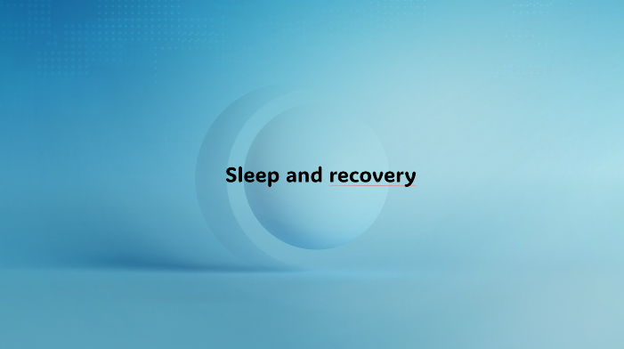

Slide 2
Recovery supports functional capacity  •Sleep is the most important driver of recovery  •Recovery is the relaxation of body and mind  •Recovery can also be active  •Listening to music and reading  •Walking and cycling in nature  •Painting and drawing  •Meditation  The nervous system works when rest and activity are in balance.  Important words: Sleep, recovery, relaxation, activity, nervous system, rest, functional capacity | 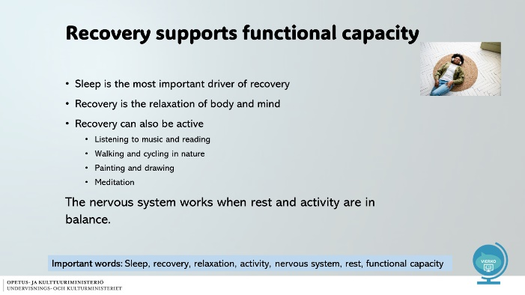

Slide 3
Recovery supports functional capacity  •The sympathetic nervous system of an overloaded person is in overdrive and it is difficult to calm down.  •Read YLE: Balance between activity and rest  -> Change the language of text on pages to English with an immersive reader in the address bar.  Important words: functional capacity, sympathetic nervous system | 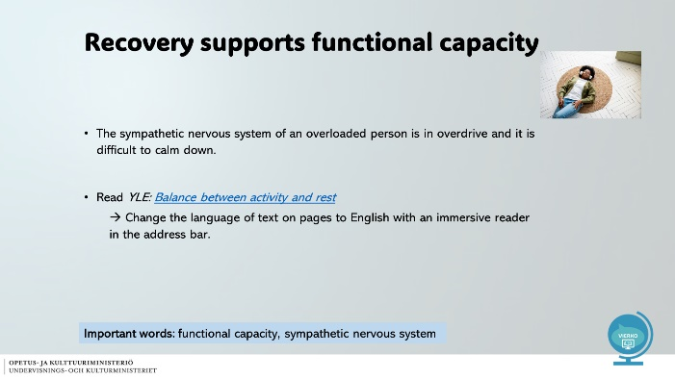

Slide 4
Recovery and recources during the working day •Small breaks during the day help you cope  • Find out what microbreaks mean.  • Tell us 2 things, how do microbreaks promote coping?  • Find different ways to take microbreaks at work  • Be merciful to yourself – do you demand too much of yourself, do you not take breaks?  • Dare to speak out about challenges – no one can see your thoughts.  • The balance between job requirements and the employee's resources promotes work ability.  • What can happen if the demands and resources of the job are not balanced?  Read more:  Improve your work ability  Important words: overload, resource - requirement, microbreak, mercy, work engagement, balance | 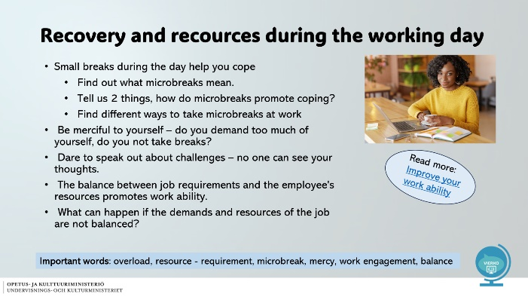

Slide 5
Sleep and recovery: Reflect on your behavior • What time of the day do you usually go to bed?  • What time of the day do you usually wake up?  • How many hours do you sleep a night?  • How does your sleep pattern change on weekends?  • Are you satisfied with your sleep pattern?  -> Watch the video:  The importance of sleep as a health promoter | 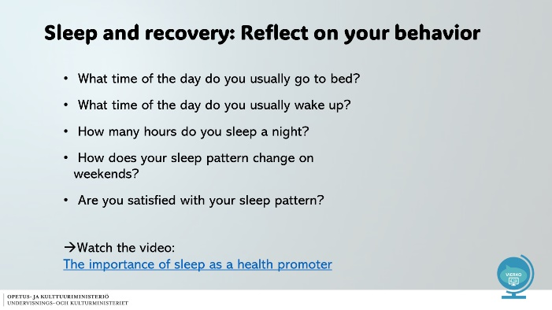

Slide 6
Adequate sleep and its stages  • Aim for 8 hours of sleep  • Children and young people need more sleep than adults -> Why do you think it is so?  • There are three different phases of sleep  - Light sleep  - Deep sleep  - Rapid eye movement sleep (REM)  • The sleep phases repeat in cycles  • Restorative sleep requires 5-7 sleep cycles = approximately 8 hours  Important words: Light sleep, deep sleep, REM sleep, sleep cycle | 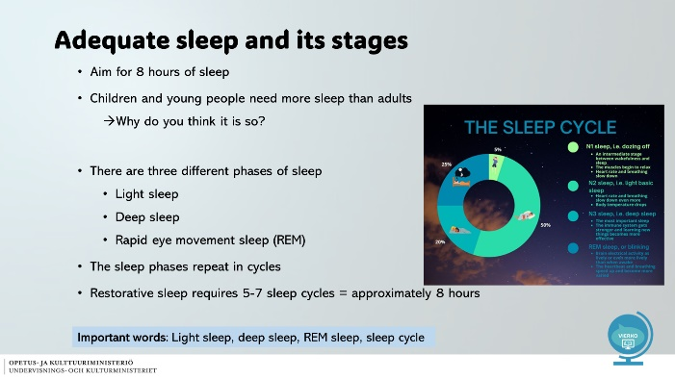

Slide 7
What happens during sleep?  •A person recovers from the day's stress à batteries are recharging  •Immunity improves  •Endocrine system becomes more efficient  • - Supports height and muscle growth  •The brain recovers and regenerates  •Promotes memory and learning  •Promotes mental health à Promotes work ability  Read more: https://thl.fi/en/topics/lifestyles-and-nutrition  Important words: Recovery, regenerate, resistance hormone, height growth, boost, memory, learning, mental health | 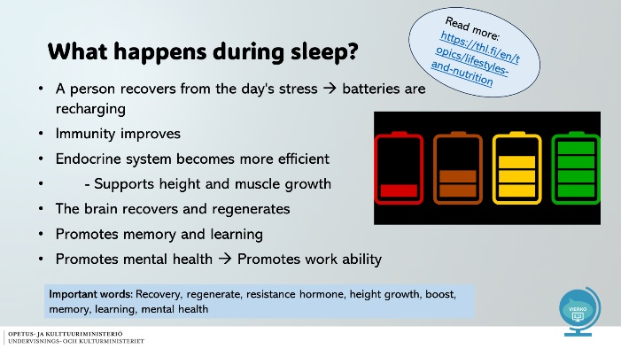

Slide 8
What happens at different stages of sleep? | 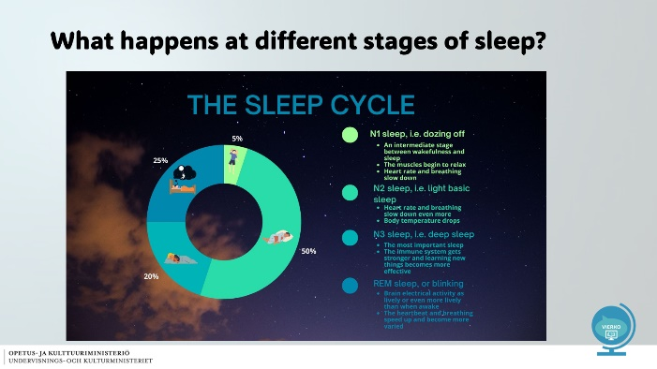

Slide 9
What happens during the night sleep? | 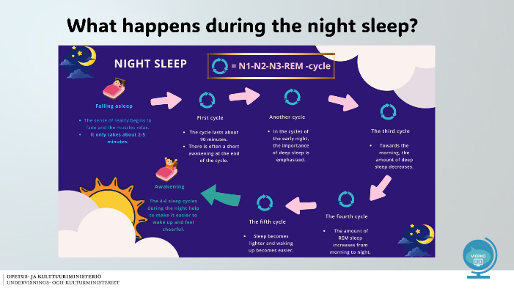

Slide 10
Sleep disorders  •Sleep disorders include:  •Insomnia, difficulty falling asleep  •Disturbances of the sleep-wake rhythm  •Frequent awakenings during the night  •Possible causes of sleep disorders:  •Phone and tablet light  •Social media and gaming at night  •Changes in sleep patterns  •Energy drinks and coffee interfere with the body's production of sleep hormones  •Passive lifestyle  •Stress  Important words: Sleep disorder, insomnia, sleep patterns, body sleep hormone, social media | 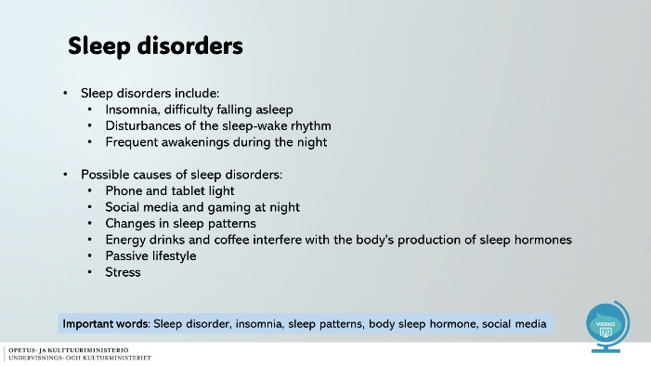

Slide 11
Tips for better sleep  Morning:  - Bright light  -Breakfast  -Physical activity helps you wake up  Day:  -Do the agreed things on time  -Regular eating  -Activity and outdoor activities  -Deal with and resolve problems  Evening:  -Turn off bright lights (including phone light)  -Light evening snack  -Evening routines  -Peaceful evening walk  -Calm down in time  -Go to bed at the same time  Important words: Breakfast, bright light, regular, eating, deal, evening routine, calm down | 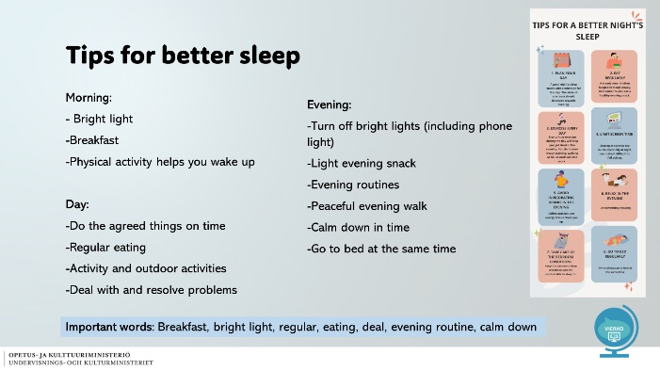

Slide 12
What if...  Jonas is 22 years old and works in the same field as you.  He loves football and his evenings are often spent watching games at home or in the pub. He gets about 5-6 hours of sleep per night.  Jonas often skips breakfast because he doesn't have the energy to wake up early enough to make breakfast. On weekends, Jonas recovers by sleeping 10-12 hours a night.  1.What kind of risks in the workplace can increase as a result of Jonas' actions?  2.What tips would you give Jonas on recovery? | 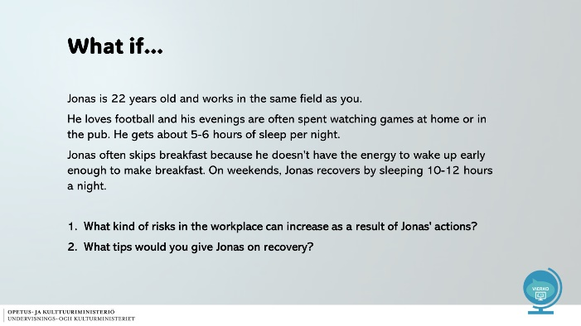

Slide 13
Breathing exercises for sleep  Diaphragmatic breathing, subtitles available in English  https://youtu.be/d58aNhoVh1A  Progressive relaxation, subtitles are available in English  https://youtu.be/oxxnk1PUoYM  Equal Breathing Exercise for Sleep  https://youtu.be/4wEDoKm40Yc | 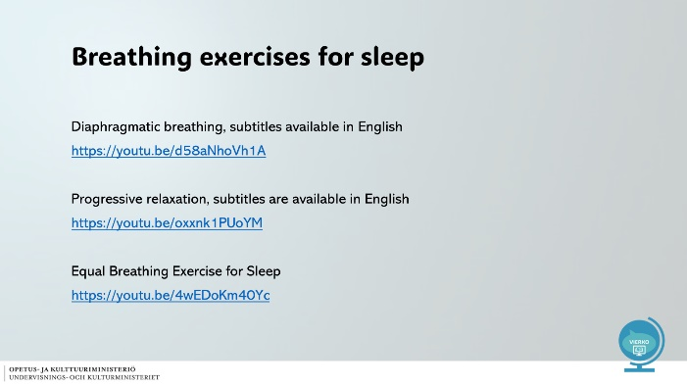

Pictures used in the slideshow (Pixabay):



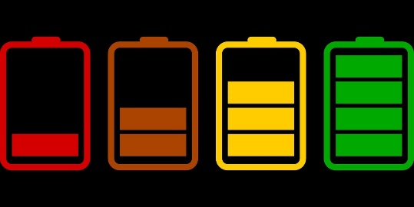
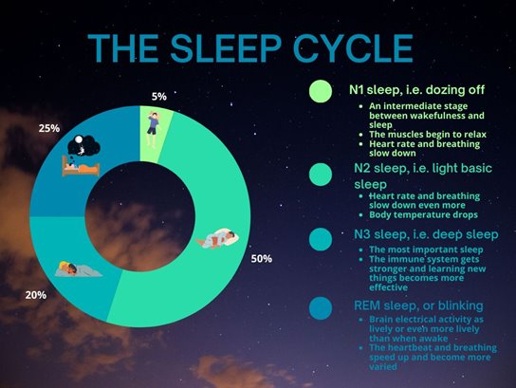
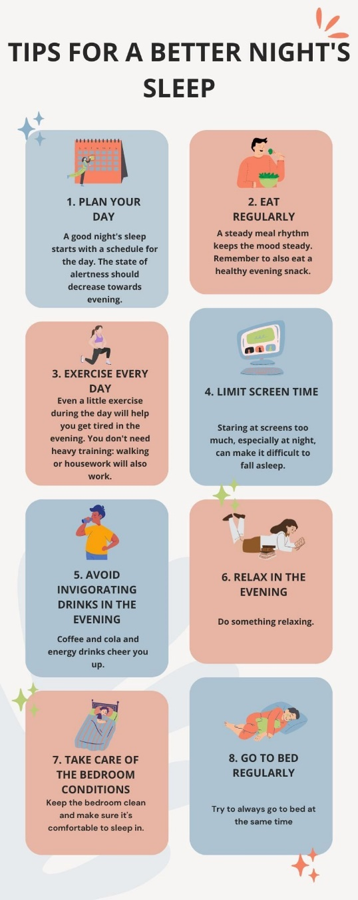

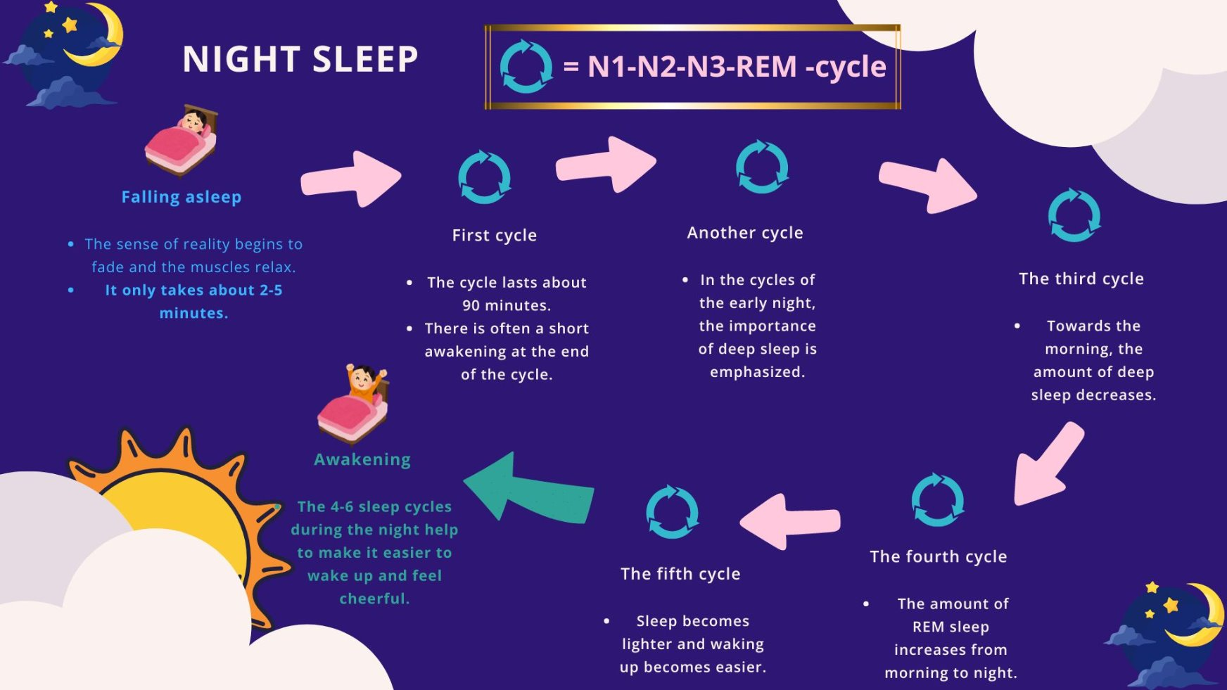

Tasks

Verkkokurssilla tehtävät on tuotettu alustan omilla toiminnoilla. Tehtävät voi tehdä myös esimerkiksi Forms-lomakkeena. Kysymyksen oikea vastaus on lihavoitu ja oikeita vastauksia voi olla useampia.

Sleep and recovery

In this section, you will learn about the significance of recovery from the perspective of well-being.
Let's study what microbreak, active recovery and sleep cycles mean, for example.
The aim of the assignment is to get the student to reflect on their own recovery and

load factors in everyday life.

Test details

Question 1

What is the most important recovery facilitator?

Sleep
Sport
Exercise
Nutrition

Question 2

Recovery refers to the relaxation of the body and mind.

True
False

Question 3

The nervous system works when rest and activity are in balance. Choose the right one from the options.

-The nervous system of an overloaded person goes into overdrive and it is difficult to calm down.

-When a person rests on the couch at the end of the working day, he recovers best.

-A person needs at least an hour of nap every day so that the nervous system is
in balance.

Question/task 4

Choose the right couples, what happens at different stages of sleep

Light sleep | Breathing and pulse stabilize,  brain activity begins to slow down
Deep sleep | Important for learning and  creativity, emotional memory traces  arises  - The immune system gets stronger and learning new things becomes more effective.
REM sleep | Brain restored, metabolism  is lively and restorative  - The heart beat and breathing speed up

Question 5

Answer

In this question, you will be presented with 9 blank fields in which you should type the
Answer.

Tips for better sleep. What should you do during the day?

Type down the factors that are likely to have a positive impact a person's sleep habits.

During the morning time:

During the daytime:

During the evening time:

Intoxicants
Osiossa on diaesitys aihealueesta päihteet ja kuusi siihen liittyvää tehtävää.

4.7.1. Slides
Slide 1
Intoxicants | 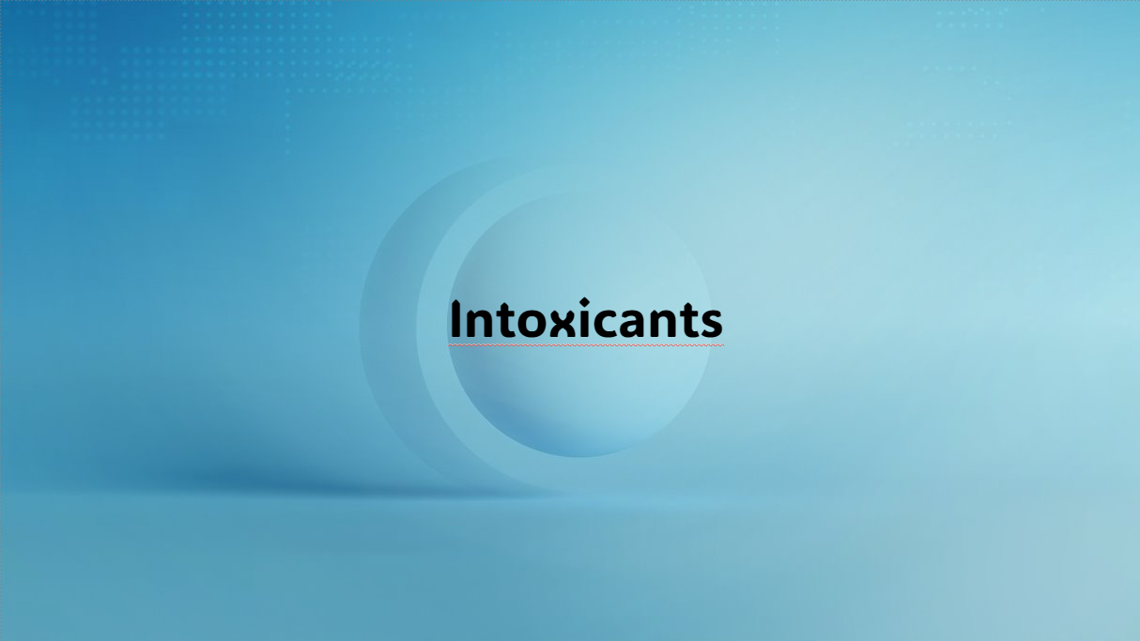

Slide 2 - Contents
- CONTENT OF THE LESSON​  - WHAT ARE INTOXICANTS?​  - CLAIMS ABOUT TOBACCO/SNUFF​  - CLAIMS ABOUT ALCOHOL​  - TOBACCO​  - SNUFF​  - CANNABIS​  - E-CIGARETTE​  - ALCOHOL​  - SOME FACTS ABOUT INTOXICANTS | 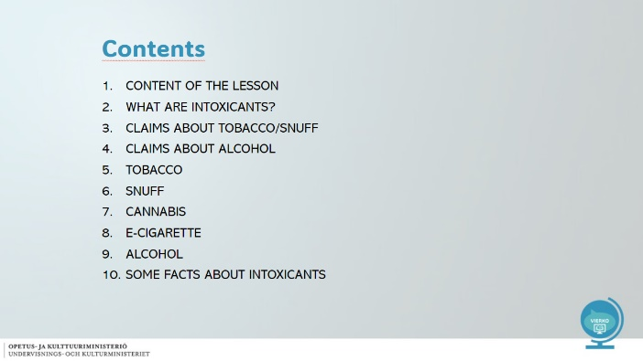

Slide 3 - Content of the lesson
What are intoxicants?​  Tobacco Act​  Tobacco products​  Alcohol​  Cannabis​  Reflection task | 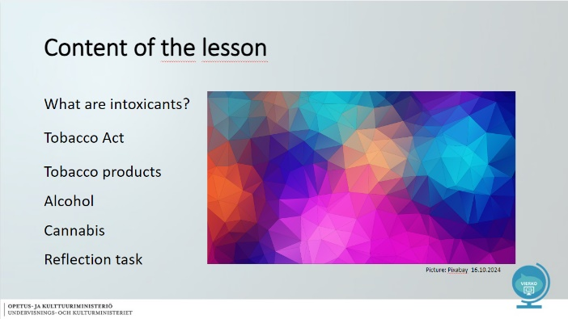

Slide 4
What are intoxicants?  Why are they used? | 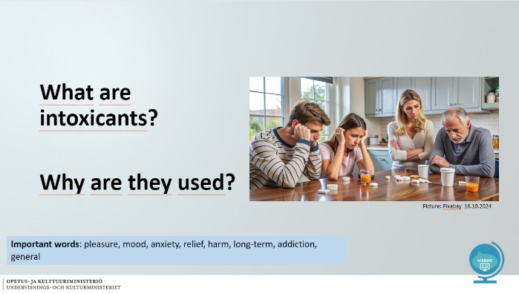

Slide 5 - Intoxicants
- Enjoyed for pleasure or mood-enhancing effect.​  - For some, a way to relieve bad feeling or anxiety​  - As a result of prolonged use, possible addiction and various diseases​  - In Finland, the most common intoxicants used by young people are alcohol and tobacco products​  Substance abuse video (eng. subtitle) | 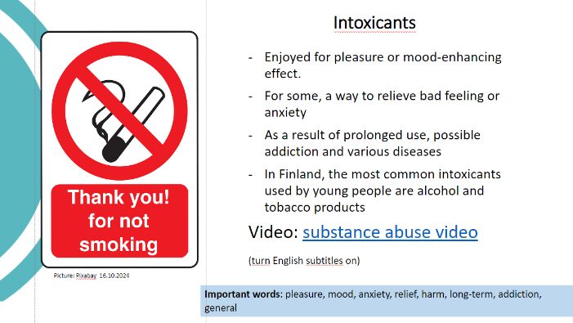

Slide 6 – True or false
- Snuff causes nicotine addiction faster than tobacco?  - Snuff is suitable for sports enthusiasts because it does not impair fitness?  - Snuff and tobacco are made from the same plant?  - E-cigarette use is not harmful to health? | 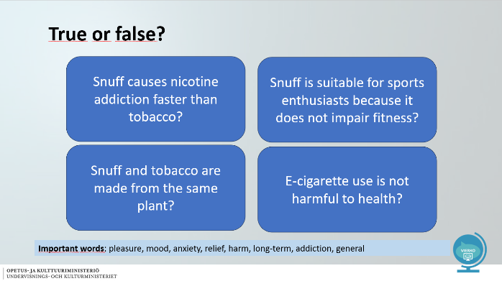

Slide 7 – True or false
- Snuff or nicotine baggs can contain up to 20 times more nicotine compared to tobacco.  - The use of snuff impairs fitness and recovery. Blood vessels constrict and blood circulation deteriorates.  - Snuff and tobacco are made from the same plant.  - E-cigarettes may contain nicotine, which is addictive and carcinogenic. | 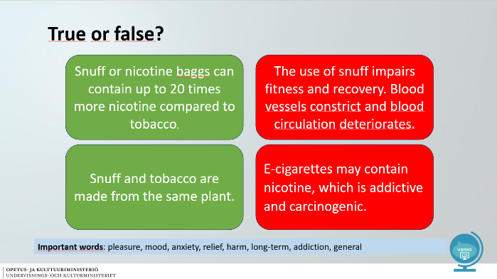

Slide 8 – True or false
- Alcohol causes cancer!  - If you have a hangover, you can go to work  - Passive smoking or e-cigarette smoke can be addictive  - Drinking alcohol before bed impairs sleep quality | 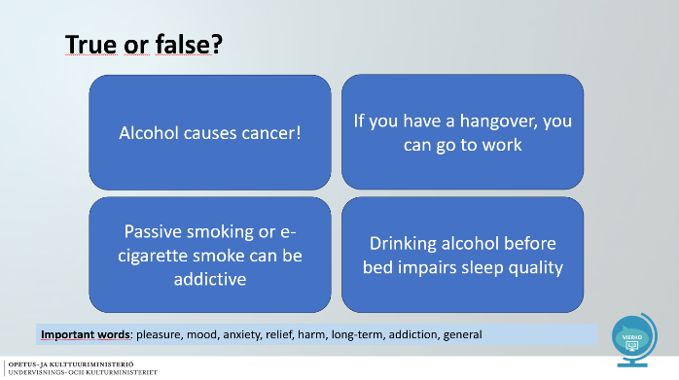

Slide 9 – True or false
- Alcohol is a carcinogen that increases the risk of developing cancer.  - Alcohol abuse is one of the most common reasons an employer uses to terminate an employment contract.  - e-cigarette and tobacco smoke contain nicotine. Nicotine is addictive.  - Being under the influence of alcohol causes a stress response in the body and impairs sleep quality. | 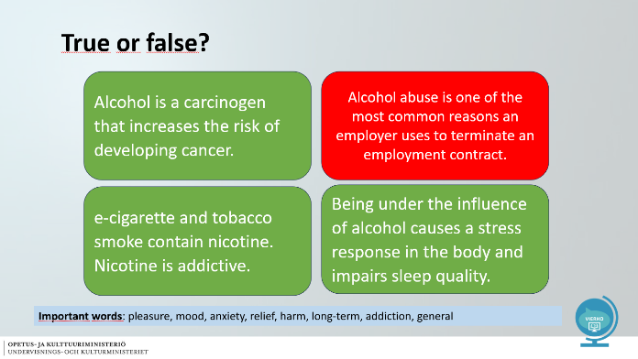

Slide 10 – Tobacco
- Tobacco is made from the tobacco plant  - Tobacco smoke contains more than 400 chemicals  - Nicotine in tobacco is highly addictive – in addition, nicotine is a carcinogen and causes cancer.  - Tobacco impairs oxygen uptake and endurance fitness  - Teeth and skin suffer  Cigarette butts are the most common waste in the world.  Tobaccobody interactive assignment | 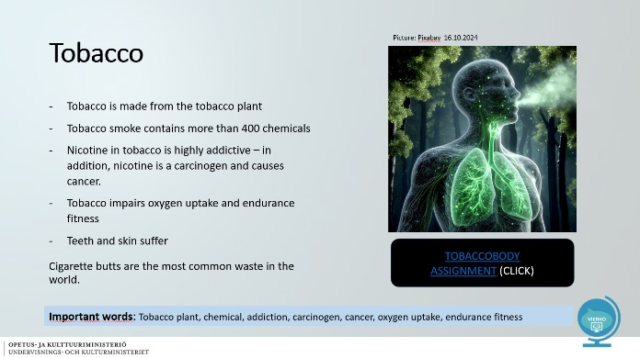

Slide 11 – Tobacco law
- Protects the population from health hazards caused by passive smoking  - The aim is to prevent people from being exposed to tobacco smoke unintentionally  - The use of snuff and nicotine pouches is prohibited in indoor and outdoor spaces intended for use by children and young people.  Schools and kindergartens | 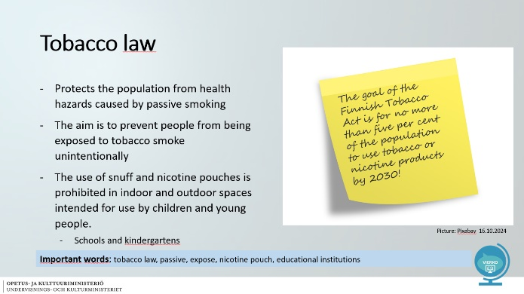

Slide 12 – Snuff
- Snuff contains up to 20 times more nicotine than tobacco  - Addiction can develop quickly if the use of snuff is regular  - Snuff causes cancer, weakens fitness, slows recovery and increases the risk of sports injuries  - Nicotine impairs blood flow to the muscles, causing the muscles not to receive enough oxygen and nutrients  - Snuff puts a strain on the heart by raising blood pressure and heart rate | 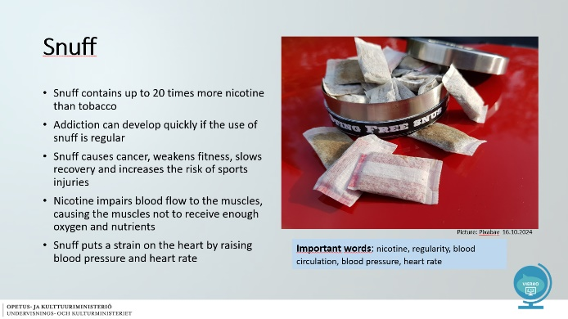

Slide 13 – Tobacco law
- Intoxicants and medicinal substances made from hemp plants  - Long-term use causes memory and learning impairment  - The risks of mental disorders (depression, anxiety) increase  - The physical harm of smoking cannabis outweighs that of tobacco  - In vocational colleges, around every fifth student had tried cannabis (School Health Survey 2019)  What are the social risks associated with cannabis use? | 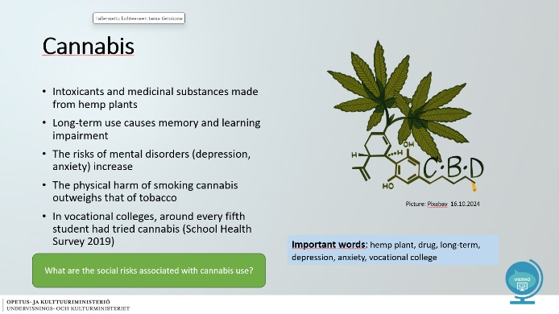

Slide 14 – E-cigarette
- The most common health hazards of e-cigarette use are irritation of the throat and mouth area, headache, cough and nausea  - Impairs normal lung function, cell health (inflammation) and lowers human function  - Increases the risk of cardiovascular diseases and cancer  - Several harmful metals have been found in e-cigarette liquids and the water vapour formed by them  - 16% of 18-year-old boys and 7% of girls had used e-cigarettes more than 20 times | 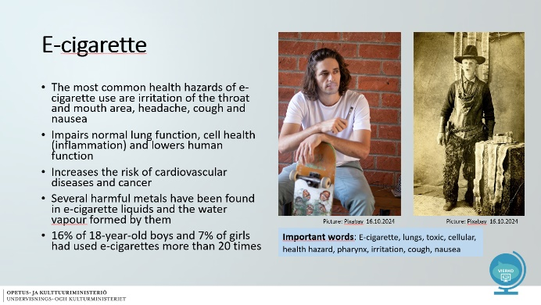

Slide 15 – Alcohol
- Paralyzes the central nervous system (state of intoxication)  - Reaction time increases, movement control decreases, speech becomes slurred  - May increase impulsivity, aggressiveness, accidents  - Heavy and long-term use can cause physical, psychological and social harm  - What kind of psychological and social harm can alcohol abuse cause?  - What kind of accidents can alcohol overuse increase in your workplace?  Video: Effects of drinking alcohol to your body (eng. subtitle) | 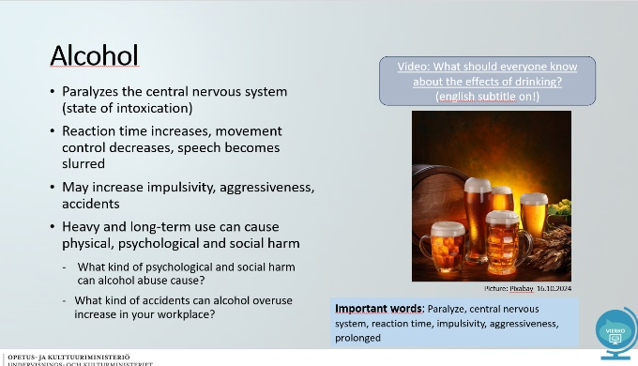

Slide 16 – True, myth or something between
- Alcohol is much more dangerous than cannabis!?  - Does cannabis help treat many diseases?  - Snuff and nicotine pouches are tobacco products?  - Does cannabis use lead to schizophrenia? | 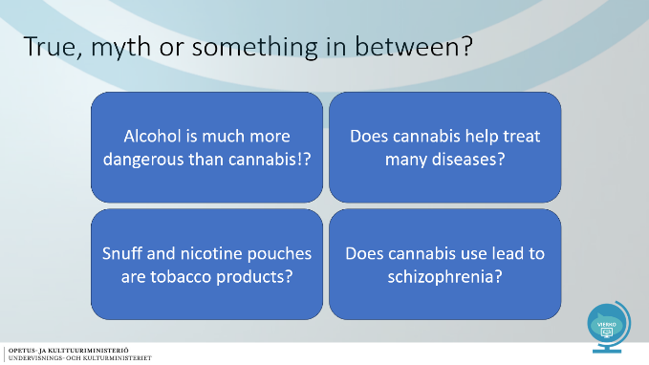

Slide 17 – Claim 1: Alcohol is much more dangerous than cannabis?

- There are risks associated with the use of both substances  - The risks of alcohol use are related to physical illnesses, the risks of cannabis to mental illness  - The hazards of using both substances depend on the user and the amount of use  - The risks are higher if the substances are used concomitantly | 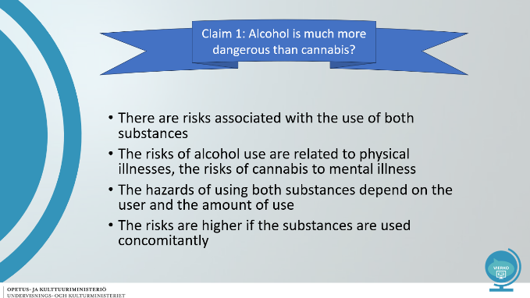

Slide 18 – Claim 2: Cannabis helps treat many diseases?

- Cannabis is used as a medicine for severe and prolonged pain, for example in multiple sclerosis. According to current research, only a small number of people benefit from treatment, not all.  - Cannabis does not cure diseases  - Just because cannabis is used as a medicine doesn't make it harmless  - Medical marijuana is taken through you as a spray and does not intoxicate | 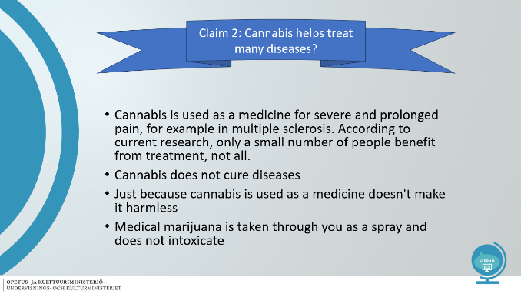

Slide 19 – Claim 3: Snuff and nicotine pouches are tobacco products

- Snuff and nicotine pouches are tobacco products  - Nicotine pouches were previously classified as medicinal substances (Fimea, 28.9.2023)  - The nicotine pouch is used in the same way as snuff, but it was originally intended for weaning from tobacco and snuff  - The sale of snuff is prohibited in Finland, but nicotine pouches are not | 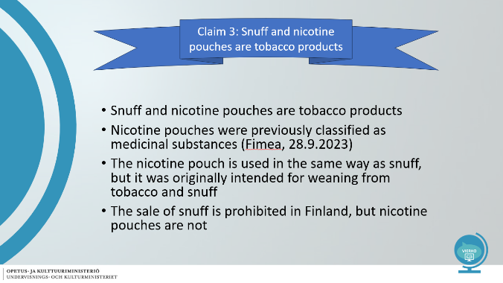

Slide 20 – Claim 4: Does cannabis use lead to schizophrenia?

- Symptoms of serious mental illnesses may appear more easily for users who are genetically predisposed to them.  - Cannabis use increases the risk of schizophrenia, especially among heavy users, doubling the risk. Daily users in Finland 10 000.  - The risk is increased by initiation of use before the age of 16, family history of psychotic disorders and previous psychotypical experiences  - Cannabis-related schizophrenia appears to occur earlier (2-7 years) than other schizophrenia, and poor adherence to medication increases the risk of recurrence | 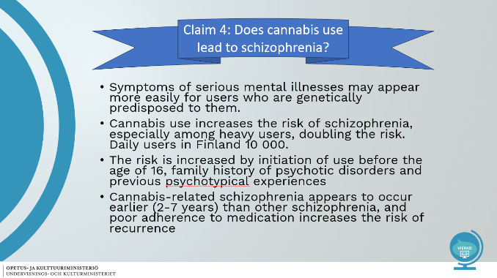



Pictures used in slideshow (Pixabay 2024)
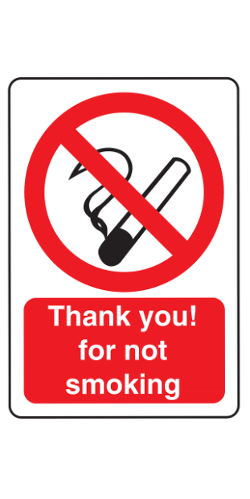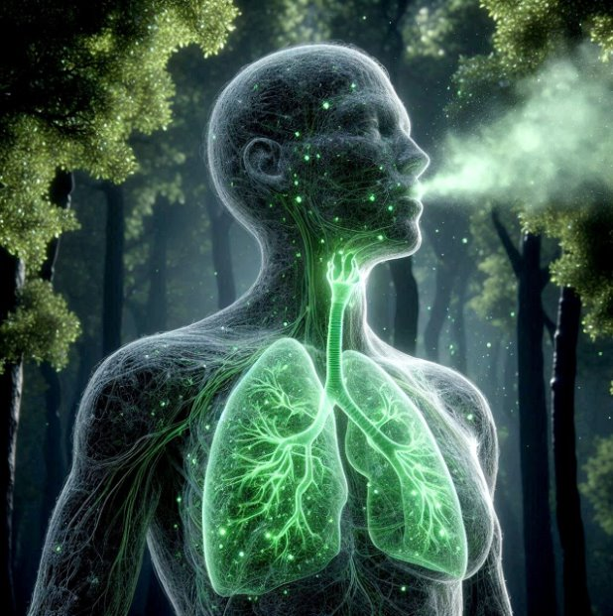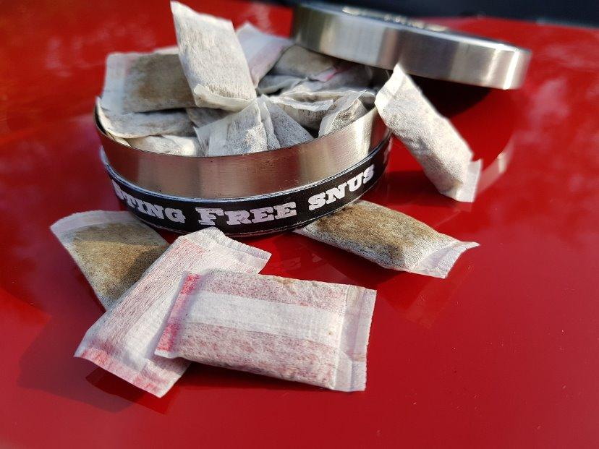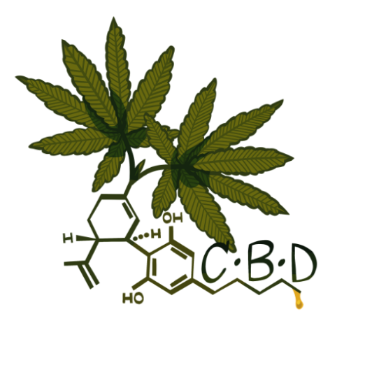
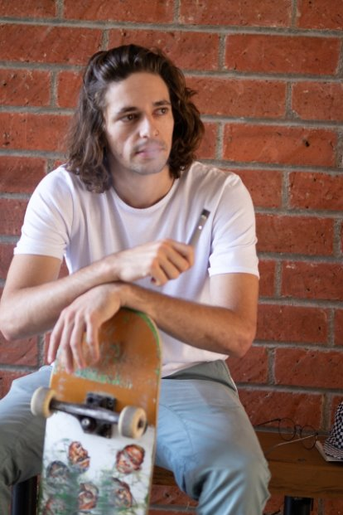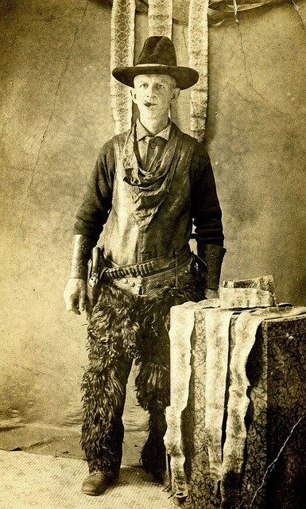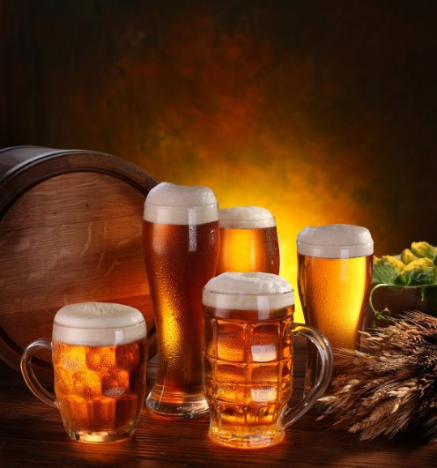

Tasks
Verkkokurssilla tehtävät on tuotettu alustan omilla toiminnoilla. Tehtävät voi tehdä myös esimerkiksi Forms-lomakkeena. Kysymyksen oikea vastaus on lihavoitu ja oikeita vastauksia voi olla useampia.

In this section, we study the harmful effects of different intoxicants on people and society.

Question 1

Which of the following are tobacco products?

Nicotine pouch
Tobacco
Electronic cigarette
Snuff

Question 2

Can tobacco products be used on the premises of the educational institution?

Yes, snuff, for example, can be used on the premises of an educational institution.
No. The use of tobacco products is also prohibited outdoors on the school grounds.

Question 3.

Which option is right? E-cigarettes are not hazardous to health?

Smoke inhaled from e-cigarettes is water vapor that is not dangerous to human health.
E-cigarettes have been found to contain a lot of substances that are harmful to human health.

Question 4.

Which option is right? Snuff is a good option for exercisers?

Yes, because it does not harm the lungs.
No, because it impairs blood circulation

Question 5.

Based on this information, which of the following is true?

Employer can fire an employee if he or she is drunk/hungover at work?
Snuff is more addictive than tobacco?
E-cigarettes contain metals that are harmful to health?
The harm of alcohol is mainly psychological?
Young people can use cannabis more carelessly because cannabis does not affect young people's health?
Nicotine increases blood pressure and heart rate?

Question 6.

Connect the right pairs. (intoxicant and possible cause of prolonged use)

Alcohol | Increased risk of accidents  Sick leave from the workplace  various deceases
Cannabis | Depression  Mental health problems  Cognitive impairment
Tobacco products | Cancer  Impaired blood circulation

Well-being at work
Osiossa on diaesitys aihealueesta työhyvinvointi ja kuusi siihen liittyvää tehtävää.

Slides

Slide 1
Well-being at work | 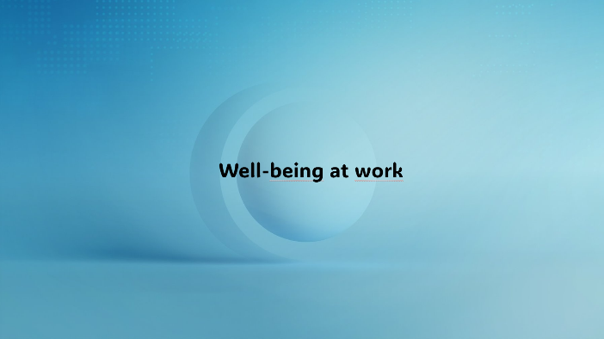

Slide 2
Health and functional capacity  Employee health and coping  Sufficient professional skills  Workplace safety  Good atmosphere in the workplace  Good leadership  -> Promoting well-being at work is the responsibility of both employers and employees.  Important words: well-being, employee, professionalism, atmosphere, leadership, employer | 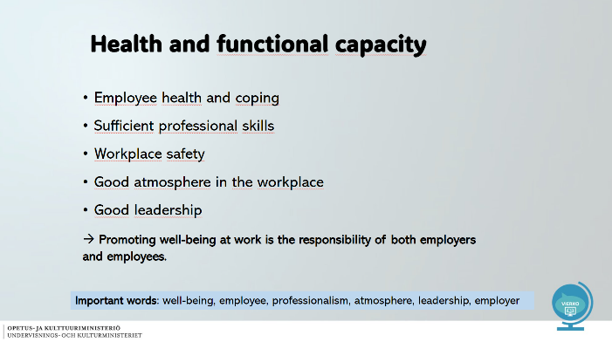

Slide 3
Work ability  Work ability refers to a person's ability to perform a work task  Work ability consists of a person's physical, mental and social functional capacity  Work ability is also affected by issues outside work  Well-being at work is part of work ability  Important words: work ability, work task, functional capacity | 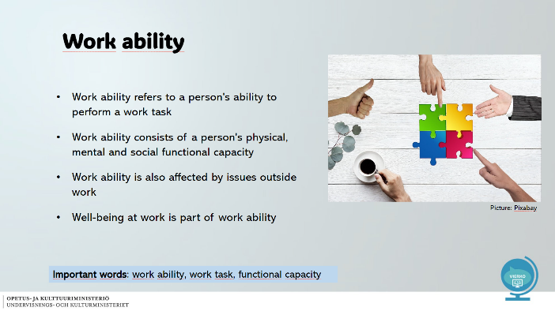

Slide 4
Work Ability House  Work ability can be presented as a house  The house has four floors  The bottom three include the personal resources of the individual  The fourth floor contains the work itself and working conditions, as well as work management  The Work Ability House remains standing when all floors support each other | 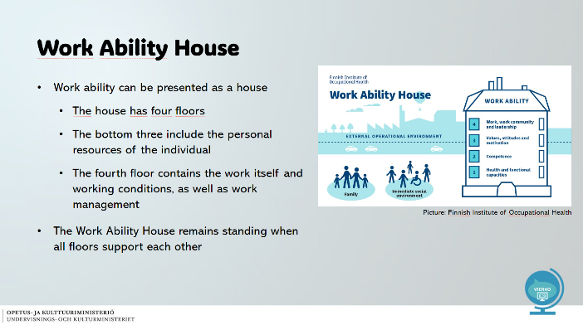

Slide 5
Health and functional capacity  You can influence your own well-being at work with your lifestyle:  with proper nutrition  with enough sleep  hobbies  These play an important role in maintaining and promoting health and functional capacity.  Important words: functional capacity, lifestyle, sufficient amount of sleep, maintenance, promotion | 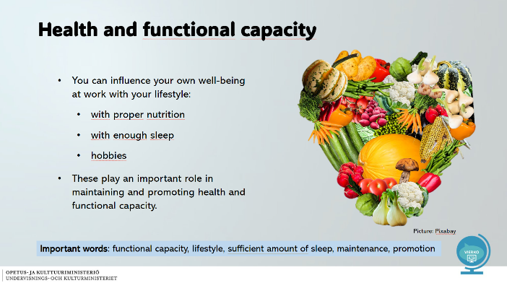

Slide 6
Professional competence  Develops through education and work experience  Professional competence should be developed throughout one's career, lifelong learning  By developing your professional skills, you have a positive impact on your work ability and well-being at work  More information about lifelong learning: https://hyplus.helsinki.fi/in-english/  Important words: work experience, career, lifelong learning | 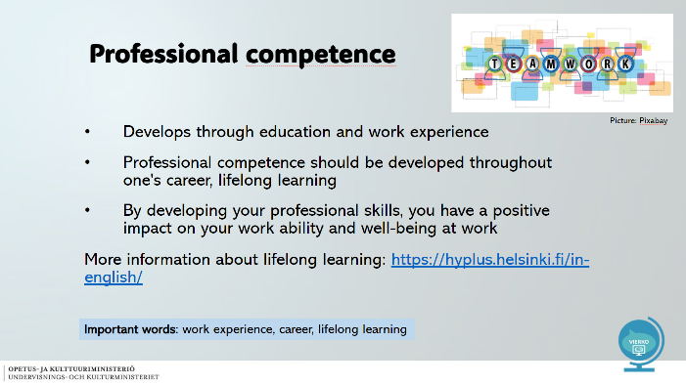

Slide 7
Employee attitude and motivation  Meaningful and suitably challenging work is part of work ability and motivates employees in their work  Your attitude towards work affects your work ability and well-being  Consider  -> How do you feel about your work?  -> What kind of things excite you?  -> What kind of colleague are you?  Important words: Attitudes, motivation, meaningful, appropriate, challenging, values | 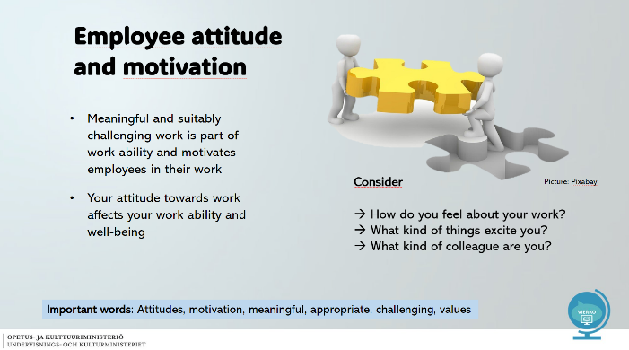

Slide 8
Management, work community and working conditions  Supervisors have a responsibility and obligation to develop working conditions and employees' work ability  → For example, working spaces and recreational days  The work community consists of employees, partners and customers  Working conditions must be supportive of work and take into account the needs of the work  All of these together affect an individual's work ability and well-being  Important words: Leadership, work community, working conditions, supervisor, duty, partner | 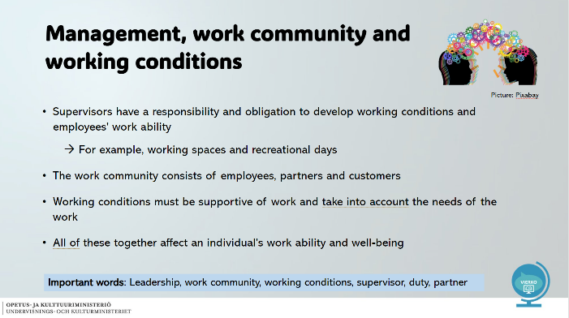

Slide 9
Are you a healthy employee?  Healthy employee  Is motivated and responsible  Knows the objectives of their work  Feels needed  Feels sufficient independence and  belonging in their work  Get to utilise their strengths and skills  Receive feedback on their work  Succeeds and gets excited in their work | 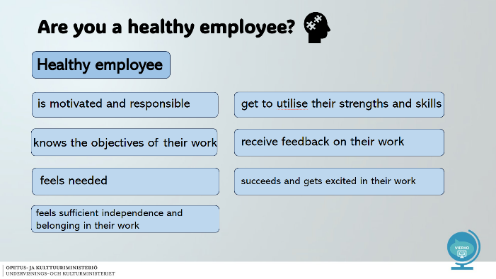

Slide 10
Is your work community healthy?  Healthy work community  is open and trusting  is giving positive feedback  people dare to talk about problems  keeps the workload under control  is inspiring and encouraging  pulls in the same direction  maintains the ability to function through changes | 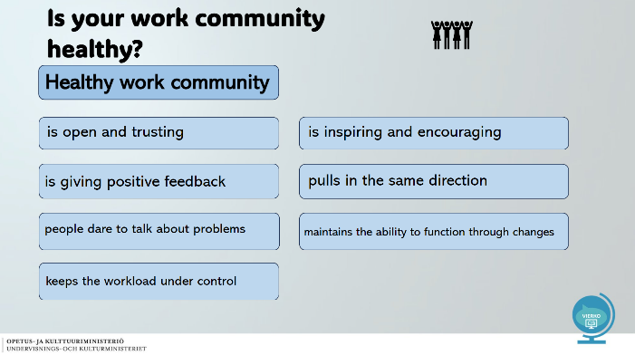

Slide 11
Occupational safety  The employer is responsible for  occupational safety at the workplace and working environment  employee orientation  the purchase of personal protective equipment and assistive devices  the organisation of occupational health care  Read more here.  The employee is responsible for  complying with instructions and regulations  taking care of one's own safety and that of others  reporting defects and deficiencies  Read more here.  Important words: Occupational safety, orientation, personal protective equipment, assistive device, occupational health care, defect | 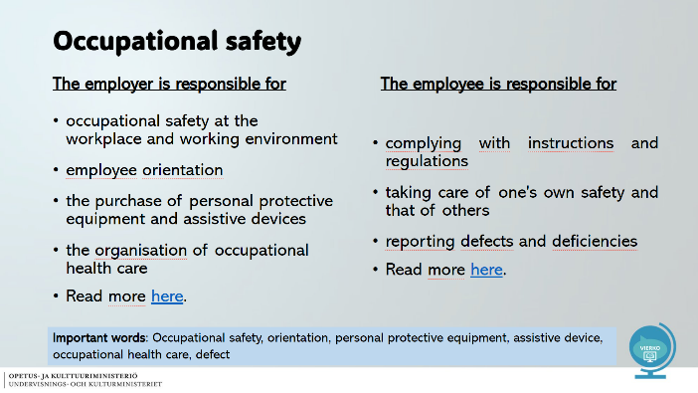
Slide 12
Examples of potential hazards  in the working environment  Accidents (slipping, tripping, sharp objects, etc.)  Physical hazards (noise, radiation, thermal conditions, etc.)  Chemical hazards (chemicals, vapours, etc.)  Biological hazards (hygiene, bacteria, etc.)  Physical stress factors (poor working postures, manual lifting, etc.)  Psychosocial stress factors (stress, difficult social situations, etc.) | 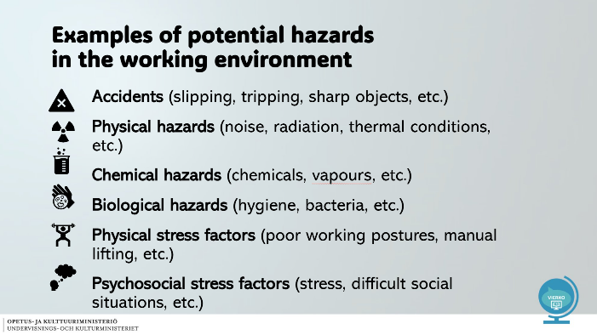

Pictures used in the slideshow (Pixabay):



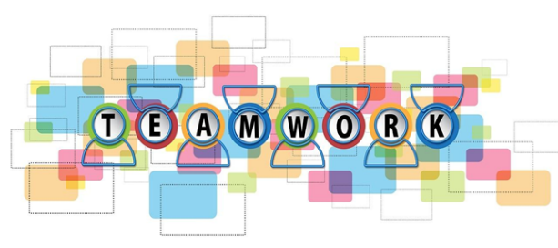

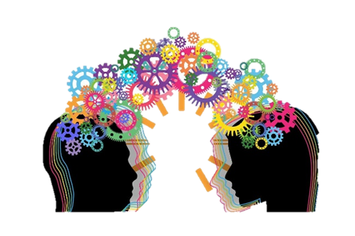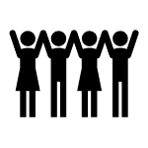
Finnish Institute of Occupational Health:
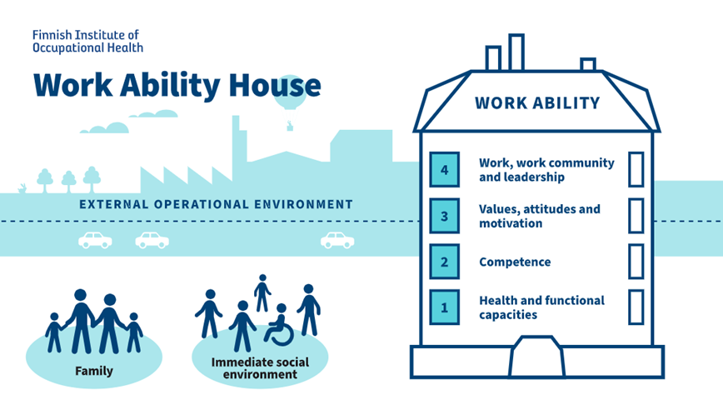

Tasks

Kysymyksen oikea vastaus on lihavoitu ja oikeita vastauksia voi olla useampia.

1. Work ability consists of many different factors.
Do things outside work affect a person's ability to work?

Yes
No

2. Which of the following options affect an employee's well-being at work?

Supervisors
Neighborhood
Workplace safety
Employee health
Workplace location

3. A work ability house is well built when each floor supports the other.
Drag the layers in the correct order (1=bottom layer):

Health and functional capacities
Competence
Values, attitudes and motivation
Work, work community and fields of work

4. Promoting well-being at work is the responsibility of both the employer and the employee.
Occupational safety is an important aspect of well-being at work.
Which three of the following options are the employer's responsibility?
Occupational safety at the workplace and working environment
Compliance with instructions and regulations
Arranging occupational health care
Purchase of personal protective equipment and assistive devices
Cleanliness of the canteen

5. Promoting well-being at work is the responsibility of both the employer and the employee.
Occupational safety is an important aspect of well-being at work.
Which three of the following options are the responsibility of the employee?

Scheduling shifts
Reporting defects and deficiencies
Taking care of one's own safety and that of others
The use of personal protective equipment and assistive devices

6. Choose the right option for each.
You can influence your own well-being at work with your lifestyle. Proper nourishment, sufficient sleep and pleasant hobbies support well-being. These factors play an important role in maintaining and promoting health and functional capacity.
Meaningful and suitably challenging work, maintaining professional skills by educating oneself and a positive attitude towards work are also part of work ability and well-being.

*nourishment / work location / lunch
*sleep / temperature / amount of friends
*hobbies / clothes / commute
*challenging / easy / difficult
*by educating oneself / by interviewing coworkers / by working

Strength training
Osiossa on diaesitys aihealueesta terveyttä edistävä liikunta ja siihen liittyvä tehtävä oman kuntosaliohjelman rakentamisesta teoriaan pohjaten.

Slides
Slide 1
- Strenght training | 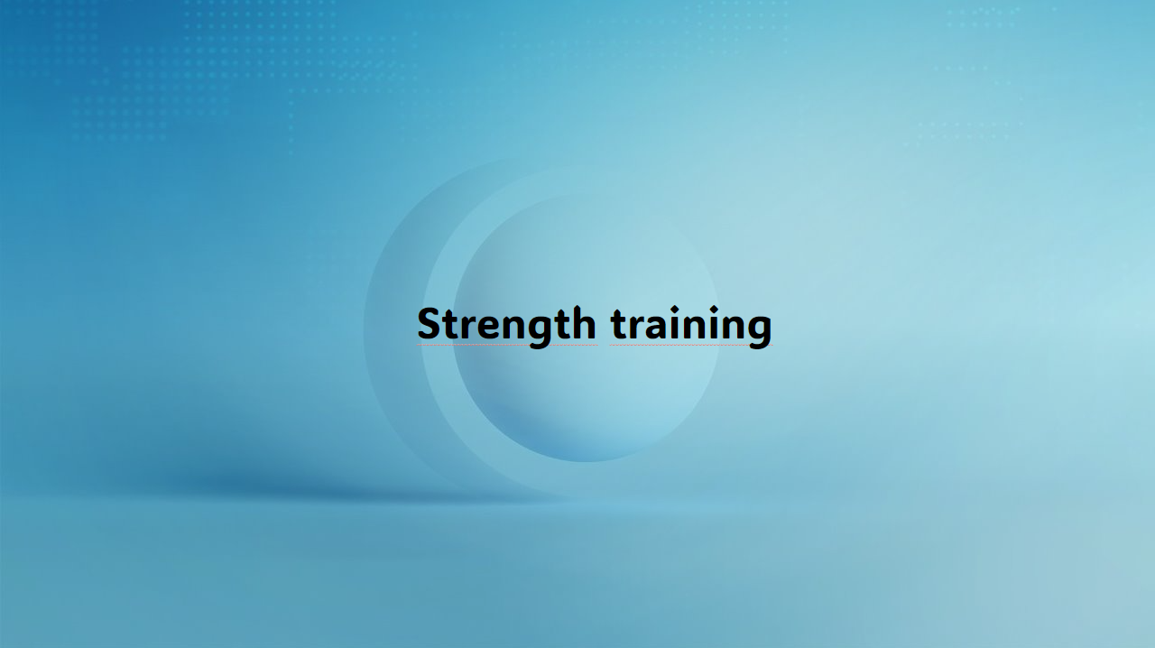

Slide 2
Contents  - Why strength training?  - How do I start training?  - How much do I train?  - Start basic strength training  - Gym program  - How do I resume gym training?  - To support your gym training  - Answer questions  - Sources | 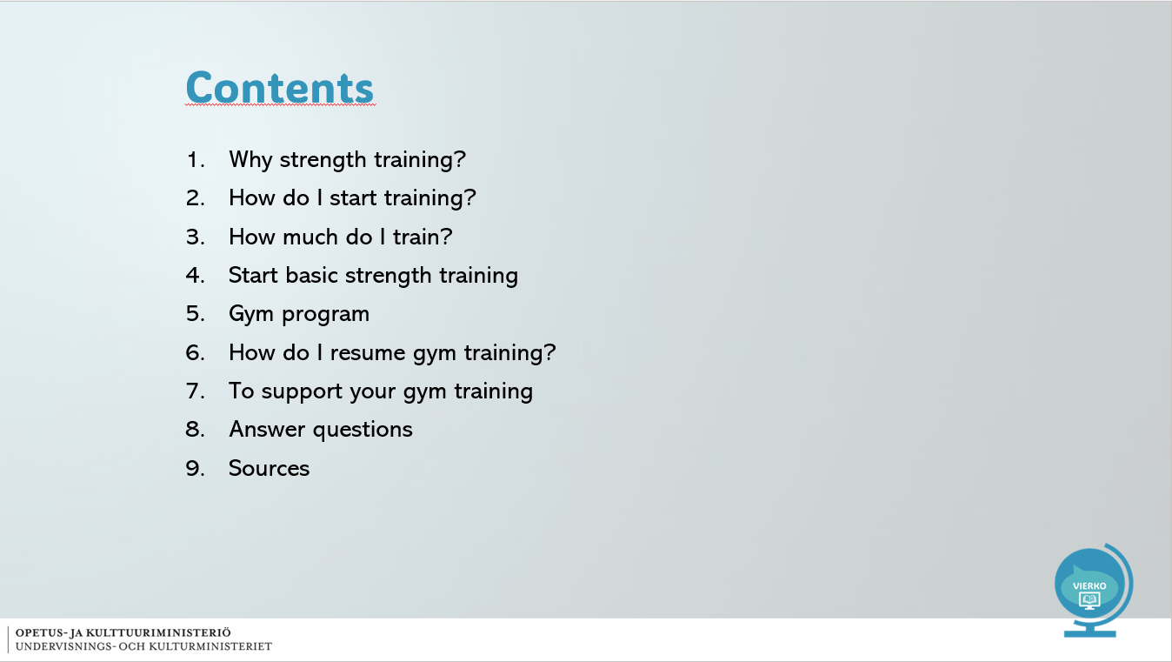

Slide 3
Why strength training?  - Important fitness factor  - Able to lift and move goods  The body lasts longer  Prevention of repetitive strain injuries  For example, back pain  - Social and psychological benefits  - Positive mood after exercise  Stress decreases  Time with a friend, time for yourself  Self-image – I am strong and able to cope  IMPORTANT WORDS:  Strength, training, fitness factor, body benefit, repetitive strain injury, back pain | 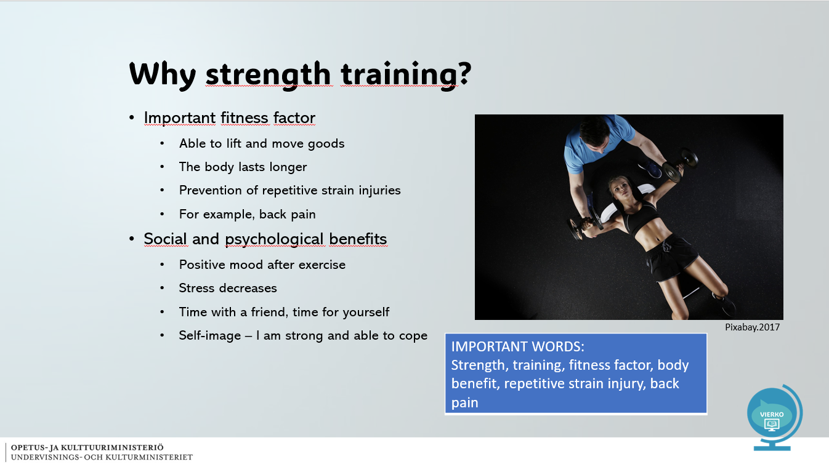

Slide 4
HOW DO I START TRAINING?  - Start with easy moves  - No pain in performance  - Calm movement, 2+2s  - Ankle, knee and hips aligned  - Good posture during movement  - See the instructions on the device – how to use the device?  - Ask for help if needed  IMPORTANT WORDS:  Performance, technique, pain, calm, ankle, knee, pelvis, posture, device, instruction, exercise | 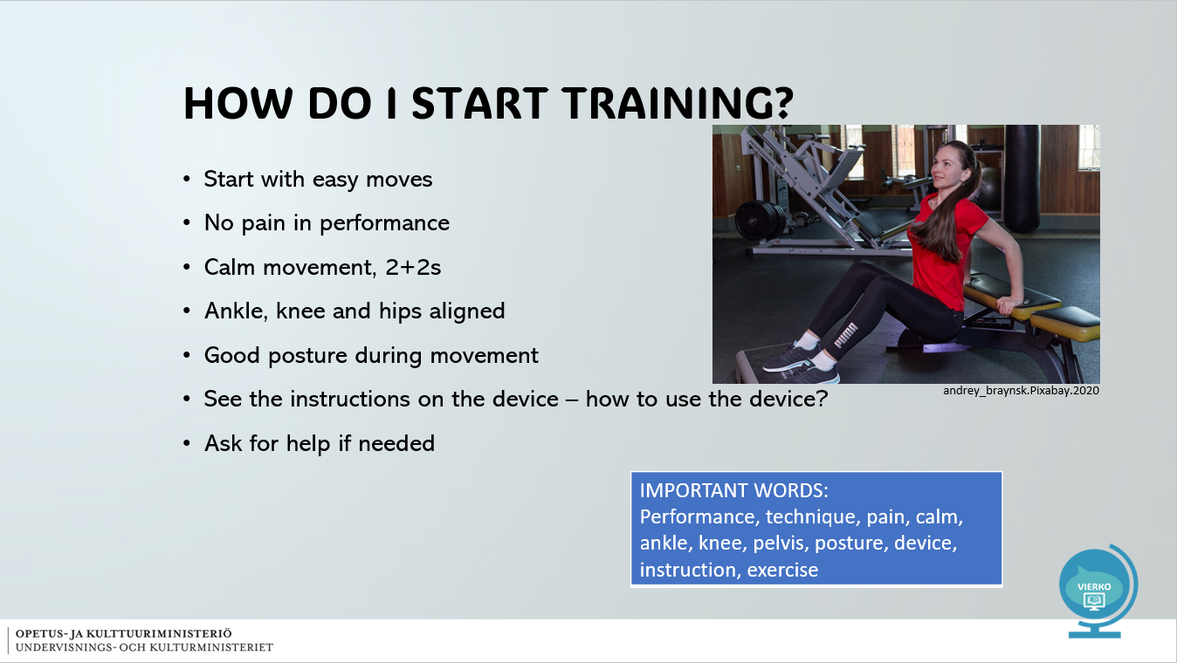

Slide 5
HOW MUCH DO I TRAIN?  - Strength training 1-2 times a week = healthy exercise  - Change movements after 4 weeks  - Exercise the whole body in a versatile way  - Back – belly – flanks  - Calves – thighs – buttocks  - Arms – chest – shoulders  A short workout is more than nothing!  IMPORTANT WORDS:  Health exercise, exercise, versatile | 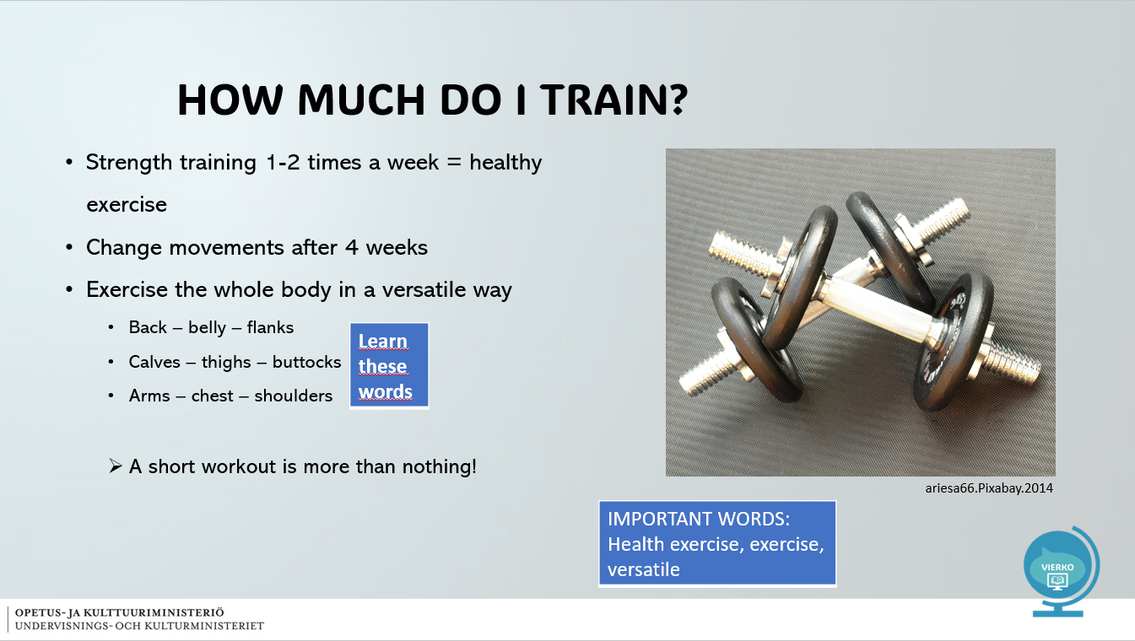

Slide 6
START BASIC STRENGTH TRAINING  - First, do a warm-up for 5-10 minutes  - E.g. exercise bike, treadmill, cross trainer  - Choose 5-7 moves  - Do 3 sets of each movement  - Do 8-12 repetitions of each movement  - Choose a suitable weight, the muscle will get tired  - Take a break between sets for 1-2 minutes  - A break helps you cope!  IMPORTANT WORDS:  Basic strength, warm-up, movement, fit, weight, muscle, break | 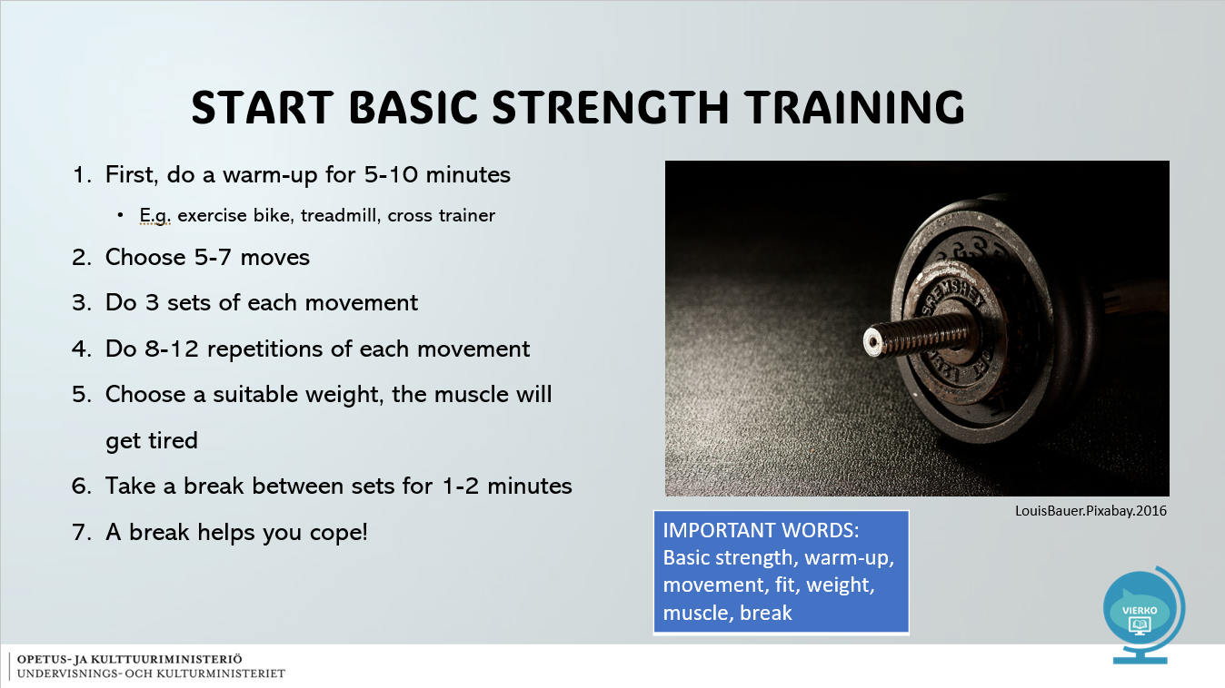

Slide 7
GYM PROGRAM  Gym program terms  - Lämmittely = Warm up  - Liike = Movement  - Toisto = Repetitions  - Sarja = Set  - Painot = Weights  - Tauko = Break  Example of a basic exercise:  Lat pulldown, wide grip 3x10  Corner row, barbell, counter grip 3x10  T-bar row 3x12  Shrugs with dumbbells 3x15  Biceps curl, Scott machine 3x10  Rope Hammer curl 3x12  Back extension machine 3x15-30  IMPORTANT WORDS:  Gym, gym program | 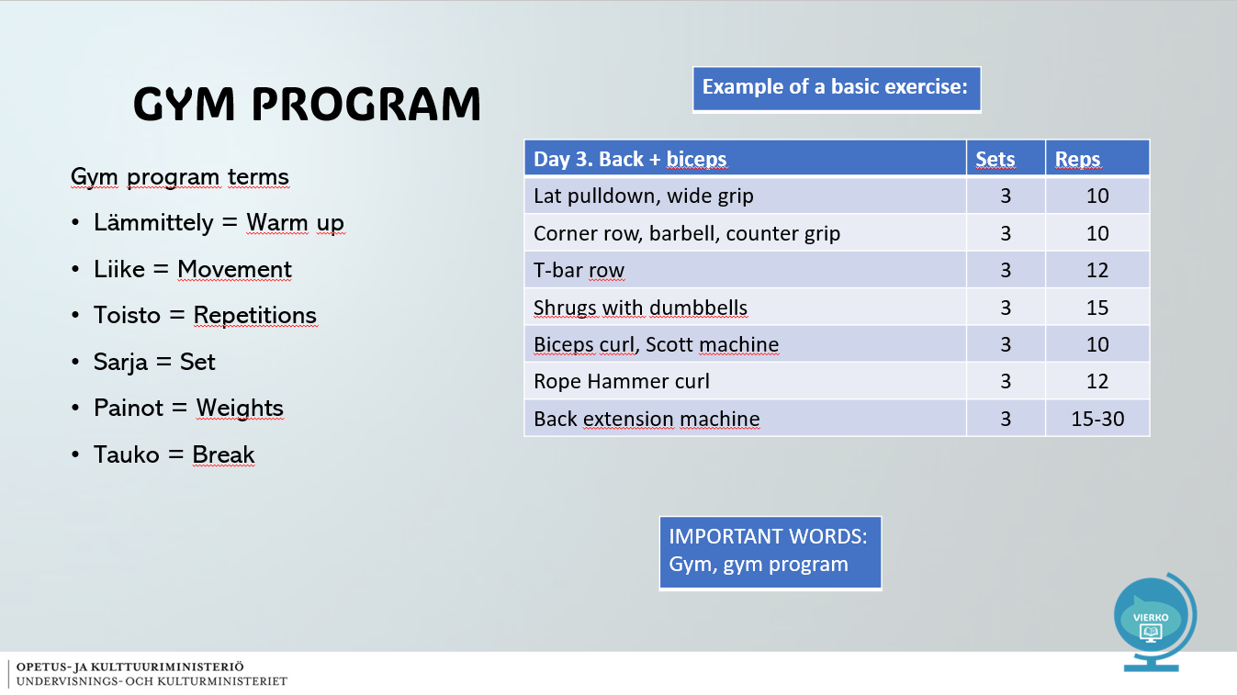

Slide 8
HOW DO I CONTINUE TRAINING IN THE GYM?  - The objectives of the training guide the activities  - Do you want to be durable, fast or strong?  Endurance power  - More than 20 reps  - 3-4 sets  - Your body weight or 0-20 % extra weight  - Calm tempo  - For example, a fitness circuit  Maximum power  - 4-12 reps  - 3-5 sets  - 50-80 % extra weight  - Return 1-3min  - Lactic acid and muscle exhaustion  Speed power  - 1-5 fast repetitions  - 3-4 sets  - Your body weight or 30-80 % load  - Return 1-4 min  - No feeling of exhaustion  IMPORTANT WORDS:  resume, endurance, maximum, strength, speed, goal, exhaustion, body weight, fitness circuit | 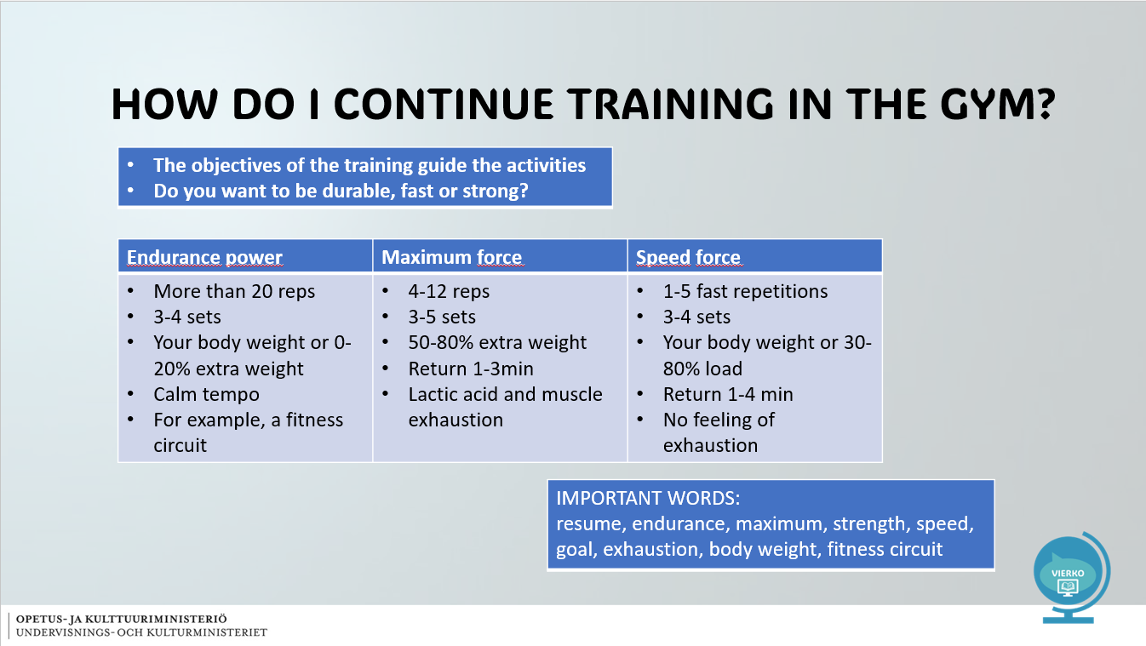

Slide 9
TO SUPPORT YOUR GYM TRAINING  - Drink enough water while exercising  - After exercise, eat, for example, fruit  - Eat a healthy meal within 1 hour after the end of exercise  - Helps recover and repairs muscle damage  - A little muscle pain the day after training is a normal sensation  - Rest days support development  - Take a rest day every 3-4 days | 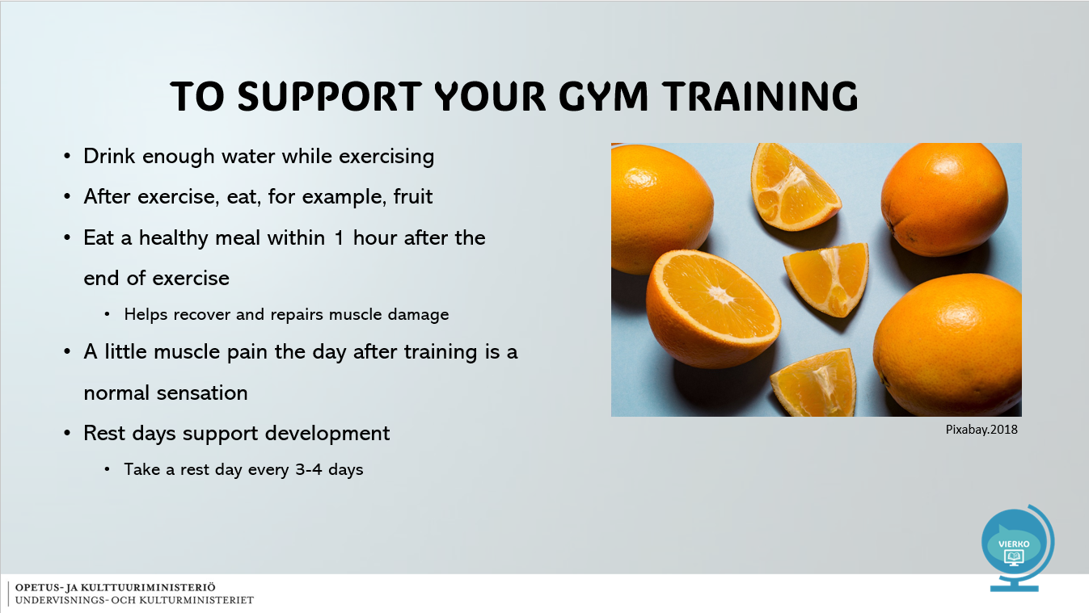

Slide 10
ANSWER QUESTIONS  - What are the benefits of strength training in terms of work ability?  - What does sets, reps and pause mean? Why take a break?  - What is important in gym training?  - Find out which gym is near you. | 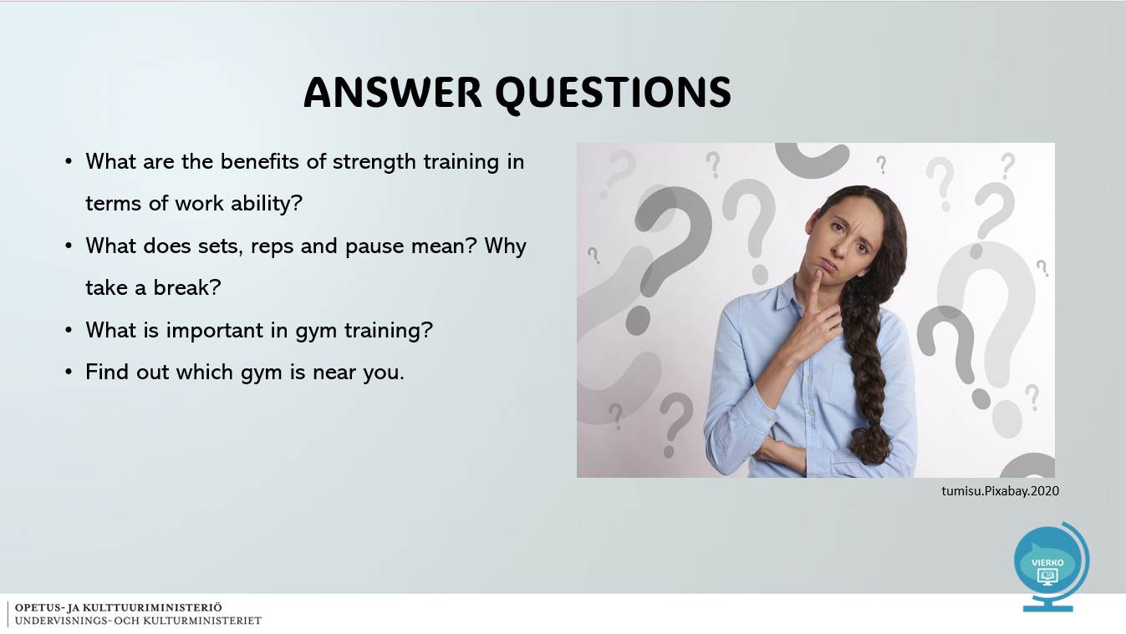

Slide 11
References  - Vantaan ammattiopisto Varia  - Pixabay | 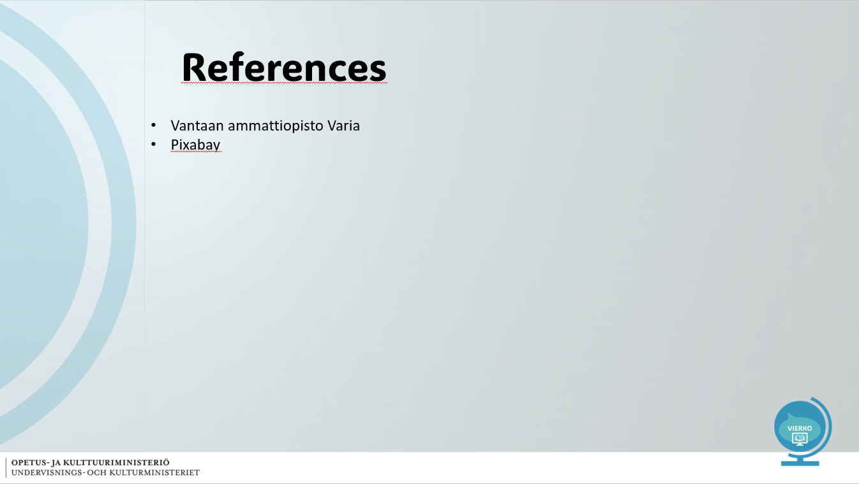

Slide 12
VIERKO  Vieraskielisen opetuksen kehittäminen  Kotimaisten kielten opetuksen tarjonnan ja laadun kehittäminen  ammatillisessa koulutuksessa  2024  Lisätietoa: https://www.keuda.fi/keuda/hankkeet/vierko/ | 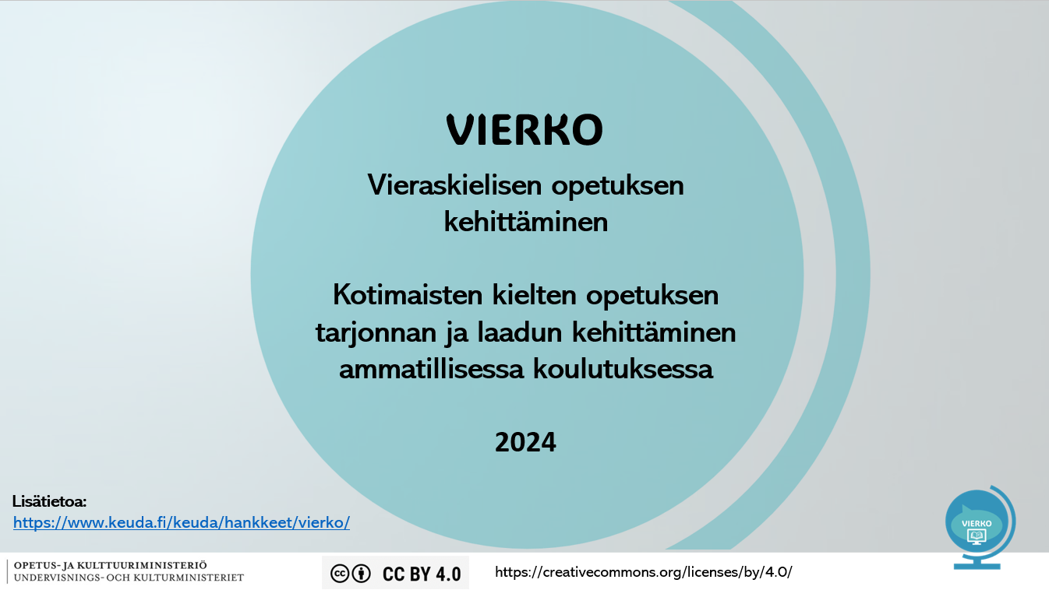

Pictures used in the slideshow (Pixabay):
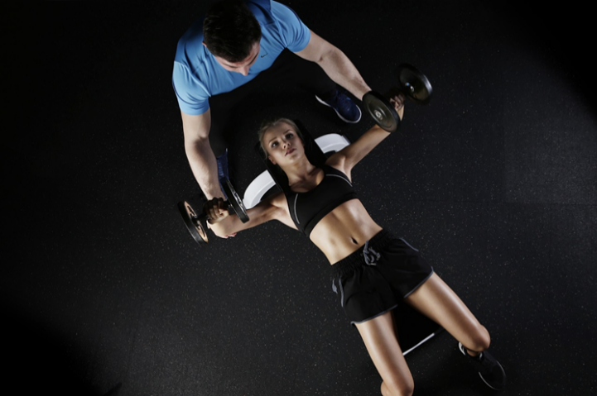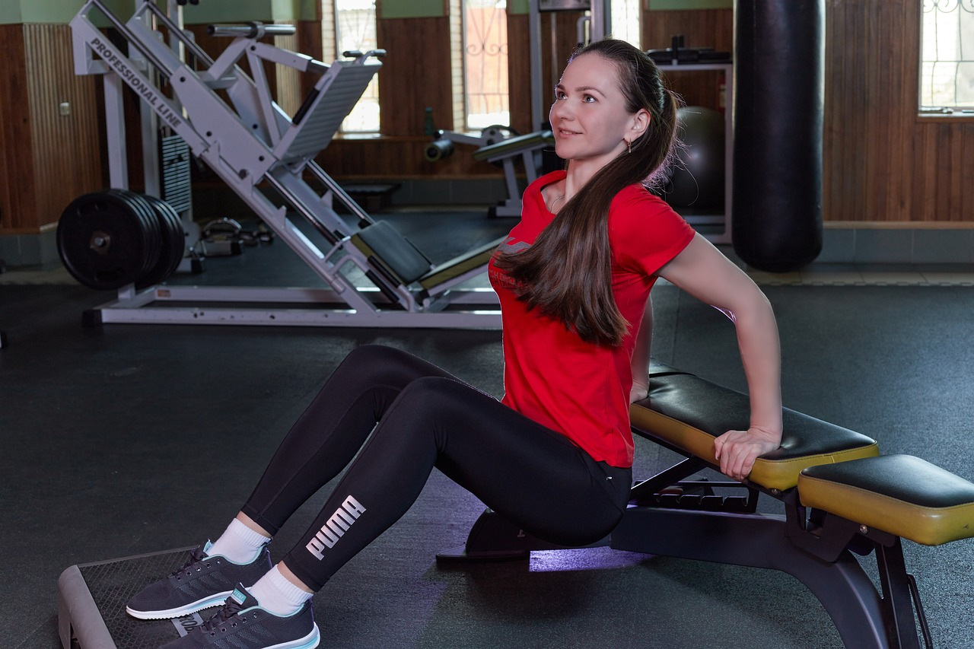
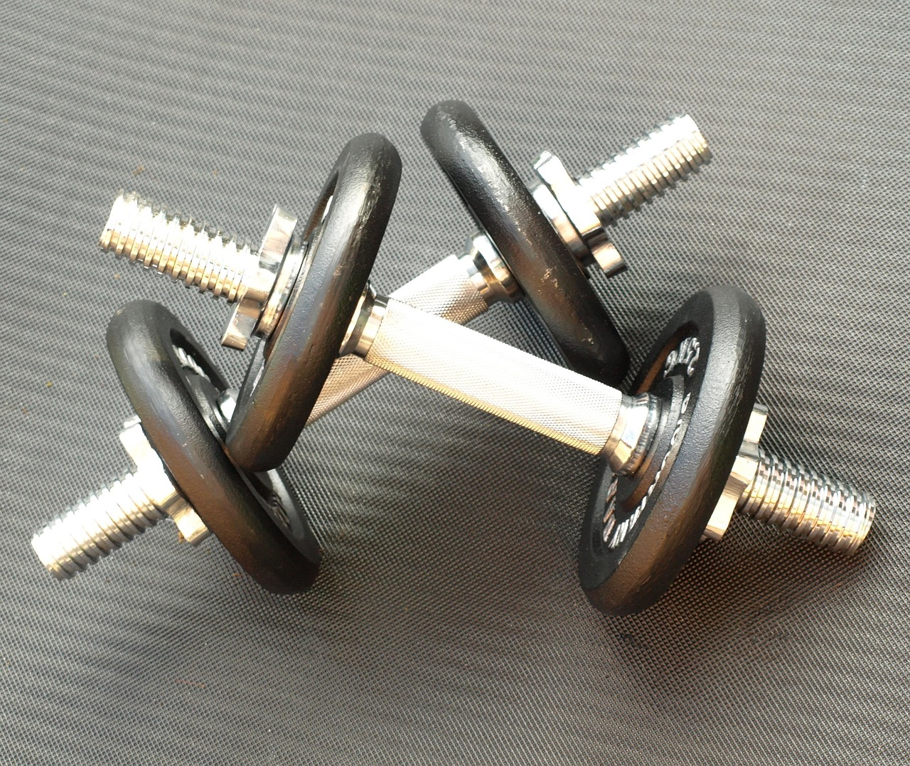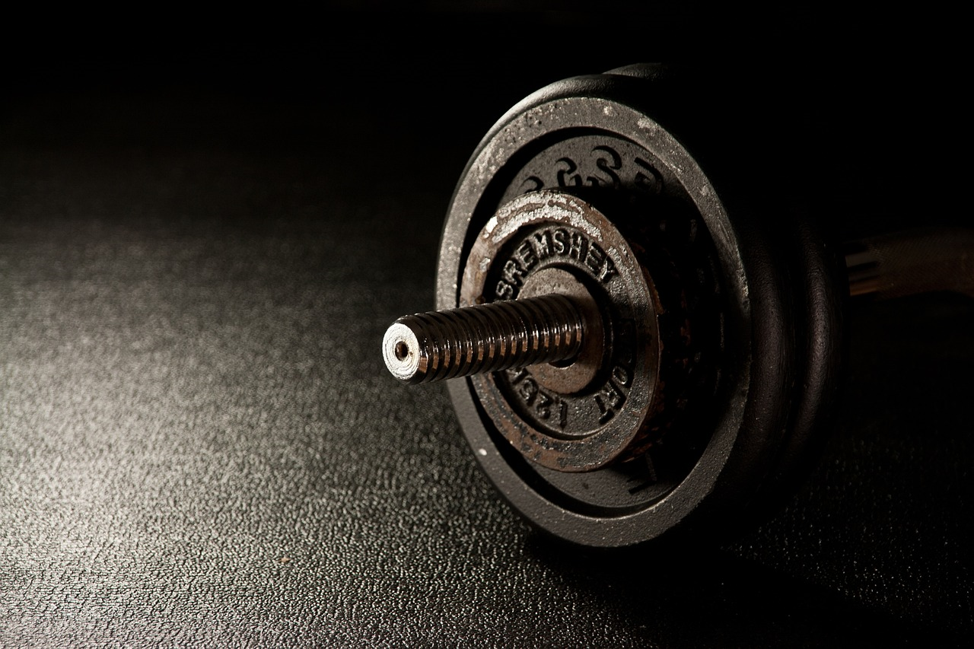
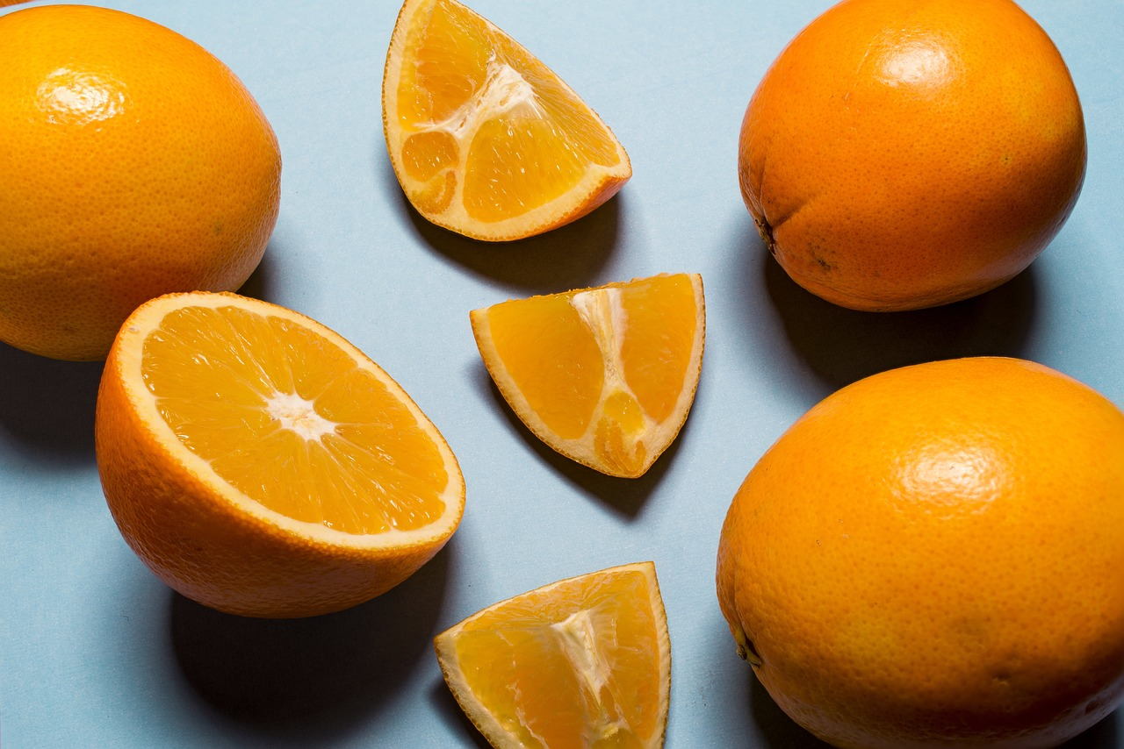

Tasks
Kuntosaliharjoittelun tehtäväosio 1 on toteutettu käytännön tehtävänä kuntosalilla. Opiskelija on tutustunut oppilaitoksen tai oman lähisalin kuntosalilaitteisiin ja luonut kurssilla oppimansa teoriatiedon perusteella itselleen sopivan kuntosaliohjelman.

Tehtäväsio 2:sta löydät kolme tehtävää aihealueen dioihin liittyen.

Task 1
- Introduction:  Teachers can share a table for the students in which they can fill in a gym program.  A program could include for example these themes:  Movement  Repetitions  Sets  Weights  Break  Directions | Gym program example:  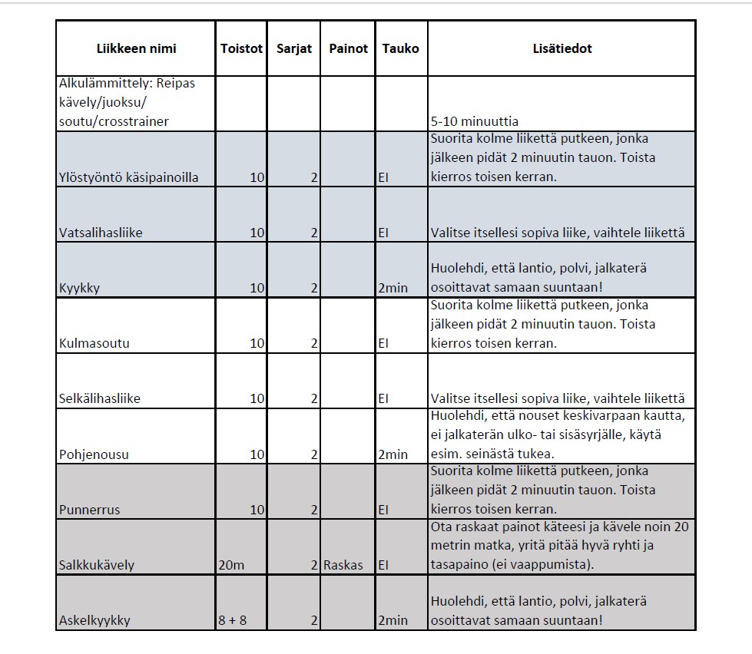

Tasks 2

Question 1

How many times I Should train at the gym during a week to support my physical health?
- 1-2
- 3-4
- At least 5
Question 2

Why gym training is beneficial for our health and working wellbeing? (Choose 3)
- People can lift and move dangerously heavy goods at work
- Conditioning gets better and our muscles lasts longer
- Prevention of repetitive strain injuries
- Gym training and sports decreases stress
- I can build my muscles to enhance my social relationships

Question 3

Which of the following sentences is NOT true.
- I should start with easy moves
- No pain in performance
- Calm movement, 2+2s
- Ankle, knee and hips aligned
- Good posture during movement
- See the instructions on the device – how to use the device?

Question 4

Which of the following sentences is NOT true.
- Drink enough water while exercising
- Eat a healthy meal within 1 hour after the end of exercise
- A little muscle pain the day after training is a normal sensation
- Rest days doesn´t really support development

Competence display and self-evaluation
Loppukokeessa opiskelija osoittaa, mitä hän on oppinut kurssin aikana. Loppukoe vaikuttaa opintojakson lopulliseen arvosanaan. Loppukoe on ajastettu ja opiskelijalla on 75 minuuttia aikaa suorittaa se. Opiskelijan on vastattava 50 prosenttiin kysymyksistä oikein, jotta hän läpäisee kokeen. Kokeessa on 3 kysymystä jokaisesta opintojaksolla opiskeltavasta aiheesta: terveysliikunta, uni ja palautuminen, päihteet, seksuaalinen hyvinvointi, vuorovaikutus, työergonomia, ravitsemus, työhyvinvointi ja voimaharjoittelu

5.1. Final exam
In this section, you will demonstrate what you have learned during the course. The final exam affects the final grade of the course.

You have 75 minutes to complete the task. You must answer 50% of the questions correctly to pass.

The exam has 3 questions for each topic studied on the course: health-promoting exercise, sleep and recovery, intoxicants, sexual well-being, work ergonomics, interaction, nutrition, well-being at work and strength training.

HEALTH-PROMOTING EXERCISE

Q1. HEALTH-PROMOTING EXERCISE:

Which of the following best describes good functional capacity? (1p.)
- A person goes to work, takes care of their social relationships, is mainly satisfied with their life, copes well with the demands of everyday life.
- A person goes to work, actively takes on physical exercise every day, helps friends with their problems and constantly strives to improve.
- A person has absences from work due to sickness, social relationships feel stressful, and the person has difficulties coping with everyday life.
- A person likes their job, but the amount of work burdens them from time to time; the person meets friends regularly, sometimes forgets to take care of themself.

Q2. CHOOSE THE CORRECT PAIRS: (2p.)

-Fitness factors
-Exercise can promote human endurance, strength, mobility, bone condition and body control

-Passive lifestyle
-A person does not exercise much, everyday life includes a lot of watching TV and using the phone. You can't keep in touch with friends

-Mental functioning
-Exercise promotes mental health, it provides experiences and energy for the days.

-Health promoting exercise
-Big benefits and small risks. Is regular and personally designed.

Q3. HEALTH-PROMOTING EXERCISE: (3p.)

Use an everyday practical example to explain how exercise can promote your

a. physical functioning,
b. mental functioning,
c. social functioning.

SLEEP AND RECOVERY

Q4. SLEEP AND RECOVERY: (1p.)

Choose the right option for the situation.

"A person's sympathetic nervous system is constantly active, it is difficult for them to calm down, and they constantly wake up in the middle of the night."
- It seems that the person is overloaded.
- It seems that the person should do more physical activity.
- It seems that the person should go to bed earlier.
- It seems to suggest that high intensity exercise should be added to the person's everyday life.

Q5. SLEEP AND RECOVERY:

Choose suitable pairs (2p.).

Overload
A person should look at which area of life takes resources. A person should take care of normal everyday routines, food rhythm, sleep patterns and regular exercise. The person should mention the issue at work.

Microbreak
A person includes short breaks in their working day. Even a short 1-2 minutes break regularly during working days can support coping at work.

Fatigue
A person should check their sleep patterns and other stress factors in life. A person should try to add light exercise to their daily life and make sure that they go to bed and wake up at about the same time. You should get about 8 hours of sleep every night.

Sleep cycles
A person needs to recover approximately 5-7 sleep cycles. This is usually achieved with about 8 hours of sleep per night. REM sleep, light sleep, and deep sleep are associated with this.

Q6. SLEEP AND RECOVERY:

Share tips on how you can influence a person's sleep habits. What you can do to improve
your sleep: (3p.)

a. in the morning,
b. during the day,
c. in the evening.

INTOXICANTS

Q7. INTOXICATION.

Tick all the right propositions. (1p.)
- Cannabis mainly causes psychological health damage. The younger you start, the more abundant the use, the more likely it is that harm will occur, and the harm is serious
- Alcohol mainly causes physical health problems. The younger you start, the more abundant the use, the more likely it is that harm will occur, and the harm is serious
- Tobacco causes discoloration of the skin and teeth
- Cannabis is not dangerous, as it very rarely causes physical harm to people

Q8. INTOXICATION.

Choose suitable pairs (2p.)

Alcohol (in women)
7 doses per week pose a moderate risk of developing various diseases

Alcohol (in men)
14 doses per week pose a moderate risk of developing various diseases

Alcohol
Regular heavy use can damage almost every organ

Snuff
Causes strong addiction, as well as various cancers and narrowing of blood vessels

Cannabis
Just one experiment has a debilitating effect on learning, attention and memory function

Electronic cigarette
May contain up to tens of thousands of different chemical compounds

Q9. INTOXICATION. (3p.)

Explain how the adverse effects of intoxicants can be seen in your work from the employee's point of view. Remember to tell which intoxicants you are mentioning in your examples.

SEXUAL WELL-BEING

Q10. SEXUAL WELLBEING:

Which of the following is NOT covered by the World Health Organization
definition of sexual health? (1 p.)
- Physical well-being
- Emotional well-being
- Well-being of both gender
- Mental well-being
- Social well-being

Q11. SEXUAL WELL-BEING:

Choose suitable pairs (2 p.).

Sexuality
Everything related to sexuality; intimacy, well-being, tenderness, transparency, security...

Sexual Health
Physical, mental, social and emotional state of sexual health

Sexual well-being
Part of human's holistic well-being

Sexual rights
Rights relating to human sexuality, defined by law

Q12. SEXUAL WELL-BEING: Choose 3 sexual rights. Justify why these three sexual rights are important (3 p.)

INTERACTION

Q13. INTERACTION: What is meant by interaction skills? (1 p.)
- The ability and desire to exchange thoughts, experiences, opinions.
- The ability to say directly what you think about things.
- Willingness to socialize with others.
- The ability and skill to talk to other people.

Q14. INTERACTION: Select a word that fits the text (2 p.)

First, read the surrounding text, and then select your answer in each field drop-down menu.
A good (listener, individual, person, colleague) looks into the eyes, reacts with gestures to what they hear, and directs his body towards another person.
(Empathy, sociability, emotional cell, emotional skills) means putting oneself in another person's shoes, i.e. thinking about that the other person could be in the situation.
(Eye contact, speaking, facial expression) and brisk (Greeting, use of voice, walking) shows that you've noticed another person.

Q15. INTERACTION: Choose from the list 3 strengths that represent you. Explain your choice,
why you chose those strengths. (3 p.)

creativity, curiosity, joy of learning, perspective-taking, courage, perseverance, honesty, enthusiasm, kindness, love, social intelligence, fairness, leadership, teamwork skills, forgiveness, understanding, modesty, prudence, self-regulation, appreciation of beauty and excellence, gratitude,hopefulness, sense of humor, spirituality, compassion and perseverance.

WORK ERGONOMICS

Q16. WORK ERGONOMICS. Choose the right options. (1p.)
- Good ergonomics supports and develops people's health and well-being
- Good work ergonomics benefits both the employee and the company.
- Ergonomics makes work productive and safe
- Ergonomics is the proactive planning of work and the operating environment, and comprehensive development

(All correct)

Q17. WORK ERGONOMICS

Choose suitable pairs. (2p.)

Cognitive ergonomics
Remembering, learning, perception, own thinking

Organizational ergonomics
Working time arrangements, work schedule, work processes, staff

Physical ergonomics
Working postures, use of work equipment and assistive devices, working environment

Q18. WORK ERGONOMICS. Reflect on your future profession from an ergonomic point of view
(3p.)

NUTRITION

Q19. NUTRITION. Choose the right options. (1p.)
- According to the plate model, vegetables should be half of the plate
- It is not worth eating fruits because they contain a lot of sugar
- Meat and processed meat products are essential for humans, because of the nutrients they contain
- Fish, and salmon in particular, contains soft, i.e. unsaturated fat (“good fat”)

Q20. NUTRITION

Choose suitable pairs (2p.)

Good carbohydrate source
Potato

Energy nutrients
Carbohydrates, proteins and fats

Vitamins, mineral and trace elements
Protective nutrients

Whole grain
Rye bread, dark pasta, dark rice

Meal rhythm
The body needs food evenly throughout the day

Q 21. NUTRITION. What things are good about your nutritional habits?
What could be improved? (3p.)

WELL-BEING AT WORK

Q22. WELL-BEING AT WORK. (1p.) Choose the right options.
How can you influence your well-being at work?

- Social interaction
- Regular exercise
- Adequate amount of sleep
- Varied nutrition

(All correct)

Q23. WELL-BEING AT WORK Choose the correct pairs (2p.)

The Occupational Safety and Health Act
The purpose is to protect employees

Employer and employee
Responsible for the working atmosphere

Employer
Responsible for the workplace's working environment safety

Employee
Instructions and regulations compliance

Q24. WELL-BEING AT WORK. (3p.) What factors affect well-being at work?
How can you maintain/promote your well-being at work? Pay attention to the special characteristics of your profession.

STRENGTH TRAINING

Q25. STRENGTH TRAINING. (1p.) Choose the right options.

Why is strength training important to the employee?
- Prevents musculoskeletal injuries
- The body lasts longer
- Feel better overall
- Can lift objects/items

Q26. STRENGTH TRAINING. (2p.) Choose the correct pairs.

Speed Force
Muscles are able to produce power at a fast pace

Maximum strength
Muscles can produce as much power as possible

Endurance force
Muscles last longer

Q27. STRENGTH TRAINING. (3p.)
Describe how you should train muscle strength to support your health at work?

Arviointi:

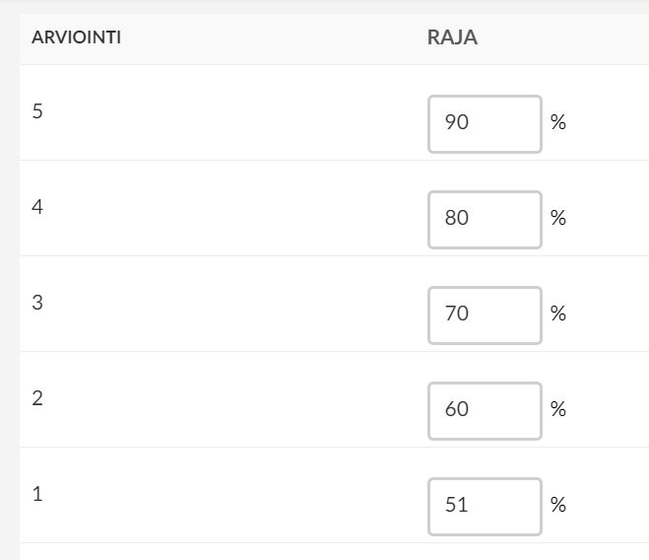

5.2. Self evaluation
Kurssin lopuksi opiskelija täyttää itsearvioinnin ja pohtii omien kurssitavoitteidensa täyttymistä sekä oppimistaan kurssin teemoihin liittyen. Itsearvioinnin merkitystä voi painottaa ja sen voi halutessaan antaa vaikuttaa arvosanaan.

- Introduction:  At the end of the course, students will complete a self-assessment form, evaluating their learning objectives and studies during the course, as well as their skills after completing the course.  Please fill out the self-assessment carefully, as it will also be considered in the evaluation.  - Questions:  1. Was the course beneficial to you in terms of promoting your own health?  2. What was the most beneficial aspect of the course for you?  3. What was the least beneficial aspect of the course for you?  4. How was your own studying during the course?  5. How did implementing the exercise plan and keeping the exercise diary go?  6. What aspects do you plan to pay attention to in the future?  7. If you had to give yourself a grade for your activity in the theoretical studies during the course, what grade would you give yourself?  8. If you had to give yourself a grade for your activity in physical exercise during the course, what grade would you give yourself?  9. Write a message and feedback to your teacher here. What do you think about the course, and how could the course be developed in the future? | Questionnarie is built into Itslearning or moodle learning platform.  You can add your own options to questions or let them be typed as “open answer”.  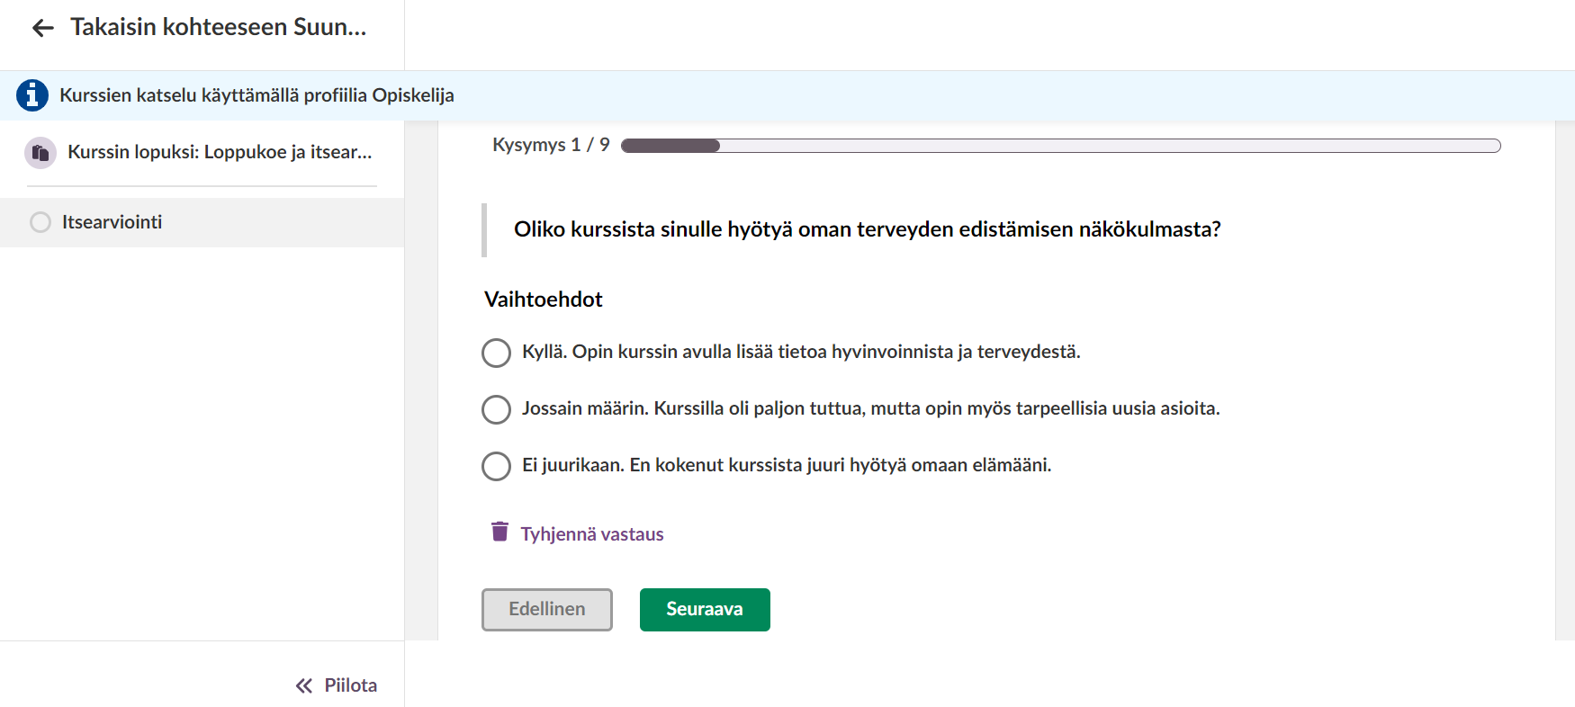

Evaluation
Kurssi arvioidaan geneeristen arviointikriteerien mukaan, jotka löytyvät e-perusteista, Perustutkintojen yhteiset tutkinnon osat (2022): Työkyvyn ja hyvinvoinnin ylläpitäminen, sisällöt ja arviointi

Kurssin arviointi perustuu etäopetuksessa hyvinvointipäiväkirjan toteutukseen (geneeriset arviointikriteerit), itsearviointiin ja loppukokeen arvosanaan. Opettaja voi valita osaamisenosoittamisen tehtäville sopivat painotukset kurssin toteuttamistavan mukaan.

Loppukokeen arvosanat ovat määritelty prosentuaalisesti seuraavalla tavalla (oppilaitos voi muokata prosenttiosuuksia parhaaksi katsomallaan tavalla):

Lähiopetuksessa opettaja painottaa lisäksi opiskelijan osallistumista teoriaopiskeluun ja liikuntatunteihin.

6.1. Evaluation requirements
Kurssin arviointikriteerit arviointiasteikolla 1-5.

Satisfactory 1
- Needs occasional support in routine situations
- Acts appropriately in familiar interaction situations
- Knows the basic concepts and information related to the area
- Uses basic knowledge in a formulaic manner
- Evaluates their performance

Satisfactory 2
- Operates mostly independently in routine situations
- Acts cooperatively in familiar interaction situations
- Knows the key concepts and information related to the area
- Uses basic knowledge purposefully
- Evaluates their performance and identifies their strengths and areas for development

Good 3
- Operates independently in routine situations
- Acts cooperatively in ordinary interaction situations
- Resolves typical problems
- Masters the key concepts and information in the area
- Uses knowledge in a versatile manner
- Evaluates their performance and makes suggestions for improvement

Good 4
- Operates independently in routine and varied situations
- Acts cooperatively and constructively in ordinary interaction situations
- Resolves problems using diverse methods
- Masters the concepts and information of the area and identifies its specific characteristics
- Applies knowledge in a versatile and well-founded manner
- Evaluates their performance realistically and identifies their strengths and areas for development

Excellent 5
- Operates independently and systematically in routine and varied situations
- Acts cooperatively and constructively in varied interaction situations
- Resolves problems in diverse ways and makes suggestions for improvement
- Master the concepts and information of the area broadly and deeply
- Applies knowledge in a versatile, well-founded, and critical manner
- Evaluates their performance realistically and presents justified solutions for developing their skills

Closing words
Kurssin lopetussanat.

After the course students have gone through topics listed under and learned skills which helps them enhance their own working wellbeing among daily topics in life. The course topics and students learning will keep on growing during the whole lifespan.
- Understanding health differences in one's own age group
- The promotion of one's own health from the perspective of exercise, nutrition, recovery, mental well-being, intoxicans, sexual health and human interactions in a planned manner
- Reflects on the implementation of one's own health-promoting plan and critically reflects on the matter
- Knows how to search for information about the benefits and recommendations of exercise, knows how to develop physical fitness factors
- Recognizes the effects of work ergonomics, load factors, and knows how to develop operating instructions
- Recognizes risks that occur at work and knows how to act in accident situations, knows how to seek additional help

References
Vantaan ammattiopisto Varia, Sanna-Kaisa Lintu (LitM), Sari Möller-Välinen (LitM), Tom Wetzell (LitM), Olli Väisänen (LitM)

Pixabay

Tämän materiaalin ovat Vierko-hankkeessa tehneet:

Lintu, Sanna-Kaisa
Pasanen, Mikko
Pisano, Annika
Rytinki, Marjo-Riitta
Tujula, Miikka
Willemsen-Puranen, Anne

Lähteet muotoon:

Sukunimi, Etunimen etukirjain, Vuosiluku, Teoksen/lähteen nimi

Linkki, päivämäärä jolloin haettu/luettu.

Verkkolähteiden merkitsemiseen apua voi katsoa: Tekstiviitteet ja lähdeluettelo: tee näin - Lähdeviittaamisen tueksi - LibGuides at Haaga-Helia University of Applied Sciences

Tämä materiaali on tuotettu VIERKO-hankkeessa
vuonna 2024.
VIERKO on toteutettu Opetus- ja kulttuuriministeriön
vuonna 2023 myöntämällä ammatillisen koulutuksen strategiarahoituksella. VIERKO on kuudenkymmenen-
kahden (62) koulutuksen järjestäjän yhteisponnistus.
Työtä on koordinoinut Keski-Uudenmaan koulutus-
kuntayhtymä Keuda.

Hankkeessa on kehitetty vieraskielisen koulutuksen laatua
ja kotimaisten kielten opetuksen tarjontaa ammatillisessa koulutuksessa.

Lisätietoa:
https://www.keuda.fi/keuda/hankkeet/vierko/

https://creativecommons.org/licenses/by/4.0/


Oppimateriaalit:

CC BY-SA 4.0 Deed | Nimeä-JaaSamoin 4.0 Kansainvälinen | Creative Commons
https://creativecommons.org/licenses/by/4.0/

Oppimateriaalit:



CC BY-SA 4.0 Deed | Nimeä-JaaSamoin 4.0 Kansainvälinen | Creative Commons

