Study and career planning
2024

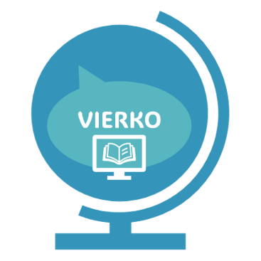

Englanninkielinen mukailtu versio urahaku-hankkeessa tuotetusta opiskelu- ja urasuunnitteluvalmiudet kurssista
_
Rahoittaja:

Vierko |www.keuda.fi/keuda/hankkeet/vierko

Sisällys
Welcome! 2
1. Your strengths and goals 7
1.1 Task 1A. Exploring your character strengths 10
1.2 Task 2. Competence and skills 11
1.3 Task 3. Resources 13
1.4 Task 4. Professional interests 15
2. Your vocational qualification 16
2.1 Task 5. Competence and skills acquired from your studies 16
2.2 Task 6. Progressing towards your qualification 17
2.3 Task 7. Me as a student 19
3. Further studies and career planning 20
3.1 Task 8. Possibilities for further studies 20
3.2 Assignment 9. Career plan 23
4. Preparing for employment 25
4.1 Assignment 10. CV 26
4.2 Assignment 11. Job application. 31
4.3 Task 12. Preparing for a job interview. 32
4.4 Task 13. An Elevator pitch. 32
4.5 Assignment 14. Portfolio of your skills. 33
Lopuksi 35

Welcome!
Welcome to Study and Career Planning!
The assignments in this course are a part of your Personal Competence Development Plan (HOKS). They also belong to the Society and Working Life Competence study unit called Study and career planning (1cp), which is a part of your common unit studies. The goal of this course is that you will be able to identify your own interests, reflect on your future and career-related issues, and prepare for finding a job and presenting your own skills. You can find the competence requirements and course assessment criteria in the file below.

This online course serves as a kind of a "home base," where you can find assignments, materials, and links. These resources help you think about and reflect on your own skills. The tasks completed during the course, such as a job application, CV, and career plan, demonstrate that you have achieved the learning objectives of this study unit. In HOKS discussions, you can go through the assignments together with your teacher. The tasks in the first part of the course help you acquire and learn skills, and the tasks in the later part serve as tools to demonstrate your competence.

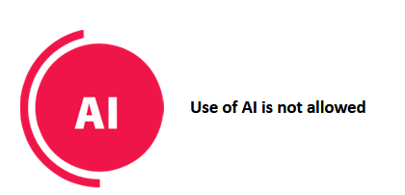
Please note!
The use of generative artificial intelligence (AI) is not allowed in this course.

Completing the course according to your personal plan and goals:
Decide with your teacher how you will complete the course.
The options are:
- For a student doing a vocational upper secondary qualification: Complete all tasks for acquiring and demonstrating skills.
- For a student doing a vocational upper secondary qualification who already has prior skills about the tasks: Complete at least the tasks for demonstrating skills.
- For a student doing a partial qualification, a further vocational qualification, a specialist qualification, or other studies: You can choose to do course tasks based on your own interests.

The tasks for demonstrating skills are:
- CV
- Job application
- Career plan
- Portfolio/learning diary
You can see all the tasks in the table below. Write down your notes to every task. Show the tasks for acquiring skills to your teacher during the HOKS discussion and also fill out the career planning form in Wilma with your teacher.

Learning goal | Acquisition of Competence | Demonstration of Competence
Identifying one's own interests, opportunities and needs for support | Task 1 A, B, C Character strengths  Task 2 Competence and skills  Task 3 Resources  Task 4 Professional interests  Task 7 Me as a student | Assignment 14 Portfolio of your skills  Assignment 9 Career plan
Making choices concerning the qualification and career | Task 5 Competence and skills acquired from your studies  Task 6 Progressing towards your qualification | Assignment 9 Career plan
Acquiring information on different opportunities for further education and the education offered while completing the qualification | Task 8 Possibilities for further studies | Assignment 9 Career plan
Preparing for employment and presenting one’s competence while completing the qualification | Task 1 Character strengths  Task 2 Competence and skills  Task 3 Resources  Task 5 Competence and skills acquired from your studies  Task 12 Preparing for a job interview  Task 13 An elevator pitch | Assignment 9 Career plan  Assignment 10 CV  Assignment 11 Job application

Study and Career Planning, 1 competence point

Compulsory competence requirements/Learning goals
 | The student
Identifying one's own interests, opportunities and needs for support | - monitors the progress of their learning and acquisition of competence, recognising potential needs for support  - identifies their interests and professional opportunities  - identifies and recognises their strengths, capabilities and development needs  - regularly evaluates their learning and competence
Making choices concerning the qualification and career | - identifies options that are suitable for them to support their career plan with the help of different information sources and electronic guidance services  - is familiar with the composition of their qualification, the qualification requirements and options that promote finding employment and advance their career plan  - monitors their progress in completing the qualification  - uses appropriate learning environments when acquiring their competence
Acquiring information on different opportunities for further education and the education offered while completing the qualification | - uses information sources, guidance services and application systems required for further studies and planning for the future  - obtains information about the further study options suitable for them and draws up a career plan  - familiarises themselves with the entrance requirements, application procedure and selection criteria for further studies.
Preparing for employment and presenting one’s competence while completing the qualification | - familiarises themselves with the opportunities, working environments and career choices provided by the world of work and explore career options suitable for themselves  - draws up a presentation of their competence for job hunting and presents their competence comprehensively  - applies for jobs and uses application systems and methods  - updates their career plan to find employment

Assessment
 | The student
Satisfactory 1 | - needs help in routine situations from time to time  - acts appropriately in familiar interactive situations  - knows some basic concepts and information of the subfield  - uses basic knowledge in an inflexible way  - assesses their performance
Satisfactory 2 | - mainly acts independently in routine situations  - acts collaboratively in familiar interactive situations  - knows the key concepts and information of the subfield  - uses basic knowledge appropriately  - assesses their performance and recognises their strengths and development areas
Good 3 | - acts independently in routine situations  - acts collaboratively in usual interactive situations  - solves usual problem situations  - masters the key concepts and information of the subfield  - uses knowledge diversely  - assesses their performance and suggests ways to develop their activities
Good 4 | - acts independently in routine and varying situations  - acts collaboratively and constructively in usual interactive situations  - solves problem situations using diverse methods  - masters the concepts and information of the subfield and recognises special features related to it  - applies knowledge diversely and with justifications  - assesses their performance realistically and recognises their strengths and development areas
Excellent 5 | - acts independently and systematically in routine and varying situations  - acts collaboratively and constructively in varying interactive situations  - solves problem situations in diverse ways and makes development proposals  - masters the concepts and information of the subfield broadly and in depth  - applies knowledge diversely, in a justified and critical manner  - assesses their performance realistically and suggests justified solutions to develop their competence

Your strengths and goals
What is my starting point and what are my goals?
This section of the course has assignments that deal with analyzing the starting point of your learning: your present competence, strengths, and skills. The assignments also deal with reflecting on your future goals and needs for development.
First, read the presentation below. You will learn why recognizing one’s strengths is important, especially nowadays.
Why is it important to recognize your strengths?



Continuous change
The skills needs in working life change so rapidly that it is nearly impossible to predict what future needs will be.

In vocational education and training students acquire both vocational competence and so-called general working life competence, which they can acquire not only in school but also in their spare time. The general working life competence is transferable competence, which means that these skills are needed in all kinds of work tasks in various fields both now and in the future.

Strengths
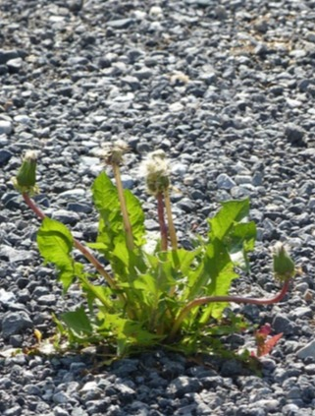
In addition to the competence and skills we have to learn, we all already have many different kinds of strengths. It is important to recognize and utilize these strengths. It is easier to find a study and career path that feels personal and exciting if you start building it upon your personal strengths.
Your strengths also have significance for your well-being. They may also help you to understand which things are stress-causing factors in your life and also understand that there are natural differences between people.
When we talk about strengths, we actually refer to six different kinds of strengths. They are presented in the following slides.
Character Strengths

These are traits of a good character of which only few are distinctive to us but which we all can exercise, activate or develop (for example courage, gratitude and humor).
Natural capabilities

These are character traits and talents that you were born with (for example calmness, systematicness, physical aptitude).

Skills and Competence

Everyone can acquire, learn and develop these (for example digital skills, language skills, cooking skills, driving skills).

Interests

Things that energize and motivate us (for example customer service, writing, outdoor activities, travelling).

Values

Things that we feel are important in our lives and which guide our choices and bring significance to our life (for example justice, family, health, success, money).

Resources

Material, physical, psychological or social resources which help with our well-being (for example livelihood, home, transportation, relationships, good physical condition, support from family).

When people are able to utilize their strengths in working life and life in general, they operate on their personal” strength zone”, which is the zone of well-being and enthusiasm.


That’s why it’s important, also in this section, to recognize your strengths as widely as possible. Depending on where you study, you may have a chance to work with the VOIMAKEHÄ® - strength cards. They help in naming, putting into words and recognizing your strengths.

If you want to know more about the VOIMAKEHÄ® - strength cards, contact your own teacher or study counsellor.


Task 1A. Exploring your character strengths

Character Strengths
Complete this task prior to your first counselling discussion with your coordinating teacher / designated responsible teacher / study counsellor)

What are character strengths?
Character strengths are usually referred to as 24 traits of a good character and we all can utilize them. All character strengths are good and valuable capabilities and using them brings joy and advantage for our well-being and relationships. We can make use of our character strengths in various tasks and roles, including our studies.
Because we are different as humans
Everyone has 3 – 7 core strengths which are characteristic and typical to us. Often these core strengths have been part of us since childhood. Using one’s core strengths feels natural and easy. They help us navigate through challenging tasks and situations.
We all have also a few so-called growth strengths which we – for one reason or another – don’t use that frequently. Using our growth strengths may, in some situations, be beneficial and they can help us in managing – for example – our study tasks better.
Task 1A. Explore your character strengths with the help of VIA Character Strength Survey
- First, watch the video where you will find instructions on how to sign in to the VIA survey. You can choose automated subtitles/captions in English from the settings (tekstitykset --> automaattinen käännös. https://youtu.be/5Wd1Ahm9H9k
- Then, go to the VIA survey using this link here: https://www.viacharacter.org/survey/account/register

- Allow 15 – 45 minutes of time for taking the survey.
- Answer the questions as your true self.
You will get your personal strength report based on your answers.
- After answering all the questions, you will receive a report describing your strengths in the e-mail address that you gave when registering into the service.
- Take the VIA-test again over the course of your studies and you will be able to see how your answers may have changed.
- You can log in to the VIA – test again with your e-mail address and your password.
Save your VIA-test results, you will need them with upcoming tasks.
Task 1B. Explore on your strengths as a student and as a professional
The aim of this task is to outline how your strengths appear in your studies and in your future job as a professional in your field.
Complete this assignment before your first counselling session.
Instructions:
Find your VIA report.
Reflect on the questions below.
Examine your core strengths
First, look at the five first character strengths listed in the report. They probably are your core strengths and using them feels natural, easy and energizing for you.
- How do these five core strengths manifest in your way of studying and working?
- Have your core strengths played a role in choosing this field of study?
- Why are your core strengths important when working as a professional in this field?
Examine your growth strengths
Look at the last five character strengths listed in the report. They are your so-called growth strengths.
- In what way could you benefit from using these strengths in your studies and in your future career field?
- Why are your growth strengths important?
Discuss these considerations together with your coordinating teacher in the counselling session.
Task 1C. Enter your strengths in your career plan in Wilma
Complete this assignment prior to your first counselling discussion with your coordinating teacher / designated responsible teacher / study counsellor.
Instructions:
In task 1B you took the VIA-survey on your strengths and found your core and growth strengths. Now write down these strengths in Wilma or a file with your notes.

- Open Wilma. Write your core and growth strengths in the Urasuunnitelma form of HOKS (personal competence development plan, PCDP)
- Or save a file with your notes in your own OneDrive-folder and fill out the career planning form with your teacher / study counsellor.

Task 2. Competence and skills
This exercise is called ‘The mind map of competence’ and its aim is to help you recognize the competence that you have acquired in various occasions and to help structuralize and concretize it. The mind map will help you in outlining your overall competence development in a wider sense in different parts of your life, such as in school, studies and work, but also hobbies and other leisure time activities.
All competence is beneficial.
Instructions for the assignment:
Create a mind map over your own life space. Save the file (for example, a photo of your mind map drawn on paper) to your OneDrive. Share the photo with your teacher / counsellor.
In the center of the paper draw a picture of yourself and then outline what areas there are in your life space. Examples of different areas are, for example, family, friends, hobbies and work. You can also do this digitally.
- Proceeding one area at a time, reflect on what knowledge or competence you have accumulated while operating in these areas. Especially, pay attention to those skills and competences that may be useful in your future profession or field.
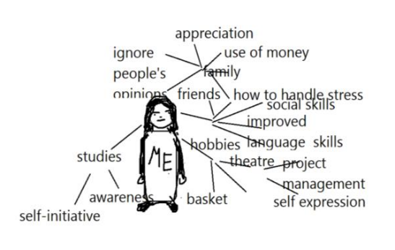
Below you can see an example of a mind map drawn by a student.

Task 3. Resources

Resources
Complete this assignment before your first HOKS-discussion (personal competence development plan, PCDP).

The aim of this assignment is to recognize factors that work towards or challenge the progression of your studies.

The progression of one’s studies is affected by many kinds of things. Sometimes these things are related to studies per se, other times to other fields of life.

It is important to identify things in your life that are going well: strengths, assets and resources which add to your well-being and resilience.

The ‘Hand of mental health’ helps you in reflecting on what things your well-being is based on.
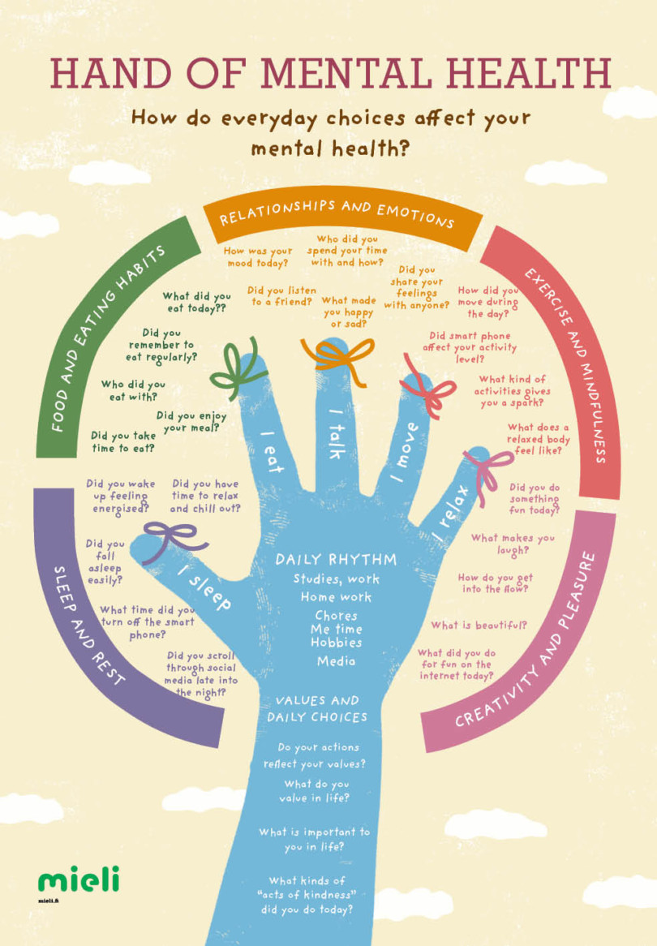
Save a file with your notes in your own OneDrive-folder.
Discuss your thoughts with your coordinating teacher/ study counsellor in the counselling session.

If any of the questions feel too difficult or personal to be answered here, you may also write: ”I would rather answer in counselling session”.
Identify your resources by continuing the following sentences:
- My well-being is improved by...
- I find it easy to get excited about and success in my studies because…
- My daily life / studies would be considerably more complicated if I didn’t have …
At times, life and studies present more challenges than is usual. It is possible to find solutions to these problems together.
Recognize the things that challenge your well-being by continuing these sentences:
- My well-being is harmed by …
- I find it difficult to progress or succeed in my studies because...
- My daily life is considerably complicated by the fact that I don’t have …

Task 4. Professional interests

Complete this assignment during the course of your studies.
This exercise will help you to identify your professional interests and understand your own possibilities when working in your professional field.

Picture in your mind your dream working day in 5 years and write down your thoughts answering the following questions.
- What are the types of tasks you are working with? Give concrete examples of tasks that fill your working days.
- What type of competence and what skills will you have in your future job? What are you good at?
- What kind of a professional are you? What things do you consider as important in your job? What kind of qualities do you have? What goals and aims do you have?
- Who are you working with? What kind of workmates do you have?
- Are you interested in studying in Finland or abroad?
Save a file with your notes in your own OneDrive-folder.
Discuss your thoughts with your coordinating teacher/ study councellor in the HOKS counselling session (personal competence development plan, PCDP).

Your vocational qualification
Learning goals:
This section includes three tasks where you will explore your vocational qualification in more detail, its learning objectives, and the opportunities available to you after completing the qualification.

Please look at eRequirements/ePerusteet before and while doing these tasks. It a service provided by the Finnish National Agency of Education. eRequirements has the curriculum (what is included) of each vocational qualification.
https://eperusteet.opintopolku.fi/#/en/selaus/ammatillinen

Task 5. Competence and skills acquired from your studies
Competence and skills acquired from your studies
Do this task during your studies, when your studies have already begun.

The aim of this task is to learn to recognize the contents of your qualification, the learning goals/requirements and your own competence. What are the things that you already know, and in which things would you like to develop your competence further?
How to complete this task:
- First, get to know the qualification units, their contents and their learning goals. You may utilize the English version of the e-perusteet website: https://eperusteet.opintopolku.fi/#/en/selaus/ammatillinenperuskoulutus
- After that answer the questions below. Save a file with your notes in your own OneDrive-folder
- Discuss your thoughts with your coordinating teacher in the counselling session.
Questions:
- List five (5) essential skills or competences strongly related to your qualification.
- What competences and skills do you already have in terms of the learning goals / requirements that are set for your qualification?
- When thinking of the learning goals/requirements set for your qualification, do you recognize any need to develop your competence? If so, where?

Task 6. Progressing towards your qualification
In this task you will learn to compare your own existing competence with the requirements of your chosen vocational qualification and to plan your personal development path.
Do this task after the initial phase of your studies.
Save a file with your notes in your own OneDrive-folder. Save the changes.
Answer the SWOT questions
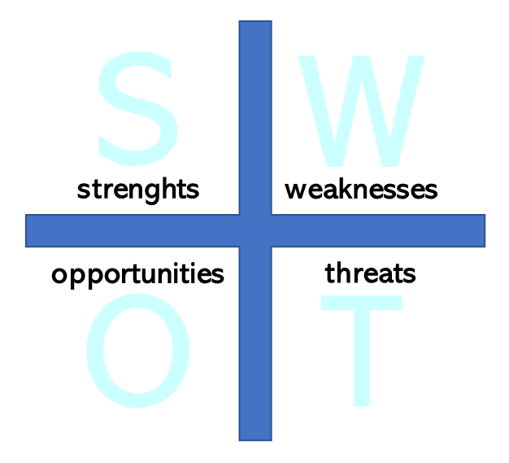
Reflect on your competences and your development goals by answering the SWOT questions below. Later, in counselling session with your coordinating teacher/study counsellor, you may ponder more over these goals.

My strengths:
- What do I think I am good at?
- What do other people know I am good at?
- What things do I enjoy doing?
- What kind of things do I do well?
My weaknesses:
- At what things, skills or activities am I not good enough yet?
- What qualities, knowledge and skills do I know that I need more of?
My opportunities:
- How could I use and take advantage of my strengths more?
- What motivates me?
- What changes, even small ones, could I make in order to succeed or learn better?
My threats:
- What causes me discomfort in different situations?
- What slows me down or makes it difficult for me to learn?
- What reduces my motivation?

Plan the contents and progression of your studies

Make a plan for the contents and progression of your studies. Choose your optional study units and explain how they will support you in reaching your goals. You may utilize the English version of the e-perusteet website: https://eperusteet.opintopolku.fi/#/en/selaus/ammatillinenperuskoulutus

Save a file with your notes in your own OneDrive-folder. Save the changes.
Questions:
- Which study units do I want to study?
- Explain how the study units you chose will support you in reaching your goals?
Next, together with your coordinating teacher/study counsellor, you may decide how and how often you will monitor your study progress in Wilma.

Task 7. Me as a student
This task will help you identify the things that affect the progression of your studies and the possible needs for support during the course of your studies.
Instructions for the task:
- Answer the questions in this digital service need indicator https://crear.fi/
- Save the results (pdf) in your own OneDrive-folder.
- Discuss your results and possible thoughts raised by the Crear indicator with your teacher in your career guidance discussions.
- As you graduation day approaches you can review your Crear results and see how far you have come during your study journey.

Further studies and career planning
Learning goals:
This section includes a task and an assignment that will help you plan your future. The goal is to gather information about different further education opportunities and programs available that can help you continue developing your skills even after graduation.

Task 8. Possibilities for further studies
A vocational qualification gives you eligibility for further studies at Universities of Applied Sciences (UAS) and Universities (U). You may also develop your competence by completing a second vocational qualification, a further vocational qualification or a specialist vocational qualification.
In this task you will examine what kind of possibilities there are for further studies after completing your vocational qualification. While doing the task you will also learn how to search for information on further studies possibilities. These skills are useful even if you are not planning to study further right after your graduation since you may face a situation in working life where more competence is expected from you.
Instructions for task 8.:
- Familiarize yourself with the qualifications and degrees.
Familiarize yourself with degrees at Universities of Applied Sciences and Universities in your own field, or degrees that otherwise interest you. Write them down.
To find more information you may browse the web pages of interesting educational institutions directly. You may also find information on the pages below.
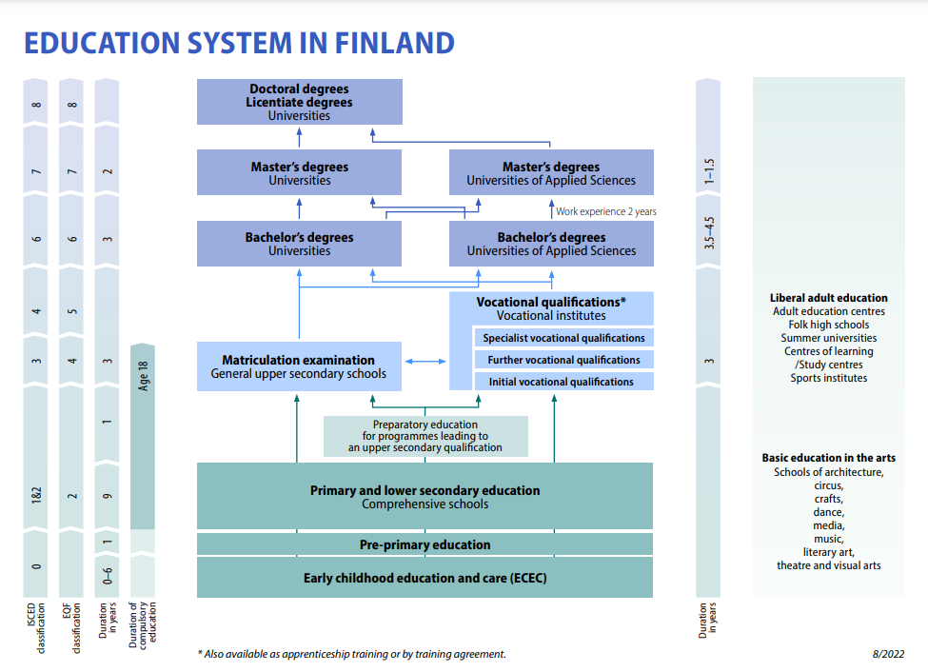
Search for study programmes and courses:
https://opintopolku.fi/konfo/en/
Vocational education:
https://opintopolku.fi/konfo/en/sivu/vocational-education-and-training-vet
General upper secondary education (lukio):
https://opintopolku.fi/konfo/en/sivu/general-upper-secondary-education-lukio
Higher education (universities of applied sciences and universities):
https://opintopolku.fi/konfo/en/sivu/higher-education
Open studies:
https://opintopolku.fi/konfo/en/sivu/open-studies
All universities of applied sciences in Finland:
https://okm.fi/en/universities-of-applied-sciences
All universities in Finland:
https://okm.fi/en/universities
Adult education centres:
https://kansalaisopistot.fi/kielet/english/
- Familiarize yourself with the admission requirements
Write down what admission requirements there are for degrees or education that interest you. If scoring is used in admission requirements, learn about the scoring and calculate whether your points are sufficient for admission. Discuss the different options with your teacher or study counsellor.
Information about universities of applied sciences:
- https://www.study.eu/article/universities-of-applied-sciences-in-finland-all-you-need-to-know
- https://www.uasinfo.fi/
Your study counsellor or coordinating teacher will give you information on how to calculate the points.
- Other ways to get to know the educational institutions
Find out whether the Universities of Applied Sciences or Universities that interest you arrange open house days or whether there are other chances to get to know the field better. Some schools share information on their programs on social media, too.
- Hand in your task
Save a file with your notes in your own OneDrive-folder. Save the changes.

Assignment 9. Career plan
Make a career plan
Do this task after the initial phase of your studies. Update your career plan with your coordinating teacher/ study counsellor throughout your studies.


Save the file containing your notes to your own OneDrive folder. Save the changes. Share the file with your teacher.
The aim of your career plan

As the name suggests, career planning is a planned activity related to your professional career. In this task you examine yourself, different possibilities and options, job opportunities and goals.
The goal of career planning is that you will get a job that you really like and are able to advance in your career. You are most likely to succeed in this when you know your own wishes and goals. When you know what kind of a workplace you want to work in, you are already one step closer to making your wishes come true!

What are the three most important things that you hope to experience in your future workplace?

Give names of three employers or companies that interest you.

Give three interesting job titles or job descriptions in your own field and job.
- What kind of skills and competences are needed in them?
- Where could you get them?

Find out what the working life situation is like in your own field. Find out at least the following things:
- What are people talking about in your field right now?
- What changes or inventions are there in your field`?
- What challenges are there in your field at the moment or in the future?
- What kind of interesting career options are there in your field?
- What kind of competence and skills are needed in your field right now, and in the future?
- What are the most important networks in your field?
- What is the trade union in your field?
What are the three most important skills in which you want to develop professionally in the next 3-5 years?
- Why are these skills important to you?
- Also write how you can acquire these skills and make a timeline for implementation.
Write down your three most important career goals during the next 3-5 years.
- Think about why these goals are important to you?
- What does it take to reach these goals?
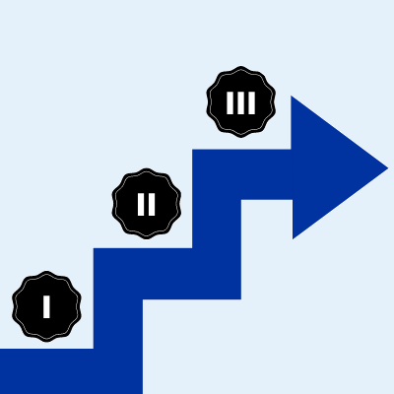
- Make a list of concrete things you can do to reach your goals and a timeline for implementation.

Preparing for employment
Learning goals:
In this section, you will identify suitable career options and opportunities for advancing in your career. You will create a CV, highlight your strengths and skills through a job application and an elevator pitch, and prepare for a job interview. You can also use the tasks in this section when applying for a training agreement or a summer job. At the bottom of the page, you will find five tasks to help you reflect on and demonstrate your skills.
Before moving on to the tasks, explore the key job search websites:


Job Market Finland:
https://tyomarkkinatori.fi/en

Public sector job openings:
https://www.kuntarekry.fi/en/

Working abroad:
https://tyomarkkinatori.fi/en/personal-customers/information-about-working-life/internationality/working-or-participating-in-an-internship-abroad

Career counselling:
https://tyomarkkinatori.fi/en/instructions-and-support/personal-customers/guidance-services-for-personal-customers/career-counselling

Finnish work culture:
https://www.workinfinland.com/en/why-finland/working-in-finland/working-culture/

Assignment 10. CV
A CV (Curriculum Vitae) is a summary of your work experience, skills, education and other strengths, which you add as an attachment to a job application. A good CV brings out your good qualities and skills easily at one glance.

The goal of this task is for you to know how to make a personal and distinctive CV that presents your skills for the purpose of job hunting.

Feel free to make your CV look your own but focus on making it clear and easy to read. Keep in mind that each work life sector may have their specific emphasis and skill requirements for the job applied for.


Tips for writing a CV in Finland
1. Customize Your CV for the Job
A basic rule: always tailor your CV and job application for the specific job you’re applying for.

Create a basic CV with the necessary structure and details, then customize it for each job. For example, if you’re applying for a sales position, highlight your sales experience, flexibility, and customer service skills. If you're applying for a cleaning job, emphasize your speed and attention to detail. Be honest!

Your life situation and experience also affect what you should highlight in your CV. If you’re a student, focus on internships, part-time jobs, and other useful experiences. Show your enthusiasm and willingness to learn—employers value high motivated young people!

If you’re looking for your first “real” job, you probably just finished school or are near graduation. Include details about your studies, especially if they relate to the job you're applying for.

For expert jobs, focus on your specific knowledge and experience, and leave out details about part-time work or hobbies.

2. Keep Your CV Clear
The most important thing is clarity. There are many ways to structure a CV, but make sure it includes all the essential information and is easy to read.

Start with your name, contact details, education, and work experience. Keep the sections short and simple—don’t use complicated language or technical jargon.

3. Watch the Length of Your CV
A good rule of thumb is to keep your CV short, around 1-2 pages. If you're applying for a specialized role, you can make it a bit longer and go into more detail.

4. What to Include in Your CV
Your CV must include:
- Your name
- Contact details
- Work experience
- Education and qualifications
- Language skills
- IT skills
You can also include:
- A short introduction about yourself
- Links to your social media profiles (like LinkedIn)
- Your strengths and other skills
- Any relevant hobbies or interests
- Names and contact details of people who can give you a reference (optional)
5. What NOT to Include
Don’t include unnecessary personal information, like:
- Your age
- Irrelevant work experience
- Too much personal detail (like your family life or religion)

6. Show Your Motivation!
Mention why you’re interested in the job in your CV introduction. A well-designed CV also shows that you care about the job you’re applying for.

7. Check for Errors
Before sending your CV, ask a friend or family member to review it for spelling and grammar mistakes. A CV full of errors doesn’t leave a good impression.

Finally, save your CV in PDF format before sending it!
Source (In Finnish): https://www.ukko.fi/yrittajyyskoulu/nain-teet-lyomattoman-cvn/


Not Interested in Networking? Here’s Why You Should Still Create a LinkedIn Profile

Do you feel like LinkedIn, personal branding, and networking are being overhyped? Some love utilizing social media, while others see LinkedIn as unnecessary fuss. However, experts believe that everyone can benefit from having a LinkedIn profile.

In fields like marketing and sales, LinkedIn is buzzing with activity, with personal brands polished to shine. But not all industries share this culture. The more LinkedIn and social media presence are discussed, the less interest some people have.

Yet, Duunitori’s Data Architecture Manager, Tuula Kaukoranta, believes that just having a LinkedIn profile can prove useful, even if you’re not into the social media buzz or personal branding.

"Many think that joining LinkedIn requires a lot of time, effort, and maintenance, and thus, don’t create an account. In reality, making a profile is no more demanding than writing a resume," says Kaukoranta, who has extensive experience in direct search.

"Your LinkedIn profile primarily acts as a CV, ensuring you're visible beyond your own network. If no one can find information about your work history or skills — and in the worst case, not even your contact details — it certainly won’t help your chances of landing on a headhunter’s radar."

A Big Opportunity with Minimal Effort

Tuula Kaukoranta encourages everyone to showcase their skills in a way that makes them easy to find when needed.

"It's silly not to use such an easy way to be discovered. In some fields, not having a profile may even give the false impression that you’re not interested in new job opportunities."

While direct search may not be equally common across all industries, Kaukoranta can’t name a single sector where LinkedIn would be entirely useless.

"The fewer professionals in a field are active online, the easier it is to stand out simply by being discoverable."

Kaukoranta hopes that even those who aren’t particularly enthusiastic about the idea will be brave enough to create a profile.

"With minimal effort, you gain a huge opportunity," she summarizes.

Even if new job opportunities don’t feel relevant at the moment, you can also join LinkedIn for professional networking purposes.

A Job Application, Resume, and Business Card All in One

Have you been convinced yet? According to Kaukoranta, even a simple LinkedIn profile is sufficient: the most important thing is that your profile includes your work history, education, skills, and interests.

"A job title doesn’t necessarily say much about your skills, so it’s worth adding a brief description of your tasks or interests in your profile."

The more specific your skills are, the more important it is to highlight them in your profile, Kaukoranta reminds.

"Basically, the same things that make a good CV are enough. In the Summary section, you can optionally provide a more personal description of yourself. You don’t need loads of contacts or posts to showcase your skills."

At its best, a good LinkedIn profile is like a CV, cover letter, and business card all in one. You can apply for many jobs with just one click, and you don’t need to tailor your entire profile for each application, saving you time.

Benefiting from a LinkedIn profile doesn’t require constantly hanging out on the platform, but Kaukoranta advises reading any potential messages regularly.

"It won’t be much consolation if you realize four months too late that there was a suitable job opening for you."

Source (in Finnish): https://duunitori.fi/tyoelama/eiko-linkedin-kiinnosta

How to complete this task:
1. Get to know the different ways to implement a CV.
- a traditional CV
- a video CV
- a LinkedIn profile
There are files below that give you information about making a CV in Finland and LinkedIn. You can find Finnish CV templates here.
https://tyollisyyspalvelut.hel.fi/en/job-seeking/help-jobseeking/cv-and-job-application

Information about a video CV here.
https://www.indeed.com/career-advice/resumes-cover-letters/how-to-make-a-video-resume
https://tyomarkkinatori.fi/en/news/video-cvlla-esittaydyt-tyonantajalle-monipuolisesti
You can find examples of video CVs for example on Youtube.

2. Create your own CV
Create a CV either using the help found in task 1 or use a template. You can find lots of templates online.
If you are creating a traditional CV, you may want to use Canva, which has many templates free of charge, so as to make your CV more eye-catching. Instructions for using Canva can be found here.
https://www.canva.com/en_gb/
https://www.canva.com/learn/how-to-canva-beginners-guide/

You might also want to think about how other assignments in this course might help you when creating your CV.
Save your CV in a place where it is available for you also after your graduation. Later, when you apply for a job, update your CV and make it match the position you are applying for.
You are free to make use of your possible existing CV while doing this task.
Remember to update your CV regularly during your studies and add skills and experiences gained from work and hobbies.
3. Submit the assignment
Save the completed CV (preferably a pdf file) in your own OneDrive folder and share the file with your teacher.
If you make a video CV or LinkedIn profile, share the link with your teacher.
Save all changes.

This assignment is part of your course evaluation.

Assignment 11. Job application.
In this assignment, you will learn how to make a good job application. The purpose of the job application is to sell your skills to a potential employer and to justify why you would be a good candidate for the position you are applying for.

How to complete the assignment:

1. Find out what things a good job application includes

You may use the following sources:

Finding work in Finland: https://www.expat-finland.com/employment/finding_work.html
Job application Template: https://tyollisyyspalvelut.hel.fi/en/job-seeking/help-jobseeking/cv-and-job-application

Please note that not all job openings are publicly available, but you can still apply for a job at a company or a position that interests you, even if they have not publicly advertised an open job. Such jobs are called hidden jobs.

2. Get to know the job openings in your field.
For example, take a look at the job openings in your field on the Työmarkkinatori/Job Market Finland website and take notes on what kind of skills and what qualities employers value in applicants. Think about which of these you possess and how they show up in practice.

https://tyomarkkinatori.fi/en/personal-customers/vacancies

3. Make a job application for a specific job or an open application
Use the knowledge that you have gained in previous tasks. Save your job application in such a place that you can access and edit it even after graduation.

4. Adding a reference
You may want to add a person who can recommend you for the job, a so-called reference. This is optional.

https://www.indeed.com/career-advice/finding-a-job/who-to-use-as-a-reference
5. Add to and update your application
The job application in this assignment is meant to be updated and edited throughout your studies. You can make use of a job application you have made before in this assignment and update it during your studies.

6. Submit the assignment
Save your job application (preferably a pdf file) to your own OneDrive folder. Share the file with your teacher.

This assignment is part of your course evaluation.

Task 12. Preparing for a job interview.
Complete this task as you progress through your studies.
The purpose of this task is to help you with getting a job and preparing for job interviews.

Instructions for the task:
- Job interview materials
Review the links that give information about how to prepare for a job interview:
- Video: A job interview in Finland: https://www.youtube.com/watch?v=UdqWPqWBONc
- Preparing for a job interview: https://www.indeed.com/career-advice/interviewing/how-to-prepare-for-an-interview
- How to prepare for a job interview in Finland: https://barona.blog/pl/en/how-to-prepare-for-a-job-interview-in-finland
- Create a tip list for your job interview
Make a list of important things to remember for your job interview. Also, include how you can succeed in the interview. Create the tip list in a Word document, for example, and save it in a place where you can access and edit it even after you graduate.
- Submit the task
Save your tip list to your OneDrive folder. Share the file with your teacher.

Task 13. An Elevator pitch.
Complete this task as you approach graduation.

When you start applying for jobs, practice summarizing your skills briefly. The goal of this task is to create an "elevator pitch" that allows you to quickly explain your skills.

Imagine you find a job posting that perfectly matches your skills. You apply for the job and get an interview. Your future employer asks you to convince them in two minutes.

Instructions for the task:
Prepare a two-minute elevator pitch, a short summary of your skills, following the guide below.
- Who are you?
Start by introducing yourself. Think about what makes you interesting and worth hiring from the employer's perspective. You can mention your hobbies, summer jobs, or any work experience.
- What can you do?
Share what skills you have and what you’re good at. You could list three key things you’re skilled in.
- What value can you offer?
This is the most important part of the elevator pitch. Convince the employer why they should hire you. What can you offer that’s unique? Do you have skills others might not, or are you eager to learn?
- Use a story to illustrate your point
If you have time, share an example of positive feedback you’ve received from a job or school project.

It’s a good idea to practice your pitch regularly so that you’re prepared when the moment comes.

You can practice and improve your elevator pitch throughout your studies. This task will be part of the course assessment.
- Record your pitch
Select the microphone icon above your phone. Record your pitch.

Assignment 14. Portfolio of your skills.
Personal Skills Portfolio
A portfolio is a great tool for showcasing and presenting your skills. In the portfolio, you can demonstrate what you've learned in relation to the learning objectives of your qualification during your studies, as well as through work experience or hobbies. You can think of the portfolio as a collection of evidence that displays your various skills.

If you create a digital portfolio, you can include things like videos and images, as well as receive comments and feedback.

Your skills portfolio will be updated and refined throughout your studies. It's a good idea to start collecting material for your portfolio right from the start of your studies.

Instructions for the task:

Create a skills portfolio where you collect different examples of your skills gained from studies, hobbies, and work experience. You can choose the format that works best for you, such as a blog, Instagram account, Padlet wall, ThingLink image, or a Word or PowerPoint document.

Examples of what you can include in your portfolio:

- Photos or videos of your work, showing the process and results.
- Documents, such as a fire safety certificate or hygiene passport.
- Learning diaries or other written work.
When your portfolio is ready for assessment: Send a link from your portfolio to your teacher.

This task is part of the course evaluation.

Lopuksi
Tämä kurssimateriaali on käännetty englannin kielelle ja muokattu Urahaku – hankkeessa (1.9.2019-31.7.2022) toteutetusta Opiskelu- ja urasuunnitteluvalmiudet verkkokurssista, https://pinja.osao.fi/course/view.php?id=3258. Vastaava uudempi suomenkielinen sisältö on julkaistu Oulun ammattikorkeakoulun/Ammatillisen opettajakorkeakoulun tuottamana toteutuksena AOE sivustolla vuonna 2022 osoitteessa https://aoe.fi/#/materiaali/2237.

Tämä materiaali on tuotettu VIERKO-hankkeessa
vuonna 2024.
VIERKO on toteutettu Opetus- ja kulttuuriministeriön
vuonna 2023 myöntämällä ammatillisen koulutuksen strategiarahoituksella. VIERKO on kuudenkymmenen-
kahden (62) koulutuksen järjestäjän yhteisponnistus.
Työtä on koordinoinut Keski-Uudenmaan koulutus-
kuntayhtymä Keuda.

Hankkeessa on kehitetty vieraskielisen koulutuksen laatua
ja kotimaisten kielten opetuksen tarjontaa ammatillisessa koulutuksessa.

Lisätietoa:
https://www.keuda.fi/keuda/hankkeet/vierko/

https://creativecommons.org/licenses/by/4.0/

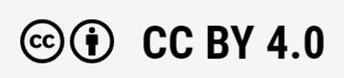
Oppimateriaalit:

CC BY-SA 4.0 Deed | Nimeä-JaaSamoin 4.0 Kansainvälinen | Creative Commons
https://creativecommons.org/licenses/by/4.0/

Oppimateriaalit:

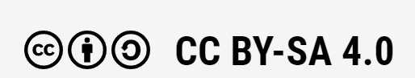

CC BY-SA 4.0 Deed | Nimeä-JaaSamoin 4.0 Kansainvälinen | Creative Commons

