Learning analytics

  - General instructions
This training is part of the Digivisio 2030 programme’s e-learning training, which aims to develop the competence of the teaching and support staff of higher education institutions in order to promote the high-quality content of the opin.fi service. The training has been implemented following the principle of micro-learning. In other words, it consists of one or more episodes with one or more assignments. The videos and podcasts of the training package can be viewed on the Digivisio 2030 programme’s YouTube channel address, and the related assignments can be downloaded from the open educational resources service (aoe.fi) on the page of the training in question.
The episodes can be used to support independent learning, or they can be combined with guidance organised by the higher education institution or network of higher education institutions, and the co-creation of educational offerings. Teachers find that using the different episodes to support the development of their own teaching is a meaningful form of learning. Higher education institutions can localise the implementation of the training to suit their own needs, for example, by altering the working methods or assignments related to the content, and by limiting or adding content to the training modules. New types of entities can be compiled from the episodes on different themes, and, for example, the episodes on modularity can be used as an introduction to other themes.
Language versions
The videos, podcasts and assignments included in the training are available in Finnish, Swedish and English. Higher education institutions decide whether the participants earn study credit or receive a competence badge for completing the training. The following statement shall be added to any certificate issued by the higher education institution: “E-learning training designed in the Digivisio 2030 programme has been used in this training.”

Licence
The CC-BY-SA 4.0 licence for this training package allows you to edit the training contents for the needs of your higher education institution. The training contents may also be used as part of other training. In such cases, the original author of the material (excluding literature and videos produced by others) and the Digivisio 2030 project shall always be mentioned in their new context of use in accordance with the CC-BY-SA 4.0 licence. If a new version of the content is made, it shall also be distributed under the CC-BY-SA 4.0 licence in the same way as the original material. However, the licence does not oblige the higher education institution to share the new version, should they not wish to do so.
Digivisio 2030 logo https://digivisio2030.fi/aineistot/
  - Introduction to the entire Podcast series

Presentation of the materials
Welcome to the Digivisio 2030 programme’s e-learning training. This is a “Why, What, How” podcast series in which we delve into the world of data and learning analytics from the perspective of teachers and learners. You are about to enter the behind-the-scenes world of learning. We engage in conversations with a variety of experts on the topic of how the data collected on studying and learning will change the design and assessment of learning.
Current technologies and digital platforms will open doors to a more efficient utilisation of data in the context of learning. But what kind of possibilities and challenges will this bring?
The series consists of 5 episodes and a variety of perspectives. You will find a challenge in connection with each episode. The aim of the challenges is to inspire you to dig deeper into the topic and to involve all you listeners in creating and producing added value to the podcast experience. In other words, they challenge you to take part in the discussion on learning and learning analytics.
Join us on the journey to the world of learning analytics and learn how to use it in your own teaching. This series of podcasts provides you with valuable information and practical tips on how to make your teaching even more effective and motivating for learners. Your own higher education institution will provide you with instructions on how to integrate learning analytics into the learning process. Different platforms offer different tools. You can find tips on Moodle analytics in the eAMK online course and the open MOOC course produced by the Finnish eLearning Centre.
We discuss learning analytics with a range of experts. I am Satu Aksovaara and I interview the experts together with Olesia Kullberg. We will guide you towards a new era of learning. So make yourself comfortable, put on your headphones and get ready to explore the next chapter in Learning Analytics!
Learning assignments/Challenges

Episode 1. Why is learning analytics important?

Tweet challenge

We encourage you to participate in the learning analytics Tweet challenge! This challenge helps you understand why learning analytics is important in your own higher education institution and how you can use it yourself.
Step 1: Familiarise yourself with the recommendations for the use of learning analytics in your own higher education institution, Digivisio’s quality criteria (learning analytics) and the policies of the Rectors’ Conference of Finnish Universities of Applied Sciences Arene. Find them on the websites or ask the teachers/support services.
Step 2: Create a tweet or a figure that summarises why learning analytics is important to you and how you currently use it. You can use, for example, Canva or similar tool to create the visual presentation.
Step 3: Ask at least three colleagues or friends to describe the ways in which they use learning analytics. Discuss how you can use learning analytics more effectively together. Complete the tweet or figure based on the ideas that emerge.
Step 4: Share the tweet or image in your social media network and use the hashtag #oppimisanalytiikkahaaste. Also tag your colleagues so they can find your post.
Step 5: Consider your expectations regarding learning analytics and your own teaching or learning in the future.
This challenge helps you deepen your understanding of the role of learning analytics and allows you to share ideas.

Episode 2. How do I use learning analytics?

Monitoring learning – challenge

We encourage you to participate in the challenge of Monitoring learning. This challenge helps you understand the impacts of activity monitoring on the development of a study unit and learner assessment.
Step 1: Outline the learning outcomes for the study unit: consider the outcomes and reflect on how the learner can achieve them, considering different options.
Step 2: Learn about the analytics tools of your learning platform: how can learner activity be monitored on the learning platform (for example: completing and submitting assignments; level of activity in discussion forums or during live lectures; participation in group work).
Step 3: Identify the environment in which the student works during the learning process. Consider how you can link those forms of learning that take place outside the learning platform (such as reports on external projects, reading literature and discussing it, independent research or online learning) to the learning platform.
Step 4: Think about the impact of monitoring on assessment: consider how the collected data affects assessment. (For example: how does the monitoring of different activities affect the definition of grades, how does the acquired data help provide individual feedback).
Step 5: Use the data generated by studying to develop the study unit. Use the accumulated data and assess how you can use the data to better understand diverse learners (e.g. what does the data tell you about the level of student engagement and participation, and the level of understanding and applying the course content).
Step 6: Incorporate learning analytics into your own study unit. Select activities for the progress bar: consider which activities make sense in the progress bar. The selection can be based on what offers the most optimal data on progress and the effectiveness of the course. Consider multiple progress bars: think about whether it makes sense to create one or more progress bars for different purposes. For example, one bar focusing on the completion of assignments and another one on participation.

Episode 3. How can I use learning analytics to support student engagement?

Play Bingo -challenge
We encourage you to participate in the learning analytics Bingo! This challenge helps you understand the possibilities of learning analytics to support the learner’s ownership of learning. The working process leads you to reflect on what kind of analytics the learner needs – in other words, it helps you understand where and what kind of analytics should be included in the pedagogical manuscript during the design of learning.
Step 1: Reflect on your own attitude and starting points for a learner-centred use of learning analytics as guided by the Bingo card – what do you agree with?
Step 2: Go through the Bingo statements with your colleagues. Discuss learning analytics from the learner’s perspective. Try to come up with ideas on how you could use learning analytics to help make studying and learning visible for both the learner and you.
Step 3: Set yourself a goal: what steps will you take to make your learners use or benefit from analytics to support their studies and learning?
This challenge helps you deepen your understanding of the possibilities of learning analytics to support the learner's ownership of learning. Share your own goal with your work community – be part of the learning analytics community!
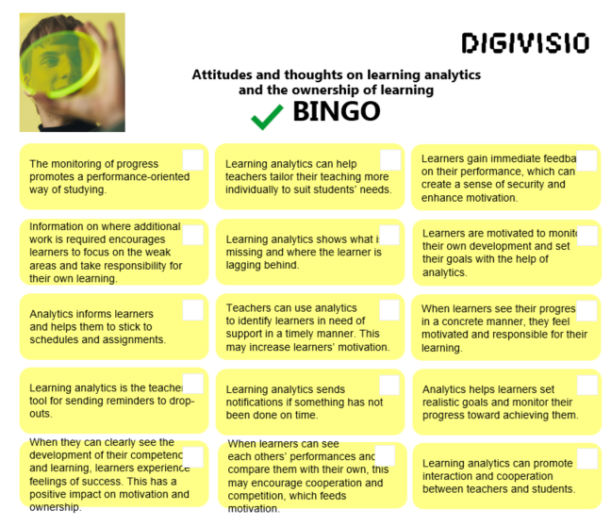

Episode 4. How to use learning analytics and artificial intelligence to streamline the assessment process?

Artificial Intelligence as a supported tool – challenge

We encourage you to participate in the challenge of using Artificial Intelligence as a support tool. This challenge helps you assess the impact of AI on the learning assignments of your study unit and to prepare an assignment in which AI is used as a tool that plays an integral role in the learning process and teaching.
Step 1: Define the impact of AI on learning: consider how different uses of AI affect the learning of learners in your study unit. Consider the following perspectives:
- Which assignments in your study unit can the learners outsource to artificial intelligence?
- How do you make sure that the learners learn when AI tools are freely available?
- How can you incorporate AI as an important part of the learning process?
- How can AI support learners’ understanding and in-depth learning?
Step 2: Consider the impact of artificial intelligence on assessment: consider how the use of AI affects the assessment of the study unit. Focus on the following perspectives:
- What is the significance of the tasks carried out with the help of artificial intelligence in the assessment?
- How can you ensure that the learners learn and understand when AI tools are freely available?
- What kinds of assessment criteria and methods should be considered when using AI in the assessment of studies?
Step 3: Develop your AI competence and participate in the discussion. Join a teacher network, such as one of Facebook’s TOT groups or similar, to get ideas and information about the use of AI in teaching and to share your insights with other teachers.
Step 4: Think of a learning assignment in which artificial intelligence is part of the learning environment: create an assignment in which AI acts as a member of a learning group. You can either edit an existing assignment or create a new one.
Step 5: Plan the assessment: think about how to assess the assignment in which artificial intelligence is involved. Consider the learning outcomes of learners and the impact of using AI.
Step 6: Guide the learner to express the role of AI in preparing the learning assignment.

