
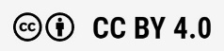
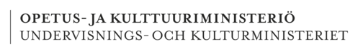
Mathematics and application of mathematics 4 osp
2024
Heikki hyväri, seija kulla, maria Mustakoski, Misa Muotio, Jarno Rekiranta, Jaana Repo
Rahoittaja:

Vierko |www.keuda.fi/keuda/hankkeet/vierko

Sisällys
Welcome to the online mathematics course! 4
1. Basic arithmetic operations 5
1.1 Basic arithmetics symbols 5
1.2 Multiply and divide by 10s 5
1.2.1 Multiplying by 10s 6
1.2.2 Dividing by 10s 6
1.2.3 Exercise 7
1.3 Operations with negative numbers 8
1.3.1 Addition and subtraction with the number line 8
1.3.2 Multiplication and division with negative numbers 9
1.3.3 Exercise 10
1.4 Order of operations 12
1.4.1 Exercise 13
1.5 Rounding 15
1.5.1 Exercise 16
1.6 Fractions 17
1.6.1 A fraction and a mixed number 17
1.6.2 Fractions and decimals 17
1.6.3 Exercise 18
1.7 Operations with fractions 20
1.7.1 Expanding and reducing fractions 20
1.7.2 Addition and subtraction with fractions 20
1.7.3 Multiplication and division with fractions 20
1.7.4 Exercise 21
1.8 Converting units 23
1.8.1 Exercise 24
1.9 Exponentiation and roots 25
1.9.1 Exponents 25
1.9.2 Roots 25
1.9.3 Exercise 26
1.10 Final test 28
2. Equations 31
2.1 Simplifying Expressions 31
2.1.1 Excercise 32
2.2 Proportion 33
2.2.1 Excercise 33
2.3 Direct Proportionality 34
2.3.1 Excercise 35
2.4 Inverse Proportionality 37
2.4.1 Excercise 38
2.5 Equations 40
2.5.1 Exercise 44
2.6 Applying Equations to Solve Word Problems 46
2.6.1 Exercise 47
2.7 Simple Quadratic Equations 48
2.7.1 Exercise 50
2.8 Final test 51
3. Geometry 53
3.1 Unit conversions 53
3.1.1 Units of area 53
3.1.2 Units of volume 53
3.1.3 Exercise 54
3.2 Using scales 55
3.2.1 Exercise 56
3.3 Calculating the area and perimeter 60
3.3.1 Square 60
3.3.2 Rectangle 60
3.3.3 Triangle 60
3.3.4 Parallelogram 61
3.3.5 Trapezoid 61
3.3.6 Circle 61
3.3.7 Exercise 62
3.4 Calculating the volume of an object 65
3.4.1 Cube 65
3.4.2 Rectangular prism or cuboid 65
3.4.3 Circular cylinder 65
3.4.4 Pyramid 66
3.4.5 Circular cone 66
3.4.6 Sphere 66
3.4.7 Exercise 67
3.5 Pythagoras theorem 72
3.5.1 Exercise 74
3.6 Final test 76
4. Percentages 80
4.1 Percentages 80
4.1.1 Exercise 81
4.2 Basic percentage calculations 82
4.2.1 Taking a percentage 82
4.2.2 Calculating a percent 82
4.2.3 Decreases/increases 83
4.2.4 Finding the base value 83
4.2.5 Permille 84
4.3 Percentage changes 84
4.3.1 Comparison percentage 84
4.3.2 Exercise 85
4.3.3 Change percentage 87
4.4 Taxes and interest 87
4.4.1 Taxes 87
4.4.2 Exercise 88
4.4.3 Interest 90
4.4.4 Compound interest 90
4.5 Excercise 92
4.6 Final test 94
5. Statistics and diagrams 97
5.1 How to read different kinds of graphs or diagrams 97
5.2 Tables and categories 97
5.3 How to draw diagrams 100
5.3.1 Vertical bar chart, Vertical bars 101
5.3.2 Horizontal bar chart, Horizontal bars 101
5.3.3 Histogram (bars are attached each other) 102
5.3.4 Pie diagram, pie chart 103
5.3.5 Practice: Reading diagrams 104
5.3.6 Practice: How to draw diagrams 111
5.4 Statistics - What Do the Figures Tell 114
5.4.1 Mean 114
5.4.2 Mode 116
5.4.3 Median 116
5.4.4 Excercise 117
5.4.5 Final test 123
Self-evaluation and feedback 125
Lähdeluettelo 126

Welcome to the online mathematics course!
In this course, you will study basic arithmetic operations, unit conversions, equation solving, percentage calculations, financial mathematics, statistical mathematics, and geometry.
Mastering basic arithmetic operations (addition, subtraction, multiplication, division, as well as powers and roots) is an essential skill for all vocational school students, regardless of your field of study. These operations form the mathematical foundation for many areas of mathematics and are useful in both daily life and professional settings. Proficiency in basic arithmetic also enhances problem-solving skills and logical thinking.

Equation solving and proportions in mathematics are important skills for vocational school students, as they can be applied in both everyday and professional life. Solving equations helps you understand many practical problems, such as financial calculations and resource management. Mastery of proportions is needed, for example, in understanding ratios and percentages, which is important in fields such as social and health care, as well as commerce and business.

Percentage calculations are needed in both professional and everyday life, for example, in price discounts and increases, as well as in taxes and interest rates. Additionally, material waste and solution concentrations are often expressed as percentages.

Mastery of financial mathematics provides you with tools for making economic decisions. You will learn about payroll calculations and how to calculate the VAT portion of a product or service price. The ability to calculate interest, investments, and loan repayments is useful for personal financial management, budgeting, and saving. These skills provide a strong foundation for understanding economic phenomena.

Mastering statistical mathematics is essential for vocational school students, as statistics is a key part of decision-making in many fields, such as business, social and health care, engineering, and social sciences. The ability to handle and interpret statistical data enables you to make fact-based decisions and helps you understand the underlying principles of various phenomena. Statistical mathematics also supports critical thinking and the ability to evaluate different sources of information.

Proficiency in geometry is an essential skill for vocational school students because it offers concrete and practical solutions to many everyday and professional challenges. Geometry allows you to design and visualize buildings, products, or graphic elements. Geometry is directly related to understanding shapes, spaces, and movement. Additionally, it supports problem-solving skills and creative thinking.
Mastering mathematical skills supports your current studies and enables continuous professional development. Furthermore, proficiency in mathematics also opens doors to further education in universities of applied sciences and universities.

Basic arithmetic operations

Basic arithmetics symbols
Symbols used in mathematics are not always the same in different countries. Here we list the symbols used in Finland. Finnish notation has been influenced a lot by Germany, where notation is mostly the same as in Finland.

+ addition

- subtraction

: / division

⋅ multiplication

In Finland we use the comma as a decimal separator and write big numbers in groups of three.
Finland 20,45 England 20.45 (twenty point fourtyfive)

Multiply and divide by 10s
We normally use a base 10 number system when writing numbers. Every number consists of one or more numerals. Numerals are 0, 1, 2, 3, 4, 5, 6, 7, 8 and 9.

Numerals have their own place in a number which tells how many ones, tens, hundreds and so on there are in a number. The comma , is used as a decimal separator in Finland.

thousands | hundreds | tens | ones | tenths | hundredths | thousandths
 | 2 | 5 | 3, | 1 | 4 | 8

There's the number 253,148 in the table above. How many...

hundreds does the number have? Answer: 2

ones does the number have? Answer: 3

thousands does the number have? Answer: 0

Multiplying by 10s
When you multiply a whole number by 10, 100 or other multiples of 10, add zeros to the end.

4 · 10 = 40

12 · 100 = 1200

When you multiply any number by multiples of 10, its value increases but numerals stay the same. You move the decimal point to the right once for every zero in the multiple of 10.

Example
Move the decimal point over two numbers when you multiply by 100.

0,525 · 100 = 52,5

3,3 · 100 = 330

Dividing by 10s
When you divide any number by multiples of 10, its value decreases but numerals stay the same. You move the decimal point to the left once for every 0 in the multiple of 10.

Example
8 : 10 = 0,8

12,5 : 10 = 1,25

400 : 1000 = 0,4

525 : 100 = 5,25

Exercise
- Calculate without a calculator

- 32 · 10 =

- 5 · 1000 =

- 0,075 · 1000 =

- 0,2 · 100 =

- Calculate without a calculator

- 32 : 10 =

- 50 000 : 1000 =

- 75 : 1000 =

- 2500 : 100 =

- Multiply and divide without the help of a calculator

- 5 · 10 =

- 14 · 100 =

- 7,8 · 10 =

- 8,4 · 100 =

- 0,35 · 1000 =

- 700 : 10 =

- 35 : 10 =

- 35 : 100 =

- 400 : 1000 =

- 2,5 : 10 =

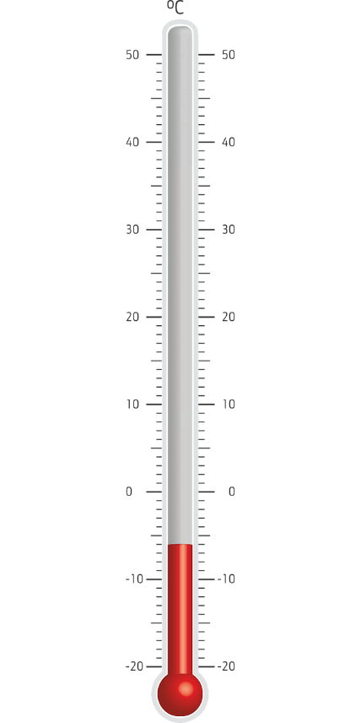
Operations with negative numbers
Negative numbers

Negative numbers are used for telling how cold it is outside in the winter. Negative numbers are written with a minus sign - in front of the number.

Check from the picture

a) how warm is it outside?
It’s -6 °C

b) if the temperature rises 10 degrees, how warm is it then?
It’s +4 °C

Addition and subtraction with the number line
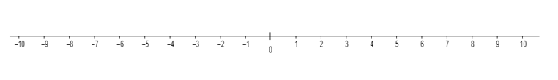
The number line helps when you subtract or add numbers especially when you go over zero. Numbers go up in value or grow when you go right on the number line.

If you want to calculate 4 - 6 with the number line, start with 4.

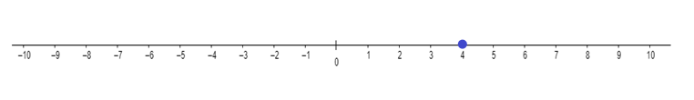

Because you want to subtract 6, move 6 steps left on the number line.

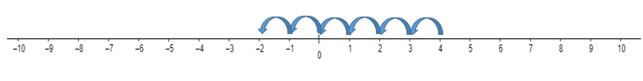

When you subtract a larger number from a smaller one, you get a negative number.
4 - 6 = -2

-3 + 4 = 1 Can be calculated with the number line so that you start with -3. Because you add 4, move 4 steps to the right.

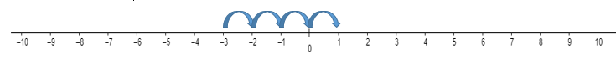
You can also change the order of numbers. If you switch the places of -3 and 4, you get
4 - 3 = 1.

If you add a negative number it is concidered the same as subtracting a number.

2 + (-4) = 2 - 4 = -2

Subtracting a negative number is concidered the same as adding a number.

2 - (-4) = 2 + 4 = 6

Also
2 + (+4) = 2 + 4 = 6

Multiplication and division with negative numbers
When you multiply a negative number with a positive number, you get a negative result.

-2 · 4 = -2 + (-2) + (-2) + (-2) = -8

When you multiply a negative number with another negative number you get a positive result.

-2 · -4 = 8

The same goes for division

-8 : 4 = -2

-8 : -4 = 2

If you multiply or divide two numbers that have the same sign, you get a positive result. If they have different signs, you get a negative one.

8 : (-4) = -2 2 · 4 = 8

-8 : 4 = -2 -2 · (-4) = 8

-8 : (-4) = 2 -2 · 4 = -8

8 : 4 = 2 2 · (-4) = -8

Exercise
Draw a number line on the paper and do the excercises

- Calculate so that you mark the first number on the number line and then move on the line accordingly

- 2 - 5 =

- 6 - 12 =

- -2 - 5 =

- Calculate with the number line

- -2 - (-4) =

- -3 + (+2) =

- -1 - (-7) =

- 2 - (+4) =

- -1 + (-3) =

- 7 + (-5) =

- Calculate

a) -2 · (-4) =

- -3 · 2 =

- -1 · (-7) =

- 8 : (-4) =

- -12 : (-3) =

- -27 : 9 =

- Calculate

- 15 + (+10)

- 5 + (-18)

- 3 - (-16)

- -19 + (+17)

- -6 - (+12)

- -1,6 - (-3,4)

- 7,5 + (-2,9)

- Calculate

- 2 · (8)

- 4 · (-5)

- -6 · (8)

- -6 · (-6)

- 10 : (-2) =

- b) -6 : (-2) =

- c) -15 : 5 =

- d) 8 : 2 =

- e) -18 : (-9) =

- f) 28 : (-7) =

- The temperature was 3°C in the morning. By the evening, it dropped by 15°C. What is the temperature in the evening?

- Alex had €23 in his bank account. He withdrew €52. What is his new balance?

- In a game, a player scored -40 points in the first round and 80 points in the second round. What is the total score?

Order of operations
There are rules in math for the order of operations. Calculate in this order:

1. Brackets ( )

2. Multiply · and divide :

3. Add + and subtract -

Example 1.
Calculate the operations in brackets first

4 · (5 - 3) =

4 · 2 = 8

Example 2.
Multiply and divide before you add or subtract

8 - 12 : 3 =

8 - 4 = 4

Example 3.
Calculate the multiplication and division first from left to right

8 + 12 : 2 · 3 =

8 + 6 · 3 =

8 + 18 = 26

Adding and subtracting are done after you multiply and divide

Exercise
- Calculate in the correct order

- 7 - (3 + 2) =

- 7 · (2 - 1 ) =

- 10 - 2 · 4 =

- 8 + 4 : 2 =

- Calculate in the correct order

- 3 + 2 · 5 =

- (3 + 2) · 5 =

- 8 : 4 - 2 =

- 8 : (4 - 2) =

- 15 : 3 + 2 · 4 =

- 15 : (3 + 2) · 4 =

- Do the operations in this order

1. Operations in brackets ()
2. Multiplication · and division :
3. Addition + and subtraction -

a) 4 + 2 · 3 =

b) 13 - 9 : 3 =

c) 40 : 8 · 3 =

d) 8 - (3 + 2) =

e) 12 - 3 · 4 + 5 =

f) 12 - 3 · (4 + 5) =

g) (12 - 3) · 4 + 5 =

h) 12 - (3 · 4 + 5) =
- Calculate

a) 50 + 3 - 2 · 5 =

b) (10 - 6) · 0,5 =

c) 12 : (2 · 3) =

d) 2 + ((4 + 2) · 3) =

e) (8 - 4) · 250 - 5 · (4 + 16) =

f) 150 - (20 - (3 - 11) · 10) =

- Matti buys a pair of shoes for €50 and 3 shirts for €19 each. He uses a €40 discount coupon. How much does he spend in total?

- You order 3 large pizzas for €19 each and 2 small pizzas for €9 each. How much do you pay in total?

- Salmon needs to be cooked for 20 minutes plus 10 minutes per kilogram. How many minutes should you cook a 1,6 kg salmon for?

Rounding
When you want to present a number in a more simple way, you can round it. You probably won't tell your friend that a loaf of bread cost € 2,99, but instead you say it cost about € 3. You round the number to the nearest euro.

thousands | hundreds | tens | ones | tenths | hundredths | thousandths
 | 2 | 5 | 3, | 1 | 4 | 8

Let's round the number from a previous excercise, 253,148.

When you round it to the nearest tenths, look for the next smallest place value. If it is 5 or larger, you round up. If it is 4 or smaller, round down. There are 4 hundreths, so round down and remove numerals 4 and 8. You get 253,1.

Rounding to the nearest hundred gives you 300 because there's a numeral 5 in the place for tens.

Example
Round 253,148 to the nearest

a) ten
Answer: 250

b) one
Answer: 253

c) hundreth
Answer: 253,15

You can also round to a specific decimal place. When you round to a given decimal place, include that many numerals after the decimal separator.

Example
Round 25,679 to two decimal places. Include two numerals after the comma and look for the next decimal place. Because there are 9 thousandths, round up to 25,68.

Exercise

- Round the number
- 946,83 to nearest tens

- 9 127 to nearest hundreds

- 403 480 000 to nearest millions

- 0,3624 to nearest tenths

- 0,5023 to the nearest hundredths

- Round the number
- 0,651 to two decimal places

- 0,00356 to four decimal places

- 12,45 to one decimal place

- 2,52680 to two decimal places

- 0,0125 to three decimal places

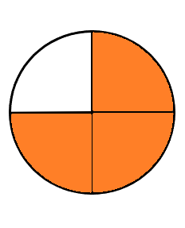
Fractions
A fraction is a part of something.
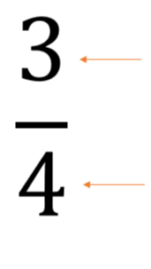

Numerator tells the number of parts taken into account.
In this fraction, we take into account 3 parts.

Denominator tells the total number of equal parts in a fraction.
In this fraction, the whole has been divided into 4 parts.

A fraction and a mixed number
Mixed number is a number with a whole number and a fraction. If the numerator of a fraction is larger than the denominator, you can convert the fraction into a mixed number.

Convert the fraction $\frac{5}{3}$ by dividing.

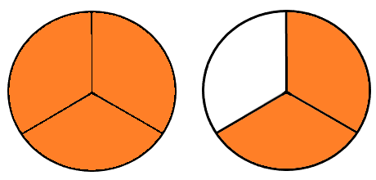
Example

The fraction is the same as the division 5 : 3

As the result from the division you get one whole and the remainder is 2. The remainder forms the fraction part of the mixed number with the denominator.

$\frac{5}{3}=1\frac{2}{3}$

Fractions and decimals
You can convert decimals into fractions by looking for the smallest decimal place in a number. 0,45 has 5 hundredths, so we get a fraction with 100 as a denominator and 45 as the numerator.

0,45 = $\frac{45}{100}$

You can convert fractions into decimals by doing the division. The fraction $\frac{4}{5}$ can be read as the division $\frac{4}{5}$ and it equals 0,8.

Exercise
- Name the numerator and the denominator.
a) $\frac{1}{3}$ The numerator is _____ and the denominator is _____
b) $\frac{3}{2}$ The numerator is _____ and the denominator is _____
c) $\frac{4}{7}$ The numerator is _____ and the denominator is _____

- What are the numerators and the denominators in the following pictures?
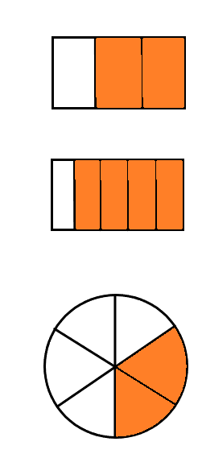
a)

b)

c)

- Connect the right fractions and mixed numbers
$$\frac{11}{4}$$ | $$\frac{9}{5}$$ | $$\frac{5}{4}$$ | $$\frac{7}{3}$$ | $$\frac{13}{5}$$ | $$\frac{5}{3}$$
$$1\frac{2}{3}$$ | $$2\frac{1}{3}$$ | $$2\frac{3}{5}$$ | $$1\frac{4}{5}$$ | $$1\frac{1}{4}$$ | $$2\frac{3}{4}$$

- Convert mixed numbers to fractions
- $1\frac{1}{4}$ =
- $2\frac{1}{8}$ =
- $1\frac{2}{3}$ =
- $2\frac{3}{4}$ =
- $1\frac{2}{7}$ =
- $3\frac{5}{6}$ =

- Convert fractions to decimals
- $\frac{3}{10}$ =
- $\frac{1}{2}$ =
- $\frac{1}{4}$ =
- $\frac{3}{4}$ =
- $\frac{45}{100}$ =
- $\frac{5}{8}$ =
- Convert decimal numbers to fractions
- 0,7 =
- 0,33=
- 1,57 =
- 0,249 =
- 0,9 =
- 0,27 =

Operations with fractions

Expanding and reducing fractions
You should usually write fractions in their simplest form so that in a fraction $\frac{a}{b}$, a and b do not have common denominators. To do this, you must often reduce them. You can reduce a fraction by dividing the denominator and the numerator with the same number as many times as necessary.
$$\frac{10}{15}=\frac{10 :5}{15 :5}=\frac{2}{3}$$

You need to expand fractions when adding and subtracting fractions with different denominators. You can expand a fraction by multiplying the denominator and the numerator by the same number.
$$\frac{3}{4}=\frac{3∙2}{4∙2}=\frac{6}{8}$$

Addition and subtraction with fractions
When you add or subtract fractions, they have to have the same denominator. You can only add or subtract parts that are the same size.

Expand one of the fractions if the bigger denominator is a multiple of the smaller one.

$$\frac{1}{2}+\frac{1}{4}=\frac{2}{4}+\frac{1}{4}=\frac{3}{4}$$

You have to expand both by multiplying by denumerators if expanding just one doesn't give you parts of the same size.

$$\frac{1}{2}-\frac{1}{5}=\frac{1∙5}{2∙5}-\frac{1∙2}{5∙2}=\frac{5}{10}-\frac{2}{10}=\frac{3}{10}$$

Multiplication and division with fractions

You can divide and multiply any two fractions by each other. Multiply two fractions by multiplying numerators and multiplying denominators of the two fractions.

$$\frac{1}{2}∙\frac{2}{3}=\frac{1∙2}{2∙3}=\frac{2}{6}=\frac{1}{3}$$

Divide two fractions by multiplying with the reciprocal of the fraction you divide by.

$$\frac{1}{2}:\frac{2}{3}=\frac{1}{2}∙\frac{3}{2}=\frac{3}{4}$$

Exercise

- Calculate

- $\frac{1}{4}+\frac{2}{4}=$

- $\frac{1}{8}+\frac{3}{8}$ =

- $\frac{1}{4}+\frac{3}{8}$ =

- $\frac{1}{3}+\frac{2}{6}$ =

- $\frac{2}{7}+\frac{1}{3}$ =

- $\frac{1}{6}+\frac{2}{5}$ =

- Calculate

- $\frac{2}{3}-\frac{1}{3}$ =

- $\frac{6}{7}-\frac{2 }{7}$ =

- $\frac{2}{3}-\frac{1}{6}$ =

- $\frac{5}{8}-\frac{1}{2}$ =

- $\frac{4}{5}-\frac{4}{7}$ =

- $\frac{1}{2}-\frac{1}{5}$ =

- A recipe for 20 pancakes calls for 2/3 cup of sugar. If you want to make half of the recipe, how much sugar do you need?
- Calculate

- $\frac{1}{3}∙\frac{1}{4}$ =

- $\frac{2}{3}∙\frac{6}{7}$ =

- $\frac{3}{4}∙\frac{2}{3}$ =

- $\frac{1}{4}∙\frac{2}{5}$ =

- $3∙\frac{1}{6}$ =

- $\frac{2}{7}∙2$ =

- Calculate

- $\frac{1}{2}:\frac{3}{2}$ =

- $\frac{2}{5}:\frac{3}{4}$ =

- $\frac{1}{2}:\frac{1}{6}$ =

- $2 :\frac{1}{2}$ =

- $\frac{4}{5}:2$ =

- $\frac{3}{4}:5$ =

- A fuel tank is 3/5 full. If the tank holds 54 liters when full, how many liters of fuel is there in the tank?

- Saara has read 3/4 of her book. If the book has 190 pages, how many pages has she read?

Converting units
You can see a can of soda on the shelf of a store. It has 330 ml of soda inside. Right next to it there is another can that is the same size and has 0,33 l of soda inside. The volume of a can of soda has been written in different multiples of the unit liter.

Multiples of units (meter for example)

kilo | hector | deka |  | deci | centi | milli
km | hm | dam | m (meter) | dm | cm | mm

You can convert units to a smaller multiple by multiplying by 10 or 100 or 1000... depending on what you are converting.

0,2 m · 100 = 20 cm

2,4 km · 1000 = 2 400 m

Convert to a bigger multiple by dividing by 10 or 100 or 1000...

750 m : 1000 = 0,75 km

550 mm : 10 = 55 cm

1 km = 10 hm = 100 dam = 1000 m

1 hm = 10 dm = 100 m

1 dm = 10 m

1 m = 10 dm = 100 cm = 1000 mm

1 dm = 10 cm = 100 mm

1 cm = 10 mm

Exercise

- Convert to the given unit  - 170 cm = _____ m  - 14 mm = _____ cm  - 30 cm = _____ m  - 4,5 dm = _____ cm  - 500 mm = _____ m | - Convert to the given unit  - 0,7 km = _____ m  - 1500 m = _____ km  - 2,5 m = _____ cm  - 300 mm = _____ dm  - 0,25 km = _____ cm

- Convert to milliliters  - 3,7 cl =  - 0,0037 l =  - 3,7 dl =  - 0,037 cl =  - 0,37 dl | - Convert to the given unit  37 ml = _____ dl  370 ml = _____ l  3,7 ml = _____ dl  3700 ml = _____ dl  0,37 ml = _____ cl

- Convert to grams  - 25 mg =  - 0,25 kg =  - 250 mg =  - 2,5 mg =  - 2,5 kg = | - Convert to the given unit  - 0,25 g = _____ mg  - 2,5 g = _____ mg  - 25 g = _____ kg  - 2500 g = _____ kg  - 0,025 g = _____ mg

Exponentiation and roots

Exponents

When you multiply a number a by itself n times, the multiplication can be written in a more compact way with an exponent. It is read as "a to the power of n".

a · a · a · ... · a = aⁿ

(n times a)
9
2³ = 2 · 2 · 2 = 8

Example
If there's a square with sides of 9, then the area of the square is

9² = 81, another way to read this is 9 squared.

Roots
If a square has an area of A, then the sides of the square have a length equal to square root of A.

x
If the area A = 49, then we get
A = 49

$\sqrt{49}=7$
x

There is also another answer because there is also a negative number which equals 49 when squared

$\sqrt{49}=-7$

The square root has both a negative and a positive answer.

Exercise
- Calculate
- 5² =

- 7² =

- 10² =

- 10³ =

- 3³ =

- 2⁴ =

- Calculate
- 3² =

- 8² =

- 12² =

- (-2)² =

- (-6)² =

- 3³ =

- 5³ =

- (-2)³ =

- Calculate
- $\sqrt{49}=$

- $\sqrt{16}=$

- $\sqrt{100}=$

- $\sqrt{81}=$

- $\sqrt{25}=$

- Calculate
- $\sqrt{9}=$

- $\sqrt{36}=$

- $\sqrt{64}=$

- $\sqrt{144}=$

- $\sqrt{10000}=$

- $\sqrt{1}=$

- Formula for the area of a square is A = a² where a is the side length of the square. If the side length of a square is 8 m, what is the area of the square?

- Formula for the volume of a cube is A = a³ where a is the side length of the cube. If the side length of a cube is 1 m, how many cubic meters is the volume of the cube?

- The area of a square is 64 m². What is the length of one side of the square?

Final test
NAME__________________ Calculations
Group ID________ Score _______/50 points

Write down all the steps in your process. You may not use a calculator in this test.

- Answer the questions about this number: 1435,862.

- How many hundreds does the number have?
- How many ones does the number have?
- How many thousandths does the number have?
_____/3

- Solve
a) -2 · 2 = b) $\frac{18}{-9}$ =

c) -4 · (-5) = d) 45 : 9 =

e) 8,5 · (-2) = f) 8,15 – 0,32 =
_____/6

- Solve, write down all the steps.

a) -4 - (-4) c) 3 + (-5)

b) 5 + 2 · (6 + 5 · 6) = d) 5 + 2 · 6 + 5 · 6 =

_____/4

- Round to the given place value

- 12,893 ≈ (round to the ones place)
- €85,97 ≈ (to full euros)
- 6,342 ≈ (to the tenths place)
_____/3

- Convert decimal numbers to fractions and fractions to decimals.

  - $\frac{3}{5}$ = c) $1\frac{3}{8}$ =

  - 0,8 = d) 2,08 =

_____/4

- Convert mixed numbers to fractions and fractions to mixed numbers.

- $\frac{7}{3}=$ b) $\frac{8}{2}=$ c) $2\frac{1}{7}$ = d) 9 =

_____/4

- Solve the operations with fractions. Reduce if possible.

a) $\frac{3}{5}+\frac{5}{5}$ = b) $1\frac{1}{2}∙\frac{4}{6}$ =

c) $\frac{5}{6} :\frac{3}{4}$ = d) $\frac{8}{9}$ : 4 =

e) $\frac{4}{5}-\frac{1}{2}$ = f) $\frac{2}{3}$ · 6 =
_____/6
- Convert to the given unit:

a) 170 g = _________ kg b) 6,25 min = _______________ s

c) 1 500 ml = __________ litres d) 8,567 km = _________ m

e) 4 cl = _______ ml f) 4,4 kg = ____________ g
_____/6

- Find the solution. Write down the whole process.

- How much does 9 litres of gasoline cost, if one litre costs € 1,45?

- How much is $\frac{2}{3}$ of a 210 cm long board?

- Paint covers 2,5 m²/litre. How much paint do you need to paint a wall with an area of 9 m²?

_____/6

- Calculate

a) 8² =

b) 3³ =

c) $\sqrt{49}$ =

d) $\sqrt{1000}$ =

_____/4

- A customer buys 3 pairs of €4,5 knitting needles, 4 meters of fabric (€7,2 /m) and a ball of wool that costs €6,5. They pay with a €50 bill. How much change do you give the customer back?

_____/3

Equations
Before we start solving equations and proportions let’s practice how to simplify mathematical expressions.

Simplifying Expressions
Let's start with a summation expression with a variable. Such expressions are called polynomials. For example, in a sum expression 3x + 5 there are two terms: 3x and 5. Number 3 is a coefficient and x is a variable. Number 5 is a constant.

If two given terms have the same variables and powers, but differ only in their numerical coefficient, then these two given terms are called like terms. Like terms can be added together. For example, 3x and 4x are like terms so we get 3x + 4x = 7x.

The members of an expression are usually written starting from the highest power. For example ${2x}^{2}+4x-5$. If there are several variables (letters), the terms are written in alphabetical order. For example 2a + 4b.

coefficient
first degree term
second degree term
Designations : x² + 5x - 9 8x
constant
variable/unknown

Examples

Combining like terms: 3x + 8 – 6 + 12 + 5x = 8x +14

Removing parentheses: x(3x+5) = x·3x + x·5 = 3x² + 5x

-3(4x+5) = -3·4x -3·5 = -12x - 15

(2x + 3)(4x+5) = 2x·4x + 2x·5 +3·4x + 3·5

= 8x² + 10x + 12x +15 = 8x² + 22x +15

Excercise

- Reduce the following expressions

- x + x + x =

- x + 2x + 3x =

- 2x + 4x + 2 + 3 =

- x² + x² + 3x² =

- x² + 2x² +4x - x + 9 - 3 =

- x + x + 2x + 2+ 3 =

- 9x² + 13 +3x -2x² +3x - x + 7 =

- Reduce the following expressions

- (x + 4) + (x + 3) =

- 9x + 2 - (5x - 3) =

- – (2x – 1) – ( –8x + 6) =

- 2 (4x + 6) =

- 10 (x² + 2x) =

- x (5 - 4x) =

- (x + 1) (x + 1) =

- (5 + 4x) (2x + 4) =

Proportion
A proportion is an equation which states that two ratios are equal. Proportions are often written in the form:
$\frac{a}{b} = \frac{c}{d}$

All proportions can be solved by cross multiplying:
from ratio $\frac{a}{b}=\frac{c}{d}$ we get an equation a ∙ d = b ∙ c.

Example
Norwegian salmon is sold at €9/kg. How much salmon would you get for €15?
Formulate a proportion:
price in euro
what if the price is €15?
$$\frac{9}{1}=\frac{15}{x}$$
quantity (kg)
quantity (kg)

When we cross multiply, we get an equation: $9x=1∙15$
$9x=15$ || divide the equation by 9
$x=\frac{15}{9}$
$x=1,66 kg$

Answer: For €15, you would get approximately 1,7 kg of salmon.

Excercise

- Solve the following proportions by using cross multiplication

- $\frac{6}{4}=\frac{90}{x}$

- $\frac{72}{24}=\frac{x}{4}$

- $\frac{3}{5}=\frac{12}{x}$

- $\frac{2x}{8}=\frac{5}{2}$

Direct Proportionality
When two things are directly proportional, it means that when one thing increases, the other thing increases too, and when one thing decreases, the other decreases in the same way. The key idea is that both things change together at the same rate. So, in direct proportionality, the ratio of the two quantities remains constant.

Example
You are riding a scooter at a constant speed of 40 km/h. The relationship between time and distance traveled is directly proportional. That is, as the time spent riding increases, the distance traveled increases at the same rate.
Here’s a table that shows the relationship between time and distance:

Time (h) | Distance (km)
1 h | 40 km
2 h | 80 km
3 h | 120 km
4 h | 160 km
etc. | etc.

To see if time and distance are directly proportional, we need to check if the ratio of time to distance is always the same.

$\frac{2 h}{1 h}=2$ and $\frac{80 km}{40 km}=2$ so both ratios are the same.

Since both quantities (time and distance) change in the same ratio, we can conclude that time and distance are directly proportional.

Example
Ville and Tiina were shopping for candy. Ville had 3,50 € money and he received 630 g of pick and mix candy. How much candy did Tiina get when she had €4? Form a proportion
and calculate.

Let’s make a table, where one column in euros, one in grams

€ | g
3,50 | 630
4,00 | x

Consider whether the quantities are directly proportional. If so, form a proportion and cross multiply to solve x.

$\frac{3,5}{4}=\frac{630}{x}$

We get an equation: $3,5x=4∙630$
$3,5x=2520$ || divide the equation by 3,5
$x=\frac{2520}{3,5}$
$x=720 g$

Answer: Tiina will get 720 g of candy.

Excercise

- In a bakery, a recipe for 20 cookies requires 15 dl of flour. If the bakery wants to bake 60 cookies, how much flour will they need?

- Complete the table below when the quantity and price are directly proportional.
Quantity (kg) | Price (€)
 | 4,50
1
2 | 18,00
 | 45,00
10

- Pekka runs 4 km in 20 minutes.
- Determine the values for the blank spots in the table.
- Calculate the value of x.

Time (min) | Distance (km)
20 | 4
40
10
7 | x

- It costs 6,50 € to buy 2.5 kg of apples. How much would 8 kg of apples cost?
- A hiker took 3 hours for a 10 km trip. Use proportion to calculate how long the trip would take for: a) A 25 km trip b) A 40 km trip

- The pick and mix candies cost 0.79€ per 100g. Use proportion to calculate how much candy you could get for 3€?

- A machine uses 8 kWh of electricity to run for 4 hours. How much electricity will the machine use if it runs for 10 hours?

- A clothing factory requires 2 meters of fabric to produce 3 shirts. How much fabric is needed to produce 18 shirts?

- A welder uses 3 meters of welding rod to weld 6 metal plates. How much welding rod will be needed to weld 15 metal plates?

- A vehicle consumes 8 liters of fuel to travel 100 kilometers. How much fuel will it consume to travel 350 kilometers?

- A factory produces 50 items in 5 hours. How many items will the factory produce in 12 hours?

- A water tank is filling at a rate of 10 liters per minute. How much water will the tank have after 6 hours?

- A farm requires 40 kilograms of fertilizer to treat 50 hectares of land. How many kilograms of fertilizer will be needed to treat 120 hectares of land?

- Kari and Tiina made a joint investment, where Kari paid 30 € and Tiina paid 40 €. Kari's share of the profit was 81 €. What was Tiina's share of the profit?

- The boss pays a total of 800€. Use proportion to determine how the money should be divided, given that Timo worked for 11,5 hours and Pekka worked for 6,5 hours.

Inverse Proportionality
Two quantities are inversely proportional if, when one quantity increases, the value of the other decreases in the same ratio. In other words, as one quantity increases, the other decreases, and their product remains constant.

Example
In the table below we have average speed and time taken for a journey for a 50 km trip.
Average Speed (km/h) | Time (h)
10 | 5
25 | 2
50 | 1
80 | 0,5

Let’s calculate the following ratios:

$\frac{50 km/h}{25 km/h}=2$ and $\frac{1 h}{2 h}=\frac{1 }{2 }$. The ratios are inverse.

When the speed doubles, the time taken for the journey is halved.

$\frac{100 km/h}{10 km/h}=10$ and $\frac{0,5 h}{5 h}=\frac{1 }{10 }$. The ratios are inverse.

When speed increases tenfold, time decreases by a tenth.

Thus, when the distance is constant, the average speed and the time taken are inversely proportional.

Example
One cleaner cleans the house in 7 hours. How long would it take to do the same job if there were 3 cleaners?

Let's make a table

Cleaners | Time (h)
1 | 7
3 | x
Consider whether directly or inversely proportional. Since it is inversely proportional, we must flip the other ratio of the proportion upside down. Then using Cross Multiplication, we get

$\frac{1}{3}=\frac{x}{7}$

We get an equation: $3x=1∙7$
$3x=7$ || divide the equation by 3
$x=\frac{7}{3}$
$x=2,333…h$

Answer: If there were 3 cleaners, the same job would take about 2,3 h.

Excercise

- Fill in the table with travel times and average speeds when the distance is constant.
Time (h) | Average Speed (km/h)
10
5 | 40
 | 50
2,5
 | 100

- A trip to summer cottage is 180 km. The table shows average speeds at which the trip was taken, along with the corresponding travel times.
a) Determine the values for the blank spots in the table.
b) Calculate the value of x.

Average Speed (km/h) | Travel Time (h)
45 | 4
90
 | 6
80 | x

- Five students took 20 hours to finish the surface treatment of the apartment walls. How many students would have completed the same task in 12 hours?
Number of students | Working hours (h)

- Maija rides her bike to school at a speed of 15 km/h, and it takes her 7 minutes. At what speed does Mikko walk if it takes him 18 minutes to cover the same distance?

- Two pumps can pump 50,000 dm³ of water in about four hours. How long would it take to pump the same amount of water if three more pumps were used?

- When driving at 80 km/h, the trip takes 6 hours. How much time would the trip take if the speed was 60 km/h?

- A worker can finish a task in 8 hours. How long will it take if 4 workers are assigned the same task, assuming they all work at the same rate?

- A contractor appoints 36 workers to build a wall. They could finish the task in 12 days. But due to some unavoidable reasons, only 16 workers turned up. How many days will 16 workers take to finish the same task?

- A ship with 18 men onboard has enough food for 70 days. The ship rescues 10 men from a stranded vessel. How long will the food last now?

- The construction company submitted the following bid for a grandstand project: 150 000 euros if the work is completed in 100 days. If the company completes the work in a different amount of time, the price is determined so that "time and price are inversely proportional." How much would the company charge if they completed the grandstand in: a) 80 days b) 120 days

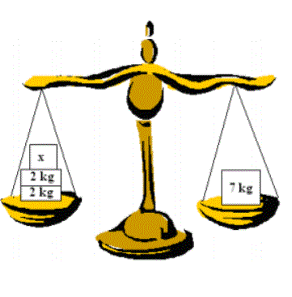
Equations
When two statements are marked as being equal, an equation is formed. Equations can be illustrated using a balance scale. When both sides of the scale weigh the same, the scale is balanced. If you add or remove objects of equal weight from both sides of the scale, the balance remains intact. Similarly, the same operations can be performed on both sides of an equation: you can add or subtract the same amount from both sides, and the equation will still hold true. What must the weight x be for the scale to be in balance?

To achieve balance, we can form an equation and calculate the value of x as follows:
$x+2 kg+2 kg =7 kg$
$x+4 kg =7 kg$
$x+4 kg-4 kg =7 kg-4 kg$ || Subtract 4 kg from both sides
$x=3 kg$

Therefore, the weight x must be 3 kg for the equation to be true.

Steps for Solving Equations:
- Identify the equation: Look for the variable (e.g., x) and constants (numbers) in the equation.
- Isolate the variable: Use basic algebraic operations (addition, subtraction, multiplication, division) to get the variable by itself on one left of the equation.
- Simplify: Combine like terms and simplify both sides of the equation whenever possible.
- Check your solution: Substitute the value of the variable back into the original equation to verify it satisfies the equation.

Example 1.

Simple Linear Equation

$x+5 =12$

Step 1: Subtract 5 from both sides of the equation to isolate x

$x+5-5 =12-5$ || Subtract 5 from both sides
$x=7$

Step 2: Check the solution: Substitute $x=7$ back into the original equation.

$7+5 =12$ (true)

So, the solution is $x=7$.

Example 2.
Solving Equations with Multiplication

$3x =15$

Step 1: Divide both sides of the equation by 3 to isolate x.

$$\frac{3x}{3}=\frac{15}{3}$$

$x=5$

Step 2: Check the solution: Substitute $x=5$ back into the original equation.

$3∙5=15$ (true)

So, the solution is $x=5$.

Example 3.
Solving Equations with Fractions

$$\frac{x}{4}=3$$

Multiply both sides by 4 to get rid of the fraction.

$\frac{4∙x}{4}=4∙3$

$x=12$

Check the solution: Substitute $x=12$ back into the original equation.

$\frac{12}{4}=3$ (true)

So, the solution is $x=12$.

Example 4.
Solving Equations with more Fractions

$$\frac{x}{2}+1=\frac{x}{3}$$

Multiply both sides by 6 to get rid of the fraction.

$$\frac{6∙x}{2}+6∙1=\frac{6∙x}{3}$$

$3x+6=2x$

Subtract 2x and 6 from both sides

$$x=-6$$

Check the solution: Substitute $x=-6$ back into the original equation.

$$\frac{-6}{2}+1=\frac{-6}{3}$$
$-2=-2$ (true)

So, the solution is $x=-6$.

Example 5.
Solving Equations with Variables on Both Sides

$2x+3=x+7$

Subtract x from both sides to get rid of the x on the right side.

$2x-x+3=x-x+7$

$x+3=7$

Subtract 3 from both sides to isolate x.

$x+3-3=7-3$

$x=4$

Step 3: Check the solution:

Substitute $x=4$back into the original equation.

$2∙4+3=4+7$
$8+3=11$
So, the solution is $x=4$.

Example 6.
Equations with Parentheses

$5(x-2)=x+6$ || Remove the parentheses
$5x-10=x+6$ || Subtract x from both sides
$4x-10=6$ || Add 10 for both sides
$4x=16$ || Divide both sides with 4
$x=4$

Check the solution:

Substitute $x=4$back into the original equation.

$5(4-2)=4+6$
$10=10$ (True)
So, the solution is $x=4$.

Key Points to Remember:
- Always perform the same operation on both sides of the equation.
- The goal is to get the variable isolated on the left side.
- Simplify as much as possible to make solving easier.

Exercise

- Solve the equations  - 6x = 30  - 3x = 21  - -3x = 21  - −x = 7 | - Solve the equations  - $\frac{x}{3}=15$  - $5=\frac{x}{6}$  - $\frac{20}{x}=5$  - $2=\frac{50}{x}$
- Solve the equations  - 2x + 1 = 5  - 9x - 1 = 80  - 6x + 1 = 37  - 10x - 5 = 85 | - Solve the equations  - 4x = 2x + 6  - 6x = -3x - 27  - -4x = -6x + 8  - x = 3x + 14
- Solve the equations  - 2 (x+3) = 14  - 9x - 2 = 7 (2x – 1)  - 11+8 (2x-5) = 16+x | - Solve the equations  - $\frac{3(x-1)}{4}=2x$  - $\frac{2x}{5}+\frac{3x}{2}+2=40$  - $\frac{x}{4}-1=\frac{x-6}{3}$
- Solve the equations  - $\frac{7x-(2-3x)}{5}=-9$  - $\frac{x}{2}-\frac{2x-3}{3}=x-13$ | - Solve the equations  - $\frac{x}{2}+\frac{x}{5}+\frac{x}{4}+120=x$  - $\frac{3}{4}-\frac{1}{8x}=0$

Applying Equations to Solve Word Problems
An equation is often a useful tool for solving practical problems mathematically. In this case, a condition given in verbal form is written as an equation. The unknown, usually represented by x, is typically the quantity being asked for. Depending on the context, the unknown can also be represented by other letters. The solution process is similar regardless of which letter is used. Here are some instructions for how to convert a word problem into an equation

- Read the problem statement carefully. Remember, the goal is to translate the task from words to the language of mathematics, i.e., to form an equation.
- Identify what is being asked. The unknown quantity is usually represented by x.
- Translate the information given in the problem into expressions using the variable x.
- Think about what common, equal relationship the expressions represent and use it to form an equation.
- Solve the equation.
- Evaluate the reasonableness of the result.

Example 1.
A rectangle is twice as long as it is wide. If the perimeter of the rectangle is 36 cm, what is the width of the rectangle?

Solution:
Identify the unknown: Let x represent the width of the rectangle in centimeters.
Translate into expressions:
  - Since the length is twice the width, the length of the rectangle is 2x.
  - The perimeter of a rectangle is given by 2×(width+length).
Set up the equation: Substitute the expressions for the width and length into the formula for perimeter:
$$2\left(x+2x\right)=36$$

Simplify and solve the equation:

$$2\left(3x\right)=36$$
$6x=36$ || Divide both sides with 6
$x=6$

Answer: The width of the rectangle is 6 cm.

Example 2.
Jesse and Peetu had a total of 140 €. How much money did Jesse have if Jesse had 18 euros more than Peetu? Form an equation and solve it.
Solution:
Let the amount of money Peetu has be x.
Since Jesse has 18 euros more than Peetu, Jesse’s money is x+18.
According to the problem, the total amount of money they have together is 140 €.
So, we can write the equation:
$$x+x+18=140$$
Simplify the equation:
$2x+18=140$ || subtract 18 from both sides
$2x=140-18$
$2x=122$ || divide by 2
$x=61$
So, Peetu has 61 €.
Since Jesse has 18 € more than Peetu, Jesse has
$x+18=61+18=79 €$

Answer:
Jesse has 79 €, and Peetu has 61 €.

Exercise

- Ville owns twice as much forest as Pekka. How much does each person own if together they own 81 hectares of forest?

- Jussi's salary is 350 € greater than Pekka's salary. Together, they earn 5450 €. What are their salaries?

- Tiina and Kaisa baked doughnuts. Tiina baked 23 more doughnuts than Kaisa. How many doughnuts did each bake if they baked a total of 145 doughnuts?

- The base fare for a taxi is €9.50, and the cost per kilometer is €1.85. How far can you travel for €30?

- The price of a device is €360. The device can also be rented for €25 per day. Solve the equation to find out how long the device must be rented for for it to be cheaper to buy it.

- Arttu, Bea, and Carlos are making money. Bea earns €50 more than Arttu, and Carlos earns 2.5 times as much as Arttu. How much does Arttu earn if, together, Arttu, Bea, and Carlos earn €1175?
- Laura ate half of the candies on the table, Joel ate a third of them, and Lenni got the remaining five candies. How many candies were there in total?

- Asher ran a certain distance 2 minutes faster and Brian 3 minutes faster than Caleb. Calculate the time taken by Asher if the total time for all three was 40 minutes.

- The cost of painting a house as a fixed-price contract is €1500, which also includes the cost of the paint. If the work is done by the hour, the hourly wage is €24, and the paint costs €640. How long can the painting job take for it to be more cost-effective to have it done at an hourly rate?

Simple Quadratic Equations
A Simple quadratic equation without the x term has the following form

${ax}^{2}+c=0$

where a is a coefficient and c is a constant.

Example 1:
Solve equation $x^{2}=36$

Solution:
${ x}^{2}=36$

Take the square root of both sides to solve for x:

$x=±6$

Thus, the solutions are: $x=6$ or $x=-6$

Example 2:
Solve equation ${2x}^{2}-8=0$

Solution:

Move 8 to the right side and change the sign:

${2x}^{2}=8$
Divide both sides by 2 to solve for $x^{2}$:

${ x}^{2}=4$

Take the square root of both sides to solve for x:

$x=±2$

Thus, the solutions are: $x=2$ or $x=-2$

Summary:

A quadratic equation form ${ax}^{2}+c=0$ can be solved in these steps:
- Move the constant c to the right side of the equation.
- Divide by the coefficient of ${ x}^{2}$ (if necessary).
- Take the square root of both sides to find the values of x.
- Quadratic equations typically have two solutions.

Exercise
- Solve the equation  - $x^{2}=36$  - $x^{2}=81$  - $x^{2}=169$ | - Solve the equation  - ${2x}^{2}-32=0$  - ${11x}^{2}-99=0$  - $x^{2}-144=0$

- The area of a square-shaped sauna is 9 square meters. Calculate the length of one side of the sauna.

- The area of a square-shaped table is 1.44 $m^{2}$. Calculate the length of one side of the table.

- Electrical Power P can be calculated using the current I and the resistance R using the formula: ${P=R∙I}^{2}$.
a) Calculate the power when the resistance $R=100 Ω$and the current $I=2,0 A$.
b) Calculate the current $I$, when the power $P=2300 W$ and resistance $R=2000 Ω$

- Kinetic energy is calculated using mass and velocity, and its magnitude is:
$$E=\frac{1}{2}mv^{2}$$

a) What is the kinetic energy of a car with a mass of 1,400 kg and a velocity of 90 km/h?
b) A full trailer combination has a mass of 30 tons and a kinetic energy of 7.5 MJ. What is the velocity of the combination?

Final test
NAME: ___________________________ Equations
Group ID: _________ Score: /31 points

1. Refine the polynomials (4p)
a) 5x – 7x

b) 6x + 4 - 2x +3

c) 3 · 4x

d) 3x · 2x

2. Refine (4p)
a) 4(2x -1)

b) – (3x + 4)

c) (2x + 7) + (8x – 9)

d) (x – 6) – (2x + 3)

3. Solve for x. (10p) a-f (1p), g,h (2p)
a) 5x = 20

b) $\frac{x}{9}=7$

c) $\frac{12}{x}=4$

d) $\frac{3}{2}=\frac{15}{x}$

e) 5x = 4x - 19

f) 5 – 3x = x + 13

g) $\frac{4-x}{x}=\frac{6}{2}$

h) –(2x + 4) - 3(-x – 6) = 0

4. Solve the equation (3p)
- $x^{2}=121$

- ${5x}^{2}=45$

- ${-3x}^{2}+108=0$

5. A cinnamon bun costs 1 € more than a coffee. How much does the coffee cost if two coffees and a bun cost 7,60 €. Form an equation and solve it. (3p)

6. Wanda has three times as many hats as Sara. Jenna has three hats fewer than Wanda. How many hats does each of them have if they have 2 hats altogether. (4p)

7. The floor area of a square-shaped house is 120 $m^{2}$. Calculate the length of one side of the house. (3p)

Geometry
Learn how to convert units of area and volume, use scales, calculate areas, perimeters and volumes of different objects.

Unit conversions
Converting units of area and volume (m³).

Units of area
÷100
÷100
÷100
÷100
÷100
÷100

km² ha a m² dm² cm² mm²
·100
·100
·100
·100
·100
·100

Relationship between these units is 100. So, when you move to the next unit, you eighter multiply or divide with 100.

Example
2,5 km² = 250 ha = 250 000 a
130 000 mm² = 1300 cm² = 0,13 m²

Units of volume
÷1000
÷1000
÷1000
÷1000
÷1000
÷1000

km³ hm³ dam³ m³ dm³ cm³ mm³
·1000
·1000
·1000
·1000
·1000
·1000

Relationship between these units is 1000. So, when you move to the next unit, you eighter multiply or divide with 1000. Also remember that 1 liter = 1 dm³.

Example
2,5 km³ = 2 500 000 000 m³
130 000 000 mm³ = 130 000 cm³ = 130 dm³ = 130 liters.

Exercise
Convert to the given units.
120 000 m² | a | ha
20 a | m² | ha
3 400 000 mm² | cm² | m²
5670 cm² | m² | a
3,1 km² | ha | a
5,12 ha | km² | a

120 000 m² | a | ha
20 a | m² | ha
3 400 000 mm² | cm² | m²
5670 cm² | m² | a
3,1 km² | ha | a
5,12 ha | km² | a

Convert to the given units.
120 000 m² | a | ha
20 a | m² | ha
3 400 000 mm² | cm² | m²
5670 cm² | m² | a
3,1 km² | ha | a
5,12 ha | km² | a
120 m³ | dm³ | l (litre)
20 l | dm³ | cm³
3 400 000 mm³ | cm³ | dm³
6,5 m³ | dm³ | ml
0,00000008 km³ | m³ | l
90 cm³ | dm³ | mm³

Give the answers without unit.
- Convert 9200 m² to are (a).
- Convert 5,9 ha to square meters (m²).
- Convert 8,3 m³ to liter (l).
- Convert 8,7 m³ to cm³.

Using scales
- Where is scale used? Maps, blueprints, scaled drawings…
- Enlarged or reduced.
- What means if a scale 1:20 000 is given in a map? It means that 1 cm is actually 20 000 cm in nature. In meters it is 200 m.
- What means if a scale 10 : 1 is given in a blueprint? It means that 10 cm in the picture is 1 cm in real life.

Example
If the scale of a map is 1 : 5000, how much is 3 cm in nature? Give the answer is meters.
map (cm) | nature (m)
1 cm | 50 m
3 cm | 150 m
Use multiplication or proportion calculation for the solution.
Answer: 150 m

Example
If the scale of a map is 1 : 5000, how much is 700 m (in real life) in the map?
map (cm) | nature (m)
1 cm | 50 m
14 cm | 700 m
Use division or proportion calculation for the solution.
Answer: 14 cm

Example
drawing (cm) | real connector (cm)
4 cm | 1 cm
16 cm | 4 cm
Diameter of an enlargement of the end of a connector is 16 cm. What is the actual diameter of the connector when the drawing is on a scale of 4 : 1?

Use division or proportion calculation for the solution.
Answer: 4 cm

Exercise
- Fill the tables.
Scale is 1 : 1000
1 cm | 10 m
2 cm
5 cm
15 cm

Scale is 1 :1 150 000
1 cm | km
2 cm | km
5 cm | km
15 cm | km

Scale is 5 : 1
5 cm | 1 cm
15 cm
150 cm
225 cm

- The scale of the blueprint is 1 : 50. The length of the living room is 15 cm and the width is 10 cm in the blueprint. What are the length and the width in real life?
Give the answer in tenths and in meters. Remember the unit.
- A map has a scale of 1:20 000. There is a river that is 2,7 km long. How long is it on the map.
Give the answer in tenths and in centimeters.
- A guide map of Helsinki is made on a scale of 1:20 000. The distance from the Parliament House to the Presidential Palace along the Mannerheimintie and Esplanadi is 8,6 cm measured on the map. How long is the distance actually?
Give the answer in kilometers rounded to hundredths and with a unit.

- Reduced (multiply): The length of a drawing is 1,2 cm. How long is the length in real life? The scale of the drawing is 1:12.
Give the answer in centimeters rounded to tenths and with a unit.
- Enlarged (dividing): Mechanical part is in a drawing 8 cm long. How long is it in a real life? The scale is 10 : 1?
Give the answer in centimeters rounded to tenths and a unit.
- The scale of a map is 1:10 000. How much is 5,5 cm in real life?
Give the answer in ones (no decimals) and with the unit (meter).
- The scale of a map is 1:20 000. How much is 9,8 cm in real life?
Give the answer in ones (no decimals) and with the unit (meter).
- The scale of a map is 1:25 000. How much is 2,8 km on the map?
Give the answer in tenths and with the unit (centimeter).
- The airplane in the picture is drawn in scale 1 : 700. How long is the actual airplane?
Give the answer is meters.
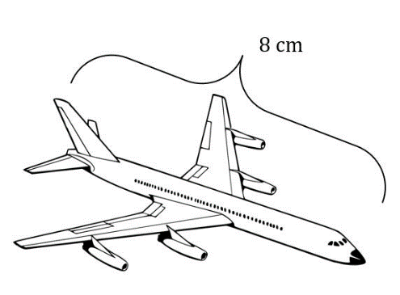

- The dresser in the picture is scaled to a doll house using scale 1 : 10.
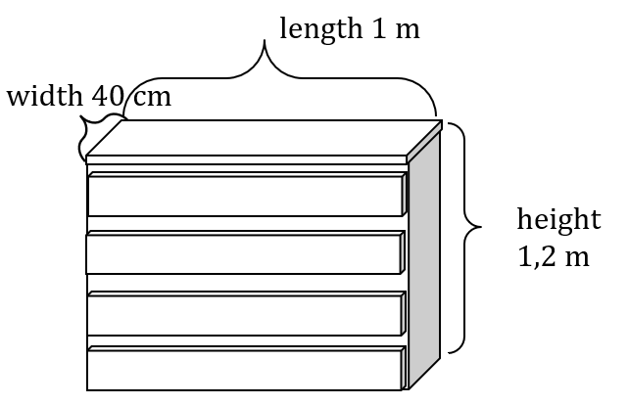
Calculate the dimensions of the dollhouse dresser.
Length ________________
Width ________________
Height ________________
Give the answers in cm.
- The desk in the picture is scaled to a doll house using scale 1 : 10.
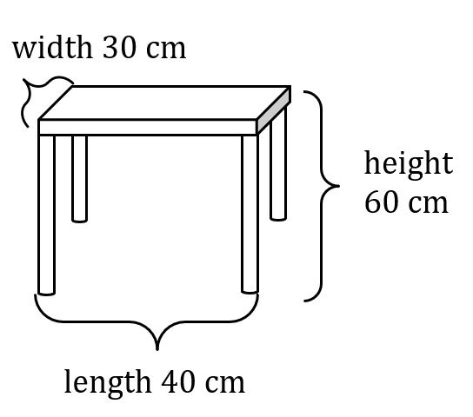

Calculate the dimensions of the dollhouse desk.
Length ________________
Width ________________
Height ________________
Give the answers in cm.

- The bed in the picture is scaled to a doll house using scale 1 : 10.
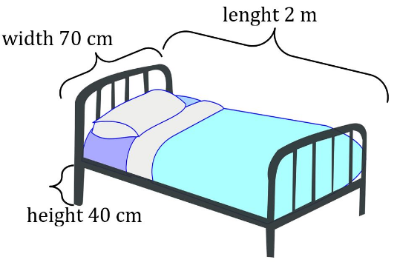
Calculate the dimensions of the dollhouse bed.
Length ________________
Width ________________
Height ________________
Give the answers in cm.

Calculating the area and perimeter

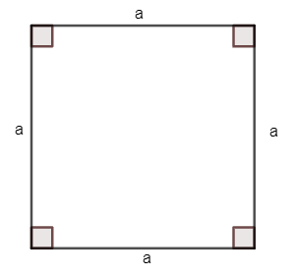
Square
- All the sides of a square have the same length.
- All the angles are 90 degrees.
- The sum of the angles is 360 degrees.

The area and perimeter of a square:
perimeter p = 4a
area A = a⋅a

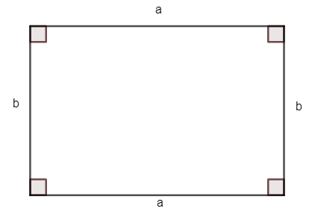
Rectangle
- The opposite sides have the same length.
- All the angles are 90 degrees.
- The sum of the angles is 360 degrees.

The area and perimeter of a rectangle is
p = 2a + 2b
A = a⋅b
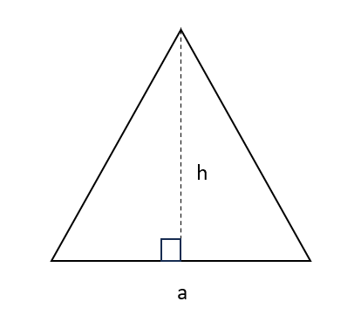

Triangle
- The area of a triangle is calculated with the formula:
A=length of base⋅height÷2
or A=a⋅h÷2
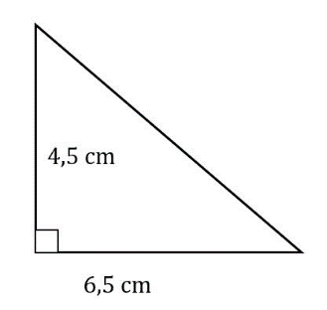
- The sum of all angles is 180 degrees.

The area of the triangle in the picture is
A=6,5cm⋅4,5cm÷2=14,625 cm²

Parallelogram
- The area of a parallelogram is calculated in the same way as rectangles. Length times the height. Just remember that height needs to be in a 90-degree angle.
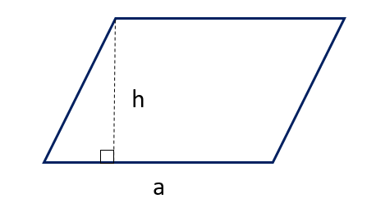
- A=length ⋅ height or A=a ⋅ h

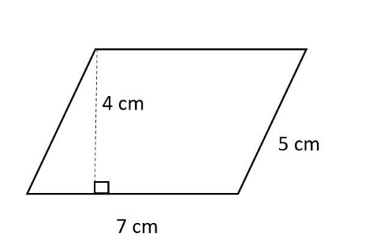

A = 7 cm ⋅ 4 cm = 28 cm²
p = 2⋅7cm + 2⋅5 cm = 24 cm

Trapezoid

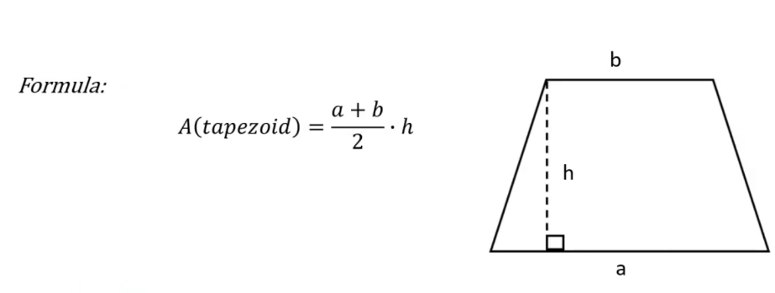

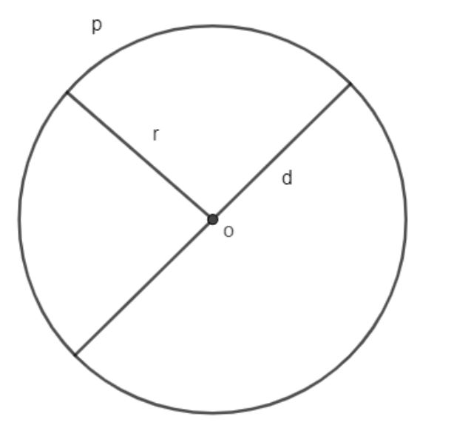
Circle
- Formulas
p = $2πr$ =$πd$
A = $πr^{2}$

Example
r (radius) = 4,5 cm
d (diameter) = 9,0 cm
p = $π∙9,0 cm≈28 cm$
A = $π∙{\left(4,5 cm\right)}^{2}≈64 cm^{2}$

Exercise
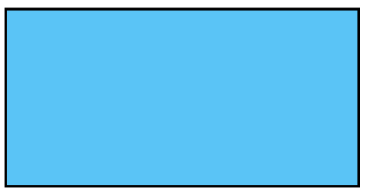
- Calculate the area and the perimeter. Length is 18 cm and the height is 10 cm.
Area A=
Perimeter p=

- Calculate the area of the triangle.
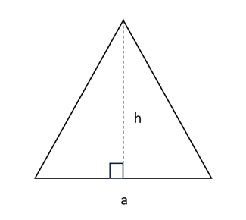
a = 20 cm
h = 25 cm

Area A =
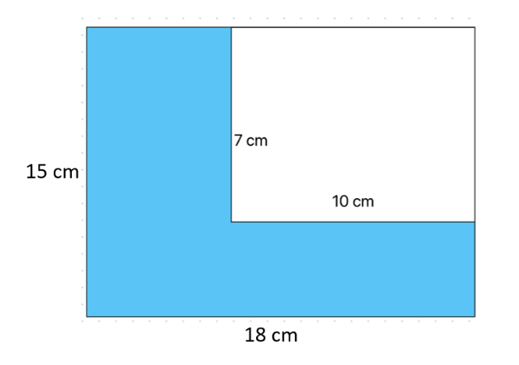
- Calculate the blue area.

Area A =
Perimeter p =

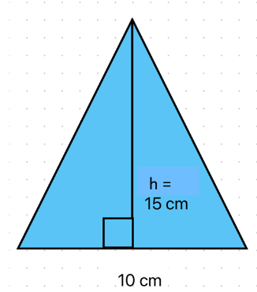
- Calculate the area of a triangle.
A =

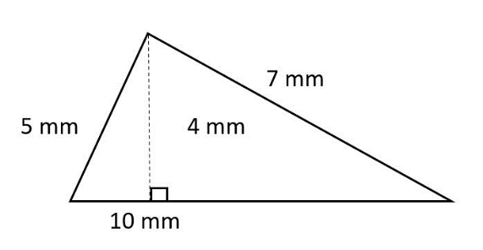
- Calculate the area and the perimeter.

A =

p =
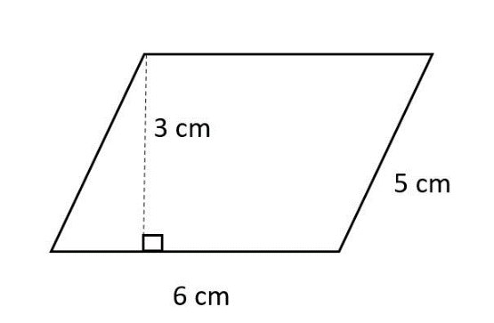
- Calculate the area and the perimeter.

A =
p =

- Calculate the area.
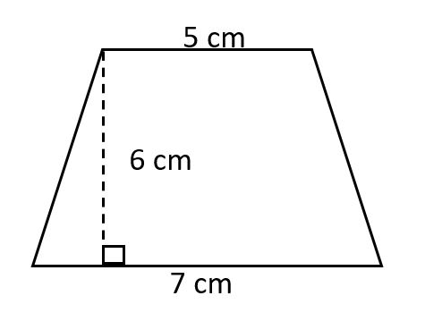
The area of a trapezoid is calculated with a formula A=(a+b)÷2·h, where a and b are the parallel sides (5 cm ja 7 cm). h is the height (6 cm).

- Calculate the area and perimeter of a circle.
r = 12 cm
r

- The length of a rectangle is 16 m and the width is 18 m. Calculate the area of the rectangle.
Give the answer without unit.
- The base of a triangle is 3,9 m and the height is 1,3 m. Calculate the area of the triangle.
Give the answer in tenths and without unit.
- The side of a square is 4 cm. Calculate the area?
Give the answer without unit.
- The length of a rectangle is 56 cm and height is 20 m. Calculate the area in square centimeters.
Give the answer without unit.
- The sides of a parallelogram are 48 cm and 59 cm. The shorter sides are 31 cm apart. Calculate area.
Give the answer without unit.

- Calculate the surface area of a desk. The length of the rectangular desk is {p} m and width is 75 cm.
Give the answer in tenths and without unit.
- A chess board consists of 64 squares. Calculate the area of the chess board when one square has the length 2 cm.
Give the answer without unit.
- The rectangular house has a surface area of 1500 m². The street side of the plot is 20 meters. How far from the street is the opposite side of the plot?
Give the answer with unit.
- Calculate the area of a circle that has a radius of 4 m.
Give the answer with 2 decimals and without unit.
- Calculate the area of a circle that has a diameter of 10 cm.
Give the answer with 2 decimals and without unit.
- The round metal wire has a cross-sectional diameter of 13 mm. Calculate the cross-sectional area of the wire.
Give the answer with 2 decimals and without unit.
- Calculate the perimeter of a circle. The radius of the circle is 5,2.
Give the answer with 2 decimals and without unit.
- Calculate the perimeter of a circle. The diameter of the circle is 9.
Give the answer with 2 decimals and without unit.

Calculating the volume of an object

Cylinders and prisms
The volume of cylinders and prisms is calculated generally with formula.
V = area of the base · height or V = Ah

Cube
a
a

a
- A cube is an object with 6 square faces that meet at right angles.
- V = a³

Rectangular prism or cuboid
- A rectangular prism is an object with 6 rectangular faces that meet at right angles.
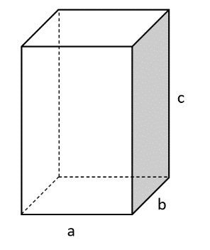
- V = a · b · c

Circular cylinder
- A circular cylinder is an object that has a circle as the base.
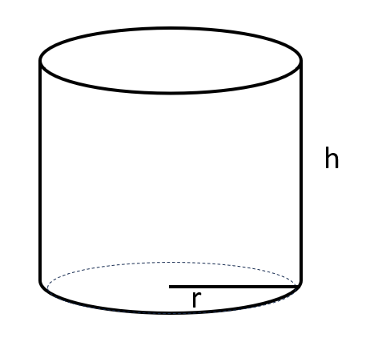
- V = πr²h

Cones (pyramids and circular cones)
The volume of cylinders and prisms is calculated generally with formula.
V = area of the base · height÷3 or V = $\frac{1}{3}$Ah

Pyramid
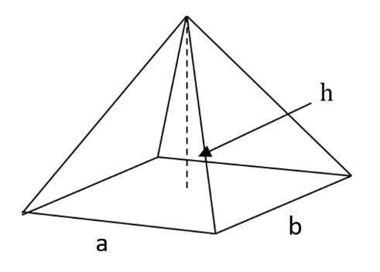
- Pyramids are cones where the base is a polygon.
- V = a · b · h ÷ 3

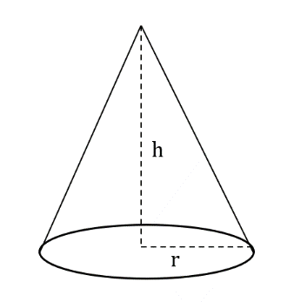
Circular cone
- A circular cone has a circle as the base.
- V = πr²h÷3

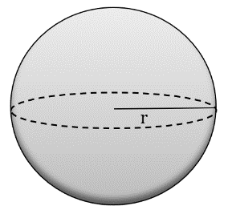
Sphere
V = $\frac{4}{3}πr^{3}$

Exercise
Calculate the volume.
The sides of a rectangular prism are 3 cm, 6 cm and 9 cm. V = _________cm³
The side of a cube is 5 cm. V = _________cm³
The base of a cone has an area of 30 cm². The height of the cone is 5 cm. V = _______cm³
The base radius of a circular cylinder is 3 cm and the height is 7 cm. V = _________cm³
The radius of a sphere is 4,6 cm. V = ____________cm³

- Calculate the volume of this rectangular prism.
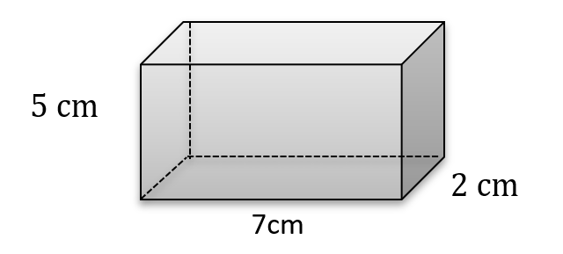
V = ______________ cm³
- Calculate the volume of this rectangular prism.
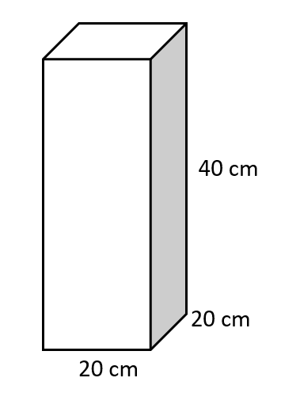
V = ___________________ cm³

- Calculate the volume of this cylinder.
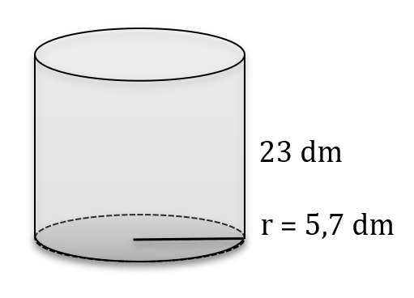
Give the answer in tenths.
V = ________________ dm³
- Calculate the area of the base and the volume of this prism.
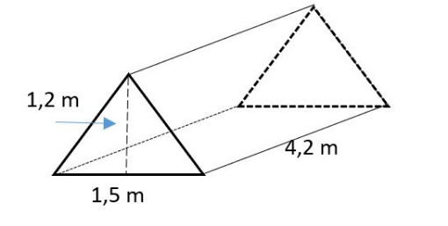
Give the answer in tenths.
Area of base A = __________ m²
Volume V = ______________ m³

- Calculate the volume of this object.
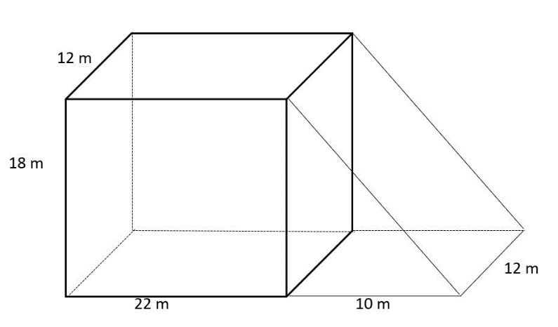
Volume V = ______________ m³

- Calculate the volume of this pyramid.
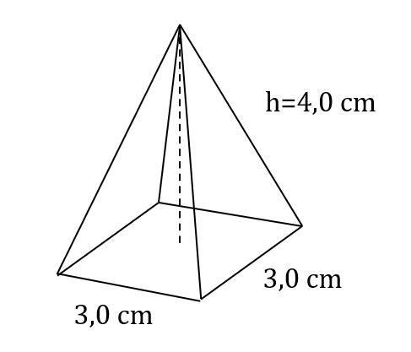
Volume V = ______________ m³
- Calculate the volume of this cone.
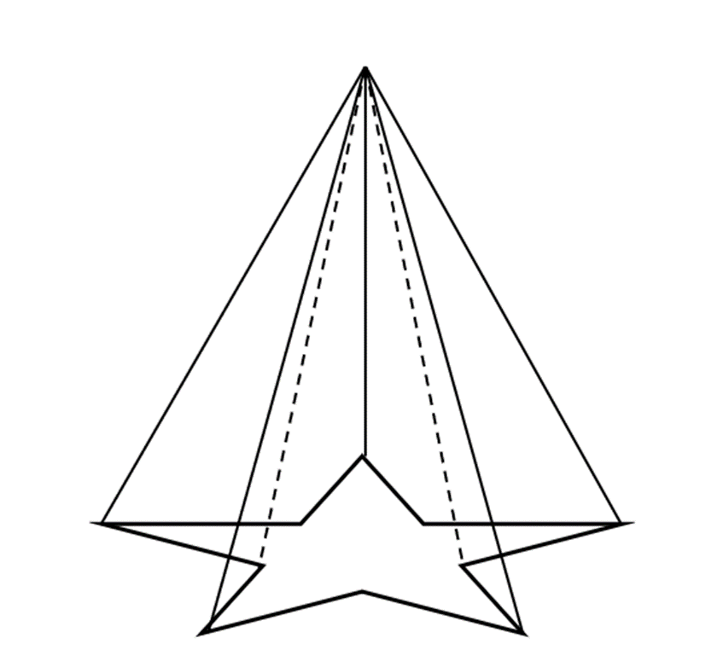
Area of the base is 21 cm².
Height is 5 cm.
Volume V = ______________ m³
- Calculate the volume of this circular cone.
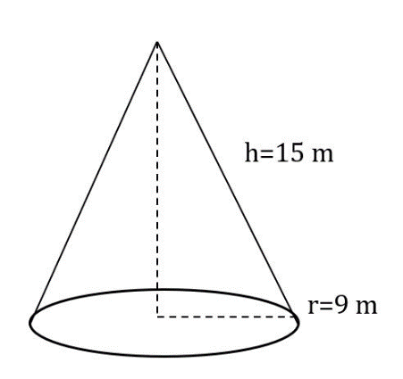
Give the answer in tenths.
Volume V = ______________ m³

- Calculate the volume of this sphere.
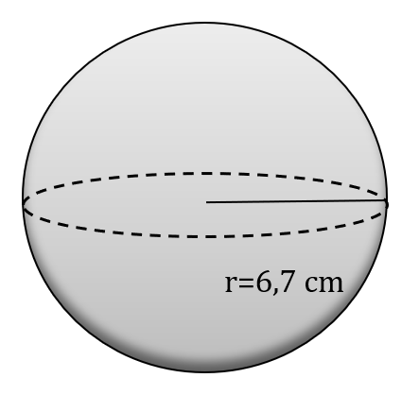
Give the answer in tenths.
Volume V = ______________ m³

- Calculate the volume of the cylinder in the picture. There is a hole in the middle. Inner radius is 1 cm and outer radius is 2 cm.
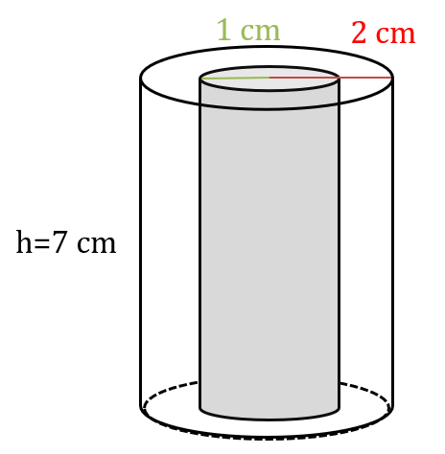
Round the answer to whole numbers.
Volume V = ______________ m³

- The sides of a rectangular prism are 6 m, 10 m and 2 m. Calculate the volume. Round answer to whole numbers and give it without unit.

- Side of a cube is 4,7 m. Calculate the volume. Round answer to tenths and give it without unit.

- Radius of a sphere is 3,2. Calculate the volume. Give the answer in hundredths.

- The area of a base in a circular cone is 9π and the height is 8,2. Calculate the volume. Give the answers in tenths.

- The base of a pyramid is a square. The length of the square is 7 cm. The height of the object is 12 cm. Calculate the volume. Round the answer to whole numbers and give it without unit.

- Solve an equation! The area of a base in a prism is 40 cm² and the volume is 1500 cm³. What is the height of this prism. Give the answer with unit.

- Solve an equation! The volume of a cube is 512 cm³. What is the length of the side of the cube? Give the answer with unit.
Hint: Use roots!

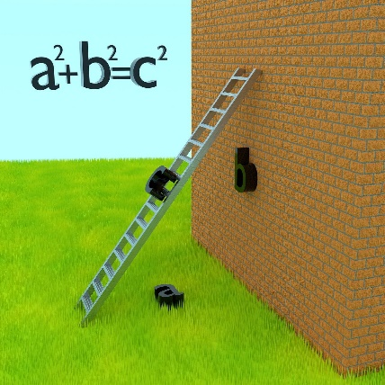
Pythagoras theorem
History: The exact origin of the theorem's application is uncertain, but evidence suggests that ancient civilizations such as the Babylonians and Egyptians had knowledge of the relationship between the sides of a right triangle even before Pythagoras. However, Pythagoras and his school formalized the theorem and its proof, which is why it bears his name.
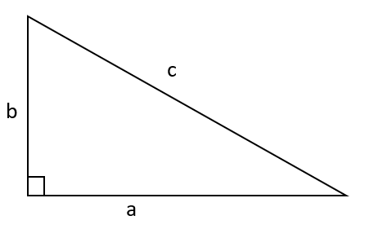
a
c
b
hypotenuse
leg

leg

c is hypotenuse (always the longest side), b and a are legs or adjacent sides to the right angle.
Formula
$$a^{2}+b^{2}=c^{2}$$

Example
Solve x.
3
x
4
$$3^{2}+4^{2}=x^{2}$$
$$25=x^{2}$$
$$x^{2}=25$$
$$x=\sqrt{25} or (x=-\sqrt{25})$$
Length can’t be negative, so answer is x = 5.

Example
Solve x.
x
25 cm
15 cm
$$x^{2}+{15}^{2}={25}^{2}$$
$$x^{2}=625-225$$
$$x^{2}=400$$
$$x=\sqrt{400} or (x=-\sqrt{400})$$

$$x=20 (cm)$$

Exercise
- Solve x.
15
x
8

8
10
x
x
25
7
12
x
5
- Solve x. Round the answer to tenths.

x
4,6 cm

9,1 m
x
3,4 cm
8,5 cm
19,4 cm
x

- A triangular lot has sides measuring 25 meters, 36 meters, and 39 meters. Is it a right triangle?
- A ladder is leaning against a wall. If the ladder is 10 meters long and the distance from the foot of the ladder to the wall is 6 meters, how far up the wall does the ladder reach?
- Find the length of the diagonal of a rectangle whose sides measure 6 cm and 8 cm.
- A right triangle has one leg measuring 5 cm and the hypotenuse measuring 13 cm. Find the length of the other leg.

Final test
FORMULAS:
Circle A $=π∙r^{2}$ $p=2∙π∙r$
Trapezoid A=(a+b)÷2·h
Cone $V=\frac{A∙h}{3}$
Circular cone $V=\frac{πr^{2}∙h}{3}$
Circular cylinder $V=πr^{2}∙h$

Volume of sphere $V=\frac{4}{3}∙πr^{3}$
Pythagoras theorem $a^{2}+b^{2}=c^{2}$

NAME__________________ Geometry
Group ID________ Score _______/25 points

230 000 m² | a | ha
21,3 a | m ² | ha
9 400 000 mm² | cm² | m²
- Covert the units

/3
2,55 m³ | dm³ | l (litre)
8 l | dm³ | cm³
9 900 000 000 mm³ | cm³ | m³
- Covert the units

/3
- Scale of a map is 1 : 20 000.
What is the distance in nature if the distance in map is 3,6 cm?
Give the answer in meters and with a unit.
/2

- Scale of a map is 1 : 20 000.
What is the distance in map if the distance in nature is 1800 m?
Give the answer in centimeters and with a unit.
/2

- Calculate the area.
The base of a triangle is 70 m and the height is 57 m. Calculate the area of the triangle.
Give the answer as a whole number and without a unit.
/2

- Calculate the area.
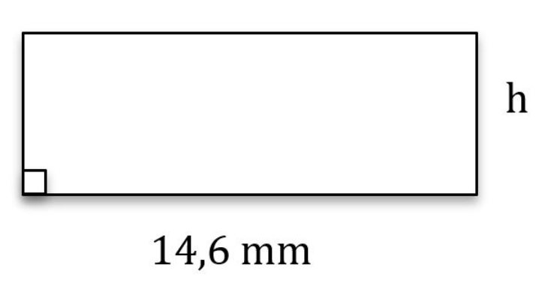
h = 7,9 mm. Give the answer in tenths and without a unit.
/2

- Calculate the area and the perimeter of a circle.
The diameter of the circle is 24 cm.
Give the answer in tenths.
Area =_________________ cm²
Perimeter =_____________________cm
/2

- Calculate the volumes of the following objects.
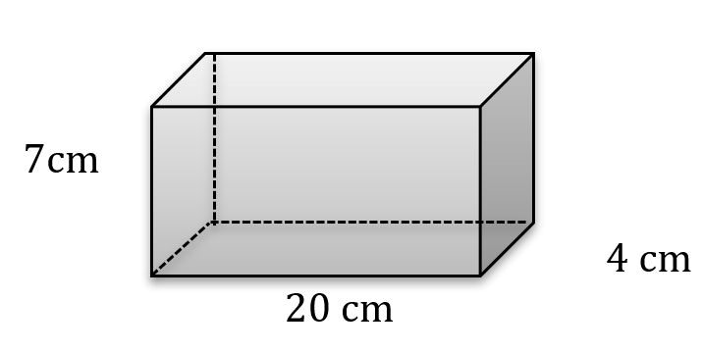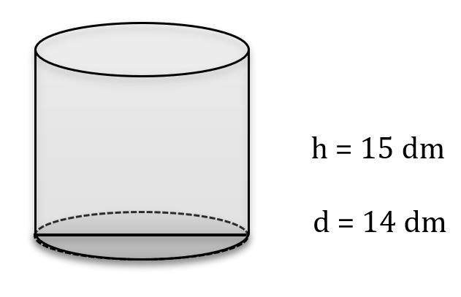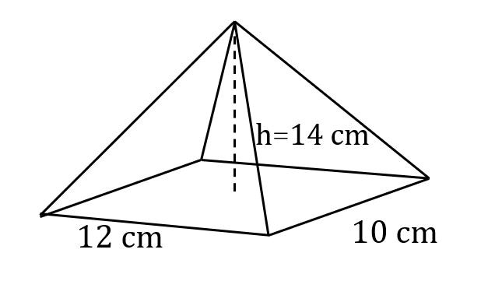
V=

Round the answer to whole number.
V=

V=

/3

- Calculate the volume.
The shape of a sport center is a half sphere. Calculate the volume when the diameter is 70 m.
Give the answer as a whole number without unit.
/2

- Solve x when h=4,6.
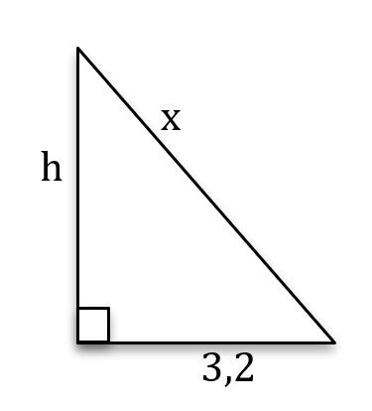
Give the answer in tenths.
/2

- Solve x when h = 10.
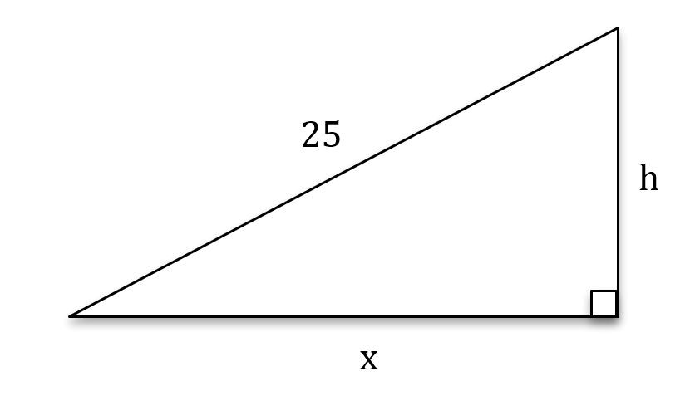
Give the answer with one decimal.
/2

Percentages

Percentages
Percentage calculations are needed in many everyday and work situations, such as price reductions, increases and tax calculations. Percentages are used to describe the relative proportion of things in the whole.

A percentage is the ratio of a number to 100. One percent equals the one hundredth:
$$1 \%=\frac{1}{100}=0,01$$

A percent can be converted to a decimal number by dividing by one hundred.

Example 1.
Write these percentages as decimals:
$$12 \%=\frac{12}{100}=0,12$$

$$2,3 \%=\frac{2,3}{100}=0,023$$

A Decimal number can be converted to percent by multiplying by on hundred.

Example 2.
Write these decimals as percentages:
$$0,47=0,47⋅100 \%=47 \%$$

$$0,09=0,09⋅100 \%=9 \%$$

Definition:
The base value or base corresponds to one hundred percent.
The base is the whole quantity.

Example 3:
The population of Finland is 5,5 million. 85,9 % of the population spoke Finnish.
In this example, the base value is 5.5 million.

Exercise
1. Change to decimal number:

a) 20 % =

b) 35 % =

c) 57 % =

d) 94,7 % =

e) 221 % =

f) 0,07 % =

2. Change to percent (remember to write %-sign).

a) 0,4 =

b) 1,2 =

c) 0,56 =

d) 13 =

e) 0,571 =

f) 0,0052 =

Basic percentage calculations

Taking a percentage

When you want to calculate how much a certain percentage represents of the base value, you are solving percentage value problems.

These problems are solved as follows:
Convert the percentage to a decimal number by dividing it by 100. This gives you the percentage coefficient.
Multiply the base value by the percentage coefficient.

Example 4a
How much is 45 % of 500 €?
Convert percent to decimal number: $45 \%=\frac{45}{100}=0,45$
Multiply the base value by the decimal number: $0,45⋅500 €=225 €$
You can also solve problems of this type by first determining what amount corresponds to 1 % share. After this, you multiply the obtained share by the desired percentage:

Example 4b
How much is 45 % of 500€?
Divide the base value by 100 to find 1% share: $\frac{500 €}{100}=5 €$
Multiply 1% share by desired percentage: $5 €⋅45=225 €$

Calculating a percent
If you want to calculate how many percent of a value is from the base value, you calculate the percent.

These types of problems are solved as follows:
Divide the specified value in the task by the base value.
Convert the answer to percentages by multiplying by 100 %.

Example 5
How many percent is 35 m of 400 m?
Divide amount by the base: $\frac{35 m}{400 m}=0,0875$
Convert decimal number to percent: $0,0875⋅100 \%=8,75 \%$

Decreases/increases
Changes in value can be expressed as a percentage. For example, a drop in the price can be announced with a discount percentage. In value changes, the amount describing the initial situation is 100 %.
When the value decreases, the percentage decrease in value is subtracted from the 100 percent amount.
Decrease: 100 % - decrease%
Example 6
20 % of phones battery has used. How many percent is left?
Phones full battery equals 100 % charge. Then 100 % - 20 % = 80 %

Correspondingly, when the value increases to one hundred percent, the percentage increase in value is added.
Increase: 100 % + increase%
Example 7
The price of the product increased by 5 %. The new price of the product is then
100 % + 5 % = 105 % of the original price.

Finding the base value
In some percentage calculations we want to find what is the initial value. In other words, we want to find the base value of the task.
To find the base value follow these steps:
Divide the known amount by the corresponding percent value.
Multiply with 100 %.
Example 8
The selling price of the shirt is 25 €. What is the price of the shirt without tax?
The sale price of the shirt consists of the tax-free price and value added tax (24 %).
The selling price of the shirt as a percentage is 100 % + 24 % = 124 %.
Taxfree price is 100 % amount and we can calculate it by using the steps above:
- Divide the known amount by the percentvalue: $\frac{25 €}{124 \%}=0,2016 €$
- Multiply the answer by 100 %: $0,2016 €⋅100 \%=20,16 €$
Answer: The price without tax is 20,16 €.

Permille
A permille is the ratio of a number to 1000. (Compare that percent is the ratio of a number to 100.)
One permille equals the one thousand: $$1 ‰=\frac{1}{1000}=0,001$$
Permille calculations are calculated in the same way as percentage calculations.
Example 9
Calculate how much is 16 $‰$ of 3000.
Convert 16 $‰$: $\frac{16 ‰ }{1000}=0,016.$
Multiply the base value by decimal number: $0,016 ⋅3000=48.$

Percentage changes
Sometimes we want to know by how many percent a quantity changes or how many percent two values differs of each other.

Comparison percentage
When comparing the difference between two things in percentages:
Find the difference between the values.

- Divide the difference by the value to be compared.
- Convert the answer to a percentage.
Tip! The comparable value can be found after the word than.

Example 10
How many percent is 75 € bigger than 50 €?
- Difference between 75 € and 50 € is $75 € - 50 € = 25 €$.
- We compare the difference to 50 €. $\frac{25 €}{50 €}=0,5$
- Multiply the answer by 100 %: $0,5 ⋅100 \%=50 \%$
Answer: 75 € is 50 % bigger than 50 €.

Exercise

1. What is

a) 20 % of 80?

b) 4 % of 150?

c) 5 % of 900?

d) 30 % of 80?

e) 200 % of 30?

f) 22,5 % of 460?

2. How many percent is

a) 2 of 50?

b) 15 of 75?

c) 400 of 1600?

d) 3 of 75?

e) 200 of 50 000?

f) 60 of 25?

3. What is the base value in the following cases?
a) The product's price decreased by 8 %, after which the price was 1200 €.
b) The value-added tax is 26 % of the product's selling price.
c) In 2019, a certain hand sanitizer had a market share of 20 % of the European hand sanitizer market.
d) The bookshelf cost 400 € with a 60 % discount.

4. Calculate the base value, if
a) 50 % of a number is 40

b) 20 % of a number is 500

c) 15 % of a number is 30

d) 25 % is 13

e) 125 % is 100

f) 3 % is 60

Change percentage
When calculating a percent change from an initial value to a final value
- Find the difference between the initial and final values.
- Divide the difference by the initial value.
- Convert the answer to a percentage.
Example 11
Your salary increased from 1 500 € to 2 000 €. How big was your salary increase as percentage?
Difference between values: 2 000 € - 1 500 € = 500 €
Initial value is the salary before increase: 1 500 €. Divide difference by that value: $\frac{500 €}{1 500 €}=0,333$
Multiply the answer by 100 %: $0,333 ⋅100 \%=33,3 \%$
Answer: Salary increases 33,3 %.

Taxes and interest
You can bump into percentages in many everyday situations. Tax rate tells you how much tax you have to pay out of your salary. Interest rate tells you what is the cost of borrowing money or the return on your savings and investments.

Taxes

Salary taxes
Salary taxes refer to the taxes deducted from an individual's income. The amount of income tax deducted depends on factors such as the individual's total income, home town, etc.
Example 12
Your salary before taxes is 2 500 €. Your tax percent is 20 %. How many euros you pay taxes?
Let’s change the percent to decimal and the multiply it with the salary:
$$0,20⋅2 500 €=500 €$$
Answer: You pay 500 € of salary and then you will be paid $2 500 €-500 €=2 000 €$.

Value Added Tax
Value Added Tax, often abbreviated as VAT (in Finland ALV = arvonlisävero) is a type of consumption tax that is levied on the value added to goods and services at each stage of production or distribution. In other words, it's a tax on the final consumption of goods and services.

The standard VAT rate in Finland is 25,5%, but there are also reduced rates of 14% and 10% for certain goods and services, such as food, books, and transportation.

Value Added Tax (VAT) is calculated based on the tax-free selling price of the product, and it is included in the selling price of the product:
Product price = tax-free price + VAT

Example 13
The tax-free price of a shirt is 23 €. What is the shirt's selling price including tax?
The VAT rate for the shirt is 25,5 %.
So, for the shirt's price: $23 €⋅ 0.255 = 5,865 €≈8,87 €$
The shirt's selling price including tax is 23 € + 5,87 € = 28,87 €

Example 14
A book costs 17 € in the store. What is the book's tax-free price? The VAT rate for the book is 10 %.
Using the finding the base value technique, divide the book's price by the percentage coefficient.
$$\frac{17 €}{110 \%}⋅100 \%=15,45 €$$

Exercise
1. How many percentage did the price of gasoline change when it
a) first increased by 10 % and then decreased by 10 %?

b) first increased by 15 % and then decreased by 8 %?

c) first decreased by 20 % and then increased by 30 %?

2. A new iPhone 12 costs 1278 € and a used iPhone 11 costs 749 €.
a) By what percentage is the iPhone 12 more expensive than the iPhone 11?

b) By what percentage is the iPhone 11 cheaper than the iPhone 12?

3. The Norwegian salmon has two prices marked: 14,50 € and 8,00 €, with the higher amount crossed out.
a) By how many euros has the price been reduced?

b) By what percentage has the price of the Norwegian salmon decreased?

c) By what percentage was the original price higher than the discounted price?

4. Timo worked at the same place for two summers.
In the first summer, he earned 1520 euros, and in the second summer, he earned 1610 euros. By what percentage did Timo's salary increase?

5. In 2003, Niko was 176 cm tall, and the following year he was already 184 cm tall.
During the same period, his weight increased from 73 kg to 79 kg.
a) By what percentage did Niko's height change over the year?

b) By what percentage did Niko's weight change over the year?

c) Which grew more in percentage terms, Niko's weight or height?

d) How many percentage points was the difference in the relative change between Niko's weight and height?

6. A party's support drops from 19 percent to 12 percent.
a) By how many percentage points does the support drop?

b) By what percentage does the support drop?

7. The original price of the food is 12,60 €. Due to the last sale day, the shopkeeper reduces the price by 30 %.
a) How much is the discount in euros?

b) How much does the customer have to pay for the item after the discount?

Interest

Both businesses and individuals often need to borrow money from a bank when making significant purchases. Because lending money must be profitable for banks, the borrower must pay back more money than they originally borrowed. This increase in the amount of money is called interest.
Interest calculations are divided into two calculation methods, depending on whether the loan period is less than one year or several years.

Simple interest calculation
When the loan period is less than a year, the interest calculations are calculated using the simple interest calculation formula: $R=Krt$, where R = interest, K = principal, r = interest rate in decimal form, t = loan period in days.
Example 15
You took out a 600 € loan for 20 days with an annual percentage rate of 450%. Calculate the amount of interest on the loan.
Because the loan period is less than a year use the $R=Krt$formula, where
R = ?
K = 600 €
r = $450 \% :100 \%=4,5$
t = $\frac{20}{365}$
Let's plug in the values into the formula:
$$R= 600∙4, 5∙\frac{20}{365}=147, 945...€≈147,95 €$$
Answer: You have to pay an interest of 147,95 €.

Compound interest
Compound interest means you earn interest not just on the money you put in, but also on the interest that money earns over time. So, your money grows faster because you're earning interest on top of interest. It's like a snowball effect, where your savings or debt increases more and more as time goes on.
Here's an example of how it works:
- Initial Principal: You start with an initial amount of money, let's say 1000 €.
- Interest Rate: You have an interest rate, for example, 5% per year.
- Compounding Period: This is how often the interest is added to the principal. It could be annually, semi-annually, quarterly, monthly, or even daily.
- Accumulation: With compound interest, each time interest is calculated and added to the principal, the next time interest is calculated, it's based on the updated principal amount. So, you're earning interest on both the original amount and the interest already earned.
This compounding effect leads to exponential growth in the value of the investment or the debt over time.
For example, if you invest 1000 € at an annual compound interest rate of 5%, after one year, you'll have 1050 €. After the second year, you won't just earn another 50 € (5% of 1000 €), but 5% of 1050 €, resulting in 1102,50 €, and so on.
Similarly, if you have a loan with compound interest, the debt grows over time as interest is added not just to the original principal, but also to the interest that has accumulated.
When the loan period is several years, it is useful to use the following interest rate calculation formula:
$K_{n}=K∙q^{n}$, where
$K_{n}$ is the capital after $n$ period
q = 1 + initial rate in decimal
n = number of initial periods

Example 14:
You deposit 5 000 € into a high-interest account for 10 years. The promised interest rate is 4,6 % per year. How much does the sum grow?
This concerns compound interest. After each year, the interest is added to the principal, causing the interest to grow not only on the original principal but also on the interest already paid.
K = 5 000 €
q = 1 + 0,046 = 1,046
n = 10
Let's plug in the values into the formula:
$$K_{10}= 5000 €∙{1,046}^{10}=7839, 472... €≈7839, 47 €$$
Answer: After 10 years, the principal is €7,839.47.

Excercise

1. a) Calculate the interest rate when the interest on a loan of € 32 000 is € 1664 in six months.
Assume that the interest rate remains the same for the entire year.

b) Mr. Digi takes out a loan of € 1400 from the bank to buy himself a new LG OLED TV.
How much does Mr. Digi repay the bank in total when he pays back the loan and interest at the same time, 7 months after taking out the loan? The annual interest rate on the loan is 8,3 %.
Hint: Think about how many percent the interest is per month and multiply this by seven. After this, you can easily calculate the interest portion of the loan.

2. A poor math teacher had luck in the Eurojackpot and won a little pocket money, namely 90 million euros.
After some small celebrations and charitable donations, he had 40 million euros left.
He invested this amount in a stable growth account with an interest rate of 2,8 percent.
How much did the lottery win produce in interest income
a) annually?

b) monthly?

c) daily?

d) hourly?

Note: Always provide the answer to two decimal places and remember the € sign, e.g., € 269,89.

3. Timo deposits 4000 € into an account with an annual interest rate of 1,6 % at the beginning of March 2024.
In June 2024, he deposits another 3000 € into the same account.
Interest is paid into the account at the end of each year, and the interest is added to the principal.
a) How much money does Timo have in his account at the end of January 2007?

b) How much money does Timo have in his account at the end of January 2010?

4. a) The initial amount of the bill was 345,00 €. You pay the bill 112 days late, and the annual late payment interest rate is 8,6%. How much do you have to pay in interest?

b) You invest 2000,00 € in fund shares with an expected return of 14 % per year.
If the increase is steady, what is the expected value of your investment in 3 months?

5. Value-added tax is 25,5 % and is calculated from the pre-tax price.
a) What is the value-added tax when the pre-tax price is 86 €?

b) What is the pre-tax price when the price with tax is 44,64 €?

c) What is the price with tax when the pre-tax price is 21 €?

d) What is the price with tax when the value-added tax is 33,60 €?

6. Value-added tax is 25,5 % and is calculated from the pre-tax price.
a) What is the value-added tax when the price including tax is 118 €?

b) What is the pre-tax price when the price including tax is 67,50 €?

c) What is the price including tax when the pre-tax price is 43,30 €?

d) What is the pre-tax price when the value-added tax is 1050,60 €?

Final test
NAME: ___________________________ Percentages
Group ID: _________ Score: /48 points

You may use a calculator in this test. Write down all the steps.
- Convert percentages to decimal numbers. (4 p)
- $12 \% =$ c) $0,75 \% =$
- $113 \% =$ d) $37,5 \% =$
Convert decimal numbers to percentages. (4p)
- $0,45 =$ c) $0,999 =$
- $0,06 =$ d) $4,01 =$

- Find the solutions (3 p)
- How much is 25 % of 160 euros?

- How many percentages is 13 kg of 75 kilograms?

- 50 ml is 20 % of what amount?

- Solve the following problems. (6 p)

- 19 % of your income is spent on rent. If your salary is € 2 100, how much is left after you pay your rent?

- How much ethanol is there in a 0.5 litre bottle of hand disinfectant if the concentration of the solution is 65 %?

- Sneakers cost 130 euros but there is a discount of 25 %. How many euros cheaper are the shoes?

- Find the solutions. (6 p.)
- How many percentages is € 4 of € 130?

- You get a € 95 discount on a € 660 phone. How many percentages was the discount?

- A cocktail has 3,5 cl of pure alcohol. The volume of the drink is 10 cl. How many percentages of alcohol is there in the drink?

- Solve. (4 p.)
- Of what amount 75 % is 15 euros?

- You have eaten 90 g of nuts, which is 45 % of the whole bag. How much nuts were there when the bag was full?

- Solve. (6 p.)
- What is the new price, when
    - a price of € 450 was increased by 20 %

    - a price of € 3 750 was decreased by 4 %

- Your salary per hour is €10.20.
    - What is your new salary per hour if you salary goes up 4,5 % in February and 2,75 % in March?

    - How many percentages did your salary increase?
- Find the percent change (6 p.)
- How much smaller is 15 than 25 in percentages?

- How much lager is 15 than 25 in percentages?

- Rent A is € 560 a month and rent B is € 600 a month. How much more expensive is apartment B in percentages?

- Solve tax related problems. (4 p.)
  - Your gross income is €3 200 per month and tax rate is 20 %. How much is your net income?

  - The price excluding VAT for a product is € 34,50 and VAT is 14 %. What is the price of the product when value added tax is included?

- Calculate the rate of interest. (4 p.)
  - There is € 1 200 on a bank account with an interest rate of 2,5 %. How much interest is paid on the account
    - a year?

    - a month?

  - How much money will there be on the account after 10 years?

- The maximum score for this test is 48 points and you have to get 30 % correct answers to pass. What is the minimum number of points you need? (1 p.)

Statistics and diagrams
What will you learn while you are studying statistics?

In this course you get to know basics of creating and reading statistics:
- what knowledge you need to create a frequency table
- how to draw different kind of graphs
- how to get out information from statistic tables and graphs
- average, mode and mean, what are they
- how we describe the accuracy of statistics

How to read different kinds of graphs or diagrams
It is said that one picture tells more than a thousand words. We have all seen different kinds of pictures, diagrams, pictographs or graph plots. They illustrate statistic tables, we can see changes easily from that. It is also said that nothing lies like statistics. It is important to select the best type of diagram to give the reader valuable information.

The interpretation of graphs involves some basic rules: you must check the axis of the diagram, what they describe, what is the range of variables. Always read the texts below graphs. You can practice this in the exercise Read and interpret graphs.

Tables and categories
Tables are a good way to collect and organize information. You can insert variables, how many times you measure each other and then count the percentages from the whole data you have.

Frequency (f) = how many times each variable exists in the data. For example, How many students got the grade 3 from a math course.

Relative frequency (f-%) = how large a percentage of variable hits in the whole group of events/measured hits. For example, 20 % of students have got the grade 3 when we consider all students.

Often statistics are managed with computers (statistic counting programs), for example Excel, but at this point we do not use it.

Example1.
15 students have their math skills tested and they got the grades listed below:

3, 4, 4, 3, 5, 4, 2, 2, 1, 0, 1, 3, 4, 5, 4

Create a table where you count the frequencies (f) and the relative frequencies (f-%).

Solution.
You must create a frequency table. The first column is for the grades. The second is how many hits that grade has and in the third you count the percentages for each grade hits/all given grades.

Math grade | f | f-%
0 | 1 | 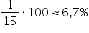  ​
1 | 2 | 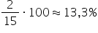  ​
2 | 2 | ​
3 | 3 | 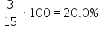  ​
4 | 5 | 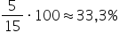  ​
5 | 2 | ​
total 15

Classes

- quite often your data is such that it is not useful without dividing it for classes

- if your data consists of a big variety of variables, it will make sense to build up classes and then create the frequency table.

- it is good to use a range where the length is the same throughout the table = the length of the class does not change.

How to create classes:

- every variable has to be included in one of the classes and only in one class

- a suitable number of classes is 4-10

- the Lower Control Limit (LCL) of classes should be ‘’round numbers’’, it is easier to notice them in graphs

Example 2
In a family gathering there were 26 persons and the range of ages was:

2, 11, 6, 12, 14, 17, 22, 20, 35, 29, 40, 52, 16, 16, 17, 18, 33, 43, 5, 68, 65, 84, 4, 57, 62, 11 (age)

Divide the given data to useful classes by using ages. (check given orders!)

Create a frequency table and calculate there the frequency (f) and relatively frequency (f%) for each class.

Solution.
In the given data the youngest person was 2 years old and the oldest was 84 years old. The first class will start from 0 (round number).

You can create classes in three different ways:
0-9, 10-19, 20-29,...
0-14, 15-29, 30-44,...
0-19, 20-39, 40-59,...

All three are suitable . Let’s choose the alternative B and fill in the table. How to count % is shown only in the first row.

Age (year) | f | f- %
0-14 | 8 | 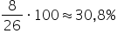​​​​
15-29 | 8 | 30,8 %
30-44 | 4 | 15,4 %
45-59 | 2 | 7,7 %
60-74 | 3 | 11,5 %
75-89 | 1 | 3,8 %
total 26

Example 3.

Children were running a 100 m track and their running times were measured.
The times were:

15,3 16,6 13,8 15,5 17,4 14,0 16,8 14,7 15,2 17,6 15,9
15,0 14,1 15,4 13,5 14,3 17,7 13,1 16,8 15,6 14,8 13,5
Create classes and draw a frequency table. Fill it in and calculate f and f%.

Solution. The best time was 13,1 s and the slowest took 17,7 s. We will start from 13,0 s and have a range of classes at an interval of 1 s. So the limits of the first class are 13,0 and 13,9. The second will be 14,0 and 14,9 etc.

running time (s) | f | f-%
13,0-13,9 | 4 | 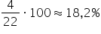​​​​
14,0-14,9 | 5 | 22,7 %
15,0-15,9 | 7 | 31,8 %
16,0-16,9 | 3 | 13,6 %
17,0-17,9 | 3 | 13,6 %
total 22
​

How to draw diagrams

When yoy want to use graphs, diagrams, bar charts etc, remember:

- PICTURE GRAPHS MUST BE EXPLICIT AND EASY TO READ, YOU DON’T NEED TO LOOK UP SOME SPECIFICATIONS TO UNDERSTAND IT (is it easy to someone else to understand what you are describing)

- always write on the vertical and horizontal axis information on what it stands for and also the scale that is used

- make it simpe, don’t be too colourful and avoid three-dimensional graphs

Here are the most common diagrams or graphs:

Vertical bar chart, Vertical bars
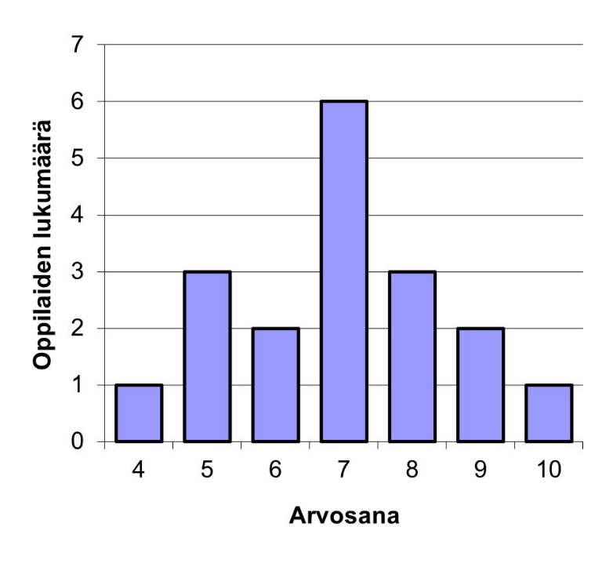

- Name the vertical and horizontal axis (grades and number of students) and don’t forget to add scales to them
- Vertical axis always starts from zero, you may not ‘’play’’ with it (for example cut it from the bottom)
- In a good bar diagram the gap between the bars is 50 % of the bar’s width

Horizontal bar chart, Horizontal bars
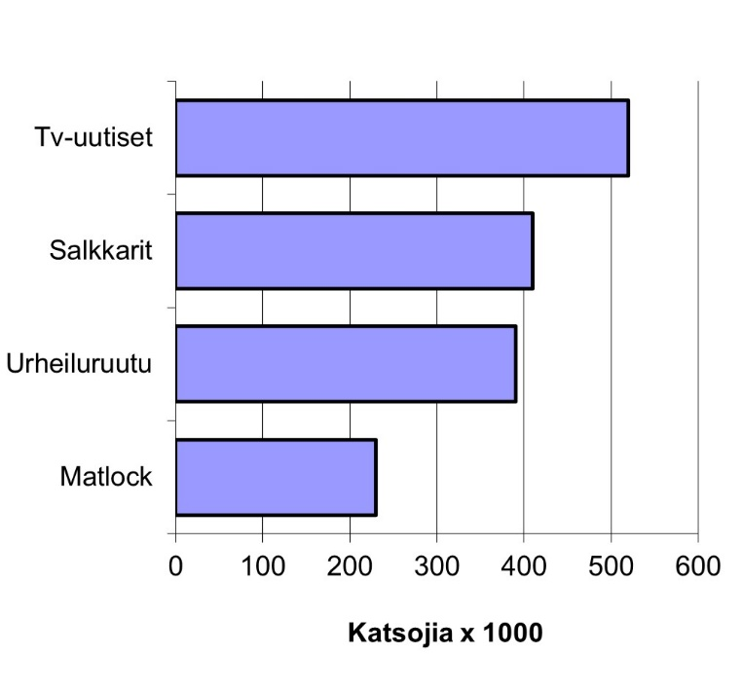
- In the horizontal bar chart all bars are arranged in logical order, WHEN THERE IS NO LOGICAL ORDER, THE LARGEST BAR IS ON TOP AND ALL OTHERS FALL IN SIZE TOWARD THE BOTTOM
- Name the axis, on the bar chart above there is no name, but we could have named it ‘’TV-programs’’
- Always give the scale on the horizontal axis
- In a good bar diagram the gap between the bars is 50 % of the bar’s width

Histogram (bars are attached to each other)
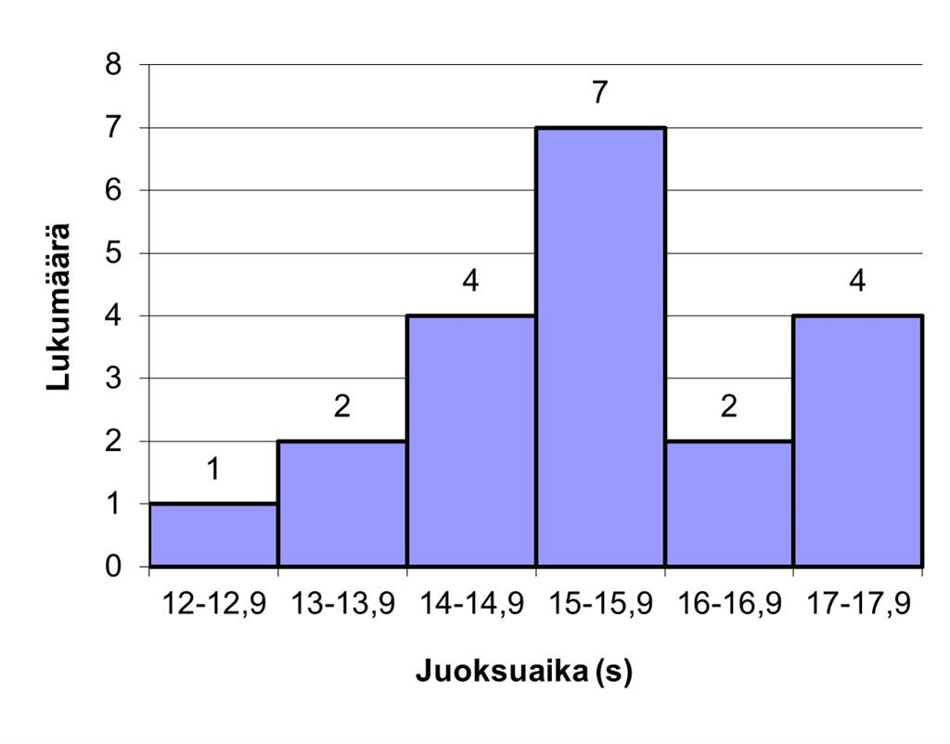
- When the data is divided in classes, we can draw a bar chart where the bars are attached to each other
- Always name the axis and add scales on them

Pie diagram, pie chart
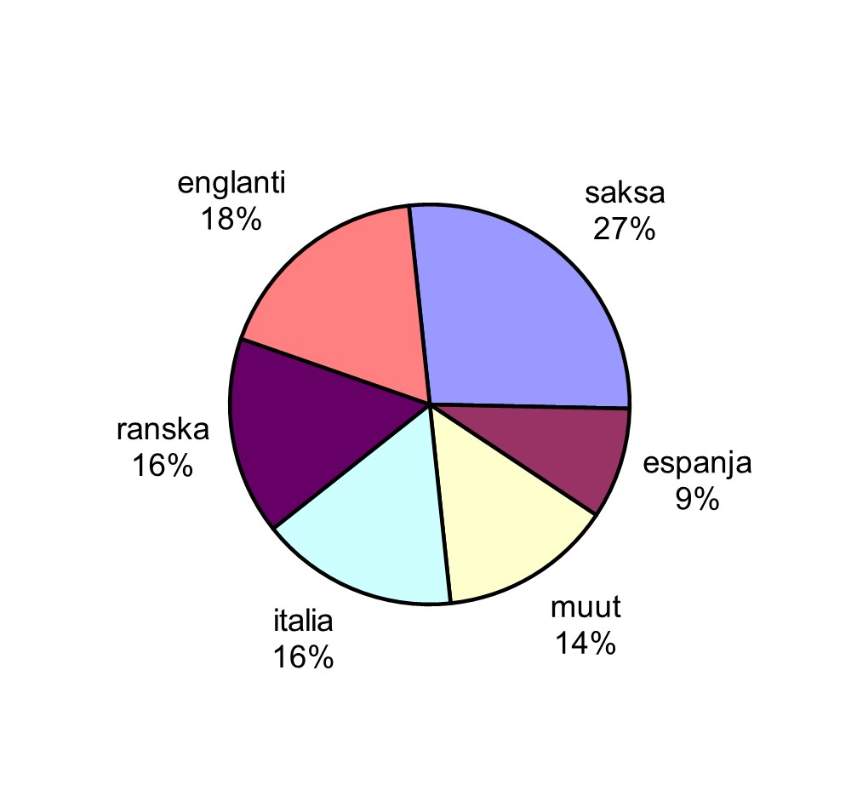
- Some guidelines on how to draw pie chart:
- in a good chart there are 6 sectors or less
- explain beside the sector what it stands for – not inside, not below (burgund means French)
- arrange the sectors by size
- if we start from 3 o’clock (the largest sector) we draw the rest of the sectors anticlockwise from the largest to the smallest. We can also draw clockwise and then we start from 12 o’clock (the largest sector) and organize the sectors from the largest to smallest

Practice: Reading diagrams

Statistics are often described by using different kind of diagrams, pie or bar charts etc. In this exercise you can practise your skills on reading them.
Always remember to be critical while reading different kinds of diagrams, as the information they give you may sometimes be inaccurate.

Exercise 1

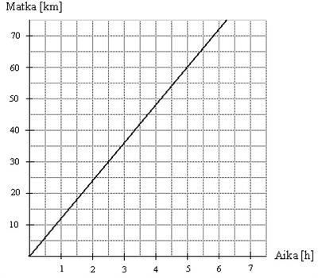

In this picture you can see Mikko’s riding kilometers versus the time (h) he has used.
Does Mikko have constant speed or does his speed alternate?
- Mikko rides his bike with constant speed
- Mikko rides his bike with alternating speed.
- I can’t get a hold of this one. I don’t know

Exercise 2

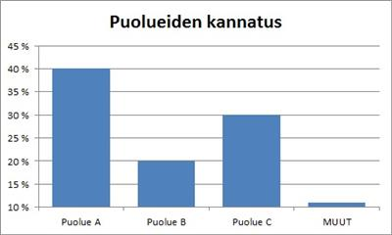

Support for parties. What argument or which arguments are true according to the above graph?
- The support for party A is double compared to the support for party B.
- The support for party C is double compared to the support for party B.
- Other parties (=Muut) are supported by hardly anyone.
- The support for party A is double compared to the support for party C.

Exercise 3
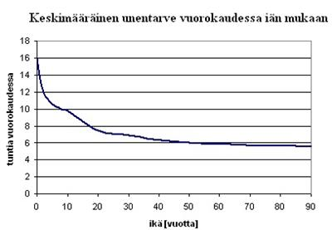
How many hours does a 90-year-old person need to sleep?
- 5 h
- 5,5 h
- 4h
- 6,5 h
- 24 h...at that age they sleep all the time
Exercise 4

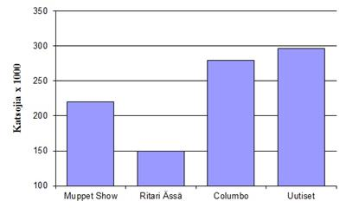
In this bar chart you can see the number of TV viewers on the vertical axis and the TV show on the horizontal axis.
By using this bar chart you have to decide which one of the following statements is true.

- Columbo is three times as popular as Ritari Ässä.
- The Muppet Show is watched twice as much as Ritari Ässä.
- Uutiset (The News) is watched nearly twice as much as Ritari Ässä.
- Nobody has ever been keen to watch these shows.

Exercise 5

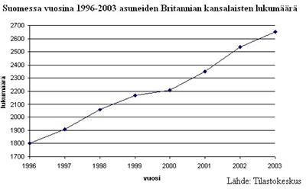

In this graph you can see how the number of British citizens has grown in Finland from 1996 to 2003. The vertical axis presents the number of people and the horizontal axis tells the year.
Question: In what year was the population of the British at its lowest? Give the year as your answer.
Exercise 6

When were there 2 200 British citizens living in Finland? Give the answer in numbers, for example 2019.

Exercise 7

In this picture you can see Mikko’s riding kilometers versus the time (h) he has used.
How many kilometers has Mikko cycled when he has used 10 hours? He does not change his velocity during that time.
- about 50 km
- about 80 km
- about 100 km
- about 120 km
Exercise 8

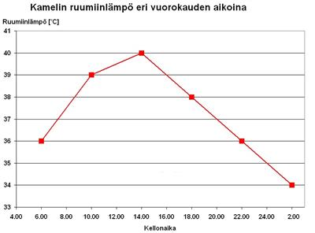

Here you can see a graph which tells you how the body temperature of a camel changes over 24 hours. The vertical axis is the body temperature and the horizontal axis tells you at what time it has been measured.
What is the body temperature of the camel at 20:00?

- I am not an expert – how can I tell!
- 35 degrees
- 36 degrees
- 37 degrees
- 38 degrees
- It burns!

Exercise 9
The average need for sleep per night considering a person’s age. The vertical axis tells you how many hours of sleep and the horizontal axis gives a person’s age.
How much sleep does a 20 years old person need?

- 10 hours
- 9 hours
- 8 hours
- 7 hours
- 6 hours
- 5 hours
- Young people do not need to sleep

Exercise 10

Here you can see a graph which tells you how the body temperature of a camel changes over 24 hours. The vertical axis is the body temperature and the horizontal axis tells you at what time it has been measured.

At what time is the body temperature of the camel at its lowest?

Practice: How to draw diagrams

Exercise 1.

Please notice, there are two tasks:

- Fill in the tables (fill in the table which is on the word document. There may be some extra lines in the tables)

- Drawing the charts (first draw charts on paper by hand, then take a picture of it and then add it at the end of the word document. (Lisää > Kuva)

Information of measurements.
Question was added to 20 students and questions (variables) were
a) my favourite food (there was list)
b) weight (kg)
c) pet
d) number of children in family
e) age

      - Fill in a frequency table for each variable. Count every frequency (f) and relatively frequency. If nesseary do divade variables in classes (f.e. age). The tables are all ready added on this sheet.

      - Draw a diagram of every variable on paper. You can hand them to teacher or take a picture of it and add it on your answer.

Follow instruction given in theory pages.

Here are diagrams you should draw:
a) favourite food => horizontal bar chart
b) weight => histogram
c) pet => pie chart
d) number of children => vertical bar chart
e) age => histogram

Number of persons | Variable  1 = pasta  2 = pea soup  3= fish soup 4 = sausage and mashed potatoes  5= pizza | Weight (kg) | Pet | Children | Age
1 | 5 | 51 | dog | 0 | 21
2 | 5 | 96 | dog | 1 | 23
3 | 2 | 55 | don’t have | 2 | 28
4 | 1 | 58 | cat | 2 | 44
5 | 1 | 70 | quinea pig | 4 | 48
6 | 4 | 68 | cat | 3 | 43
7 | 4 | 60 | dog | 2 | 34
8 | 5 | 85 | don’t have | 1 | 35
9 | 5 | 92 | don’t have | 0 | 21
10 | 4 | 72 | dog | 1 | 20
11 | 5 | 74 | quinea pig | 0 | 29
12 | 5 | 62 | dog | 0 | 41
13 | 3 | 88 | cat | 2 | 37
14 | 4 | 78 | don’t have | 2 | 28
15 | 1 | 65 | dog | 3 | 35
16 | 5 | 62 | dog | 2 | 24
17 | 1 | 64 | gold fish | 2 | 26
18 | 5 | 68 | don’t have | 1 | 44
19 | 4 | 75 | dog | 2 | 37
20 | 2 | 76 | cat | 1 | 29

a)

- Favourite food | Frequency  f | Relative  frequency  f%
pasta

b)

- Weight | Frequency  f | Relative  frequency  f%

c)
- Pet | Frequency  f | Relative  frequency  f%

e)

- Number of children | Frequency  f | Relative  frequency  f%

f)
- Age | Frequency  f | Relative  frequency  f%

Statistics - What Do the Figures Tell
What you will learn about statistical parameters:

- statistic values: mean or average, mode, median,
- statistics and Excel

Mean

The mean tells you about the average value of data. The mean is calculated by adding up each individual piece of data and then dividing it with the number of findings.

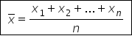

Example 1.

A students’ math test grades were: 7, 9+, 10, 6-, 8, 8, 9-, 7+, 8+ and 5.5. What is the mean?

Solution

If we know the value of each variable x_{i} and its frequency f_{i,} we can build up the formula

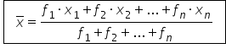

Example 2.

In the following frequency table we can see how the grades from a math course are divedid between students. Calculate the mean of the grades.

Grade | Frequency
0 | 2
1 | 4
2 | 6
3 | 10
4 | 8
5 | 5

Solution:

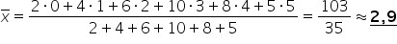

The mean is sensitive for big differencies of values.
If the data is small, one bigger deviation within values can shift the mean substantially towards that value.

Mode

The mode is the variable which is the most common within data. If there are two or more values that have the same common frequency they are all modes.
  - The mode can be identified for different kinds of variables (the most common grade, the TV show you watch etc.)
  - Within the data there can be more than one mode
  - If the data has been divided in classes, the mode is a class or in the middle of that class. For example data on students’ way to school has classes 1 – 199 m (f = 5), 200 – 399 m (f = 8), 400 – 599 m (f = 7) and 600 – 799 m (f = 2). Here the mode can be presented as 200 – 399 m or 300 m.

Example.
Here you have a frequency table of grades. Grade 3 has the highest frequency = 10
so Mo = 3.

Grade | Frequency
0 | 2
1 | 4
2 | 6
3 | 10
4 | 8
5 | 5

Median

When all data is organized from the smallest variable to the biggest one (or vice versa), the median Md is the middle one. If the number of observations is odd, Md will be in the middle. If the number of variables is even, the Md is the mean of those two in the middle or it is the smaller one of them.
- The median can be measured only when the data is organized according to the size of the observations

Example

Here you see math class grades after a period: 5, 6, 7, 9, 10, 9, 9, 6, 7, 8, 8, 4, 5
a) What is the median?
b) How does the Md change when we add one more 8 in the grades?

Solution.

First you have to organize the grades in order from the smallest to the highest:

4, 5, 5, 6, 6, 7, 7, 8, 8, 9, 9, 9, 10

a) The number of observations is 13, an odd number. Number of observations/2 = 13/2 = 6,5 => 7th observation is the median. Its value is 7 so Md = 7.

b) When we add one more 8, the number of observations is even. The two middle observations (7th and 8th) have values 7 and 8. Thus the mean is (7 +8)/2 = 7,5.
The median is then 7,5 or 7, both are correct.

You can always draw a frequency table and from there count the middle observation
(total f/2).

Excercise

1. When Pekka finished his basic education his marks on 12 subjects were:
8, 8, 7, 9, 6, 7, 6, 8, 7, 7, 6, 9
What is the mean of Pekka’s grades? Use one decimal (round up or down if necessary)

2. Tero Pitkämäki threw the javelin and his 6 best throws are
91,53 m
91,33 m
91,23 m
91,11m
90,54 m
90,33 m
Calculate the mean and give the answer by using two decimals (round up/down if necessary).

3. In this frequency table you can see the students’ grades and how many of them got the same grade. Calculate the mean. Use one decimal when answering.

Grade | Number of students
1 | 2
2 | 5
3 | 7
4 | 12
5 | 4
Total | 30

4. 8 workers were asked about their monthly earnings. Here you have the list of their answers:
1450 €
2100 €
1680 €
1850 €
1920 €
3100 €
2340 €
1800 €

Calculate the mean. Give the answer on the accuracy of one €.

5. Calculate the mean of the following lengths:
52 cm, 50 cm, 49 cm, 53 cm, 47 cm, 48 cm, 51 cm

6. Here you have a list of wages in euros. Can you find out the median?
1450, 2100, 1680, 1850, 1920, 3100, 2340, 1800, 2400

7. What is the median when the values are
1450, 2100, 1680, 1850, 1920, 3100, 2340, 1800

8. A distance between two places was measured and here are the results. What is the median?
52 cm, 50 cm, 49 cm, 53 cm, 47 cm, 48 cm, 51 cm

9. Jarmo’s grades are from the top to the bottom:
5, 6, 6, 7, 7, 7, 7, 7, 7, 8, 8, 8, 8, 9, 9

Calculate (if possible) the median.

10. A group of students has pets as listed:
a cat, a cat, a dog, a dog, a dog, a dog, a dog, a dog, a guinea pig, a rabbit, a horse, a horse, a budgie, a turtle.

Find the median (if possible).

a. You don't have a median!
b. a horse
c. a dog
d. a cat

11. A group of students has pets as listed:
a cat, a cat, a dog, a dog, a dog, a dog, a dog, a dog, a guinea pig, a rabbit, a horse, a horse, a budgie, a turtle.

Find the mode (if possible).

a. You don't have a mode!
b. a horse
c. a dog
d. a cat

12. What is the mode in the given data?
2 €, 2 €, 2 €, 5 €, 15 €, 15€, 20 €

13. What is the median in the given data?
2 €, 2 €, 2 €, 5 €, 15 €, 15€, 20 €

14. What is the mode in this data?

Opinion | Frequency
bad | 6
quite bad | 8
good | 14
excellent | 9
a. good
b. quite bad
c. excellent
d. bad

15. What is the mode in this data?

Pocket money | Number of persons
0-4 € | 5
5-9 € | 22
10-14 € | 7
15 € or more | 3
a. 10-14 €
b. Something else
c. 5-9 €

d. 0-4 €

e. 15 € or more

16. Here we have a bar chart of students’ grades. On the vertical axis is the number of students and on the horizontal axis are the grades from 1 to 5.

Calculate the average and use one decimal when you add your answer.

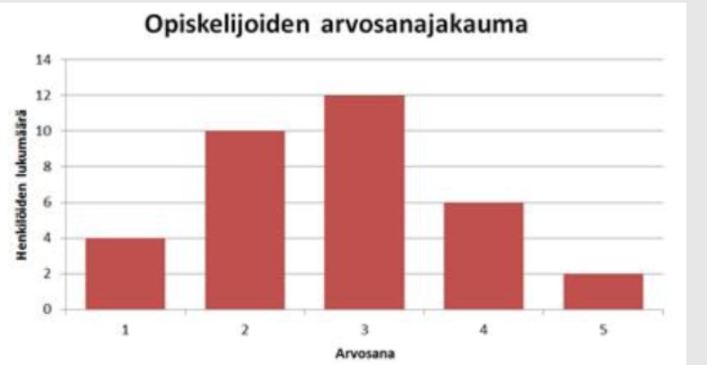

17. Here we have a bar chart of students’ grades. On the vertical axis is the number of students and on the horizontal axis are the grades from 1 to 5.
Calculate the mode.

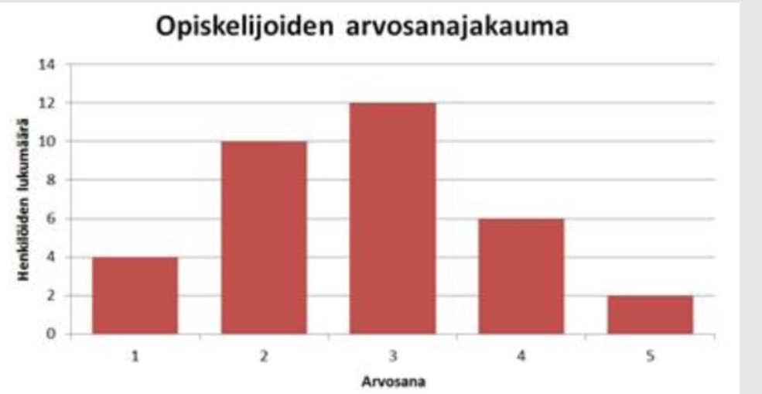

18. Here we have a bar chart of students’ grades. On the vertical axis is the number of students and on horizontal axis are the grades from 1 to 5.

Calculate the median and use one decimal when you add your answer.

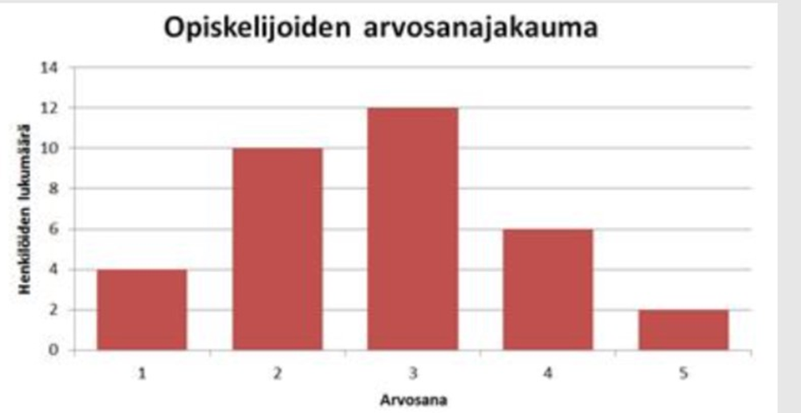

Final test

NAME__________________ Statistics
Group ID________ Score _______/16 points

1. A student got the following grades: 4, 4, 3, 2, 1, 4, 5, 5, 2, 3, 3, 3. Fill in frequencies and relative fre quencies in the table below. (6p)

Grade | Frequency | Relative frequency %
1
2
3
4
5

2. Shoe sizes of a group of friends are 43, 41, 45, 39, 46, 42 and 41. What is the shoe number
a) mean (2p)

b) median (1p)

c) mode (1p)

3. Answer using the information in the table below (3p)

Job vacancies 2020/IV – 2021/IV
 | Year/Quarter
 | 2020/IV |  | 2021/IV
 | Number | Share, % | Number | Share, %
Job vacancies | 33 400 |  | 59 100
Part-time | 5 300 | 16 | 9 300 | 16
Fixed term | 9 000 | 27 | 17 600 | 30
Hard-to-fill vacancies | 15 700 | 47 | 34 300 | 58

- How much did the total of job vacancies increase between 2020 and 2021?

- What kind of vacancies increased their share of the total number of vacancies the most?

- Sum up all the share percentages in the year 2021. Why is the sum not 100 %?

4. Answer questions about the graph below. (3p)

Source: Tilastokeskus

a) How many nights were spent in a hotel in the year 2023?

b) What is the difference in hotel use between 2010 and 2019?

c) What year had the lowest use of hotels in Finland? Why?

Self-evaluation and feedback
Time to complete max 5 min.
1) Please rate the following. Circle you choice.
Rating Scale 1 = Strongly disagree 2 = Disagree 3 = No comment 4= Agree 5= Strongly agree
- The contents of the course met my expectations. 1 2 3 4 5
- I enjoyed studying on this course. 1 2 3 4 5
- The instructions were clear. 1 2 3 4 5
- The tasks were versatile. 1 2 3 4 5
- The number of tasks was appropriate/OK. 1 2 3 4 5
- The course was useful and improved my skills. 1 2 3 4 5
2) The hours spent on studying. Please tick your answer.
0 - 10 h □
11 - 20 h □
more than 20 h □
3) Describe you studying process. Please tick your answer.
I did the tasks independently. □
I needed help in doing the tasks. □
- Please write how you received assistance.

4) What was your best achievement?

5) What did you find challenging?

6) How would you rate your skills on completing this course ? Please tick your choice.
Satisfactory 1 □
Satisfactory 2 □
Good 3 □
Good 4 □
Excellent 5 □

Give reasons.

Lähdeluettelo
Pixabay, s.a., lentokone https://pixabay.com/fi/vectors/lentokone-ilma-alus-suihkukone-2026921/, 20.11.2024
Pixabay, s.a., Pythagoras https://pixabay.com/fi/illustrations/pythagoras-lauseke-phytagoras-sats-6915523/ 20.11.2024
Pixabay, s.a., p,ythagoras https://pixabay.com/fi/vectors/pythagoras-kreikkalainen-5649998/, 20.11.2024
Pixabay, s.a., talo https://pixabay.com/fi/illustrations/suunnitelma-talo-arkkitehtuuri-998441/, 20.11.2024
Pixabay, s.a., kartta https://pixabay.com/fi/photos/kartta-matkustaa-kompassi-2685795/, 20.11.2024
Pixabay, s.a., sänky https://pixabay.com/fi/vectors/s%C3%A4nky-runko-metalli-tyyny-304051/, 20.11.2024

Tämä materiaali on tuotettu VIERKO-hankkeessa
vuonna 2024.
VIERKO on toteutettu Opetus- ja kulttuuriministeriön
vuonna 2023 myöntämällä ammatillisen koulutuksen strategiarahoituksella. VIERKO on kuudenkymmenen-
kahden (62) koulutuksen järjestäjän yhteisponnistus.
Työtä on koordinoinut Keski-Uudenmaan koulutus-
kuntayhtymä Keuda.

Hankkeessa on kehitetty vieraskielisen koulutuksen laatua
ja kotimaisten kielten opetuksen tarjontaa ammatillisessa koulutuksessa.

Lisätietoa:
https://www.keuda.fi/keuda/hankkeet/vierko/

https://creativecommons.org/licenses/by/4.0/

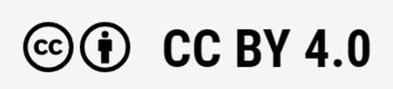
Oppimateriaalit:

CC BY-SA 4.0 Deed | Nimeä-JaaSamoin 4.0 Kansainvälinen | Creative Commons
https://creativecommons.org/licenses/by/4.0/

Oppimateriaalit:

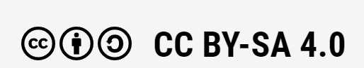

CC BY-SA 4.0 Deed | Nimeä-JaaSamoin 4.0 Kansainvälinen | Creative Commons

