Operating as a member of society and a citizen
2024

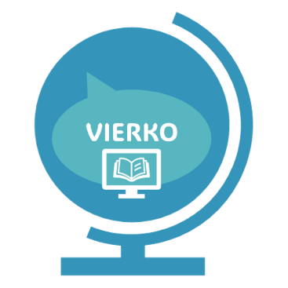
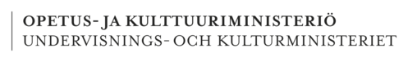

Laura Ahonen, Juha erämaa, jan hokkanen, jyrki juntunen, tiina kujala, teemu planting, nina pulkkanen, ville räsänen, tuomo tuomainen
Rahoittaja:

Vierko |www.keuda.fi/keuda/hankkeet/vierko

Sisällys
Johdanto 3
1. Orientation 5
1.1 TASK: Finnish society and values 6
1.2 TASK: Reliable sources of information 8
1.3 TASK: More than 100 years of independence 9
2. Fundamental Rights and Civic duties in Finland 10
2.1 TASK: Fundamental Rights - Drag and drop 10
2.2 TASK: Fundamental Rights - Test your knowledge 13
2.3 TASK: Fundamental rights – Observe and analyze 16
2.4 TASK: Use your voting right 17
2.5 TASK: Memory game on Civic duties 18
2.6 TASK: Civic duties - Real life cases 18
2.7 TASK: Civic duties and responsibilities - Test your knowledge 19
2.8 TASK: Rights and obligations of a citizen 21
3. Services 23
3.1 TASK: Organization of services – read background information 23
3.2 TASK: Services provided by society 24
3.3 TASK: Production and financing of services 25
3.4 TASK: Social security in Finland – Drag and drop 26
3.5 TASK: Social security in Finland - Fill in the gaps 27
3.6 TASK: Taxation 28
3.7 TASK: Immigration and integration services 29
4. Decision-making globally/in the world 31
4.1 TASK: Forms of governing 31
4.2 TASK: Forms of governing and voting 32
4.3 TASK: Reflect and write 34
5. Decision-making in Finland 34
5.1 TASK: Municipalities - the local level of public administration 35
5.2 TASK: Wellbeing services counties 40
5.3 TASK: Parliament of Finland and political parties 41
5.4 TASK: The President 42
5.5 TASK: You can make a difference 42
5.6 TASK: Read and reflect 43
5.7 TASK: Crossword puzzle on terms of decision-making in Finland 43
5.8 TASK: Test your knowledge about the decision-making in Finland 44
6. Decision-making in Europe 46
6.1 TASK: Background History of European Union 46
6.2 TASK: The EU's success in its basic objectives (economy and peace) 47
6.3 TASK: Test your knowledge on European Union 48
7. Personal Financial Planning 50
7.1 TASK: Planning one’s finances, consumption and financial risks 50
7.2 TASK: Terms related to your own finances 52
7.3 TASK: Word meanings 52
7.4 TASK: I consider my purchases, if the cost exceeds… 53
7.5 TASK: Planning your own finances 53
8. Purchasing goods and financing 54
8.1 TASK: Economy and Consumption 54
8.2 TASK: Terms related to payments and interests 56
8.3 TASK: Drag the words, consumer society 57
8.4 TASK: Saving Tips 57
8.5 TASK: Total interest rate 59
8.6 TASK: Planning one's purchases 60
9. Controlling one’s financial risks 61
9.1 TASK: Terms related to one’s financial risks 61
9.2 TASK: Financial risks 61
9.3 TASK: How to avoid a payment default? 62
10. Self-evaluation 62
Lopuksi 64
Lähdeluettelo 65
Liitteet 66

Johdanto

Käsikirjoituksessa on kaikki kurssin materiaalit tekstimuodossa. Käsikirjoituksen lopussa luvussa Liitteet on myös esitysgrafiikkaohjelmilla tehdyt materiaalit tekstinä. Avointen oppimateriaalien kirjastossa on alkuperäiset PowerPoint-tiedostot, jos niitä haluaa käyttää.

Otsikot kertovat tehtävän nimen. Tehtävien alussa on kuvaus siitä, millainen tehtävä on. Sen lisäksi kuvauksessa voi olla vaihtoehtoisia toteuttamistapoja, jos oppilaitos ei käytä Moodlea tai Itslearningia. Oppilaitos voi halutessaan käyttää tehtäviä myös paperisena, jos se on oppilaitoksessa hyväksytty suoritustapa. Kuvaus on sijoitettu tekstiruudun sisään kursiivilla:

Kuvaus on sijoitettu tekstiruudun sisälle.

Kurssi on jaettu selkeästi kuuteen eri osa-alueeseen: orientaatio, perusoikeudet, palvelut, päätöksenteko, oma talous ja itsearviointi. Näiden osa-alueiden sisällä on laajasti erilaista materiaalia ja tehtäviä. Itsearviointi toimii lopullisen arvioinnin tukena ja osaamisen osoittamisen tehtävänä.

Orientaatio | - Orientation
Perusoikeudet | - Fundamental rights and Civic duties in Finland
Palvelut | - Services
Päätöksenteko | - Decision-making globally/in the world
Päätöksenteko | - Decision-making in Finland
Päätöksenteko | - Decision-making in Europe
Talous | - Personal financial planning
Talous | - Purchasing goods and financing
Talous | - Controlling one’s financial risks
Itsearviointi/osaamisen osoittaminen | - Self-evaluation

Osa-alueen osaamistavoitteet ja arviointikriteerit ovat luettavissa ePerusteista. Osaamistavoitteet ja arviointikriteerit on myös selkokielistetty VIERKO-hankkeessa.

VIERKO-hankkeessa tuotetuissa englanninkielisissä YTO-kursseissa on käytössä tekoälyn liikennevalomalli. Yhteiskunnassa ja kansalaisena toimimisen osa-alueen oletuksena on, että tekoälyä ei saa käyttää. Käsikirjoituksessa jokaiseen tehtävään on merkitty punainen liikennevalo, joka kertoo, että tehtävässä ei saa käyttää tekoälyä. Moodlessa ja Itslearningissa liikennevaloa ei ole laitettu jokaiseen tehtävään, vaan opiskelijalle kerrotaan orientaatio-osan yhteydessä, että tekoälyn käyttö on kiellettyä. Oppilaitos saa itse päättää, voiko joissain tehtävissä käyttää tekoälyä.

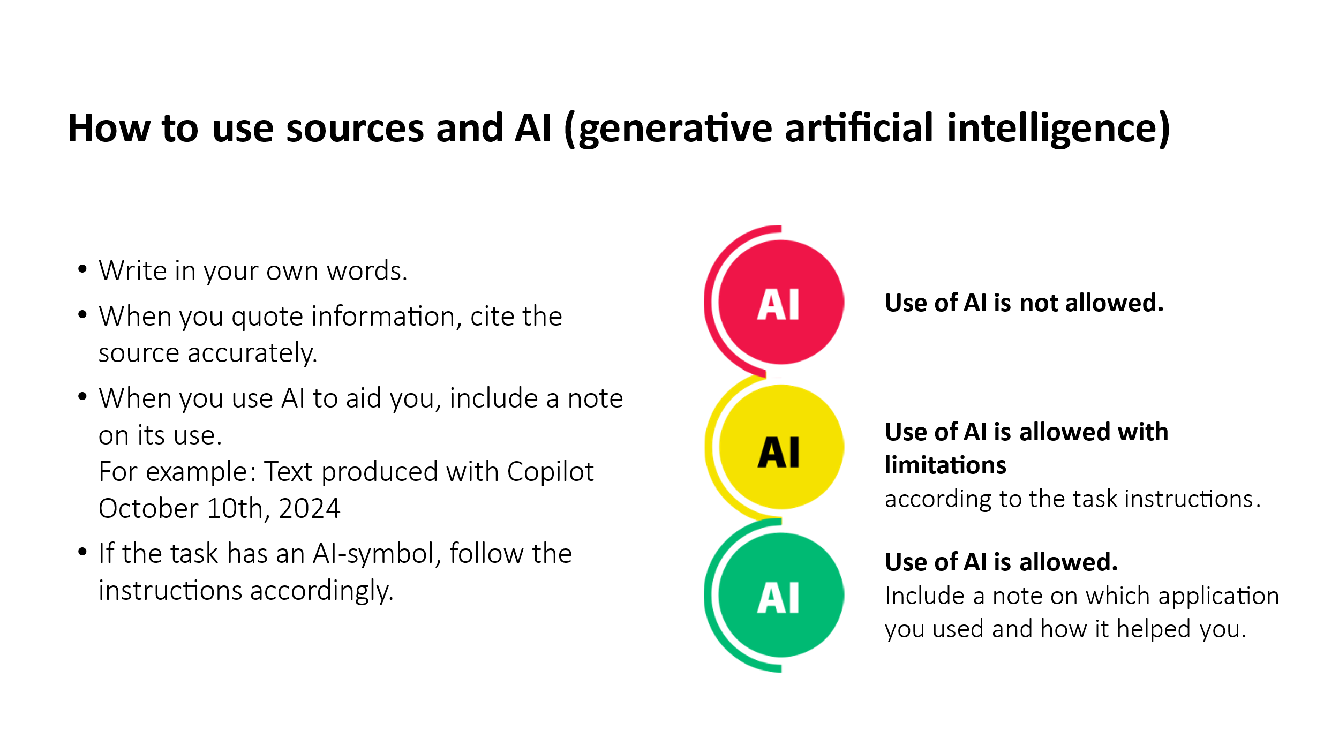

Tehtäviä saa muokata sellaisiksi, että ne soveltuvat oppilaitoksen käyttöön. Kaikkia tehtäviä ei tarvitse ottaa käyttöön, jos oppilaitos haluaa luoda omat englanninkieliset materiaalit.

Orientation
Teksti on osion kuvaus. |   Use of AI is not allowed.

Welcome to course Operating as a member of society and citizen!

During this course, you will learn about many topics and skills that help you understand society, participate in decision-making, and being a responsible consumer.

The first goal of the course is to prepare you to participate and be active in society, as well as to teach you about the rights and responsibilities of a citizen. You learn how decisions are made and how you can participate in politics in Finland. The course also introduces you to some of the unwritten rules of Finnish society.

The second goal is to learn basic information about how you can manage your finances, and that you understand risks and how to prepare for changing life situations. Consumer decisions affect the environment in many ways, it is therefore important to learn how you can make sustainable purchasing decisions and that you know your rights and responsibilities as a consumer.

Do not use AI unless the task requires it.

TASK: Finnish society and values
Tehtävä on monivalintaa. Lihavoidut vastausvaihtoehdot ovat oikeita vastauksia. | Use of AI is not allowed.

- If you are expected at work at a certain time, you go in
  - exactly at the correct time or a little before
  - approximately at the time when your workday begins
  - as soon as you can
  - usually, a little after the agreed time - a few minutes don't matter
- When you are interacting with people in Finland lying is
  - considered shameful
  - met with understanding if it was done to save face or honor
  - met with understanding if it was necessary
- When you apply for work it's good to talk about your work history
  - honestly
  - exaggerate just a little
  - so that your chances of getting the job are maximized
- If you are absent from work
  - you should make up a food reason for the absence
  - it is best to tell honestly why you are absent
  - it is acceptable to lie if you are ashamed about the true reason
- Not knowing something or how to do something is considered
  - something you can brag about
  - something you can talk about openly
  - something to be ashamed of
- Young children can also receive care in the home. In those cases, the children are cared for
  - by the mother or father
  - by the mother
  - by the father
- According to Finnish law, the following are considered to be family members
  - everyone who lives together
  - grandparents, parents and their minor children
  - parents and their minor children
- Fundamental rights and responsibilities are written into law in Finland. In practice
  - they have only a small role in society
  - they can't be seen in how society functions
  - efforts are made to uphold them
- Honesty is a fundamental value for Finns, and it is expected of people in all situations. Lying is viewed negatively in Finland, and it can lead to
  - losing your job
  - everyone having a laugh about it together
  - a warning for breaking the rules at work
- In Finland seniors are usually cared for
  - by staff in a care home
  - by their children in their homes
  - by their children who move in with the seniors
- There are certain rules for working life in Finland. The rules are usually determined
  - With universally binding agreements that apply to all workplaces
  - in writing in the workplace
  - through discussions in the workplace
- Lying to authorities
  - doesn't really matter if you have a good reason
  - often results in big problems
  - results in being further questioned
- When it comes to choosing life partners, whether marriage or otherwise the decision is made by
  - relatives
  - their parents
  - the people themselves
- Finland is a welfare society where the government provides services extensively for various everyday situations. Pre-school-aged children in Finland are most often cared for
  - by the father at home
  - in daycare
  - by the mother at home
  - by the grandparents or other relatives
- Care homes in Finland provide seniors with
  - company of people who are the same age
  - activities and support to help their physical and mental abilities
  - good quality care
  - a place that you end up in because there are no other choices
- When you are in contact with government offices in Finland it is usually done
  - by making an appointment or going to the offices
  - by going to the offices and waiting in line
  - electronically
- The parent caring for children at home
  - has to quit their job
  - does not lose their job
- On your CV you should write
  - what you think is best
  - honestly about your experience and skills
  - only work history that makes you look like a better candidate
- When you have an appointment, you are expected to be there
  - as soon as you can get there
  - the same day
  - exactly at the appointment time
- The political system in Finland is called democracy, which means
  - oligarchy (a small number of people rule)
  - autocracy (dictatorship)
  - that the people decide (popular rule)
- Being late from work
  - is no problem at all
  - is a part of culture
  - is a sign of disrespect and causes distrust and even losing the job

TASK: Reliable sources of information
Tehtävässä valitaan, onko lähde luotettava vai ei. Vaihtoehdot ovat reliable, can be unreliable tai unreliable. | Use of AI is not allowed.

Choose reliable, can be unreliable or unreliable
- government webpages reliable
- Vero.fi reliable
- Yle.fi reliable
- blogs of private individuals can be unreliable
- webpages of private individuals can be unreliable
- THL reliable
- Tulli reliable
- social media unreliable
- MIGRI reliable
- discussion forum on the Internet unreliable

TASK: More than 100 years of independence
Tehtävä on suunniteltu keskustelutehtäväksi, mutta se voi olla myös palautettava tehtävä. | Use of AI is not allowed.

Watch the video about how Finland became a modern welfare society.

100 years in the lives of one Finnish family

Discuss different topics in the video.
- How has Finnish society changed?
- What made that change possible?
- What do you think still needs to change?
- How can that change become a reality?

Fundamental Rights and Civic duties in Finland
Teksti on osion kuvaus..  Tehtävien PowerPoint-opiskelumateriaalit löytyvät Avointen oppimateriaalien kirjastosta. | Use of AI is not allowed.

Finnish citizenship entails a number of rights and obligations that do not apply to foreigners living in Finland. Although equality, religious freedom, freedom of expression and many other rights apply to everyone, including foreigners living in Finland.

In this part of the course, you will familiarize yourself with the fundamental rights and civic duties and responsibilities.

TASK: Fundamental Rights - Drag and drop
Tehtävässä yhdistetään käsite ja kuva. Tehtävän voi tehdä H5P-tehtävänä, josta on mallikuva alempana. Tehtävän liitteenä on Fundamental rights.pptx. | Use of AI is not allowed.

 | Suomi | Englanti | Kuva
1 | Oikeus työhön ja elinkeinon vapaus | Right to work | 
2 | Oikeus tasa-arvoiseen kohteluun/Yhdenvertaisuus | Right to equality | 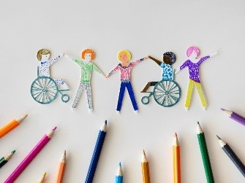
3 | Oikeusturva | Right to justice | 
4 | Liikkumisvapaus | Freedom of movement | 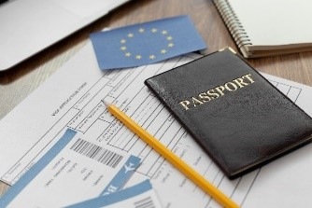
5 | Uskonnonvapaus | Freedom of religion | 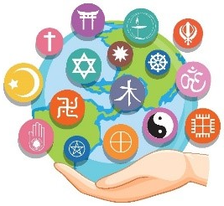
6 | Omaisuuden suoja | Right to own property | 
7 | Sosiaaliturva | Social security /  Right to health care and social services | 
8 | Oikeus äänestää ja asettua ehdolle vaaleissa | Right to vote | 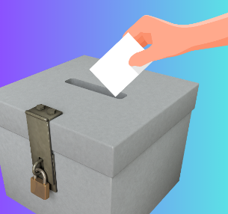
9 | Yksityiselämän suoja | Right to privacy | 
10 | Sivistykselliset oikeudet | Right to education | 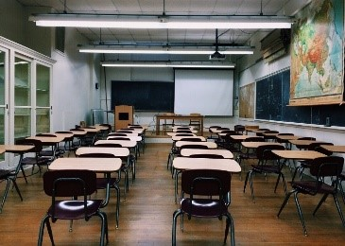
11 | Sananvapaus | Freedom of speech | 
12 | Kokoontumis- ja yhdistymisvapaus | Right to assembly | 
13 | Oikeus elämään sekä henkilökohtaiseen vapauteen | Right to live and personal freedom | 
14 | Rikosoikeudellinen laillisuusperiaate | Rule-of-law principle | 
15 | Oikeus omaan kieleen ja kulttuuriin | Right to have and use own mother language and culture | 

Mallikuva H5P-tiedostosta
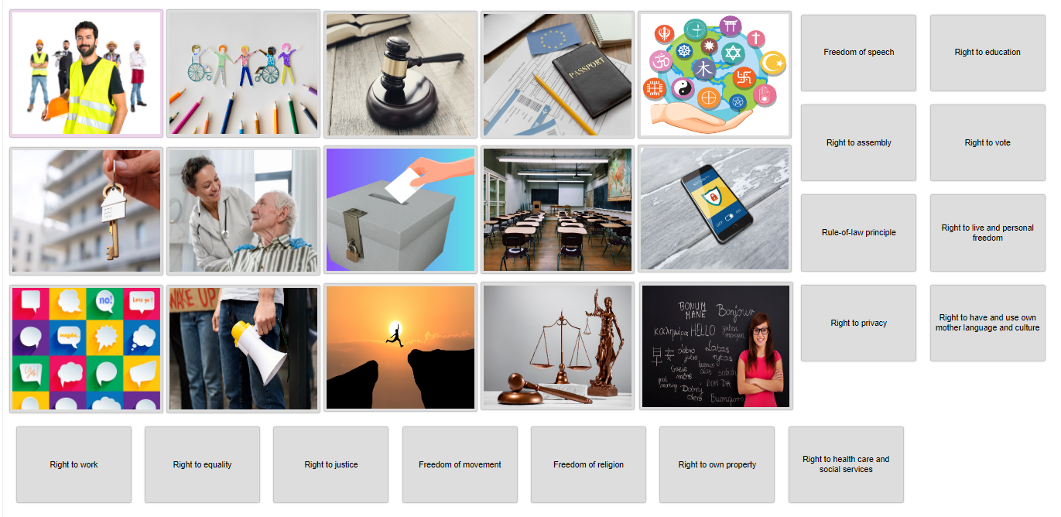
Drag the right term with the picture, which represents it.

TASK: Fundamental Rights - Test your knowledge
Tehtävä koostuu 11 kysymyksestä. Oikeudet on jaettu eri tehtävätyyppeihin. Alla jako väreittäin eri tehtäviin.  lila = merkitse kuvaan oikeutta vastaava kohta  sininen = yhdistä sana ja selite (oikeus ja oikeuden kuvaus)  oranssi = oikeuden kuvaus omin sanoin | Use of AI is not allowed.

 | Fundamental Right in English | Perusoikeus suomeksi
1 | Equality | Oikeus tasa-arvoiseen kohteluun/Yhdenvertaisuus
2 | Right to Life and Personal Freedom | Oikeus elämään sekä henkilökohtaiseen vapauteen
3 | Principle of Legality in Criminal cases  (Right to justice) | Oikeusturva
4 | Freedom of Movement | Liikkumisvapaus
5 | Right to Privacy | Yksityiselämän suoja
6 | Freedom of Religion and Conscience | Uskonnonvapaus
7 | Freedom of Expression and Right of Access to Information  (Freedom of speech) | Sananvapaus
8 | Freedom of Assembly and Freedom of Association | Kokoontumis- ja yhdistymisvapaus
9 | Electoral and Participatory Rights  (Right to vote) | Oikeus äänestää
10 | Protection of Property (Right to own property) | Omaisuuden suoja
11 | Educational rights  (Right to study) | Sivistykselliset oikeudet
12 | Right to one’s language and culture | Oikeus omaan kieleen ja kulttuuriin
13 | Right to work and the freedom to engage in commercial activity | Oikeus työhön ja elinkeinon vapaus
14 | Right to Social Security | Sosiaaliturva
15 | Protection under the Law | Rikosoikeudellinen laillisuusperiaate
Testin kysymykset
- Explain in your own words. What does the Freedom of Assembly and Freedom of Association mean?
  - organize meetings and demonstrations without needing a permit
  - can choose to be members or not and participate in association activities
  - freedom to form trade unions
- Explain in your own words. What does Electoral and Participatory Rights mean?
  - right to vote if older than 18 years
  - right to run for office
- Explain in your own words. What does the Protection of Property mean?
  - Right to own property
  - Property is safeguarded
- Explain in your own words. What does the Right to Social Security mean?
  - right to receive essential support
  - public authorities are responsible for providing adequate social, health, and medical services
- Explain in your own words. What does Protection under the Law mean?
  - the right to a fair legal process
  - legal proceedings must be transparent
  - the right to be heard
  - the right to be heard
  - the right to receive reasoned decisions
- Do you remember the fundamental rights in Finland? Click the right photo that represents the right to education.
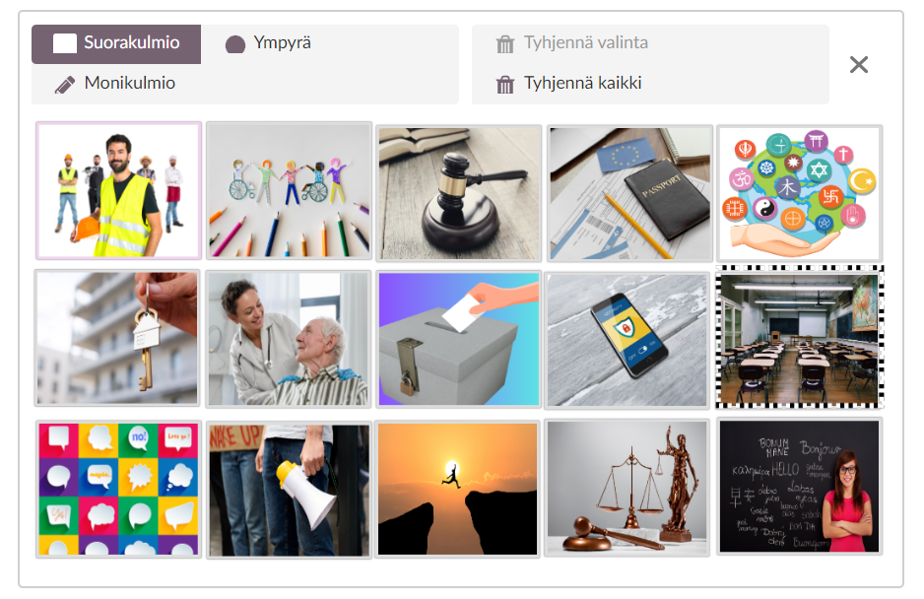
- Do you remember the fundamental rights in Finland? Click the right photo that represents the right to work.

- Do you remember the fundamental rights in Finland? Click the right photo that represents the right to private life.
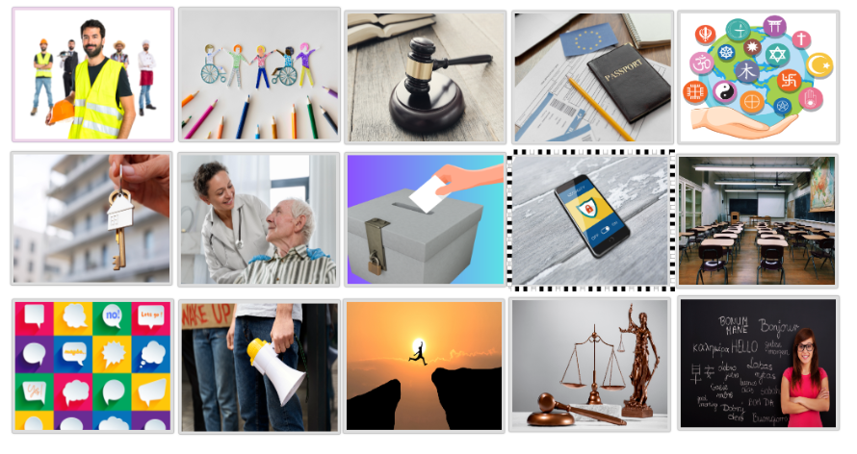
- Do you remember the fundamental rights in Finland? Click the right photo that represents the freedom of religion.



- Do you remember the fundamental rights in Finland? Click the right photo that represents freedom of speech.

- Match the civil right to correct description.
Equality | No one may be placed in a different position without an acceptable reason based on gender, age, origin, language, religion, conviction, opinion, health condition, disability, or any other personal reason.
Right to Life and Personal Freedom | Everyone has the right to life, personal freedom, inviolability and security.
Principle of Legality in Criminal cases | No one can be found guilty of a crime or punished for an act that wasn’t illegal when they committed it.
Freedom of Movement | People living in Finland can move and live freely anywhere in the country.
Right to one’s language and culture | The national languages of Finland are Finnish and Swedish.

TASK: Fundamental rights – Observe and analyze
Tehtävä palautetaan erillisenä tiedostona tai muulla opettajan kanssa sovitulla tavalla. | Use of AI is not allowed.

Choose three fundamental rights from the Constitution of Finland and, in your own words, write a short description of each.

Follow the news, social media or your own surroundings for a week and find examples, where the three fundamental rights you have chosen are either actualized or aren’t.

Keep a diary of your observations and analyze how well fundamental rights are actualized in practice. Discuss also what the consequences can be if fundamental rights aren’t realized.

Make a short presentation of your observations (e.g. a 2-minute video, a poster, a PowerPoint slideshow or a 2-minute podcast), which you submit to the teacher.

TASK: Use your voting right
Tehtävässä on opiskelumateriaalia. Tarvittaessa opiskelijalta voi pyytää kertomaan omin sanoin, miten Suomessa äänestetään. | Use of AI is not allowed.

Read more on elections
Read more on elections on the official site: vaalit.fi and suomi.fi

How to vote in advance in Finland (Video 4 min 58 sec)
https://www.youtube.com/watch?v=feKCn892Z6c

How to vote on election day in Finnish elections (Video 3 min 31 sec)
https://www.youtube.com/watch?v=bsktD9DQwxg

TASK: Memory game on Civic duties
Tehtävä on muistipeli. Tehtävän voi tehdä yhdistä kuva ja velvollisuus -tyyppisenä tehtävänä, jos oppilaitos ei käytä H5P-tehtäviä. Tehtävän liitteenä on Civic duties and responsibilities.pptx. | Use of AI is not allowed.

Mallikuva:
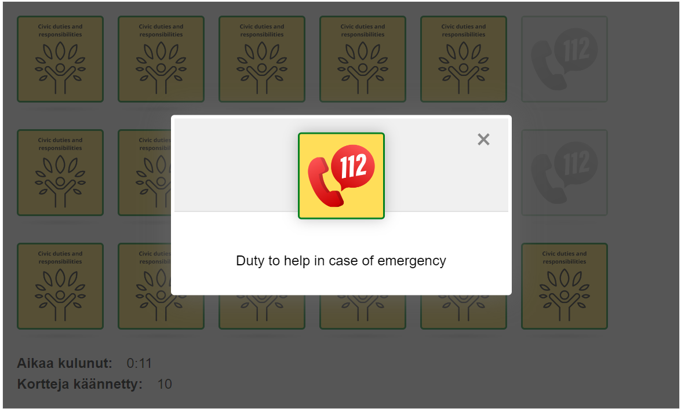

TASK: Civic duties - Real life cases
Tehtävä palautetaan erillisenä tiedostona tai muulla opettajan kanssa sovitulla tavalla. | Use of AI is not allowed.

- You got an email from Suomi.fi web service concerning a received tax return. What do you do?
- You live in an apartment building with a family with children living next door. For a while now, you have noted that their 13-year-old child is still awake at 1 a.m. playing online games. You know of this, because the wall is thin, and the child is loudly yelling when the game isn’t going as planned. You are upset at not being able to sleep at night because of the child. What do you do?
- You are going on a picnic in the park. You pack snacks and invite friends. In the park you notice that the trash cans are full, and your trash won’t fit in. What do you do?
- You receive a letter from district court, subpoenaing you to appear as a witness in court in a case concerning an assault you witnessed in a corner store 3 months ago. What do you do?
- You’re talking to your friend, and they say that they are anxious about some messages they’ve received. You ask more about it, and they tell you about an older person living in the same street, sending them threatening messages. In the messages the person curses at your friend and threatens to call the police due to the constant, noisy partying. Your friend tells you that they haven’t been partying and the messages are unfounded. What do you advise your friend to do?

TASK: Civic duties and responsibilities - Test your knowledge
Tehtävä on monivalintaa. Lihavoidut vastausvaihtoehdot ovat oikeita vastauksia. | Use of AI is not allowed.

Choose the correct alternative, there can be more than one right answer.
- What does the Act on compulsory education lay down? (A)
  - Compulsory education starts in the year when the child turns seven.
  - Compulsory education starts in the year when the child turns eight.
  - Compulsory education starts in the year when the child turns six.
- When does compulsory education end? (A, D)
  - Compulsory education ends in the year when the child turns 18.
  - Compulsory education ends in the year when the child turns 16.
  - Compulsory education can end sooner if the student applies for an exemption from compulsory education.
  - Compulsory education can also end before the age of 18 if the child completes their vocational education or the Finnish matriculation examination test.
- Who is liable for military service? (C)
  - All Finnish citizens are liable for military service.
  - All men that have acquired Finnish citizenship are liable for military service.
  - All male Finnish citizens between the ages of 18-60 are liable for military service.
- What does conscription mean? (B, C, D, E)
  - Women must complete military service.
  - All male Finnish citizens are liable to participate in the defense of Finland and complete their military service.
  - All Finnish people, both men and women, are liable to defend the country.
  - Conscription begins at the age of 18 and ends the year the person turns 60.
  - Women can complete military service if they wish to.
- What does the duty to defend the country mean? (B)
  - Women must partake in armed national defense.
  - Women do not have to participate in military service.
  - Women must complete military service.
- How long of a sentence can you get if you do not help in an accident? (B)
  - 4 months at the most
  - 6 months at the most
  - 9 months at the most
- A Finnish person must obey the law. Which law determines the penalties for breaking the law? (A)
  - Criminal Law
  - Constitution
  - Police Act
- What does tax residency mean? (A, C)
  - Taxes are paid for income received from Finland and abroad.
  - Only income received from Finland is subject to tax.
  - Taxes are paid both for income received from working and income made by selling property.
- When is a person allowed to refuse to testify? (A)
  - When the testifier is closely related to the perpetrator.
  - When the testifier is a friend.
  - When the testifier is the employer.
- Who has the primary responsibility of a child’s welfare? (A)
  - the parents or the guardian of the child
  - the relatives of the child
  - the authorities
- How many forenames can a Finnish person have according to the Act? (B)
  - 2
  - 4
  - 6
- Continue the phrase: (A) The name of a newborn child must be announced within three months of the birth to the…
  - Digital and Population Data Services Agency
  - Police department
  - Regional State Administrative Agency

True or false?
- True or False?
Women must participate in national defense. (True)
- True or False?
Foreign men who have acquired Finnish citizenship must participate in armed national defense if needed. (False)
- True or False?
Income from selling property is subject to tax. (True)
- True or false?
A Finnish person has a duty to testify in court. If you do not testify, the punishment will be a Penalty payment. (True)
- True or False?
The parent of a child must make sure that the child attends school. (True)

Yes, or no?
- Can a Finnish citizen have 6 forenames? (No)
- Can a surname consist of two names? (Yes)
- Is the name Mirja-Anneli Maria Valo Arra Mönkkönen allowed in Finland? (Yes)

TASK: Rights and obligations of a citizen
Tehtävä palautetaan erillisenä tiedostona tai muulla opettajan kanssa sovitulla tavalla. | Use of AI is not allowed.

- What do you think is a fundamental civil right? How would it affect a person if the right was denied? Why?

- What significant things happened in the following years regarding people's civil rights? Which year and reform do you consider the most important for modern people? Give reasons.
  - 1776: The US Constitution was written, the oldest still valid democratic constitution, its basic idea was to give (new) immigrants the strongest possible right to self-determination, how to live their lives, e.g. freedom of religion, speech and the right to bear arms.
  - 1789: The great French revolution, the bourgeoisie also got the right to vote in addition to the nobility and the clergy - France's first republic, the king was violently overthrown
  - 1848: Europe's crazy year, civil rights were demanded. Nationalism, liberalism, socialism began to influence the history of Europe -> new and new old states were born.
  - 1906: Women's right to vote was first in the world in New Zealand and in Europe in Finland.

- How would the situation of Finland and Finns be different if some of the duties of a Finnish citizen had been abolished twenty years ago?
  - conscription, i.e. the conscription army, would be abolished and the army would be fully voluntary, i.e. maybe about 10-20% of the age group would attend it.
  - compulsory education, i.e. free, public basic education (grades 0-9/10) would be abolished, and teaching would work in a company-led manner.

- How would the situation of Finland and Finns be different if some of the freedoms of the Finnish citizen had been abolished or had not been granted in the beginning more than a hundred years ago?
  - freedom of religion
  - freedom of speech
  - freedom of association and assembly

Services
Teksti on osion kuvaus. | Use of AI is not allowed.

Society provides services for the citizens. In this part of the course, you will learn about the different service providers in Finnish society.

TASK: Organization of services – read background information
Tehtävä on opiskelumateriaalia. | Use of AI is not allowed.

Public actors, or the public sector, include the state, municipalities, and wellbeing services counties. Their activities are funded by tax revenues, and they do not aim to make a profit from their operations. The law determines which services are the responsibility of the state and which are the responsibility of municipalities or wellbeing services counties.

Private actors are commercial companies that are owned by private individuals. The goal of private companies is to generate profit for their owners.

The third sector does not aim to make a profit from its activities but instead offers services of general benefit that are available to anyone. Examples of third sector actors include organizations, clubs, associations, congregations, and volunteers.

Most of the funding for organizing public services comes from taxes collected by the state and municipalities from citizens. However, not all public services are entirely free for the user. For many services, citizens must pay part of the cost themselves, while part of the cost of services is covered by tax revenues.

Sometimes the third sector receives funding from the state or municipalities.

TASK: Services provided by society
Tehtävä palautetaan erillisenä tiedostona tai muulla opettajan kanssa sovitulla tavalla. | Use of AI is not allowed.

A welfare state offers its citizens a variety of services. The state, municipalities and wellbeing service counties take care of providing these services to the citizens. These public services are largely funded by taxation. Some of the public services are free, while others are partially or fully subject to a charge.

Take a look at public services in Finland from the links below:
https://www.suomi.fi/citizen
https://stm.fi/en/social-and-health-services
https://okm.fi/en/student-financial-aid-system

What kind of support / services does the Finnish society offer
a) for children?
https://stm.fi/en/children-youth-families
https://www.oph.fi/en/education-system/basic-education

b) for students?
https://okm.fi/en/student-financial-aid-system

c) for families with children?
https://stm.fi/en/services-to-families

d) for the unemployed (from TE-office)?
https://www.suomi.fi/citizen/working-life-and-unemployment/unemployment/services

e) for pensioners?
https://www.suomi.fi/citizen/social-security/services-for-the-elderly

TASK: Production and financing of services
Tehtävässä on yhdistetään palveluntuottaja ja palvelu. | Use of AI is not allowed.

Who provides the service and how is it financed?
A doctor’s visit at the health station | The service is arranged by the wellbeing services county and funded by taxes and co-payments by those who use the service.
Studying in a vocational school | The service is usually provided by cities or municipalities and funded by taxes.
Shopping in a grocery store | The service is provided by a private company that sells groceries and the customer pays for the service.
Remodeling a bathroom in your home | The service is provided by a private company that sells remodeling services and is paid for by the customer.
Daycare for children | The service is arranged by a city or municipality. It is funded by taxes and a co-payment based on the family’s income.
Maternity and child health clinic | The service is provided by the wellness services counties. It is free for mothers and children and funded by taxes.
Playing football in a club in your spare time | The service is provided by a sports club. It is funded by paying membership dues. Sometimes the club can get funding from municipalities or sponsors.
Red Cross volunteer friends for lonely people | The service is provided by an organization. It is funded by donations, public funding and membership fees. It is free for the clients.
Household advice for families, youth and more | The service is provided by an organization. It is funded by membership dues and some public funding.

TASK: Social security in Finland – Drag and drop
Tehtävässä yhdistetään sosiaalietuus ja selitys. | Use of AI is not allowed.

Drag and drop – connect the definition to the correct allowance.
Study material: https://www.kela.fi/main-page

Pension | Compensation paid to a person after their career, as well as when they are unable to earn a living due to illness or injury.
Housing allowance | Intended to support housing expenses for residents in Finland, and the amount depends on income.
Unemployment fund | A form of support for an unemployed person who is entering the job market for the first time, has not been in the job market long enough, or whose basic or earnings-related unemployment benefit period has expired.
Health insurance reimbursement | for example, sickness allowance, reimbursements for medicine expenses, reimbursements for medical expenses, reimbursements of travel costs and Annual maximum limit on out-of-pocket costs
Basic social assistance | is a last resort form of financial aid which is affected by all of the income and assets available to you. Other social security benefits are counted as income.
Disability allowance | Functioning has been impaired due to illness or injury for at least a year. Supports daily life, work, and studies.
Child home care allowance | Support can be applied for if a child under 3 years old is cared for outside of municipal early childhood education, for example, at home.

TASK: Social security in Finland - Fill in the gaps
Tehtävässä valitaan tai kirjoitetaan oikea sana. Oikeat vaihtoehdot ovat lihavoituja. | Use of AI is not allowed.

The options include choices related to service fees and forms of support paid by Kela, which depend on factors such as age, income, type of housing, family situation, or employment status. Receiving support requires applying for it.

Our Services | Kela https://www.kela.fi/main-page

Maternity and child health clinics - Ministry of Social Affairs and Health (stm.fi)
https://stm.fi/en/maternity-and-child-health-clinics

First, read the surrounding text, and then select the correct answer from the drop-down menu.

Family with children

The Hämäläinen family is an ordinary Finnish family. The family has three children, the oldest of whom attends comprehensive school, the middle one is in preschool, and the youngest is in daycare. Both of the parents work; the mother in the technical field and the father in the care sector. The parents are considering what public services and support measures they have received as a family.

While expecting children, the family has used free/paid child health clinic services. All the children were born at the city central hospital, and a daily fee, which is the same for everyone/depending on income, was paid. Each child’s growth and development have been monitored at the clinic, which is a free/paid service for them.

Kela pays the family tax-free child benefit/caregiver’s allowance/rehabilitation allowance of over 300 euros every month. The parents have received caregiver’s allowance/national pension/parental allowance from Kela to take care of the children at home.
The children have also been in daycare. They have paid a monthly fee for daycare, which is the same for everyone/depends on income. Preschool and comprehensive school are free, and the free education continues until the end of the year when the children turn 16/18/20 years old. Health and dental services are also free for those under 16/18/20 years old.

Student

17-year-old Maija is studying for a vocational qualification in mechanical and production technology at a vocational school. She commutes to school by public transport. Her school commute is over 7 km, so she receives school transport subsidy/student loan/school transport loan for the costs of the commute. Maija lives with her mother, and her mother’s income is less than 40,000 euros per year. Maija is thus entitled to a study grant/state guarantee for a student loan/study material supplement.

Employee/Unemployment

Write the words to the correct place: basic unemployment allowance, labor market subsidy, unemployment benefit

26-year-old Zara has graduated as a makeup artist and has worked on several different film projects. However, due to the worsening economic situation, Zara has not been able to find work in her field. She can receive /basic unemployment allowance/, provided she registers as an unemployed jobseeker at the employment and economic development office. If Zara had been employed for at least 6 months, she would be entitled to /unemployment benefit/. Zara has been employed for a total of 4 months, so she is entitled to /labor market subsidy/.

Pensioner

Ulla is a 68-year-old woman who fell ill at a young age and has not been able to participate in working life. Thus, she has not accrued earnings-related pension/social assistance/national pension. In retirement, she is entitled to receive national pension/earnings-related pension/basic unemployment allowance paid by Kela.
Ulla has a long-term illness diagnosed by a doctor, so she has also been able to receive pensioner’s care allowance/basic unemployment allowance/disability allowance. Ulla’s pension income does not cover the minimum pension amount guaranteed in Finland (976.59 €/month), so she also receives a guarantee pension/basic unemployment allowance/earnings-related pension.

TASK: Taxation
Tehtävä on monivalintaa. Lihavoidut vastausvaihtoehdot ovat oikeita vastauksia. | Use of AI is not allowed.

Find information about the Finnish Tax Card from this link Tax Card and answer the multiple-choice questions.

- Why is it important to fill out the tax card correctly?
  - To avoid large tax returns or additional taxes
  - So your employer knows your home address
  - To avoid fines
  - So you can use workplace services
- What can happen if you don´t give the tax card to your employer?
  - The employer can terminate the employment
  - The employer has to withhold a higher tax rate, usually 60%
  - The employer won't pay your salary
  - The employer can pay you extra salary
- What information do you need to fill out the tax card?
  - Personal ID number, employer's name and address, estimated annual income, possible deductions
  - Passport number, employer's name and address, estimated annual income
  - Bank account number, employer's name and address, estimated annual income
  - Personal ID number, employer's name and address, estimated annual income, family members' names
- What deductions can you report when filling out the tax card?
  - Rent
  - Travel expenses, income-related expenses, household deductions
  - Loans
  - Medical and medication expenses
- Where can you get a tax card?
  - From your employer
  - From the Tax Administration's website
  - From KELA (Social Insurance Institution of Finland)
  - From the police station

TASK: Immigration and integration services
Tehtävä palautetaan erillisenä tiedostona tai muulla opettajan kanssa sovitulla tavalla. | Use of AI is not allowed.

Read information about immigration and integration services from this link: https://www.suomi.fi/citizen/moving-and-traveling/migration/guide/as-an-immigrant-in-finland/integration-services-help-the-immigrant

https://www.suomi.fi/citizen/moving-and-traveling/migration/guide/as-an-immigrant-in-finland/an-immigrant-s-check-list

Find answers to following questions:

What services are available for immigrants regarding integration into Finnish society?
- Information and assistance on integration services by TE Offices or immigration advisors in your municipality of residence.
- An initial assessment will be carried out at least for immigrants who are unemployed or receive social assistance. Initial assessment from the TE Office or your municipality of residence.
- An integration plan is drawn up together with either an integration expert at the TE Office or a social worker at your local social welfare office.
- Integration training will provide you with skills for Finnish working life and further education.

Where can an immigrant get information on integration services?
TE Offices or immigration advisors in an immigrant's municipality of residence.

For which immigrants will initial assessment be carried out?
An initial assessment will be carried out at least for immigrants who are unemployed or receive social assistance. During the assessment the immigrant’s skills, competence and situation will be assessed.

What is an integration plan?
If it is determined during the initial assessment that you need support with integration, a personal integration plan will be drawn up for you. The plan is drawn up together with either an integration expert at the TE Office or a social worker at your local social welfare office. Your integration plan will include, for example, information on what training or education you need in order to integrate.

What does integration training for immigrants include?
On the basis of immigrant's integration plan, they will be steered to the integration training those best suits their needs. The training includes either Finnish or Swedish language studies. It usually also includes training on the Finnish customs as well as information about working and education in Finland.

What should an immigrant take care or at least know of when moved to Finland?

- Open a Finnish bank account It is wise to purchase a home insurance policy for your residence.
- Purchase Finnish internet and telephone subscriptions.
- You will be assigned a municipality of residence.
- Get a Finnish tax card from the Tax Office.
- Kela is responsible for the social security of all people living permanently in Finland.
- You can search for job vacancies on the public employment and business services i.e. TE Services website.
- Integration services are available for immigrants.

Decision-making globally/in the world
Teksti on osion kuvaus. | Use of AI is not allowed.

Have you ever wondered how society functions and how different countries around the world are governed?

In this section, you will learn about various societal structures and leadership styles across different countries.

By examining these diverse frameworks, you will develop a deeper understanding of how cultural, political, and economic factors influence governance and social organization globally and how they differ from Finnish society.

TASK: Forms of governing
Tehtävä on opiskelumateriaalia. | Use of AI is not allowed.

Democracy is a multifaceted concept, and its different forms can vary. Here are some options for democracy:
- Representative democracy: In this form, the people elect representatives who make decisions on their behalf. Parliament or Congress is an important institution that represents the people.
- Direct democracy: In this model, citizens participate directly in decision-making. For example, referendums and citizens' initiatives are manifestations of direct democracy.
- Liberal Democracy: This combines the principles of democracy and the rule of law. It emphasizes individual rights and freedoms and the sharing of power between different institutions.
- Social democracy: This emphasizes social justice and welfare state principles. Social democracy aims to equalize economic differences and provide extensive social security.
- Anarchy: In anarchy there is no centralized government. Decisions are made decentralized without state structures.
- Technocracy: In this model, experts and technocrats guide decision-making. Their knowledge and skills are essential.
- Oligarchy and plutocracy:
  - Oligarchy: In an oligarchy, power is in the hands of a few rich or influential people.
  - Plutocracy (Greek for "money power") is a political system where citizens' social influence is based on property and not, for example, descent.[1] In such a form of government, power is distributed based on the amount of property and public respect. Income differences are usually large, and income transfers remain small.
- Theocracy: Religious leaders guide decision-making. This could be, for example, an Islamic theocracy.
- Despotism: One person or a small group rule in an authoritarian manner.
- Totalitarianism: In this model, the state controls all aspects of life, including the thinking and actions of citizens.
- Aristocracy and Monarchy: Aristocracy is a state system in which state power is in the hands of a privileged class of citizens, i.e. the aristocracy. The concept has its roots in ancient Greece, where it originally meant the power of a hereditary overlord proud of his noble birth. The aristocracy ruled by holding the bule or Gerousia, i.e. the city council, as well as official positions, such as the post of archon in Athens. In Greek state theories, the form of government could be called aristocracy if the ruling class sought the good of society as a whole. The difference with monarchy is that in monarchy the power is concentrated in one ruler, while in aristocracy it is in the hands of the nobility. In other words, aristocracy is the rule of many for the benefit of all, while in monarchy, one ruler decides things.

TASK: Forms of governing and voting
Tehtävä on monivalintaa. Lihavoidut vastausvaihtoehdot ovat oikeita vastauksia. | Use of AI is not allowed.

https://www.suomi.fi/citizen/rights-and-obligations/fundamental-rights-and-civic-activity

- In which countries are these systems of governance in use?
  - anarchy
    - Belgium
    - Great Britain
    - Yemen
    - Sweden
  - despotism
    - South Korea
    - North Korea
    - Germany
    - USA
  - oligarchy
    - military dictatorships
    - Qatar
    - United Arab Emirates
    - Austria
  - direct democracy
    - Finland
    - Switzerland
    - USA
    - Russia
  - technocracy
    - EU
    - Democratic Republic of Congo
    - Switzerland
    - Canada
  - theocracy
    - Iran
    - France
    - Vatican
    - USA
  - totalitarianism
    - Netherlands
    - North Korea
    - Denmark
    - Russia
- Which election is not open for all citizens (within an election region)?
  - European Union parliamentary elections
  - Presidential elections
  - County elections (for wellbeing services counties)
  - Municipal elections
  - Bishop elections
  - Parliamentary elections

TASK: Reflect and write
Tehtävä palautetaan erillisenä tiedostona tai muulla opettajan kanssa sovitulla tavalla. | Use of AI is not allowed.

- Democracy is the most common governing model in the Western countries
  - What are the benefits of democracy?
  - What possible difficulties and instabilities could it cause?
- What other governing models exist?
- Do you think that some part of another model could work (even better than democracy) in Finland?
- Answer the questions
  - What does universal and equal suffrage mean?
  - Is there anybody who cannot vote if there is universal and equal suffrage?
  - How long has universal and equal suffrage been granted in Finland?

Decision-making in Finland
Teksti on osion kuvaus. | Use of AI is not allowed.

In this section, you will explore the Finnish public decision-making system and its key stakeholders.
You will cover the structure of Finland’s political system, the unique characteristics of decision-making processes, and the roles and influence of various actors.

By the end of this section, you will have a comprehensive understanding of how public decision-making works in Finland and who the main influencers are.

TASK: Municipalities - the local level of public administration
Tehtävä palautetaan erillisenä tiedostona tai muulla opettajan kanssa sovitulla tavalla. PDF-tiedosto on liitteenä Avointen oppimateriaalien kirjastossa, mutta se on myös tekstinä käsikirjoituksessa. | Use of AI is not allowed.

In this task, you will become familiar with the Finnish local government system and its operations.

Look at the material of Finnish municipalities and their government and decision-making process. What kind of duties do municipalities have? What are the duties and roles of municipal council, government, and committees? How do municipal councils, governments and committees operate?

Study material for this task:
https://www.localfinland.fi/
Finnish Local Government Act Notice! The site is in Finnish, use the translator of your internet browser.

After you have read the material, write a brief summary of what you discovered about the local level administration.

Attachment file: Municipalities.pdf

Municipalities –the local level of administration

In 2024, there are a total of 309 municipalities in Finland, of which 108 use the self-designation city and 201 municipalities the designation municipality.

The municipalities organize public services for their residents. Most of these services are defined by law as being duties of local government. Duties can be assigned to local government only by laying down provisions to this effect in the law.

Tasks and responsibilities of municipalities
Municipalities are responsible for organizing the following public services:
- education and early childhood education and care
- cultural, youth, library, and sports services
- urban planning and land use
- water and waste management
- environmental services
The Municipal Act guides the administration of municipalities in Finland.

The municipality’s administration is based on the self-government of the residents
According to Section 121 of the Constitution, the municipality's administration is based on the self-government of the municipality's residents. The municipality's residents elect the municipality's highest institution, the council, in municipal elections held every four years.

The council is responsible for the municipality's finances and operations and exercises the municipality's decision-making power. It decides which institutions there are in the municipality and how the authority and tasks are divided between trustees and office holders.

The provisions of the Equality Act
When choosing institutions, the provisions of the Equality Act must be considered. According to Section 4a of the Equality Act, municipal and inter-municipal cooperation institutions must have at least 40 percent of both women and men each, unless there are special reasons. The provision does not apply to councils.

Who can stand as a candidate in Municipal elections?
There are restrictions to who is eligible to stand as a candidate in Municipal elections.
- The candidate must be a resident of the municipality in which they run for office.
- The candidate must have the right to vote in municipal elections in some municipality.
- The candidate must not be deficient, for example under guardianship.

The management system of the municipality
The Municipal Act creates the framework for the management system of the municipality. It enables a wide range of different management and organizational models. In each model, the municipality's decision-making power is exercised by a council elected by the residents. The council decides on the structure of the administration and how authority and tasks are divided between different actors.

According to the Municipal Act, the mandatory institutions and actors in the municipality are only the council, the municipal government, the inspection board and the central election board. In addition to these, the council appoints boards and executive boards.

Municipal Institutions and management
According to Section 30 of the Municipal Act, the municipal institutions are:
- council
- municipal government and its divisions
- boards or committees and their divisions
- executive boards and their divisions
- committees.

The members of the municipal board, audit committee and other committees are elected at the council meeting held in June after the Municipal elections.

The council
The council is responsible for the municipality's finances and operations and exercises the municipality's highest decision-making power. It decides which institutions there are in the municipality and how the authority and tasks are divided between trustees and office holders.

Council members and alternate members are elected in the municipal elections held in April. The term of office of the council is four years and it starts at the beginning of June of the election year. The council members are also called municipal trustees.

The municipality chooses the number of councilors, at least the required minimum number. This is determined by the number of inhabitants, according to § 16 of the Municipal Act. The Municipal Act states that the number of councilors differs between 13 to 79. For example, in 2024 there are approximately 3500 inhabitants in Vieremä and its council consists of 21 councilors. Instead, Tampere, with over 250 000 inhabitants, has a council of 67 councilors.

To organize the administration of the municipality, the council must approve the administrative regulations of the municipality, which stipulate e.g., on the division of authority and tasks of the municipality's various authorities.

Municipal government
The municipal government is the central institution of the municipality. Its task is to manage the municipality's operations, administration, and finances. The municipal government is responsible for the preparation, implementation, and monitoring of legality of the council's decisions, and for coordinating the municipality's activities about ownership control of the municipality's operations.
In addition, the municipal government's statutory task is to supervise the interests of the municipality and, unless otherwise stipulated in the administrative regulations, represent the municipality, use its authority to represent the municipality as an employer and is responsible for the municipality's personnel policy care of the municipality's internal supervision and the organization of risk management. More precisely, the board's powers of action and decision-making are defined in the administrative rules approved by the council.

The chairperson of the municipal board
The chairperson of the municipal board leads the political cooperation that is required to conduct the tasks of the municipal board. Other duties of the chairperson of the municipal board are determined in the administrative regulations. The council can decide whether the chairperson and vice-chairmen of the municipal board work as full-time or part-time trustees.

Municipal manager and mayor
The municipality can be managed by an ex officio municipal manager or a mayor. The mayor serves as the chairman of the municipal board. Both manage the municipality's administration, housekeeping, and other activities under the municipal government.

The municipal manager is elected by the council. The municipal manager can be elected either indefinitely or for a fixed period, and he is employed by the municipality. The municipality and the municipal manager draw up a management contract where they agree on the conditions for managing the municipality.

The council elects the mayor. The mayor can be elected for a maximum term of office of the council. A person who is not eligible for election to the municipal board and board can also be elected mayor.

The central election board of the municipality
The municipality's central election board, which is elected for the entire election period, is responsible for the many practical arrangements of the elections. The Central Election Board has five members.

The inspection board
The council appoints an inspection board to organize administration and financial audits and evaluations. The number of members of the inspection board is at the discretion of the council, and personal deputies are chosen for the members.

The main task of the board is to assess whether the operational and financial goals set by the council have been realized in the municipality and the municipal group and whether the activities
have been organized in a productive and appropriate manner, and to assess whether the financial balance has been achieved.

Executive boards, committees, and boards
The council decides which institutions there are in the municipality and how the authority and tasks are divided between trustees and office holders.

Boards of Directors
The board can work directly under the municipal government, but also under the board. In this case, it may be justified to stipulate that the relevant board elects the members of the executive board. For example, the school board may be subordinate to the board responsible for education. The council can also decide that the members of the executive board or a part of them are elected based on the proposal of the residents, staff, or service users.

Committees
The municipal government can directly appoint committees to conduct the assigned task based on the law. Like the board, the members of the committee do not have special restrictions on their eligibility for election. Committees are needed in project-related tasks, for example in the implementation of a construction project. Other institutions can also appoint committees based on the council's decision. The council can give the institution the general right to appoint committees, but it can also limit the authority to, for example, only appointing a building committee. The term of office of the committee can be at most the length of the term of office of the institution that appointed it.

In general, the council chooses the municipality’s trustees. However, the election of board members can be transferred to another institution, and the board members are chosen by the institution that appoints the board. Members of the board and committee are not subject to the restrictions on election eligibility that apply to members of the municipal board or board.

Boards
The council decides on the board structure of the municipality in the administrative regulations. The council appoints the committees that operate under the municipal government and decides on their number of members and their powers of action and decision. The council can decide to appoint committees to manage permanent tasks instead of boards.

The members of the board are elected for the term of office of the council unless the council has decided on a shorter term of office. Usually, an odd number of members is chosen so that the votes are not equal when voting on individual meeting issues. The board must have a chairperson and the necessary number of vice-chairpersons.

Boards can have divisions. Their members may also include deputy members of the board. If the council decides, members other than board members or alternate members can be elected as members of the division.

An example of a municipal institutions and management: Vieremä

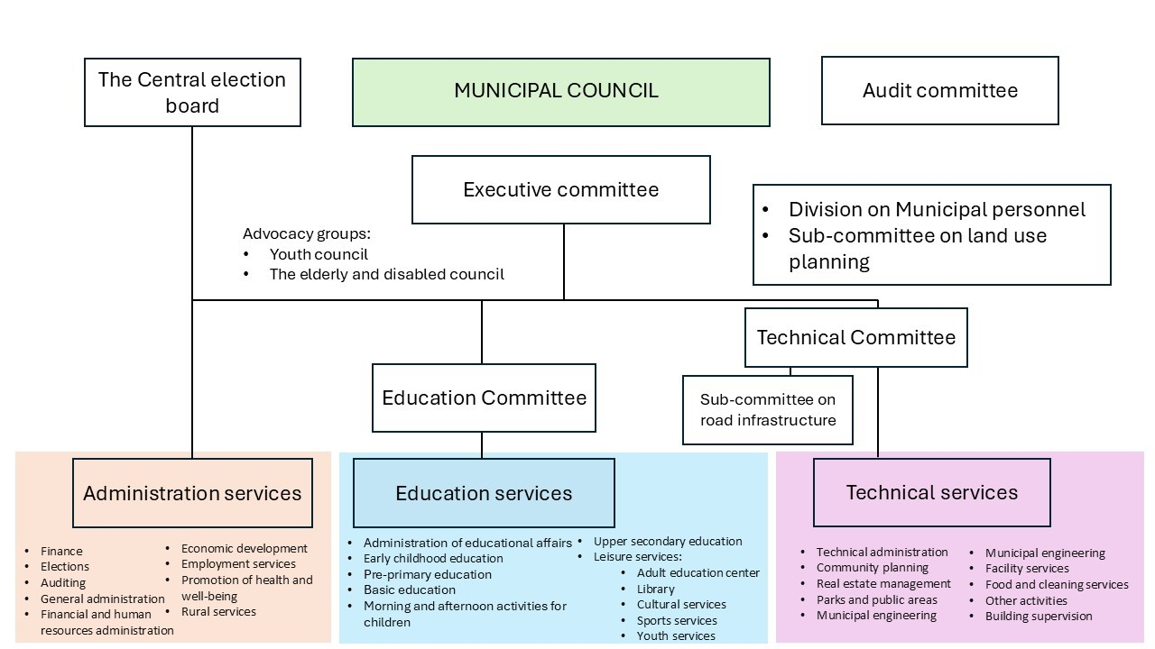
Resources:
https://www.kuntaliitto.fi/laki/toimielimet-ja-johtaminen
https://vm.fi/en/local-government-s-duties-and-activities
www.vierema.fi
www.tampere.fi

TASK: Wellbeing services counties
Tehtävä palautetaan erillisenä tiedostona tai muulla opettajan kanssa sovitulla tavalla. | Use of AI is not allowed.

In this task you find out information about wellbeing service counties. Browse through the study material and find out answers to the following questions:
- What is the purpose of the Wellbeing service counties?
- What services does Wellbeing service counties offer?
- How do the counties get their financing?
- What is the name of the wellbeing service county in your area?
- How many councilors are there in the regional council of your area?

https://www.suomi.fi/citizen/rights-and-obligations/digital-support-and-administrative-services/guide/how-finlands-public-administration-works/wellbeing-services-county
https://stm.fi/en/wellbeing-services-counties-on-the-map1

TASK: Parliament of Finland and political parties
Tehtävä palautetaan erillisenä tiedostona tai muulla opettajan kanssa sovitulla tavalla. | Use of AI is not allowed.

What is the Parliament of Finland and how does it work?

Browse through the official site of Parliament of Finland (Eduskunta) and read the attachment file Parliament of Finland.pdf

You will find more information on political parties from these links:
National Coalition Party https://www.kokoomus.fi/?lang=en
Left Alliance https://vasemmisto.fi/frontpage/
Social Democratic Party https://www.sdp.fi/en/
Centre Party https://keskusta.fi/en/
Liberal party https://liberaalipuolue.fi/liberal-party-in-english/
The Greens https://www.greens.fi/
Swedish People's Party of Finland https://sfp.fi/en/frontpage/
Christian Democrats in Finland https://www.kd.fi/en/
The Finns Party https://www.perussuomalaiset.fi/kielisivu/in-english/
Movement Now (https://www.liikenyt.fi/) Notice! Use translator in your browser, site is in Finnish.
The Open Party https://avoinpuolue.fi/en/
Finnish Communist Party https://skp.fi/english
Crystal Party https://www.kristallipuolue.fi/ Notice! Use translator in your browser, site is in Finnish.
Valta kuuluu kansalle https://vkkpuolue.fi/fi Notice! Use translator in your browser, site is in Finnish.
Vapauden liitto https://vapaudenliitto.fi/ Notice! Use translator in your browser, site is in Finnish.
Totuuspuolue https://www.totuuspuolue.net/ Notice! Use translator in your browser, site is in Finnish.

Find out answers to the following questions:
- How many members does the Parliament of Finland consist of?
- How does Parliament work?
- Who leads the politics in Finland?
- What is an MP?
- How are political parties related to Parliament?

TASK: The President
Tehtävä palautetaan erillisenä tiedostona tai muulla opettajan kanssa sovitulla tavalla. | Use of AI is not allowed.

Your task is to browse through the official site of presidency and find out, what kind of role does the president have in Finnish politics and decision-making?

Study material: https://www.presidentti.fi/en/home/

TASK: You can make a difference
Tehtävä palautetaan erillisenä tiedostona tai muulla opettajan kanssa sovitulla tavalla. | Use of AI is not allowed.

In Finland, every citizen has the possibility to make suggestions about the politics.

Find out on https://www.demokratia.fi/en/home/ website how a citizen can participate in and influence politics.

TASK: Read and reflect
Tehtävä palautetaan erillisenä tiedostona tai muulla opettajan kanssa sovitulla tavalla. | Use of AI is not allowed.

Read the following two articles on Finnish civil society.

The articles on Finnish civil society:
Finnish civil society (2020)
https://kansalaisyhteiskunta.fi/tietopankki/finnish-civil-society/

Groups and organizations (2020)
https://kansalaisyhteiskunta.fi/tietopankki/groups-of-organizations/

Reflect on the texts and answer to the following questions:
- Are you an active citizen?
- What are your interests?
- What is your way of influencing society?

TASK: Crossword puzzle on terms of decision-making in Finland
Tehtävä on sanaristikko. Jos tällaiseen ei ole mahdollisuutta, tehtävän voi tehdä monivalintana tai testinä. | Use of AI is not allowed.

- What consists of 200 members? parliament
- Who is the Supreme Commander of the Defense Forces? president
- What is the name of the working group that prepares a law? committee
- What is the name of a body that exercises the highest decision-making authority of the municipality? municipal council
- What paper needs 50 000 supporters to proceed? Citizen's initiative
- What is the name of political parties that aren’t part of the Government? opposition
- What is the name of the citizen’s opportunity to influence municipal issues? municipal initiative
- What event is held every fourth year? county elections
- What is the name of a group that an MP must be a member of? political party
- What is the name of a plan of action that is renewed every fourth year? government program
- What is the name of a body whose number of members varies in different municipalities? municipal council
- Who do the Committees invite to make a statement about a legislative proposal? expert

TASK: Test your knowledge about the decision-making in Finland
Tehtävä on monivalintaa, järjestämistä oikeaan järjestykseen ja oikein/väärin-kysymyksiä. Lihavoidut vastausvaihtoehdot ovat oikeita vastauksia (ensimmäisessä kysymyksessä kaikki vastausvaihtoehdot ovat oikein, mutta ne pitää järjestää oikeaan järjestykseen). | Use of AI is not allowed.

Questions about Finnish Governance: Parliament, Government, President
- In this test you can show how much you have learned about the Finnish decision-making system.
- The test consists of 13 questions.
- The test is time-limited to 20 minutes.
- To pass this test, you must answer 80 % of the answers correctly.

- How does a bill become a law? Arrange in the correct order. Place the starting point at the bottom and the final step at the top.
  - The President confirms the law.
  - The bill is returned to the plenary session of Parliament for two different readings.
  - Preparation of the bill in committees.
  - Parliamentary introductory debate.
  - A proposal for a new law is made.
- Is the statement true or false? (true)
  - The President is the Commander-in-Chief of the Defense Forces. He decides on war and peace.
- What is the role of a committee?
  - To prepare bills.
  - To make bills.
  - To hear various experts.
  - To decide whether the bill is sent for approval.
- How many members of Parliament are there?
  - 150
  - 200
  - 250
  - 300
- Who can become a member of Parliament?
  - A Finnish citizen who is 21 years old.
  - A Finnish citizen who is 18 years old.
  - A person residing in Finland who is 18 years old.
- What does the opposition mean?
  - The parties that are part of the government form the opposition.
  - The parties that are not part of the government form the opposition.
- What is the government program?
  - An action plan for the government term.
  - A financial plan for the government term.
  - A collection of bills for the government term.
- Who is the political leader of Finland?
  - The President
  - The Prime Minister
  - The Speaker of Parliament
- What is a plenary session?
  - A meeting where proposals to be submitted to Parliament are discussed.
  - A meeting where the budget proposal is discussed.
  - A meeting where experts are heard for bills.
- For how many years can the President serve in office in Finland?
  - 8 years
  - 10 years
  - 12 years
  - 6 years
- How many years does the President’s term last?
  - 4 years
  - 6 years
  - 8 years
- Complete the text about the Presidency. Choose the correct option from the menu.
The most important power of the President of Finland is leading the country’s foreign policy / domestic policy / regional policy. Other powers of the President of Finland include, among others, the power to appoint officials / to dismiss from office / to lead the police, the power to confirm laws / to return laws for reconsideration / to comment on laws, and the power to grant pardons / judicial power / the power to dissolve Parliament.

Decision-making in Europe
Teksti on osion kuvaus. | Use of AI is not allowed.

Finland and 26 other European countries are part of European Union. In this part of the course, you will get to know how it works and how it affects the lives of citizens in Finland.

TASK: Background History of European Union
Tehtävä on opiskelumateriaalia, jonka voi yhdistää tehtävään 6.2. | Use of AI is not allowed.

HISTORY OF EUROPE -> Background to the Idea and establishment of European Union

Map 1 (1800's): https://commons.wikimedia.org/w/index.php?curid=12104648
Map 2 (1914): https://peda.net/p/Sivula/historia/hks/sryimv/eurooppa_1914-png:file/download/130e59f081c43cdd4e35fd556e8656a2dc2492b7/Eurooppa_1914.png

The text below can be found read from the attached file (Eu history.m4a)

History of Europe is the history of wars:
- Roman Empire
- Modern times wars were mainly between France and Prussia/Germany
- Napoleon wars (1800-1815)
- Bismarck war (1866-67)
- First World War (1914-18)
- Second World War (1939-45)

Therefore, after the Second World War, the idea that Western Europe should become an economic unit, which can compete in some way against USA, and China as well, was born. War was so devastating that the first aim was to prohibit any war ever again on European soil.

The steel and coal communities were the first step to the EU, because steel was the most important war material and coal was needed mostly for heating and as a source of energy. Also, in 1945 and soon after that, Europe and World was divided into two camps: the capitalistic world with the USA and its European allies: collapsing world powers Great Britain and France.

On the other hand, Stalin and his Soviet Union rose as the communist regimes in power through Eastern Europe, while they occupied them as they drove Hitler’s armies back to the Germany. The Cold war started as soon as the Second World War ended in 1945 in Europe. It lasted until the Soviet Union collapsed, in 1991, and the countries of the Eastern Europe started to integrate towards the West: EU-membership (11 countries in 2004-2013) and NATO (12 countries between 1999-2009)

https://european-union.europa.eu/principles-countries-history/history-eu_en

TASK: The EU's success in its basic objectives (economy and peace)
Tehtävän voi yhdistää tehtävään 6.1. Tehtävä palautetaan erillisenä tiedostona tai muulla opettajan kanssa sovitulla tavalla. | Use of AI is not allowed.

- How many wars have there been on European soil after the Second World War?
  - inside European Union member countries?
  - outside EU?
- How many wars have there been in Europe since World War II?
  - between EU countries
  - outside the EU area
- How well has the European Economic Area worked out? Has it been successful against the USA, China and Russia?

TASK: Test your knowledge on European Union
Tehtävässä on monivalintaa, oikean kuvan valintaa ja yhdistämistä. Lihavoidut vastausvaihtoehdot ovat oikeita vastauksia. | Use of AI is not allowed.

https://learning-corner.learning.europa.eu/learning-materials/eu-nutshell_en
https://learning-corner.learning.europa.eu/learning-materials/european-union-facts-and-figures_en
https://op.europa.eu/webpub/com/eu-what-it-is/en/index.html

This test has seven questions about the European union.
- Before you take the test, read the study material!
- The test is not time limited.
- You can retake the test as many times as you like.
- The test is graded from Satisfactory 1 to Excellent 5.

- What are the roles of the different bodies of the European union. Combine the body with its right description.
The European Council | Defines the EU’s direction and priorities.
The EU’s President | Decides on the big questions to be tackled at each meeting and bring everyone to an agreement.
The Council of the European Union | It is a a place where ministers from the elected national governments of the Member States work together.
The European Parliament | Represents the interests of EU citizens.
The European Commission | Manages the day-to-day running of the EU and proposes the EU budget.
- Which body within the European Union represents the views of the citizens? Click on the name of the body. (European Parliament)
- Which body within the European Union represents the European views? Click on the name of the body. (European Commission)
- Which body within the European Union represents the views of the National Governments? Click on the name of the body. (The European Council, The Council of the European Union)
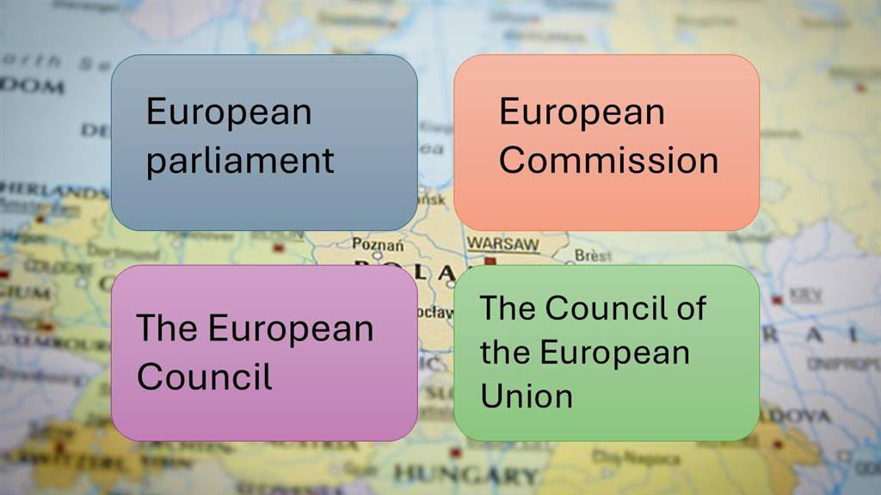

- What does Schengen mean?
  - An area of countries with the same currency
  - An area of countries without internal border controls
  - An area of countries with the same values
  - An area that shares military forces
- Why was the European Union formed?
  - to keep peace after the World War 2
  - to make money as much as possible
  - to help people migrate between countries
- What are the areas that only the European union can legislate?
  - marine plants and animals regulated by the common fisheries policy
  - industry
  - competition rules for the single market
  - customs union
  - tourism
  - public health
  - monetary policy for the eurozone countries

Personal Financial Planning
Teksti on osion kuvaus. | Use of AI is not allowed.

What does financial planning mean?
In this part of the course you will learn what different financial terms mean and why planning is important.

TASK: Planning one’s finances, consumption and financial risks
Tehtävä on opiskelumateriaalia. | Use of AI is not allowed.

Planning one's finances
We have to consider how far our money will go. We also have to think about how long we need to manage a certain amount of money. A budget is a plan that allows us to consider income and expenses over a certain period of time.

We can create a personal or household budget. A household refers to a family or individuals who share living expenses.

Sources of income include salary earned from work. Various benefits or entitlements are also considered income and are received when one is not in the workforce. For example, this includes student grants or parental allowances. A household can also receive capital income. These refer to income obtained through property ownership, such as rent from a property owned by the household.

Expenses refer to all the things that money is spent on. Typically, the biggest expenses are housing costs, household expenses (food, water, electricity, clothing, and other goods). Most of these are necessary expenses. In addition to these, hobbies, leisure activities, and transportation also come with a cost. It is good if there is money left over after expenses. This can be saved for larger purchases or unexpected expenses.
Purchasing goods and financing
We are consumers when we buy goods and services. Some expenses are necessary (housing, food, etc.), while others are non-essential, or we can choose from different options. We also know that there are products of different prices and qualities within each product category (e.g. flat-screen TV’s). We can compare different features and rank products based on them. We compare the utility of the products and can consider the option that is suitable for us. In addition, a product also has display value, symbolic value, which tells something about us and our preferences, for example, by choosing a specific brand or product brand. Our choices are influenced through advertisements, and needs are created for us.

We have various ways to pay. The use of cash is decreasing all the time and payment is increasingly being made with bank or credit cards. With a bank card, money is debited from the account immediately, whereas with a credit card, one gets more time to pay the bill. With a credit card, one has to pay interest and other costs. In many stores, it is also possible to pay in installments, where the customer pays a small amount each month for a certain period, for example, a month. A credit agreement is made between the seller and the buyer regarding this. Often, there are various fees and interest associated with them, which increase the price of the item. It is essential to compare the real annual interest rate that takes into account all the costs related to the loan. Other digital payment methods, such as contactless payment or mobile payments, have also become more common. With these, money is transferred immediately to the other party and is debited from the account right away.

Risks and preparing for them
Economic risk refers to unexpected changes in one's income or expenses. Income can decrease, for example, as a result of starting studies or unemployment. This requires revising one's budget and possibly adjusting expenses to the situation. Sometimes expenses can also increase suddenly. A common situation can be a household appliance or a larger item breaking down. In such cases, we have to think about how we will handle the situation.

One way to prepare is to save money in advance. This way, we can use our savings to address the situation. It has been suggested that a household should have savings equivalent to about three months of net income. Sometimes installment payments or credit cards can provide a payment period for essential purchases. The key is to consider income and expenses and think about how to keep them balanced.

TASK: Terms related to your own finances
Tehtävässä yhdistetään käsite ja selitys. | Use of AI is not allowed.

Household = A unit formed by private individuals who share living costs or refrigerator.
Budget = A calculation that lists income and expenses.
Income = Earned from work
Government benefits = Benefits paid by the state when one is not employed (e.g., Kela benefits).
Capital income = Returns generated from wealth, such as dividends or interest.
Expenses = refer to all the things that money is spent on

TASK: Word meanings
Tehtävässä yhdistetään asia ja selitys. Lihavoidut vastausvaihtoehdot ovat oikeita vastauksia. | Use of AI is not allowed.

https://oikeus.fi/talousjavelkaneuvonta/en/index/unnamed2/8205planningyourfinances.html#

- Plan your spending
  - Use credit card always when you do not have enough money
  - Think beforehand what you need to purchase
  - Spend more than you earn
- Finances are in balance
  - Your incomes and expenses are in balance
  - You have enough money to buy things you need
  - Your expenses cannot be covered with your income
- everyday expenses
  - you need these ones on daily basis, and it is difficult to cut on these
  - costs that are necessary for your everyday life
  - Sports equipment, hobbies, larger items
- plan your spending according to your income
  - changes in your income may affect your expenses as well
  - even if your income drops, use money as regular
  - you have to adjust your expenses with your income
- save money
  - it is worth save money, even a small amount
  - it is not worth saving, it is better to consume everything
  - it is a good way to prepare for some unexpected events

TASK: I consider my purchases, if the cost exceeds…
Tehtävä palautetaan erillisenä tiedostona tai muulla opettajan kanssa sovitulla tavalla. | Use of AI is not allowed.

- I consider my purchases, if the cost exceeds...
  - 30€
  - 50€
  - 100€
  - 200€
  - 500€
- Why is that your limit?

TASK: Planning your own finances
Tehtävä palautetaan erillisenä tiedostona tai muulla opettajan kanssa sovitulla tavalla. | Use of AI is not allowed.

This exercise is related to your or your household's situation. Do not use artificial intelligence but reflect on your own situation. You do not have to add sums, but more likely think about the big picture.
  - What are your households' sources of income?
  - What kind of expenses does your household have?
  - If your income is higher than expenses, what options do you have?
  - If your expenses exceed your income, how can you balance your finances?

Purchasing goods and financing
Teksti on osion kuvaus. | Use of AI is not allowed.

We make various purchasing decisions almost every day that affect our financial situation.
What is important to remember when you are making purchases?

TASK: Economy and Consumption
Tehtävä on opiskelumateriaalia. | Use of AI is not allowed.

Economy and Consumption, Living in a Consumption Society
The economy is an essential part of society, and it affects all of us. Understanding economic phenomena helps us navigate daily life and make decisions that align with our personal finances. From a national perspective, we are part of a larger whole, where our consumption choices matter. Private households constitute the foundation of the economy, formed by individual people who collectively create households. A common definition of a household is based on the “refrigerator principle”: everyone who shares the same refrigerator belongs to the same household. Private consumer demand significantly contributes to overall demand. Therefore, everyday financial decisions made by households have a substantial impact on the entire national economy.

The distribution of income and expenses varies among households. If income is low, expenses must also be limited. When a consumer’s income doesn’t cover expenses, the household may resort to borrowing. Taking on debt allows households to access additional funds. Typically, households borrow for significant purchases such as cars or homes. However, debt always comes with the obligation to repay it, along with interest. Conversely, if a consumer’s income exceeds expenses, savings can accumulate.

In 2021, the national median income was €26,236. The poverty threshold in 2021 was €15,741 annually, approximately €1,312 per month. People are considered low-income if they have less than 60% of the national median income. Poverty depends on the income distribution for everyone, not just those with low incomes.
Households usually face more consumption needs than available funds. Scarcity forces us to make choices. Simultaneously, we consider opportunity costs—what else could we do with our money.

Consumption in Identity Building
Typically, consumption is seen as fulfilling needs. We acquire things because we require them. However, within each product category (e.g., flat-screen TVs), there are items with varying prices and qualities. We compare features and rank products based on their utility. Additionally, products have symbolic value—an aspect of identity. Choosing a specific brand or product communicates something about ourselves and our preferences. This can be conscious or subconscious, signaling our affiliation with a particular group. We may also use products for purposes other than their original design. For instance, despite increased media consumption on other smart devices, many still buy televisions. We want to stand out and actively participate.

Consumption, Desires, and Needs
Consumption is routine, daily behavior that we engage in without much thought. Its purpose is to satisfy needs, which can be physical, psychological, social, or cultural. In consumer societies, marketing creates needs artificially to generate demand for new goods. Distinguishing between artificially created needs and desires without clear targets can be challenging. Desires are also fluid and often impossible to fully satisfy through consumption. True happiness doesn’t come from fulfilling needs but from the perpetual growth and reinforcement of desires, leading to a consumption cycle (Baumann, 2007).

Characteristics of a Consumer Society
In a consumer society, consumption choices are central to human behavior, and consumption is seen as both a right and a duty. Since it is the consumer’s task to maintain their consumption, product design and marketing aim to ensure that old products are quickly replaced with new ones. Sustainability and permanence are not highly valued in a consumer society because a decline in consumption demand would halt economic growth. Continuously generating new desires and meeting consumer demands leads to excess and an increasing amount of waste in a consumer society.

According to Bauman, in a consumer society—where the relationship between the consumer and the commodity is fundamental—people themselves become commodities, and others are treated similarly. Commodities serve not only to boost the consumer’s self-esteem but also their market value and attractiveness.

Kaj Ilmonen (2007) has noted that, in addition to traditions, customs, styles, and fashions, the most significant factors influencing consumer choices are available time, money, and information. The limited availability of time rationalizes consumer behavior, as time management depends on the amount of free time and willingness to consume. Money affects consumption through both available income and commodity prices. Higher incomes mean more choices, but traditions, habits, and routines also guide decisions.
Consumers’ knowledge about commodities and their prices is also limited. The number of products on the market has increased, along with the amount of available information and marketing related to commodities. This has led to an overwhelming information flood, making it challenging for consumers to manage. Consequently, purchasing decisions increasingly rely on marketing-created impressions and promises of utility.

Pantzar, Hyvönen, Repo, and Timonen (2008) have studied the role of consumers as producers and users of information related to consumption. Consumers generate information themselves to support purchasing decisions. In addition to publicly provided consumer information from government and businesses, there is a growing amount of peer-to-peer information based on consumers’ own experiences, perspectives, and choices. The rise of social media, media personalities, influencers, and new cultural practices has strengthened consumers’ role as information producers. Compared to traditional statistical data, peer-provided information is often more relevant and real-time for purchasing decisions. However, the reliability of peer information remains a matter for consumers to consider. In the consumer society of the 21st century, consumers are no longer merely passive recipients of enlightenment and information; they are also active producers, intermediaries, and users of knowledge.

In summary, consumption is, at its simplest, about satisfying needs, but it involves other perspectives as well. Through consumption, we construct our identities and signal our affiliation with specific groups. In today’s consumer society, the mere need for satisfaction is insufficient; new desires are continually created, fueled by factors like fast fashion. Meeting needs isn’t enough; we desire more consumption if our finances allow it. In today’s society, we seek peer information from acquaintances and share our own experiences.

References:
1. Bauman, Z. (2007). Consuming Life. Polity Press.
2. Ilmonen, K. (2007). Kuluttajatieto ja kulutuskäyttäytyminen. Gaudeamus.
3. Pantzar, M., Hyvönen, T., Repo, V., & Timonen, P. (2008). Kuluttajatieto ja kuluttajatutkimus. Gaudeamus.

TASK: Terms related to payments and interests
Tehtävässä yhdistetään käsite ja selitys. | Use of AI is not allowed.

Payment methods = refers to different ways to pay, eg. cash, debit card, digital payment tools
Consumer = a person who buy products and services
Bank account = is used for storage of money, payments and withdrawals
Interest rate = the percentage charged by a lender (such as a bank)
The real annual interest rate = takes into account all the costs related to the loan

TASK: Drag the words, consumer society
Tehtävä on aukkotehtävä. Lihavoidut sanat tai käsitteet puuttuvat tekstistä ja ne täytyy laittaa paikalleen tai kirjoittaa oikein. | Use of AI is not allowed.

We live in a consumer society and spending is part of our everyday life.

We go to the store and buy what we need. Some purchases are necessary, some may be impulse purchases. Needs are also constantly created for us, and, for example, the online store has an innumerable number of different goods. Buying things from the world does not end.

The consumer society is related to the fact that the circulation of products is aimed at speeding up. New models regularly enter the market, and some products are designed to last only a short time.

But consumption has other meanings. By buying certain brands, we want to tell something about ourselves. We are building our identity and maybe we want to tell which group we belong to, and our style reflects that.

Few can afford to buy everything they want. Most people have to consider the available financial resources. In terms of managing your own finances, it is essential to understand what matters to you and how to make your money stretch to cover those priorities.

TASK: Saving Tips
Tehtävä palautetaan erillisenä tiedostona tai muulla opettajan kanssa sovitulla tavalla. | Use of AI is not allowed.

Read the document Saving Tips. Which ones are the most suitable for you? Please tell examples of which ones you have used, or you will use in future.

There is no one right answer, more importantly you can reflect these ones in real life.

- Set a Goal:
  - If your money is burning a hole in your checking account, start saving elsewhere—perhaps in another account or an investment fund.
  - Consider what and when you want to use your savings. Goals can be big or small.
  - For example, if you dream of taking a sabbatical year, estimate the necessary savings and regularly set money aside for that purpose.
  - Alternatively, become a micro-saver in your daily life: deposit ten euros per month into a savings account or investment fund, and watch how a small savings amount grows over time.
- Track Income and Expenses:
  - Gain an understanding of where your money goes. If you primarily use a bank or credit cards, review your monthly statements to see where your money is being spent.
  - Are there many unnecessary café or restaurant bills? Do you really spend that much on clothes that end up unused in your closet? How often do you buy candy from the kiosk?
  - Your expenses should not consistently exceed your income. Effective budget tracking is essential. Use handy apps like penno.fi or start with pen and paper.
  - Plan ahead for how you’ll allocate your money—set aside cash for monthly groceries, for example, and make it last.
- Review Contracts:
  - You may be committed to recurring expenses like loan payments, insurance premiums, TV channel subscriptions, or gym memberships.
  - Do you need all those TV channels? Are you using the gym membership? Are your insurance policies up to date? Check your contracts and consider what you could eliminate.
  - Regularly compare and renegotiate your contracts.
- Save from Small Streams:
  - Those daily takeaway coffees, snacks, and impulse purchases add up over the year. Cutting back on these can lead to significant savings.
  - For instance, if you skip buying a soft drink each week, you’ll save about a hundred euros annually. If you can’t give up entirely, try reducing consumption.
  - Involve your children in planning and make every day saving a fun shared activity, rewarding yourselves when you reach your goals.
- Sleep on It:
  - Do you really need that new sweater or running shoes? Calculate how many hours you’d need to work to afford them.
  - Take a pause whenever you feel the urge to make an impulsive purchase. If swiping your card feels too easy, leave it at home occasionally and carry only a small amount of cash.
(Source: Marttojen säästövinkit)

TASK: Total interest rate
Tehtävä on opiskelumateriaalia. | Use of AI is not allowed.

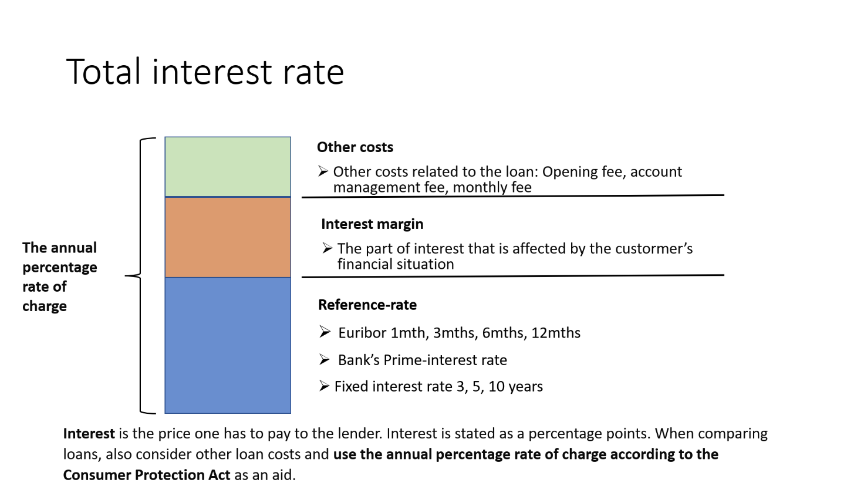

TASK: Planning one's purchases
Tehtävä palautetaan erillisenä tiedostona tai muulla opettajan kanssa sovitulla tavalla. Tehtävän voi jakaa kolmeen osaan arvioinnin mukaan. Näin on tehty Itslearningissa. | Use of AI is not allowed.

Purchases, planning and financing
In this task, you’ll consider various significant purchases for which you’ve saved or plan to save in the future. Think about acquisitions that your monthly income won’t cover.

Start with tasks T1-T2. If you aim for a higher grade, also complete tasks H3-H4 and K5.

T1-T2:
- What purchases have you been considering in the near future?
- How do you plan to achieve your goals?
- What financing options do you have for funding the purchase?
H3-H4:
Your phone broke, and you need a new one. What different financing options do you have for buying a new phone?

Define the following terms:
- Annual Percentage Rate (APR) according to the Consumer Protection Act
- Euribor 6 months + 7.5% margin
- Account management fee: €5/month
- Often the length of the contract is mentioned in months. How many years are the following: 12 months, 24 months, 36 months, 60 months.
K5:
Think of a larger purchase and present a realistic calculation to achieve it.
- Where will you obtain the loan?
- How do you plan to repay it?
- What are the total costs of the loan?

Controlling one’s financial risks
Teksti on osion kuvaus. | Use of AI is not allowed.

Life situations change. You can get married and have babies. You can start to study for a new job. You can get unemployed. Some of the changes are planned and expected, but not all of them.

In case you lose your job or can't do your work because you are ill, your financial situation can deteriorate quickly.

It's good to understand what kind of risks there are and how you can prepare yourself if something happens.

TASK: Terms related to one’s financial risks
Tehtävässä yhdistetään käsite ja selitys. | Use of AI is not allowed.

Economic risk = unexpected changes in one's income or expenses
Adjusting expenses = checking if all expenses are necessary
Net income = is the difference between gross income minus taxes and deductions
Savings money = that is not spent and is an important tool to risk management

TASK: Financial risks
Tehtävä palautetaan erillisenä tiedostona tai muulla opettajan kanssa sovitulla tavalla. | Use of AI is not allowed.

Think about your household's financial situation. What kind of risks or unexpected events may affect it? Think about both income sources and expenses as well.

TASK: How to avoid a payment default?
Tehtävä palautetaan erillisenä tiedostona tai muulla opettajan kanssa sovitulla tavalla. | Use of AI is not allowed.

https://www.youtube.com/watch?v=O2lR3FX5d6I
Video is in Finnish. The subtitles can be translated automatically through settings.

Study material:
https://oikeus.fi/talousjavelkaneuvonta/en/index.html
https://oikeus.fi/talousjavelkaneuvonta/en/index/unnamed4/financialself-help.html#

Check the following video regarding payment default. Based on it, briefly describe how to avoid payment default. If you have no money to pay the bills, what do you have to do?

Self-evaluation
Tehtävä on itsearviointia ja toimii osaamisen osoittamisen tehtävänä, jolla opettaja voi arvioida opiskelijan osaamista. | Use of AI is not allowed.

- Evaluate your own skills on a scale from T1 to K5. (T1 = satisfactory, H3 = good, K5 = excellent)
- I know the basic rights and duties of citizens.
  - Name at least one right and duty
- I adhere to the principles of equality and non-discrimination.
  - Give some examples.
- I act as an active citizen and know how to use various means of influence.
  - Name at least one way to influence in society
- I know and can use public services.
  - Name three public services
- I know my rights and duties as a consumer.
- I make responsible consumption decisions.
- I know how to seek information on consumer matters.
- I recognize various factors that affect the economy.
- I keep track of my income and expenses.
- I plan my purchases in advance.
- I can compare different financing options.
    - Name two different financing options
- I can set personal financial goals, such as creating a savings plan.
- I understand how the economic situation varies in different life situations and how to prepare for it.
    - Name an example
- Name three things that you think were the most important in this course.
- On a scale from Satisfactory 1 to Excellent 5, what grade would you give yourself for this course?
- Justify why you would give that grade.
- How much time did you spend studying this course (approximately)
  - Less than 10 hours
  - 11-20 hours
  - 21-30 hours
  - More than 30 hours

Lopuksi
Osa-alueen opettajat eri oppilaitoksista ovat luoneet verkkokurssin sisällön. Sisältöä saa muokata oppilaitoksen tarpeisiin sopivaksi. Verkkokurssista on olemassa valmis Moodle-pohja, joka löytyy Avointen oppimateriaalien kirjastosta. Itslearning-kurssi löytyy Itslearningin kirjastosta, josta tehtävät täytyy poimia tehtävä kerrallaan.

Lähdeluettelo
Verkkoaineistot
Euroopan unioni. History of the EU. https://european-union.europa.eu/principles-countries-history/history-eu_en, luettu 12.11.2024
Finlex. www.finlex.fi, luettu 12.11.2024
Kuntaliitto. Toimielimet ja johtaminen. https://www.kuntaliitto.fi/laki/toimielimet-ja-johtaminen, luettu 12.11.2024
Tampereen kaupunki. www.tampere.fi, luettu 12.11.2024
Vaalit. www.vaalit.fi, luettu 12.11.2024
Valtiovarainministeriö. Local government’s duties and activities. https://vm.fi/en/local-government-s-duties-and-activities, luettu 12.11.2024
Vieremän kunta. www.vierema.fi, luettu 12.11.2024

Painetut lähteet
Bauman, Z. (2007). Consuming Life. Polity Press.
Ilmonen, K. (2007). Kuluttajatieto ja kulutuskäyttäytyminen. Gaudeamus.
Pantzar, M., Hyvönen, T., Repo, V., & Timonen, P. (2008). Kuluttajatieto ja kuluttajatutkimus. Gaudeamus.

Liitteet
Fundamental rights.pptx
Tiedosto tekstinä:

1 | Fundamental rights in Finland
2 | Finland is a democracy  Citizens’ basic rights are based on Finland’s Constitution.  The Finnish Constitution was updated on June 11, 1999.
3 | Equality  Article 6  - Definition: No one may be placed in a different position without an acceptable reason based on gender, age, origin, language, religion, conviction, opinion, health condition, disability, or any other personal reason.  - Law: People are equal before the law.  - Children: Children must be treated equally as individuals, and they must have the opportunity to influence matters concerning themselves in accordance with their development.  - Gender equality must be promoted in societal activities and working life, especially when determining salaries and other terms of employment, as further provided by law.
4 | Right to Life and Personal Freedom  Article 7  - Right to Life and Freedom: Everyone has the right to life, personal freedom, inviolability, and security.  - Prohibition of Cruel Treatment: No one can be sentenced to death, tortured, or treated in a way that violates human dignity.  - Inviolability and Freedom: Personal inviolability cannot be interfered with arbitrarily, and freedom cannot be deprived without a legal basis.  - Legal Safeguards: Courts determine punishments involving deprivation of liberty, and the legality of other deprivations of liberty can be reviewed by a court. The rights of those deprived of liberty are protected by law.
5 | Principle of Legality in Criminal Law  Article 8  - Ex Post Facto Principle: No one can be found guilty of a crime or punished for an act that wasn’t illegal when they committed it.  - No Retroactive Punishment: The punishment for a crime cannot be more severe than what the law allowed at the time the act occurred.
6 | Freedom of Movement  Article 9  - Free Movement: People living in Finland can move and live freely anywhere in the country.  - Leaving Finland: Everyone can leave Finland, but the law may limit this right for certain reasons like court cases, punishment, or national defense duties.  - Entering Finland: Finnish citizens can’t be forced to leave Finland or sent to another country against their will, unless it’s to ensure legal rights and protection.  - Foreigners’ Rights: Foreigners’ entry and stay in Finland are controlled by law. They can’t be sent to a country where they might face harsh punishment or human rights violations.
7 | Right to Privacy  Article 10  - Privacy Rights: Everyone’s private life, honor, and the sanctity of their home are protected.  - Protection of Personal Data: More detailed rules about safeguarding personal data are specified by law.  - Secrecy of Communications: The confidentiality of correspondence, phone calls, and other private communications is inviolable.  - Measures Affecting Home Sanctity: If necessary to protect basic rights or investigate crimes, certain measures affecting the sanctity of the home can be established by law.  - Limitations on Communication Secrecy: In cases involving individual or societal security, trials, security checks, deprivation of liberty, or obtaining information on military activities, communication secrecy may be restricted by law.
8 | Freedom of Religion and Conscience  Article 11  - Freedom of Religion and Conscience: Everyone has the right to practice their religion, express personal beliefs, and decide whether to be part of a religious community.  - No Obligation: No one is required to participate in religious practices that go against their conscience.
9 | Freedom of Expression and Right of Access to Information  Article 12  - Freedom of Expression: Everyone has the right to express themselves freely. This includes sharing and receiving information, opinions, and other communications without prior censorship.  - Restrictions on Pictorial Programs: Laws may limit certain visual programs to protect children.  - Public Documents and Recordings: Documents and recordings held by authorities are public unless specifically restricted by law. Everyone has the right to access public documents and recordings.
10 | Freedom of Assembly and Freedom of Association  Article 13  - Freedom of Assembly: Everyone has the right to organize meetings and demonstrations without needing a permit. They can also participate in these events.  - Freedom of Association: People can form associations without requiring a permit. They can choose to be members or not and participate in association activities.  - Trade Unions and Organizing: The freedom to form trade unions and organize for other interests is also guaranteed.  - Detailed Provisions: Specific rules about exercising freedom of assembly and association are defined by law.
11 | Electoral and Participatory Rights  Article 14  - Voting Rights: Finnish citizens who are eighteen years old can vote in national elections and referendums. Specific rules determine eligibility for running for office in national elections.  - European Parliament Elections: Finnish citizens and other European Union residents in Finland who are eighteen years old can vote in European Parliamentary elections as specified by law.  - Municipal Elections: Finnish citizens and foreign residents permanently living in Finland who are eighteen years old can vote in municipal elections and referendums as provided by law.  - Participation in Society: Public authorities must encourage individual participation in societal activities and decision-making processes.
12 | Protection of Property  Article 15  - Property Protection: Everyone’s property is safeguarded.  - Expropriation Rules: Specific provisions regarding property expropriation for public purposes and compensation are defined by law.
13 | Educational rights  Article 16  - Free of charge: Everyone has the right to basic education without any cost.  - Equal rights: The government ensures equal opportunities for all to access additional educational services based on their abilities and special needs. Economic hardship should not hinder personal development.  - Special note: Freedom of education in science, arts, and higher education is guaranteed.
14 | Right to one’s language and culture  Article 17  - Two official languages: The national languages of Finland are Finnish and Swedish.  - Legal proceedings: Everyone has the right to use their own language (either Finnish or Swedish) in legal proceedings and when dealing with authorities.  - Official documents must also be provided in the individual’s chosen language. Public authorities are responsible for meeting the cultural and societal needs of both Finnish-speaking and Swedish-speaking populations equally.  - The Sami people: as an indigenous group, have the right to maintain and develop their own language and culture. Provisions regarding the use of the Sami language before authorities are specified by law.  - Sign language: Individuals who use sign language or require interpretation or translation assistance due to disability are also protected by legislation.
15 | Right to work and the freedom to engage in commercial activity  Article 18  - Freedom of choice: Everyone can choose their job, work, or business to make money. Criminal activity is prohibited.  - The government’s role: The government protects workers. The government also makes sure everyone can work. There are rules for getting job training to help people get jobs.  - Legal protection: If someone loses their job, there must be a good legal reason.
16 | Right to Social Security  Article 19  - Essential support: Individuals who lack the means for a dignified life have the right to receive essential support. This includes basic subsistence during unemployment, illness, disability, old age, childbirth, or loss of a provider.  - Public authorities’ role: Responsible for providing adequate social, health, and medical services, as well as supporting families to ensure the wellbeing and development of children.  - Living situation: Everyone has the right to housing and the opportunity to arrange their own living situation.
17 | Protection under the Law  Article 21  - Fair legal process ensures that everyone has the right to a fair legal process. This includes the right to have their case heard promptly by a competent court or authority.  - Transparent documents: Individuals also have the right to review decisions related to their rights and obligations through an independent legal body. The law specifies provisions related to proceedings’ transparency, the right to be heard, receiving reasoned decisions, and the right to appeal. These safeguards contribute to a fair trial and good governance.
18 | Note!  Basic Rights and Liberties in Situations of Emergency  Article 23  - In case of emergency: In Finland, provisions allow for temporary exceptions to basic rights and liberties when there’s an armed attack or other serious threats to the nation.  - These exceptions must be authorized by an Act or Government Decree, with specific criteria and limitations. The grounds for these exceptions are defined by law, and Parliament reviews Government Decrees promptly to assess their validity.

Civic duties and responsibilities.pptx
Tiedosto tekstinä:

1 | Civic duties and responsibilities  Operating as a member of Society and a Citizen
2 | Civic duties and responsibilities  - Compulsory education  - Duty of national defence  - Tax liability  - Obligation to a name  - Guardians Duty to take care Children  - Rescue duty  - Obligation to comply with the law  - Responsibility to take care of the Environment
3 | Compulsory education  The Finnish Compulsory Education Act (1214/2020)  - Education is compulsory for children aged 7 to 18 years.  - The obligation to education ends earlier in case a student completes either vocational upper secondary qualification or matriculation examinations.
4 | Duty of national defense  The Finnish Constitution Act (731/1999)  The Conscription Act (1438/2007)  - Every citizen has an obligation to participate in the defense of the country or assist it as specified by law.  - Every male Finnish citizen is liable for military service aged 18-60 years.  - Military service includes service as a conscript, participation in reservist training, extra service, and service during mobilization, in addition to participation in call-ups and examinations assessing fitness for military service.
5 | Tax liability  The Income tax act (1535/1992)  - Finnish citizens are obligated to pay taxes from earned income.  - Taxes are paid to the state, municipalities and parishes.  - Taxable income in Finland includes property, business, professional and employment income.
6 | Obligation to a name  The Finnish Name Law (946/2017)  - Individuals must have a first name, up to four.  - A first name must not cause offense, harm, or be clearly unsuitable.  - Everyone must also have a surname, which can be changed or combined with another under certain conditions.  - Guardians must notify the authorities of a child’s first name and surname within specific timeframes after birth.
7 | Guardians Duty to take care Children  The Child Welfare Act (417/2007)  - Finland aims to protect children’s rights to a safe growth environment, balanced and well-rounded development, and special protection.  - Primary responsibility for a child’s well-being is based on their parents and other custodians.  - A child must be provided with good care and upbringing, as well as necessary supervision and care according to the child’s age and developmental level.
8 | Rescue duty  The Criminal code of Finland (39/1889)  - Finnish citizens have a duty to assist a person in mortal danger or serious health risk.  - Neglecting this duty is considered a criminal act.  - The Criminal Code states that if a person knowingly fails to provide or obtain such assistance as can reasonably be expected of them, considering their capabilities and the nature of the situation, they may be guilty of neglecting rescue duty.  - The penalty can be a fine or imprisonment for up to six months.
9 | Obligation to comply with the law  The Finnish Constitution Act (731/1999)  - Finnish citizens and people living in Finland are obligated to act in accordance with the country’s laws.  - The Constitution Act forms the ground to this obligation:  - Finland’s constitution safeguards human dignity, individual freedom, and rights.  - Public authority belongs to the people, and the exercise of public power must be based on law.  - Legislative authority is vested in the Parliament, and executive authority lies with the President of the Republic and the Council of State.  - Fundamental rights include equality, the right to life, freedom of movement, and various other rights.  - Crimes committed by Finns against each other are subject to Finnish criminal law regardless of the location of the offense.
10 | Responsibility to take care of the Environment  The Finnish Constitution Act (731/1999)  - Nature and its biodiversity, the environment and the national heritage are the responsibility of everyone.  - The public authorities shall endeavor to guarantee for everyone the right to a healthy environment and for everyone the possibility to influence the decisions that concern their own living environment.

Tämä materiaali on tuotettu VIERKO-hankkeessa
vuonna 2024.
VIERKO on toteutettu Opetus- ja kulttuuriministeriön
vuonna 2023 myöntämällä ammatillisen koulutuksen strategiarahoituksella. VIERKO on kuudenkymmenen-
kahden (62) koulutuksen järjestäjän yhteisponnistus.
Työtä on koordinoinut Keski-Uudenmaan koulutus-
kuntayhtymä Keuda.

Hankkeessa on kehitetty vieraskielisen koulutuksen laatua
ja kotimaisten kielten opetuksen tarjontaa ammatillisessa koulutuksessa.

Lisätietoa:
https://www.keuda.fi/keuda/hankkeet/vierko/

https://creativecommons.org/licenses/by/4.0/


Oppimateriaalit:

CC BY-SA 4.0 Deed | Nimeä-JaaSamoin 4.0 Kansainvälinen | Creative Commons
https://creativecommons.org/licenses/by/4.0/

Oppimateriaalit:



CC BY-SA 4.0 Deed | Nimeä-JaaSamoin 4.0 Kansainvälinen | Creative Commons

