Operating in a digital environment
2024
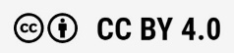



JAN HOKKANEN, jani hovi, mikko kari, tero koho, kati mehtomaa, teemu planting, JOHANNA RISKILÄ, satu tasala, tapio varis
Rahoittaja:

Vierko |www.keuda.fi/keuda/hankkeet/vierko

Sisällys
Johdanto 2
1. Orientation 4
1.1 TASK: Orientation 4
1.2 TASK: Evaluate your digital skills 5
2. Devices and Wilma/Studenta 7
2.1 TASK: Wilma/Studenta 7
2.2 TASK: Main functions of Wilma/Studenta 8
2.3 TASK: Devices and peripherals 9
2.4 TASK: Cables 10
2.5 TASK: Devices and their use 11
3. Office and other applications 13
3.1 TASK: Word instructions 13
3.2 TASK: Word - Vocations 13
3.3 TASK: Word CV 14
3.4 TASK: Powerpoint 15
3.5 TASK: Basics of Excel 15
4. Copyright, data privacy and cyber security 16
4.1 TASK: Kopiraittila Academy 16
4.2 TASK: Data protection, data security, firewall and viruses 17
4.3 TASK: Information influence 25
4.4 TASK: Digital footprint and online identity 28
5. Artificial intelligence (AI) 29
5.1 TASK: Artifical intelligence (AI) 29
5.2 TASK: Create an image 32
6. Final test 34
6.1 TASK: Final test 34
Lopuksi 38
Lähdeluettelo Virhe. Kirjanmerkkiä ei ole määritetty.

Johdanto
Käsikirjoituksessa on kaikki kurssin materiaalit tekstimuodossa. Poikkeuksena ovat Office-ohjelmien harjoitukset. Avointen oppimateriaalien kirjastossa on alkuperäiset tiedostot, jos niitä haluaa käyttää.

Otsikot kertovat tehtävän nimen. Tehtävien alussa on kuvaus siitä, millainen tehtävä on. Sen lisäksi kuvauksessa voi olla vaihtoehtoisia toteuttamistapoja, jos oppilaitos ei käytä Moodlea tai Itslearningia. Oppilaitos voi halutessaan käyttää tehtäviä myös paperisena, jos se on oppilaitoksessa hyväksytty suoritustapa. Kuvaus on sijoitettu tekstiruudun sisään kursiivilla:

Kuvaus on sijoitettu tekstiruudun sisälle.

Kurssi on jaettu selkeästi kuuteen eri osa-alueeseen: orientaatio, laitteet ja opiskelijahallintajärjestelmät, Office-ohjelmat, tekijänoikeudet ja turvallisuus, tekoäly ja lopputesti. Näiden osa-alueiden sisällä on laajasti erilaista materiaalia ja tehtäviä. Osaamisen osoittaminen osoitetaan lopputestillä.

Orientaatio | - Orientation
Laitteet ja opiskelijahallintajärjestelmät | - Devices and Wilma/Studenta
Office-ohjelmat | - Office and other applications
Tekijänoikeudet ja turvallisuus | - Copyright, data privacy and cyber security
Tekoäly | - Artificial intelligence (AI)
Lopputesti | - Final test

Osa-alueen osaamistavoitteet ja arviointikriteerit ovat luettavissa ePerusteista. Osaamistavoitteet ja arviointikriteerit on myös selkokielistetty VIERKO-hankkeessa.

VIERKO-hankkeessa tuotetuissa englanninkielisissä YTO-kursseissa on käytössä tekoälyn liikennevalomalli. Toiminta digitaalisessa ympäristössä -osa-alueen oletuksena on, että tekoälyä ei saa käyttää. Käsikirjoituksessa lähes jokaiseen tehtävään on merkitty punainen liikennevalo, joka kertoo, että tehtävässä ei saa käyttää tekoälyä. Yhdessä tehtävässä käytetään tekoälyä. Moodlessa ja Itslearningissa liikennevaloa ei ole laitettu jokaiseen tehtävään, vaan opiskelijalle kerrotaan orientaatio-osan yhteydessä, että tekoälyn käyttö on oletuksena kiellettyä. Oppilaitos saa itse päättää, voiko joissain tehtävissä käyttää tekoälyä.
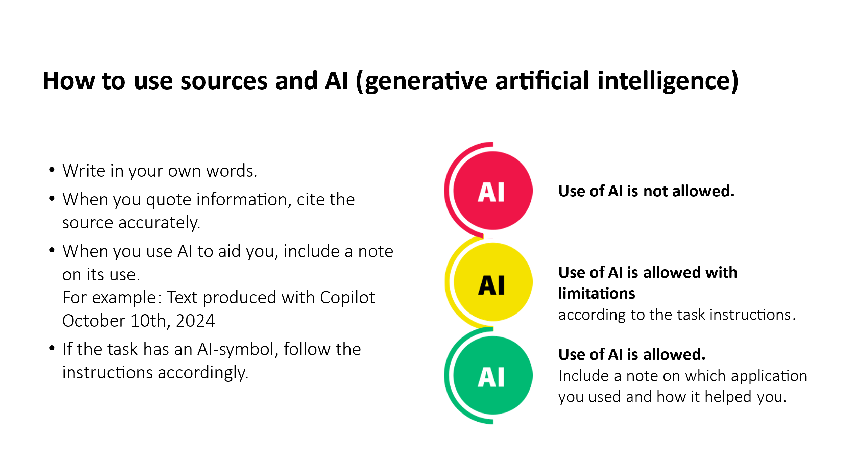

Tehtäviä saa muokata sellaisiksi, että ne soveltuvat oppilaitoksen käyttöön. Kaikkia tehtäviä ei tarvitse ottaa käyttöön, jos oppilaitos haluaa luoda omat englanninkieliset materiaalit.

Orientation

TASK: Orientation
Teksti voi olla kurssin kuvaus tai luettava materiaali. |   Use of AI is not allowed.

Competence requirements for this course

Selecting and using ICT devices

After you have completed this course, you will know how to
- select devices and applications that are appropriate for the purpose
- use appropriate digital devices

Using digital services and applications

After you have completed this course, you will know how to
- search for, process and share information of different forms
- assess the reliability of digital content
- use the most common applications for text processing, spreadsheets and presentation graphics
- use appropriate digital services and applications in your work tasks

Responsible and safe use of ICT

After you have completed this course, you will know how to
- comply with the data protection and data security instructions
- protect your personal data and privacy
- identify the most typical cybersecurity and data security threats
- use messaging services and social media services responsibly
- use and share digital content in compliance with copyrights
- identify some impacts of using digital devices and applications on health and wellbeing

This course will be evaluated on scale 1-5: Satisfactory 1- Satisfactory 2 - Good 3 - Good 4 - Excellent 5

Do not use AI on this course unless the task instructions allow it.

TASK: Evaluate your digital skills
Tehtävää ei ole valmiilla Moodle-kurssilla, mutta se löytyy Itslearning-kirjastosta. Tehtävän voi ottaa käyttöön oppilaitokseen, jos haluaa. Tehtävän tarkoituksena on toimia opiskelijan itsearviointina kurssin alussa ja lopussa. Tehtävä tehdään siis kaksi kertaa: kerran kurssin alussa ja kerran kurssin lopussa. Vaihtoehdot ovat yes tai no. Kysymyksen 21 vastausvaihtoehdot ovat numerot 1–5. | Use of AI is not allowed.

Digital skills – evaluate your skills

READ THIS FIRST:
Answer the questions honestly and yourself - the purpose of this test is to evaluate your digital skills.

Section 1: Basic use of the computer and mobile devices
- I know how to type capital letters and special characters like @, €, $, ", ( ) and + ?
- I know how to create a folder and upload files to a cloud service (like OneDrive or Google Drive) and share them with others.
- I know how to record a video with my mobile device and save it to a cloud service (like YouTube, Google Drive, OneDrive).
- I know how to download a new application from the application store and install it on my mobile device.
Section 2: Basic use of the internet and applications
- I know how to send an email with an attachment file.
- I know how to use social media apps, like Facebook, Youtube or Whatsapp.
- I know which online services can be used legally for free content (images, videos, music).
- I know how to save or copy an image from e.g. Pixabay and add the image to a Word document or email.
- I know how to copy a link and add it to a Word document or email.
- I know how to take a screen shot with my computer and add it to a Word document or email.
- I know what Chrome, Firefox and Microsoft Edge are.
- I know what OmaKanta, Suomi.fi and OmaVero are.
Section 3: Office applications
- I know what the key combinations Ctrl+C ja Crtl+V do.
- I know which Office application is used to write a CV, job application or an offer.
- I know which Office application is used to write a presentation.
- I know which office application is used for a budget (calculate your incoming and outcoming money).
Section 4: Safety
- I can recognize a scam message, if I receive one via SMS or email.
- I know what cookies do in online services.
- I always pay attention to safety when I use digital devices and services.
Section 5: Self development
- Which digital skills would you like to improve?
- Consider your basic digital skills in general. How many stars would you give to yourself? (scale 1 to 5)

Devices and Wilma/Studenta

TASK: Wilma/Studenta
Muokkaa tähän osioon se järjestelmä, jota oppilaitoksessa käytetään. Lisää myös linkki, josta kirjaudutaan järjestelmään. Wilmasta ja Studentasta on yksinkertainen harjoitus, mutta sen voi korvata oppilaitoksen omilla harjoituksilla, jos sellaisia löytyy englanniksi. | Use of AI is not allowed.

What is Wilma? | What is Studenta?
Wilma is an application with important information related to studying and the student.  in Wilma:  - You can see your own schedule and choices.  - You can see the dates of the exams.  - You can see your own absences and other entries made by the teacher.  - You can send and receive messages.  - You can look at the grades given for the studies.  - You can open other applications.  - You can look at the teachers' work schedules.  Other purposes for Wilma:  - The teachers make lesson notes, exam dates, homework markings and evaluations to Wilma.  - The teacher can send messages to an individual student or a group of students.  - Guardians can monitor school attendance and keep in touch with teachers. | Studenta is an application with important information related to studying and the student.  in Studenta:  - You can see your own schedule.  - You can see your own absences and other entries made by the teacher.  - You can send and receive messages.  - You can look at the grades given for the studies.  Other purposes for Studenta:  - The teachers make lesson notes, homework markings and evaluations to Studenta.  - The teacher can send messages to an individual student or a group of students.  - Guardians can monitor school attendance and keep in touch with teachers.

TASK: Main functions of Wilma/Studenta
Muokkaa tähän osioon se järjestelmä, jota oppilaitoksessa käytetään. Lisää myös linkki, josta kirjaudutaan järjestelmään. Wilmasta ja Studentasta on yksinkertainen harjoitus, mutta sen voi korvata oppilaitoksen omilla harjoituksilla, jos sellaisia löytyy englanniksi. Itslearning-kirjastossa on kaksi tehtävää, 2.2 TASK Wilma ja 2.2 TASK Studenta. Ota käyttöön se, kumpaa oppilaitoksessa käytetään. | Use of AI is not allowed.

Main functions of Wilma | Main functions of Studenta
In this task, you get to know how to use Wilma. Do the following 8 steps and then answer the question.  - Open the Wilma application using a computer and your mobile device.  - Log in with your username and password.  - Read new messages.  - Search for your studies and schedule.  - Search for you responsible teacher's name and contact information.  - Practice, how you could send a message to your responsible teacher. You don't need to send it: just check how you could do it.  - Search for attachments. Practice how to add an attachment to Wilma.  - Search for Wilma instructions / help.  After you have done these 8 tasks, give your answer:  - Were you able to do all the 8 tasks? If not, which of the tasks was/were too difficult to do?  - Was it easy to use Wilma?  - Do you prefer using Wilma on computer and mobile device? | In this task, you get to know how to use Studenta. Do the following 6 steps and then answer the question.  - Open the Studenta application using a computer and your mobile device.  - Log in with your username and password.  - Read new messages.  - Search for your schedule.  - Practice, how you could send a message to your responsible teacher. You don't need to send it: just check how you could do it.  - Search for attachments. Practice how to add an attachment to Studenta.  After you have done these 6 tasks, give your answer:  - Were you able to do all the 6 tasks? If not, which of the tasks was/were too difficult to do?  - Was it easy to use Studenta?  - Do you prefer using Studenta on computer and mobile device?

TASK: Devices and peripherals
Tehtävässä yhdistetään kuva ja sana. Voit ottaa kuvat käsikirjoituksesta tai etsiä itse sopivat kuvat esimerkiksi Pixabaysta tai Papunetistä. Kuvia voi myös luoda tekoälyllä tai ottaa kuvat itse. | Use of AI is not allowed.



- desktop computer
- charger
- external hard drive
- headphones
- printer
- router/modem
- laptop computer
- USB memory
- keyboard
- mouse
- screen

TASK: Cables
Tehtävässä yhdistetään kuva ja sana. Voit ottaa kuvat käsikirjoituksesta tai etsiä itse sopivat kuvat esimerkiksi Pixabaysta tai Papunetistä. Kuvia voi myös luoda tekoälyllä tai ottaa kuvat itse. Joitakin sanoja on useamman kerran, koska esimerkiksi näytön voi yhdistää eri tavoilla laitteeseen. | Use of AI is not allowed.

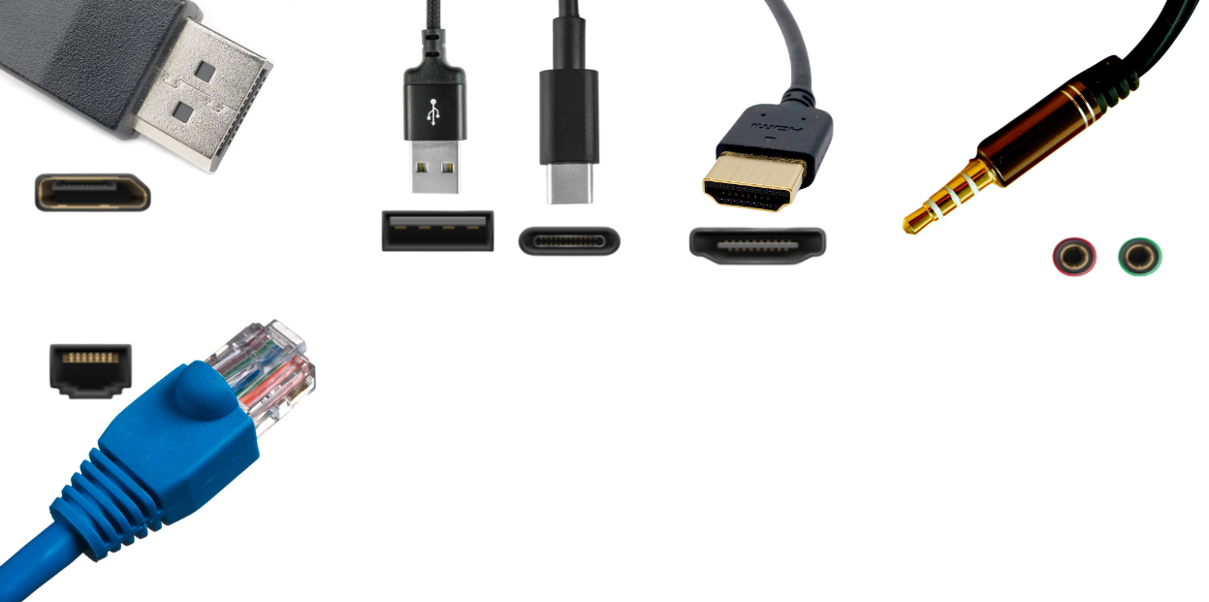

- display port
- ethernet
- HDMI
- sound in
- sound out
- USB A
- USB C
- peripherals
- peripherals
- internet
- microphone
- microphone
- headphones
- headphones
- headphones
- screen
- screen
- screen
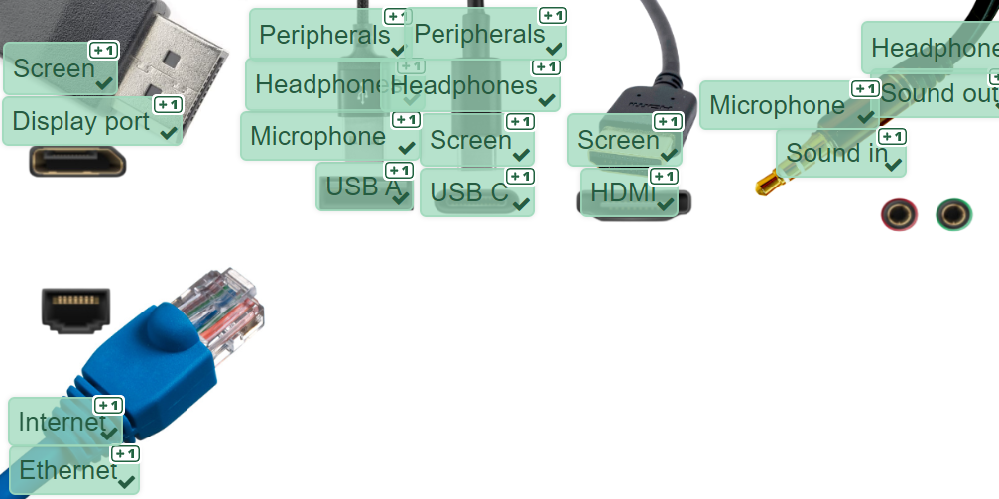

TASK: Devices and their use
Tehtävä palautetaan erillisenä tiedostona tai muulla opettajan kanssa sovitulla tavalla. | Use of AI is not allowed.

Answer the questions and prompts based on your own devices and how you use them.
- Give three examples of how you utilize various devices in your studies.
- Give three examples of how you use a computer in your free time.
- Where do you use a wifi network with your devices? How can you protect yourself and your devices when using those wifi networks, especially if they are public?
- How do you use your phone? Give at least three examples on how you use it for your studies and/or your work, and three examples on how you use it in your free time.
- Do you think you use your phone and computer too much? What kind of positive and negative effects do you use of these devices have on you?
- How could you better utilize your devices?
- Do you have any other devices that can connect to the Internet or your phone (via Bluetooth for example)? Do they all need to connect to the Internet? Why and why not? For example, my headphones connect to my phone and that is useful because... or My washing machine can connect to the Internet and that is not necessary because...
- Read this guide to office ergonomics. Is your workspace at home or at school ergonomic? How could you improve your workspace?

Office and other applications

TASK: Word instructions
Materiaali on Avointen oppimateriaalien kirjastossa (Word instructions). Materiaali on Wordin ohjeet. | Use of AI is not allowed.

TASK: Word - Vocations
Materiaali on Avointen oppimateriaalien kirjastossa (Vocations). Tehtävä palautetaan erillisenä tiedostona tai muulla opettajan kanssa sovitulla tavalla. | Use of AI is not allowed.

Replicate the Vocations.pdf using word. It is highly recommended that you use the desktop application.
- Copy and paste the first page.
- Type out the second page, or if you wish, you can instead write similar things about 2 vocations of your choice. Make the necessary adjustments.
  - Change the font, size, bold, use bullet points etc.
  - Center the headings, justify the text, increase line spacing for the bullet points and change margins to medium.
- Add pictures you find from the internet where necessary.
  - Only use pictures that are free to use (CC-license or similar copyrights).
- Recreate the SmartArt –object, the table and the arrow on the 3rd page.
- Add the header with information as in the pdf. Insert tab --> Header and Footer
  - Name of the school, your name, group, date
  - Also add the page number using the page number tool on Word.
Save your work and upload the file to Moodle/Itslearning.

TASK: Word CV
Tehtävä palautetaan erillisenä tiedostona tai muulla opettajan kanssa sovitulla tavalla. | Use of AI is not allowed.

- Find suitable CV template in Word/Docs, on the Internet, or write without a template but following some guide.
- Write a CV based on the template using your own information and good English.
- Take a professional-looking and relevant photo of yourself. Insert the photo in your CV in an appropriate place.
- Save your CV in an editable format and in PDF format.
- Save the CV to a cloud service (e.g. Office 365 OneDrive) and turn in the link to the CV with read-only permission for this assignment.
- Send an email to your teacher with the CV in PDF format as an attachment.
If you already have a CV, update and improve on it.

Assessment criteria:
Grade | Content
T1 | - The CV follows general conventions and includes your own information.  - Your own photo is on the CV.  - The CV has been turned in as a PDF file with email.
H3 | - The CV follows a general pattern or formula and contains information relevant to getting hired for a job.  - The CV is neat and readable.  - The CV is written using good English.  - The CV has your own picture, which is professional-looking and relevant. The picture is correctly positioned.  - The CV has been turned in as a PDF file (using email) and as an editable file (MSOffice, Libre Office, etc.).  - The CV is linked from the cloud to the assignment and the link is read-only, not allowing editing.
K5 | - The CV is comprehensive in terms of information, follows a common template or pattern and is neat and readable.  - The CV has your own picture, which is professional-looking and relevant. The picture is positioned well.  - The CV is turned in as a PDF file (using email) and as an editable file (Office, Libre Office, etc.).  - The CV is linked from the cloud to the assignment response and the link is read-only, not allowing editing.  - The CV is ready to be sent to a potential employer

TASK: Powerpoint
Materiaali on Avointen oppimateriaalien kirjastossa (PowerPoint instructions). Tehtävä palautetaan erillisenä tiedostona tai muulla opettajan kanssa sovitulla tavalla. | Use of AI is not allowed.

Create a PowerPoint presentation of the topic of your choosing. Use all the tools mentioned in the PowerPoint Instructions. If you are having a hard time at choosing a topic, you can replicate the Instructions.

TASK: Basics of Excel
Materiaali on Avointen oppimateriaalien kirjastossa (Basics of Excel). Tehtävä palautetaan erillisenä tiedostona tai muulla opettajan kanssa sovitulla tavalla. | Use of AI is not allowed.

Download the attached file, do the exercises in the file, save your work and upload the file to Moodle/Itslearning.

Copyright, data privacy and cyber security

TASK: Kopiraittila Academy
Tehtävä tehdään Kopiraittilan sivuilla. Suorituksesta saatu osaamismerkki palautetaan opettajalle sovitulla tavalla. | Use of AI is not allowed.

Learning Task: Copyrights

Purpose:

The purpose of this task is to raise awareness about copyrights and help you identify what materials you can use freely and what you cannot. Understanding copyrights is crucial for responsible behavior online.

Objective:

The objective is for you to learn how copyrights influence and limit the use of materials online. After completing this task, you will be able to recognize copyright-protected content and understand how to proceed when you want to use it in your own work.

Activity:
- Log in to the Kopiraittila Academy website and start the copyright-related game: Kopiraittila Academy.
- To complete the sections, you need to study the contents of each section and answer the quiz at the end of each one.
- Play the game at your own pace. Completing the game may take 1-2 hours, but you can pause and continue later if needed.
- Once you finish all five sections, you can request your Copyright Expert badge by email. Alternatively, you can take screenshots of your quiz results.
- Return the final badge OR completion of each of the five sections to this folder.
Note: If you want to continue the game later from where you left off, make sure to register and log in.

TASK: Data protection, data security, firewall and viruses
Tehtävässä on teoria ja tehtävät. Kokonaisuutta voi keventää tekemällä useamman eri tehtävän, joissa on teoria ja aiheeseen liittyvät kysymykset. Kysymykset ovat monivalintoja. Lihavoidut vastausvaihtoehdot ovat oikeita vastauksia. | Use of AI is not allowed.

Read the following text and answer the questions.

Data privacy in information technology refers to the protection of users' personal data and privacy. It encompasses the security and privacy of data collection, usage, storage, and sharing.

Data privacy and cybersecurity are two core concepts in information technology, but they have slightly different focuses:
- Cybersecurity encompasses a broader concept, aiming to protect data from various threats and dangers, including data breaches, malware, data loss, and denial-of-service attacks. Cybersecurity seeks to prevent, detect, and respond to these threats using information systems, networks, and IT devices.
- Data privacy, on the other hand, focuses on safeguarding individual users' personal data and privacy. It deals with how data is collected, used, stored, and shared within the context of information technology. The goal of data privacy is to ensure that users can retain control over their data and that this data is handled and used appropriately and lawfully.
So, the main distinction between data privacy and cybersecurity is their focus: cybersecurity addresses the broader protection of information systems and networks, whereas data privacy is more concerned with protecting users' privacy and the handling of personal data.

GDPR (General Data Protection Regulation) is a regulation of the European Union that sets rules and standards for the processing of personal data and privacy protection within the European Economic Area. GDPR aims to enhance the protection of individuals' personal data and give them more control over their own data.


The key principles and requirements of GDPR include:
- Consent requirement: Organizations must clearly and explicitly request consent from individuals before collecting and using their personal data.
- Data minimization: Organizations are allowed to collect and process only the necessary personal data for the purpose for which it was collected.
- Accuracy and precision of data: Organizations must ensure that personal data is accurate and up-to-date...
...GDPR
- Data retention limitations: Personal data should not be stored longer than necessary for the original purpose.
- Security and protection: Organizations must implement appropriate technical and organizational measures to protect personal data from unauthorized or unlawful processing, accidental loss, destruction, or damage.
- Individual rights: GDPR grants individuals several rights, such as the right to access their own personal data, the right to correct inaccurate data, the right to be forgotten, and the right to data portability.
Compliance with GDPR is crucial for organizations that process personal data of EU citizens, and failure to comply can result in significant penalties, including fines.

Data protection and data security questions:
- What is the goal of data privacy in information technology?
  - To protect users' personal data and privacy
  - To improve computer performance
  - To prevent system crashes
  - To speed up data transmission
- How does data privacy affect data processing?
  - It increases data collection
  - It ensures that data is processed appropriately and lawfully
  - Not at all
  - It causes system slowdowns
- What is one aspect of data privacy practices?
  - Deleting data when it is no longer needed
  - Data encryption
  - Widely sharing data online
  - Collecting data without consent
- How can users influence data privacy?
  - Only by shutting down the computer
  - By blocking all network traffic
  - By clearing computer files daily
  - By using strong passwords and carefully considering data sharing
- What does cybersecurity aim to protect?
  - Usernames and passwords
  - Personal data and privacy
  - Computer speed
  - Data systems and networks
- What is the goal of cybersecurity in information technology?
  - To protect systems and networks from harmful threats and attacks
  - To leave systems vulnerable
  - To improve internet connection speed
  - To increase the spread of viruses and malware
- How does cybersecurity affect data systems?
  - Not at all
  - It slows down data systems
  - It increases data availability
  - It strengthens systems by protecting them from harmful threats and attacks
- What does cybersecurity include?
  - Openly sharing data online
  - Collecting data without user consent
  - Protecting systems from harmful threats and attacks
  - Storing data without protection
- What can you do to improve cybersecurity?
  - Install and update antivirus software and firewalls
  - Leave systems unprotected
  - Provide everyone access to data
  - Share your passwords publicly

Firewall
A firewall is a security technology used in computer networks and systems. Its purpose is to protect computers and networks from unwanted network attacks and malicious software such as viruses and hackers.

A firewall acts as a barrier that monitors and regulates network traffic between the network and the outside world. It analyzes incoming and outgoing data packets and decides whether they should be allowed to pass through the network or be blocked. Firewalls can be based on various rules and models, such as port filters, application-layer firewalls, and monitoring-based systems.

The purpose of a firewall is versatile. It helps prevent the spread of malware and viruses, protects computers and networks from intrusions and data theft, and blocks unauthorized access to systems or networks. Additionally, it can help monitor and manage network traffic and ensure compliance with security regulations within organizations.

Firewall devices and software are key cybersecurity solutions that help protect computers and networks from malicious network attacks and threats. Here's an overview of both:

Firewall Devices:
- Firewall Appliances: Physical devices designed specifically for firewall tasks. They can be standalone units or integrated network devices such as routers or switches with built-in firewall functionality.
- Application Firewalls: These firewalls operate at the application level, allowing them to monitor and block specific applications or services if they are identified as a security risk.
- Next-Generation Firewalls: These firewalls continuously monitor network traffic and dynamically respond to potential threats. They may utilize various techniques such as behavior-based analysis or threat intelligence to identify and mitigate threats.


Firewall Software:
- Network-based Firewalls: Software-based solutions that can be installed on computers or servers to protect them from network attacks. They typically operate by using configured rules and filters to monitor and block network traffic.
- Application Firewall Software: These software solutions have the ability to monitor specific applications and their network traffic. They may allow users to define precise rules for application usage and network access.
- Anti-virus Software: While not firewall software per se, they are an essential part of comprehensive cybersecurity. They detect and remove malicious programs such as viruses and trojans that could otherwise bypass the firewall.
These devices and software can operate alone or together to form a multi-layered cybersecurity solution that helps protect computers and networks from a variety of threats.

Virus
Computer viruses are malicious software that spread and infect computers in various ways. Their primary purpose is to damage or disrupt computer operation and compromise user data security. Viruses can cause various harms, such as file destruction, data theft, and system slowdowns or crashes.

Malware is a broad term encompassing various harmful programs such as viruses, worms, trojans, spyware, and ransomware. Their purposes may vary, but they all aim to damage the user's computer, steal data, or perform other malicious actions.


The significance of computer viruses and malware is extremely high for cybersecurity. They can cause severe damage to computers and user data security. They are primarily used as a means of attack to spy on users, steal sensitive information, deny data availability, extort ransom, and much more.

Viruses and malware are often used unlawfully to steal data or hijack computers. They can be spread through email attachments, malicious websites, or infected USB drives. They can also propagate automatically through networks by exploiting vulnerabilities in systems.

Firewalls and viruses questions
- What is the primary purpose of a firewall in computer networks?
  - To increase network speed
  - To regulate network traffic
  - To provide network storage
- Which of the following is NOT mentioned as a function of a firewall?
  - Preventing the spread of malware
  - Protecting against data theft
  - Enhancing network performance
  - Blocking unauthorized access
- What does a firewall analyze to determine whether network traffic should be allowed or blocked?
  - Incoming and outgoing data packets
  - System hardware configurations
  - User login credentials
  - Internet service provider details
- Which type of firewall operates at the application level?
  - Next-Generation Firewalls
  - Network-based Firewalls
  - Anti-virus Software
  - Application Firewalls
- What distinguishes Next-Generation Firewalls from traditional firewalls?
  - They are hardware-based only
  - They use behavior-based analysis
  - They lack dynamic threat response
  - They focus only on port filtering
- Which is not malware?
  - Virus
  - Firewall
  - Trojan
  - Spyware
- What is the significance of malware for cybersecurity?
  - To enhance computer speed
  - To damage user files
  - To cause severe damage to computers and user data security
  - To protect user computers
- Where is malware primarily used?
  - To help data security
  - To prevent internet usage
  - As a means of attack to hijack computers and steal data
  - To enhance computer performance
- How can malware spread?
  - Only through email
  - Through infected USB drives
  - Through networks by exploiting vulnerabilities in systems
  - Only by manual installation
Cybersecurity
Cybersecurity is a subset of information security that focuses on protecting digital systems and computer networks from online threats and attacks. Its purpose is to ensure that information, systems, and services are effectively protected from potential breaches, data leaks, malware, and other security risks.

The significance of cybersecurity is high in the modern digital environment where computer networks are widely used in business, government, healthcare, and private households. It ensures the protection of confidential information such as personal data and trade secrets. Additionally, it helps maintain the operation of critical infrastructures such as power grids, water supplies, and healthcare systems.

Cybersecurity is manifested through various measures and practices, such as the use of strong passwords, installation of firewalls and antivirus software, data encryption, patching vulnerabilities in software and systems, and continuous monitoring and response to potential threats.

Tips
A regular computer user can protect themselves against viruses and cyber threats through several practical measures:
- Install reliable antivirus software: Obtain and install up-to-date and reliable antivirus software on your computer. Keep the software updated and perform regular scans on your computer for viruses.
- Update your operating system and software: Ensure that your operating system (such as Windows or macOS) and other software are up to date. Updating patches known vulnerabilities that could be susceptible to attacks.
- Be cautious with email attachments and links: Do not open emails or attachments from unknown senders. Also, avoid clicking on suspicious links that may lead to malicious websites.
- Use strong passwords and two-factor authentication: Use strong passwords of at least eight characters in length and, where possible, enable two-factor authentication to enhance the security of your accounts.
...Tips
- Back up your data regularly: Make regular backups of important data and files. This allows you to restore your data if your computer falls victim to malware.
- Practice safe browsing: Avoid visiting suspicious websites and only download software from trusted sources. Use browser ad-blocking and anti-malware protection features.
- Stay informed about cyber threats and scams: Keep up to date with current information on cybersecurity threats and scams. Be aware of common frauds and cyberattack techniques to protect yourself.
- By implementing these practical measures, a regular computer user can significantly reduce the risk of falling victim to viruses and cyber threats.
Cybersecurity questions
- What is the significance of cybersecurity in modern society?
  - Equipping military forces
  - Protecting confidential information and maintaining the operation of critical infrastructures
  - Creating digital entertainment products
  - Preventing telemarketing
- How is cybersecurity manifested in practice?
  - Acting as a secret agent
  - Protecting computer networks with firewalls and antivirus software
  - Sending emails
  - Maintaining accounting records
- What are examples of practical measures in cybersecurity?
  - Sharing passwords
  - Encrypting data
  - Leaving software vulnerabilities unpatched
  - Opening random emails
- What does cybersecurity particularly help with?
  - Monitoring the consumption behavior of private households
  - Protecting personal data and trade secrets
  - Operating national defense forces
  - Combating climate change

TASK: Information influence
Tehtävässä on teoria ja monivalintakysymykset. Tekstin voi erottaa omaksi materiaaliksi, jos haluaa, tai tehdä yhden kokonaisen tehtävän. Lihavoidut vastausvaihtoehdot ovat oikeita vastauksia. | Use of AI is not allowed.

What is Information Influence?
- Aims to influence public opinion, behavior, and the functionality of society.
- False information spreads quickly through global networks.


Undermining Trust in Society
- Information influence aims to weaken trust in information and informational authorities, such as science, media, and authorities.
- The goal is to create uncertainty and distrust.
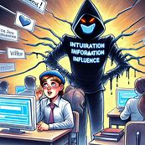
Strategies of Information Influence
- Questioning evidence-based information.
- Creating alternative narratives.
- Discrediting informational authorities.
- Utilizing social media algorithms to foster doubt.
Human Cognitive Weaknesses
- Cognitive biases, such as the fluency effect and confirmation bias, make us susceptible to false information.
- Crisis situations increase the tendency to believe in simple explanations.
Exploiting Emotional Reactions
- Social media algorithms favor emotionally charged content.
- For example, Facebook’s emoji reactions increased the spread of disinformation.

Countering Information Influence
- Teaching media literacy and critical thinking is crucial.
- Quick response to influence attempts helps counter them.
- Trust in authorities and media is strong in Finland, aiding in countering influence.


Questions
- What is the main goal of information influence?
  - To increase people’s knowledge
  - To influence public opinion and decision-making
  - To improve societal functionality
  - To reduce the amount of information
- What is one effect of information influence on society?
  - Strengthening trust in authorities
  - Increasing distrust towards epistemic authorities
  - Increasing the amount of information
  - Improving societal functionality
- Which of the following is an example of using algorithms in information influence?
  - Utilizing Facebook’s emoji reactions
  - Playing computer games
  - Reading books
  - Watching movies
- What is one of the strategies of information influence?
  - Increasing the amount of information
  - Creating alternative narratives
  - Sharing information openly
  - Strengthening trust
- What is one way to counter information influence?
  - Trusting all information without doubt
  - Reacting quickly to influence attempts
  - Reducing the amount of information
  - Avoiding all kinds of information gathering

TASK: Digital footprint and online identity
Tehtävä palautetaan erillisenä tiedostona tai muulla opettajan kanssa sovitulla tavalla. | Use of AI is not allowed.

Answer the following questions. You can search the Internet to find answers to the questions.
1. What is a digital footprint?
2. What does your own digital footprint consist of?
3. What is an online identity and how does it differ from a digital footprint?
4. What does your own online identity consist of? What social media do you use? Are your profiles public or private? Why/why not?
5. Google yourself to see what kind of information about you is available on the Internet. Is the information something you have put online yourself or has someone else put it out there? Are there things about you online you wish weren't?

Artificial intelligence (AI)

TASK: Artifical intelligence (AI)
Tehtävässä on teoria ja monivalintakysymykset. Tehtävn voi olla kokonaisena tehtävänä tai jakaa materiaalin ja kysymykset erillisiin tehtäviin. Lihavoidut vastausvaihtoehdot ovat oikeita vastauksia. | Use of AI is not allowed.

Read the following text and do the assignment.

Artificial intelligence creates an image of AI

Artifical intelligence (AI)
Artificial intelligence (AI) is a computer program that does things for humans. It can control traffic, search for information on the internet, or create new images. AI works using algorithms, which tell the computer what to do. An algorithm is like a recipe in cooking.

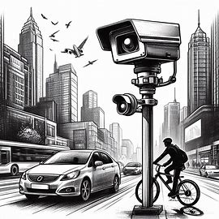
AIs usually only know how to do one task they are trained for. Current AIs, like ChatGPT, are “weak AIs,” meaning they cannot create new information or evaluate the accuracy of their data. They also do not understand human emotions or complex needs.

The ethics of AI depend on its programming. AI does not know what is right or wrong but follows the rules given to it. This can be a problem in areas like healthcare, where human emotions and needs are important.

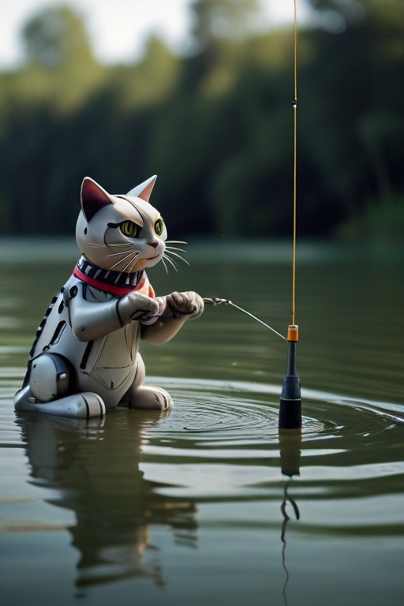
AI needs instructions, like any other computer program. AI instructions can be divided into three categories:
- Rule-based AI: Works according to predefined rules.
- Data-based AI: Learns from data, like pictures of cats and dogs.
- Self-training AI: Receives feedback on its actions and learns from it.

AI models, like ChatGPT and DALL-E, are trained with vast amounts of data. However, AI cannot make creative decisions but works according to its programming. AI can be a useful tool when used correctly.

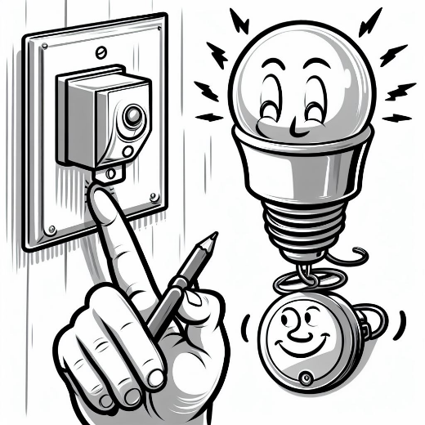
A few examples

ChatGPT 3.5 is a completely free AI for text production for consumers. ChatGPT 4 is a paid version.


Microsoft 365 Copilot, under which artificial intelligence solutions are collected that assist the user in various applications.


AI Art Generator — AI generated images with unparalleled speed and style to elevate your creativity.


DeepL Translates large amounts of text smoothly. Wide range of languages.



Gemini is Google's AI assistant that runs directly across Gmail, Docs, Sheets, and more.


Questions:
- What is the main operating principle of artificial intelligence?
  - AI operates without algorithms
  - AI operates based on human emotions
  - AI operates using algorithms
  - AI operates randomly
- What is one ethical challenge of AI?
  - AI can assess the accuracy of its data
  - AI has a human moral compass
  - AI cannot assess the accuracy of its data
  - AI always operates correctly and honestly
- Which of the following is NOT a use of AI?
  - Directing traffic
  - Searching for information on the internet
  - Creating new images
  - Handling human emotions
- What is one way AI is trained?
  - AI learns without data
  - AI is trained using training data and background truth
  - AI learns only through human instructions
  - AI does not need training
- What is one limitation of AI?
  - AI can make creative decisions
  - AI can replace humans in all tasks
  - AI cannot make creative decisions
  - AI does not need algorithms to operate

TASK: Create an image
Tehtävässä harjoitellaan tekoälyn käyttöä. Tehtävä palautetaan erillisenä tiedostona tai muulla opettajan kanssa sovitulla tavalla. |   Use of AI is allowed with limitations  according to the task instructions.

Assignment: Using AI to Create an Image
Objective: Learn to use AI in a creative process and understand the possibilities and limitations of AI.

Steps:
- Choose a Topic:
  - Select a topic for your image. It could be a historical event, a natural landscape, or a task related to your future profession.
- Research:
  - Conduct brief research on your chosen topic. Gather information and inspiration to help you create the image.
- Select an AI Tool:
  - Choose an AI tool, such as DALL-E, Copilot, MidJourney, or Stable Diffusion, that can create images based on text descriptions.
- Write a Description:
  - Write a detailed description of the image you want to create. Be specific about colors, style, and details.
- Create the Image:
  - Input your description into the chosen AI tool and let it generate the image.
- Evaluate and Edit:
  - Review the AI-generated image. Does it match your vision? If not, make necessary adjustments to the description and generate a new image.
Submit the image as an attachment.

Final test

TASK: Final test
Tehtävä on osaamisen osoittamisen tehtävä. Kysymykset ovat monivalintakysymyksiä ja avoimia kysymyksiä. Lihavoidut vastausvaihtoehdot ovat oikeita vastauksia monivalintatehtävissä. Itslearningissa viimeiset kysymykset ovat sellaisia, joissa tehtävä tallennetaan OneDriveen, josta tehtävä jaetaan opettajalle. | Use of AI is not allowed.

- You are given an assignment to make a presentation. Which application is the best choice for that?
  - PowerPoint
  - Excel
  - Word
- You need to find out information about the services provided by your hometown. Which source is the most reliable?
  - An Internet forum you found online
  - Social media posts
  - Official website of your hometown
- You will attend Qstock festival in the summer. The festival has not banned cell phone photography. At the festival, you photograph different artists with your mobile phone’s camera. The audience is also shown in your photos. Can you share your photos in your Instagram account?
  - Yes, you can publish photos taken in public places as long as they are not offensive.
  - No, even if the festival allows photography, you still need permission from artists and audience members before sharing their photos online.
- Statement: Permanent works of art in a public place may be photographed freely unless photography has been specifically prohibited by the museum.
  - True
  - False
- What is the main operating principle of artificial intelligence?
  - AI operates without algorithms
  - AI operates using algorithms
  - AI operates based on human emotions
- What is the primary goal of cybersecurity?
  - To monitor social media activity
  - To protect systems and networks from digital attacks
  - To create viruses
- What is the main purpose of data protection regulations like GDPR?
  - To promote data sales
  - To allow free sharing of personal data
  - To protect individuals' personal data and privacy
- What is the main goal of information influence?
  - To reduce the amount of information available
  - To influence public opinion and decision-making
  - To increase people's knowledge
- Which of the following is a key principle of information security?
  - User convenience
  - Confidentiality, integrity, and availability
  - Data deletion
- What is a computer virus?
  - A harmless software update
  - A malicious software program that can replicate itself and spread
  - A type of hardware malfunction
- How can you protect yourself online? Give four different ways to do so.

Do tasks 1.-10. in Word and upload your finished document to Moodle/Itslearning. Each task is worth 1 point.
- Open a new Word document, copy the text below and paste it to the document.
- Move the three chapters in number order.
- Format the font: Heading font Arial size 16 in bold, colour blue, sub-heading font Arial size 14, colour red, and text font Verdana, size 12, black.
- Center the heading and sub-headings, and justify the text so that it is aligned with both margins.
- Format the line spacing. Set it to 1.5.
- Set the margins: left 4 cm, right 2 cm, top and bottom 3 cm.
- Insert a header. Add page numbering and the date to the header.
- Insert a footer. Write your name in the center of the footer.
- Proof the text and fix any spelling errors.
- Add a blue star to the end of the text.

Text:

Finland in the Stone Age

3. Neolithic

By 5300 BC, pottery was present in Finland. The earliest samples belong to the Comb Ceramic cultures, known for their distinctive decorating patterns. This marks the beginning of the neolithic period for Finland, although subsistence was still based on hunting and fishing. Extensive networks of exchange existed across Finland and northeastern Europe during the 5th millennium BC. For example, flint from Scandinavia and the Valdai Hills, amber from Scandinavia and the Baltic region, and slate from Scandinavia and Lake Onega found their way into Finnish archaeological sites, while asbestos and soap stone from Finland (e.g. the area of Saimaa) were found in other regions. Rock paintings—apparently related to shamanistic and totemistic belief systems—have been found, especially in Eastern Finland, e.g. Astuvansalmi.

Between 3500 and 2000 BC, monumental stone enclosures, colloquially known as Giant's Churches (Finnish: Jätinkirkko), were constructed in the Ostrobothnia region. Te purpose of the enclosures is unknown.

In recent years, a dig at the Kierikki site north of Oulu on the River Ii has changed the image of Finnish neolithic Stone Age culture. The site had been inhabited year-round and its inhabitants traded extensively. Kierikki culture is also seen as a subtype of Comb Ceramic culture. More of the site is excavated annually.

From 3200 BC onwards, either immigrants or a strong cultural influence from south of the Gulf of Finland settled in southwestern Finland. This culture was a part of the European Battle Axe cultures, which have often been associated with the movement of the Indo-European speakers. The Battle Axe, or Cord Ceramic, culture seems to have practiced agriculture and animal husbandry outside of Finland, but the earliest confirmed traces of agriculture in Finland date later, approximately to the

2nd millennium BC. Further inland, societies retained their hunting-gathering lifestyles for the time being.

The Battle Axe and Comb Ceramic cultures eventually merged, giving rise to the Kiukainen culture that existed between 2300 BC and 1500 BC, and was fundamentally a comb ceramic tradition with cord ceramic characteristics.

1. Paleolithic

If confirmed, the oldest archeological site in Finland would be the Wolf Cave in Kristinestad, in Ostrobothnia. The site would be the only pre-glacial (Neanderthal) site so far discovered in the Nordic countries, and it is approximately 125,000 years old.

2. Mesolithic

Pieces of the Antrea Net (8,300 BC), the oldest-known fishing net in the world.

The last ice age in the area of the modern-day Finland ended c. 9000 BC. Starting about that time, people migrated to the area of Finland from the south and southeast. Their culture represented a mixture of Kunda, Butovo, and Veretje cultures [fi]. At the same time, northern Finland was inhabited via the coast of Norway. The oldest confirmed evidence of post-glacial human settlements in Finland is from the area of Ristola in Lahti and from Orimattila, from c. 8900 BC. Finland has been continuously inhabited at least since the end of the last ice age up to the present. The earliest post-glacial inhabitants of the present-day area of Finland were probably mainly seasonal hunter-gatherers. Among finds is the net of Antrea, the oldest fishing net known ever to have been excavated (calibrated carbon dating: ca. 8300 BC).

Do tasks 1.-10. in Excel and upload your finished spreadsheet to Moodle/Itslearning. Each task is worth 1 point.
- Open a new Excel spreadsheet and create the table below in Excel.
 | amount (kg) | price (€/kg)
apples | 1,75 | 1,92
bananas | 2,5 | 2,39
mangos | 0,8 | 1,62
oranges | 3,3 | 1,89

- Add a new column 'Price €' on the right side of 'Price €/kg'
- Calculate the prices for the fruit by multiplying the amount with the price €/kg. Do not write the numbers.
- Put the fruit in alphabetical order.
- Add a new row, lime 0.5kg 3.49€/kg in the correct place so the fruit remain in alphabetical order. Calculate the price.
- Add a new row below the table and calculate the total price of all the fruit.
- Format the cells so that each cell displays the price with one decimal and the weight with two decimals.
- Format the cells so that the amount -column's cell format is number and the price €/kg and price columns' format is currency.
- Give the table a heading and highlight (change the background colour) the heading cell and the cell with the total price.
- Make sure the table is easy to read and looks clean.

Lopuksi
Osa-alueen opettajat eri oppilaitoksista ovat luoneet verkkokurssin sisällön. Sisältöä saa muokata oppilaitoksen tarpeisiin sopivaksi. Verkkokurssista on olemassa valmis Moodle-pohja, joka löytyy Avointen oppimateriaalien kirjastosta. Itslearning-kurssi löytyy Itslearningin kirjastosta, josta tehtävät täytyy poimia tehtävä kerrallaan.

Tämä materiaali on tuotettu VIERKO-hankkeessa
vuonna 2024.
VIERKO on toteutettu Opetus- ja kulttuuriministeriön
vuonna 2023 myöntämällä ammatillisen koulutuksen strategiarahoituksella. VIERKO on kuudenkymmenen-
kahden (62) koulutuksen järjestäjän yhteisponnistus.
Työtä on koordinoinut Keski-Uudenmaan koulutus-
kuntayhtymä Keuda.

Hankkeessa on kehitetty vieraskielisen koulutuksen laatua
ja kotimaisten kielten opetuksen tarjontaa ammatillisessa koulutuksessa.

Lisätietoa:
https://www.keuda.fi/keuda/hankkeet/vierko/

https://creativecommons.org/licenses/by/4.0/


Oppimateriaalit:

CC BY-SA 4.0 Deed | Nimeä-JaaSamoin 4.0 Kansainvälinen | Creative Commons
https://creativecommons.org/licenses/by/4.0/

Oppimateriaalit:



CC BY-SA 4.0 Deed | Nimeä-JaaSamoin 4.0 Kansainvälinen | Creative Commons

