Operating in the world of work
2024




tarja aaltonen, Jan hokkanen, marjo kunnia, jenna mertala, virpi peltoniemi, salla petäjä, heidi pienonen, teemu planting, ville räsänen, kati saario, iina varis, anne-mari viitasalo, Tuula väisänen
Rahoittaja:

Vierko |www.keuda.fi/keuda/hankkeet/vierko

Sisällys
Johdanto 2
1. Orientation 4
1.1 TASK: Orientation 4
1.2 TASK: Working Life in Finland 5
1.3 TASK: What is Finnish Working Life Like 6
2. Determining the situation and competence needs in the labour market in the vocational field 8
2.1 TASK: Labour Market Situation in One’s Field of Occupation 8
2.2 TASK: The Finnish Labour Market System 8
2.3 TEST: Labour Market System 9
2.4 TASK: Professional Networks 10
2.5 TASK: Competences Required in Your Field 11
3. Concluding an Employment Contract with the Employer 13
3.1 TASK: What Determines the Terms of an Employment Contract? 13
3.2 TASK: Terms of Employment in Your Vocational Field 14
3.3 TASK: Collective Agreement for the Commercial Sector 15
3.4 TASK: Collective Agreement for the Hotel, Restaurant and Leisure Industry 16
3.5 TASK: Key Employment Legislation 17
3.6 TASK: The Employment Contract Explained 19
3.7 TASK: Employment Contract 22
3.8 TASK: Some Employment Legislation 23
3.9 TEST: Concluding an Employment Contract with the Employer 28
4. Acting as Part of the Work Community 31
4.1 TASK: Good Working Life 31
4.2 TASK: Important Things to Remember in the Workplace 32
4.3 TASK: Personal Protective Equipment and Protective Clothing at Work 33
4.4 TEST: Personal Protective Equipment and Protective Clothing at Work 34
4.5 TASK: Learn More about Equality at Work 35
4.6 TEST: Job interview 36
5. Self-Evaluation 38
Lopuksi 39
Lähdeluettelo 40

Johdanto
Käsikirjoituksessa on kaikki kurssin materiaalit tekstimuodossa. Otsikot kertovat tehtävän nimen. Tehtävien alussa on kuvaus siitä, millainen tehtävä on. Sen lisäksi kuvauksessa voi olla vaihtoehtoisia toteuttamistapoja, jos oppilaitos ei käytä Moodlea tai Itslearningia. Oppilaitos voi halutessaan käyttää tehtäviä myös paperisena, jos se on oppilaitoksessa hyväksytty suoritustapa. Kuvaus on sijoitettu tekstiruudun sisään kursiivilla.

Kuvaus on sijoitettu tekstiruudun sisälle.

Kurssi on jaettu selkeästi viiteen eri osa-alueeseen: orientaatio, työmarkkinoiden tilanteen ja osaamistarpeiden selvittäminen, työsopimuksen solmiminen, työyhteisen osana toimiminen ja itsearviointi. Näiden osa-alueiden sisällä on laajasti erilaista materiaalia ja tehtäviä. Osaaminen osoitetaan tehtävillä, joiden nimessä on TEST.

Orientaatio | - Orientation
Työmarkkinoiden tilanteen ja osaamistarpeiden selvittäminen | - Determining the situation and competence needs in the labour market in the vocational field
Työsopimuksen solmiminen | - Concluding an employment contract with the employer
Työyhteisön osana toimiminen | - Acting as part of the work community
Itsearviointi | - Self-evaluation

Osa-alueen osaamistavoitteet ja arviointikriteerit ovat luettavissa ePerusteista. Osaamistavoitteet ja arviointikriteerit on myös selkokielistetty VIERKO-hankkeessa.

VIERKO-hankkeessa tuotetuissa englanninkielisissä YTO-kursseissa on käytössä tekoälyn liikennevalomalli. Työelämässä toimimisen osa-alueen oletuksena on, että tekoälyä ei saa käyttää. Käsikirjoituksessa jokaiseen tehtävään on merkitty punainen liikennevalo, joka kertoo, että tehtävässä ei saa käyttää tekoälyä. Moodlessa ja Itslearningissa liikennevaloa ei ole laitettu jokaiseen tehtävään, vaan opiskelijalle kerrotaan orientaatio-osan yhteydessä, että tekoälyn käyttö on kiellettyä. Oppilaitos saa itse päättää, voiko joissain tehtävissä käyttää tekoälyä.

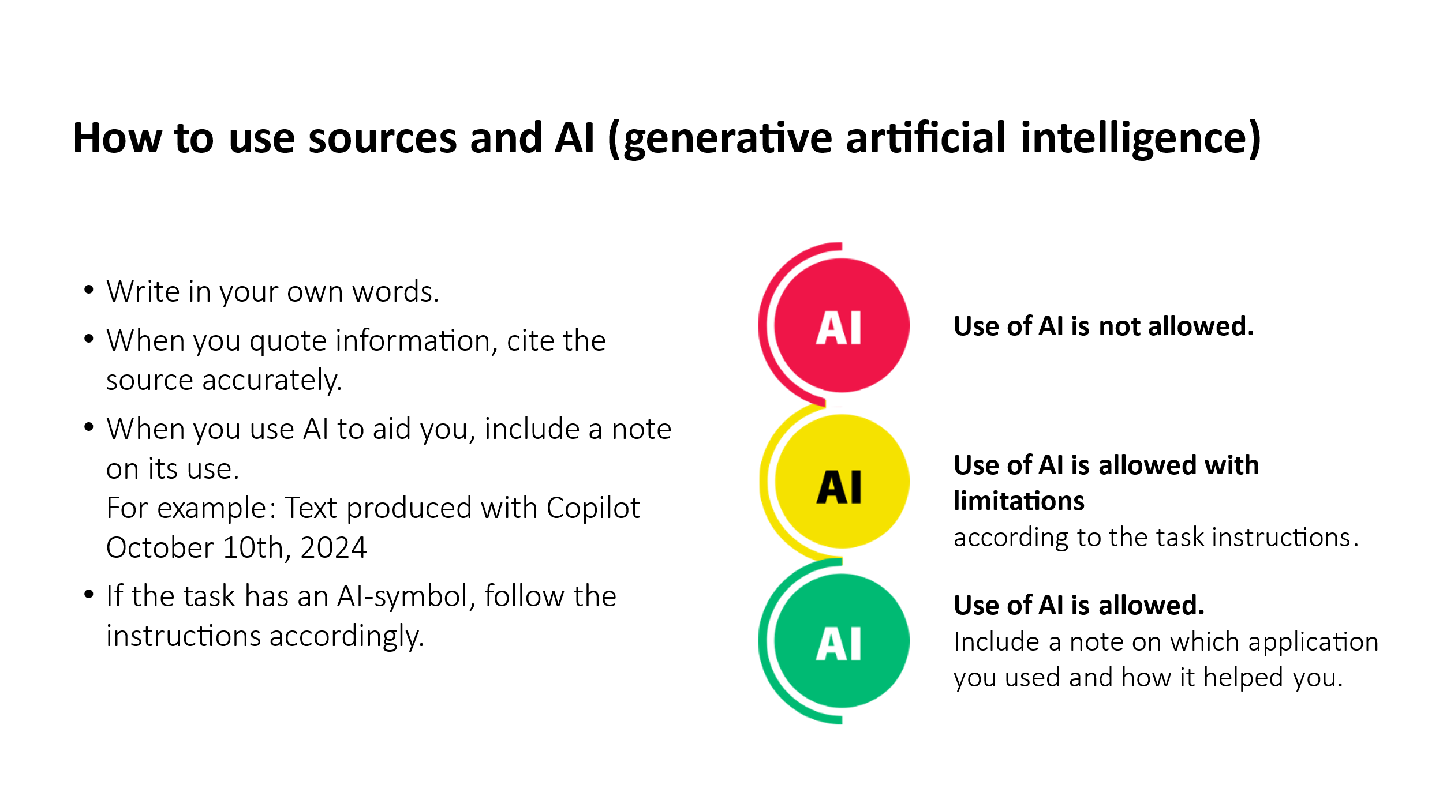
Tehtäviä saa muokata sellaisiksi, että ne soveltuvat oppilaitoksen käyttöön. Kaikkia tehtäviä ei tarvitse ottaa käyttöön, jos oppilaitos haluaa luoda omat englanninkieliset materiaalit.

Orientation

TASK: Orientation
Teksti on kurssin kuvaus. |   Use of AI is not allowed.

Orientation

Welcome to the Operating in the World of Work course! This course is designed to provide you with the necessary knowledge and skills to succeed in the workplace. In this introduction, we will go over the key topics and objectives of the course.

1. Determining the situation and competence needs in the labour market in the vocational field:
Before entering the workforce, it is important to understand the job market situation and skill requirements in your field. This will help you prepare and plan your career effectively. In this course, you will learn to:
- Investigate the job market situation in your field.
- Understand the key principles of the labor market system.
- Know the key professional networks in your field.
- Identify the skills required for different job roles.

2. Concluding an employment contract with the employer:
Signing an employment contract is the first step in your career, and it is important to understand the terms of employment and labor laws. In this course, you will learn to:
- Familiarize yourself with the terms of employment and key labor laws in your field.
- Review the content of an employment contract and understand its significance.
- Use expert assistance if necessary to review the employment contract.

3. Acting as part of the work community:

When you enter the workforce, you must be ready to function as part of a work community and follow its rules and norms. In this course, you will learn to:
- Adapt to set working hours and agreed-upon practices.
- Consider guidelines related to appearance and dress code.
- Use appropriate protective clothing and follow safety instructions.
- Work naturally as part of a diverse and culturally varied work community.

Conclusion:
The goal of this course is to help you develop strong work skills and build the confidence you need to succeed in the workplace.

TASK: Working Life in Finland
Tehtävä on monivalintaa. Lihavoidut vastausvaihtoehdot ovat oikeita vastauksia.  Moodlessa tämä tehtävä on Task 1.1. | Use of AI is not allowed.

First, let's explore the development of working life in Finland from the early 1900s to the present day. Watch the video about the Virtanen family and then answer the multiple-choice questions.

https://yle.fi/aihe/artikkeli/2017/05/09/suomen-100-vuotta-virtasten-silmin-nain-koyhasta-maatalousmaasta-tuli-moderni

1. Which of the following reforms improved the position of the Finnish working class in the 1920s?
- A) Introduction of child benefits
- B) Progressive taxation
- C) Joining the European Economic Area
- D) Establishment of the comprehensive school system
2. What happened to Finnish industry after World War II?
- A) Industry decreased significantly
- B) Industry developed significantly due to war reparations to the Soviet Union
- C) Agriculture replaced industry
- D) Industry focused solely on the forestry sector
3. How did urbanization affect Finnish working life in the 1960s and 1970s?
- A) Agriculture grew significantly
- B) Many Finns moved from rural areas to cities in search of a better life
- C) Agricultural jobs increased significantly
- D) Most Finns moved abroad
4. What was a significant factor in Finland's economic growth in the 1980s?
- A) Intensification of agriculture
- B) Slowing down of urbanization
- C) Export of goods to other countries
- D) Reduction in education
5. What happened in the early 1990s that affected Finnish working life?
- A) Finland joined the European Union
- B) An economic recession began
- C) The first female president was elected
- D) Universal and equal suffrage was introduced
6. Which company was central to Finland's technological development in the 1990s?
- A) Fiskars
- B) Nokia
- C) Valio
- D) Neste
7. What was one significant reason for the recession in Finland in the 1990s?
- A) The collapse of the Soviet Union
- B) Rising oil prices
- C) Climate change
- D) Rising electricity prices
8. How did the rise in education levels affect Finns in the 1990s?
- A) Workdays shortened
- B) Fewer people moved to cities
- C) Society became more equal
- D) Agricultural jobs increased
9. How did World War II affect women's employment?
- A) Women did not go to work because they were on the front lines
- B) Women took care of children at home
- C) Women were required to work on farms or in factories
10. In the 1950s, one of the largest employers was:
- A) Agriculture
- B) Forestry
- C) Service industries
- D) Technology sector

TASK: What is Finnish Working Life Like
Tehtävä on oikein/väärin kysymyksiä. Halutessaan opiskelijaa voi pyytää korjaamaan väärät väittämät. Viimeiset kysymykset voi jättää pois tai lisätä avoimina kysymyksinä.  Moodlessa tämän tehtävän nimi on Task 1.2. True or False? ja se sisältää vain oikein/väärin väittämät, joita ei tarvitse tehtävässä korjata. Viimeisistä avoimista kysymyksistä on tehty Moodleen erillinen tehtävä, joka on nimeltään Task 1.3. Reflective assignment. | Use of AI is not allowed.

Watch the video "What is Finnish Working Life Like". You can turn on automatic English subtitles in the video settings.

https://www.youtube.com/watch?v=dOg9KHDw61U

After watching the video, answer the following true/false questions. (If the statement is false, correct it to make it true.)
- In Finnish work culture, it is important that agreed-upon tasks are completed within the agreed schedule. TRUE
- In Finnish work culture, it is completely acceptable to arrive late to work. FALSE
- You can express a well-founded opinion, even if it differs from others. TRUE
- A leader can be good and respected, regardless of their gender. TRUE
- It is good for employees in different positions to maintain a polite distance from each other. FALSE
- If you don't know something, it's better to stay quiet than to ask for advice. FALSE
- In Finnish work culture, self-promotion and emphasizing social status are valued. FALSE.
Answer in your own words:
- Did anything in the video about Finnish work culture surprise you? What?
- What aspect of Finnish work culture did you like most, and why?
- How do you feel about getting to know Finnish work culture?

Determining the situation and competence needs in the labour market in the vocational field

TASK: Labour Market Situation in One’s Field of Occupation
Tehtävä palautetaan erillisenä tiedostona tai muulla opettajan kanssa sovitulla tavalla. Työvoimabarometrin linkkiä ei saa suoraan englanniksi, vaan opiskelijaa tulee neuvoa, että kieli täytyy itse vaihtaa englanniksi. | Use of AI is not allowed.

The student
- analyses the labour market situation in their vocational field
Study the following websites:
https://tyovoimabarometri.fi/ (The Labour Force Barometer)
https://tyomarkkinatori.fi/en/personal-customers (Job Market Finland)

Answer the questions. Use the websites above to find the information.
- What is the job description of your (future) occupation?
- What is the average salary in your field?
- Where can you find information about vacancies in your field?
- Which regions in Finland offer the most job opportunities in your field?
- What is the employment situation in your field in the region where you live?
- What types of employment contracts and working hours are available?
- What education and/or qualifications are typically required in job advertisements in your field?
- Can you find any job vacancies that interest you on the websites? List them here.

TASK: The Finnish Labour Market System
Tehtävä on aukkotehtävä. Lihavoidut kohdat täytyy joko vetää paikalleen tai kirjoittaa oikein. | Use of AI is not allowed.

The student
- knows the main principles of the labour market system
Read about the Finnish labour market system and complete the task.
https://tyoelamanpelisaannot.fi/en/the-finnish-labour-market-system/

Fill in the missing words.
Trade unions negotiate collective agreements with the employers' association.
As a member of a trade union, the union representative helps you at the workplace. They ensure that the employer follows the agreed working conditions.
"Collective agreement" is called työehtosopimus (TES) in Finnish.
Rakennusliitto, Tehy, SuPer, Teollisuusliitto, and PAM are examples of trade unions.

TEST: Labour Market System
Tehtävä on osaamisen osoittamisen tehtävä, joka koostuu oikein/väärin-kysymyksistä. Lihavoidut vastausvaihtoehdot ovat oikeita vastauksia. | Use of AI is not allowed.

The student
- knows the main principles of the labour market system
In the previous task 2.2, you read about the Finnish labor market system. Now it’s time to test what you’ve learned. Choose whether the statement is true or false. You have only one attempt for this task.
- SAK and EK are employers’ confederations.
  - yes
  - no
- The National Conciliator helps if the trade union and employers’ association have trouble reaching agreement.
  - yes
  - no
- All employers in a sector must comply with a universally binding collective agreement.
  - yes
  - no
- The labour market is a place for selling tools.
  - yes
  - no
- The labour market is a platform where employers and employees meet.
  - yes
  - no
- A collective agreement is a synonym for an employment contract.
  - yes
  - no
- Trade union confederations (AKAVA, SAK, STTK) represent employees.
  - yes
  - no
- Different sectors (such as the construction sector, commerce sector, restaurant sector) have separate collective agreements.
  - yes
  - no
- Strikes and overtime bans are the employers’ industrial actions.
  - yes
  - no
- Industrial action happens when agreement is not reached on the terms and conditions of employment.
  - yes
  - no
- The trade union can initiate a strike or overtime ban if an agreement is not reached otherwise.
  - yes
  - no
- Mediation is mandatory in Finland. This means that the trade union and the employers’ association must take part in negotiations. However, reaching an agreement is not obligatory.
  - yes
  - no

TASK: Professional Networks
Tehtävä on monivalintaa ja yksi avoin kysymys. Viimeistä kysymystä voi rajata enemmän, jos 2–3 esimerkkiä on liikaa. Lihavoidut vastausvaihtoehdot ovat oikeita vastauksia. | Use of AI is not allowed.

The student
- knows the most important professional networks of their vocational field
https://duunitori.fi/tyoelama/how-make-networking-profitable-these-tips-will-help-you-succeed
https://www.ttl.fi/en/learning-materials/international-professional-finland-towards-work-life/maintaining-and-expanding-networks

Find information online and answer the following questions.
- What does networking mean?
  - Presenting yourself at every opportunity.
  - A concept related to fishing.
  - Creating connections and relationships with other professionals in your field.
  - A tool for learning.
- What benefits can a professional network provide?
  - You can win awards from them.
  - They help you learn more about your field.
  - Unemployment benefits depend on the number of professional networks.
  - They can help you find jobs.
- How can you network effectively?
  - By attending various events in your field.
  - By researching companies in your field.
  - By staying at home.
  - By telling your friends about networks.
- Who can be part of your network as a student?
  - Myself
  - Neighbors and classmates
  - Parents and guardians
  - Teachers and mentors
- What networks exist in your current field of study? Give 2–3 examples.

TASK: Competences Required in Your Field
Tehtävä palautetaan erillisenä tiedostona tai muulla opettajan kanssa sovitulla tavalla. | Use of AI is not allowed.

The student
- recognises competences required in different tasks in their vocational field
Identify the skills needed in your profession by looking at three different job ads.

Find a job in Finland (infofinland.fi),
Job vacancies - EURES Suomi - TE-palvelut,
How will I find vacancies? - Work in Finland (suomi.fi),
Service sector - Job Market Finland (tyomarkkinatori.fi)

Browse the links about the Finnish labor market and vacancies.

Write answers to the following questions:
- Find three job titles that you might apply for after graduating. List them in your answer.
- Identify the skills required for these jobs (e.g., professional qualifications, degrees, language skills, and other abilities). List the skills needed for each job title.
- Think about your attitude, strengths, skills, and talents. What skills do you need to develop to be employed in Finland?

Concluding an Employment Contract with the Employer

TASK: What Determines the Terms of an Employment Contract?
Tehtävä on opiskelumateriaalia. | Use of AI is not allowed.

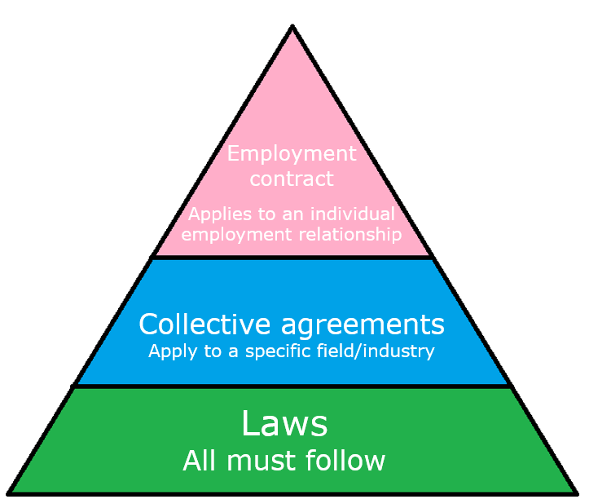
The triangle illustrates the different levels of rules that have to do with employment (laws, collective agreements, employment contracts)

Laws
The foundation of all regulations, setting minimum standards for employment conditions. There are several laws that deal with work, such as The Employment Contracts Act, The Annual Holidays Act, and The Working Time Act.

Collective Agreements (In Finnish: Työehtosopimus -> TES):
- Collective agreements are specific to an industry or occupational sector. For example, there is a collective agreement for the commercial sector, a collective agreement for the facilities services sector, and a collective agreement for private social services.
- Terms of employment in collective agreements can be better than the minimum standards set by law.
- Collective agreements specify terms and conditions of employment in more detail than the law, such as pay scales, sick leave rules, and working hours.
- Employers’ and employees’ organisations (trade unions) negotiate public and private collective agreements. Universally binding collective agreements also apply to unaffiliated employers, who do not belong to an employers’ organisation.

Employment Contracts:
- The specific terms agreed between an employer and an employee, which may be more favorable than the standards set by the collective agreements.

Note: In Finland, there is no legally defined minimum wage. Instead, wages are set in collective agreements.

This part of the course has two parts: The most important laws that apply to working in Finland, and the rules and regulations that apply to working in a specific field or sector in Finland (collective agreements).

TASK: Terms of Employment in Your Vocational Field
Tehtävä on opiskelumateriaalia. Tämän voi halutessaan tuottaa tehtävänä niin, että tekstin yhdistää tehtäviin 3.3 ja 3.4, jolloin muodostuu yksi tehtävä työehtosopimuksista. Valmiilla Itslearning-kurssilla on tehty näin testityökalulla. | Use of AI is not allowed.


As mentioned at the beginning of this section, the rules that are more detailed than the law, are set out in collective agreements. It is a contract made between employers (=employer organizations) and employees (or trade unions) that sets out the terms and conditions of employment for workers in a particular industry or sector. They are usually negotiated by trade unions, and regular workers do not participate in the negotiations directly.

When you sign an employment contract, it is very important that you understand what collective agreements are, as many of the details in your individual employment contract come from the collective agreement used in that sector. For example, if you work in the restaurant industry, your employment contract may state: "Payment: Collective Agreement Employees in Hotel, Restaurant and Leisure Industry". You are then expected to understand what this means, find the collective agreement online, and be able to find the wage tables in that specific collective agreement. Once you know the name of the collective agreement, it is very easy to find it online.

Collective agreements are usually negotiated again every few years. Once the term is ending, a new collective agreement is negotiated. Usually, not all of the text in the agreement changes when a new agreement is reached, but it is very common for at least the wages to go up a little. That is why you need to be aware of the changes and make sure that the new rules are followed in your workplace.

Since each field and sector has its own collective agreement, it is very useful to practice reading collective agreements and to remember what is in them.

Here's a video about collective agreements. Please note that it was made to be used as part of the trade union's marketing and member recruitment:

https://youtu.be/NBGdwq3fl00?feature=shared

As collective agreements are different in each field, it is impossible to list them all here. Also, not all collective agreements have been translated into English. Because of this, in the following tasks you will only focus on the two collective agreements below.

Please open the collective agreements and do the tasks. They have questions about these agreements. The purpose of these tasks is for you to practice reading them, not to remember specific details.

If you can find the collective agreement that is used in the field that you are studying, you can try to find similar information in it.

TASK: Collective Agreement for the Commercial Sector
Tehtävä on monivalintaa ja oikein/väärin-kysymyksiä. Lihavoidut vastausvaihtoehdot ovat oikeita vastauksia.  Moodlessa tämä on osion ensimmäinen tehtävä eli Task 3.1. | Use of AI is not allowed.

Collective Agreement for the Commercial Sector (Kaupan alan työehtosopimus):
https://www.pam.fi/wp-content/uploads/2023/11/Kauppa_TES_kansi_ENG_web_PAM.pdf

- Daily rest period: How many hours should there be between two shifts at least?
  - 14 hours
  - 24 hours
  - 11 hours
- If your shift is longer than ____hours, you should have a meal break.
  - 7 hours
  - 6 hours
  - 8 hours
- Sales assistants should be paid an evening bonus for work that is done between....
  - 17-22 (5 p.m. - 10 p.m.)
  - 18-24 (6 p.m. - 12 a.m.)
  - 16-21 (4p.m. - 9 p.m.)
- How much is the holiday bonus?
  - 30% of the holiday pay
  - 20% of the holiday pay.
  - 50% of the holiday pay
- Pay scales: The wages in Helsinki are higher than in Tampere.
  - True
  - False
- The Saturday bonus for sales assistants is paid on Saturdays from 13:00 to 24:00.
  - True
  - False

TASK: Collective Agreement for the Hotel, Restaurant and Leisure Industry
Tehtävä on monivalintaa. Lihavoidut vastausvaihtoehdot ovat oikeita vastauksia.  Moodlessa tämä on nimeltään Task 3.2. | Use of AI is not allowed.

Collective agreement for employees in hotel, restaurant and leisure industry:
https://www.pam.fi/wp-content/uploads/2024/04/Collective-agreement-for-the-Hotel-Restaurant-and-Leisure-industry_employees_2023-2025.pdf

- The number of working hours is determined for ___ weeks at a time.
  - 1
  - 3
  - 2
- Rest period: There should be at least ____ hours between each shift (If not agreed otherwise)
  - 11
  - 12
  - 14
- Pay scale groups: A waiter or a cook who works in a place where no alcohol is served belongs to which pay scale group?
  - 4
  - 2
  - 3
- The supplement for evening work is paid from ___ to ____.
  - 19-23 (7pm to 11pm)
  - 16-21 (4pm-to 9pm)
  - 18-24 (6pm to 12am)
- The holiday bonus is...
  - 50% of the holiday pay
  - 30% of the holiday pay
  - 10% of the holiday pay

TASK: Key Employment Legislation
Tehtävä on opiskelumateriaalia. Jos haluaa, tehtävän voi yhdistää tehtävän 3.9 kanssa, jolloin muodostuu yksi tehtävä työlainsäädännöstä. Valmiilla Itslearning-kurssilla on tehty näin testityökalulla.  Moodlessa tämä on opiskelumateriaalia, joka on kuvana osion sivulla. Myös video on upotettu osion sivulle materiaaleihin. | Use of AI is not allowed.

When you start a new job, make sure that you and your employer have a proper employment contract. This is also important for summer jobs and other short-term positions. The employment contract sets out the terms and rules of the job that both you and the employer must follow. Read the contract carefully before signing it, because once signed, it is legally binding for both parties. Below you can see a template for a Finnish employment contract in Word format.

The actions of both employers and employees are governed by labor laws and collective agreements. Employees’ and employers’ unions negotiate collective agreements. A collective agreement is specific to an industry/occupational sector. It is a general agreement on the working conditions that apply in the industry. Your employment contract should mention which industry’s collective agreement is being followed.

Collective agreements cover matters such as:
- The minimum wage for the industry
- Overtime pay (if different from standard working hour legislation)
- General wage increases in the industry
- Social benefits for employees
If you need advice on labor law issues, you can contact your workplace union representative for help.

You can study the most important labour laws below. First, watch the video:

https://youtu.be/tAIdCU7yqvk

Employment Contracts Act | https://www.finlex.fi/en/laki/kaannokset/2001/en20010055_20180597.pdf  https://tyosuojelu.fi/en/employment-relationship/employment-contract
Occupational Safety and Health Act | https://www.finlex.fi/fi/laki/kaannokset/2002/en20020738_20230222.pdf  https://tyosuojelu.fi/en/safety-and-health-in-workplace  https://tyosuojelu.fi/en/working-conditions/unfair-treatment
Working Time Act | https://www.finlex.fi/fi/laki/kaannokset/2019/en20190872_20191405.pdf  https://tyosuojelu.fi/en/employment-relationship/working-hours
Non-discrimination Act | https://www.finlex.fi/fi/laki/kaannokset/2014/en20141325.pdf  https://tyosuojelu.fi/en/employment-relationship/non-discrimination
Annual Holidays Act | https://www.finlex.fi/fi/laki/kaannokset/2005/en20050162_20190346.pdf  https://tyosuojelu.fi/en/employment-relationship/annual-holidays

TASK: The Employment Contract Explained

Tehtävä on opiskelumateriaalia. Jos haluaa, tehtävän voi yhdistää tehtävien 3.7 ja 3.8 kanssa, jolloin muodostuu yksi tehtävä työsopimuksista. Valmiilla Itslearning-kurssilla on tehty näin.  Moodlessa tämä on opiskelumateriaalia, johon on linkki otsikolla Info slides: The Employment Contract Explained | Use of AI is not allowed.

https://tyosuojelu.fi/en/employment-relationship/employment-contract
https://tyosuojelu.fi/documents/154017715/168008487/tyosopimus_mallipohja_EN.pdf/b41c68c8-5e9e-7762-606d-03ddbfd6a7ba?t=1719588749721

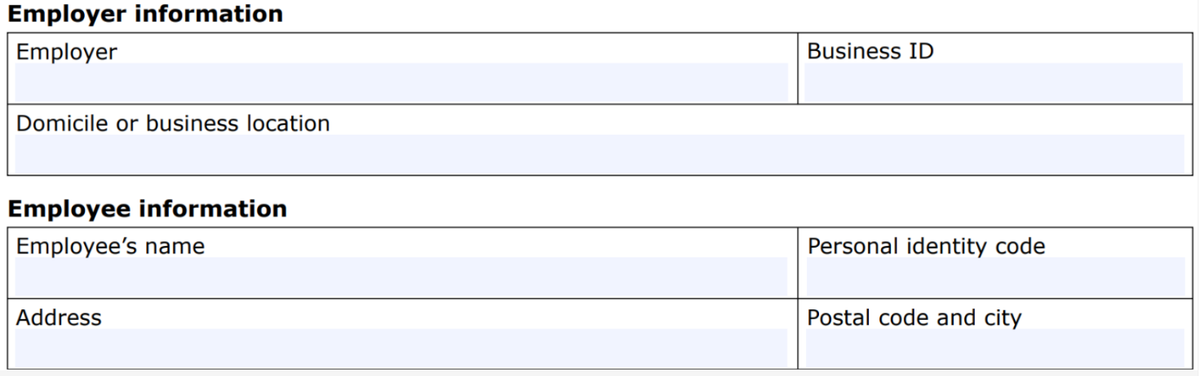
- The employee's and employer's information is written here
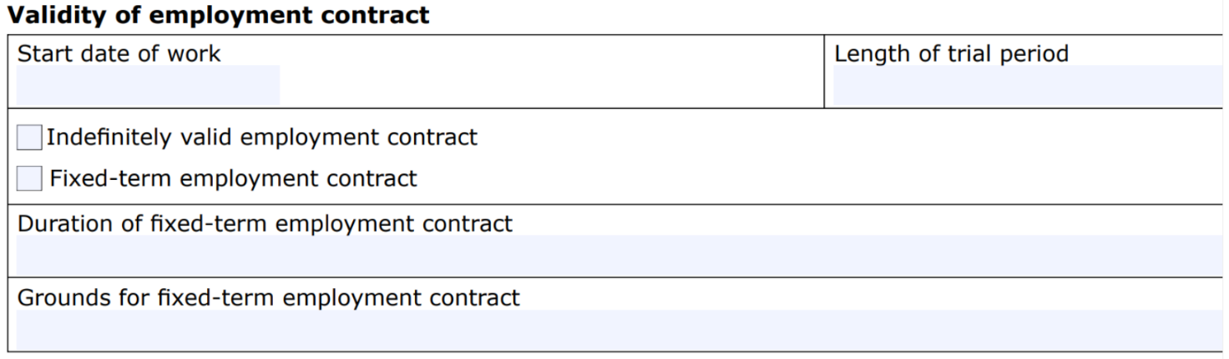
- The date when employment begins. If there is a trial period at the beginning, the length of it should be given here. The maximum length is 6 months or 50% of the duration of a fixed-term contract (still max 6 months)
- The type of the employment contract:
  - Indefinitely valid: The employment continues until either the employee or the employer decides to end it by giving notice
  - Fixed-term: has a specific start and end date
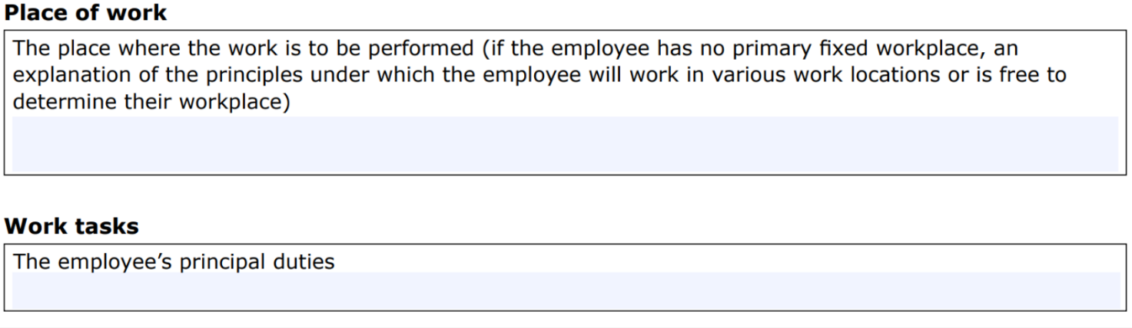
- Place of work and main duties.
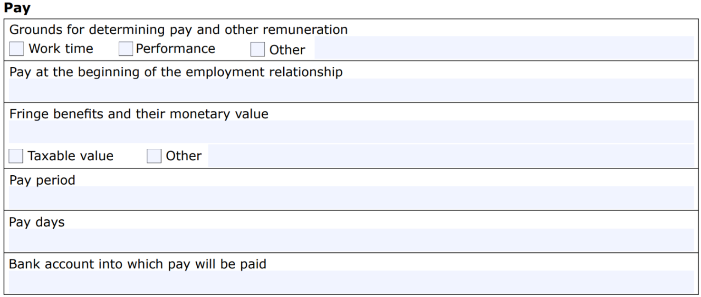
- Grounds: hours worked or for example commission based on sales
- Pay at the beginning: The amount of the basic salary or a salary grade or group in the collective agreement that is used
- Fringe benefits: non-monetary form of benefits that your company may provide to its employees (accommodation, car, meals)
- Pay period: Salary is usually paid twice a month or once a month
- Pay days: The salary must be paid on the last day of the pay period, for example on the 15th or on the 30th
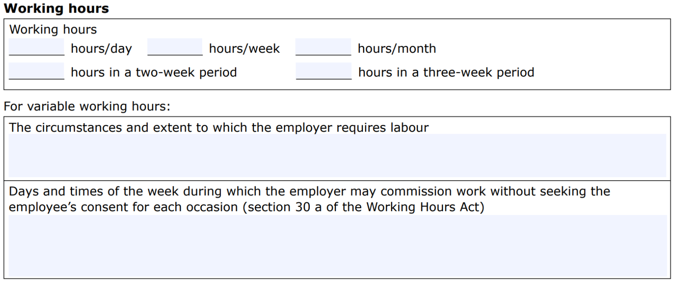
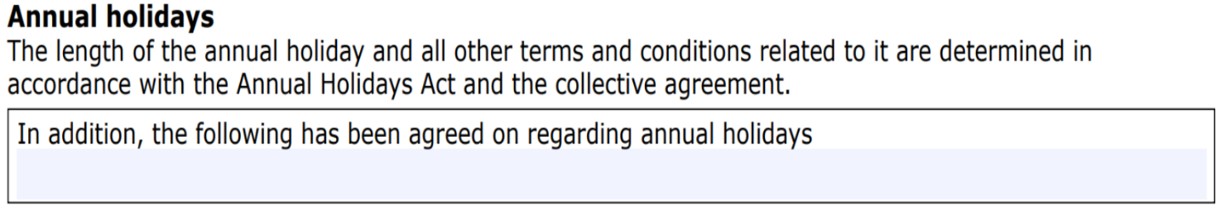
- Very often the rules of the annual holidays act are used, although some collective agreements have rules that differ from the law. Link: Number of holiday days.
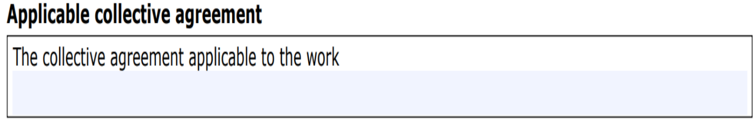
- The name of the collective agreement used
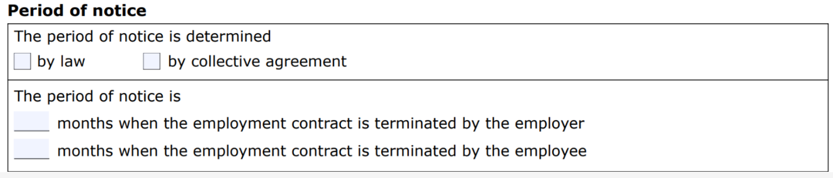
- The periods of notice are in the Employment Contracts Act. The length depends on how long the employment has continued and on whether the employer or the employee terminates the contract. You can find the periods of notice in the law here.
- Some collective agreements have rules that differ from the law.
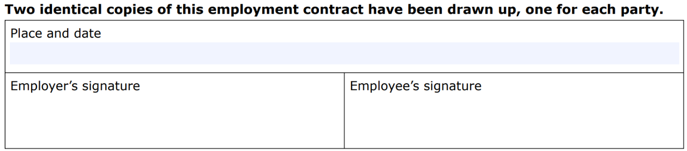

TASK: Employment Contract
Tehtävä on aukkotehtävä. Lihavoidut kohdat täytyy joko vetää paikalleen tai kirjoittaa oikein.  Moodlessa tämä tehtävä on nimellä Task 3.3 Employment Contract. | Use of AI is not allowed.

Employment contract
https://tyosuojelu.fi/en/employment-relationship/employment-contract

Drag the words into the correct boxes

An employment relationship is a contract between an employee and an employer, which is established when work begins. The terms of employment are agreed upon in an employment contract. The contract can be made orally, in writing, or electronically. It is advisable to make the employment contract in a written format, as it is easier to refer to it later.

Work is done for the employer. This means that the work is done for the benefit of the employer. Compensation for this work is received in the form of a salary. The work is for the purpose of earning money, which is one of the characteristics of an employment relationship.

The employer has the right to direct, supervise, and control the work. Therefore, the employer has the right of direction.

The terms of employment are determined on the basis of several sources. These include labor laws, industry-specific collective agreements, local agreements, established practices, and the employer’s regulations and instructions.

TASK: Some Employment Legislation

Tehtävä sisältää sekä opiskelumateriaalin että varsinaisen tehtävän. Tehtävät ovat monivalintaa ja oikein/väärin-kysymyksiä. Lihavoidut vastausvaihtoehdot ovat oikeita vastauksia.  Moodlessa tehtävä on nimellä Task 3.4. Some Employment Legislation. | Use of AI is not allowed.

Several different laws govern work and working life. This section highlights some points of labor legislation.

You can find all the laws in their entirety at www.finlex.fi.

Additionally, the collective agreement for the sector contains binding provisions for both the employee and the employer, and these terms should also be taken into account.

These laws include, among others:
- Employment Contracts Act
- Working Hours Act
- Annual Holidays Act

The Employment Contracts Act – Some Points
- An employment contract is valid indefinitely unless it has been made for a fixed term for a justified reason. A fixed-term employment contract made at the employer’s initiative without a justified reason shall be considered valid indefinitely.
- The employer and the employee may agree on a probationary period of up to six months from the start of work.
- An employee who is unable to perform their work due to illness or accident is entitled to sick pay. If the employment relationship has lasted for at least one month, the employee is entitled to full pay for the period of incapacity until the end of the ninth working day following the day of falling ill, but not beyond the start of their entitlement to daily allowance under the Health Insurance Act (1224/2004). If the employment relationship has lasted less than one month, the employee is entitled to 50 percent of their salary.

Questions:
- An employment contract must be made for an indefinite period (commonly referred to as permanent) unless otherwise agreed.
  - True
  - False
- An employment contract may include a probationary period of up to four months.
  - True
  - False
- Another form of employment contract is a fixed-term contract.
  - True
  - False
- Salary is paid during sick leave.
  - True
  - False
- You have arrived at the workplace, but you are unable to work due to the lack of equipment (which the employer has promised you). Are you entitled to salary?
  - True
  - False
- Salary can be paid at any time.
  - True
  - False

The Employment Contracts Act - Some Points
- The employer is obligated to pay the employee full wages if the employee has been available to the employer as per the agreement but is unable to work due to reasons attributable to the employer, unless otherwise agreed.
- Wages must be paid on the last day of the pay period, unless otherwise agreed. If the basis for the time wage is shorter than a week, wages must be paid at least twice a month, and otherwise once a month.
- Layoff refers to the temporary suspension of work and payment of wages based on the employer’s decision or an agreement initiated by the employer, while the employment relationship otherwise remains in force.

Questions:
- What does layoff mean?
  - Payment of wages and work are suspended.
  - In a layoff, the employment relationship remains in force.
  - You are paid, but you do not work.
  - You work, but you do not get paid.

The Working Hours Act – Some Points
According to the Employment Contracts Act, the employee is available to the employer at the agreed time. Next, you will learn about the Working Hours Act and how it affects work.

Read the info texts and answer the following questions.

Working Hours
- Working hours include the time spent on work and the time during which the employee is required to be at the workplace available to the employer. Time spent traveling is not counted as working hours unless it is considered part of the work performance.
- The employer and the employee may agree on on-call duty and the compensation for it. During on-call duty, the employee must be reachable by the employer so that they can be called to work. On-call time is not counted as working hours unless the employee is required to stay at the workplace or in its immediate vicinity. On-call duty must not unreasonably interfere with the employee’s use of their free time.
- The amount of on-call compensation or the basis on which it is determined, as well as the terms of on-call duty, must be known to the employee when the agreement is made.
- Regular working hours are a maximum of eight hours per day and 40 hours per week.
- However, weekly working hours can be arranged to average 40 hours over a period of up to 52 weeks without exceeding the regular daily working hours of eight hours.
- Work performed between 11 PM and 6 AM is considered night work.

- Select the right answers:
  - You may be asked to work 10 hours without additional compensation.
  - Weekly working hours may vary.
  - Night work is performed between 11 PM and 6 AM.
  - Regular working hours may not exceed 8 hours per day.

Work Schedule
- A work schedule must be prepared for each workplace, indicating the start and end times of the employee’s regular working hours and the times of breaks.
- The work schedule must be prepared for the same period as the working hours adjustment plan, unless it is extremely difficult due to the length of the adjustment period or the irregular nature of the work.
- The work schedule must be prepared for the longest possible period, but at least for one week. When preparing the work schedule, the employer must give the employee or their representative the opportunity to express their opinion upon request.
- The work schedule must be made known to the employees in writing well in advance, at least one week before the start of the period referred to in the schedule. After this, the work schedule can only be changed if the employee agrees or for a compelling reason related to the organization of work.
- In this law, a working time bank refers to a system for reconciling work and free time where working hours, earned leave, or monetary benefits converted into free time can be saved and combined.

- Select the right answers.
  - The employee must have an opportunity to comment on the work schedule in advance.
  - The work schedule specifies the start and end times of work tasks.
  - The work schedule can be communicated verbally.
  - The work schedule must be made in a written format and at least one week before the start of the period.
  - The work schedule can be communicated to employees one day before it starts.

Flexible Working Hours
- The employer and the employee may agree on flexible working hours, that differ from the provisions of the collective agreement concerning the length and placement of regular working hours. This allows the employee to choose the placement of their daily working hours within agreed limits.
- In flexible working hours, the regular daily working hours can be shortened or extended by a flextime period, which can be a maximum of four hours.
- The employer and the employee may agree that the accumulation of overtime is reduced by paid time off given to the employee. The employer must strive to provide the time off in full working days if requested by the employee.
- In this law, a working time bank refers to a system for reconciling work and free time, where working hours, earned leave, or monetary benefits converted into free time can be saved and combined.

- Select the right answers.
  - The daily flexitime can be up to four hours.
  - Flexible working time means that you can, for example, start work between 7 AM and 10 AM and finish between 3 PM and 6 PM, if the agreed working hours are completed.
  - Flexible working hours can vary at any time during the day.
  - Overtime can be compensated with paid time off.
  - If you have flexible working hours, you can come to work whenever it suits you.

Annual Holidays Act – Some Points

Accrual of Leave
An employee accrues 2 days of annual leave per month when the employment relationship has lasted less than one year. In an employment relationship lasting more than one year, the employee accrues 2.5 days of leave per month. A full holiday accrual month is considered to be a calendar month in which the employee has accumulated at least 14 days of work.

Definitions:
- Holiday Accrual Year: The period between April 1st and March 31st, inclusive of these dates.
- Holiday Season: The period between May 2nd and September 30th, inclusive of these dates.
- Weekday: Any day of the week other than Sunday, religious holidays, Independence Day, Christmas Eve, Midsummer Eve, Easter Saturday, and May Day.

Holiday Compensation

An employee is entitled to receive at least their regular or average salary during their annual leave as defined by this law.

An employee is entitled to receive holiday compensation amounting to 9 percent, or if the employment relationship has continued for at least one year by the end of the holiday accrual year preceding the holiday season, 11.5 percent of the salary paid or due to be paid for the time worked during the holiday accrual year, excluding any increase paid for emergency work or overtime as per law or agreement.

Upon termination of the employment relationship, the employee is entitled to receive holiday compensation for the period for which they have not yet received leave or holiday compensation.

- You go to a summer job for three months. How many days of annual leave do you accrue?
  - 3 days
  - 2 days
  - 6 days
- Upon termination of employment
  - You are entitled to receive holiday compensation for accrued holidays.
  - You do not need to be paid for accrued holiday compensation.
  - You must take your leave immediately after you resign.
- You have worked for over a year. How many days of leave do you accrue per year?
  - 24 days
  - 36 days
  - 30 days
- Is Saturday considered a weekday according to the Annual Holidays Act?
  - Yes
  - No
- Does an employee receive pay during their annual leave?
  - Yes
  - No
- What compensation does an employee receive during their annual leave (when they are regularly employed)?
  - normal monthly salary
  - salary and holiday compensation
  - holiday compensation
  - none

TEST: Concluding an Employment Contract with the Employer
Tehtävä on osaamisen osoittamisen tehtävä, joka on monivalintaa, avoimia kysymyksiä ja oikein/väärin-kysymyksiä. Lihavoidut vastausvaihtoehdot ovat oikeita vastauksia.  Moodlessa tämä on nimellä TEST 3.5. Concluding an employment contract with the employer. | Use of AI is not allowed.

- Select the right answers
  - The employment contract must be made for an indefinite period unless there is a specific reason for it to be fixed-term.
  - In a fixed-term employment contract, the end date of the contract is known.
  - In a permanent employment contract, the end date is known.
  - A fixed-term employment contract can last for five years or longer.
  - The form of the employment contract can be either indefinite or fixed-term.
- Why should a work contract be made in written format?

Mikko is starting a new job. He was happy when the employer called and told him that he could start working immediately. Mikko starts the next day and is excited about the new job. He does not meet his supervisor right away and does not sign an employment contract. One of his new colleagues briefly shows him where to start.

Briefly explain what risks Mikko might face in this situation.

- Select the right answers about an employment contract and a collective agreement.
  - An employment contract is made between you and an employer.
  - An employment contract is personal.
  - Collective agreement is for those who work in the same industry/field.
  - Labour unions and employer organisations negotiate the collective agreement.
  - The collective agreement is a personal contract.
- Answer the questions.
  - Briefly explain the difference between an employment contract and a collective agreement.
  - You get a summer job in your vocational field/sector. How does the collective agreement affect your employment contract?
- Select the right answers related to trial period.
  - No salary is paid during the trial period.
  - During the trial period, the employer sees what kind of employee you are, and you see what the workplace is like.
  - No annual holidays are earned during the trial period.
  - There is no notice period during the trial period.
  - The employment relationship is valid, but there is no notice period.
- Earning of annual leave/paid vacation days

An employee earns annual leave at a rate of 2 days per month if the employment relationship has lasted less than one year. For employment relationships longer than one year, paid vacation days are earned at a rate of 2.5 days per month. Paid vacation is earned for each month the employee works at least 14 days in a calendar month

(Annual leave does not accrue if part-time work amounts to less than 14 days or less than 35 hours in a calendar month).

You are going to a summer job in your field for three months. How many days of annual leave will you earn?
  - None
  - 2 days
  - 6 days
  - 7,5 days
- The job advertisement mentions that the salary is 10.15 euros per hour and it is paid twice a month. Is the following employment contract completed correctly?
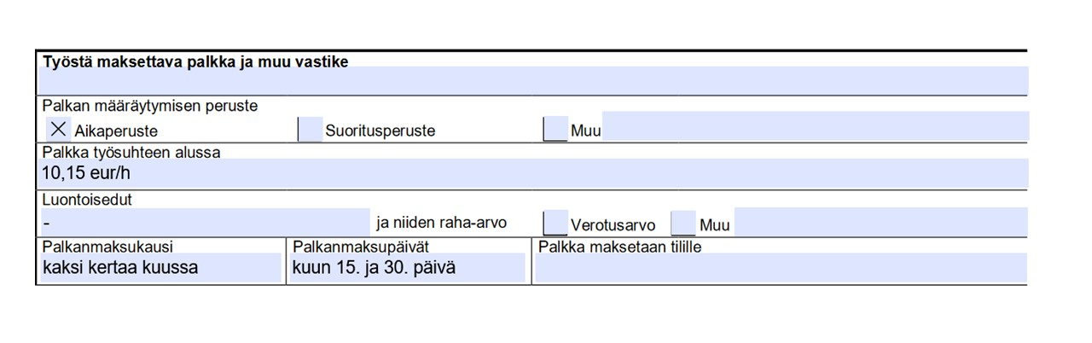
  - True
  - False
- What does lay-off mean in the Finnish employment legislation?
  - Laying off means that the employer may temporarily stop work and payment of wage and the employee stops working.
  - In a lay-off the employment relationship is not terminated.
  - You continue working but do not get paid.
  - You get paid, but you are not working.

Acting as Part of the Work Community

TASK: Good Working Life
Tehtävässä on opiskelumateriaalia ja palautettava osuus. Tehtävä palautetaan erillisenä tiedostona tai muulla opettajan kanssa sovitulla tavalla. | Use of AI is not allowed.

A Guide to Finnish Working Life

How am I expected to behave in the workplace? What are my rights and responsibilities? How can I adapt to a new work community?

A guide to Finnish working life in English by the Finnish Institute of Occupational Health (also available in many other languages):

Working in Finland – Information for immigrants

Good Working Life Skills
Good working life skills can be summarized as: attitude, initiative, professionalism, and communication.

Watch the video @HenriAsenne (3.52 min) and learn about work skills.

Which skills do you already have, and which ones still need improvement? How could you develop your skills?

@HenriAsenne: Putting your skills and mindset to work for you

Familiarize yourself with the guide provided by the Finnish Institute of Occupational Health.

Then create a poster (e.g. PowerPoint) to be displayed on the workplace wall. The poster should include the 10 most important workplace rules. Also give reasons why you have chosen them.

TASK: Important Things to Remember in the Workplace

Tehtävässä yhdistetään sääntö ja selitys. Jos haluaa, tehtävä voi olla myös sellainen, jossa opiskelija vapaasti selittää omin sanoin, mitä säännöt tarkoittavat. | Use of AI is not allowed.

Now you get to test your knowledge and skills in the workplace. How should you behave in a work community, and what are your rights and responsibilities?

Having a proactive attitude and a positive approach to work and colleagues will take you far. You will achieve the best results by being yourself!

Match the workplace rule with the explanation from the options below.

Good manners | Good manners are important at work, as in other areas of life. This does not mean flattering the employer and colleagues, but normal, friendly, and considerate behavior. Swearing is not appropriate at the workplace!
Arrive on time | If work starts at 8:00 AM, make sure you are ready in your work clothes to start at 8:00 AM, not a minute later. Remember that getting enough rest is important for staying productive. Working when tired reduces efficiency and increases safety risks!
Maintain your appearance and hygiene | Take care of your personal hygiene and dress according to the employer’s instructions. In some jobs, there are also specific instructions regarding jewellery, perfume, etc. based on the law. Appropriate work clothing also affects safety. If there is no work uniform, make sure you have neat and clean work clothes.
Follow safety regulations | Job orientation is the basis for safety and efficiency. Therefore, demand adequate training. It is the employer's responsibility to provide appropriate safety equipment. Note that some tasks require special training and qualifications, such as a hot work licence or a hygiene passport.
Greet colleagues, supervisors and customers | Show consideration for others by greeting them and saying goodbye. This reflects good communication skills and helps to improve the atmosphere in the workplace. Greeting customers gives a positive impression of your workplace.
Act according to workplace practices | Ensure the work environment is clean and safe by tidying up after yourself. Put tools back in place and throw rubbish in the bin. Remember to keep the break area tidy.
Be proactive | Take initiative in your work and try to look for tasks you can do proactively. If you don’t know what to do, ask a colleague or supervisor. If you don't know or can’t remember how to do a task, ask for help. It is always better to ask than to do it wrong or leave it undone!
Focus on tasks assigned by the employer | Working time is the time for which the employer pays you. Do not use your phone during working hours, except during breaks. Listening to music with headphones may not be appropriate in all jobs and socializing with friends is not acceptable during work hours. Don’t waste the employer’s money by using valuable work time for anything other than work!
Remember loyalty to the employer | Employees have a duty of loyalty to their employer. This means that they must keep workplace matters confidential and avoid any personal activities that could harm the employer’s business. Do not share confidential workplace information on social media or anywhere else! Be careful with photos and respect the privacy of the employer, colleagues, and customers.

TASK: Personal Protective Equipment and Protective Clothing at Work
Tehtävä sisältää opiskelumateriaalin ja palautettavan tehtävän. Tehtävä palautetaan erillisenä tiedostona tai muulla opettajan kanssa sovitulla tavalla. | Use of AI is not allowed.

Different workplaces have different rules for using personal protective equipment and protective clothing.

Study material:
https://www.ttl.fi/en
https://tyosuojelu.fi/en/working-conditions/personal-protective-equipment
https://www.finlex.fi/en/laki/kaannokset/2002/en20020738_20230222.pdf
https://www.finlex.fi/en/laki/kaannokset/2009/en20090205.pdf
https://tukes.fi/en/products-and-services/personal-protective-equipment

Answer the questions and compile your answers into a Word or PowerPoint file, which you will submit.

- Find out what kind of personal protective equipment is used in your field. Use pictures or videos.
- Find out what kind of protective clothing is used in your field. Use pictures or videos.
- What kind of personal protective equipment, protective clothing or workwear have you used in your workplace or during practical training?
- What kind of clothing and appearance is appropriate in your field and what is not?

TEST: Personal Protective Equipment and Protective Clothing at Work

Tehtävä on osaamisen osoittamisen tehtävä. Kysymykset ovat monivalintaa. Lihavoidut vastausvaihtoehdot ovat oikeita vastauksia. | Use of AI is not allowed.

- Who is responsible for the cost of personal protective equipment?
  - employee
  - state
  - employer
- Personal protective equipment is
  - personal
  - shared with your coworker
  - shared with your team members
- Personal protective equipment must have
  - CE marking
  - CG marking
  - CP marking
- How can you use personal protective equipment properly?
  - by checking the user manual
  - by experimenting
  - by reading the newspaper
- Why is it important to wear protective clothing?
  - it protects the worker
  - it looks nice
  - it is practical
- It is important that protective clothing
  - is oversized
  - size doesn’t matter
  - is the right size
- You should change protective clothing
  - at home
  - at work
  - on the way to work
- Which of these is personal protective equipment?
  - reflective backpack
  - oven mitt
  - reflective cap

TASK: Learn More about Equality at Work

Tehtävä palautetaan erillisenä tiedostona tai muulla opettajan kanssa sovitulla tavalla. | Use of AI is not allowed.

Choose one of the articles (a - d) below. The articles discuss discrimination and unequal treatment at work.
- Job hunters switch to 'Finnish-sounding' surnames to avoid discrimination - https://yle.fi/a/3-12198076
- "Finding a job in Finland was not easy" — Racism, discrimination hinder foreign graduates' job hunts - https://yle.fi/a/3-11742593
- "I lost a traineeship over my headscarf": Workplace discrimination often difficult to prove - https://yle.fi/a/3-10843839
- Woman told she's 'unsuitable' for job because of skin colour - https://yle.fi/a/3-10456302

Task:
- Read the article.
- Explain why and what kind of discrimination the person experienced. (If there are several cases in the article, it is enough to describe one person's case.)

Questions and examples to help you think:
- What happened?
- How did the discrimination occur?
- On what basis is the treatment a person experiences considered discrimination?
- How was the case dealt with, and where? Explain. For example: in no way / not at all / the case is ongoing / negotiations / trial (court of law)

- Reflect: If this situation had happened to you, would you have taken the matter further and tried to get fair treatment? Explain.
Write your answers in your own words.

TEST: Job interview
Tehtävä on osaamisen osoittamisen tehtävä. Opiskelumateriaali To work as part of diverse work community - EQUALITY IN WORKING LIFE löytyy Avointen oppimateriaalien kirjastosta. Tehtävä on monivalintaa. Lihavoidut vastausvaihtoehdot ovat oikeita vastauksia. | Use of AI is not allowed.

Study material:
To work as part of diverse work community - EQUALITY IN WORKING LIFE
https://www.finlex.fi/fi/laki/kaannokset/2014/en20141325.pdf
https://tyoelamaan.fi/en/blog/2021/06/09/what-questions-are-allowed-in-a-job-interview/
https://tasa-arvo.fi/en/front-page



A job interview can be exciting. You need to prepare well for the interview so that you can talk about yourself and show that you are qualified for the job. You may think about what questions might be asked in a job interview. You may also wonder if you need to answer every question. What if they ask you something you don’t want to answer? What can you say then?

- What type of questions should you prepare to ask the employer?
  - Questions about their personal life
  - Questions about their salary
  - Questions about the job and company
  - Questions that are irrelevant to the job
- Which of the following questions must relate to the job you are applying for?
  - Why are you applying for this job?
  - Do you have children?
  - What is your religion?
  - Are you a member of a political party?
- Which question do you NOT have to answer in a job interview?
  - Are you thinking of having children any time soon?
  - Are you pregnant?
  - What jobs do you like?
  - What is your work experience?
- If the employer asks about your language skills by using another language, what should you do?
  - Tell about your language skills honestly
  - Answer in the same language, even if you are not fluent
  - Refuse to answer the question
  - Change the topic to something else
- What should you do if the interviewer asks about your weaknesses?
  - Say you have none, because you know everything
  - Think of them as development points related to the job
  - Refuse to answer the question
  - Complain about the interview process
- Which of the following questions is acceptable to ask in a job interview?
  - Is there anything that could prevent you from doing this job?
  - Do you have any serious illnesses?
  - What does your family think about you working here?
  - Who will take care of your children while you are working?
- What can you do if the interviewer asks you a 'forbidden question' that you know you don't have to answer?
  - I can answer if it feels appropriate to me, even though I'm not thrilled that they are asking forbidden questions.
  - I will politely ask how this relates to the job and lead the conversation elsewhere.
  - I will answer anyway because I don't want to lose the job.
  - I won't answer anything, I will just look at them angrily.

Self-Evaluation
Osio löytyy Moodlesta erillisenä aiheena. Vastaukset tulee kirjoittaa itse ja palauttaa joko suoraan Moodlen verkkotekstikenttään tai tiedostona. Tehtävää ei ole valmiina Itslearningissa.  Tähän voi myös lisätä ohjeen, että ”kun olet palauttanut itsearvioinnin, opettaja tietää, että kurssisuorituksesi on valmis arvioitavaksi”. | Use of AI is not allowed.

Self-Assessment Task

Answer questions 1–4 and submit your response (link below):
- Which topic do you think was the most important? Briefly explain why you chose this topic.
- Did you learn anything new during the course? Tell me what it was!
- How much time and effort did you invest in studying the course topics/tasks? (a little - moderately - a lot?)
- Evaluate your own competence on a scale of 1–5 and briefly justify your rating.

You can also provide additional feedback:
A) What was good?
B) What was bad / what didn’t work?
C) How could the course be improved?

Lopuksi
Osa-alueen opettajat eri oppilaitoksista ovat luoneet verkkokurssin sisällön. Sisältöä saa muokata oppilaitoksen tarpeisiin sopivaksi. Verkkokurssista on olemassa valmis Moodle-pohja, joka löytyy Avointen oppimateriaalien kirjastosta. Itslearning-kurssi löytyy Itslearningin kirjastosta, josta tehtävät täytyy poimia tehtävä kerrallaan.

Tämä materiaali on tuotettu VIERKO-hankkeessa
vuonna 2024.
VIERKO on toteutettu Opetus- ja kulttuuriministeriön
vuonna 2023 myöntämällä ammatillisen koulutuksen strategiarahoituksella. VIERKO on kuudenkymmenen-
kahden (62) koulutuksen järjestäjän yhteisponnistus.
Työtä on koordinoinut Keski-Uudenmaan koulutus-
kuntayhtymä Keuda.

Hankkeessa on kehitetty vieraskielisen koulutuksen laatua
ja kotimaisten kielten opetuksen tarjontaa ammatillisessa koulutuksessa.

Lisätietoa:
https://www.keuda.fi/keuda/hankkeet/vierko/

https://creativecommons.org/licenses/by/4.0/


Oppimateriaalit:

CC BY-SA 4.0 Deed | Nimeä-JaaSamoin 4.0 Kansainvälinen | Creative Commons
https://creativecommons.org/licenses/by/4.0/

Oppimateriaalit:



CC BY-SA 4.0 Deed | Nimeä-JaaSamoin 4.0 Kansainvälinen | Creative Commons

