Physical and chemical phenomena and their application
2 osp
2024

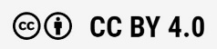

PHYSICS (1 OSP)
Misa Muotio, Piritta Niemi, Leena ristiharju, Tanja suikkanen, sampo tuominen, EEro Heimari
Rahoittaja:

Vierko |www.keuda.fi/keuda/hankkeet/vierko

Physical and chemical phenomena and their application – Physics part course material 2
1. Course overview 2
1.1 Learning objectives and assessment criteria 2
2. Units and quantities, accuracy 2
2.1 Quantity and unit 2
2.2 Measurement accuracy 11
3. Mechanics 20
3.1 Theory: Velocity and acceleration 20
3.2 Theory: Force, Newton’s laws, moment of force and friction 28
3.3 Work, power and pressure 35
3.4 Task: Mechanics quiz 41
4. Energy 43
4.1 Energy 43
4.2 Energy crossword 47
4.3 Quiz 49
5. Thermodynamics 50
5.1 Theory: Thermodynamics 50
5.2 Task: Thermodynamics crossword 56
5.3 Task: Heat transfer from the perspective of your field 58
6. Electricity 58
6.1 Theory: Electricity 59
7. Demonstrating knowledge 67
7.1 Knowledge of physics and chemistry in your field 67
7.2 Physics exam 68
Lopuksi Virhe. Kirjanmerkkiä ei ole määritetty.
Lähdeluettelo 72

Physical and chemical phenomena and their application – Physics part course material

Course overview
The course introduces key concepts in physics and their application in everyday life and the workplace. In the chemistry section, students will explore common substances used in the field, their properties, and how to handle them safely.

Learning objectives and assessment criteria
Some topics covered in this course may need to be understood more thoroughly in your specific field than what is presented in this introductory course, while others may not be as relevant to your area of study. Experimental work in physics and chemistry will be conducted in elective studies. However, within your field, you may encounter tasks and measurements that require knowledge of physics and/or chemistry. Therefore, consider for each topic whether it is essential in your field and which job tasks require this theoretical knowledge. Keep in mind that the entrance exams and studies in university of applied sciences for technical fields require proficiency in physics calculations, so this will be practiced particularly in the area of mechanics.
Further information about compulsory competence requirements: eRequirements
The course consists of theory sections with exercises, tasks and tests. You can progress through the course entirely at your own pace and track your progress using the Progress Tracking block on the right side of the page.

The use of artificial intelligence (AI) is not allowed in any tasks or exercises.

Units and quantities, accuracy

The goal is to learn
- concepts: SI units, quantity, unit
- symbols of quantities and units
- measurement accuracy

Quantity and unit
Get to know the concept of quantity and the SI system with this task.

To pass, you need to answer at least 90 % of the tasks correctly. The result of the task is saved only when you open the last summary page.

Seuraavat materiaalit on toteutettu Pinjassa H5P-aineistona. Tehtävät tarkistuvat kalvojen check-painiketta painamalla.

Slide 1: Quantities and units
Background image:

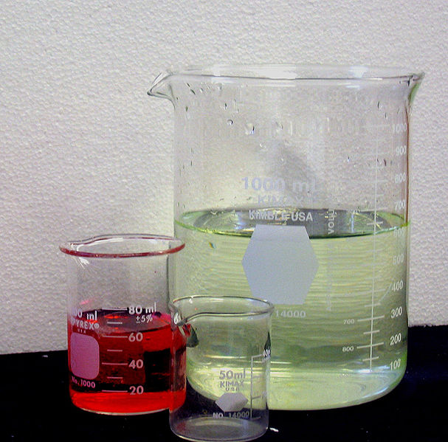

Slide 2: Quantity

We define a physical quantity either by specifying how it is measured or by stating how it is calculated from other measurements.

Quantity is a property of a material or system that can be quantified by measurement.

The quantities are measured with measuring instruments by comparing them with an agreed unit of measurement (e.g 1.0 m or 1.0 kg).

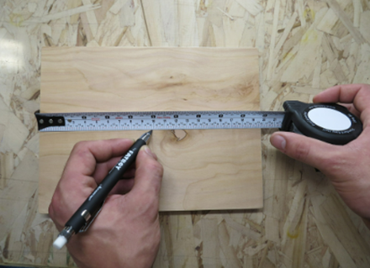 Image
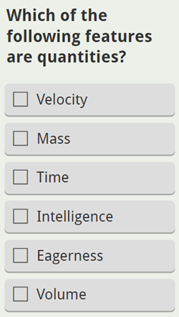

Tehtävä tekstinä:
Which of the following features are quantities?
- Velocity
- Mass
- Time
- Intelligence
- Eagerness
- Volume

Slide 3:

A quantity always has a numerical value and a unit of measurement, i.e.

quantity = numerical value x unit

Example. The mass of a dog, m = 26,5 kg.

The mass is quantity, which is represented by the letter m.
The numerical value of the quantity is 26,5 and the unit of the quantity is the kilogram with the symbol kg.

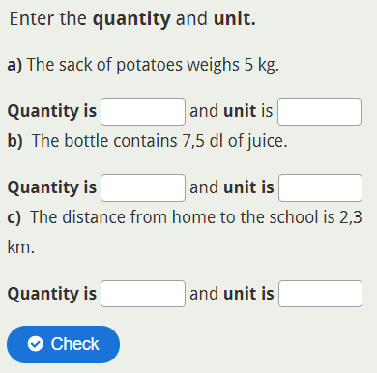
Oikea vastaus
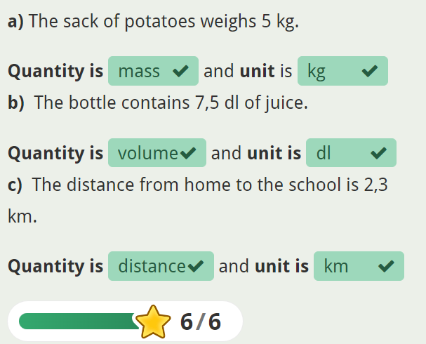

Tehtävä tekstinä:
Enter the quantity and unit.
a) The sack of potatoes weighs 5 kg.
Quantity is _____ and unit is _____
b) The bottle contains 7,5 dl of juice.
Quantity is _______ and unit is _______
c) The distance from home to the school is 2,3 km.
Quantity is ________ and unit is _______

Slide 4:
ADD A SUITABLE UNIT

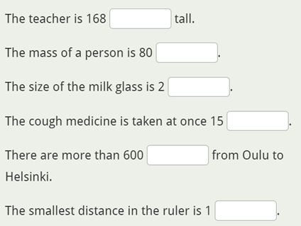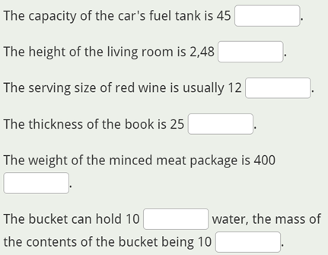

Tehtävä tekstinä;
Add a suitable unit

The teacher is 168 _____ tall.
The mass of a person is 80 _____
The size of the milk glass is 2 _____
The cough medicine is taken at once 15 _____
There are more than 600 _____ from Oulu to Helsinki.
The smallest distance in the ruler is 1 _____

The capacity of the car's fuel tank is 45 _____
The height of the living room is 2,48 _____
The serving size of red wine is usually 12 _____
The thickness of the book is 25 _____
The weight of the minced meat package is 400 _____
The bucket can hold 10 _____ water, the mass of the contents of the bucket being 10 _____

Slide 5:

There are two major systems of units used in the world: SI units (also known as the metric system) and English units (also known as the customary or imperial system).

English units were historically used in nations once ruled by the British Empire and are still widely used in the United States. Virtually every other country in the world now uses SI units as the standard; the metric system is also the standard system agreed upon by scientists and mathematicians. The acronym “SI” is derived from the French Système International.

The quantities with their symbols and units have been compiled into the SI system (International System of Units).

The SI comprises a coherent system of units of measurement starting with seven base units.

Open the SI system from the link provided and complete the following text. (suomeksi: kansainvälinen mittayksikköjärjestelmä)

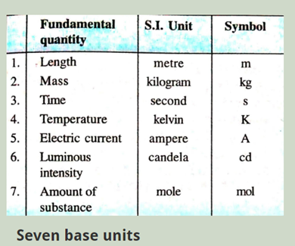

Slide 6:

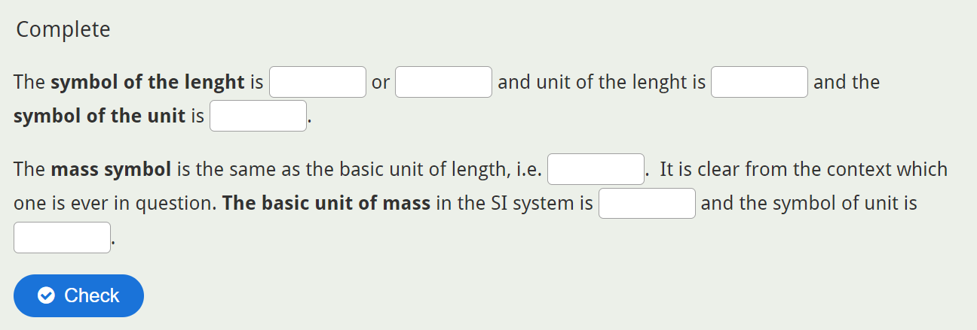 Ratkaisu
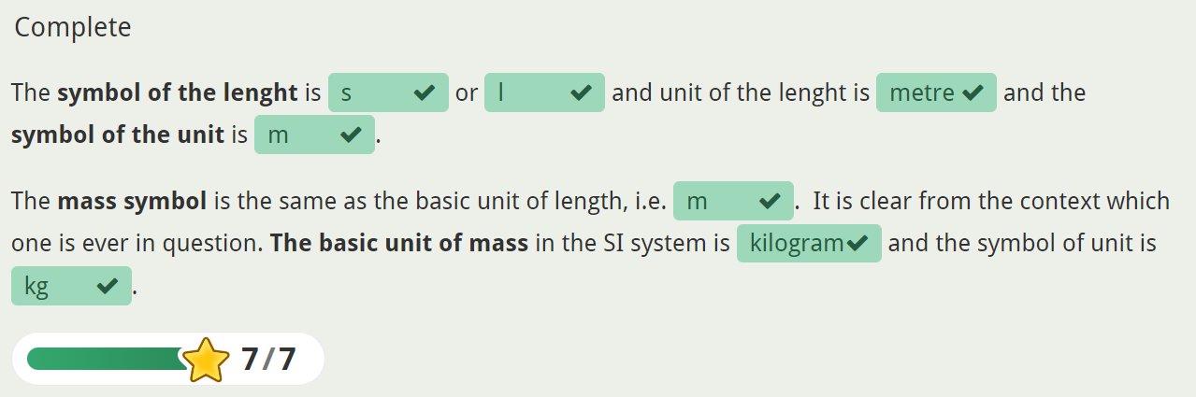

Tehtävä tekstinä:
The symbol for length is _____ or _____ and unit of length is _______ and the symbol for the unit is _____
The mass symbol is the same as the base unit of length, i.e. ____ It is clear from the context which one is meant. The base unit of mass in the SI system is _________ and the symbol for the unit is _____

Slide 7:

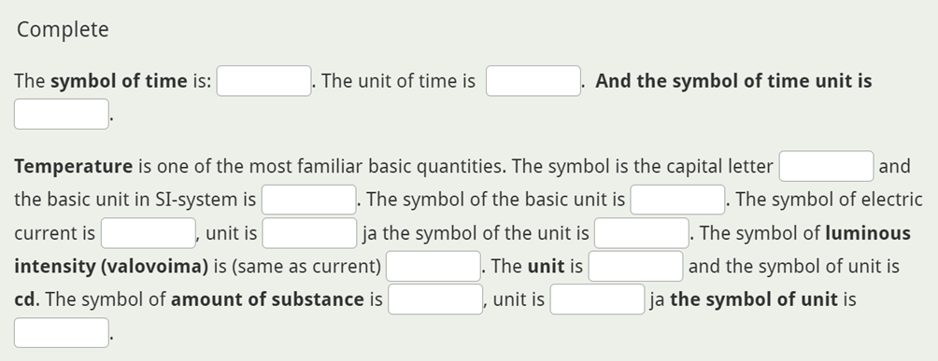

Ratkaisu
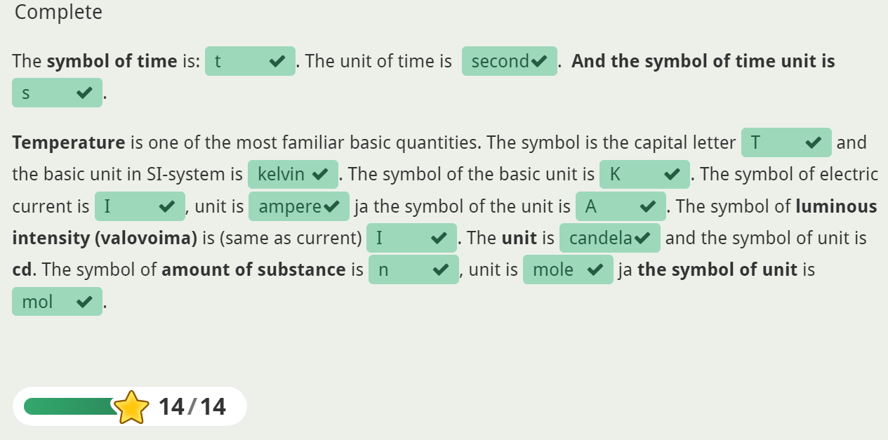

Tehtävä tekstinä:
The symbol for time is: ____ The unit of time is _______ And the symbol for time unit is ____
Temperature is one of the most familiar basic quantities. The symbol is the capital letter ___ and the basic unit in SI-system is _________. The symbol for the base unit is ____. The symbol for electric current is ___, the unit is _________ ja the symbol for the unit is ____. The symbol for luminous intensity (valovoima) is (the same as current) ____. The unit is __________ and the symbol for the unit is cd. The symbol for the amount of substance is _____, the unit is ________ and the symbol for the unit is ______.

Slide 8:

Scalar: A scalar is a quantity that has only magnitude (size) and no direction. Examples of scalar quantities include pure numbers, mass, speed, temperature, energy, volume, and time. For example:
- Mass: The mass of an object (e.g., 5 kg) is a scalar because it only indicates the amount of matter.
- Temperature: A temperature reading (e.g., 25°C) is also a scalar.

Vector: A vector has both magnitude and direction. Examples of vector quantities include:
- Velocity: It specifies both how fast an object is moving (magnitude) and the direction of its motion (e.g., 30 m/s eastward).
- Acceleration: Similar to velocity, acceleration includes both magnitude and direction.
- Force: Force vectors indicate both the strength of the force and the direction in which it acts.

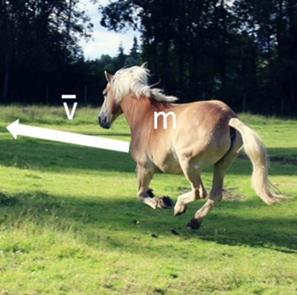

Slide 9:

Prefixes in physics are used to represent very large or very small quantities in a more manageable way. They are added to the base units of measurement to indicate a multiple or fraction of that unit.

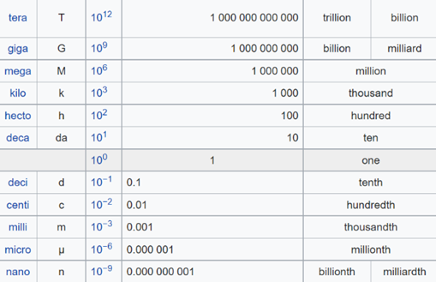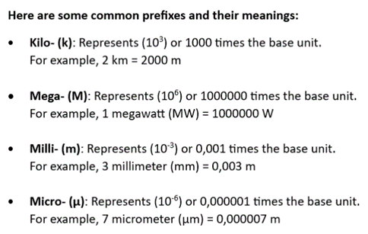

Slide 10:
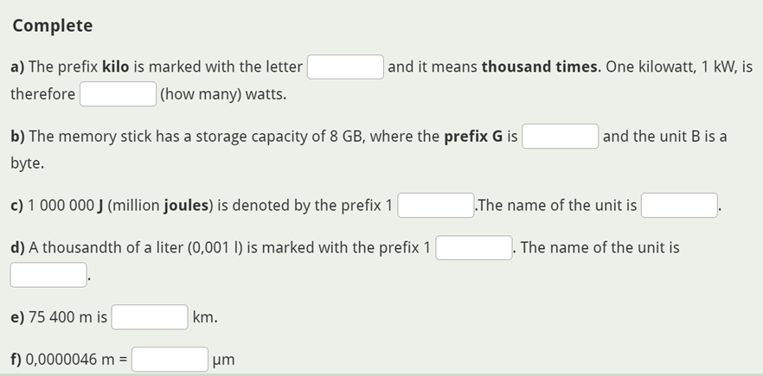
Ratkaisu
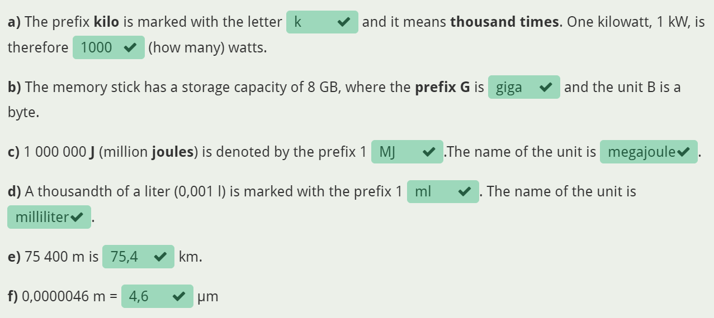

Tehtävä tekstinä:

a) The prefix kilo is marked with the letter ____ and it means thousand times. One kilowatt, 1 kW, is therefore _______ (how many) watts.
b) A memory stick has a storage capacity of 8 GB, where the prefix G is ______ and the unit B is a byte.
c) 1 000 000 J (million joules) is denoted by the prefix 1 _____. The name of the unit is ___________.
d) A thousandth of a liter (0,001 l) is marked with the prefix 1 _____. The name of the unit is __________.
e) 75 400 m is _______ km.
f) 0,0000046 m = ________ µm

Slide 11:

Derived units

All other quantities can be derived from the seven basic quantities.

For example, speed (v) is a derivative quantity whose base unit is m/s. The unit of speed is therefore the unit of distance (s) m divided by the unit of time (t) s.

Some of the derivative units have their own special name.

For example, the force (F) unit N (newton) is obtained by multiplying the mass (m) unit kg by the acceleration (a) unit m/s², i.e. kg ·m/s²= N.

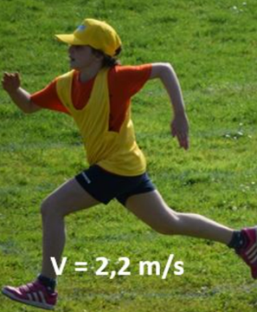

Measurement accuracy
Get to know
- Measurement accuracy, or simply accuracy
- Errors

To pass, you need to answer at least 90% of the tasks correctly. The result of the task is saved only when you open the last summary page.

Slide 1: Measurement accuracy

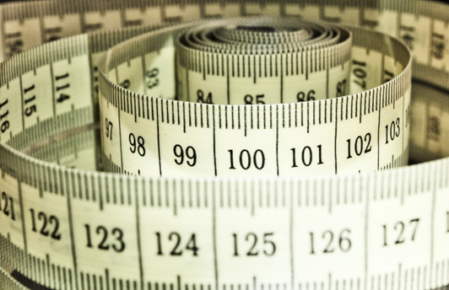
background image

Slide 2: Measurement accuracy

Measurement accuracy, or simply accuracy, refers to how close a measured value is to the true value.
If a measurement result is very close to the reference value and shows high consistency, it indicates that the measurement accuracy is high. Conversely, if the result deviates significantly from the reference value, the accuracy is low.
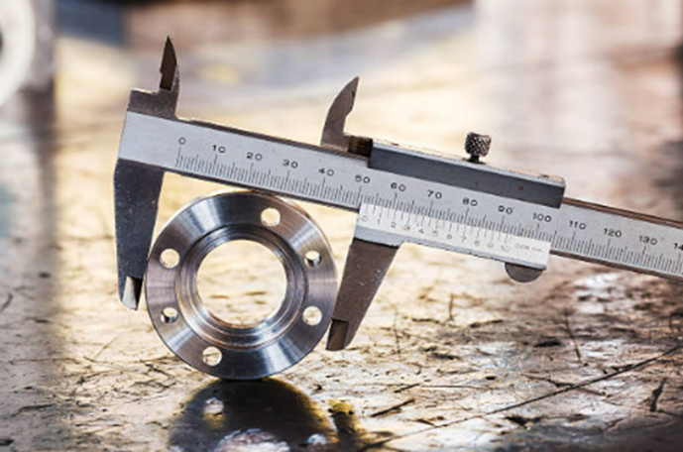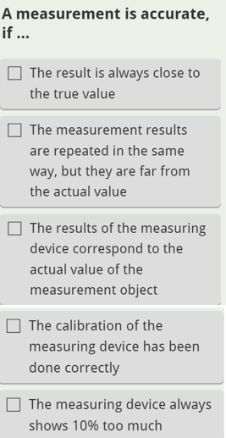

Tehtävä tekstinä:
A measurement is accurate, if ...
- The measurement results are repeated in the same way, but they are far from the actual value
- The result is always close to the true value
- The results of the measuring device correspond to the actual value of the measurement object
- The measuring device always shows 10 % too much
- The measuring device has been calibrated correctly

Slide 3:
Measurement results are always approximate due to measurement errors.
Measurement accuracy can be improved by, for example, repeating the measurement several times, using a more precise measuring device, or rejecting clearly deviating measurement results.

One way to improve the result is by calculating the average of the measurement results.

Five students measured the length of a rod, and the results were 1,6 cm, 1,7 cm, 1,4 cm, 1,5 cm, and 1,8 cm. What is the length of the rod if the average of the measurements is used as the answer?

Answer. The length is ____________ (numerical value and unit)

Slide 4:
Sources of errors in measurement
Measurement error can be caused by the measurer, measurement object, measurement device, measurement environment or measurement method.

Causes a measurement error | Examples
Measurer | - The measurer's competence, state of mind, accuracy, and attention to detail
Measurement object | - Characteristics of the measurement object (e.g., shape, size, slipperiness, smoothness, roughness)  - Age, behavior, and mood (e.g., a restless baby or a tense person)
Measuring device | - Selection of measuring devices and their various functions  - Age and condition of the measuring device, as well as the clarity and accuracy of the measuring scale  - Calibration of the measuring device
Measurement environment | - Location of the measuring device (e.g., softness, hardness, or evenness of the table, and whether the device is indoors or outdoors)  - Conditions of the measurement environment (e.g., temperature, noise, lighting, and vibration)
Measurement method | - Method selection  - Measurement procedure (e.g., whether the measurement is always performed in the same way, in the same place, under the same conditions, and at the same time)

Slide 5:
What causes measurement error?
Write measurer, object, device, environment or method.

Watermelon is heavy and round. __________
The scale has not been calibrated for a long time. __________
A person comes in a hurry for a blood pressure measurement. __________
There is a strong wind at the long jump location. __________
The person does not understand the measuring scale of the device. __________
The measuring tape is stretched. __________

Ratkaisu:
Watermelon is heavy and round. *object*
The scale has not been calibrated for a long time. *device*
A person comes in a hurry for a blood pressure measurement. *object*
There is a strong wind at the long jump location. *environment*
The person does not understand the measuring scale of the device. *measurer*
The measuring tape is stretched. *device*
Slide 6:
Systematic error or random error?

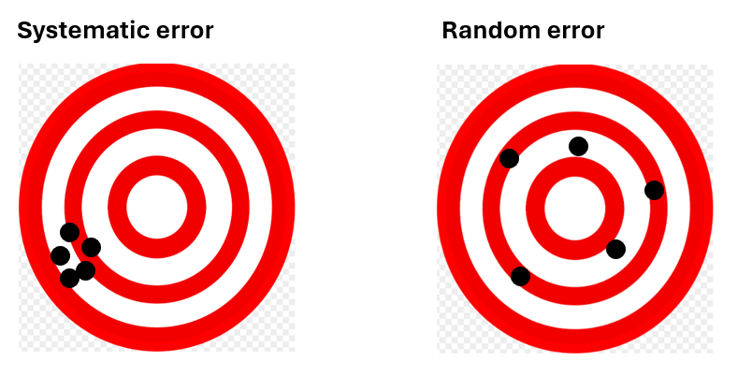
Systematic error always occurs and has the same value when repeating measurements the same way.

Random errors are (as the name suggests) completely random. They are unpredictable and can’t be replicated by repeating the experiment again.

Slide 7:
Systematic error is consistent or proportional to the measurement, so it primarily affects accuracy. Causes of systematic error include poor instrument calibration, environmental influence, and imperfect measurement technique.
Systematic errors are consistently in the same direction (e.g. they are always 50 g, 1% or 99 mm too large or too small).
Random error (also called unsystematic error, system noise or random variation) has no pattern. One minute your readings might be too small. The next they might be too large. You can’t predict random error and these errors are usually unavoidable.
Random errors produce different values in random directions. For example, you use a scale to weigh yourself and get 69 kg, 72 kg, and 74 kg.

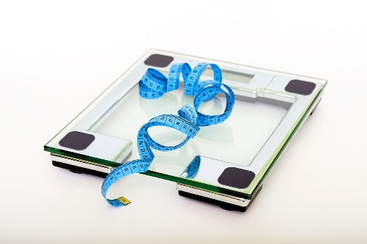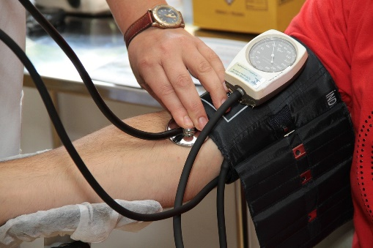

Slide 8:
Systematic or random? Mark "s" or "r".

A scale that reads 0,5 kg too high will produce this error across all measurements. ____
Temperature changes might cause materials to expand ____
The person does not understand the scale of the device and reads it incorrectly. ____
An old, stretched cloth measuring tape gives consistent, but different measurements than a new tape. ____
Weight measurements on a scale vary because it’s impossible to stand on the scale exactly the same way each time. ____
Posture changes affect height measurements. ____

Ratkaisu:
A scale that reads 0,5 kg too high will produce this error across all measurements. *s/S*
Temperature changes might cause materials to expand *s/S*.
The person does not understand the scale of the device and reads it incorrectly. *r/R*.
An old, stretched cloth measuring tape gives consistent, but different measurements than a new tape. *s/S*
Weight measurements on a scale vary because it’s impossible to stand on the scale exactly the same way each time. *r/R*
Posture changes affect height measurements. *r/R*.

Slide 9:

Preventing errors

If a systematic error is identified, it can be reduced.
This may involve calibrating equipment, warming up instruments before taking readings, comparing values to standards, and using experimental controls.
With experience in using the device and knowledge of its limitations, systematic error can be further minimized.

Random error, on the other hand, cannot be eliminated, but its impact can be reduced.
Measurements can be repeated, the sample size can be increased, or the results can be averaged.

Slide 10:

Drag the words to the right place.
Random errors may be reduced by_________________________ and calculating an average.
A common example of a systematic error is a _____________________that always gives readings that are too high.
_____________________ refers to how close a measured value is to the true value of the quantity being measured.
Factors such as ________________________can impact measurement accuracy and lead to errors.
Accurate measurements are essential in science and engineering to ensure __________________.
In conclusion, measurement errors arise from both ___________________, such as improper calibration and environmental effects, and _____________________, such as human mistakes and instrumental noise.

WORDS:
*taking multiple measurements*
*systematic sources*
*Measurement accuracy*
*reliable results*
*miscalibrated scale*
*environmental conditions*
*random sources*

Ratkaisu:
Random errors may be reduced by *taking multiple measurements* and calculating an average.
A common example of a systematic error is a *miscalibrated scale* that always gives readings that are too high.
*Measurement accuracy* refers to how close a measured value is to the true value of the quantity being measured.
Factors such as *environmental conditions* can impact measurement accuracy and lead to errors.
Accurate measurements are essential in science and engineering to ensure *reliable results*.
In conclusion, measurement errors arise from both *systematic sources*, such as improper calibration and environmental effects, and *random sources*, such as human mistakes and instrumental noise.

Slide 11:
Which of the following describes measurement accuracy?
- The ability of the measurement result to be as close as possible to the true value.
- The ability of the measurement result to be as far from the true value as possible.
- The ability of the measurement results to be as close to each other as possible.
What could happen if the measurement accuracy is poor?
- The measurement results are always exactly correct.
- The measurement results are consistently wrong.
- The measurement results are always the same.
Which of the following is an example of a measurement error?
- You get exactly the same result every time you measure.
- You use a new meter that gives an accurate result every time.
- The device's result is consistently 5% higher than the true value.
What does improving measurement accuracy mean?
- Repeating measurements to identify errors.
- Performing measurements as quickly as possible.
- Reducing the number of measurements.

Which of the following is an example of random error?
- A measuring device always gives results that are 3% too high.
- Measurement results fluctuate slightly due to environmental factors.
- The same measurement gives the exact same wrong value each time.

Which of the following improves the precision of measurements?
- Repeating the measurements and calculating the average.
- Guessing the measurement result.
- Measuring only once to avoid mistakes.

How can systematic errors be reduced?
- By calibrating the instrument properly before use.
- By increasing the number of measurements.
- By ignoring small measurement differences.

TASK1: Quantities needed in the world of work and everyday life, measurement accuracy

1. What is the SI system? Explain the main points of it (base units, prefixes).
2. Why should we use the SI system?
3. Which measurements are important in your professional field?
4. What measuring instruments are used in your professional field?
5. List some quantities in your professional field.
Also write the quantity symbol, the unit in the SI system, and the unit symbol.
6. Five friends went for a bike ride. Each of them had their own speedometer, which showed the following readings: 15.1 km, 15.34 km, 15,740 m, 15.00 km, and 14.95 km. The bike ride took 35 minutes.
a) What kind of quantities and units can you find in the example above?
b) What number would you report as the distance based on these measurements?
7. You have three measurements taken with similar scales: 5,01 g, 4,99 g, and 5,02 g. The true mass is 5,00 g.
a) Are the measurements accurate?
b) What could you do to improve the accuracy of the measurements?
8. Imagine that a laboratory device consistently gives a result that is 2% higher than the true value. Additionally, you notice that the measurement results vary by ±0,5% each time.
a) What is the systematic error in the measurement results?
b) What is the random error in the measurement results?
c) How can you reduce the impact of both errors?

TASK2: (tehtävätyypissä valikosta valitaan sopiva vaihtoehto, tässä vain tekstinä ja valikon kohdalla viiva)
Combine the derived quantity and the symbol
Resistance ___
Force ___
Energy, work ___
Pressure ___
Power ___
Voltage ___
Acceleration ___
(vaihtoehdot: R, a, P, F, p, U, ja E, W)
(oikeat vastaukset: Resistance R, Force F, Energy and Work E, W, Pressure p, Power P, Voltage U, Acceleration a)

Combine the basic quantity and the unit symbol
Temperature ___
Electric current ___
Lenght ___
Amount of substance ___
Luminous intensity ___
Time ___
Mass ___
(vaihtoehdot: K, A, m, mol, cd, s, m
Oikeat vastaukset: Temperature K, Electric current A, lenght m, Amount of substance mol, Luminous intensity cd, Time s, Mass kg)

Combine the basic quantity and the basic unit
Temperature ___
Electric current ___
Lenght ___
Amount of substance ___
Luminous intensity ___
Time ___
Mass ___
(vaihtoehdot: Kelvin, metre, ampere, candela, mole, second, kilogram
Oikeat vastaukset: Temperature Kelvin, Electric current ampere, Lenght metre, Amount of substance mole, Luminous intensity candela, Time second, Mass kilogram)

Combine the basic quantity and the symbol
Temperature ___
Electric current ___
Lenght ___
Amount of substance ___
Luminous intensity ___
Time ___
Mass ___
(vaihtoehdot: n, I (small letter L), T, I (big letter i), t, m
Oikeat vastaukset: Temperature T, Electric current I (big letter i), Lenght l (small letter L), Amount of substance n, Luminous intensity I (big letter i), Time t, Mass m)

Combine the prefixes and the multipliers
Micro __________
Nano __________
Mega __________
Hecto __________
Deca ___________
Deci ____________
Centi ___________
Milli ____________
(vaihtoehdot: 0,001; 0,01; 0,1; 10; 100; 1000000; 0,000000001; 0,000001
Oikeat vastaukset: micro: 0,000001, nano: 0,000000001, mega: 1000000, hecto: 100, deca: 10, deci: 0,1, centi: 0,01, milli: 0,001)

Mechanics

The goal is to learn
- concepts of physics related to mechanics (e.g. motion, force, work)
- to solve simple mechanical problems mathematically
- to observe fundamental mechanical phenomena
Think! Is some area of mechanics essential in your field of study?

Theory: Velocity and acceleration

With this assignment you will familiarize yourself with constant and accelerating motion. You will learn to convert the units of speed and to calculate the average speed, average acceleration and circular velocity. To pass, you need to answer at least 60% of the tasks correctly.

Seuraavat materiaalit on toteutettu H5P-aineistona. Tehtävät tarkistuvat kalvojen check-painiketta painamalla.

Slide 1: Mechanics – Velocity and acceleration
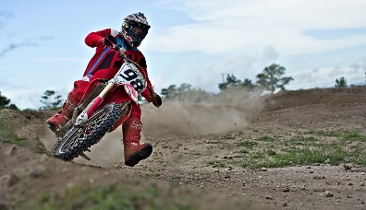 Background image

Slide 2: Average velocity
Motion is constant if its direction and velocity do not change. In real life motion is usually not constant. However, even if the motion is not constant, when moving from one place to another the average velocity can be expressed based on the distance traveled and time spent on this.
If the distance (s) and time (t) are known, the average velocity (v) can be calculated by dividing the distance by the time. The unit of velocity is m/s.

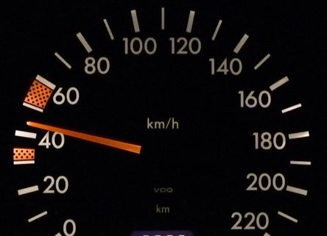
The car speedometer displays the instantaneous velocity.

$$v=\frac{s}{t}$$
where
v = velocity (m/s)
s = distance (m)
t = time (s)

Slide 3: Converting from km/h to m/s and vice versa

In different situations we may use different units of velocity. It is reasonable to use the speed unit km/h when expressing velocity in road traffic, such as the movement of cars or bicycles, as well as in aviation. On the other hand, m/s is commonly used as the velocity unit in scientific and technical contexts, such as in physics or engineering, because m and s are base units of the SI system, making m/s more convenient for calculations and measurements.

The following video explains how to convert the velocity units from one to another:

Converting units of velocity

Slide 4:

Convert the units of speed:
a) 20 m/s = __________ km/h (answer: 72)
b) 36 km/h = _________ m/s (answer: 10)
c) 126 km/h = _________ m/s (answer: 35)
d) 2,5 m/s = __________ km/h (answer: 9)
Background image

Slide 5:

Answer the questions based on the graph: 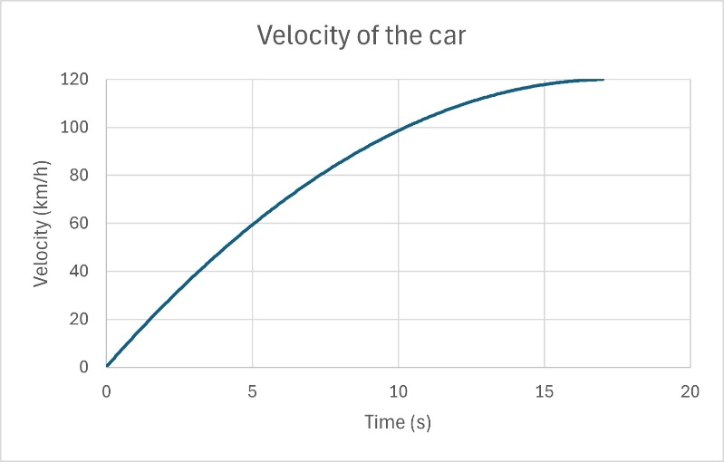

a) What is the velocity of the car when 5.0 seconds have elapsed since the start?
________ km/h (answer: 60)

b) How long does it take for the car to reach a velocity of 100 km/h?
Approximately ________ s (answer:10)

c) What is the car's top velocity during acceleration?
_________ km/h (answer: 120)

Slide 6: Calculating velocity, distance and time

You can use the triangle to help you calculate velocity, distance and time.

To calculate velocity, cover up v in the triangle and you get $v=\frac{s}{t}$.

To calculate time, cover up t in the triangle and you get $t=\frac{s}{v}$.

To calculate distance, cover up s in the triangle and you get $s=v∙t$.
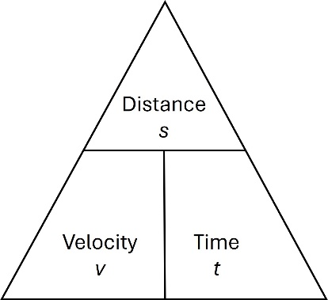

Watch the following video for examples: Calculate velocity, distance and time
Take notice! In the video distance is denoted as D and velocity as S, so don't be confused by the different symbols used.

Slide 7: Exercises

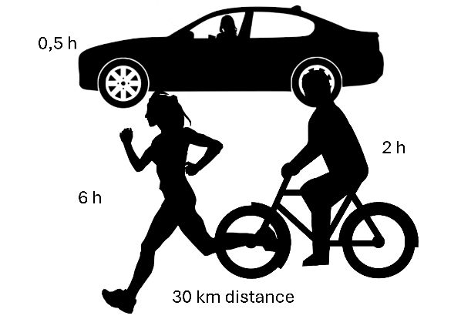

Calculate the average velocity (based on the image).
The average velocity of the runner is _________ km/h. (answer: 5)
The average velocity of the cyclist is _________ km/h. (answer: 15)
The average velocity of the car is _________ km/h. (answer: 60)

Calculate the time.
The distance from Kotka to Helsinki is 120 km. How long does the drive take, if the average velocity of the car is 80 km/h?
Answer: The drive takes _________ h. (answer: 1,5)

Slide 8: Average acceleration
If the direction or speed of the motion changes, the motion is not constant but accelerating. If velocity decreases, it means that acceleration has a negative value. Acceleration is a physical quantity that describes the change in velocity per second, and its unit is m/s².
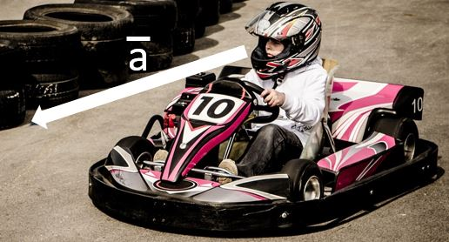
Image text: Even if the velocity is constant, motion is accelerating if its direction is changed.

Even if the velocity is constant, motion is accelerating if its direction changes.
A free-falling object is an object moving only because of the action of gravity and it is in an accelerating motion. The acceleration is constant and equal to the gravitational acceleration g which is 9,81 m/s².
The average acceleration is the change in velocity divided by the time required for the acceleration:

$$a=\frac{v_{2}-v_{1}}{t}$$
where
a = acceleration (m/s²)
v₂ = final velocity (m/s)
v₁ = initial velocity (m/s)
t = time

Slide 9: Examples

Example 1. A car is in a constant accelerating motion. It takes 8 seconds to accelerate from 80 km/h to 120 km/h. What is the acceleration of the car?

Solution:
v₁ = 80 km/h
v₂ = 120 km/h
t = 8 s
a = ?

Let’s first calculate the change in velocity and convert it into unit of m/s.

v₂ – v₁ = 120 km/h – 80 km/h = 40 km/h ≈ 11,1111 m/s

$$a=\frac{v_{2}-v_{1}}{t}=\frac{11,1111 m/s}{8 s}=1,388…\frac{m}{s^{2}}≈1,4 m/s^{2}$$

Answer: the acceleration is 1,4 m/s².

Example 2. Two friends did a tandem skydiving jump. Before opening the parachute, they were free falling. How long did it take for them to reach the velocity of 120 km/h?

Solution:
v₁ = 0 km/h
v₂ = 120 km/h
g = 9,81 m/s²
t = ?

Let’s first calculate the change in velocity and convert it into unit of m/s.
v₂ – v₁ = 120 km/h – 0 km/h = 120 km/h ≈ 33,3333 m/s
Let’s solve the equation $g=\frac{v_{2}-v_{1}}{t}$ for t:
$$t=\frac{v_{2}-v_{1}}{g}=\frac{33,3333 m/s}{9,81 m/s^{2}}=3,397… s≈3,4 s$$

Answer: it took 3,4 seconds.

Slide 10: Exercises (fill in the blanks)

1. A car accelerated on the motorway in 4 seconds from a velocity of 28 m/s to a velocity of 34 m/s. Calculate the car's average acceleration during the acceleration.
t = ___________ s (answer: 4)
v₂ - v₁ = __________ m/s - __________ m/s (answers: 34, 28)
= ___________ m/s (answer: 6)
a = ___________ m/s² (1 decimal place) (answer: 1,5)

2. A moped decelerated from a velocity of 40 km/h to a stop in 3 seconds. Convert the velocity into m/s and calculate the average deceleration.
t = ___________ s (answer: 3)
v₁ = 40 km/h = ____________ m/s (3 decimal places) (answer: 11,111)
v₂ - v₁ = __________ m/s - __________ m/s (answers: 0; 11,111)
= ___________ m/s (answer: -11,111)
a = ___________ m/s² (1 decimal place) (answer: -3,7)

Slide 11: Rotational speed or frequency

When sewing, the sewing machine makes, for example, 1400 stitches per minute. The machine makes the same number of stitches in the same amount of time as the main shaft of the machine makes rotations. This is called the rotational speed (n) and it also indicates the sewing speed. Sometimes it is also referred to as rotational frequency, or revolutions per minute (RPM).
The SI-unit of rotational speed is 1/s. The unit r/min (RPM) is also often used. For example, the rotational speed of spinning cycle in laundry machines is expressed as RPM.
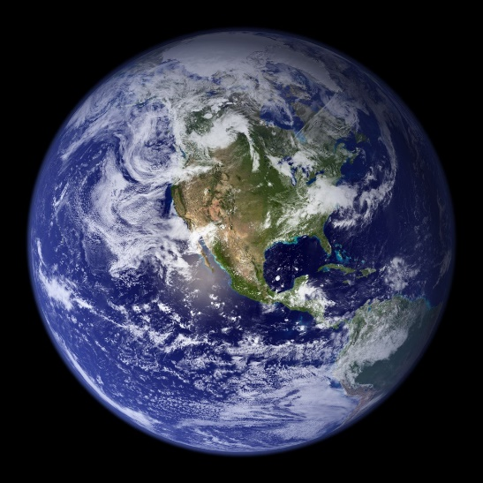
Image text: What is the rotational speed of the Earth? How long does it take the Earth to rotate around its axis?

Slide 12: Tangential velocity
The velocity of an object moving along a circular path is called the tangential velocity (v). When the circumference of the circle is known, the tangential velocity can be calculated by multiplying the circumference (i.e., the perimeter) by the rotational speed. The circumference can be calculated using either the radius r or the diameter d.

When maximum velocity is given for blades and grinding wheels, it refers to the velocity of a point at the outer edge (i.e. tangential velocity). For drills and other machine tools, when setting the speed, you are setting the rotational speed, that is, the number of revolutions in a certain unit of time (usually in RPM unit).

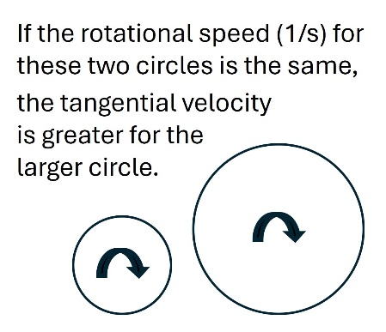
Rotational speed
$$n=\frac{r}{t}$$
where
r = the number of rotations
t = time

Tangential velocity
$$v=πdn$$
where
d = diameter of the
circular path
n = rotational speed
Slide 13:

Consider the black dots on both circles. If the rotational speed (1/s or RPM) is the same for both circles, it takes the same time for both dots to complete one revolution. However, the one on the rigth hand side travels a longer distance in this time because the circumference of the larger circle is greater than that of the smaller circle. Therefore, the tangential velocity is greater for the larger circle.
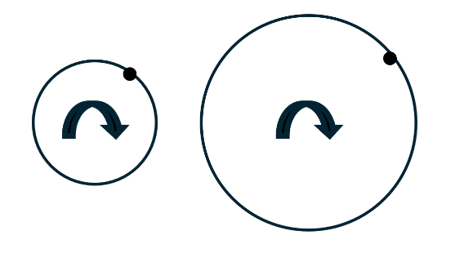
Example 1. The rotational speed of a table saw blade is 2500 RPM, and the diameter of the blade is 500 mm. Calculate the tangential velocity of the blade.

Solution:
The circumference of the blade is
$$π∙d=π∙0,500 m≈1,5708 m$$

Convert the unit of rotational speed from 1/min to 1/s:
$$n=\frac{2500}{60}\frac{1}{s}≈41,667 1/s$$

Tangential velocity:
v = 41,667 1/s ⋅ 1,5708 m ≈ 65 m/s

Slide 14: Exercise

What is the tangential velocity of a cutting disc (d =150 mm) when its rotational speed is 2950 RPM?

First calculate the circumference and convert it to meters:
p = __________ mm = _________ m (3 decimals) (answer: 471,239; 0,471)

Convert RPM (1/min) to 1/s:
n = _________ 1/s (3 decimals) (answer: 49,167)

Calculate the circular velocity:
v = _________ m/s (3 decimals) (answer: 23,158)

Answer. The tangential velocity is _________ m/s (1 decimal) (answer: 23,2)

Theory: Force, Newton’s laws, moment of force and friction
Study Newton's laws and try to understand their core concepts. Learn to calculate force and moment of force. Strive to understand the significance of friction. To pass, you need toanswer at least 80% of the questions correctly.

Slide 1: Mechanics – Force, Newton’s laws, moment of force and friction  Background image

Slide 2: Force
The motion of an object is caused by the forces affecting it. The area of mechanics that studies forces and their effect on the motion of objects is called dynamics.

The symbol for force is F and the unit is Newton (N). The force by which the Earth draws objects towards its center is called gravity or weight. The symbol of gravity is G.

A force applied to a particle is a vector as it has both a magnitude and a direction. In illustrations forces are demonstrated as arrows whose length and direction express their magnitude and direction.
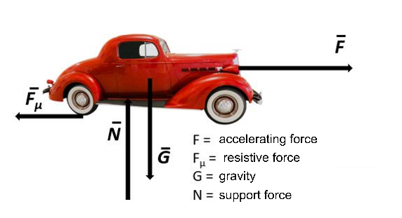

Slide 3:

When an object is moving in accelerating motion without changing its direction (and other forces affecting it are not considered), the force (F) affecting the object can be calculated by multiplying the mass (m) of the object by the acceleration (a):

F = ma (Newton’s 2nd law)
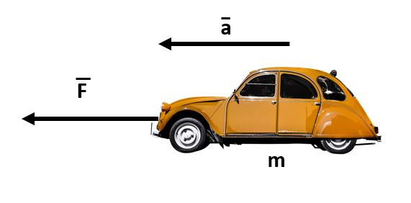
Example 1. The car is moving forward, accelerating at a constant rate of 5,6 m/s². What is the force propelling the car forward if the car weighs 750 kg? Counterforces are not considered.

Solution:
m = 750 kg
a = 5,6 m/s²
F = ma
= 750 kg ⋅ 5,6 m/s²
= 4200 kgm/s²
= 4200 N

Slide 4:
When an object is free falling (vertical motion) the acceleration is 9,81 m/s². This is called gravitational acceleration (g) and the force causing it is gravity (G). The force of gravity is calculated by multiplying the mass of the object by the gravitational acceleration g:

G = mg

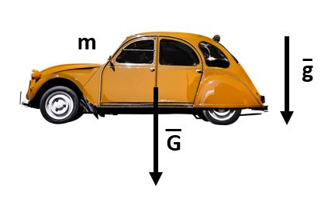
Example 2. The mass of the car is 750 kg. What is the gravitational force acting on it?
Solution:
m = 750 kg
a = 9,81 m/s²
G = mg
= 750 kg ⋅ 9,81 m/s²
= 7357,5 kgm/s²
≈ 7400 N

Slide 5: Calculate the magnitude of the forces:

What is the gravity affecting a person weighing 80 kg? Give the answer in Newtons (N), as a whole number.
Answer. _______ N (answer: 785)

What is the gravity affecting a vehicle weighing 14 tons? 1 ton = 1000 kg. Give the answer in Newtons (N), as a whole number
Answer. ________ N (answer: 137340)

In shot put, how big is the force needed to put ("throw") the shot (mass 7,3 kg) in order to achieve the acceleration of 44 m/s²? Give the answer in Newtons, as a whole number.
Answer. ________ N (answer: 321)

Slide 6: The laws of mechanics (Newton's laws)

The motion of an object is determined by the forces acting upon it. The branch of mechanics that studies the effects of forces on the motion of objects is called dynamics.

Newton's first law (the law of inertia):
An object at rest will remain at rest, and an object in motion will continue to move at a constant speed and in a straight line unless acted upon by an unbalanced force. It takes a force to set an object in motion from rest or to bring a moving object to a stop.

Video: Newton in space: part I

Slide 7:
The acceleration of an object depends on both its mass and the amount of force applied. The mass of an object tends to resist changes in its state of motion. In other words, mass is a measure of an object's inertia. The greater the mass, the smaller its acceleration.

Newton's second law (law of force):
The net force F acting on an object is the product of the object's mass and the acceleration caused by the force, or F = ma.

Video: Newton in space: part II

Slide 8:
An external force means that some other object is causing the force. If you pull your own hair, that is an internal force. If your friend pulls your hair, that is an external force. You cannot lift yourself into the air, but if your friend is strong enough, they can lift you.

Newton's third law (the law of action and reaction):
Whenever one object exerts a force on another object, the second object exerts an equal and opposite force on the first object.

Video: Newton is space: part III

Slide 9:
Newton's laws (fill in the blanks by selecting the correct word or phrase)
The symbol of force is ___________. The unit of force is ___________, which comes from the name of Isaac Newton. The symbol for gravity is ___________. The first law, ____________ goes: an object will remain at rest or in uniform motion in a straight line unless compelled to change its state by the action of an external force. The second law, ____________ says, that F = ma. The third law, ___________
is: for every action (force) in nature there is an equal and opposite reaction. Force is a __________, because it has both a magnitude and a direction. The acceleration of an object depends on _________. A ball thrown up in the air will fall down because of ___________.

force and mass
the law of inertia
gravity
the law of action and reaction
vector quantity
the law of force
G
N
F

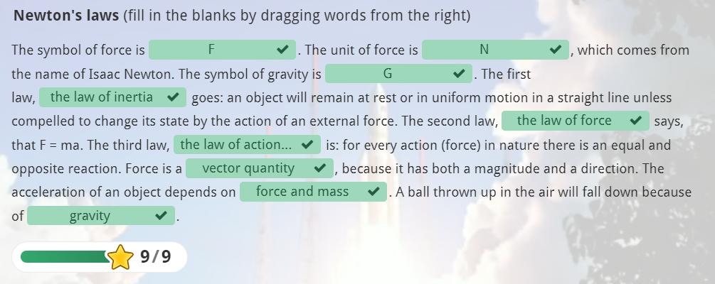

Slide 10:
Choose the appropriate Newton's law for each situation. Write 1, 2 or 3 in each box according to the number of law in question.
a) In lifting, the cable affects the load and the load is lifted. Similarly, the load affects the cable, and it must be ensured that the cable can withstand it. ________ (answer: 3)
b) The higher the diver jumps from, the faster they hit the water's surface. ______ (answer: 2)
c) After a spacecraft has broken free from Earth's gravitational pull, it doesn't need energy to maintain its velocity. ________ (answer: 1)
d) The teacher lies on the couch unless some force makes them move. _______ (answer: 1)
e) The car is being lifted by a hydraulic crane. The crane exerts an equal force on the car as the car does on the crane. ________ (answer: 3)

Slide 11: Moment of force

In addition to the pulling and pushing effects, force has a twisting effect on the object, causing it to rotate. The magnitude of this twisting effect is described by the moment of the force, denoted as M. It is calculated by multiplying the force F by the length of the lever arm, r. The lever arm of the force is the perpendicular distance from the line of action of the force to the pivot axis O.

The unit of moment is newton meter, Nm. The twisting effect of force is evident, for example, when tightening a nut. The static friction holds the nut in place when it is tightened, and this force must be overcome when loosening the nut.

M = F ⋅ r
where
M = moment (Nm)
F = force (N)
r = lever arm (m)
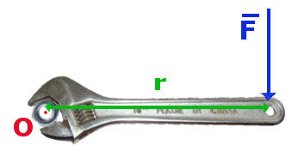
The line of action is marked by an arrow.

Slide 12:
In equilibrium, the sum of the moments is zero, meaning that the moments acting on either side of the pivot point must be equal.

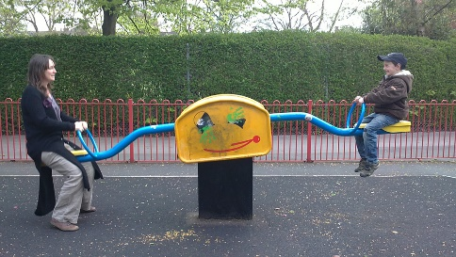
The force caused by the people on the seesaw is equal to their gravity. Remember: G = mg.

Let’s first mark moments on both sides of the pivot point equal:
$$F_{1}∙r_{1}=F_{2}∙r_{2}$$

Next solve the equation for F₂ by dividing both sides by r₁:
$$F_{1}=\frac{F_{2}∙r_{2}}{r_{1}}=\frac{800 N∙3,2 m}{2,3 m}=575 N$$

Slide 13: Fill in the blanks by choosing the correct word

If you can't loosen the car wheel bolt with a short-handled wrench, you can try loosening it with a _________ wrench.
When a mother and child are sitting on a seesaw and it is balanced, the phenomenon involves ________. The mother’s _________ is 600 N, and she is sitting 1.5 m from the
of the seesaw. The child, whose weight is 300 N, needs to sit __________ from the pivot point for the seesaw to be in _________. A person's _________ is the product of their ________ and __________.

longer-handled
gravitational acceleration
moment of force
equilibrium
pivot point
10 m
gravity
mass
weight
3 m

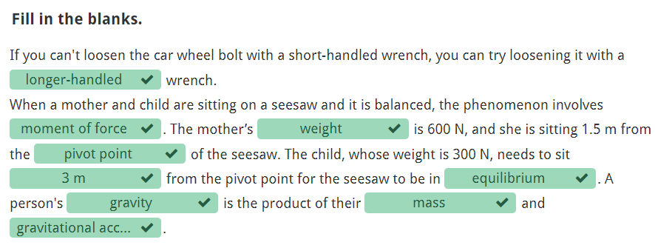

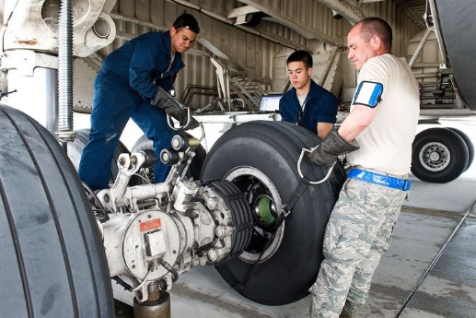

Slide 14: Friction

Friction is a force that resists motion, and it is caused by the contact between surfaces. The magnitude of friction is influenced by the quality of the surfaces and the mass of the object. However, the size of the rubbing surfaces does not affect the magnitude of friction.

Static friction is the friction between non-moving surfaces and it resists the start of an object's motion, while kinetic friction is the friction between moving surfaces and it resists the motion of an object already in motion. Both static and kinetic friction have a coefficient of friction that depends on the quality of the surfaces.

Table. Coefficients of friction for different pairs of materials.
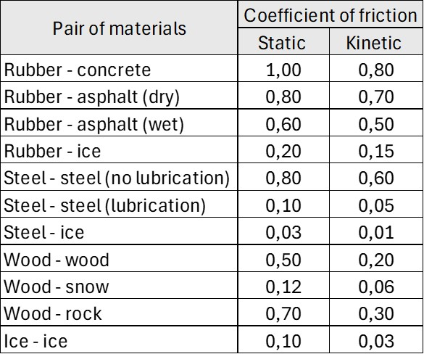

Slide 15:

The force that resists the movement of an object through gases and liquids is called viscosity. Stirring porridge requires more force than stirring water because the viscosity of porridge is greater than the viscosity of water.

Viscosity depends on temperature and pressure. As temperature increases, the viscosity of gases increases, while the viscosity of liquids decreases. As pressure increases, the viscosity of gases remains unchanged, but the viscosity of liquids increases.

Video of three liquids with different viscosity

Slide 16:
Friction can be reduced with various lubricants, for example motor oil is used as a lubricant in car engines. If machinery is not regularly maintained, it will wear out, and energy will be wasted as frictional heat.

Sanding roads in winter time, on the other hand, increases friction and prevents people from slipping. Water reduces friction of floor surfaces, and therefore roughened floor surfaces are often used in places like public swimming pools. Slipping can also be prevented by using shoes with textured and flexible soles.

Exercise: choose the correct alternative (the correct answer is marked with green color)

Lubrication…
- increases friction
- decreases friction
The size of the contact area between the rubbing surfaces…
- does not affect friction
- affects friction
The viscosity of water is...
- greater than the viscosity of syrup
- smaller than the viscosity of syrup
Kinetic friction is…
- greater than static friction
- smaller than static friction
Which one is true?
- Static friction resists the start of an object's motion.
- Kinetic friction resists the start of an object's motion.

Without friction our daily life would be difficult.
- Yes
- No
Simply put, friction can be thought of as arising from...
- ...the roughness between contact surfaces.
- ...the size of the contact area between surfaces.
The greater the friction coefficient
- the smaller the friction.
- the greater the friction.
When plunging into the Earth's atmosphere, a meteor rubs against the air due to friction, becoming so hot that it begins to glow and burn.
- True
- False
The speed of the object
- ...affects the magnitude of friction.
- ...does not affect the magnitude of friction.
The friction coefficient of rubber and asphalt...
- ...depends on the wetness of the asphalt.
- ...does not depend on the wetness of the asphalt.

Work, power and pressure

Learn to calculate work done horizontally, lifting work, and power. Strive to understand the significance of air pressure. To pass, you need to answer 60 % of the tasks correctly.

Slide 1: Mechanics – Work, power and pressure
Background image

Slide 2: Work
When a force is applied to an object causing it to move, work is done.
The work done is measured as the amount of energy consumed. The work (W) done by a force (F) is the product of the force and distance (s) moved by the object, W = Fs.
The unit of work is therefore Newton meter (Nm), which is called a joule (J). However, although the unit for both work and moment of force is Nm, they are not the same. This is because the moment of force is a vector quantity (it has a direction) while work is a scalar quantity.

W = F ⋅ s
where
W = work (J)
F = force moving the object (N)
r = distance moved by the object (m)

Example. A person pushes a shopping cart full of groceries from the checkout to their car in the store’s parking lot. How much work does the person do, if the distance is 120 m and they push the cart with a force of 35 N?
Answer: W = F ⋅ s = 35 N ⋅ 120 m = 4200 J = 4,2 kJ

Slide 3:
In lifting work, work is done against gravity. The work is calculated in the same way, but the force is gravity G, and the distance is represented by the vertical height h: W = Gh.
Since gravity is calculated by multiplying the object's mass m by the acceleration due to gravity g, the formula for lifting work can be written as W = mgh.

W = m ⋅ g ⋅ h
where
W = work (J)
m = mass (kg)
g = gravitational acceleration (m/s²)
h = height (m)
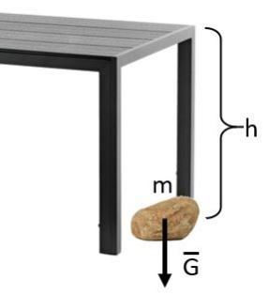
Example. A stone with a mass of 2,3 kg is lifted from the floor onto the table. The height of the table is 1 m. How much work is done?
Solution.
m = 2,3 kg
g = 9,81 m/s²
h = 1 m
W = m ⋅ g ⋅ h
= 2,3 kg ⋅ 9,81 m/s² ⋅ 1 m
= 22,563 J ≈ 23 J
Answer. The work done is 23 J.

Exercise: Calculate the work done by Pete.
1) Pete pulls an object 3,7 meters horizontally with a force of 80 N. Pete does ________ joules of work (a whole number). (answer: 296)
2) Pete lifts a 15 kg bag of cement to a height of three meters. Pete does ________ joules of work (a whole number). (answer: 441)
3) The mass of the object is 38 kg. Pete lifts it to a height of 15 meters. Pete does ________ kJ of work (one decimal place). (answer: 5,6)

Slide 4: Power

In physics, power describes the rate at which work is done. The faster a job is completed, the greater the power. Power P indicates the time it takes to perform work. Power is the ratio of work W to time t, expressed as P=W/t. The unit of power is joules per second (J/s), which is called a watt (W).

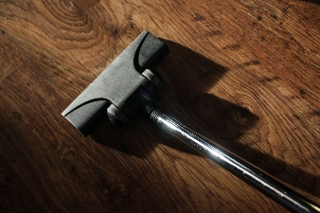
A man vacuums the apartment in half an hour, while his wife takes one hour. Is the man therefore more efficient than his wife?

$$P=\frac{W}{t}$$

where
P = power (W)
W = work (J)
t = time (s)

Example. An elevator rises three floors doing a work of 8800 J. What is the power of the elevator when the ascent takes 5,5 seconds?
Solution:
W = 8800 J
t = 5,5 s

$$P=\frac{W}{t}=\frac{8800 J}{5,5 s}=1600 W$$

Answer. The power of the elevator is 1600 W.

Slide 5: Power exercises

1) A weightlifter lifts 90 kg of weights over a distance of 2,3 meters in 1,8 seconds. What is the power of the weightlifter? Provide the answer in whole watts.
Answer: 1128 W

2) A truck travels at a constant speed of 20 km/h through difficult terrain. The pulling force transmitted by its drive wheels is 5300 N. Calculate the engine power required in this situation. Provide the answer in kilowatts, with one decimal place.
Answer: 29,4 kW
Slide 6: Pressure

Pressure P is the ratio of force F to the area A over which the force is applied, expressed as P=F/A. The unit of pressure is pascal (Pa). Another commonly used unit is bar: 1 bar = 100 000 Pa.

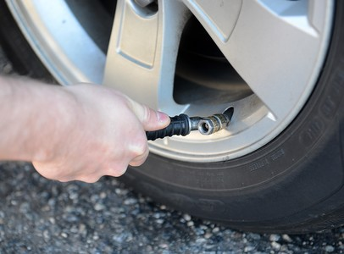

The atmospheric pressure on Earth's surface is caused by the weight of the air above it. The unit of atmospheric pressure is the bar. Atmospheric pressure typically ranges between 0,950 and 1,050 bar. A pressure of 1,013 bar is referred to as the standard atmospheric pressure.

In everyday language, pressure is sometimes used to refer to excess pressure or underpressure, meaning the difference from atmospheric pressure. This difference is called gauge pressure. For example, the pressure of car tires is still regularly indicated and measured as gauge pressure. This means that if the pressure in the tire is 2 bars according to the meter, it is the difference between the tire and atmospheric pressure. The absolute pressure inside the tire is then approximately 3 bars.

Slide 7:
Fill in the blanks by dragging the words to the correct places.
The distribution of weight over an area is called ____________. The units of pressure are
(Pa) and _________. Normal atmospheric pressure is _____________.
The most commonly measured pressure is _____________, which compares pressure to normal atmospheric pressure. Gauge pressure is referred to as positive pressure when it is ______________ than atmospheric pressure, and vacuum pressure when it is ____________ than atmospheric pressure. Car tire pressures are typically gauge pressures and are expressed in ___________.

higher
bars
gauge pressure
lower
Pascal
bar
pressure
1 bar

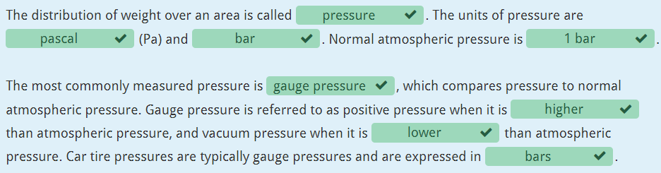

Slide 8: Fill in the blanks by dragging the words to correct places.

Pressure P is force F divided by area A: P=F/A. Pressure __________ when the force is applied to a smaller area. For example, to protect against an impact on your head, one can use a helmet, which distributes the ___________ over a larger area and therefore ____________ the pressure.
Pressure also increases when the volume of a closed gas container is ______________ and decreases when the volume of the container is ___________. However, this only holds true if the temperature remains constant, as an increase in temperature also increases the pressure.

reduces
increases
increased
force
decreased

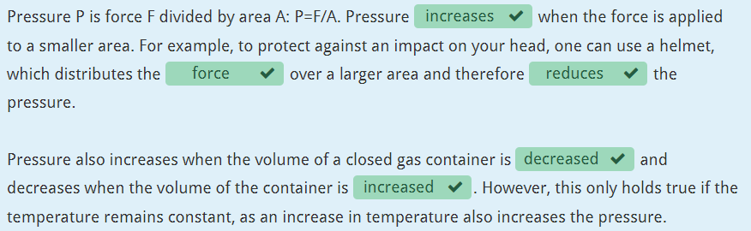

Slide 9: Ergonomics

The goal of ergonomics is to develop physical activity as a whole in a way that is suitable for the individual in terms of repetition and force requirements. A good work outcome should be achieved in a manner that preserves the employee's resources, as well as their work and functional capacity for as long as possible.

Technical aids, such as machines and equipment, can be used to assist in performing work. The physical environment and tools can also be designed to optimize the individual's own power.

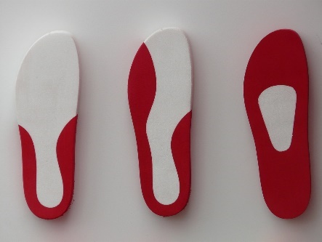

Slide 10:
From an ergonomic perspective, it is important to recognize the difference between static and dynamic muscle work. In static work, the muscle is tense without performing any movement.

In dynamic work, muscle tension is associated with performing movement. In static work, the tension is long-lasting, and the muscle does not have a chance to relax.

Static muscle work occurs whenever a muscle is required to support a load. Negative effects can be reduced by eliminating unnecessary support of limbs and tools.



Task: Mechanics quiz

You can use the following information to help you:

$$v=\frac{Distance s}{Time t}$$

$$a=\frac{Velocity v}{Time t}$$

Example 1. 80 km/h = 80 : 3,6 m/s = 22,2 m/s

Example 2. 16,7 m/s = 16,7 ⋅ 3,6 km/h ≈ 60 km/h

Round your answers to 2 decimal places.

1) An elevator ascends a distance of 29,3 meters in 20 seconds. What is the elevator's average velocity?
Answer: 1,47

2) The average velocity of the tour bus was 70 km/h, and the distance from the hometown to the venue was 371,3 km. How long did the band's outbound journey take? (answer: 5,30)

3) A stone is dropped into the water from the bridge.

a) What is the gravitational acceleration of the stone? (answer: 9,81)

b) What velocity does the stone reach within the first second? (answer: 9,81)

c) At what speed does the stone hit the surface of the water when the fall lasts for 3 seconds? (answer: 29,43)

4) In what time does a car stop from a velocity of 89,1 km/h, if its deceleration during braking is 9,9 m/s² ?

Force F = mass m · acceleration a

Gravity G = mass m · gravitational acceleration g

5) What force gives a 5,8 kg object an acceleration of 8,7 m/s²?

6) The gravity of an elephant is 66,1 kN. What is the mass of the elephant?

7) What is the acceleration of a 1,6 kg cannon ball when it is fired with a force of 38,4 N?

Work W

Work transfers energy from one form to another. Energy represents the ability to do work.
Work is calculated by multiplying force and distance, i.e.

W = F · s

where W = work, F = force ja s = distance. The unit of work is joule (J).

If work is done against gravity, the formula is

W = m · g · h

where m = mass, g = 9.81 m/s² and h = height.

For inclined plane the following formula can be applied:

F · s = m · g · h

8) How much work is done when an object is pulled along the floor for 2,2 m with a force of 7,2 N?

9) How much work is done when an object with a mass of 4891 kg is lifted to a height of 15 m?

Moment of force
Moment of force (symbol M) is a quantity that describes the rotational effect applied to a system. Its unit is newton-meter (Nm).
The moment of force is the magnitude of the force multiplied by the distance between its point of application and the axis of rotation:
M = F · r

where M = moment, F = force ja r = distance.

An object is in equilibrium when the counterclockwise and clockwise moments of force acting on it are equal relative to the pivot point:

counterclockwise moment = clockwise moment
F₁ · r₁ = F₂ · r₂
10) What is the moment when the force acting on the object is 6,9 N and the length of the lever arm is 3,9 m?

11) Two men are sitting on a seesaw. The mass of one of the men is 180,7 kg and he is sitting 1,2 m from the pivot point of the seesaw. How far should the other man with a mass of 62 kg sit in order for the seesaw to be balanced?

Energy
The goal is to
- learn about different forms of energy
- understand the concepts of direct and indirect energy consumption
- learn how to calculate efficiency.
Think! Are new energy sources and forms of energy relevant for your field of study and do they have decisive influence for the development of your field?

Energy
Learn about different forms of energy, renewable and non-renewable energy sources and to calculate efficiency. To pass, 80% of the answers must be answered correctly.

Slide 1: Energy

Background image

Slide 2:
Energy means (is defined as) the ability to do work
Energy
- is a theoretical concept (cannot be experimentally defined)
- can exist in various forms
- can transform from one form to another
- can transfer with objects and matter
- symbol (E) and unit joule (J)
=> Law of conservation of energy: Energy can transform to another form (from one form to another), but it cannot be created or destroyed.
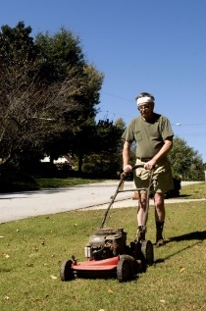

Slide 3: Forms of energy

Electrical energy
- produced e.g. by water, wind, fossil fuels, or nuclear energy
- generators or turbines convert their energy into electrical energy in the power station
- electrical energy can be converted into mechanical energy, light or heat

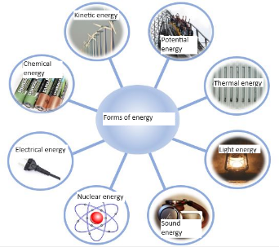

Slide 4:

Kinetic energy
- possessed by any object in motion
- is proportional to the mass and speed of the object
- increases with mass and speed
Potential energy or positional energy
- possessed by stationary objects
- e.g. a pot that has been lifted on the table holds the lifting work "stored" as its potential energy
Thermal energy
- needed in e.g. cooking
- e.g. oven, stove
Energy in the human body
- produced when the nutrients from food react with oxygen
- is spent on e.g. metabolism, doing work and heat production

Slide 5: Energy production and consumption

The higher standard of living a country has, the more energy is consumed. In Finland energy consumption per capita is the highest in the European Union. What could be the reason for this?
As the population grows and the standard of living rises globally, the consumption of energy will increase. Non-renewable energy sources will not be enough for the energy production we need. Therefore, non-renewable energy sources are being replaced with renewable energy sources.
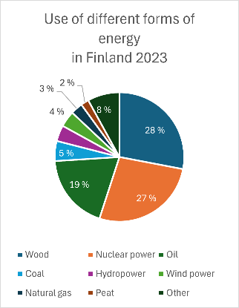

source: https://www.motiva.fi/ratkaisut/energiankaytto_suomessa/energian_kokonaiskulutus

Slide 6:
The construction, maintenance, and decommissioning of renewable energy plants also cause environmental harm, but these impacts are smaller compared to those of traditional non-renewable energy sources. The advantages and disadvantages of different energy sources are are summarized in the following slides.

Energy can be transferred as electricity, heat or transporting fuel. Wires and cables are used to transmit electricity, and underground pipes are used to transfer heat and natural gas. Fuel is transported by tankers, ships and trains. The transported fuel is usually oil, coal, or forest chips. Costs of energy transfer can be reduced by using geothermal heat and solar energy.

Slide 7:
Table. Non-renewable energy sources.
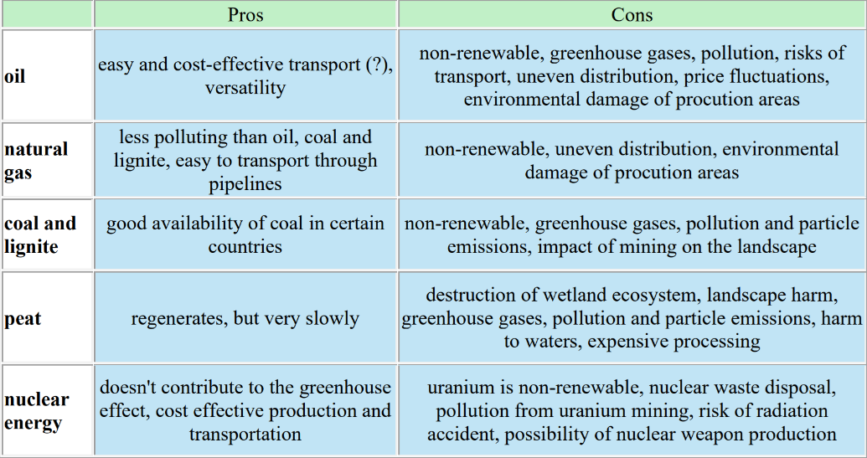

Slide 8:
Table. Renewable energy sources.

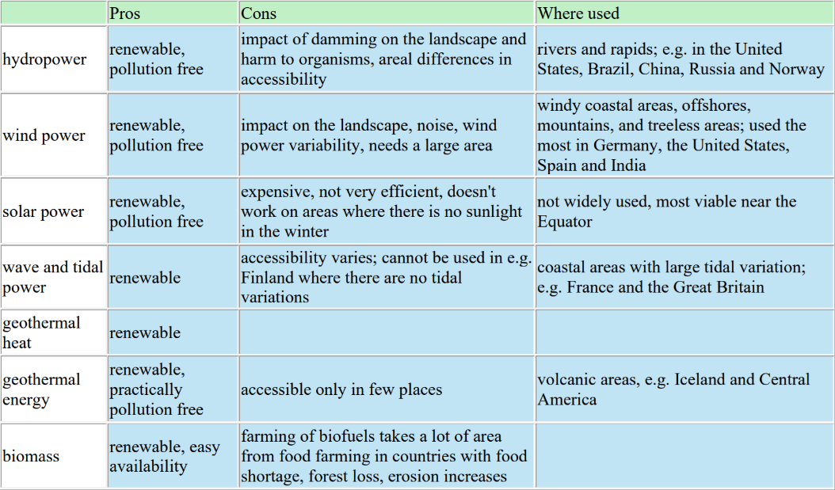

Slide 9:
Which of the following are renewable energy sources?
- geothermal heat
- peat
- oil
- hydropower
- bio energy
- wind energy
- nuclear power
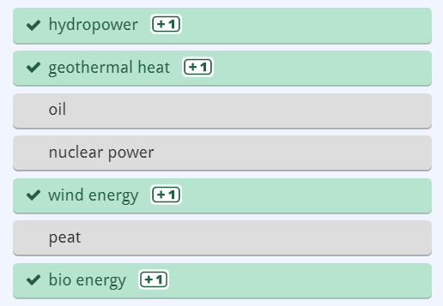

Slide 10: Energy in households

Energy used for heating and various household devices is called direct energy consumption. Of the direct energy consumption, 50% is used for heating, 20% for water heating, and 30% for household energy.

Up to 60 % of energy used in households is consumed indirectly i.e. for the products we buy and the energy used to manufacture them. We can decrease our energy consumption by making better choices: by reducing unnecessary shopping, recycling and favoring/preferring devices that use less energy.

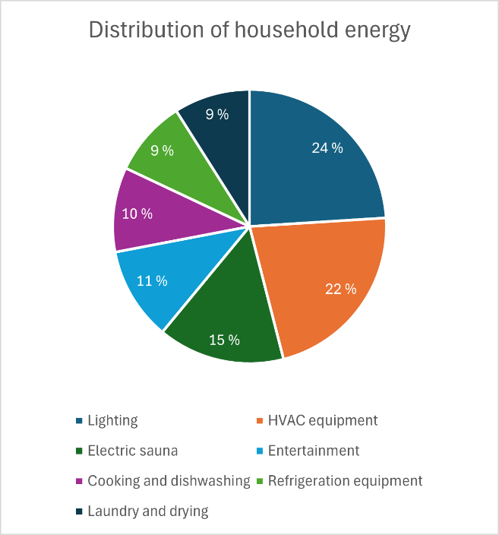

More information about energy can be found here: https://stat.fi/tup/suoluk/suoluk_energia_en.html

Slide 11: (Thermal) efficiency
- means how well energy used by (input of) a device can be utilized for its purpose
- often expressed as percentage
- e.g. out of the power input of a 100 W light bulb only 5 W is used to create light and the remaining 95 W is wasted in terms of lighting
=> efficiency of the light bulb is 5 W / 100 W = 0,05 = 5 %.
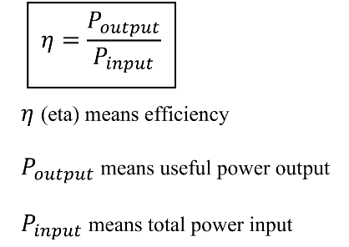

Slide 12:
Calculate.
1) Calculate the efficiency of a 7 W light bulb that has lighting power of 3 W. Give answer as whole number.
Answer. Efficiency is ________ %. (answer: 43)

2) A computer needs 350 W power to operate and the efficiency of the power supply at full load is 80 %. What is the power input needed from grid? Give the answer to the nearest 10 watts.
Answer. Needed input is ________ W. (answer: 440)

Energy crossword

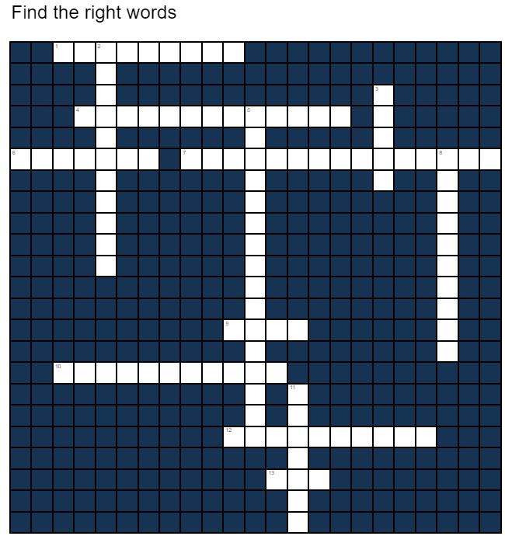

Across
1) A device that converts kinetic energy into electricity
4) Non-renewable source of energy that does not produce carbon dioxide emissions.
6) Organic mass that can be used for energy production
7) Direct use of geothermal energy for heating
9) Type of soil that is used as fuel
10) The conversion of energy from sunlight into electricity
12) Power generation via movement of water
13) A non-renewable energy source that forms when plants are compressed under high pressure and heat deep within the Earth's crust.

Down
2) A gas consisting primarily of methane, notable fossil fuel
3) The unit of energy
5) Form of energy stored in a stationary object. Also called positional energy
8) A quantity that states how well the energy input of a system can be utilized
11) A rotary mechanical device that turns energy of a flowing substance into rotational energy

Solution:
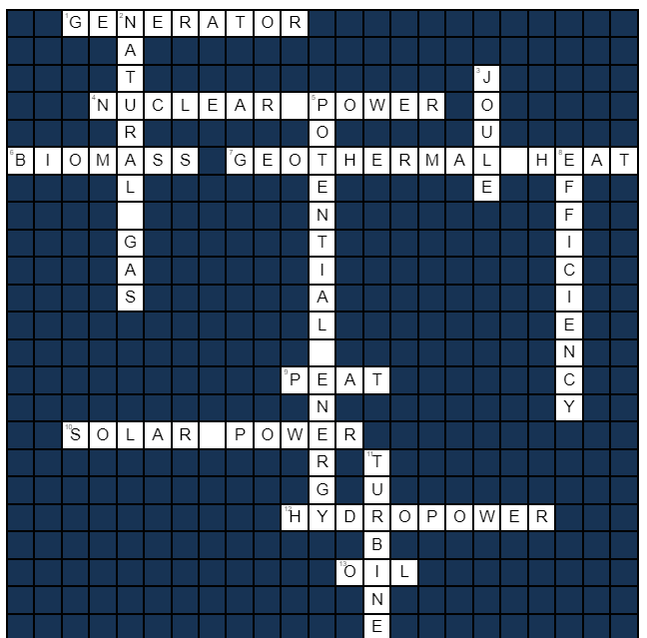

Quiz
Questions:
1) Power input of a machine is 1339 W and its power output is 122 W. What is the efficiency of the machine?
Answer: 0,09

2) Electric engine takes 7,1 kW power from the grid. The engine spins a pump with 5,2 kW power. Calculate efficiency.
Answer: 0,73

3) Power of a Suzuki PV moped is 1,9 kW (after changing the carburetor and the piston). As the fuel burns in the engine, energy is produced with 4,1 kW power. Calculate the efficiency of the moped.
Answer: 0,46

4) How great is the lifting power of an electric forklift, if the power of the electric engine of the forklift is 9,1 kW? Efficiency is 0,68. Include the unit in your answer.
Answer: 6,19 kW

5) In the engine of the East German family car Trabant (engine capacity 600 cubic centimeters), fuel produces energy at 64,6 kW power. How many horsepowers is the useful power output of the engine, if the efficiency is 0.3? (1 horsepower = 0.7355 kW)
Answer: 26,35 horsepowers

Thermodynamics

The goal is to learn
  - physical concepts related to thermodynamics
  - to recognize different methods of heat transfer

Think! How and where is your field of study related to thermodynamics and heat transfer?

Theory: Thermodynamics
Familiarize yourself with the basics of thermodynamics using this task. To pass, you need to answer 80% of the tasks correctly.

Slide 1: Thermodynamics

Background image

Slide 2:
We constantly deal with thermal phenomena. We heat our homes, we cook food, we boil, freeze, melt and evaporate water. In the mornings, we read the outdoor temperature from the thermometer and check if the weather is hot or cold, rainy or clear, and dress accordingly.

Temperature and air pressure are important factors affecting our living environment. The temperature of the ground, bodies of water, and the air have a significant impact on weather phenomena. For example, winds are air currents caused by differences in air pressure between different areas.
Temperature and pressure also affect the state and volume of matter. The electrical properties of substances depend on temperature. Temperature and pressure are crucial for the occurrence and progress of chemical reactions.

Slide 3: Heat is energy

The vibration of atoms and molecules causes thermal motion. The higher the temperature, the more the components of the substance move. The state of matter depends on temperature.
The Sun radiates thermal energy. Solar energy is utilized as electrical or thermal energy through a solar cell or solar collector. Radiant energy is stored in plants as chemical energy. It transforms into thermal energy during combustion.


Slide 4: Phase transitions

Drag the phase transitions to the correct place in the diagram.
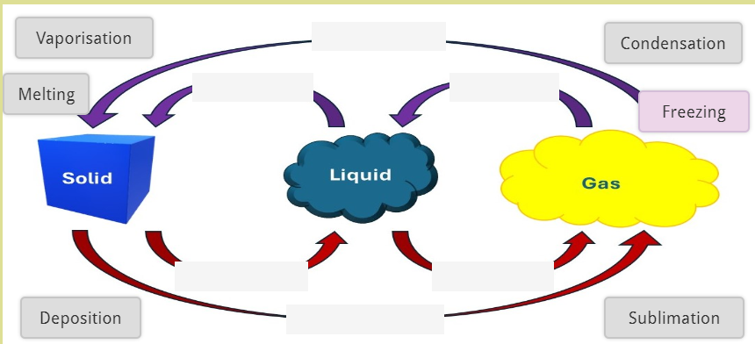

Solution
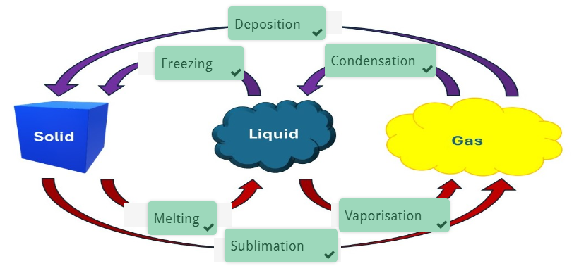

Slide 5:
The 0th law of thermodynamics: In an isolated system, temperature differences tend to equalize.
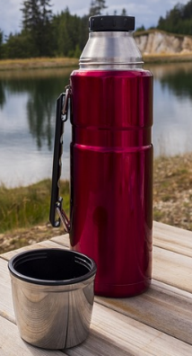
A thermos flask is an example of an isolated system.

The 1st law of thermodynamics: The energy of a system can change from one form to another, but its total amount remains constant.
When striking a match, mechanical energy is converted into thermal energy, which causes the match to ignite. Falling onto a carpet or a varnished floor can cause burns to the skin for the same reason. On the other hand, heat can also be converted into mechanical energy, as is done in internal combustion engines. Heat and mechanical energy are both forms of energy, so their quantities can be expressed in the same units, such as calories or joules. They can be added together or subtracted from each other. This concept is included in the first law of thermodynamics.

Slide 6:
The 2nd law of thermodynamics: Natural processes proceed towards greater disorder, i.e., the system tends to move in the direction where entropy increases.
All spontaneous phenomena have a direction towards greater disorder (entropy or randomness); therefore, heat always transfers from the warmer to the cooler body. At a lower temperature, the components of the air are more ordered than at a higher temperature because, at higher temperatures, the thermal motion of the components is greater. Understanding thermal phenomena involves knowing the direction of heat transfer.
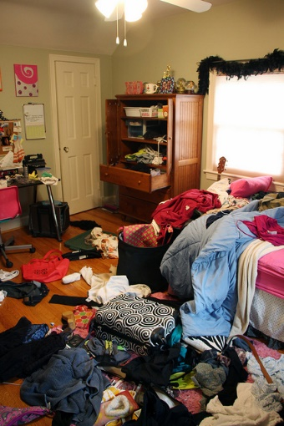
A common analogy for entropy is the increasing disorder of a room if no effort is made to keep it tidy.

Slide 7:
A cooling substance transfers thermal energy to its surroundings, such as food that is placed in a refrigerator. This energy then needs to be further transferred to the room at a higher temperature, which requires external energy (electricity).
The heat that moves into the room, in turn, naturally moves outside the room as long as the temperature outside is lower than the room temperature. This is important to know when planning the placement of cooling devices within a space.
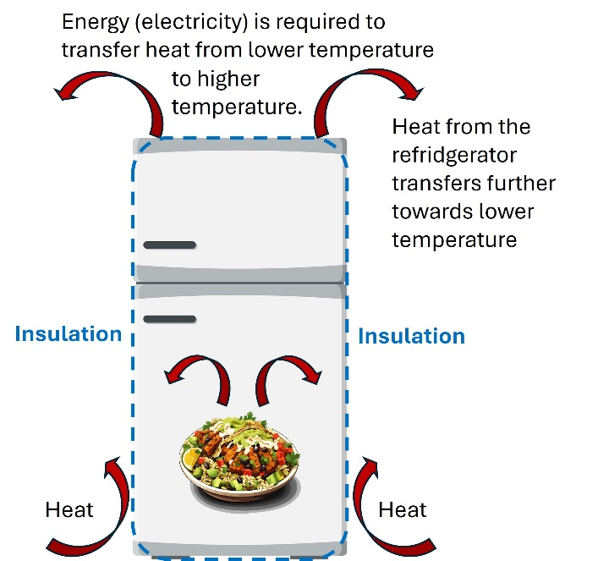

A refrigerator thus raises the outside temperature while lowering its internal temperature. Ignorance comes at a cost: in the placement of the refrigerator, it must be understood that the heat around it must be carried away by the airflow; otherwise, the refrigerator will unnecessarily consume electricity.

Slide 8:
The transfer of thermal energy from a higher temperature to a lower temperature is utilized in heat engines.
A heat engine converts thermal energy transferring from a higher temperature to a lower temperature into work. The greater the difference between the engine's hot and cold reservoirs, the more efficiently the engine can perform work. Examples of heat engines include steam engines, pressure cookers, internal combustion engines, and coffee makers.
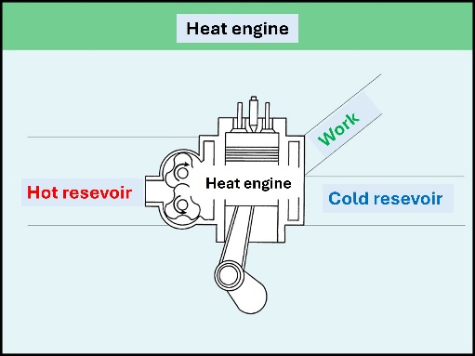

Slide 9: Measuring temperature

Celsius scale:
• symbol of temperature: t
• unit: 1 °C
• based on the melting and boiling point of water, i.e. 0 °C and 100 °C

Kelvin scale:
• symbol of temperature: T
• unit: 1 K
• based on absolute zero, 0 K (equal to -273 °C), which is the lowest limit of the thermodynamic temperature scale.
The change of one degree in Kelvin is equal to the change of one degree in Celsius.

Slide 10:
Converting between Kelvin and Celsius
Celsius degrees are often used in our daily life, whereas Kelvin degrees are used in solving physical problems and in scientific work as the SI unit of temperature is Kelvin.
When converting from Kelvin to Celsius you need to subtract 273. For example:
0 K = (0 - 273) °C = -273 °C
285 K = (285 - 273) °C = 12 °C
When converting from Celsius to Kelvin you need to add 273. For example:
0 °C = (0 + 273) K = 273 K
-5 °C = (-5 + 273) K = 268 K

Slide 11: Exercises

Convert between Celsius and Kelvin
a) 50 °C = _______ K (answer: 323)
b) 423 K = _______ °C (answer: 150)
c) 193 °C = _______ K (answer: 466)
d) 193 K = ______ °C (answer: -80)

Calculate
1) You mix one liter of water of 60 °C and one liter of water of 40 °C. The final temperature is ________ °C. (answer: 50)
2) You mix four deciliters of boiling water and one deciliter of water of 20 °C. The final temperature is ________ °C. (answer: 84)

Slide 12: Heat transfer

Heat is transferred by conduction, convection, and radiation.
Conduction mainly occurs in solids, for example, a silver spoon in hot coffee or a pan on a stove. Heat transfers, but the medium does not.

In liquids and gases, heat is transferred by convection with the medium. An example of this is the Gulf Stream or hair dryer.
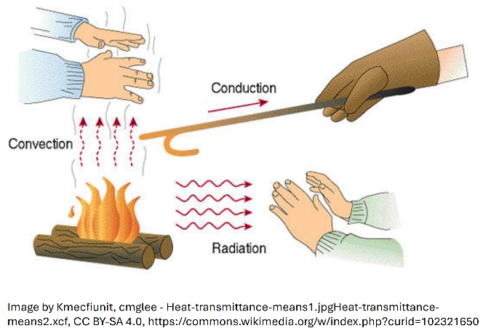

Radiation does not require a medium. For example, the sun radiates its heat energy to the Earth.
Solids, especially metals, conduct heat well, while gases conduct heat poorly. This property is utilized in thermal insulation. A vacuum does not conduct heat. More about heat transfer: video

Slide 13:
Choose the correct alternative (the correct answer is marked with green)

1) This heat transfer method does not require a medium.
- radiation
- conduction
- convection
2) Heat is transferred by the movement of a fluid (liquid or gas).
- radiation
- conduction
- convection
3) In this heat transfer method the medium does not move.
- radiation
- conduction
- convection

Slide 14: Thermal expansion
The operation of liquid thermometers and thermostats is based on thermal expansion, which is caused by increased thermal motion. Structural components need more space as vibrations of atoms and molecules increase.

A solid expands uniformly in all directions. Since thermal expansion changes the length of a long object, expansion is accommodated in structures with expansion gaps and expansion joints.

The magnitude of thermal expansion is influenced by:
- Temperature change
- Material; each material has a characteristic coefficient of linear expansion, which indicates the change in length
- The original length/volume of the material

Slide 15: Heat

Fill in the blanks by dragging the correct word

Heat is the movement of ___________. Heat can also be called ___________. Temperature can be measured using ____________ but physicists use ______________. The Celsius scale is based on the ______________ (0 Celsius degrees) and the _____________ (100 Celsius degrees). The Kelvin scale is based on absolute zero or ______________. Thermal expansion of an object depends on _________________ of the material(s), ______________ of the object and the change in ________________.

structural components
boiling point of water
thermal coefficient
temperature
thermal energy
original size
melting point of water
Kelvin scale
Celsius scale
0 K

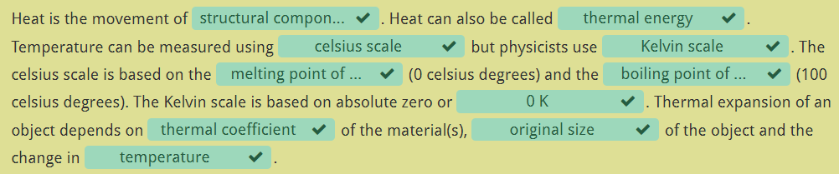

Task: Thermodynamics crossword
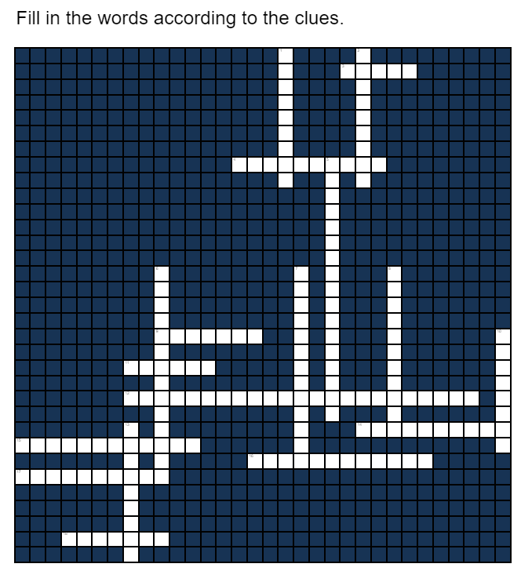

Across
3) The phase in which the structural particles of matter are closest to each other or form a crystal structure
4) The windscreen of your car is covered in frost after a cold night. What is the phenomenon causing this?
9) Solid turning into liquid
11) The SI unit of temperature
12) A numerical value that describes how the length of a material changes with temperature
14) The process by which heat energy is transferred through a material without the material itself moving
15) It's a hot day and you have a cold beverage in your hand. You notice water droplets appearing on the glass. What is happening?
16) Liquid turning into gas
17) The process of heat transfer through the movement of fluids (liquids or gases)
18) This expresses the disorder or randomness in a system

Down
1) A material that resists the flow of heat or electricity
2) A material that allows the flow of heat or electric charge
5) The function of thermometers is based on this phenomenon.
6) The movement of particles in a substance due to thermal energy
7) The lowest possible temperature, 0 Kelvin or -273,15°C, where molecular motion theoretically stops
8) Solid turning into gas
10) Liquid turning into solid
13) Heat is transferred from the sun to the earth through this phenomenon

Solution
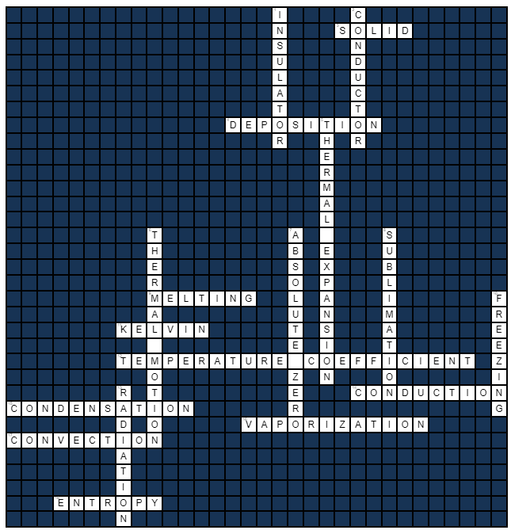

Task: Heat transfer from the perspective of your field

Create a one-page presentation (poster, flyer, etc.) on methods of heat transfer (e.g., using PowerPoint or an image editing program).

The presentation should include the theory of heat transfer methods and concrete examples from your field. If you can’t think of examples from your field, come up with examples from your daily life. Use images and text.

Submit the presentation in PDF format.

Electricity
The goal is to learn
- physical concepts related to electricity
- to recognize electrical safety issues related to your own field of work
Think! What kind of electrical safety issues do you need to know in your own field of work?

Theory: Electricity
Familiarize yourself with the basics of electricity using this task. To pass, you need to answer 80% of the tasks correctly. The result of the task will be recorded when you open the final summary page.

Slide 1: Electricity
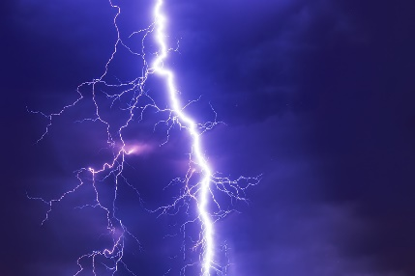
Background image

Slide 2: Electrical force arises between charged bodies

An electron has a negative charge, a proton has a positive charge and a neutron is electrically neutral. Charging a neutral body is occurs due to the transfer of electrons. A body receiving electrons gets a negative charge and a body giving electrons away gets a positive charge.

Electrical charges cannot be created or destroyed, but they can transfer between bodies. When combing clean hair, it gets electric because electrons are transferred from the hair to the comb, making the hair positively charged. Individual hairs repel each other because they have same type of charge.
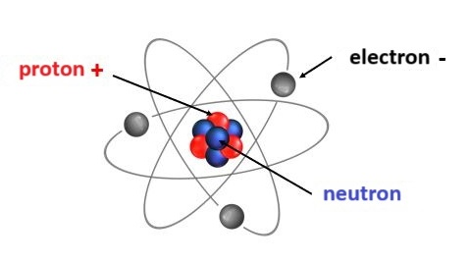
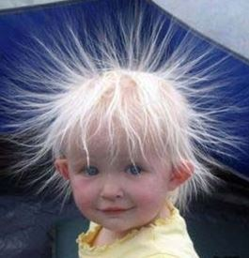

Slide 3:
The accumulation of electric charge is called static or friction electricity. It is generated everywhere when we move and work. For example, running in wool socks at the gym generates static electricity, as does rubbing hair against a beanie or shirt. When we touch an electrically conductive object while electrically charged, the charge is discharged from our body into the object, causing an "electric shock".
A spark generated by static electricity may cause a hazardous situation when dealing with flammable substances. The vaporized petrol in the car's tank can catch fire as a result of a spark. Similarly, in a bakery, a mixture of flour dust and air can flare up from a small spark.
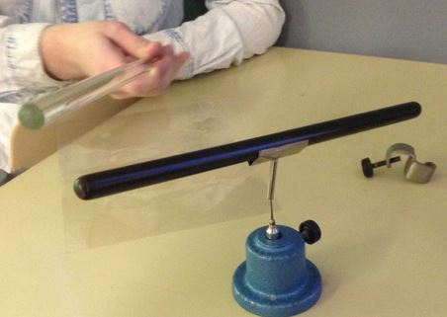
After rubbing an ebonite rod with a piece of fur and a glass rod with plastic film, they attract each other. So, they have opposite electric charges.

Slide 4: Voltage, current and resistance

Voltage is the difference between electrical states of two points. This difference causes an energy flow between these points which can be observed as electrical current. The current is proportional to the voltage.
Current is flow of electrical charges. Charge can be carried by electrons, ions, etc. The more charges flow through a surface over time the higher the current.
Resistance tells how much a given body resists the flow of current. Resistance is thus inversely proportional to the current.
Quantity | Symbol | Unit | Symbol
Voltage | U | Volt | V
Current | I | Ampere | A
Resistance | R | Ohm | Ω


Ohm's law describes the relationship between Voltage, current and resistance.

Slide 5: Current circuit

1) There is a voltage between the terminals of a battery.
2) When the terminals are connected, current starts to flow
3) Chemical reactions maintain the voltage and the current stays constant. This kind of constant current is called direct current (dc).
4) The battery along with wires and electrical devices connecting the battery terminals form a current circuit.
5) The current transfers chemical energy from the battery to the devices.

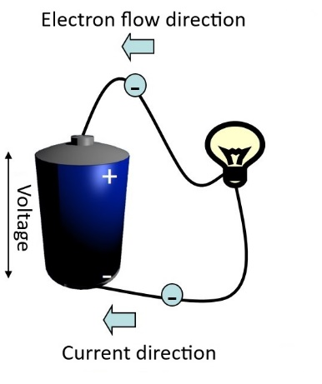
Current circuit formed by battery, wires and a light bulb. The direction of current is defined as same as the direction of positive charge flow. Electrons are negative and their direction is opposite.

Slide 6:

Voltage is also found between terminals of an electrical socket. This voltage alternates periodically with time and is called alternating voltage. When current circuit connects the terminals and current starts to flow, it also alternates and is called alternating current (ac).

Root mean square (RMS) value of the voltage is used as effective value when measuring alternating voltages. In common household socket, this RMS voltage is 230V and its frequency is 50Hz, thus the voltage alternates a full period 50 times per second.

Current circuits consist of conductors, materials with low resistivity through which current flows easily. Insulators, materials with high resistivity are used around conductors to prevent current flow out of the circuit. All metals are good conductors and e.g. plastic is a commonly used insulator. Practically, however, almost all materials except metals are insulators.

Slide 7: Batteries in series and parallel

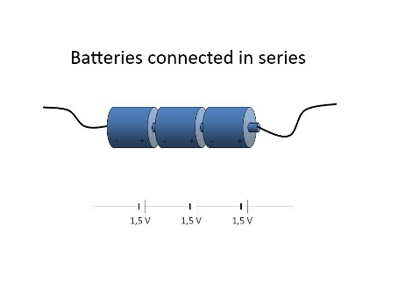
Batteries are connected in series when their different signed terminals are connected (positive to negative). This way the voltages are added together. Output voltage of the connection in the picture is 4,5V.
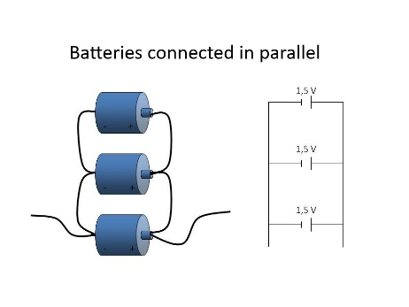
Batteries are connected in parallel when their same sign terminals are connected. This way the batteries last longer. Output voltage of the connection in the picture is 1,5V.

Slide 8: Electrical power

Power is calculated as the product of voltage and current. The symbol for power is P and its unit is watt (W).
Power indicates the performance of the device. The higher the power a device has, the higher its performance.

E.g. a sewing machine can have a power rating of 40W to 1000W and clothes iron 1000W to1200W.
Household electrical sockets are usually protected with a 10A fuse. The maximum power they can provide is 2300W as P = 230 V ∙ 10 A = 2300W.

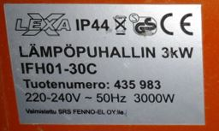
Specification plate of an electrical heater.
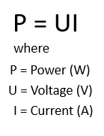
Slide 9:
Example:
An electric kettle has values 2000 W / 230 V in the specification plate. Can you use an additional 1000 W hair dryer in the same socket, when the socket is protected by a 10 A fuse?
Solution:
No, you can't. The sum of the powers is 2000 W + 1000 W = 3000 W which is more than the 2300 W available from the socket. The result is a burned fuse.

Slide 10:
Choose the correct alternative (the correct answer is marked with green)
- The symbol of voltage is
  - U
  - I
  - P
- The symbol of power is
  - P
  - U
  - I
- The symbol of current is
  - I
  - P
  - U
- The unit of voltage is
  - volt V
  - ampere A
  - watt W
- The unit of current is
  - ampere A
  - watt W
  - volt V
- The unit of power is
  - watt W
  - volt V
  - ampere A
- Batteries are connected in series when their
  - different signed terminals are connected.
  - same signed terminals are connected.
- Pick the correct formula.
  - P = UI
  - U = PI
  - I = PU

Slide 11: Calculate
1. Household sockets are protected with 10 A fuses. How high power can be obtained when the mains voltage is 230 V? __________W (Answer: 2300 W)

2. An electric kettle is connected to a 230 V mains voltage and uses 3,5 A current. What is the power consumption of the kettle?_________W (Answer: 805 W)

3. An outdoor socket gives 230 V voltage and is protected with a 16 A fuse. The power limit is then ________W. (Answer: 3680 W) The motor heater of a car takes usually 500 W power and inside heater 1400 W. Two cars then need a total of _______W power. (Answer: 3800 W) Can you simultaneously heat two cars using this socket (yes/no)? (Answer: no)
4. The power consumption of a hair dryer is 1500 W. How high current flows through the dryer when it's connected to a 230 V mains? Give the answer using one decimal. ________A (Answer: 6,5 A)

Slide 12: 3-phase and single phase power

An ordinary socket gives out single-phase 230 V voltage. When high power is required, for example, an industrial sewing machine can be connected to a three phase socket, in which case the available voltage is 400 V. In this case, the electrical panel has three fuses for the same device. In a common household, stoves and water heaters are connected to three-phases.
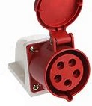
3 phase socket
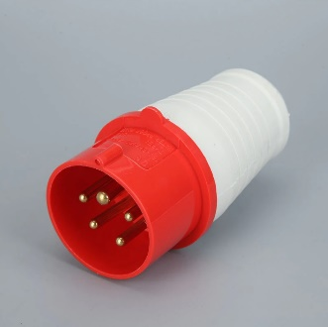
3 phase plug

Slide 13: Self-made electrical work

The do it yourself electrical work (link to: tukes.fi/en/do-it-yourself-electrical-work) page on the Finnish Safety and Chemicals Agency (Tukes) website contains information on electrical work you can do without electrical qualification.
It is important to know what electrical work you can do yourself and what jobs require an electrical professional. Tukes reminds of the dangers of repairing electrical equipment independently. "Interest in the reuse and self-refurbishment of old electrical appliances, especially lighting fixtures, has grown dangerously. There are plenty of instructions for enthusiastic craftsmen in magazines, website forums and various hobby circles. However, when distributing instructions, do not usually remember to state that luminaires made at home are subject to the same safety regulations and requirements as industrially manufactured electrical products."
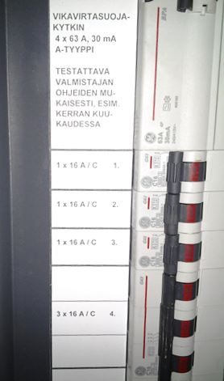
Fuse box

Slide 14:
Drag the words into correct places.

Terminals of the same sign are connected. _________
Single phase power_________
Current doesn't easily flow through this material. ________
3 phase power. ________
Series connection of batteries gives ________
Can be created while combing hair. ________
Parallel connection of batteries gives ________
Quantity that measures how easily current flows through a circuit part. ________
Safety equipment in a current circuit. ________

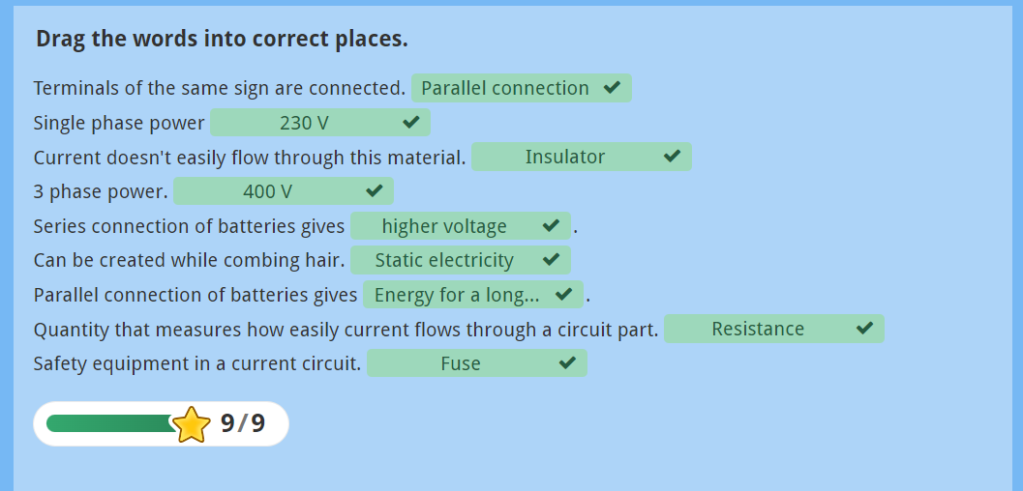

Task: Electricity crossword
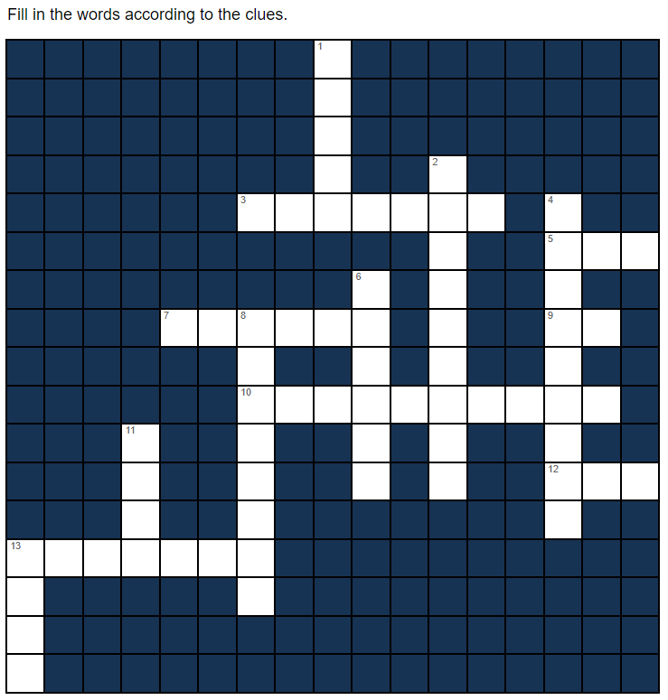

Across
3) The flow of electrical charge
5) The unit of resistance
7) The unit of current
9) A current that keeps its direction
10) The quantity that tells how much a circuit part resists the flow of current
12) The number of phases in a household socket
13) The potential difference between two points

Down
1) The product of voltage and current
2) Current flows poorly through
4) Current flows easily through
6) The connection for batteries that gives higher output voltage
8) The connection for batteries that gives longer lifetime
11) The unit of power
13) The unit of voltage

Solution
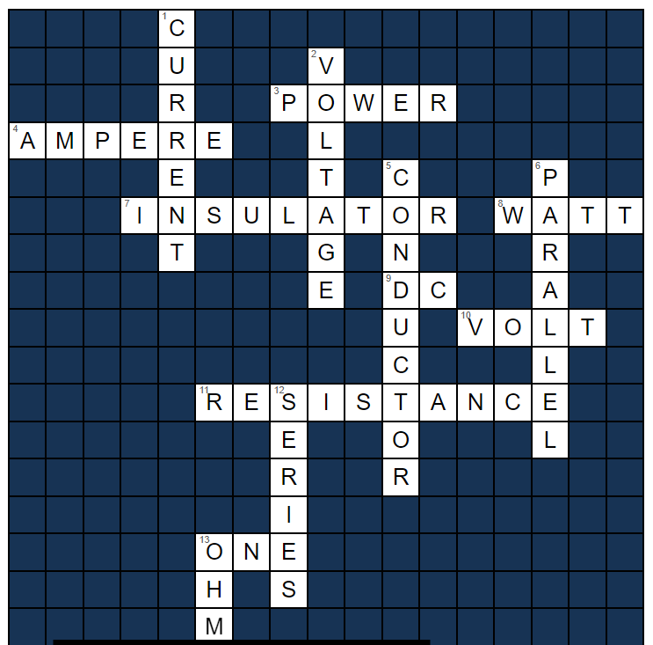

Demonstrating knowledge

Knowledge of physics and chemistry in your field

You have explored the most common phenomena in physics and chemistry during the course. Reflect on what you have learned in relation to your field and demonstrate your knowledge through a poster, video, Padlet, or PowerPoint presentation. Be sure to use images as well.

Your poster, video, or presentation should address the following points:
- Which is more significant in your field, physics or chemistry?
- Which topics from the course are most relevant to your field?
- What are the key quantities and units used in your field?
- What are the key measuring instruments or measurement setups commonly used in your field?
- What specific knowledge and skills in physics and/or chemistry will you need in your future profession?
- What types of chemicals are used in your field? (Especially if chemistry plays a key role in your field.)
- What physics and chemistry phenomena do you need to understand in your field?

Do not write answers to these questions directly. Instead, demonstrate your competence through images and explanatory text.
Submit your poster as a PDF to Moodle or your video in mp4 format. For Padlet, submit a link in the text box. The PowerPoint presentation can be submitted in any format.

In the text box, also explain:
- Which key topics in physics and chemistry related to your field are easy for you
- What areas you need to improve
- How you plan to develop your skills further

Physics exam

1. Do you recognize physical phenomena? Combine the correct phenomena.

An apple falls down from a tree.

You go up the stairs.

You buckle up your seat belt in the car.

The inner surface of a thermos flask is shiny.

Opening a bolt with a wrench.

Walking in high heels causes a dent in the wooden floor.

A kicksled does not slide on a sanded road

A feather and a stone fall at the same rate in a vacuum.

The difference in electrical state.

Water should not be used to clean an electrical device.

static electricity
voltage
gravity
convection
friction
sublimation
phase transition
radiation
power surge
radiation
moment of force
gravitational acceleration
conduction
the law of inertia
lifting work
electrical conductivity
pressure

2. Combine the derived quantity and the unit

Force
Pressure
Energy, work
Power
Voltage

Pa
N
W
V
J

3. Combine the quantity and the unit

Length
Mass
Time
Current
Temperature
second
kilogram
metre
Kelvin
ampere

4. The athlete’s speed is 2 m/s. How many kilometers does he travel in 3,2 hours?

Solution:
2 m/s converted into km/h: 2⋅3,6 km/h = 7,2 km/h
v = s/t à s = v⋅t = 7,2 km/h ⋅ 3,2 h = 23,04 km

5. What is the distance from the pivot point in order for the seesaw to be balanced if F = 3,5 N ? Round the answer to 2 decimal places.
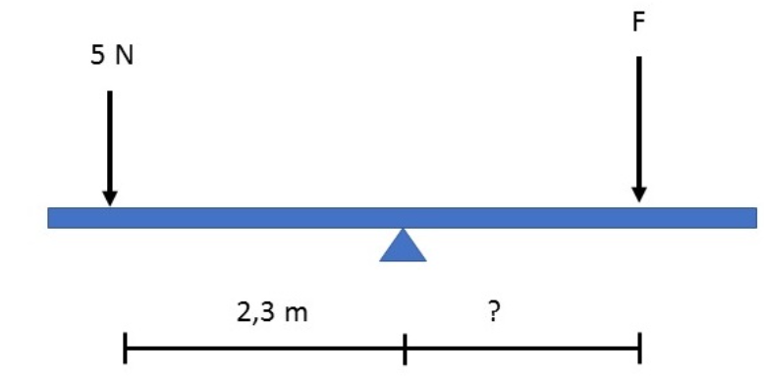

Solution:
Let’s first mark moments on both sides of the pivot point equal:
$$F_{1}∙r_{1}=F_{2}∙r_{2}$$
Next solve the equation for r₂ by dividing both sides by F₂:
$$r_{2}=\frac{F_{1}∙r_{1}}{F_{2}}=\frac{5 N∙2,3 m}{3,5 N}=3,285…m≈3,29 m$$

6. An object was pushed up a slide for 2,5 meters. The height of the ascent was 1,6 meters. The mass of the object was 1,7 kg. What was the pushing force? (Friction is not considered)

Solution:
The work done is
W = m ⋅ g ⋅ h = 1,6 kg ⋅ 9,81 m/s² ⋅ 1,6 m = 26,6832 J

The work depends on the force and the distance: W = F ⋅ s, and we can solve for F:
F = W/s = 26,6832 J / 2,5 m = 10,67328 N ≈ 10,67 N

7. Which of the following statements are true? Select one or more.

a. O K is equal to -273 ºC.
b. In the sauna, you are comfortable sitting on the wooden seat but not touching any metallic objects because the metallic objects are much hotter.
c. When ice melts, energy is released.
d. All energy is created in the sun.
e. Energy is needed to transfer heat from cooler to hotter temperature.
f. Nuclear power, peat and wind power are renewable sources of energy.
g. Energy is the ability to do work.
h. Heat is a form of energy.
i. Energy from the sun is stored by plants and converted to other forms of energy for example by burning wood or eating potatoes.
j. The efficiency of a machine is 55 %. This means that almost half of the energy used by the machine is wasted.

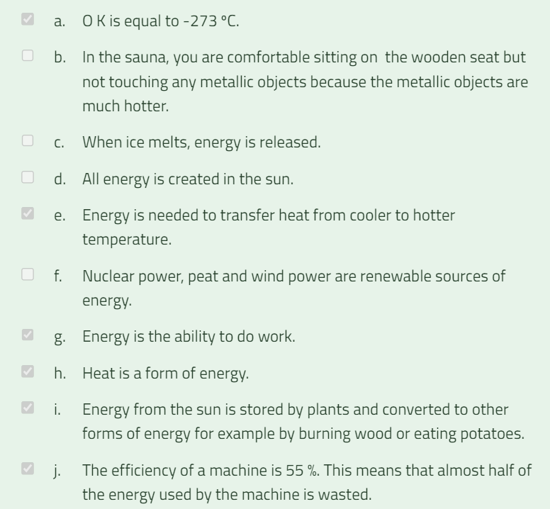

8. A simple circuit consists of a battery, a 10-ohm resistor, and an ammeter that shows 0,15 A. What is the voltage of the battery?

Solution: To find the voltage of the battery, we use Ohm’s Law, which states:
U = R ⋅ I = 10 Ω ⋅ 0,15 A = 1,5 V

Lähdeluettelo

Materiaali pohjautuu Avointen oppimateriaalien kirjastossa olevaan suomenkieliseen vastaavaan Moodle-pohjaiseen materiaaliin: Fysikaaliset ja kemialliset ilmiöt ja niiden soveltaminen (pakollinen) 2osp - Avointen oppimateriaalien kirjasto (aoe.fi)
Alkuperäisen materiaalin tekijät: Jaana Parkkila, Ulla-Maija Norman, Krista Lehto, Mira Pirttikoski, Timo Suorsa (OSAO)

Tämä materiaali on tuotettu VIERKO-hankkeessa
vuonna 2024.
VIERKO on toteutettu Opetus- ja kulttuuriministeriön
vuonna 2023 myöntämällä ammatillisen koulutuksen strategiarahoituksella. VIERKO on kuudenkymmenen-
kahden (62) koulutuksen järjestäjän yhteisponnistus.
Työtä on koordinoinut Keski-Uudenmaan koulutus-
kuntayhtymä Keuda.

Hankkeessa on kehitetty vieraskielisen koulutuksen laatua
ja kotimaisten kielten opetuksen tarjontaa ammatillisessa koulutuksessa.

Lisätietoa:
https://www.keuda.fi/keuda/hankkeet/vierko/

https://creativecommons.org/licenses/by/4.0/


Oppimateriaalit:

CC BY-SA 4.0 Deed | Nimeä-JaaSamoin 4.0 Kansainvälinen | Creative Commons
https://creativecommons.org/licenses/by/4.0/

Oppimateriaalit:



CC BY-SA 4.0 Deed | Nimeä-JaaSamoin 4.0 Kansainvälinen | Creative Commons

