Video Message from Johan: Introduction to the PESTE Framework
Johan:
Hello everyone! I'm Johan, your guide through this exciting journey of strategic foresight.
Before we dive into our “Foresight for Export Growth” workshop, let's ensure we're all on the same page about the factors that shape our industry's future.
I am glad you are watching this orientation video. Please remember to complete the preliminary task at the end.
[Transition to Slide Presentation: Title - Understanding PESTE Framework]
Johan:
In this video, we'll explore the PESTE framework, a powerful tool for analyzing external factors impacting the export industry.
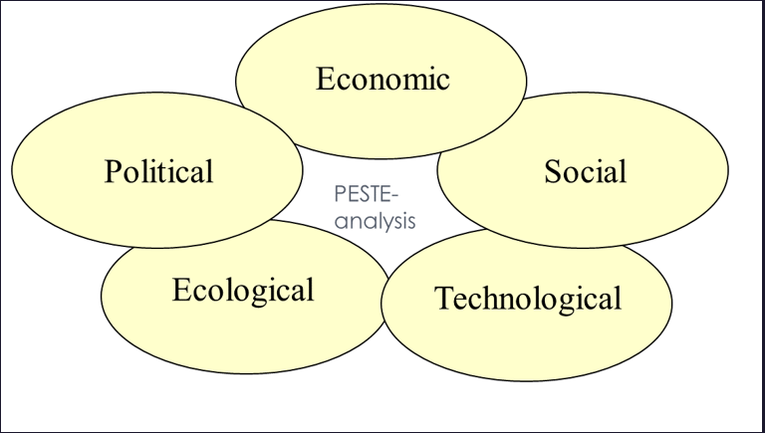
Director Timo Vuori from the Confederation of Finnish Industries (EK) recently shared data that perfectly aligns with this framework.
[Slide 1: Overview of PESTE Framework]
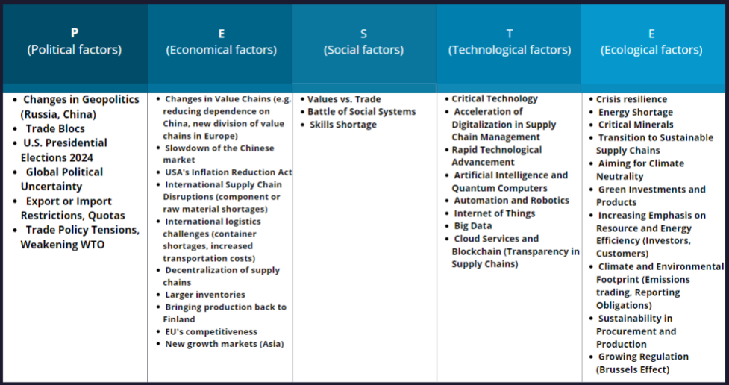
Johan:
PESTE stands for Political, Economic, Social, Technological, and Environmental factors. These elements help us understand the broader context in which our businesses operate.
[Slide 2: Political Factors]
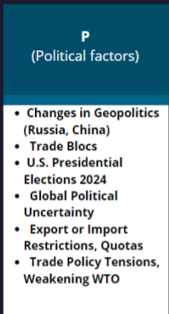
Johan:
Let's start with political factors. These include geopolitical changes, trade policies, and government regulations. For instance, upcoming elections or international trade agreements greatly influence export strategies.
Example: A new trade agreement between the EU and a non-EU country could open new markets or impose new tariffs affecting export pricing.
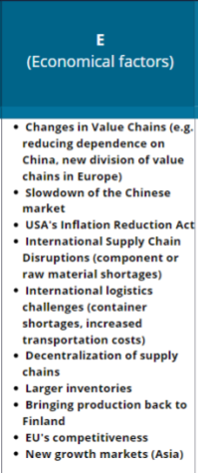
Johan:
Next, economic factors such as inflation rates, currency fluctuations, and global economic growth impact market dynamics and profitability.
Example: Fluctuations in the exchange rate can affect the cost competitiveness of your exports in different markets.
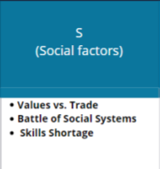
Johan:
Moving on to social factors, which encompass demographic shifts, cultural trends, and consumer behavior. Understanding societal changes helps you tailor your products and services to meet evolving customer needs.
Example: An aging population in certain countries may increase demand for healthcare products and services.
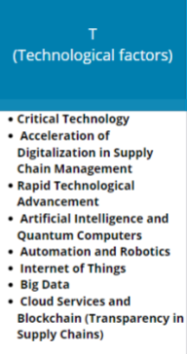
Johan:
Technological factors are crucial in today's digital age. Advancements in AI, IoT, and blockchain revolutionize supply chains and operational efficiencies, presenting new opportunities and challenges.
Example: The adoption of blockchain technology can enhance transparency and traceability in your supply chain, appealing to customers concerned about ethical sourcing.
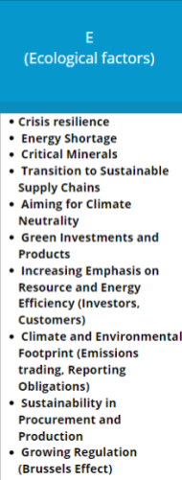
Johan:
Lastly, environmental factors, including climate change and sustainability efforts, increasingly shape business practices and corporate responsibility strategies.
Example: Increasing regulations on carbon emissions might require businesses to invest in cleaner technologies or adopt more sustainable practices.
[Closing Scene: Johan back on camera]
Johan:
Thank you for watching! For self-reflection: Which external factors affect your business most?
Your insights will be valuable as we prepare for our workshop. Let's put these insights into action!
Now, let's test your knowledge with a hands-on activity.
Below this video, you'll find Timo Vuori's presentation, and a drag-and-drop task based on it. Sort the factors into the correct PESTE categories. This exercise will prepare you for our upcoming scenario-building workshop, where we'll explore how these factors influence future skill needs in the export sector.
Get ready to dive deeper into strategic foresight!

This course content is offered under a CC attribution share alike license.

