Webinar part 1

Hello everyone, and welcome to our webinar on Export Circular Transformation!
I'm Riitta, your guide for today's session, and I'm thrilled to have you join me as we explore the exciting world of circular economy transformation for the export industry.
Now, let's get started and make the most out of today's session.
Today we'll explore how to identify your business opportunities, what capabilities circular economy transformation requires, and what steps could be part of your transformation journey.
Before we begin, I'd like to let you know that today's presentation draws heavily from SITRA's handbook titled “Sustainable growth with circular economy business models: A playbook for businesses.”. This comprehensive resource is packed with valuable insights, practical tools and case studies.
I encourage each of you to explore this playbook carefully after today's training.
The playbook guides you in constructing a business model canvas as you progress through the book. The business model is surely a familiar concept to all of you. Simply put, a business model is a view of how a company operates and a way to describe how it fulfills the value proposition it offers to customers. It's essential to ensure that costs do not exceed revenue in the long term.
I also want to introduce you to a tool that is based on the traditional business model and has been developed based on the Circular Economy Business Model by Christiaan Kraaijenhagen, Cecile van Oppen, and Nancy Bokken. In this tool, the value proposition is divided into three sections, where the impact of the value proposition on society, the environment, and the economy is assessed.
Additionally, under the cost and revenue streams, both negative and positive environmental impacts in this model are taken into account. It is important to also record how the model reduces negative environmental impacts and increases positive impacts. This tool helps to delve into environmental impacts and related management aspects.
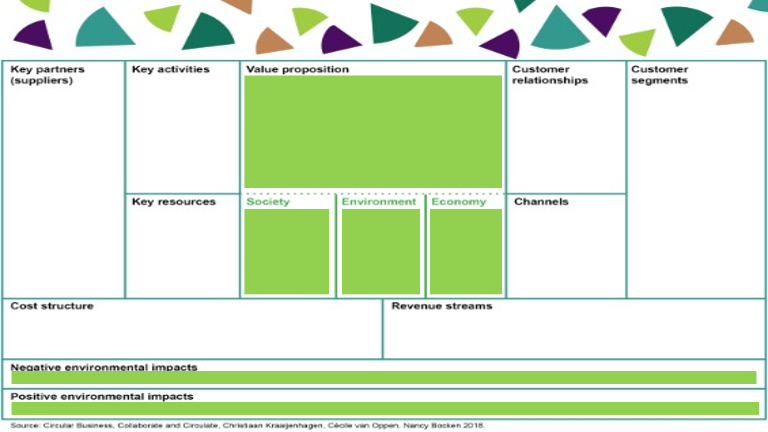

In this playbook, there are five parts, of which the first one is "Understanding the importance of the circular economy." We've already talked a lot about this before.
The first part of the playbook compiles changes in the operating environment that the circular economy helps to adapt to:
1. Climate change and biodiversity loss,
2. Regulation and policy,
3. Customer-orientation and changing consumption,
4. Technology and data,
5. Economic rationale.
We're asked to consider what the change in the operating environment means to companies from these perspectives: license to operate, efficiency and resilience, as well as growth and differentiation.
The goal of the first part of the playbook is to identify the risks and opportunities of the changing operating environment:
What risks relating to the changing business environment can you identify today?
What opportunities relating to the changing business environment can you identify today?
The goal is also to start outlining the company's circular economy vision:
What could the company's circular economy business look like in the future?
Indeed, since we have already discussed these matters before, I just want to remind you of how I see this. So, the goal of the circular economy is a profitable business within the Earth's carrying capacity. In that sense, the circular economy offers solutions to our environmental challenges.
The playbook provides a valuable tool for reflecting on the effects of environmental changes on business operations.
You must think: "What does this mean for my business?
I highlight that each company must undertake this task independently. Nobody can do it for you.
I want to give you one example. We often think that this change incurs costs, but companies have reported that transitioning to a circular economy supply chain can enhance their resilience.
For example, during the pandemic and logistical challenges, a customer noted that transitioning to a circular economy supply chain improved their resilience by reducing their dependence on externally sourced raw materials and components.
We have multiple other examples that transitioning to a circular economy supply chain reduced costs in several ways:

- Reduced dependence on external suppliers
- Lowered risk of supply chain disruptions
- Efficiency improvements
- Long-term sustainability
Overall, transitioning to a circular economy supply chain can simultaneously reduce costs and enhance resilience, thereby improving companies' ability to adapt to changing circumstances.
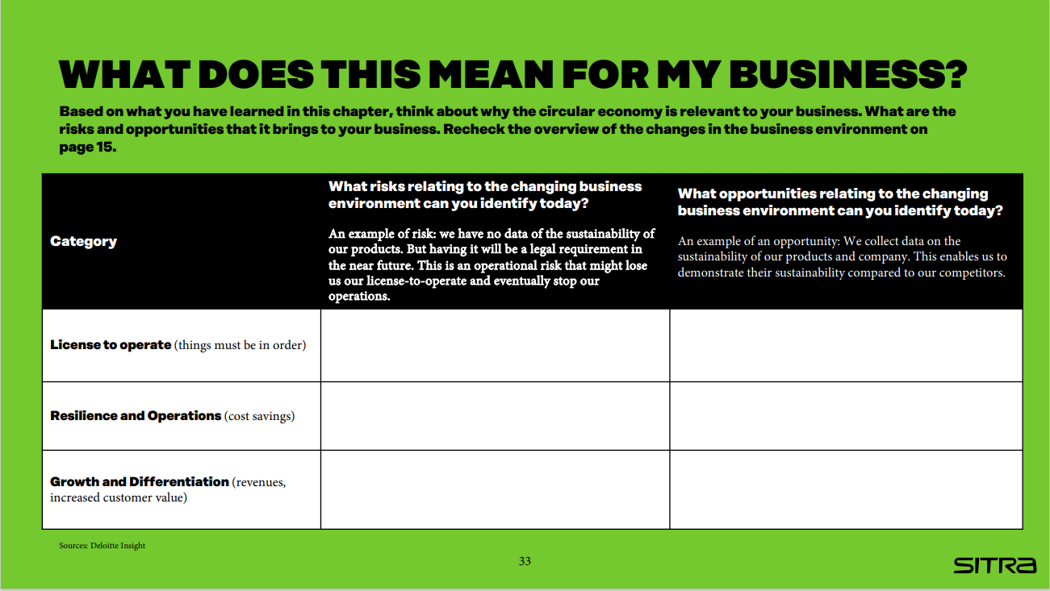
Back to this tool. This tool is a simple table, the added value of which is to guide thinking towards the right aspects. What is filled into the table is indeed specific to the industry, company, product/service/solution.
In addition, I hope that in this context, we also consider how the business currently impacts the environment and what opportunities there are to reduce this impact - or not so much to do less harm, but rather to see if we could perhaps do something that affects nature's ability to regenerate.
Today, there is much talk about regenerative circular economy, where the focus is on considering the environmental impacts while making decisions about our operations - and especially those positive environmental impacts.
And that doesn't appear in this tool. But it's something I would like you to consider alongside the questions in the playbook.
And then, when you move on to the business model after you have considered what changes are happening in the business environment - what risks and opportunities are associated with them and what impacts they have on your company specifically, it's good to consider what we would like to aim for.
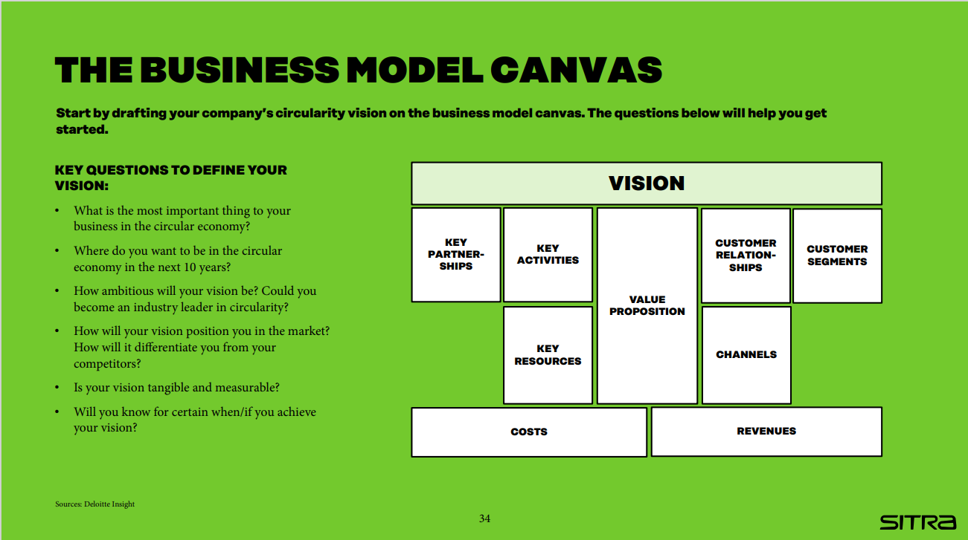
When you write this down, it doesn't mean that it's set in stone, but I strongly recommend that you draft a circular economy vision for your company.
The vision should incorporate thoughts on risks and opportunities, and these playbook questions also help in defining the vision:
- What is the most important thing to your business in the circular economy?
- Where do you want to be in the circular economy in the next 5 - 10 years?
- How ambitious will your vision be? Could you become an industry leader in circularity?
- How will your vision position you in the market? How will it differentiate you from your competitors?
- Is your vision tangible and measurable?
The vision is good to summarize in one sentence.
In the early stages, it's indeed good to think about what direction we want to take and then refine it as thinking progresses in later stages.

Webinar part 2

So, how are those circular economy opportunities identified?
At this point, I've combined chapters 2 and 3 of the playbook. Chapter 2 focuses on Unlocking the circular opportunities. Here are the essential questions:
• What are the inefficiencies in your value chain?
• How can the circular economy turn inefficiencies into opportunities?
• How can the circular economy add value?
I would remind you that globally, less than 10% of materials return to circulation. Everything we can do for recycling and reuse is important and necessary. The key is how to act differently in inefficiencies - that's where the potential lies.
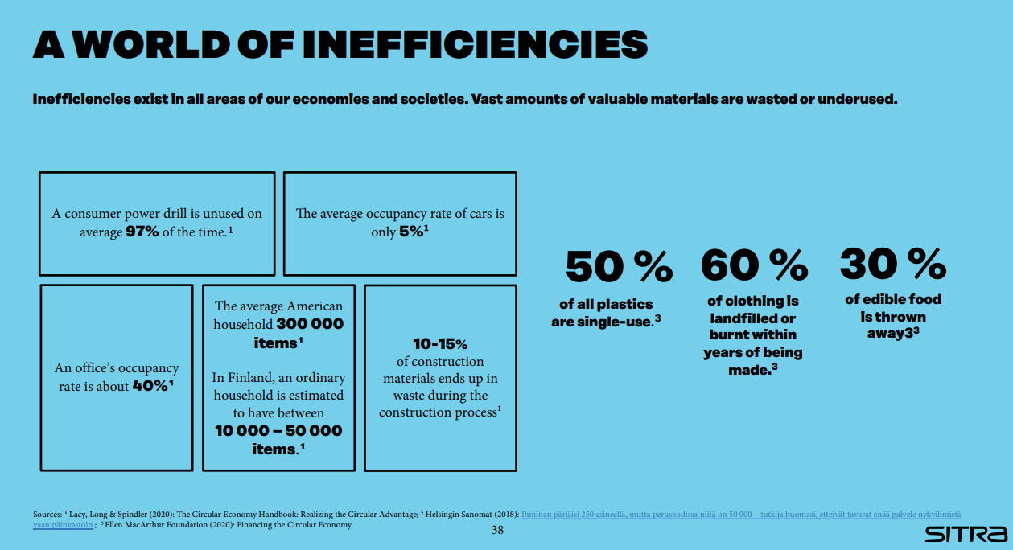

Inefficiencies include unsustainable use of materials and underutilized capacities, premature product lives, wasted end-of-life value, and unexploited customer engagements.
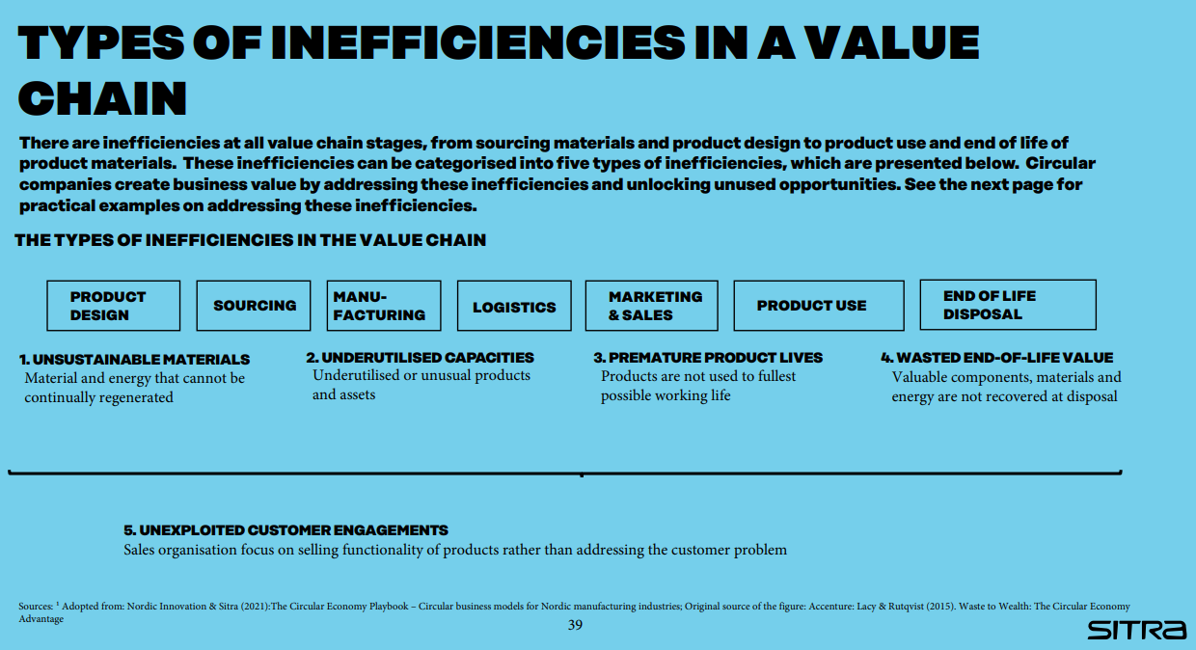

Well, how can we then derive business values from inefficiencies?
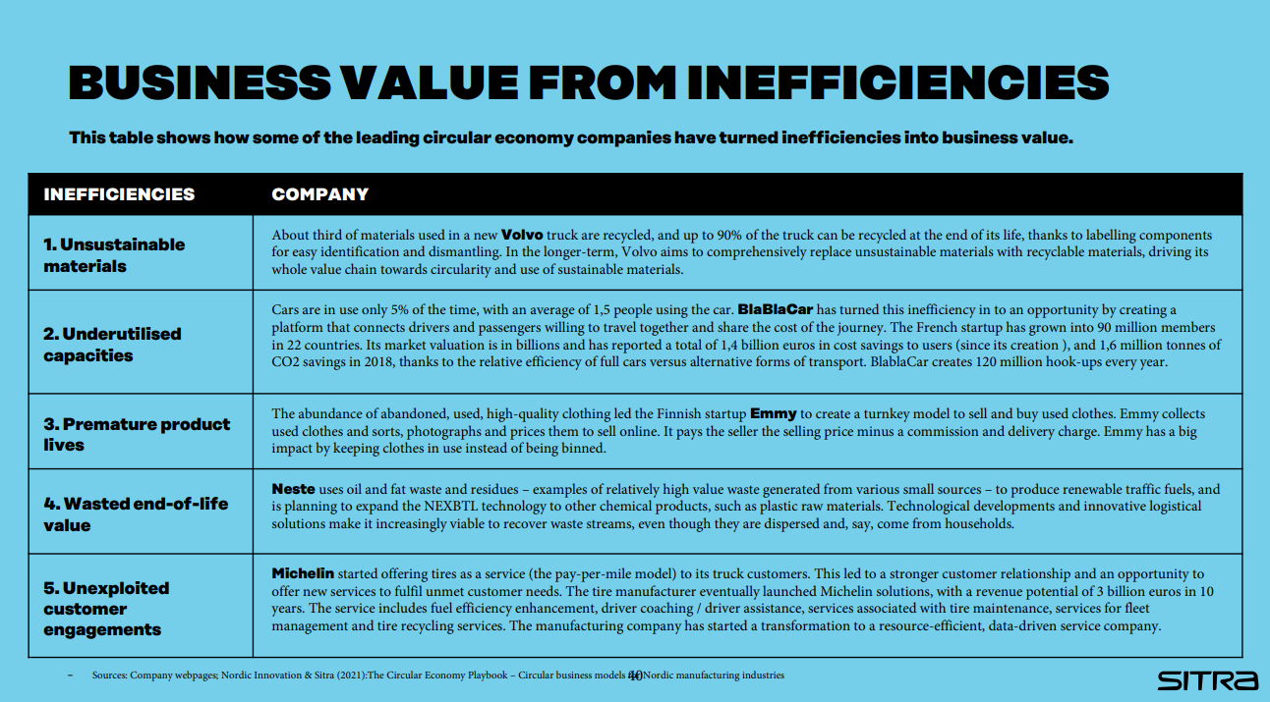

When addressing unsustainable materials, businesses can begin by assessing their current practices and pinpointing areas for integrating sustainable raw materials. This could entail sourcing recycled materials or investigating renewable alternatives to conventional resources. Businesses can also adopt renewable energy sources like solar or wind power.
Volvo as an example: About a third of the materials used in a new Volvo truck are recycled, and up to 90% of the truck can be recycled at the end of its life. In the longer term, Volvo aims to comprehensively replace unsustainable materials with recyclable materials.
When tackling underutilized capacities, businesses can optimize their use of facilities, equipment, and personnel. This involves implementing energy-efficient technologies, promoting resource sharing, and investing in workforce training to boost productivity.
BlaBlaCar is an example who has turned this inefficiency into an opportunity by creating a platform that connects drivers and passengers willing to travel together and share the cost of the journey.
When dealing with premature product lives, businesses can prioritize waste reduction, reuse, and recycling throughout the product lifecycle. This involves redesigning products to facilitate easier recycling, establishing take-back programs, and exploring innovative recycling technologies.
Emmy for example, collects used clothes and sorts, photographs, and prices them to sell online.
When faced with wasted end-of-life value, businesses can transition to solution-centric sales approaches by comprehending customers' sustainability requirements. This could entail bundling products and services or providing leasing and maintenance alternatives to prolong product lifecycles and minimize waste.
Neste for example, uses oil and fat waste to produce renewable traffic fuels.
When confronted with unexploited customer engagements, businesses can implement strategies to better understand customer needs and preferences. This may involve conducting market research, gathering feedback, and analyzing customer data to identify opportunities for improved engagement and enhanced customer satisfaction. By leveraging these insights, businesses can tailor their products and services to better meet the needs of their target audience, ultimately driving growth and fostering long-term customer relationships.
Michelin for example, started offering tires as a service (the pay-per-mile model) to its truck customers.

Part 3

Now, let’s talk about adding value to a company through the circular economy.
When considering how customer-centricity helps realize circular economy opportunities, the focus should shift from individual products and production to holistic solutions and the entire value chain.
When it comes to information flow, data should flow in from customers, rather than the company solely pushing information outwards.
By listening to customers and addressing their needs, it's crucial that information also flows internally within the company, from sales representatives to other departments.
Efficient information sharing enables the utilization of customer insights across the entire company, in all different functions. Based on this, new and better solutions can be provided to customers. Data integration should be achieved throughout the entire value chain.
Performance indicators should be designed to measure progress toward future goals rather than focusing solely on the present. Instead of measuring the sales value of products individually, it's important to measure it by customer. The goal is to determine how much value the current service offering generates for an individual customer.

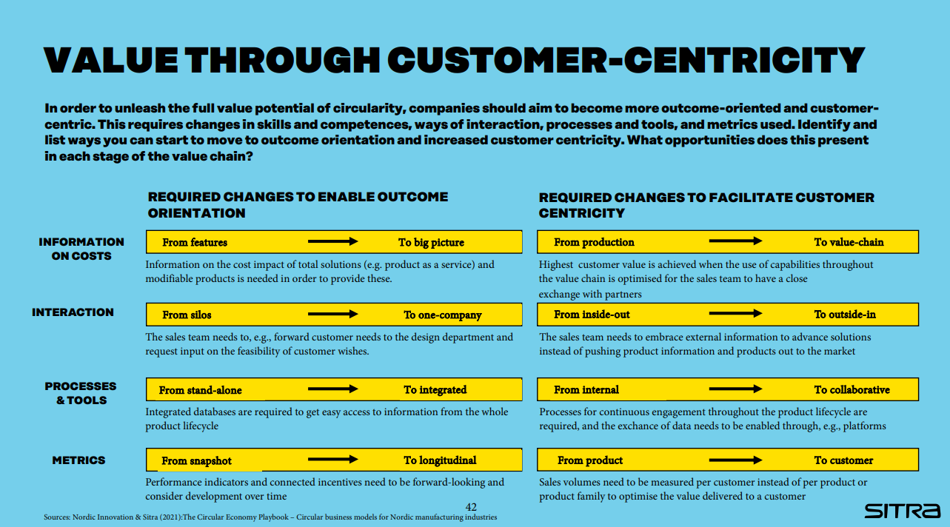

Now we are back to the inefficiencies.
In the playbook, there's another table aimed at helping to contemplate the right aspects: Tools: "Assess inefficiencies and opportunities". This tool is for reflecting on the inefficiencies we currently have. Besides identifying existing inefficiencies, it's important to consider whether these can be transformed into customer value. The tool provides useful guiding questions for identifying inefficiencies.
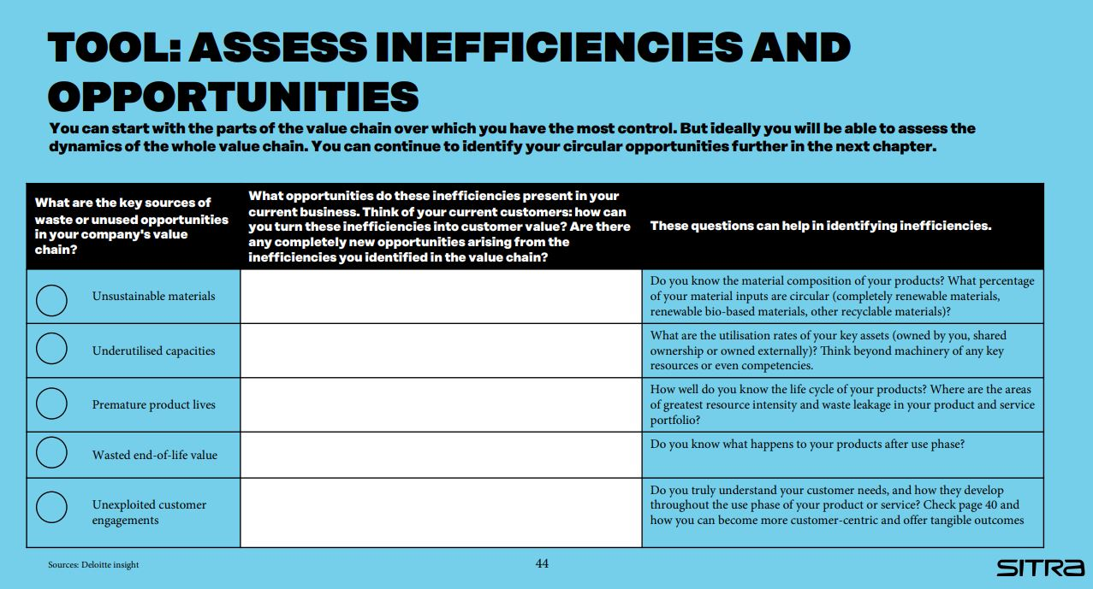

Once we've taken a look at the inefficiencies in our current operations, the next step is to consider how we can improve efficiency and generate new value through our business model.
The five Circular economy business models offer innovative approaches to achieve this goal:
1 Circular inputs: This involves using recycled, bio-based materials, and renewable energy in our production processes. By creating sustainable, repairable, and recyclable products, we can minimize waste and environmental impact.
2 Sharing platforms: Digital platforms enable us to optimize the utilization of goods and resources by facilitating sharing, renting, and leasing. This not only reduces resource consumption but also promotes collaborative consumption. It's worth noting that not all sharing platforms are circular economy initiatives, although sharing platforms enable circular economy business models. With these examples, it's important to be cautious.
3 Product as a service: Instead of traditional ownership models, we can offer our clients access to products through services like leasing and renting. This shift towards "product-as-a-service" encourages longer product lifecycles and fosters a circular consumption pattern.
4 Product life extension: We can prolong the lifespan of products through repair, maintenance, upgrades, and resale services. By extending the life of products, we reduce the need for new resource extraction and minimize waste generation.
5 Resource recovery: This involves recovering materials and resources from products that have reached the end of their useful life. By implementing effective resource recovery processes, we can reintroduce valuable materials back into the production cycle, closing the loop and reducing the need for virgin resources.

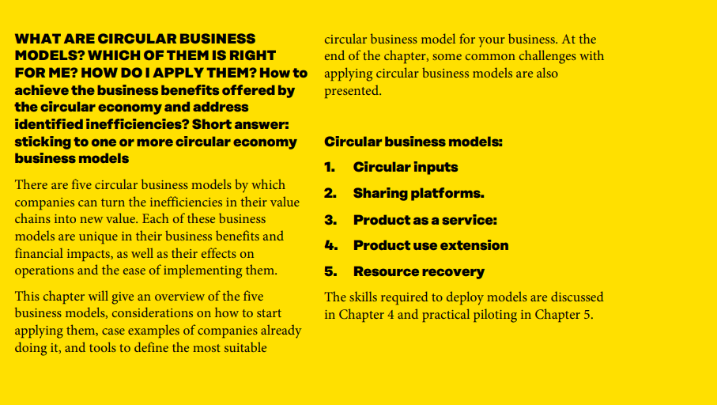

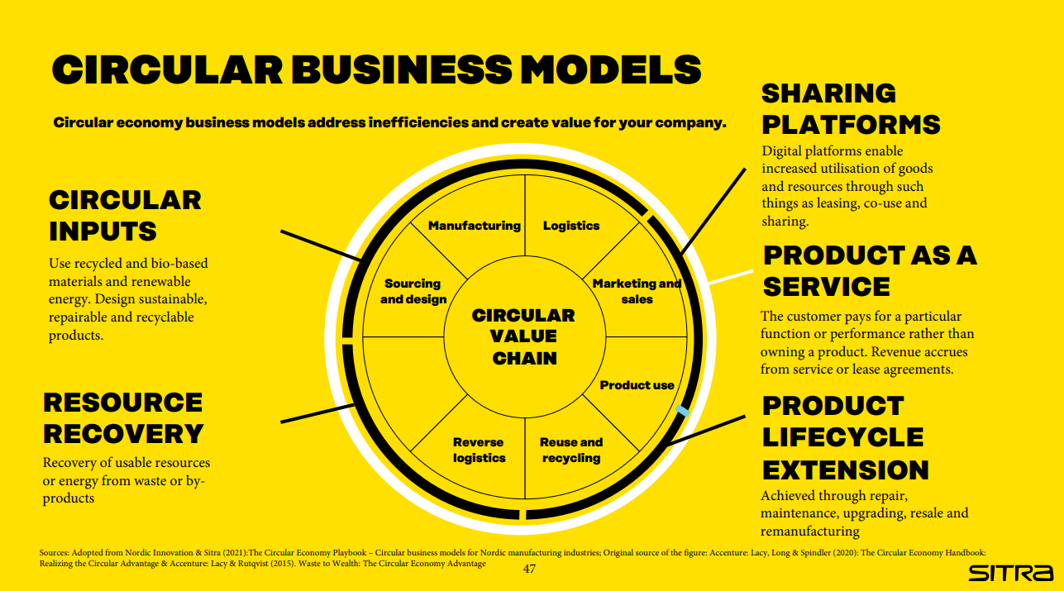

Each circular business model includes several sub-models, which offer practical insights into implementing circularity in various industries. These sub-models outline specific actions companies can take to transition towards circular practices.
Let's take a quick look at some of these sub-models:
Sustainable product design focuses on creating durable and repairable products, such as modular designs.
Circular supplies involve using recyclable materials in production, like renewable and bio-based materials, to increase recovery rates.
Sharing platforms enable increased utilization of capacity.
Product-as-a-Service offers customers access to products through subscription or usage-based charges.
Product use extension includes activities like repair, maintenance, and upgrading to prolong product lifecycles.
Resource recovery encompasses recycling, upcycling, and returning materials to the source to minimize waste.
Understanding these sub-models can provide valuable insights into how your company can embrace circularity and create new opportunities for sustainability and innovation.
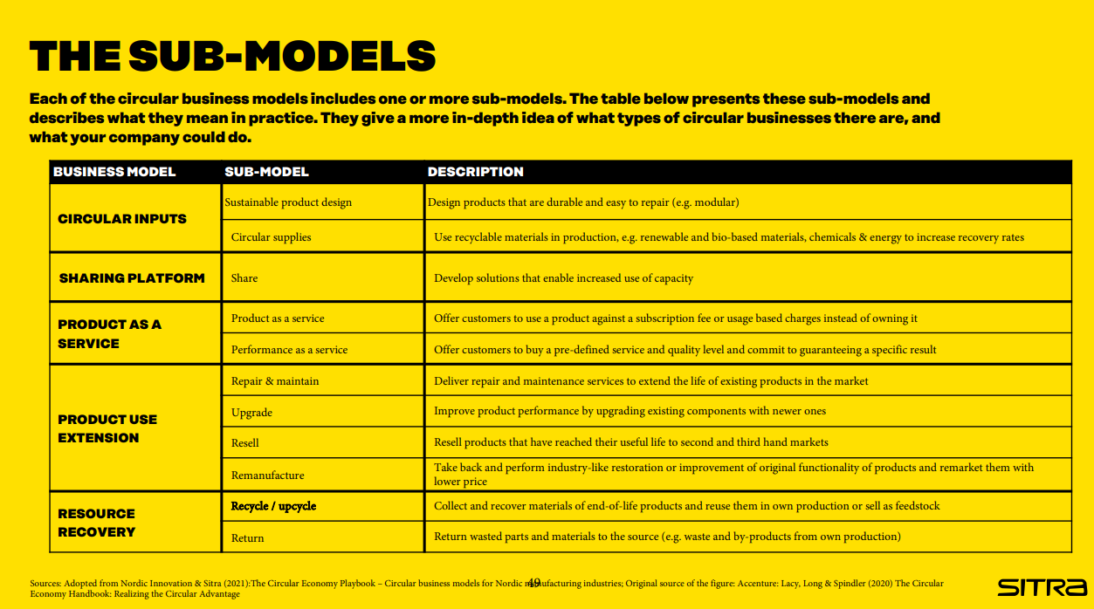

Part 4

Next, let's delve into how different business models impact the value chain.
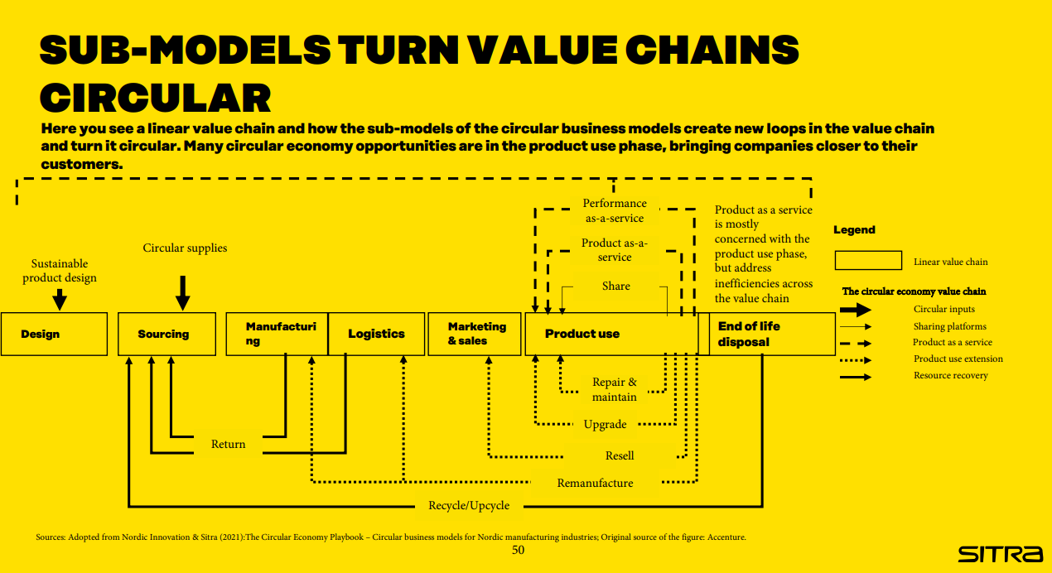Here you see a linear value chain and how the sub-models of the circular business models create new loops in the value chain and turn it circular. Many circular economy opportunities are in the product use phase, bringing companies closer to their customers.
It's important to note that various circular economy models impact different segments of the value chain.
In the playbook, there's more detailed information on different business models, their impacts, implementation methods, and case examples.

Here's a tool that aims to draw your attention to how the business models you've conceptualized would impact your value chain and what factors should be considered. With this tool, you sketch your value chain on paper and then contemplate which of these business models or their sub-models could work for your company. It helps identify opportunities at various stages of the value chain.
These tools are extremely valuable. They help to think, focus attention, but also to visualize. They make thoughts visible. And that enables sharing thoughts and having discussions within the organization. They facilitate collective thinking.

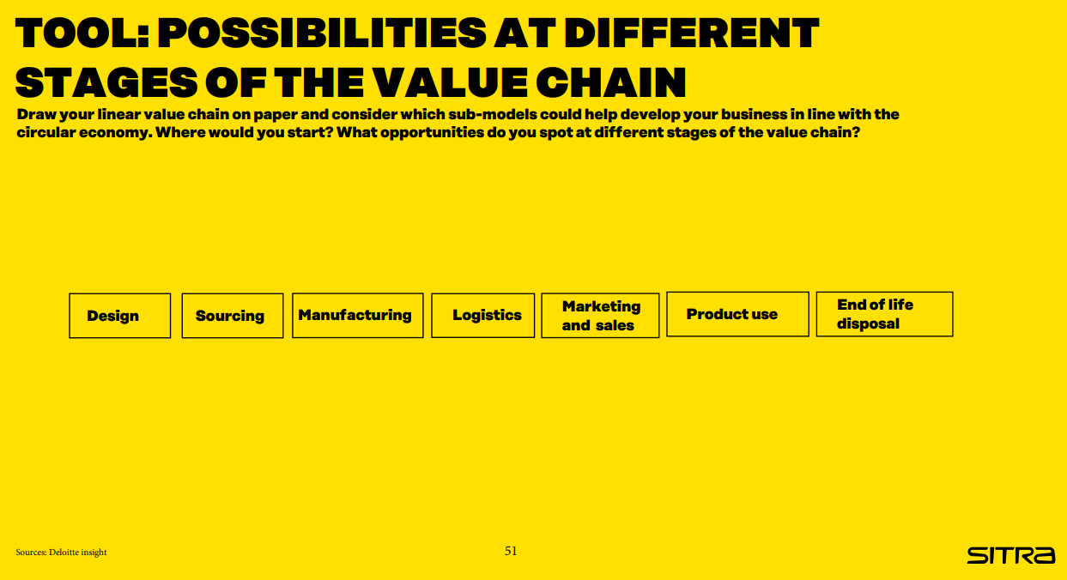

Each of these business models naturally has its challenges. Somewhat different challenges. Of course, any business transformation involves challenges. These are both generally related to business and specifically related to the circular economy.
If we think about internal challenges for the company related to organizational competence, it certainly requires investment. Actions affect different parts of the organization. If we want a comprehensive change in the organization, it also requires a change in mindset throughout the organization. Old structures and cultures change slowly. It requires more patience and investment than building a new company based on circular economy principles or implementing change in a very young organization.
There are challenges related to customers. And it's important to consider the adoption of the new business model from the perspective of customers. What are the incentives? Can we offer incentives to customers? Incentives that make the new model appealing.
Customer communication is extremely important to clearly and understandably convey the additional benefits offered by the new model to customers.
The third level is the ecosystem level, where these challenges exist. And often, if we transition to such a circular economy business model, we need to rethink the entire partnership network and ecosystem. There may be new players, some players may drop out, and in this context, building the circular economy value chain and implementing a new collaboration model throughout the entire ecosystem is extremely important.
If our cycle doesn't work properly, neither will our business.
I won't go through the challenges in detail now, but you can revisit them independently in the playbook.
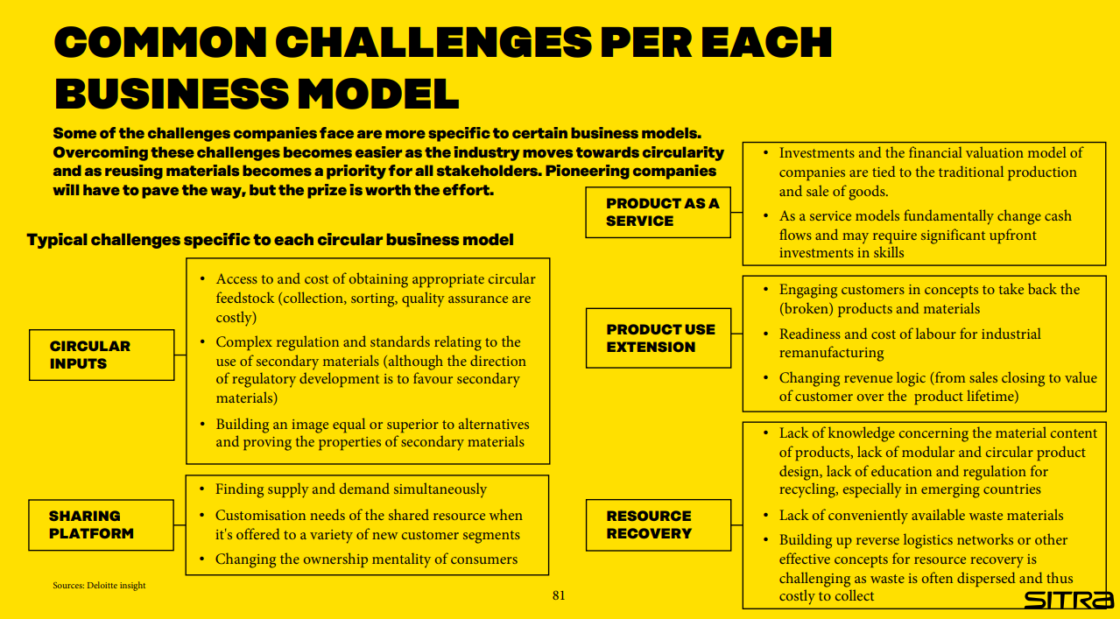

In the next tool, there's just a list of questions, but that's actually a very good thing because it contains the right questions. These are the things to ponder and seek answers to when planning your own business model.

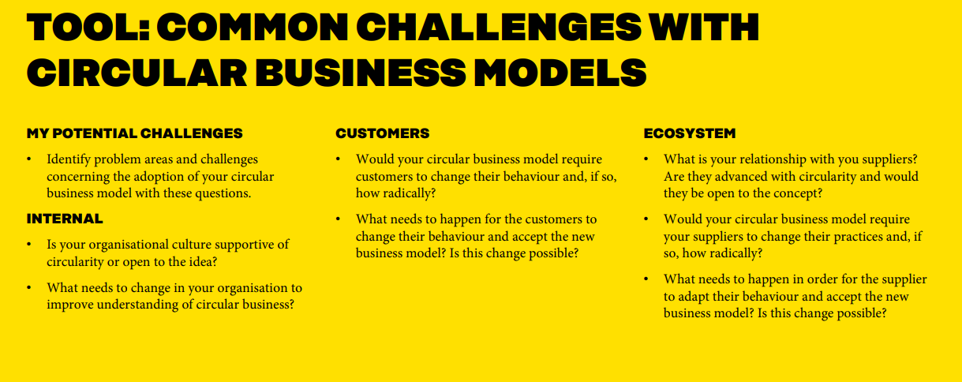

And then in the playbook, there's a separate tool for the actual planning of the business model. It's good to plan the business model. And all these things should be done step by step.
Once we've gone through the earlier stages, here we can consider what could be a suitable business model or business models for our company.
What is the business potential of the business model/models?
What are the new revenue and expense streams?
Are there any new kinds of cost savings?
Does it affect customers' image of the company?
Does the change in the business model help manage risks?
Does it help improve environmental or social impacts?
These are perhaps the most important questions when considering business potential.
And then, for the business to have any chance, we also need customers.
Who would be the customers for this new type of business model? Who would be interested? Would anyone be interested? If not, we have to go back to the starting point and think again.
What is the additional value and benefit the customer receives?
What is the thing that customers would be willing to pay enough for to create a profitable business?
Finally, you need to look inward and examine the company's readiness for change, for developing a circular economy business. You can do that by revisiting those previously discussed challenges.

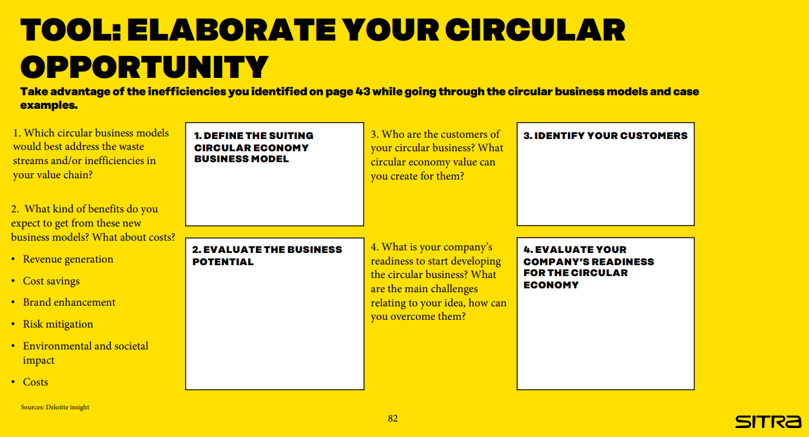

Businesses have several opportunities, so it's important to consider where to start. In that case, a quadrant like this is useful. If you have identified various circular business opportunities, this tool will help you gain an understanding of which initiatives to prioritize.
Accessibility refers to how easy or difficult it is for the company to implement the planned solution.
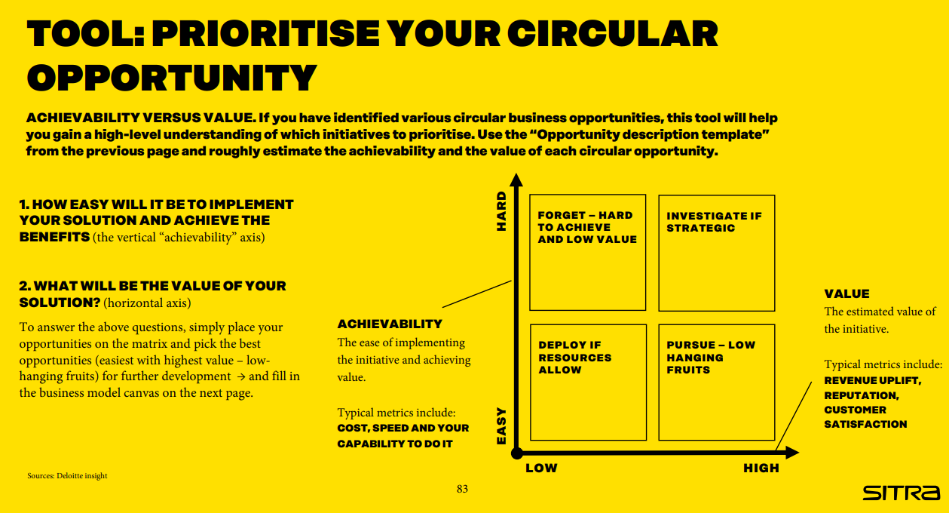
After going through these different stages we've covered today, the company is ready to fill out the entire business model canvas.
Let’s go through the questions:
KEY ACTIVITIES
• What measures are needed to deliver your circular value proposition and set up the business?
VALUE PROPOSITION:
• What unique value can you create with circular economy and for whom?
• What is your compelling circular economy story line?
CUSTOMER RELATIONSHIP:
• How can you engage with customers to gain meaningful feedback and include them in the journey?
CUSTOMER SEGMENTS:
• Who are your main customers?
• Who else can benefit from your value proposition?
CHANNELS:
• What channels will you use to sell your
products or services?
COSTS:
• What is your cost structure?
• Where can circular thinking decrease the costs of operations?
• Where could partnerships and the utilization of shared assets decrease costs?
REVENUE:
• How do you generate revenue?
• What types of other values are created with your circular vision and how do they impact the value of your business

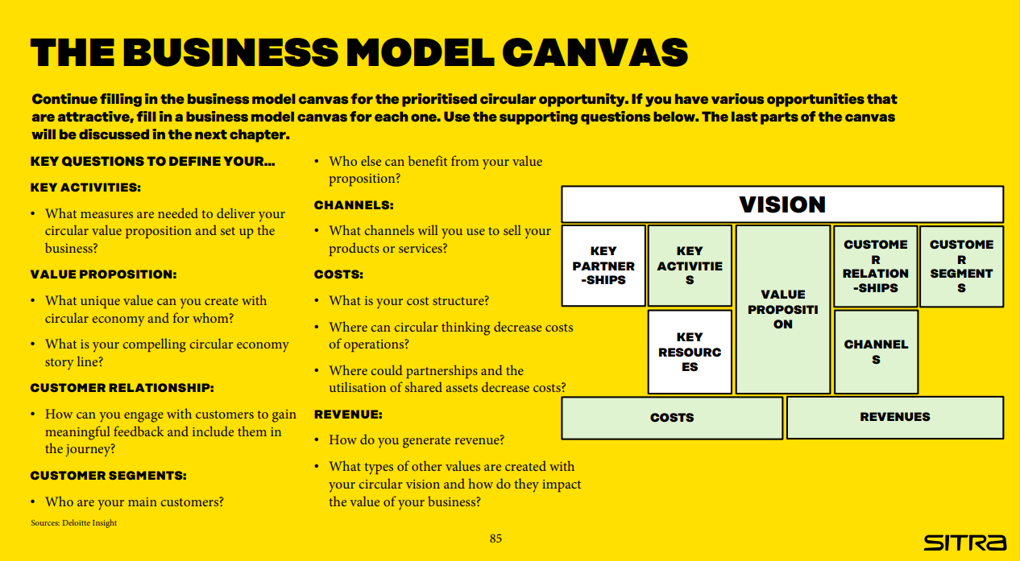

Part 5

Alright everyone,
We have had a long session already, but I want to emphasize a crucial aspect: the capabilities we need to make this circular business model shift a reality.
Think of your company as a ship navigating uncharted waters. To sail smoothly into the circular economy, we need a sturdy vessel with the right crew and equipment. These are the capabilities that will steer us in the right direction and weather any storms along the way.
First off, let's talk about company culture. It's not just about policies and procedures; it's about mindset. We need to foster a culture that values innovation, collaboration, and sustainability. It's about getting everyone on board with the idea that change is not just necessary but exciting.

Next up, let's dive into operations. We need to rethink every aspect of how we do business – from design and production to distribution and waste management. It's about finding ways to do more with less, to minimize waste, and to maximize the value of every resource we use.
And let's not forget about partnerships. No company can go it alone on this journey. We need to work hand in hand with suppliers, customers, and other stakeholders to create a truly circular ecosystem. It's about building relationships based on trust, transparency, and shared values.
So, as we wrap up, I want each of you to think about the capabilities your company needs to thrive in the circular economy. Identify areas where you can strengthen your skills, invest in training and development, and foster a culture of continuous improvement.

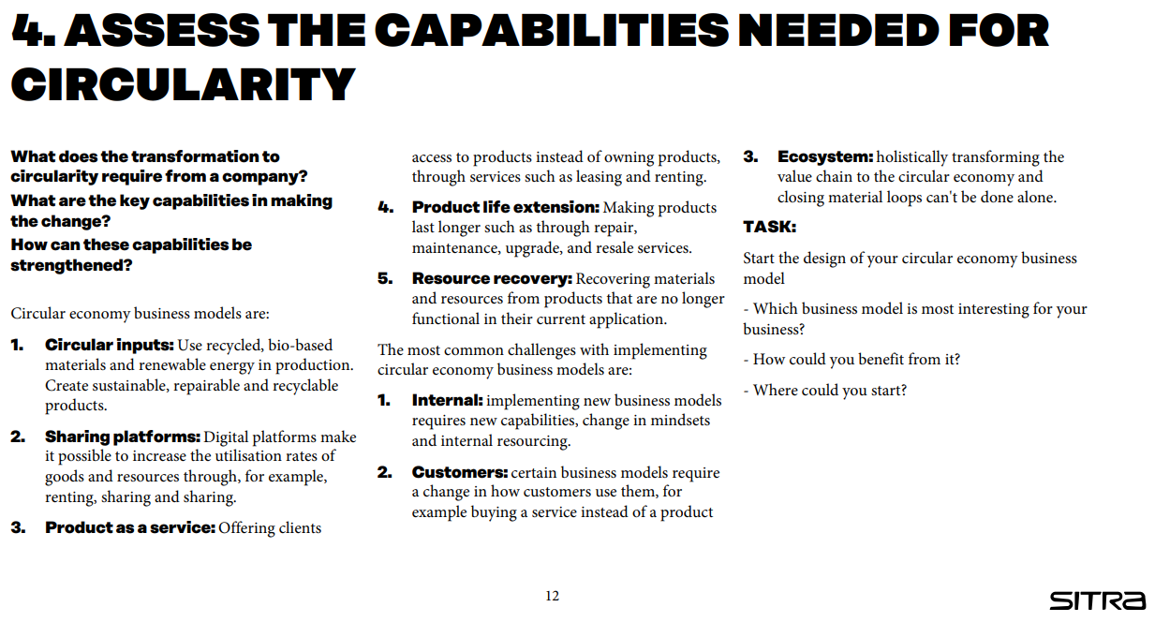

In the playbook, there's a detailed section on different capabilities, how to build them, and examples related to each. I strongly recommend using the tools provided to evaluate the required capabilities.

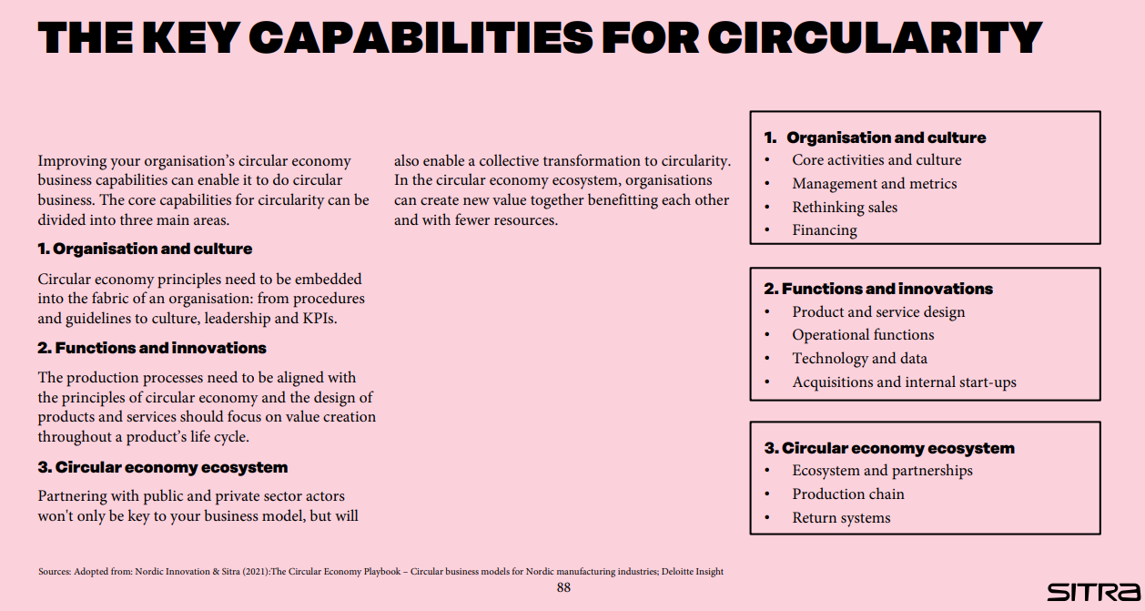

Use the capability assessment tool to start thinking about the most relevant circular capabilities of your company and the areas where you need to improve.

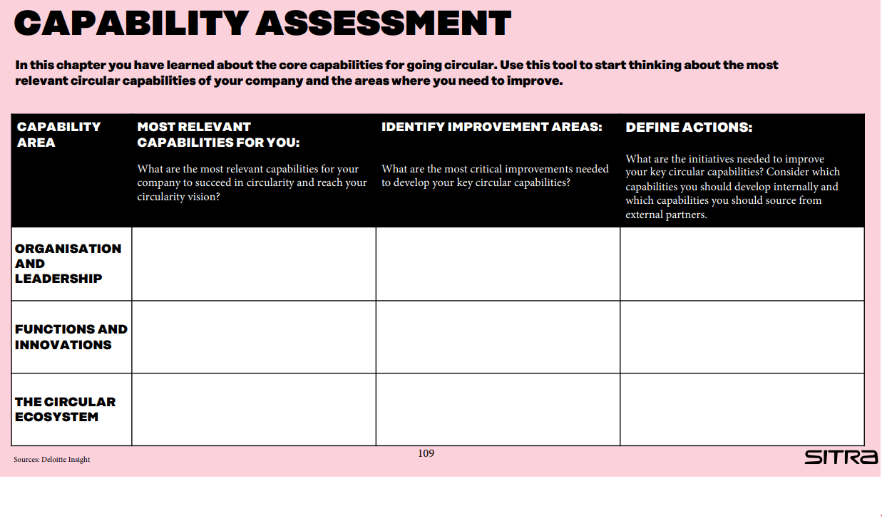
Now, let's focus on the two remaining sections of the business model canvas: Key Partnerships and Key Resources.
In Key Partnerships, we need to identify the essential collaborators who can help us leverage existing circular opportunities or even create new ones. Think about who you need to work with to achieve your circular goals. Are there specific challenges you're facing that require collaboration? Consider potential partners who can help address these challenges. Also, reflect on whether there are any gaps in your network. Have you identified any needs or demands that aren't being met? Perhaps there are opportunities for new partnerships to support your circular business endeavors.
Moving on to Key Resources, here we'll determine what material or immaterial capabilities are necessary to bring our value proposition to life. Take stock of the resources you currently have and assess whether they align with your needs. Do you possess all the capabilities required to execute your circular business model effectively? If not, consider how you can acquire or develop these capabilities to ensure success.

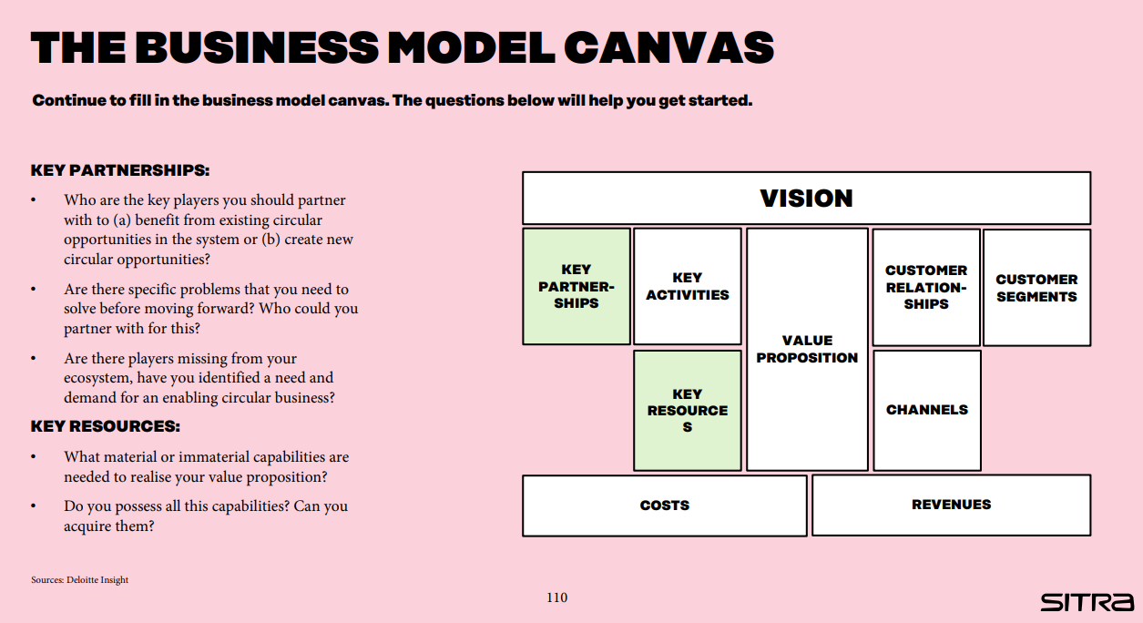

All right, let's discuss quickly how to move forward on our journey toward circular business transformation. In this chapter, we'll explore two distinct approaches that any company can adopt to carve out its path to circularity.
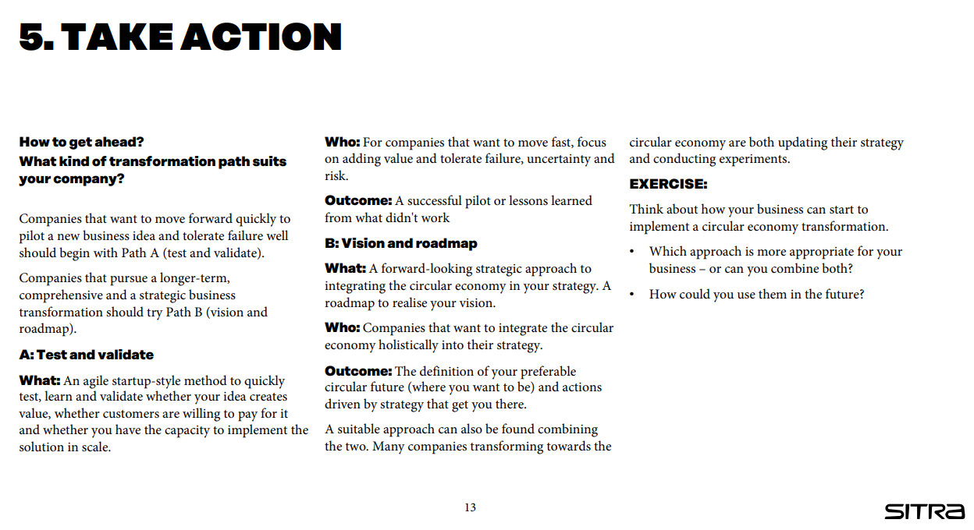

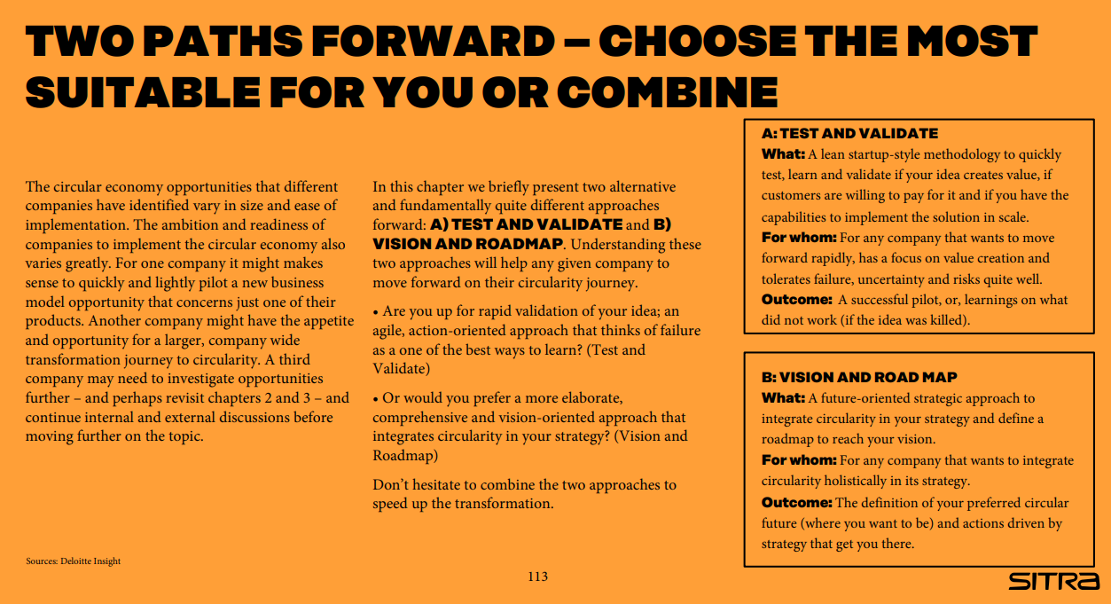

First up, we have Path A: Test and Validate. This approach is ideal for companies eager to swiftly pilot a new business idea and are comfortable with the possibility of failure.
Here, we embrace a lean startup mindset, finalize our circular business model canvas, and mobilize our company resources to kickstart quick piloting and validation of our circular business concept.
Through testing and iteration based on customer feedback, we'll hit (or miss) our pilot targets and ultimately decide the fate of our pilot—whether to scale it up, pivot, or discontinue it.

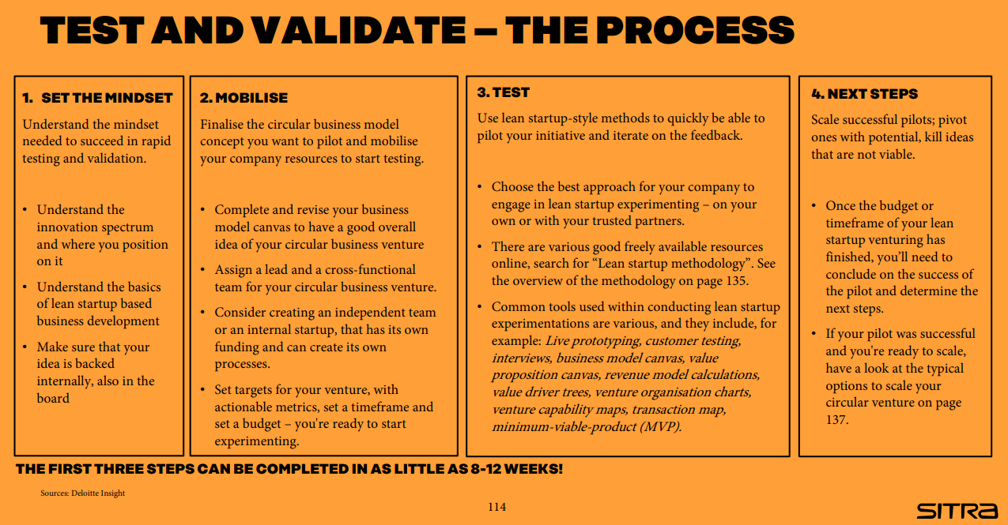

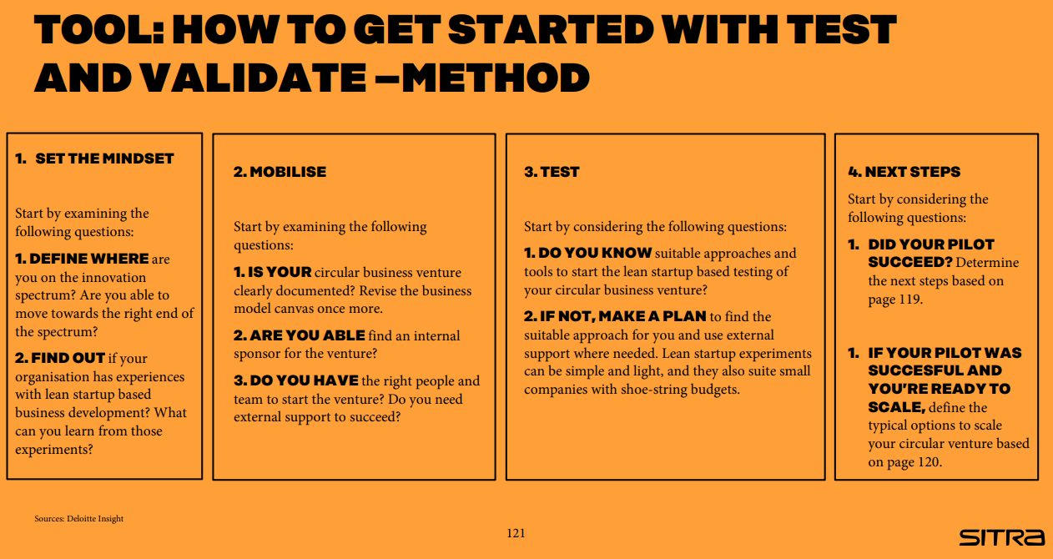

Next, we have Path B: Vision and Roadmap. This path is tailored for companies committed to a more long-term, strategic business transformation towards circularity.
We start by envisioning where we want to be in the next decade or so, integrating circularity into our company strategy, and defining the necessary initiatives to unlock the full potential of circularity and realize our circular vision.

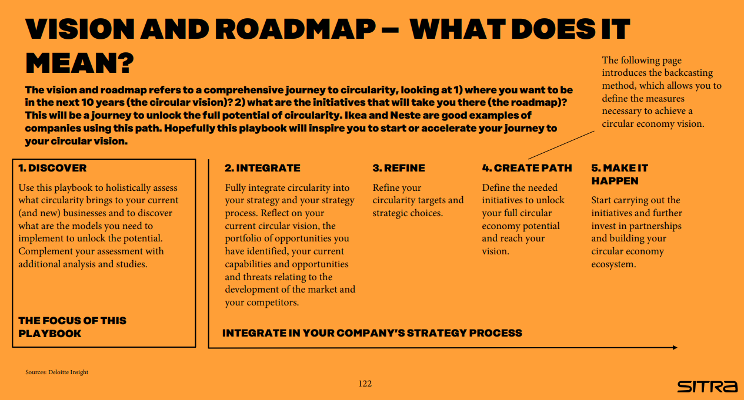

Let's delve into a concept called backcasting, also known as strategies of trajectory. It's a method that flips the traditional planning approach on its head. Instead of starting from where we are now and projecting into the future, we begin with a clear vision of our desired future and work backward to determine the actions needed in the present to make that vision a reality.
Here's how it works:
First, we define our preferred future—where we want to be in the long term, say 5 to 10 years down the line.
Then, we map out the most effective path to reach that future, considering three key timeframes: the now (what we can do in the next 6 to 12 months), the next (our goals for the next 1 to 5 years), and the beyond (our vision for the 5 to 10-year horizon).
Our circular economy vision, seamlessly integrated into our company strategy, serves as our compass for this journey. Backcasting empowers us to analyze our future aspirations, trace them back to the present, and identify the actions that will generate the most value along the way.
While the overall structure of the roadmap to our circular vision will be unique to our company, it's crucial to maintain a balanced focus across all three time horizons. By continuously operating on these horizons and avoiding the temptation to fixate solely on short-term gains, we can effectively steer our organization toward the realization of our circular vision.

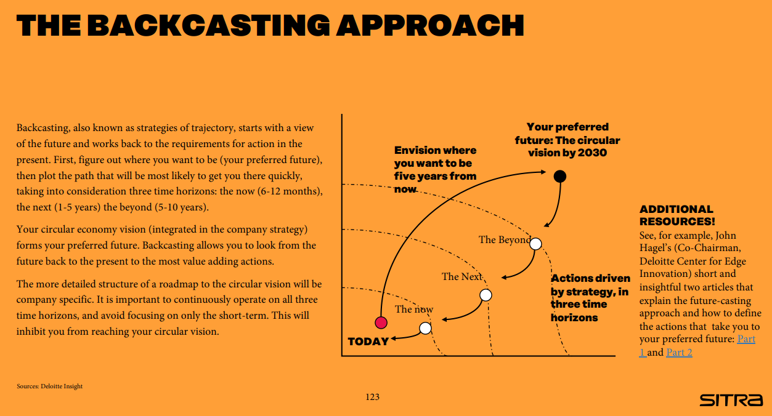

In conclusion, let's remember these key action recommendations:
- Share your newfound insights with our team or board, fostering understanding and alignment.
- Advocate for the prioritization of the circular economy with our company directors, driving commitment from the top.
- Establish a dedicated team to spearhead circular change, ensuring focused efforts and accountability.
- It's crucial to regularly assess our strategy's alignment with evolving business landscape dynamics, staying agile and responsive.
- Uncover circular economy opportunities across our entire value chain, maximizing our potential impact.
- With these insights in mind, craft a comprehensive plan for executing circular operations, ensuring clarity and direction.
- Finally, let's actively engage colleagues, customers, and partners in refining and validating our plan, leveraging their diverse perspectives for success.

Thank you.

