“Foresight for Export Growth" Online Scenario Creation Workshop

Part 1
Greetings everyone, and a warm welcome to today's online workshop on foresight processes tailored for SMEs in the export industry. I'm Johan, and I bring with me years of experience advising businesses like yours on strategic planning and scenario analysis to navigate the complexities of global markets.
I have structured this workshop into small chunks of micro-learnings. After each chunk, there will be interactive small tasks for you to complete.
To kick things off, we have an icebreaker task designed to ignite your imagination. The task is called: “Future News Headlines for Finnish Export SMEs”.
Imagine yourself as a journalist forecasting future scenarios impacting Finnish export SMEs.
Craft one positive and one negative news headline based on the PESTE factors identified in the orientation video.
This exercise encourages you to think critically about the potential future scenarios. By creating positive and negative headlines, you engage with the complexities of the PESTE factors and their implications for business success.
First, you will have 5 minutes for independent thinking. After this, we'll move into smaller breakout rooms to brainstorm and refine your headlines collaboratively. In the breakout room, your goal is to choose one positive and one negative headline as your final output.

part2
All right, time to wrap up. For each breakout room, please type your positive headlines into the chat.

Let's take a look
Breakout room 1: Trade Blocs Open Lucrative Markets for Finnish Export SMEs
Breakout room 2: AI Revolutionizes Supply Chains for Finnish Exports
Breakout room 3: Green Investments Expand Finnish Export Market
Breakout room 4: Ethical Consumption - Trends Drive Finnish Export Growth
Breakout room 5: Political Stability Fuels Finnish Export Opportunities
Breakout room 6: Economic Recovery Bolsters Finnish Export Sales
Great work, everyone! These headlines are a fantastic start and show a range of positive futures for Finnish export SMEs.
Now, let's move on to your negative headlines. Please type your selected negative headlines into the chat.
Let's see what can be found here
Breakout room 1: Geopolitical Tensions Disrupt Trade for Finnish Export SMEs
Breakout room 2: Technological Failures Hinder Finnish Export Efficiency
Breakout room 3: Environmental Regulations Increase Costs for Finnish Exports
Breakout room 4: Social Unrest Leads to Declining Demand for Finnish Products
Breakout room 5: Political Instability Creates Barriers for Finnish Export Growth
Breakout room 6: Economic Downturn Shrinks Market for Finnish Exports

Well done! Great efforts! This warm-up has opened our minds to a wide range of possible futures – both positive and negative. These headlines perfectly showcase various opportunities and challenges that we might face. Thank you all for your active participation!

Part 3

Next, I'll introduce the foresight process along with two practical models designed to help you effectively prepare for the future: a 2x2 scenario planning matrix and a spectrum of scenarios spanning from positive to negative outcomes. These models encompass a wide range of potential developments that could impact your business.

KUVION ALLA ON AINA KYSEISEEN KUVIOON KUULUVA TEKSTI
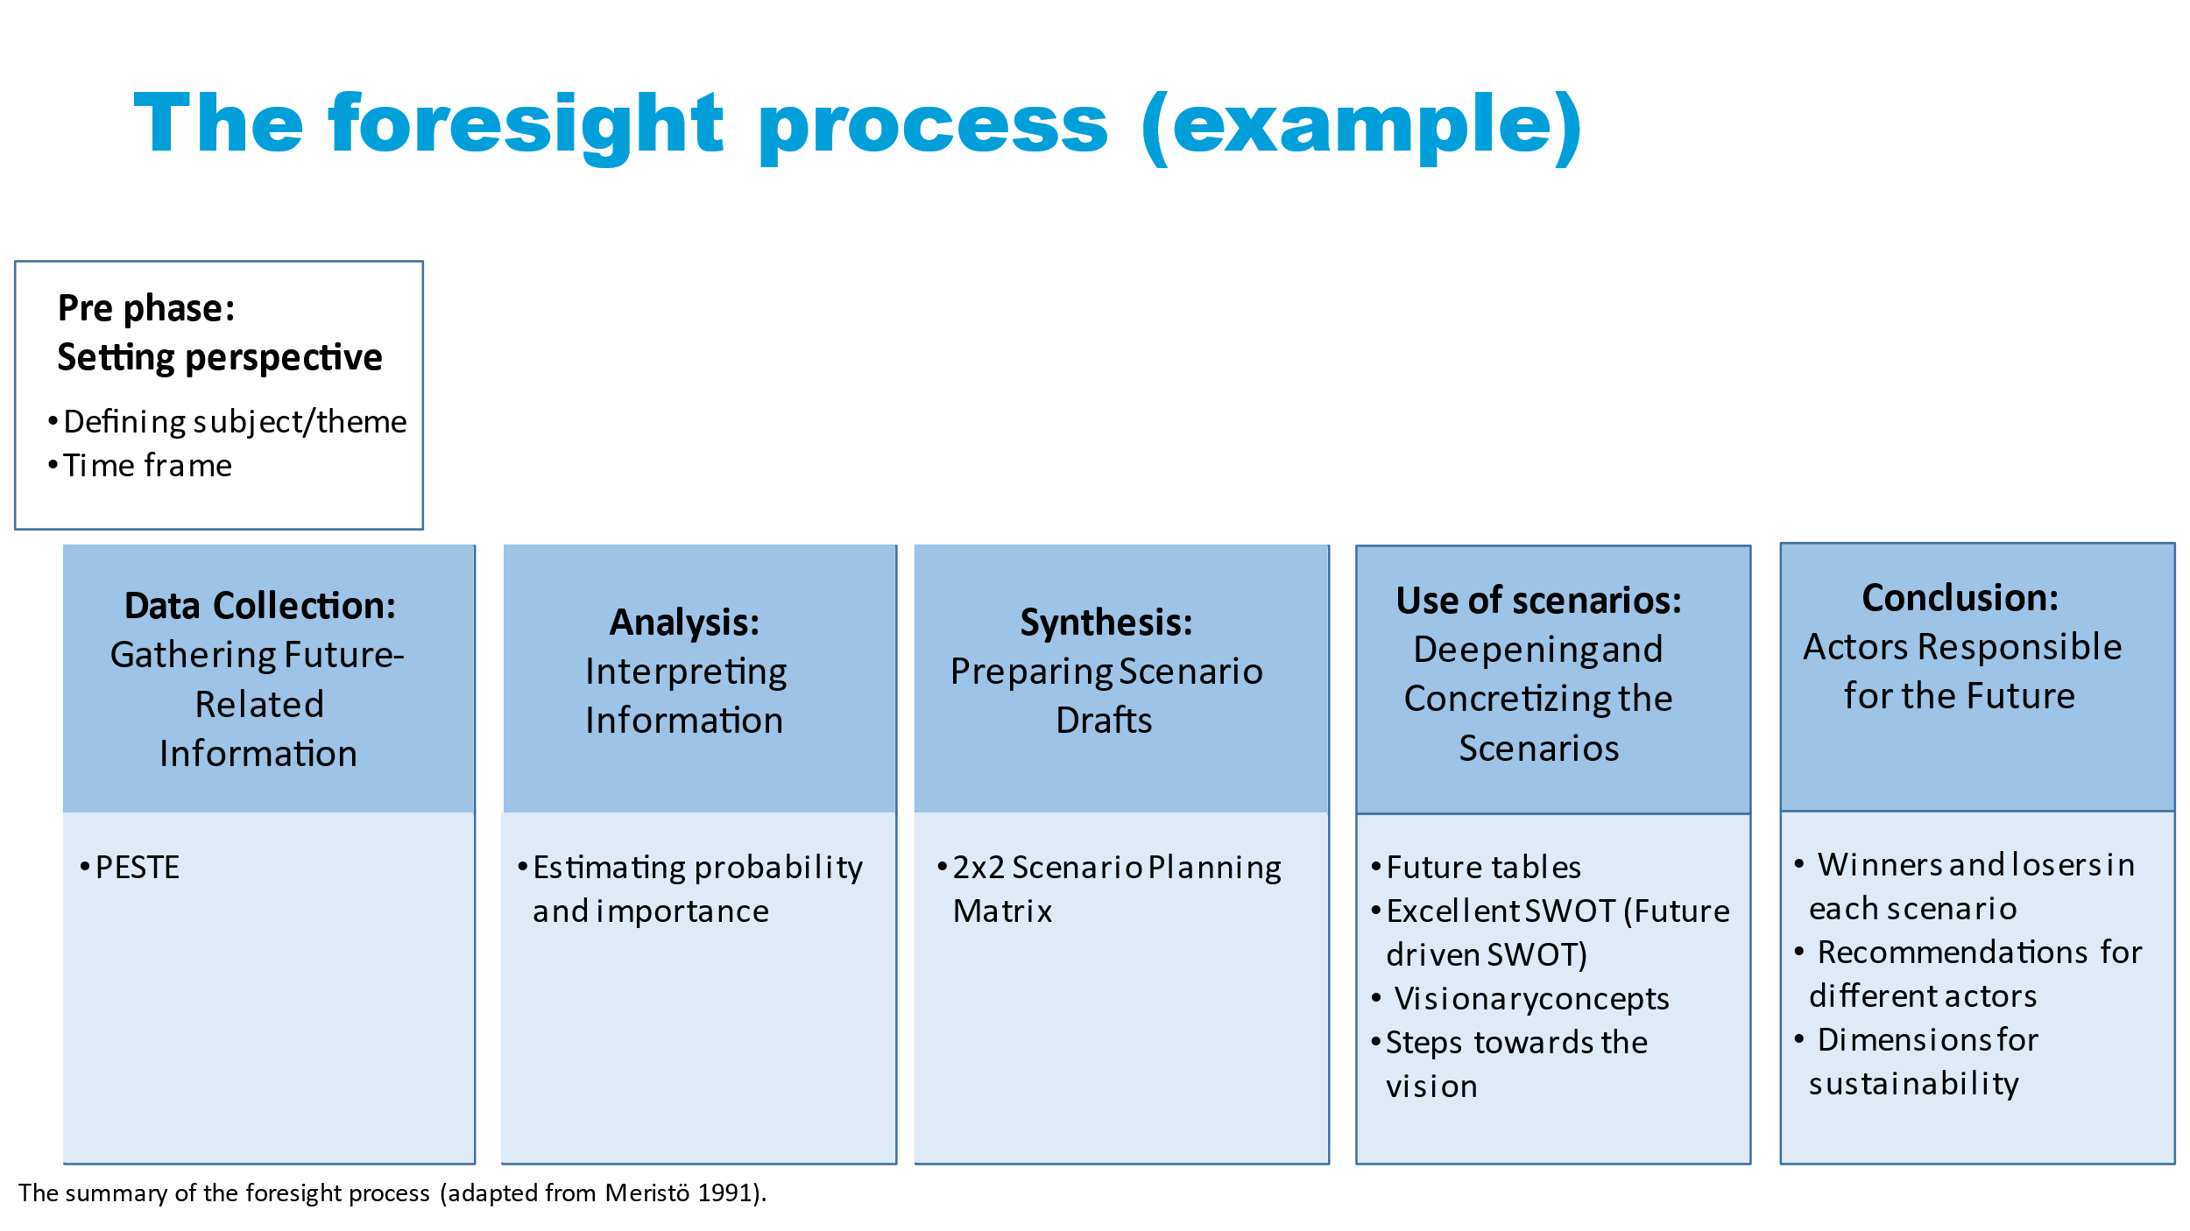

Here’s a visual overview of the entire process. Let's explore each element in detail:

Pre-phase:
Setting perspective
- Defining subject/theme
- Time frame

Firstly, every successful foresight initiative begins with establishing the perspective during the pre-phase. Here, we define our subject—Finnish SMEs—and our timeframe, with a specific focus on a 3-5-year horizon.

Data Collection: Gathering Future- Related Information

- PESTE

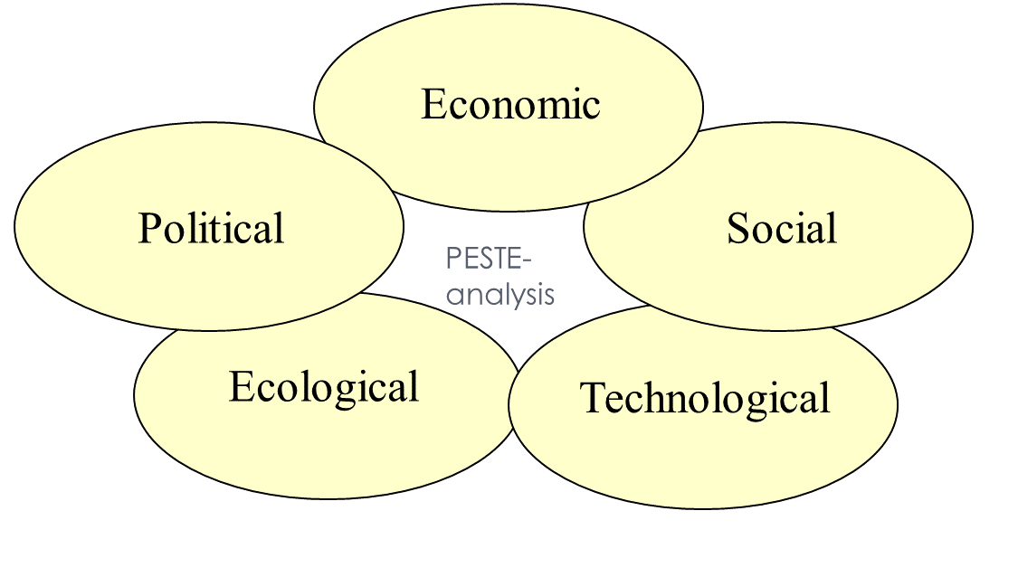
The first phase involves data collection, where we gather future-related information and categorize it using frameworks like PESTE, which covers political, economic, social, technological, and environmental factors. You should be familiar with this approach from the preliminary orientation task I sent you before this workshop.
I will use a Finnish technology exporter as an example. The company specializes in exporting advanced cybersecurity solutions to global markets. Here's how we could apply the PESTE framework:
Political Factors: Evaluate international regulations on data privacy and cybersecurity standards, trade agreements affecting export tariffs, and government policies supporting cybersecurity initiatives.
Changes in data protection laws in key export markets could impact compliance requirements for cybersecurity solutions.
Economic Factors: Assess global economic conditions affecting corporate IT budgets, currency exchange rates influencing export pricing, and economic growth in emerging markets.
Economic downturns in major export destinations may reduce IT spending, affecting demand for cybersecurity solutions.
Social Factors: Analyze trends in digital transformation, awareness of cybersecurity risks among businesses, and cultural attitudes toward data privacy.
Increasing awareness of cyber threats could drive demand for advanced cybersecurity solutions in global markets.
Technological Factors: Consider advancements in artificial intelligence for threat detection, innovations in cloud security solutions, and trends in remote work technologies.
The adoption of AI-driven cybersecurity tools could enhance the effectiveness of cybersecurity products.
Environmental Factors: Consider environmental policies influencing digital transformation trends or sustainability initiatives impacting technology adoption.
Regulations promoting energy-efficient data centers or eco-friendly IT practices could influence the demand for cybersecurity solutions that align with sustainable business practices.

Analysis: Interpreting Information

- Estimating probability and importance

Once we have gathered the data on political, economic, social, technological, and environmental factors, we move on to analysis and interpretation for example, by estimating the probability and the importance of the data. This step helps us identify key drivers shaping the future landscape of our businesses.
Using our case company again, here is an example of estimating probability:
Political Factors: Evaluate the likelihood of changes in international regulations impacting data privacy laws and cybersecurity standards. Assess the probability of new trade agreements that could influence export tariffs.
The probability of stricter data protection regulations being implemented in key export markets within the next two years is moderate to high based on current political discourse and legislative proposals.
Economic Factors: Analyze the likelihood of economic downturns affecting corporate IT budgets and the purchasing power of potential clients in emerging markets.
With recent economic forecasts indicating a potential slowdown in global GDP growth, there is a moderate probability of reduced IT spending among businesses, impacting demand for cybersecurity solutions.
Social Factors: Determine the probability of increased awareness and concern among businesses regarding cybersecurity risks and data breaches.
Given recent high-profile cyber incidents, the probability of businesses prioritizing cybersecurity investments over the next few years is considered high.
Technological Factors: Assess the probability of advancements in AI-driven cybersecurity technologies impacting market demand and competitive dynamics.
Environmental Factors: Evaluate the probability of environmental policies indirectly affecting digital transformation trends or sustainability initiatives within the technology sector.
Although cybersecurity is not directly impacted by environmental factors, there is a probability of green technology initiatives indirectly influencing corporate IT strategies and expenditures.

Next, let’s look at assessing importance.

Political Factors: Determine the potential impact of political changes on regulatory compliance costs and market access.
Changes in data privacy regulations could significantly impact the cost structure of cybersecurity solutions and market entry strategies, making this factor highly important.

Economic Factors: Evaluate the importance of economic conditions on pricing strategies and revenue projections.
Economic downturns could critically affect the purchasing power of potential clients and alter budget allocations for cybersecurity investments, highlighting the importance of economic factors.
Social Factors: Assess the influence of societal attitudes towards data privacy and cybersecurity awareness on market demand.
Increased awareness and concern among businesses regarding cybersecurity risks could profoundly impact market demand and customer preferences, making social factors highly important.
Technological Factors: Analyze the significance of technological advancements in shaping competitive advantages and product innovation.
Advances in AI-driven cybersecurity technologies are crucial for maintaining competitive edge and meeting evolving customer expectations, underscoring the importance of technological factors.
Environmental Factors: Consider the indirect effects of environmental policies on corporate IT strategies and digital transformation initiatives.
While environmental factors have minimal direct impact on cybersecurity solutions, understanding their potential indirect influence on market dynamics is still important for comprehensive strategic planning.

By estimating the probability and importance of each factor, our Finnish cybersecurity technology exporter can prioritize strategic initiatives and allocate resources effectively. This analysis enables the company to anticipate future challenges and opportunities in the global cybersecurity market, ensuring proactive decision-making and sustainable growth.

Part 4

Synthesis: Preparing Scenario Drafts

- 2x2 Scenario Planning Matrix

Next, we draft scenarios using methods like the 2x2 scenario planning matrix. This matrix helps us visualize potential futures based on two critical drivers chosen from our analysis.

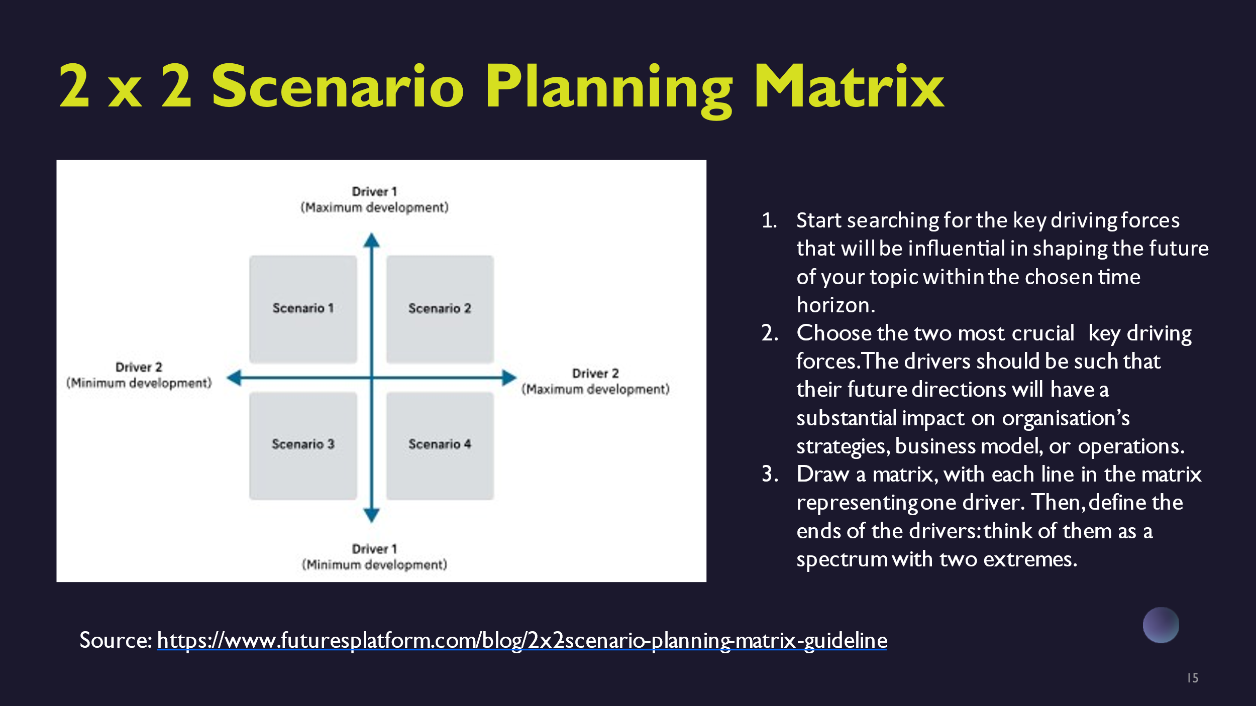

We begin by identifying the key driving forces that will shape the future of your topic. You can utilize the PESTE framework (Political, Economic, Social, Technological, Environmental) to guide this process. Once these driving forces are identified, choose the two most critical ones that will significantly impact your organization’s strategies, business model, or operations in the future.
Next, create a matrix where each axis represents one of these key drivers. Define the extremes of each driver along its axis to create a spectrum. The first key driver will be represented on the vertical axis, while the second key driver will be on the horizontal axis. This matrix setup will visually illustrate how different combinations of these drivers could potentially shape various future scenarios.

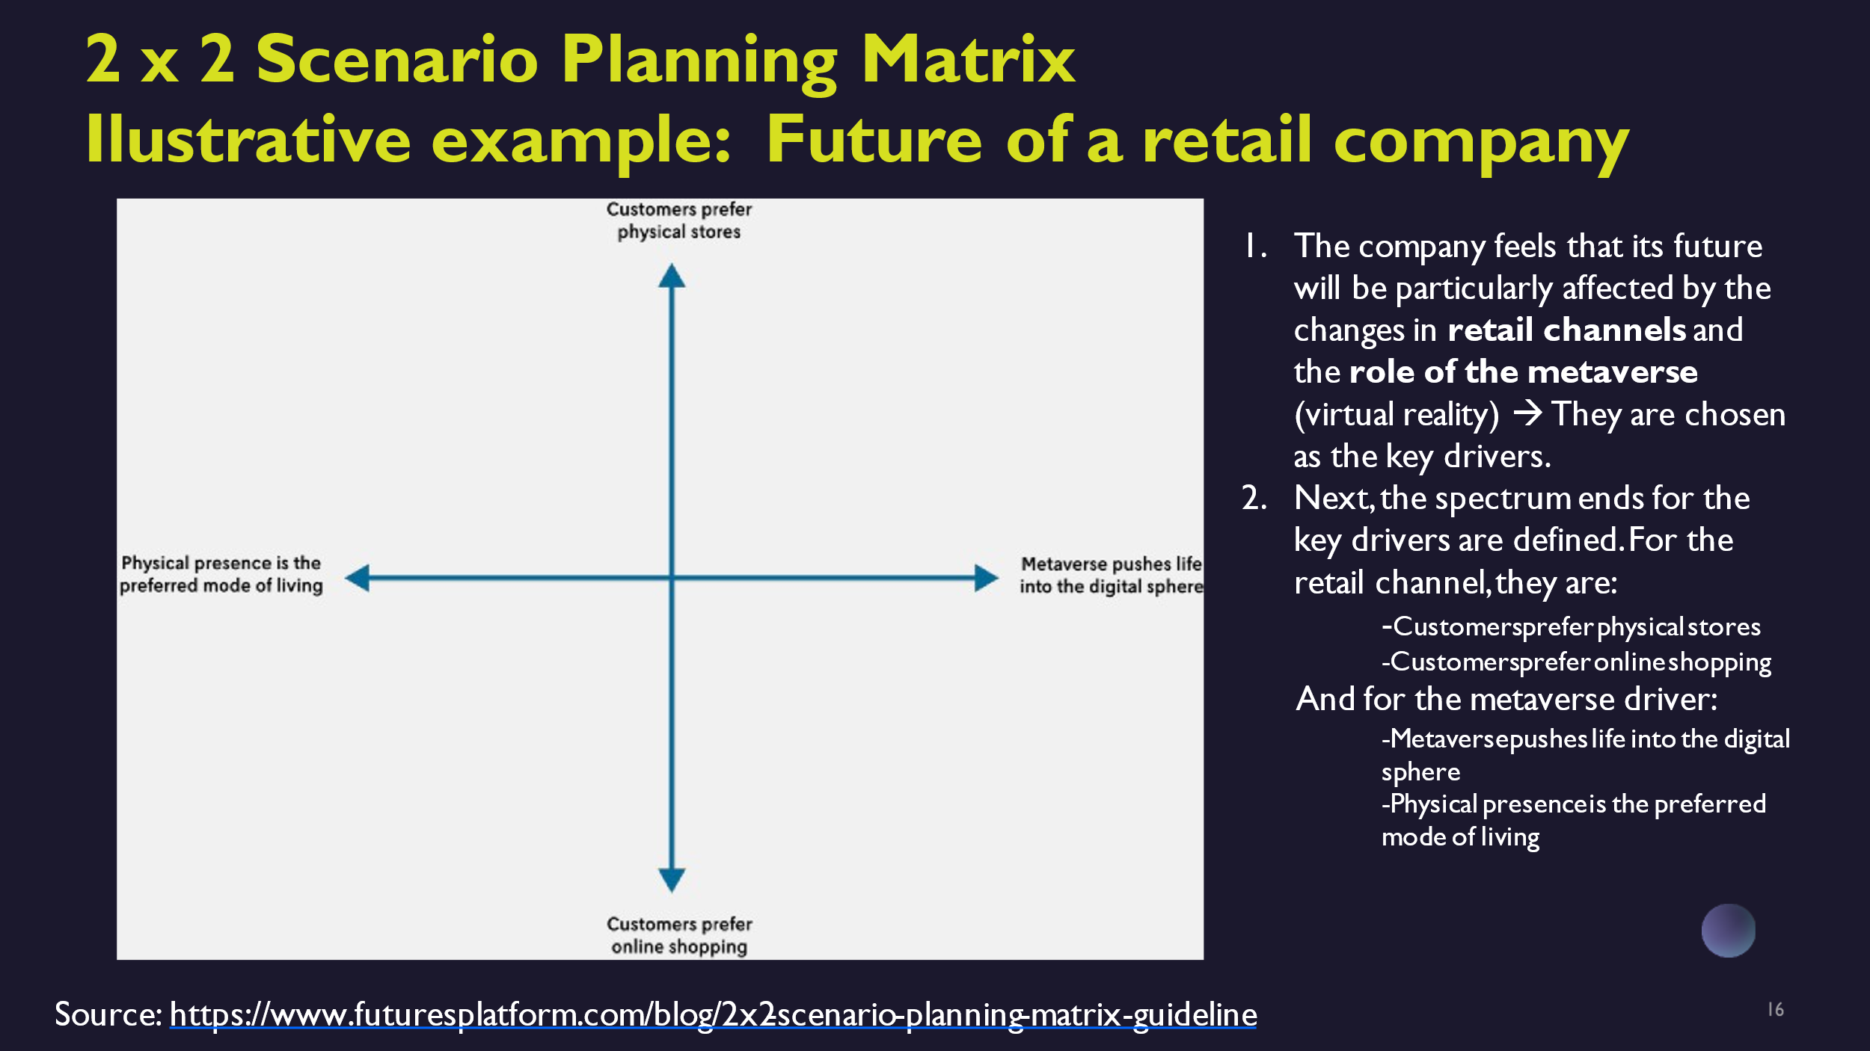

First, before we continue with our case company, we here envision exploring the impact of retail channel changes and the role of the metaverse on a hypothetical retail company's future. By delineating the extremes of these drivers, we generate multiple plausible scenarios to explore strategic responses.
In this example, the retail company anticipates that changes in retail channels and the emergence of the metaverse (virtual reality) will significantly shape its future. These factors are identified as the key drivers.
Next, we define the spectrum ends for each key driver:
For the retail channel, the spectrum ranges from “Customers prefer physical stores” to “Customers prefer online shopping”.
Regarding the metaverse driver, the spectrum ranges from “Metaverse accelerates life in the digital realm” to “Physical presence remains the preferred mode of living”.
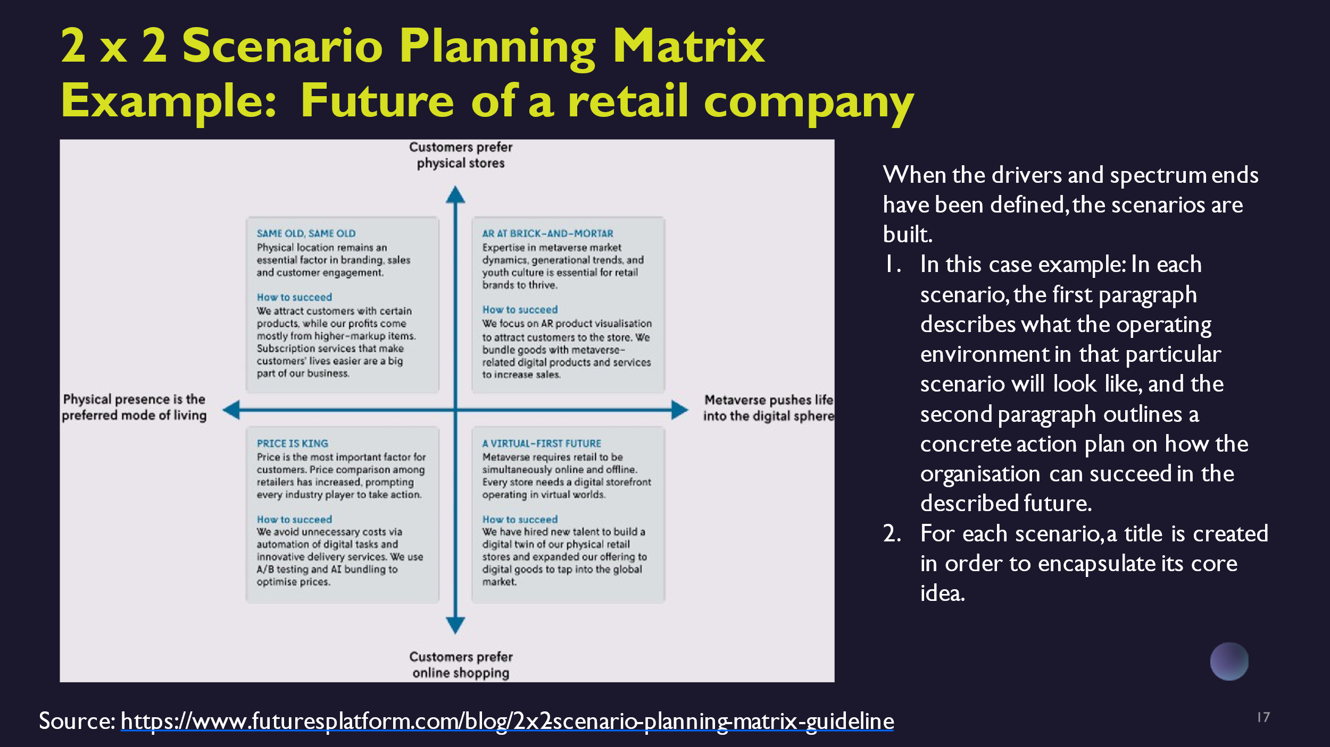

Once the key drivers and their spectrum ends have been defined, you can start building the scenarios.
In this example, each scenario includes two main parts:
- A description of what the operating environment will look like in that particular scenario.
- A concrete action plan outlining how the organization can succeed in the future.
Each scenario is given a title that encapsulates its core idea.
For our case company, we identify the key driving forces that will shape the future of the cybersecurity technology exporter within our chosen time horizon. These key drivers significantly impact the organization’s strategies, business models, or operations. In our case, those are
- technological advancements in AI and
- regulatory changes in data privacy.
We visualize potential futures based on these two critical drivers:
- The vertical axis represents technological advancements in AI, ranging from minimal integration in cybersecurity solutions to widespread adoption leading to autonomous threat detection and response systems.
- The horizontal axis depicts regulatory changes in data privacy, ranging from stringent regulations imposing heavy compliance burdens to harmonized global standards fostering seamless market access.
By plotting these drivers on the matrix, we can create four distinct scenarios that outline plausible futures for our cybersecurity technology exporter:
Scenario A: Minimal AI Integration with Stringent Data Privacy Regulations
Scenario B: Minimal AI Integration with Harmonized Data Privacy Standards
Scenario C: Advanced AI Integration with Stringent Data Privacy Regulations
Scenario D: Advanced AI Integration with Harmonized Data Privacy Standards

Part 5

Now, let's take a closer look at the scenarios.

In Scenario 1, which we can name AI-Powered Expansion,
AI-driven cybersecurity solutions dominate the market, enhancing operational efficiency and threat mitigation. Favorable regulatory conditions facilitate global market expansion without major compliance hurdles.
Action Plan could be:
- Invest heavily in AI research and development.
- Expand into new markets with relaxed data privacy regulations to capitalize on early adopter advantages.

In Scenario 2, which we can name Regulated AI Revolution,
technological breakthroughs in AI bolster cybersecurity capabilities, but stringent data privacy regulations increase compliance costs and operational complexities.
Action Plan could be:
- Develop adaptive compliance strategies.
- Strengthen partnerships with regulatory bodies to influence policy development while optimizing existing solutions for regulatory compliance.

In Scenario 3, which we can name Agile Market Entry,
the slow adoption of AI in cybersecurity limits technological advancement. However, favorable regulatory environments foster agile market entry and operational flexibility.
Action Plan could be:
- Focus on incremental AI integration.
- Leverage regulatory leniency to innovate customer-centric cybersecurity solutions tailored to emerging market needs.

In Scenario 4, which we can name Compliance-Driven Innovation,
minimal progress in AI applications hinders cybersecurity innovation. Complex data privacy regulations restrict market expansion and increase compliance burdens.
Action Plan could be: Diversify product offerings beyond AI-driven solutions. Invest in compliance automation tools and strategic partnerships to navigate regulatory complexities while exploring niche markets.

Use of scenarios: Deepening and Concretizing the Scenarios

- Future tables
- Excellent SWOT (Future driven SWOT)
- Visionary concepts
- Steps towards the vision

From here, we can further develop and refine these scenarios using additional methods such as future tables, future-driven SWOT analyses, visionary concepts, and actionable steps toward achieving our vision. For today’s workshop, we will focus specifically on developing visionary concepts.

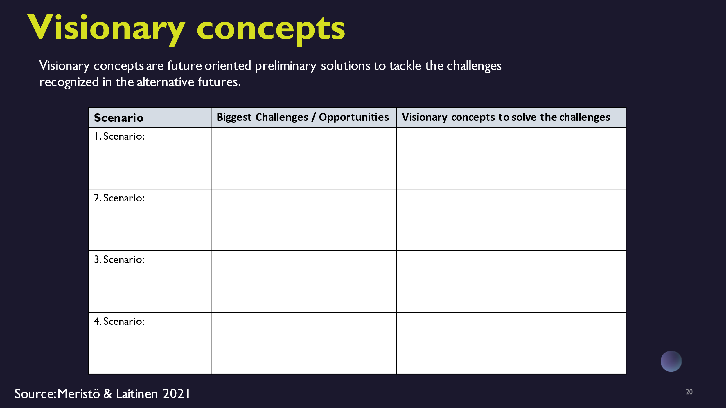

Visionary concepts that are future-oriented preliminary solutions to address challenges identified in alternative future scenarios. These concepts should aim to position your organization competitively in the future landscape. You can create a table including the following sections:
- List the alternative future scenarios.
- Identify the major challenges and opportunities associated with each scenario.
- Propose innovative concepts or strategies to solve the identified challenges for each scenario.

Scenario | Biggest Challenges | Opportunities | Visionary Concepts
AI-Powered Expansion | - Ensuring the quality and security of AI solutions - Managing rapid growth in diverse regulatory environments | - Leading the market with AI-driven innovations - Expanding globally without major compliance issues | AI-Focused Niche Expertise - Partner with established AI firms to enhance offerings - Focus on a few key markets with relaxed regulations to maximize impact
Regulated AI Revolution | - High compliance costs - Navigating complex and varying regulations | - Establishing a strong compliance-oriented brand - Leveraging regulatory expertise as a competitive edge | Compliance-Ready AI Solutions - Develop scalable AI solutions that meet regulatory requirements - Create a compliance advisory service to assist customers with regulations
Agile Market Entry | - Slow technological adoption - Potential market fragmentation due to varying regulatory leniency | - Ability to quickly enter and adapt to new markets - Flexibility in product offerings | Flexible AI Integration - Provide modular AI solutions that can be easily adapted - Focus on customer feedback to quickly iterate and improve products
Compliance-Driven Innovation | - Limited innovation in AI - High compliance and operational costs | - Niche market opportunities in non-AI solutions - Strong positioning in compliance automation | Smart Compliance Tools - Develop user-friendly compliance tools tailored for SMEs - Diversify offerings with non-AI cybersecurity solutions to reduce dependency on AI innovation

We also aim to apply this method to anticipate future skills needs. You can analyze the future skills needed in each alternative business scenario and identify existing skills gaps. This involves emphasizing the specific skills crucial for business resilience and growth, as well as assessing current gaps and emerging needs in different future contexts. Here’s how you can map skills needs in our case:
- As you develop visionary concepts, consider the skills necessary to implement these strategies effectively.
- Skills needs may include technical expertise (e.g., AI development skills, cybersecurity knowledge, soft skills (e.g., regulatory compliance, agile methodologies), domain-specific knowledge (e.g., international regulations, market analysis), and specialized competencies (e.g., UX/UI design).
In our case, we anticipate these future skills needs:
- AI expertise in cybersecurity: To develop and secure AI solutions effectively.
- AI development skills: To integrate and innovate AI-powered technologies.
- Regulatory compliance knowledge: To navigate complex and varying regulations globally.
- Global market expansion: To effectively expand into new international markets.
- Legal knowledge: To ensure compliance with regulatory requirements.
- Compliance management skills: To develop and maintain compliance-oriented strategies.
- Regulatory analysis: To understand and comply with evolving regulations.
- Agile development methodologies: To quickly adapt to changing market needs.
- Market analysis: To identify and capitalize on market opportunities.
- Customer feedback analysis: To iteratively improve products based on user input.
- UX/UI design: To create user-friendly compliance tools and solutions.
These skills are crucial for navigating challenges and seizing opportunities outlined in each scenario effectively. After mapping the skills, you can identify any skill gaps, which requires understanding the current skills and competencies of your personnel. This knowledge helps pinpoint areas where continuous learning should be focused.
Furthermore, you can explore Generative AI tools such as Copilot and Chat-GPT. These tools enhance interactive discussions and refine ideas during scenario development and decision-making. Training for these tools will be conducted in a separate workshop.

Conclusion:
Actors Responsible for the Future

- Winners and losers in each scenario
- Recommendations for different actors
- Dimensions for sustainability

After scenario crafting, we identify winners and losers and then create actionable recommendations to understand the implications for stakeholders. For instance, in a scenario of increased global demand for cybersecurity solutions due to rising threats to critical infrastructure, Finnish cybersecurity technology exporters could thrive. Their expertise in advanced encryption and threat detection positions them well to meet the demand for secure digital infrastructures. Conversely, organizations in countries with lax cybersecurity regulations or outdated measures may face heightened risks and disruptions, potentially categorizing them as losers.
Actionable recommendations include:
- Strengthening international partnerships: Encouraging Finnish firms to forge alliances with global enterprises and governments seeking robust cybersecurity solutions.
- Investing in innovation: Increasing R&D investments to enhance cybersecurity technologies continually, staying ahead in innovation.
- Advocating for stringent cybersecurity policies: Urging policymakers to enforce global standards, creating an environment conducive for Finnish exporters.
- Enhancing workforce skills: Promoting cybersecurity training programs to equip local talent with skills to develop cutting-edge solutions.
These steps help Finnish cybersecurity exporters navigate global challenges effectively, ensuring sustained growth and resilience in the digital era.

Johan: We'll now take a 15-minute break. Afterward, I'll introduce you to one additional method for creating scenarios. If you have any questions or uncertainties about the foresight process, please feel free to share them in the chat. I'll collect them for a Q&A session later.

Part 6

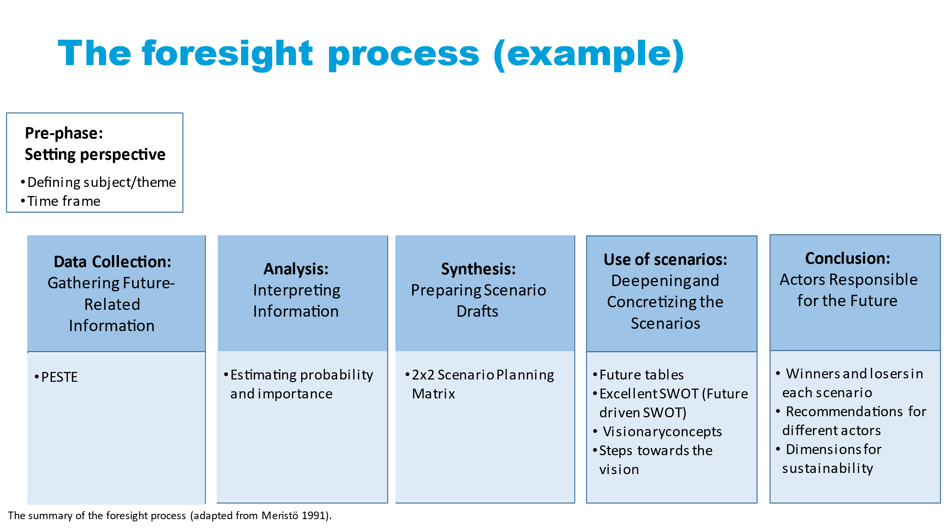

All right, welcome back! Let's continue exploring the foresight process with a focus on leveraging Generative AI insights. In our previous session, you learned how to create scenarios using the 2x2 scenario planning matrix. Now, we will delve into a spectrum of scenarios ranging from positive to negative outcomes. I'll guide you through this step-by-step process.

Step 1: Define Your Focus
Select a specific business area for scenario planning (e.g., market expansion, product innovation).
Step 2: Gather Information
- Collect data from high-quality sources.
- Categorize data using the PESTELE framework - Political, Economic, Social, Technological, Ecological, Legal, and Ethical factors.
- Utilize Chat-GPT or Copilot via platforms like OpenAI's API for brainstorming, trend analysis, and extracting information.
- Clearly define PESTELE factors of interest and engage in interactive discussions with Chat-GPT or Copilot to explore and refine ideas.
- Pose questions or prompts to AI tools about trends, regulations, and market conditions for each PESTELE category.
- Leverage AI capabilities for efficient data processing and pattern recognition.

Step 3: Analyze Insights
- Use AI-driven insights to identify key drivers impacting your business’s future.
- Engage in real-time discussions with Chat-GPT or Copilot discussions to interpret complex data from Step 2's data collection.
- Pose specific questions or prompts to Chat-GPT or Copilot about insights derived from data analysis.
- Review outputs generated by Chat-GPT or Copilot to pinpoint influential drivers for strategic responses.
- Inform strategic decision-making processes with AI-generated insights.

Step 4: Generate Scenarios
- Develop scenarios (Continuation, Positive Development, Negative Development, Catastrophic, Unexpectedly Positive) based on identified key drivers:
  - Continuation Scenario: Projecting current trends and stability.
  - Positive Development Scenario: Envisioning favorable conditions and outcomes.
  - Negative Development Scenario: Considering challenges and risks.
  - Catastrophic Scenario: Exploring extreme events or disruptions.
  - Unexpectedly Positive Scenario: Anticipating unforeseen opportunities.
- Use AI to adjust variables and explore alternative futures.
- Utilize AI-generated scenarios for decision support and contingency planning.

Step 5: Analyze Scenarios
- Pose scenario-specific queries to AI tools regarding workforce implications.
- Use AI to analyze scenario impacts on future skills environments.
- Identify skill gaps and align workforce capabilities with future needs using AI insights.
- Support strategic decision-making with AI-generated scenario analyses.

Step 6: Continuous Learning
- Real-time Monitoring and Adjustment:
  - Employ AI for ongoing monitoring of industry trends and scenario evolution.
  - Continuously analyze new data against scenario indicators.
  - Refine scenario analyses based on updated data and changing business conditions.
Iterative Refinement:
  - Engage in iterative discussions with AI tools to fine-tune scenario parameters.
  - Adjust inputs based on the latest developments and insights.
Learning Integration:
  - Integrate AI-generated insights into organizational planning frameworks.
  - Inform long-term workforce planning and skills development strategies.
  - Ensure alignment of learning initiatives with anticipated future business scenarios.

By following these steps and leveraging AI-driven insights, export SMEs can enhance their strategic foresight capabilities, making informed decisions that foster resilience and sustainable growth in an evolving business landscape.
I want to emphasize that in both foresight processes we covered today—the 2x2 scenario planning matrix and exploring a spectrum of scenarios from positive to negative outcomes—you have the opportunity to integrate visionary concepts and other previously discussed tools. Before we wrap up today, I'll provide a brief introduction to these tools.

Future Tables
Future tables are structured frameworks designed to outline potential future developments and their implications. They provide a visual representation of scenarios, helping anticipate shifts in markets, regulations, and technology. By organizing potential futures systematically, you can align your business strategies with upcoming trends. For example, if stricter environmental regulations are anticipated, a future table can aid in planning for compliance and innovation in sustainable practices.

Excellent SWOT (Future-driven SWOT)
This approach extends traditional SWOT analysis by focusing on future strengths, weaknesses, opportunities, and threats. For export SMEs, it involves anticipating how future trends and disruptions could impact competitive positioning. For instance, identifying opportunities in emerging eco-friendly markets or threats from new trade barriers ensures proactive strategy formulation that prepares for diverse scenarios.

Steps Towards the Vision
This method involves mapping out concrete actions and milestones to achieve long-term strategic goals. For export SMEs, it breaks down visionary aspirations into manageable steps. For example, leading in exporting sustainable products might require investing in green technologies, obtaining certifications, and forming partnerships with eco-conscious suppliers. This approach ensures your overarching vision is supported by a clear, actionable roadmap.
By integrating these methods into your foresight processes, you can develop robust strategies that prepare your export SME for a spectrum of possible futures, fostering resilience and sustainable growth in an evolving business landscape.
To conclude today's session, I recommend the Foresight Workbook for Practitioners by Meristö & Laitinen, 2021. This resource contains the tools and models we discussed today, along with additional valuable information.
I've noticed several questions in the chat, and I'll address them in a video that I'll send to you.
Johan: Thank you all for your engagement and insightful questions during today's session. Your active participation has been invaluable. I look forward to addressing your queries in the video and don't hesitate to reach out if you have further thoughts or need additional information.

