General Information

Schedule
Topic | Date | Notes
Introduction | Wed 6.9.
Server Side Topics | Thu 14.9.
Server Side Topics | Thu 21.9.
Server&Client Side Topics | Thu 28.9.
Client Side Topics, legislation | Thu 5.10.
Exam on legislation | Thu 12.10.
No Lecture on week 42 | -
SW SDL, DevSecOps | Thu 26.10.
Setting up Secure CI/CD | Thu 2.11.
Automation | Thu 9.11.
Integration | Thu 16.11.
Project | Thu 23.11.
Project | Thu 30.11.
Project | Thu 7.12.
Reserved | Thu 14.12.

Course Structure
Sessions once a week on Thursdays.

Course conventions:
- Material on topics will be provided one week before the lecture. You are required to familiarize yourself with the material before the lab work.
- Homework is expected to be returned before the lecture.
- Test on legislation is compulsory part of the course and will be held at campus.
- On the second period we will secure a CI/CD pipeline. Familiarity with DevOps is not required, but of course will help.

Grading
Exam – Compulsory, Pass/Fail
Homework 35% of the grade
Lab assignments 35% of the grade
Project 30 % of the grade

Grading for Homework/Lab assignments:
90% – 5
80% – 4
70% – 3
60% – 2
50% – 1

Course feedback form

Other Learning Environments
- TryHackMe
- Hack the Box
- Over the Wire - Using Linux Shell
- Under the Wire - Using Windows Powershell

Web Application Security

Web Security Academy account

Assignment
Please create an account on Web Security Academy https://portswigger.net/web-security and return your account name here.

Using Burp Suite

Install Options
You can run Burp Suite on several platforms. You may run it either on your host operating system or use a virtual machine with some common operating system and recent Java support. Please check https://portswigger.net/burp/documentation/desktop/getting-started for up-to-date guidance.
Burp Suite Community Edition is pre-installed in Kali https://kali.org/ and Parrot Security https://www.parrotsec.org/ penetration testing distributions. It is advisable to check for and install updates, if available. Recent versions of Burp Suite do this automatically on startup.

Using Burp Suite
Most important tabs: https://securityzines.com/flyers/burp.html
User Interface: https://youtu.be/nECt-0zW0O4
Intercepting HTTP Traffic: https://youtu.be/ouDe5sJ_uC8
Defining Target Scope: https://youtu.be/0mTg2BsYVmg
Interception Rules: https://youtu.be/SaRJgLQ5fOM
Repeating and Modifying Requests: https://youtu.be/_Wifm2g9ugg

Extending Burp Suite
https://portswigger.net/burp/documentation/desktop/tools/extender

Web Security Academy Lab Results
Please take and return two screenshots from the page https://portswigger.net/web-security/hall-of-fame while you are logged in:
One at the top of the page showing your rank at the top as well as your progress on the right side, and
One at the bottom of the page showing your username at the bottom of the Hall of Fame.
Examples:
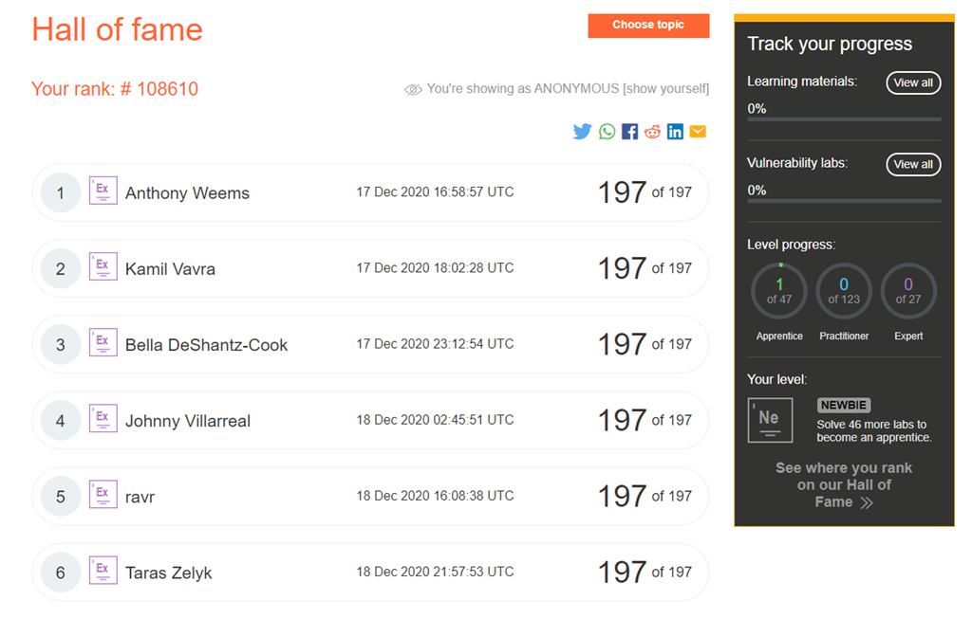

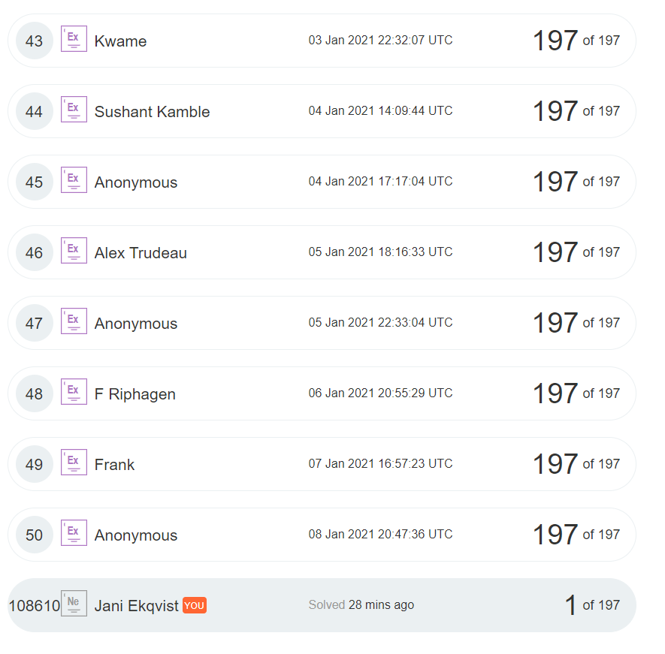

OWASP Top Ten
OWASP Top Ten assignment

Assignment
Please identify, how each of the OWASP Top Ten Application Security Risks affect server-side programming, and how they affect the client side? Find an example issue of each risk for both server and client side, if applicable.

Please return a table following this formatting:

Risk | Example of Server issue | Example of Client issue
A1...
A2...
...

Advanced Topics

Extra Assignment
Please finish at least 10 lab exercises either from the topics listed in the Advanced topics page or from the practitioner or expert level labs on the topics we have covered.
10 labs – +½ to your homework grade
20 labs – +1 to your homework grade
30 labs – +1½ to your homework grade

Topics not included in the course
Clickjacking https://portswigger.net/web-security/clickjacking
WebSockets https://portswigger.net/web-security/websockets
DOM-based vulnerabilities (in addition to DOM XSS) https://portswigger.net/web-security/dom-based
Insecure Deserialization https://portswigger.net/web-security/deserialization
Server-Side Template Injection https://portswigger.net/web-security/server-side-template-injection
Web Cache Poisoning https://portswigger.net/web-security/web-cache-poisoning
HTTP Host Header Attacks https://portswigger.net/web-security/host-header
HTTP Request Smuggling https://portswigger.net/web-security/request-smuggling
OAuth Authentication Vulnerabilities https://portswigger.net/web-security/oauth

Server-Side Vulnerabilities
Injections

OWASP
https://owasp.org/Top10/A03_2021-Injection/

SQL Injection attacks
https://portswigger.net/web-security/sql-injection

Additional Tools:
https://sqlmap.org/ → https://portswigger.net/support/using-burp-with-sqlmap

OS Command Injections
https://portswigger.net/web-security/os-command-injection

XML External Entity Injections
https://portswigger.net/web-security/xxe

https://owasp.org/Top10/A05_2021-Security_Misconfiguration/
Preventing Injection attacks

Assignment
- What is the standard secure method for retrieving information from an SQL database based on user provided input?
- What is the most effective way to prevent command injection vulnerabilities in your code?
- What XML parser features you should disable to minimize the risk of an XXE vulnerability?
- (2p) Write a function in Javascript, Java, Python, PHP or C that accepts username and password as input, securely checks from an SQL database whether the user is allowed to log in and returns true if login is allowed. You are not required to secure the passwords at this point. You can use
create table users (
username TEXT PRIMARY KEY,
password TEXT NOT NULL,
email TEXT NOT NULL UNIQUE
);
as your table schema. If you want to test your code, SQLite provides sufficient features.
Injection Labs
Please complete the following labs:
SQL
https://portswigger.net/web-security/sql-injection/lab-retrieve-hidden-data
https://portswigger.net/web-security/sql-injection/lab-login-bypass
https://portswigger.net/web-security/sql-injection/union-attacks/lab-determine-number-of-columns
https://portswigger.net/web-security/sql-injection/union-attacks/lab-find-column-containing-text
https://portswigger.net/web-security/sql-injection/examining-the-database/lab-querying-database-version-mysql-microsoft
https://portswigger.net/web-security/sql-injection/examining-the-database/lab-listing-database-contents-oracle
OS Command:
https://portswigger.net/web-security/os-command-injection/lab-simple
https://portswigger.net/web-security/os-command-injection/lab-blind-time-delays
XXE:
https://portswigger.net/web-security/xxe/lab-exploiting-xxe-to-retrieve-files
https://portswigger.net/web-security/xxe/lab-exploiting-xxe-to-perform-ssrf

Authentication& Authorization

Authentication
https://portswigger.net/web-security/authentication

Additional material:
NIST Special Publication 800-63, especially 800-63B:
https://pages.nist.gov/800-63-3/

https://owasp.org/Top10/A07_2021-Identification_and_Authentication_Failures/

Authorization
https://portswigger.net/web-security/access-control

OWASP https://owasp.org/Top10/A01_2021-Broken_Access_Control/

Directory Traversal
https://portswigger.net/web-security/file-path-traversal

Additional tools:
Gobuster https://github.com/OJ/gobuster
Dirbuster – Abandoned project, included as Forced Browse in OWASP ZAP. You’ll still see great wordlists created and shared for dirbuster, so check it out.
FFUF https://github.com/ffuf/ffuf – Developed here in Turku by Joona Hoikkala
wfuzz https://github.com/xmendez/wfuzz

Preventing IAAA attacks

Assignment
- Please provide at least 5 general principles you should follow when implementing an authentication mechanism.
- Please provide at least 5 general principles you should follow when implementing an authorization mechanism.
- What is the most effective way to prevent path traversal attacks?
- (2p) Write a function in Javascript, Java, Python, PHP or C that accepts username and password as input, secures the password using a suitable one-way key derivation function and stores it in the SQL database from the previous homework assignment. In addition to returning the code, what are the initial values your key derivation function is initialized with?

Authentication&Authorization Labs
- Description
Please complete the following labs:
Authentication
https://portswigger.net/web-security/authentication/password-based/lab-username-enumeration-via-different-responses
https://portswigger.net/web-security/authentication/password-based/lab-broken-bruteforce-protection-ip-block
https://portswigger.net/web-security/authentication/multi-factor/lab-2fa-simple-bypass
https://portswigger.net/web-security/authentication/other-mechanisms/lab-password-reset-broken-logic
https://portswigger.net/web-security/authentication/other-mechanisms/lab-password-brute-force-via-password-change
Authorization
https://portswigger.net/web-security/access-control/lab-unprotected-admin-functionality
https://portswigger.net/web-security/access-control/lab-unprotected-admin-functionality-with-unpredictable-url
https://portswigger.net/web-security/access-control/lab-user-role-controlled-by-request-parameter
https://portswigger.net/web-security/access-control/lab-user-role-can-be-modified-in-user-profile
https://portswigger.net/web-security/access-control/lab-user-id-controlled-by-request-parameter
https://portswigger.net/web-security/access-control/lab-user-id-controlled-by-request-parameter-with-password-disclosure
https://portswigger.net/web-security/access-control/lab-insecure-direct-object-references
Directory Traversal
https://portswigger.net/web-security/file-path-traversal/lab-simple

Information disclosure&business logic

Information disclosure
https://portswigger.net/web-security/information-disclosure

Touches two OWASP Top Ten Vulnerabilities:
https://owasp.org/Top10/A02_2021-Cryptographic_Failures/
https://owasp.org/Top10/A05_2021-Security_Misconfiguration/

Additional Tools:
shhgit https://github.com/eth0izzle/shhgit
urlscan https://urlscan.io/
Object storage https://buckets.grayhatwarfare.com/
Shodan https://www.shodan.io/
And don’t forget Google Dorks.

Business Logic
https://portswigger.net/web-security/logic-flaws

Additional material:
https://github.com/kdeldycke/awesome-falsehood

Preventing Information disclosure and business logic issues

Assignment
- Please list 5 typical sources of unwanted information disclosure in web applications.
- What 6 prevention steps does OWASP list for security misconfigurations?
- What proactive controls does OWASP suggest for preventing the exposure of sensitive data and protecting that data everywhere?
- Please list 5 typical examples of business logic vulnerabilities.
- Which steps of the MS SDL are most effective in preventing business logic vulnerabilities?

Disclosure&logic labs
Please complete the following labs:
Information Disclosure
https://portswigger.net/web-security/information-disclosure/exploiting/lab-infoleak-in-error-messages
https://portswigger.net/web-security/information-disclosure/exploiting/lab-infoleak-on-debug-page
https://portswigger.net/web-security/information-disclosure/exploiting/lab-infoleak-via-backup-files
https://portswigger.net/web-security/information-disclosure/exploiting/lab-infoleak-authentication-bypass
Business Logic
https://portswigger.net/web-security/logic-flaws/examples/lab-logic-flaws-excessive-trust-in-client-side-controls
https://portswigger.net/web-security/logic-flaws/examples/lab-logic-flaws-high-level
https://portswigger.net/web-security/logic-flaws/examples/lab-logic-flaws-inconsistent-security-controls
https://portswigger.net/web-security/logic-flaws/examples/lab-logic-flaws-flawed-enforcement-of-business-rules

MS SDL Group assignment

Assignment
Please return your group’s list of MS SDL most effective controls for preventing business logic issues here.

Server-Side Request Forgery

Server Side Request Forgery (SSRF) Issue
https://portswigger.net/web-security/ssrf

OWASP 2021
https://owasp.org/Top10/A10_2021-Server-Side_Request_Forgery_%28SSRF%29/

SSRF Labs
Please complete the following labs:
https://portswigger.net/web-security/ssrf/lab-basic-ssrf-against-localhost
https://portswigger.net/web-security/ssrf/lab-basic-ssrf-against-backend-system

Client-Side Vulnerabilities

Cross-Site Scripting (XSS)

Web Security Academy
https://portswigger.net/web-security/cross-site-scripting

Useful payloads
JavaScript://%250Aalert?.(1)//'/*\'/*"/*\"/*`/*\`/*%26apos;)/*<!--></Title/</Style/</Script/</textArea/</iFrame/</noScript>\74k<K/contentEditable/autoFocus/OnFocus=/*${/*/;{/**/(alert)(1)}//><Base/Href=//X55.is\76→

https://brutelogic.com.br/blog/building-xss-polyglots/

Preventing XSS Attacks

Assignment
- Please name four different methods for preventing XSS vulnerabilities in web applications.
- What is the difference between CSRF and XSS?
- Why stored XSS attacks are more impactful than reflected XSS attacks?
- (2p) Please provide a function in Javascript, PHP, Python, Java or C that accepts a user provided string as an input and returns unicode-encoded string you can safely use in Javascript context to prevent XSS attacks.

XSS Labs
Please complete the following labs:
https://portswigger.net/web-security/cross-site-scripting/reflected/lab-html-context-nothing-encoded
https://portswigger.net/web-security/cross-site-scripting/stored/lab-html-context-nothing-encoded
https://portswigger.net/web-security/cross-site-scripting/dom-based/lab-document-write-sink
https://portswigger.net/web-security/cross-site-scripting/dom-based/lab-innerhtml-sink
https://portswigger.net/web-security/cross-site-scripting/dom-based/lab-jquery-href-attribute-sink
https://portswigger.net/web-security/cross-site-scripting/contexts/lab-attribute-angle-brackets-html-encoded
https://portswigger.net/web-security/cross-site-scripting/contexts/lab-href-attribute-double-quotes-html-encoded
https://portswigger.net/web-security/cross-site-scripting/contexts/lab-javascript-string-angle-brackets-html-encoded

Cross-Site Request Forgery (CSRF)

Web Security Academy
https://portswigger.net/web-security/csrf

Preventing CSRF and CORS Attacks

Assignment
- What CSRF and reflected XSS attacks have in common?
- What is the best way to prevent CSRF attacks against a web application?
- How should you transmit this additional information from the client to the server? Please provide a valid example HTML snippet.
- Please provide four CORS configuration guidelines for implementing the CORS policy correctly.
- How can XSS vulnerabilities be exploited to bypass even correctly configured CORS restrictions?
CSRF Labs
Please complete the following labs:
https://portswigger.net/web-security/csrf/lab-no-defenses
https://portswigger.net/web-security/csrf/lab-token-validation-depends-on-token-being-present

Cross-Origin Resource Sharing (CORS)

Cross Origin Resource Sharing
https://portswigger.net/web-security/cors

CORS Labs
Please complete the following labs:
https://portswigger.net/web-security/cors/lab-basic-origin-reflection-attack
https://portswigger.net/web-security/cors/lab-null-origin-whitelisted-attack

ICT Legislation
EU Directive on attacks against information systems
https://eur-lex.europa.eu/legal-content/EN/ALL/?uri=CELEX:32013L0040
Rikoslaki / Finnish Criminal Code
https://finlex.fi/fi/laki/ajantasa/1889/18890039001
Finnish Criminal Code in English
https://finlex.fi/en/laki/kaannokset/1889/en18890039
Tietoturvatestauksen lailliset kysymykset
1 Open answer
Milloin syyllistyt viestintäsalaisuuden loukkaukseen?
2 Open answer
Onko laillista pitää hallussaan tietokoneohjelmaa, jolla pystyy tekemään tietomurron? Perustele.
3 Open answer
Mitä lain mukaan tarkoittaa tietojärjestelmän häirintä?
4 Open answer
Milloin syyllistyt tietomurtoon?
5 Open answer
Miten laki suhtautuu epäonnistuneeseen tietomurron yritykseen?
6 Either/Or
Ymmärrän, että minun tulee käyttää tällä kurssilla oppimiani taitoja lakien mukaisesti ja vain lainmukaisiin tarkoituksiin. Ymmärrän, että murtautumistestaajalla on oltava kohdeorganisaation lupa tehdä testaustaan. Testausta suorittaessani varmistan, että lupa toimintaan on pyydetty myös kaikilta asiaan liittyviltä palveluntarjoajilta, kuten esimerkiksi kaikilta testikoneen ja kohteen välisistä verkkoyhteyksistä vastaavilta verkkopalvelujen tarjoajilta sekä ulkoistamistilanteissa myös asianomaiselta palveluntarjoajalta.
Legal Issues in Information Security Testing
1 Open answer
Is it legal to hold software that is suitable for carrying out the offences mentioned in the directive? Please explain.
2 Open answer
What is illegal data interference according to the directive?
3 Open answer
When are you guilty of illegal access to an information system?
4 Open answer
Can a failed attempt of illegal system interference or illegal data interference be an offence? Please explain.
5 Open answer
What does ”without right” mean according to the directive?
6 Either/Or
I understand that I must use the skills that I’ve learned during this course in accordance with the law. I understand that the penetration tester must have the target organization’s permission for testing. I also make certain that a permission to do the tests is requested from all the relevant service providers, such as all network service providers responsible for network connections between the test computer and the target, and in the outsourcing situations, from the relevant service provider.

Secure Software Development
Software Development Lifecycle
MS Security Development Lifecycle
https://www.microsoft.com/en-us/securityengineering/sdl
Webshop of Many Things

Basics
We have been tasked with building a shiny new webshop for our customer. They will be selling many things to many people, but are still a bit unsure about what their actual business is. The focus will be on customer engagement and interactive shopping experience.

Technologies
- The webshop will be using MS Azure as the backend infrastructure.
- All code will be written in some dialect of Javascript
- Backend will be based on node.js
- Project code will be stored in github

Timeline, Resources and Scope
Initial release of the webshop for the public: 15.12.
Working beta: 1.12.

Team size: 3 FTE

Set up infrastructure, backend and frontend software. Graphics and UI design will be outsourced to lowest bidder.
Security in Software Development Lifecycle

Assignment
You have been tasked with leading the development of the Webshop of Many Things.
Please compile a list of security related tasks that your team must accomplish before you begin the actual coding. Please only include tasks that your team has the resources and time to accomplish within the project scope.
IT Security
CISecurity Benchmarks
https://www.cisecurity.org/cis-benchmarks/

CI/CD
Project
Project Directions

Notes and debugging
Some useful commands to gather information and debug your setup:
Docker
docker ps – list running containers
docker images – list created images
docker exec -it jenkins-blueocean bash – gain shell access to your jenkins container
docker logs jenkins-blueocean – show container logs

Systemd
systemctl status docker.service – show the status of the docker service
journalctl xe – show systemd logs

Networking
ip a – check your virtual machine’s IP address. Look for interface like enp3S0.

Configuration
TBD

General
Please note that you can do the project either on your own laptop or utilize the dc lab network server and provided vms.
There are separate assignments related to the project. Please remember to return them.

Please note that the docker in docker (dind) container does not start automatically at startup. This will lead into an error message: dial tcp: lookup docker on 127.0.0.11:53: server misbehaving
Check that both containers are up and running with docker ps, and start the dind using the command in the guide if necessary.

Step 1: Create CI/CD Environment
Please create an Ubuntu Server 22.04 virtual machine. Minimum requirements: 2 CPU, 1GB RAM, 20GB HD.
Install Jenkins and create test project following this guide:
https://www.jenkins.io/doc/tutorials/build-a-node-js-and-react-app-with-npm/
For installing docker, this guideline works well: https://www.digitalocean.com/community/tutorials/how-to-install-and-use-docker-on-ubuntu-22-04
Please return the assignment Initial CI/CD pipeline after finishing this task.

Step 2: Integrate First Security Tests
Integrate Dastardly into your Jenkinsfile. Please note that since these pipelines use separate containers, you'll have to run them in parallel and synchronize the state somehow.
https://portswigger.net/burp/documentation/dastardly/jenkins
You can use the same pipeline and utilize parallel staging for this. You can do a manual synchronization by waiting on input message steps.
Please return an architecture diagram after finishing this step.

Step 3: Continue application implementation
Create a working login page and backend for it for your application. You may create and use a SQLite database for storage and add users statically.
Please return the implementation assignment when you finish this step.

Step 4: Generate unit tests
Create relevant unit tests for your application and integrate them into your CI/CD pipeline. This is a great use case for LLM:s like ChatGPT.
Please return assignment Unit Tests once you have finished this step.

Step 5: Monitor and Report
Create reporting and monitoring functions for your pipeline:
- Build/Deploy status (pass/fail)
- Relevant error messages
- Security Status report
Test your reports by introducing security defects in your code. Document:
- Defective code
- Test Result
- Modifications to tests required based on the results

Step 6: Presentation
Please be prepared to show your finalized CI/CD environment during our final lab session on 7.12.
Finalize your architecture diagram and collect your sources, documentation and reports.
I will review your project and a live demo during the lab session and grade it.

Present your initial CI/CD pipeline

Assignment
Please return here the text of your Jenkinsfile and a screen capture of your Jenkins Blue Ocean view of the CI/CD pipeline you created.

Architecture diagram

Assignment
Please create an architecture diagram showing all the containers and their relations in your build process and return it here. Keep this diagram up-to-date, you'll need it in the future.
Include at least your Jenkins setup, react app and Dastardly in the diagram.

Present your implementation for login
Assignment
Please return here the source code files of your implementation.

Present your Unit Tests

Assignment
Please return here your unit test source code files and a document describing:
- what test cases are you covering?
- what tests are manually generated?
- what tests are automatically generated?
- what mistakes did the automatically generated tests include?
Present completed project

Assignment
Please present your completed project during our final lab session at C3036. Be prepared to show your:
- Finalised architecture diagram
- Pipeline
- Code
- Unit Tests
- Test reports
This assignment will count twice towards your project grade.
Extra: Other Security issues

Assignment
Please document other security issues you have noticed and/or fixed in the project that come from the environment or the tutorials we used. This is an extra assignment which will be calculated towards your total score.

