YTO01-ENP22 Vieras kieli
2024
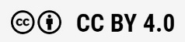


Verna Dahlman, Hanna Korteniemi, Tuomo Kylliäinen, Reetta Laitila, Hanna-Liisa Makkonen, Johanna Palmgren, Noora Pirhonen, Johanna Riskilä, Minna Rissanen, Anni Saaranen, Tuire Salo, Marja-Leena Timonen, Maija Varpula
Rahoittaja:

Vierko |www.keuda.fi/keuda/hankkeet/vierko

Sisällys
Johdanto 3
1. Communication and Interaction 4
1.1 Part 1: Small Talk and Everyday Phrases 5
1.1.1 Polite Phrases 1 6
1.1.2 Polite Phrases 2 7
1.1.3 Everyday conversation 8
1.2 Part 2: Introducing Yourself 9
1.2.1 How to Introduce Yourself 9
1.2.2 Introduce Yourself by Speaking 10
1.3 Part 3: On the Phone and Writing an Email 11
1.3.1 On the Phone 1 11
1.3.2 On the Phone 2 12
1.3.3 Practice writing dates and time 13
1.3.4 Dates and time 13
1.3.5 Spelling Names and Addresses 14
1.3.6 Tips for Writing an Email 15
1.3.7 Writing an Email 16
1.4 Part 4: Working Life 17
1.4.1 Terminology in Your Own Field, Pronunciation 17
1.4.2 Talking about Your Work Tasks 17
1.4.3 Applying for a Job by Email 19
1.4.4 Job Interview 20
2. Information Search 22
2.1 Part 1: Online Dictionaries 23
2.1.1 Online Dictionaries 23
2.1.2 Translators in Test 25
2.1.3 Visual Dictionary 26
2.1.4 English Definitions for Words 26
2.2 Part 2: Reliable Sources and Online Safety 27
2.2.1 How to Stay Safe Online 27
2.2.2 Types of Scams 27
2.2.3 Evaluate Websites 28
2.2.4 Reliable Sources 29
2.3 Part 3: Different Sources for Information Search 30
2.3.1 Wikipedia as a Cross-cultural Dictionary 30
2.3.2 Video from Your Field of Studies 32
2.3.3 Writing a Text with AI 32
2.3.4 Extra Task: Around the World 32
3. Culture 33
3.1 Part 1: Communication in a Multicultural Environment 34
3.1.1 Conversation Starters 34
3.1.2 Stand-up Comedy by Ismo Leikola 34
3.1.3 Formal and Informal Expressions 35
3.1.4 Polite Work Life Conversation 37
3.2 Part 2: Comparing and Understanding Cultures 38
3.2.1 English as a Lingua Franca 38
3.2.2 Multilingual School 39
3.2.3 Culture Comparison 40
3.3 Part 3: Going International 40
3.3.1 Professionals around the World 40
3.3.2 Business Culture Presentation 41
3.3.3 Working Internationally 41
4. Self-evaluation and Feedback 42
5. Skills Demonstration 43

Johdanto
Käsikirjotus mukailee Moodle- ja Itslearning-oppimisympäristöihin luotuja digitaalisia opetusmateriaaleja yhteisten tutkinnon osien pakolliseen osa-alueeseen Viestintä ja vuorovaikutus vieraalla kielellä. Käsikirjoituksessa on kaikki kurssin materiaalit tekstimuodossa. Lisäksi joissain tehtävissä on linkki videoon tai muuhun ulkopuoliseen lähteeseen.

Kurssi on jaettu kolmeen eri teemaan: vuorovaikutus, tiedonhankinta ja kulttuuri. Jokaisen teeman alla on erilaisia tehtävätyyppejä. Tehtävät on tarkoitettu osaamisen hankkimiseen. Ne ovat siis harjoitustehtäviä eikä niitä ole tarkoitettu osaamisen arvioimiseen.

Materiaalin lopussa omana osiona on osaamisen osoittamisen tehtävät. Kyseisillä tehtävillä opiskelija osoittaa osaamisensa englannin kielessä. Opiskelija tekee osaamisen osoittamisen tehtävät sitten, kun hän on tehnyt osaamisen hankkimisen tehtävät.

Käsikirjoituksen lopussa on myös materiaalia opiskelijan itsearviointia ja palautetta varten.

Communication and Interaction
Using a foreign language in different interactive situations.

The student
- manages oral interactive situations
- produces messages needed in interaction
- discusses their work tasks
- produces texts related to their vocational field
- interprets texts related to their vocational field
- assesses and develops their language proficiency

Part One: Small Talk and Everyday Phrases
Polite Phrases 1
Polite Phrases 2
Everyday Conversation

Part Two: Introducing Yourself
How to Introduce Yourself
Introduce Yourself by Speaking

Part Three: On the Phone and Writing an Email
On the Phone 1
On the Phone 2
Practice Writing dates and Time
Dates and Time
Spelling Names and Addresses
Tips for Witing an Email
Writing an Email
Part Four: Working Life
Terminology in Your Own Field, Pronunciation
Talking about Your Work Tasks
Applying for a Job by Email
Job Interview

Part 1: Small Talk and Everyday Phrases
1) Familiarize yourself with these tips:

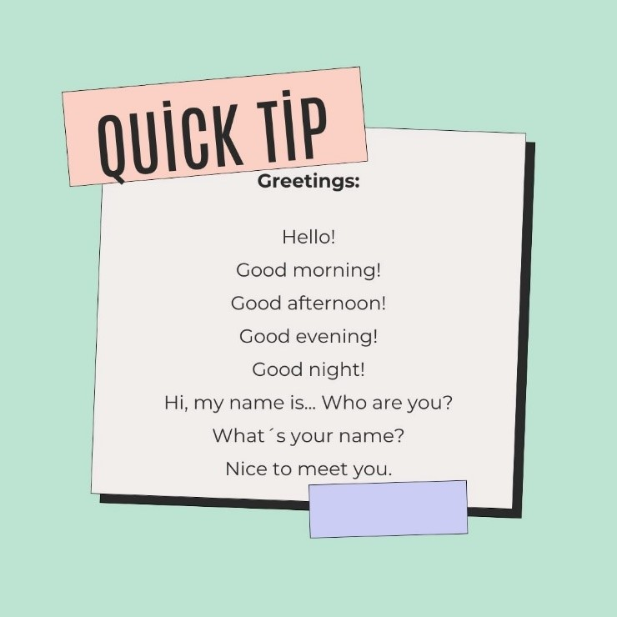

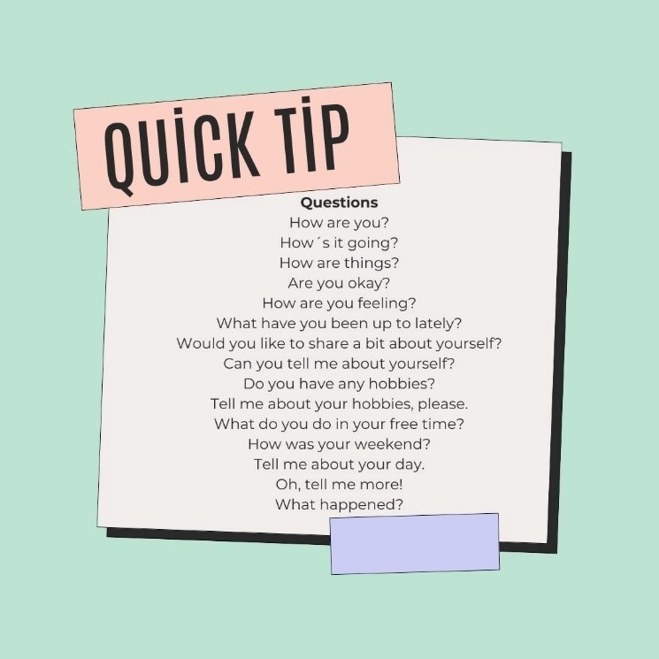
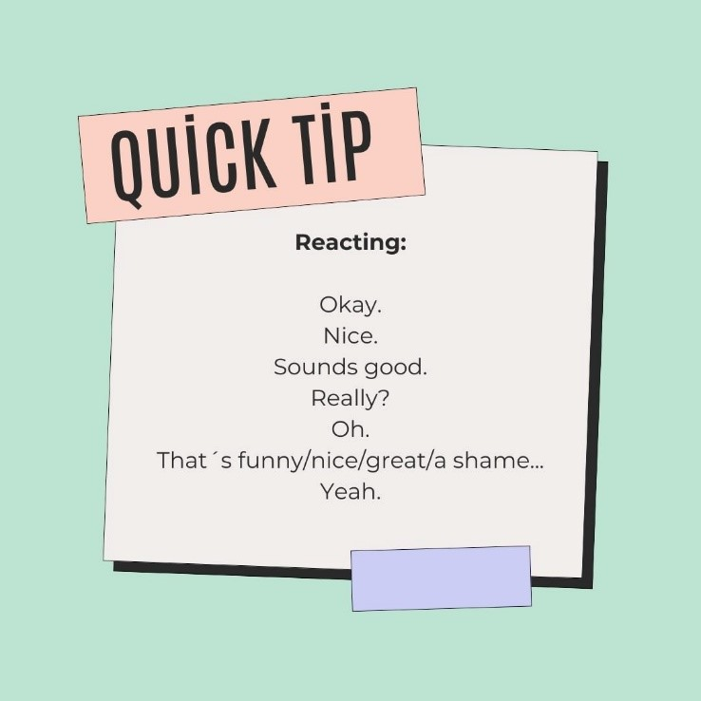

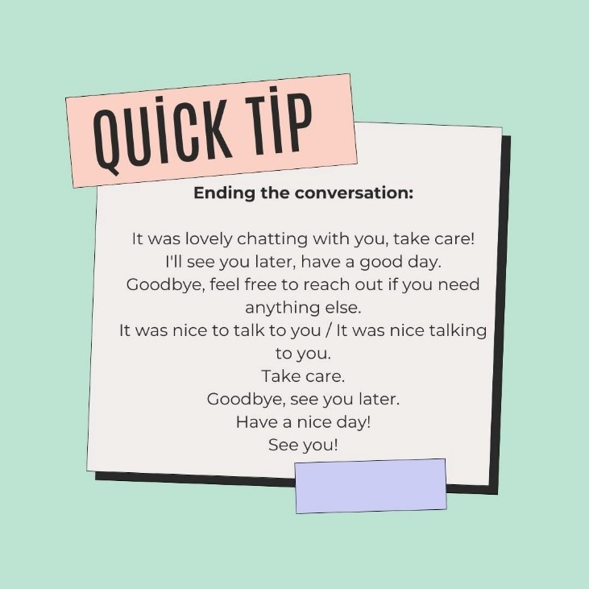
Accessible picture: Greetings info corner.pdf

Kuvat teksteinä:
Greetings:
Hello!
Good morning!
Good afternoon!
Good evening!
Good night!
Hi, my name is... Who are you?
What’s your name?
Nice to meet you.

Reacting:
Okay.
Nice.
Sounds good.
Really?
Oh.
That’s funny/nice/great/a shame...
Yeah.

Questions:
How are you?
How’s it going?
How are things?
Are you okay?
How are you feeling?
What have you been up to lately?
Would you like to share a bit about yourself?
Can you tell me about yourself?
Do you have any hobbies?
Tell me about your hobbies, please.
What do you do in your freetime?
How was your weekend?
Tell me about your day.
Oh, tell me more!
What happened?

Eding the conversation:
It was lovely chatting with you, take care.
I’ll see you later, have a good day.
Goodbye, feel free to reach out if you need anything else.
It was nice to talk to you.
Take care.
Goodbye, see you later.
Have a nice day!
See you!
2) Then complete tasks 1.1.1 and 1.1.2

Polite Phrases 1
Complete the phrases in the exercise. Choose the correct word(s) for the sentences.

- Would you like some coffee? Yes, _________.
- How can I help you? _________ a coke, please.
- Anything else? No, _________.
- Sorry, I dropped your bag. It's_________.
- May I borrow your pencil? Sure, _________.
- Have a nice weekend! Thanks, _________to you!
- Do you mind if I sit here? _________, go ahead.
- Isn't it a lovely day? Yes, _________.
- How about next Tuesday? _________!
- _________, I´ll see you then.
- This is my friend Mark. _________!
- Mark, this is Josh. _________ !
- I’d like you to meet my boss, Mr. Burns. _______________, Mr. Burns.

Great
Hello, Mark
here you are
Hi Josh
I’d like
Nice to meet you too, Mrs. Peterson
Nice to meet you, Mr. Burns
No, not at all, go ahead.
OK, no problem
please
Sounds good
thank you
the same
very nice

KEY:
- Please
- I’d like
- Thank you
- OK, no problem
- Here you are
- The same
- No, not at all
- Very nice
- Sounds good
- Great
- Hello, Mark
- Hi Josh
- Nice to meet. You, Mr. Burns.
- Nice to meet you too, Mrs. Peterson.

Polite Phrases 2

How would you respond? Choose the correct response to each sentence.
- Hello Pat, how are you today?
- Sorry I kept you waiting.
- That's a great jacket.
- I wonder if I could use your phone.
- Wow! I've won € 100!
- It's my birthday today, I turn twenty-three.
- I've got two tickets for tonight's match. Would you like to join me?
- My brother had to stay at home. He's got the flu.
- Guess what! I'm going to a job interview tomorrow.
- Thanks for driving me home the other night.
- Thank you. I quite like it myself, too.
- Happy birthday!
- Good, thanks! And you?
- Yes please! I’ve never been to a hockey match!
- No problem.
- Really? Good luck! What kind of a job is it?
- My pleasure. It was nice chatting with you.
- Sure, here you are.
- Congratulations!
- Sorry to hear that. I hope he’ll get better soon!

KEY
- C Good, thanks! And you?
- E No problem.
- A Thank you. I quite like it myself, too.
- H Sure, here you are.
- I Congratulations!
- B Happy birthday!
- D Yes please! I’ve never been to a hockey match!
- J Sorry to hear that. I hope he’ll get better soon!
- F Really? Good luck! What kind of a job is it?
- G My pleasure. It was nice chatting with you.

Everyday conversation

Practice your conversational skills. Choose either A or B.

A) Have a conversation by speaking with somebody you know (friend, classmate, family member…).

OR

B) Have a conversation by speaking with Chat GPT Mia.

If you choose option A, chatting with a real person, follow the instructions below:

1. Create a video with a real person.
2. See tips for the contents of the discussion at the bottom of this page.
3. Record your conversation.

If you choose option B, follow the instruction below:
- If you don’t have an account on ChatGPT, register according to the site instructions. https://chatgpt.com/
- Next go to www.google.com
- Type in “Voice control for ChatGPT x Mia AI” and install the program.
- Now open ChatGPT and start a conversation with AI by clicking the microphone symbol.
- Submit a screenshot of your dialogue.

Tips for creating the conversation for options A and B:

Step 1: Start the conversation.
Say a greeting like Hello or Hi, my name is [your name], and you are.
Ask for example How's life or Where are you from.

-> reply (and record them) too.

Step 2: Ask simple questions
Keep the conversation going by asking for example about the following topics:

free time
current news
studies
sports

Step 3: Reply to questions and continue the conversation

Step 4: End the conversation politely
Say something like It was so nice talking to you, how about if we… or I'm afraid I have to go now because..., see you later.

(ChatGPT accessed September 30, 2024)

Part 2: Introducing Yourself

How to Introduce Yourself
1) Read the profiles of Emma Foster, Lucas Adams and Sophia Martinez below.

2) One of the texts is very formal and one is informal. Which one is formal, and which one is informal?

3) Write a list of a) formal and b) informal expressions used in the texts.

4) Submit your list.

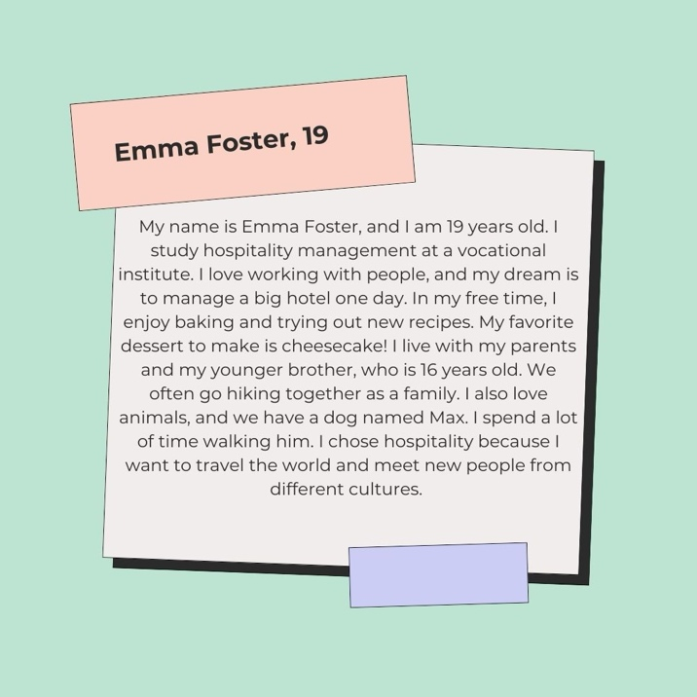

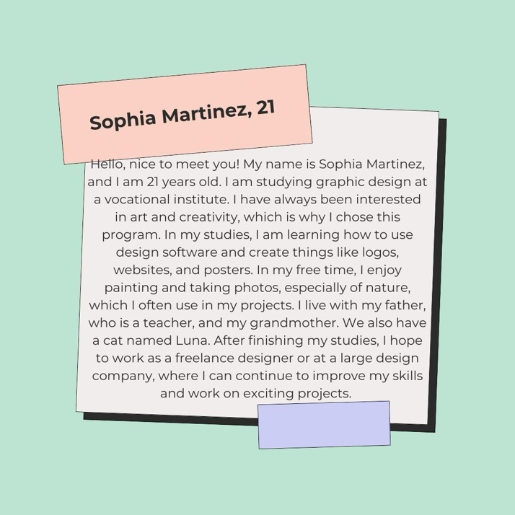

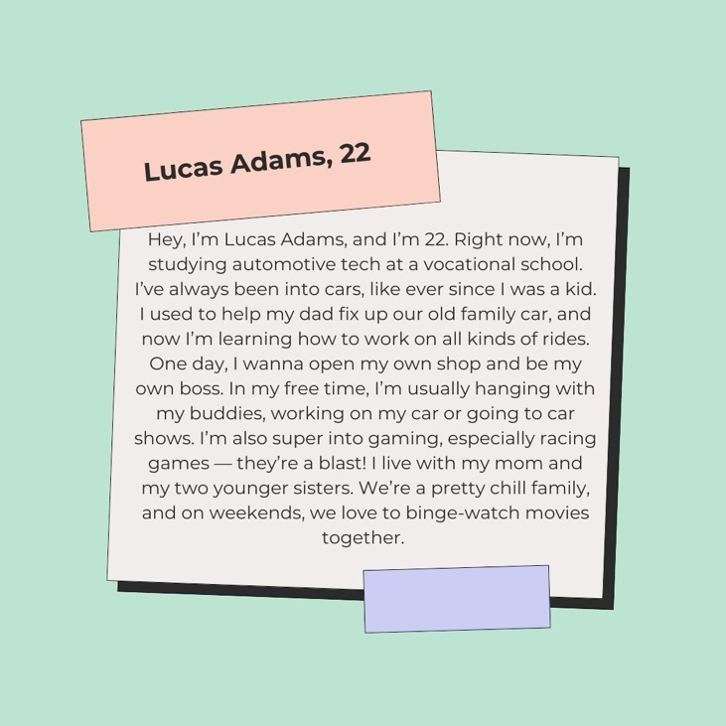

Accessible picture: Introducing yourself examples.pdf

Kuvat teksteinä:

Emma Foster, 19
My name is Emma Foster, and I am 19 years old. I study hospitality management at a vocational institute. I love working with people, and my dream is to manage a big hotel one day. In my free time, I enjoy baking and trying out new recipes. My favorite dessert to make is cheesecake! I live with my parents and my younger brother, who is 16 years old. We often go hiking together as a family. I also love animals, and we have a dog named Max. I spend a lot of time walking him. I chose hospitality because I want to travel the world and meet new people from different cultures.

Sophia Martinez, 21
Hello, nice to meet you! My name is Sophia Martinez, and I am 21 years old. I am studying graphic design at a vocational institute. I have always been interested in art and creativity, which is why I chose this program. In my studies, I am learning how to use design software and create things like logos, websites, and posters. In my free time, I enjoy painting and taking photos, especially of nature, which I often use in my projects. I live with my father, who is a teacher, and my grandmother. We also have a cat named Luna. After finishing my studies, I hope to work as a freelance designer or at a large design company, where I can continue to improve my skills and work on exciting projects.

Lucas Adams, 22
Hey, I’m Lucas Adams, and I’m 22. Right now, I’m studying automotive tech at a vocational school. I’ve always been into cars, like ever since I was a kid. I used to help my dad fix up our old family car, and now I’m learning how to work on all kinds of rides. One day, I wanna open my own shop and be my own boss. In my free time, I’m usually hanging with my buddies, working on my car or going to car shows. I’m also super into gaming, especially racing games — they’re a blast! I live with my mom and my two younger sisters. We’re a pretty chill family, and on weekends, we love to binge-watch movies together.

Introduce Yourself by Speaking
Talk about yourself and make a one-minute-long video.
1) List things about yourself as follows:
- Your name and age, hometown, family, hobbies and interests
- The field and subjects you are studying
- Your future work, duties and the type of business or employer that interest you the most
2) Practice speaking
- Speak clearly.
- Pay attention to your pronunciation.
- Do not read a text or your notes. Talk instead. Remember that reading and talking are two different skills.
- Try to speak naturally to the camera. Don’t forget eye contact.

You can chat with ChatGPT Mia first and ask for feedback on your content and pronunciation.

3) Click the microphone or video icon and start speaking.

Part 3: On the Phone and Writing an Email

On the Phone 1

1) Read the quick tips below for making a phone call.

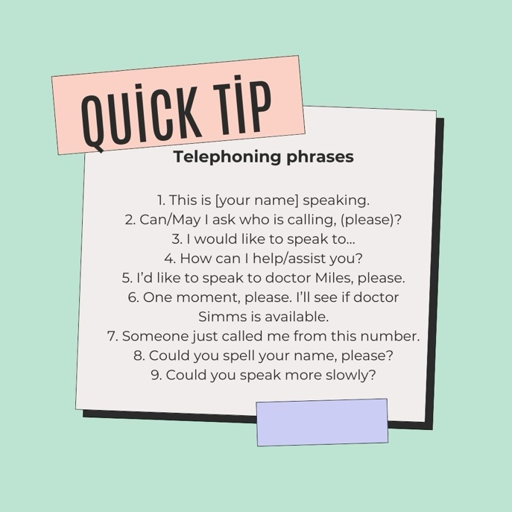

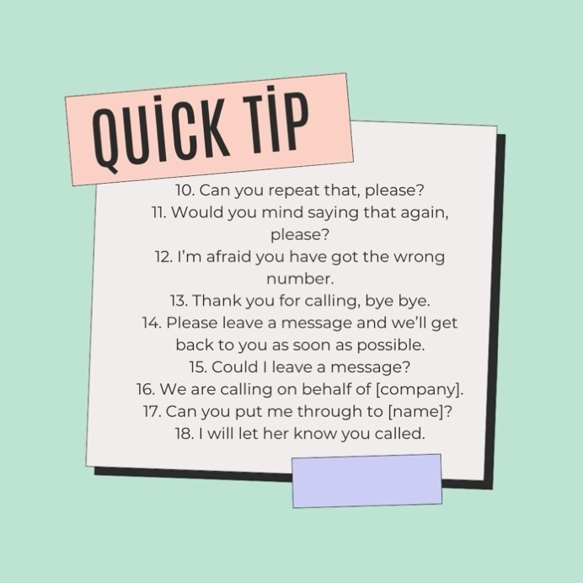
Accessible pictures: Telephoning phrases info corner.pdf

Kuvat teksteinä:
This is [your name] speaking.
Can/May I ask who is calling, (please)?
I would like to speak to…
How can I help/assist you?
I’d like to speak to doctor Miles, please.
One moment, please. I’ll see if Doctor Simms is available.
Someone just called me from this number.
Could you spell your name, please?
Could you speak more slowly?
Can you repeat that, please?
Would you mind saying that again, please?
I’m afraid you have got the wrong number.
Thank you for calling, bye bye.
Please leave a message and we’ll get back to you as soon as possible.
Could I leave a message?
We are calling on behalf of [company].
Can you put me through to [name]?
I will let her know you called.

2) Write what you would say in the following situations.

a. You introduce yourself when calling a prospective customer.
b. You didn't hear what the caller just said.
c. The signal strength is not good, and you can’t hear the caller well.
d. You need to check something, and you hope the caller will not hang up the call.
e. The caller has got a name which is not very common. You should write it down correctly.
f. Your workmate is not in, and the caller leaves them a message. You promise to deliver the message.
g. You finish the call with your loyal customer Mr. Jackson.

Use the quick tips for help. Submit your answers.

On the Phone 2
Put the words in the correct order and rewrite the sentences.

1. how can I / Transport Easy Ltd / help you
2. Jane Peterson, please / put me through to / Could you
3. hold / please
4. on business / I’m afraid / she is away
5. to call / you back / like her / would you
6. it’s / urgent / rather / please / yes
7. please / calling / who’s
8. Kellie Stevens / Lovely Logistics / from / this is
9. due / it’s about / this Friday / the delivery
10. ASAP / let her know / I’ll / right
10. I look forward / her soon / thank you / to hearing from

KEY:
1.Transport Easy Ltd, how can I help you?
2.Can you put me through to Jane Peterson, please?
3.Please hold.
4.I’m afraid she is away on business.
5. Would you like her to call you back?
6. Yes, please. It’s rather urgent.
7. Who’s calling, please?
8. This is Kellie Stevens from Lovely Logistics.
9. It’s about the delivery due this Friday.
10. Right. I’ll let her know ASAP.

11. Thank you. I look forward to hearing from her soon.

Practice writing dates and time

1) Complete the sentences below. Write numbers in letters, for example 11 = eleven.

2) Copy the questions and write down your answers.

a. Today is... (the weekday)
b. Tomorrow will be... (the date)
c. Next month will be... (the month)
d. I was born on... (the date and the year)
e. The New Year's Eve is ... (the date)
f. The official Midsummer Day is... (the date)
g. The Finnish Labour Day is... (the date)

KEY:
e. The New Year’s Eve is on 31 December (Br) / 31st December (Br) / December 31 (Am) /
December 31st (Am)
f. The official Midsummer Day is on 24 June (Br) / 24th June (Br) / June 24 (Am) / June 24th (Am)
g. The Finnish Labour Day is on 1 May (Br) / 1st May (Br) / May 1 (Am) / May 1st (Am)

Dates and time
Fill in the missing date and time. The date format is DD/MM, and the time is am/pm.

For example: Can you do fifth of March (5.3.) at one thirty pm (13:30)?

1. Can you do _________ (5.3.) at _________ (13.30)?
2. Would it be ok on _________ (7.4.) at _________ (8.15)?
3. Can we meet _________ (18.6.) at _________ (12.00)?
4. How about _________ (20.7.) at _________ (8.30)?
5. Well maybe then _________ (27.10.) at _________ (10.10)?
6. Can we meet _________ (28.9.) at _________ (14.10)?
7. How about _________ (2.11.) at _________ (11.05)
8. Can you do _________ (7.2.) at _________ (17.05)?
9. Would it be ok on _________ (11.12) at _________ (16.20)?
10. Can we meet _________ (12.8) at _________ (16.25)?
11. How about _________ (21.5.) at _________ (9.55)?
12. Would it be ok on _________ (26.4.) at _________ (10.50)
13. How about _________ (10.8.) at _________ (7.50)?
14. Can you do _________ (3.1.) at _________ (8.45)?
15. How about _________ (4.7.) at _________ (15.10)?
16. Would it be ok on _________ (9.4.) at _________ (12.05)?

KEY:
1. Can you do fifth of March at one thirty pm?
2. Would it be ok on the seventh of April at a quarter past eight am?
3. Can we meet the eighteenth of June at noon?
4. How about the twentieth of July at half past eight am?
5. Well maybe then the twenty-seventh of October at ten past ten am?
6. Can we meet the twenty-eighth of September at ten past two pm?
7. How about the second of November at five past eleven am?
8. Can you do the seventh of February at five past five pm?
9. Would it be ok on the eleventh of December at twenty past four pm?
10. Can we meet August twelfth at twenty-five past four p?
11. How about May twenty-first at five to ten am?
12. Would it be ok on April twenty-sixth at ten to eleven am?
13. How about the tenth of August at ten to eight am?
14. Can you do the third of January at quarter to nine am?
15. How about the fourth of July at ten past three pm?
16. Would it be ok on April ninth at five past twelve pm?

Spelling Names and Addresses

You must sometimes spell names and addresses letter by letter, especially when speaking on the phone.

1) Revise the spelling and visit The English alphabet on www.worldometers.info/languages/english-alphabet/
Please note how to spell the Finnish Ä: ei with two dots, Ö: ou with two dots, Å: ei with a circle on top.

2) Go to https://ieltsliz.com/alphabet-practice-for-spelling
Listen to the following exercises and repeat what you hear:

- Alphabet Review (letters A-Z)
- Similar Letters Practice. (comparing letters like B/P or D/T). Can you hear the difference?
3) Spell the following names in English, letter by letter, and record yourself.
a. Spell your own name (first and last name) in English.
b. Spell the name Georgina Hernandez.
c. Spell the name Tuure Jälä.
d. Spell the address Yliköyliöntie 6.

Tips for Writing an Email

1) Read the text below on how to write a business email.

1. Start your email with a greeting, “Dear Mr. Smith” or “Dear Sandra Jones”. In more
casual or informal emails, you can say “Hi Alex” or “Hello Dennis”. If the recipient is a
company, i.e. not addressed to a certain person, you can start with “Dear Sir/Sirs” or “To whom this may concern”.
2. If your customer has replied to your email, start by thanking them. For example, “Thank
you for your interest in our products”, “Thank you for your prompt reply”, “Thank you for
your enquiry” or “Thank you for the information”. Thanking creates a positive and polite
impression of you.
3. At the very beginning of the email you should be specific about the purpose of your email, for example “I am writing with regard to…”, “We visited your website…”, “With reference to our telephone conversation this morning…” or “I am writing to you as …”
4. Thank the recipient and add some polite phrases before the closing the email: “I look
forward to hearing from you soon”. Choose a suitable phrase to close your email: “Best
regards/Kind regards” (informal), “Yours sincerely” (formal), “Yours faithfully” (when you
start with Dear Sir/Madam)
5. It is important to keep emails clear, short and precise. Use the KISS test: Keep It Short and Simple.
- Keep the subject line short and clear as it should summarise the contents of the message. (Re: Our telephone conversation this morning)
- When you write your message, keep it to the point.
- Adjust your communication style (informal/formal) to the situation.
- Check grammar and spelling.
- Start and finish your email with a positive note.
- Reread your email before sending it.
- Double check typos, grammar and vocabulary

2) Then answer the questions based on the text and submit your answers.
a. What is an appropriate greeting when you write an email to
- a friend called Sam
- your customer called Jim Joplin
- to a business named Tyre service Ltd?

b. You write a reply to an email. What is a good way to start it to make a good impression?

c. A customer is interested in the services of your business. How should you mention it?

d. How do you finish the email when writing to a customer you know well?

e. Explain the concept of KISS with one sentence.

Writing an Email

Complete the email by choosing the correct word(s) in the right gaps.

_____ Janet Jones
_____ the latest visit at your warehouse.
The _____ you sent _____ _____ were most useful.
Could we meet again _____,10 October at _____ at our premises ?
We _____ our _____ plans in more details.
_____
Greta Jackson, _____
SportsShop

Dear Ms
Store Manager
To
documents
next week
October
by email
2 pm
coopoeration
could discuss
From
Yours sincerely
Thank you for
as attachment

KEY:

Dear Ms Janet Jones

Thank you for the latest visit at your warehouse. The documents you sent by email as attachment were most useful. Could we meet again next week,10 October at 2 pm at our premises? We could discuss our cooperation plans in more details.

Yours sincerely
Greta Jackson, Store Manager

Part 4: Working Life

Terminology in Your Own Field, Pronunciation

1) Choose 10 terms in your field you find difficult to pronounce. Write them down. Feel free to visit https://www.dictionary.com/e/hard-words-to-pronounce/ where there is a list of difficult English words to pronounce.

2) Use some pronunciation dictionary and practice the words. Example dictionary: https://dictionary.cambridge.org/dictionary/english/

3) Create 5 sentences using the words. For example, “I think this exercise is a bit weird”.

4) Record the sentences.

Talking about Your Work Tasks

Talk about your field of study. Choose A or B.

A) Talk with ChatGPT

B) Talk by making a video.

Follow the instructions below.

Option A, talk with ChatGPT

1) Go to ChatGPT.
2) Follow the instructions below. Record your questions to Mia and listen to Mia’s response.
3) Submit a screenshot of you conversation with Mia below

ChatGPT Mia instructions for the assignment:
In this task, you will talk about what you do (or will do) in your vocational field. If you don’t know the right words, don’t worry! You can ask me for help to learn new vocabulary. Follow the steps below:
Step 1: Introduce your field. Start by telling me what you’re studying and what kind of work you will do.

For example:
"I’m studying plumbing, and I will install and fix pipes."

Step 2: Describe a task. Tell me about one thing you do or will do at work. If you’re not sure how to explain it in English, ask for help using these prompts:

"What’s the word for [tool/task]?"

For example:
"In a restaurant, I set up tables. What’s the word for that?"

Step 3: Ask for vocabulary help. If you don’t know the right words, use these prompts to learn:

"What’s the word for [tool or task] in my work?"

For example:
"How do I describe cleaning the kitchen?"
"What’s the word for the tool that cuts pipes?"

Step 4: Talk about tools or skills. Explain what tools or skills you use in your job. Ask for vocabulary if you’re unsure.

"We use [tool name]. How do I describe it?"

For example:
"I use a wrench to fix pipes."

Step 5: Review and practice. After the conversation, review the new words you’ve learned. You can practice with me again by asking:

"Can we go over the words for my tools again?"

Option B, making a video

Step 1: Choose a tool or work task in your field.

Step 2: Ask for vocabulary help. If you don’t know the right words, use Google, for example:

"What’s the English word for [tool or task in your language]?”

Step 3: Talk about tools or tasks and make a video of it.
a) Start by telling
- what you’re studying
- what kind of work you will do

b) Describe a work task or tool

For example: “We/I use a [tool name] to… First you… then… and finally…”

Step 4: Submit your video.

Applying for a Job by Email

Complete the job application by choosing the correct word(s) in the right gaps.

_________ (TYÖHAKEMUS)

4 _________ 20xx

Your _________ on 8 Aug 20xx

VEHICLE BODY MECHANIC

*Dear Mr* Roy Recruiter,

I wish to _________ _________ online.

I have a _________ in the Vehicle Sector.
I _________ damage repairs.

I have worked in Gary’s garage _________ 2023.

My _________ include _________ in addition to vehicle body repairs.

I am eager to improve my _________ in the field.

With my vocational _________ and work _________ I am confident that I am the person you _________.

_________ hearing from you.

_________

Mickey Mechanic (Mr)
Dear Mr.
vocational qualification
specialized in
as advertised
Looking forward to
customer service
apply for the vacancy
Yours sincerely
experience
duties
are looking for
skills and knowledge
since
ad online
September
APPLICATION
education

KEY:

APPLICATION

4 September 20xx

Your ad online on 8 Aug 20xx

VEHICLE BODY MECHANIC

Dear Mr. Roy Recruiter,

I wish to apply for the vacancy as advertised online. I have a vocational qualification in the Vehicle Sector. I specialized in damage repairs. I have worked in Gary’s garage since 2023.
My duties include customer service in addition to vehicle body repairs. I am eager to improve my skills and knowledge in the field. With my vocational education and work experience I am confident that I am the person you are looking for.

Looking forward to hearing from you.

Yours sincerely
Mickey Mechanic (Mr)

Job Interview

Practice what to say at a job interview.

1) Take a look at common job interview questions below.
- Tell me about yourself.
- Describe yourself as an employee (at least three adjectives).
- Why are you interested in this job?
- What do you consider your strengths? What are you good at?
- What is your biggest weakness?
- What situations make you stressed?
- How do you handle pressure? When it comes to work environment, name three things that are most important to you.
- Do you prefer working alone or as part of a team? Why?
- Why do you think you would be the right person for this job?
- What would you like to ask us?

2) Practice answering the questions.

3) Make a video of you answering the questions.

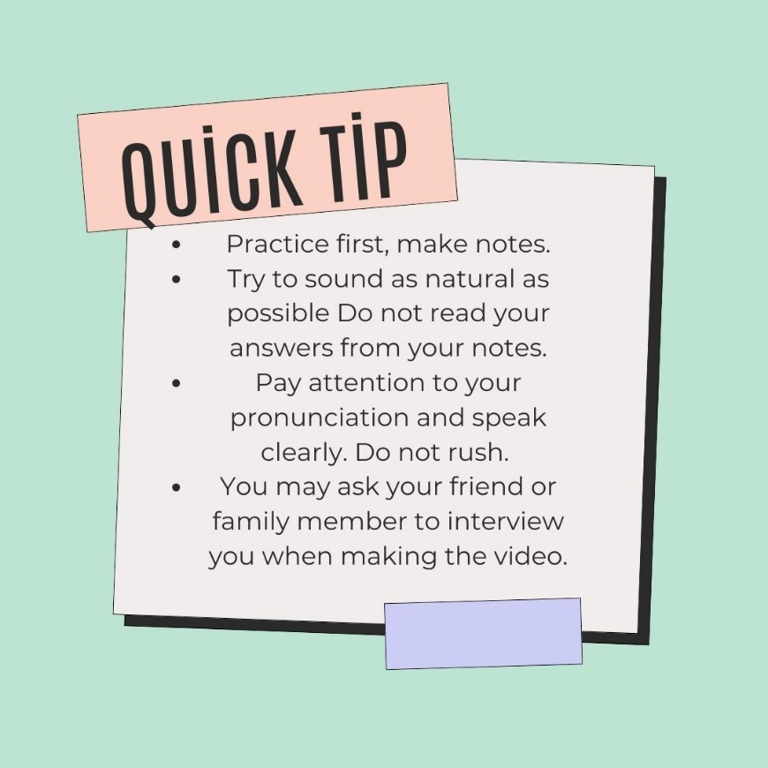
Accessible picture Job interview preparing.pdf

Kuva tekstinä:
Practice first, make notes.
Try to sound as natural as possible.
Do not read your answers from your notes.
Pay attention to your pronunciation and speak clearly. Do not rush.
You may ask your friend or family member to interview you when making the video.

Information Search
Searching for information from different foreign-language sources

The student
- searches for the foreign-language information required in their activities from different sources
- assesses and selects information based on how appropriate, reliable and up to date it is

Part One: Online Dictionaries
Online Dictionaries
Translators in Test
Visual Dictionary
English Definitions for Words
New Words and Expressions

Part Two: Reliable Sources and Online Safety
How to Stay Safe Online
Types of Scams
False News
Evaluate Websites
Reliable Sources
Part Three: Different Sources for Information Search
Wikipedia as a Cross-cultural Dictionary
Website, Blog and Vlog as a Source of Information
Video from Your Field of Studies
Writing a Text with AI

Pre-assignment

1) Take a look at the questions below:
a. Give examples of information you need to search for daily/ weekly/ monthly.
b. Give examples of how and where you search for information.
c. What tools/ devices / apps do you use?
d. How else can you update your knowledge in general? Give examples.
e. How can you update your knowledge in your own field?
f. Name some (online) dictionaries you already know and use. Which one is your favourite?
g. What are the pros and cons of using online tools for translation (such as Google Translator)?
h. What other online tools do you know for translating?
i. Why is it important to use many dictionaries and not just one?

2) Now answer the questions in English. Use complete sentences. You can answer either in written form

OR
by recording your answer.

Part 1: Online Dictionaries
In this section you identify your skills and learn to use appropriate sources for language learning.

Online Dictionaries

Try various online sources to check the meaning of words and phrases.

1) Fill in the chart by using different online dictionaries. See Quick Tips below.
2) What kind of translations do you get for the different words?

3) Submit your word document.

 | Tutkinto | Tutkinnon nimi | Opiskella | Todistus
www.sanakirja.org
www.refoxsanakirja.fi
https://ilmainensanakirja.fi
https://fi.glosbe.com/
thefreedictionary.com/
vocational+school
See the correct, official version on opintopolku.fi Hakutulokset - Opintopolku | No text here. |  | No text here. | No text here.

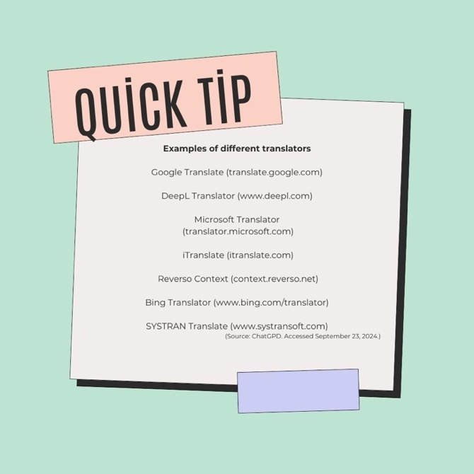
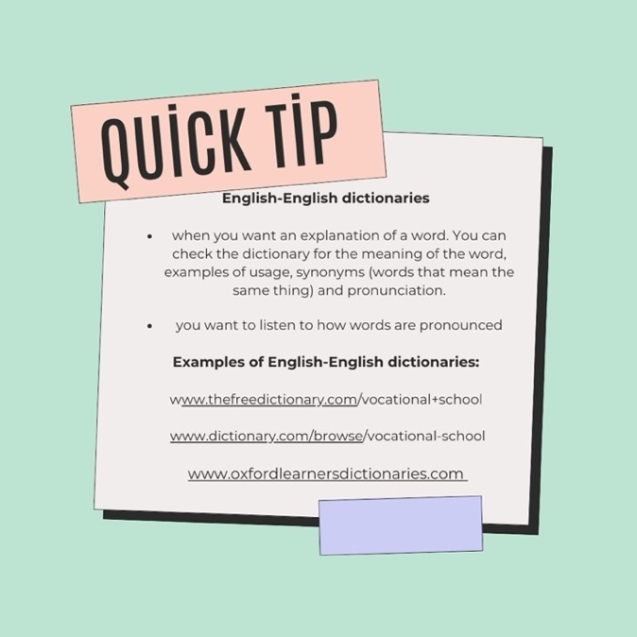

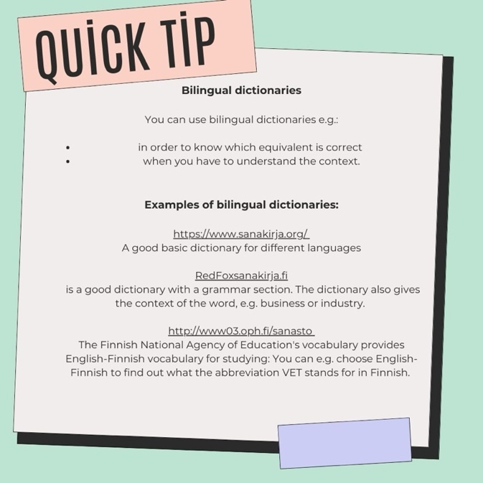
Accessible picture: Translators Info corner.pdf

Kuvat tekstinä:

Examples of different translators:

Google Translate (translate.google.com)
DeepL Translator (www.deepl.com)
Microsoft Translator (translator.microsoft.com)
iTranslate (itranslate.com)
Reverso Context 8context.reverso.net)
Bing Translator (www.bing.com/translator)
SYSTRAN Translate (www.systransoft.com)

English–Englsih dictionaries

When you want an explanation of a word, you can check the dictionary for the meaning of the word, examples of usage, synonyms (words that mean the same thing) and pronunciation.

Examples of English–English dictionaries
www.thefreedictionary.com/vocational+school
www.dictionary.com/browse/vocatinal-school
www.oxfordlearnersdictionaries.com

Bilingual dictionaries

You can use bilingual dictionaries e.g.
- in order to know which equivalent is coorect
- when you have to understand the context

Examples of bilingual dictionaries

https://sanakirja.org/
A good basic dictionary for different languages

Redfoxsanakirja.fi
A good dictionary with a grammar section. The dictionary also gives the context of the word, e.g. business or industry.

http://www03.oph.fi/sanasto
The Finnish National Agency of Education’s vocabulary provides English–Finnish vocabulary for studying. You can e.g. choose English-Finnish to find out what the abbreviation VET stands for in Finnish.

Translators in Test

1) Here is a text that translates the following way:

Finnish text:
Hänellä oli kotona viisi lasta ja kuusi lastaa. Jouluna he hulluttelivat ja ostivat kuusi kuusta. Tarvittiin paljon sisua ja Sisuja, jotta ne saatiin kannettua kartanolle.

English translation:
He had five children and six spatulas. At Christmas they went a little crazy and bought six Christmas trees. It took a lot of determination, sisu, and Sisu candy to get them carried to the yard.

2) Copy the same Finnish text in three (3) different translators of your choice and see which gets the closest to the translation above. Can’t come up with three different translators? Check the Quick Tip for different online translators from the previous task.

3) Write all translations and the source you used for each translation. Answer the following questions in your response:
- Which translator gets the closest?
- How can you avoid poor translations?

Visual Dictionary

1) Open the dictionary: http://www.visualdictionaryonline.com/index.php

2) Go through the “themes” on the left side of the page and choose a theme that suits your field the best.

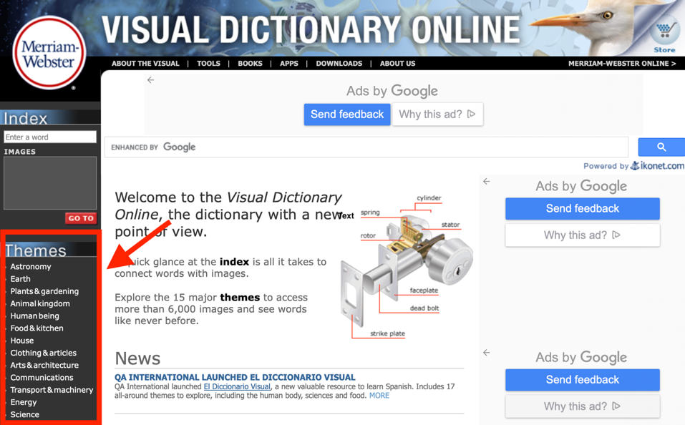
Picture: A screenshot from visualdictionaryonline.com.
3) Explore the pictures and words.

4) Summarize briefly in English what theme you chose and what you learned. How could the dictionary be useful to you in the field you are studying? Record your answer.

English Definitions for Words
You sometimes need to explain the meaning of a word in English. Find some English definitions for words according to the instructions.

1) Choose five (5) words that are new to you in your own field. Find definitions for these words.

2) Are there synonyms i.e. words with a similar meaning for this word? Which of them are more formal and what would you use with your close colleagues?

3) Build up five sentences using these words.

4) Submit your sentences.

For example:
Hammer: a hand tool used for pounding (Tip: Google hammer + definition).
I ordered a new hammer from an online store last week.

Part 2: Reliable Sources and Online Safety

In this section you will learn about online safety and evaluating different sources and their reliability.

How to Stay Safe Online
1) Go to https://www.youtube.com/watch?v=aO858HyFbKI and watch the video.

2) Answer the questions below.
- What tips do you get in the video for staying safe online?
- Name one important thing to remember (safety-wise) when going to new websites or downloading new applications.
- What’s the most important safety tip for your personal life online in your opinion?
- What’s the most important safety tip for your work in your opinion?
3) Submit your answers.

Types of Scams

1) Find out what the following concepts of scam are.
- bot
- troll
- deepfake
- phishing
- smishing
- vishing

2) What kind of problems have you or anyone you know had with the scams mentioned above? Answer the question in your own words.

3) What kind of challenges could these scams bring to your field? How big a risk are they in your opinion? Answer the question in your own words.

4) Write your definitions for the scams and your responses. Remember to add your source for task 1, for example (ChatGPT accessed Sept 24, 2024.)

Evaluate Websites
1) Go to https://youtu.be/FxyKHp47EnQ and watch a video on evaluating websites.

2) Choose the correct answer based on the video.

1. When is it important to evaluate the information on a website?
a) When making important decisions in life.
b) When updating your Facebook profile.
c) When doing school assignments.

2. What are Google, Yahoo and Bing?
a) People who answer your questions
b) Search engines
c) Clothing companies

3. When using a search engine, the results...
a) ...vary according to which search engine you use
b) ...are in a certain order with the best result first
c) ...are always the same if you use Google, Bing or some other search engine.

4. If you want to use the information on a website, it is good to check... (choose three)
a) how long the text is
b) if there are opinions or facts
c) who has written the text
d) if the writer or writers work for a company
e) if there are nice pictures

5. com is often used for commercial websites.
a) True
b) False

6. A tilde ~ is often in the url of a blog.
a) True
b) False

7. When you assess the website by checking the author, motivation, evidence and timeliness, you should… (choose four)
a) check if the website is supported by a company
b) check information on the author
c) check if you can translate the text into another language.
d) check when the information was published.
e) check if there are citations or links to other sources

KEY:
1. c
2. b
3. a
4. b, c, d
5. a
6. a
7. a, b, d, e

Reliable Sources
1) Go to https://www.youtube.com/watch?v=q1k8rcYUmbQ and watch the video on assessing the reliability of sources.

2) Choose the correct answer based on the video.

1. Why do we need reliable sources? Choose two.
a) To make life easier
b) To understand better
c) To give others good information

2. A source is either reliable or not reliable at all.
a) True
b) False

3. What should you find out about the writer of the text you are reading? Choose two.
a) Nationality
b) Education
c) Age
d) Experience

4. What is the most important objective of a reliable source?
a) To educate
b) To entertain
c) To sell
d) To persuade

5. What is a biased source like? Choose two.
a) It tries to influence opinions.
b) It gives objective information
c) It can include strong feelings

6. It is good to check many sources because...
a) Some reliable sources are expensive
b) Then you can check if the information is correct
c) Even news organizations can have an agenda

7. Which of the three below most likely will not provide objective information?
a) Social media
b) Blogs
c) Advertisement
d) News

KEY:
1. a, b
2. b
3. b, d
4. a
5. a, c
6. a, b, c
7. a, b, c

Part 3: Different Sources for Information Search

Wikipedia as a Cross-cultural Dictionary
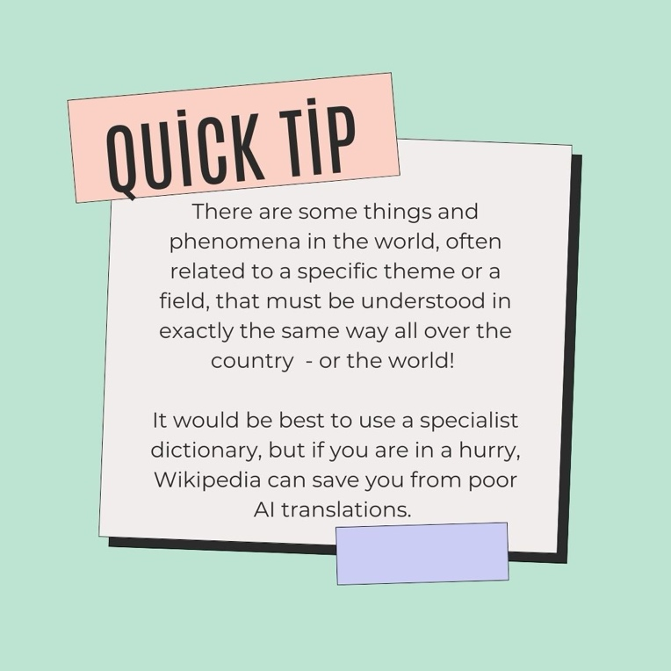

Accessible picture: Wikipedia info corner.pdf

Kuva tekstinä:

There are some things and phenomena in the world, often related to a specific theme or a field, that must be understood exactly the same way all over the country – or the world!

It would be best to use a specialist dictionary, but if you are in a hurry, Wikipedia can save you from poor AI translations.

1) Go to Finnish-language Wikipedia: https://fi.wikipedia.org/wiki/.

2) Choose five of the topics below and check their Finnish Wikipedia article.
- saamelaiset
- suomenajokoira
- kiertäjähermo
- tasavalta
- kuningaskalastaja
- jokamiesluokka
- aavikoituminen
- voikukka
- kärpässieni
- keliakia

3) Find the names of the topics in English. When you have found the Finnish Wikipedia article, change the language of the article into English by clicking the language on the left of the page.
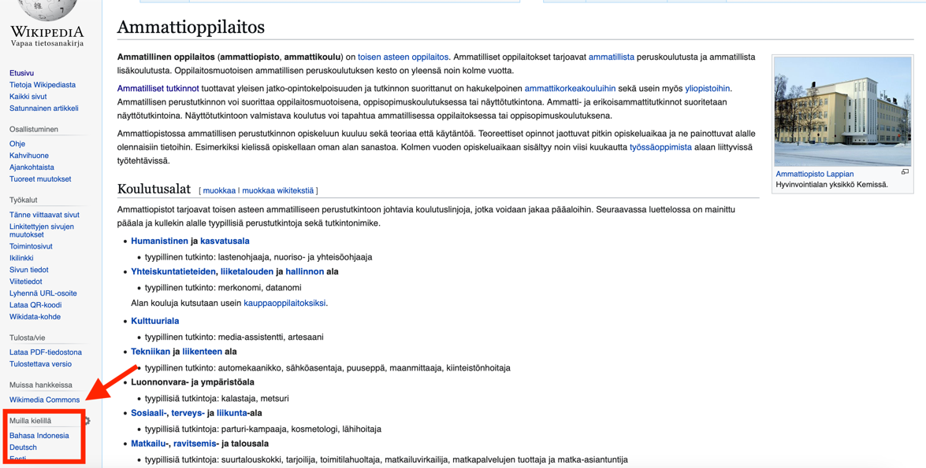
Picture: A screenshot from Wikipedia and how to change the language of a Wikipedia article.

4) Write the English words and submit your answer.

Video from Your Field of Studies

Practice searching for information and assessing the reliability of a source.

1) Find an English language YouTube video that is useful in your work or field of study.
TIP! You can ask AI to give you good keywords to find suitable videos in your field.

2) Watch the video and make notes for yourself.

3) Talk about the video by answering the following questions:
- What’s the name of the video and when was it published?
- Explain what happens in the video.
- Explain why the video is useful and for whom it is useful: you, your client, a new colleague or someone else.
- How do you assess the reliability of the video?
- Would you explain the topic in a different way? How?
4) Record your answers.

Writing a Text with AI

1) Write a text of 100-200 words with the title “My studies in vocational school”. Do not use any translators or any other help for this part.

2) Create another text with AI. Ask ChatGPT or other AI source to write a text on the same topic. As a prompt, you can use the very first sentence of this task.

3) Create one more text with AI. Try different prompts to mimic a similar tone to that which you have used in your original text.

4) Gather all 3 texts in a Word document and submit your text.

Extra Task: Around the World

Tämä tehtävä on matka maailman ympäri pakohuonepelien hengessä. Opiskelijoiden täytyy etsiä verkosta vastaukset 28 kysymykseen, jotka on jaoteltu neljä per manner. Jokainen sivu käsittelee yhtä mannerta, ja jotta pääsee siirtymään seuraavalle mantereelle, täytyy jokaiseen kysymykseen löytää oikea vastaus. Tästä linkistä pääsee testaamaan peliä (älä jaa tätä linkkiä suoraan opiskelijoille): https://docs.google.com/forms/d/e/1FAIpQLScgvniQfCfzsZLj_VK0sfD3QrOSeSBvdqJm-Y_e_xGQhQWcYA/viewform?usp=sf_link

Kun haluat ottaa tehtävän käyttöön opiskelijoiden kanssa, kirjaudu ensin omalle Google-tilillesi ja aukaise sitten tämä linkki https://docs.google.com/forms/d/1GEREb8In5_gZQzdO_l9AzF98fQgYbYNGIZBTT1Si6wA/copy jolloin teet itsellesi muokattavan kopion pelistä, ja voit ottaa sen käyttöön omien opiskelijoidesi kanssa.

Around the world

Use the internet to find the correct answers to the questions. Read the questions carefully and make sure you understand what is actually being asked.

Be careful! You need to answer all the questions in each section correctly to move on to the next section. Remember that the names of people, countries, oceans and the like are always written with an uppercase letter.

You will be given clues, for example how many letters (A-Z) or how many digits (for example 24 has two digits) or how many words some of the answers require.

If you answer incorrectly, the question will have a red frame. If there is no red frame, your answer is correct. Most of the questions with numerical answers have a range for the correct answer, since the answers may vary a little bit depending on where you find it.

Culture

Acting in a linguistically and culturally diverse environment

The student
- knows how the language and culture they are studying affect interactive situations
- communicates in a multilingual and multicultural environment
- encounters people on an equal basis and with appreciation

Part One: Communication in a Multicultural Environment
Conversation Starters
Stand-up comedy by Ismo Leikola: Video + H5P
Formal/Informal language: Info corner + H5P
Polite work life conversation: make a dialogue + polite phrases

Part Two: Understanding and Comparing Cultures
English as a lingua franca: Video + make a mind map
Multilingual school: Fill in Power point -presentation
Cross-cultural communication: Video + H5P + fill in a culture comparison chart

Part 3 Going International
Professionals around the world: Finding companies around the world + fill in a comparison chart
Business culture: Make a presentation
Working international: Finding information + answer questions

Part 1: Communication in a Multicultural Environment

Conversation Starters

1) Choose one of the videos below and watch it:
- 4 Great Conversation Starters: https://www.youtube.com/watch?v=5U3gWUuV1BI
- How to Get Good at Small Talk, and even Enjoy it: https://www.youtube.com/watch?v=IRG-YubP1rw

2) Write down the tips mentioned on the video. Write briefly, in your own words.

3) Which one of the tips works the best in your opinion? Why do you think so?

4) Submit your answers in one document.

Stand-up Comedy by Ismo Leikola

1) Watch a video from Ismo Leikola’s stand-up show: https://youtu.be/V5aDB7WgTeo

2) Answer the following questions in English.

1. What is Ismo's favorite word?
a) and
b) coffee
c) ha-ta-ta-ta-ta-ta

2. What does Ismo’s favorite word mean?
a) someone is acting strange
b) that’s enough
c) coffee

3. What do Americans say to stop someone from cursing?
a) stop it
b) language
c) yell out

4. What does Ismo think would be a similar exclamation when someone is about to get hit by a bus?
a) transportation
b) public rides
c) transit
KEY:
1. c
2. b
3. b
4. a

Formal and Informal Expressions

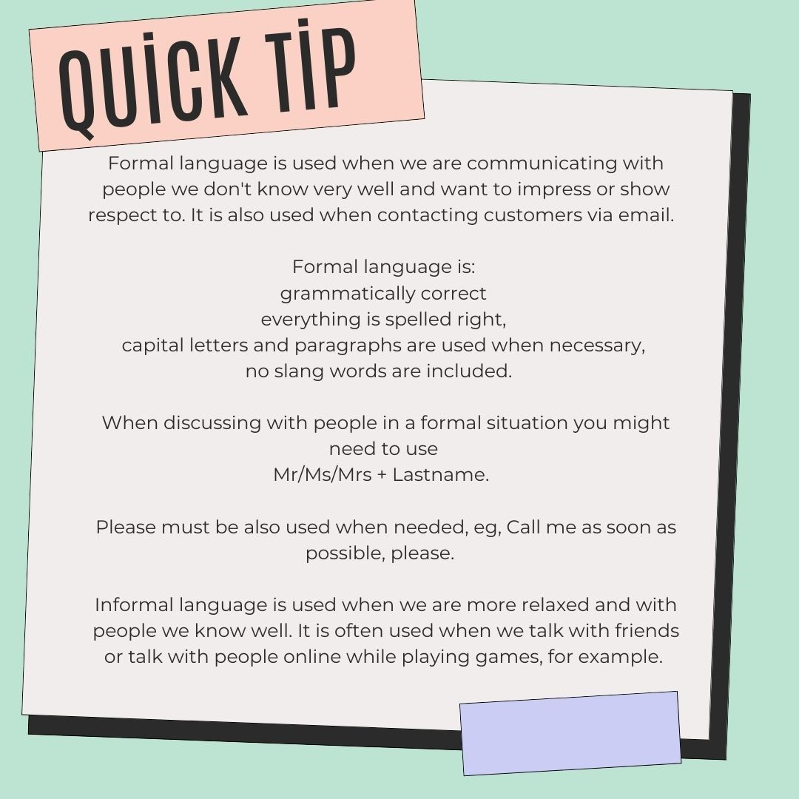
Accessible picture: Formal language info corner.pdf

Kuva tekstinä:

Formal language is used when we are communicating with people we don't know very well and want to impress or show respect to. It is also used when contacting customers via email.

Formal language has
- correct grammar
- correct spelling
- capital letters and paragraphs, when necessary
- no slang words

When discussing with people in a formal situation you might need to use Mr/Ms/Mrs + Lastname.

Please must be also used when needed, eg. “Call me as soon as possible”, please.

Informal language is used when we are more relaxed and with people we know well. It is often used when we talk with friends or talk with people online while playing games, for example.

1) Are the following expressions formal or informal? Fill in the chart by checking the correct box for each phrase.

Phrase | Formal | Informal
How do you do
Good morning, Ms. Henriksson.
I wanna
I am writing to enquire about
Hey, Maija, how's it going?
Sorry about that
Could you please assist me?
I appreciate your assistance
Can you help me out?
Please accept my apologies
Hi there, Sam!
Hey!
Yours sincerely
Thanks for your help
Yo, Alex, got a minute?
Sir, could you please assist me?
Mr. Johnson, may I have a moment of your time?
Sorry to tell you
Excuse me, Mrs. Smith.
I look forward to hearing from you
Can't wait to hear back!
Thanks a lot
Hey, Sarah, can you help me out
Just checking in
Thank you very much
I regret to inform you
Best (at the end of an email)
I would like to

KEY:

Phrase | Formal | Informal
How do you do | X
Good morning, Ms. Henriksson. | X
I wanna |  | X
I am writing to enquire about | X
Hey, Maija, how's it going? |  | X
Sorry about that |  | X
Could you please assist me? | X
I appreciate your assistance | X
Can you help me out? |  | X
Please accept my apologies | X
Hi there, Sam! |  | X
Hey! |  | X
Yours sincerely | X
Thanks for your help |  | X
Yo, Alex, got a minute? |  | X
Sir, could you please assist me? | X
Mr. Johnson, may I have a moment of your time? | X
Sorry to tell you |  | X
Excuse me, Mrs. Smith. | X
I look forward to hearing from you | X
Can't wait to hear back! |  | X
Thanks a lot |  | X
Hey, Sarah, can you help me out |  | X
Just checking in |  | X
Thank you very much | X
I regret to inform you | X
Best (at the end of an email, meaning terveisin) |  | X
I would like to | X

Polite Work Life Conversation

1) Choose a common workplace scenario from your field, for example a lunch break or a client meeting.

2) Create a polite work life conversation for that situation. Have a look at the Quick Tips below for help. You can also use AI in this task. Your conversation should have at least 10 sentences (two people talking, both say something at least five times).

3) Highlight all polite phrases that you used in your dialogue.

4) List what polite phrases you already know well and what you should learn to use more.

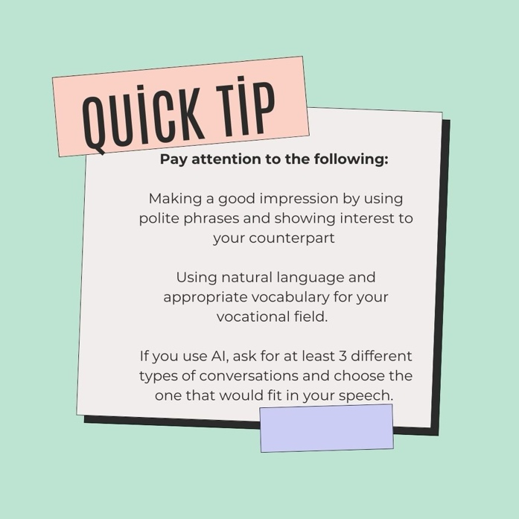
LISÄÄ TEKSTIVERSIO QUICK TIPSEIHIN!
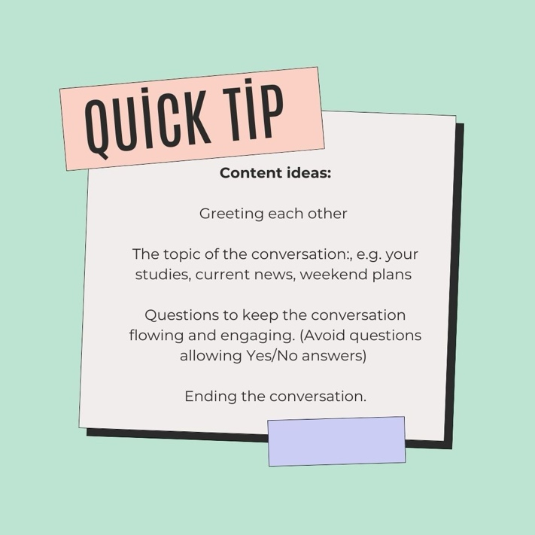

Accessible pictures: Polite worklife conversation.pdf

Kuvat tekstinä:

Pay attention to the following:
- Making a good impression by using polite phrases and showing interest to your counterpart.
- Using natural language and appropriate vocabulary for your vocational field.
- If you use AI, ask for at least 3 different types of conversations and choose the one that would fit in your speech.
Content ideas:
- Greeting each other
- The topic of the conversation, e.g. your studies, current news, weekend plans.
- Questions to keep the conversation flowing and engaging. (Avoid questions allowing yes/no answers.)
- Ending the cinversation

Part 2: Comparing and Understanding Cultures

English as a Lingua Franca

1) Watch a video about English as Lingua Franca: https://www.youtube.com/watch?v=_xmJxKO5INE

Try to understand what Lingua Franca means and why it is important to have different ways of communicating.

2) Make a mind map of the video where you list the most important points about English as a Lingua Franca.

3) Add your own comments in the mind map: In which contexts do you use English as a Lingua Franca.

You can draw the mind map by hand or use digital tools, for example www.mindmeister.com.

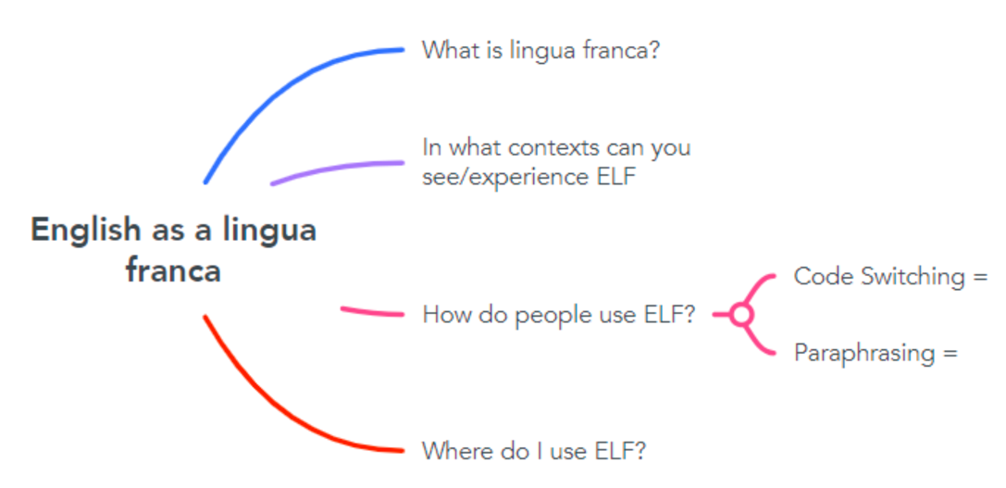
Accessible picture: English as a lingua franca mind map.pdf

Multilingual School

1) Read the introduction:

Multilingual means using or knowing more than one language. Finland is a multilingual and multicultural country. But how multilingual and multicultural is your school?

A foreign exchange student is coming to your school to study the same field as you. You are asked to give a short introduction to the new student.

What would you tell them about your school in English?

2) Fill in the chart with the information asked.

The name of the school
Opening hours
Contact information
(address and phone number)
Website
Languages used at school
List at least five rules that you have at school.
What kind of healthcare services are available for students?
What kind of recreational opportunities are available for students?
What kind of classrooms are there and where are they located?
How are different cultures considered?
Best things about my school

A link to the PowerPoint version of the task:
https://osekk-my.sharepoint.com/:p:/g/personal/annisaar_osao_fi/Ea-K0dwhPcxHiJ-I-qVTUKYBBXSuQpKhDjH8t3HYRQ_ngw?e=TWquae

Culture Comparison
1) Watch a video on cross-cultural communication: https://www.youtube.com/watch?v=YMyofREc5Jk
2) Reflect on Finnish culture and stereotypes about Finns. Compare two countries, Finland and another country of your choice.

3) Fill in the cultural comparison chart below.
Cultural comparison
 | Finland | My country of comparison  __________________
Try to define a typical person in the country.
Name common stereotypes of the country and/or its people.
My thoughts on the stereotypes I mentioned above.
What can people do to avoid cultural clashes in the country? Give at least 3 tips.
Typical foods, name at least five.
Give examples of when you became more aware of different cultures.

A link to the Word document version of the task:
https://osekk-my.sharepoint.com/:w:/g/personal/annisaar_osao_fi/EZbMSicp8wtOp-Va3_plspkBP6nBPjfkR3erMrvkeCtb_g?e=8A5X4a

Part 3: Going International

Professionals around the World
1) Find a company or an organization operating in the field you’re studying from the following countries:
- Australia
- Britain
- India
- Canada
- the United States.
Find 1 company for each country → 5 companies from 5 countries.

When you search for information online, you can type in the search box for example “metalwork company Delhi" or "hospital Manchester".

2) Fill in all the necessary information of each company in the chart below:

 | Australia | Britain | India | Canada | USA
Name of the company
Company website
Services/products of the company
Contact information
My observations when getting to know the company (how is information presented, for example)

A link to the Word document version of the task:
https://osekk-my.sharepoint.com/:w:/g/personal/annisaar_osao_fi/EQ7F8xZdfZBApkT0xYGAhEEB-5GpVEE39Wj1zAI2LNJ_XA?e=dFb4Xy

Business Culture Presentation
1) Go to https://businessculture.org/

2) Choose one country that you would like to learn more about.
3) Prepare a presentation with Power Point or Prezi, for example. Include at least the following aspects in your presentation:
- 5 of the most interesting and important facts of the country, or more
- 5 of the most interesting and important facts of the culture of the country, or more
- 5 of the most interesting and important facts ofr the business life in the country. For example, if you wanted to do your on-the-job learning in this country, what would be useful to know?

Working Internationally

1) Choose a country in Europe that seems interesting to you or where you would like to work.

2) Find information about working as an EU-citizen in the country of your choice.

3) Find answers to the following questions:

a) How and where can you apply for a job in that country?
b) What are your rights and duties if you decide to work in some other European or non-European country except Finland?
c) Where do you pay your income taxes?
d) If you become ill in a foreign country, are you entitled to use the public health services?
e) Who pays for your medicine and doctor's appointments?
f) How are the working hours and holidays?
g) What is the minimum pay in that country?
h) What is an example job agreement like? What kind of information does it have?

You can use AI for your help to get started but do check the information from official websites. Mark your sources.

Self-evaluation and Feedback
Evaluate your own skills on this course and give feedback on the course contents.

Answer the questions below.

Rating Scale
 | Strongly  disagree | Disagree | No  comment | Agree | Strongly agree
The contents of the course met my expectations.
I enjoyed studying on this course.
The instructions were clear.
The tasks were versatile.
The number of tasks was OK.
The course improved my skills.

The hours I spent with this course
a) 0–10 hours
b) 11–20 hours
c) 21–30 hours
d) 30 hours or more

My greatest accomplishment on this course:

What I found challenging on this course:

Describe your studying process:
a) I did the tasks independently.
b) I needed help in doing the tasks.

If you needed help in this course, describe what kind of help you needed:

Which grade would you give yourself for completing this course?
a) Satisfactory 1
b) Satisfactory 2
c) Good 3
d) Good 4
f) Excellent 5

Give reasons for your grade.

Would you like give more feedback?

Skills Demonstration
Osaamisen osoittamisessa on yhteensä kolme osiota. Ensiksi on kaksi ennakkoon tehtävää työtä, jotka opettaja laittaa näkyväksi opiskelijalle, kun osaamisen hankkimisen tehtävät on tehty:

1) Osaamisen osoittaminen tehtävä 1: kirjallinen sähköposti

SEKÄ

2) Osaamisen osoittamisen tehtävä 2: suullinen video-CV.

Näiden lisäksi opiskelija varaa opettajan kanssa

3) 15 minuutin keskusteluajan koululla/Teamsissa suullisen kielitaidon ja vuorovaikutustaitojen osaamisen osoittamista varten. Tässä varmistetaan myös, että osaaminen vastaa sitä tasoa, miten muut osaamisen osoittamisen tehtävät on tehty.
Skills demonstration, task 1: Email

1) Finding a Job Advertisement: Search for an English job advertisement from another country.

2) Write a Polite Email Cover Letter: In the email, include the following:
- Information about yourself: your age, and field of study.
- Information about your interest towards the job.
- Your work experience: previous work experience (summer jobs, internships), duration, and tasks.
- Inquire if the company can assist you with finding accommodation.
- Mention that you have attached your video CV.
3) Attach a link to the job advertisement and the company website.

Skills demonstration, task 2: Video CV

1. Make a video CV for the same job ad that you “sent an email to”.

In your video CV you should:
- Talk about yourself: what you are studying, what skills you have, and what kind of job and tasks/duties you are interested in.
- Explain why you would like to work specifically for that company (refer to the company’s website).
- Share what you have learned about the target culture/country and the job there.
- Include a sample work from your field: description or a demonstration (you actually doing the task) of a task related to your field.

Examples:
this is how I properly use a tool
this is how I perform this task
this is how I politely serve a customer.

Further examples:
this is how I fix a kitchen sink
here I set a table and serve food to customers
here is a photo of a wall I built. The first thing I did was…
here are before and after photos of…
I show how I…

Skill demonstration, task 3: Suullinen osaamisen osoittaminen opettajan kanssa

Järjestetään Teams- tai live-tapaaminen koululla (kesto noin 15min). Kysytään opiskelijalta kysymyksiä, jotka liittyvät opintojakson tehtäviin. Käydään opiskelijan kanssa vapaamuotoista keskustelua. Varmistetaan, että opiskelija on itse tehnyt tehtävät ja osaa kertoa niistä. Lisäksi tässä osaamisen osoittamisessa testataan reagointikykyä vuorovaikutustilanteessa.

Esimerkkikysymyksiä
- Tell me about yourself.
- Tell me about the field you are studying.
- Describe a duty from your field.
- Describe what kind of information you have learnt during the course.
- What country did you study in your business culture presentation?
- What did you learn?
- You compared different cultures during the course. What kind of findings did you have?
- How can you make sure the information you search is reliable, relevant and up to date?
- What tools (AI/online dictionaries/visual dictionaries) do you think you’ll use in the future?
- Name a few sources from your field that you find useful/relevant for you as a professional.
- Name a few sources from your field that you find useful/relevant for your customer/client.

Itsearviointikysymyksiä
- How would you describe your learning process during the course?
- What grade would you give yourself for the course: communication/information search and cultural understanding? The scale is 1 to 5.
- Your comments on the tasks.

Extra material: Traditional job interview questions
- Why are you interested in this job?
- What do you consider your strengths? What are you good at?
- What is your biggest weakness?
- What situations make you stressed?
- How do you handle pressure?
- When it comes to working environment, what things are most important to you (name three)?
- If you had a choice, would you prefer to work alone or as part of a team? Why?
- Why do you think you would be the right person for this position? Where did you work? Tell something about the place (size, location, field of expertise).
- How long did you work there? / How long have you been working there?
- What was / is your typical day like (working hours, work tasks, teamwork vs independent work)?
- • What can you tell about the work atmosphere (co-workers, supervisor, communication
- • between co-workers)?
• What did you learn? Did you try something new?
• Did you become better at something? Explain further.
• What was the most challenging thing for you? The most enjoyable?
• Share one interesting incident or a funny thing that happened.

Nykyisessä asiakirjassa ei ole lähteitä.

Tämä materiaali on tuotettu VIERKO-hankkeessa
vuonna 2024.
VIERKO on toteutettu Opetus- ja kulttuuriministeriön
vuonna 2023 myöntämällä ammatillisen koulutuksen strategiarahoituksella. VIERKO on kuudenkymmenen-
kahden (62) koulutuksen järjestäjän yhteisponnistus.
Työtä on koordinoinut Keski-Uudenmaan koulutus-
kuntayhtymä Keuda.

Hankkeessa on kehitetty vieraskielisen koulutuksen laatua
ja kotimaisten kielten opetuksen tarjontaa ammatillisessa koulutuksessa.

Lisätietoa:
https://www.keuda.fi/keuda/hankkeet/vierko/

https://creativecommons.org/licenses/by/4.0/

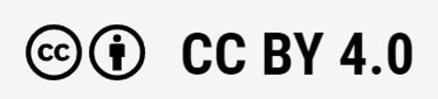
Oppimateriaalit:

CC BY-SA 4.0 Deed | Nimeä-JaaSamoin 4.0 Kansainvälinen | Creative Commons
https://creativecommons.org/licenses/by/4.0/

Oppimateriaalit:

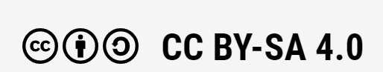

CC BY-SA 4.0 Deed | Nimeä-JaaSamoin 4.0 Kansainvälinen | Creative Commons

